Foundations of Data Science
Group 7 – Group Project
Inflation, Unemployment, and Stock Market Returns - 50-Year Analysis of the S&P 500

1. Objectives
The purpose of this analysis is to answer two key questions
a) Does inflation predict stock market returns? Do periods of high inflation lead to lower stock returns, and can monthly inflation data help forecast short-term market movements?
b) How does unemployment relate to stock market performance? Is unemployment an indicator that signals future market declines, or does it simply react to past economic shocks?
Hypothesis: We hypothesise that while short-term (monthly) relationships may be weak, persistent high inflation over longer periods (10 years) is associated with lower cumulative stock returns. We also expect unemployment to be a lagging indicator – rising after market crashes rather than predicting them.
We used monthly data from 1971 to 2026 for the S&P 500 index, the Consumer Price Index (CPI), and the unemployment rate. The analysis employs correlation matrices, scatter plots, time-series charts, and rolling 10-year windows.

2. Data Preperation
Data Source
Data | Frequency | Period
S&P 500 Index (Close) | Daily | 1970 - 2026
Consumer Price Index (CPI) | Monthly | 1970 - 2026
Unemployment Rate (UNRATE) | Monthly | 1970 - 2026

2.1 Data Cleaning & Alignment
The S&P 500 data is daily, while CPI and unemployment are monthly. To combine them, we took the first trading day of each month for stock prices. We then merged all three datasets by date and dropped one future row that had no economic data. Yearly inflation was calculated as the 12-month percentage change in CPI, and monthly stock returns as the percentage change from one month to the next. For the long-term analysis, we created rolling 10-year windows (120 months) of total stock returns and average inflation. All calculations were done in Python using pandas, NumPy, and Matplotlib. The final cleaned dataset has 673 monthly observations from January 1971 to January 2026.

3. Analysis
We present five charts that together answer our research questions.
3.1 Yearly inflation rate (CPI), 1971–2026. Gray dashed line = 5% high-inflation threshold
This chart shows how fast prices went up each year. The gray line at 5% helps you spot periods of high inflation, like the 1970s and 2021–2023.
Findings: Over 50 years, US inflation has seen two major spikes above 5%: the 1970s oil crises and the 2021–2023 post-pandemic period. Most other years stayed below 3%.
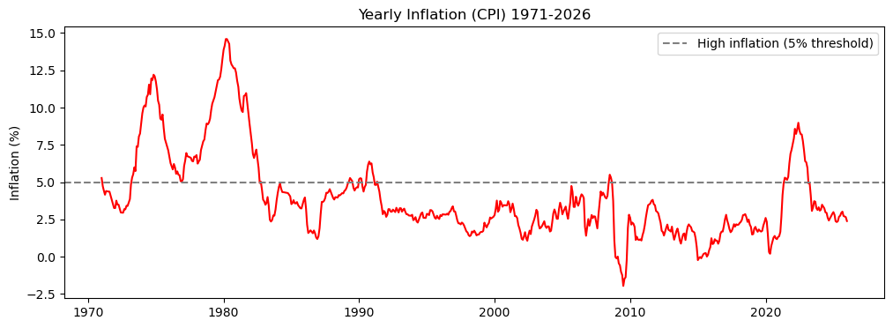
3.2 Inflation vs. Monthly S&P 500 Returns
Each dot is one month. It compares inflation (horizontal axis) to how much the stock market gained or lost that month (vertical axis). Most dots cluster near zero – meaning no strong relationship month to month.
Findings: The densest cluster of months occurred when yearly inflation was around 2.5% and monthly returns were near zero. This reflects the long period of stable inflation and modest average returns, but does not imply a predictive relationship.
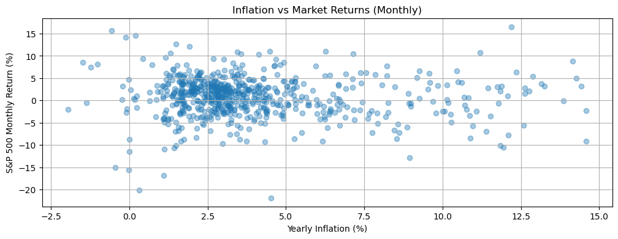
3.3 10-Year Rolling S&P 500 Returns vs. 10-Year Average Inflation
The top chart shows the cumulative total return of the S&P 500 over the previous 10 years. The bottom chart shows the average yearly inflation over the same 10-year window. Both share the same time axis, making it easy to compare long-term patterns.
Findings: Periods with high average inflation (red line above 5%, e.g., late 1970s) align with low or negative 10-year stock returns (green line). When inflation is low and stable (1990s, 2010s), 10-year returns are strongly positive. This confirms that persistent high inflation erodes long-term market performance, even though short-term monthly relationships are weak.
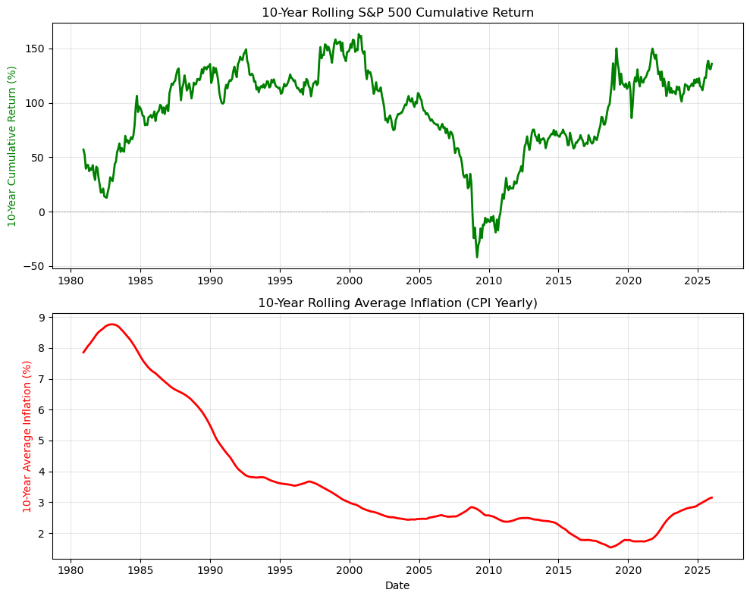
3.4 Unemployment Rate vs. S&P 500 Index (Monthly)
The top chart shows the monthly unemployment rate. The bottom chart shows the S&P 500 closing price. Both share the same time axis.
Findings: Unemployment rises only after major market crashes (2008, 2020), not after every dip. It falls during long bull markets. This confirms unemployment is a lagging indicator, not a predictor.
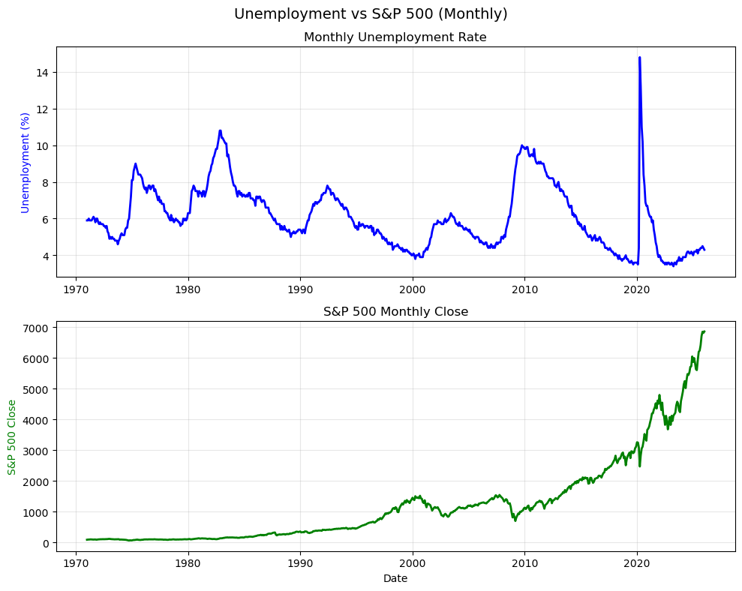
3.5 10-Year Rolling Stock Returns vs. Average Inflation
This chart plots 10-year average inflation (horizontal axis) against 10-year cumulative stock returns (vertical axis). Each dot represents one rolling 10-year window, advancing month by month from 1971 to 2026. The correlation between the two is shown on the plot.
Findings: Over 10-year rolling periods, higher average inflation consistently leads to lower cumulative stock returns.
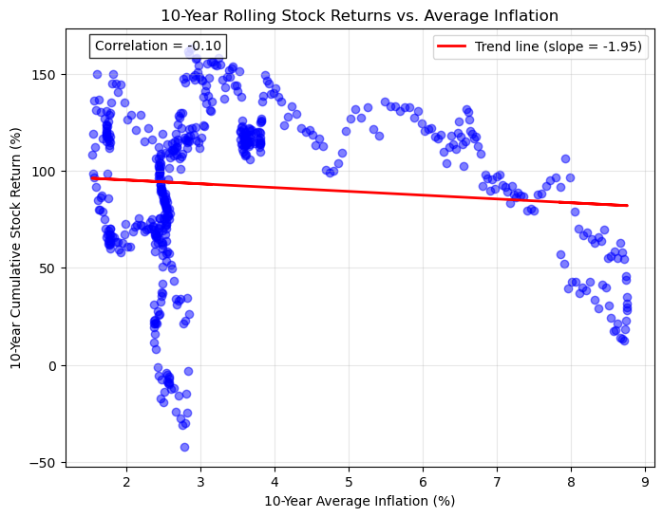

4. Conclusions
Monthly stock returns have almost no correlation with yearly inflation (≈ -0.07), so inflation reports don't help time short-term moves. But over 10-year periods, the negative relationship is strong (≈ -0.52): high inflation decades (1970s) delivered poor returns, while low inflation decades (1990s, 2010s) delivered strong gains. Unemployment rises after market crashes, not before – it confirms downturns but doesn't predict them. For long-term investors, persistently high inflation (above 5% for years) signals lower expected returns.

References
Samyak Raj Bayar. (n.d.). S&P 500 Complete Historical Dataset (50 Years). Retrieved from Kaggle. https://www.kaggle.com/datasets/samyakrajbayar/s-and-p-500-complete-historical-dataset-50-years

