**Real Estate Property MANAGEMENT**

A PROJECT SUBMITTED TO

**Sarvodaya College of Computer Science**

**RAJKOT**

**(Affiliated to Saurashtra University)**



*Submitted in partial fulfillment of the requirements for the degree of*

**“**Master of Science in Information Technology**”**

**Sem-1**

**(Year 2024-2025)**

**Submitted By :~ Guided By :~**

**Borad Denish Prof. Radha Ranpara**

**Mugalpara Denish**

INDEX

|  |  |  |  |  |  |  |  |  |  |  |  |  |  |  |  |  |  |  |  |  |  |  |  |  |  |  |  |  |  |  |  |  |  |  |  |  |  |  |  |  |  |  |  |  |  |  |  |  |  |  |  |  |  |  |  |  |  |  |  |  |  |  |  |
| --- | --- | --- | --- | --- | --- | --- | --- | --- | --- | --- | --- | --- | --- | --- | --- | --- | --- | --- | --- | --- | --- | --- | --- | --- | --- | --- | --- | --- | --- | --- | --- | --- | --- | --- | --- | --- | --- | --- | --- | --- | --- | --- | --- | --- | --- | --- | --- | --- | --- | --- | --- | --- | --- | --- | --- | --- | --- | --- | --- | --- | --- | --- | --- |
| |  |  |  | | --- | --- | --- | | **No.** | **Description** | **Page No.** | | 1 | Preface | 3 | | 2 | Declaration | 4 | | 3 | Acknowledgment | 5 | | 4 | Project Profile | 6 | | 5 | Project Definition | 7 | | 6 | Web Architecture | 9 | | 7 | SQL Server | 10 | | 8 | Cost and Benefit Analysis | 11 | | 9 | Introduction to MySQL | 12 | | 10 | System Requirement | 13 | | 11 | Fact Finding Techniques | 14 | | 12 | System Development Life Cycle (SDLC) | 15 | | 13 | Data Dictionary | 17 | | 14 | DFD Diagram | 21 | | 15 | Use Case Diagram | 23 | | 16 | Admin Panel webpage | 25 | | 17 | Client panel webpage | 29 | | 18 | About Testing | 32 | | 19 | Bibliography | 34 | |  |  |  | |

PREFACE

We have designed this platform to cater to diverse needs and preferences in the real estate market. The website is organized into various categories, including Residential Properties, Commercial Properties, Rental Listings, and Investment Opportunities. Additionally, we have included sections for Contact & Feedback to ensure a seamless experience for our users. This platform is designed to save time and make it easy to inquire about properties through contact numbers or branch addresses.

The trend of searching for properties online has been steadily increasing across the globe. To better understand customer needs, we conducted primary research by administering surveys. The findings reveal that authenticity, location, and pricing are the primary factors that buyers and renters consider when exploring real estate options.

DECLARATION

We are the student of M.Sc. (IT) sem-1 hereby declare that the project work presented in this folio is my contribution and have been carried out under supervision of all professors of M.Sc. (IT) Department of Sarvodaya College, Rajkot.

The main objective of this training undertaken is to get specialized knowledge in a particular specialized field, which further sharpen the skill and also include that it is a part of our studies undergoing.

This work has not been previously submitted to any other institute /university for any of the purposes.

Place: Rajkot

Thank You,

**Denish Borad**

ACKNOWLEDGMENT

We are the student of M.Sc. (IT) studying in the Sarvodaya College-Rajkot. Thanks the entire person who has landed their support in shaping of the systemic

We thank **Prof. Radha Ranpara** before giving us full guidance and cooperation in understanding the system. We also thank them for their unconditional help in making of this project.

We have great deal of gratitude to wards our Head of Department who encourage us in taking up this activity. We thank all faculties and administrative staff of the institute in enhancing their cooperation.

PROJECT PROFILES

Developed At :~ Sarvodaya College - Rajkot

Developed By :~ Denish Borad

Main Pages :~ Home page (Home)

Operating System :~ Microsoft Windows XP,

95, 98, 2000, Professional 7,8,10.

Front End :~ php , CSS, JavaScript etc..

Back End :~ MySQL

Web Browser :~ Internet Explorer 6.0, Mozilla Firefox,

Google Chrome, Opera.

Editor :~ Visual Studio code

Hardware Requirement

For Internet Access :~ 486 D*2 or Higher Processor.

Free Disk Space 100 MB.

Color Monitor & Multimedia Kit.

One Free comport For Modem.

Modem 56 Kbps.

Guided By :~ Prof. Radha Ranpara

**Submission At****:*~*** M.Sc.(it) Department of Sarvodaya College

PROJECT DEFINITION

* General Introduction:
  + In today’s fast-paced digital world, the real estate market has embraced technological advancements to streamline property transactions and management. Our platform is meticulously designed to cater to three key roles: **Admin**, **Agent**, and **User**, ensuring an efficient and seamless experience for all stakeholders.
  + **Users** can easily explore and find their ideal properties based on preferences such as location, budget, and property type.
  + **Agents** have the ability to list property details, manage property availability, and connect with potential buyers or renters.
  + **Admins** play a pivotal role in overseeing the platform, managing agents, builders, and users, and ensuring the integrity and smooth functioning of the system.
  + This platform is created to save time and enhance accessibility, allowing properties to be discovered, listed, and managed from the comfort of your home. With a user-friendly interface and robust features, we aim to redefine how real estate transactions are handled.
  + We believe that transparency, trust, and efficiency are the cornerstones of a great real estate experience. By integrating these values into our platform, we aspire to meet the diverse needs of all our users while keeping up with the growing trend of online property searches and management.
* **Benefits of the Platform:**

1. **For Users**:
   * Effortlessly search and find properties tailored to their needs, including location, budget, and type.
   * Save time by exploring properties online instead of physically visiting multiple locations.
   * Easily contact agents for inquiries, property tours, or negotiations.
2. **For Agents**:
   * A convenient platform to list properties with detailed descriptions, images, and pricing.
   * Directly connect with potential buyers or renters to close deals faster.
   * Manage property availability and updates in real-time.
3. **For Admins**:
   * Full control to manage agents, builders, and users, ensuring the smooth functioning of the platform.
   * Maintain platform integrity by overseeing listings and user activities.
   * Analytics and insights to track performance and improve user engagement.

Web Architecture

A **Web Server** is a computer that runs the web server software**,** which responds to page requests**.** It is also called **host.** The two main types of web server are **HTTP Server** that follows the HTTP protocol**,** and FTP servers that follow the FTP protocol.

A **Web Client** sends requests for data to a web server**.** When the web server processes the request and sends the requested page to the client (remember the browser is used to view these pages and send requests**.**)

SQL SERVER

* **What is Database?**

Database is a collection of facts and Figures and we have humungous data available to the user via the internet and other sources to manipulate the data Structured Query Language in short has been introduced year ago. There are different versions of SQL available in the market provided by different organizations. In this article we shall see the version of SQL provided by Microsoft.

* **Introduction Of Microsoft SQL Server :~**
  + Microsoft SQL server or MS SQL server for short is the query language provided for data definition and manipulation.
  + SQL Server is a Relational Database Management System which was developed and marketed by the Microsoft Company
  + SQL And SQL Servers are Built as two layers where the SQL Server is on the top for Interacting with the relational databases.
  + SQL Server also has T-SQL or Transact-SQL and the main focus of T-SQL is to handle the transactions.
  + As it is a Microsoft developed system, it worked only on microsoft environment until it was made available on Linux platforms in the year 2016.
* **Features :~**
  + **Data Storage:**

Data Storage is a database which is a collection of tables with typed columns. SQL Server Supports Different data types, including Primitive types such as integer, float, decimal, char(including character string), varchar(variable length character strings),binary(for Unstructured blobs of data),Text(for textual data) among others.

* + **Concurrency and Locking:**

SQL server allows multiple clients to use the same database concurrently. As such, it needs to control concurrent access to shared data, to ensure data integrity-when multiple clients update the same data, or clients attempt to read data.

* + **Speed:**

Using techniques such as efficient indexing mechanisms, in memory temporary tables, and highly optimized join algorithms, MySQL executes most queries much faster than most other database systems.

COST AND BENEFIT ANALYSIS

* **Feasibility Study:~**

Feasibility study provides us information about cost of our project. This work on three-feature technical, economical, operational feasibility study.

* + **Technical:**

Technical feasibility check the project is technically possible or not. Technical feasibility can work for the project to be done with current equipment, existing software technology & available personnel. There is need for new technology.

* + **Economical:**

Economic Feasibility check, there are sufficient benefits to creating the system. It determines costs and expected of each of the alternative.

* + **Operational:**

Will the system be used if it is developed & implemented? Will there be resistance from user that will undermine the possible application the possible application benefits?

Introduction to MySQL

* What is My SQL?

MySQL is an open source relational database management system (RDBMS) that uses Structured Query Language (SQL), the most popular language for adding, accessing, and processing data in a database.

* **Features :~**
* **Portability:**

MySQL runs on almost every flavor of Unix, as well as Windows and MacOS X. User can obtain binaries or source code for the MySQL server as well as the tools that access it. More ports of the software become available every day. It is almost a given that MySQL will run on all Os.

.

* **Speed:**

Using techniques such as efficient indexing mechanisms, in memory temporary tables, and highly optimized join algorithms, MySQL executes most queries much faster than most other database systems

* **Scalability:**

Because of its modularity and its flexibility in configuration, MySQL can run in systems varying in size from embedded systems to large multiprocessor Unix servers hosting databases with tens of millions of records.

* **Flexibility:**

MySQL lets user to choose the table types that they need to meet their Software’s requirements, ranging from in-memory heap tables, fast on-disk MyISAM tables, merge tables that group together other sets of tables to form larger “virtual” tables, and transaction-safe tables

System Requirements

It specified minimum requirement of any project .It contain hardware and software requirements of project. The detail about minimum system requirement in this project as given bellow.

1. **Platform (Software):~**
   * Windows XP
   * Windows 98
   * Windows any other platform
2. **Front End And Back End Tools (Software):~**

* **Front End Tools:**
* HTML
* JavaScript/CSS
* **Back End:**
* Php, MySql

1. **Hardware Requirement Specification:~**

* 512 MB RAM.
* Visual studio Code
* Xampp

Fact Finding Techniques

The analysis doesn’t know the working process of the user for which, he is going to develop information system. The analyst use specific methods for collecting data about requirement, which is called fact-finding technique.

It includes the interview, questionnaire and record review. Analyst employees more than one of these techniques to help an accurate and comprehensive investigation. Analyst requires progressive lower level of detail for logical design. Hence it is also true that two project are never same in am information system. It means that analyst must use information-gathering tool.

* **Interview:~**

This is technique is used to collect information from individual or from groups. It is an art better learned from practice than books. It is an individual technique to gather qualitative information, opinions, policies, suggestion, underlying problem etc.

* **Questionnaires:~**

This technique is used to collect information from large number of people. Questionnaires give to every person and they fill Questionnaires. According to their answer decision are taken.

* **Record Review:~**

A good analyst gets facts from documentation. An existing system can be better understood by examining existing documents, forms and files. This record review can take place at beginning of the system study or letter in the study for comparing actual operation with what the records indicates.

* **Observation:~**

Observation can bring in missed facts, new ways to improve the existing procedures, duplicate work done inadvertently etc. Observation provides close view of working of real system. This task is delicate because people do not like to be observer when they work.

System Development Life Cycle(SDLC)

* Feasibility Study
* Requirements and specification
* Design
* Coding and testing
* Implementation
* Documentation

In the this planning and scheduling forward and backward steps are given which indicates the system study again during another work of project.

Maintenance

Integration

Implementation

Design

Specification

Requirements

Updated Requirement

Verify

Verify

Verify

Verify

Test

Test

Development

Maintenances

Product

Deliverable

This diagram gives information about day scheduling information in our project.

|  |  |  |  |  |  |
| --- | --- | --- | --- | --- | --- |
| Feasibility  Study |  |  |  |  |  |
|  | Require-  Ment  Specifica-  Tion |
|  | Design |
|  | Description |
|  | Implemen-  tation |
|  | Documan-  Tation |
| 10 Days | 12 Days | 08 Days | 20 Days | 10 Days | 5 Days |

Data Dictionary

Data dictionary is the center responsibility of information about system and Organization. Data dictionary contain a list of tram and their meaning for all data items and data storages of the system.

**Show tables:~**

**~: About US :~**

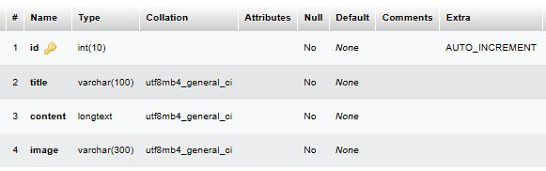

**~: Admin :~**

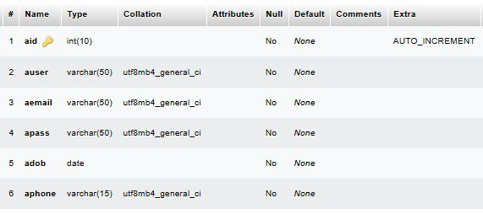

**~: Users :~**

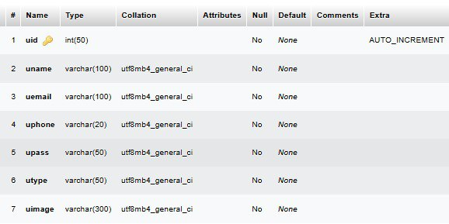

**~: Sub Category :~**

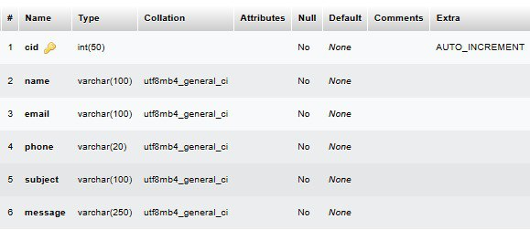

**~: State :~**

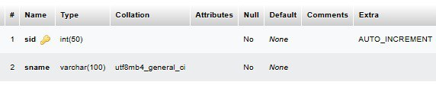

**~: City :~**

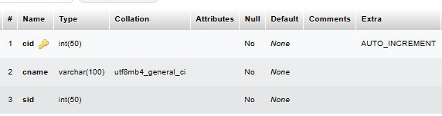

**~: Feedback :~**

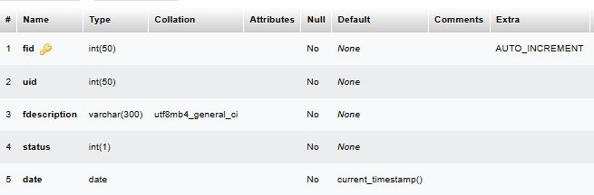

**~: Property :~**

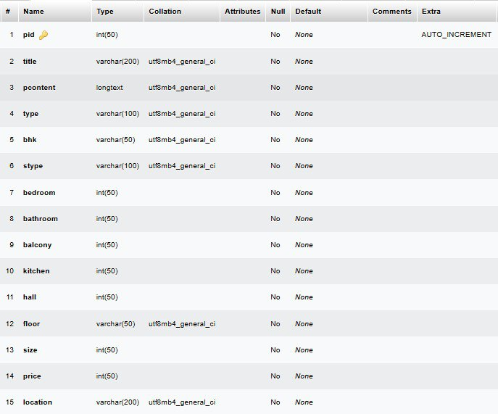

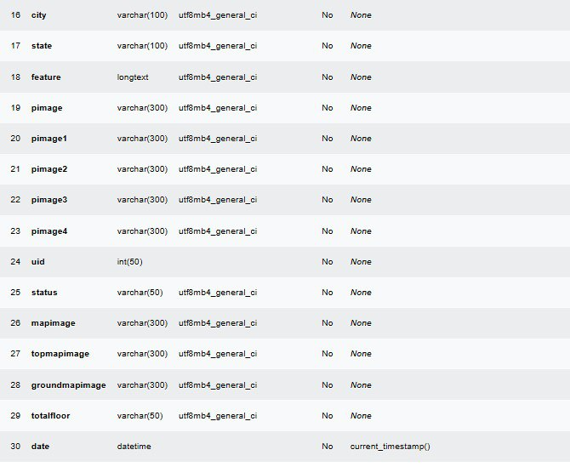

DFD Diagram

**Context Level DFD**

Admin

User

Request Response

Response Request

**DFD for Client side**

Login

1. Registration

View Property

1. Home

Your Property

**USER**

1. Property Request

Logout

Details

1. About Us
2. Contact Us

**DFD for Admin side**

Login

1. Login

Contact Us

6. About Us

Handle query

View

View Property

View User

**ADMIN**

5. Manage query

4. Manage state & city

1. Manage Property
2. Manage User

**Use case diagram (User)**



**USER**

**Use case diagram (Admin)**



**ADMIN**

.

**Admin panel webpages**

**Login Page:**

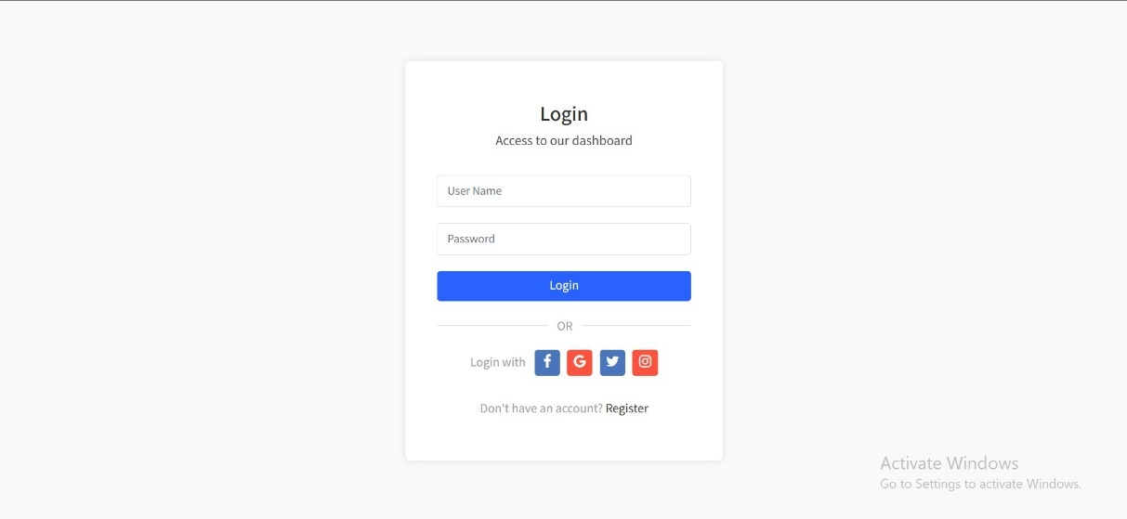

**Home Page:**

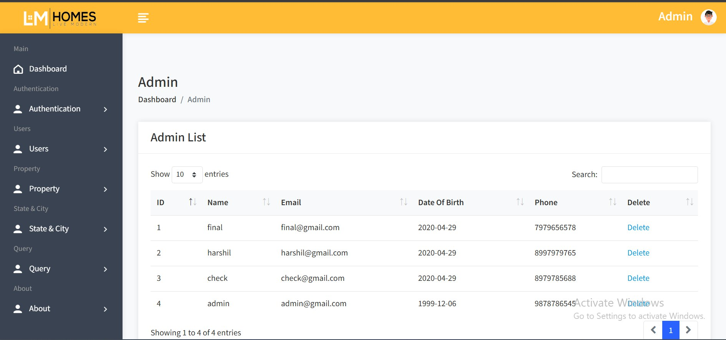

**User List:**

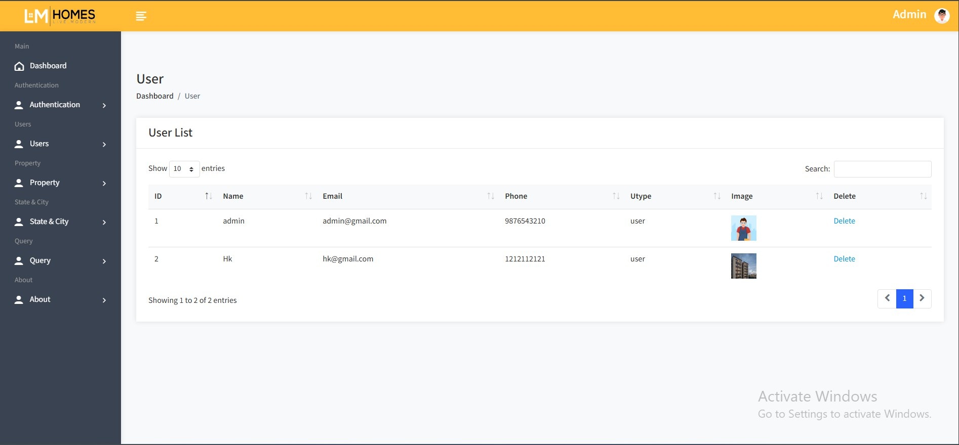

**Builder List:**

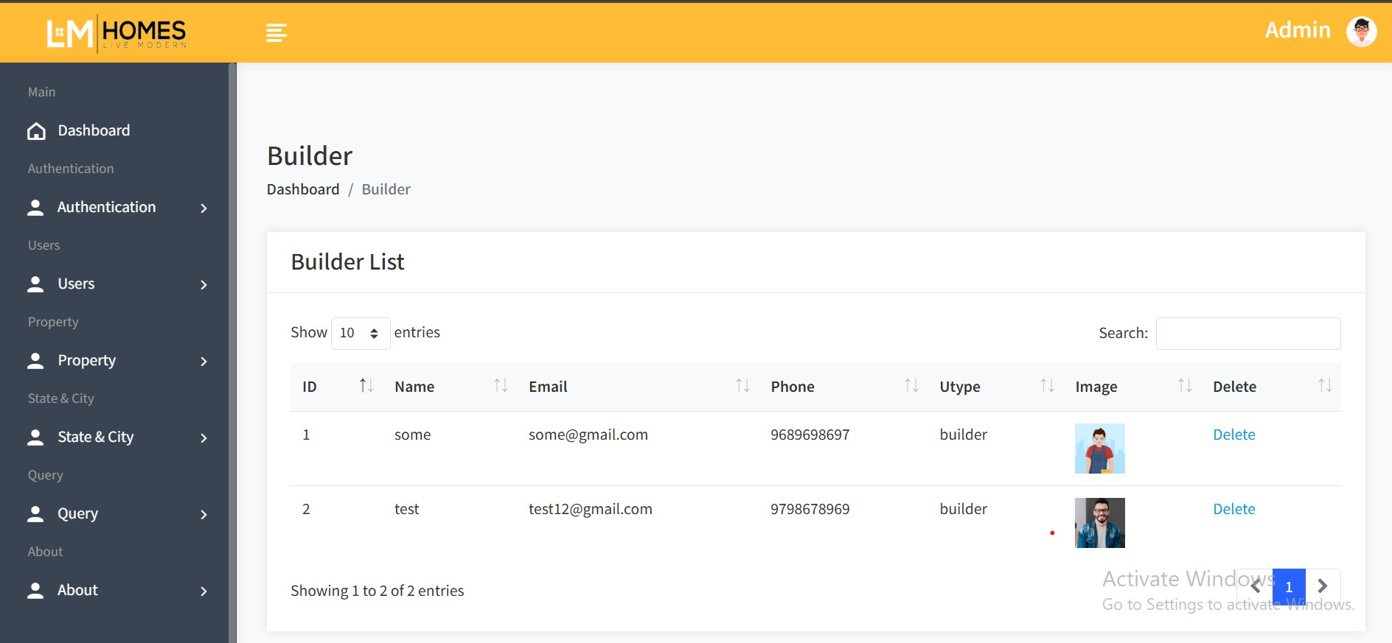

**Add property:**

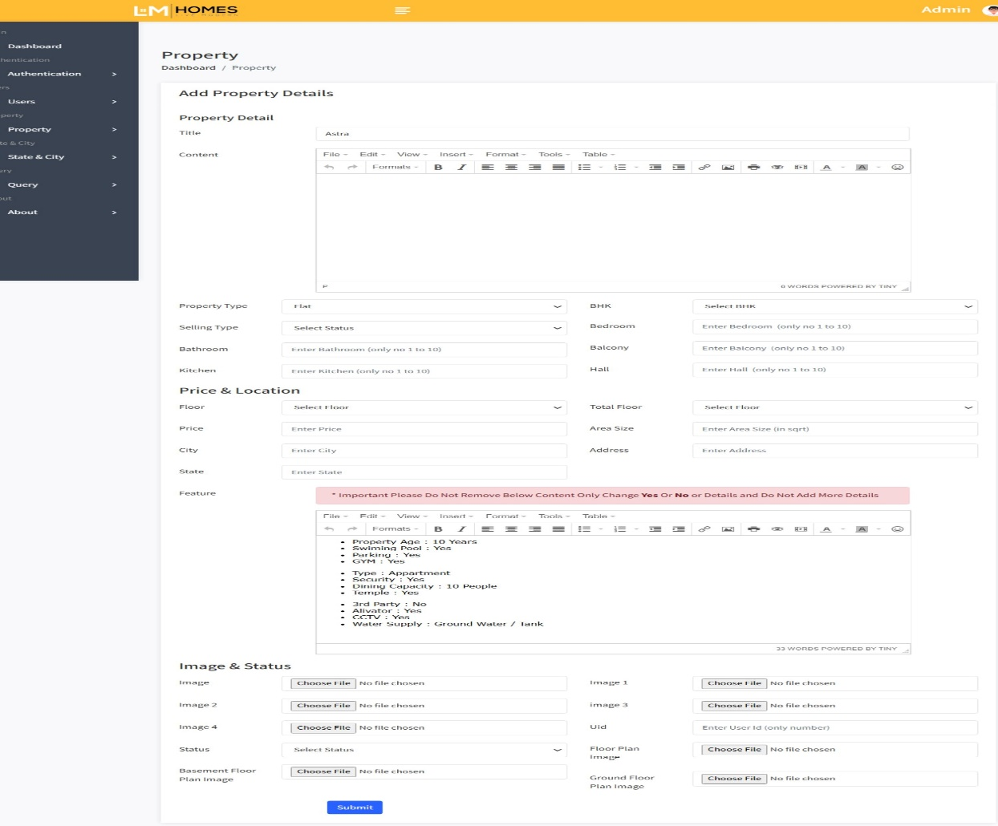

**Property List:**

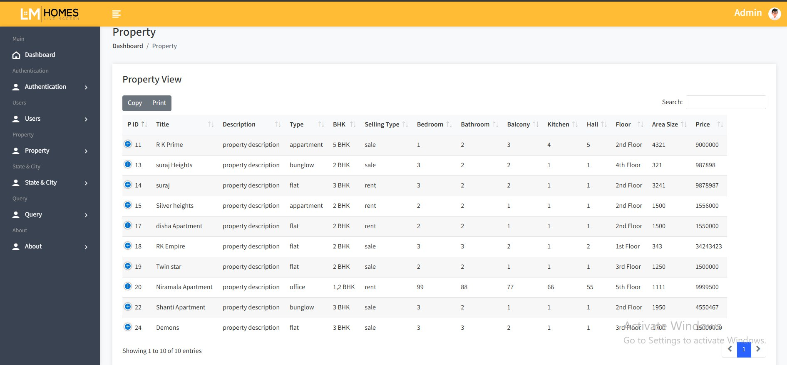

**State & City:**

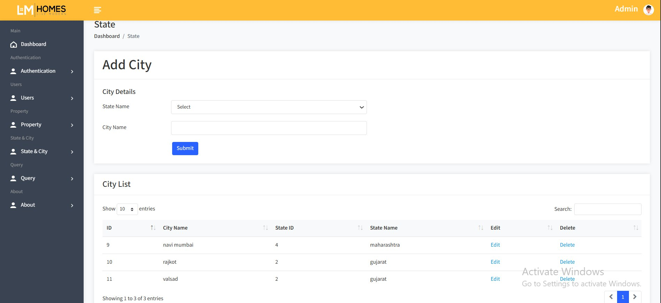

**About Us:**

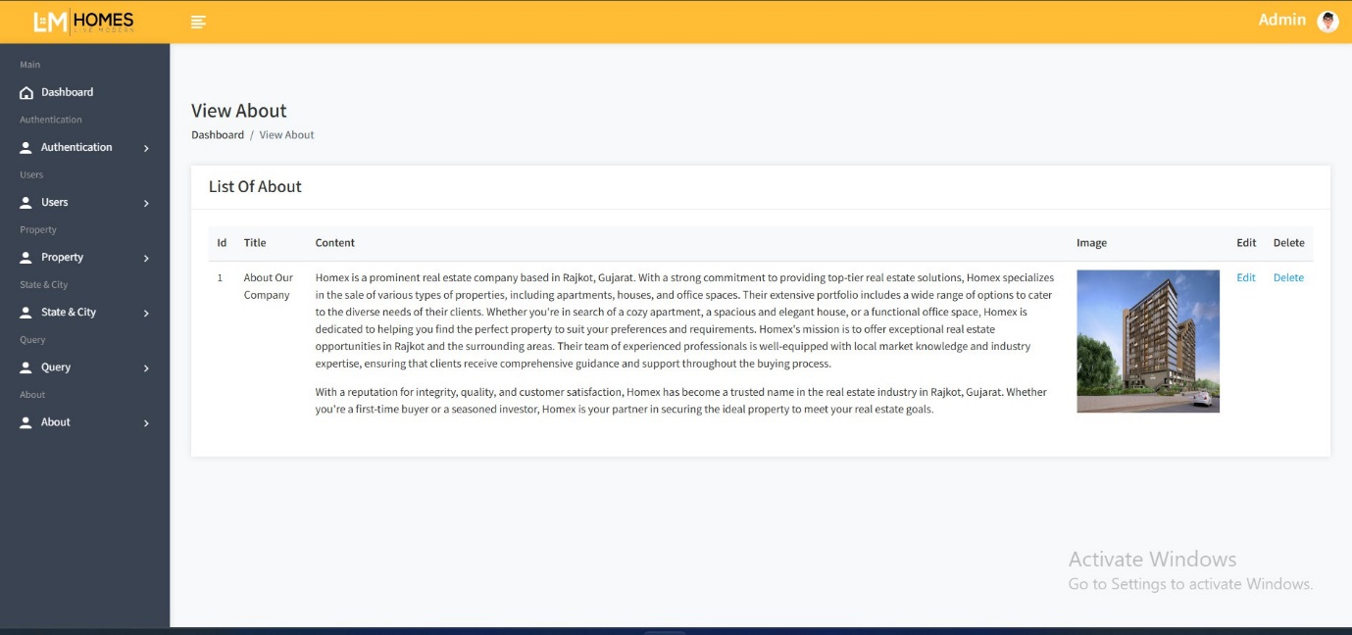

**Client side panel WebPage**

**Login:**

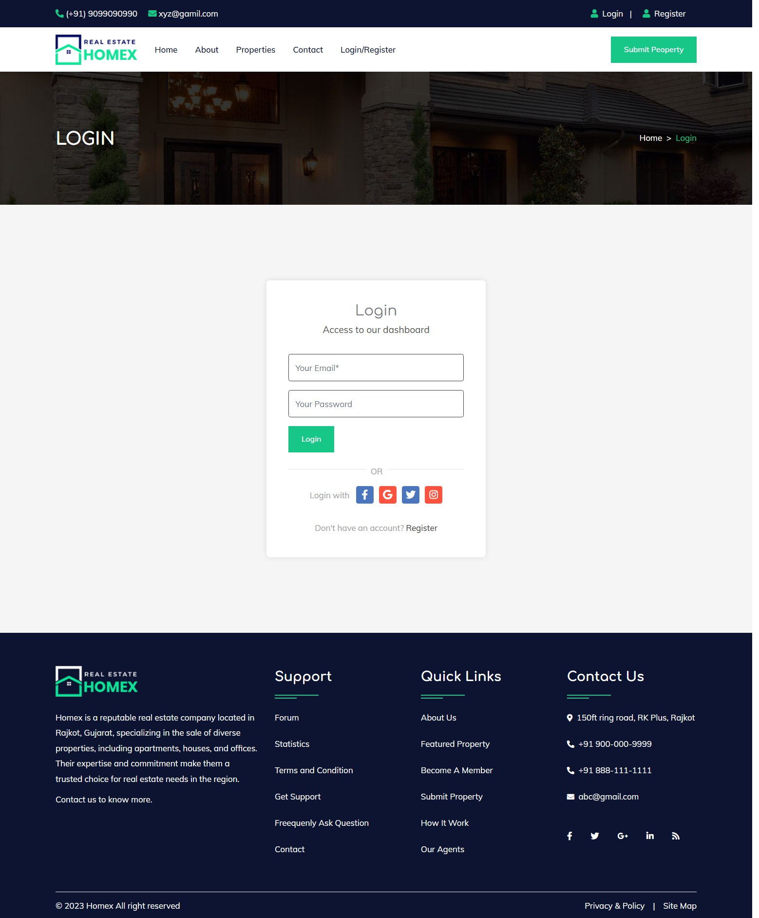

**Home Page:**

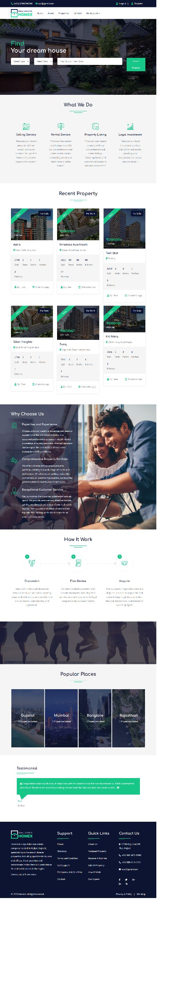

**Property List:**

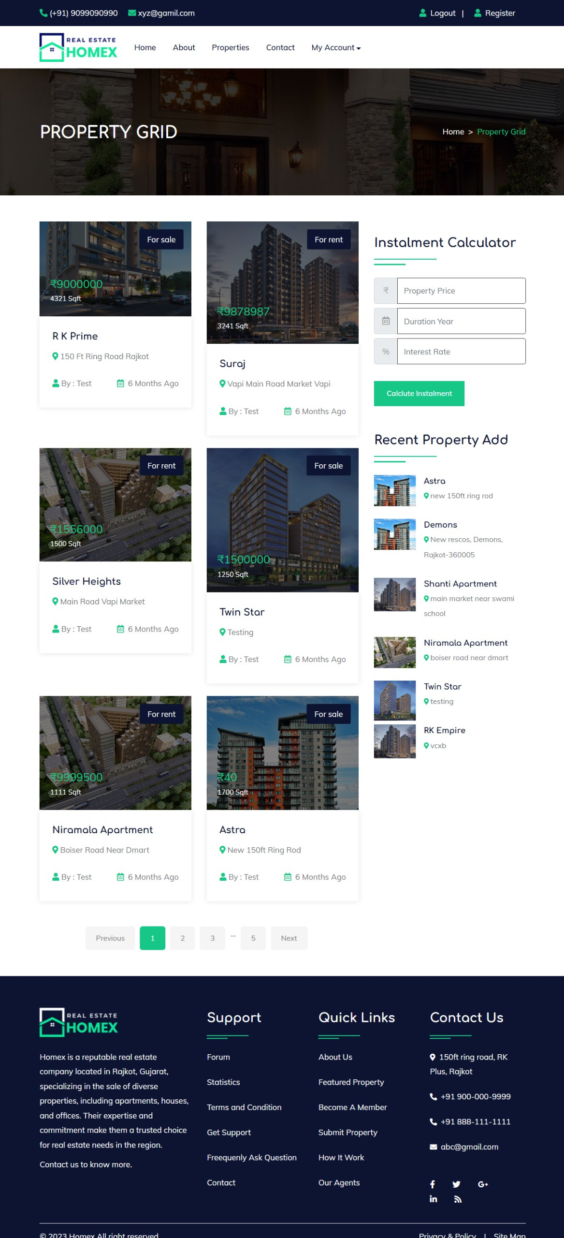

About Testing

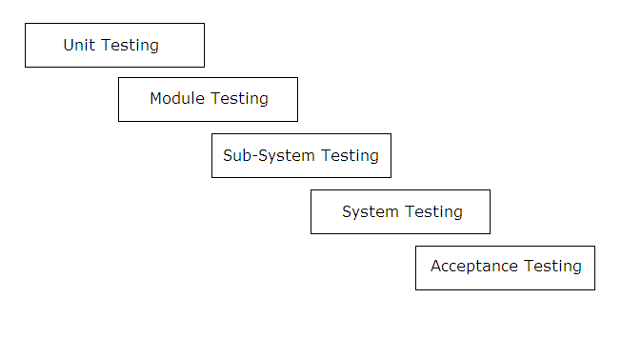This is the most crucial phase in the software development cycle. The developed application is thoroughly tested. Testing procedures and requirements differ with the nature of the product. It basically involves running through the whole application and verifying that the functionality is as per the designs.

Process is an iterative one with information being fed back from later stages to earlier parts of the process. The stage defines to earlier parts of the process. The stages defined in the above figure are explained as further:

**Unit Testing**

Individual components are tested to ensure that they operate correctly. Each component is tested independently without other system components. For example, whether an individual procedure is working properly or not is tested here.

**Module Testing**

A module is a collection of dependent components. A module encapsulates related components so that it can be tested without other system modules. In this project, one module is there, which contains a procedure, which is used by the project.

**Sub-System Testing**

This phase involves testing of collection of modules, which have been integrated into sub-systems. In this project, public module is, which is used by the project.

**System Testing**

The sub-systems are integrated to make the entire system. This testing process is concerned with finding errors, which normally results from unanticipated interaction between sub-system and components.

**Acceptance Testing**

This is the final test in the testing process before the system is accepted for operational use, sometimes called alpha testing. This process states whether the project satisfies all requirements specified by the customer or not.

Bibliography

We are creating this project initial stage of our currier. To complete this project we refer books and website to learn many topics. Those are very useful to create this project. We use following books and websites:

**Books**

php

**Website**

**Website: http://www.meesho**

.