Data Wrangling QBS 181

Homework -2-Due 10/17/2018

Instructions:

* Print random 10 rows to show these changes. Please also include the code
* Insert the answers directly into this document.
* You may collaborate on the homework but you must write it up yourselves.
* Please save the files in this format:
* Name of the file should be username(database)_HW2_QBS181
* Email the file with the subject line same as the file name.

1. Create a new column “Enrollment group” in the table Phonecall
2. Insert EnrollmentGroup=Clinical Alert :code is 125060000
3. Insert EnrollmentGroup =Health Coaching :code is 125060001
4. Insert EnrollmentGroup =Technixal Question: Code is 125060002
5. Insert EnrollmentGroup =Administrative: Code is 125060003
6. Insert EnrollmentGroup =Other: Code is 125060004
7. Insert EnrollmentGroup =Lack of engagement : Code is 125060005

select * into blu.phonecall from PhoneCall

alter table blu.phonecall add Enrollmentgroup nvarchar(100)

update blu.phonecall set Enrollmentgroup = 'Clinical Alert'

where [EncounterCode] = 125060000

update blu.phonecall set Enrollmentgroup = 'Health Coaching'

where [EncounterCode] = 125060001

update blu.phonecall set Enrollmentgroup = 'Technical Question'

where [EncounterCode] = 125060002

update blu.phonecall set Enrollmentgroup = 'Administrative'

where [EncounterCode] = 125060003

update blu.phonecall set Enrollmentgroup = 'Other'

where [EncounterCode] = 125060004

update blu.phonecall set Enrollmentgroup = 'Lack of Engagement'

where [EncounterCode] = 125060005

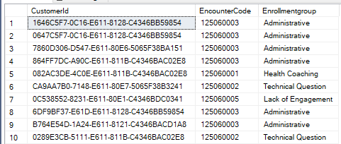

1. Obtain the # of records for each enrollment group

select count(Enrollmentgroup) from blu.phonecall

where [EncounterCode] = 125060000

select count(Enrollmentgroup) from blu.phonecall

where [EncounterCode] = 125060001

select count(Enrollmentgroup) from blu.phonecall

where [EncounterCode] = 125060002

select count(Enrollmentgroup) from blu.phonecall

where [EncounterCode] = 125060003

select count(Enrollmentgroup) from blu.phonecall

where [EncounterCode] = 125060004

select count(Enrollmentgroup) from blu.phonecall

where [EncounterCode] = 125060005

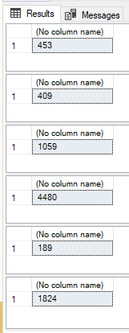

1. Merge the Phone call encounter table with Call duration table.

select A.*,B.* into blu.mergePC from blu.phonecall A

inner join

CallDuration B

on A.CustomerId=B.tri_CustomerIDEntityReference

select * from blu.mergePC

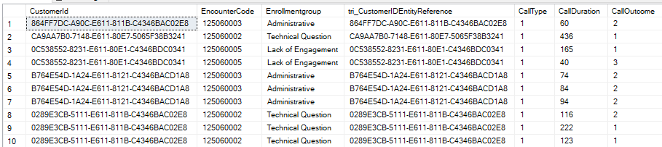

1. Find out the # of records for different call outcomes and call type. Use 1-Inbound and 2-Outbound, for call types; use 1-No response,2-Left voice mail and 3 successful. Please also find the call duration for each of the enrollment groups

alter table blu.mergePC add CallTypeRecord nvarchar (100)

update blu.mergePC set CallTypeRecord = 'Inbound'

where CallType = 1

update blu.mergePC set CallTypeRecord = 'Outbound'

where CallType = 2

alter table blu.mergePC add CallOutcomeRecord nvarchar (100)

update blu.mergePC set CallOutcomeRecord = 'No response'

where CallOutcome = 1

update blu.mergePC set CallOutcomeRecord = 'Left voice mail'

where CallOutcome = 2

update blu.mergePC set CallOutcomeRecord = 'Successful'

where CallOutcome = 3

select count(CallTypeRecord) from blu.mergePC

where CallTypeRecord = 'Inbound'

select count(CallTypeRecord) from blu.mergePC

where CallTypeRecord = 'Outbound'

select count(CallOutcomeRecord) from blu.mergePC

where CallOutcomeRecord = 'No response'

select count(CallOutcomeRecord) from blu.mergePC

where CallOutcomeRecord = 'Left voice mail'

select count(CallOutcomeRecord) from blu.mergePC

where CallOutcomeRecord = 'Successful'

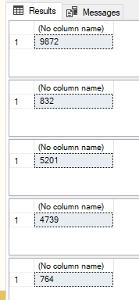

select sum (CallDuration) from blu.mergePC

where [EnrollmentGroup] = 'Clinical Alert'

select sum (CallDuration) from blu.mergePC

where [EnrollmentGroup] = 'Health Coaching'

select sum (CallDuration) from blu.mergePC

where [EnrollmentGroup] = 'Technical Question'

select sum (CallDuration) from blu.mergePC

where [EnrollmentGroup] = 'Administrative'

select sum (CallDuration) from blu.mergePC

where [EnrollmentGroup] = 'Other'

select sum (CallDuration) from blu.mergePC

where [EnrollmentGroup] = 'Lack of Engagement'

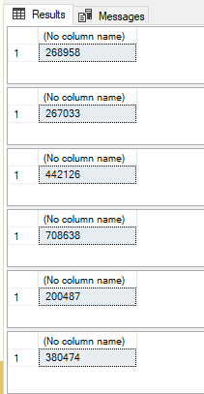

1. Merge the tables Demographics, Chronic Conditions and TextMessages. Find the # of texts/per week, by the type of sender.

select A.*,B.*,C.* into blu.mergeDCT from Demographics A

inner join

ChronicConditions B

on A.contactid=B.tri_patientid

inner join

Text C

on A.contactid=C.tri_contactId

select * from blu.mergeDCT

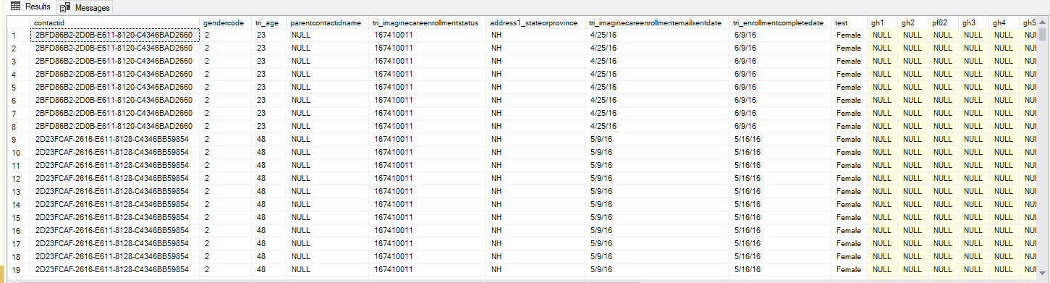

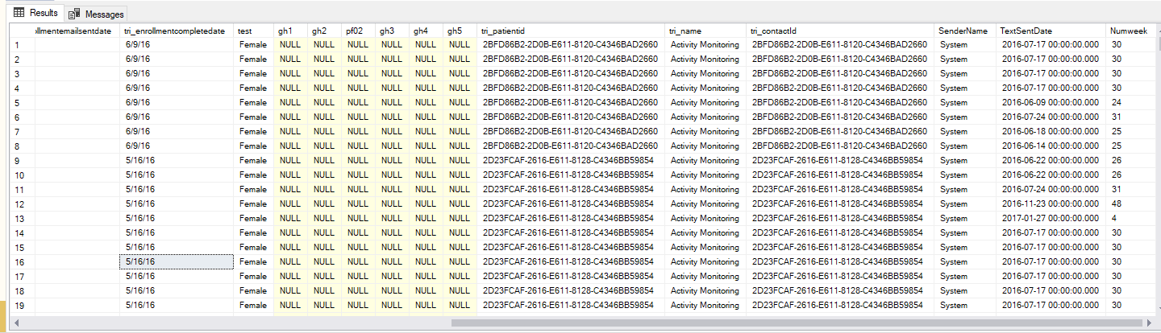

select SenderName as 'sendername', datediff(wk, min(blu.mergeDCT.TextSentDate), max(blu.mergeDCT.TextSentDate)) as 'week' from blu.mergeDCT

group by SenderName

select SenderName, count(*) as 'Text' from Text

where TextSentDate IS NOT NULL

group by SenderName

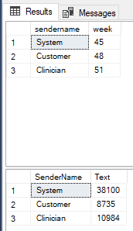

1. Obtain the count of texts based on the chronic condition over a period of time (say per week)

select tri_name, count(*) SentTexts, datediff(wk, min(blu.mergeDCT.TextSentDate), max(blu.mergeDCT.TextSentDate)) as 'week' from blu.mergeDCT

where TextSentDate IS NOT NULL

group by tri_name

