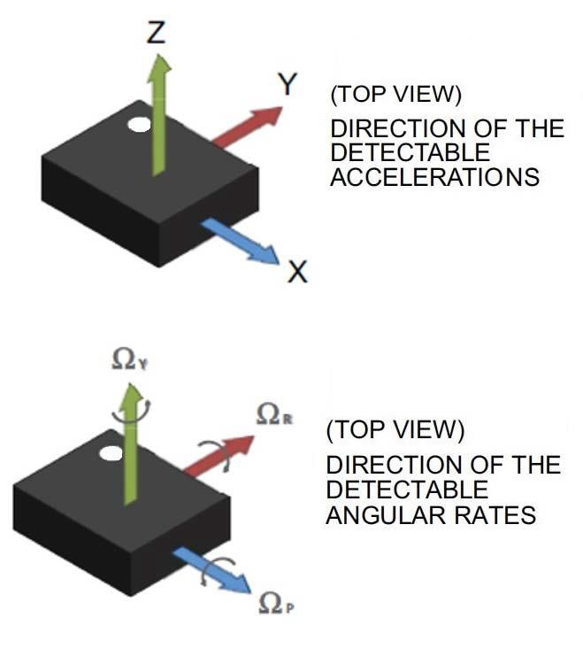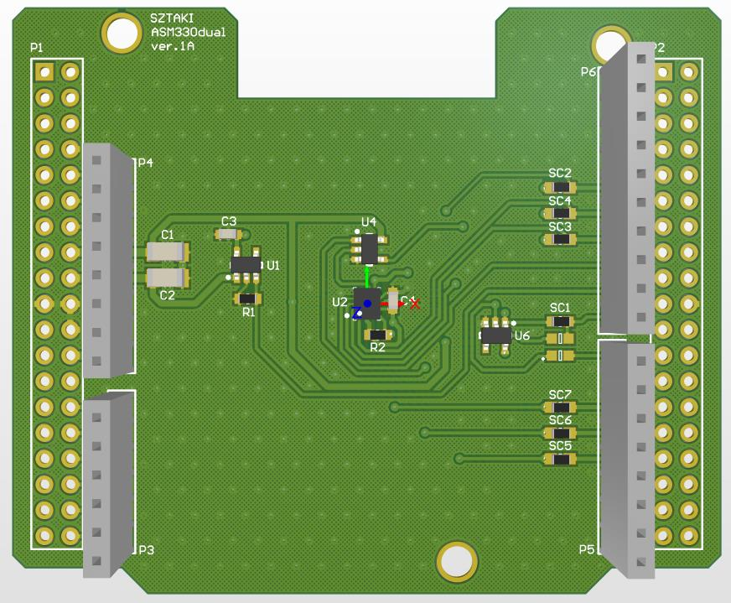
Positive rotation direction: counter clockwise
Rotation order: Yaw, Pitch, Roll

Y, Ω_{r}
Z, Ω_{y}
X, Ω_{p}

