Project Initiation Documentation

Development Project Automation: Towards Self-Service Projects

Project Team:

Chad Gay   
Hayat Khan  
Jasveer Benny  
Kirsty Mitchell

Contents

1 Executive Summary 3

2 Purpose 3

2.1 Relevant documentation 3

3 Project definition 4

3.1 Background 4

3.2 Strategic objectives alignment 4

3.3 Business value statement 5

3.4 Business success criteria 5

3.5 In Scope 5

3.6 Out of scope 6

3.7 Change impacts of the project 6

4 Project approach 7

4.1 Project assumptions 7

4.2 Project constraints 7

5 Dependencies 7

6 Project team 8

6.1 Team structure 8

6.2 Roles and responsibilities 8

6.3 Project governance 8

7 Project plan 9

7.1 Work Breakdown Structure 9

7.1.1 Work breakdown Structure table and description 10

7.2 Approved project financial overview 11

8 Quality management approach 12

9 Change control approach 12

10 Issue management approach 12

11 Risk Management 12

11.1 Risk register 13

12 Communications management approach 13

13 Resource management approach 14

14 Project specific terms and acronyms 14

# Executive Summary

Currently the Department is one year down the path of a journey to continuous integration and continuous development (CI/CD). This journey is a key initiative in the context of the Department moving away from legacy bespoke system to modern and robust technical solutions that facilitate the Department to function in an efficient and effective manner. Much has been achieved on this journey already, but it has not been without its challenges. The challenge that this project seeks to address is the challenge presented to the implementation team in keeping pace with the Department’s adoption of the platform.

Over the last twelve months, the BorderTech team have created, on average, thirty artefacts per week (with 1-4 artefacts being created per user request) across four separate systems. Each request is currently taking, on average, 45 minutes to fulfil and has placed a burden upon the implementation team. As continued adoption continues (and likely accelerates), it is anticipated that the BorderTech team will lack the requisite resources to service these requests and keep pace with the Department’s needs.

Hence, this project proposes to leverage workflow automation through development of a single unified artefact creation interface to assist the BorderTech team in servicing the needs of the Department’s business units as they join the CI/CD journey. This outcome will ameliorate the duplication of effort experienced by BorderTech admins accessing four separate systems, allowing for a greater level of consistency and standardisation projects within the Department. It is anticipated that the average time to fulfil a request will be reduced from 45 minutes to 5 minutes, with an error reduction of approximately 10%.

Finally, this project will provide the basis for the future development of a self-service portal to allow end-users to create project pipeline artefacts without the need for direct assistance by members of the BorderTech team.

# Purpose

The purpose of this Project Initiation Documentation (PID) is to define and plan the project through its life, in order to form the basis for its management and an assessment of its overall success. The PID gives the direction and scope of the project and along with the project plan forms the ‘contract’ between the Project Manager and the Project’s Executive.

The production of the PID is to ensure there is a single source of information that supports the major commitment of the business case.

The PID is a living document; it should reflect the status of the Business case, evolving plans and controls of the project at the beginning of each planned stage. If the project has an indicative multiyear budget allocation, then the PID will detail the life of the project.

## Relevant documentation

| Description | Document name |
| --- | --- |
| WBS | WBS.xls |

# Project definition

## Background

In mid-2018, the Department initiated a staged roll-out of a new collaboration platform for software development projects, comprising of a suite of Atlassian products; namely, Confluence, Jira and Atlassian. This product suite was also complimented by an open source build automation application known as Jenkins. This technology framework is owned and managed by the BorderTech team. As part of this, members of this team are responsible for servicing all requests for new projects utilising this collaboration platform.

The existing workflow for servicing these requests involves a manual request-response method built upon the issue collector functionality available as part of the Jira tool. This approach has proved problematic for the BorderTech team as it allows for end-users to enter their requests in an unstructured format. This is challenging for the team member tasked with implementing the collaboration space as information has historically often been incomplete or erroneous. The result is that a previously straightforward implementation task expands in scope to one of requirements gathering from the end-user, which greatly extends time to implementation and requires additional resources from BorderTech.

This workflow is further compounded by the volume of artefacts required to be created to service all the requests. Over the course of the twelve months since the implementation of this platform, there have been, on average, thirty artefacts created per week. On average, the artefact creation process to service a single request is in the order of 45 minutes – much of which is spent requesting additional information or clarification. In accordance with the strategic direction of the Department, it is expected that this platform much wider adoption (replacing numerous bespoke utilities); the result of which is that the number of requests, and in turn, artefacts created weekly will greatly exceed the current value of thirty per week – exceeding the operational resources available of the BorderTech team.

Finally, the artefact creation processes are a tedious data entry process that does not maximise the skillset of the team currently for managing this process. Servicing of a single request can result in the administrator creating artefacts though repetitive data entry across four separate systems. Issues relating to consistency of data entry and setup between administrator have also become problematic, resulting in a lack of a coherent template or standard for all projects using the collaboration platform.

## Strategic objectives alignment

The project ties into all 4 of the strategic decisions that have been laid out in the Technology Strategy 2020:

1. Recognise the strategic value of ‘information at the core’
   * Ensuring that all created artefacts follow the same structure and contain the same necessary components allowing for greater interoperability both internally and when interfacing with partner organisations.
2. Enhance the speed of change by decoupling business domains
   * Allowing end users to request multiple tailored business solutions in one location facilitates more robust use of those tailored solutions with less barriers for entry.
3. Implement robust integration capabilities
   * The delivered project will allow for high customisation to add, update or remove delivered business solutions to newly created solutions allowing the department to respond quickly to changes in technology.
4. Employ a business-driven, extensible and adaptable architecture
   * Utilising flexible and adaptable technology and licences already within the department’s toolkit will allow this project to provide a robust and dynamic system with no financial outlay.
   * This approach also facilitates the decision in that it reduces the barrier of entry into utilising more discreet toolsets (perceived or otherwise) to the end user.

## Business value statement

The successful completion of this project will develop a fast, reliable and robust tool that:

* Enhances the quality and efficiency of the creation of CI/CD pipeline artefacts
* Is easy to use and is accessible by all users and stakeholders
* Provides the basis for a self-service creation model
* Provides the basis of a modular, cost effective system that can be easily extended to further business cases.

## Business success criteria

The business will recognise the business value has been meet by:

|  |  |
| --- | --- |
| Goal | Measure |
| Improved Efficiency | Reduce average end-to-end fulfillment from 45 minutes to 5 minutes. This will allow re-allocation of resources. |
| Reduced errors | Reduced human errors in the end-to-end process by 10%. |

## In Scope

The current scope, as proposed, includes:

Functional:

A web application that is:

* Capable of creating a set of artefacts in the Departments CI/CD pipeline using existing platform APIs, using a standard set of configuration and boilerplate.
* Useable by Departmental administrators to create artefacts across multiple CI/CD systems using a single interface. The current CI/CD platforms considered within this scope are:
  + Atlassian Bitbucket Server
  + Atlassian Confluence Server
  + Atlassian Jira Server
  + Jenkins
* Compliant with WCAG 2.0 AA accessibility standards.
* Includes end-to-end automated testing in accordance with current Departmental best-practices.

Geographic/Environmental:

* Due to the nature of the final deliverable, an open source web application, there are no physical territory or operation requirements required.

Organisational:

The following persons of the Department are directly involved in this project:

* Renate Croker, Department of Home Affairs – Visa Citizenship & Digital Systems
  + As project sponsor
* Mark Reeves, Department of Home Affairs – Visa Citizenship & Digital Delivery
  + as project advisor and senior user, as well as other capacities as may be necessary throughout the project
* Rowena Foot, Department of Home Affairs – Enterprise Integration Systems
  + As Home Affairs ICT graduate coordinator/support officer
* Project graduates enrolled in Diploma of Government Informatics:
  + Chad Gay, Department of Home Affairs – Client Digital Systems
  + Hayat Khan, Department of Home Affairs
  + Jasveer Benny, Department of Home Affairs
  + Kirsty Mitchell, AUSTRAC

Time:

* A total resource utilisation of 18 days for each project team as per the requirements of the University of Canberra for the purpose of the Diploma of Government Informatics. This resource utilisation concerns the period up to and including the completion of the university qualification in November 2019.

It is noted that both the in and out of scope sections of the document will likely be adjusted as the project progresses. This will be conducted in consultation with the Project Sponsor and Project Advisor with amendments made to this document where necessary.

## Out of scope

The current scope, as proposed does not include:

* Management or changes of existing artefacts, either created with or without the proposed application. Management of these artefacts will remain within the control of the application tools native to the platform. For instance, a Jira project may be created utilising the proposed tool, but ongoing changes to the project configuration will leverage the existing capabilities of the Atlassian platform. Re-implementing these controls would amount to a duplication of functionality without conceivable benefit.
* Deployment of the proposed application into any Departmental environment. Control of Department environments is managed by other teams within the Department; hence, deployment will be within their area of concern and control. The application will instead be provided, at the request of the project sponsor, to the relevant persons in a form suitable for deployment within the Departments environments.
* The development of functionality intended to be consumed by platform end-users directly. The current scope, as proposed, forms the basis for a future work within the same context that, at present, are considered out of scope for this project. In principle, the work outside of scope involves the provision of a self-service model for end-users to create their own artefacts within the collaboration platform without the direct assistance of BorderTech.

## Change impacts of the project

End-users will experience no change in processes and will require no additional training or assistance.

Border Tech administrators will see (on average) around a 90% time reduction in the end-to-end process. This allows for faster responses to requests for end users and better allocation of resources.

No additional infrastructure, either technical or structural, are necessary for successful completion or will change as a result of the project.

Full user guide documentation will be provided to the administrator users at launch along with any necessary training.

# Project approach

The project will follow an agile methodology.

## Project assumptions

| No. | Description |
| --- | --- |
| 1 | Dedicated person from BorderTech to act as Project Advisor and Senior User. |
| 2 | Access to development resources (e.g. non-production environments) with requisite permissions to execute required application actions (e.g. create an artefact). |
| 3 | Project team will be able to allocate (at minimum) 18 days' worth of project time each, throughout the course of the project. |
| 4 | All project team members will remain employed by the Department for the duration of the project. |
| 5 | Completion date requirement for project will be in November 2019. |

## Project constraints

|  |  |  |
| --- | --- | --- |
| No. | Description | Impact/Comment |
| 1 | Resourcing | Project team is made up of 4 Graduates and includes only 1 developer.  1 Graduate is from AUSTRAC, a Home Affairs portfolio agency and as such has no access to Home Affairs internal networks or tools. |
| 2 | Geographic | Members of the project team are placed with different teams in different locations both in Canberra and in Brisbane. |
| 3 | Funding | No funding allocated to project and no option to request. |
| 4 | Schedule | Graduates are only afforded 18 days total to spend towards project outcomes.  Graduates will also be required to continue pre-determined rotations during this time. This may pose schedule impacts unforeseen at project initiation. |

# Dependencies

 This project has no internal dependencies on other existing or ongoing sub-programs/projects.

# Project team

## Team structure

**Program Board**

**Senior User/Owner – Mark Reeves**

Lead Developer: Chad Gay

Business Analyst: Jasveer Benny

Tester: Hayat Khan

UI Designer and Project Manager: Kirsty Mitchell

## Roles and responsibilities

|  |  |
| --- | --- |
| Role | Responsibilities |
| UI Designer and Project Manager | Product Designer and Project Management |
| Lead Developer | Programmer |
| Business Analyst | Analysing Business Requirements |
| Tester | System Testing |

## Project governance

| Meeting and Reporting Schedule | Frequency |
| --- | --- |
| Project team scrum meetings | Weekly, other meetings as required |
| University board | As requested |
| Project Advisor | Fortnightly |
| Project Sponsor | Quarterly or as requested |

# Project plan

## Work Breakdown Structure

Please see attached document “WBS.xls” if closer inspection of the below image is required.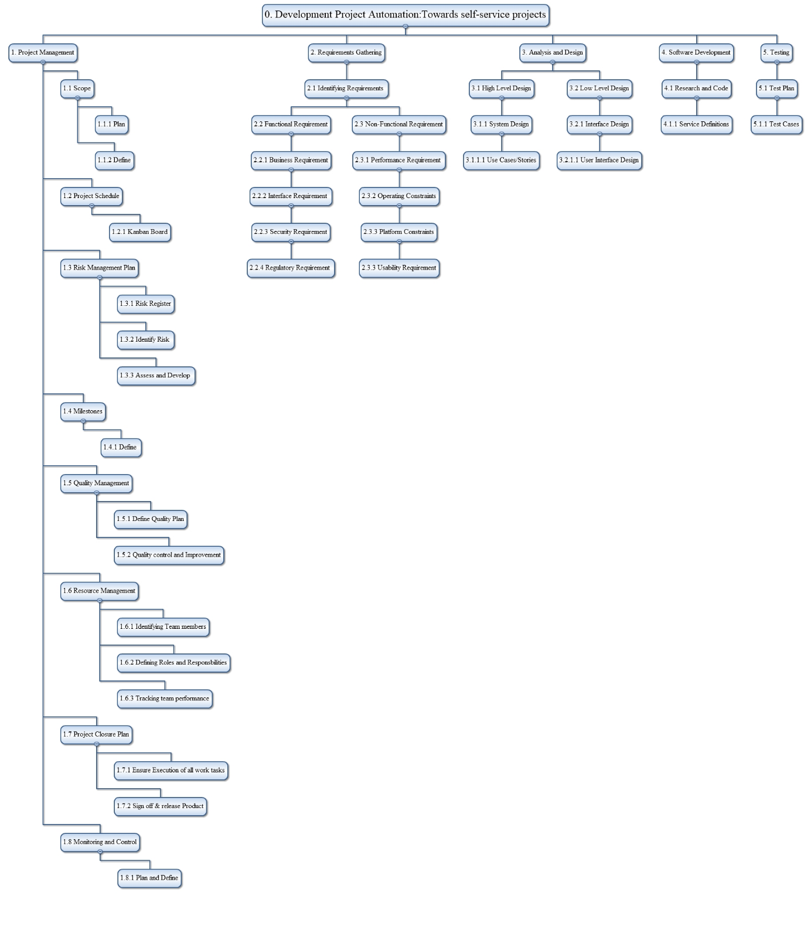

### Work breakdown Structure table and description

| Level 1 | Level 2 | Level 3 | Level 4 | Description |
| --- | --- | --- | --- | --- |
| 1.Project Management | 1.1 Scope | 1.1.1 Plan |  | Provide the sum of the projects, services and results to be provided by a project including the boundaries |
|  |  | 1.1.2 Define |  | Reveal the activities based on 1.1.1 |
|  | 1.2 Project Schedule |  |  | Scheduling activities based on Kanban Board |
|  | 1.3 Risk Management plan | 1.3.1 Risk Register |  | Brainstorm about the problem. Interview senior users and border tech administrators. Perform a SWOT (strength, weakness, opportunities and threat) analysis of the project |
|  |  | 1.3.2 Identify Risk |  | Identify risk based on 1.3.1 |
|  |  | 1.3.3 Assess and Develop |  | Use a risk register to know the cause and effect of the risk and develop a mitigation approach in the risk register |
|  | 1.4 Milestones | 1.4.1 |  | With the amount of deliverables completed, major aspect of the work completed can be identified. Milestone can be defined once a deliverables is completed |
|  | 1.5 Quality Management | 1.5.1 Define Quality Plan |  |  |
|  |  | 1.5.2 Quality control and improvement |  |  |
|  | 1.6 Resource Management | 1.6.1 Identifying team members |  |  |
|  |  | 1.6.2 Defining roles and responsibilities |  |  |
|  |  | 1.6.3 Tracking team performance |  |  |
|  | 1.7 Project Closure Plan | 1.7.1 Ensure execution of all work tasks |  | Project requirements will need to be looked upon to conform what was actually developed so that at the close of the project the deliverables meets the requirements. |
|  |  | 1.7.2 Sign off and release the product |  | Finalize all the activities of the project and obtain sign off deliverables from the business and deploy the product |
|  | 1.8 Monitoring and control | 1.8.1 Plan an define |  | All the team members involved in the project (technical, project management, testing, analysis etc) will be involved to monitor and control the project. |
| 2.Requirements Gathering | 2.1 Identifying Requirements |  |  | Identifying all project stakeholder and asking them the right questions. Performing requirement gathering techniques such as Brainstorming, interviewing the end user, reverse engineering etc. Verifying the results and obtaining a sign off with the major parties |
|  | 2.2 Functional requirement | 2.2.1 Business Requirement |  | Identifying high-level business objectives and goals for the project. Measuring the business value and scoping them accordingly |
|  |  | 2.2.2 Interface Requirement |  | Eliciting requirements based on any external interface |
|  |  | 2.2.3 Security Requirement |  | Making sure the product aligns with the CIA traid i.e confidentiality, integrity and availability. |
|  |  | 2.2.4 Regulatory Requirement |  | Making sure the product aligns to all of the department regulatory requirement |
|  | 2.3 Non-Functional requirement | 2.3.1 Performance requirement |  | Measuring performance by reducing errors caused by human intervention i.e. reducing errors by 80% and improving efficiency via automation i.e. reducing time taken from 1hr to 5minutes |
|  |  | 2.3.2 Operating Constraints |  | Constraints based on business rules and operational environment |
|  |  | 2.3.3 Platform Constraints |  | Technology used to build the product complies with the department’s constraints. |
|  |  | 2.3.3 Usability requirements |  | The product is usable based on performance requirements |
| 3.Analysis and design | 3.1 High Level Design | 3.1.1 System Design | 3.1.1.1 Use Cases/User Stories | Writing use cases and user stories |
|  | 3.2 Low Level Design | 3.2.1 Interface Design | 3.2.1.1 User Interface design | Ensuring the product is user friendly and easy to use |
| 4.Software Development | 4.1 Research and Code | 4.1.1 Service Definitions |  | Researching technology and Writing codes |
| 5.Testing | 5.1 Test Plan | 5.1.1 Test cases |  | Writing test cases and Running them to ensure the product is behaving the way it should behave and conform to the requirement. |

## Approved project financial overview

As this project requires no budget, no finding approval is required.

# Quality management approach

At the time of writing, formal Quality and Test Plans have not yet been created. In the context of the Agile/Scrum approach undertaken to manage this project, the current stage of the project is not the appropriate stage to undertake formalisation of these documents. However, with that in mind, mutual assent has been reached regarding how quality of the project outputs is to be determined, along with how those outputs are to be tested.

In the context of principle output, a software application, quality of output will be determined through continuous code inspection and implementation of quality gates that preclude the submission of poor-quality software code. The tool that has, in principle, been selected to achieve this is a SonarQube (an existing continuous inspection tool of the Department). Software code must achieve an A rating regarding SonarQube’s evaluation of bugs, code smells and security vulnerabilities.

With respect to test plans for the software application, the project is adopting Behaviour Driven Development (BDD) as part of Agile software development. This process allows for the definition of application features (by the product owner) that can be utilised for development and ultimately be utilised as part of an automated testing pipeline. Again, the tool that has been chosen, in principle, is Cucumber (an existing tool within the Department to test business-readable specifications against program code).

# Change control approach

The purpose of change control is to identify, assess and control any potential and approved changes to the project baselines. The project will follow the Department’s exception reporting process for changes outside of tolerances in the [Sub-program and project tolerance guide](https://bordernet.immi.local/ProgramsandProjects/Documents/frameworks-templates-artefacts/ZZsub-program-project-tolerance-guide.pdf).

# Issue management approach

The project manager will manage and track issues in the Issues Register. An issue is something that has happened and is affecting the project, and must be dealt with quickly to minimise the impact on the project.

The project manager will escalate Issues to the Board and/or Program Manager in a timely manner as required in the [Sub-program and project tolerance guide](https://bordernet.immi.local/ProgramsandProjects/Documents/frameworks-templates-artefacts/ZZsub-program-project-tolerance-guide.pdf) using the Exception report.

There are currently no issues listed in the Issue Register.

# Risk Management

The [Project and sub-program risk management approach](https://bordernet.immi.local/ProgramsandProjects/Documents/frameworks-templates-artefacts/project-sub-program-risk-management-approach.pdf) defines how this project will identify, analyse, treat and manage risks, and is in accordance with the approved Enterprise Risk Management Policy. The current risk register is below.

## Risk register

|  |  |  |  |  |  |
| --- | --- | --- | --- | --- | --- |
| Risk ID | Risk description | Risk owner | Consequence | Likelihood | Mitigation |
| 1 | Project completion deadline not met due to limited development time allowances. | Lead developer & project team | High | Low | Consistent use of agile and scrum methodologies allowing identification of time slippage. Re-allocation of resources or negotiation with stakeholder as required. |
| 2 | Incomplete project due to reduced end-to-end time allowance. | Project team | High | Low | As above. |
| 3 | Increase in project scope creates an unworkable volume of work. | Project team | High | Low | Remain clear with stakeholders about the agreed scope. Only agree to scope expansion if project team are comfortable the expansion can be implemented within the agreed timeframe. |
| 4 | Project team have limited availability causing project timeline slippage due to new graduate program rotations or other factors outside the project. | Project team | High | Low | Team members need to clearly articulate the project requirements and time constraints with their respective managers. If issues arrise contact respective graduate coordinators. |

# Communications management approach

| Stakeholder | Relationship to project | Key message(s) | Format (e.g. Email, focus group, All Staff message) | Timeframe / frequency |
| --- | --- | --- | --- | --- |
| Mark Reeves | Senior User, Project Advisor | Project updates, project specific questions and feedback | Email, phone calls, meetings | Fortnightly |
| Renate Croker | Project Sponsor | Project updates | Email, meetings | Quarterly or as required/requested |
| David Williams | University Mentor | Project progress updates, project management queries and guidance. | Email | Monthly through mentor catch-ups |
| Luke Nguyen | University Unit Convenor | Project and university requirement queries. | email | As required |
| Bordertech team | End users | Project specifics relating to their usage. | Email | As required |

# Resource management approach

This section refers to financial resource management. As there is no allocated budget for this project there is no resource management approach required.

# Project specific terms and acronyms

| Term | Definition |
| --- | --- |
| CI/CD | Continuous Integration / Continuous Deployment |
| BDD | Behaviour Driven Development |
| TDD | Test Driven Development |