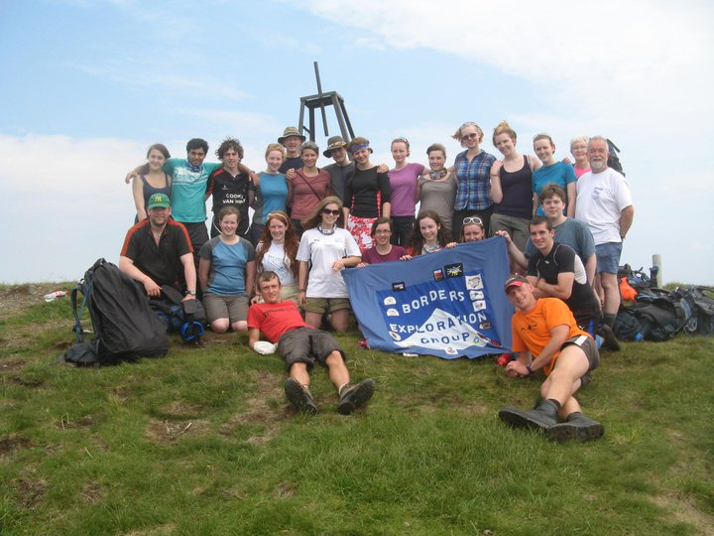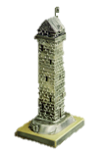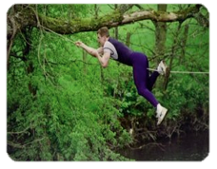

http://www.borders-exploration-group.org.uk/

The Borders Exploration Group (BEG) is a charity run by a group of local volunteer adults to assist in the development of young people through the challenges of expeditions - both overseas and at home.

# Tower Trophy

# CHALLENGE EVENT 2015

# Sunday 7th June 2015 at

# Riddell Estate, Lilliesleaf

# This is BEGs main fund raiser of the year - the only one aimed at adults..!

**The challenge is an adventure / team building event for groups representing towns and villages in and around the Borders. The aim of the tasks are set to challenge the mentally and physically fit. The challenges in the past have included raft building, river crossing, assault courses, cracking codes, shooting at targets, speed marching... and more activities aimed at getting the best from every member of the team.**

# Conquer the challenge and lead your team to victory:

* Team of 6 representing a village, town, area, club or company
* Complete challenges against the clock
* Only £60 per team to enter; plus a minimum of £40 sponsorship
* A prize for each person in the team that raises most sponsorship
* A Shield for the team that raises most sponsorship

The prestigious ‘Tower Trophy’ for the winning team

A true test of Team Spirit, Stamina, Determination and Initiative

*** **30 April is the closing date for entries**\*\*\*

For further information contact Andrew Grant [asgrant@supanet.com](mailto:asgrant@supanet.com) or

Nancy Anderson [nancyhaggis@aol.com](mailto:nancyhaggis@aol.com)

# A Great Day Out Awaits You…