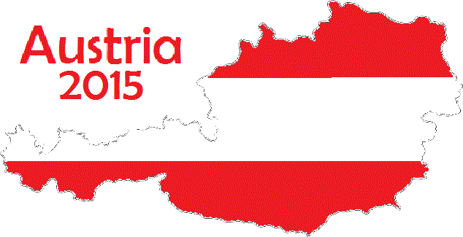
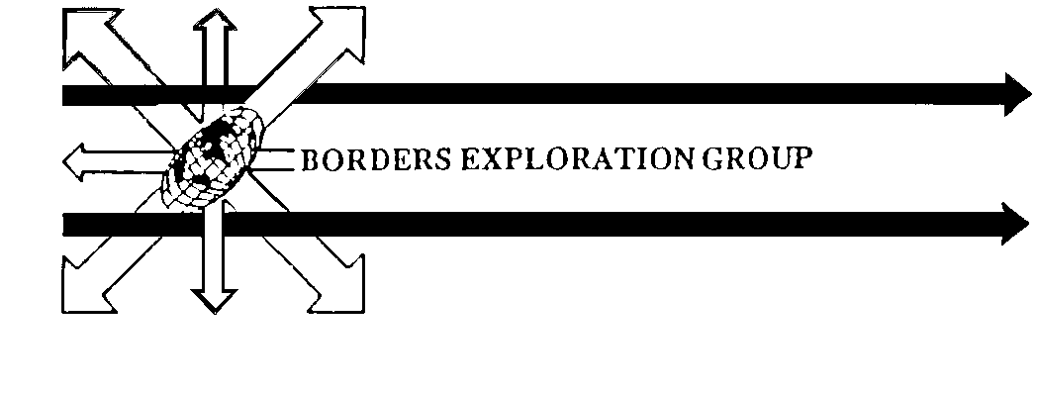
17 Hillview Crescent
Selkirk,
TD7 4AY
November 2014

Thank you for showing an interest in the proposed Borders Exploration Group (BEG) expedition to Austria. The planned departure will be late June / early July 2015 for approximately 2 weeks, depending upon final flight arrangements. The final team will be about twenty to twenty five in total. Venturers need to be between 16 and 24 years old on the date of departure and must be resident within the Borders area. There are no age restrictions for Leaders.
BEG is a local organisation run by self-funding volunteers. The group has now been on the go for over 20 years, in which time they have achieved a range of highly successful activities i.e. local activity days, survival weekends, challenge days for schools and businesses. There have been 16 Expeditions to destinations varying from European ones such as Norway and the Pyrenees and International ones to Mongolia, Zambia and Peru amongst many others.
The format of each expeditions have all followed a basic theme, divided into different phases.
COMMUNITY ADVENTURE, SOCIAL, SCIENTIFIC/ENVIRONMENTAL
The exact amount of time spent on each of these will depend on research and planning still to be done; once we have a team in place, everyone will be involved in this.
We will be looking for a range of skills and experience from potential venturers and leaders but in particular the qualities of; team work, cooperation, commitment, enthusiasm, versatility and a good sense of humour. Experiences of Camping, Outdoor Activities, Independent Travel and First Aid etc are helpful, but not essential, as a full and varied training programme will be undertaken. However a reasonable level of personal fitness would definitely be advantageous.
When completing your application form please be honest, we do not expect everybody to have done everything. This expedition is about providing young people (and some older ones) of the Scottish Borders with an opportunity to do something new and different. The closing date for your application form and references is Thursday the 8th of January. Selection will take place on the weekend of 6th / 8th February. Leader applicants need to be there all weekend, while Venturer applicants only need to attend on the Sunday.
All successful team members will be expected to attend training days and weekends over the following 6 Months, the first of which is likely to be a single day on Sunday the 22nd of February, with a weekend event on 20th/22nd March. The final cost to each individual will be in the region of £600
If some of the information seems a bit sparse, this expedition is your chance to sort that. Every participant will be allocated an area of research related to one of the “phases” mentioned earlier, or some other aspect of Expedition organisation. This should mean 3 or 4 folk working on each aspect of the expedition, to feed back to the rest of the group, for us all to decide on. So the lack of detail just now is deliberate and your opportunity to mould the final expedition into what we will do in Austria. So the little boxes at the bottom of page 4 on the Application form are much more important than they first appear.
If this sounds like the kind of Expedition you would like to help plan and then take part in, then please complete the application form, find some referees, and get everything back to me by January 8th and good luck with your application
Thank you for your interest so far and I hope to hear from you soon
Jim McPherson

