

Tower Trophy
Challenge
2015

SUNDAY 7th June

At

Riddell Estate Nr. Lilliesleaf

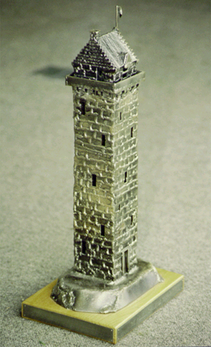

INFORMATION PACK

General Information

Welcome to the Tower Trophy Challenge and thank you for taking part. Please read the following instructions carefully and pass them on to all of your team members. If you have any queries or require further information then please contact any of the people below. We hope you have a very enjoyable and exciting day, oh one more thing-
Best of luck!!!!

Organising Team

Nancy Anderson
Mosspark
West Morriston
Earlston

TD4 6AZ

Tel 01896 849362

Mobile 0779 222 1449

Email nancyhaggis@aol.com

Allan McGee allansrmcgee@btinternet.com Tel 07957474375

Andrew Grant
Riddell Estate
Lilliesleaf Tel 01835 870309
Email asgrant@supanet.com

Jim Shepherd
Tel 07789233504
jshepherd@buccleuch.com

Geraldine Bouglas
Tel 07753363540
Geri-b@tiscali.co.uk

GENERAL INFORMATION

The objective of the Tower Trophy Challenge is to raise awareness of the Borders Exploration Group and the opportunities it can bring to young people in the Borders. It is hoped that this will generate some much-needed funds to support the very worthwhile work carried out by the group.

To enter you require:

- A team of 6 participants (over 18 years old) who are of reasonable fitness.
- A team manager who will form part of the team but will also act as the team co-ordinator (see team managers responsibilities).
- The team must raise a minimum of £60 (£10 per head paid at time of registration)
- In addition teams are invited to increase their donation to Borders Exploration Group via sponsorship of a minimum £40 per team.
- To bring along on the day a sense of humour, variety of skills and loads of team spirit

All teams will compete for the prestigious Tower Trophy, which will be awarded to the winning team, and a bottle of wine will be given to each team member. Brains and brawn are important but so is the ability and commitment to raise as much money for the Borders Exploration Group. In recognition of this, the team that raises the most money will receive a special surprise prize.

This event has now been running for a number of years and has proved enormously successful. It is run with the assistance and kind permission or Mr and Mrs Andrew Grant, Riddell Estate, Lilliesleaf.

Amongst previous winners are:
- The Media Team
- Tweed Valley Mountain Rescue
- Earlston High School
- Borders Health Team
- Ecodyn
- Capricorn Mountaineering Club
- Lilliesleaf Village

Other Requirements

We require your team to be clearly identified during the entire event.

All team members must have a reasonable level of fitness – it is not however a requirement to be “super fit”. Many of the events will require a sharp mind coupled with a determined attitude.

The organisers must be informed of team members who have any medical conditions or requirements. This information should be conveyed by the team manager to the organisers and will be held in confidence.
Form B (Provided on receipt of registration form) must be completed by all team members and carried at all times throughout the event.

The team will be required to arrive at Riddell Estate between 8.30 and 8.45 for registration for an 8.55am briefing. Please do not be late as a prompt start is essential for the smooth running of the entire day.

Riddell Estate is situated on the B6400 west of Lilliesleaf, Grid Ref 517 246 Landranger Map73

There will be a BBQ for participants at the end of the event at the time of presentation of prizes.

Kit List

Per Individual

- Waterproof trousers and Jacket

- Walking boots or walking trainers/approach shoes are recommended to be worn all day – light weight sports trainers won’t be suitable.

- Complete change of clothes

- Towel

- Packed lunch

- Sweets for energy on route

- 1 Litre of water

- Rucksack to carry your kit for the entire day

- Compass

- Pen and Note Pad

- Small first aid kit

- Survival Bag

- Deck chair/folding chair or rug to sit on for BBQ

- Soft drinks will be provided for the BBQ but if you fancy a beer bring your own

Team Manager’s Responsibilities

The Team Manager will be responsible for:

- Ensuring a full team on the day
- Team selection.
- Ensuring he/she is fully conversant with all the requirements.
- Attending a briefing meeting prior to the event. (Date to be arranged)
- Distributing all the information to the team members.
- Ensuring their team is clearly identified
- Maintaining team discipline.
- Monitoring team welfare during the event.
- Team motivation.
- Ensuring prompt arrival of their team on the day.
- Photocopying the sponsor form and distributing it to all members
- Ensuring that all money raised is forwarded to the organisers. Amount must be indicated at registration at the beginning of the day to allow for presentation of the sponsorship shield
- Ensuring completion of form B ( Medical form)
- Ensuring team members have full kit.

