**Vision:**

We designed a simulation that deals with the rules and methods that a student must follow during the selection process.

**Problem Statement:**

1. Students select courses according to the semester they in.
2. If the quota of the course they are trying to choose is ful or they have not been successful in the prerequisite course they cannot take the course.
3. If the student’s weekly Schedule is not suitable for taking a course, if the courses overlap, students cannot take the course.
4. Each student has an advisor.
5. After the students make the selection process, they send their selections to the advisor for approval.
6. If there is no problem, the advisor confirms and the selection process is over.

**Glossary:**

**Student ID**: Student ID is a composite attribute of students generaterd with faculty code, enrollment year, and enrollment order.

**Elective Course:** One choosen by a student from a number of optional subjects or courses in a curriculum.

**Use Cases:**

1. Student enters the online registeration system.
2. Student accesses the list of available courses.
3. Student selects the courses in which he/she wants to enroll.
4. Selected courses are sent to an advisor for approval.
5. Advisor approves the courses.
6. Registeration completes.
7. Student can see his/her transcript.

**Extensions:**

3-a) If the quota of the section of the course that the student is trying to choose is full, the student chooses another section.

5-a) If the advisor does not approve the course selection, the student reviews the course selection and sends it back to the advisor for approval.

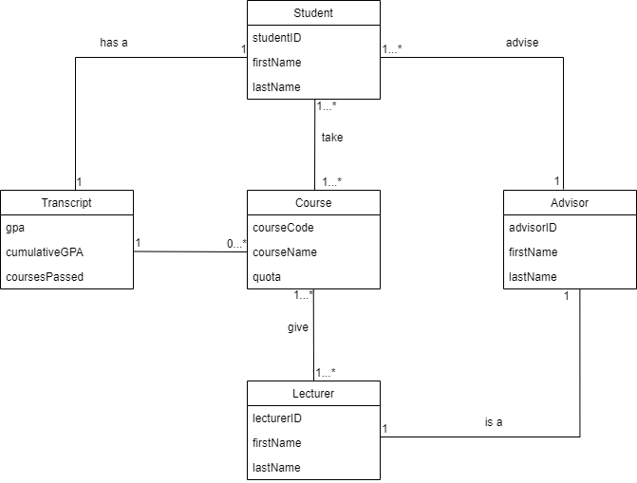**Domain Class Diagram:**

**Stakeholders:**

Murat Can Ganiz (Professor)

Ahmet Can Bağırgan

Emir Said Haliloğlu

Mert Sağlam