Software Requirements Specification

Project: 校园超速监控系统

Authors: 小组成员的姓名+学号

Published on: 2024-06-06

Version: 1.0

**Table of Contents**

1. Introduction 3

1.1 Purpose 3

1.2 Scope 3

1.3 Product perspective 3

1.3.1 User interfaces 4

1.3.2 Hardware interfaces 4

1.3.3 Software interfaces 4

1.3.4 Communications interfaces 5

1.4 Product functions 5

1.5 User characteristics 6

1.6 Definitions 6

1.7 Acronyms and Abbreviations 6

2. Requirements 7

2.1 External interfaces 7

2.2 Functions 7

2.3 Performance requirements 8

2.4 Logical database requirements 8

2.5 Standards compliance 9

2.6 Software system attributes 9

3. Supporting information 11

4. References 12

# Introduction

## Purpose

Delineate the purpose of the software to be specified.

【示例】本软件系统的主要目的是…

本软件系统的主要目的是为了监控和管理校园内行驶车辆的速度，确保校园交通安全。通过部署于校园内关键路段的车速检测器和车速显示器，系统可以实时检测并记录车辆的车速信息。对于超出校园规定安全车速上限的车辆，系统能够识别并处理，及时提醒驾驶员遵守校园交通规定，并按需提醒报备人员。

要写

## Scope

Describe the scope of the software under consideration by:

a) identifying the software product(s) to be produced by **name** (e.g., Host DBMS, Report Generator, etc.);

b) explaining what the software product(s) will **do**;

c) describing the **application** of the software being specified, including relevant **benefits**, **objectives**

and goals; and

d) being consistent with similar statements in higher-level specifications (e.g., a system requirements specification), if they exist.

【示例】本软件系统称之为“校园超速监控系统”。

该系统会：1) 通过安装在校园关键路段的车速检测器实时监控车辆的车速，并记录车速信息; 2) 识别超出校园安全车速上限的车辆，对驾驶员进行警示教育; 3) …

通过将该系统部署到校园内，可以实时监控校园内的超速行为，有助于规范校园管理、维护校园安全环境

本软件系统称之为“校园超速监控系统”。

该系统会：

1）通过安装在校园关键路段的车速检测器实时监控车辆的速度，并记录车速信息；

2）识别超出校园安全车速上限的车辆，对驾驶员进行警示教育；

3）通过路旁的车速显示器，实时显示车辆当前速度和校园规定的安全车速上限，提醒驾驶员遵守校园交通规定；

4）系统会在每月和每季度的最后一天处理超速超过规定次数的人员；

5） 超级管理员可调整安全车速上限和超速次数限制，查看各单位的月度、季度报表，并管理普通后台管理员的权限。普通管理员可按车辆或按路段查看详细记录。

通过将该系统部署到校园内，可以实时监控校园内的超速行为，有助于规范校园管理、维护校园安全环境。

要写

## Product perspective

**Define the system's relationship to other related products.**

If the product is an element of a larger system, relate the requirements of that larger system to the functionality of the product covered by the SRS.

If the product is an element of a larger system, identify the **interfaces** between the product covered by the SRS and the larger system of which the product is an element.

Consider a block diagram showing the major elements of the larger system, interconnections and external interfaces.

Describe how the software operates within the following constraints:

a) system interfaces;

**b) user interfaces;**

**c) hardware interfaces;**

**d) software interfaces;**

**e) communications interfaces;**

f) memory;

g) operations;

h) site adaptation requirements; and

**i) interfaces with services.**

可将【**软件系统上下文类图】**放置在这里！包括简要的描述和分析。

需要填写的具体内容即下面的1.3.1-1.3.4小节。

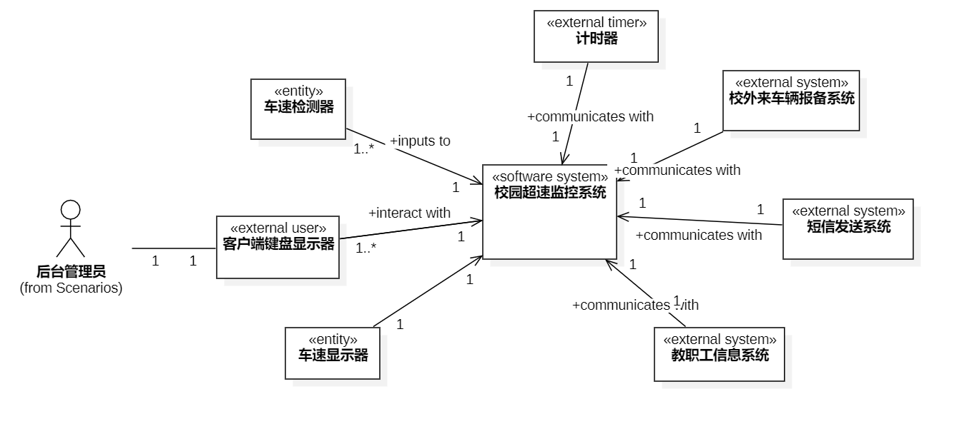

要写 – 软件系统上下文类图

### User interfaces

**Specify the logical characteristics of each interface between the software product and its users.**

NOTE A **style guide** for the user interface can provide consistent rules for organization, coding and

interaction of the user with the system.

【示例】PC-based user interface: This interface provides authorized users to access the software system. The **GUI** provides menus, buttons, input boxes, selection boxes, and forms. Users can manage the system by adjusting speed limits, viewing monthly and quarterly reports, and updating personal information such as “phone number” and “address” based on their identity.

Mobile-based user interface: This interface is similar to the PC-based interfaces, but allows for mobile access to the backend management system from authorized devices.

PC端管理员界面：管理员可以使用账号密码登录系统。界面提供了一系列按钮、复选框、文本框，管理员可以调整限制速度，查看月度季度报表，或者修改自己的个人信息。

要写 – 也可以简单绘制2-3张GUI界面

### Hardware interfaces

**Specify the logical characteristics of each interface between the software product and the hardware elements of the system.** This includes configuration characteristics (number of ports, instruction sets, etc.). It also covers such matters as what devices are to be supported, how they are to be supported, and protocols. For example, terminal support may specify full-screen support as opposed to line-by-line support.

【示例】Vehicle speed detection sensor interface: The software should be capable of receiving data from multiple vehicle speed detection sensors.

Vehicle speed display interface: The software should be able to display the speed and whether the speed is exceeded by vehicle speed display units.

PC and Mobile device interface: The software should be able to access the backend server through both mobile devices and personal computers.

车辆速度检测传感器接口：软件应能够从多个车辆速度检测传感器接收数据。

车速显示界面：软件应能够显示车牌号、检测时间和车速，并指示是否超速。

PC和移动设备界面：软件应能够通过移动设备和个人计算机访问后端服务器

有则写，不强求

比如车速检测器，车速检测器

### Software interfaces

**Specify the use of other required software products (e.g., a data management system, an operating system, or a mathematical package), and interfaces with other application systems (e.g., the linkage between an accounts receivable system and a general ledger system).**

For each required software product, specify:

a) name;

b) mnemonic;

c) specification number;

d) version number; and

e) source.

NOTE It is acceptable to specify required platforms or operating systems, but rarely feasible to require a specific version. Typically, a version number most recent version or any currently maintain version can be specified for software.

For each interface, specify:

a) discussion of the purpose of the interfacing software as related to this software product;

b) definition of the interface in terms of message content and format. It is not necessary to detail any well-documented interface, but a reference to the document defining the interface is required.

【示例】Interface to SMS System:

a) Purpose: To send SMS notifications to drivers who exceed the safe speed limit.

b) Message content: SMS messages containing notification of speeding violations and educational messages regarding safe driving practices.

Interface to Campus Employee Information System:

a) Purpose: To get employee information.

b) Message content: Requests for employee information.

与短信系统的接口：

a) 目的：向超速的驾驶员发送短信通知。

b) 消息内容：包含超速违规通知和有关安全驾驶实践的教育信息的短信消息。

与教职工信息系统的接口：

a) 目的：获取员工信息。

b) 消息内容：请求员工信息。

要写 – 外部系统、数据库系统、操作系统等

### Communications interfaces

Specify the various interfaces to communications such as local network protocols.

本系统中没有特别指定，下面仅供参考: **// e.g., SYSU-Secure校园网**

【示例】Local Network Protocols: This interface enables the communication between the software system and other systems on the local network, such as the vehicle registration system or employee information system.

要写

## Product functions

**Provide a summary of the major functions that the software will perform.** For example, an SRS for an accounting program may use this part to address customer account maintenance, customer statement and invoice preparation **without mentioning the vast amount of detail that each of those functions requires**. Sometimes the function summary that is necessary for this part can be taken directly from the section of the higher-level specification (if one exists) that allocates particular functions to the software product.

**Use cases**, user stories, and scenarios are also used to describe product functions.

Note that for the sake of clarity:

a) the product functions should be organized in a way that makes the list of functions understandable to the acquirer or to anyone else reading the document for the first time.

b) textual or **graphical methods** can be used to show the different functions and their relationships. Such a **diagram** is not intended to show a design of a product, but simply shows the logical relationships among variables.

将**【用例建模】**放在这里！

要写 – 整个系统的用例图+每个用例的用例描述

## User characteristics

**Describe those general characteristics of the intended groups of users of the product including characteristics that may influence usability, such as educational level, experience, disabilities, and technical expertise.** This description should not state-specific requirements, but rather should state the reasons why certain specific requirements are later specified in specific requirements in 9.6.9.

【示例】The intended groups of users of the product are mainly the authorized personnel of the campus security department, including officials and ordinary staff members. They should have basic computer skills and knowledge of operating a web-based system.

有则写，不强求

## Definitions

Provide definitions for any words or phrases that have special meanings beyond normal dictionary

definitions.

【示例】Campus Speed Monitoring System: A software system designed to monitor the speed of vehicles in a campus environment and identify vehicles that exceed the defined safe speed limit. Also, it provides administrative functions, including data storage, user management, and configuration management.

有则写，不强求

## Acronyms and Abbreviations

Spell out or define all acronyms and abbreviations used in the documents.

NOTE This information can be provided by reference to one or more appendixes in the documents or by

reference to other documents.

【示例】PC: Personal Computer

SMS: Short Message Service

有则写，不要求

# Requirements

## External interfaces

**Define all inputs into and outputs from the software system.** The description should complement the interface descriptions in 9.6.4.1 through 9.6.4.5, and should not repeat information there.

Each interface defined should include the following content:

a) name of item;

b) description of purpose;

c) source of input or destination of output;

d) valid range, accuracy and/or tolerance;

e) units of measure;

f) timing;

g) relationships to other inputs/outputs;

h) data formats;

i) command formats; and

j) data items or information included in the input and output.

【示例】Vehicle Speed Detector Interface:

**a) Purpose**: Detects the speed of vehicles passing through key points in the campus

**b) Source/Destination**: Inputs from passing vehicles, outputs to the Speed Display and Back-end Management System

**c) Valid Range/Accuracy/Tolerance**: Should accurately detect speeds up to 100 km/h with an accuracy of at least +/- 5 km/h

**d) Units of measure**: Kilometers per hour (km/h)

**3) Timing**: Real-time

**4) Relationships to other inputs/outputs**: Outputs data to the Speed Display and Management System

**5) Data formats**: Digital signal

**6) Command formats**: N/A

**7) Data items or information included in the input**: Vehicle speed, detection time, location

有则写，不要求

## Functions

**Define the fundamental actions that have to take place in the software in accepting and processing the inputs and in processing and generating the outputs**, including:

**a) validity checks on the inputs;**

**b) exact sequence of operations;**

**c) responses to abnormal situations**, including:

1) overflow;

2) communication facilities;

3) hardware faults and failures; and

4) error handling and recovery;

d) effect of parameters;

e) relationship of outputs to inputs, including:

1) input/output sequences; and

2) formulas for input-to-output conversion.

It may be appropriate to partition the functional requirements into sub-functions or sub-processes.

This does not imply that the software design will also be partitioned that way.

将**【动态交互建模】**放在这里！

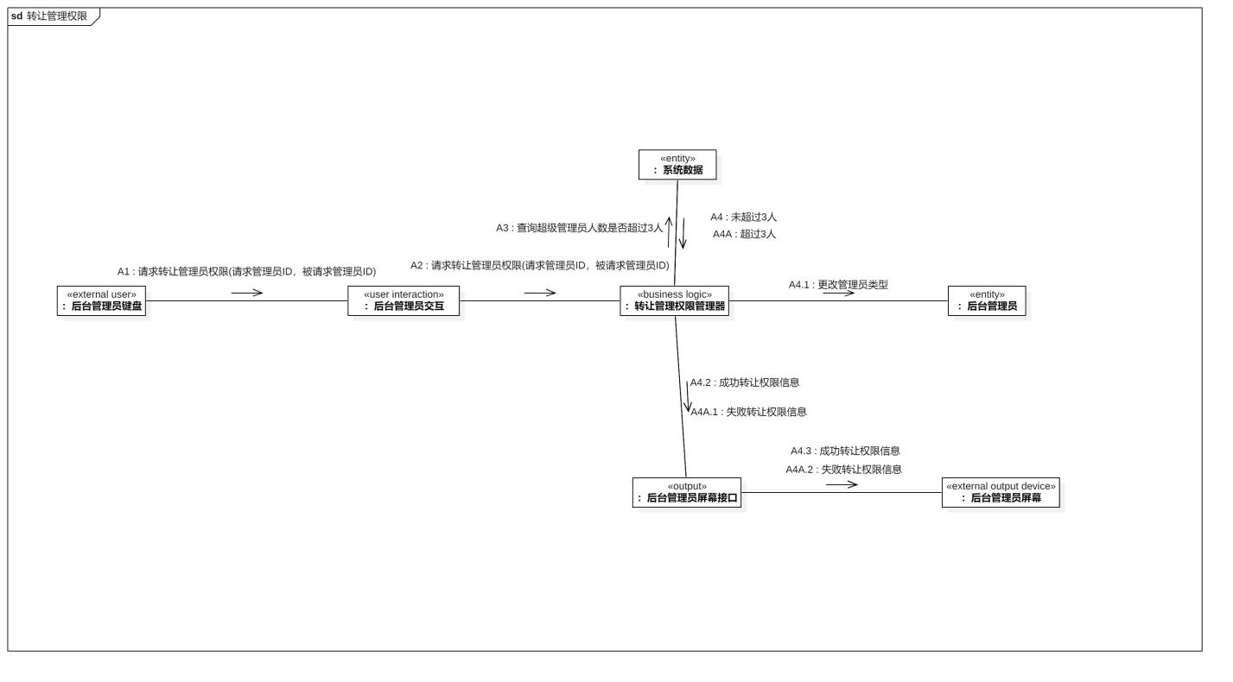

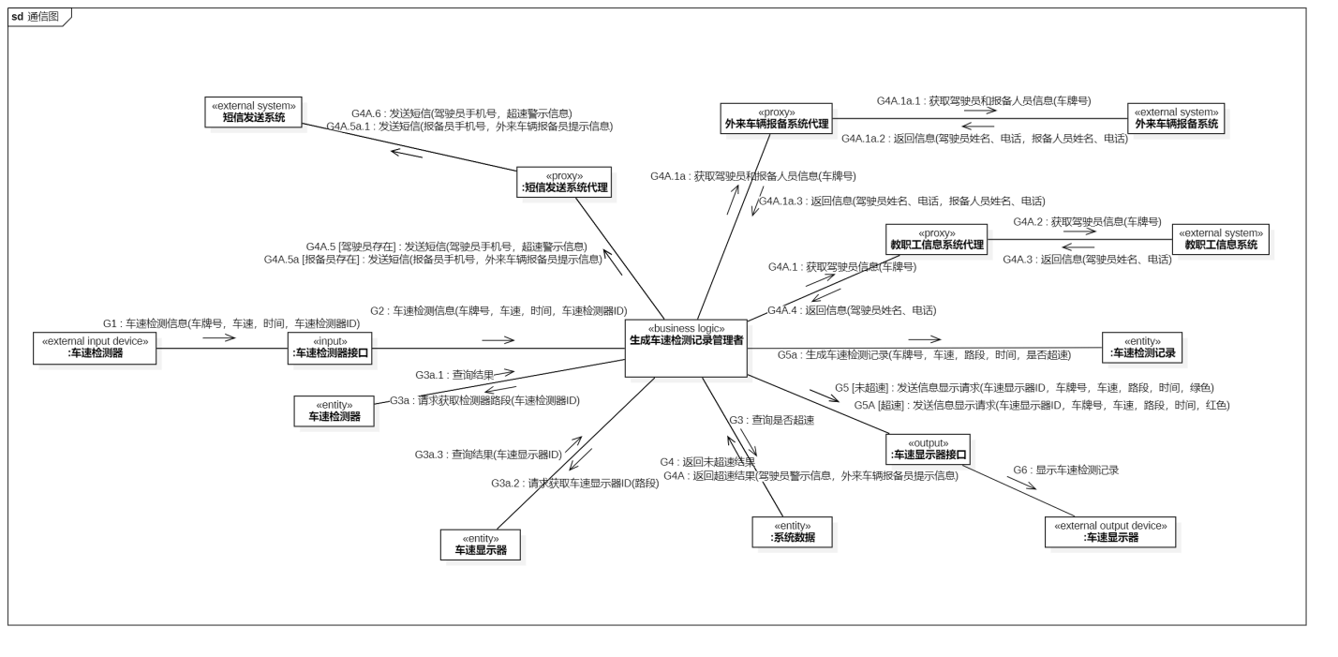

要写 – 每位同学写一个用例的通信图+消息序列描述即可，但要与前面系统的用例图对应。

说明：如果想要完成系统全部用例的动态交互建模是可以的，但需要明确指明2-3个是用于评分的用例，其余的用例将不用作评分。

要和用例描述的用例相同

## Performance requirements

Specify both the static and the dynamic numerical requirements placed on the software or on human interaction with the software as a whole.

Static numerical requirements may include the following:

a) the number of terminals to be supported;

b) the number of simultaneous users to be supported; and

c) the amount and type of information to be handled.

Static numerical requirements are sometimes identified under a separate section entitled Capacity. Dynamic numerical requirements may include, for example, the number of transactions and tasks and the amount of data to be processed within certain time periods for both normal and peak workload conditions.

The performance requirements should be stated in measurable terms.

For example,

95 % of the transactions shall be processed in less than 1 s.

rather than,

*An operator shall not have to wait for the transaction to complete.*

NOTE Numerical limits applied to one specific function are normally specified as part of the processing subparagraph description of that function.

有则写，不要求

## Logical database requirements

Specify the logical requirements for any information that is to be placed into a database, including:

a) types of information used by various functions;

b) frequency of use;

c) accessing capabilities;

**d) data entities and their relationships;**

e) integrity constraints;

f) security; and

**g) data retention requirements.**

将**【实体类建模】**放在这里！

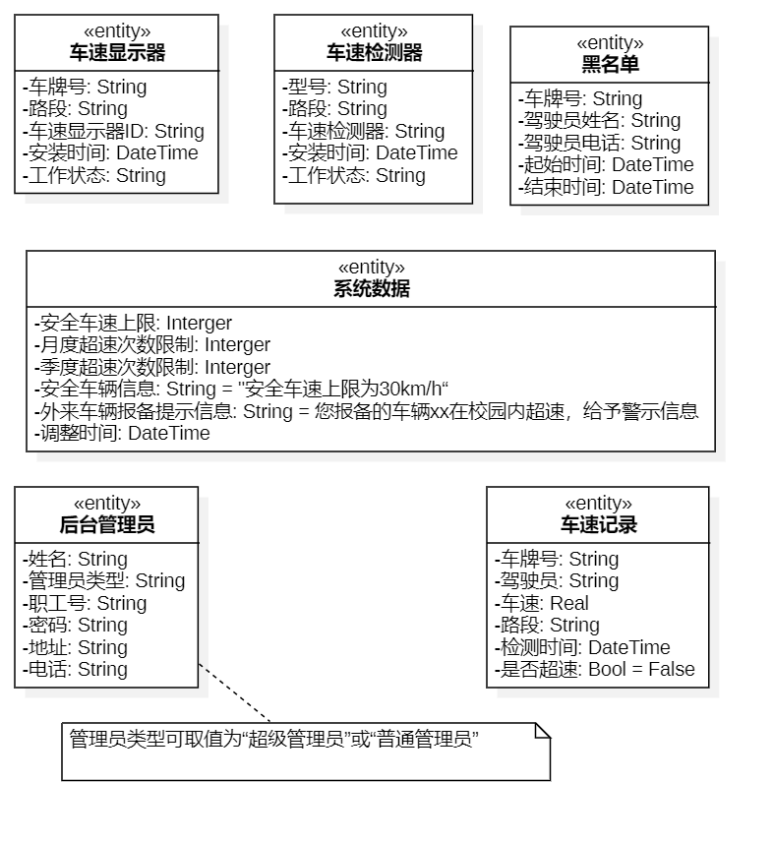

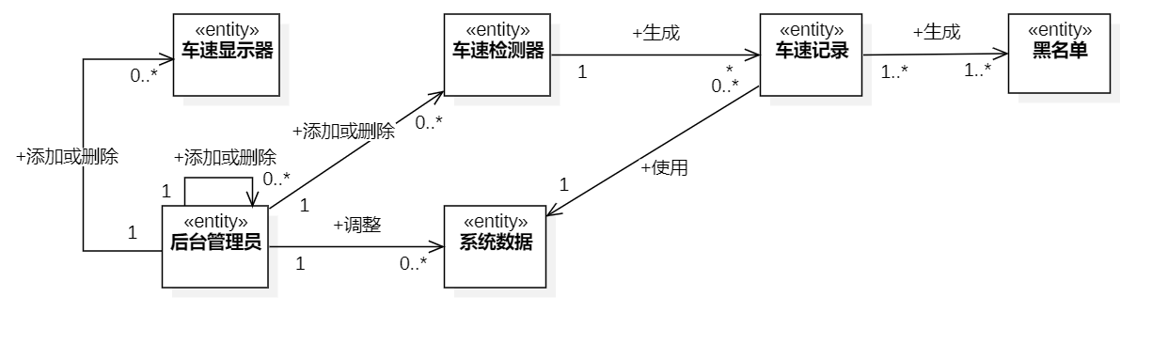

要写 – 实体类的关联图+属性图

## Standards compliance

Specify the requirements derived from existing standards or regulations, including:

**a) report format;**

**b) data naming;**

c) accounting procedures; and

d) audit tracing.

For example, this could specify the requirement for software to trace processing activity. Such traces are needed for some applications to meet minimum regulatory or financial standards. An audit trace requirement may, for example, state that all changes to a payroll database shall be recorded in a trace file with before and after values.

有则写，不要求

## Software system attributes

Specify the required attributes of the software product. The following is a partial list of examples:

a) **Reliability** - specify the factors required to establish the required reliability of the software system at the time of delivery.

b) **Availability** - specify the factors required to guarantee a defined availability level for the entire system such as checkpoint, recovery and restart.

c) **Security** - specify the requirements to protect the software from accidental or malicious access, use modification, destruction, or disclosure. Specific requirements in this area could include the need to:

1) utilize certain cryptographic techniques;

2) keep specific log or history data sets;

3) assign certain functions to different modules;

4) restrict communications between some areas of the program;

5) check data integrity for critical variables; and

6) assure data privacy.

d) **Maintainability** - specify attributes of software that relate to the ease of maintenance of the software itself. These may include requirements for certain modularity, interfaces, or complexity limitation. Requirements should not be placed here just because they are thought to be good design practices.

e) **Portability** - specify attributes of software that relate to the ease of porting the software to other

host machines and/or operating systems, including:

1) percentage of elements with host-dependent code;

2) percentage of code that is host dependent;

3) use of a proven portable language;

4) use of a particular compiler or language subset; and

5) use of a particular operating system.

有则写，不要求

# Supporting information

Additional supporting information to be considered includes:

**a) sample input/output formats, descriptions of cost analysis studies, or results of user surveys;**

b) supporting or background information that can help the readers of the SRS;

**c) a description of the problems to be solved by the software**; and

d) special packaging instructions for the code and the media to meet security, export, initial loading

or other requirements.

The SRS should explicitly state whether or not these information items are to be considered part of the requirements.

有则写，不要求

# References

Include the following information regarding references:

**a) provide a complete list of all documents referenced elsewhere;**

b) identify each document by title, report number (if applicable), date, and publishing organization; and

c) specify the sources from which the references can be obtained.

有则写，不要求