**GUJARAT TECHNOLOGICAL UNIVERSITY**

Chandkheda, Ahmedabad

Affiliated

K. J. Institute of Engineering and Technology, Savli

A Report On

### HOME AUTOMATION

Under subject of

**DESIGN ENGINERING- 1B (3140005)**

B. E. Semester – IV BRANCH ENGINEERING

Submitted by:

|  |  |  |
| --- | --- | --- |
| Sr. | Name of student | Enrollment No. |
| 1 | Sujan S. Barman | 190640107001 |
| 2 | Jaydeep M. Parmar | 190640107019 |
| 3 | Mohini S. Salvi | 190640107033 |
| 4 | Vaishali M. Rathwa | 190640107031 |

Mrs. Tiwari Rohit Dharmanand Assistant professor(CE), KJIT, Savli

(Internal Guide)

Mr. Rohit Tiwari Head of the Department

Academic year (2019-2020)

## K. J. Institute of Engineering & Technology, Savli Information Technology

**2020**

### CERTIFICATE

**Date:**

This is to certify that **Barman Sujan(190640107001), Parmar Jaydeep(190640107019), Salvi Mohini(190640107019) and Ratwa Vaishali(190640107031)** has successfully completed their work in **DESIGN ENGINERING- 1B (3140005)** for the project titled “ML Based Cryptocurrency Trading Bot**”** in 4th semester during the term of 2020-2021. He been very much disciplined, hardworking and submitted all our report on the project he has under gone.

|  |  |  |
| --- | --- | --- |
| **Internal Guide** | **Examiner** | **Head of the Department** |
| Asst Prof. Rohit Tiwari |  | Asst. Prof. Rohit Tiwari |

## K. J. Institute of Engineering & Technology, Savli Information Technology

**2020**

### DECLARATION

We hereby declare that the work presented in this project entitled **“ML BASED CRYPTOCURRENCY TRADING BOT”** submitted towards completion of project in **Fourth Semester** of B.E. (Branch) is an authentic record of my original work carried out under the guidance of **“Mr. Rohit Tiwari”**

We have not submitted the matter embodied in this project for the award of any other

degree.

Semester: 4th Semester Place: KJIT, Savli

#### Project Team

Barmam Sujan S.(190640107001)

Parmar Jaydeep M.(190640107019)

Salvi Mohini S.(190640107033)

Ratwa Vaishali M.(190640107031)

## K. J. Institute of Engineering & Technology, Savli Branch

**2020**

### ACKNOWLEDGEMENT

We have taken many efforts in this project. However, it would not have been possible without the kind support and help of many individuals and organizations. We would like to extend my sincere thanks to all of them.

We are highly indebted to ***“Mr. Rohit Tiwari”*** sir for their guidance and constant supervision as well as for providing necessary information regarding the Design Engineering Project Titled **“ML BASED CRYPTOCURRENCY TRADING BOT”.** We would like to express my gratitude towards staff members of **Computer Engineering**, K. J. Institute of Engineering & Technology, Savli for their kind co-operation and encouragement which helped us in completion of this project.

We even thank and appreciate to our colleague in developing the project and people who have willingly helped us out with their abilities.

#### Project Team

Sujan Barman(190640107001)

Parmar Jaydeep M.(190640107019)

Salvi Mohini S.(190640107033)

Ratwa Vaishali M.(190640107031)

### Abstract

Our project is about making a Automated Crypto-Currency trading bot that would be able to autonomously place orders of these coins. This bot will be getting getting it's data from a customly made machine algorithm that would be able to predict them flow of the market. The machine learning model will be using a dataset which will be retrive and made from the binance api. This dataset for machine learning algorithm will be updated regularly for better predictions. As Crypto Coins markets are volatile and the values of these coins are dependent on each other it becomes easy to predict the near future value these coins with machine learning algorithms that takes all of these coins into account.

|  |  |  |
| --- | --- | --- |
| **Sr. No** | **Topic** | **Page No.** |
| **1)** | Introduction | 7 |
|  | **1.1)** Introduction Of project | 7 |
|  | **1.2)** Project definition | 8 |
|  | **1.3)** Objective and scope of project | 8 |
| **2)** | Design Thinking Canvas | 9 |
|  | **2.1)** AEIOU Canvas | 9 |
|  | **2.2)** Mind Mapping Canvas | 11 |
|  | **2.3)** Empathy Mapping Canvas | 12 |
|  | **2.4)** Ideation | 14 |
|  | **2.5)** Product Development Canvas | 16 |
| **3)** | Refinement in the rough prototype | 18 |
| **4)** | Conclusion | 19 |
| **6)** | References | 20 |

**CHAPTER: 1**

* 1. **INTRODUCTION OF PROJECT**

The world is changing and so does it’s ways to do trading. In today’s modern world there is a new way to do trading good and that is cryptocurrency trading. Cryptocurrency is a digital form of currency that is gaining popularity in recent times. This new curenncy is both secure and transparent unlike any other thing that we have seen. But there is a small catch in this new currency. The word that I am using cryptocurrency is actually representing more than 1600 cryptocoins/cryptocurrency that is available to public. The more famous cryptocoins amoung them are ethereum, monero, ripple, doge and finally the most famous one BITCOIN. But these coins and there market are really volatile. Due to this it becomes a two sided sword if you are not actively monitoring the situation of market as one could lose a large sum of there assets in an instant or they could also gain a huge profit in an instant. So to tackel this very problem our team is working on **“ML BASED CRYPTOCURRENCY TRADING BOT”.**

**PROJECT DEFINATION**

Our project is designed to provide a service that is able to provide people with a trading bot that would be able to do trading of these so called cryptocoins. The bot will be trained every few hours with the customly made ML Algorithm so that it can keep up with the market and could provide the user with some profits that is statically calculated.

### OBJECTIVES AND SCOPE OF PROJECT

**Objectives**: -

The objective of this project is to provide a service that can be used by people to better manage their cryptocoins as well as do some automatic trading to gain some profit at the same time.

### Scope of Project: -

### This project is basically a software that will be hosted on a remote server to provide it’s services, so basically anyone can access this from anywhere in the world.

# Chapter 2

**Design Thinking Canvas**

## AEIOU Canvas

ACTIVITY ENVIRONMENT INTERACTIONS OBJECTS USER is the full form of

AEIOU. From this sheet we learn about how to do survey. This sheet is about to whom we have to interact, who the users are and what activities doing and object are found in **ML BASED CPYPTOCURRENCY TRADING BOT**.

### 

### Activities

* + - User can manage their cryptocoins with this service
    - User can also manually withdraw or deposit coins into this service
    - User can do trading manually also with the modified binance api
    - User can also see his/her past activities

### Environment

* + - Home
    - Work place
    - Office

### Interactions

* + - The User will be able to access this with a web interface
    - On the server the programs will be taking care of the user account with the binance apis
    - The bots will be using the instructions of ML algorithm results generated from datasets acquired from binance.

### Objects

* + - Server
    - Python (for ML algorithm)
    - React (for front end)
    - Express (for back end)
    - MongoDB (As the database)

### Users

* + - CE/IT Students
    - Bussiness enthusiast
    - Traders
    - Data scientists

## Mind Mapping

In this canvas mind mapping has been discussed how it works in this project, in different Object, activities, user, features etc.

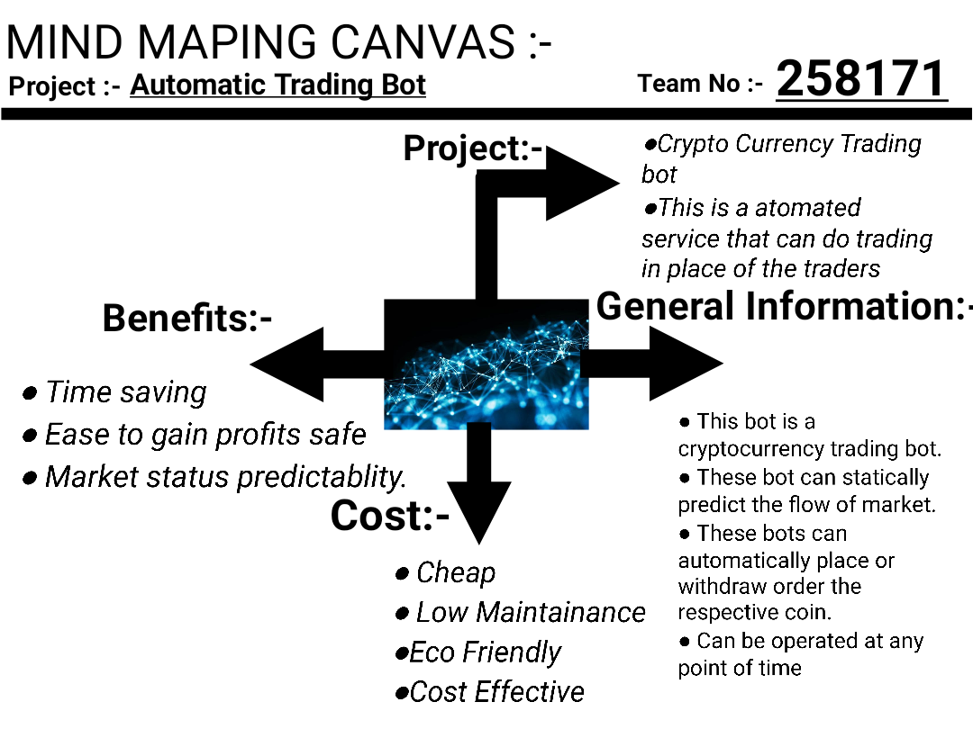

* 1. **Empathy mapping canvas**

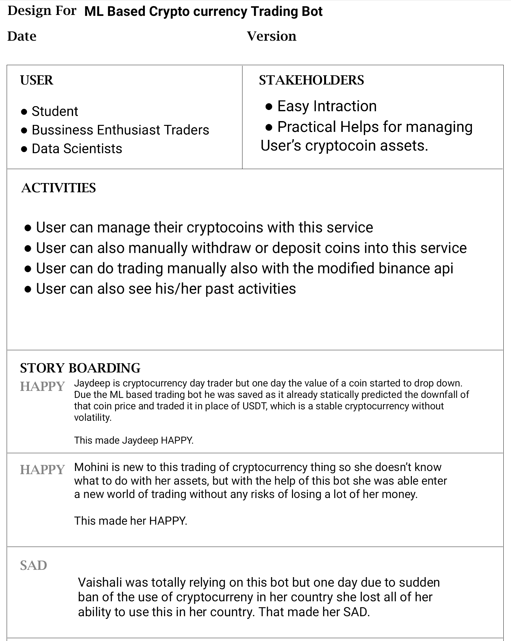

**USER**

* + - Student
    - Bussiness Enthusiast
    - Traders
    - Data Scientists

**STAKEHOLDERS**

* + - Easy Intraction
    - Practical Helps for managing User’s cryptocoin assets

### Activities

* + - User can manage their cryptocoins with this service
    - User can also manually withdraw or deposit coins into this service
    - User can do trading manually also with the modified binance api
    - User can also see his/her past activities

### Story Boarding

**Happy:**

Jadeep is cryptocurrency day trader but one day the value of a coin started to drop down. Due

the ML based trading bot he was saved as it already statically predicted the downfall of that

coin price and traded it in place of USDT which is a stable cryptocurrency without volatility

This made jaydeep HAPPY.

### Happy:

Mohini is new to this trading of cryptocurrency thing so she doesn’t know what to do with her assets, but with the help of this bot she was able enter a new world of trading without any risks of losing a lot of her money.This made her HAPPY.

### Sad:

### Vaishali was totally relying on this bot but one day due to sudden ban of the use of cryptocurreny in her country she lost all of her ability to use this in her country. That made her sad.

## ideation

### 

### People

* + - Student
    - Bussiness Enthusiast
    - Traders
    - Data scientists

### Activities

* + - Day Trading
    - Futures Trading

### Situation/context

* + - Cryptocurrency markets are volatile
    - Due to volatile nature of these markets it is easy to gain or lose profits
    - Also these markets are somewhat statically predictable

### Props

* Due to volatile nature of these markets it gives a chance to ML algorithms to predict their flow
* Due to this the user can avoid major loses of his assets
* The user can also gains profits with this service

## Product development canvas

### 

### Products experience

* + - Easy to navigate UI.
    - Easily accessible from anywhere.
    - Available at anytime of the day.

### Product function

* + - Able to do trading of cryptocurrency by itself.
    - Able to retain user previous trading history.

### Product features

* + - Secure web interface for user.
    - Able to do trading of cryptocurrency in place of his human counterpart.
    - Can do trading of various coins parallely.
    - Will be able to notify user of the tradings of cryptocurrency in realtime.

### Components

* + - Backend made up of express js.
    - MongoDB will be used as Database.
    - React js will be used to make the front end for user.
    - Machine learning algorithms will be used to analyse the market.
    - Binance will act as the Trading platform for this program also it will be providing the data of coins value history.

### Purpose

* + - Easy to statically predict market.
    - Cryptocurrency Trading becomes easy.
    - Automate the task of placing orders for cryptocurrencies.

**People**

* Student
* Bussiness Enthusiast
* Traders
* Data scientists

**CH: 3**

**Refinement in the rough prototype**

**As this a project completely based on software we do constant updates on it. It can be found at** https://github.com/sujan-arm64/Trading-Bot

**CH:4**

**Conclusion**

So this project is all about creating a trading bot that will be getting it’s instruction

from a machine learning algorithm that is designed to predict the future flow of cryptomarket by using the current up to date data provided by binance. This bot

will be accessible via a web application to the registered users. With this the system

will be able to record various activity of the bot as well as user to further optimise

itself. With this the user’s crypto assets will be more safe in compare to handeling

it by a human. This system will be monitoring the market almost all the time as to

not lose the value of assets the user posseses.

**Ch:5**

**References**

**htttps://github.com/sujan-arm64/Trading-Bot**