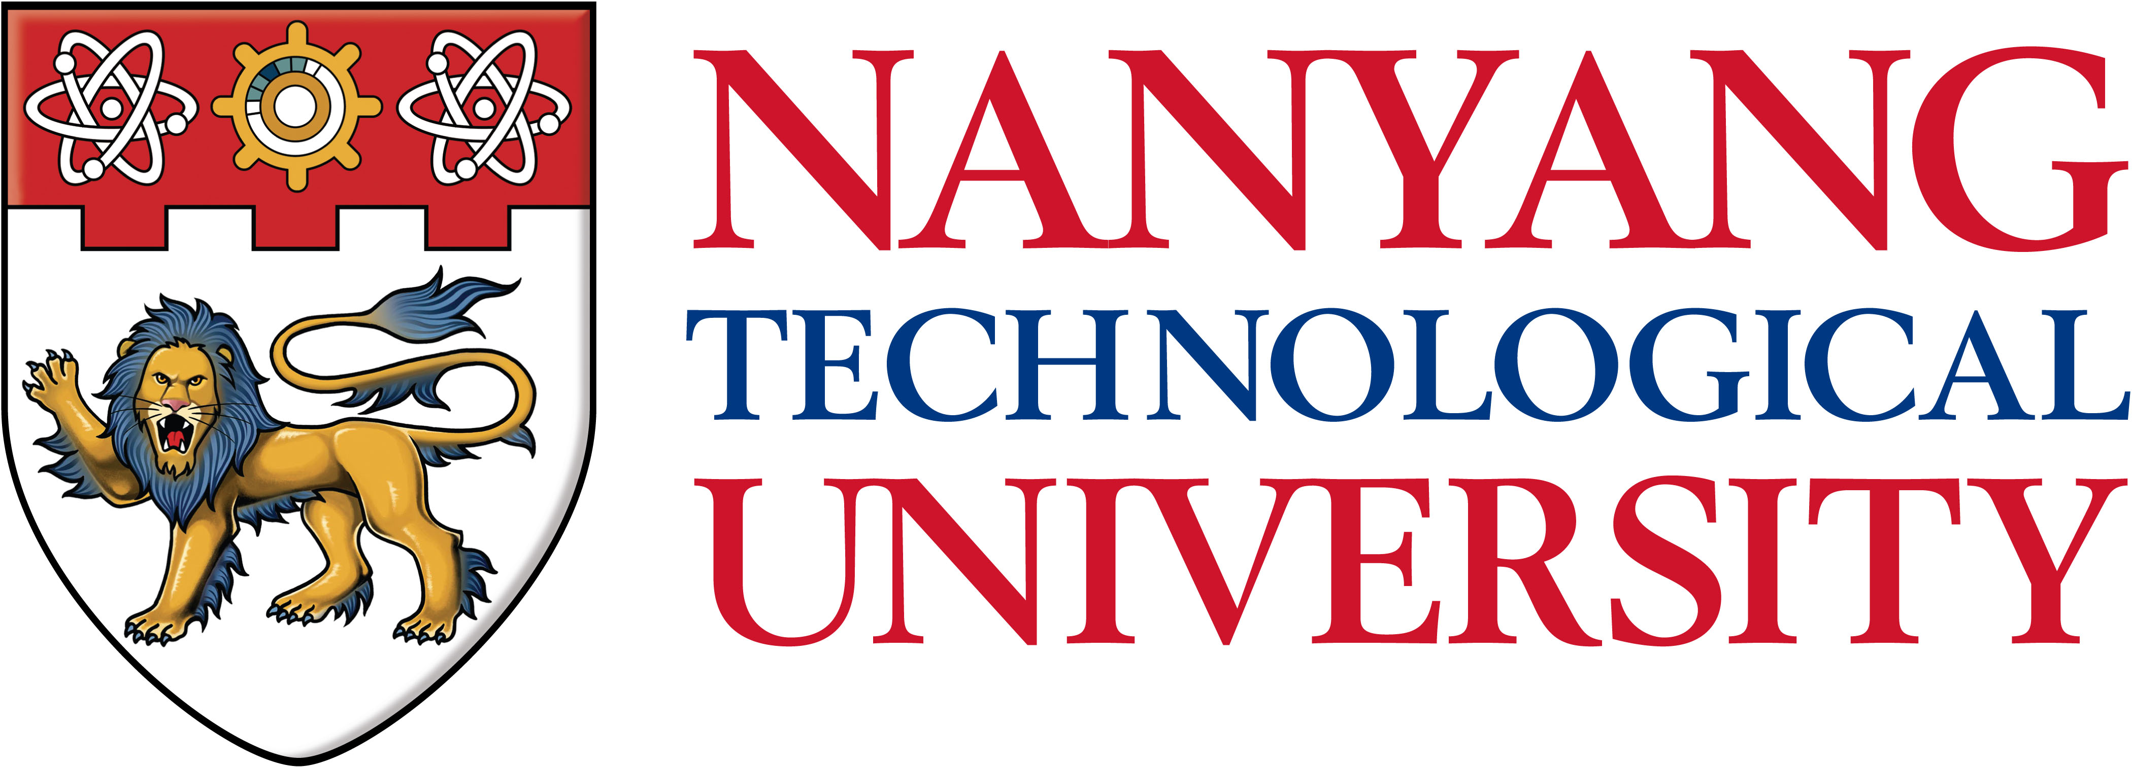
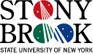

Nanyang Technological University

and

Stony Brook University

MEMORANDUM OF UNDERSTANDING

In order to promote co-operation between the Nanyang Technological University, Singapore and Stony Brook University, U.S.A, the two institutions agree as follows:-

The two institutions will encourage direct contact and co-operation between their faculty and administrative staff, departments and research institutions.

Within fields that are mutually acceptable, the following general forms of co-operation will be pursued:-

• Visits by exchange of undergraduate students for study and research.

• Visits by and interchange of staff for research, teaching and discussions.

• Exchange of information including, but not limited to, exchange of library materials and research publications.

• Joint research activities.

This Memorandum is not intended to create binding or legal obligations on either party. As and when details of any of the above activities are developed mutually, such details will be set forth in agreements supplemental to this Memorandum.

Both parties understand that all financial arrangements will have to be negotiated and will depend on the availability of funds.

If the Memorandum remains dormant for three consecutive years it will be deemed to have lapsed. Where the Memorandum continues to be active, the two institutions agree to review it after five years from the date hereof. It may be terminated at any time by mutual consent or by six (6) months' notice in writing by either party.

Should on-going collaborative activities be affected by termination, the parties undertake to resolve any issue amicably by mutual agreement.

_____________________________ _______________________________

Dr. Su Guaning Dr. Samuel Stanley, Jr

President President

Nanyang Technological University Stony Brook University

Date: Date:

