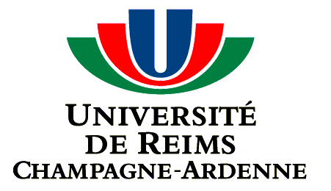 C:\Users\jlgreen\Desktop\SBLogoCMYK225.tiff

MEMORANDUM OF UNDERSTANDING

between

STATE UNIVERSITY OF NEW YORK AT STONY BROOK

STONY BROOK,

UNITED STATES OF AMERICA

And

THE UNIVERSITY OF REIMS CHAMPAGNE-ARDENNE (URCA), FRANCE

The University of Reims Champagne-Ardenne (URCA) and State University of New York at Stony Brook, United States of America, hereinafter referred to as Stony Brook, in recognition of their common interests in developing bilateral relations and convinced that cooperation between institutes of higher learning contributes to cultural enrichment, scientific progress, and the consolidation of friendship between countries, agree to establish the following Agreement of Cooperation.

I

This agreement will promote activities in the following areas:[1]

- Exchange of students

- Exchange of faculty and academic staff

- Instructional and cultural programs

II

1. Specific mechanisms for the implementation of particular cooperative and collaborative activities shall be established and described in writing by the responsible authority of each institution prior to the initiation of any particular program or activity.

III

1. All activities developed under the auspices of this Agreement will comply with the procedures, policies, and practices, of each University as well as the law and regulations of the host, including applicable portions of the U.S. Export Controls Act.
2. Both Institutions acknowledge that the visit by faculty and students from one institution to the other shall be subject to the entry and visa regulations of the United States of America and, shall comply with the regulations and policies of URCA and SBU.

IV

1. The present Agreement should not be interpreted in the sense of having created a legal and financial relationship between the two parties. It constitutes a declaration of intent, the purpose of which is to promote a genuine relationship of mutual benefits which is in essence that of academic collaboration.

V

1. This Agreement is established for a period of five years, effective on the date of signing.
2. In order to enhance the efficacy of their cooperative activities, URCA and SBU agree that it shall be possible to introduce changes and additions to the Agreement by means of mutually agreed upon additional written clauses.
3. At the end of each five-year period, this Agreement will be automatically renewed by mutual agreement for an additional five year, unless Stony Brook or URCA provide written notification of a decision of non-renewal prior to the expiration date. A minimum period of six months notice will be required from either party wishing to terminate the Agreement. In the event of termination, all commitments to students participating in the program will be honored by relevant parties.

VI

1. The resolution of any possible dispute inherent in the interpretation or execution of the present agreement shall be transferred to a body of mediators selected from Stony Brook and URCA staff by the signatories or by persons to whom they delegate their authority.

VII

1. The Agreement exists in four copies (two in French, two in English) and is signed by the representatives of both institutions. The four copies are equally valid.

For the University For STONY BROOK University

of REIMS CHAMPAGNE-ARDENNE

_________________________ ________________________________

Richard VISTELLE Date Samuel Stanley, Jr., M.D. Date President President

________________________________

W. Arens, Ph.D. Date

Dean, International Academic Programs

1. A separate Appendix is required.