Gabija

Daniel Antal

2022-10-04

# Handshake with @Borid

## Star the repository

# By the way this is how you include a png file as illustration from   
# ../png/linux/github_star_repository.png  
knitr::include_graphics(here("png", "linux", "github_star_repository.png"))

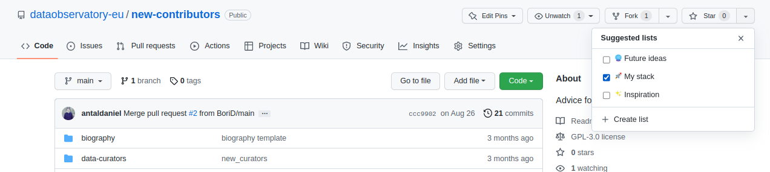

## Download this file

Follow the steps here: [First_steps_Github.md](https://github.com/antaldaniel/new-contributors/blob/main/First_steps_Github.md)

## Hello, world!

Good afternoon!

## Add a file to the png folder

Choose any png file that you like (and which is royalty free, not too big), and place it on your drive to the /png/subfolder of your local repository copy. The name of the png file should be changed below:

# By the way this is how you include a png file as illustration from   
# ../png/<your_filename>.png  
knitr::include_graphics(here("png", "1200px-Sunflower_sky_backdrop.jpg"))

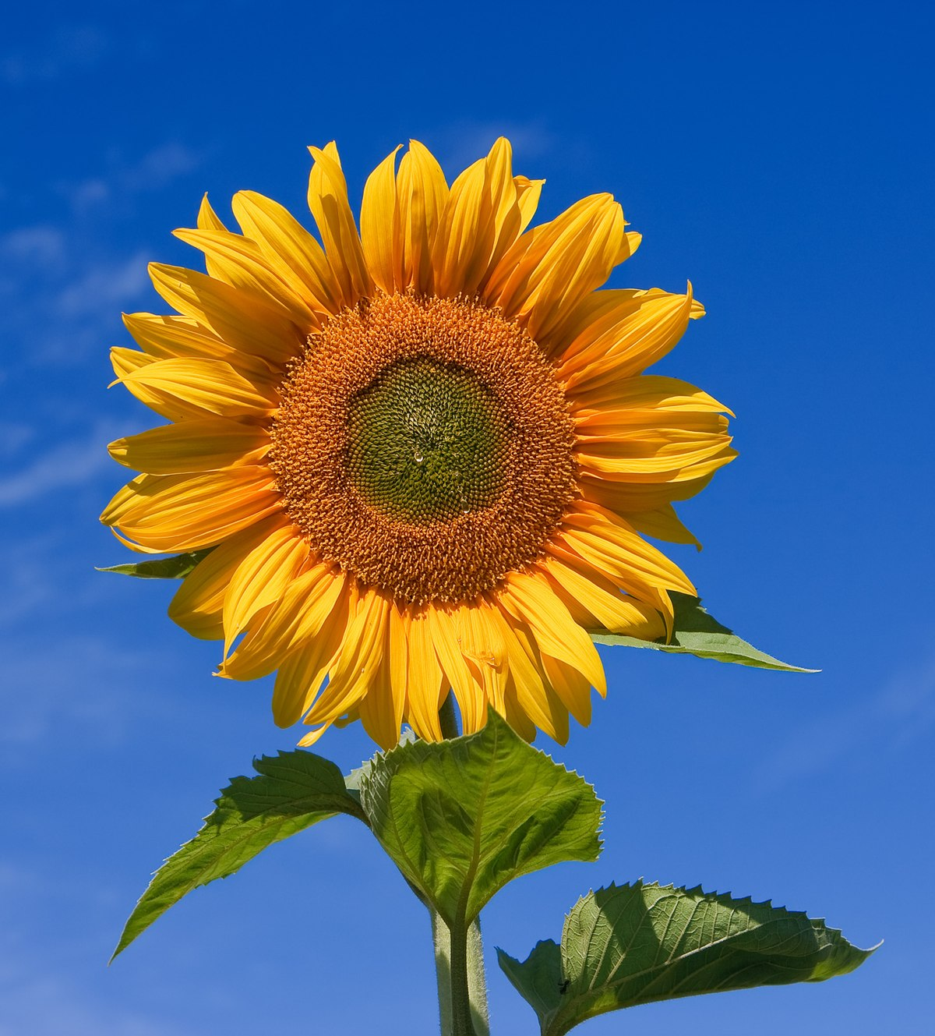

## Sync it with us!

Follow the steps here: [First_steps_Github.md](https://github.com/antaldaniel/new-contributors/blob/main/First_steps_Github.md)