Kanban project management intro on Github

Although it is not necessary to use Github beyond looking at Kanban card system, I would strongly recommend it, since Github significantly facilitates simultaneous collaborations and offers a very high level of security for sharing contract documents or later data. The goal of this short tutorial is to provide support to those wanting to use only the Kanban project management tool. Detailed tutorial [and if necessary, personal help] is provided to those who are willing to use other functions of Github from right now.

1. To access the Kanban card system, you will need a Github account. Creating one is easy and only takes a few minutes. Go to<https://github.com/>, click on sign up on the top right corner, and follow the steps.

2. Once you have an account, Github offers to select a plan and recommends setting up other personal settings. You can skip this step.

3. The [OpenMuse project board](https://github.com/orgs/dataobservatory-eu/projects/8/) is confidential, as it is connected to confidential files, and only authorized users see it. **By default, you do not see it**. Give your Github username to Daniel. He will send you an invitation and after that you can see the Kanban board relevant for you.

4. The Kanban board has two view settings, the table view, and the board view.

5. In the table view, you can see the title of the projects, their assignees, and their status. If you are an assignee of a project, Github will also send you an e-mail about the assignment.

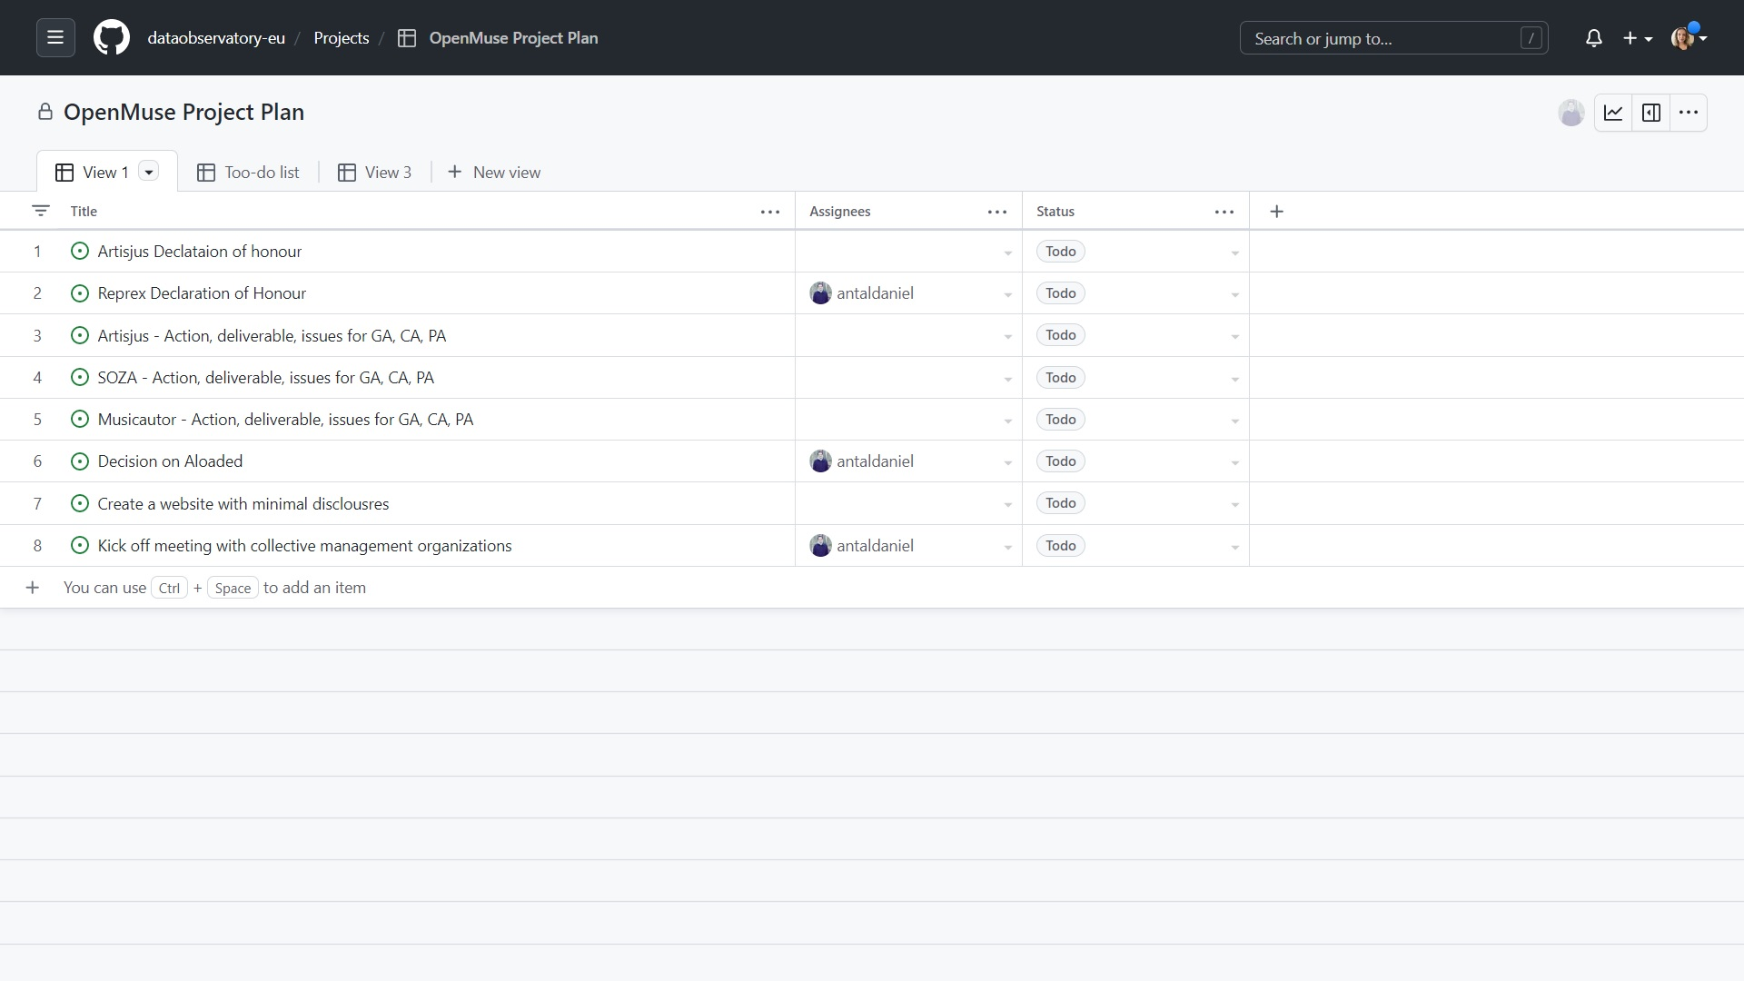

6. In the board view, you can change the status of the projects you are working on by simply moving (drag-and-drop) the project to/from the To do/In progress/Help wanted/Done part of the board. Most task have a short description, link to help, and deadline. If you use our system and move cards from the Todo to In progress or help wanted, please mark yourself as Assignee (your icon will show up). Move only cards that relate to your organization. Do not move anything to Done -- it is our final check to see if the task is ready.

