---------林加帮, at 2016.04.12

1. python版本需要3以上, 附上一个python3.5下载地址: http://sqdx.newhua.com/down/python-3.5.1.zip

2. treepack覆盖原来的treepack, 修改conv_cd.bat的path, 转换时直接双击conv_cd.bat即可

3. 不支持二维字符数组, 修改_tagGAME_WIN里TCHAR szLevelNames[MAX_CHAIRS_PER_TABLE][MAX_LEVELNAME_LEN], 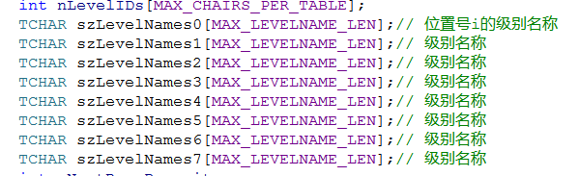

或者



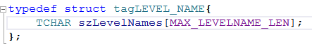

4. Req.lua尾部添加cc.load('treepack').resolveReference(****Req), 再return

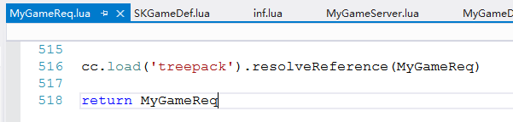

---------吕阳林, at 2016.04.12

5. TreePack.lua里新增了alignpacks和unpacks 2个函数, 用于一次收发多个结构, 用法如下

发送加密:

data = treepack.alignpacks( {dataGameMsg, MyGameReq["GAME_MSG"]},

{dataThrowCards, MyGameReq["THROW_CARDS"]})

收到后解密:

local table = treepack.unpacks( pData,

MyGameReq["GAME_MSG"],

MyGameReq["THROW_CARDS"]}

table[1], table[2]便是GAME_MSG, THROW_CARDS格式的数据