Genre Conventions & Influences:
See art_designs/external_inspirations folder for references and influences.
Genre conventions: 2D top-down view with a lot of focus on bubbly sense of water and viscocity, mud and haze. Underwater geologics, flora and especially lighting are important.
Bubbles/cavitation effects are important. Strong sounds, vibrations and shockwave visualizations are important.

Target Audience:
14-50, people with mystery or underwater fantasies, hybrid technocrat-biopunk enjoyers. Lovecraft fans as well. World of Warships aesthetics enjoyers.

Mood & Atmosphere:
Cold water that goes hot and more dangerous and pressurized with the progression. Mood of an alien ecosystem that evolved without sunlight. Multiple biomes, some are cold-themed (upper layers of the ocean), some are crystal-themed (middle layers), some are lava/hot-themed (deepest, hottest layers).

Color Palette:
Europa shark:
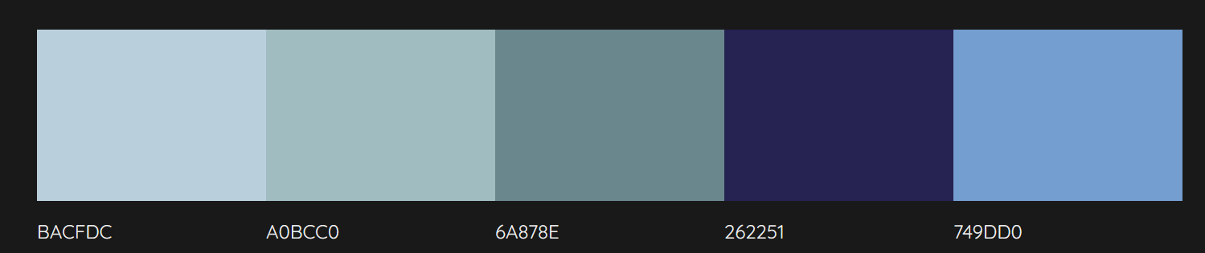
Sunless sea
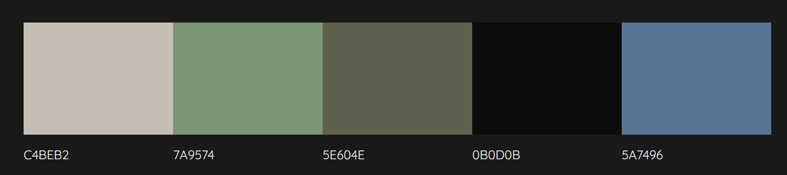

subnautica
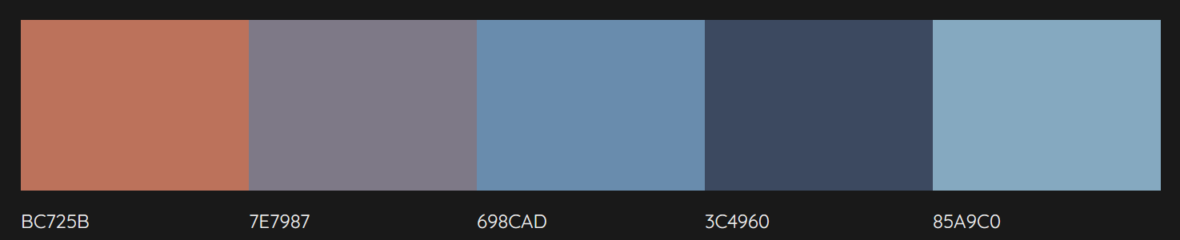
Sunless skies
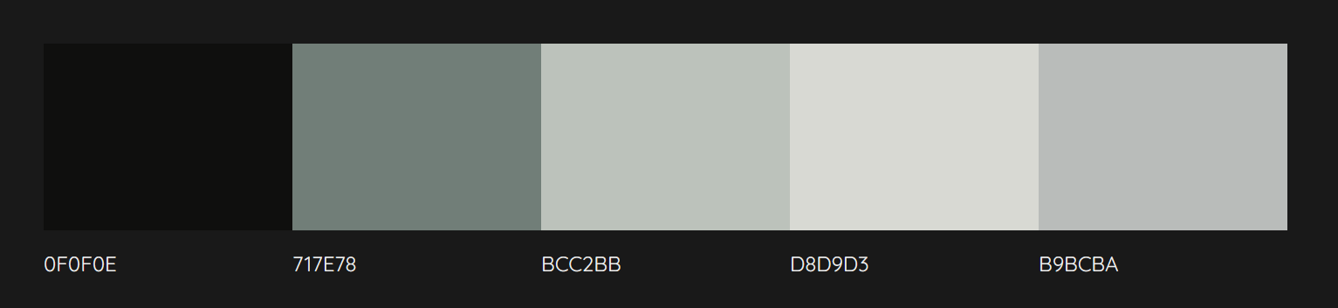

Original 1:
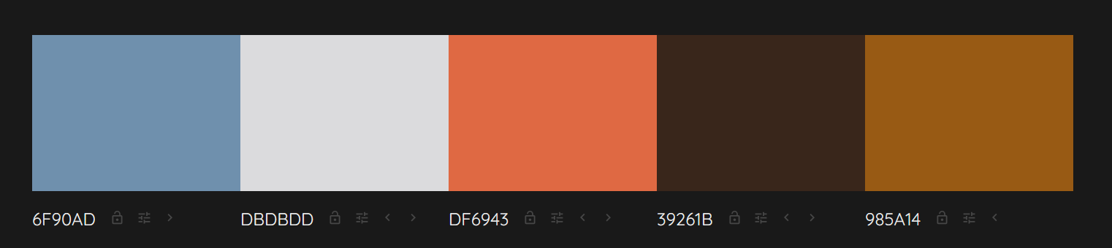

Dsubs demo variations:
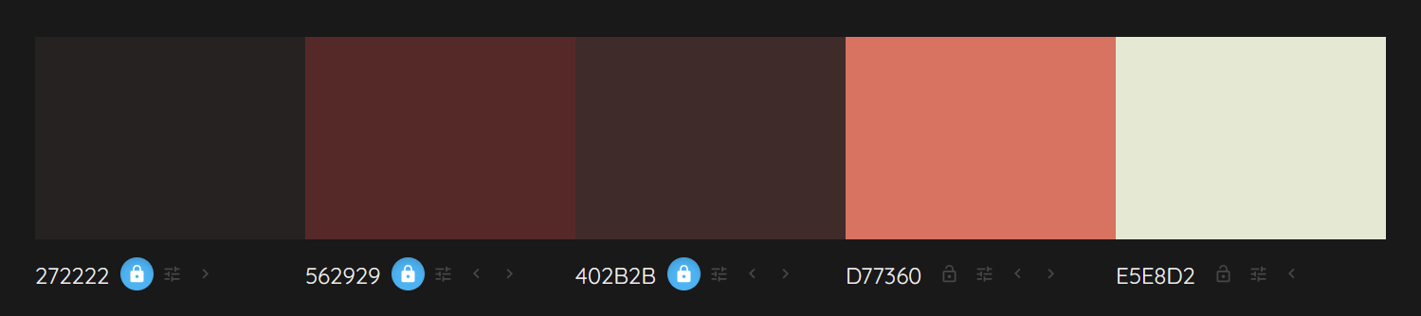
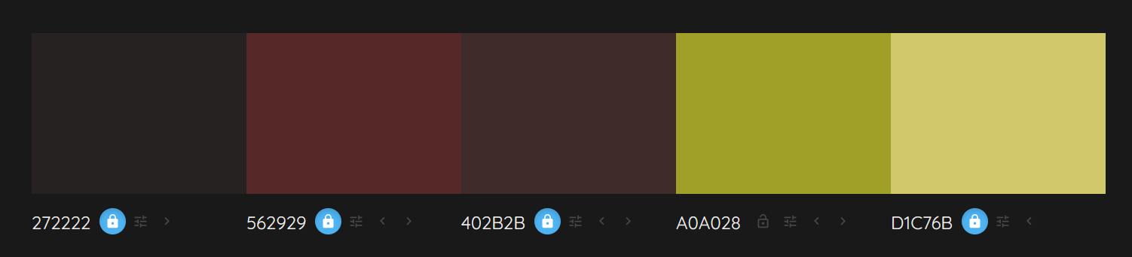

Character Archetypes & Roles
I would like to go for a VN/LN style of cutscenes, LOGH+Homeworld+Frostpunk cost-saving techniques and vibes. Characters there are low-detail, middle-contrast, realistic stylization, gritty and down-to-earth.

