Dsubs demo manual
Table of Contents
System requirements 1
Installing and running 1
Registration and login 2
Loadout menu 3
Multiple windows and COOP 3
Tactical screen, demo scenario 4
Navigation controls 5
Contacts 5
Passive sonar screen 6
Active sonar screen 6
Target motion analysis 6
Torpedo tubes 6

System requirements
Dsubs demo binary release is tested on Windows7 and Windows10. It is compiled as 32bit application.
Visual C++ Redistributable for Visual Studio 2015 (x86 version) must be installed on fresh systems like Windows7:
https://www.microsoft.com/en-US/download/details.aspx?id=48145
Application needs a hardware graphics acceleration that supports OpenGL 2.0 profile.
Outbound TCP connections to port 17955 must be allowed by your infrastructure to connect to the game server.

Installing and running
Latest binary release can be downloaded from:
https://github.com/Boris-Barboris/dsubs_demo/releases
Download the “dsubs-win-x86.zip” archive from the release’s “Assets” to your machine. Unpack it to your preferred game directory. Internal “dsubs” folder contains all game files. Run “dsubs_client” to play.
When launched, game process spawns 2 windows: console with logging and graphical window.
Windows defender and firewall may interfere with the game, in which case they must be instructed to grant the game required permissions.

Registration and login
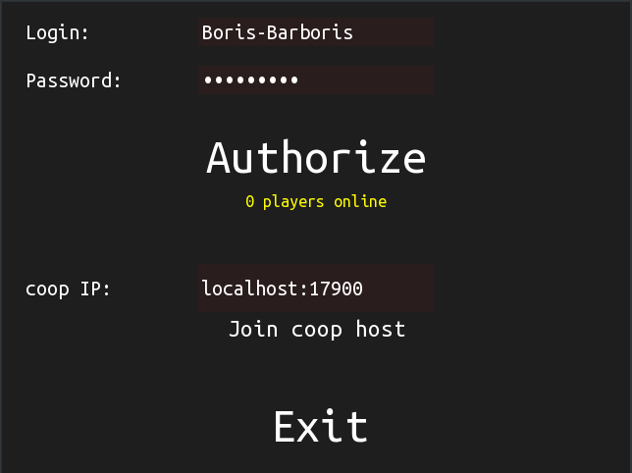
Enter your desired login and password to top two text fields. By clicking “Authorize” you will be registered and logged in. You will now be able to use the same login-password pair to reconnect to your submarine.

Loadout menu
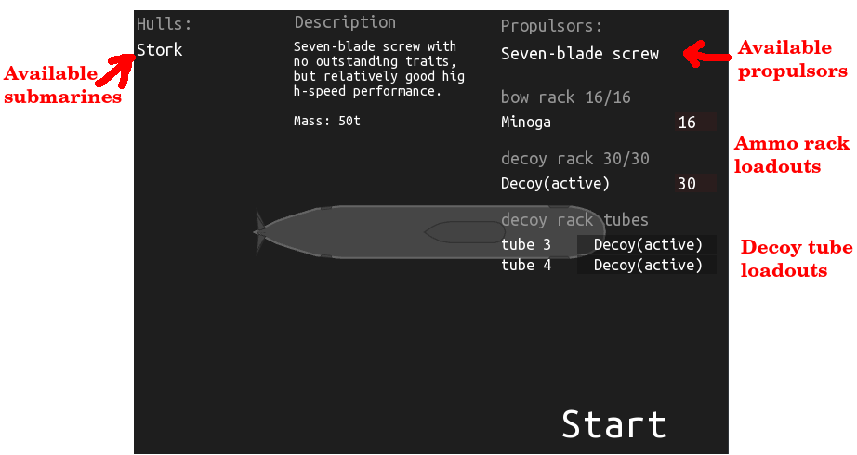
At the time of writing, only one submarine, propulsor, torpedo and decoy type are available. You can read their description by hovering your mouse over the object of interest.
When ready, press “Start” button.

Multiple windows and COOP
Once spawned, your main authorized window becomes a COOP server. You can connect other windows to it. You can forward TCP ports 17900-17905 on your router to your machine to play cooperatively with your friends.
In order to connect to COOP server, enter it’s IPv4 and port pair into “coop ID” text field and press “Join coop host” button.
Connected windows are anonymous and not authenticated. When the main window dies or is disconnected, all it’s peers get disconnected as well.
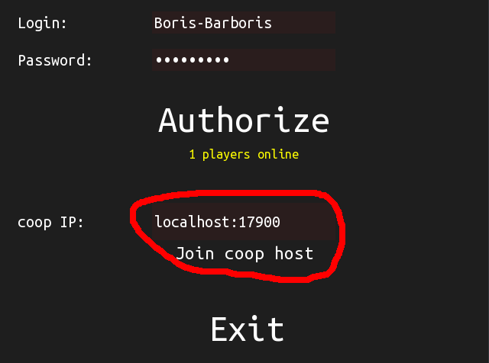

Tactical screen, demo scenario
Main screen is tactical screen, opened by F1 hotkey.
To zoom, rotate your mouse wheel. Hotkeys Q and E zoom as well.
To pan, hold your right mouse button and move the cursor. Arrow keys pan as well.
To reset camera position and center it on your submarine, press Escape on your keyboard.

Demo scenario that is running on the server designates the circular arena (dark blue circle) and forces all players inside it by overriding the desired course and throttle command.
There are passive bots swimming to random destinations, that you can practice your aim on.
When low on torpedoes or decoys, you can replenish your stores by swimming into yellow circle.
Periodically the arena is moved and players are given a limited time of unrestricted navigation.
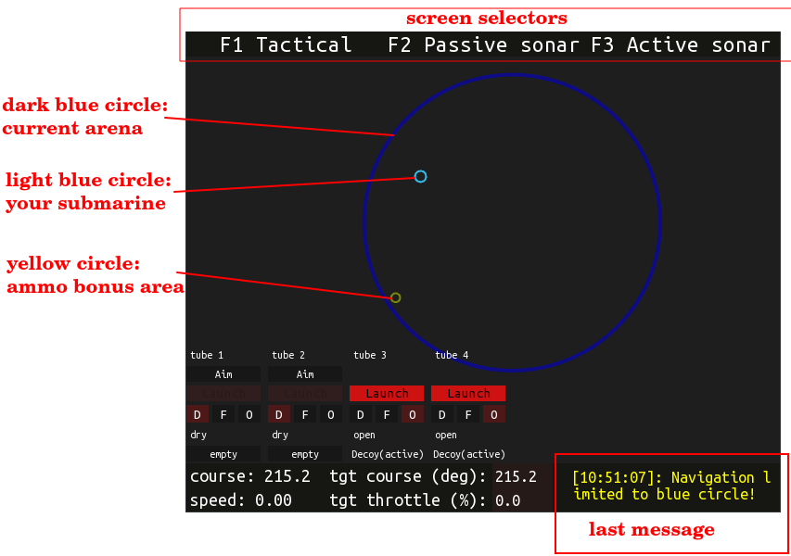

Navigation controls
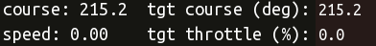

Your submarine is controlled by setting desired course and desired throttle (maps to percent of your top speed).
To change the desired course or throttle, press C or T hotkeys or click on the text field and enter a new value, then press Enter. Unless you press Enter, no command is sent to the server.
You can set desired course from the tactical screen by right-clicking in empty space and selecting “set course towards”. Keep in mind that it is still setting desired course and not a destination point.

Contacts
Targets and objects of interest that you encounter can be registered in your combat information center database (CIC) as contacts. You can create a manual contact in tactical screen by right-clicking empty space and selecting “create manual contact”.
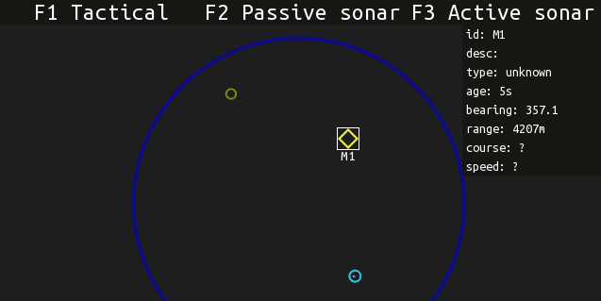
When the mouse is hovered over the contact, it’s information is displayed in a panel in the top right corner.
Contact is the container for data points – sensor and imaginary data samples that together can be used to estimate contact solution: it’s position and velocity.
Contacts can be classified in broad “type” categories, deleted, merged or trimmed (removing old data points) by right clicking on them and selecting the relevant options.

Passive sonar screen
Your submarine is equipped with a passive sonar – an array of hydrophones that let’s you listen to surroundings.
Press F2 to switch to passive sonar “waterfall” screen. Waterfall is a noise-time-bearing history display that lets you visually examine history of surrounding noises, create and manage contacts and “trackers” that continuously add data samples to contacts.
Waterfall display is zoomable and pannable with mouse wheen and right mouse button.
Dsubs server allows you to select one bearing to listen to and will stream audio data to tour client. Select “beamforming” bearing by clicking with left mouse button once in interior waterfall area.
WARNING: streamed audio is 1 second delayed behind rendered broadband noise picture due to implementation details.
You can change the volume of the sound by moving the “Volume” slider in the top left corner of the waterfall via mouse. Left button hold and drag or hover + mouse wheel interact with sliders in Dsubs UI.
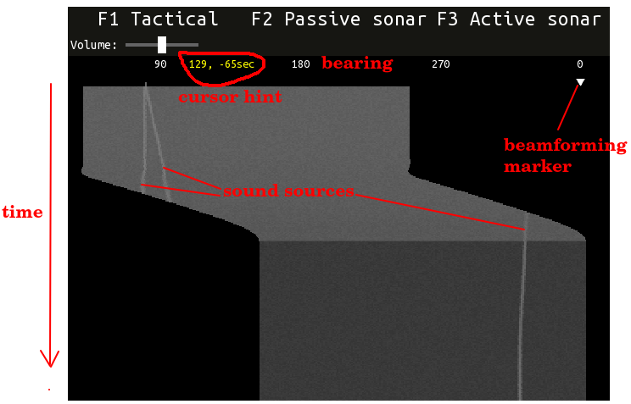

There are two ways to create a contact from waterfall screen:
1). By creating a tracker.
2). By right-clicking inside interior waterfall point and creating contact. This way is usefull for registering aperiodic events, like pings.
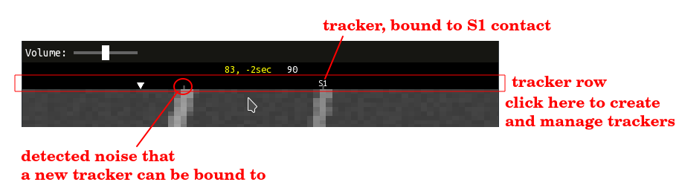
Trackers are created by right-clicking inside a “tracker row” near a detected noise pip and selecting “create tracker”. New contact will be created, and the tracker will periodically add bearing samples to it.
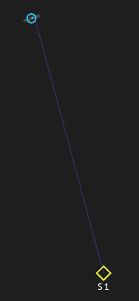
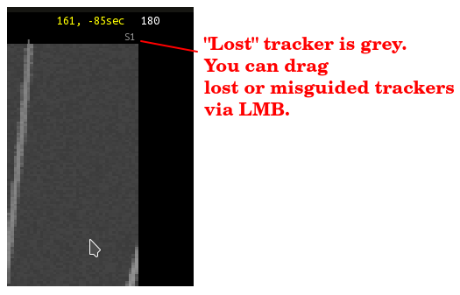

Trackers are imperfect and simply track the local broadband signal maxima, so sonar operator is expected to perform manual corrections.

Active sonar screen

Target motion analysis

Torpedo tubes and decoys

