# Final Project BI Course



Description:

The project describing statistics and finance results of football clubs of England, Germany, Spain and Italy. Used data of 2012-2021 years.

step 1:

Creating a list of business question for understanding the specific data we have search for:

* Who are the most “spending money” teams in four European best football leagues?
* What is the distribution of spent money between countries?
* How many totally spent during last 10 years?
* What is the total income and final balance?
* Who are the most scoring team?
* What is the distribution of goals between four countries?
* Who is the most suffering team?
* Who have reached most wins during last 10 years?
* Who are the most fans attended team, and how much totally fans attended the team during last 10 years?
* Marketing / MatchDay/ Tv Translation income during last 10 years and distribution between countries?
* Best 5 football clubs by income?
* Personal best players statistics:
* Most goals
* Most assists
* Most goals & assists
* Players with highest % of involvement in teams results

step 2:

Creation of data scheme.

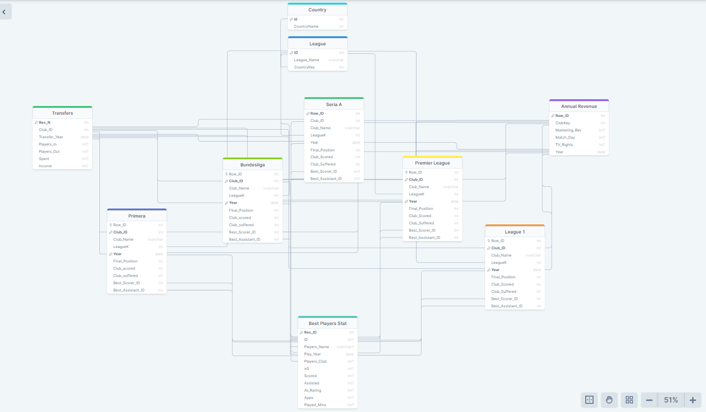

step 3:

Data collection. Used recourses:

* <https://mockaroo.com/> - used for fake Income data creation
* <https://www.footstats.co.uk/index.cfm?task=home> , <https://footystats.org/> , <https://www.soccerstats.com/> , <https://fbref.com/en/> - used for historical statistics collection
* <https://www.transfermarkt.co.uk/> - used for transfer market records

step 3:

Files creation

Have been created files of transfers history, personal players statistics, club’s statistics, clubs’ income for 2012-2021 years.

Attached a list of files:

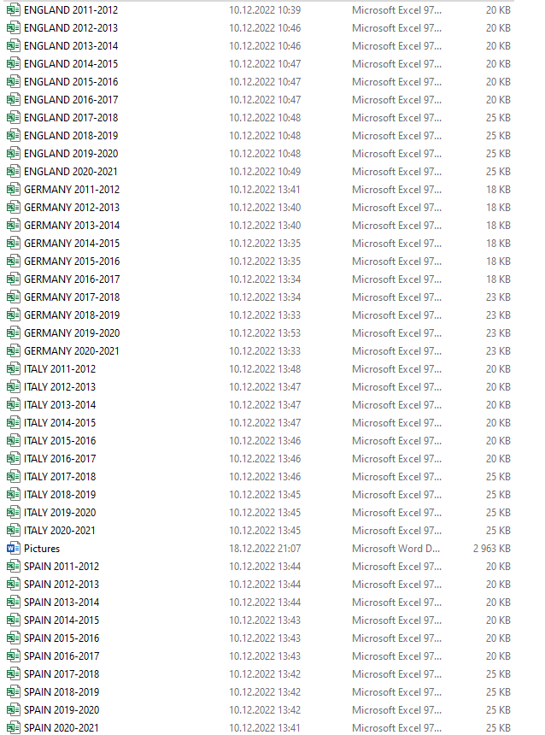

step 4:

Data aggregation, transformation, creation of consolidated files.

Python code used for data manipulation:

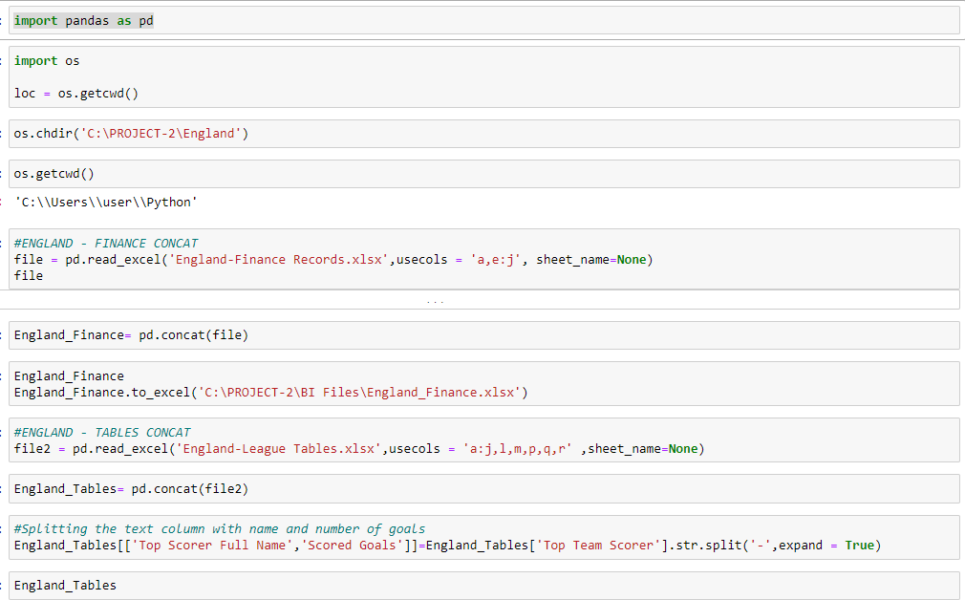

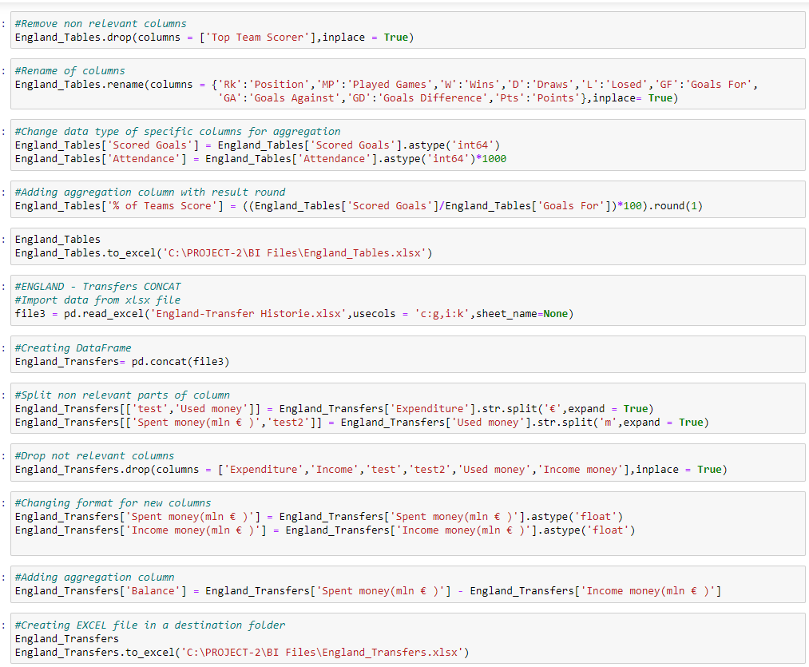

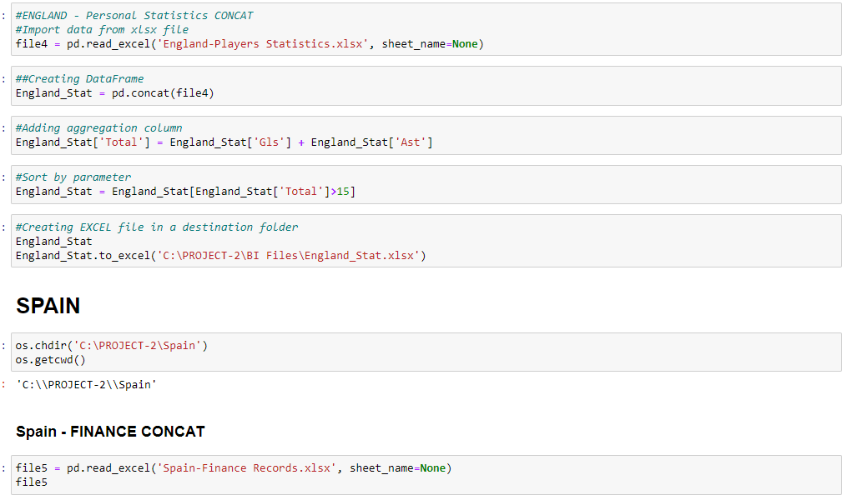

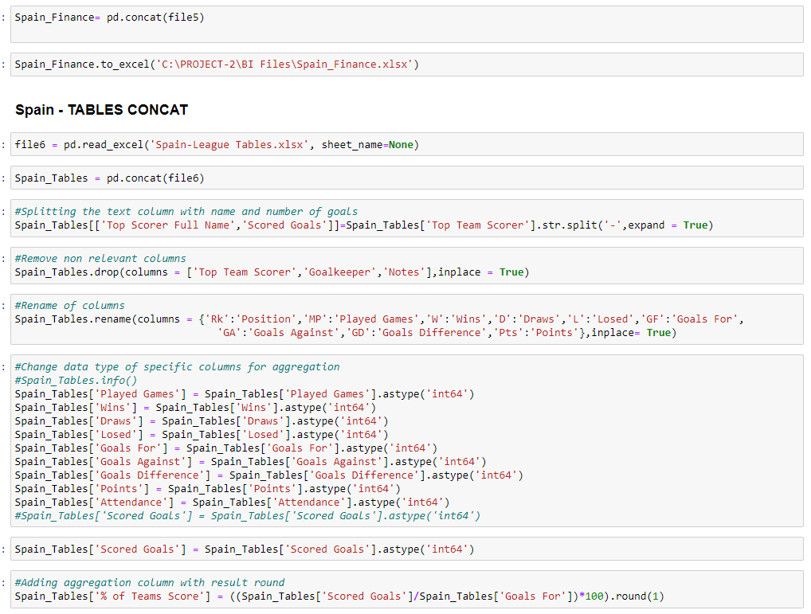

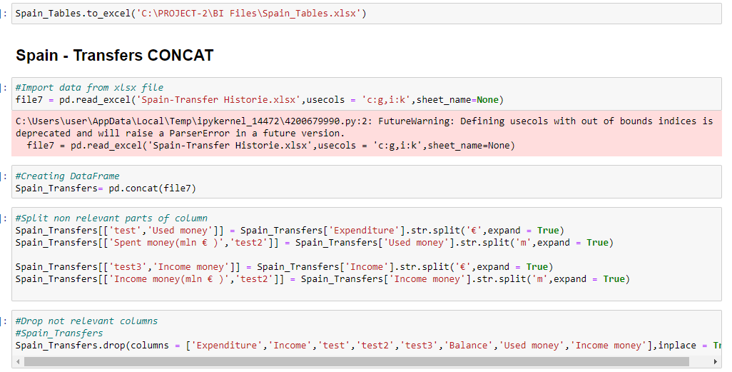

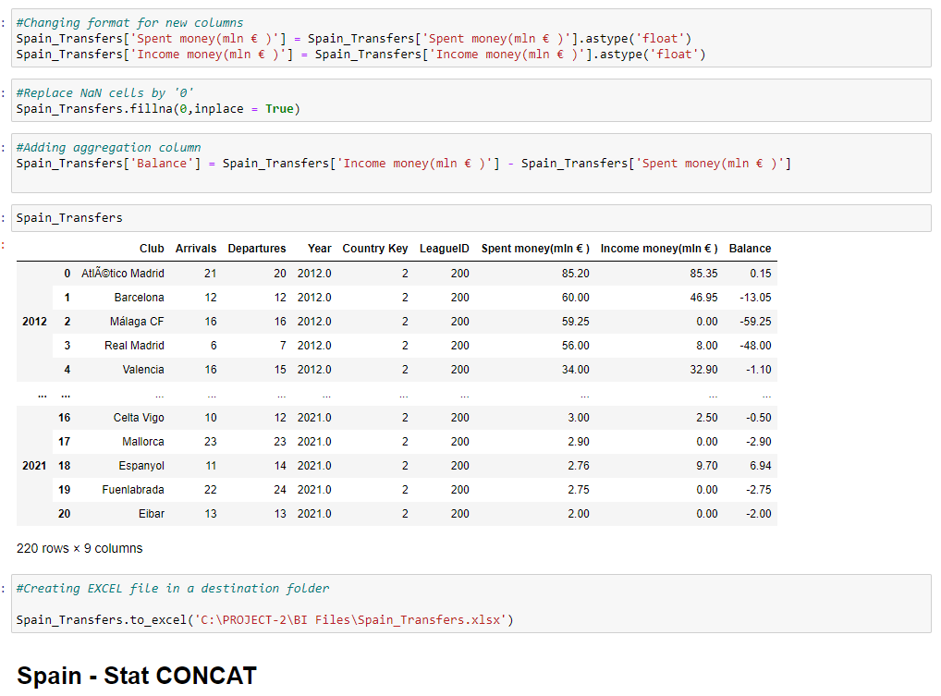

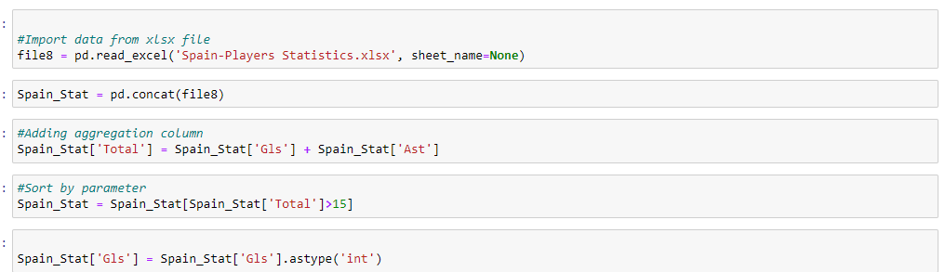



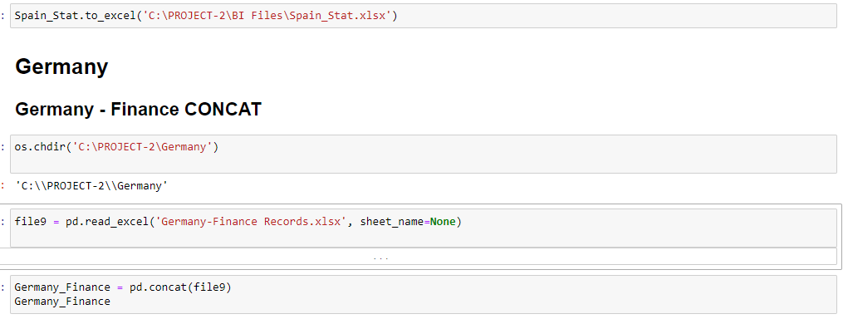

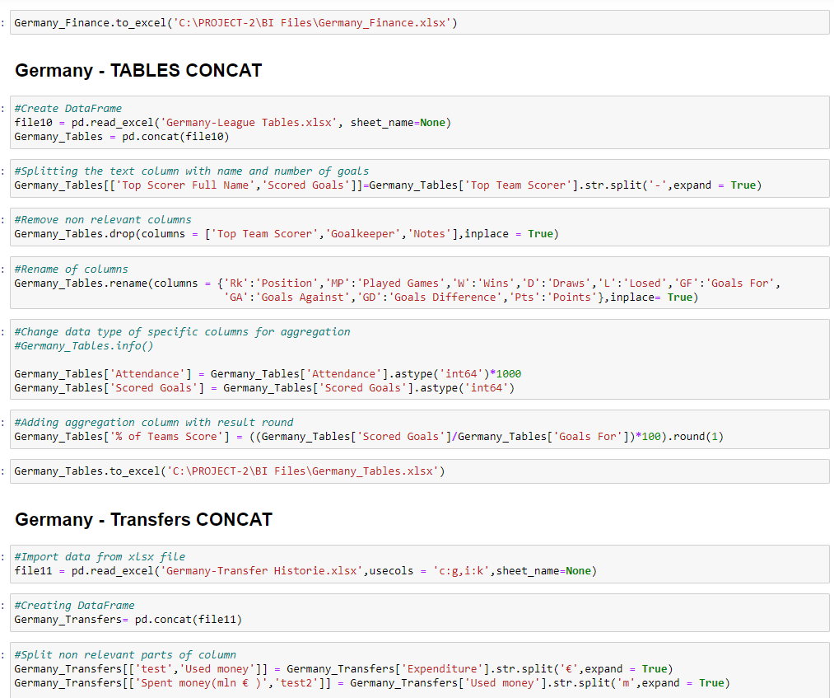

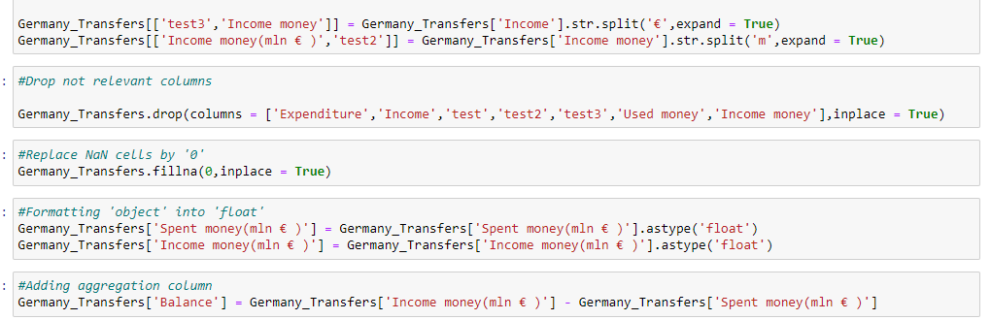

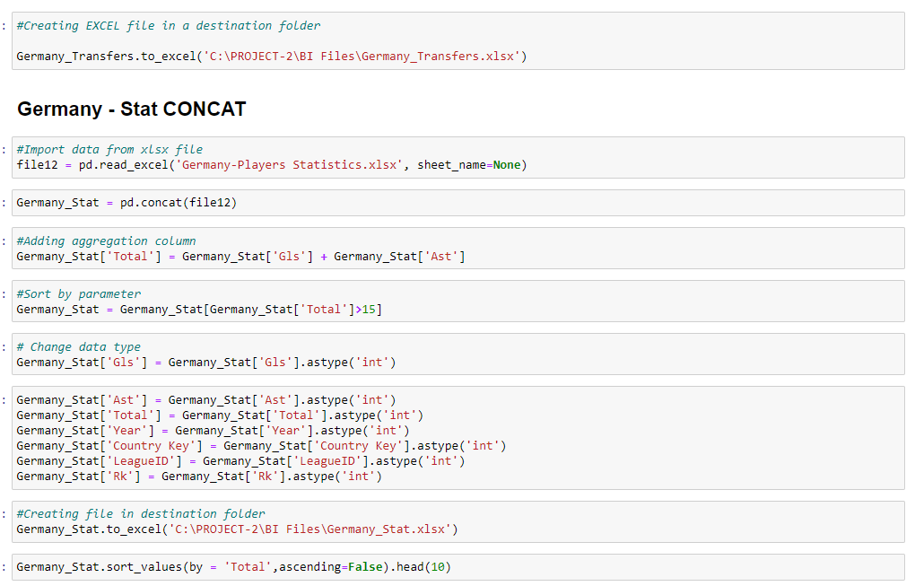

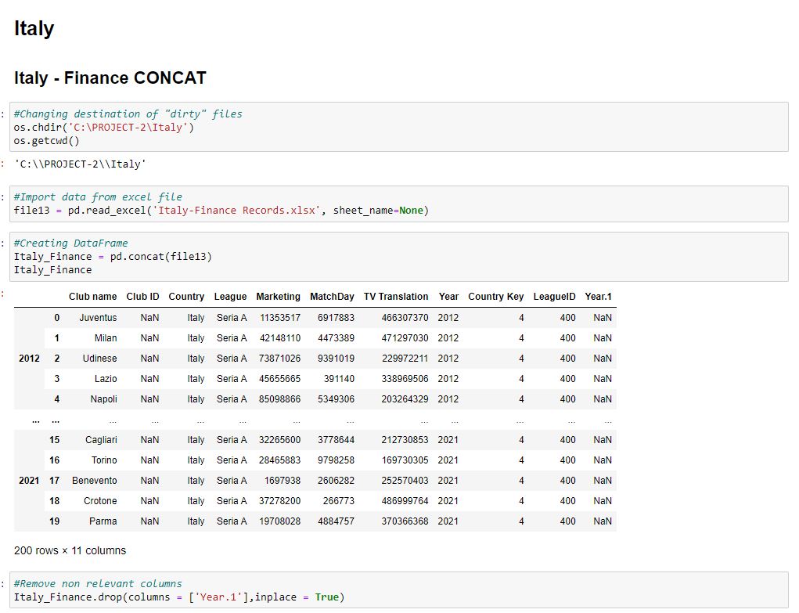

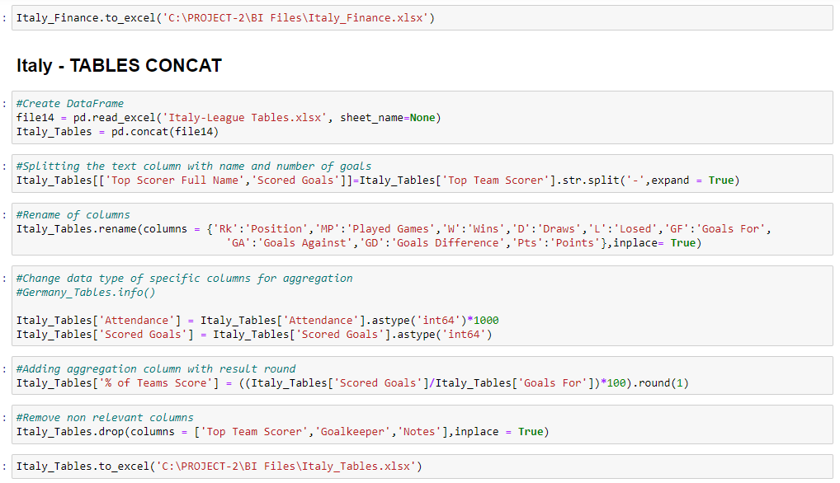

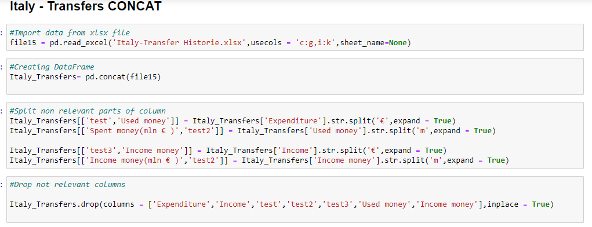

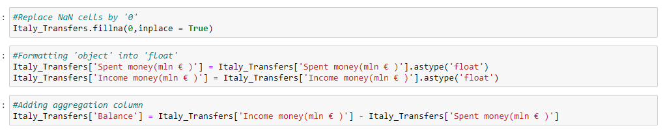

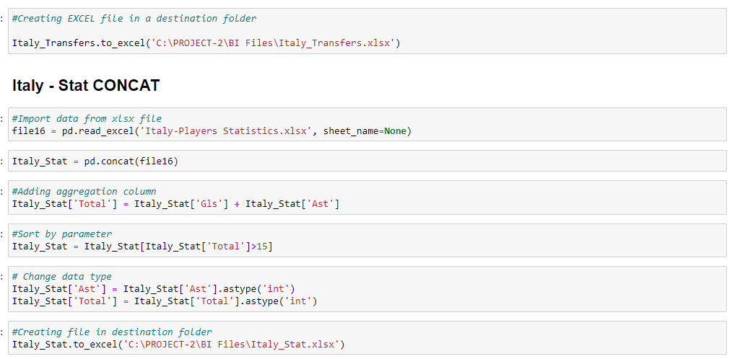

step 5:

* Uploading prepared data to Power BI
* Creation of dashboards according to questions from STEP 2

**Transfers analysis**

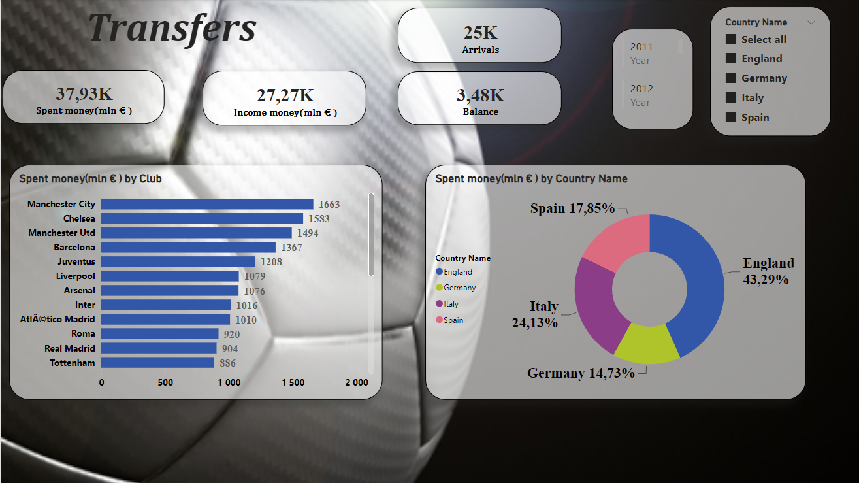

**Clubs Statistics analysis**

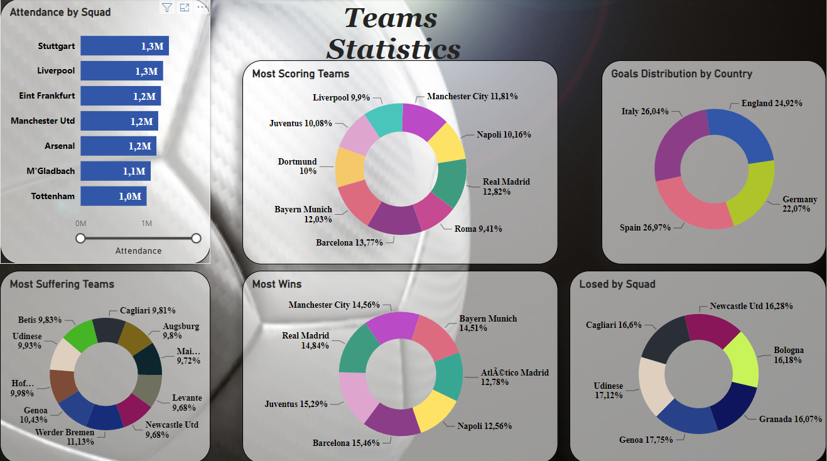

**Personal Player’s Statistics**

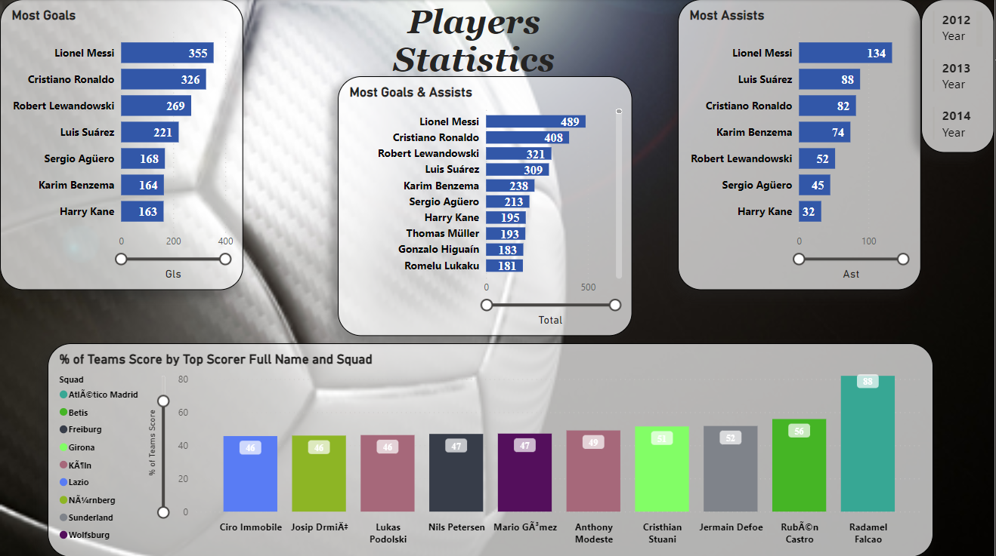

**Clubs Income analysis**

