Assignment 2
Boris Bojanov · Student ID 3608550 · Part 2, Problem 1: Sentiment Analysis with RNN, LSTM and GRU

Introduction
This problem classifies IMDb movie reviews as positive or negative with three recurrent networks written in PyTorch: a simple RNN, an LSTM and a GRU. After a base comparison, the LSTM and GRU (and the RNN) are re-run with different embedding sizes, sequence lengths, vocabulary sizes and pre-trained GloVe embeddings.

Preprocessing
- Data: the 25,000 training and 25,000 test reviews of the Large Movie Review dataset (balanced), loaded with torchnlp.
- Tokenization: <br /> tags are removed, text is lowercased and split into words with a regular expression, which also drops punctuation. Stop words were kept, since negations such as “not” carry sentiment. Lowercasing loses emphasis such as ALL CAPS.
- Vocabulary: 1,000 entries: the 998 most frequent training words plus <pad> (0) and <unk> (1), built from training data only.
- Sequences: each review is cut to its first 200 tokens and left-padded to length 200, so the last position is always the end of the kept text. Batches of 32, training data shuffled.

Model architecture and rationale
All three models are Embedding (1000, 100) → one recurrent layer with 128 hidden units (nn.RNN, nn.LSTM or nn.GRU) → Linear (128, 1) → sigmoid. The final hidden state summarizes the review and feeds the output layer, and the single sigmoid output is the probability of “positive”. Training uses binary cross-entropy, Adam (lr 0.001) and 5 epochs; the seed is fixed. LSTM and GRU add gates that let gradients flow across 200 steps, which a plain RNN cannot do (vanishing gradients).

Training curves
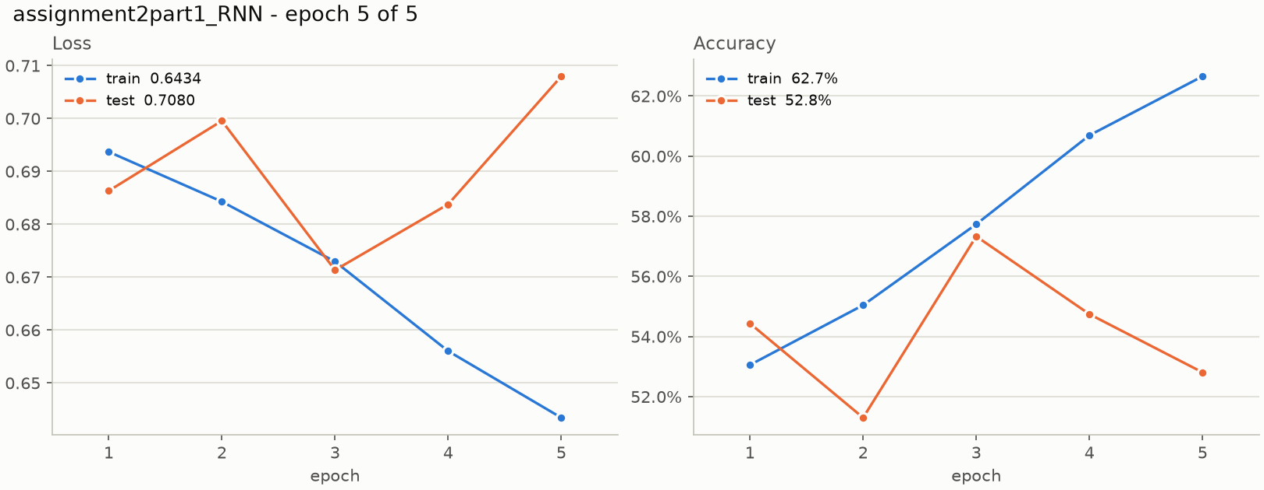
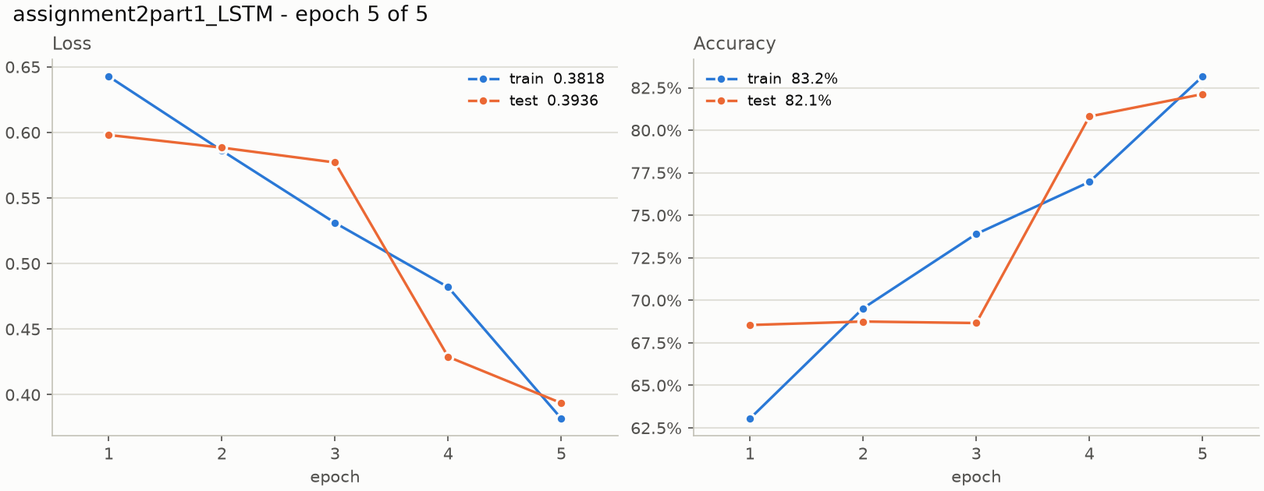
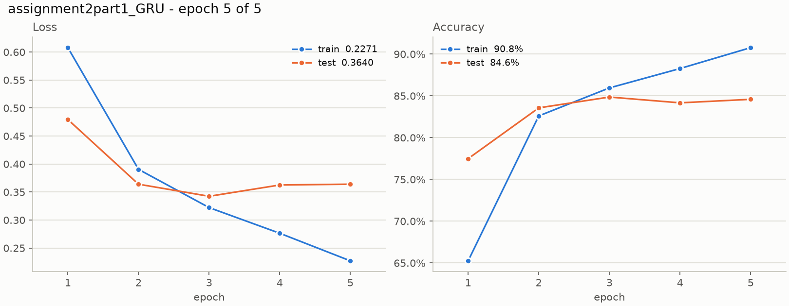
Figure 1. Loss and accuracy per epoch for the RNN, LSTM and GRU (test set scored after each epoch).
The RNN barely learns: training loss only falls from 0.694 to 0.643 and test accuracy bounces around 51–57%. The LSTM sits near 69% for three epochs before jumping to 82%. The GRU learns fastest and its test loss is lowest at epoch 3 (0.342) then drifts up while training loss keeps falling, which is mild overfitting.

Evaluation results
Model | Accuracy | Precision | Recall | F1 | TN / FP | FN / TP
RNN | 52.8% | 51.6% | 92.1% | 66.1% | 1,694 / 10,806 | 992 / 11,508
LSTM | 82.1% | 87.0% | 75.5% | 80.9% | 11,094 / 1,406 | 3,063 / 9,437
GRU | 84.6% | 82.6% | 87.6% | 85.0% | 10,200 / 2,300 | 1,553 / 10,947
Table 1. Test results, 25,000 reviews (positive = class 1). TN, FP, FN, TP are confusion-matrix counts.
The RNN labels 89.3% of all reviews positive: its recall (92.1%) is high only because it says “positive” almost always, and its precision is near chance. The LSTM is cautious (precision 87.0%, recall 75.5%, 3,063 missed positives). The GRU is the most balanced, with 2,300 false positives and 1,553 false negatives, and the best accuracy and F1.

Embedding size, sequence length and GloVe
The base setting was changed one factor at a time. GloVe (6B, 100 d) vectors initialize the embedding layer, either kept frozen or fine-tuned; words without a vector get a small random one. Table 2 gives test accuracy; the base row repeats the base setting with three seeds. Full precision, recall and F1 values are in the appendix.
Setting | RNN | LSTM | GRU
Base (mean of 3 seeds; range) | 63.8% (58.1%–70.0%) | 84.0% (83.8%–84.3%) | 84.6% (84.2%–84.9%)
Embedding 50 d | 55.2% | 82.2% | 84.6%
Embedding 200 d | 60.9% | 82.2% | 84.5%
Length 100 | 52.7% | 80.0% | 79.9%
Length 400 | 54.3% | 82.4% | 87.0%
Vocabulary 10,000 | 61.4% | 85.2% | 84.9%
GloVe frozen | 51.4% | 82.2% | 84.2%
GloVe fine-tuned | 58.0% | 85.3% | 85.6%
10k + GloVe frozen | 58.3% | 84.8% | 84.7%
10k + GloVe fine-tuned | 66.8% | 85.3% | 83.5%
Table 2. Test accuracy by setting (embedding 100 d, length 200, vocabulary 1,000 unless stated).
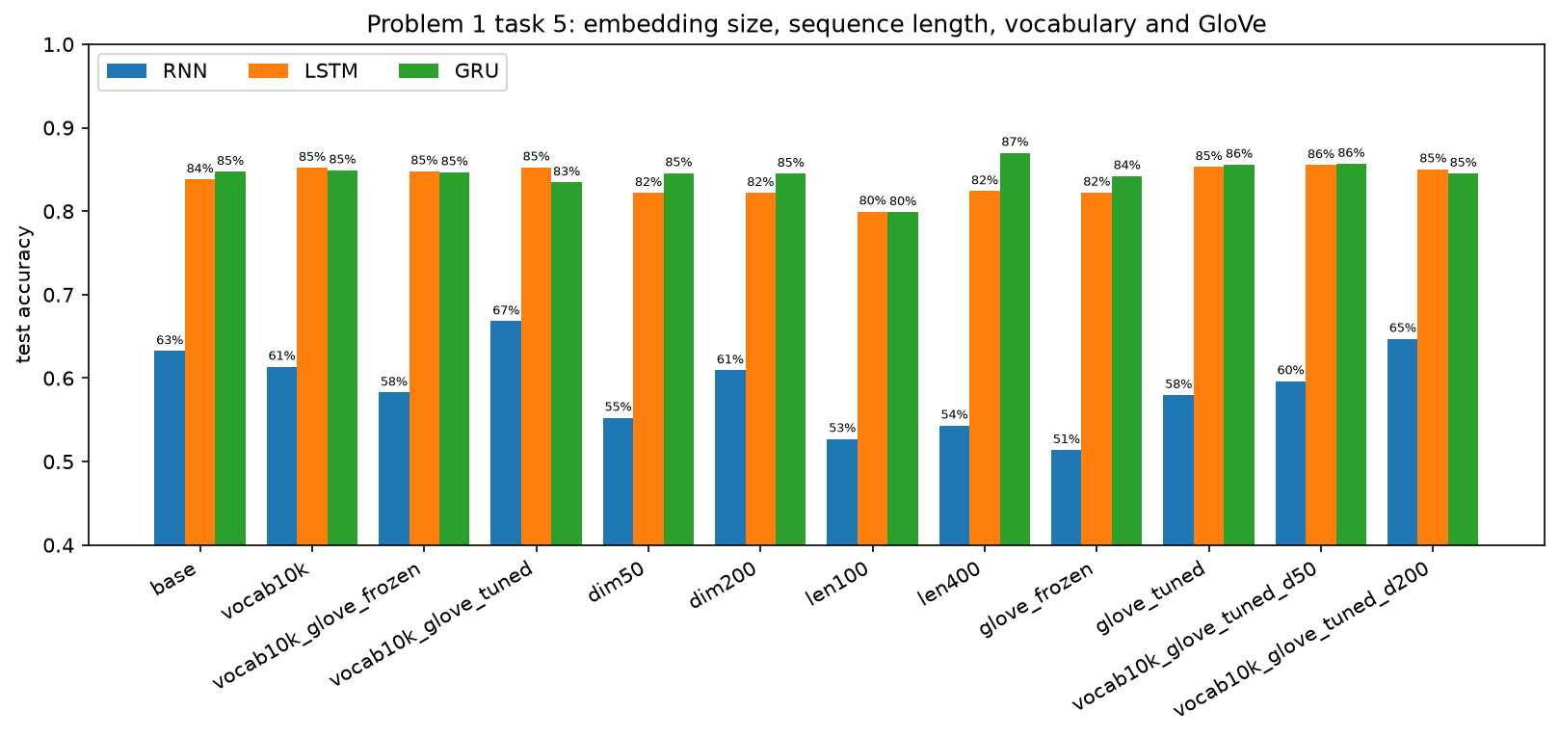
Figure 2. Test accuracy of every setting.
- Embedding size: 50, 100 and 200 dimensions give almost the same result for the LSTM (82.2%, 83.8%, 82.2%) and the GRU (84.6%, 84.7%, 84.5%).
- Sequence length: 100 tokens loses roughly 4 points for both (80.0% LSTM, 79.9% GRU). 400 tokens helps the GRU most (87.0%, the best single run) but not the LSTM (82.4%), and doubles training time.
- GloVe: frozen vectors do not beat embeddings learned from scratch. Fine-tuned GloVe helps at a 1,000-word vocabulary (LSTM 85.3%, GRU 85.6%, up 1–1.5 points) and gives no gain at 10,000 words. The RNN stays far behind in every case.

Discussion and future improvements
Gating matters most. The simple RNN reaches only 63.8% (58.1%–70.0%) over three seeds, a range of 12 points, so it is both weak and unstable. The LSTM and GRU reach 84.0% (83.8%–84.3%) and 84.6% (84.2%–84.9%). The GRU is ahead of the LSTM in most settings with a 1,000-word vocabulary but not with 10,000 words, and gaps of about one point are within noise.
Why GloVe helps so little. The 25,000 training reviews are enough to learn good embeddings for common words, and GloVe is trained for word similarity, not polarity, so “good” and “bad” are close together. Fine-tuning lets the model correct this.
Limitations. The test set was scored after every epoch (no validation split). Most settings were run once; two runs of the same LSTM base setting and seed gave 82.1% and 83.8% likely because GPU training is not fully repeatable, so differences under about 1.5 points should not be over-read. Only the first 200 tokens of a review are kept.
Future work. Add a validation split with early stopping; use gradient clipping, bidirectional or stacked layers and attention; use 300 d GloVe with a 20,000-word vocabulary; keep the last tokens of long reviews or pack sequences instead of truncating; average more seeds; and try a pre-trained transformer.

Appendix: all runs (not part of the word count)
Run | Embedding | Vocab | Dim | Len | Acc | Prec | Rec | F1
RNN base | random | 1000 | 100 | 200 | 0.632 | 0.630 | 0.642 | 0.636
LSTM base | random | 1000 | 100 | 200 | 0.838 | 0.816 | 0.872 | 0.843
GRU base | random | 1000 | 100 | 200 | 0.847 | 0.818 | 0.893 | 0.854
RNN base seed1 | random | 1000 | 100 | 200 | 0.581 | 0.558 | 0.784 | 0.652
LSTM base seed1 | random | 1000 | 100 | 200 | 0.838 | 0.819 | 0.868 | 0.843
GRU base seed1 | random | 1000 | 100 | 200 | 0.842 | 0.876 | 0.798 | 0.835
RNN base seed2 | random | 1000 | 100 | 200 | 0.700 | 0.736 | 0.624 | 0.675
LSTM base seed2 | random | 1000 | 100 | 200 | 0.843 | 0.814 | 0.888 | 0.849
GRU base seed2 | random | 1000 | 100 | 200 | 0.849 | 0.836 | 0.867 | 0.851
RNN dim50 | random | 1000 | 50 | 200 | 0.552 | 0.544 | 0.653 | 0.593
LSTM dim50 | random | 1000 | 50 | 200 | 0.822 | 0.812 | 0.838 | 0.825
GRU dim50 | random | 1000 | 50 | 200 | 0.846 | 0.809 | 0.906 | 0.854
RNN dim200 | random | 1000 | 200 | 200 | 0.609 | 0.584 | 0.756 | 0.659
LSTM dim200 | random | 1000 | 200 | 200 | 0.822 | 0.809 | 0.843 | 0.826
GRU dim200 | random | 1000 | 200 | 200 | 0.845 | 0.835 | 0.860 | 0.847
RNN len100 | random | 1000 | 100 | 100 | 0.527 | 0.515 | 0.950 | 0.668
LSTM len100 | random | 1000 | 100 | 100 | 0.800 | 0.781 | 0.833 | 0.806
GRU len100 | random | 1000 | 100 | 100 | 0.799 | 0.778 | 0.836 | 0.806
RNN len400 | random | 1000 | 100 | 400 | 0.543 | 0.526 | 0.865 | 0.654
LSTM len400 | random | 1000 | 100 | 400 | 0.824 | 0.801 | 0.862 | 0.830
GRU len400 | random | 1000 | 100 | 400 | 0.870 | 0.849 | 0.901 | 0.874
RNN vocab10k | random | 10000 | 100 | 200 | 0.614 | 0.605 | 0.656 | 0.629
LSTM vocab10k | random | 10000 | 100 | 200 | 0.852 | 0.837 | 0.875 | 0.855
GRU vocab10k | random | 10000 | 100 | 200 | 0.849 | 0.894 | 0.792 | 0.840
RNN glove frozen | GloVe frozen | 1000 | 100 | 200 | 0.514 | 0.507 | 0.991 | 0.671
LSTM glove frozen | GloVe frozen | 1000 | 100 | 200 | 0.822 | 0.795 | 0.870 | 0.830
GRU glove frozen | GloVe frozen | 1000 | 100 | 200 | 0.842 | 0.816 | 0.884 | 0.848
RNN glove tuned | GloVe fine-tuned | 1000 | 100 | 200 | 0.580 | 0.544 | 0.983 | 0.701
LSTM glove tuned | GloVe fine-tuned | 1000 | 100 | 200 | 0.853 | 0.831 | 0.886 | 0.858
GRU glove tuned | GloVe fine-tuned | 1000 | 100 | 200 | 0.856 | 0.832 | 0.891 | 0.861
RNN vocab10k glove frozen | GloVe frozen | 10000 | 100 | 200 | 0.583 | 0.565 | 0.715 | 0.631
LSTM vocab10k glove frozen | GloVe frozen | 10000 | 100 | 200 | 0.848 | 0.861 | 0.830 | 0.845
GRU vocab10k glove frozen | GloVe frozen | 10000 | 100 | 200 | 0.847 | 0.913 | 0.767 | 0.833
RNN vocab10k glove tuned | GloVe fine-tuned | 10000 | 100 | 200 | 0.668 | 0.668 | 0.670 | 0.669
LSTM vocab10k glove tuned | GloVe fine-tuned | 10000 | 100 | 200 | 0.853 | 0.862 | 0.839 | 0.851
GRU vocab10k glove tuned | GloVe fine-tuned | 10000 | 100 | 200 | 0.835 | 0.889 | 0.764 | 0.822
RNN vocab10k glove tuned d50 | GloVe fine-tuned | 10000 | 50 | 200 | 0.596 | 0.574 | 0.752 | 0.651
LSTM vocab10k glove tuned d50 | GloVe fine-tuned | 10000 | 50 | 200 | 0.855 | 0.835 | 0.886 | 0.860
GRU vocab10k glove tuned d50 | GloVe fine-tuned | 10000 | 50 | 200 | 0.857 | 0.862 | 0.849 | 0.856
RNN vocab10k glove tuned d200 | GloVe fine-tuned | 10000 | 200 | 200 | 0.647 | 0.638 | 0.680 | 0.658
LSTM vocab10k glove tuned d200 | GloVe fine-tuned | 10000 | 200 | 200 | 0.850 | 0.862 | 0.834 | 0.848
GRU vocab10k glove tuned d200 | GloVe fine-tuned | 10000 | 200 | 200 | 0.845 | 0.857 | 0.829 | 0.843

Training log of the base run
Epoch 1/5 train loss 0.6937 acc 53.1% | test loss 0.6863 acc 54.4%
Epoch 2/5 train loss 0.6843 acc 55.0% | test loss 0.6996 acc 51.3%
Epoch 3/5 train loss 0.6730 acc 57.7% | test loss 0.6713 acc 57.3%
Epoch 4/5 train loss 0.6560 acc 60.7% | test loss 0.6838 acc 54.7%
Epoch 5/5 train loss 0.6434 acc 62.7% | test loss 0.7080 acc 52.8%
assignment2part1_RNN test: loss 0.7080 acc 0.5281 precision 0.5157 recall 0.9206 F1 0.6611 (binary)
Epoch 1/5 train loss 0.6427 acc 63.0% | test loss 0.5981 acc 68.5%
Epoch 2/5 train loss 0.5861 acc 69.5% | test loss 0.5884 acc 68.8%
Epoch 3/5 train loss 0.5311 acc 73.9% | test loss 0.5771 acc 68.7%
Epoch 4/5 train loss 0.4820 acc 77.0% | test loss 0.4289 acc 80.8%
Epoch 5/5 train loss 0.3818 acc 83.2% | test loss 0.3936 acc 82.1%
assignment2part1_LSTM test: loss 0.3936 acc 0.8212 precision 0.8703 recall 0.7550 F1 0.8086 (binary)
Epoch 1/5 train loss 0.6078 acc 65.3% | test loss 0.4795 acc 77.5%
Epoch 2/5 train loss 0.3905 acc 82.6% | test loss 0.3640 acc 83.6%
Epoch 3/5 train loss 0.3222 acc 86.0% | test loss 0.3424 acc 84.9%
Epoch 4/5 train loss 0.2764 acc 88.3% | test loss 0.3626 acc 84.2%
Epoch 5/5 train loss 0.2271 acc 90.8% | test loss 0.3640 acc 84.6%
assignment2part1_GRU test: loss 0.3640 acc 0.8459 precision 0.8264 recall 0.8758 F1 0.8504 (binary)
Model | Acc | Prec | Rec | F1
RNN | 0.5281 | 0.5157 | 0.9206 | 0.6611
LSTM | 0.8212 | 0.8703 | 0.7550 | 0.8086
GRU | 0.8459 | 0.8264 | 0.8758 | 0.8504

