Assignment 2
Boris Bojanov · Student ID 3608550 · Part 2, Problem 2: Word Sense Disambiguation on SemCor

Introduction
A word such as “bank” has several meanings, and only its context says which one is meant. This problem builds a system that, given a sentence and a target word, picks the correct WordNet sense. A bidirectional LSTM trained from scratch and a fine-tuned BERT are compared with a no-context baseline, and a small program prints the predicted sense with its gloss and example for any sentence the user types.

Preprocessing
- Target words (22): bank, bat and charge (required) plus line, play, run, head, hand, point, case, interest, state, power, plant, party, field, fence, light, face, place, work and book, added so the test set is large enough to compare models.
- Extraction: each occurrence of a target lemma in sense-tagged SemCor (via NLTK) is one example with lowercased tokens, the target’s position and its WordNet synset: 3,606 examples.
- Split: by sentence (id mod 5 = 0 is test), so no sentence is in both sets: 2,851 train and 755 test.
- Lemmatization: unnecessary for training because SemCor stores the target lemma; typed demo words use WordNet’s morphy. Stop words and punctuation were kept because words like “in” and “of” help separate senses.
- Senses: WordNet gives every sense of each target word (550 in total) with gloss and examples; a mask limits each word to its own senses.
- Inputs: the LSTM sees ±10 words around the target (5,000-word vocabulary from training data); BERT sees ±25 words with the target in quotes, paired with a gloss.

Model architecture and rationale
BiLSTM. Embedding(5000, 100) → bidirectional LSTM(128) → hidden state at the target position → Linear(256, 550). Logits of senses outside the target word are masked, and training uses cross-entropy with Adam (lr 0.001, batch 32, 5 epochs). The target-position state is used rather than the last state (Problem 1) because the sense depends on words on both sides.
BERT gloss-pair (GlossBERT/WiC style). bert-base-uncased plus a Linear(768, 1) layer on [CLS]. Input: “[CLS] sentence with the target in quotes [SEP] word : gloss [SEP]”; output: one match score. Each example yields its correct gloss (label 1) and four wrong glosses of the same word (label 0); training uses binary cross-entropy and AdamW (lr 2×10⁻⁵, batch 32, 3 epochs). At prediction time all glosses of the word are scored and the best wins.
Rationale. The LSTM has one output per sense, so it learns only senses seen in training and never reads a gloss. BERT scores sentence–gloss pairs, so it can rank any WordNet sense and brings pre-trained language knowledge.

Training curves
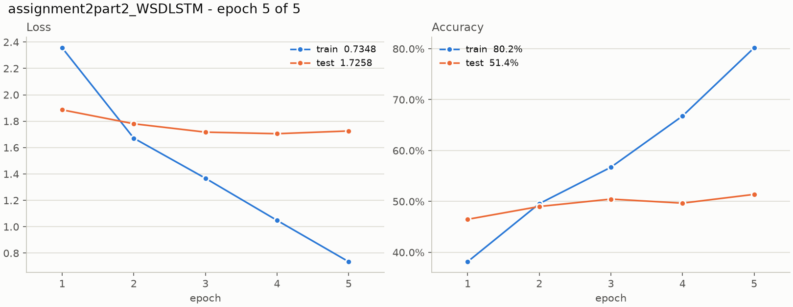 | 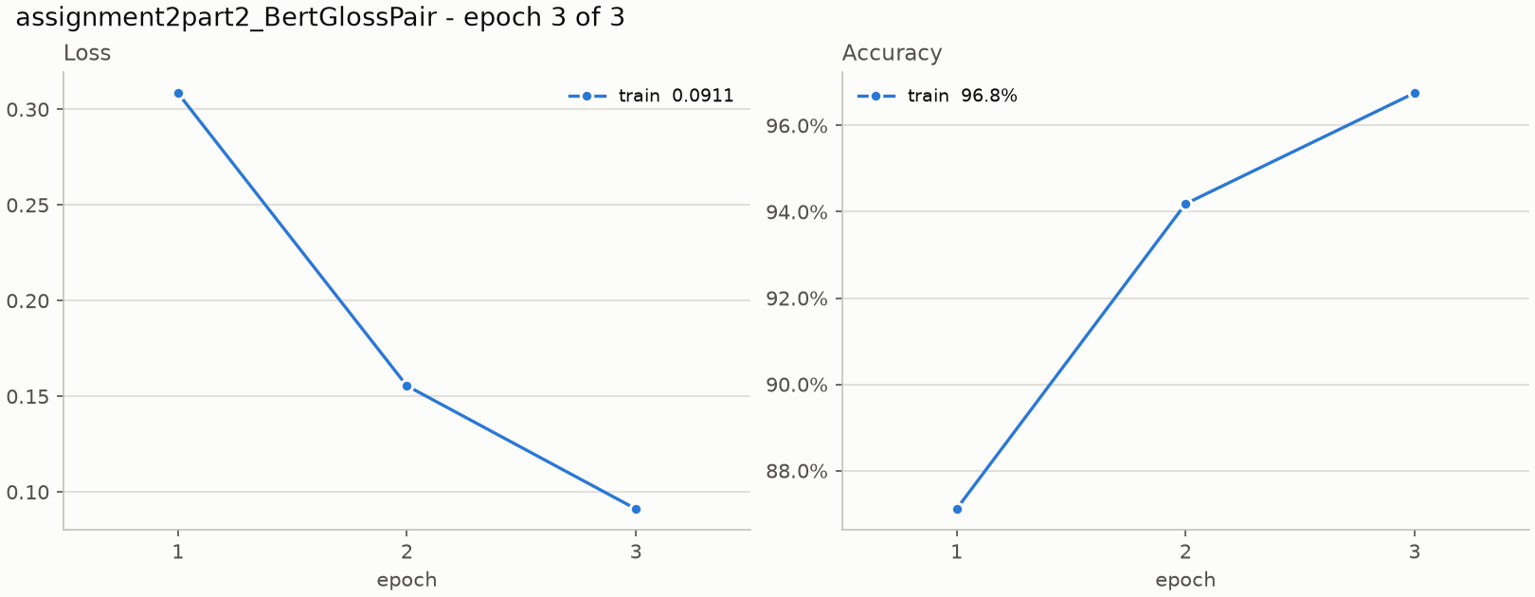
Figure 1. Loss and accuracy per epoch: BiLSTM (left), BERT training only (right).
The LSTM’s training accuracy reaches 80.2% while test accuracy stays near 51% and test loss stops falling after epoch 4 (1.705 → 1.726): it memorizes the training windows. BERT’s 96.8% is inflated by easy negatives (four of five pairs), so the sense-level results below are the fair measure.

Evaluation results
Because SemCor is dominated by each word’s first sense, accuracy alone can flatter a model that ignores context. Table 1 therefore adds macro precision, recall and F1 over the senses that occur, and a most-frequent-sense (MFS) baseline.
Model | Accuracy | Precision | Recall | F1
MFS baseline | 0.396 | 0.056 | 0.121 | 0.073
BiLSTM (from scratch) | 0.514 | 0.204 | 0.224 | 0.200
BERT gloss-pair | 0.690 | 0.385 | 0.414 | 0.382
Table 1. Test results, 755 examples (macro averages).
BERT beats the LSTM by 17.6 accuracy points and the baseline by 29.4. Macro scores are low for all models because many of the 550 senses have only one or two test examples, so each miss zeroes a whole class.
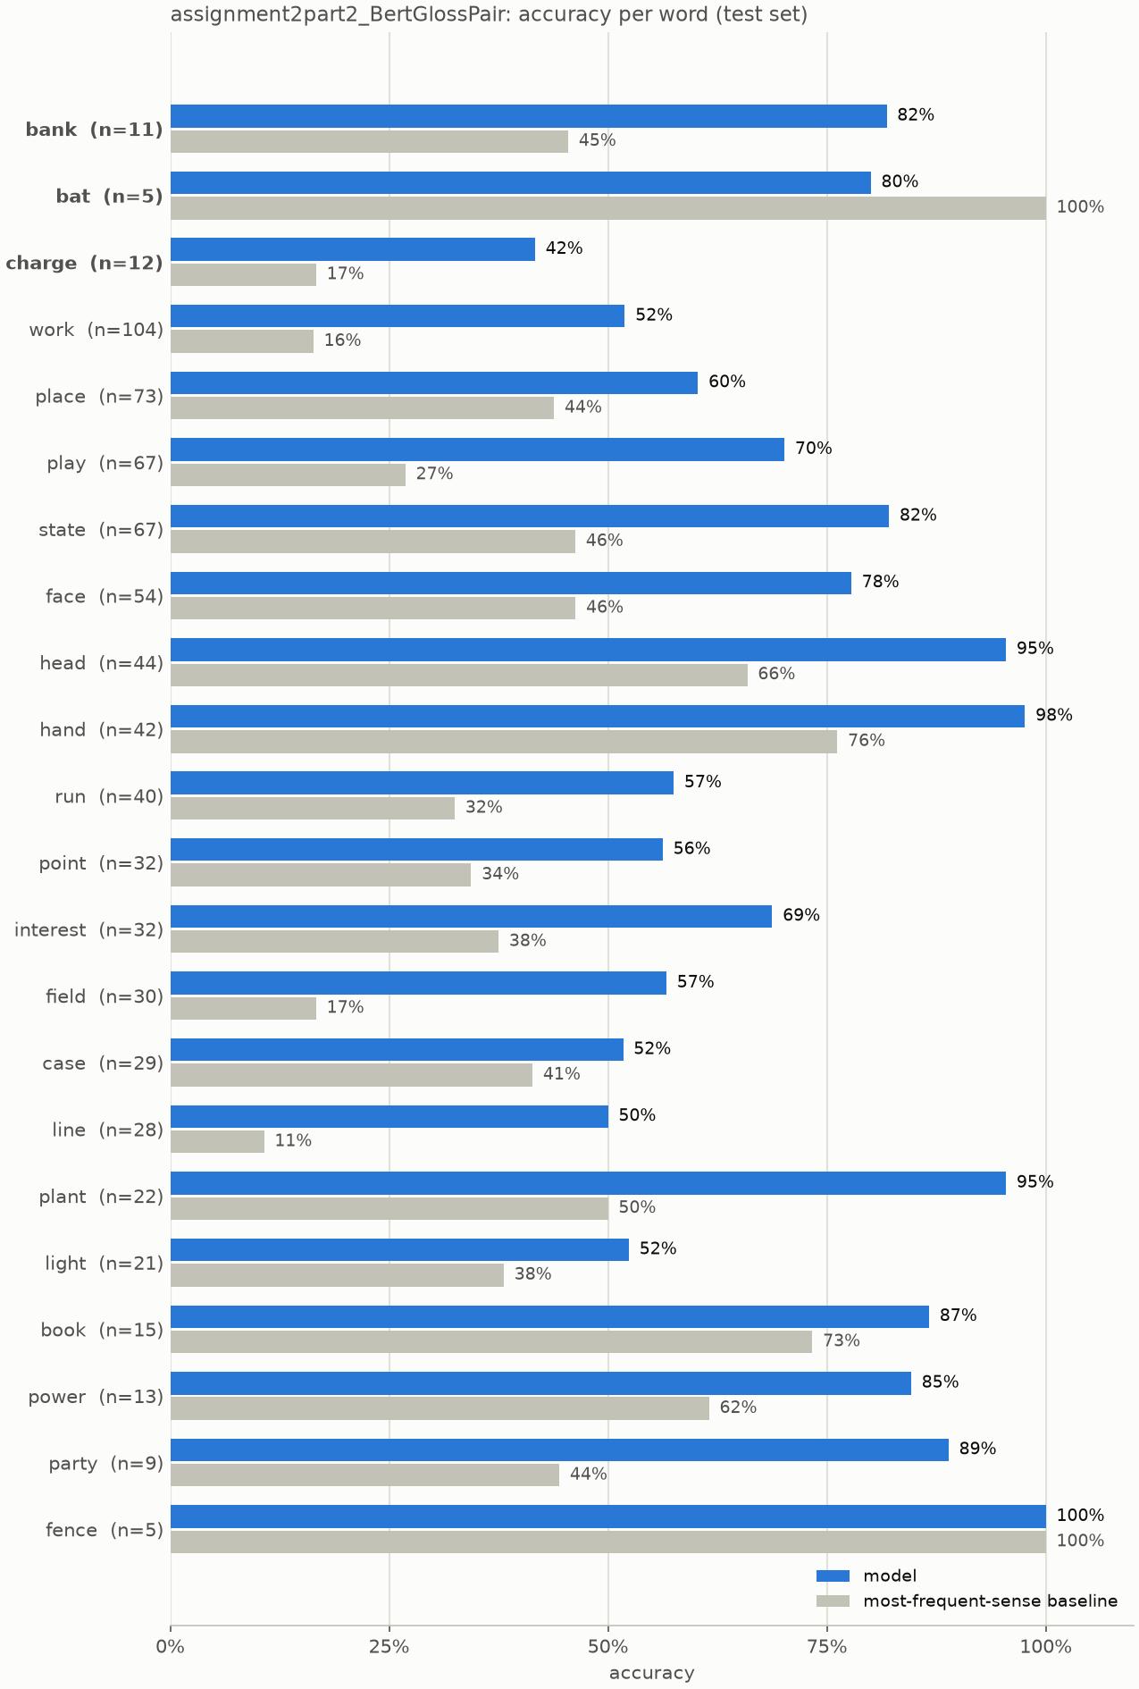
Figure 2. BERT accuracy per word against the baseline.
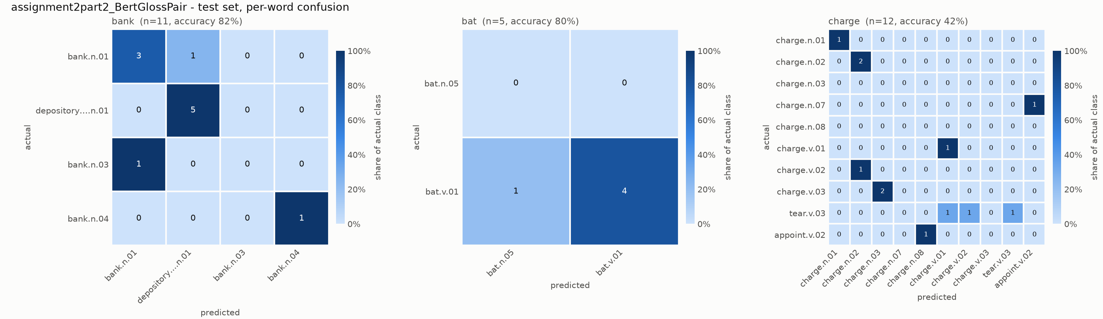
Figure 3. BERT confusion matrices for bank, bat and charge.
BERT is best on “hand” (97.6%), “head” and “plant” (95.5%). On “charge” (eight senses in the test set) the LSTM scores 0.0% and BERT 41.7%. “Bat” has one test sense (the verb, five examples), so the baseline scores 100% and BERT 80%.

Discussion and future improvements
Observations. The LSTM learns word associations from about 2,900 examples and overfits; on “bank” it only matches the baseline (45.5%) and on “charge” it does worse. BERT already knows how words are used and reads the gloss, so it can score senses with few or no training examples. On “bank” it errs twice in eleven: one river-bank example read as financial, and one “ridge or pile” example read as river-bank (Figure 3).
Demo. For “I love feeling the wind in my face” both models choose face.n.01 (99% and 97% confident). For “What is the best bat for baseball?” the right sense is the club, bat.n.05. BERT chooses it, but with only 50% confidence, tied with the verb bat.v.04. The LSTM answers the verb bat.v.01 (45%), the only “bat” sense in the SemCor test examples, so it appears to follow the corpus rather than the sentence.
Limitations. 755 test examples, one seed, and no separate validation set (the “test” curve is the final test set).
Future work. GloVe-initialized LSTM with dropout and early stopping; more target words or all of SemCor; hard negatives (sibling senses) re-drawn each epoch; a validation split with several seeds; WordNet examples as extra training pairs.

Appendix: raw output (not part of the word count)

Training log
WSDLSTM (5 epochs, Adam lr 0.001)
Epoch 1/5 train loss 2.3563 acc 38.2% | test loss 1.8861 acc 46.5%
Epoch 2/5 train loss 1.6713 acc 49.6% | test loss 1.7804 acc 49.0%
Epoch 3/5 train loss 1.3675 acc 56.7% | test loss 1.7171 acc 50.5%
Epoch 4/5 train loss 1.0481 acc 66.8% | test loss 1.7052 acc 49.7%
Epoch 5/5 train loss 0.7348 acc 80.2% | test loss 1.7258 acc 51.4%

BertGlossPair (3 epochs, AdamW lr 2e-5; pair-level numbers)
Epoch 1/3 train loss 0.3085 acc 87.1%
Epoch 2/3 train loss 0.1555 acc 94.2%
Epoch 3/3 train loss 0.0911 acc 96.8%

Per-word test results (accuracy; baseline = most frequent sense)
Word | n | Senses in test | LSTM acc | BERT acc | Baseline
bank | 11 | 4 | 0.455 | 0.818 | 0.455
bat | 5 | 1 | 0.800 | 0.800 | 1.000
charge | 12 | 8 | 0.000 | 0.417 | 0.167
line | 28 | 12 | 0.214 | 0.500 | 0.107
play | 67 | 16 | 0.343 | 0.701 | 0.269
run | 40 | 20 | 0.275 | 0.575 | 0.325
head | 44 | 6 | 0.864 | 0.955 | 0.659
hand | 42 | 4 | 0.905 | 0.976 | 0.762
point | 32 | 9 | 0.500 | 0.562 | 0.344
case | 29 | 8 | 0.517 | 0.517 | 0.414
interest | 32 | 6 | 0.531 | 0.688 | 0.375
state | 67 | 7 | 0.731 | 0.821 | 0.463
power | 13 | 5 | 0.769 | 0.846 | 0.615
plant | 22 | 4 | 0.636 | 0.955 | 0.500
party | 9 | 4 | 0.333 | 0.889 | 0.444
field | 30 | 10 | 0.333 | 0.567 | 0.167
fence | 5 | 1 | 1.000 | 1.000 | 1.000
light | 21 | 13 | 0.429 | 0.524 | 0.381
face | 54 | 7 | 0.611 | 0.778 | 0.463
place | 73 | 19 | 0.521 | 0.603 | 0.438
work | 104 | 16 | 0.337 | 0.519 | 0.163
book | 15 | 3 | 0.600 | 0.867 | 0.733

Interactive demo output
Sentence: I love feeling the wind in my face Target word: face
'face' -> lemma 'face', 22 WordNet senses
BERT: face.n.01 (99% confident)
gloss : the front of the human head from the forehead to the chin and ear to ear
example : he washed his face
LSTM: face.n.01 (97% confident)

Sentence: What is the best bat for baseball? Target word: bat
'bat' -> lemma 'bat', 10 WordNet senses
BERT: bat.n.05 (50% confident)
gloss : a club used for hitting a ball in various games
example : (WordNet has no example sentence for this sense)
also : bat.v.04 (50%) - use a bat
LSTM: bat.v.01 (45% confident)
gloss : strike with, or as if with a baseball bat
example : bat the ball

