Assignment 2 REPORT
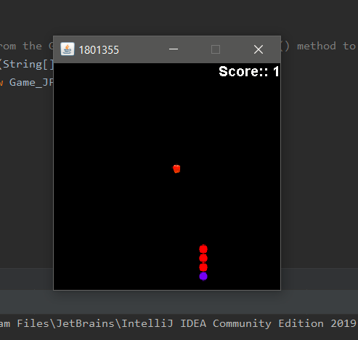
- Your user interface should be run as an application in which shapes objects(s) can be moved / rotated either in a 2D pane or fixed grid of filled squares.
I decided to use images instead of squares.

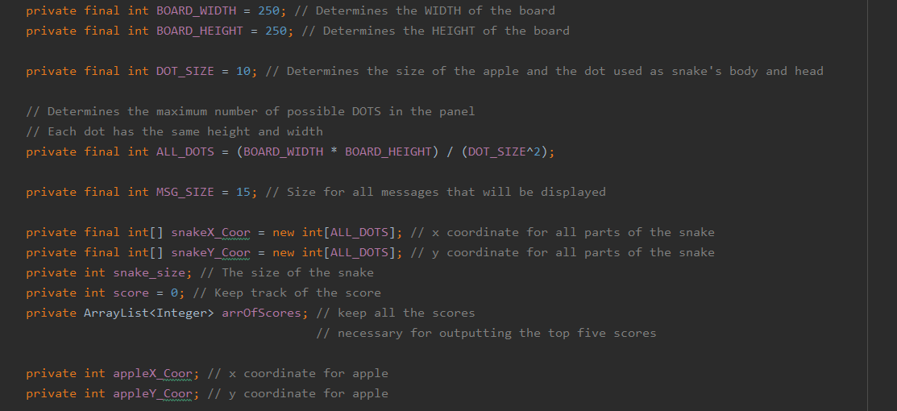
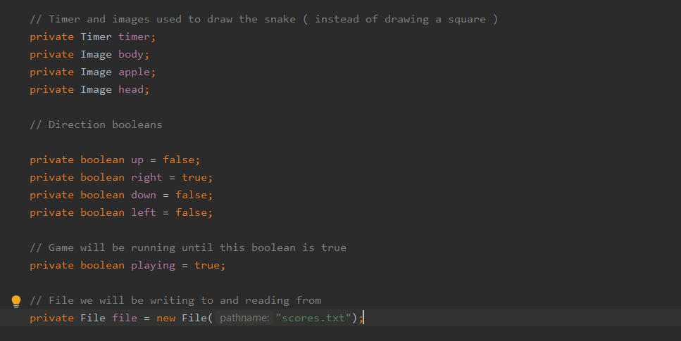
Those are all global variables. On each of them it is described what it is doing.
- All the data is encapsulated
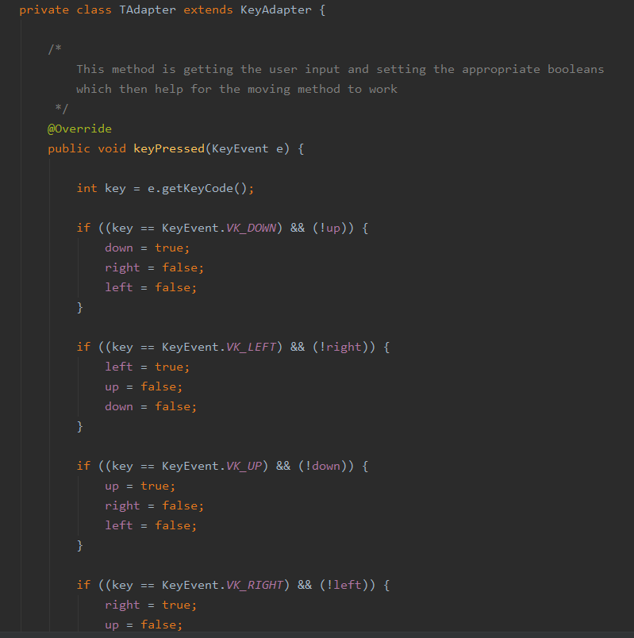
C) There is an event class handling when the user is pressing arrows.
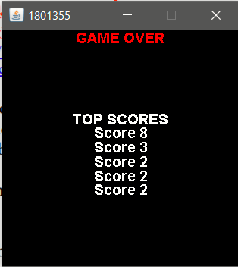
D) Keep scores of top 5 players.
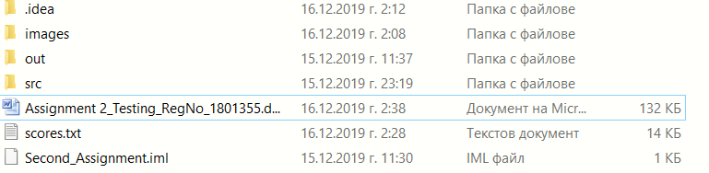
E) Make a report


F) The program is not simply putted within a single class. It has three classes one for the panel, the frame and the launcher of the program.

