Retail Image Set QA Report
Verification date: July 3, 2026 | Constraint: PHP CLI memory_limit=128M | Result: all 7 images passed

Summary
This report verifies the seven retail fixture images against the library's public APIs and the repository's expected retail outputs. Each image was tested individually, the path-based and file-handle-based results were compared, and the returned color distributions were checked against the visible artwork.
The requested directory qa_reports/assets/2026-07-03-retail-set was empty in this workspace. The matching retail fixtures present under tests/Fixtures/real/retail were used as the authoritative seven-image set.

Test Process
The acceptance condition was the repository's constrained retail regression path: composer test -- --filter RetailImageSetMemoryTest. That integration test executes each image with both public APIs under a 128M PHP memory limit and checks for exact expected outputs.
Independent spot verification was also performed by running tests/Support/analyze_retail_fixture.php in path and handle modes for every fixture, confirming exit code 0 and exact agreement with the expected retail color sets.
Visual review confirmed that each output's dominant colors and proportions match the underlying logo or poster composition, with small gray clusters appearing only where antialiasing makes them plausible.

Results Table
Image | Size | Verification | Result
Apache_Jeans_38x45.png | 1077x1276 | Exact expected match in path and handle modes; visual review passed | Pass
Boutique_Klamotte_35_30.png | 993x852 | Exact expected match in path and handle modes; visual review passed | Pass
Coffee_Station_32_33.png | 908x937 | Exact expected match in path and handle modes; visual review passed | Pass
Decathlon_50_55.png | 1419x1561 | Exact expected match in path and handle modes; visual review passed | Pass
E-Wheels_Europe_45_50_All.png | 1276x1417 | Exact expected match in path and handle modes; visual review passed | Pass
STAR_BE_RESTAURANT_GERMANY_32_24.png | 907x681 | Exact expected match in path and handle modes; visual review passed | Pass
Wholefoods_38x41_.png | 1077x1162 | Exact expected match in path and handle modes; visual review passed | Pass

Detailed Image Checks

Apache_Jeans_38x45.png
Verification: Path API matched expected output, handle API matched expected output, and the two APIs matched each other exactly.
Reported colors: #000000 52.3%, #FEFEFE 45.5%, #797A7D 2.2%
Observation: Black-and-white concentric ring artwork. The output is dominated by black and near-white, with a small gray antialiasing remainder, which matches the visible design.

Figure 1. Apache_Jeans_38x45.png (1077x1276)

Boutique_Klamotte_35_30.png
Verification: Path API matched expected output, handle API matched expected output, and the two APIs matched each other exactly.
Reported colors: #FFFFFF 71.0%, #020202 27.0%, #A1A1A1 2.0%
Observation: Large white field with a black wordmark, bee motif, and small black subtitle. The reported white, black, and minor gray split is visually consistent.
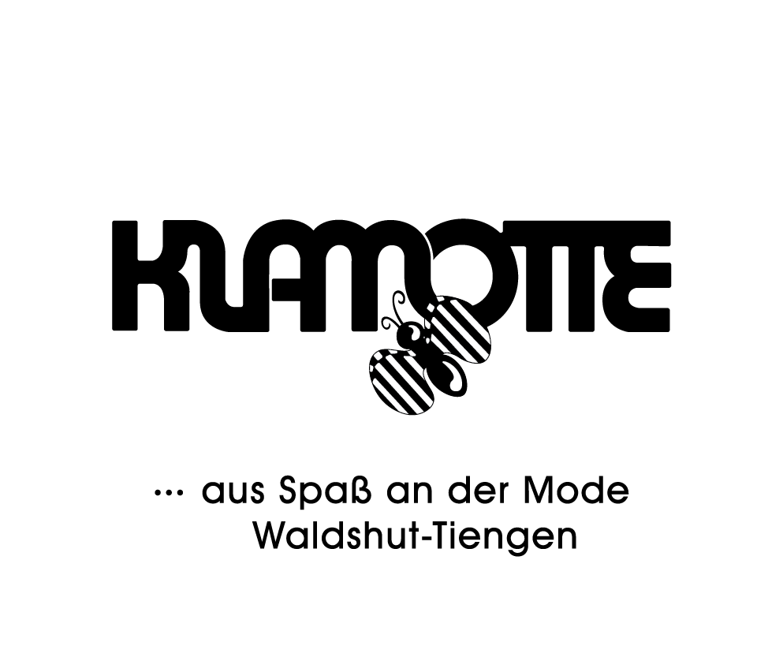
Figure 2. Boutique_Klamotte_35_30.png (993x852)

Coffee_Station_32_33.png
Verification: Path API matched expected output, handle API matched expected output, and the two APIs matched each other exactly.
Reported colors: #FFFFFF 80.6%, #020202 13.4%, #DE4445 3.2%, #8F9092 1.8%, #CAC1C2 1.0%
Observation: Mostly white poster with bold black lettering, a red accent in the steam and the final "ON", and light gray subtitle text. The cluster mix matches the visible artwork.
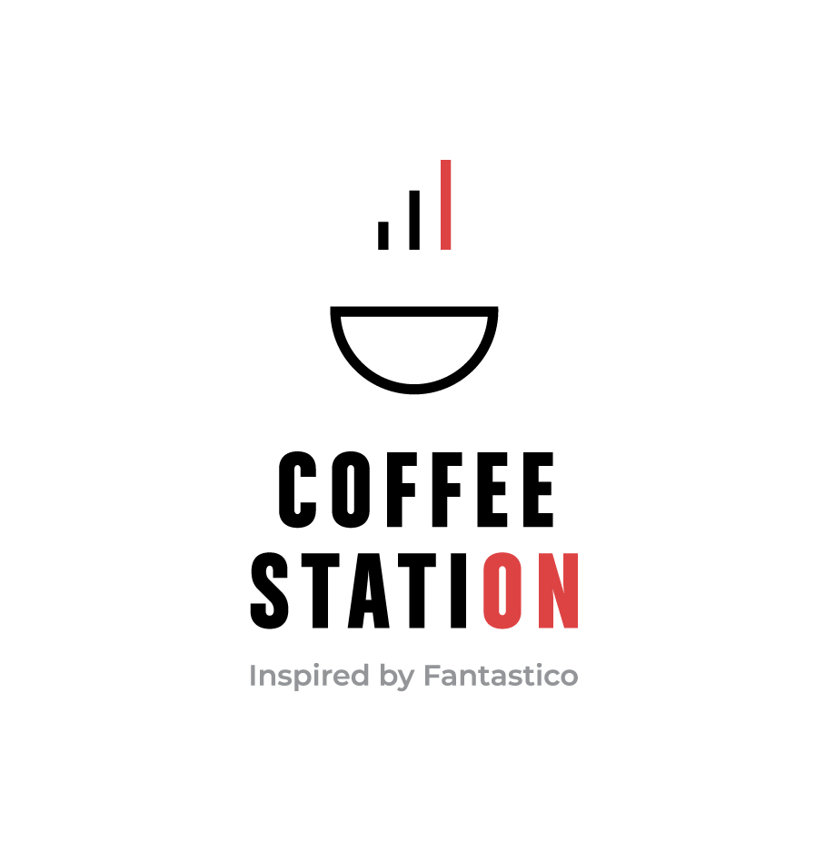
Figure 3. Coffee_Station_32_33.png (908x937)

Decathlon_50_55.png
Verification: Path API matched expected output, handle API matched expected output, and the two APIs matched each other exactly.
Reported colors: #FFFFFF 91.8%, #0B0B0B 8.2%
Observation: Very large white sheet with black logo, wordmark, URL, QR code, and barcode. A two-color result of mostly white plus near-black is correct for this composition.
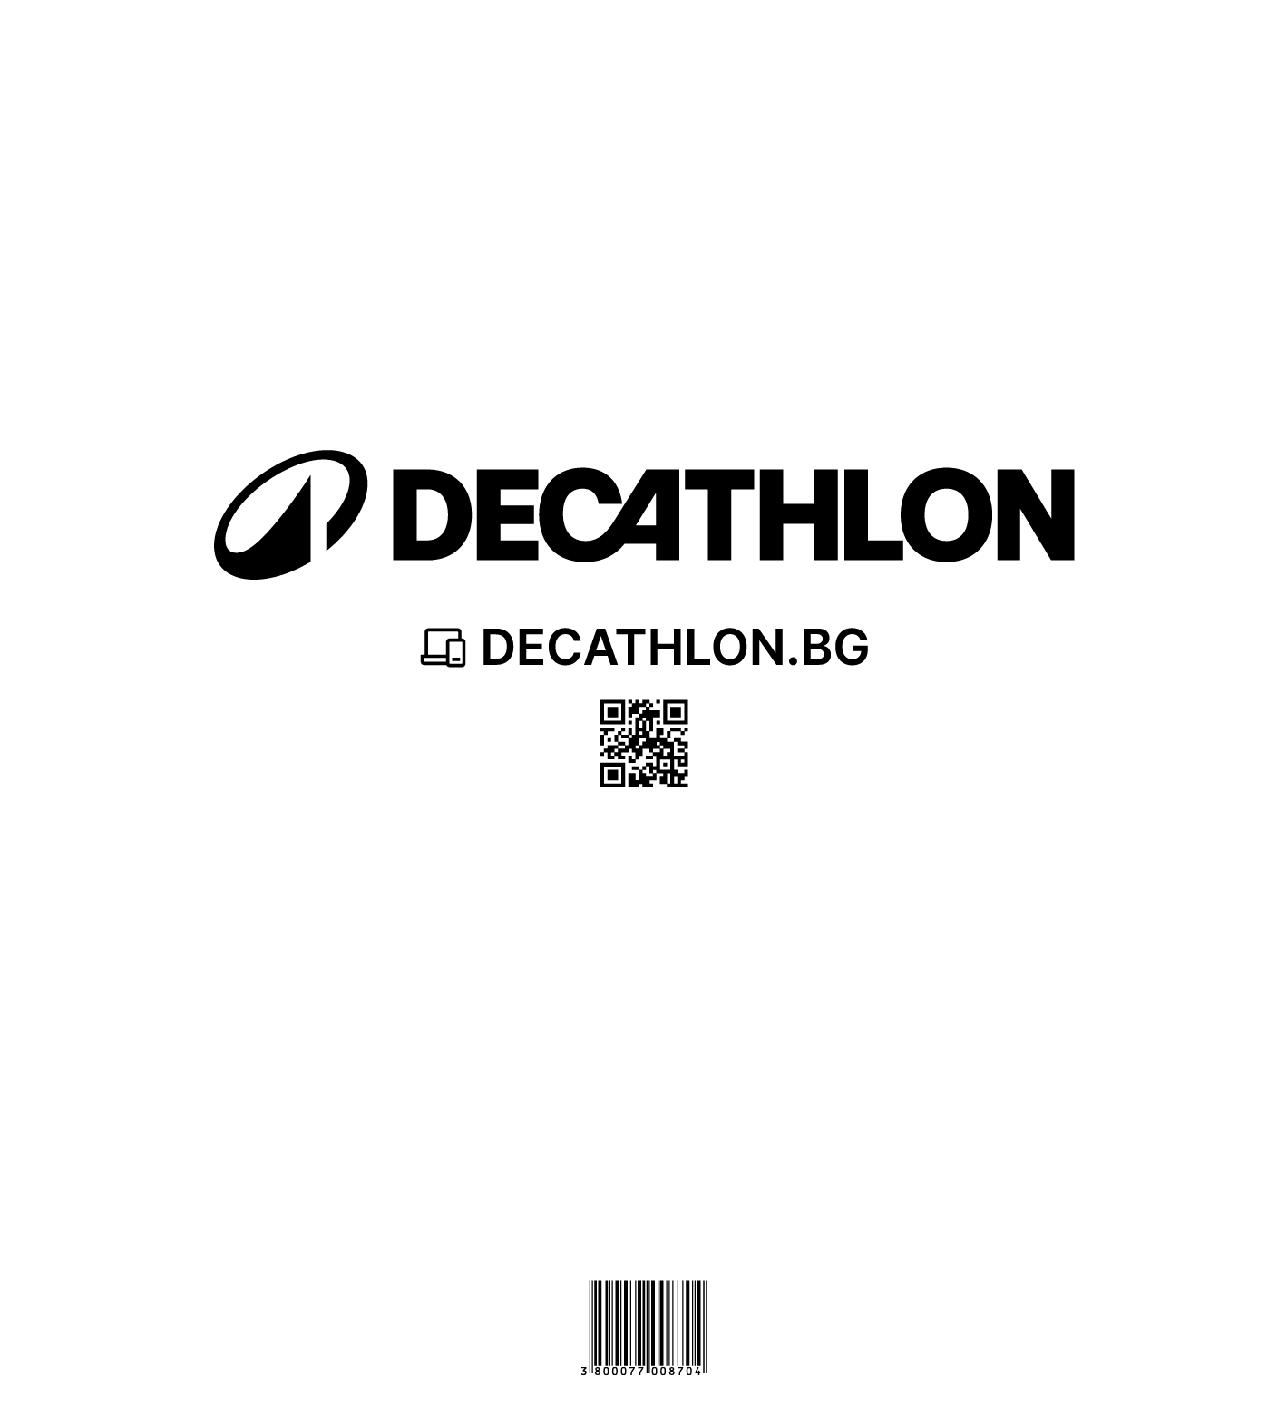
Figure 4. Decathlon_50_55.png (1419x1561)

E-Wheels_Europe_45_50_All.png
Verification: Path API matched expected output, handle API matched expected output, and the two APIs matched each other exactly.
Reported colors: #FFFFFF 80.3%, #131E28 15.2%, #76C6D7 2.3%, #70777D 1.1%, #BDCACF 1.1%
Observation: Repeated dark navy wordmarks and cyan monograms on a white sheet. The dominant white, navy, cyan, and small gray edge clusters match the image well.
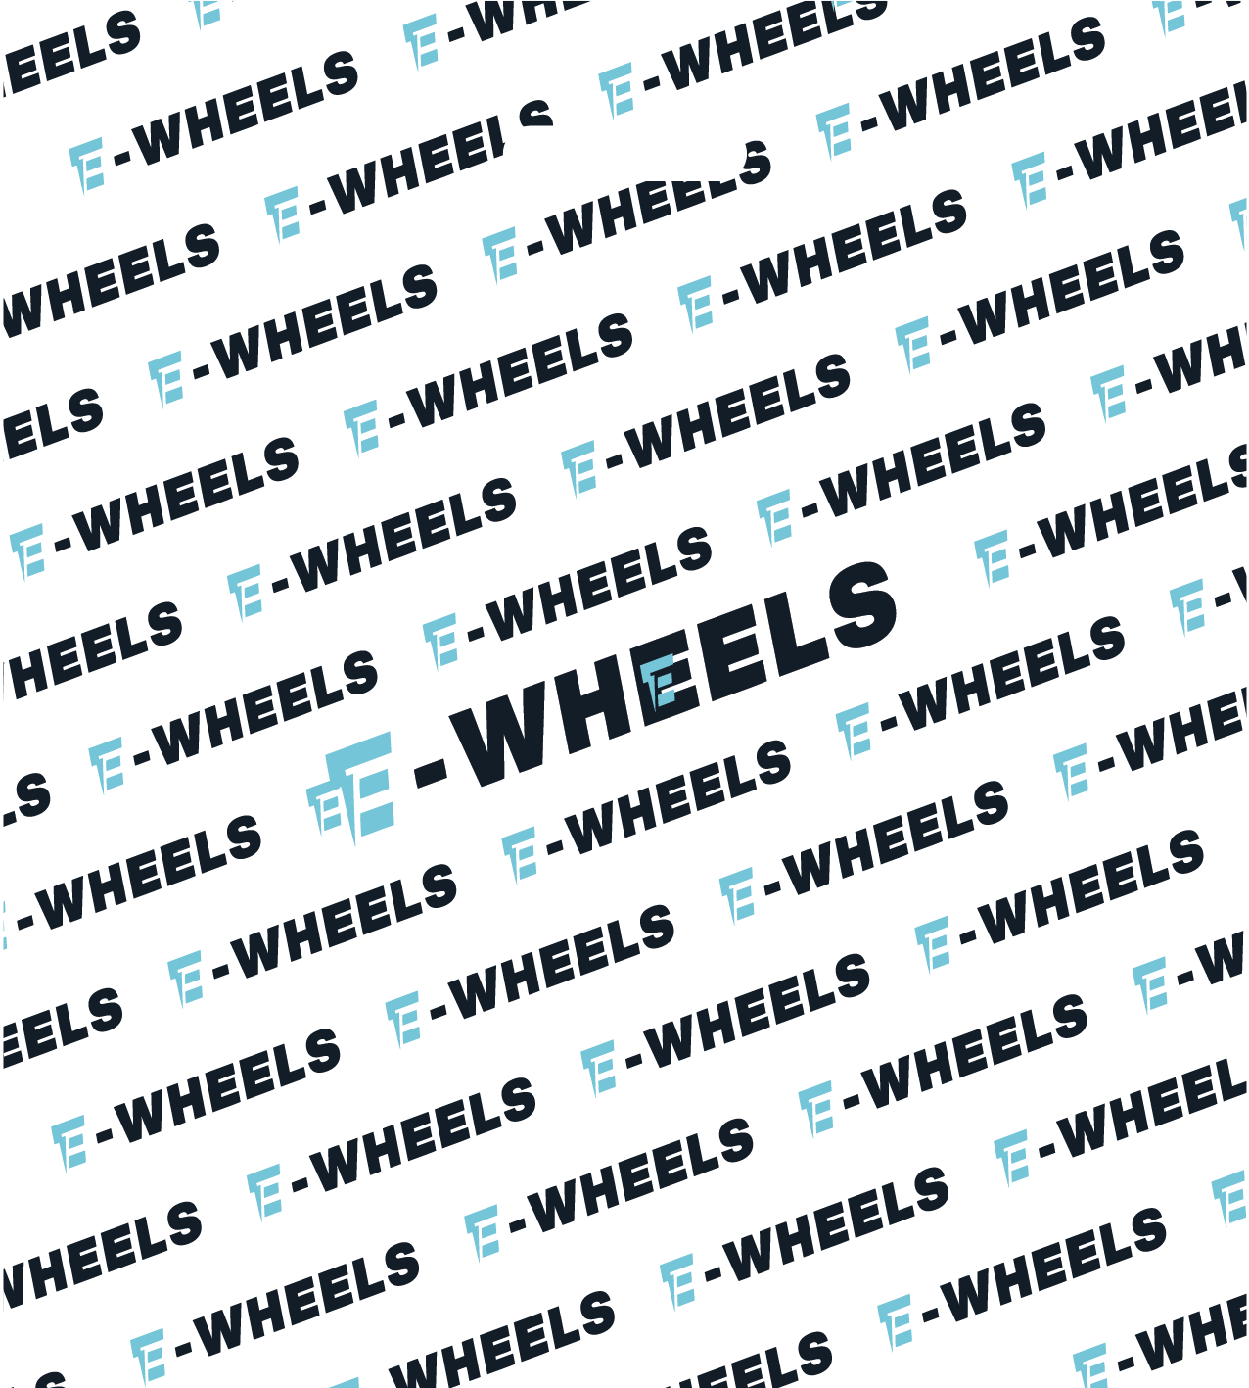
Figure 5. E-Wheels_Europe_45_50_All.png (1276x1417)

STAR_BE_RESTAURANT_GERMANY_32_24.png
Verification: Path API matched expected output, handle API matched expected output, and the two APIs matched each other exactly.
Reported colors: #FFFEFE 83.1%, #C75362 10.9%, #070707 4.9%, #9F9F9F 1.1%
Observation: White background with rose-red logo and banners, black headline and QR code, and minimal gray antialiasing. The reported distribution is clearly correct.
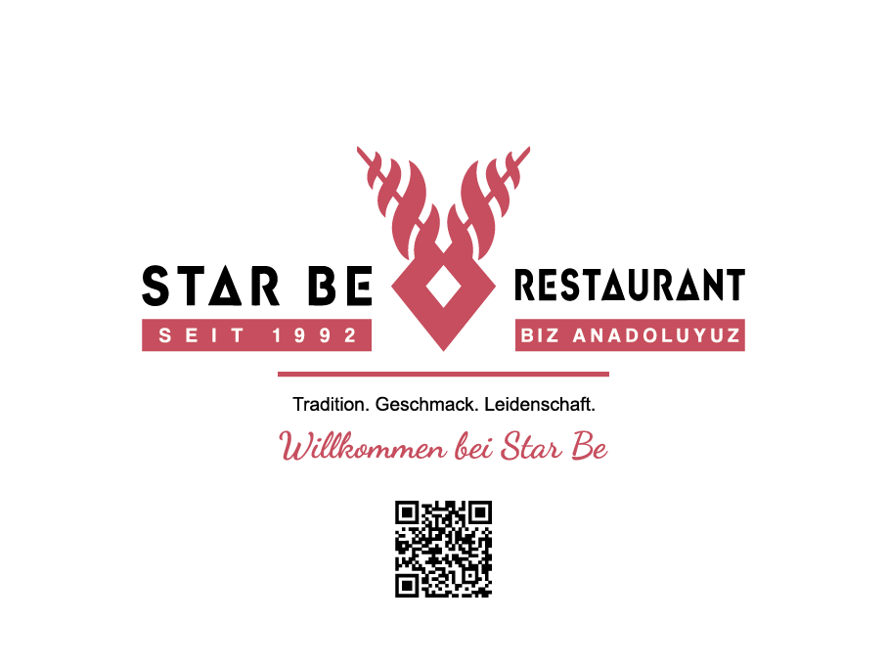
Figure 6. STAR_BE_RESTAURANT_GERMANY_32_24.png (907x681)

Wholefoods_38x41_.png
Verification: Path API matched expected output, handle API matched expected output, and the two APIs matched each other exactly.
Reported colors: #FEFEFE 83.2%, #000000 15.4%, #5E5E5E 1.4%
Observation: White background with black iconography, wordmark, and social marks. The near-white, black, and slight gray output matches the visible edges and text.

Figure 7. Wholefoods_38x41_.png (1077x1162)

Conclusion
All seven retail images passed. The library completed analysis successfully under the 128M runtime constraint, the path and file-handle APIs returned exact expected outputs for every image, and the reported principal colors were visually correct for each embedded fixture.
Based on this image set, the current library implementation works correctly for the evaluated retail fixtures.

