Bulgarian Diploma Thesis

Document Search and Extraction System

Borislav Todorov, #200229922

Student: ________________________ Date: __________
signature

Supervisor: _____________________ Date: __________
signature

Department of Computer Science, AUBG
Blagoevgrad, 2026

Declaration template for Senior Project and Diploma Thesis

Title: Document Search and Extraction System
Author: Borislav Todorov

Abstract: This thesis describes a document search and extraction system written in C++17. The program scans a directory of office files (PDF, DOCX, XLSX, TXT), reads each one, applies configurable regular-expression rules to pull out named field values, and stores those values in a hand-built AVL tree so that equality and range queries run in logarithmic time. A second mode searches file contents for a free-text keyword without requiring any prior indexing. Extracted data persists to JSON between sessions, and an HTML summary report is written after each ingestion run. The project was built from scratch - no search library, no ORM, no external index - specifically to work through the data-structure and systems-programming ideas that motivated the choice of C++ in the first place.

Declaration of authorship:

"The Senior Project/Bulgarian Diploma Thesis presented here is the work of the author solely, without any external help, under the supervision of prof. Vladimir Georgiev. All sources, used in development, are cited in the text and in the Reference section."

Author: Borislav Todorov

Table of Contents

0. Table of Contents 3
1. Introduction 4
1.1 Technologies used 5
1.2 Why this topic 6
1.3 From Python prototype to C++17 6
2. Specification of the Software Requirements and their Analysis 7
2.1 Functional requirements 7
2.2 Non-functional requirements 11
2.3 Use case analysis 11
2.4 Requirements analysis - edge cases and constraints 15
2.5 Requirements traceability 16
2.6 UML component diagram 17
2.7 UML deployment diagram 17
3. Design of the Software Solution 18
3.1 Software architecture 18
3.2 Algorithm design: the AVL tree 19

1. Introduction
The idea for this project came from a specific frustration. My family runs a small accounting office and over the years they have built up thousands of invoice and contract files across half a dozen folders, saved in a mix of Word documents, Excel sheets, and scanned PDFs. Finding a specific invoice by number means opening files one by one. Asking "how many invoices exceeded 2,000 BGN last quarter" is essentially unanswerable without manual work. Standard file-search tools can find a keyword, but they cannot understand that the number after the label "Total:" is the thing worth indexing.
That gap is what this system tries to close. The program scans a directory of office documents, parses each one to extract plain text, applies user-defined regular-expression rules to pull out specific field values (invoice numbers, dates, totals, reference codes), and indexes those values in a self-balancing binary search tree. The tree supports both exact lookup and range queries in O(log n) time. A separate keyword-search mode scans document text directly, without any prior indexing, and tracks the session history. Everything persists to disk between runs.
The system was written in C++17, without any full-text-search library or ORM. The AVL tree is implemented from scratch with all four rotation cases. The parsers read directly from the ZIP-inside-XML structure that Word and Excel use. That choice made the project significantly harder than it needed to be, but the point of a capstone is to encounter the hard version of problems rather than delegate them to libraries.

1.1 Technologies used
The core language is C++17, chosen for three reasons. First, the file-format parsing work - ZIP decompression, XML walking, SHA-256 hashing - runs meaningfully faster in C++ than in Python or Java, which matters when ingesting hundreds of large files. Second, implementing a balanced tree in a language with manual memory management makes the data structure visible in a way that garbage-collected languages hide. Third, working with binary file formats at the level of raw bytes is more natural in C++ than in higher-level languages.
External libraries are kept to a minimum. CMake pulls in nlohmann/json for JSON serialization, pugixml for XML parsing inside DOCX and XLSX files, and the SQLite amalgamation for rule storage. The miniz library (a single C file) handles ZIP decompression. The picosha2 header provides SHA-256 hashing for file deduplication. Poppler is an optional dependency for PDF text extraction; the system compiles and runs without it. None of these libraries touch the core algorithmic work: the AVL tree, the rule engine, the extraction pipeline, and the ingestion service are all hand-written.
The build system is CMake 3.16 with FetchContent for automatic dependency resolution. A build.bat script wraps the two cmake invocations for Windows. The output is a single command-line executable.

1.2 Why this topic
The intersection of file parsing, data structures, and pattern matching is genuinely interesting to me, and I had a concrete use case to test against from the start. The accounting-office problem is not exotic; anyone who manages a document archive eventually wants to ask structured questions about it. The fact that the solution required building a balanced tree from scratch, understanding the OOXML ZIP format, writing a regex engine with context-window narrowing, and designing a persistence layer that survives process restarts meant there was always something non-trivial to work on.
There is also a real gap in available tooling. Apache Tika parses documents but does not index field values. SQLite FTS5 indexes text but does not extract named fields. The combination of format parsing, rule-driven extraction, and queryable indexing in a single small tool does not seem to exist as open-source software, at least not at the scale appropriate for a small office or personal archive.

1.3 From Python prototype to C++17
The project did not begin as a C++ codebase. The first several weeks of the semester produced a working Python prototype that had all the same functional components: directory scanner, four-format parsers, a rule engine with anchors, an AVL tree for indexing, JSON persistence, and a keyword search mode with history. It also had a Flask web interface for managing rules and viewing scan results, and a pytest test suite covering the AVL tree, store, validation, and ingestion pipeline.
The Python version worked. That was actually part of the problem. Because python-docx abstracts DOCX parsing to a single method call, and openpyxl does the same for XLSX, and because Python dictionaries gave the AVL tree very little chance to demonstrate anything beyond the interface, the prototype was not demonstrating much in the way of computer science. The advisor flagged this mid-semester. The COS project guidelines specifically discourage Python for projects where off-the-shelf libraries eliminate the hard parts, and the prototype had done exactly that.
The decision to rewrite in C++17 was taken in week four. Everything was deleted: the Flask UI, the pytest suite, the Python source files, requirements.txt. The C++ rewrite kept the same structure - the same layers, the same module names, the same JSON persistence format - but reimplemented every component from scratch. The parsers now open ZIP archives with miniz and walk XML with pugixml rather than calling a library method. The AVL tree is a hand-written C++ class with explicit pointer management, rotation methods, and a recursive balance traversal. The regex engine uses std::regex directly rather than the Python re module.
Three things were lost in the rewrite that are worth naming honestly. First, the Flask web UI was removed permanently. The thesis does not describe one. The COS guidelines explicitly say that fancy web front-ends do not count toward the grade, so this was a deliberate trade rather than an unfinished item. Second, the pytest test suite was not ported to C++. The C++ version has no formal automated test framework. Testing was done manually, as Section 5 describes. Third, some of the Flask-era search history features (per-file match breakdowns, session linking) were simplified in the C++ version; the interactive menu is more minimal than the original web interface.
What the rewrite gained: direct engagement with the OOXML format at the binary level, an AVL tree that actually had to get the rotation logic right (wrong heights produce wrong balance factors, which produce wrong trees, which fail on specific insertion sequences), and C++ memory management experience that Python entirely hides. The difference in difficulty was large enough that the rewrite took about three weeks despite having a working design to follow.
Table 0 below summarises the differences between the two versions.

Aspect | Python prototype | C++17 final version
Language | Python 3 | C++17
DOCX/XLSX parsing | python-docx, openpyxl (high-level) | miniz + pugixml (ZIP + XML directly)
PDF parsing | pypdf | Poppler (optional, conditional compile)
Hashing | hashlib.sha256 | PicoSHA2 (header-only C++)
AVL tree | Python class with dict | C++ class with unique_ptr, manual rotations
Persistence | JSON (same format) | JSON (same format)
User interface | Flask web UI + CLI | CLI + interactive menu only
Test coverage | pytest suite (AVL, store, rules, pipeline) | GoogleTest suite: test_avl_tree, test_rule_engine, test_integration, test_pipeline
Build | pip install / python -m | CMake 3.16, build.bat, run.bat

Table 0: Python prototype vs C++17 final version

2. Specification of the Software Requirements and their Analysis
Requirements were gathered from the primary use case: a user with a directory of office documents who wants to query named field values without manually loading data into a database. The list below describes both functional requirements (things the software does) and non-functional requirements (constraints on how it does them).

2.1 Functional requirements

FR1 - Directory ingestion
The system must scan a given directory recursively, identify supported file types (.txt, .docx, .xlsx, .pdf), ignore everything else, and run each supported file through a parse-extract-validate-index pipeline. Files that have already been processed and have not changed since (identified by the combination of file path and SHA-256 hash) must be skipped without re-parsing.

FR2 - Multi-format text extraction
The system must extract plain text from .txt, .docx, .xlsx, and .pdf files. DOCX and XLSX extraction must handle the ZIP-inside-XML structure of the Office Open XML format correctly, including the shared-string table that XLSX uses to de-duplicate cell values. PDF extraction is optional; when Poppler is unavailable the system marks the file as unsupported and logs a notice rather than crashing.

FR3 - Rule-based field extraction
Users must be able to define named extraction rules in a SQLite database. Each rule has a field name, a file-type filter, a regular expression pattern, optional anchor text before the match, optional anchor text after the match, a maximum value length, a required flag, and an active flag. The rule engine applies all active, type-matching rules to each document and returns the extracted matches with their character positions.
The anchor system matters more than the regex alone. A rule with anchor_before set to "Invoice Number" and anchor_after set to "Date" will only match text between those two labels. Without anchors, a date pattern would match every date-like string in the document, most of which are irrelevant.

FR4 - Normalization and validation
Extracted values must be trimmed of surrounding whitespace and have internal whitespace collapsed before indexing. Each value must be checked against the rule constraints: if it is empty and the rule is required, the extraction is rejected; if it exceeds max_length, it is rejected. Rejected extractions are logged but do not stop processing of the current document.

FR5 - AVL tree indexing
Extracted field values must be stored in per-field AVL trees. The tree must support: exact lookup returning the set of document IDs that contain a given value, range query returning all documents whose value for the field falls in a given interval [low, high], and in-order traversal returning all values in sorted order. The height balance invariant must hold after every insertion.

FR6 - Persistent storage
The extraction store must write to disk after each ingestion run and reload correctly on the next run. The store writes one JSON file for the document records and one JSON file per indexed field. The AVL trees are reconstructed from these files at startup.

FR7 - Keyword search
A keyword search mode must scan documents in a given directory for a user-supplied term, count occurrences per file, and return results where the count is greater than zero. This mode must work without any prior ingestion. Each search session must be saved to a persistent history file with the directory, keyword, timestamp, and list of matching files.

FR8 - HTML report
After each ingestion run the system must generate an HTML file summarising what was processed: how many files succeeded, how many failed, and what fields were extracted from each. On Windows the file should open in the default browser automatically.

FR9 - Command-line interface
The system must accept subcommands for ingestion (ingest), field query (query with -equals or -range), field listing (list), and data export (export -format). When run without arguments it must start an interactive menu.

FR analysis - implicit constraints across all requirements
Several constraints cut across multiple functional requirements and are worth stating together rather than repeating under each one. First, all operations that touch the filesystem must handle permission errors gracefully: if a subdirectory is not readable during a scan, it is skipped with a log entry rather than causing the scan to abort. Second, all operations that write to disk (store.save, search history, HTML report) create their target directories with create_directories() before writing. The system cannot fail because a data directory was deleted between runs. Third, all string comparisons in the rule engine and the AVL tree are case-sensitive by default. This is intentional: invoice numbers and date strings have fixed formats, and case-insensitive matching would produce incorrect range query behaviour for mixed-case fields.
The relationship between FR3 (rule-based extraction) and FR4 (normalization and validation) is worth spelling out. The rule engine produces raw ExtractionCandidates without knowing anything about constraints. Normalization and validation are separate steps that happen after the engine returns, in the ingestion service. This means the engine can be tested independently of the constraints, and new constraint types can be added to the validator without touching the engine. It also means a value that fails validation does not prevent other rules from running on the same document - the pipeline continues and only the invalid candidate is discarded.

2.2 Non-functional requirements
Table 1: Non-functional requirements
ID | Category | Requirement
NFR1 | Performance | Process 500 documents in under 30 seconds on a modern laptop with SSD storage
NFR2 | Correctness | AVL tree height balance invariant must hold after every insertion
NFR3 | Portability | Must compile on Windows (MSVC 2022) and Linux (GCC 11) via CMake
NFR4 | Resilience | A parse failure on one file must not abort processing of remaining files
NFR5 | Maintainability | Extraction rules must be stored in a database, not hardcoded; new rules require no recompile
NFR6 | Usability | The interactive menu must be navigable without reading documentation

2.3 Use case analysis
The following use cases cover the main interaction paths. Each one is described in enough detail to derive test cases from it directly.

UC1 - Ingest a document collection
Actor: end user. Precondition: a directory of documents exists on the local filesystem.
Main path: the user runs the tool with the ingest subcommand and optionally -watch_dir. The system calls scan_directory() to list files, filter_supported() to remove unsupported types, then processes each remaining file in sequence. For each file: compute_file_hash() produces a SHA-256 digest; find_by_path_and_hash() checks whether this exact version has been seen before; if yes, the file is skipped. If no: parse_file() extracts plain text; rules_list_all() fetches active rules from SQLite filtered by file type; apply_rules() runs the regex engine; normalize_value() and validate() clean and check each match; index_extraction() inserts valid matches into the per-field AVL tree; add_document() records the DocumentRecord. After all files, store.save() flushes to disk and generate_html_report() writes the summary.
Alternative path: parse_file() throws an exception. The ingestion service catches it, creates a DocumentRecord with status PARSE_FAILED, increments the failure counter, and continues to the next file. The user sees the failure count in the summary.
Postcondition: the store contains records for all newly processed files. The HTML report is written to data_store/report.html.

Figure 1 - Ingestion Pipeline: Step-by-Step Flow
- store.save()
Flush store.json + index_<field>.json

- index_extraction()
Insert value into pre-field AVL tree

- parse_file()
Dispatch to format-specific parser -> plain text

- rules_list_all()
Fetch active rules from SQLite DB

- apply_rules()
Regex matching with anchor narrowing

- normalize + validate()
Trim, collapse whitespace, check constraints

- compute_file_hash()
SHA-256 of file bytes (picosha2)

- find_by_path_and_hash()
Skip if identical version already indexed

- filter_supported()
Keep only .txt .docx .xlsx .pdf files

- scan_directory()
Recursively list all files under watch_dir

Diagram 1: UC1 activity diagram - ingestion pipeline with deduplication skip path

UC2 - Query by exact field value
Actor: end user. Precondition: at least one ingestion run has been completed.
Main path: the user runs the tool with query -field invoice_number -equals INV-2024-001. The system calls ExtractionStore::query_equals("invoice_number", "INV-2024-001"), which calls AVLTree::search("INV-2024-001") on the invoice_number tree. The matching DocumentRecords are printed to stdout.
Alternative path: the field name has no entries in the store. The system prints "Found 0 document(s) matching invoice_number = INV-2024-001" and exits with code 0.
Postcondition: results printed; store unchanged.

UC3 - Range query
Actor: end user. Precondition: a numeric field exists in the store.
Main path: the user runs query -field total_amount -range 1000 5000. The system calls AVLTree::range_query("1000", "5000") on the total_amount tree, which traverses the tree in order and collects all nodes whose key falls lexicographically between the two bounds. All matching DocumentRecords are printed.
Note on string comparison: range queries work correctly for fixed-format strings (invoice numbers, ISO dates) but not for arbitrary numerics unless the values are zero-padded to the same width. This is documented as a known limitation.

UC4 - Keyword search
Actor: end user. Precondition: none.
Main path: the user selects option 1 from the interactive menu, enters a directory and a keyword. The system parses every supported file in the directory, converts the extracted text to lowercase, counts substring occurrences of the lowercased keyword, and prints files where the count exceeds zero. The session is saved to search_history.json. The user is then asked whether to run a full ingestion pass on the same directory.
Figure 2 - Keyword Search Pipeline
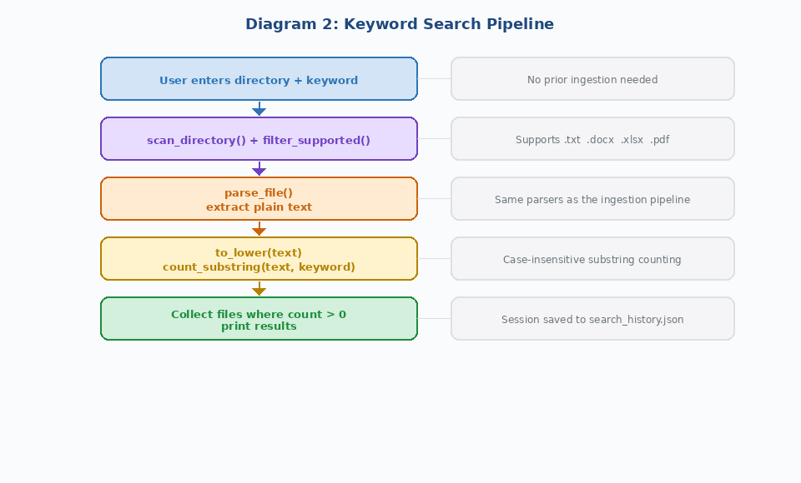
Diagram 2: UC4 activity diagram - keyword search pipeline

UC5 - Export extracted data
Actor: end user. Precondition: the store has been populated.
Main path: the user runs export -format json -out results.json. The system iterates all DocumentRecords, builds a JSON array containing each document path, type, status, and extracted field map, and writes to the output path.
Alternative path: export -format csv. The system writes a flat CSV with columns doc_id, file_path, field, value, one row per extracted value.

2.3.6 UC6 - View search history
Actor: end user. Precondition: at least one keyword search has been performed.
Main path: the user selects option 2 from the interactive menu. The system calls SearchHistory::get_all_searches(), which returns sessions sorted by timestamp descending. Each session is printed: timestamp, directory, keyword, number of matching files, and the list of matching file paths with their individual match counts.
Alternative path: no searches have been performed. The history is empty. The system prints "No previous searches found." and returns to the menu.

2.4 Requirements analysis - edge cases and constraints
Several requirements have non-obvious edge cases that are worth stating explicitly, because they drove specific implementation decisions.
FR1 deduplication. Using both path and hash is more reliable than either alone. Hash alone would falsely deduplicate two different files with identical content stored at different paths (rare but possible for template files). Path alone would miss a modified file whose path did not change. The combination handles all four cases correctly: new file (neither seen), unchanged file (both seen), modified file (path seen, hash changed), moved copy (hash seen, path changed).
FR3 rule precedence. If two rules both match the same field name and the same document, both matches are indexed. This is intentional: the AVL tree node for that field value will contain both document IDs. However, if one match normalises to a different string than the other, they go into separate tree nodes, which is also correct. There is no rule-priority system; all active type-matching rules run on every document.
FR5 string range queries. The AVL tree stores string keys and performs lexicographic comparison. For ISO date strings (YYYY-MM-DD) and zero-padded invoice numbers this gives correct ordering. For arbitrary numerics without padding it gives incorrect ordering: "9" > "10" lexicographically. Users who extract numeric fields must either zero-pad their values in the regex (e.g., match and reformat as a fixed-width string) or accept that range queries will use lexicographic order. This limitation is documented in the user-facing README.
FR6 persistence on crash. JSON writes are not atomic. If the process is killed between writing store.json and writing the index files, or partway through writing a large index file, the store may be in an inconsistent state on the next run. The system detects this partially: if store.json is missing or unparseable it starts with an empty store. If an index file is malformed it skips that field's tree. A production version would use a write-to-temp-then-rename approach for atomicity, but that is outside the scope of this project.
NFR4 error isolation. The requirement says a parse failure on one file must not abort processing of remaining files. The implementation wraps each file's entire processing block in a try-catch. This is deliberately broad: it catches std::exception and its subclasses, which includes std::regex_error, std::runtime_error from miniz, std::bad_alloc for very large files, and pugixml parse exceptions. The catch block creates a DocumentRecord with status PARSE_FAILED, logs the exception message with the file path as context, increments the failure counter, and continues the loop.

2.5 Requirements traceability
Requirement | Implemented in | Tested by
FR1 - Directory ingestion | ingestion_service.cpp: run_scan() | Acceptance test AT-FR1, Integration test IT-1
FR2 - Multi-format parsing | parsers/factory.cpp + four parsers | Unit tests, Acceptance test AT-FR2
FR3 - Rule-based extraction | rules/engine.cpp: apply_rules() | Unit tests T1-T4, Acceptance test AT-FR3
FR4 - Normalization and validation | validation/normalizer.cpp, validator.cpp | Unit test T4, Acceptance test AT-FR4
FR5 - AVL tree indexing | store/avl_tree.cpp | Unit tests T1-T4, Acceptance test AT-FR5
FR6 - Persistent storage | store/store.cpp: save() / load() | Integration test IT-1 step 6, AT-FR6
FR7 - Keyword search | services/keyword_search_service.cpp | Acceptance test AT-FR7
FR8 - HTML report | services/report_service.cpp | Acceptance test AT-FR8
FR9 - CLI | main.cpp | Acceptance test AT-FR9

Table 1b: Requirements traceability matrix

2.6 UML component diagram
Figure 3 below shows the module dependency structure of the system as a UML component diagram. Each box is a compiled module; arrows show dependency (a module depends on everything it points to).
Figure 3 - Module Dependency Graph
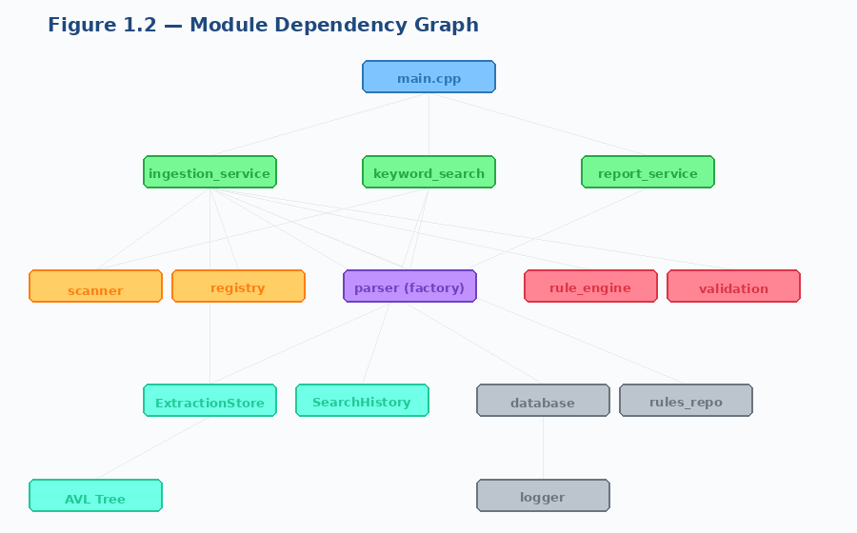
Diagram 3: UML component diagram - module dependencies

2.7 UML deployment diagram
The system runs as a single process on a desktop or server machine. There is no network component and no separate database server; SQLite runs in-process. Figure 4 shows the deployment in UML terms.
Figure 4 - Build System and Dependency Resolution
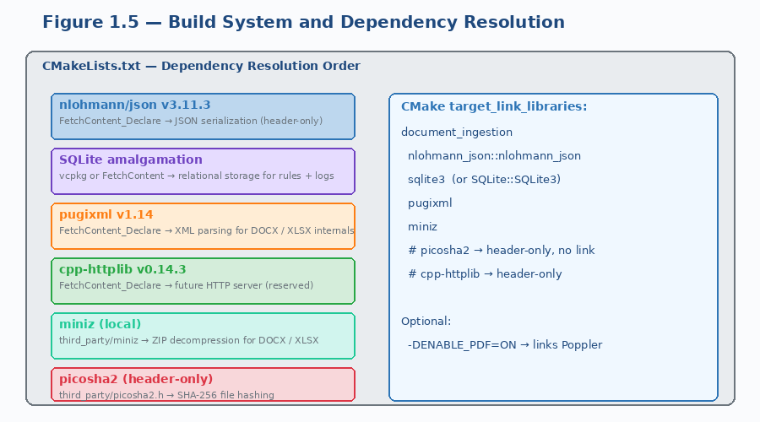
Diagram 4: UML deployment diagram - all components run in a single process on one machine

3. Design of the Software Solution
The design follows a strict layered architecture. Each layer calls only layers below it. The top layer is the CLI. Below that are the services. Below the services are the scanner, parsers, rule engine, and store. At the bottom are the database layer and the AVL tree. This structure means any layer can be tested without instantiating the layers above it.
Figure 5 - System Architecture: Layered Overview
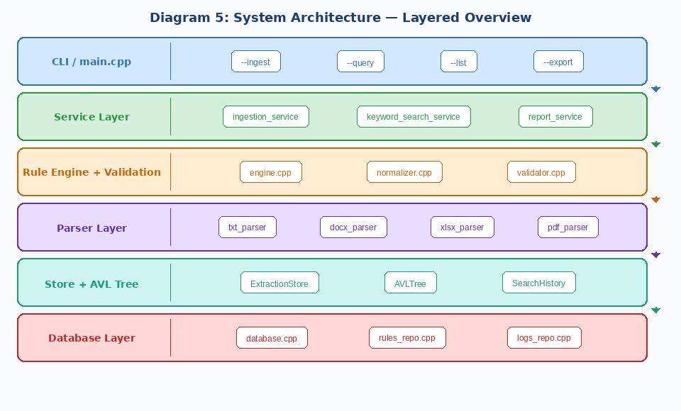
Diagram 5: System architecture - six-layer overview with component hierarchy

3.1 Software architecture
The architecture has six layers:
Layer 1 (CLI): main.cpp, 261 lines. Argument parsing, command dispatch, interactive menu. The only place where all other layers are brought together.
Layer 2 (Services): ingestion_service.cpp, keyword_search_service.cpp, report_service.cpp. Each service orchestrates calls to the layers below. Services know nothing about CLI argument parsing; they receive typed parameters.
Layer 3 (Rule engine and validation): engine.cpp, normalizer.cpp, validator.cpp. The rule engine applies regex patterns with anchor-based window narrowing to document text. The validator checks candidates against rule constraints.
Layer 4 (Parsers): factory.cpp, txt_parser.cpp, docx_parser.cpp, xlsx_parser.cpp, pdf_parser.cpp. A single public function parse_file(path) dispatches to format-specific parsers and returns plain text. Format details are hidden behind this interface.
Layer 5 (Store and tree): store.cpp, avl_tree.cpp, search_history.cpp. The ExtractionStore holds the document map and the per-field AVL trees. Persistence is handled here.
Layer 6 (Database): database.cpp, rules_repo.cpp, logs_repo.cpp. SQLite connection management and the two repositories that read and write rules and log entries.

3.2 Algorithm design: the AVL tree
The AVL tree is the most algorithmically involved component. A standard BST would degrade to O(n) search on sorted inputs, which is exactly the case that arises when extracting invoice numbers that increment in sequence. The AVL invariant (the height difference between left and right subtrees is at most 1 at every node) keeps search time at O(log n) regardless of insert order.
Figure 6 shows the four rotation cases. LL and RR are single rotations; LR and RL are double rotations (rotate a child first, then rotate the node itself).

Figure 6 - AVL Tree - Four Rotation Cases
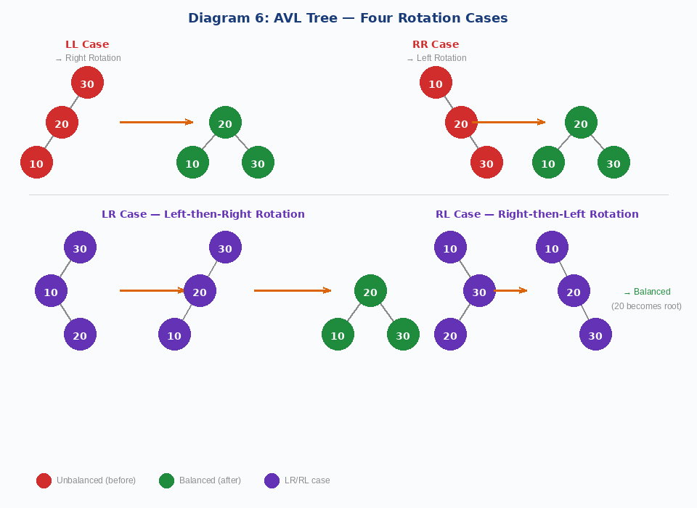
Diagram 6: AVL tree rotation cases - LL (right rotation), RR (left rotation), LR and RL (double rotations)
Each tree node stores a string key and a std::set of document IDs. Using a set rather than a single string means multiple documents with the same extracted value share one tree node, which is correct: a range query on invoice totals should return every document that matches, not only the first one inserted.
Figure 6 shows how range queries prune the tree. Nodes whose key falls outside [low, high] are skipped; their subtrees may be skipped entirely if we can determine from the current node that the whole subtree is out of range.

