Proceso exitoso
import java.io.File;
import java.io.IOException;
import java.util.*;
import java.util.concurrent.TimeUnit;
//TIP To <b>Run</b> code, press <shortcut actionId="Run"/> or
// click the <icon src="AllIcons.Actions.Execute"/> icon in the gutter.
public class Main {
public static void main(String[] args) {
ProcessBuilder pb=new ProcessBuilder();
try {
int exitCode;
pb.command("cmd.exe", "/c", "dir");
var process= pb.inheritIO().start();
exitCode=process.waitFor();
// System.out.println();
System.out.println(pb.directory());
System.out.println("la ejecution de cmd.exe devuelve "+exitCode);
System.out.println();
// pb.directory(new File("C:/Users/a24borjapp/Desktop/asignaturas"));
//
// Map<String,String> mapa= pb.environment();
// for(String key : mapa.keySet()){
// System.out.println(key +": "+ mapa.get(key));
// }
// System.out.println();
// process=pb.inheritIO().start();
// exitCode=process.waitFor( );
// System.out.println();
// System.out.println(pb.directory());
// System.out.println("la ejecution de cmd.exe devuelve "+exitCode);
//
}catch (IOException e){
System.out.println("ocurrio una excepcion de entrada y salida");
System.exit(2);
} catch (InterruptedException e) {
System.out.println("proceso interrumpido");
System.exit(3);
}
}
}

Resultado
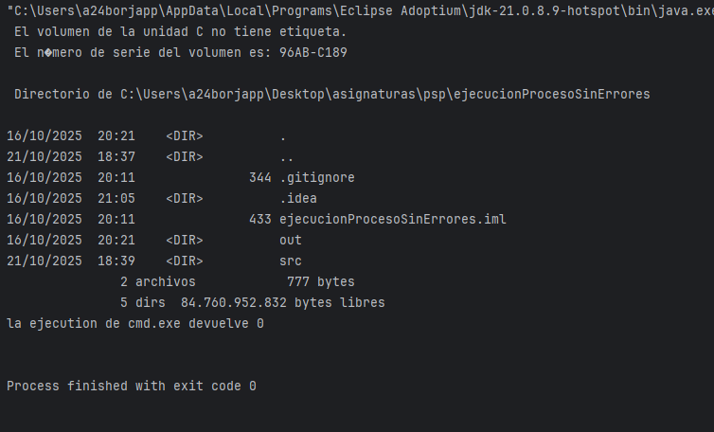

Proceso no existente
import java.io.File;
import java.io.IOException;
import java.util.*;
import java.util.concurrent.TimeUnit;
//TIP To <b>Run</b> code, press <shortcut actionId="Run"/> or
// click the <icon src="AllIcons.Actions.Execute"/> icon in the gutter.
public class Main {
public static void main(String[] args) {
ProcessBuilder pb=new ProcessBuilder();
try {
int exitCode;
pb.command("pachanga.exe");
var process= pb.inheritIO().start();
exitCode=process.waitFor();
// System.out.println();
System.out.println(pb.directory());
System.out.println("la ejecution de cmd.exe devuelve "+exitCode);
System.out.println();
// pb.directory(new File("C:/Users/a24borjapp/Desktop/asignaturas"));
//
// Map<String,String> mapa= pb.environment();
// for(String key : mapa.keySet()){
// System.out.println(key +": "+ mapa.get(key));
// }
// System.out.println();
// process=pb.inheritIO().start();
// exitCode=process.waitFor( );
// System.out.println();
// System.out.println(pb.directory());
// System.out.println("la ejecution de cmd.exe devuelve "+exitCode);
//
}catch (IOException e){
System.out.println("ocurrio una excepcion de entrada y salida");
System.exit(2);
} catch (InterruptedException e) {
System.out.println("proceso interrumpido");
System.exit(3);
}
}
}

Resultado
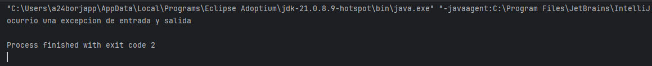

Proceso intruccion no valida
import java.io.File;
import java.io.IOException;
import java.util.*;
import java.util.concurrent.TimeUnit;
//TIP To <b>Run</b> code, press <shortcut actionId="Run"/> or
// click the <icon src="AllIcons.Actions.Execute"/> icon in the gutter.
public class Main {
public static void main(String[] args) {
ProcessBuilder pb=new ProcessBuilder();
try {
int exitCode;
pb.command("cmd.exe", "/c", "guayaba");
var process= pb.inheritIO().start();
exitCode=process.waitFor();
// System.out.println();
System.out.println(pb.directory());
System.out.println("la ejecution de cmd.exe devuelve "+exitCode);
System.out.println();
// pb.directory(new File("C:/Users/a24borjapp/Desktop/asignaturas"));
//
// Map<String,String> mapa= pb.environment();
// for(String key : mapa.keySet()){
// System.out.println(key +": "+ mapa.get(key));
// }
// System.out.println();
// process=pb.inheritIO().start();
// exitCode=process.waitFor( );
// System.out.println();
// System.out.println(pb.directory());
// System.out.println("la ejecution de cmd.exe devuelve "+exitCode);
//
}catch (IOException e){
System.out.println("ocurrio una excepcion de entrada y salida");
System.exit(2);
} catch (InterruptedException e) {
System.out.println("proceso interrumpido");
System.exit(3);
}
}
}

Resultado

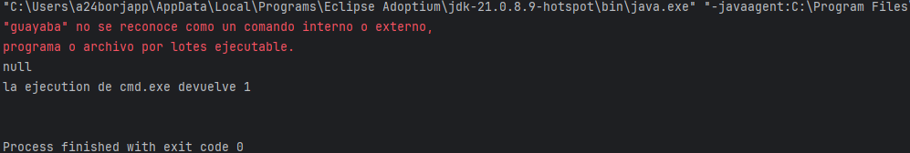

Proceso donde se muestra directorio y se cambia
import java.io.File;
import java.io.IOException;
import java.util.*;
import java.util.concurrent.TimeUnit;
//TIP To <b>Run</b> code, press <shortcut actionId="Run"/> or
// click the <icon src="AllIcons.Actions.Execute"/> icon in the gutter.
public class Main {
public static void main(String[] args) {
ProcessBuilder pb=new ProcessBuilder();
try {
int exitCode;
pb.command("cmd.exe", "/c", "dir");
var process= pb.inheritIO().start();
exitCode=process.waitFor();
// System.out.println();
System.out.println(pb.directory());
System.out.println("la ejecution de cmd.exe devuelve "+exitCode);
System.out.println();
pb.directory(new File("C:/Users/a24borjapp/Desktop/asignaturas"));
// Map<String,String> mapa= pb.environment();
// for(String key : mapa.keySet()){
// System.out.println(key +": "+ mapa.get(key));
// }
System.out.println();
process=pb.inheritIO().start();
exitCode=process.waitFor( );
// System.out.println();
System.out.println(pb.directory());
System.out.println("la ejecution de cmd.exe devuelve "+exitCode);
}catch (IOException e){
System.out.println("ocurrio una excepcion de entrada y salida");
System.exit(2);
} catch (InterruptedException e) {
System.out.println("proceso interrumpido");
System.exit(3);
}
}
}

Resultado

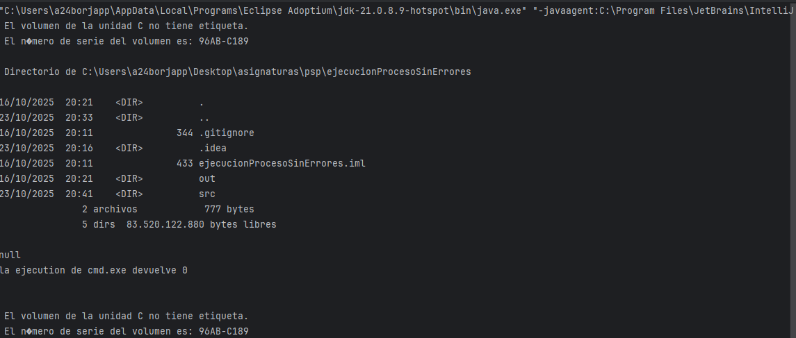

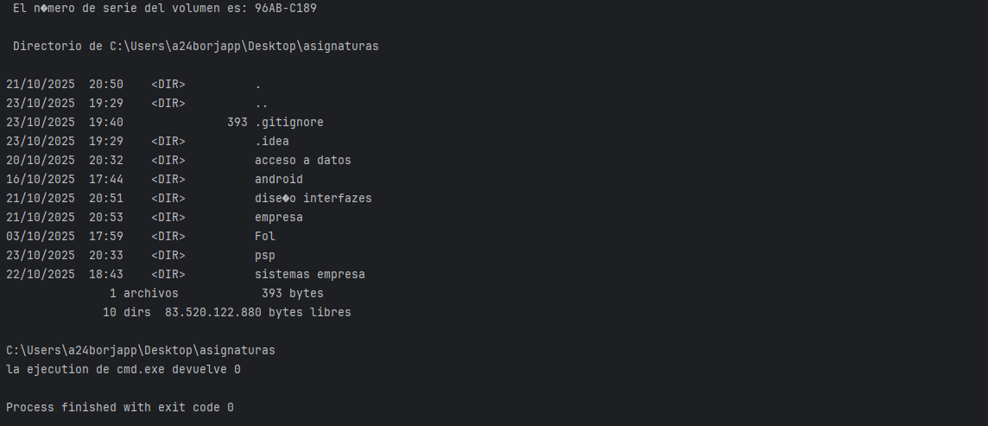

Proceso con enviroment
import java.io.File;
import java.io.IOException;
import java.util.*;
import java.util.concurrent.TimeUnit;
//TIP To <b>Run</b> code, press <shortcut actionId="Run"/> or
// click the <icon src="AllIcons.Actions.Execute"/> icon in the gutter.
public class Main {
public static void main(String[] args) {
ProcessBuilder pb=new ProcessBuilder();
try {
int exitCode;
pb.command("cmd.exe", "/c", "dir");
var process= pb.inheritIO().start();
exitCode=process.waitFor();
System.out.println();
System.out.println(pb.directory());
System.out.println("la ejecution de cmd.exe devuelve "+exitCode);
System.out.println();
pb.directory(new File("C:/Users/a24borjapp/Desktop/asignaturas"));
Map<String,String> mapa= pb.environment();
for(String key : mapa.keySet()){
System.out.println(key +": "+ mapa.get(key));
}
System.out.println();
process=pb.inheritIO().start();
exitCode=process.waitFor( );
System.out.println();
System.out.println(pb.directory());
System.out.println("la ejecution de cmd.exe devuelve "+exitCode);
}catch (IOException e){
System.out.println("ocurrio una excepcion de entrada y salida");
System.exit(2);
} catch (InterruptedException e) {
System.out.println("proceso interrumpido");
System.exit(3);
}
}
}

Resultado
