**Markov model for the online multi-channel attribution problem.**

**Davide Altomare and David Loris 01/09/2015**

**INTRODUCTION**

Advertisers use a variety of online marketing channels to reach consumers and they want to know the degree each channel contributes to their marketing success. It’s called the online multi-channel attribution problem. In many cases, advertisers approach this problem through some simple heuristics methods that do not take into account any customer interactions and often tend to underestimate the importance of small channels in marketing contribution.

This package provides a function that approaches the attribution problem in a probabilistic way. It uses a first-order Markov representation to identifying structural correlations in the customer journey data. This would allow advertisers to give a more reliable assessment of the marketing contribution of each channel. The approach basically follows the one presented in F. Anderl, I. Becker, F. v. Wangenheim, J.H. Schumann (2014). Differently for them, we solved the estimation process using stochastic simulations. In this way it is possible to take into account conversion values and their variability in the computation of the channel importance.

For more details or a more extensive version of the package, which includes a k-order Markovian model and useful functions to handle customer journey data, and for customizations please contact [davide.altomare@gmail.com](mailto:davide.altomare@gmail.com) .

The following paragraph is a gentle introduction to Markov model. It also contains some considerations on heuristic models.

**MARKOV MODEL**

Consider the following example in which we have 4 states: (START), A, B, (CONVERSION) and 3 paths recorded:

|  |  |
| --- | --- |
| **PATH** | **CONVERSIONS** |
| (START) -> A -> B -> A -> B -> B -> A -> (CONVERSION) | 1 |
| (START) ->A -> B -> B -> A -> A -> (CONVERSION) | 1 |
| (START) -> A -> A -> (CONVERSION) | 1 |
| **TOTAL** | **3** |

For every couple of ordered states we count the number of directed edges:

|  |  |
| --- | --- |
| **EDGE** | **ARROW.COUNT** |
| (START) -> A | 3 |
| (START) -> B | 0 |
| A -> A | 2 |
| A -> B | 3 |
| A -> (CONVERSION) | 3 |
| B -> A | 3 |
| B -> B | 2 |
| B -> (CONVERSION) | 0 |
| **TOTAL** | **16** |

From the table we can calculate the transition probabilities between states:

|  |  |  |
| --- | --- | --- |
| **EDGE** | **ARROW.COUNT** | **TRANSITION.PROBABILITIES** |
| (START) -> A | 3 | 3/3 |
| (START) -> B | 0 | 0 |
| **TOT (START)** | **3** |  |
| A -> A | 2 | 2/8 |
| A -> B | 3 | 3/8 |
| A -> (CONVERSION) | 3 | 3/8 |
| **TOT A** | **8** |  |
| B -> A | 3 | 3/5 |
| B -> B | 2 | 2/5 |
| B -> (CONVERSION) | 0 | 0 |
| **TOT B** | **5** |  |

Now we have all the information to plot the Markov Graph: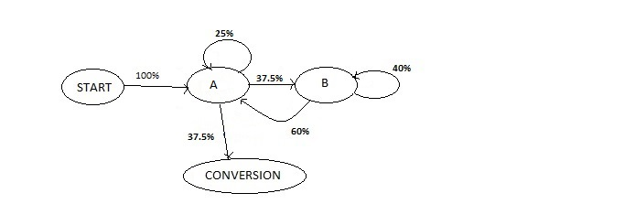

This kind of Markov Graph is called First-Order Markov Graph because the probability of reaching one state depends only on the previous state visited.

From the Graph, or more clearly from the original data, we see that every path leads to conversion. Thus the conversion rate of the Graph is 1.

Now we want to define a measure of channel importance using the relationship between states described by the Graph.

Importance of channel A can be defined as the change in conversion rate if channel A is dropped from the Graph, or in other terms if channel A becomes a NULL state.

A NULL state is an absorbing state so if one reaches this STATE can’t move on.

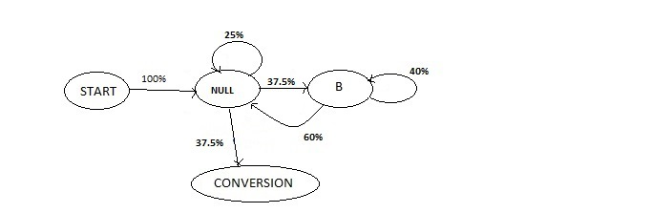

This Graph simplifies to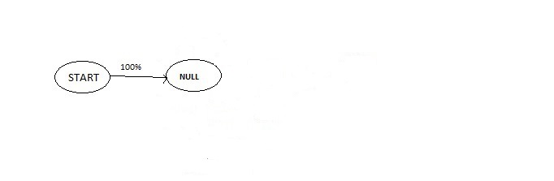In previous Graph it’s easy to see that if channel A becomes a NULL state there is no way of reaching conversion from START state. So conversion rate of this Graph is 0. The conversion drops from 1 (conversion of the original Graph) to 0. Thus importance of channel A (defined as the change in conversion rate) is **1**.

In similar way we define the importance of channel B as the change in conversion rate if channel B is dropped from the Graph, or in other terms if channel B becomes a NULL state.

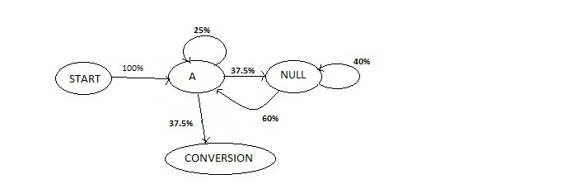This Graph simplifies to:

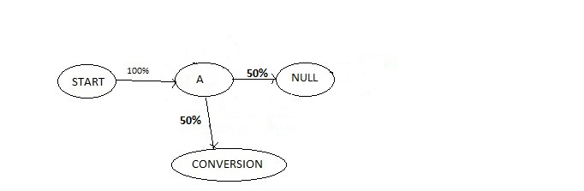

In previous Graph we see the probability of reaching conversion from START state is 0.5. Conversion drops from 1 (conversion rate of the original Graph) to 0.5. Thus the importance of channel B (defined as the change in conversion rate) is **0.5**.

Once we have the importance weights of every channel we can do a weighted imputation of total conversions (3 in this case) between channels.

|  |  |
| --- | --- |
| **CHANNEL** | **CONVERSIONS** |
| A | 2 [ =3 x 1/(1+0.5) ] |
| B | 1 [ = 3 x 0.5/(1+0.5) ] |
| **TOTAL** | **3** |

Now let’s go back to the original data:

|  |  |
| --- | --- |
| **PATH** | **CONVERSIONS** |
| (START) -> A -> B -> A -> B -> B -> A -> (CONVERSION) | 1 |
| (START) ->A -> B -> B -> A -> A -> (CONVERSION) | 1 |
| (START) -> A -> A -> (CONVERSION) | 1 |
| **TOTAL** | **3** |

We see that if we use a first-touch or last-touch approach, all the conversions are assigned to channel A, despite the important work of channel B in “conversion game” is clear from the data.

The channel attribution problem can be viewed as a football match, to better understand how different approaches work. So channels can be viewed as players, paths are game actions and conversions are goals.

Markov Model analyses relationships between game actions to understand the role of the player in scoring. While heuristic approach analyzes one action (path) at the time.

So last-touch approach rewards only players who scored, while first-touch approach rewards only players who started the action. Linear approach rewards with the same credit to every player who took part the action, while time-decay approaches gives subjective weights to every player who took part the action.

As we have seen Markov Model require as inputs paths and total conversions and does not require subjective assumptions, differently from heuristic approaches.