|  |  |  |
| --- | --- | --- |
| Bananapus! | | |
| Game Design Document | | |
|  | | |
| Eldritch Fruit Beat ‘Em Up | | |
|  | | |
|  | | |
|  | | |
| By Capybara Studios | | |
| Andre Borja  Eduardo Cavalcante  Naomi Freire  Sebastian Beltran | | |
|  | | |
|  | | |
|  | Table of Contents  Overview  3 Cs  Features  Production  UI  Art  Audio  Tech |  |

# Overview

## Description

Top-down beat ‘em up game where all characters are living fruit that takes place in a trash dump.

## Goals

The main design goal of this game was to elaborate on the potential of the Atari Controller constraints in combat. We approached the project with the ideal of having more than one melee attack with the one button. That was achieved by implementing a three-attack combo in which each attack affects a different area around the character.

## Pillars

1. Combat – the main focus of the game is combat, whereas the only button aside from the directionals is the SPACE bar for melee attacks.
2. Enemies – in the prototype for this game, there are two enemies with entirely different behaviors. This is one of the core elements sought out when designing the game: having varied enemies and eventually also bosses that somewhat mirror the smaller enemies’ behaviors.

## Hook

Beat ‘em up game with living fruit that uses the input constraints of an Atari controller.

# Logo Description automatically generated3 Cs

## Character

The main character is the Bananapus! A banana peel that has come back to life due to a cosmic strike in the trash dump. Her goal is to escape the trash dump and avoid going to the landfill.

## Camera

This is a 2D top-down game.

## Controls

Her controls are based on the constraints of an Atari controller: one joystick and one button. The Banana Peel moves in all four directions in the game pad and performs combat actions with the button. Double-tapping on any of the arrows makes the Banana Peel dash in that direction.

The button that was chosen aside from the directionals is the SPACE bar. It is tied to the banana’s melee attack. A single tap on the button is a light attack one unit below the character onscreen. If done so a short period after the first, the second tap does more damage and affects one unit above the character. The third tap finishes the attack combo and affects all directions around the banana.

# Features

## Enemies

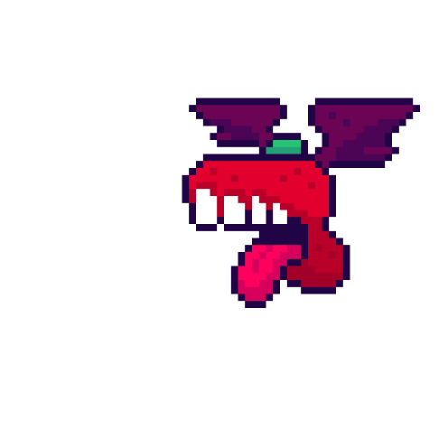

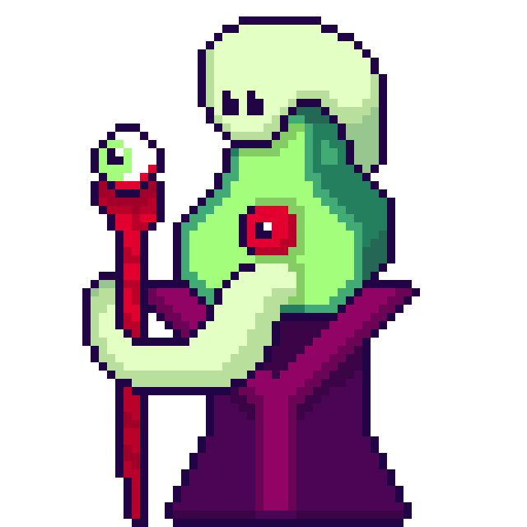

## Barricades

## Acid Pools

## Hearts

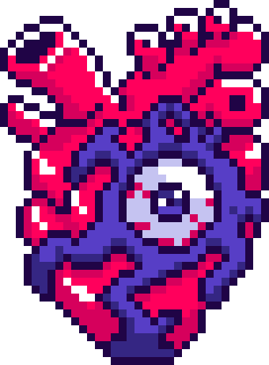

# Production

## Kanban Board

Link to the board.

## Team Members and Responsibilities

|  |  |
| --- | --- |
| Team Member | Main Responsibilities |
| Andre Borja | Programmer |
| Eduardo Cavalcante | Level Designer |
| Naomi Freire | Project Manager, 2D Artist |
| Sebastian Beltran | 2D Artist |

## Risks and Mitigation

Identify any risks and their possible mitigations. Add more rows as needed. Check example below.

|  |  |
| --- | --- |
| Risk | Mitigation(s) |
| Team has never made a beat ‘em up game | Prioritize combat and enemy AI implementation. |
| Atari controller is limiting | Explore what can be done to augment the power of the few buttons available |

## Publishing

A link to the itch.io game page.

# Art

Lovecraftian horror in pixel-art cartoon form.

<https://br.pinterest.com/nanahfreire/bananapus/>

# Tech

Unity.

Are you using any plug-ins or packages?

Are there any technical considerations, requirements, or constraints?

# Audio

What is the game’s audio direction?

Are there any audio considerations, requirements, or constraints?

Funky, energetic with some low tones.

# UI

The UI will be very closely related to the visuals of the game itself. This means that a lot of the elements that would be considered UI (text bubbles, combo scores and such) are intertwined with characters and background and have a similar visual style that doesn’t try to separate them.

What UI elements will be needed in the game?

What information must be relayed to the player?