

RST Commissioning Activity Request

CAR-171 |  |  |  |  |  |  |  |  | CAR Title: |  |  |  | Ghosts and Scattered light
Draft Date: |  |  |  |  | 12/8/25 |  |  |  |  |  |  |  |  |  |  |  | Adjudicated Date: |  |  |  |  |  |  | 7/15/2026
Author: |  | Alex Borlaff/Maxime Rizzo/Scott Rohrbach/Eric Switzer |  |  |  |  |  |  |  |  |  |  |  |  |  |  | Subsystem: |  |  |  |  |  | WFI
Desired Start: |  |  |  | After PFAC |  |  |  |  |  | Duration: |  |  |  | 30 hours |  |  |  |  |  | Execution Method: |  |  |  |  |  | SOSE
Guiding Mode |  |  | WIM |  |  |  | ☐ Actuator Moves |  |  |  |  |  |  |  | PID |  |  |  | ##### |  |  | Seg/Pass IDs |  |  | ####
Data Vol | TBD Gb |  |  |  |  |  |  | #ACM Moves |  |  |  | No |  |  |  |  |  | ACM Poses |  |  | Nominal focus
☐ sRCS | # EWA Moves |  |  |  |  | Yes |  |  |  |  | EWA Filters |  |  |  |  | All
Scheduling Notes & Prerequisites
Information the scheduling team will need to ensure that your activity is placed in the correct location in the timeline

Needs ACM deployed, in best focus post PFAC, and WIM guiding needs to work to place stars.

This CAR can be broken up into discrete segments as needed.

Applicable Constraints/Rules
Revision/Change Notes
12/20/24: First Draft
12/7/25: Combined with Alex CAR, update PSF
03/31/26: First CAIT review.

- Added two dithering patterns for target OUT_pos_1_a (Roman Channel) and IN_pos_4_a and IN_pos_5_a (Dragon’s breath).
- Major correction NDI maps – WFI Stray-light flux levels are now a factor 26.2x lower than previously estimated. This arises from a missing area factor in the WFI superpixel arrays.
- Addition of one activity to 171.2 - Negative Gap. The additional two pointings will place a bright star in the gap between SCA2-SCA3, and SCA11-SCA12. This region located inside the FPA is expected to present extremely high suppression of stray-light. Negative Gap will serve as a benchmark for the stray-light ray-tracing model, will provide high SNR of the diffraction spikes without stray-light, and will enable suppression of stray-light for difficult observations (i.e., Galactic Bulge).

CAR Summary

- What is the goal of this activity?
  - Map the wings of the optical PSF:
    - 1) know how far from bright sources to point to achieve target background (operational)
    - 2) to provide a map of outer PSF for low surface brightness science users
    - 3) test upstream mirrors for scattering (not probed as part of SCIPA or PFAC). Perform tests on both sides of the field to map out PSF scattering with field dependence, such as from the tertiary.
  - Assess scattering of bright sources on the FPA and outer structure, use to validate ray-tracing models that enable predictive modeling. Features here include secondary mirror support legs, baffle edge scatter and the rogue path, aperture stop scatter, light shield scatter (equivalent of “Dragon’s breath”). These will be quantified as normalized detector irradiance (NDI).
  - NOTES:
    - We have identified a reduced set of activities to perform as a risk reduction earlier in Commissioning. These will facilitate exposure time adjustment or possibly source selection.
    - All target sources are stellar and selected in the CVZ to facilitate scheduling and APT implementation.

  - What are the success criteria? Is the data quality acceptable?

    - Scattering paths are within a factor of 10 of expectation and follow expected spatial dependence.
    - Ghosts are consistent with expectations (they should be essentially non-detectable in the PSF)

- Which exit criteria (if any) is this CAR in support of?
  - Section 2.3.5: Backgrounds/Ghosts/Crosstalk Straylight Sky
  - Section 2.3.1: PSF calibration
  - Section 2.3.3: Persistence

- Detail how this activity will be accomplished
Observations: (CALSPEC sources in the CVZ-North shown)
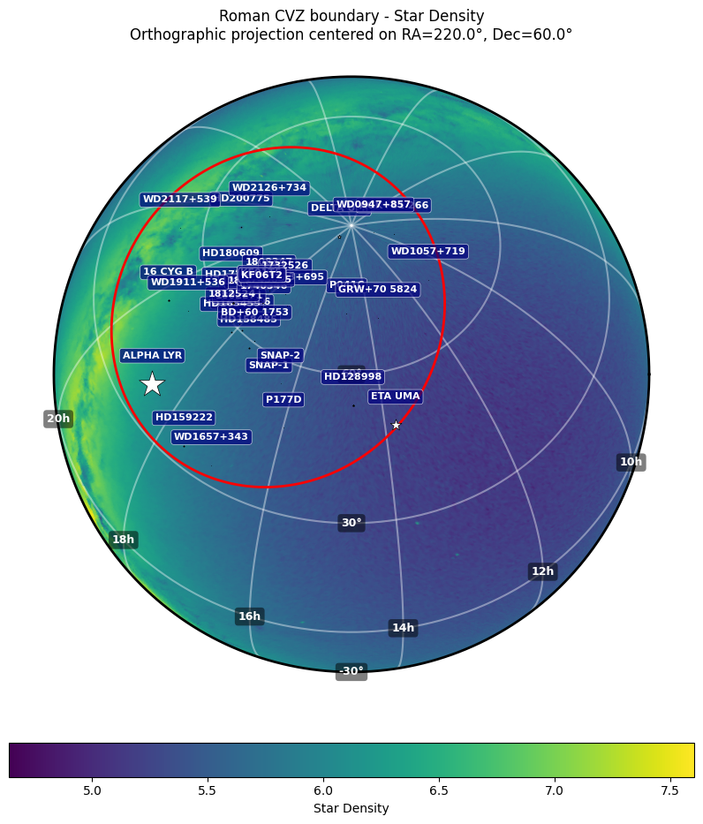
Car 171.1: PSF and ghost mapping [Switzer]
Acquire a series of 55-frame exposures with one exposures per pointing for
- Out of SCA: map the outer PSF. Use eta Uma source (mAB ranging from 2-4 from F062 to F213, with fluence ~2e8 to 3e6 e/s), each WIM filter.
  - ~1” outward from lower edge of SCAs 14 and 5 (shown below). These positions have low NDI, illuminate different regions of the tertiary mirror. These provide lateral (X half-planes) coverage of the PSF pattern in SCAs 18/14 (left side) and SCAs 5/9 (right side)
  - In the middle of the abutment between SCAs 5/6 and SCAs 14/15. This provides coverage of the vertical (Y half-planes).
- In SCA: map the near PSF, centers of SCAs 14 and 5, using HD128998 (CALSPEC, mAB 6-7.5, from F062 to F213, with fluence of 5e6-1e5 e/s) in each filter. There is a dependency on different stellar colors but the observing constraints (in the CVZ and away from the Galactic Plane) restricts our choices.
- Offsets for PSF positions in angle relative to WFI field (APT pointings give the field center which lands target sources on a given offset). Note: APT v3pa survey step requirement ~20 arcsec. Mosaic tool is in observatory coordinates. Need to provide information in TSR to schedulers.

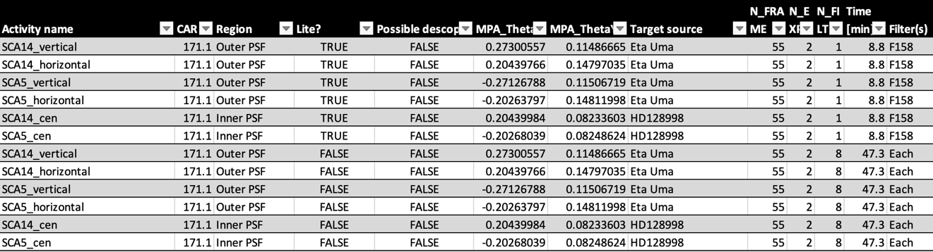
Offsets on NDI map:
- 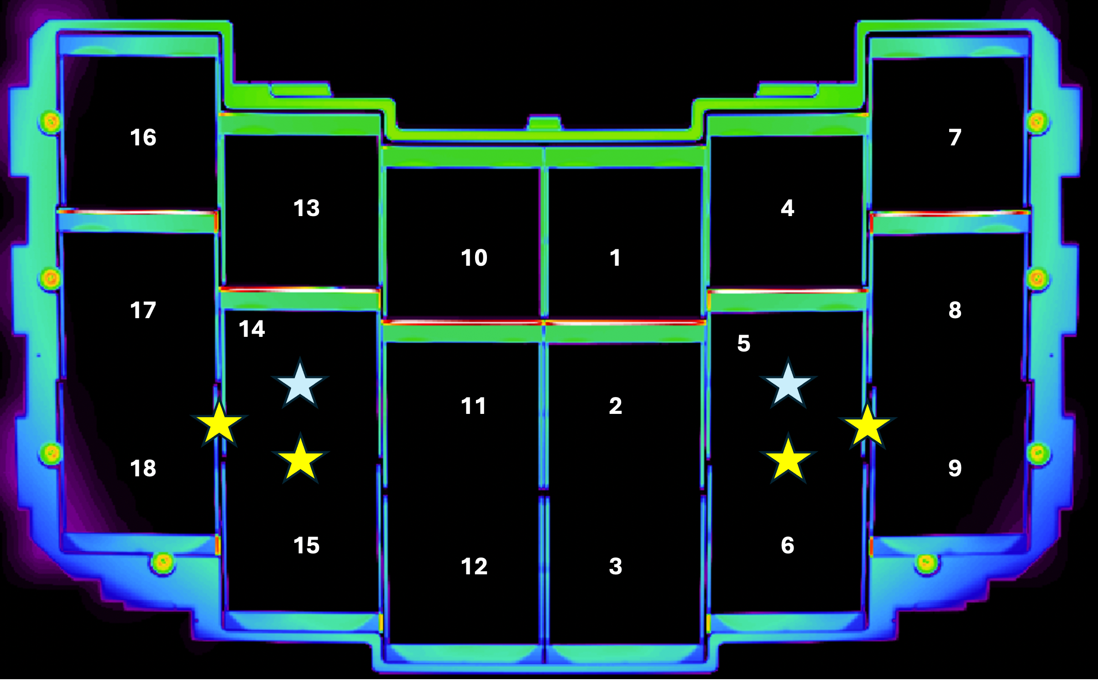

- Relevant requirement for ghosts: RWFI-178: integrated power in the ghost in a 10 arcsec region around the PSF is <0.2% of the PSF. That is met on the filter edges (most stringent). In the filter band, the counts per pixel are down by ~1e7 from the center PSF. No ghost was detectable in WFI TVAC1. S1-S2 ghost appears near the PSF and at a level well below the diffraction spikes.
- Expectation for scattering: 1e-4 of the total power is scattered out of the primary psf due to surface roughness and EOL particulate scatter. 95% of the power is within 6.9 mm radius, or over ~1.5 Mpixels. So 1e8 e/sec becomes 1e-2 e/pix/sec, or ~2 e/pix in a 55 frame exposure.

Expected scattering at 1.29 um from all sources:
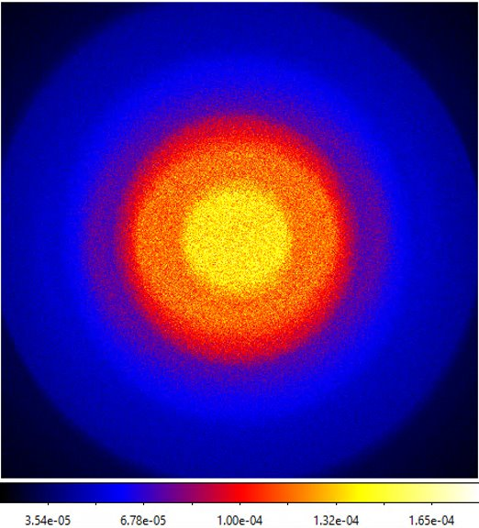
PSF for comparison:
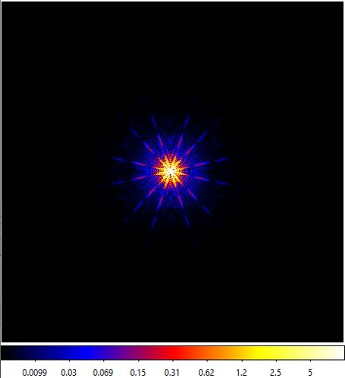
WFI TVAC2 TCR-125 compiles a summary of TVAC-1 stray light test activities

Car 171.2: Normalized detector irradiance [Borlaff]
Canopus used for all observations and is in the CVZ-S and is well-separated from the galactic plane. ROSALIA simulations predict a surface brightness of 23 - 27 mag/arcsec² for the stray-light background at sensitive locations. Roman WFI ETC gives SNR = 3.91 using MA table IM_193_11 (3 min 16s) integrating over 10x10 arcsec2 boxes for a source with 28.9 mag/arcsec2. ROSALIA (independent exposure time calculator) provides the same surface brightness limit, SNR=3 over 10x10 arcsec2 on 3 minutes. Zodiacal light will be brighter than stray-light, requiring correction by on-off observations on non-sensitive stray-light pointing.

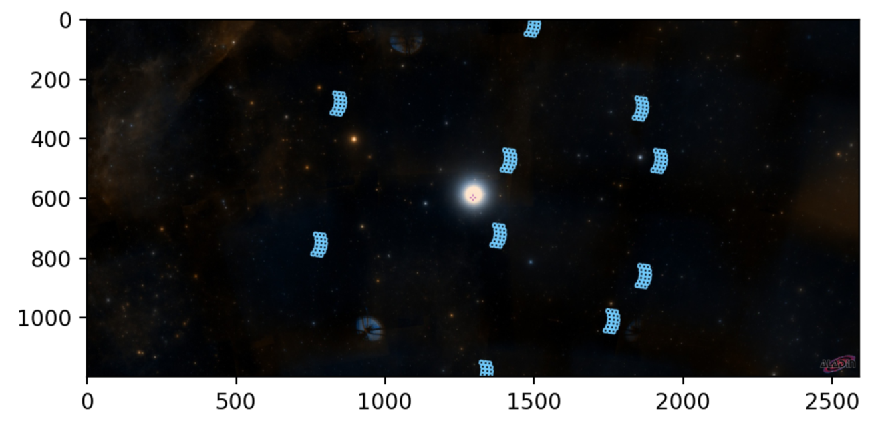
Figure 1: Example of observation plan around Canopus star.
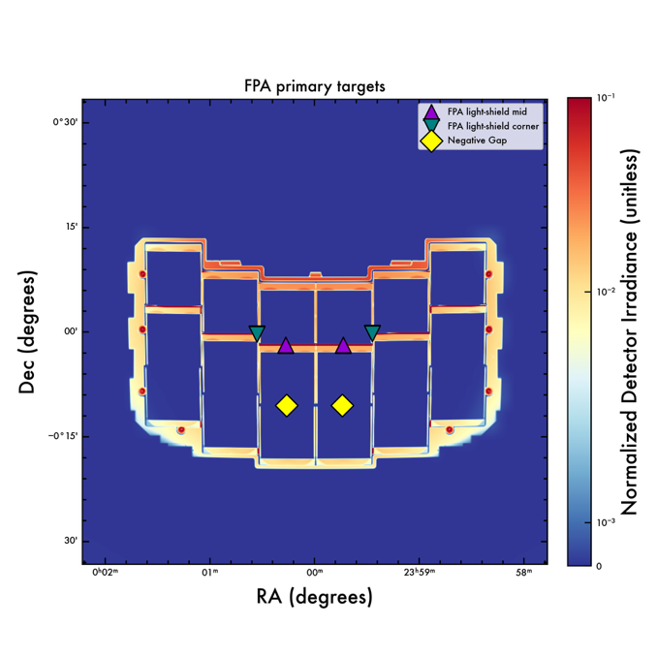
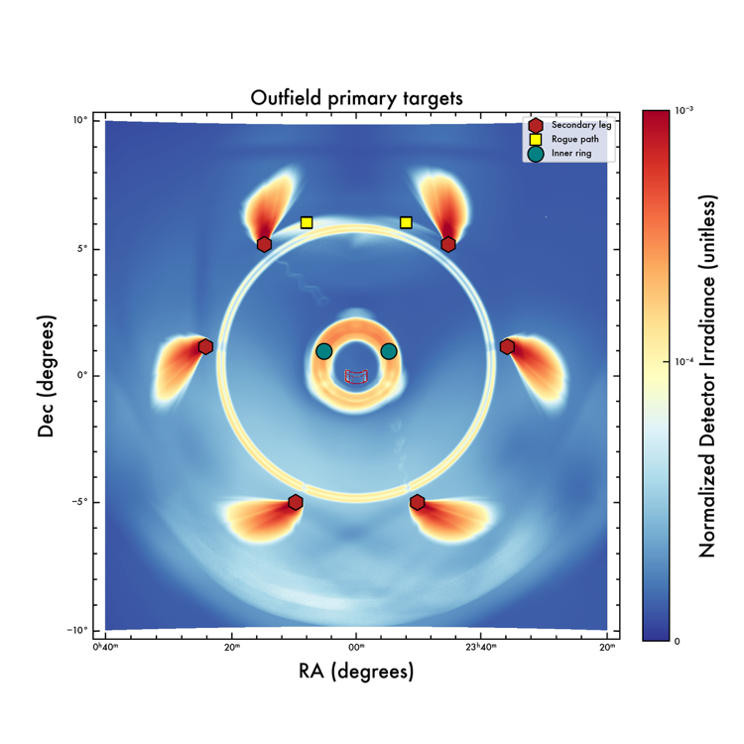
Figures 2 and 3: Normalized Detector Irradiance for Roman/WFI, showing the regions of maximum stray-light sensitivity. Top: Detail around 2x2 degrees from the center of the WFI focal plane. Bottom: Zoom out on the NDI map, extending up to 20x20 degrees. Notice the six secondary mirror struts and the shape of WFI focal plane in the center. The markers represent the primary targets. See below for dithering patterns over OUT_pos_1a, OUT_pos_2a, IN_pos_4a and IN_pos_5a

CAR 171.2 is divided into six types of targets, four of them subdivided into a dithering scan to ensure that the source illuminates the high sensitivity region. These targets are:
- FPA light-shield center – (13 pointings, horizontal and vertical scan of the light-shield SCAN_DRAGON1)
- FPA light-shield corner – (7 pointings, hexagonal pattern + center).
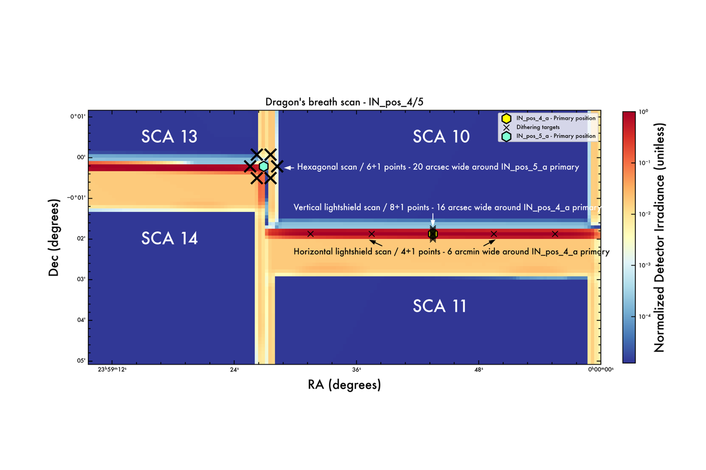

- Rogue path – (OUT_pos_2). Roll (x9) and radial pattern (x3). Total 27 pointings, including central positions. 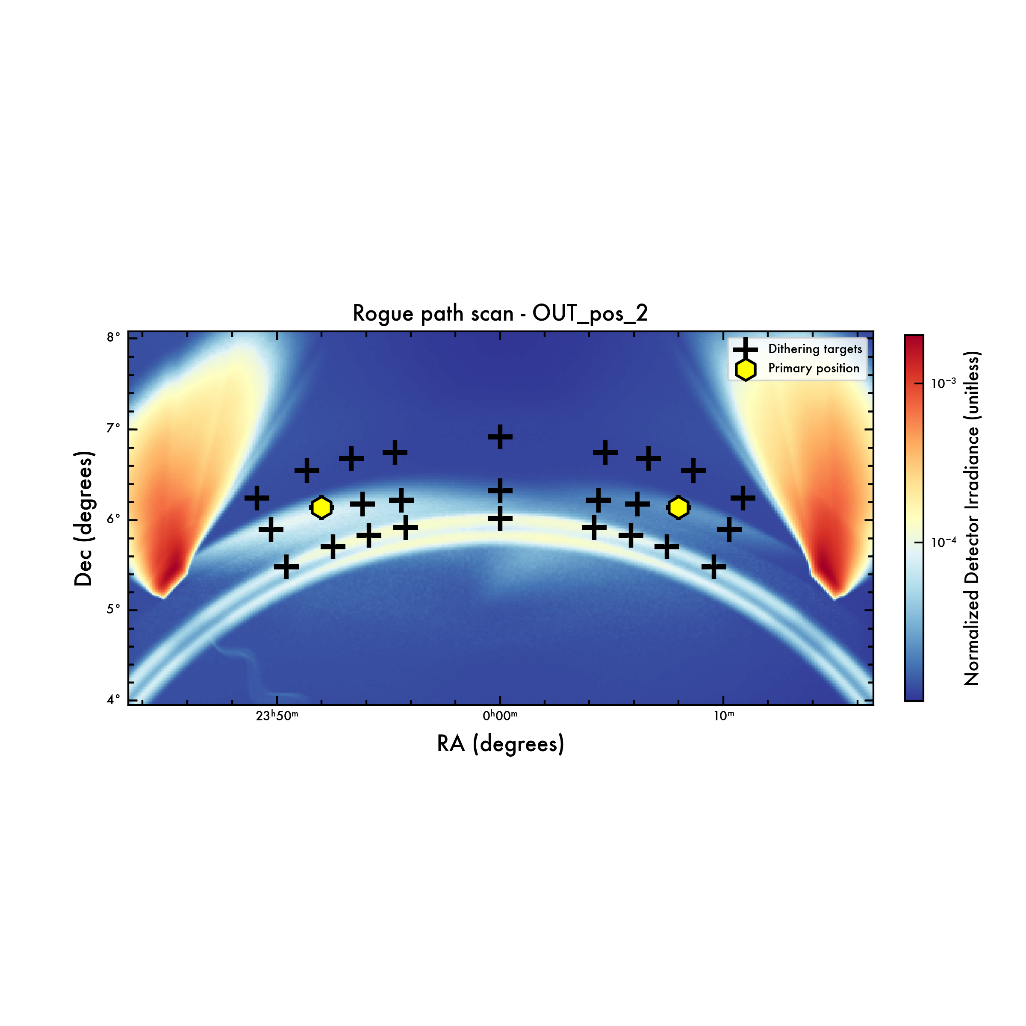
- Secondary leg (OUT_pos_1): 7+1 arc-shaped dithering across feature.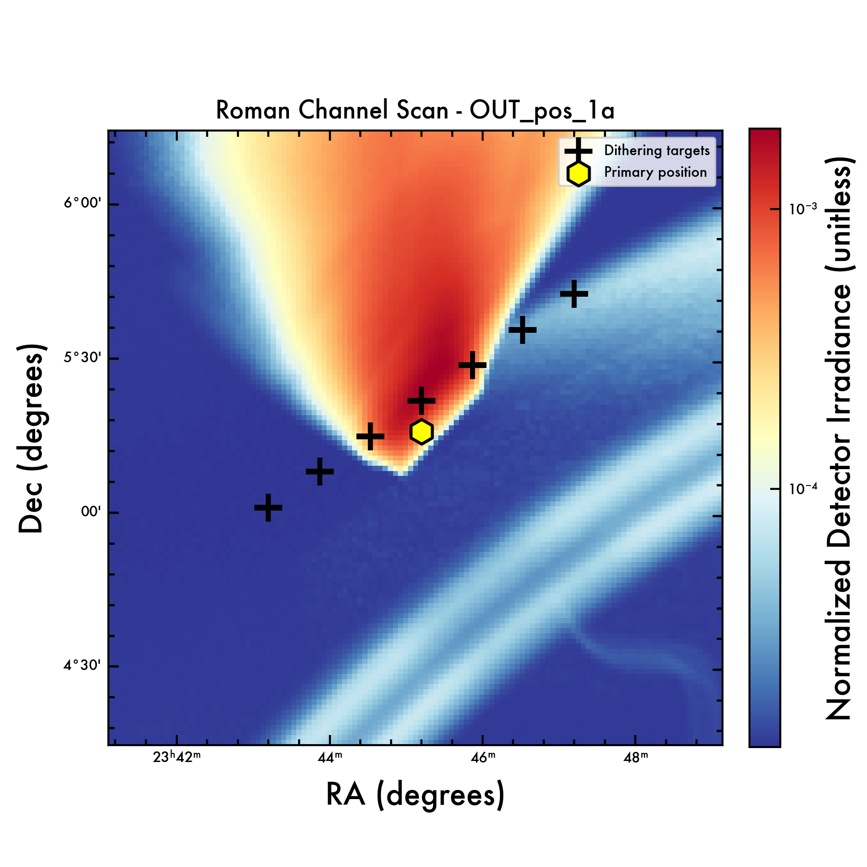
- Inner ring (OUT_pos_3): 2 pointings.

- Negative gap: The gap between SCAs 2 and 3, and SCAs 11 and 12 is expected to have a highly suppressed NDI level. Placing a star in this location will allow to obtain a high SNR of the PSF diffraction spikes up to long distances while suppressing most of the stray-light, and at the same time, benchmark the stray-light models with a test negative. The expected stray-light background level placing Canopus in this gap is 30 – 31 mag/arcsec², below detectability. Negative detection of stray-light patterns in this region would indicate a successful test for the stray-light model.

Targets:
 | Activity name | CAR | Region | Lite? | Possible descope | dX | dY | Target source | N_FRAME | N_EXP | N_FILT | Time | Filter(s) | Notes
0 | OUT_pos_1_a | 171.2 | Outer stray | TRUE | FALSE | -3.7 | 5.27 | Canopus | 55 | 4 | 1 | 14.3 | ? | Secondary mirror leg - 1
1 | OUT_pos_1_b | 171.2 | Outer stray | TRUE | FALSE | 3.7 | 5.27 | Canopus | 55 | 4 | 1 | 14.3 | ? | Secondary mirror leg - 2
2 | OUT_pos_1_c | 171.2 | Outer stray | TRUE | FALSE | 6.05 | 1.18 | Canopus | 55 | 4 | 1 | 14.3 | ? | Secondary mirror leg - 3
3 | OUT_pos_1_d | 171.2 | Outer stray | TRUE | FALSE | 2.45 | -5.07 | Canopus | 55 | 4 | 1 | 14.3 | ? | Secondary mirror leg - 4
4 | OUT_pos_1_e | 171.2 | Outer stray | TRUE | FALSE | -2.45 | -5.07 | Canopus | 55 | 4 | 1 | 14.3 | ? | Secondary mirror leg - 5
5 | OUT_pos_1_f | 171.2 | Outer stray | TRUE | FALSE | -6.05 | 1.18 | Canopus | 55 | 4 | 1 | 14.3 | ? | Secondary mirror leg - 6
6 | OUT_pos_2_a | 171.2 | Outer stray | TRUE | FALSE | -2.0 | 6.15 | Canopus | 55 | 4 | 1 | 14.3 | ? | Rogue path central lobe - 1
7 | OUT_pos_2_b | 171.2 | Outer stray | TRUE | FALSE | 2.0 | 6.15 | Canopus | 55 | 4 | 1 | 14.3 | ? | Rogue path central lobe - 2
8 | OUT_pos_3_a | 171.2 | Outer stray | TRUE | FALSE | -1.3 | 1.0 | Canopus | 55 | 4 | 1 | 14.3 | ? | Inner ring - 1
9 | OUT_pos_3_b | 171.2 | Outer stray | TRUE | FALSE | 1.3 | 1.0 | Canopus | 55 | 4 | 1 | 14.3 | ? | Inner ring - 2
10 | IN_pos_4_a | 171.2 | Outer stray | TRUE | FALSE | -0.0688 | -0.0312 | Canopus | 55 | 4 | 1 | 14.3 | ? | Center lightshield SCA1
11 | IN_pos_4_b | 171.2 | Outer stray | TRUE | FALSE | 0.0688 | -0.0312 | Canopus | 55 | 4 | 1 | 14.3 | ? | Center lightshield SCA10
12 | IN_pos_5_a | 171.2 | Outer stray | TRUE | FALSE | -0.138 | -0.0035 | Canopus | 55 | 4 | 1 | 14.3 | ? | Corner lightshield SCA1 - 4
13 | IN_pos_5_b | 171.2 | Outer stray | TRUE | FALSE | 0.138 | -0.0048 | Canopus | 55 | 4 | 1 | 14.3 | ? | Corner lightshield SCA10 - 13
14 | SCAN_RCHANNEL | 171.2 | Outer stray | TRUE | FALSE | -4.2 | 5.02 | Canopus | 55 | 4 | 1 | 14.3 | ? | Dithering pattern over secondary leg
15 | SCAN_RCHANNEL | 171.2 | Outer stray | TRUE | FALSE | -4.033 | 5.1369 | Canopus | 55 | 4 | 1 | 14.3 | ? | Dithering pattern over secondary leg
16 | SCAN_RCHANNEL | 171.2 | Outer stray | TRUE | FALSE | -3.867 | 5.2531 | Canopus | 55 | 4 | 1 | 14.3 | ? | Dithering pattern over secondary leg
17 | SCAN_RCHANNEL | 171.2 | Outer stray | TRUE | FALSE | -3.7 | 5.37 | Canopus | 55 | 4 | 1 | 14.3 | ? | Dithering pattern over secondary leg
18 | SCAN_RCHANNEL | 171.2 | Outer stray | TRUE | FALSE | -3.533 | 5.4869 | Canopus | 55 | 4 | 1 | 14.3 | ? | Dithering pattern over secondary leg
19 | SCAN_RCHANNEL | 171.2 | Outer stray | TRUE | FALSE | -3.37 | 5.601 | Canopus | 55 | 4 | 1 | 14.3 | ? | Dithering pattern over secondary leg
20 | SCAN_RCHANNEL | 171.2 | Outer stray | TRUE | FALSE | -3.2 | 5.72 | Canopus | 55 | 4 | 1 | 14.3 | ? | Dithering pattern over secondary leg
21 | SCAN_ROGUEPATH | 171.2 | Outer stray | TRUE | FALSE | -2.0 | 6.1492 | Canopus | 55 | 4 | 1 | 14.3 | ? | Rogue path scan
22 | SCAN_ROGUEPATH | 171.2 | Outer stray | TRUE | FALSE | -2.567 | 5.9027 | Canopus | 55 | 4 | 1 | 14.3 | ? | Rogue path scan
23 | SCAN_ROGUEPATH | 171.2 | Outer stray | TRUE | FALSE | -1.1041 | 6.2326 | Canopus | 55 | 4 | 1 | 14.3 | ? | Rogue path scan
24 | SCAN_ROGUEPATH | 171.2 | Outer stray | TRUE | FALSE | -1.1784 | 6.7592 | Canopus | 55 | 4 | 1 | 14.3 | ? | Rogue path scan
25 | SCAN_ROGUEPATH | 171.2 | Outer stray | TRUE | FALSE | -2.1641 | 6.5565 | Canopus | 55 | 4 | 1 | 14.3 | ? | Rogue path scan
26 | SCAN_ROGUEPATH | 171.2 | Outer stray | TRUE | FALSE | -2.7211 | 6.2505 | Canopus | 55 | 4 | 1 | 14.3 | ? | Rogue path scan
27 | SCAN_ROGUEPATH | 171.2 | Outer stray | TRUE | FALSE | -1.0562 | 5.9322 | Canopus | 55 | 4 | 1 | 14.3 | ? | Rogue path scan
28 | SCAN_ROGUEPATH | 171.2 | Outer stray | TRUE | FALSE | -1.8705 | 5.7158 | Canopus | 55 | 4 | 1 | 14.3 | ? | Rogue path scan
29 | SCAN_ROGUEPATH | 171.2 | Outer stray | TRUE | FALSE | -2.3948 | 5.4927 | Canopus | 55 | 4 | 1 | 14.3 | ? | Rogue path scan
30 | SCAN_ROGUEPATH | 171.2 | Outer stray | TRUE | FALSE | -1.6659 | 6.6978 | Canopus | 55 | 4 | 1 | 14.3 | ? | Rogue path scan
31 | SCAN_ROGUEPATH | 171.2 | Outer stray | TRUE | FALSE | -1.54 | 6.1909 | Canopus | 55 | 4 | 1 | 14.3 | ? | Rogue path scan
32 | SCAN_ROGUEPATH | 171.2 | Outer stray | TRUE | FALSE | -1.469 | 5.8422 | Canopus | 55 | 4 | 1 | 14.3 | ? | Rogue path scan
33 | SCAN_ROGUEPATH | 171.2 | Outer stray | TRUE | FALSE | 0.0 | 6.9335 | Canopus | 55 | 4 | 1 | 14.3 | ? | Rogue path scan
34 | SCAN_ROGUEPATH | 171.2 | Outer stray | TRUE | FALSE | 0.0 | 6.3394 | Canopus | 55 | 4 | 1 | 14.3 | ? | Rogue path scan
35 | SCAN_ROGUEPATH | 171.2 | Outer stray | TRUE | FALSE | 0.0 | 6.0327 | Canopus | 55 | 4 | 1 | 14.3 | ? | Rogue path scan
36 | SCAN_ROGUEPATH | 171.2 | Outer stray | TRUE | FALSE | 2.0 | 6.1492 | Canopus | 55 | 4 | 1 | 14.3 | ? | Rogue path scan
37 | SCAN_ROGUEPATH | 171.2 | Outer stray | TRUE | FALSE | 2.567 | 5.9027 | Canopus | 55 | 4 | 1 | 14.3 | ? | Rogue path scan
38 | SCAN_ROGUEPATH | 171.2 | Outer stray | TRUE | FALSE | 1.1041 | 6.2326 | Canopus | 55 | 4 | 1 | 14.3 | ? | Rogue path scan
39 | SCAN_ROGUEPATH | 171.2 | Outer stray | TRUE | FALSE | 1.1784 | 6.7592 | Canopus | 55 | 4 | 1 | 14.3 | ? | Rogue path scan
40 | SCAN_ROGUEPATH | 171.2 | Outer stray | TRUE | FALSE | 2.1641 | 6.5565 | Canopus | 55 | 4 | 1 | 14.3 | ? | Rogue path scan
41 | SCAN_ROGUEPATH | 171.2 | Outer stray | TRUE | FALSE | 2.7211 | 6.2505 | Canopus | 55 | 4 | 1 | 14.3 | ? | Rogue path scan
42 | SCAN_ROGUEPATH | 171.2 | Outer stray | TRUE | FALSE | 1.0562 | 5.9322 | Canopus | 55 | 4 | 1 | 14.3 | ? | Rogue path scan
43 | SCAN_ROGUEPATH | 171.2 | Outer stray | TRUE | FALSE | 1.8705 | 5.7158 | Canopus | 55 | 4 | 1 | 14.3 | ? | Rogue path scan
44 | SCAN_ROGUEPATH | 171.2 | Outer stray | TRUE | FALSE | 2.3948 | 5.4927 | Canopus | 55 | 4 | 1 | 14.3 | ? | Rogue path scan
45 | SCAN_ROGUEPATH | 171.2 | Outer stray | TRUE | FALSE | 1.6659 | 6.6978 | Canopus | 55 | 4 | 1 | 14.3 | ? | Rogue path scan
46 | SCAN_ROGUEPATH | 171.2 | Outer stray | TRUE | FALSE | 1.54 | 6.1909 | Canopus | 55 | 4 | 1 | 14.3 | ? | Rogue path scan
47 | SCAN_ROGUEPATH | 171.2 | Outer stray | TRUE | FALSE | 1.469 | 5.8422 | Canopus | 55 | 4 | 1 | 14.3 | ? | Rogue path scan
48 | SCAN_DRAGON1 | 171.2 | Outer stray | TRUE | FALSE | -0.1188 | -0.0312 | Canopus | 55 | 4 | 1 | 14.3 | ? | Central light shield scan
49 | SCAN_DRAGON1 | 171.2 | Outer stray | TRUE | FALSE | -0.0938 | -0.0312 | Canopus | 55 | 4 | 1 | 14.3 | ? | Central light shield scan
50 | SCAN_DRAGON1 | 171.2 | Outer stray | TRUE | FALSE | -0.0688 | -0.0312 | Canopus | 55 | 4 | 1 | 14.3 | ? | Central light shield scan
51 | SCAN_DRAGON1 | 171.2 | Outer stray | TRUE | FALSE | -0.0438 | -0.0312 | Canopus | 55 | 4 | 1 | 14.3 | ? | Central light shield scan
52 | SCAN_DRAGON1 | 171.2 | Outer stray | TRUE | FALSE | -0.0188 | -0.0312 | Canopus | 55 | 4 | 1 | 14.3 | ? | Central light shield scan
53 | SCAN_DRAGON1 | 171.2 | Outer stray | TRUE | FALSE | -0.0688 | -0.0334 | Canopus | 55 | 4 | 1 | 14.3 | ? | Central light shield scan
54 | SCAN_DRAGON1 | 171.2 | Outer stray | TRUE | FALSE | -0.0688 | -0.0328 | Canopus | 55 | 4 | 1 | 14.3 | ? | Central light shield scan
55 | SCAN_DRAGON1 | 171.2 | Outer stray | TRUE | FALSE | -0.0688 | -0.0322 | Canopus | 55 | 4 | 1 | 14.3 | ? | Central light shield scan
56 | SCAN_DRAGON1 | 171.2 | Outer stray | TRUE | FALSE | -0.0688 | -0.0315 | Canopus | 55 | 4 | 1 | 14.3 | ? | Central light shield scan
57 | SCAN_DRAGON1 | 171.2 | Outer stray | TRUE | FALSE | -0.0688 | -0.0309 | Canopus | 55 | 4 | 1 | 14.3 | ? | Central light shield scan
58 | SCAN_DRAGON1 | 171.2 | Outer stray | TRUE | FALSE | -0.0688 | -0.0302 | Canopus | 55 | 4 | 1 | 14.3 | ? | Central light shield scan
59 | SCAN_DRAGON1 | 171.2 | Outer stray | TRUE | FALSE | -0.0688 | -0.0296 | Canopus | 55 | 4 | 1 | 14.3 | ? | Central light shield scan
60 | SCAN_DRAGON1 | 171.2 | Outer stray | TRUE | FALSE | -0.0688 | -0.029 | Canopus | 55 | 4 | 1 | 14.3 | ? | Central light shield scan
61 | SCAN_DRAGON2 | 171.2 | Outer stray | TRUE | FALSE | -0.1324 | -0.0035 | Canopus | 55 | 4 | 1 | 14.3 | ? | Corner light shield scan
62 | SCAN_DRAGON2 | 171.2 | Outer stray | TRUE | FALSE | -0.1352 | 0.0013 | Canopus | 55 | 4 | 1 | 14.3 | ? | Corner light shield scan
63 | SCAN_DRAGON2 | 171.2 | Outer stray | TRUE | FALSE | -0.1408 | 0.0013 | Canopus | 55 | 4 | 1 | 14.3 | ? | Corner light shield scan
64 | SCAN_DRAGON2 | 171.2 | Outer stray | TRUE | FALSE | -0.1436 | -0.0035 | Canopus | 55 | 4 | 1 | 14.3 | ? | Corner light shield scan
65 | SCAN_DRAGON2 | 171.2 | Outer stray | TRUE | FALSE | -0.1408 | -0.0083 | Canopus | 55 | 4 | 1 | 14.3 | ? | Corner light shield scan
66 | SCAN_DRAGON2 | 171.2 | Outer stray | TRUE | FALSE | -0.1352 | -0.0083 | Canopus | 55 | 4 | 1 | 14.3 | ? | Corner light shield scan
67 | SCAN_DRAGON2 | 171.2 | Outer stray | TRUE | FALSE | -0.1324 | -0.0035 | Canopus | 55 | 4 | 1 | 14.3 | ? | Corner light shield scan
68 | NEGATIVE_1 | 171.2 | Outer stray | TRUE | FALSE | -0.0665 | -0.1754 | Canopus | 55 | 4 | 1 | 14.3 | ? | Gap between SCA11 and SCA12
69 | NEGATIVE_2 | 171.2 | Outer stray | TRUE | FALSE | 0.0665 | -0.1754 | Canopus | 55 | 4 | 1 | 14.3 | ? | Gap between SCA2 and SCA3
 | TOTAL |  |  |  |  |  |  |  |  |  |  | 1001.0 |  | Total time = 16.68 hours

Analysis:
- Produce FPA mosaics to map scattered light across the focal plane
- Form cutouts that combine the bright sources out/in SCA to map out the outer PSF from all polar angles
- Analyze scattered light rate contributions across the field
- Verify light rejection of the dark element

Fig. Example of expected stray-light background on secondary leg.

Duration:
Model: 3 minutes for 1 exposure, 200 second slews + 10 second settle
Name | N_pointings | N_filt | N_activities | Duration (min)
Out SCA | 4 | 8 | 32 | 200
In SCA | 2 | 8 | 16 | 100
Secondary mirror legs | 7 | 1 | 7 | 100
Rogue path | 27 | 1 | 27 | 382.5
Inner ring | 2 | 1 | 2 | 28
FPA light-shield center | 13 | 1 | 13 | 184
FPA light-shield corner | 7 | 1 | 7 | 100
Negative Gap | 2 | 1 | 2 | 28

18.7 hr + 15% overhead ~ 21.5 hr

- Who is responsible for the data analysis?
Alex Borlaff, Eric Switzer, Maxime Rizzo, Scott Rohrbach
  - How long will it take?
    - ~1 week upon receipt of the data
    - ~1 month: Stay light correlation and predictive modeling, based on ROSALIA

- What are the outputs of this activity?
  - Maps of scattering and ghosts, outer PSF
  - Correlation of optical models for FPA scattering, ghosts and upstream light scattering
  - Operational guidance for avoidance zones for bright stars in the FPA and rogue paths
  - Data, approvals, reference file/product?
Project science approves findings

- Are there specific analysis that needs to be developed for this activity?
Simulated data based on WFI scattering and bright star tests should be used to test the pipeline

Execution Details
Execution Time: |  | DOY |  |  | ### |  | Start Time: |  |  | 00:00:00 |  | End Time: |  |  | 00:00:00
Subsystem SME(s) on-shift:
OARs Executed: | 1. |  |  |  |  |  |  |  | 2. |  |  |  | 3.
Execution Status: |  |  | ☐ SUCCESSFUL |  |  |  |  | ☐ SUCCESSFUL w. DEVIATIONS |  |  |  |  |  | ☐ NOT SUCCESSFUL
Execution Notes:

