, SAFRAN
SAFRAN LANDING SYSTEMS UK Ltd
CAGE: K0654
Cheltenham Road, Gloucester, GL2 9QH, England
Telephone: +44 (0) 1452 712424
www.safran-landing-systems.com

MAIN LANDING GEAR LEG
PART NUMBER
201587001, 201587002
201587003, 201587004
201587005, 201587006
201587007, 201587008
COMPONENT MAINTENANCE MANUAL
WITH
ILLUSTRATED PARTS LIST
STATEMENT OF INITIAL CERTIFICATION
This manual complies with British Civil Airworthiness Requirements, Section A, Chapter A5-3.
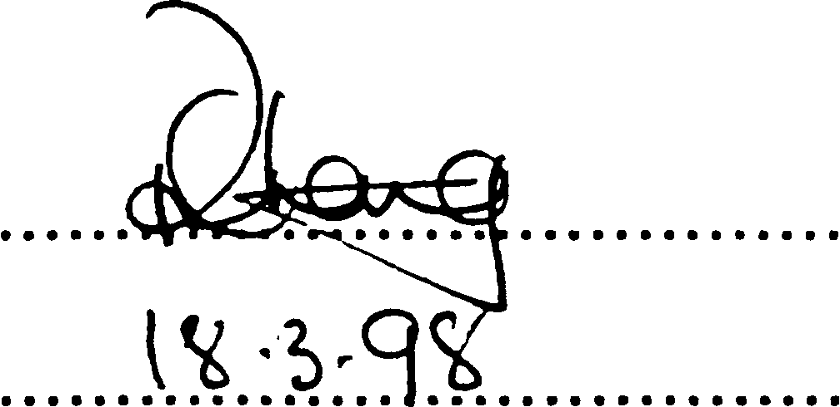
CAA Approval No. DAI/1018/39
NOTE: The above certification does not apply to revisions or amendments made after the date of initial certification by other Approved
Organisations. Revisions or Amendments made by other Approved Organisations must each be separately certified and recorded
on separate record sheets.
The technical data in this document (or file) may contain US data and be controlled for export under the Export Administration
Regulations (EAR), 15 CFR Parts 730-774, ECCN: 9E991. Violations of these laws may be subject to fines and penalties under the Export
Administration Act.
©
SAFRAN LANDING SYSTEMS 2016 (AND SUBSEQUENT REVISION PAGE DATES)
This document and all information contained herein is the sole property of Safran Landing Systems (and/or its affiliated companies).
No intellectual property rights are granted by the delivery of this document or the disclosure of its content. This document shall not be
reproduced to a third party without the express written consent of Safran Landing Systems (and/or the appropriate affiliated company).
TITLE PAGE
32⁻12⁻22 Sep 16/2016

SAFRAN LANDING SYSTEMS UK Ltd
CAGE: K0654

INTENTIONALLY BLANK
32-12-22

>SAFRAN
PART No. 201587001 AND 201587002 COMPONENT MAINTENANCE MANUAL
MAIN LANDING GEAR LEG
TABLE OF CONTENTS
Page
Description and Operation 1
General 1
Description 1
Operation 1
Data 2
Testing and Fault Isolation 101
Equipment and Materials 101
Test Conditions 102
Procedure 102
Fault Isolation 109
Disassembly 301
General 301
Procedure 307
Cleaning 401
General 401
Procedure 401
Check 501
General 501
Detailed Inspection 501
Special Detailed Inspection 501
Repair 601
General 601
Repair Procedure Conditions 602
Protective Treatment 602
Approved Repairs 689
Repair No. 1-1 Lower Bearing Subassembly Repair No. 1-1 601
Repair No. 1-2 Lower Bearing Subassembly Repair No. 1-2 601
Repair No. 2-1 Pin Repair No. 2-1 601
Repair No. 3-1 Pivot Pin Repair No. 3-1 601
Repair No. 4-1 Uplock Pin Repair No. 4-1 601
Repair No. 5-1 Pin Repair No. 5-1 601
Repair No. 6-1 Pin Repair No. 6-1 601
Repair No. 6-2 Pin Repair No. 6-2 601
Repair No. 6-3 Pin Repair No. 6-3 601
Repair No. 7-1 Pin Repair No. 7-1 601
Repair No. 7-2 Pin Repair No. 7-2 601
Repair No. 8-1 Bracket Repair No. 8-1 601
Repair No. 8-2 Bracket Repair No. 8-2 601
Repair No. 9-1 Sliding Tube Repair No. 9-1 601
Repair No. 9-2 Sliding Tube Repair No. 9-2 601
Repair No. 9-3 Sliding Tube (Superseded) Repair No. 9-3 601
Repair No. 9-4 Sliding Tube Repair No. 9-4 601
Repair No. 9-5 Sliding Tube Repair No. 9-5 601

TABLE OF CONTENTS
32
Page 1
-- Mar 18/2025

