MAIN LANDING GEAR LEG
PART NUMBER

201587001, 201587002
201587003, 201587004
201587005, 201587006
201587007, 201587008
COMPONENT MAINTENANCE MANUAL WITH
ILLUSTRATED PARTS LIST
STATEMENT OF INITIAL CERTIFICATION
This manual complies with British Civil Airworthiness Requirements, Section A, Chapter A5-3.
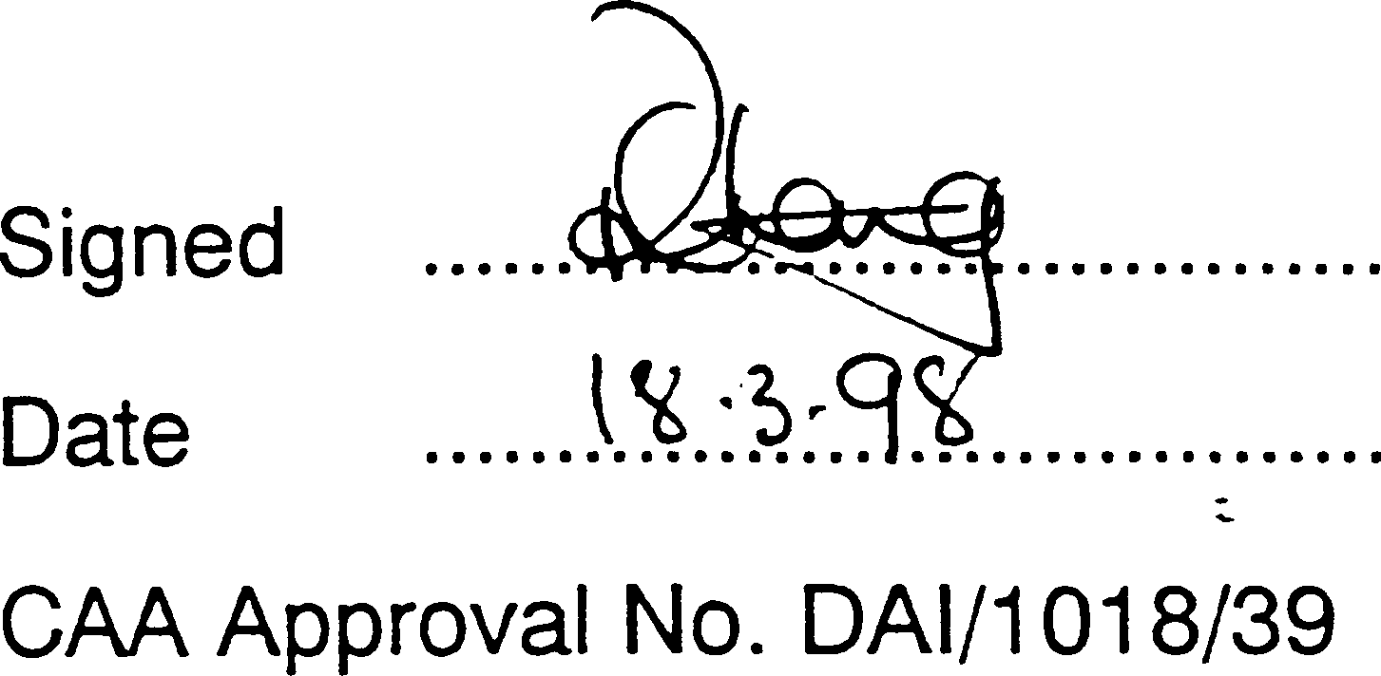

NOTE: The above certification does not apply to revisions or amendments made after the date of initial certification by other Approved Organisations. Revisions or Amendments made by other Approved Organisations must each be separately certified and recorded on separate record sheets.

The technical data in this document (or file) may contain US data and be controlled for export under the Export Administration Regulations (EAR), 15 CFR Parts 730-774, ECCN: 9E991. Violations of these laws may be subject to fines and penalties under the Export Administration Act.
©
SAFRAN LANDING SYSTEMS 2016 (AND SUBSEQUENT REVISION PAGE DATES)
This document and all information contained herein is the sole property of Safran Landing Systems (and/or its affiliated companies).
No intellectual property rights are granted by the delivery of this document or the disclosure of its content. This document shall not be reproduced to a third party without the express written consent of Safran Landing Systems (and/or the appropriate affiliated company).

PART No. 201587001 AND 201587002 COMPONENT MAINTENANCE MANUAL MAIN LANDING GEAR LEG

INTENTIONALLY BLANK

32-12-22

РУКОВОДСТВО ПО ТЕХНИЧЕСКОМУ ОБСЛУЖИВАНИЮ КОМПОНЕНТА 32-12-22 ОСНОВНАЯ СТОЙКА ШАССИ
СОПРОВОДИТЕЛЬНОЕ ПИСЬМО К РЕВИЗИИ № 69
- ПОСТОЯННЫЕ РЕВИЗИИ
  - Убедиться, что ревизия № 68 внесена в руководство и зарегистрирована как вставленная..
- NEW/REVISED PAGES

Subject Reference | Remove and Destroy Pages | Insert New/Revised |  | Reason for Change
Subject Reference | Remove and Destroy Pages | Pages | Dated | Reason for Change
Record of Revisions | 1 | 1 | Mar 18/2025 | Updated revision status
Unit Identification Chart | 1 to 4 | 1 to 8 | Mar 18/2025 | Added Ref. Codes 2253 and 2255 details
List of Effective Pages | 1 to 14 | 1 to 16 | Mar 18/2025 | Updated pages
Table of Contents | 1 to 12 | 1 to 14 | Mar 18/2025 | Added content. Updated page numbers. Updated figure numbers
Disassembly | 314 to 316 | 314 to 316 | Mar 18/2025 | Added para 2.P.(31)
Check | 504, 507 to 512 | 504, 507 to 514 | Mar 18/2025 | Updated tables 501 and 502
Repair | 606 to 684 | 606 to 698.2 | Mar 18/2025 | Updated table 601. Updated caution at para  3.C. Updated figure titles. Deleted figures 626, 627, 649, 650, 653  and 654. Updated figure 626. Added figures 642  648. Updated table 602. Updated figure numbers
Repair No. 9-1 | 601 and 602 | 601 and 602 | Mar 18/2025 | Added fig-item (18-80A) in para 1. Updated Messier-Dowty Limited to Safran Landing Systems
Repair No. 9-2 | 601 to 603 | 601 to 603 | Mar 18/2025 | Added fig-item (18-80A) in para 1. Updated Messier-Dowty Limited to Safran Landing Systems

Subject Reference | Remove and Destroy Pages | Insert New/Revised |  | Reason for Change
Subject Reference | Remove and Destroy Pages | Pages | Dated | Reason for Change
Repair No. 9-4 | 601 and 602 | 601 and 602 | Mar 18/2025 | Added fig-item (18-80A)  in para 1. Updated Messier-Dowty Limited to Safran Landing Systems
Repair No. 9-5 | 601 | 601 | Mar 18/2025 | Added fig-item (18-80A) in paras 1. Updated Messier-Dowty Limited to Safran Landing Systems
Repair No. 9-6 | 601 and 602 | 601 and 602 | Mar 18/2025 | Added fig-item (18-80A) in para 1. Updated Messier-Dowty Limited to Safran Landing Systems
Repair No. 9-7 | 601 and 602 | 601 and 602 | Mar 18/2025 | Added fig-item (18-80A) in paras 1. and 1.A.(2)
Repair No. 9-8 | 601 to 603 and  605 | 601 to 603 and  605 | Mar 18/2025 | Added fig-item (18-80A) in para 1. Updated Messier-Dowty Limited to Safran Landing Systems. Updated conversion value in figure 602
Repair No. 9-9 | 601 and 602 | 601 and 602 | Mar 18/2025 | Added fig-item (18-80A) in para 1. Updated Messier-Dowty Limited to Safran Landing Systems
Repair No. 9-10 | 601 to 606 | 601 to 608 | Mar 18/2025 | Added fig-item (18-80A) in para 1. Updated Messier-Dowty Limited to Safran Landing Systems
Repair No. 9-11 | 601, 602 and 605 | 601, 602 and 605 | Mar 18/2025 | Added fig-item (18-80A) in para 1. Updated material specification in para 1.D.(1). Updated Messier-Dowty Limited to Safran Landing System. Updated  figure 603

