
SAFRAN LANDING SYSTEMS UK Ltd
CAGE: K0654
Cheltenham Road, Gloucester, GL2 9QH, England
Telephone: +44 (0) 1452 712424 www.safran-landing-systems.com

MAIN LANDING GEAR LEG
PART NUMBER

201587001, 201587002
201587003, 201587004
201587005, 201587006
201587007, 201587008
COMPONENT MAINTENANCE MANUAL WITH
ILLUSTRATED PARTS LIST
STATEMENT OF INITIAL CERTIFICATION
This manual complies with British Civil Airworthiness Requirements, Section A, Chapter A5-3.
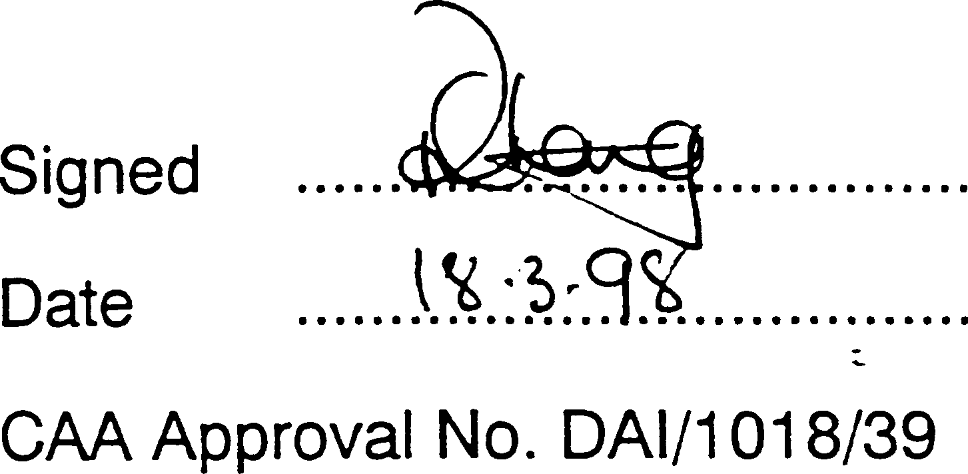

NOTE: The above certification does not apply to revisions or amendments made after the date of initial certification by other Approved Organisations. Revisions or Amendments made by other Approved Organisations must each be separately certified and recorded on separate record sheets.

The technical data in this document (or file) may contain US data and be controlled for export under the Export Administration Regulations (EAR), 15 CFR Parts 730-774, ECCN: 9E991. Violations of these laws may be subject to fines and penalties under the Export Administration Act.
©
SAFRAN LANDING SYSTEMS 2016 (AND SUBSEQUENT REVISION PAGE DATES)
This document and all information contained herein is the sole property of Safran Landing Systems (and/or its affiliated companies).
No intellectual property rights are granted by the delivery of this document or the disclosure of its content. This document shall not be reproduced to a third party without the express written consent of Safran Landing Systems (and/or the appropriate affiliated company).

32-12-22

TITLE PAGE Sep 16/2016

SAFRAN LANDING SYSTEMS UK Ltd
CAGE: K0654
PART No. 201587001 AND 201587002 COMPONENT MAINTENANCE MANUAL MAIN LANDING GEAR LEG

INTENTIONALLY BLANK

32-12-22

SAFRAN LANDING SYSTEMS UK Ltd
CAGE: K0654
Cheltenham Road, Gloucester, GL2 9QH, England
Telephone: +44 (0) 1452 712424 www.safran-landing-systems.com

РУКОВОДСТВО ПО ТЕХНИЧЕСКОМУ ОБСЛУЖИВАНИЮ КОМПОНЕНТА 32-12-22 ОСНОВНАЯ СТОЙКА ШАССИ
СОПРОВОДИТЕЛЬНОЕ ПИСЬМО К РЕВИЗИИ № 69
- ПОСТОЯННЫЕ РЕВИЗИИ
A. Убедиться, что ревизия № 68 внесена в руководство и зарегистрирована как вставленная..

NEW/REVISED PAGES

Subject Reference | Remove and Destroy Pages | Insert New/Revised |  | Reason for Change
Subject Reference | Remove and Destroy Pages | Pages | Dated | Reason for Change
Record of Revisions | 1 | 1 | Mar 18/2025 | Updated revision status
Unit Identification Chart | 1 to 4 | 1 to 8 | Mar 18/2025 | Added Ref. Codes 2253 and 2255 details
List of Effective Pages | 1 to 14 | 1 to 16 | Mar 18/2025 | Updated pages
Table of Contents | 1 to 12 | 1 to 14 | Mar 18/2025 | Added content. Updated page numbers. Updated figure numbers
Disassembly | 314 to 316 | 314 to 316 | Mar 18/2025 | Added para 2.P.(31)
Check | 504, 507 to 512 | 504, 507 to 514 | Mar 18/2025 | Updated tables 501 and 502
Repair | 606 to 684 | 606 to 698.2 | Mar 18/2025 | Updated table 601. Updated caution at para  3.C. Updated figure titles. Deleted figures 626, 627, 649, 650, 653  and 654. Updated figure 626. Added figures 642  648. Updated table 602. Updated figure numbers
Repair No. 9-1 | 601 and 602 | 601 and 602 | Mar 18/2025 | Added fig-item (18-80A) in para 1. Updated Messier-Dowty Limited to Safran Landing Systems
Repair No. 9-2 | 601 to 603 | 601 to 603 | Mar 18/2025 | Added fig-item (18-80A) in para 1. Updated Messier-Dowty Limited to Safran Landing Systems

Mar 18/2025
Letter of Transmittal No. 69
Page 1 of 8
Page Repair No. 11-37 Main Fitting . . . . . . . . . . . . . . . . . . . . . . . . . . . . . . . . . . . . . Repair No. 11-37 601
Repair No. 12-1 Lower Torque Link . . . . . . . . . . . . . . . . . . . . . . . . . . . . . . . . . Repair No. 12-1 601
Repair No. 12-2 Upper Torque Link . . . . . . . . . . . . . . . . . . . . . . . . . . . . . . . . . Repair No. 12-2 601
Repair No. 12-3 Upper Torque Link . . . . . . . . . . . . . . . . . . . . . . . . . . . . . . . . . Repair No. 12-3 601
Repair No. 12-4 Lower Torque Link . . . . . . . . . . . . . . . . . . . . . . . . . . . . . . . . . Repair No. 12-4 601
Repair No. 12-5 Upper Torque Link . . . . . . . . . . . . . . . . . . . . . . . . . . . . . . . . . Repair No. 12-5 601
Repair No. 13-1 Upper Slave Link . . . . . . . . . . . . . . . . . . . . . . . . . . . . . . . . . . Repair No. 13-1 601
Repair No. 13-2 Upper Slave Link . . . . . . . . . . . . . . . . . . . . . . . . . . . . . . . . . . Repair No. 13-2 601
Repair No. 14-1 Upper Diaphragm Tube . . . . . . . . . . . . . . . . . . . . . . . . . . . . . Repair No. 14-1 601
Repair No. 14-2 Upper Diaphragm Tube . . . . . . . . . . . . . . . . . . . . . . . . . . . . . Repair No. 14-2 601
Repair No. 14-3 Upper Diaphragm Tube . . . . . . . . . . . . . . . . . . . . . . . . . . . . . Repair No. 14-3 601
Repair No. 14-4 Upper Diaphragm Tube . . . . . . . . . . . . . . . . . . . . . . . . . . . . . Repair No. 14-4 601
Repair No. 15-1 Bracket . . . . . . . . . . . . . . . . . . . . . . . . . . . . . . . . . . . . . . . . . . Repair No. 15-1 601
Repair No. 15-2 Bracket . . . . . . . . . . . . . . . . . . . . . . . . . . . . . . . . . . . . . . . . . . Repair No. 15-2 601
Repair No. 16-1 Bracket . . . . . . . . . . . . . . . . . . . . . . . . . . . . . . . . . . . . . . . . . . Repair No. 16-1 601
Repair No. 17-1 Pivot Bracket. . . . . . . . . . . . . . . . . . . . . . . . . . . . . . . . . . . . . . Repair No. 17-1 601
Repair No. 18-1 Cylinder. . . . . . . . . . . . . . . . . . . . . . . . . . . . . . . . . . . . . . . . . . Repair No. 18-1 601
Repair No. 18-2 Cylinder. . . . . . . . . . . . . . . . . . . . . . . . . . . . . . . . . . . . . . . . . . Repair No. 18-2 601
Repair No. 18-3 Cylinder (Withdrawn) . . . . . . . . . . . . . . . . . . . . . . . . . . . . . . . Repair No. 18-3 601
Repair No. 18-4 Cylinder. . . . . . . . . . . . . . . . . . . . . . . . . . . . . . . . . . . . . . . . . . Repair No. 18-4 601
Repair No. 18-5 Cylinder. . . . . . . . . . . . . . . . . . . . . . . . . . . . . . . . . . . . . . . . . . Repair No. 18-5 601
Repair No. 18-6 Cylinder. . . . . . . . . . . . . . . . . . . . . . . . . . . . . . . . . . . . . . . . . . Repair No. 18-6 601
Repair No. 18-7 Cylinder. . . . . . . . . . . . . . . . . . . . . . . . . . . . . . . . . . . . . . . . . . Repair No. 18-7 601
Repair No. 18-8 Cylinder. . . . . . . . . . . . . . . . . . . . . . . . . . . . . . . . . . . . . . . . . . Repair No. 18-8 601
Repair No. 19-1 Lock Stay Cardan . . . . . . . . . . . . . . . . . . . . . . . . . . . . . . . . . . Repair No. 19-1 601
Repair No. 19-2 Lock Stay Cardan . . . . . . . . . . . . . . . . . . . . . . . . . . . . . . . . . . Repair No. 19-2 601
Repair No. 20-1 Lower Slave Link . . . . . . . . . . . . . . . . . . . . . . . . . . . . . . . . . . Repair No. 19-2 601
Repair No. 21-1 Transfer Block . . . . . . . . . . . . . . . . . . . . . . . . . . . . . . . . . . . . . Repair No. 21-1 601
Repair No. 21-2 Transfer Block . . . . . . . . . . . . . . . . . . . . . . . . . . . . . . . . . . . . . Repair No. 21-2 601
Repair No. 21-3 Transfer Block . . . . . . . . . . . . . . . . . . . . . . . . . . . . . . . . . . . . . Repair No. 21-3 601
Repair No. 21-4 Transfer Block. . . . . . . . . . . . . . . . . . . . . . . . . . . . . . . . . . . . . Repair No. 21-4 601
Repair No. 21-5 Transfer Block. . . . . . . . . . . . . . . . . . . . . . . . . . . . . . . . . . . . . Repair No. 21-5 601
Repair No. 21-6 Transfer Block. . . . . . . . . . . . . . . . . . . . . . . . . . . . . . . . . . . . . Repair No. 21-6 601
Repair No. 22-1 Spherical Bearing . . . . . . . . . . . . . . . . . . . . . . . . . . . . . . . . . . Repair No. 22-1 601
Repair No. 23-1 Pintle pin. . . . . . . . . . . . . . . . . . . . . . . . . . . . . . . . . . . . . . . . . Repair No. 23-1 601
Repair No. 23-2 Pintle Pin. . . . . . . . . . . . . . . . . . . . . . . . . . . . . . . . . . . . . . . . . Repair No. 23-2 601
Repair No. 24-1 Harness Support Bracket . . . . . . . . . . . . . . . . . . . . . . . . . . . . Repair No. 24-1 601
Repair No. 25-1 Retaining Pin . . . . . . . . . . . . . . . . . . . . . . . . . . . . . . . . . . . . . Repair No. 25-1 601
Repair No. 25-2 Retaining Pin . . . . . . . . . . . . . . . . . . . . . . . . . . . . . . . . . . . . . Repair No. 25-2 601
Repair No. 26-1 Upper Pivot Bracket . . . . . . . . . . . . . . . . . . . . . . . . . . . . . . . . Repair No. 26-1 601
Assembly (Including Storage) . . . . . . . . . . . . . . . . . . . . . . . . . . . . . . . . . . . . . . . . . . . . . . . . . . 701
General . . . . . . . . . . . . . . . . . . . . . . . . . . . . . . . . . . . . . . . . . . . . . . . . . . . . . . . . . . . . . . . . . . . 701
Procedure . . . . . . . . . . . . . . . . . . . . . . . . . . . . . . . . . . . . . . . . . . . . . . . . . . . . . . . . . . . . . . . . . 706

TABLE OF CONTENTS

Storage 798.12
Fits and Clearances . . . . . . . . . . . . . . . . . . . . . . . . . . . . . . . . . . . . . . . . . . . . . . . . . . . . . . . . . 801
Fits and Clearances Definitions . . . . . . . . . . . . . . . . . . . . . . . . . . . . . . . . . . . . . . . . . . . . . 801
Remarks. . . . . . . . . . . . . . . . . . . . . . . . . . . . . . . . . . . . . . . . . . . . . . . . . . . . . . . . . . . . . . . 869
Torque Data . . . . . . . . . . . . . . . . . . . . . . . . . . . . . . . . . . . . . . . . . . . . . . . . . . . . . . . . . . . . 869
Special Tools, Fixtures and Equipment . . . . . . . . . . . . . . . . . . . . . . . . . . . . . . . . . . . . . . . . . . . 901
General . . . . . . . . . . . . . . . . . . . . . . . . . . . . . . . . . . . . . . . . . . . . . . . . . . . . . . . . . . . . . . . 901
Illustrated Parts List. . . . . . . . . . . . . . . . . . . . . . . . . . . . . . . . . . . . . . . . . . . . . . . . . . . . . . . . . . 1001
Introduction . . . . . . . . . . . . . . . . . . . . . . . . . . . . . . . . . . . . . . . . . . . . . . . . . . . . . . . . . . . . 1002
How To Use This Illustrated Parts List . . . . . . . . . . . . . . . . . . . . . . . . . . . . . . . . . . . . . . . . 1003
Vendor Codes, Names and Addresses . . . . . . . . . . . . . . . . . . . . . . . . . . . . . . . . . . . . . . . 1004
Numerical Index . . . . . . . . . . . . . . . . . . . . . . . . . . . . . . . . . . . . . . . . . . . . . . . . . . . . . . . . . 1005
Detailed Parts List . . . . . . . . . . . . . . . . . . . . . . . . . . . . . . . . . . . . . . . . . . . . . . . . . . . . . . . 1031
ILLUSTRATIONS
Fig. Page
- Main Landing Gear Leg . . . . . . . . . . . . . . . . . . . . . . . . . . . . . . . . . . . . . . . . . . . . . . . . 3
- Diagram of Operation. . . . . . . . . . . . . . . . . . . . . . . . . . . . . . . . . . . . . . . . . . . . . . . . . . 4
- Main Landing Gear Leg (1-1). . . . . . . . . . . . . . . . . . . . . . . . . . . . . . . . . . . . . . . . . . . . 105
- Electrical Bonding Resistance Test Points (Tables 101 and 102) . . . . . . . . . . . . . . . . 108
- Bracket (2-120 and 2-130) - Protective Treatment. . . . . . . . . . . . . . . . . . . . . . . . . . . . 622
- Transfer Block (2-340, 2-340A, 2-350 and 2-350A) - Protective Treatment. . . . . . . . . 623
- Bracket (4-140 and 4-150) - Protective Treatment. . . . . . . . . . . . . . . . . . . . . . . . . . . . 624
- Bracket (5-160) - Protective Treatment . . . . . . . . . . . . . . . . . . . . . . . . . . . . . . . . . . . . 625
- Bracket (6-170 and 6-180) - Protective Treatment. . . . . . . . . . . . . . . . . . . . . . . . . . . . 626
- Slave Link (6-230) - Protective Treatment . . . . . . . . . . . . . . . . . . . . . . . . . . . . . . . . . . 627
- Slave Link (6-230A) - Protective Treatment . . . . . . . . . . . . . . . . . . . . . . . . . . . . . . . . . 628
- Pin (10-80) - Protective Treatment. . . . . . . . . . . . . . . . . . . . . . . . . . . . . . . . . . . . . . . . 629
- . . . . . . . . . . . . . . . . . . . . . . . . . . . . . . . . . . . . . . . . . . . . . . . . . . . . . . . . . . . . . . . . . . . 630
- Pin (11-130) - Protective Treatment . . . . . . . . . . . . . . . . . . . . . . . . . . . . . . . . . . . . . . . 631
- . . . . . . . . . . . . . . . . . . . . . . . . . . . . . . . . . . . . . . . . . . . . . . . . . . . . . . . . . . . . . . . . . . . 632
- Valve Stem (12-90) - Protective Treatment . . . . . . . . . . . . . . . . . . . . . . . . . . . . . . . . . 633
- Retaining Pin (13-10) - Protective Treatment. . . . . . . . . . . . . . . . . . . . . . . . . . . . . . . . 633
- Inflation Valve (13-110A) - Protective Treatment . . . . . . . . . . . . . . . . . . . . . . . . . . . . . 634
- Pin (13-190 and 13-190A) - Protective Treatment . . . . . . . . . . . . . . . . . . . . . . . . . . . . 635
- Upper Diaphragm Tube (15-390) - Protective Treatment. . . . . . . . . . . . . . . . . . . . . . . 636
- Cylinder (17-230) - Protective Treatment. . . . . . . . . . . . . . . . . . . . . . . . . . . . . . . . . . . 637
- Sliding Tube (18-80) or (18-80A) - Protective Treatment (Sheet 1) . . . . . . . . . . . . . . . 638
618 Sliding Tube (18-80) or (18-80A) - Protective Treatment (Sheet 2) . . . . . . . . . . . . . . . 639
619 Main Fitting Subassembly (20-90, 20-90A, 20-100 and 20-100A)
- Protective Treatment (Sheet 1) . . . . . . . . . . . . . . . . . . . . . . . . . . . . . . . . . . . . . . . . . 640
619 Main Fitting Subassembly (20-90, 20-90A, 20-100 and 20-100A)
- Protective Treatment (Sheet 2) . . . . . . . . . . . . . . . . . . . . . . . . . . . . . . . . . . . . . . . . . 641
620 Main Fitting (20-410) and (20-420) - Protective Treatment . . . . . . . . . . . . . . . . . . . .

INTENTIONALLY BLANK

- This manual contains Description, Operation, Maintenance procedures and an Illustrated Parts List (IPL). IPL Figure and Item numbers in parentheses follow the part name to identify them.
- A Unit Identification Chart is included to show the modification status of the unit. The modification status is related to the unit part number by the dash number: the dash number is marked on the unit name plate adjacent to the part number.
- All references in this manual are to the left configuration of the unit unless the instructions tell you differently.
- All dimensions and quantities in this manual are in SI units with Imperial units in parentheses. A comma shows a decimal part of an SI unit. A full point shows a decimal part of an Imperial unit.
- This manual refers to Process Specifications (M-DLPS and PCS) and Non-destructive Tests (M-DLNDT). These are available within the Safran Landing Systems Technical Publications on-line service.
- All the materials in this manual have a Ref. Item identification. This is the reference item number of the material in the Aircraft Manufacturer’s Consumable Materials List.
- Use approved persons and good aircraft engineering practice for all procedures in this manual.
- The repairs in this CMM have been approved under Airbus’ EASA Design Organisation Approval No. EASA.21J.031.
- On occasion a REF. CODE can be identified in the NOMENCLATURE column in the DETAILED PARTS LIST. This is a Safran Landing Systems reference code and is used for cross-reference purposes only.
- The accuracy and the adequacy of the instructions in this CMM have been technically verified by shop verification (performed or simulated) or by similarity with manufacturing instructions or with component maintenance manuals instructions from other programs that have been verified in shop.
- Reference Publications
  - Safran Landing Systems UK Ltd Component Maintenance Manual, Main Landing Gear Leg and Dressings, 32-12-21.
  - Safran Landing Systems UK Ltd Component Maintenance Manual, Axle Harness 1M and 2M, 32-12-29.
  - Safran Landing Systems UK Ltd Component Maintenance Manual, Damper, 32-11-93.
  - Safran Landing Systems UK Ltd Component Maintenance Manual, Damper, 32-12-85.

32-12-22

INTRODUCTION
Page 1

INTENTIONALLY BLANK

DESCRIPTION AND OPERATION
- General
  - The main landing gear leg is a two stage, telescopic shock absorber.
- Description (Refer to Figures 1 and 2)
  - The main landing gear leg has a sliding tube subassembly that operates in a main fitting subassembly. The sliding tube subassembly operates through a lower bearing subassembly. The lower bearing subassembly also seals the sliding tube subassembly in the main fitting subassembly.
  - An upper torque link subassembly attaches to the main fitting subassembly. A lower torque link subassembly attaches to the sliding tube subassembly. A damper attaches to the upper torque link subassembly. A pin installs through the damper and connects the upper and lower torque link subassemblies.
  - A slave link subassembly and a lower slave link subassembly attach opposite the upper and lower torque link subassemblies.
  - A rod and a cylinder install in the sliding tube subassembly. A piston installs in the cylinder. An upper diaphragm tube subassembly installs in the main fitting subassembly. A baffle, a compression orifice plate and a diaphragm subassembly install in the upper diaphragm tube subassembly. The rod goes through the baffle.
  - An upper bearing housing installs between the top of the sliding tube subassembly and the main fitting subassembly. A recoil orifice plate operates in the upper bearing housing.
- Operation (Refer to Figure 2)
  - Compression
    - The sliding tube subassembly moves into the main fitting subassembly. The subsequent decrease in volume causes hydraulic fluid to flow through the upper bearing housing: the recoil orifice plate moves and slows the flow of hydraulic fluid. The decrease in volume also causes hydraulic fluid to move through the diaphragm and lift the compression orifice plate: the hydraulic fluid flows through the baffle and into the upper diaphragm tube subassembly. This slows the speed of the compression.
    - Hydraulic fluid that moves into the upper diaphragm tube compresses the nitrogen in the main fitting subassembly and the upper diaphragm tube subassembly. As the pressure of the nitrogen increases, the hydraulic fluid in the rod moves against the piston. The piston is pushed into the cylinder and compresses the nitrogen in it. This slows the speed of the compression more.
  - Recoil
    - After compression, the nitrogen pressure in the cylinder pushes the piston to the end of the cylinder: hydraulic fluid moves out of the cylinder and into the rod. The nitrogen pressure in the main fitting subassembly and the upper diaphragm subassembly pushes the hydraulic fluid through the baffle: the compression orifice plate is pushed against the diaphragm subassembly and limits the flow of hydraulic fluid through it. This slows the speed of the recoil. The sliding tube subassembly moves out of the main fitting subassembly.

  - The Upper and Lower Torque Link Subassemblies
    - The upper and lower torque link subassemblies prevent the sliding tube subassembly from turning in the main fitting subassembly.
    - The damper controls the movement of the upper and lower torque link subassemblies.
- Data
Weight with hydraulic fluid 522 kg (1151 lb) approximately
Weight without hydraulic fluid 505 kg (1113 lb) approximately
Hydraulic fluid . . . . . . . . . . . . . . . . . . . . . . . . . . . . . . . . . . . . . . . . . . . . . . Material Ref. Item 02-501

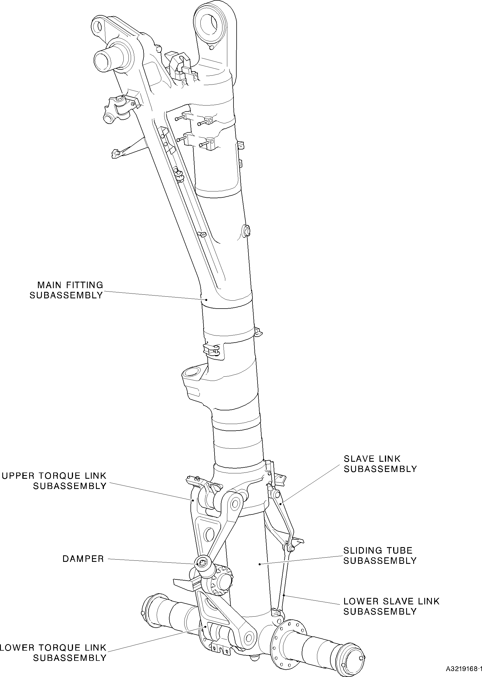

Main Landing Gear Leg Figure 1

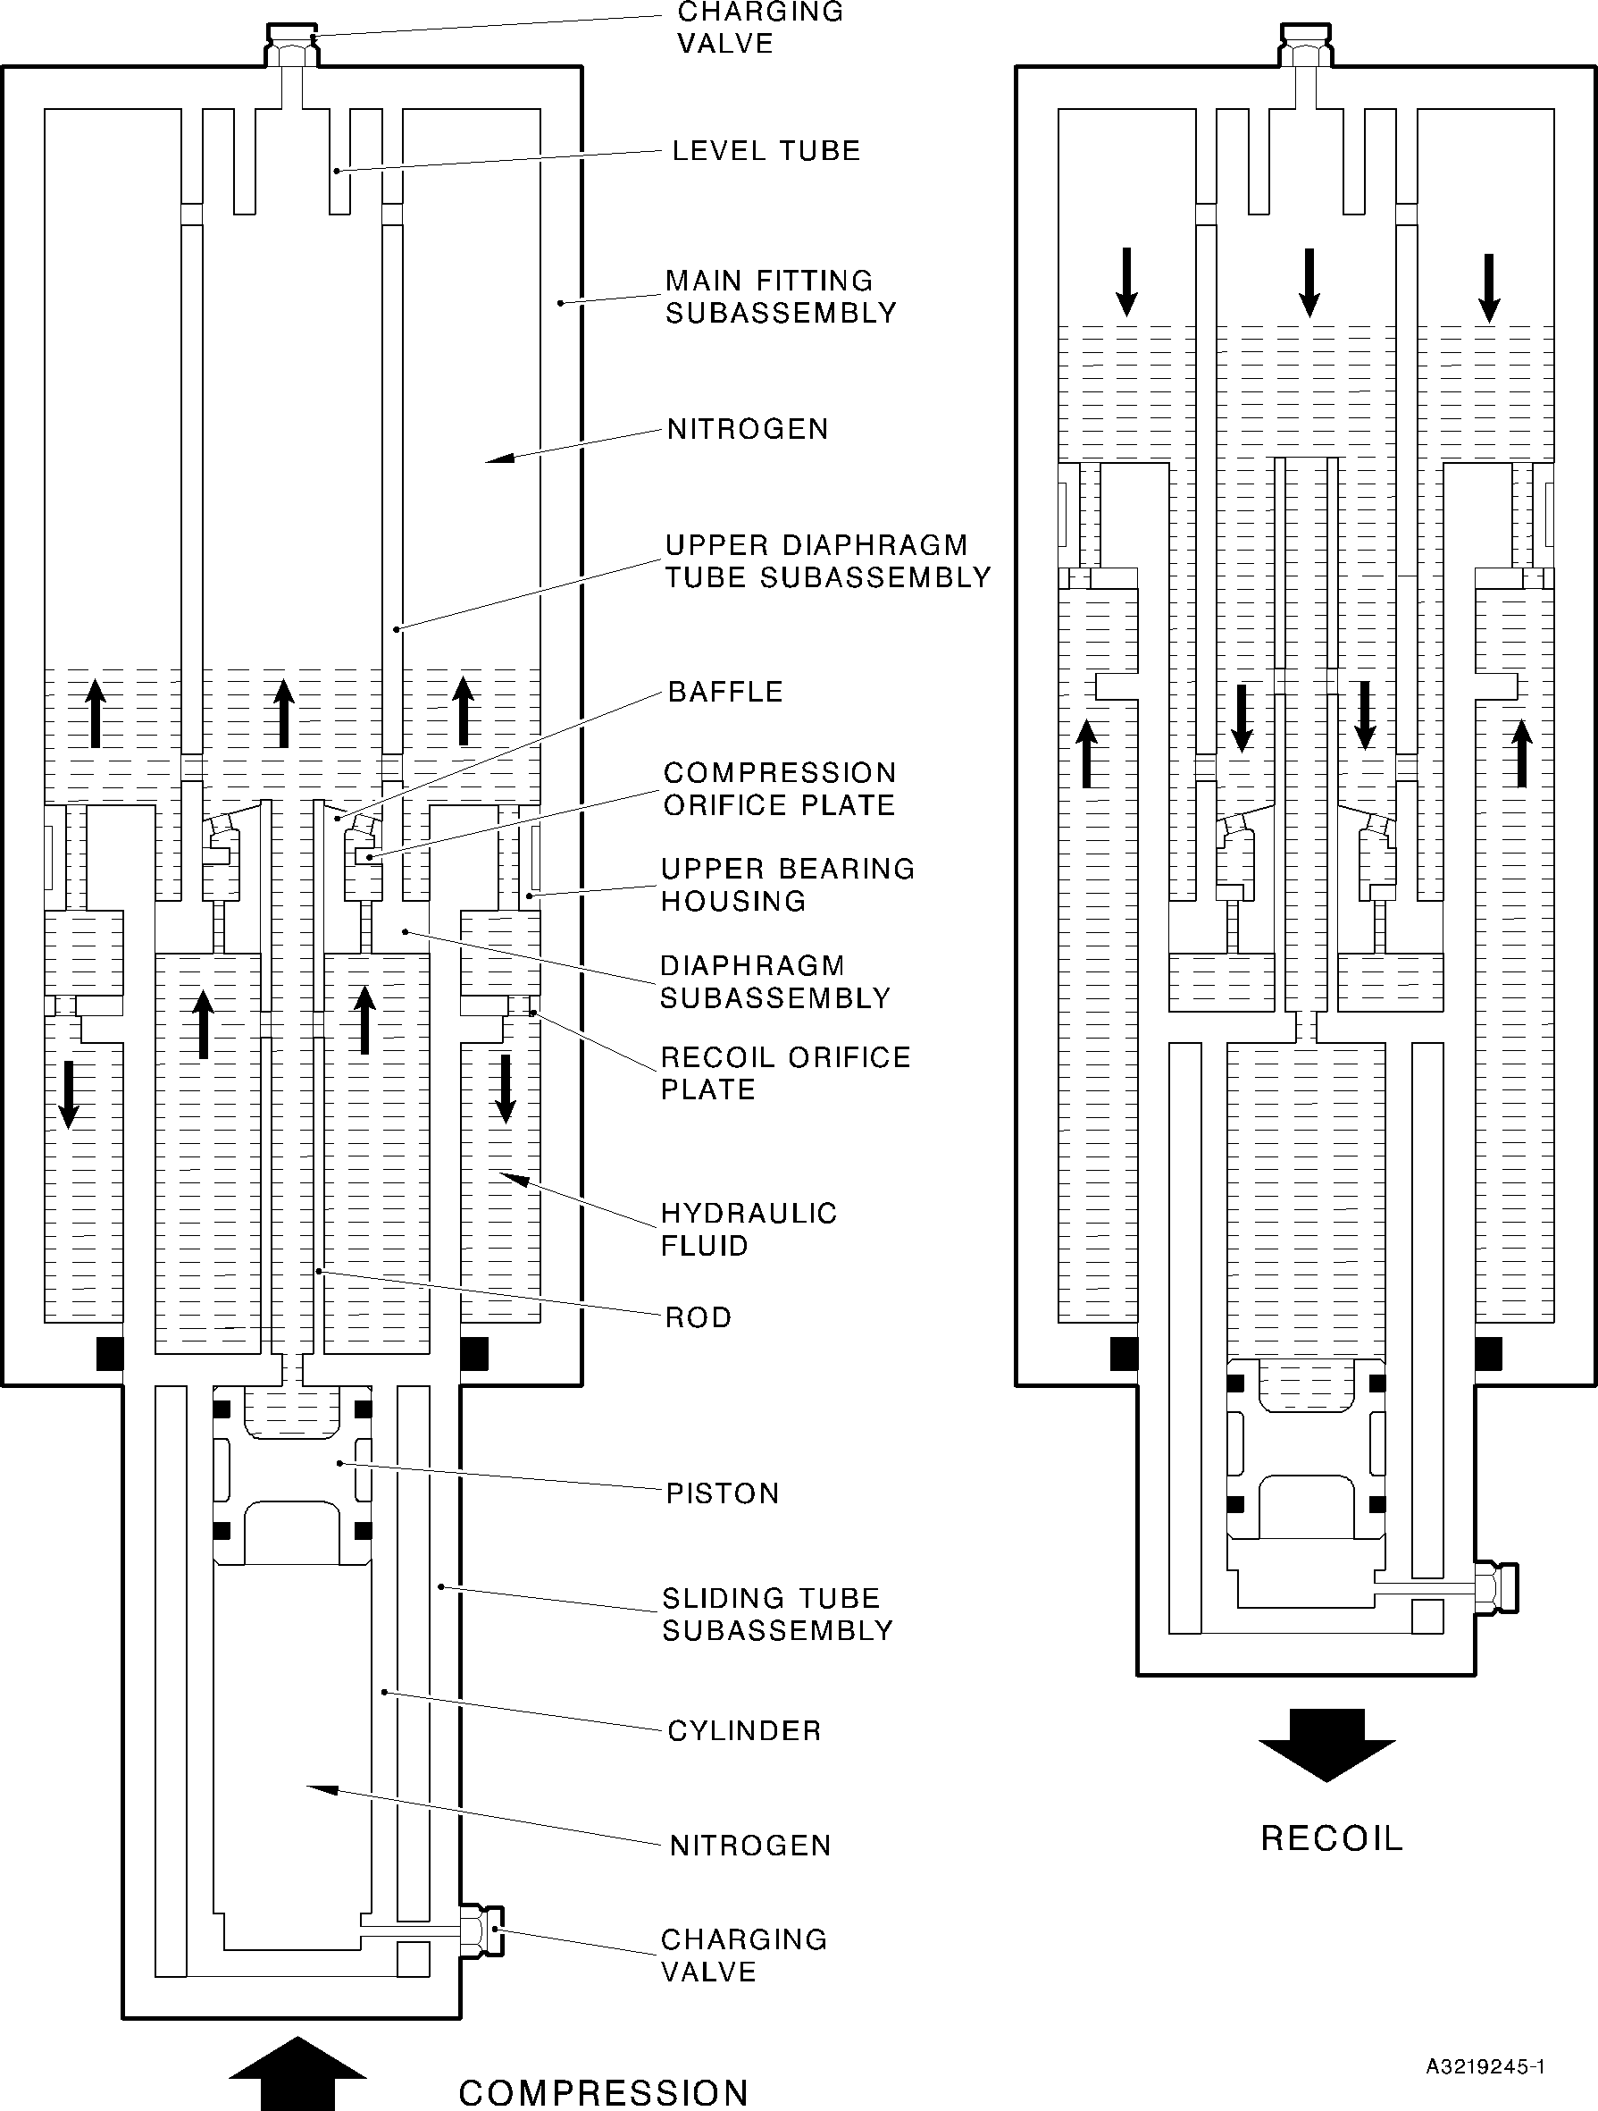

Diagram of Operation Figure 2

TESTING AND FAULT ISOLATION
- Equipment and Materials
  - Equipment
    - This equipment is necessary:

NOTE: Alternative equivalents are permitted.

Part No. | Equipment | Function
- | Hydraulic Test Rig
- | Nitrogen Supply | Main landing gear leg (1-1) tests
- | Loading Press
- | Milliohmmeter Megger, Type BT51 | Electrical bonding resistance tests
- | 28 VDC Power Supply | Proximity switch and target tests
T14218 | Turner Inflation Equipment | Main landing gear leg (1-1) tests
T14500 | Crowfoot Wrench | Close the charging valves (13-60 and 17-20)
460002502 | Charging Adapter | Main landing gear leg (1-1) tests
460005842 | Lampbox | Proximity switch and target tests
460006231 | Holding Fixture
460006232 | Load Cell and Adapter
460006233 | Press Adapter | Main landing gear leg (1-1) tests
460006234 | Offset Adapter
460007260 | Bottom Press Adapter
  - Materials
    - These materials are necessary:

NOTE: Alternative equivalents are permitted.

Ref. Item | Material
TBA | Nitrogen
02-501 | Hydraulic fluid

- Test Conditions

WARNING: DO NOT GET HYDRAULIC FLUID ON YOUR SKIN OR IN YOUR EYES. DO NOT BREATHE THE FUMES. ONLY USE IN A LOCATION THAT HAS A CONTINUOUS FLOW OF CLEAN AIR. HYDRAULIC FLUID IS POISONOUS AND DANGEROUS.
  - General
    - The hydraulic test rig must have a hand pump and a power pump. The power pump must have a controlled flow of not less than 4,5 l/min (4.62 in³/sec).
    - The inflation equipment must be to MIL-G-8348.
    - The temperature of the test fluid must be between 20 and 40 °C (68 and 104 °F).
    - The test fluid must be clean: refer to M-DLPS910-1.
    - During all hydraulic tests, the unit and the test circuit must be hydraulically full.
    - Examine the unit for damage before you start the tests.
    - During the proximity switch tests the ambient temperature must be between 15 and 25 °C (59 and 77 °F).
- Procedure
  - Piston (17-200) Leakage Tests
    - Use the Charging Adapter 460002502 and the Turner Inflation Equipment T14218: connect the charging valve (17-20) to the nitrogen supply. Open the charging valve (17-20).
    - Slowly increase the nitrogen pressure to between 9,32 and 10,68 bar (135 and
155 lbf/in²). Make a record of the pressure. Close the charging valve (17-20) and hold the nitrogen pressure for 15 minutes.
    - Open the charging valve (17-20) and measure the nitrogen pressure: it must be the same as the record in para (2). Leakage must not occur.
    - Release the nitrogen pressure.
    - Disconnect the nitrogen supply and remove the Turner Inflation Equipment T14218 and the Charging Adapter 460002502.
    - Make sure that all of the nitrogen pressure has been released: remove the charging valve (17-20).
    - Refer to ASSEMBLY: install the charging valve (17-20) and complete the assembly procedure.
  - Main Landing Gear Leg (1-1) Tests
    - Initial Operations
      - Use these special tools to install the main landing gear leg (1-1) vertically in the loading press:
        - The Holding Fixture 460006231.
        - The Press Adapter 460006233.

        - The Bottom Press Adapter 460007260.
      - Assemble the Load Cell and Adapter 460006232 and the Offset Adapter 460006234 to the main landing gear leg (1-1).
- Procedure to Fill and Pressurize the Main Landing Gear Leg (1-1)

CAUTION: DO NOT PUT AN END LOAD OF MORE THAN 5,08 TONNES (5 TONS) ON THE MAIN LANDING GEAR LEG (1-1).
  - Make sure that there is no pressure in the main landing gear leg (1-1): open the charging valves (13-60 and 17-20).
  - Use the Charging Adapter 460002502 to connect the hydraulic test rig to the charging valve (13-60).
  - Slowly increase the hydraulic pressure to between 13,11 and 14,48 bar (190 and 210 lbf/in²) and let the unit extend fully.
  - Release the hydraulic pressure and fully close the unit.
  - Do para (c) and (d) until the hydraulic fluid that comes out of the unit does not have air in it.
  - Fully close the unit and disconnect the hydraulic test rig.
  - Use the Charging Adapter 460002502 and the Turner Inflation Equipment T14218 to connect the nitrogen supply to the charging valve (13-60).

CAUTION: DO NOT USE A PRESSURE OF MORE THAN 7,58 BAR (110 LBF/IN²).
  - Slowly increase the nitrogen pressure until the unit starts to extend. Hold the pressure and fully extend the unit. The pressure must not be more than 7,58 bar
(110 lbf/in²).

NOTE: The charging valve (17-20) must be open to let the unit extend fully.
  - Refer to Figure 101 and measure the dimension X: it must be between 483,05 and 487,85 mm (19.017 and 19.207 in).
  - Disconnect the nitrogen supply and remove the Turner Inflation Equipment T14218 and the Charging Adapter 460002502.
  - Open the charging valve (13-60) and release the nitrogen pressure. Do not close the charging valve (13-60).
  - Use the Charging Adapter 460002502 and the Turner Inflation Equipment T14218 to connect the charging valve (17-20) to the nitrogen supply.
  - Slowly increase the nitrogen pressure to between 13,11 and 14,48 bar (190 and 210 lbf/in²).

NOTE: Nitrogen will be released through the charging valve (13-60) as the piston (17-200) moves.
  - Slowly increase the nitrogen pressure to between 67,59 and 70,34 bar (980 and1020 lbf/in²).

  - Close the charging valve (17-20); use the Crowfoot Wrench T14500 to torque it to between 5,7 and 7,9 N m (50 and 70 lbf in).
  - Disconnect the nitrogen supply and remove the Turner Inflation Equipment T14218 and the Charging Adapter 460002502.
  - Use the Turner Inflation Equipment T14218 and the Charging Adapter 460002502 to connect the nitrogen supply to the charging valve (13-60).
  - Slowly increase the nitrogen pressure to between 6,90 and 8,27 bar (100 and 120 lbf/in²).
  - Close the charging valve (13-60); use the Crowfoot Wrench T14500 to torque it to between 5,7 and 7,9 N m (50 and 70 lbf in).
  - Disconnect the nitrogen supply and remove the Turner Inflation Equipment T14218 and the Charging Adapter 460002502.
- Leakage Tests
  - Make a record of the nitrogen pressure at the charging valve (13-60), (P1A) and the charging valve (17-20), (P1B).
  - Make a record of the ambient temperature, (T1).
  - Keep the unit in this condition for a minimum of six hours.
  - Measure the nitrogen pressure at the charging valve (13-60), (P2A) and the charging valve (17-20), (P2B).
  - Measure the ambient temperature, (T2).
  - Compare the pressures P1A and P2A and compare the pressures P1B and P2B. The pressures P1A and P2A must be the same and the pressures P1B and P2B must be the same, unless:
    - There is a difference between the temperatures T1 and T2
    - There is an error because of the pressure gauge capacity.
  - If there is a difference between the temperatures T1 and T2, calculate the correct value for the nitrogen pressures (these will be P3A and P3B) and adjust the pressures to the corrected values. Use the formula:

P3A =

P3B =
(P2A + Z) x (T1 + K)
- Z
(T2 + K)
OR
(P2B + Z) x (T1 + K)
- Z
(T2 + K)

Where K = 273 for temperatures in °C
(459 for temperatures in °F)
Z = 1 for pressures in bar
(15 for pressures in lbf/in2)

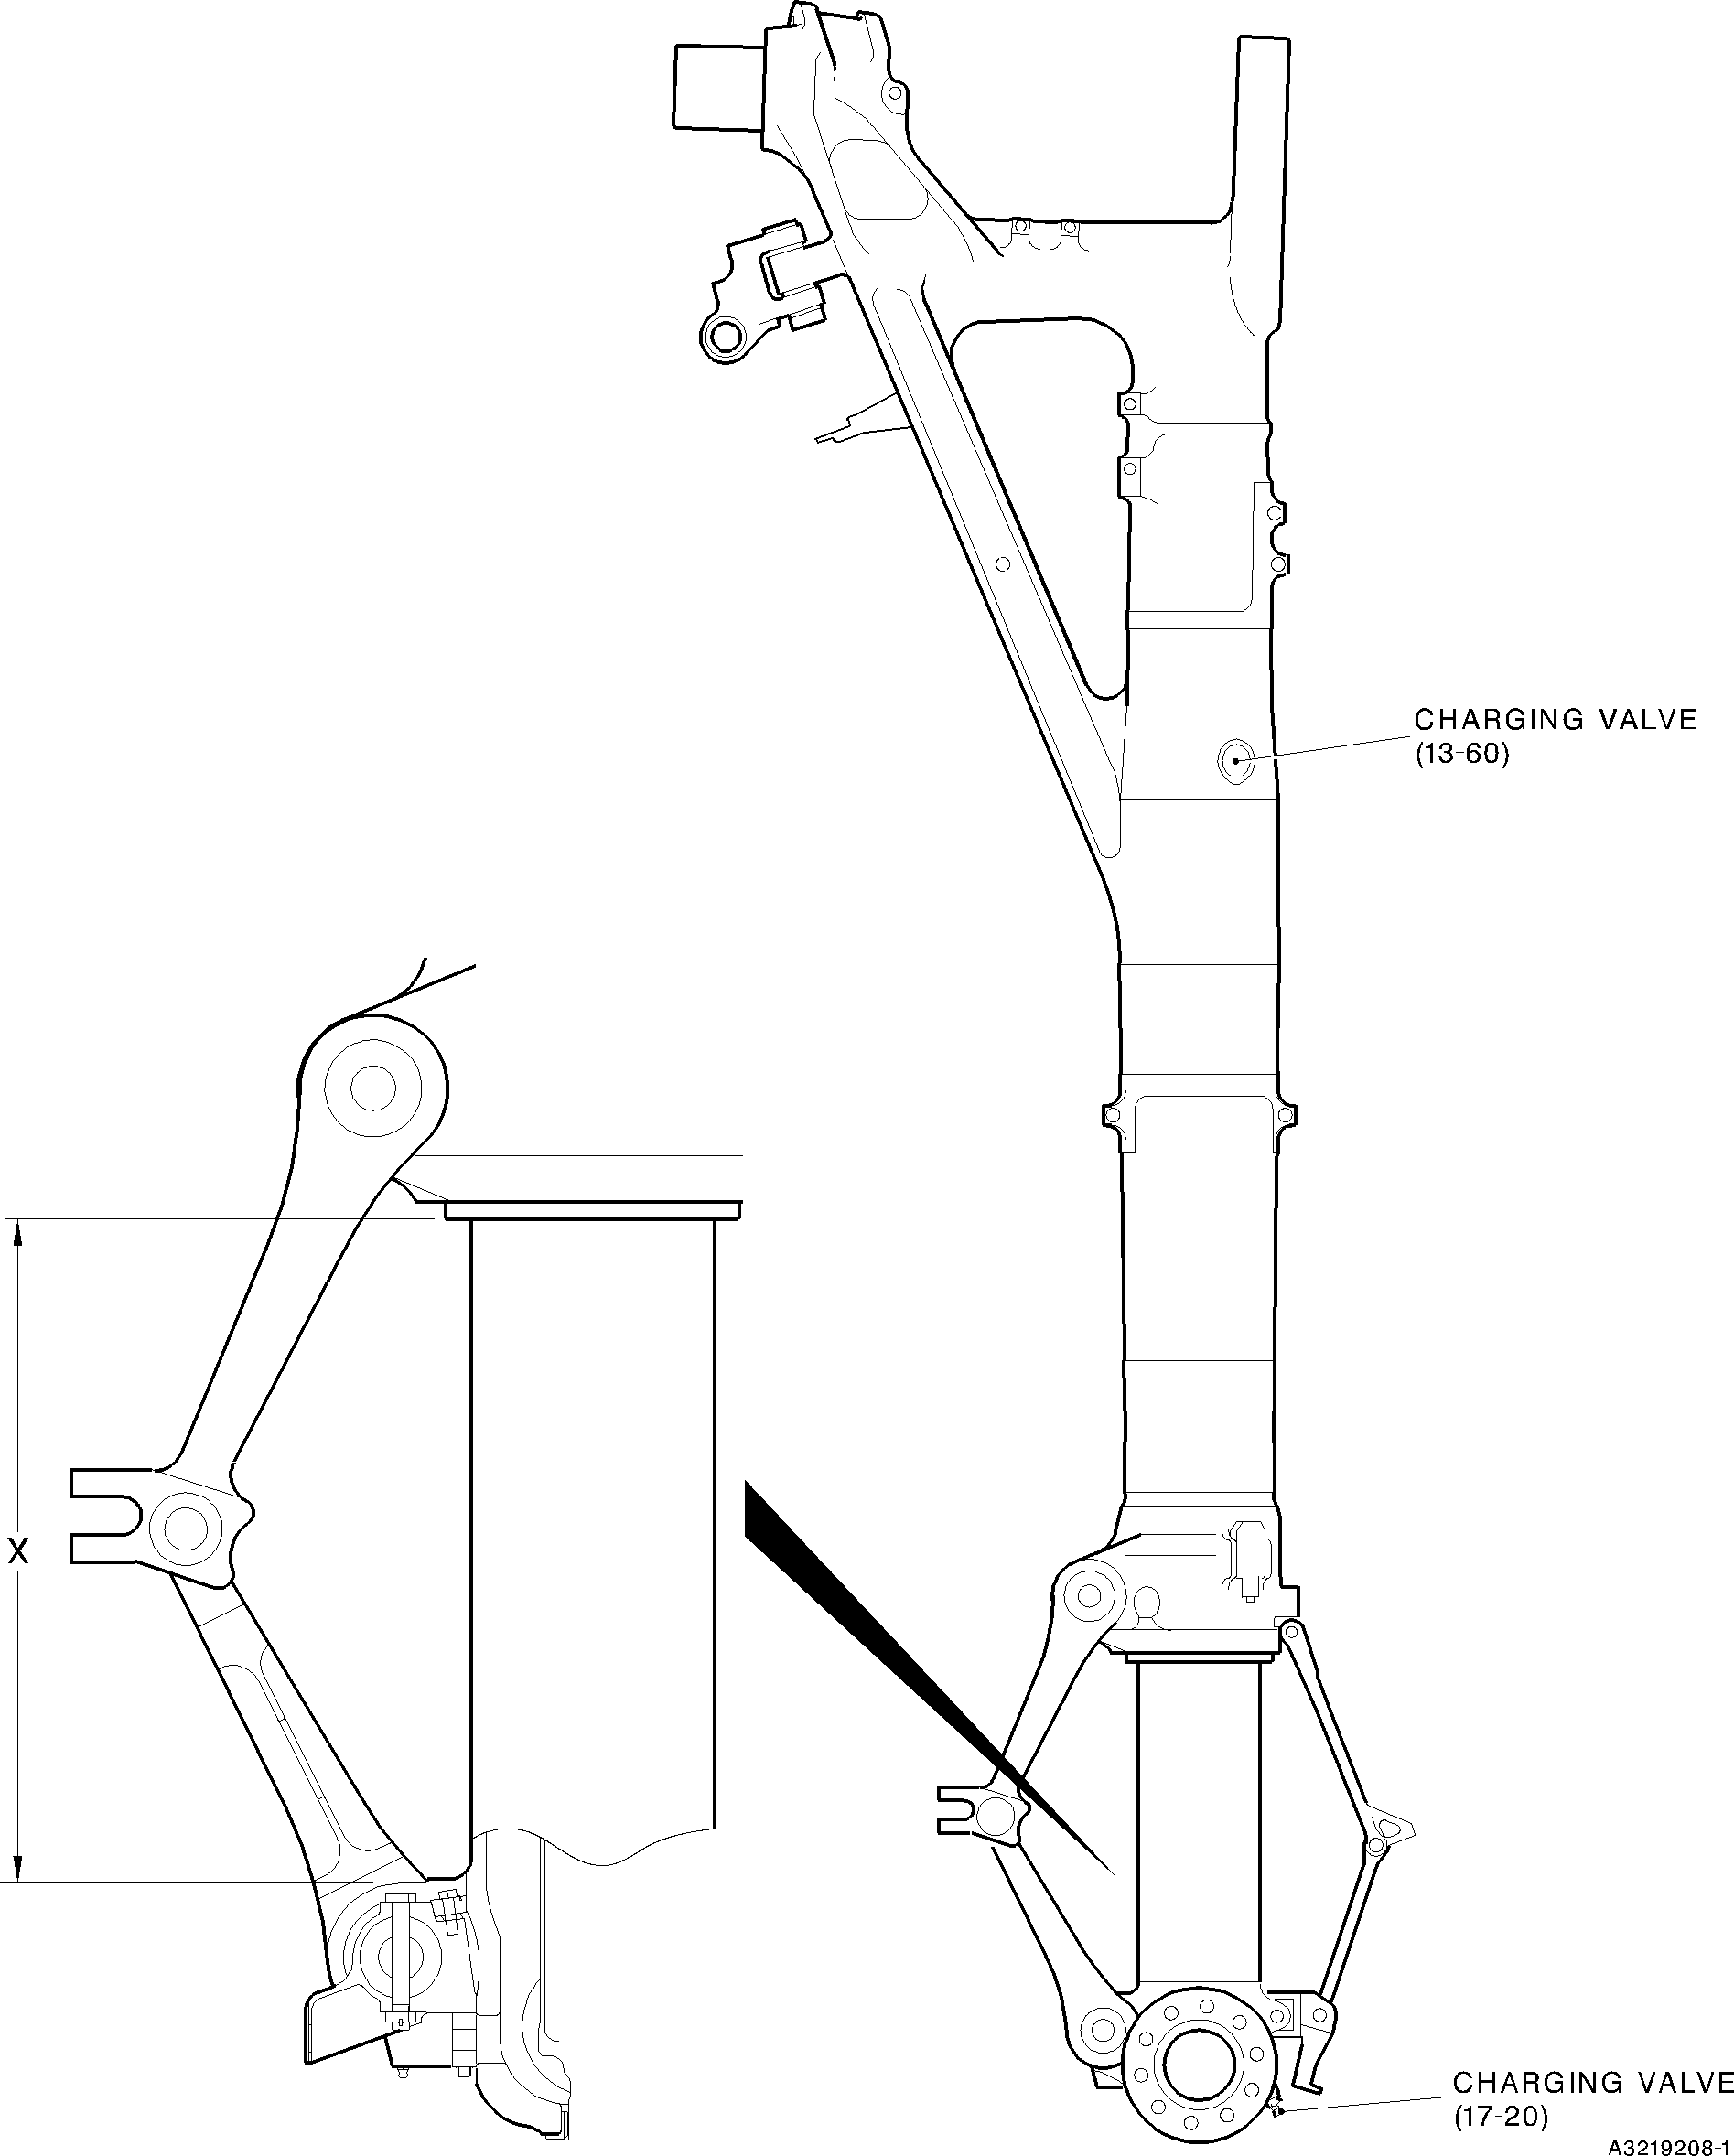

Main Landing Gear Leg (1-1) Figure 101

  - If there is an error because of the gauge capacity:
    - Close the charging valve (13-60).
    - Release the pressure in the gauge.
    - Open the charging valve (13-60) and measure the nitrogen pressure, (P4A).
    - Close the charging valve (13-60).
    - Close the charging valve (17-20).
    - Release the pressure in the gauge.
    - Open the charging valve (17-20) and measure the nitrogen pressure, (P4B).
    - Calculate the correct values for the nitrogen pressures (these will be P5A and P5B) and adjust the pressures to the corrected values. Use the formula:

P5A = P1A + (P2A - P4A) OR
P5B = P1B + (P2B - P4B)
- Prepare for Transport and Storage
  - Open the charging valve (13-60) and reduce the nitrogen pressure to between 3,45 and 4,82 bar (50 and 70 lbf/in²).
  - Close the charging valve (13-60); use the Crowfoot Wrench T14500 to torque it to between 5,7 and 7,9 N m (50 and 70 lbf in).
  - Open the charging valve (17-20) and reduce the nitrogen pressure to between 3,45 and 4,82 bar (50 and 70 lbf/in²).
  - Close the charging valve (17-20); use the Crowfoot Wrench T14500 to torque it to between 5,7 and 7,9 N m (50 and 70 lbf in).
  - Write this data on a label and attach it to the unit: THE GEAR MUST BE INFLATED TO THE APPROPRIATE PRESSURES BEFORE BEING PLACED IN SERVICE.
- Complete the torque procedure for the retaining pins (13-10): refer to ASSEMBLY.
  - Proximity Switches (7-40 and 7-230) Adjustments and Tests
    - Use the loading press: set the dimension between the pins (10-80 and 11-130) to between 632,80 and 636,95 mm (24.9134 and 25.0767 in).
    - Adjust the spacers (6-140, 7-50, 7-190 and 7-240) or laminated shims (6-140A, 7-50A, 7-90A and 7-240A): refer to ASSEMBLY.

NOTE: If the calculated gap is in the tolerance, the spacers (6-140, 7-50, 7-190 and 7-240) or laminated shims (6-140A, 7-50A, 7-90A and 7-240A) are not necessary.
    - Connect the 28 VDC power supply, the Lampbox 460005842 and the main landing gear leg (1-1).

    - Use the loading press to fully extend the main landing gear leg (1-1).
    - Use the loading press to slowly close the main landing gear leg (1-1):
      - The proximity switch (7-230) must operate before the main landing gear leg (1-1) has closed by 26,00 mm (1.0236 in).
      - The proximity switch (7-40) must operate before the main landing gear leg (1-1) has closed by 29,30 mm (1.1535 in).
    - Do para (4) and (5) again.
    - Disconnect the 28 VDC supply and the Lampbox 460005842.
    - Remove the main landing gear leg (1-1) from the loading press.
  - Electrical Bonding Resistance Tests (Refer to Figure 102)

CAUTION: DO NOT CAUSE DAMAGE TO THE PAINT FINISH.

NOTE: Make sure that the main landing gear leg (1-1) is electrically isolated from the equipment that is used to hold it.
    - Use the Milliohmmeter Megger, Type BT51, to measure the electrical bonding resistance.
      - Measure between the bearing (20-250) and the test points given in Table 101. The electrical bonding resistance must not be more than the limit given in Table 101.
      - Measure between the axle of the sliding tube subassembly (17-240) and the test points given in Table 102. The electrical bonding resistance must not be more than the limit given in Table 102.

