3,000 to 4,000mm (0.1181 to 0.1575in) RAD.
2 PLACES
0,100mm (0.0039in)
A
2,200 to 2,500mm (0.0866 to 0.0984in)
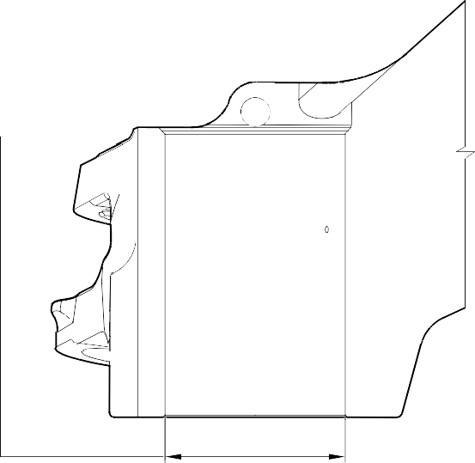
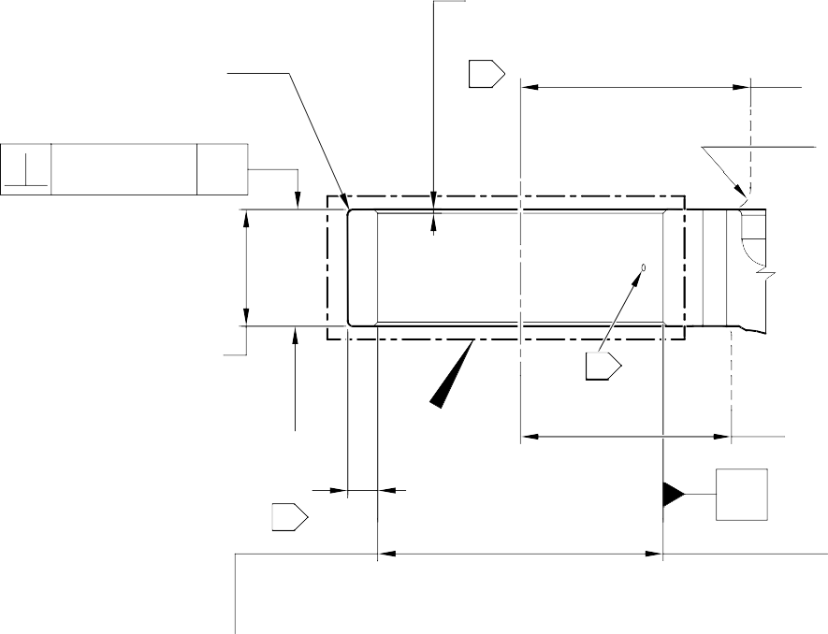

x 89 to 91 DEGREES INCLUSIVE CHAMFER 2 PLACES
03
144,750 to 145,250mm
(5.6988 to 5.7185in) RAD.
18,800 to 19,300mm
(0.7402 to 0.7598in)
2 PLACES SMOOTH BLEND
TO ADJACENT SURFACES

67,750 to 68,250mm (2.6673 to 2.6870in) REF.

C
 |  | 0,100mm (0.0039in) | A

MINIMUM WALL THICKNESS
02

COMMON ZONE

01

130,000 to 132,000mm (5.1181 to 5.1969in) RAD.

A
DIA. A 03
REFER TO TABLE 601

0,100mm (0.0039in)

0,150mm (0.0059in) DIA.

SECTION Z-Z
(WITHOUT OVERSIZE REAR SPHERICAL BEARING) 90 DEGREES ROTATED

NOTE:
1,6
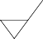
(63)


THE SURFACE FINISH MUST BE OR BETTER UNLESS GIVEN DIFFERENTLY. DIAMETER A MUST FOLLOW THE AXIS OF EXISTING BORE.
01
02
REMOVE THE BREAK EDGES WITHIN 0,500 to 2,000mm (0.0197 to 0.0787in) RAD.
FOR THE MAIN FITTING (20-410B), (20-410C), (20-420B) and (20-420C): THE MINIMUM WALL THICKNESS IS 15,382mm (0.6056in).
FOR THE MAIN FITTING (20-410D) and (20-420D):
THE MINIMUM WALL THICKNESS IS 15,582mm (0.6134in).
PRIMER PAINT ONLY: REFER TO PCS-2500. NO WITNESS OF TOP COAT PAINT PERMITTED ON THESE SURFACES.
03

A321-T-32-12-22-147-0

Repair to Main Fitting Figure 601- Sheet 2

OVERSIZE SPHERICAL BEARING ASSEMBLY
06 REFER TO FIGURE 6001
SPLIT PIN (MS24665-300)
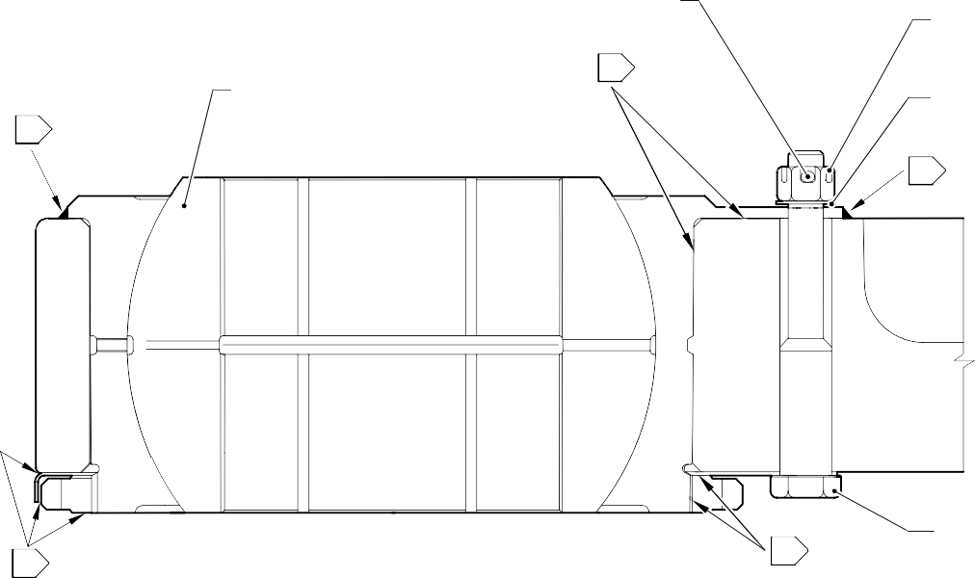
04

NUT (MS17825-6)

WASHER (AN960-616)

06

05 04
SECTION Z-Z
(WITH OVERSIZE REAR SPHERICAL BEARING) 90 DEGREES ROTATED

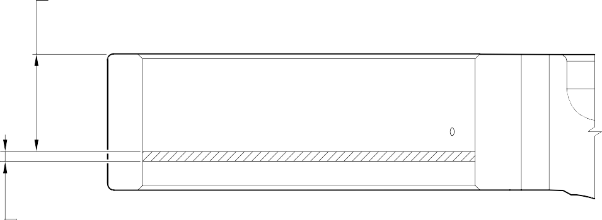
40,000 to 50,000mm
(1.5748 to 1.9685in)
BOLT (201160650)

5,000 to 7,000mm
(0.1969 to 0.2756in) NO PAINT

DETAIL C

NOTE:
APPLY MOLYKOTE 111 TO THE BOLT SHANKS, THREADS, UNDERCUTS AND ALL INTERFACES BETWEEN MATING PARTS MUST BE COATED BEFORE ASSEMBLY: REFER TO PCS-7303.
04
ALL CAVITIES AND VOIDS MUST BE FILLED TO PREVENT MOISTURE INGRESS.
APPLY A FULL BEAD OF SEALANT, PR340-2 WITH A MAXIMUM HEIGHT OF 1,000mm (0.0394in) ABOVE ADJOINING SURFACES: REFER TO PCS-7200.
05
06
APPLY SEALANT: REFER TO PCS-7200 TYPE 2.

Repair to Main Fitting Figure 601 - Sheet 3

A321-T-32-12-22-148-0

Repair No. 11-33

- Repair No. 11-34 Main Fitting (20-410B, 20-410C, 20-410D, 20-420B, 20-420C and 20-420D)
  - Specified Damage and Material Specification
    - Specified Damage
      - Wear or damage or corrosion to diameter(s) A and/or B.
    - Material Specification

IPL Figure and  Item No. | Name | Material Specification
20-410B and  20-420B | Main fitting | UHT Steel E35NCD16THQ to MTL-1203  with UTS 1800 MPa (261.0 ksi)
20-410C,  20-410D,  20-420C and 20-420D | Main fitting | UHT Steel 300M to MTL-1201 with UTS 1930 MPa (279.9 ksi)
  - Special Tools
    - Special tools are not necessary.
  - Materials
    - These materials are necessary:

NOTE: Alternative equivalents are permitted.

Ref. Item | Material
TBA | Zinc loaded Molykote 111
TBA | Sealant
  - Repair Parts
    - These repair parts are necessary:

Part No. | Repair Part | Material Specification
61-4533019-00 | Repair blank bush | Aluminium Bronze to  AMS-4640 Ftu ≥ 758 MPa (109.9 ksi)

  - Procedure (Refer to Figure 601 and Figure 602)

CAUTION: FOR DAMAGE MORE THAN THE LIMITS OF THIS REPAIR SCHEME, WRITE TO SAFRAN LANDING SYSTEMS: REFER TO GUIDE-CS-001.
CAUTION: APPLY TEMPORARY CORROSION AND DAMAGE PROTECTION: REFER TO PCS-2800
    - Do this procedure if there is wear or damage or corrosion to diameter(s) A and/or B: refer to Figure 601 and Figure 602.
      - Remove the paint from the main fitting: refer to PCS-2700.
      - Remove the cadmium plate from the main fitting: refer to PCS-2100.
      - Machine diameter(s) A and/or B to remove the minimum amount of material to remove the wear or damage or corrosion. Do not increase diameter(s) A and/or B to more than 13,727 mm (0.5404 in). The surface finish must be 1,6 micrometers (63 micro-inches) or better: refer to PCS-4100 and Figure 601.
      - Measure and record the diameter(s) A and/or B.
      - Machine the chamfer(s) and/or radii as shown: refer to PCS-4100 and Figure 601.
      - Examine the machined areas for flaws: refer to PCS-3100, inclusion Class 4 and PCS-3600.
      - Shot peen the machined areas only: refer to PCS-2300.
      - Apply cadmium plate all over but not to the areas shown. The cadmium plate thickness must be between 0,010 and 0,020 mm (0.0004 and 0.0008 in): refer to PCS-2100. No bare metal is permitted.
      - Apply primer paint to the main fitting where shown: refer to PCS-2500.
      - Prepare the repair bush from the blank bush 61-4533019-00 with these dimensions for installation (qty 1 to 2 as necessary): refer to Figure 601 and Figure 602.
        - Machine diameter Z, use the formula:
Dia. Z = Diameter A and/or B (as measured) + 0,018 to + 0,029 mm (+ 0.0007 to + 0.0011 in).
        - Apply cadmium plate all over. The cadmium plate thickness must be between 0,010 and 0,015 mm (0.0004 and 0.0006 in): refer to PCS-2101 and
Figure 602.
      - Use Zinc loaded Molykote 111, Material Ref. Item TBA, to install the repair bush. Apply heat to the housing to 100°C and then cool the repair bushes: refer to PCS-5105-2, PCS-7304 and Figure 601 and Figure 602.
      - Apply fillet of Sealant, Material Ref. Item TBA, to the bush flange and bush tail end: refer to PCS-7200 and Figure 601.
      - Apply top coat paint all over but not to the areas where shown: refer to PCS-2500.
      - Record the repair number onto the documentation which is attached to the part. Optionally, identify the part with the Safran Landing Systems repair number 64-4505112-00 adjacent to the existing part number: refer to PCS-6000-07.
      - Examine the part to make sure that you have obeyed all the repair instructions correctly.
Repair No. 11-34

SECTION Z-Z

Repair to Main Fitting Figure 601 - Sheet 1
DIA. B
 |  | 0,100mm (0.0039in) DIA. | Z

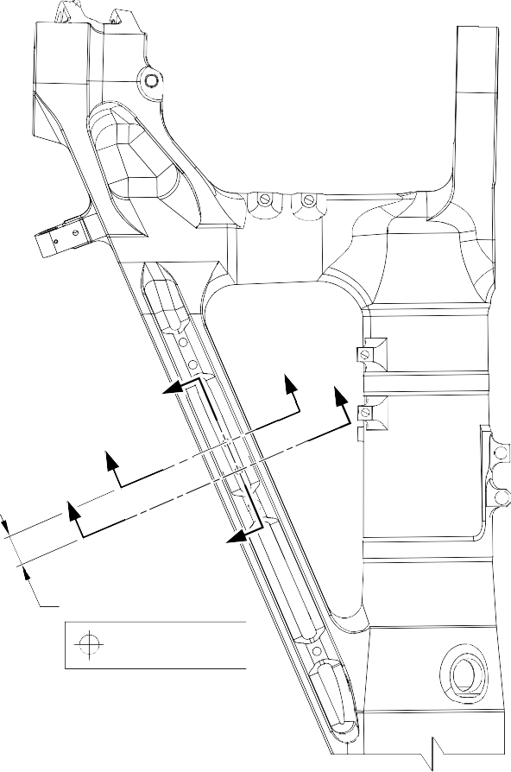
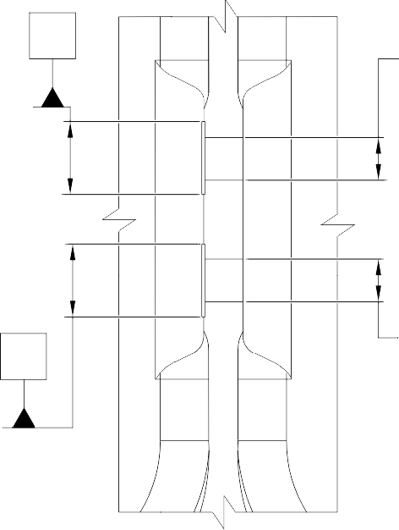
DIA. A
Y
Z
Y
Y
Y
Z
50,000mm (1.9685in)
COMMON ZONE
Z
Y
0.150mm (0.0059in) DIA.
 |  | 0,100mm (0.0039in) DIA. | Y

A321-T-32-12-22-134-0

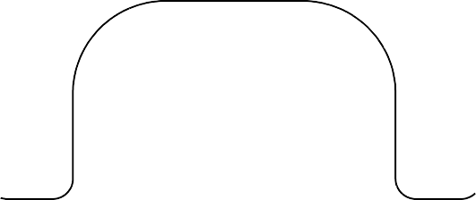
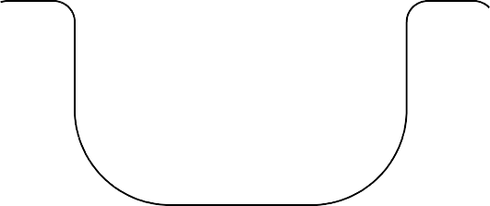
DIA. A AND B
13,727mm (0.5404in) DIA. MAX .

SECTION Y-Y
(WITHOUT BUSHES)

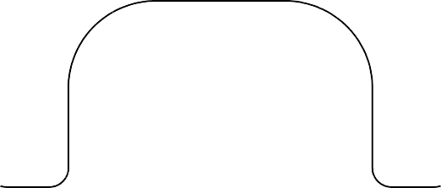
REPAIR BUSH (61-4533019-00)

NO PRIMER PAINT TO BE VISIBLE AFTER SEALANT APPLICATION
01

8,050 to 8,550mm (0.3169 to 0.3366in) DIA. 2 PLACES

SECTION Y-Y
(WITH BUSHES)

NOTE:

1,6

(63)

THE SURFACE FINISH MUST BE OR BETTER UNLESS GIVEN DIFFERENTLY. DIAMETERS A AND B MUST FOLLOW THE AXIS OF EXISTING BORE.
DEBURR THE SHARP EDGES WITH 0,500 to 1,000mm (0.0197 to 0.0394in) RAD. UNLESS GIVEN DIFFERENTLY.
APPLY FILLET SEALANT: REFER TO PCS-7200. MAKE SURE THAT THE SEALANT COMPLETELY COVERS EXPOSED PRIMER PAINT.
01

A321-T-32-12-22-135-0

Repair to Main Fitting Figure 601 - Sheet 2

Repair No. 11-34


2,900 to 3,150mm
(0.1142 to 0.1240in)

0,300 to 0,500mm (0.0118 to 0.0196in) RAD.
0,750 to 1,250mm
(0.0295 to 0.0492in)
x 14,5 to 15,5 DEGREES CHAMFER

DIA. Z

8,050 to 8,550mm (0.3169 to 0.3366in) DIA. REF.
1,6
(63)

0,750 to 1,250mm
(0.0295 to 0.0492in)
x 14,5 to 15,5 DEGREES CHAMFER
11,500 to 12,000mm
(0.4528 to 0.4724in)

NOTE:
3,2
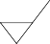
(125)

THE SURFACE FINISH MUST BE OR BETTER UNLESS GIVEN DIFFERENTLY. DEBURR THE SHARP EDGES WITH 0,130 to 0,380mm (0.0051 to 0.0150in) RAD. UNLESS GIVEN DIFFERENTLY.
APPLY CADMIUM PLATE ALL OVER: REFER TO PCS-2101. THE CADMIUM PLATE THICKNESS MUST BE BETWEEN 0,010 to 0,015mm (0.0004 to 0.0006in).

Repair to Main Fitting - Bush Figure 602

A321-T-32-12-22-136-0

Repair No. 11-34

INTENTIONALLY BLANK

- Repair No. 11-35 Main Fitting (20-410B, 20-410C, 20-410D, 20-420B, 20-420C and 20-420D)
  - Specified Damage and Material Specification
    - Specified Damage
      - Wear or damage or corrosion to diameter(s) A and B.
    - Material Specification

IPL Figure and  Item No. | Name | Material Specification
20-410B and  20-420B | Main fitting | UHT Steel E35NCD16THQ to MTL-1203  with UTS 1800 MPa (261.0 ksi)
20-410C,  20-410D,  20-420C and 20-420D | Main fitting | UHT Steel 300M to MTL-1201 with UTS 1930 MPa (279.9 ksi)
  - Special Tools
    - Special tools are not necessary.
  - Materials
    - These materials are necessary:

NOTE: Alternative equivalents are permitted.

Ref. Item | Material
TBA | Zinc loaded Molykote 111
TBA | Sealant
  - Repair Parts
    - These repair parts are necessary:

Part No. | Repair Part | Material Specification
61-4533018-00 | Repair blank bush | Aluminium Bronze to  AMS-4640 Ftu ≥ 758 MPa (109.9 ksi)

  - Procedure (Refer to Figure 601 and Figure 602)

CAUTION: FOR DAMAGE MORE THAN THE LIMITS OF THIS REPAIR SCHEME, WRITE TO SAFRAN LANDING SYSTEMS: REFER TO GUIDE-CS-001.
CAUTION: APPLY TEMPORARY CORROSION AND DAMAGE PROTECTION: REFER TO PCS-2800
    - Do this procedure if there is wear or damage or corrosion to diameter(s) A and B: refer to Figure 601 and Figure 602.
      - Remove the paint from the main fitting: refer to PCS-2700.
      - Remove the cadmium plate from the main fitting: refer to PCS-2100.
      - Machine diameter(s) A and B to remove the minimum amount of material to remove the wear or damage or corrosion. Do not increase diameter(s) A and B to more than 15,727 mm (0.6192 in). The surface finish must be 1,6 micrometers
(63 micro-inches) or better: refer to PCS-4100 and Figure 601.
      - Measure and record the diameter(s) A and B.
      - Machine the chamfer(s) and/or radii as shown: refer to PCS-4100 and Figure 601.
      - Examine the machined areas for flaws: refer to PCS-3100 inclusion, Class 4 and PCS-3600.
      - Shot peen the machined areas only: refer to PCS-2300.
      - Apply cadmium plate all over but not to the areas shown. The plating thickness must be between 0,010 and 0,020 mm (0.0004 and 0.0008 in): refer to PCS-2100. No bare metal is permitted.
      - Apply primer paint to the main fitting where shown: refer to PCS-2500.
      - Prepare the repair bushes from the blank bush 61-4533018-00 with these dimensions for installation (qty 1 to 2 as necessary): refer to Figure 602.
        - Machine diameter Z, use the formula:
Dia. Z = Dia. A (as measured) + 0,018 to + 0,029 mm (+ 0.0007 to + 0.0011 in).
        - Apply cadmium plate all over. The plating thickness must be between 0,010 and 0,015 mm (0.0004 and 0.0006 in): refer to PCS-2101 and Figure 602.
      - Use Zinc loaded Molykote 111, Material Ref. Item TBA, and install the repair bushes. Apply heat to the housing to 100°C and then cool the repair bushes: refer to PCS-5105-2, PCS-7304 and Figure 601 and Figure 602.
      - Apply fillet of Sealant, Material Ref. Item TBA, to the bush flange and bush tail end: refer to PCS-7200 and Figure 601.
      - Apply top coat paint all over but not to the areas shown: refer to PCS-2500.
      - Record the repair number onto the documentation which is attached to the part. Optionally, identify the part with the Safran Landing Systems repair number 64-4505111-00 adjacent to the existing part number: refer to PCS-6000-07.
      - Examine the part to make sure that you have obeyed all the repair instructions correctly.
Repair No. 11-35

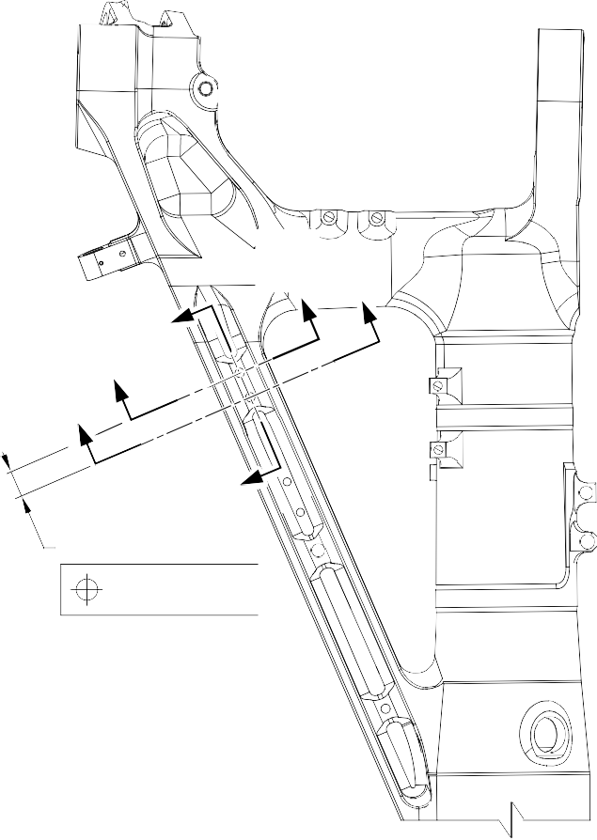
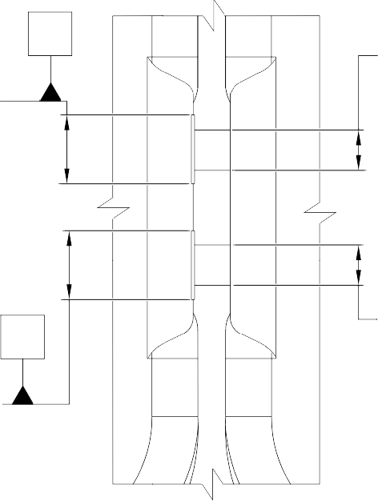
DIA. B
Y
Y
Z
Y
Y

Z
40,000mm (1.5478in)
COMMON ZONE
Z
23,000 to 25,000mm (0.9055 to 0.9847in) DIA.
Y
23,000 to 25,000mm (0.9055 to 0.9847in) DIA.
0.150mm (0.0059in) DIA.
 |  | 0,100mm (0.0039in) DIA. | Z

DIA. A
 |  | 0,100mm (0.0039in) DIA. | Y

SECTION Z-Z A321-T-32-12-22-137-0

Repair to Main Fitting Figure 601 - Sheet 1

DIA. A AND B
15,727mm (0.6192in) DIA. MAX .

SECTION Y-Y
A (WITHOUT BUSHES)

REPAIR BUSH (61-4533018-00)
NO PRIMER PAINT TO BE VISIBLE AFTER SEALANT APPLICATION
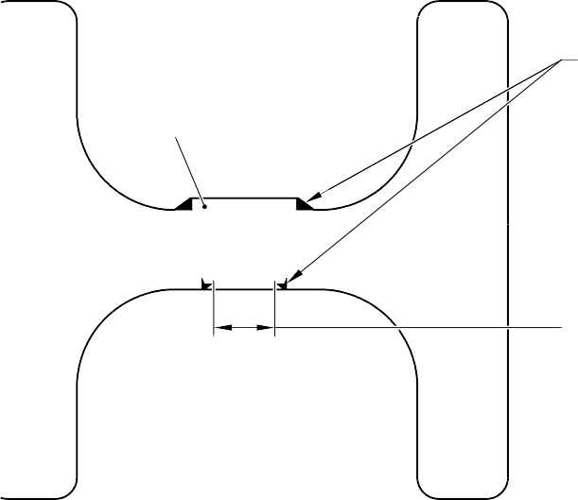
01

9,750 to 10,250mm (0.3839 to 0.4035in) DIA. 2 PLACES
ORIENTATION OF BUSHES

SECTION Y-Y
(WITH BUSHES)

NOTE:
1,6



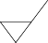
(63)
VIEW A

THE SURFACE FINISH MUST BE OR BETTER UNLESS GIVEN DIFFERENTLY. DIAMETERS A AND B MUST FOLLOW THE AXIS OF EXISTING BORE.
DEBURR THE SHARP EDGES WITH 0,500 to 1,000mm (0.0197 to 0.0394in) RAD. UNLESS GIVEN DIFFERENTLY.
APPLY FILLET SEALANT: REFER TO PCS-7200. MAKE SURE THAT THE SEALANT COMPLETELY COVERS EXPOSED PRIMER PAINT.
01

A321-T-32-12-22-138-0

Repair to Main Fitting Figure 601 - Sheet 2

Repair No. 11-35

1,800 to 2,000mm
(0.0709 to 0.0787in)
0,300 to 0,500mm (0.0118 to 0.0197in) RAD.

0,750 to 1,250mm
(0.0295 to 0.0492in)
x 14,5 to 15,5 DEGREES

1,6
(63)

0,750 to 1,250mm
(0.0295 to 0.0492in)
x 14,5 to 15,5 DEGREES
DIA. Z

9,750 to 10,250mm (0.3838 to 0.4035in) DIA. REF.

11,750 to 12,250mm
(0.4626 to 0.4823in)

NOTE:
3,2
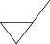
(125)

THE SURFACE FINISH MUST BE OR BETTER UNLESS GIVEN DIFFERENTLY. APPLY CADMIUM PLATE ALL OVER: REFER TO PCS-2101. THE PLATING THICKNESS MUST BE BETWEEN 0,010 to 0,015mm (0.0004 to 0.0006in).
DEBURR THE SHARP EDGES WITH 0,130 to 0,380mm (0.0051 to 0.0150in) RAD. UNLESS GIVEN DIFFERENTLY.

A321-T-32-12-22-139-0

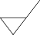
Repair to Main Fitting - Bush Figure 602

Repair No. 11-35

INTENTIONALLY BLANK

- Repair No. 11-36 Main Fitting (20-410B, 20-410C, 20-410D, 20-420B, 20-420C and 20-420D)
  - Specified Damage and Material Specification
    - Specified Damage
      - Wear or damage or corrosion to diameter(s) A and/or B and/or C and/or D.
    - Material Specification

IPL Figure and  Item No. | Name | Material Specification
20-410B and  20-420B | Main fitting | UHT Steel E35NCD16THQ to MTL-1203  with UTS 1800 MPa (261.0 ksi)
20-410C,  20-410D,  20-420C and 20-420D | Main fitting | UHT Steel 300M to MTL-1201 with UTS 1930 MPa (279.9 ksi)
  - Special Tools
    - Special tools are not necessary.
  - Materials
    - Materials are not necessary.
  - Repair Parts
    - Repair parts are not necessary.
  - Procedure (Refer to Figure 601)

CAUTION: FOR DAMAGE MORE THAN THE LIMITS OF THIS REPAIR SCHEME, WRITE TO SAFRAN LANDING SYSTEMS: REFER TO GUIDE-CS-001.
CAUTION: APPLY TEMPORARY CORROSION AND DAMAGE PROTECTION: REFER TO PCS-2800
    - Do this procedure if there is wear or damage or corrosion to diameter(s) A and/or B and/or C and/or D: refer to Figure 601.
      - Remove the paint from the main fitting: refer to PCS-2700.
      - Remove the cadmium plate from the main fitting: refer to PCS-2100.
      - Machine diameter(s) A and/or B and/or C and/or D to remove the minimum amount of material to remove wear or damage. Do not increase diameter(s) A and/or B and/or C and/or D to more than 16,170 mm (0.6366 in). The surface finish must
be 1,6 micrometers (63 micro-inches) or better: refer to PCS-4100 and Figure 601. The minimum wall thickness must not be less than 1,915 mm (0.0754 in): refer to Figure 601.
      - Machine the chamfer(s) and/or radii as shown: refer to PCS-4100 and Figure 601.
      - Examine the machined areas for flaws: refer to PCS-3100, inclusion Class 4 and refer to PCS-3600.

      - Shot peen the machined areas only: refer to PCS-2300.
      - Apply cadmium plate all over. The plating thickness must be between 0,010
and 0,020 mm (0.0004 and 0.0008 in): refer to PCS-2100 or PCS-2141. No bare metal is permitted.
      - Apply primer and paint finish all over but not to the areas shown. No bare cadmium is permitted but not to the areas where there is no paint: refer to PCS-2500 and Figure 601.
      - Record the repair number onto the documentation which is attached to the part. Optionally, identify the part with the Safran Landing Systems repair number 64-4505234-00 adjacent to the existing part number: refer to PCS-6000-07.
      - Examine the part to make sure that you have obeyed all the repair instructions correctly.

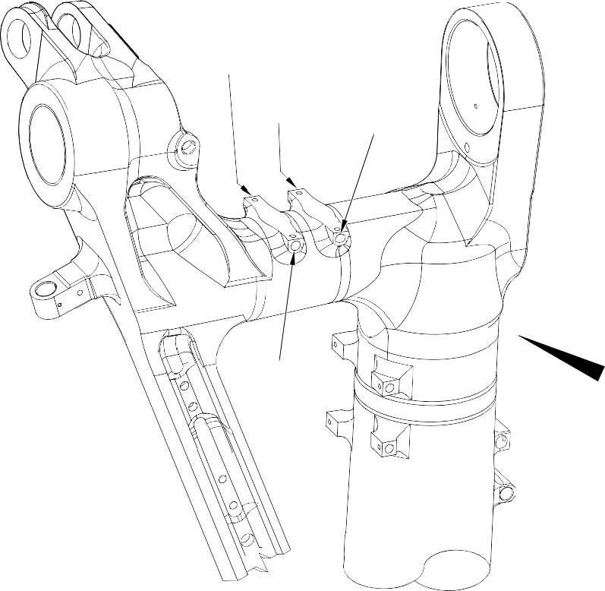
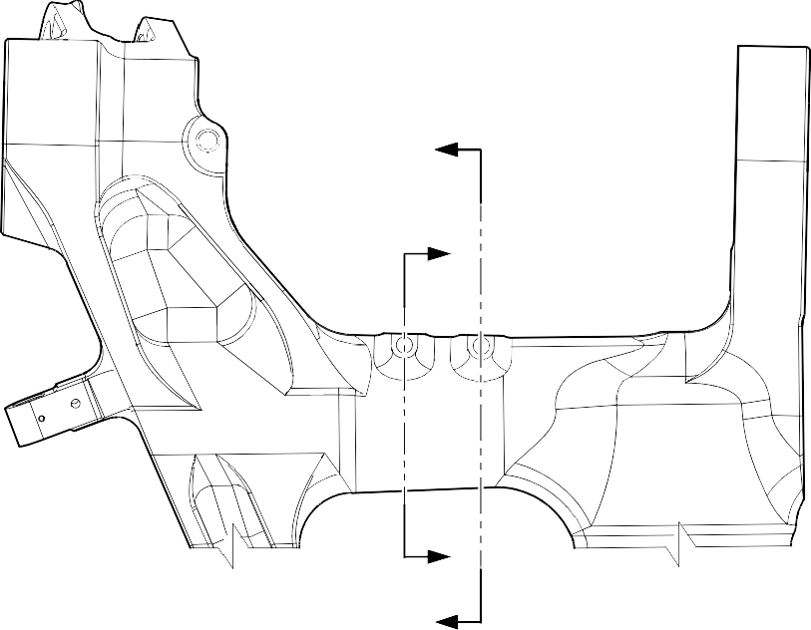
A
DIA. D
DIA. C
DIA. B
DIA. A
Z
Y
Y
Z

VIEW A

Repair to Main Fitting Figure 601 - Sheet 1

A321-T-32-12-22-140-0

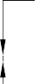
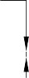
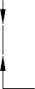

A B
1,915mm (0.0754in) MINIMUM WALL THICKNESS

1,915mm (0.0754in) MINIMUM WALL THICKNESS

DIA. D
02
DIA. C
02

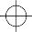 | 0,500mm (0.0197in) DIA. | A

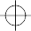 | 0,500mm (0.0197in) DIA. | B

1,915mm (0.0754in) MINIMUM WALL THICKNESS
SECTION Z-Z

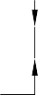

C D
B

27,500 to 28,500mm
(1.0827 to 1.1220in)
4 PLACES
1,915mm (0.0754in) MINIMUM WALL THICKNESS

DIA. B DIA. A
02 16,170mm (0.6366in) DIA. MAX.
4 PLACES
 | 0,500mm DIA. (0.0197in) | C

02

 | 0,500mm DIA. (0.0197in) | D

SECTION Y-Y


01
4 PLACES

01
4 PLACES

SPHERICAL RAD. 4 PLACES
02

NOTE:
1,6
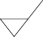
(63)
DETAIL B

THE SURFACE FINISH MUST BE OR BETTER UNLESS GIVEN DIFFERENTLY. DIAMETERS A, B, C AND D MUST FOLLOW THE AXIS OF EXISTING BORES.
01
02
REMOVE THE SHARP EDGES OF 0,250 to 1,000mm (0.0098 to 0.0394in) RAD. NO PAINT.

A321-T-32-12-22-141-0

Repair to Main Fitting Figure 601 - Sheet 2

- Repair No. 11-37 Main Fitting (20-410B, 20-410C, 20-410D, 20-420B, 20-420C and 20-420D)
  - Specified Damage and Material Specification
    - Specified Damage
      - Wear or damage or corrosion to diameter(s) A.
    - Material Specification

IPL Figure and  Item No. | Name | Material Specification
20-410B and  20-420B | Main fitting | UHT Steel E35NCD16THQ to MTL-1203  with UTS 1800 MPa (261.0 ksi)
20-410C,  20-410D,  20-420C and 20-420D | Main fitting | UHT Steel 300M to MTL-1201 with UTS 1930 MPa (279.9 ksi)
  - Special Tools
    - Special tools are not necessary.
  - Materials
    - These materials are necessary:

NOTE: Alternative equivalents are permitted.

Ref. Item | Material
TBA | Loctite Grade 601
TBA | Molykote 111
  - Repair Parts
    - These repair parts are necessary:

Part No. | Repair Part | Material Specification
62-4505252-00 | Repair sleeve | Stainless Steel -17-4PH to  AMS5643 H1025
  - Procedure (Refer to Figure 601 and Figure 602)

CAUTION: FOR DAMAGE MORE THAN THE LIMITS OF THIS REPAIR SCHEME, WRITE TO SAFRAN LANDING SYSTEMS: REFER TO GUIDE-CS-001.
    - Do this procedure if there is wear or damage or corrosion to one or more holes diameter A: refer to Figure 601 and Figure 602.
      - Remove the paint from the main fitting: refer to PCS-2700.
      - Remove the cadmium plate from the main fitting: refer to PCS-2100.

Repair No. 11-37

