Fig Item  No. | Name | Material Type | M-D  Spec | Remarks
9-150  Only | Bracket | Aluminium Alloy,  L113  or  Aluminium Alloy, BS L168-T6511  or BS 2L93 or 7075-T73, T7351, T73510  or T73511 to MTL-2701 | PCS-3200 | -
9-150A | Bracket | Aluminium Alloy, L168-T6511 7075-T73, T7351, T73510  or T73511 to MTL-2701 | PCS-3200 | -
9-190  Only | Spacer | Aluminium Alloy, BS L168-T6511  or BS 2L93 or 7075-T73, T7351, T73510  or T73511 to MTL-2701 | PCS-3200 | -
9-190A | Spacer | Aluminium Alloy, L168-T6511 or 7075-T73, T7351, T73510  or T73511 to MTL-2701 | PCS-3200 | -
10-30 | Wedge | Aluminium Alloy, BS L168-T6 or BS 2L93 or 7075-T73, T7351, T73510  or T73511 to MTL-2701 | PCS-3200 | -
11-30 | Harness support | Aluminium Alloy, BS L168-T6 or BS 2L93 or 7075-T73, T7351, T73510  or T73511 to MTL-2701 | PCS-3200 | -

Fig Item  No. | Name | Material Type | M-D  Spec | Remarks
11-80 | Wedge | Aluminium Alloy,  BS L168-T6 or BS 2L93 or 7075-T73, T7351, T73510  or T73511 to MTL-2701 | PCS-3200 | -
11-140 | Harness support bracket | Aluminium Alloy, L168 or L93 | PCS-3200 | -
12-120 | Transfer dowel | Aluminium Alloy, L168-T6511 | M-DLNDT8 | -
12-170  Only | Housing | Aluminium Alloy, L168T6511 | PCS-3200 | -
12-170A | Housing | Aluminium Alloy, L168-T6511 or 7075-T73, T7351, T73510  or T73511 to MTL-2701 | PCS-3200 | -
13-220 | Washer | Aluminium Alloy, 2024T4 or T351 | PCS-3200 | -
14-70 | Stop ring | Stainless Steel, Z12CN18-10 | PCS-3200 | -
15-40 | Upper bearing housing | Aluminium Alloy, 2024T3511 | PCS-3200 | -
15-140 | Two piece stop | Aluminium Alloy, 2024T4 or T351 | PCS-3200 | -
15-210 | Diaphragm | Aluminium Alloy, 2024T3511 | PCS-3200 | -
15-210A | Diaphragm | Aluminium Alloy, 7050-T7451 to AMS 4050 | PCS-3200 | -
15-240 | Baffle | Aluminium Alloy, 2024T4 or T351 | PCS-3200 | -
16-140 | Gland housing | Aluminium Alloy, 2024T3 | PCS-3200 | -
17-50 | Valve support | Aluminium Alloy, 2024T4 or T452 | PCS-3200 | -
17-50A | Valve support | Aluminium Alloy, 2024T351 or T3 | PCS-3200 | -

Fig Item  No. | Name | Material Type | M-D  Spec | Remarks
17-150 | Nut | Aluminium Alloy,  2024T3511 | PCS-3200 | -
17-160 | Rod | Aluminium Alloy, 2024T3 or T351 | PCS-3200 | -
17-200 | Piston | Aluminium Alloy, 7175T7351 | PCS-3200 | -

INTENTIONALLY BLANK

REPAIR
- General
  - Repair Levels
    - There are two levels of repair procedure for parts that are found to be unserviceable after inspection: refer to CHECK.
      - Repair of surface damage.
      - Repair of wear or damage with an approved Messier-Dowty Limited or Safran Landing Systems repair.
  - Surface Damage
    - Repair isolated external scores, smooth dents and abrasions, that have no cracks and no effect on internal dimensions: refer to para (2). Such damage must not be:
      - More than 19,00 mm (0.750 in) in length
      - More than 0,76 mm (0.030 in) in depth
      - Less than one diameter from a hole and less than 6,35 mm (0.250 in) from a bearing surface
      - On a radius.
    - Remove burrs, corrosion and sharp edges: the area of damage must not be more than 645 mm2 (1.0 in2) for each 6450 mm2 (10.0 in2). Subsequently, remove 0,127 mm (0.0050 in) more of the material and repair the protective treatment.
    - In a bore that will not seal, ignore abrasions and small scores that have no burrs. If there are burrs, remove them plus 0,127 mm (0.0050 in) of material from the area. Repair the protective treatment.
    - In a bore that will seal, polish scores to remove them. Make sure that the surface finish, concentricity and fits and clearances do not change.
    - Remove burrs from external screw threads.
  - Approved Repairs

CAUTION: DO NOT REPAIR A PART WITH A PROCEDURE THAT IS NOT APPROVED.
    - Approved repairs are in para 4. The repairs in this CMM have been approved under Airbus’ EASA Design Organisation Approval No. EASA.21J.031.
    - Unless instructions are different in the approved repair, the applicable tolerances are:
      - General tolerance: + or - 0,25 mm (0.010 in)
      - Holes that are drilled or machined: + 0,25 to - 0,05 mm (+ 0.010 to - 0.002 in)
      - Angular tolerance: + or - 0,5 degree.
    - Before you repair a part that is identified with a concession, salvage or repair number, write to Safran Landing Systems for approval. Such numbers are adjacent to the part number, for example:
      - Concession - CON 14235
      - Salvage - 440015644
      - Repair - 450213024.

    - If the repairs in this manual cannot correct the wear or damage to the part, write to Safran Landing Systems: refer to M-DLPS3002.
- Repair Procedure Conditions
  - Cleaning
    - Clean the parts after repair: refer to CLEANING.
  - Identification
    - Identify the parts after repair with the Messier-Dowty Limited or Safran Landing Systems Repair Number: refer to the applicable repair for instructions.
- Protective Treatment
  - Protective Treatment Repair
    - Cadmium Plated Surfaces
      - Repair damage to small areas of cadmium plated surfaces: refer to PCS-2141.
    - Anodized Surfaces
      - Repair damage to small areas of anodized surfaces: refer to PCS-2220.
    - Paint Finish
      - Repair damage to small areas of paint finish: refer to M-DLPS1003-1, use paint to PCS-2500.
    - Sermetel W
      - Chip damage of less than 10,0 mm² (0.015 in²) can be restored with Sermetel 249 with Sermetel 273 catalyst: refer to M-DLPS637 (cold rework only).
  - Protective Treatment Replacement
    - Protective treatment replacement procedures and the applicable parts are given in Table 601.
Protective Treatment Table 601

IPL Figure and  Item No. | Name | Material  Specification | Protective Treatment
1-40 | Bolt | Steel, S99 | Apply cadmium plate: refer to  M-DLPS100-2. Do not include areas that have chromium plate. Paint: refer to M-DLPS1003-1 and  PCS-2500. Do not paint:  - areas that have chromium plate  - the thread and undercut  - the split pin hole.

IPL Figure and  Item No. | Name | Material  Specification | Protective Treatment
1-47, 1-47A, 1-49  and 1-49A | Cross bolt | Steel, S99 | Apply cadmium plate, but not to the  chromium plated areas: refer to M-DLPS100-2.  Apply paint: refer to M-DLPS1003-1 and PCS-2500. Do not paint:  - the thread  - chromium plated areas  - the 1,5 mm (0.060 in) hole for the Bowden cable(1-45).
1-60 | Pintle pin | Steel, S155 or 300M to MTL1201 | Apply cadmium plate: refer to  PCS-2100. Do not include areas that have chromium plate. Paint: refer to M-DLPS1003-1 and  PCS-2500. Do not paint:  - areas that have chromium plate  - the two holes through the end. Apply a thin coat of primer paint to the holes through the end: refer to PCS-2500.
1-60A | Pintle pin | Steel, 300M or MTL1201 | Refer to Figure 639. Apply cadmium plate: refer to PCS-2100. Do not include areas that have chromium plate. Make the cadmium plate thickness between 0,010 and 0,020  mm (0.0004 and 0.00078 in). The cadmium plate must overlap the chromium plate run out. Bare metal not permitted.  Apply primer paint to the areas A: refer to PCS-2500. Apply paint all over: refer to PCS-2500. Do not apply paint to:  - areas that have chromium plate  - the areas A.
2-30 | Pin | Stainless steel, 17- 4PH to AMS5643 | Passivate: refer to AMS2700
2-40 | Spacer | Stainless steel, S80 | Passivate: refer to AMS2700
2-50 | Threaded insert | Steel, S154 | Apply cadmium plate all over: refer to M-DLPS100-1. The cadmium plate must be 0,010 to 0,015 mm (0.0004 to 0.0006 in) thick. Apply paint all over: refer to PCS-2500. Do not apply paint to the thread or to the surfaces that enter the transfer block (2-340 and 2-350)

IPL Figure and  Item No. | Name | Material  Specification | Protective Treatment
2-80 and 2-90 | Bracket | Aluminium Alloy, L113 or L168-T6511 | Refer to Figure 631. Chromic acid  anodise all over, but not the spotface A and area B: refer to M-DLPS102-1. Apply Alocrom 1200 to the spotface A and area B: refer to M-DLPS114. Apply paint all over but not to the spotface A, areas B and holes C. Apply only primer paint to the holes C: refer to PCS-2500.
2-120 and 2-130 | Bracket | Aluminium Alloy, L113 | Refer to Figure 601. Anodise all over, but not areas A. Apply Alocrom 1200 to areas A: refer to PCS-2220. Paint all over but do not include on areas A and bores B. Apply primer to bores B: refer to PCS-2500.
2-340 Only and  2-350 Only | Transfer block | Aluminium alloy, L168 - T6511 | Chromic acid anodize: refer to  M-DLPS102-1. Do not include areas  A. Alocrom areas A: refer to M-DLPS114. Paint: refer to  M-DLPS1003-1 and PCS-2500. Do  not paint the holes and areas A, B and C. Apply primer to areas C: refer to PCS-2500. Refer to Figure 602.
2-340A and 2-350A | Transfer block | Aluminium alloy, L168 - T6511 | Refer to Figure 602. Chromic acid anodize: refer to MIL-A-8625 Type 1B, Class 1, do not include areas A. Apply Alocrom to areas A: refer to PCS-2220, Type 2.  Paint: refer to M-DLPS1003-1 and PCS-2500. Do not paint:  - the holes  - areas A  - areas B  - areas C.  Apply primer to areas C: refer to PCS-2500.

IPL Figure and  Item No. | Name | Material  Specification | Protective Treatment
2-340B and 2-350B | Transfer block | Aluminium Alloy, BS L168-T6511 or BS 2L93 or 7075- T73 T7351, T7310  or T73511 to  MTL-2701 or 7050 T7451 to MTL-2712 | Refer to Figure 635. Chromic acid  anodize all over, but not the spotfaces A: refer to MIL-A-8625 Type 1B, Class 1. Apply Alocrom to spotfaces A: refer to PCS-2220, Type  2. Paint all over: refer to PCS-2500. Do not paint:  - The threads  - areas A  - areas B  - areas C.  Apply primer to areas C: refer to PCS-2500.
3-50 | Pin | Steel, S99 | Apply cadmium plate: refer to  M-DLPS100-2. Do not include areas that have chromium plate. Paint: refer to M-DLPS1003-1 and  PCS-2500. Do not paint:  - areas that have chromium plate  - the threads  - the thread undercut  - the hole through the threads.
3-60 | Spacer | Stainless steel, S80 | Passivate: refer to AMS2700
3-70 | Spacer | Stainless steel, S80 | Passivate: refer to AMS2700
3-140 | Lock stay cardan subassembly | - | Paint: refer to M-DLPS1003-1 and PCS-2500. Apply primer only to the flanges of the bushes. Do not paint:  - the bushes  - the holes for the lubrication fittings.
3-170 | Lock stay cardan | Aluminium alloy, 7010T736 | Chromic acid anodize: refer to  M-DLPS102-1. Apply primer: refer to PCS-2500. Do not include the holes for lubrication
4-60 | Rod end | Steel, S154 | Apply cadmium plate: refer to  M-DLPS100-1. The cadmium plate must be 0,004 to 0,005 mm (0.00015 to 0.0002 in) thick. Paint to  PCS-2500 but not on the threaded diameter, shank and the adjacent flange face. Apply a light coat of primer paint only to the bore for the spherical bearing (4-50).

IPL Figure and  Item No. | Name | Material  Specification | Protective Treatment
4-140 and 4-150 | Bracket | Aluminium Alloy, BS L168-T6511 or BS 2L93 or 7075-T73, T7351, T73510 or T73511 to  MTL-2701 | Refer to Figure 603. Chromic acid  anodise all over but not to the areas A: refer to M-DLPS102-1. Apply Alocrom 1200 to the areas A: refer to M-DLPS114. Apply a light coat of primer paint only to the  holes B: refer to PCS-2500. Paint all over but not to the areas A and holes B: refer to PCS-2500.
4-180 Only | Spacer | Aluminium Alloy, L156 | Refer to Figure 640. Chromic acid anodise all over: refer to  M-DLPS102-1. Paint all over but not to the areas A: refer to PCS-2500. Apply primer to areas A: refer to PCS-2500.
4-180A | Drag-arm Spacer | Aluminium Alloy, 7075-T73 to AMS  QQ-A-250/12 or to MTL-2701 | Refer to Figure 641. chromic acid anodise all over: refer to MIL-A-8625, Type IB class 1. Paint all over but not to the areas A: refer to PCS-2500.  Apply primer to areas A: refer to PCS-2500.
4-190 | Bolt | Steel, S154 | Apply cadmium plate all over: refer to M-DLPS100-1.
4-190A | Special Bolt | Steel, 4340 to MTL-1101 | Apply cadmium plate all over: refer to PCS-2101. Make the cadmium plate thickness between 0,010 and  0,015 mm (0.0004 and 0.00059 in).
4-210 | Bracket | Aluminium Alloy, 6082 to BS EN 4007 (MAT206)  or  Aluminium Alloy, 2014A to BS L168  or  6082 to BS EN 2326  or  BS 2L93 OR 7075-T73, T7351,  T73510 or T73511 to MTL-2701 | Refer to Figure 642. Anodise all over: refer to MIL-A-8625 Type 1B,  Class 1. Apply Alocrom 1200 to the spotfaces A: refer to PCS-2220.  Apply paint all over but not to the spotfaces A and areas B: refer to PCS-2500. Apply primer paint only to areas B. Do not paint spotfaces A.

IPL Figure and  Item No. | Name | Material  Specification | Protective Treatment
5-160 | Bracket | Steel, S99 | Apply cadmium plate: refer to  M-DLPS100-2. The cadmium plate must be 0,010 to 0,015 mm (0.0004 to 0.0006 in) thick. Paint: refer to  M-DLPS1003-1 and PCS-2500. Do  not paint areas A and B. Apply primer to area A: refer to Figure 604.
5-200 | Bolt | Steel, S154 | Apply cadmium plate all over: refer to M-DLPS100-1.
5-390 | Static discharge connector | Stainless steel, MAT130 or  AMS5659 condition H1025 | Apply cadmium plate all over: refer to M-DLPS100-2S. The cadmium plate must be 0,010 to 0,015 mm (0.0004 to 0.0006 in) thick.
5-400 | Uplock pin | Steel, S99 | Apply cadmium plate: refer to  M-DLPS100-2. Do not include the area that has chromium plate. Paint: refer to M-DLPS1003-1 and  PCS-2500. Apply primer paint only to the contact faces of the flanges. Do not paint:  - the area that has chromium plate  - 15,00 mm (0.591 in) diameter areas around the holes on the inside face of one flange.
5-400A | Uplock pin | Steel, 4340 to MTL-1101 | Refer to Figure 637.  Apply cadmium plate all over but not to the chromium plated areas: refer to PCS-2101. Make the cadmium plate thickness between 0,010 and 0,015 mm (0.0004 and 0.00059 in).  The cadmium plate must overlap the chromium plate run out. Bare metal not permitted.  Apply one layer of primer paint only to the areas A: refer to PCS-2500. Apply paint all over as per PCS-2500 but not to:  - Chromium plated areas,  - Areas A and B.
6-50 | Spacer | Stainless steel, S130 | Passivate: refer to AMS2700.

IPL Figure and  Item No. | Name | Material  Specification | Protective Treatment
6-90 | Pivot pin | Steel, S99 | Apply cadmium plate: refer to  M-DLPS100-2. Do not include areas that have chromium plate and the 9,00 mm (0.354 in) bore. Paint: refer to PCS-2500. Do not include areas that have chromium plate, the thread and the thread undercut.
6-170 and 6-180 | Bracket | Aluminium Alloy, BS L168-T6511 or BS 2L93 or 7075-  T73, T7351, T73510  or T73511 to MTL-2701 | Refer to Figure 605. Anodise all over, but not the spotfaces A: refer to  M-DLPS102-1. Apply Alocrom 1200 to the spotfaces A: refer to  PCS-2220. Apply paint all over, but not to spotfaces A and bores B. Apply primer paint to bores B: refer to PCS-2500.
6-230 Only | Slave link | Aluminium Alloy, L99 | Refer to Figure 606. Anodise all over: refer to M-DLPS102-1. Apply paint all over but not on areas A and B. Apply a thin coat of primer paint to areas A: refer to PCS-2500.
6-230A | Slave link | Aluminium Alloy, L168 or L93 | Refer to Figure 607. Anodise all over: refer to M-DLPS102-1. Apply paint all over but not on areas A and B. Apply a thin coat of primer paint to areas A: refer to PCS-2500.
6-280 | Spacer | Stainless steel, S130 | Passivate: refer to AMS2700.
7-100 and 7-110 | Harness support bracket | Aluminium Alloy, L99 | Refer to Figure 632. Chromic acid anodise all over but not the spotfaces A, B, C and F: refer to M-DLPS102-1. Apply Alocrom 1200 to the spotfaces A, B, C and F: refer to M-DLPS114. Apply paint all over but not to the spotfaces A, B, C, F and holes E, D. Apply a coat of primer to the holes D: refer to PCS-2500.
7-100A and 7-110A | Harness support bracket | Aluminium Alloy, L168 or L93 | Refer to Figure 632. Chromic acid anodise all over but not the spotfaces A, B, C and F: refer to M-DLPS102-1. Apply Alocrom 1200 to the spotfaces A, B, C and F: refer to M-DLPS114. Apply paint all over but not to the spotfaces A, B, C, F and holes E, D. Apply a coat of primer to the holes D: refer to PCS-2500.

IPL Figure and  Item No. | Name | Material  Specification | Protective Treatment
8-170 | Bracket | Aluminium Alloy, L168 or L93 | Refer to Figure 633. Chromic acid  anodise all over but not the spotfaces A: refer to M-DLPS102-1. Apply Alocrom 1200 to the spotfaces A: refer to M-DLPS114.  Apply paint all over but not to the areas A, B and C: refer to PCS-2500. Apply only primer to areas B: refer to PCS-2500.
9-50 | Nut | Steel, S99 MAT123 | Apply cadmium plate: refer to M-DLPS100-2. Paint: refer to  M-DLPS1003-1 and PCS-2500. Do  not include the load bearing face and the thread.
9-70 | Pin | Steel, S155 or MTL1201 | Apply cadmium plate: refer to  M-DLPS131. Do not include areas that have chromium plate. Paint the head of the pin only: refer to  M-DLPS1003-1 and PCS-2500. Do  not paint the undercut below the head.
9-90 | Sleeve | Steel, S99 Mat123 | Apply cadmium plate: refer to  M-DLPS100-2. The cadmium plate must be 0,0035 to 0,005 mm (0.00014 to 0.00020 in) thick. Do not include areas that have chromium plate.
9-150 Only | Bracket | Aluminium Alloy,  L113  or  Aluminium Alloy, BS L168-T6511  or BS 2L93 or 7075-T73, T7351, T73510 or T73511 to MTL-2701 | Refer to Figure 643. Chromic acid anodise all over: refer to  M-DLPS102-1. Apply Alocrom 1200 to the spotfaces A: refer to  M-DLPS114.  Apply paint all over but not to the spotfaces A and areas B: refer to PCS-2500. Apply primer paint only to areas B. Do not paint spotfaces A.
9-150A | Bracket | Aluminium Alloy, L168-T6511  7075-T73, T7351, T73510 OR T73511 to MTL-2701 | Refer to Figure 644. Chromic acid anodise all over: refer to MIL-A-8625 Type IB, Class 1. Apply  Alocrom 1200 to the spotfaces A: refer to PCS-2220 Type 2.  Apply paint all over but not to the spotface A and areas B: refer to PCS-2500. Apply primer paint only to areas B. Do not paint spotface A.

IPL Figure and  Item No. | Name | Material  Specification | Protective Treatment
9-180 | Spacer | Stainless steel,  S145 | Passivate: refer to AMS2700
9-190 Only | Spacer | Aluminium Alloy, BS L168-T6511 or BS 2L93 or  7075-T73, T7351, T73510 or T73511 to MTL-2701 | Refer to Figure 645. Chromic acid anodise all over: refer to  M-DLPS102-1. Apply paint all over but not to the areas A: refer to  PCS-2500. Apply primer paint only to the areas A.
9-190A | Spacer | Aluminium Alloy, L168-T6511 or 7075-T73, T7351, T73510 or T73511 to MTL-2701 | Refer to Figure 646. Chromic acid anodise all over: refer to  MIL-A-8625 Type IB, Class 1.  Apply paint all over but not to the areas A and B: refer to PCS-2500. Apply primer paint only to areas A. Do not paint areas B.
9-200 | Sleeve | Stainless steel, S145 | Passivate: refer to AMS2700
10-80 | Pin | Steel, S155 or MTL1201 | Apply cadmium plate: refer to  M-DLPS131. Do not include areas that have chromium plate. Paint: refer to M-DLPS1003-1 and  PCS-2500. Do not paint areas A and areas that have chromium plate: refer to Figure 608.
10-160 Only | Upper Pivot Bracket | Aluminium Alloy, L168 or L93 | Refer to Figure 626. Chromic acid anodise all over but not the spotfaces A: refer to M-DLPS102-1. Apply Alocrom 1200 to the areas A: refer to M-DLPS114. Apply paint all over but not to the areas A, B, C and D: refer to PCS-2500. Primer paint only on faces D. Apply light coat of primer to area B.
10-160A | Upper Pivot Bracket | Aluminium Alloy, L168, L93 or 7075-T73, T7351,  T73510 or T73511 to MTL-2701 | Refer to Figure 627. Chromic acid anodise all over but not the spotfaces A: refer to MIL-A-8625 Type 1B, Class 1. Apply Alocrom 1200 to the areas A: refer to PCS-2220 Type 2. Apply one coat of primer to the areas B: refer to PCS-2500. Apply primer only to the areas D: refer to  PCS-2500.  Apply paint all over but not to the areas A, C and D: refer to PCS-2500.

IPL Figure and  Item No. | Name | Material  Specification | Protective Treatment
10-170 and 10-170A | Upper torque link subassembly | - | Paint: refer to M-DLPS1003-1 and  PCS-2500. Do not paint:  - the bushes  - the lubrication fittings  - the identification washers.
10-170B | Upper torque link subassembly | - | Paint: refer to PCS-2500. Do not paint:  - the bushes  - the lubrication fittings  - the identification washers  - lubrication adapters.
10-260 and 10-260A | Upper torque link | Steel, MAT125 | Apply cadmium plate all over: refer to M-DLPS100-2. Make the cadmium plate thickness between 0,010  and 0,015 mm (0.0004  and 0.0005 in).
10-270 | Spacer | Stainless steel, S80 | Passivate: refer to AMS2700
11-30 | Harness support | Aluminium Alloy, BS L168-T6 or BS 2L93 or  7075-T73, T7351, T73510 or T73511 to MTL-2701 | Refer to Figure 647. Chromic acid anodise all over: refer to  M-DLPS102-1.  Apply paint all over but not to the areas A: refer to PCS-2500. Do not paint areas A.
11-130 | Pin | Steel, S155 or MTL1201 | Refer to Figure 610. Apply cadmium plate: refer to M-DLPS131. Do not include areas that have chromium plate. Paint: refer to M-DLPS1003-1 and PCS-2500. Do not paint areas A and areas that have chromium plate.
11-140 | Harness support bracket | Aluminium Alloy, L168 or L93 | Refer to Figure 634. Chromic acid anodise all over but not the spotface A: refer to M-DLPS102-1. Apply Alocrom 1200 to the areas A: refer to M-DLPS114. Apply paint all over but not to the areas A, B, C and D: refer to PCS-2500. Apply a light coat of primer to the hole B: refer to  PCS-2500. Apply only primer to face D: refer to PCS-2500.
11-150 and 11-150A | Lower torque link subassembly | - | Paint: refer to M-DLPS1003-1 and PCS-2500. Do not paint:  - the bushes  - the lubrication fittings  - the identification washers.

IPL Figure and  Item No. | Name | Material  Specification | Protective Treatment
11-150B | Lower torque link subassembly | - | Paint: refer to PCS-2500. Do not  paint:  - the bushes  - the lubrication fittings  - the identification washers  - lubrication adapters.
11-240 and 11-240A | Lower torque link | Steel, MAT125 | Apply cadmium plate all over: refer to M-DLPS100-2. Make the cadmium plate thickness between 0,010  and 0,015 mm (0.0004  and 0.0005 in).
12-70 | Pin | Steel, S154 | Apply cadmium plate all over: refer to M-DLPS100-1.
12-90 | Valve stem | Steel, S99 | Refer to Figure 612. Apply cadmium plate to where shown: refer to  PCS-2101. The cadmium plate must be 0,010 to 0,015 mm (0.0004 to  0.0006 in) thick.
12-90A | Valve stem | Steel, S99 or 4340 to AMS 6414 | Refer to Figure 628. Apply cadmium plate to the area A: refer to  PCS-2101. Make the cadmium plate thickness between 0,010 and 0,015  mm (0.0004 and 0.0005 in).  Apply paint all over but not to the areas B, C and D: refer to PCS-2500. Use three coat process to apply red paint to the area B as given below: (refer to PCS-2500)  - Apply primer 463-12-8.  - Apply top coat with Aerodur SGL ALUM.  - Apply over layer with red color paint AVIOX 77702  Make sure that the outer diameter is not more than 12,540 mm (0.493 in) after the paint.  Apply green color paint FED-STD- 595-14062 only to the area C: refer to PCS-2500.
12-120 | Transfer dowel | Aluminium Alloy, L168-T6511 | Chromic acid anodise all over: refer to M-DLPS102-1.
12-170 Only | Housing | Aluminium alloy, L168T6511 | Paint external areas only: refer to M-DLPS1003-1 and PCS-2500.  Apply primer paint only to the contact face. Paint must not go in the bores.

IPL Figure and  Item No. | Name | Material  Specification | Protective Treatment
12-170A | Housing | Aluminium alloy,  L168-T6511 or 7075-T73, T7351, T73510 or T73511 to MTL-2701 | Paint external areas only: refer to M-DLPS1003-1 and PCS-2500.  Apply primer paint only to the contact face. Paint must not go in the bores.
13-10 and 13-10A | Retaining pin | Steel, S99 | Refer to Figure 613. Apply cadmium plate: refer to M-DLPS100-2. Do not include areas that have chromium plate. Paint area A: refer to  M-DLPS1003-1 and PCS-2500.
13-10B | Retaining pin | Steel, 4340 to MTL-1101 | Refer to Figure 613. Apply cadmium plate: refer to PCS-2101. Make the cadmium plate thickness between 0,010 and 0,015 mm (0.0004 and 0.0005 in). Do not include areas that have chromium plate. Paint area A: refer to PCS-2500.
13-110 | Inflation valve | Stainless steel, Z8CND17-04 | Refer to Figure 614. Passivate all over: refer to AMS 2700. Apply paint all over externally but not on areas A. Apply primer paint to areas B: refer to PCS-2500.
13-110A | Inflation valve | Stainless steel, Z8CND17-04T1 | Refer to Figure 614. Passivate all over: refer to AMS 2700. Apply paint all over externally but not on areas A. Apply primer paint to areas B: refer to PCS-2500
13-190 and 13-190A | Pin | Steel, 35NCD16 | Refer to Figure 615. Apply cadmium plate: refer to M-DLPS100-2. Do not include areas that have chromium plate. Paint: refer to M-DLPS1003-1 and PCS-2500. Do not paint areas that have chromium plate and areas A and B. Apply primer to areas B.
14-60 | Nut | Steel, 35CD4 | Apply cadmium plate: refer to M-DLPS100-2. Paint: refer to  M-DLPS1003-1 and PCS-2500. Do  not paint the screw threads and the face that touches the wheel bearings.
14-70 | Stop ring | Stainless steel, Z12CN18-10 | Passivate: refer to AMS2700

IPL Figure and  Item No. | Name | Material  Specification | Protective Treatment
15-50 | Locking pin | Steel, 35CD4 or  4340 to AMS6414 or  35NCD16 to  NCT 10-123-11MD | Protective treatment is not necessary
15-60 | Retaining ring | Steel, 35CD4 or 4340 to AMS6414 or  35NCD16 to  NCT 10-123-11MD | Protective treatment is not necessary
15-180 | Lock plate | Steel, 25CD4S | Protective treatment is not necessary
15-220 | Compression orifice plate | Steel, 35CD4 or 4340 to AMS6414 or  35NCD16 to  NCT 10-123-11MD | Protective treatment is not necessary
15-230 | Clapper seat | Steel, 35CD4 or 4340 to AMS6414 or  35NCD16 to  NCT 10-123-11MD | Protective treatment is not necessary
15-300 | Level tube | Stainless Steel, Z15CN17-03 Type1  or 17-4PH to AMS 5604/5643 | Passivate: refer to AMS2700
15-350 | Bolt | Stainless steel, Z6CNU17-04 | Protective treatment is not necessary
15-360 | Upper diaphragm tube sub-assembly | - | Refer to Figure 629. Before installation of bushes: Apply primer paint to the areas A: refer to  IFC 30-117-05.  After installation of bushes: Apply paint to the areas B but not to the bushes: refer to IFC 30-117-05.
15-360A | Upper diaphragm tube sub-assembly | - | Refer to Figure 630. Before installation of bushes: Apply primer paint to areas A but not to the areas B: refer to PCS-2500.  After installation of bushes: Apply paint to the areas C but not to the areas D: refer to PCS-2500.
15-390 | Upper diaphragm tube | Steel, NCT10-123- 21MD | Refer to Figure 616. Apply cadmium plate internally and externally on area A: refer to M-DLPS100-2. Do not apply cadmium plate to bores B  and C

IPL Figure and  Item No. | Name | Material  Specification | Protective Treatment
15-390A | Upper diaphragm tube | Steel, 4340 to MTL-1101 | Refer to Figure 623. Apply cadmium  plate internally and externally over area A: refer to PCS-2101. Make the cadmium plate thickness between 0,010 and 0,015 mm (0.0004 and  0.0006 in).
17-80 | Jacking dome | Steel, 35NCD16 | Apply cadmium plate: refer to  PCS-2100. Make the cadmium plate thickness 0,010 to 0,015 mm  (0.0004 to 0.0006 in).  Paint: refer to M-DLPS1003-1 and PCS-2500. Do not paint:  - the threads  - the axial hole and chamfers  - the two radial holes.
17-120 | Lock plate | Steel, 25CD4S or MTL011 | Protective treatment is not necessary
17-170 | Washer | Steel, 35NCD16 | Protective treatment is not necessary
17-230 | Cylinder | Steel, 35NCD16 | Refer to Figure 617. Cadmium plate all over to M-DLPS100-2. Make cadmium plate thickness 0,010 to 0,015 mm (0.0004 to 0.0006 in). Do  not cadmium plate:  - the area B  - chromium plated area C  - the 3 holes in face D  Paint areas A: refer to PCS-2500. Primer paint only on face D and areas E and F including the chamfer. Do not paint:  - chromium plated area C  - the 3 holes in face D.
17-230A | Cylinder | Steel, 35NCD16 to NCT 10-123-11MD  or Steel, 4340 to AMS6414 | Refer to Figure 624. Apply cadmium plate all over but not to the areas A: refer to PCS-2101. Cadmium plate is optional on radii and chamfer B. Make the cadmium plate thickness between 0,010 and 0,015 mm  (0.0004 and 0.0006 in).  Apply only primer paint to areas C including chamfer: refer to  PCS-2500. Apply paint to areas D: refer to PCS-2500. No bare cadmium permitted.

IPL Figure and  Item No. | Name | Material  Specification | Protective Treatment
18-80 and 18-80A | Sliding tube | Steel, 300M | Refer to para 3.C. and Figure 618.  Apply cadmium plate to PCS-2100. The cadmium plate thickness should be between 0,010 and 0,015 mm (0.0004 and 0.0006 in). Do not apply cadmium plate:  - to the areas where Sermetel W is applied  - to the chromium plated areas  - where identified on Figure 618. Apply Sermetel W where shown: refer to IFC 40-860-03MD. Apply primer as shown and finish paint to PCS-2500. Do not apply paint:  - where identified on Figure 618  - to the chromium plated areas.  - to the threaded surfaces.
18-80B | Sliding tube | Steel, 300M to MTL-1201 | Refer to Figure 625. Apply cadmium plate all over but not to the chromium plated areas A and areas B and C: refer to PCS-2100. Make the cadmium plate thickness between 0,010 and 0,020 mm (0.0004 and  0.0008 in).  Apply sermetel W only to the areas C: refer to IFC 40-860-03MD.  Sermetel is optional in areas D. If sermetel is not applied in areas D, apply cadmium plate to areas D. Make the sermetel W coating thickness between 0,025 and  0,050 mm (0.001 and 0.002 in). The Sermetel W coating must overlap the chromium plated areas and cadmium plated areas.  Apply primer paint only to the areas  E. Apply paint all over but not to the chromium plated areas A, areas E and F: refer to PCS-2500.  Do not paint areas F.

IPL Figure and  Item No. | Name | Material  Specification | Protective Treatment
18-80D, 18-80E,  18-80F and 18-80G | Sliding tube | Steel, 300M to MTL-1201 | Refer to Figure 648. Apply zinc-nickel  plate all over but not to the chromium plated areas A and areas B, C, D, E and F: refer to PCS-2133.  Make the zinc-nickel plate thickness between 0,010 and 0,030 mm  (0.0004 and 0.0011 in). Zinc-nickel plate must extend onto the chrome surfaces completely covering the base material. Apply zinc-nickel plate to the areas B, C and D: refer to PCS-2133. Make the zinc-nickel plate thickness in areas B, C and D as below:  - In areas B between 0,0250 and 0,0375 mm (0.00100  and 0.00147 in). Zinc-nickel plate must extend onto the chrome surfaces completely covering the base material  - In areas C between 0,010 and 0,020 mm (0.0004 and 0.0008 in)  - In areas D between 0,025 and 0,050 mm (0.0010 and 0.0020 in).  Zinc-nickel plate must extend onto the chrome surfaces completely covering the base material.  Zinc-nickel plate is optional on areas  E. Do not apply zinc-nickel plate in areas F.  Apply two coat of paint all over but not to the areas G, H and J. Paint must extend onto the chrome surfaces completely covering the zinc-nickel plate areas. Apply primer paint only to the areas G. Primer paint is optional on areas H: refer to PCS-2500. Do not paint areas J.
19-40 | Bolt | Steel, S154 | Apply cadmium plate all over: refer to M-DLPS100-1
19-50 | Spherical bearing | Steel, S99 | Apply cadmium plate to the split housing (cadmium plate is not per- mitted inside the housing or the outer race split line): refer to PCS-2101, PCS-2141 or DEF STAN 03-19.

IPL Figure and  Item No. | Name | Material  Specification | Protective Treatment
19-52 | Locking nut | Steel,S99 | Apply cadmium plate: refer to  M-DLPS100-2, M-DLPS137 or DEF STAN 03-19.
19-54 | Locking washer | Stainless steel, S526/S527 | Apply cadmium plate: refer to M-DLPS100-2, M-DLPS137 or DEF STAN 03-19.
20-90, 20-90A  20-100,  20-100A | Main fitting subassembly | - | Refer to Figure 619. Apply primer paint only to the areas D: refer to Figure 619 and PCS-2500.  Refer to PCS-2500 and apply paint all over externally, but not to:  - the bearings, bush bores and flanges  - the lubrication fittings and their identification washers  - the holes (with or without threads)  - the areas A and D.  Refer to PCS-2500 and apply paint internally along surface B, but not along surface C.
20-90B and 20-100B | Main fitting subassembly |  | Refer to Figure 638. Apply paint all over externally, but not to areas A: refer to PCS-2500.
20-410 and  20-420 | Main fitting | Steel, MAT135 | Refer to Figures 620 and 621. Apply cadmium plate to M-DLPS131, do not apply cadmium plate to areas A. Primer paint all over but not in holes and on areas identified B and the 22,0 mm (0.87 in) diameters C: refer to PCS-2500.
20-410A and 20-420A | Main fitting | Steel, MAT135 or 35NCD16THQ | Refer to Figure 622. Apply cadmium plate all over but not to the chromium plated areas and areas A: refer to  M-DLPS131. Apply brush cadmium plate to the areas D: refer to  M-DLPS137. Paint all over externally and internally to areas B but not to the chromium plated areas, the bush and bearing bores, the chamfers, the lubrication fitting bores and areas C and D: refer to PCS-2500.

IPL Figure and  Item No. | Name | Material  Specification | Protective Treatment
20-410B and 20-420B only | Main fitting | Steel, E35NCD16THQ to MTL-1203 | Refer to Figure 636. Apply cadmium  plate all over including the holes less than diameter 10 mm (0.393 in) but not to the chromium plated areas and areas A: refer to PCS-2100. Make the cadmium plate thickness between 0,010 and 0,020 mm  (0.0004 and 0.0008 in). The cadmium plate must overlap the chromium plate run out. The cadmium plate is optional on the lubrication fitting bores where the lubrication adaptors (20-130),  (20-160), (20-190) and (20-220) will  install.  Apply primer paint only to areas B: refer to PCS-2500.  Apply wet primer to PCS-2804 or apply resin to PCS-2802 to the area D.  Apply paint all over but not on the chromium plated areas, the areas A, B, C and on the lubrication fitting bores where the lubrication adaptors (20-130), (20-160),  (20-190) and (20-220) will install: refer to PCS-2500. Paint finish is optional in areas E.

IPL Figure and  Item No. | Name | Material  Specification | Protective Treatment
20-410C and 20-420C | Main fitting | Steel,  300M to MTL-1201 | Refer to Figure 636. Apply cadmium  plate all over including the holes less than diameter 10 mm (0.393 in) but not to the chromium plated areas and areas A: refer to PCS-2100. Make the cadmium plate thickness between 0,010 and 0,020 mm  (0.0004 and 0.0008 in). The cadmium plate must overlap the chromium plate run out. The cadmium plate is optional on the lubrication fitting bores where the lubrication adaptors (20-130),  (20-160), (20-190) and (20-220) will  install.  Apply primer paint only to areas B: refer to PCS-2500.  Apply wet primer to PCS-2804 or apply resin to PCS-2802 to the area D.  Apply paint all over but not on the chromium plated areas, the areas A, B, C and on the lubrication fitting bores where the lubrication adaptors (20-130), (20-160), (20-  190) and (20-220) will install: refer to PCS-2500.

IPL Figure and  Item No. | Name | Material  Specification | Protective Treatment
20-410D and 20-420D only | Main fitting | Steel,  300M to MTL-1201 | Refer to Figure 636. Apply cadmium  plate all over including the holes less than diameter 10 mm (0.393 in) but not to the chromium plated areas and areas A: refer to PCS-2100. Make the cadmium plate thickness between 0,010 and 0,020 mm  (0.0004 and 0.0008 in). The cadmium plate must overlap the chromium plate run out. The cadmium plate is optional on the lubrication fitting bores where the lubrication adaptors (20-130),  (20-160), (20-190) and (20-220) will  install.  Apply primer paint only to areas B: refer to PCS-2500.  Apply wet primer to PCS-2804 or apply resin to PCS-2802 to the area D.  Apply paint all over but not on the chromium plated areas, the areas A, B, C and on the lubrication fitting bores where the lubrication adaptors (20-130), (20-160), (20-  190) and (20-220) will install: refer to PCS-2500. Paint finish is optional in areas E.
  - Protective Treatment - Sequence of Application

CAUTION: YOU MUST COMPLETE THE PROCESSES THAT FOLLOW IN THE SEQUENCE SHOWN. FAILURE TO DO THE PROCESSES IN THE CORRECT SEQUENCE CAN DAMAGE THE SLIDING TUBE (18-80) OR (18-80A) OR
(18-80B) OR REDUCE THE EFFECT OF THE PROTECTIVE TREATMENTS.
    - If you apply protective treatment processes that include Sermetel W to any ultra high tensile (UHT) steel part, the sequence of the processes is important. The sequence of the protective treatment processes must be as follows:
      - Chromium plate processes.
      - Cadmium plate processes.
      - Sermetel W processes.
      - Paint processes.



A
A
A

B

A321A5907-1

Bracket (2-120 and 2-130) - Protective Treatment Figure 601

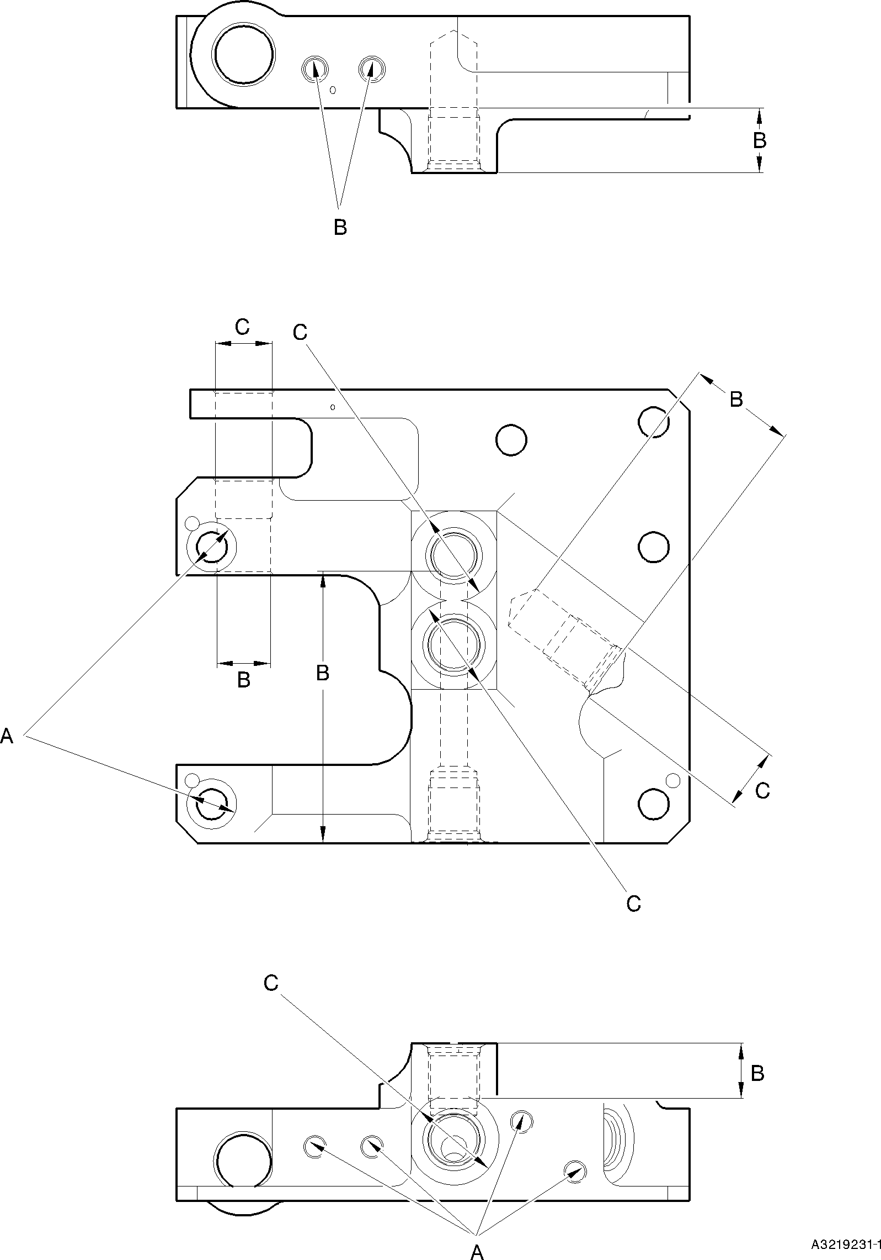

Transfer Block (2-340, 2-340A, 2-350 and 2-350A) - Protective Treatment Figure 602


A
SPOTFACE
16,00mm (0.630in) DIA.
x 0,05 to 0,13mm (0.002 to 0.005in) DEEP
A
A
SPOTFACE
B

VIEW A
A



0,05 to 0,13mm
(0.002 to 0.005in) DEEP

A321-S-32-12-22-096-0

Bracket (4-140 and 4-150) - Protective Treatment Figure 603

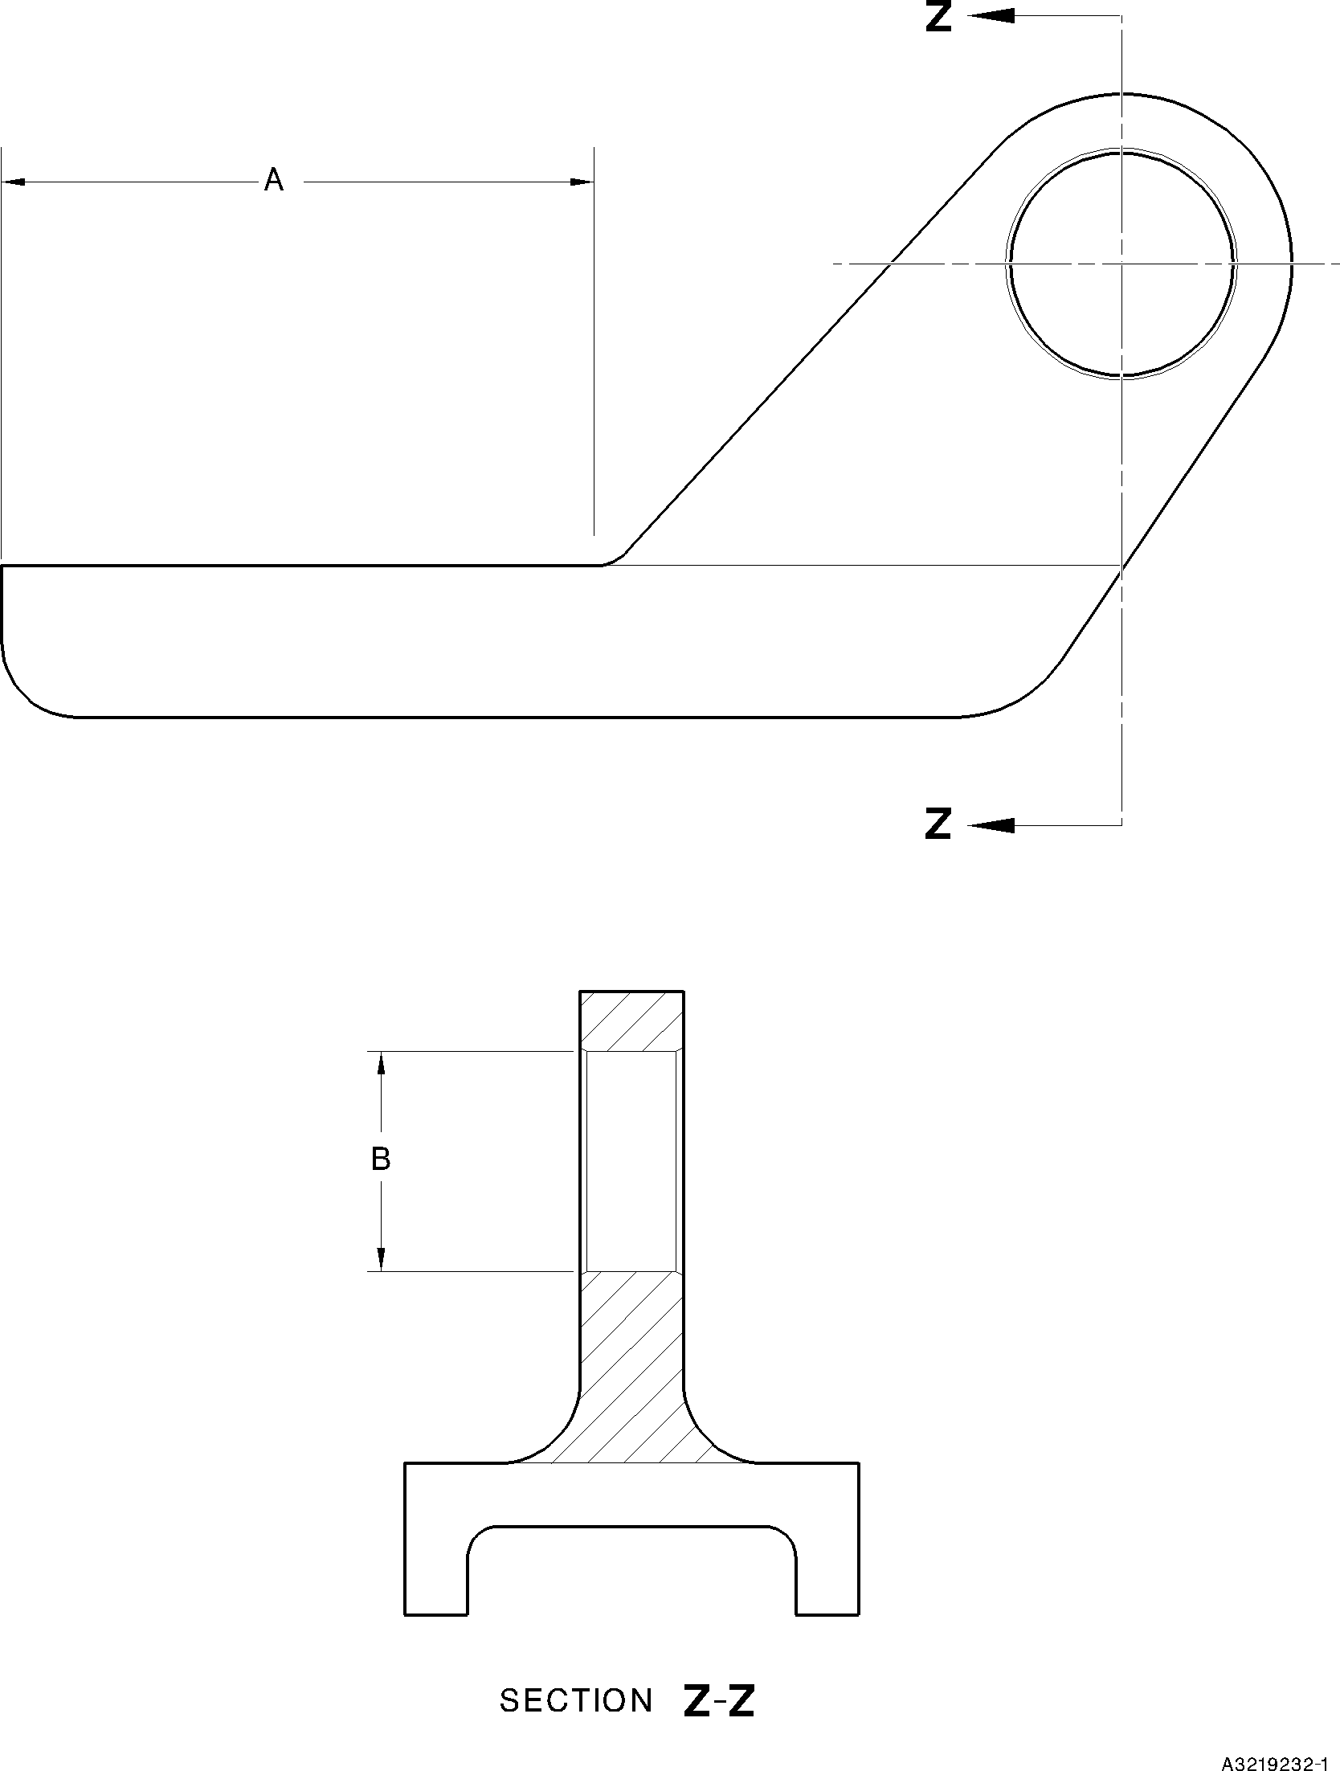

Bracket (5-160) - Protective Treatment Figure 604





A
B


B A

A321A6512-1

Bracket (6-170 and 6-180) - Protective Treatment Figure 605

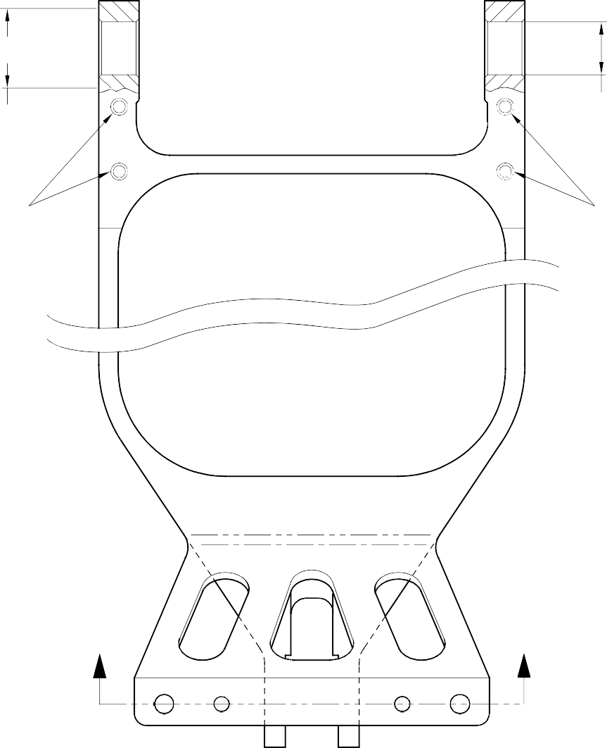
A A

27,00mm (1.062in) DIA (4 PLACES)
(BOTH HOLES)

B B

Z Z

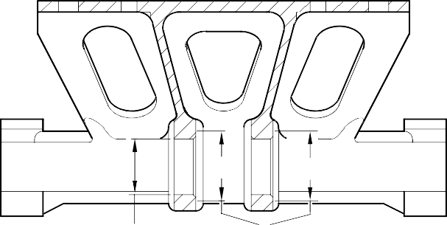
SECTION Z-Z
A
A
A

(BOTH HOLES)
27,00mm (1.062in) DIA

A321A6405-1

Slave Link (6-230) Only - Protective Treatment Figure 606


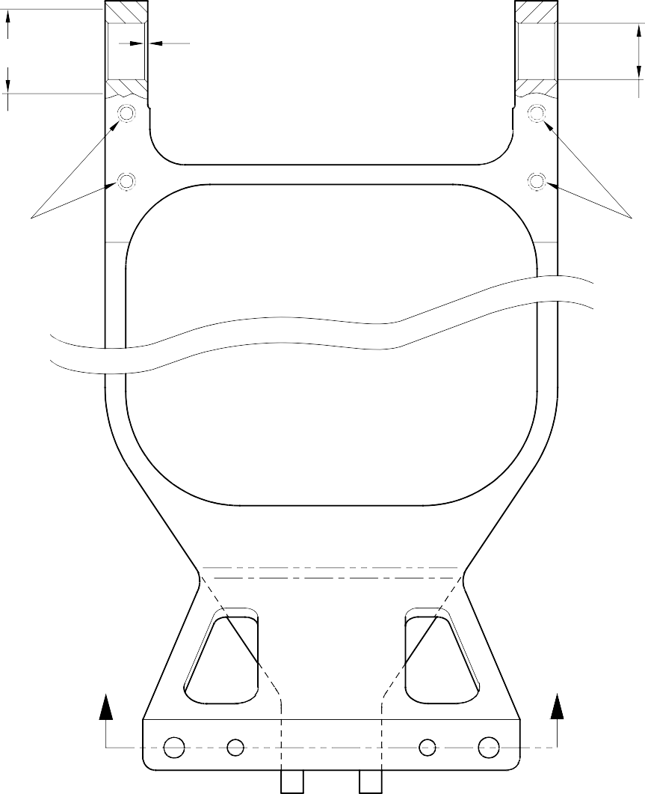
A A A
(4 PLACES)

27,00mm (1.062in) DIA (4 PLACES)
(BOTH HOLES)

B B

Z Z

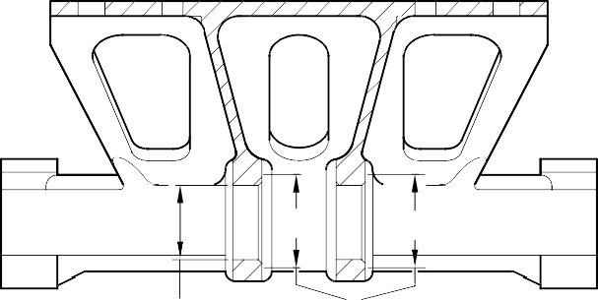
SECTION Z-Z
A
A
A

(BOTH HOLES)
27,00mm (1.062in) DIA

A321A6406-1

Slave Link (6-230A) - Protective Treatment Figure 607

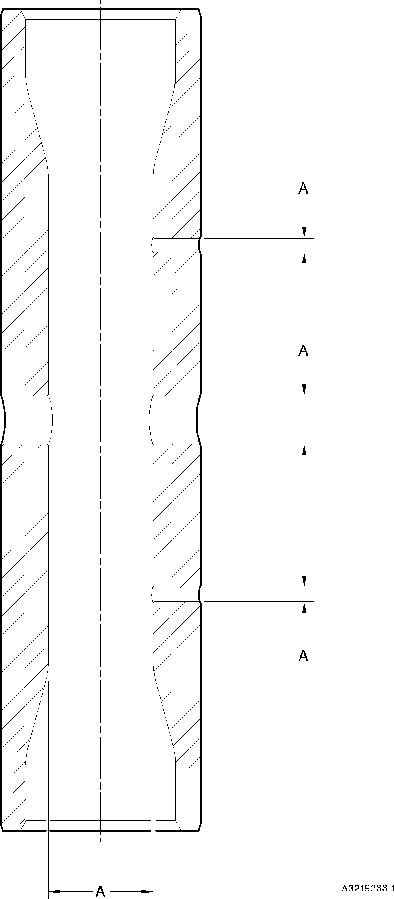

Pin (10-80) - Protective Treatment Figure 608

Figure Deleted Figure 609

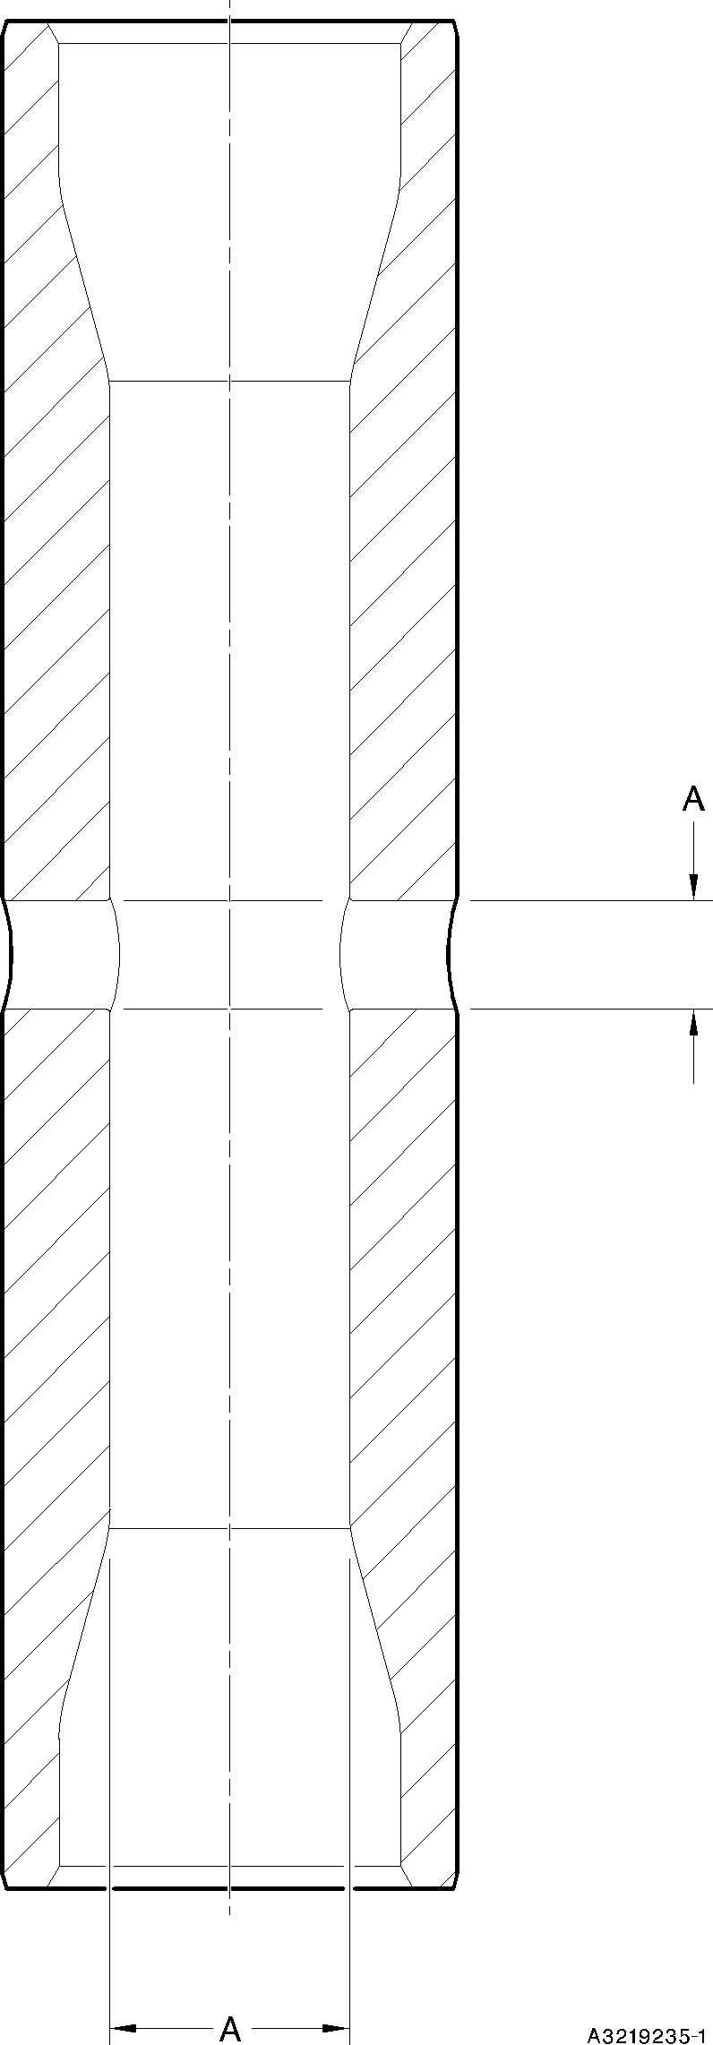

Pin (11-130) - Protective Treatment Figure 610

Figure Deleted Figure 611

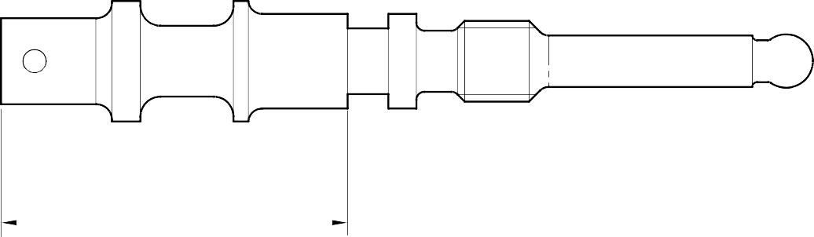
LENGTH OF CADMIUM PLATE

A321A4849-1

Valve Stem (12-90) - Protective Treatment Figure 612

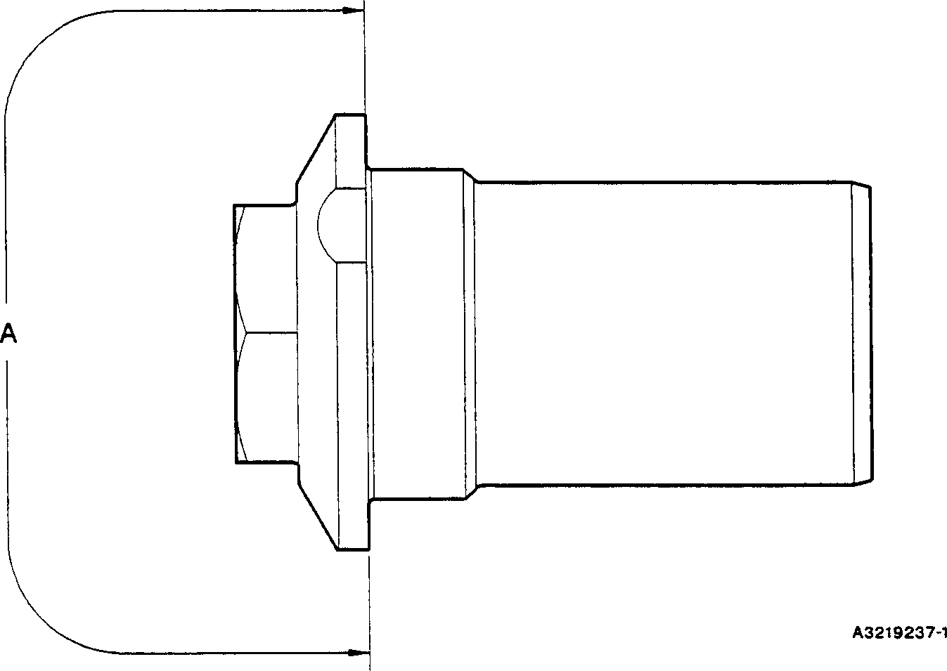

Retaining Pin (13-10) - Protective Treatment Figure 613

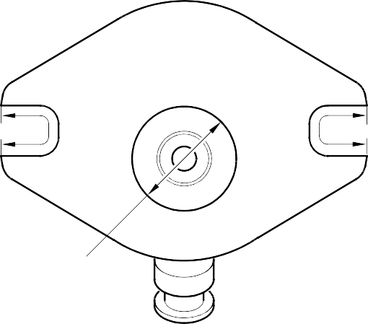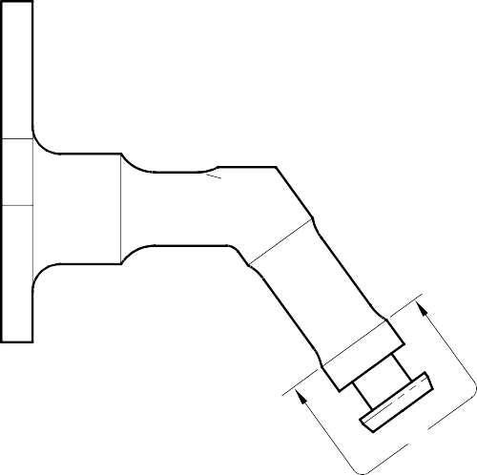
B
B
A
SPOTFACE
A

A321A4850-2

Inflation Valve (13-110 and 13-110A) - Protective Treatment Figure 614

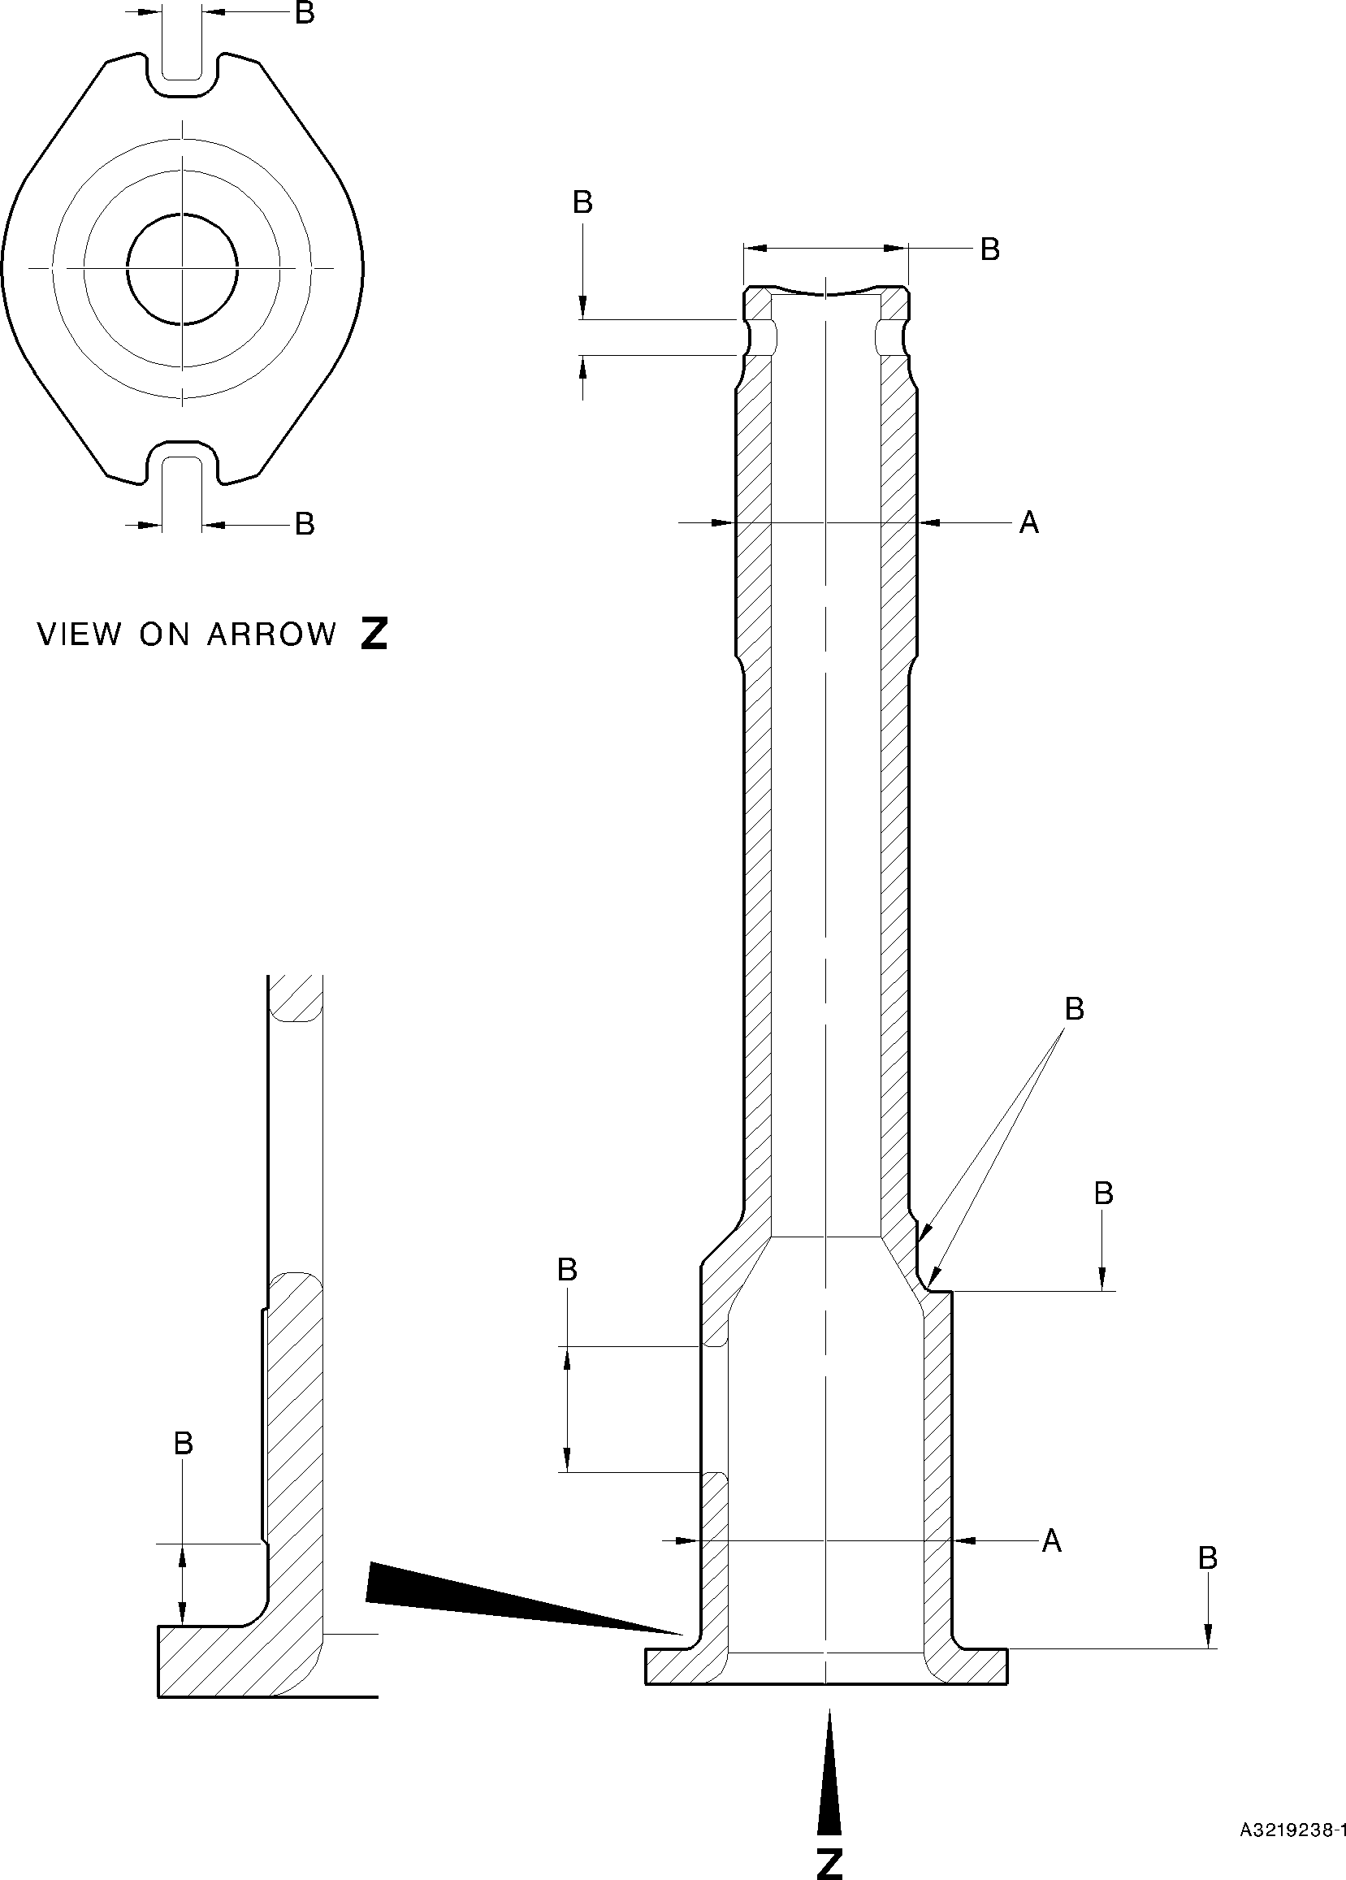

Pin (13-190 and 13-190A) - Protective Treatment Figure 615

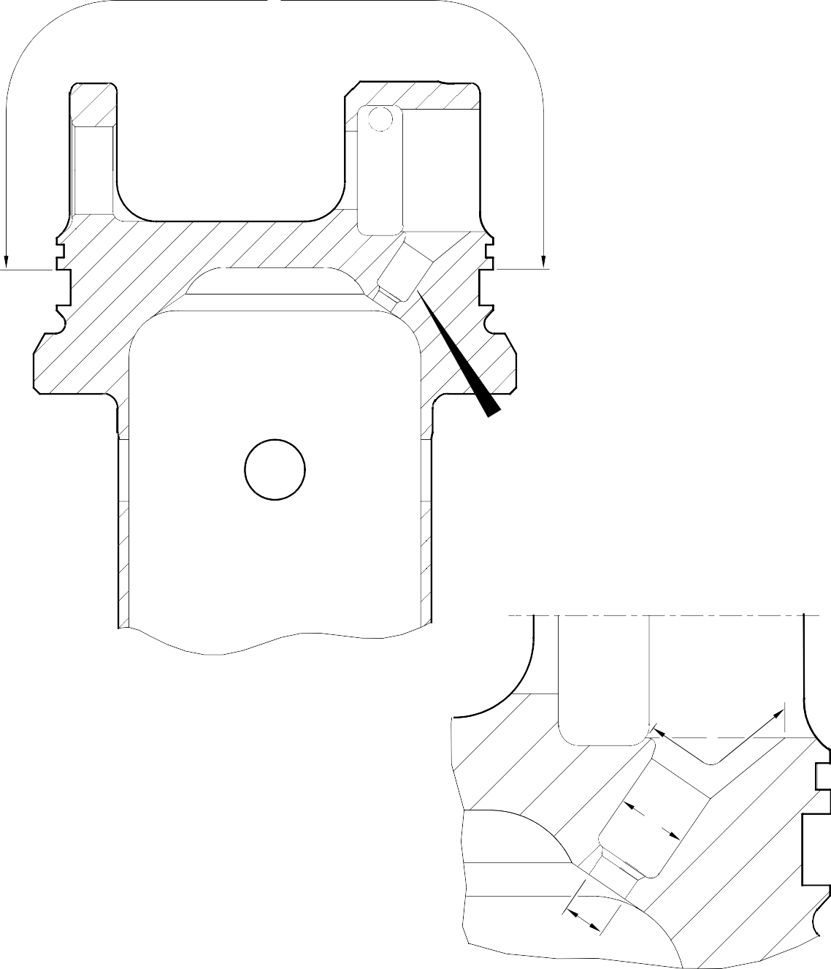
A
Z
A
B
C

DETAIL Z

A321A3758-1

Upper Diaphragm Tube (15-390) - Protective Treatment Figure 616

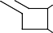
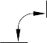
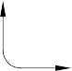
Z
B
B
A
A
FACE D
A
DIAMETER C

B

1,0mm (0.04in) MAXIMUM

F

128,0 to 132,0mm
5.04 to 5.19in
DIAMETER A

DETAIL Z

E A321A5553-1

Cylinder (17-230) - Protective Treatment Figure 617

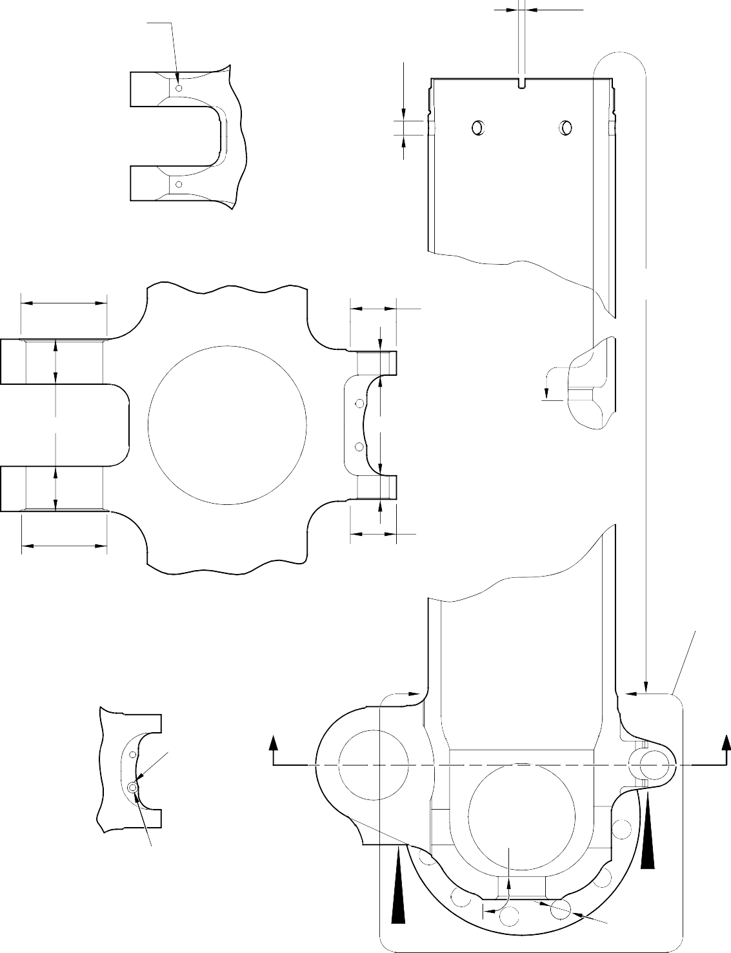
NO CADMIUM PLATE NO PAINT (2 PLACES)
NO CADMIUM PLATE NO PAINT
IN HOLES (Qty 6)
NO CADMIUM PLATE NO PAINT
(2 PLACES)
NO PAINT 80,00 to 81,00mm
(3.150 to 3.188in) DIA.
VIEW W
NO CADMIUM PLATE NO PAINT
NO PAINT
39,00 to 40,00mm (1.535 to 1.575in) DIA.
NO PAINT
NO PAINT
NO PAINT
NO PAINT
39,00 to 40,00mm (1.535 to 1.575in) DIA.
80,00 to 81,00mm
(3 .
.150 to 3.188in) DIA
SECTION Z-Z
PAINT TO PCS-2500 UP TO BUSH FLANGES
Z
Z
NO PAINT 13,00mm (0.512in) DIA.
NO PAINT
PRIMER PAINT TO PCS-2500
6,50 to 6,70mm (0.256 to 0.263in) DIA. for (18-80)
6,60 to 6,80mm (0.259 to 0.268in) DIA. for (18-80A) (4 PLACES)
V
VIEW V
W
NO PAINT (Qty 24)

A321-S-32-12-22-088-0

Sliding Tube (18-80) or (18-80A) - Protective Treatment Figure 618 - Sheet 1

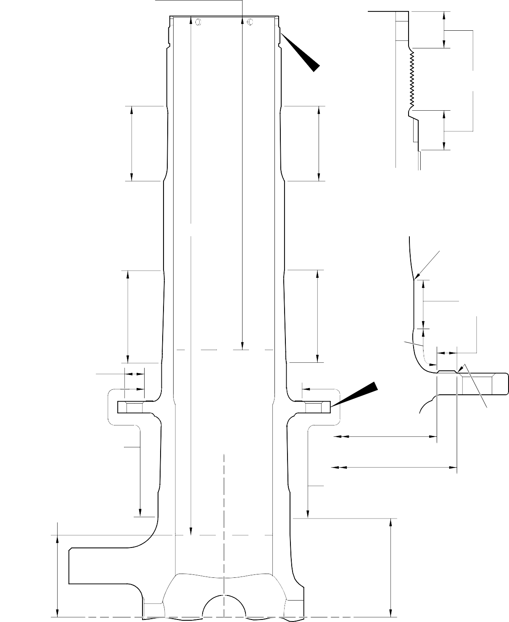
PRIMER PAINT TO PCS-2500 OVER SERMETEL W TO LENGTH 305,00mm (12.000in) for (18-80)
220,00mm (8.661in) for (18-80A)

B PAINT TO
PCS-2500

SERMETEL W
TO IFC 40-860-03MD
SERMETEL W TO
IFC 40-860-03MD

NOTE:-
SERMETEL W ON INTERNAL
DIAMETER OVER LENGTH A A
TO IFC 40-860-03MD
DETAIL B

0 to 2,00mm
(0 to 0.078in) RUNOUT

(BOTH SIDES)

SERMETEL W
TO IFC 40-860-03MD

PRIMER PAINT TO
PCS-2500 29,50 to 30,50mm
(1.161 to 1.200in) DIA. SPOTFACE (Qty. 24)

SERMETEL W TO IFC 40-860-03MD
SERMETEL W TO
IFC 40-860-03MD

SERMETEL W
TO IFC 40-860-03MD

149,90mm (5.901in) DIAMETER

160,00mm (6.299in) DIAMETER
CHROMIUM PLATE

0 to 2,00mm
(0 to 0.078in) RUNOUT (BOTH SIDES)

LIMIT OF SERMETEL W TERMINATION FROM CENTER 84,00 to 96,00mm
(3.307 to 3.779in)
SERMETEL W
TO IFC 40-860-03MD

CENTERLINE OF SLIDING TUBE
LIMIT OF SERMETEL W TERMINATION FROM CENTER 95,50 TO 107,50MM
(3.759 TO 4.232IN)

A321-S-32-12-22-089-0
Sliding Tube (18-80) or (18-80A) - Protective Treatment Figure 618 - Sheet 2

L

W
W W

W
R W W
V
M N

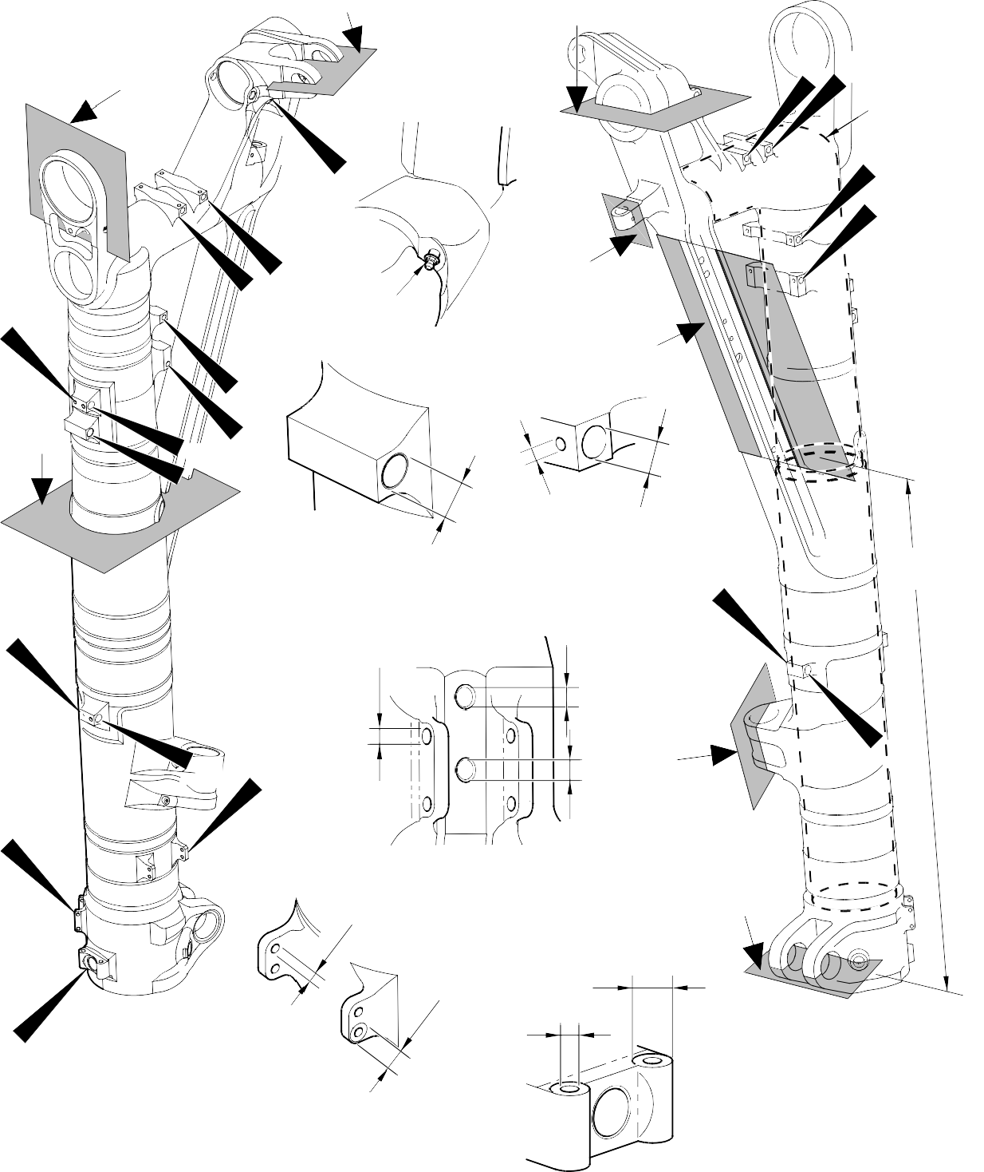
U

P
A

DETAIL U Q
A

A

D

W W
B
INTERNALLY

W W

DETAIL V
W 4 PLACES
A
DETAIL W
14 PLACES W

A
C
INTERNALLY

W Y
X

A
4 PLACES

A
DETAIL X
S W

T
- PLACES

16,0mm (0,63in) DIA. THIS FACE ONLY
22,00mm (0.866in) DIA. THIS FACE ONLY
A

Z 2 PLACES
A

A
VIEW Y

FOR ALL SECTION VIEWS SEE SHEET 2
DETAIL Z

A321-S-32-12-22-033-1

Main Fitting Subassembly (20-90, 20-90A, 20-100 and 20-100A) - Protective Treatment Figure 619 - Sheet 1

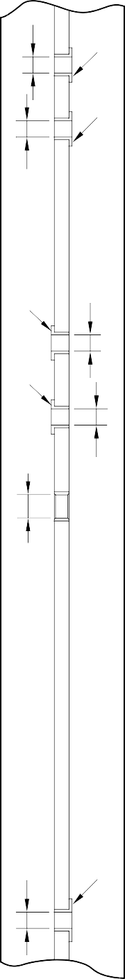
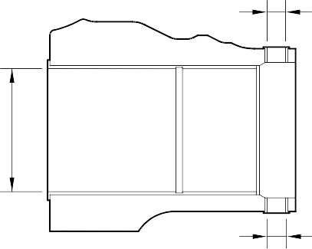
A
A
A
A
A
A
A
A
A
A
A
A
A
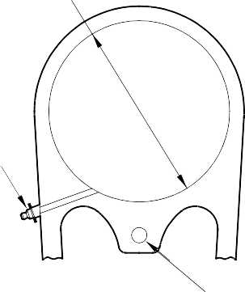
A

A
A

A
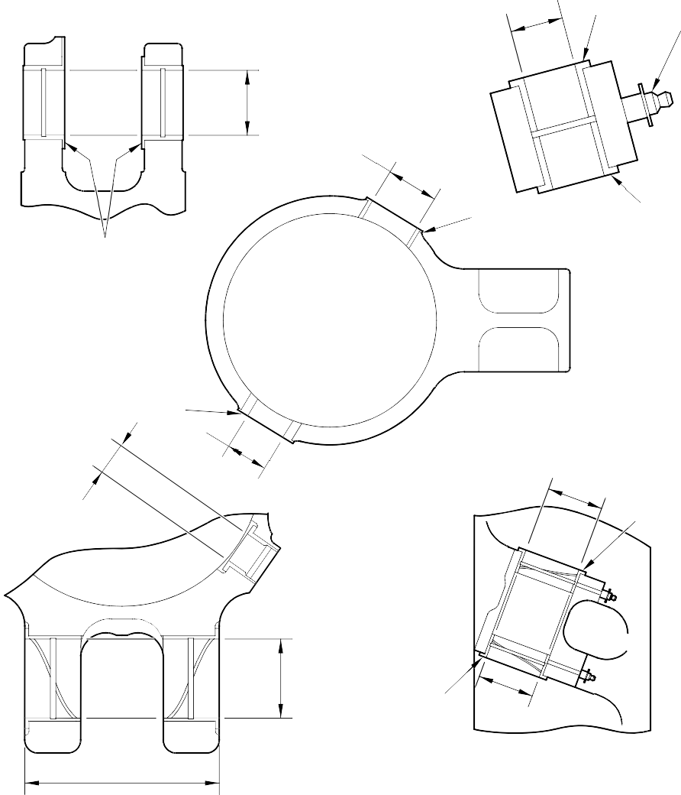
SECTION L
A
A
A
A
A
A
A
SECTION M
A
SECTION P
A
A
SECTION R
A 3 PLACES
A
A
A
A
A
A
SECTION S
SECTION N

SECTION T
SECTION Q

A321-S-32-12-22-087-0

Main Fitting Subassembly (20-90, 20-90A, 20-100 and 20-100A) - Protective Treatment Figure 619 - Sheet 2

A and B
(INNER DIAMETER)
B (2 HOLES)

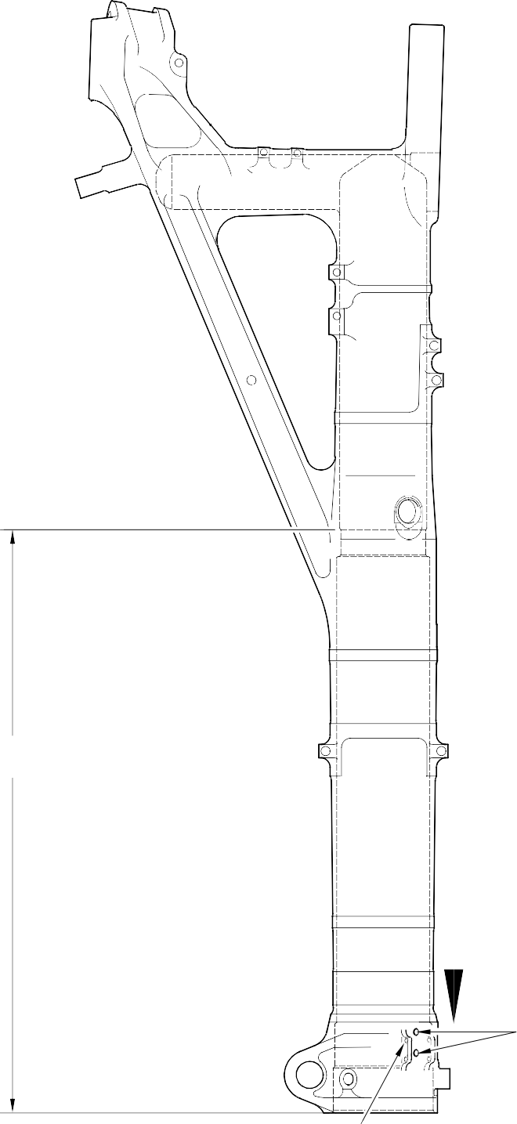
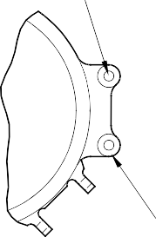
C (2 DIAMETERS)
VIEW ON ARROW

Z Z

B (2 HOLES)

B (4 HOLES)
A3219241-4

Main Fitting (20-410) and (20-420) - Protective Treatment Figure 620

B
(HOLE TO DEPTH OF 16,0mm (0.63in)
FROM THIS SURFACE)

B

B (DIAMETER)

B B (DIAMETER)

Z B
B
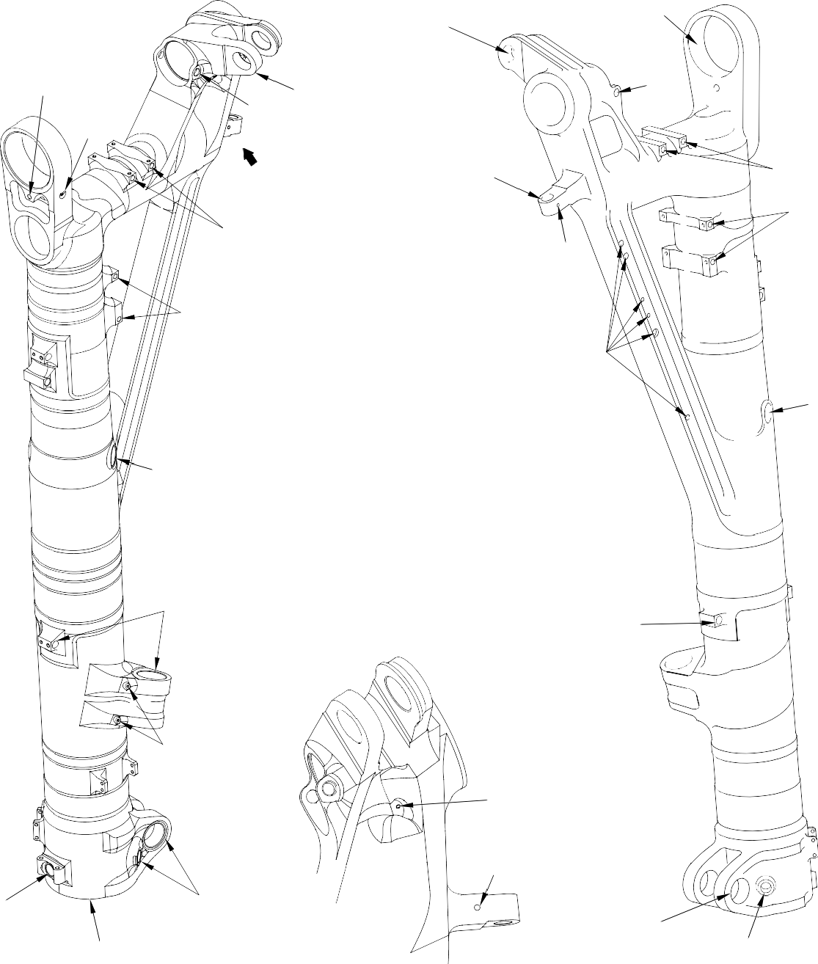
(DIAMETER)

B

B

(DIAMETER)
B
B
B

B
B

B

B

B (DIAMETER)
B (DIAMETER)

B

B

B
(DIAMETER)

B
(CHAMFER)

B
(DIAMETER)
B

VIEW ON ARROW Z

B
(DIAMETER)

B
(DIAMETER)

A321A3506-1

Main Fitting (20-410) and (20-420)- Protective Treatment Figure 621

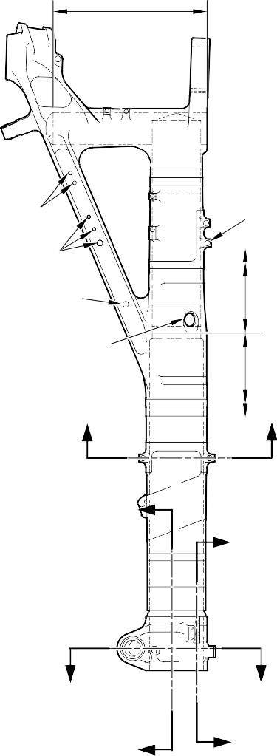
B INTERNALLY

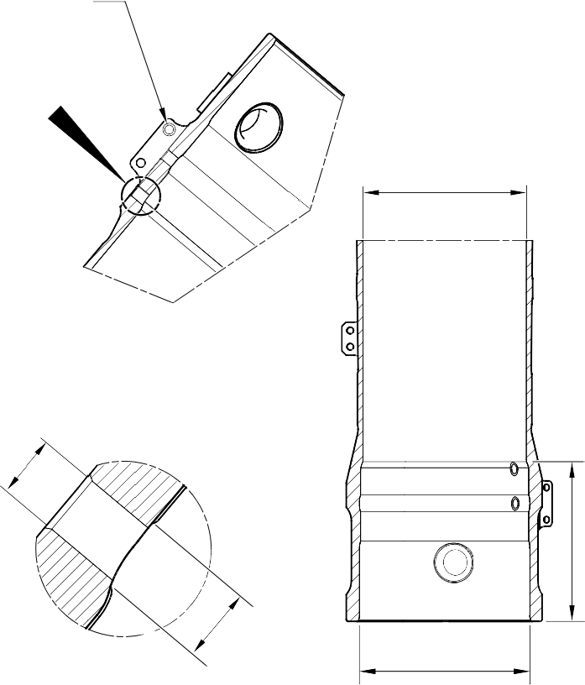
C 16,000mm (0.6299in)
- POSITION ONLY

W

A
C
19,800 to 20,000mm
C (0.7795 to 0.7873in) DIA.

C

C B SECTION Y-Y

52,000mm (2.0472in) C
THROUGH DIA.

X
INTERNALLY
C INTERNALLY
X _{A}

Z
Y
A
DETAIL W
TYPICAL 2 PLACES

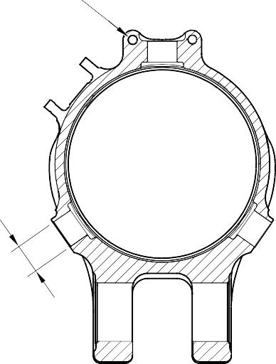
C 2 HOLES
9,700 to 10,000mm
U U
(0.3818 to 0.3936in) DIA.

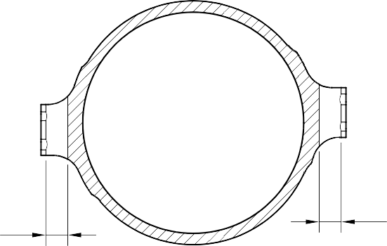
Z Y
A

C
SECTION Z-Z

C
C

SECTION X-X
C
- BORES

SECTION U-U

A321-S-32-12-22-085-0

Main Fitting (20-410A) and (20-420A) - Protective Treatment Figure 622 - Sheet 1

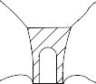
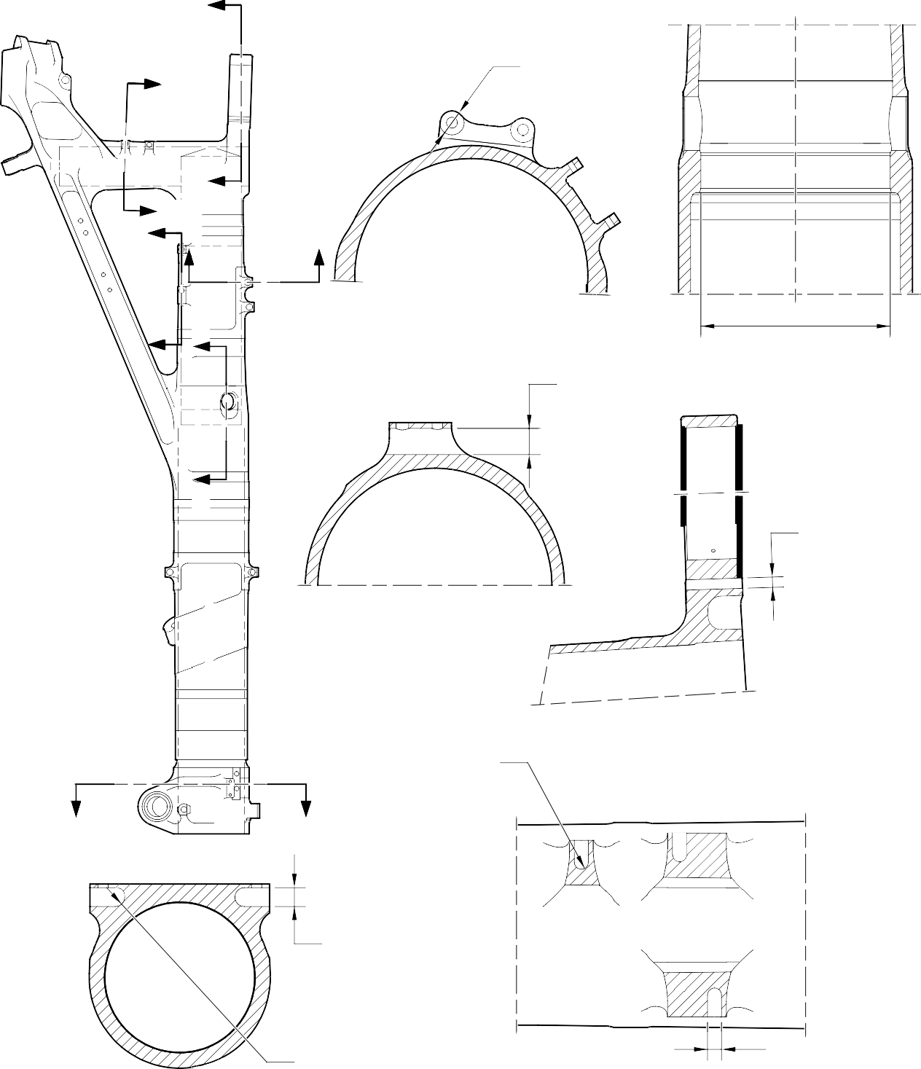
Z
C 22,000mm
(0.8661in) DIA.
Y 2 POSITIONS
IN THIS FACE ONLY

Z
X YW W

X V SECTION U-U
C
A

SECTION V-V

V

SECTION W-W

C
TO A DEPTH OF 16,000mm (0.6299in)
FROM OUTSIDE FACE

D RAD.
- PLACES

U U
SECTION Z-Z

C
4 HOLES

SECTION Y-Y

C RAD.
4 PLACES

SECTION X-X
D
4 PLACES

A321-S-32-12-22-086-0

Main Fitting (20-410A) and (20-420A) - Protective Treatment Figure 622 - Sheet 2

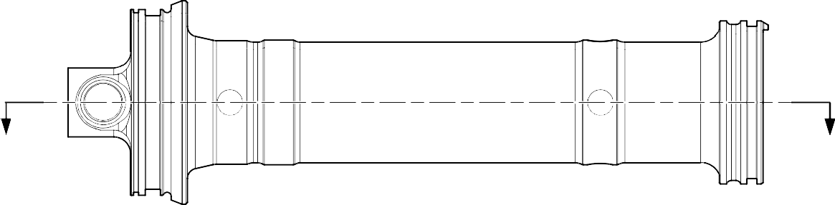
Z
Z


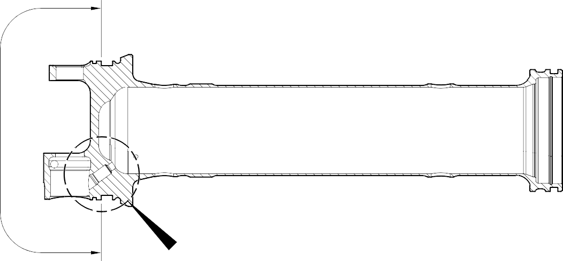
A
Y
SECTION Z-Z

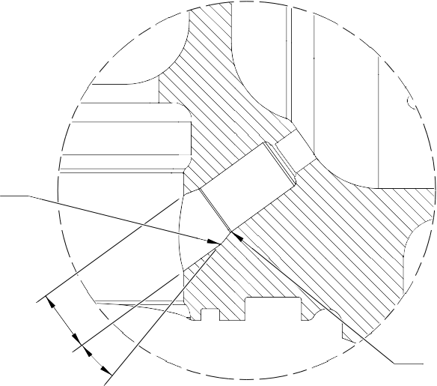
A
A
A
A

DETAIL Y

A321-T-32-12-22-109-0

Upper Diaphragm Tube (15-390A) - Protective Treatment Figure 623

