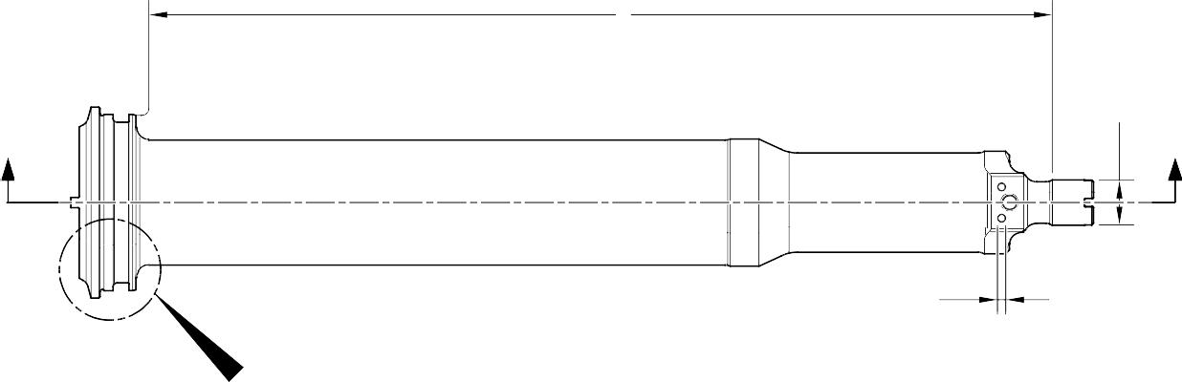
D

A

Z Z

A 2 PLACES

X
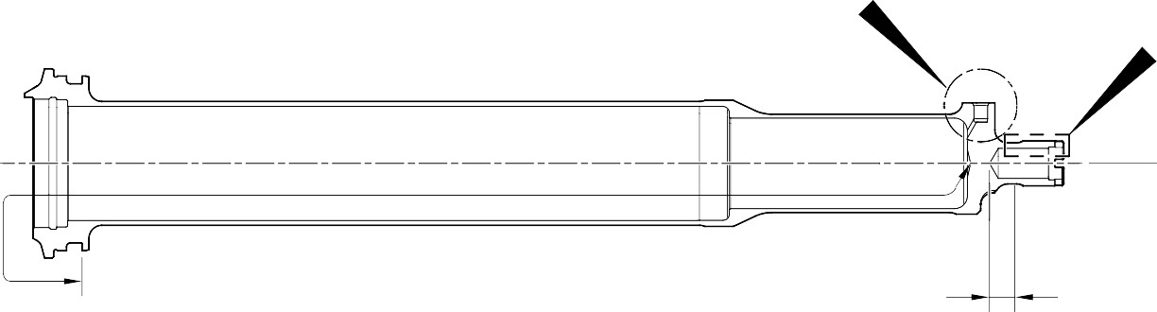
Y
W

A

D
128,00 to 132,00mm
(5.0393 to 5.1968in)
SECTION Z-Z

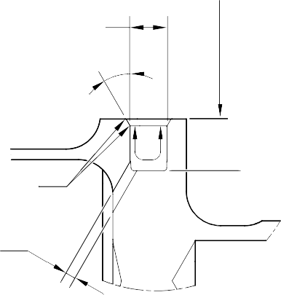
PRIMER PAINT FACE C

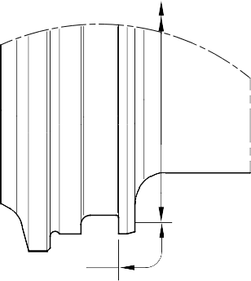
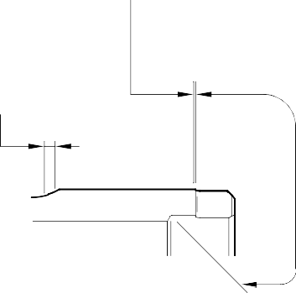
A
C AFTER THREAD

CADMIUM PLATE AND PAINT TO OVERLAP ON CHROMIUM RADIUS

1,0 to 2,0mm
B (0.04 to 0.07in)
CADMIUM PLATE AND PAINT TO OVERLAP
A

A
B
C

A
CADMIUM PLATE C
AND PRIMER PAINT

DETAIL X DETAIL Y DETAIL W

A321-T-32-12-22-110-0

Cylinder (17-230A) - Protective Treatment Figure 624

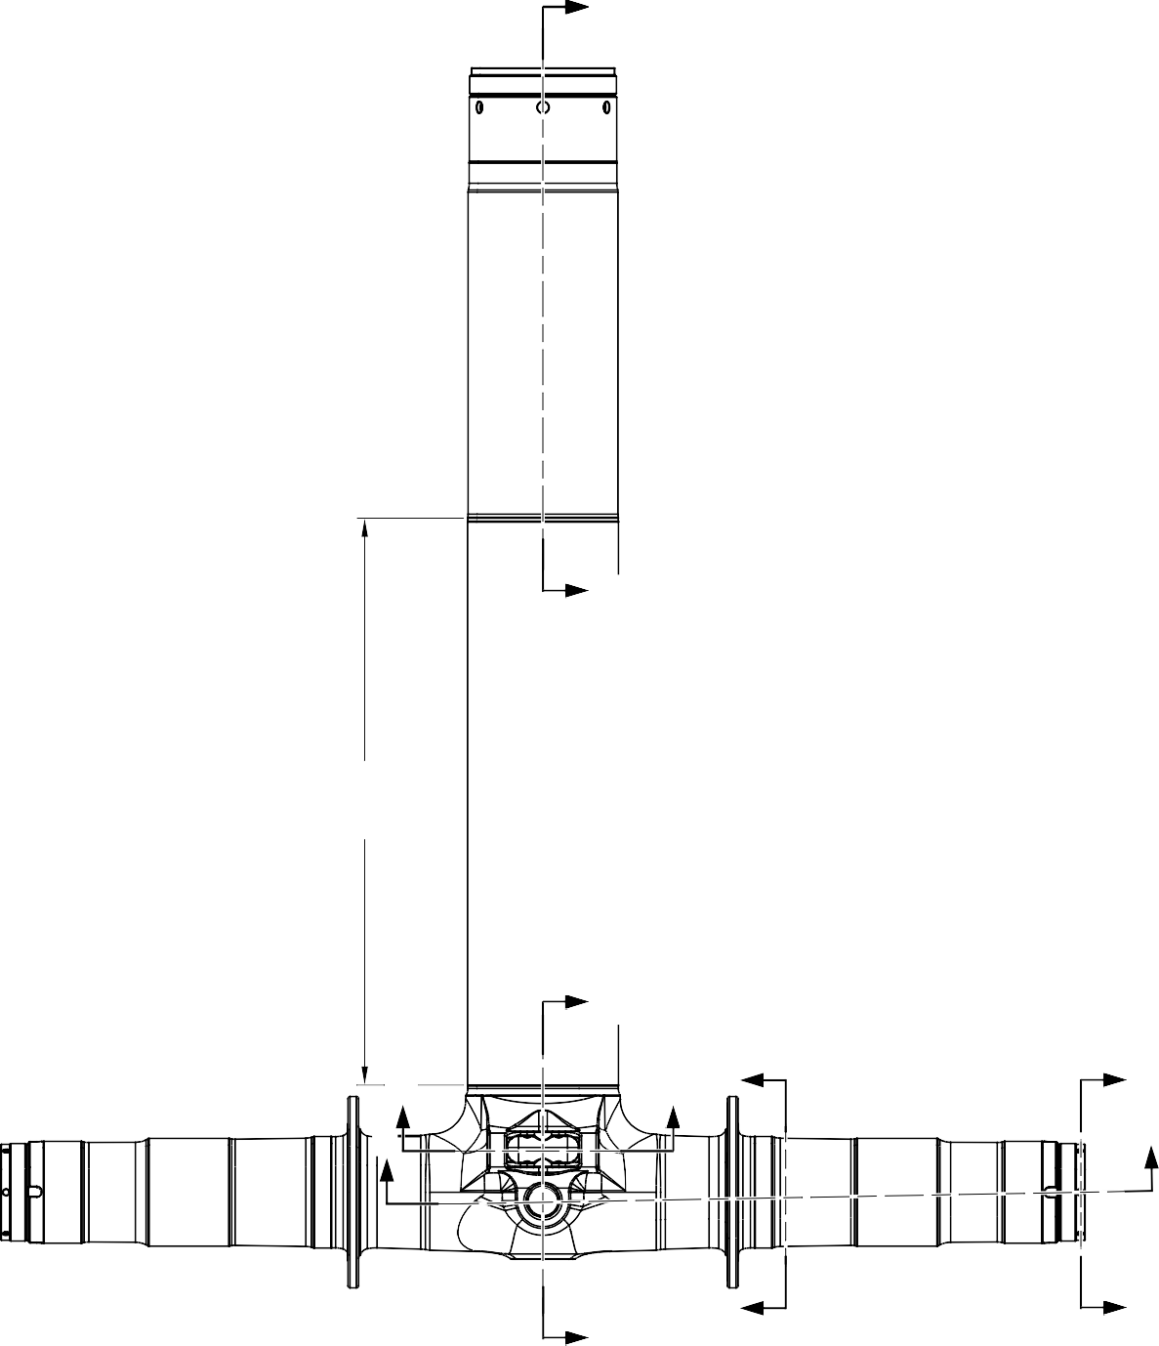
F
F
A
663,6 to 663,9mm
(26.13 to 26.14in)
A
C
B
C E
D B
A
E
D

A321-T-32-12-22-125-0

Sliding Tube (18-80B) - Protective Treatment Figure 625 - Sheet 1

E
17,750 to 18,250mm
(0.6988 to 0.7185in)
E
71,750 to 72,250mm (2.8248 to 2.8445in) DIA.
16,75 to 17,25mm
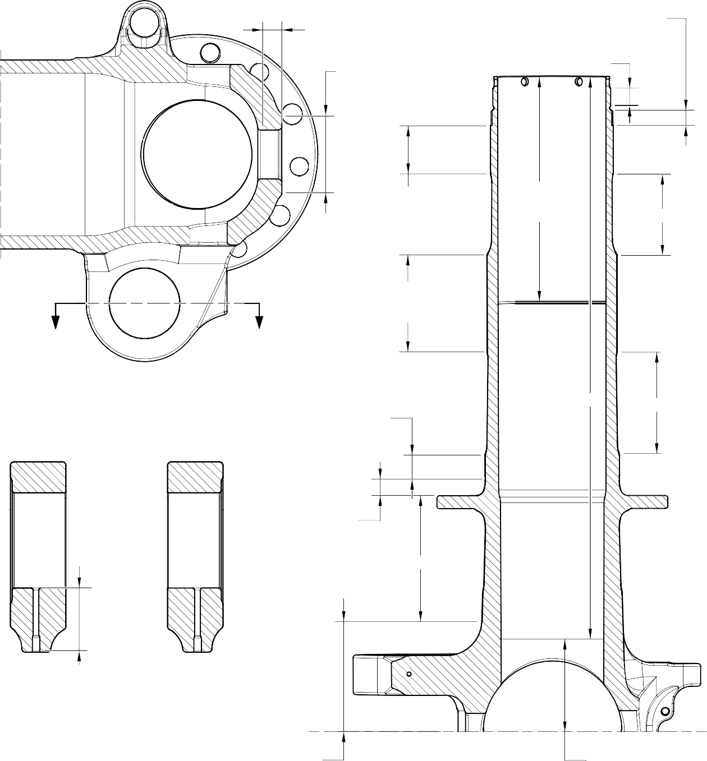
(0.6594 to 0.6791in)

F

A
119,929 to 119,964mm (4.7216 to 4.7230in) DIA.
E
220.00mm
(8.6614in) MIN. C

G G
SECTION A-A
KNUCKLE BORES
A
126,917 to 126,957mm (4.9967 to 4.9983in) DIA.

C C
A

131,294 to 131,357mm (5.1690 to 5.1715in) DIA.

B and F TYPICAL 2 PLACES
C
19,500 to 20,500mm
(0.7677 to 0.8071in)
C

SECTION G-G
KNUCKLE TOOLING LUG
GREASE HOLES

95,500 to 107,500mm
(3.7598 to 4.2323in)
EXTERNAL SERMETEL LIMIT

SECTION B-B
(BOTH SIDES)
AXLE BORE

84,000 to 96,000mm
(3.3071 to 3.7795in) INTERNAL SERMETEL LIMIT

A321-T-32-12-22-126-0

Sliding Tube (18-80B)- Protective Treatment Figure 625 - Sheet 2

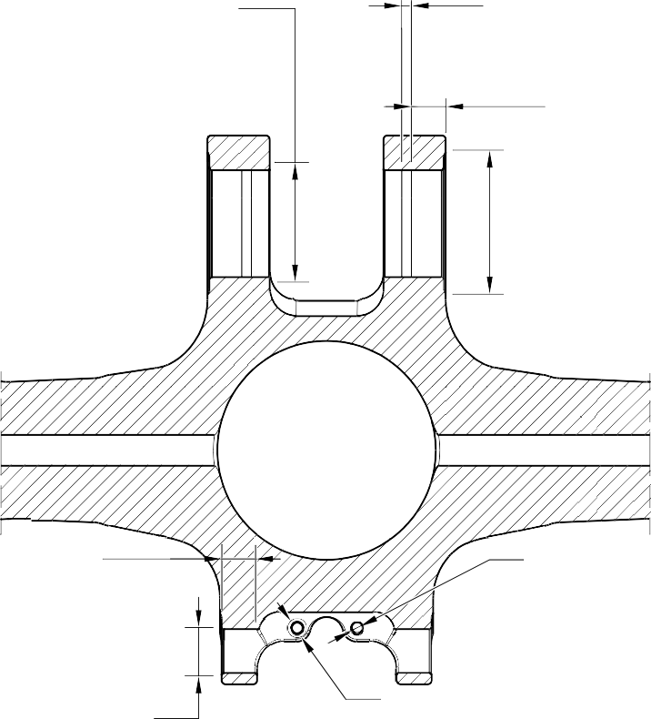
E
69 ,7 50 to 70 ,2 50mm
( 2 .7461 to 2 .76 57 in) DIA. SPOTFACE TYPICAL
- PLACES
F
5 ,000 to 7 ,000 mm
( 0 .1968 to 0 .2755 in)
TYPICAL 2 PLACES
19,000 to 21,000mm
(0.7481 to 0.8268in)
TYPICAL 2 PLACES

E
81 ,7 50 to 82 ,2 50mm
(3. 2185 to 3. 2382 in) DIA. SPOTFACE TYPICAL
2 PLACES

E 23,400mm (0.9213in) MIN. TYPICAL 2 PLACES

E
6 ,50 to 6 ,70 mm
( 0 .256 to 0 .264 in) DIA.
TYPICAL 4 PLACES
SECTION D-D
(BOTH SIDES)
AXLE NUT CROSS BOLT HOLES
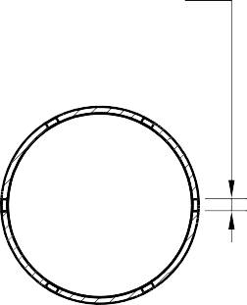
D
6 ,70 to 6 ,90 mm
( 0 .2638 to 0 .2717 in) DIA.
TYPICAL 6 PLACES

E
38 ,7 50 to 39 ,2 50mm
( 1 .52 56 to 1 .5453 in) DIA. SPOTFACE TYPICAL 2 PLACES INCLUDING
CHAMFER

SECTION C-C
LUG BORES
F
13 ,00 0mm
( 0 .5 118 in) DIA.
SPOTFACE TYPICAL 4 PLACES INCLUDING CHAMFER

SECTION E-E
(BOTH SIDES)
BRAKE FLANGE

E
30 ,7 50 to 31 ,2 50mm
( 1 .2106 to 1 .2303 in) DIA. SPOTFACE TYPICAL
12 PLACES INCLUDING
CHAMFER
A
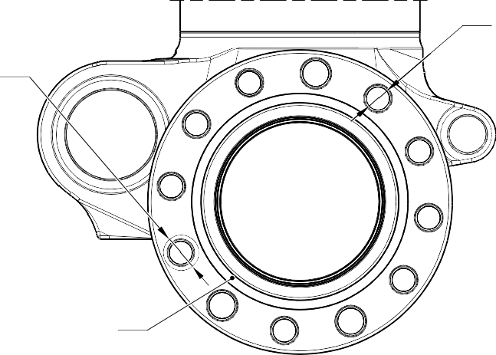
TYPICAL 12 PLACES
A

A321-T-32-12-22-127-0

Sliding Tube (18-80B)- Protective Treatment Figure 625 - Sheet 3

B and F
1197,9 to 1199,6 mm
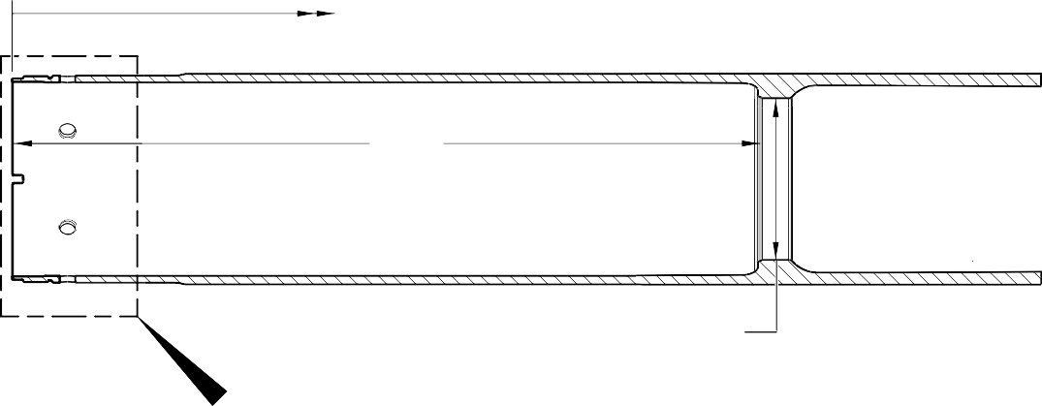
( 47.16 to 47.23 in)
B and F
A
135 ,860 to 135 ,923 mm
( 5 .3488 to 5 .3518 in) DIA.
Z

SECTION F-F
BARREL

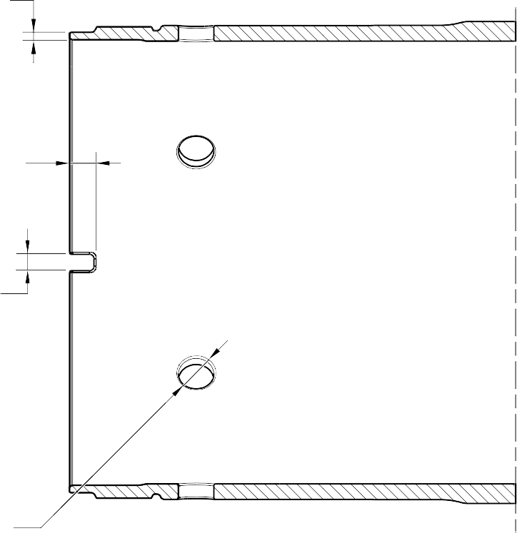
B and F

B and F 9,000mm (0.1181in) TYPICAL 2 PLACES INCLUDING CHAMFER

B and F
5 ,950 to 6 ,050 mm
( 0 .2343 to 0 .2382 in) DIA.
TYPICAL 2 PLACES

B and F TYPICAL 6 PLACES INCLUDING CHAMFER

DETAIL Z

A321-T-32-12-22-128-0

Sliding Tube (18-80B)- Protective Treatment Figure 625 - Sheet 4

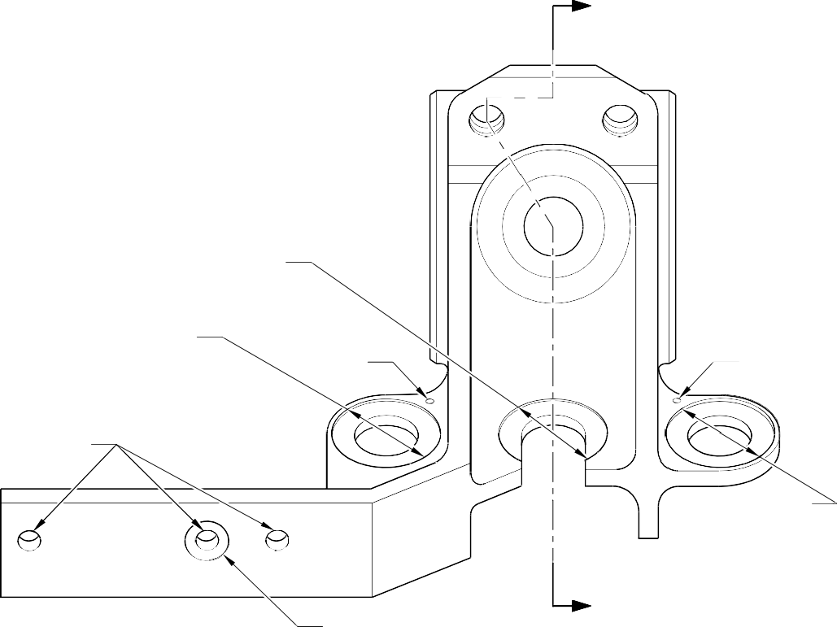
A

A SPOTFACE (BOTH SIDES)
A SPOTFACE (BOTH SIDES)
C C

C

A SPOTFACE (BOTH SIDES)

A SPOTFACE

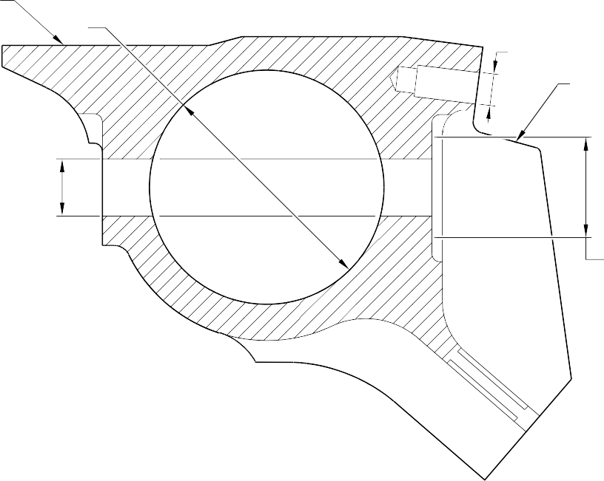
D
B
C
D
ON FACE
C
A SPOT
SECTION A-A
A3
A

FACE

21-T-321222-0001-01

Upper Pivot Bracket (10-160) Only - Protective Treatment Figure 626

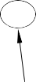

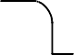
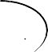

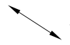
A
A
C
A
SPOTFACE (BOTH SIDES)
A
SPOTFACE (BOTH SIDES)
A
A
SPOTFACE (BOTH SIDES)

SPOTFACE

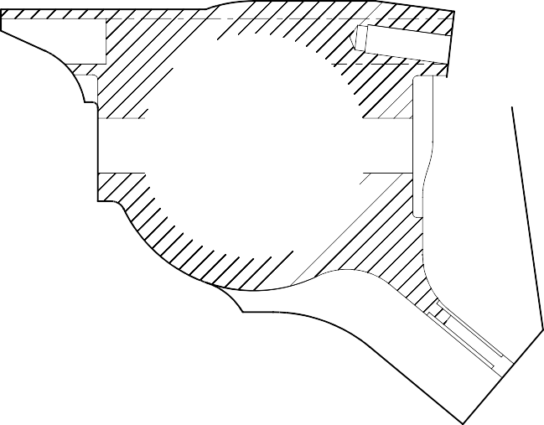
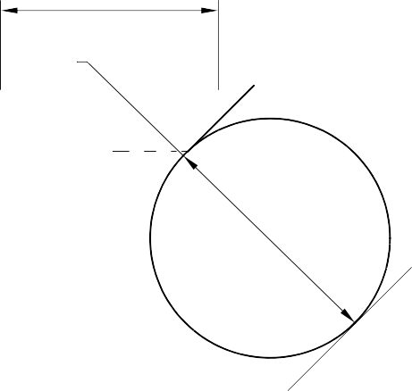
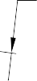
D

B C

D
ON FACE

A
C SPOTFACE

SECTION A-A

A321-T-321222-0002-01

Upper Pivot Bracket (10-160A) - Protective Treatment Figure 627





A

D C
B

( 2 PLACES )
DO NOT PAINT
D

A321-T-321222-0003-00

Valve Stem (12-90A) - Protective Treatment Figure 628

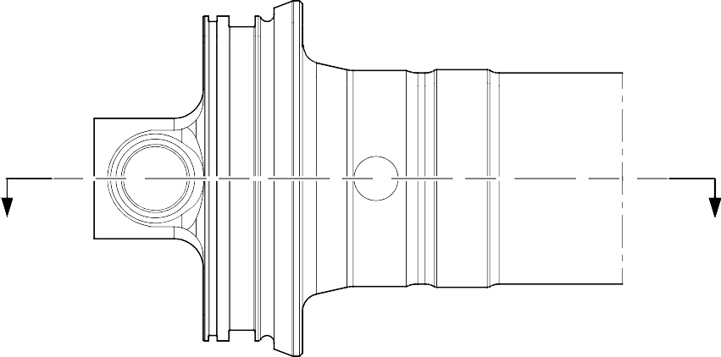
A
A

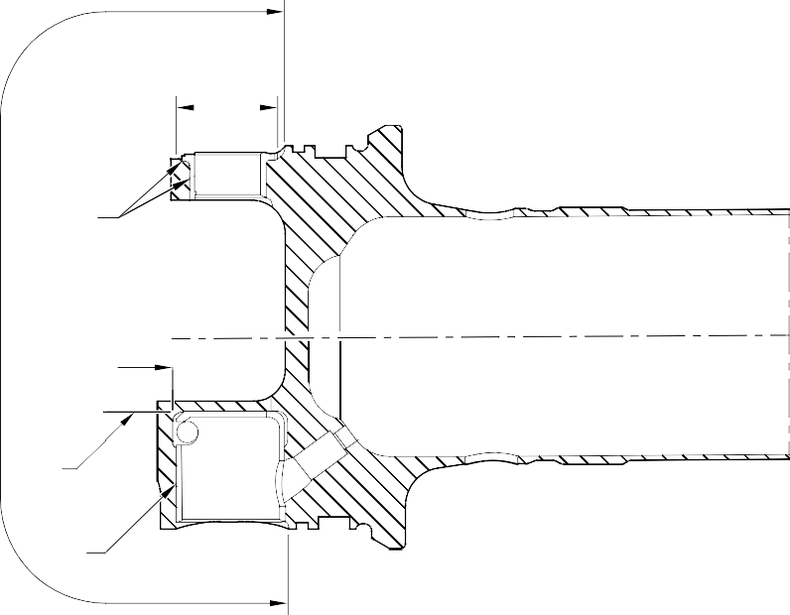
B
A
A
A
A
A

SECTION A-A

A321-T-321222-0004-00

Upper Diaphragm Tube Subassembly (15-360) - Protective Treatment Figure 629

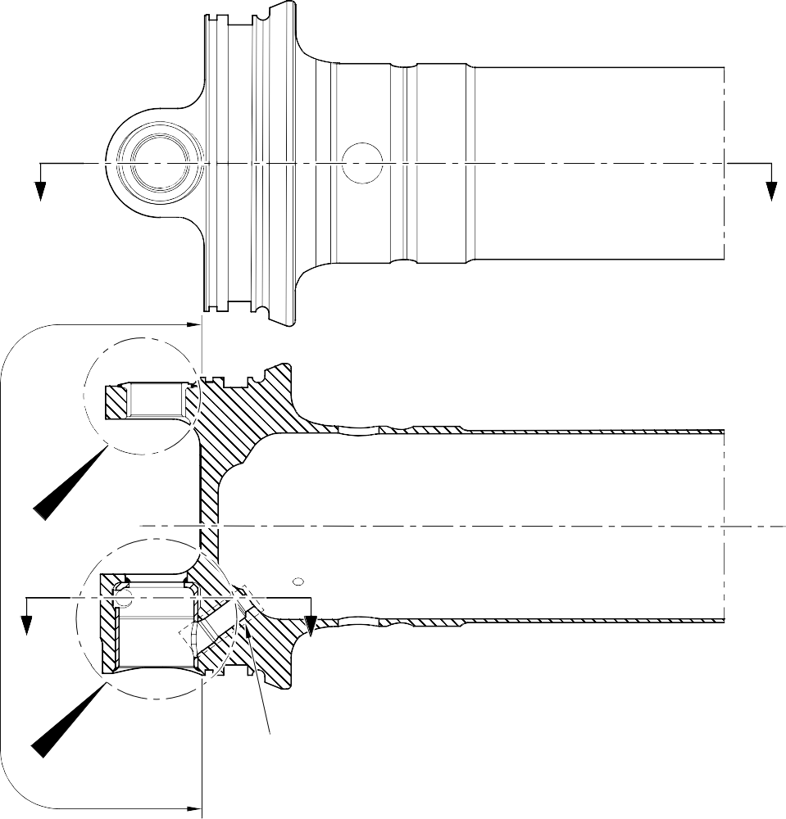
A AND C
A
A
A
Z
Z
B
B AND D
SECTION A-A

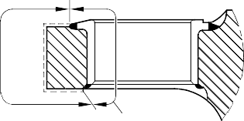
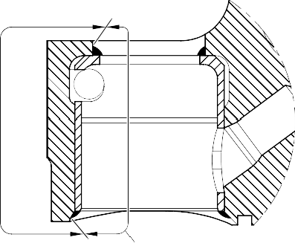
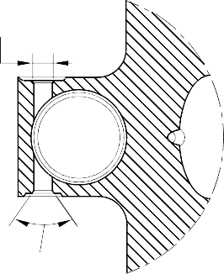
B AND D
D

C C

B AND D
D

DETAIL A DETAIL B SECTION Z-Z

A321-T-321222-0005-00

Upper Diaphragm Tube Subassembly (15-360A) - Protective Treatment Figure 630

A
A
SPOTFACE

B
C (2 PLACES)

VIEW A
Bracket (2-80 and 2-90) - Protective Treatment Figure 631

A321-T-321222-0006-00

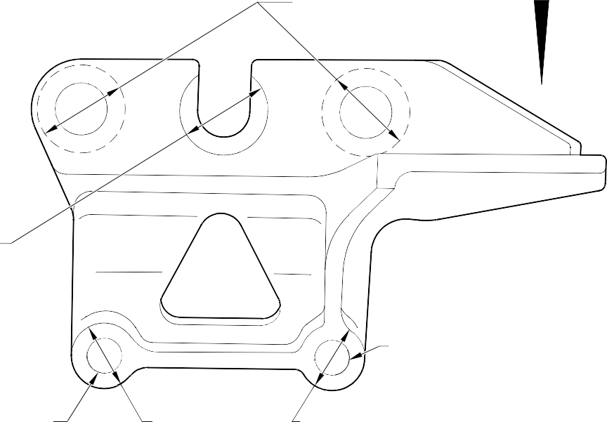
A
A
SPOTFACE
D
D
B
B

F
SPOTFACE (BOTH SIDES)

SPOTFACE (BOTH SIDES)
SPOTFACE (BOTH SIDES)

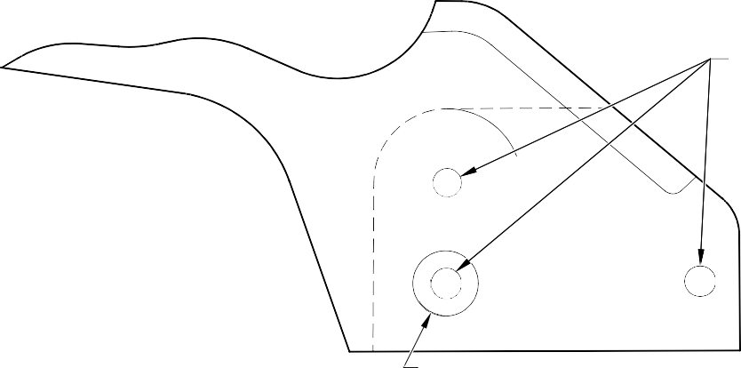
E
C
SPOTFACE

VIEW A

A321-T-321222-0007-00

Harness Support Bracket (7-100, 7-100A, 7-110 and 7-110A) - Protective Treatment Figure 632

B
30,5mm (1.20in)
Y
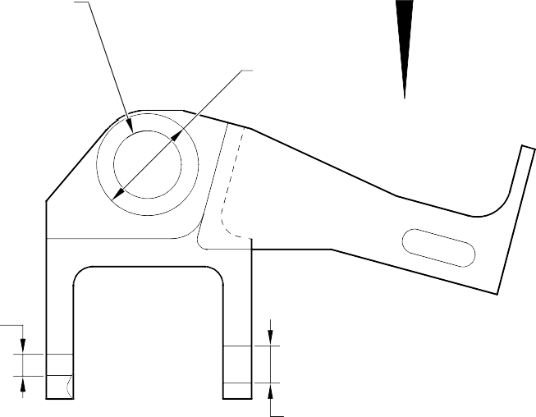
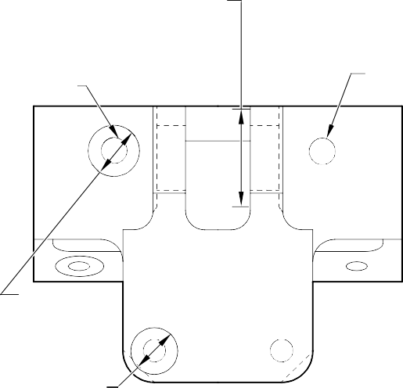
B
(BORE AND CHAMFER INCLUDED)

SPOTFACE
C
C (2 PLACES)
B
(2 PLACES)

A
SPOTFACE C

A C
SPOTFACE

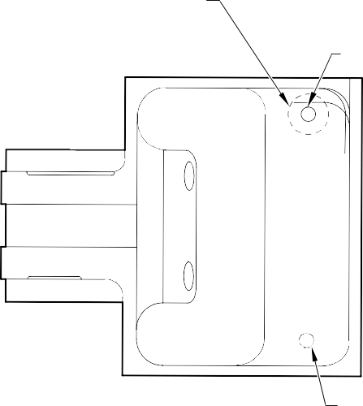
A
SPOTFACE (REARSIDE ONLY)
C
VIEW Y
C

A321-T-321222-0009-00

Bracket (8-170) - Protective Treatment Figure 633

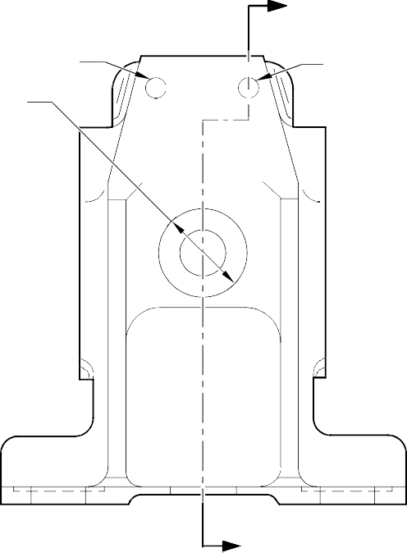
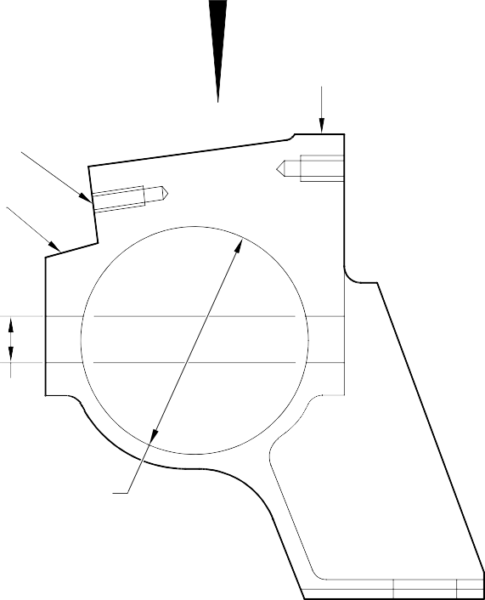
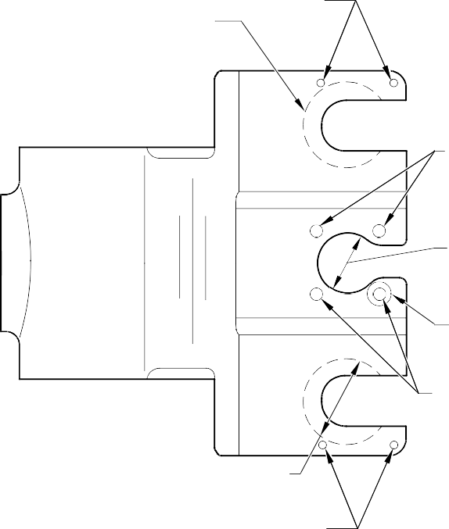
Z

C C
A

Z
C
A
C
(2 PLACES)

FACE D
B

FACE D

C

C

C
A

C B

A

C
VIEW B

SECTION Z-Z

A321-T-321222-0010-00

Harness Support Bracket (11-140) - Protective Treatment Figure 634

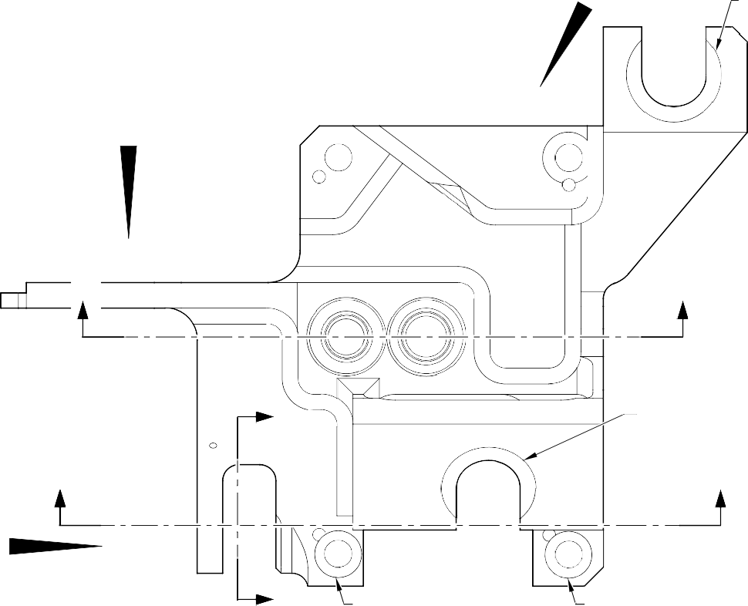
B _{A}
SPOTFACE

A

Y Y

X A
SPOTFACE

Z Z

C
X _{A}
SPOTFACE

A
SPOTFACE

SPOTF
C
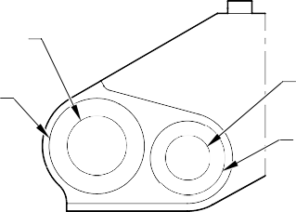
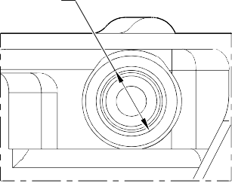
HOLE
C
HOLE
A
ACE
C
SPOTFACE
A
SPOTFACE

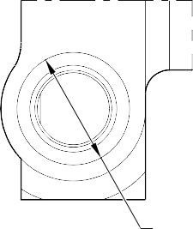
VIEW A VIEW B
C

VIEW C
SPOTFACE

A321-T-321222-0012-00

Transfer Block (2-340B and 2-350B) - Protective Treatment Figure 635 - Sheet 1

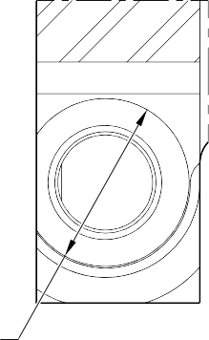
C
SPOTFACE SECTION X-X

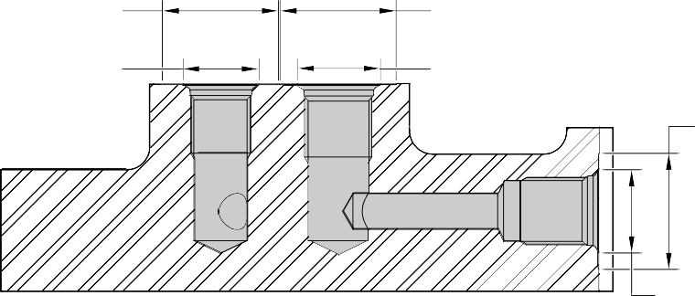
C
C
SPOTFACE
B
C
SPOTFACE
B
B
SPOTFACE

SECTION Y-Y

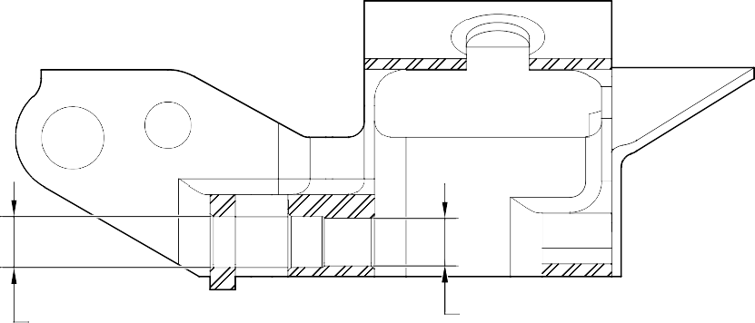
C B
SECTION Z-Z

A321-T-321222-0008-00

Transfer Block (2-340B and 2-350B) - Protective Treatment Figure 635 - Sheet 2

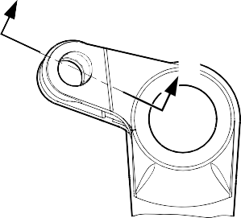
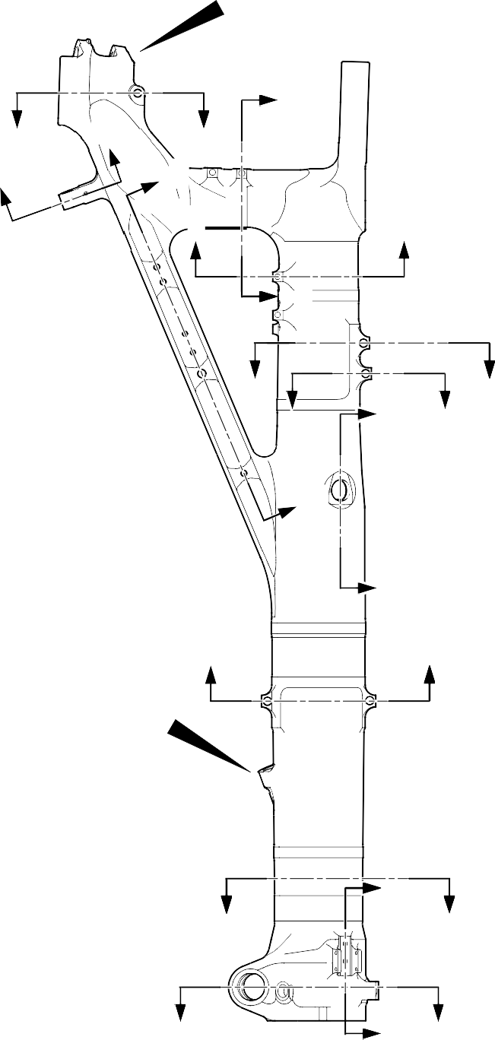
D
D
A
E
C A
C
B A
F
F
E
G
G
H
J H
B
J
K
K
B
L
N
N
P
L P

VIEW A

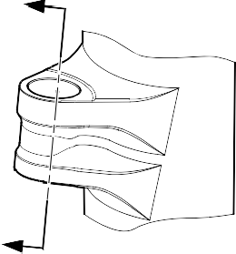
M
M
VIEW B

A321-T-321222-0020-00

Main Fitting (20-410B, 20-420B, 20-410C, 20-420C, 20-410D and 20-420D) - Protective Treatment Figure 636 - Sheet 1

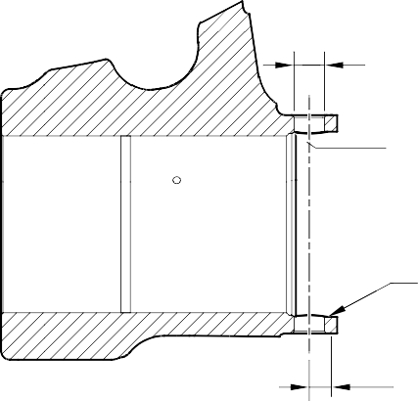
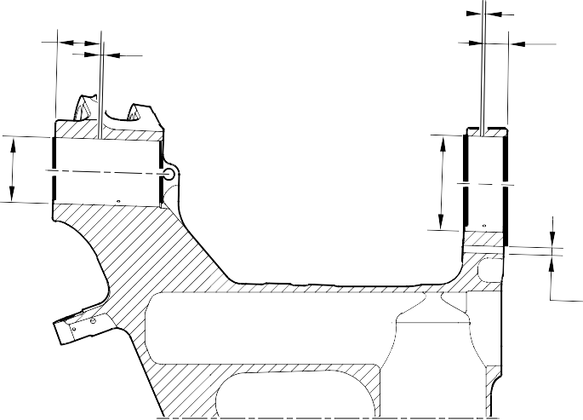
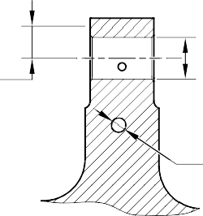
B
70,000 to 80,000mm
(2.7558 to 3.1495in)
REF.
C
C
5,000 to 7,000mm
(0.1968 to 0.2755in)
5,000 to 7,000mm
(0.1968 to 0.2755in)
40,000 to 50,000mm
(1.5747 to 1.9684in) REF.
B INCLUDING CHAMFERS
B INCLUDING CHAMFERS
C
C DIAMETER THRU BORE
B
RADIUS
PINTLE BORE S
FOR MAIN FITTING (20-410C AND 20-420C) ONLY
B
RADIUS
B
SPOTFACE 18,000 to 19,000mm (0.7086 to 0.7480in) RAD.
C
TYPICAL 2 PLACES
INCLUDING CHAMFERS TYPICAL 2 PLACES
SECTION A-A
B
SPOTFACE 14,000 to 15,000mm (0.5511 to 0.5905in) RAD.

PINTLE CROSS BORES
INCLUDING CHAMFERS TYPICAL 2 PLACES
SECTION C-C
LOCK LINK BORE

C TYPICAL 2 HOLES
B
11,500 to 12,500mm (0.4527 to 0.4921in) RAD. TYPICAL 2 PLACES
B
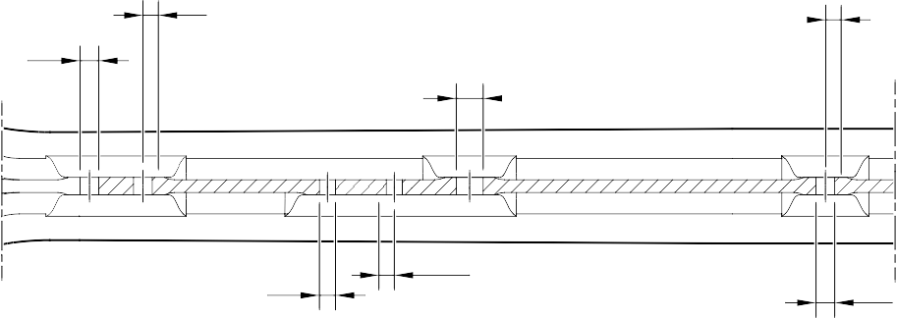
11,750 to 12,750mm (0.4626 to 0.5019in) RAD.

C

C TYPICAL 2 HOLES
SECTION B-B
DRAG ARM HOLES
B
10,750 to 11,750mm
(0.4232 to 0.462in) RAD. C
TYPICAL 2 PLACES

FOR MAIN FITTING (20-410C, 20-420C) ONLY
A321-T-321222-0021-02

Main Fitting (20-410B, 20-420B, 20-410C, 20-420C, 20-410D and 20-420D) - Protective Treatment Figure 636 - Sheet 2

C
5,000 to 7,000mm
(0.1968 to 0.2755in)
TYPICAL 2 PLACES

B 30,000 to 31,000mm (1.1810 to 1.2204in)
SPOTFACE RAD.
B
51,500 to 52,500mm
(2.0275 to 2.0669in) SPOTFACE RAD.
14,000 to 16,000mm (0.5511 to 0.6299in) REF.

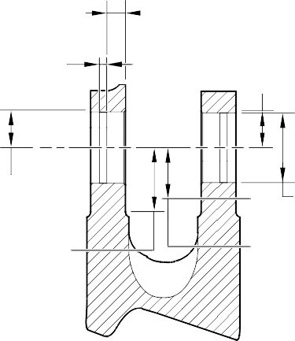
B
29,500 to 30,500mm
(1.1614 to 1.2007in) SPOTFACE RAD.
B
DIAMETERS THRU BORES INCLUDING CHAMFERS
B
35,500 to 36,500mm
(1.3976 to 1.4370in) SPOTFACE RAD.

SECTION D-D

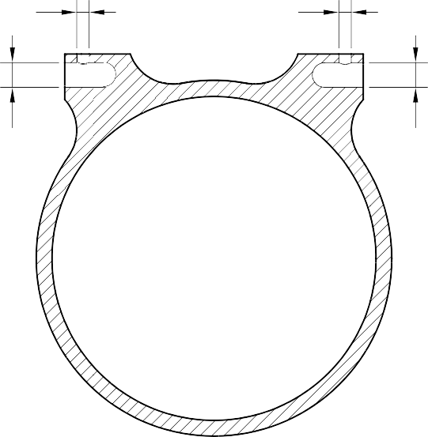
RETRACTION BORES
C
C
C
C
FOR MAIN FITTING (20-410C AND 20-420C) ONLY

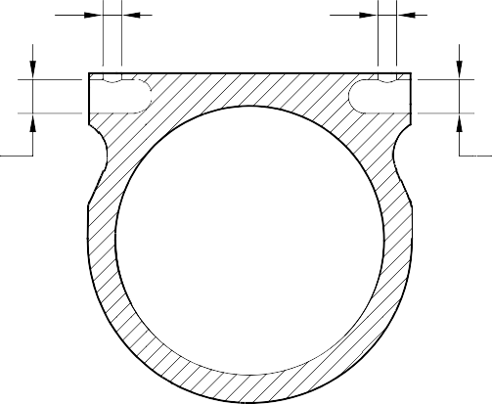
C C
C
C

SECTION E-E
TYPICAL 2 TRANSFER BLOCK LUGS

SECTION F-F
TYPICAL 2 BRAKE MANIFOLD LUGS

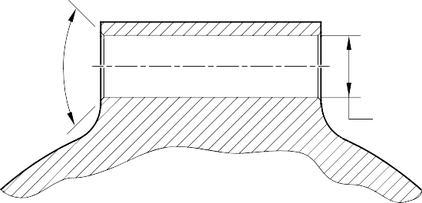
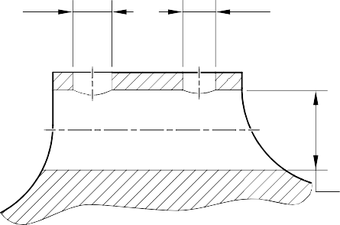
B CHAMFERS ONLY TYPICAL 2 PLACES
C
C
C

C

SECTION G-G
UPPER DOOR LUGS
SECTION H-H
TOOLING LUG
FOR MAIN FITTING (20-410C AND 20-420C) ONLY
A321-T-321222-0022-01

Main Fitting (20-410B, 20-420B, 20-410C, 20-420C, 20-410D and 20-420D) - Protective Treatment Figure 636 - Sheet 3

C
C 2 LUGS C
B
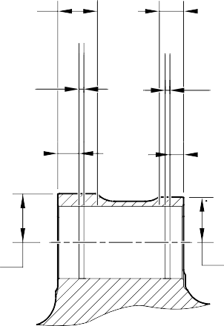
51,500 to 52,500mm
(2.0275 to 2.0669in)
EXTENT OF FINE LIMIT DIA.
C
5,000 to 7,000mm
(0.1968 to 0.2755in)
27,000 to 29,000
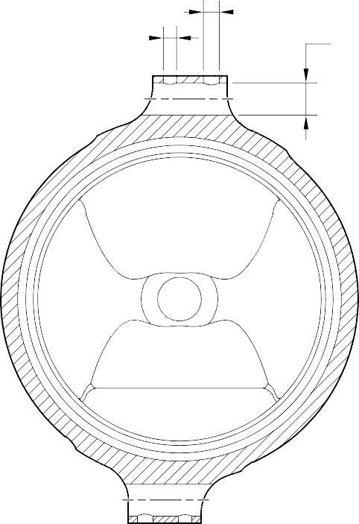
(1.0629 to 1.1417in)
REF.
B
25,000 to 26,000mm (0.9842 to 1.0236in) EXTENT
OF FINE LIMIT DIA.
C
5,000 to 7,000mm
(0.1968 to 0.2755in)
14,000 to 16,000mm (0.5511 to 0.6299in) REF.

2 LUGS
2 LUGS

B B

52,500 to 53,500mm
(2.0669 to 2.1063in) SPOTFACE RADIUS INCLUDING CHAMFERS

SECTION M-M
LOWER CARDAN BORE
47,000 to 48,000mm
(1.8503 to 1.8897in) SPOTFACE RADIUS INCLUDING CHAMFERS

SECTION K-K
LOWER DOOR LUGS

B
30,500 to 31,500mm
(1.2007 to 1.2401in) SPOTFACE RADIUS TYPICAL 2 PLACES

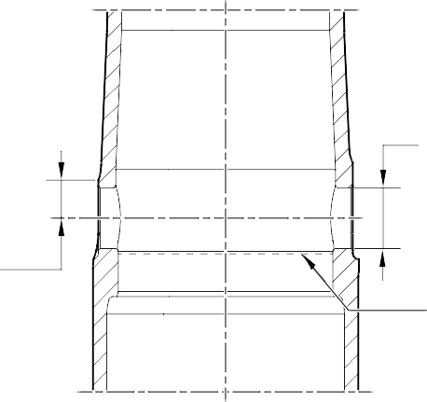
SECTION J-J
UPPER DIAPHRAGM TUBE CROSS BORE
FOR MAIN FITTING (20-410C AND 20-420C) ONLY
B
DIAMETER THRU BORE INCLUDING CHAMFERS

NO CADMIUM PLATE OR PAINT BEYOND THIS LINE

A321-T-321222-0023-01

Main Fitting (20-410B, 20-420B, 20-410C, 20-420C, 20-410D and 20-420D) - Protective Treatment Figure 636 - Sheet 4

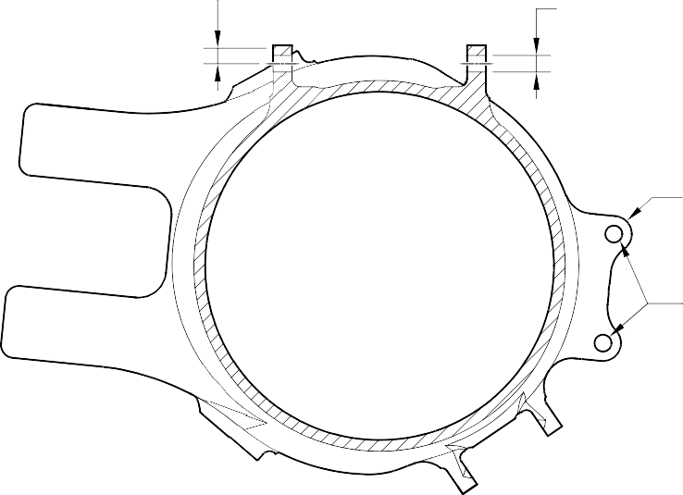
C
9,000 to 10,000mm
(0.3543 to 0.3936in) SPOTFACE RAD IUS
B
4 HOLES

C
10,500 to 11,500mm
(0.4133 to 0.4527in)
RADIUS TYPICAL 2 PLACES

C

C
5,000 to 7,000mm
(0.1968 to 0.2755in)
TYPICAL 2 PLACES
SECTION N-N
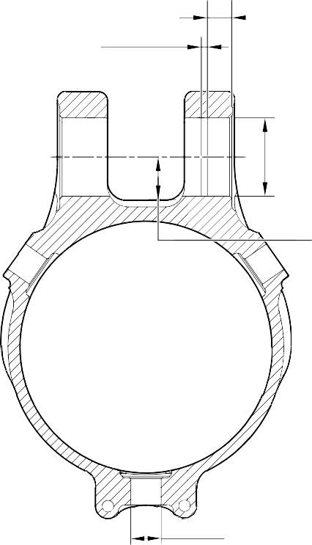
UPLOCK LUGS
22,000 to 24,000mm (0.8661 to 0.9448in) REF.

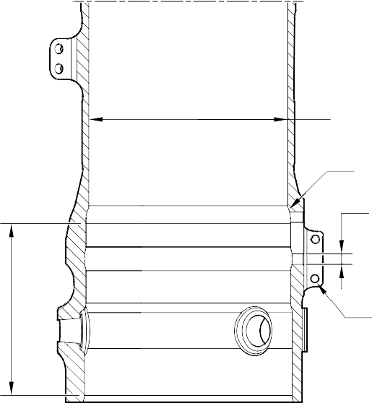
B
INCLUDING CHAMFER TYPICAL 2 LUGS

B
34,500 to 35,500mm
(1.3583 to 1.3976in) RADIUS
TYPICAL 2 PLACES
A

A

A and C
2 HOLES

D B
TYPICAL 4 HOLES

SECTION P-P
B
DIAMETER INCLUDING CHAMFER 3 BORES

SECTION L-L CHANGE OVER VALVE HOLES AND LUGS

TORQUE LINK AND RETAINING PIN BORES

A321-T-321222-0024-01

Main Fitting (20-410B, 20-420B, 20-410C, 20-420C, 20-410D and 20-420D) - Protective Treatment Figure 636 - Sheet 5

70,000 to 80,000mm
(2.7558 to 3.1495in)
C 5,000 to 7,000mm
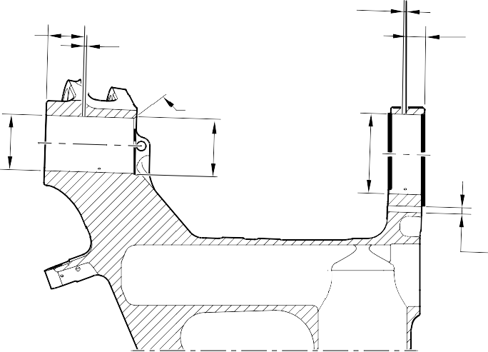
C (0.1968 to 0.2755in)

40,000 to 50,000mm
(1.5747 to 1.9684in)

B INCLUDING CHAMFERS
REF.
5,000 to 7,000mm
(0.1968 to 0.2755in) B
E

B INCLUDING CHAMFERS
REF.

C

PINTLE BORES
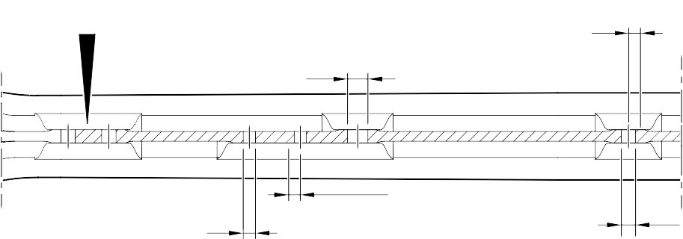
FOR MAIN FITTING (20-410B, 20-420B,
C 20-410D AND 20-420D) ONLY

B 11,750 to 12,750mm

C (0.4626 to 0.5019in) RAD.

C TYPICAL 2 HOLES

SECTION B-B
B
10,750 to 11,750mm
(0.4232 to 0.462in) RAD. C
TYPICAL 2 PLACES

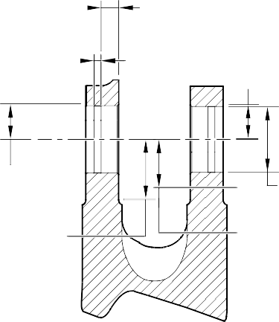
14,000 to 16,000mm (0.5511 to 0.6299in) REF.
C
5,000 to 7,000mm (0.1968 to 0.2755in)
TYPICAL 2 PLACES

B 30,000 to 31,000mm (1.1810 to 1.2204in)
SPOTFACE RAD.

B 50,500 to 51,500mm
(1.9881 to 2.0275in) SPOTFACE RAD.
DRAG ARM HOLES
FOR MAIN FITTING (20-410B, 20-420B, 20-410D AND 20-420D) ONLY

B
29,500 to 30,500mm
(1.1614 to 1.2007in) SPOTFACE RAD.
B
DIAMETERS THRU BORES INCLUDING CHAMFERS
B
35,500 to 36,500mm
(1.3976 to 1.4370in) SPOTFACE RAD.

SECTION D-D
RETRACTION BORES
FOR MAIN FITTING (20-410B, 20-420B, 20-410D AND 20-420D) ONLY

A321-T-32-12-22-125-1

Main Fitting (20-410B, 20-420B, 20-410D and 20-420D) - Protective Treatment Figure 636 - Sheet 6

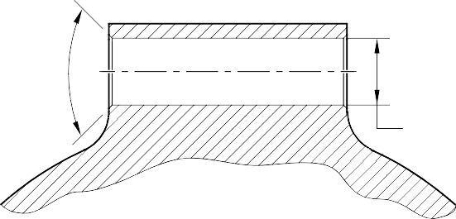
B AND E CHAMFERS ONLY TYPICAL 2 PLACES
C

SECTION H-H
TOOLING LUG
FOR MAIN FITTING (20-410B, 20-420B, 20-410D AND 20-420D) ONLY

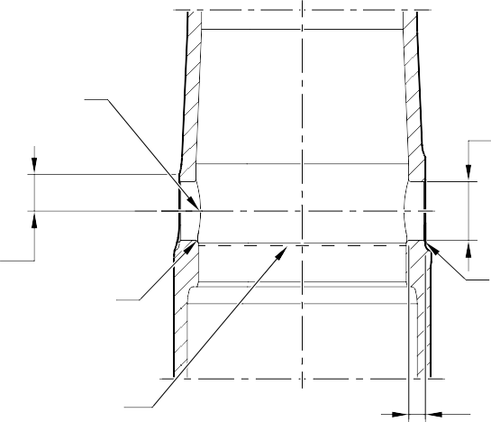
E 2 PLACES

B
DIAMETER THRU BORE INCLUDING CHAMFERS

B 30,500 to 31,500mm
(1.2007 to 1.2401in) SPOTFACE RADIUS TYPICAL 2 PLACES

E 2 PLACES

E
INCLUDING CHAMFER

NO CADMIUM PLATE OR PAINT BEYOND THIS LINE

SECTION J-J
UPPER DIAPHRAGM TUBE CROSS BORE
B
15,300mm MIN. (0.6023in)

FOR MAIN FITTING (20-410B, 20-420B, 20-410D AND 20-420D) ONLY

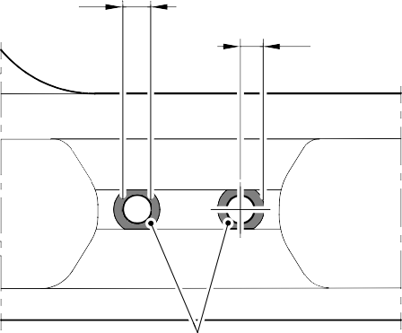
C TYPICAL 2 HOLES

11,500 to 12,500mm (0.4527 to 0.4921in) RAD. TYPICAL 2 PLACES

B
VIEW C
FOR MAIN FITTING (20-410B, 20-420B, 20-410D AND 20-420D) ONLY

A321-T-32-12-22-126-1

Main Fitting (20-410B, 20-420B, 20-410D and 20-420D) - Protective Treatment Figure 636 - Sheet 7

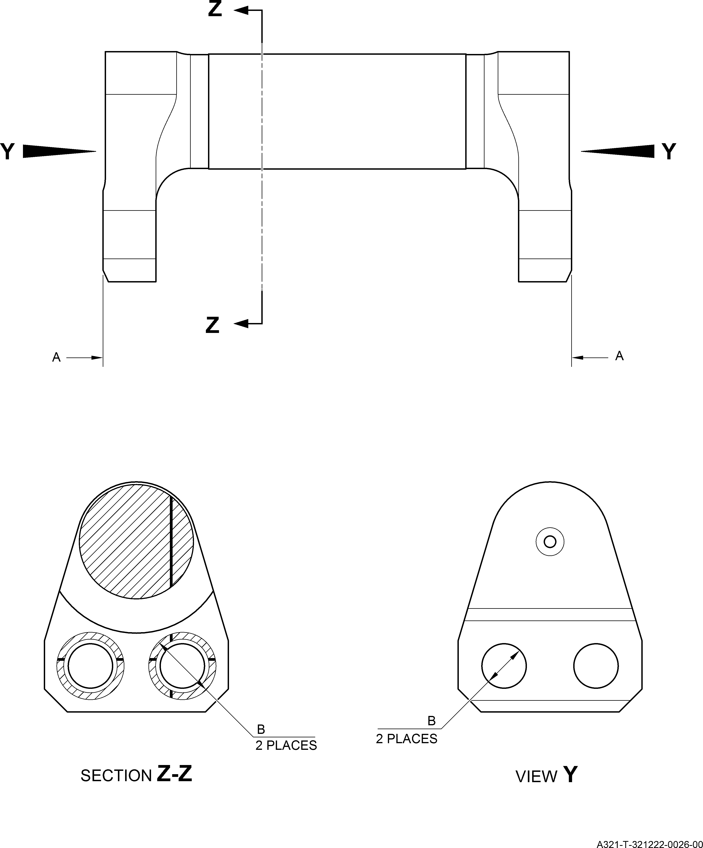

Uplock Pin (5-400A) - Protective Treatment Figure 637

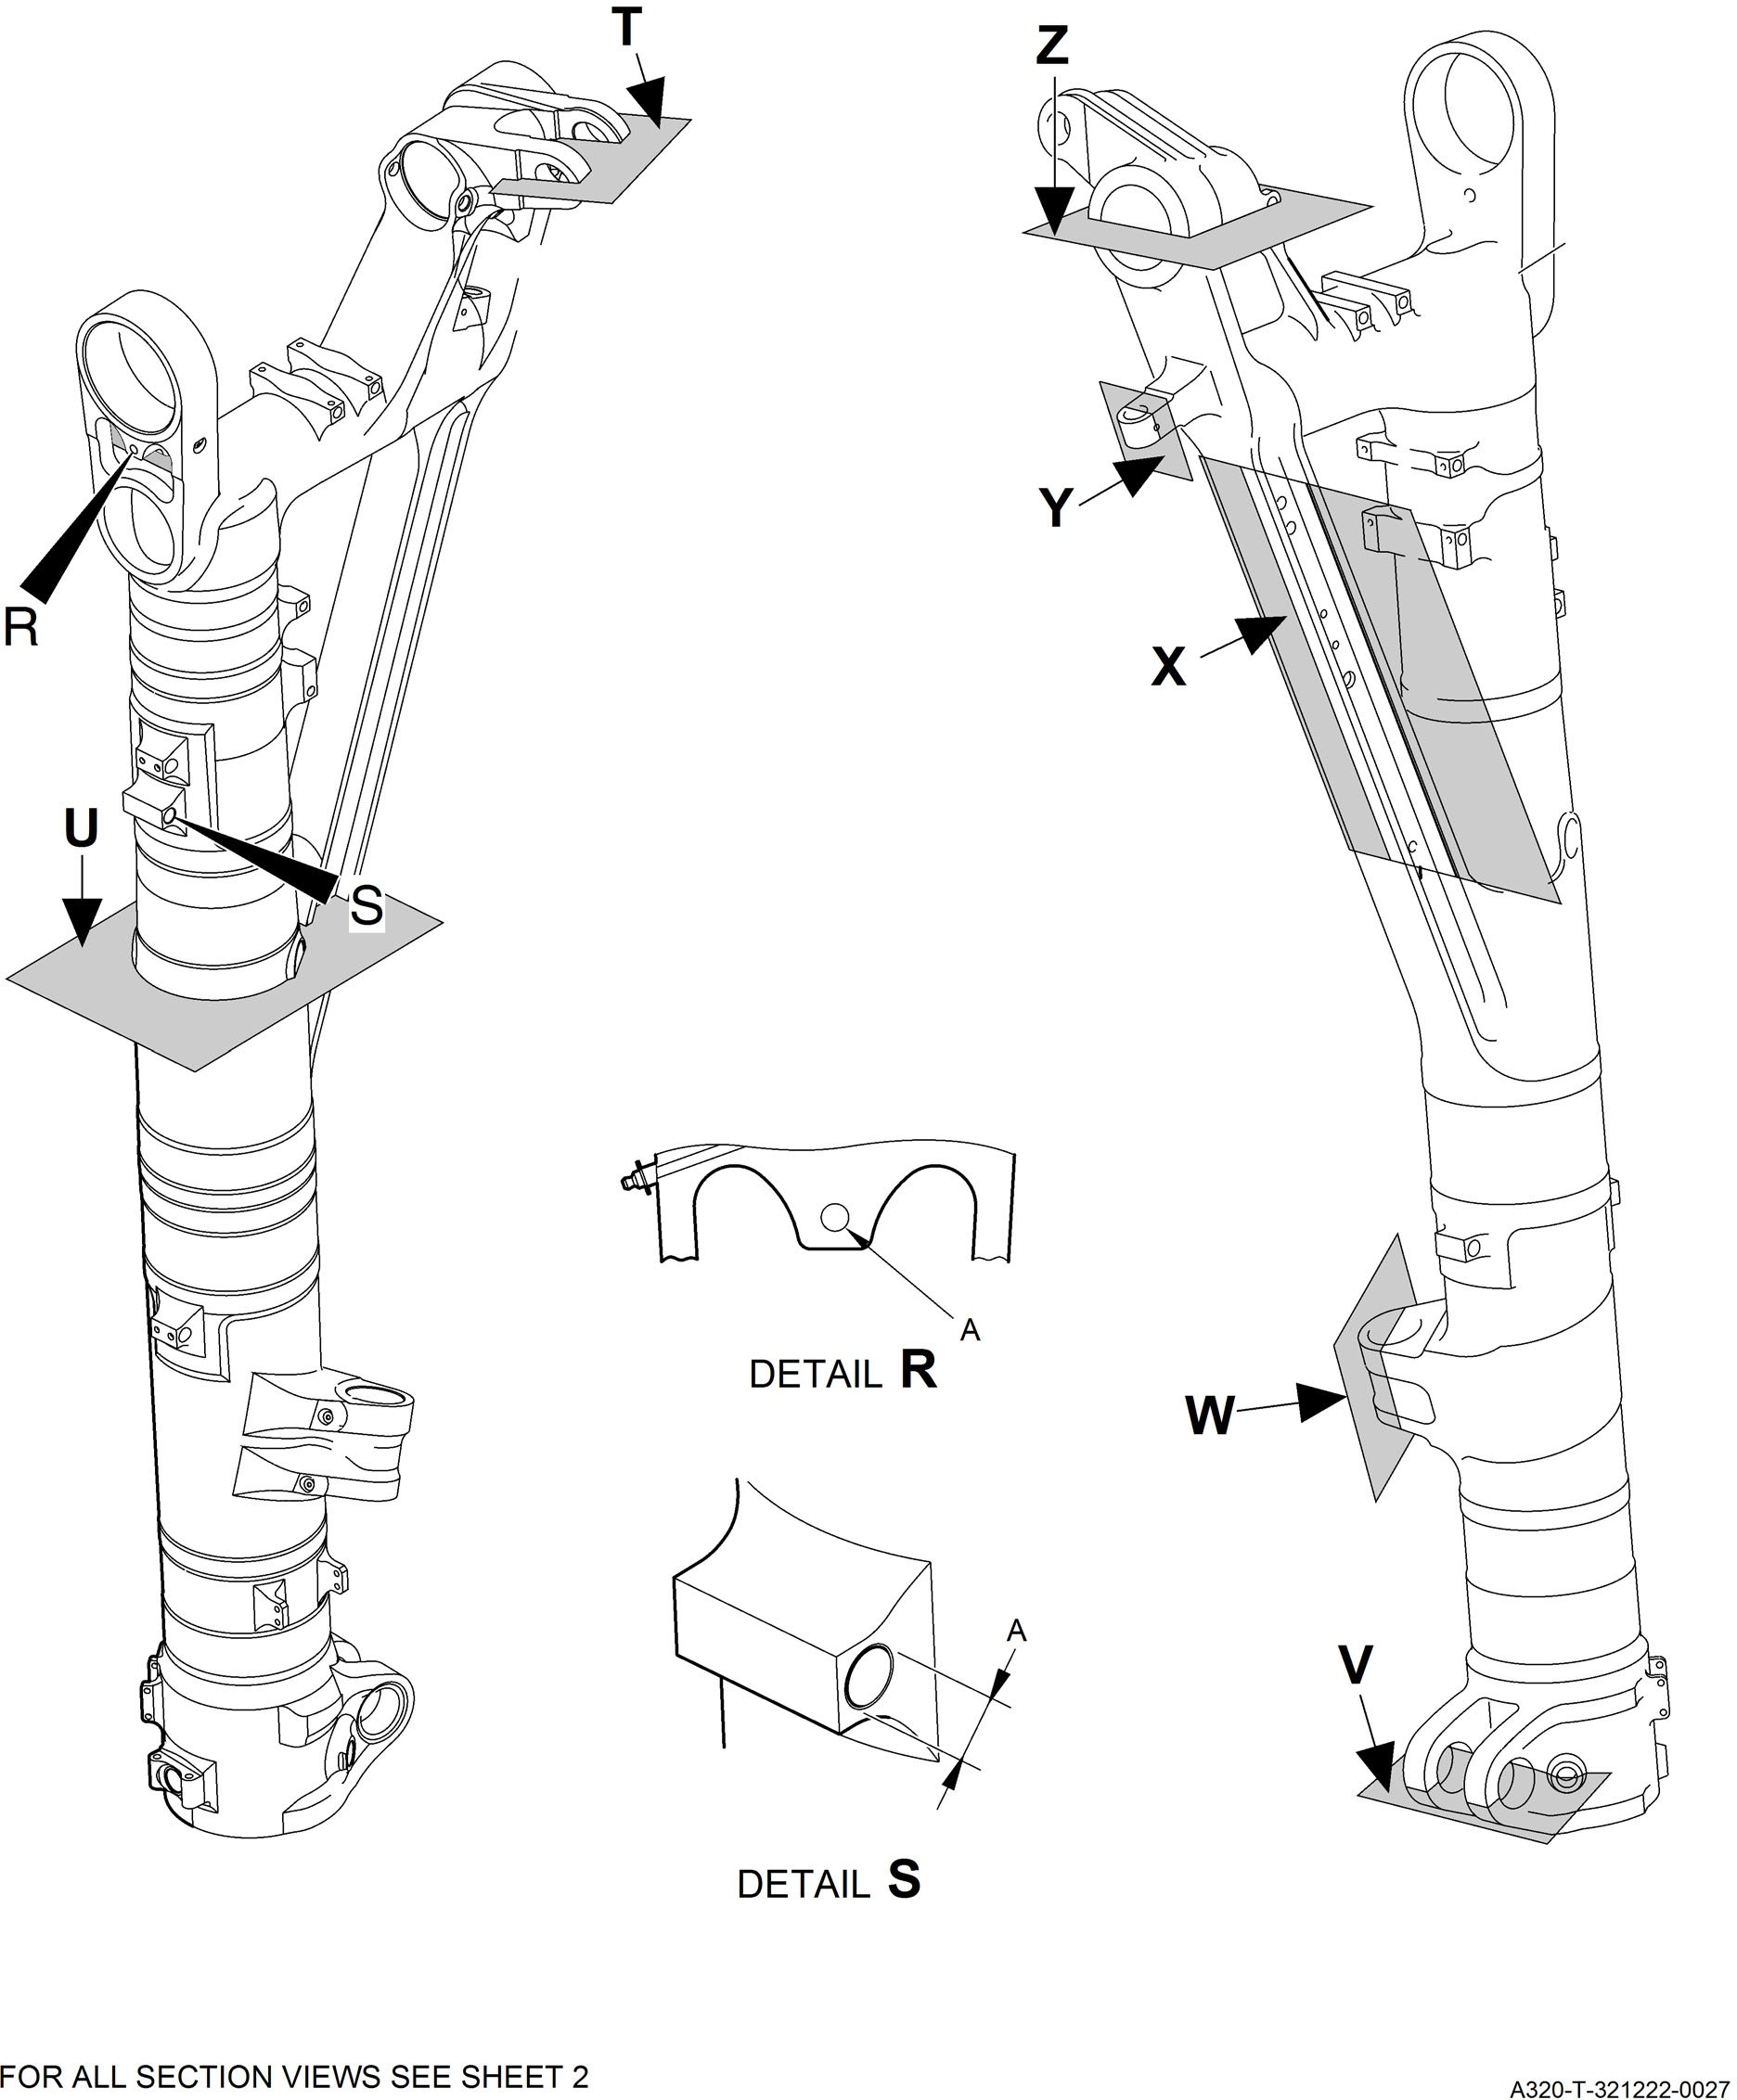

Main Fitting Subassembly (20-90B and 20-100B) - Protective Treatment Figure 638 - Sheet 1

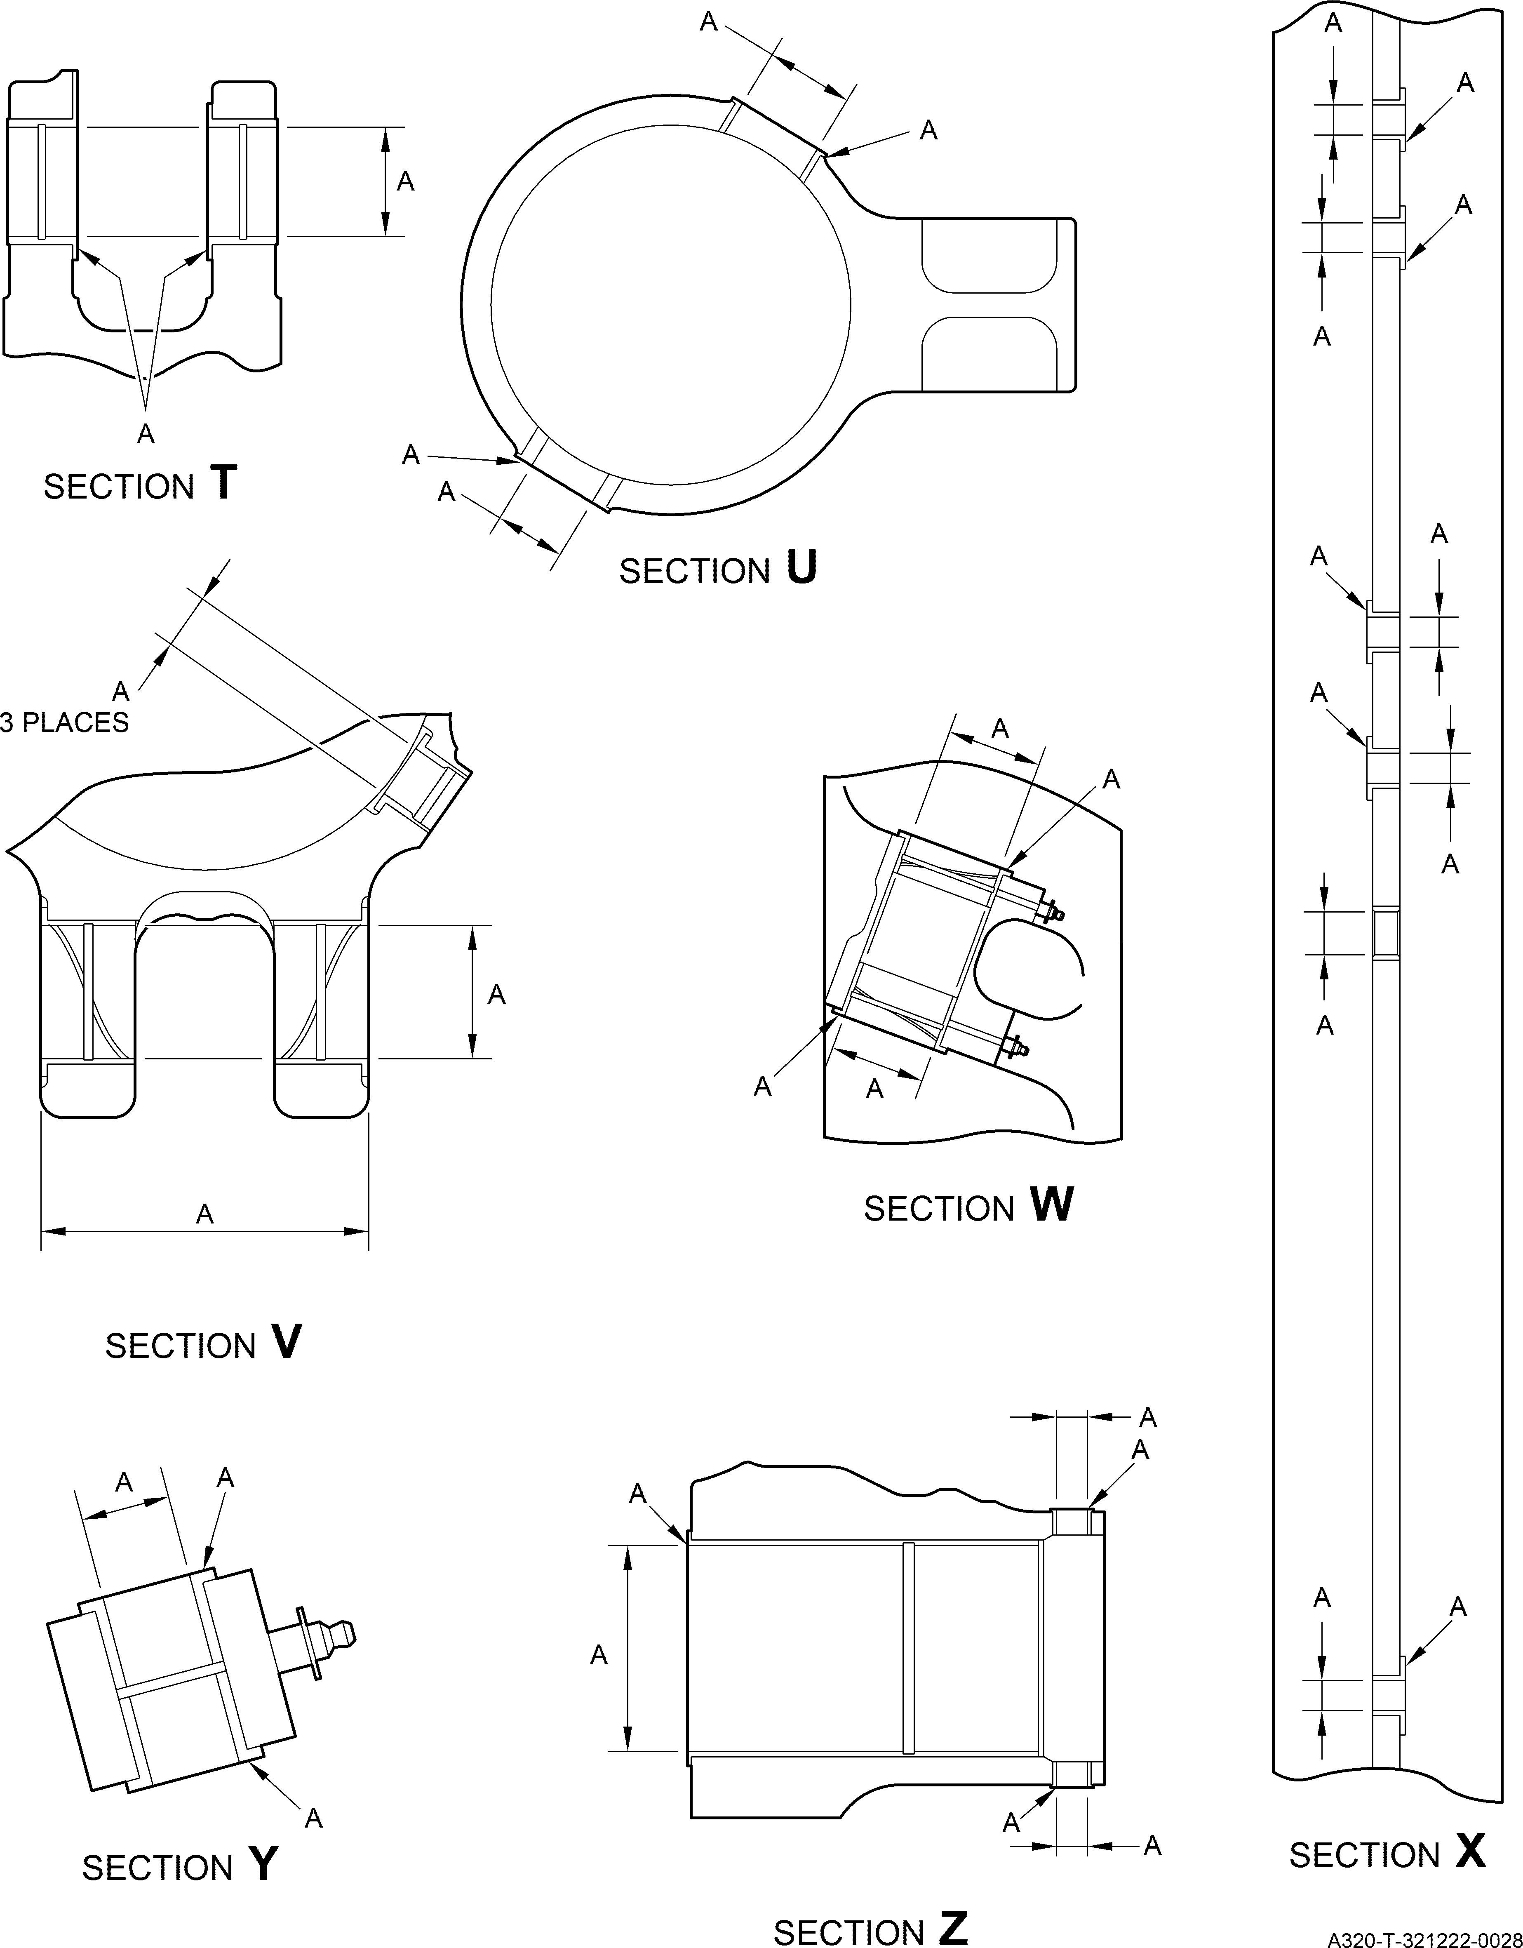

Main Fitting Subassembly (20-90B and 20-100B) - Protective Treatment Figure 638 - Sheet 2

A

A CHROMIUM PLATED SURFACE
A

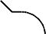
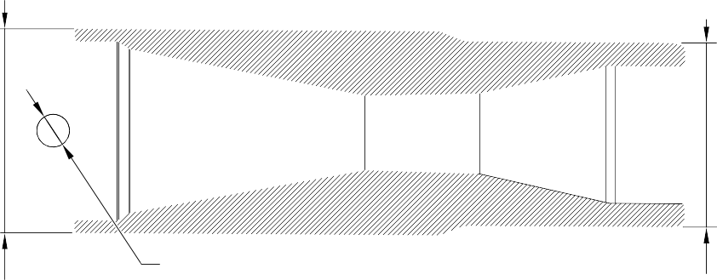
TWO PLACES

SECTION A-A

CHROMIUM PLATED SURFACE

A321-T-32-12-22-124-0

Forward Pintle Pin (1-60A) - Protective Treatment Figure 639

A A


A321-T-32-12-22-131-00

Spacer (4-180) Only - Protective Treatment Figure 640

A (2 PLACES)

A (2 PLACES)

A321-T-32-12-22-132-00

Drag-arm Spacer (4-180A) - Protective Treatment Figure 641

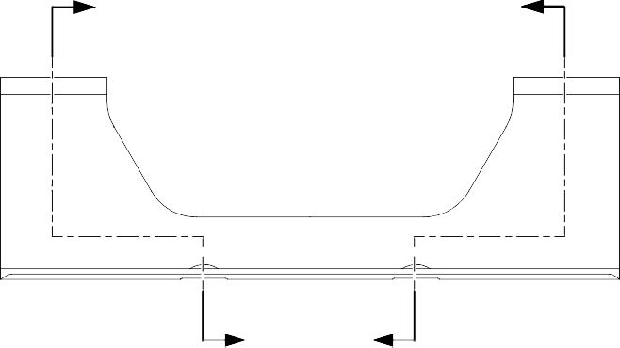
Z
A
Z
Z
Z
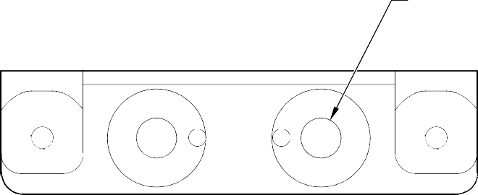
B
(2 HOLES)

A 23,750 to 24,250mm (0.9351 to 0.9547in) DIA.
SPOTFACE
VIEW A

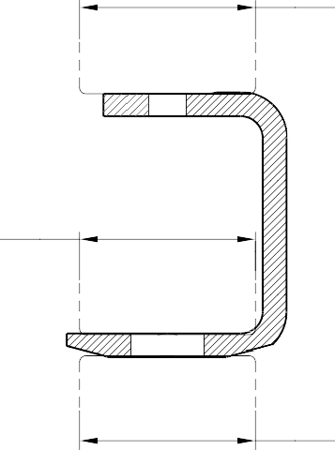

SECTION Z-Z
TYPICAL

A
23,750 to 24,250mm (0.9351 to 0.9547in) DIA. SPOTFACE

A
23,750 to 24,250mm (0.9351 to 0.9547in) DIA. SPOTFACE

A321-T-32-12-22-106-0

Bracket (4-210) - Protective Treatment Figure 642



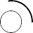
A
B
(4 HOLES)

A
18,750 to 19,250mm (0.7382 to 0.7578in) DIA. SPOTFACE
(BOTH SIDES)


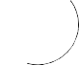

A
18,750 to 19,250mm (0.7382 to 0.7578in) DIA. SPOTFACE

B (2 HOLES)

VIEW A

A321-T-32-12-22-103-0

Bracket (9-150) Only - Protective Treatment Figure 643

A



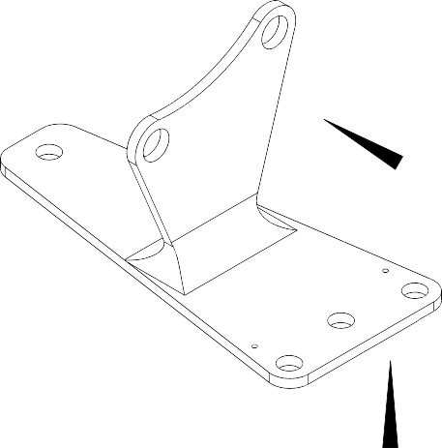
B HOLE
B
(2 PLACES)



C

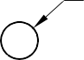
B HOLE
(2 PLACES)
B HOLE
(4 PLACES)

VIEW A

VIEW B
A





18,750 to 19,250mm (0.7382 to 0.7578in) DIA. SPOTFACE

VIEW C

A321-T-32-12-22-105-0

Bracket (9-150A) - Protective Treatment Figure 644

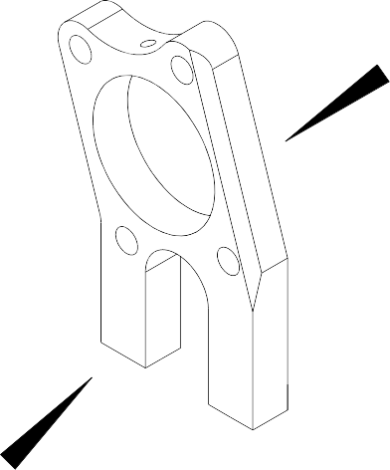
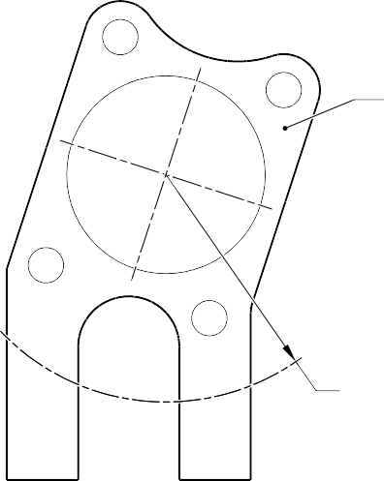
A
B
A

LIMIT OF A
51,750 to 52,250mm (2.0374 to 2.0570in) RAD. (BOTH SIDES)

VIEW A

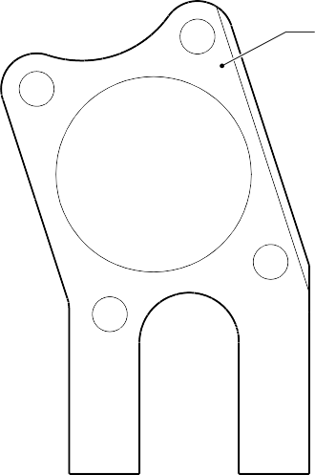
A

VIEW B

A321-T-32-12-22-102-0

Spacer (9-190) Only - Protective Treatment Figure 645

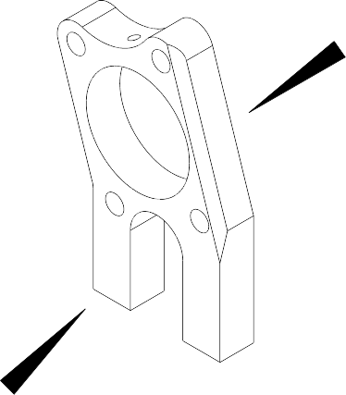
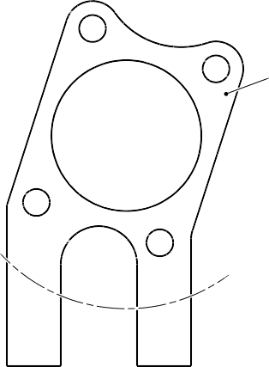
A
B

A

VIEW A
LIMIT OF A
51,750 to 52,250mm (2.0374 to 2.0570in) RAD. (BOTH SIDES)

VIEW B
B





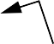
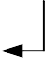

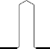
(2 PLACES)
Z
A
Z

SECTION Z-Z

A321-T-32-12-22-104-0

Spacer (9-190A) - Protective Treatment Figure 646

A

A
(2 HOLES)
VIEW A

A321-T-32-12-22-101-0

Spacer (11-30) - Protective Treatment Figure 647

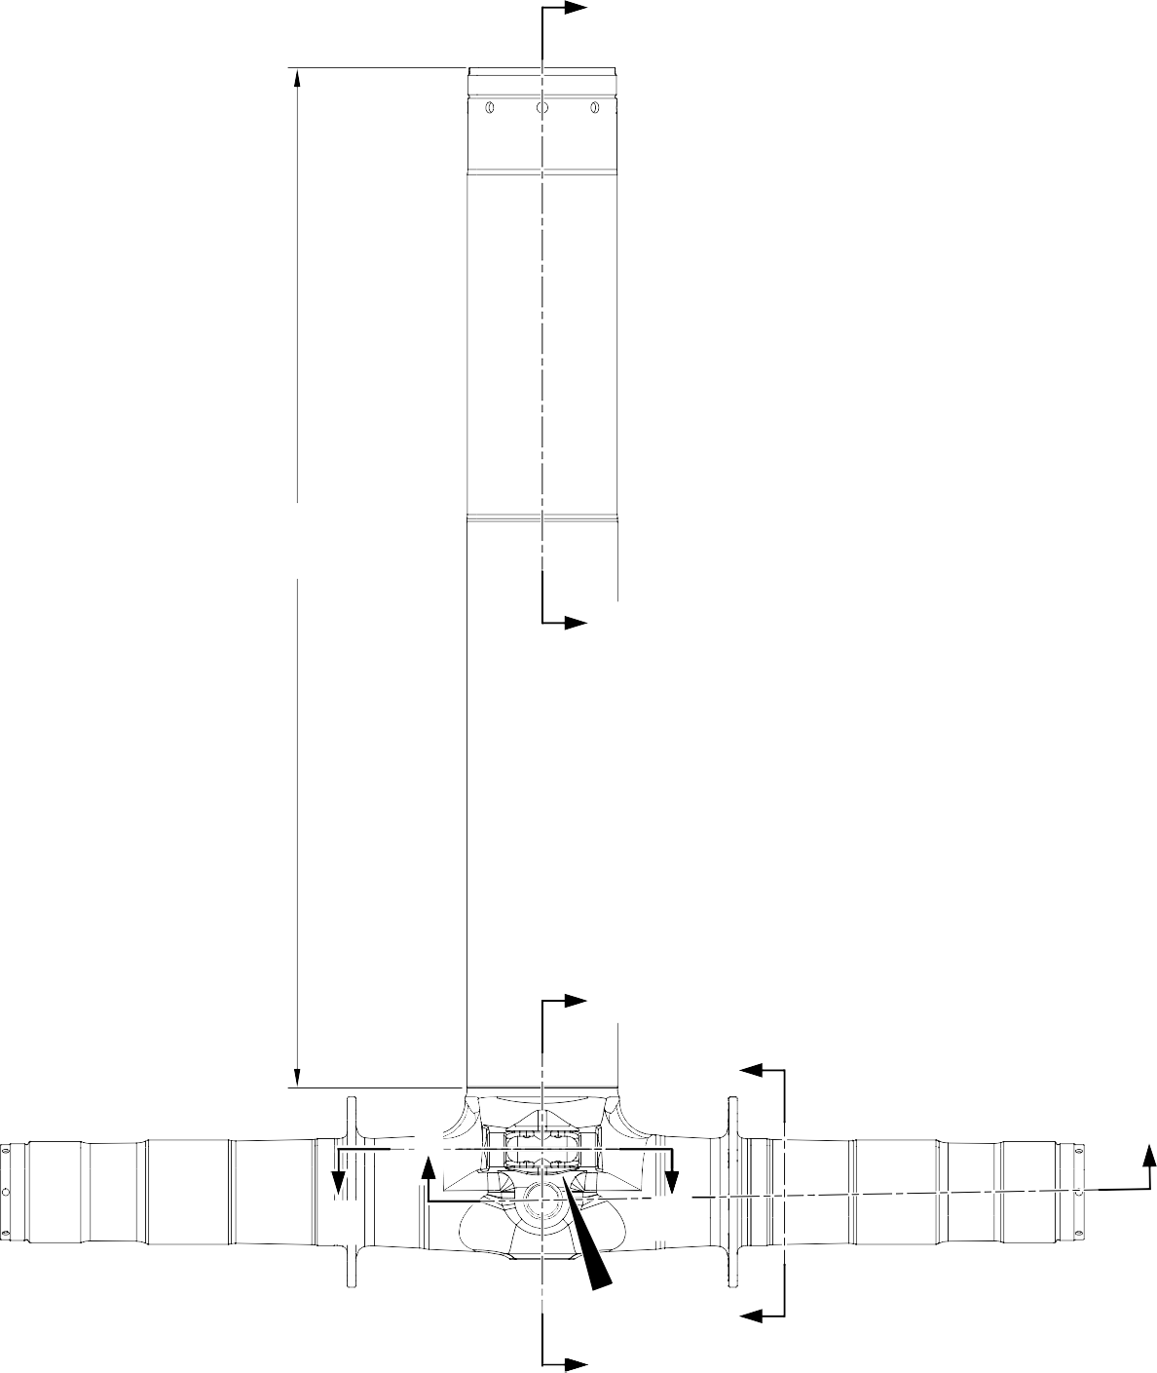
U
F and J
1197,9 to 1199,6mm
(47.16 to 47.22 in)
U
Z
V
X
X
W
W
A
Z
V

A321-T-32-12-22-153-0

Sliding tube (18-80D, 18-80E, 18-80F and 18-80G) - Protective Treatment Figure 648 - Sheet 1

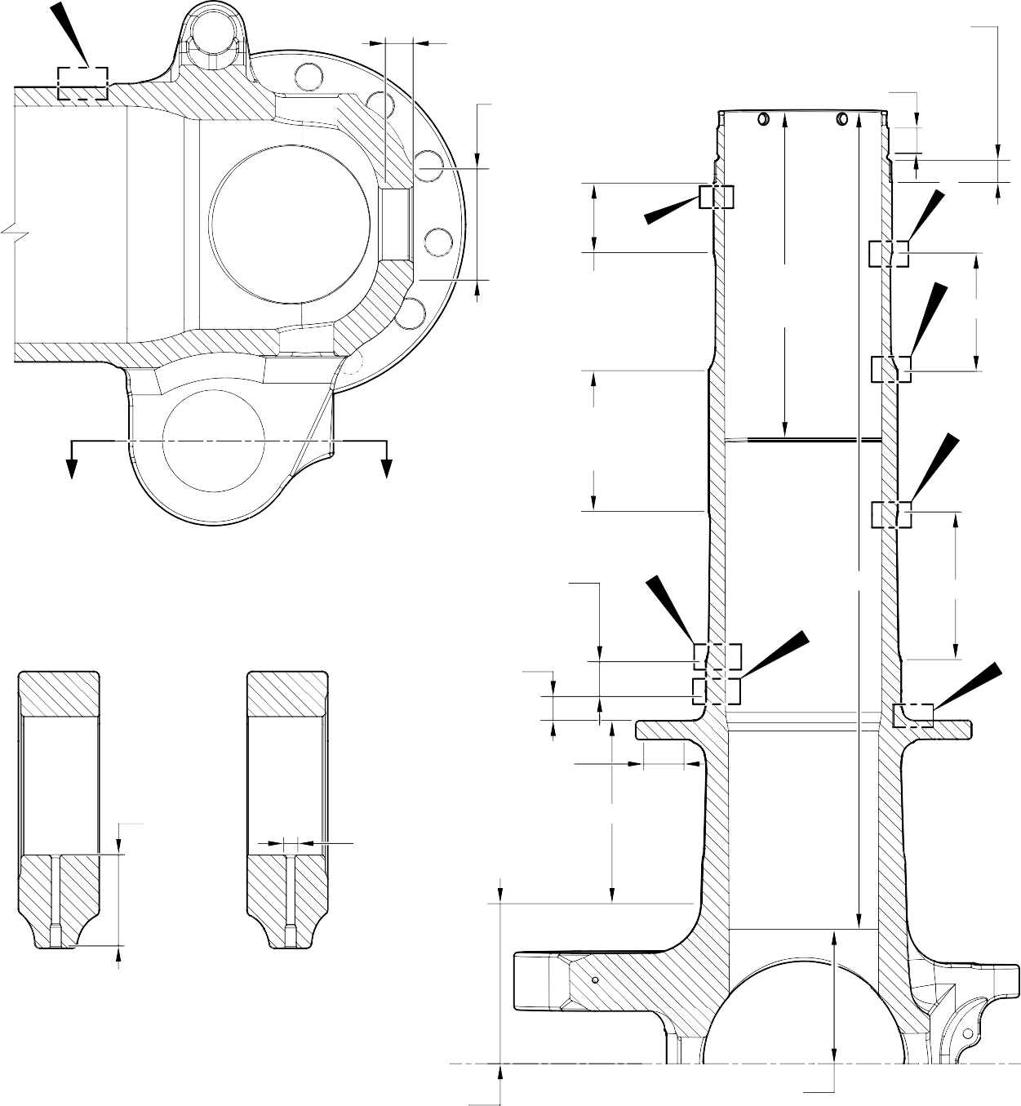
C
C and G
17,750 to 18,250mm
(0.6988 to 0.7185in)
C and G
71,750 to 72,250mm (2.8248 to 2.8444in) DIA.

D
A and J
119,929 to 119,964mm (4.7216 to 4.7229in) DIA.

16,750 to 17,250mm
(0.6595 to 0.6791in)

C and J

F

G F
220,000mm
(8.6614in) MIN. B

Y Y
SECTION Z-Z
KNUCKLE BORES
A and J F
126,917 to 126,957mm
(4.9967 to 4.9982in) DIA.

F
A and J B B

F and J
TYPICAL 2 PLACES
131,294 to 131,357mm
(5.1690 to 5.1715in) DIA. G
_{D} E
19,500 to 20,500mm
(0.7677 to 0.8070in)

LIMIT OF D
25,000mm (0.9842in) DIA. MAX. D
12 PLACES
F and H
TYPICAL 2 PLACES
INCLUDING RADIUS

SECTION Y-Y
KNUCKLE TOOLING LUG
GREASE HOLES

95,500 to 107,500mm
(3.7598 to 4.2323in)

84,000 to 96,000mm
(3.3071 to 3.7795in)

EXTERNAL THICK ZINC-NICKEL
PLATING LIMIT
INTERNAL THICK ZINC-NICKEL
PLATING LIMIT
SECTION X-X
(BOTH SIDES)
AXLE BORE

A321-T-32-12-22-154-0

Sliding tube (18-80D, 18-80E, 18-80F and 18-80G) - Protective Treatment Figure 648 - Sheet 2

C and G
69 , 7 50 to 70 ,2 50mm
( 2 .7461 to 2 . 76 57 in) DIA.
TYPICAL 2 PLACES

C and G
TYPICAL 2 PLACES
J
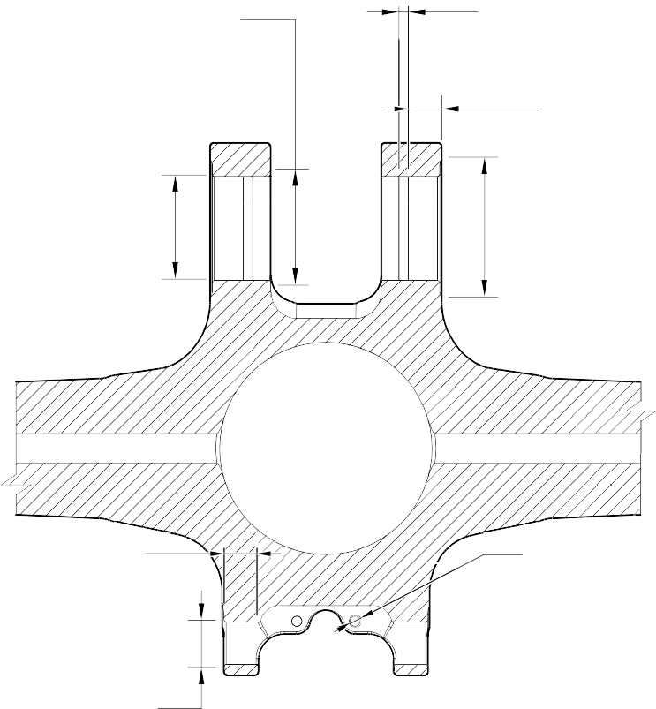
5 ,000 to 7 , 000 mm
( 0 .1968 to 0 . 2755 in)
TYPICAL 2 PLACES
19,000 to 21,000mm
(0.7481 to 0.8267in)
TYPICAL 2 PLACES
C and G
81 ,7 50 to 82 , 2 50mm
(3. 2185 to 3. 2381 in) DIA.
TYPICAL 2 PLACES

C and G
23,400mm
(0.9213in) MIN. TYPICAL 2 PLACES INCLUDING CHAMFER

C and G
38,750 to 39,250mm
(1.5256 to 1.5453in) DIA. TYPICAL 2 PLACES

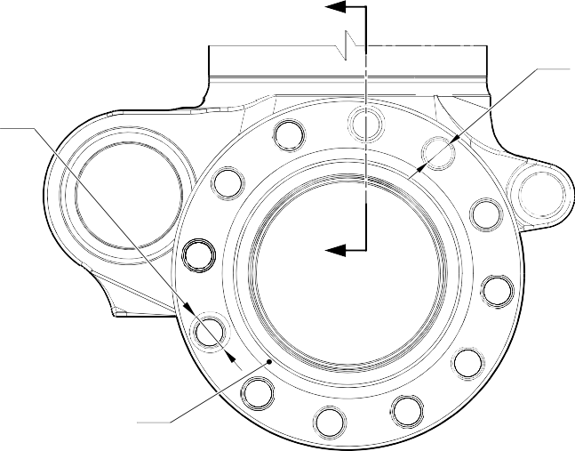
SECTION W-W
LUG BORES
T
m
. L
R
T
A
G
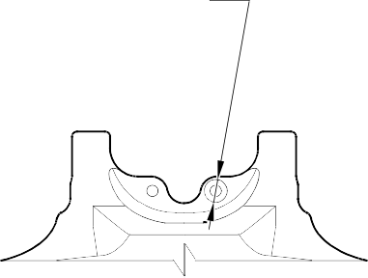
6 , 50 to 6 ,70 mm
J
13,000mm (0.5118in) DIA. SPOTFACE INCLUDING CHAMFER
.
( 0 .256 to 0 . 263 in) DIA
TYPICAL 4 PLACES

VIEW A

G
30 ,7 50 to 31 ,2 50m
(1 .2106 to 1 .2303 in) DIA SPOTFACE TYPICA
12 PLACES INCLUDING
CHAMFE

SECTION V-V
(BOTH SIDES)
BRAKE FLANGE
C and J
TYPICAL 12 PLACES

A321-T-32-12-22-155-0

Sliding tube (18-80D, 18-80E, 18-80F and 18-80G) - Protective Treatment Figure 648 - Sheet 3

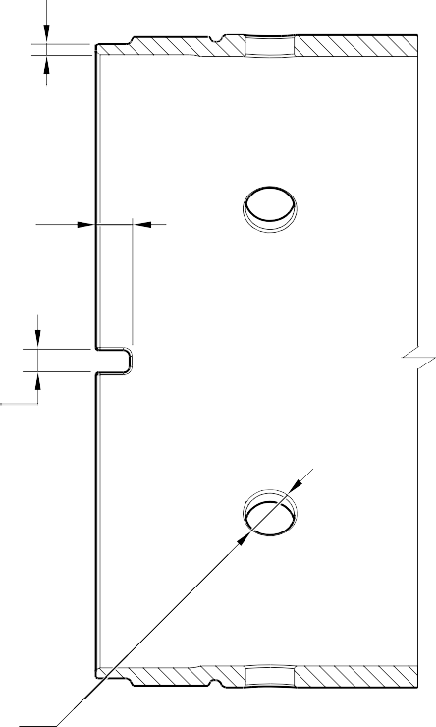
F and J
SECTION U-U
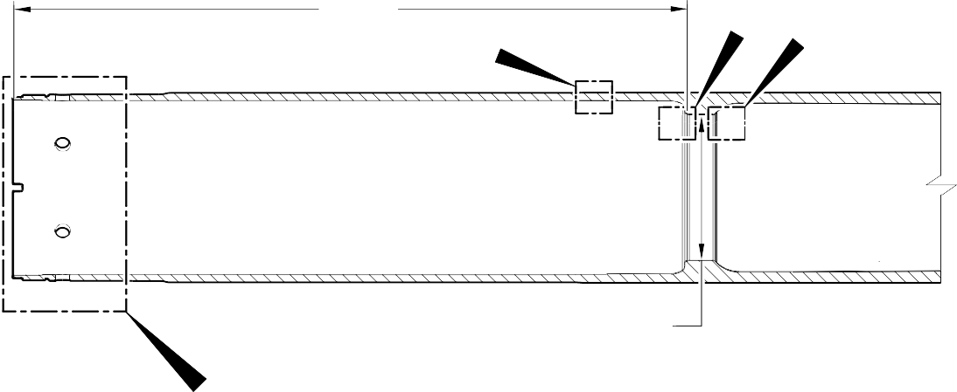
BARREL
F and J
K
H
J
A and J
135 ,860 to 135 ,923 mm
( 5 .3488 to 5 .3512 in) DIA.
B

F and J
9,000mm (0.3543in) TYPICAL 2 PLACES INCLUDING CHAMFER

F and J
5 ,950 to 6 ,050 mm
( 0 . 2343 to 0 .2381 in) DIA.
TYPICAL 2 PLACES
C and H

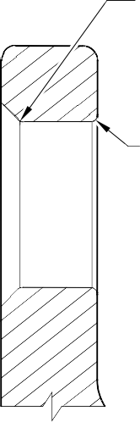
H

F and J
TYPICAL 6 PLACES INCLUDING CHAMFER

DETAIL B

SECTION T-T
BRAKE FLANGE TYPICAL 12 PLACES

A321-T-32-12-22-156-0

Sliding tube (18-80D, 18-80E, 18-80F and 18-80G) - Protective Treatment Figure 648 - Sheet 4

FULL CHROME PLATING THICKNESS
NO ZINC-NICKEL OR PAINT DEPOSIT TO REMAIN ON OR PROUD OF WORKING DIA. AFTER GRINDING CHROME
RUN OUT BAND 2,000mm (0.0787in) MAX.

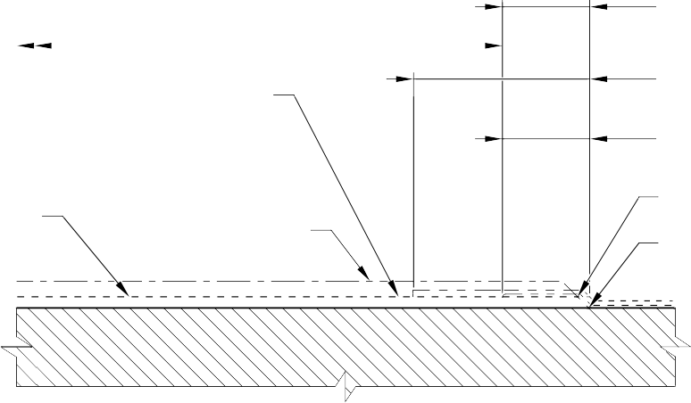
PAINT DEPOSIT OVERLAP
ZINC-NICKEL DEPOSIT OVERLAP
EDGE BLENDED WITH

DIA. AFTER GRINDING CHROME
CHROME PLATING
DEPOSIT

DETAIL C
BARREL OUTER DIA. LOWER CHROME TERMINATION

ZINC-NICKEL DEPOSIT OVERLAP AND
RUN OUT BAND 2,000mm (0.0787in) MAX.

PAINT DEPOSIT OVERLAP
A SMOOTH TRANSITION WAVY OR IRREGULAR LINE PERMISSIBLE

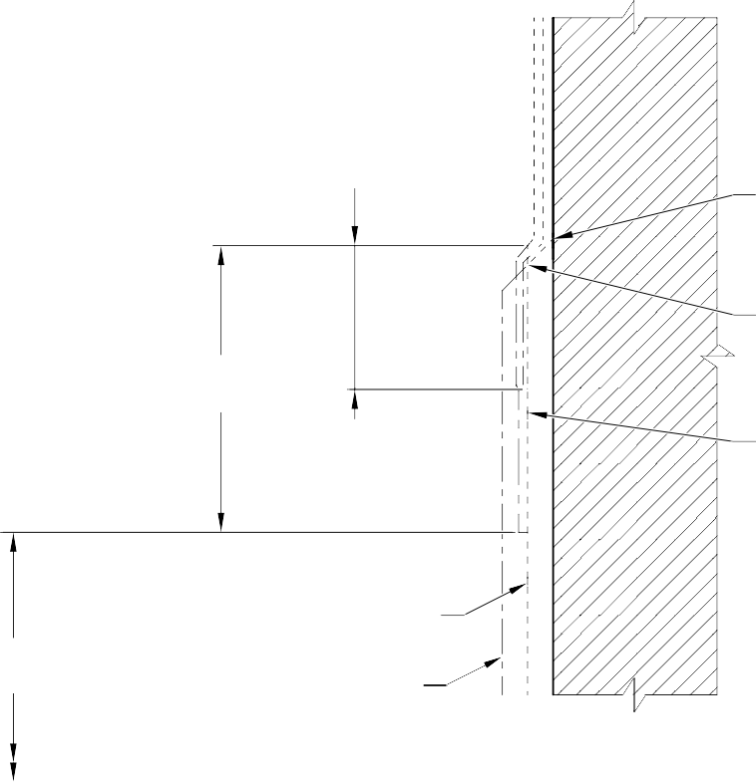
WAVY OR IRREGULAR LINE PERMISSIBLE

EDGE BLENDED WITH
A SMOOTH TRANSITION

NO ZINC-NICKEL OR PAINT DEPOSIT TO REMAIN ON OR PROUD OF WORKING DIA. AFTER GRINDING CHROME

DIA. AFTER GRINDING CHROME
FULL CHROME

PLATING THICKNESS
CHROME PLATING
DEPOSIT

DETAIL D
JOURNAL A OUTER CHROME TERMINATION (TYPICAL)

A321-T-32-12-22-157-0

Sliding tube (18-80D, 18-80E, 18-80F and 18-80G) - Protective Treatment Figure 648 - Sheet 5

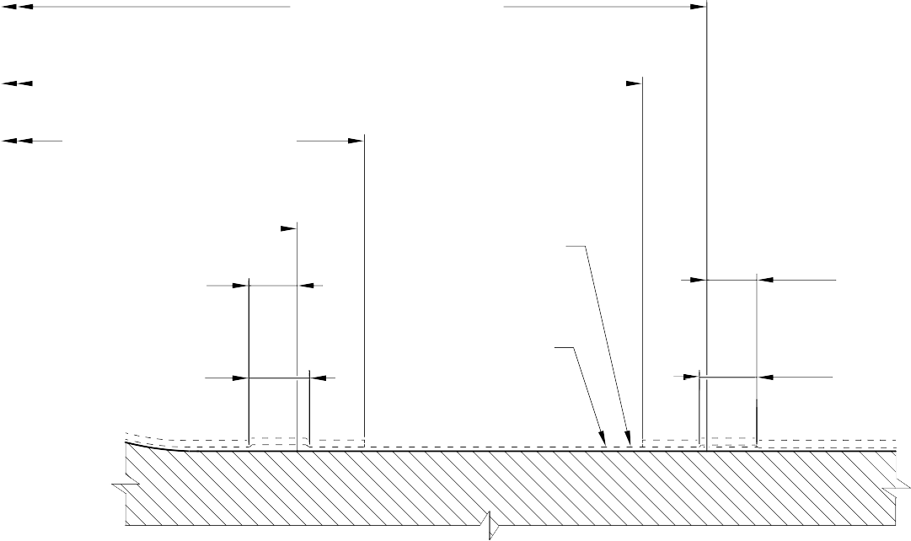
159,750 to 160,250mm (6.2894 to 6.3090in) DIA.

PAINT DEPOSIT OVERLAP
157,750mm (6.2106) DIA.
MIN.
PAINT DEPOSIT OVERLAP 150,000mm (5.9054in) DIA. MAX.

147,500 to 148,000mm (5.8071 to 5.8267in) DIA.

RUN OUT BAND 0,000 to 2,000mm
(0.000 to 0.0787in)

ZINC-NICKEL DEPOSIT OVERLAP

DIA. AFTER GRINDING CHROME

NO ZINC-NICKEL OR PAINT ON THIS
SURFACE

RUN OUT BAND 0,000 to 2,000mm
(0.000 to 0.0787in)

ZINC-NICKEL DEPOSIT OVERLAP

DETAIL E
BREAK FLANGE FACE CHROME TERMINATION (TYPICAL)

CHROME RUN OUT BAND
(TO RADIUS INTERSECTION POINT) 1,000 to 5,000mm (0.0394 to 0.1968in)

ZINC-NICKEL DEPOSIT OVERLAP

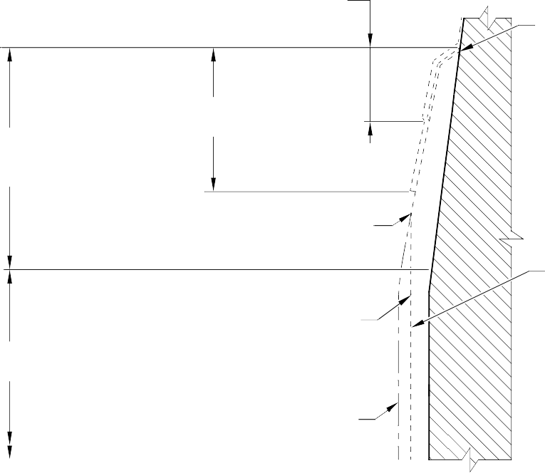
PAINT DEPOSIT OVERLAP

WAVY OR IRREGULAR LINE PERMISSIBLE

FULL CHROME PLATING THICKNESS
EDGE BLENDED WITH A SMOOTH TRANSITION

NO ZINC-NICKEL OR PAINT DEPOSIT TO REMAIN
ON OR PROUD OF WORKING DIA. AFTER GRINDING CHROME

CHROME PLATING
DEPOSIT

DIA. AFTER GRINDING CHROME

DETAIL F
JOURNAL A,B,C CHROME TERMINATION (TYPICAL)

A321-T-32-12-22-158-0

Sliding tube (18-80D, 18-80E, 18-80F and 18-80G) - Protective Treatment Figure 648 - Sheet 6

FULL CHROME PLATING THICKNESS
CHROME PLATING
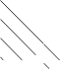

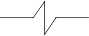
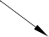
DEPOSIT
NO ZINC-NICKEL OR PAINT DEPOSIT TO REMAIN
ON OR PROUD OF WORKING DIA. AFTER GRINDING CHROME
DIA. AFTER GRINDING CHROME

RUN OUT BAND 2,000mm (0.0787in) MAX.

ZINC NICKEL PLATE
EDGE BLENDED WITH
A SMOOTH TRANSITION
WAVY OR IRREGULAR LINE PERMISSIBLE

PAINT DEPOSIT OVERLAP
ZINC-NICKEL DEPOSIT OVERLAP

DETAIL G
JOURNAL C INNER CHROME TERMINATION (TYPICAL)

RUN OUT BAND
FULL CHROME PLATING THICKNESS
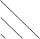

DIA. AFTER GRINDING

2,000mm (0.0787in) MAX.
EDGE BLENDED WITH A SMOOTH TRANSITION
CHROME PLATING DEPOSIT
CHROME

WAVY OR IRREGULAR LINE PERMISSIBLE
DETAIL H
BARREL OUTER DIA. UPPER CHROME TERMINATION

A321-T-32-12-22-159-0

Sliding tube (18-80D, 18-80E, 18-80F and 18-80G) - Protective Treatment Figure 648 - Sheet 7

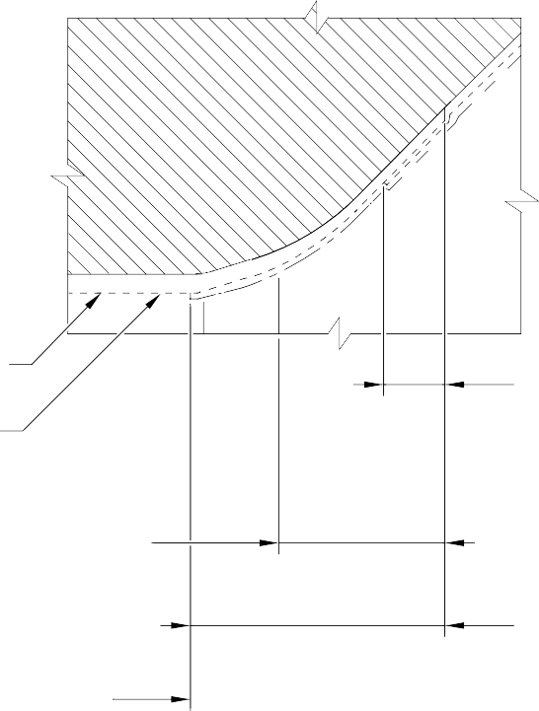
DIA. AFTER CHROME PLATING

NO ZINC-NICKEL OR PAINT DEPOSIT
TO REMAIN ON WORKING DIA. AFTER CHROME PLATING
CHROME RUN OUT BAND (TO RADIUS INTERSECTION POINT) 1,000 to 5,000mm (0.0394 to 0.1968in)

F and J
WORKING DIA.
26,000mm (1.0236in) MIN. (TO HPC ABUTMENT FACE)

DETAIL J

ZINC-NICKEL DEPOSIT OVERLAP

PAINT DEPOSIT OVERLAP

HPC SEAL ABUTMENT LOWER CHROME TERMINATION

CHROME PLATING WILL TERMINATE ANYWHERE ON THE CHAMFER

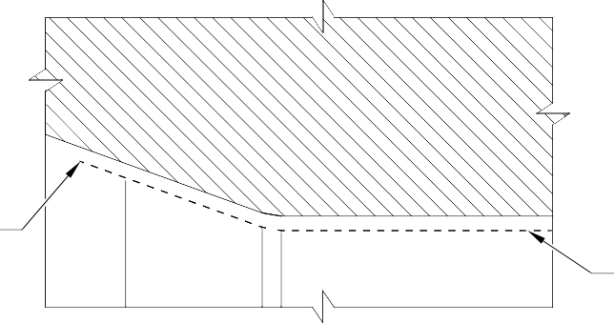
DETAIL K
HPC SEAL ABUTMENT UPPER CHROME TERMINATION

DIA. AFTER CHROME PLATING

A321-T-32-12-22-160-0

Sliding tube (18-80D, 18-80E, 18-80F and 18-80G) - Protective Treatment Figure 648 - Sheet 8

- Approved Repairs
  - Refer to Figures 649 to 657 and Table 602.
Approved Repairs Table 602

Repair No. | Messier-Dowty Limited or Safran  Landing Systems Repair No. | Applicable Part
1-1 | 450237790 | Lower bearing subassembly (16-110)
1-2 | 450237610 | Lower bearing subassembly (16-110)
2-1 | 450217145 | Pin (13-190 and 13-190A)
3-1 | 450217385 | Pivot pin (6-90)
4-1 | 450237490 | Uplock pin (5-400)
5-1 | 450217170 | Pin (3-50)
6-1 | 450258420 | Pin (10-80)
6-2 | 450258260 | Pin (10-80)
6-3 | 450266211 | Pin (10-80)
7-1 | 450258410 | Pin (11-130)
7-2 | 450258430 | Pin (11-130)
8-1 | 450217195 | Bracket (5-300)
8-2 | 450217205 | Bracket (5-300)
9-1 | 450258460 | Sliding tube (18-80 and 18-80A)
9-2 | 450266100 | Sliding tube (18-80 and 18-80A)
9-3 | 450258400 (Superseded) | Sliding tube (18-80)
9-4 | 450266290 | Sliding tube (18-80 and 18-80A)
9-5 | 450237720 | Sliding tube (18-80 and 18-80A)
9-6 | 450258470 | Sliding tube (18-80 and 18-80A)
9-7 | 450265140 | Sliding tube (18-80 and 18-80A)
9-8 | 450266310 | Sliding tube (18-80 and 18-80A)
9-9 | 450265180 | Sliding tube (18-80 and 18-80A)
9-10 | 450258401 | Sliding tube (18-80 and 18-80A)
9-11 | 450266295 | Sliding tube (18-80 and 18-80A)
10-1 | 450266210 | Pin (9-70)
11-1 | 450266060 | Main Fitting (20-410, 20-410A, 20-420 and 20-420A)
11-2 | 450266070 | Main Fitting (20-410, 20-410A, 20-420 and 20-420A)
11-3 | 450266020 | Main Fitting (20-410, 20-410A, 20-420 and 20-420A)

Approved Repairs Table 602 (Continued)

Repair No. | Messier-Dowty Limited or Safran  Landing Systems Repair No. | Applicable Part
11-4 | 450266075 | Main Fitting (20-410, 20-410A, 20-420  and 20-420A)
11-5 | 450266080 | Main Fitting (20-410, 20-410A, 20-420 and 20-420A)
11-6 | 450266085 | Main Fitting (20-410, 20-410A, 20-420 and 20-420A)
11-7 | 450266045 | Main Fitting (20-410, 20-410A, 20-420 and 20-420A)
11-8 | 450266010 | Main Fitting (20-410, 20-410A, 20-420 and 20-420A)
11-9 | 450266030 | Main Fitting (20-410, 20-410A, 20-420 and 20-420A)
11-10 | 450267270 (Withdrawn) | Main Fitting (20-410 and 20-420 Only)
11-11 | 450266015 | Main Fitting (20-410, 20-410A, 20-420 and 20-420A)
11-12 | 450266035 | Main Fitting (20-410, 20-410A, 20-420 and 20-420A)
11-13 | 450266050 | Main Fitting (20-410, 20-410A, 20-420 and 20-420A)
11-14 | 450266110 | Main Fitting (20-410, 20-410A, 20-420 and 20-420A)
11-15 | 450267230 | Main Fitting (20-410 and 20-420 Only)
11-16 | 450237690 | Main Fitting (20-410 and 20-420 Only)
11-17 | 450237695 | Main Fitting (20-410, 20-410A, 20-420 and 20-420A)
11-18 | 450217235 | Main Fitting (20-410, 20-410A, 20-420 and 20-420A)
11-19 | 450258210 | Main Fitting (20-410, 20-410A, 20-420 and 20-420A)
11-20 | 450265100 (Withdrawn) | Main Fitting (20-410 and 20-420 Only)
11-21 | 450258230 | Main Fitting (20-410, 20-410A, 20-420 and 20-420A)
11-22 | 450266450 | Main Fitting (20-410, 20-410A, 20-420 and 20-420A)
11-23 | 450266400 | Main Fitting (20-410, 20-410A, 20-420 and 20-420A)
11-24 | 450266390 | Main Fitting (20-410, 20-410A, 20-420 and 20-420A)

Approved Repairs Table 602 (Continued)

Repair No. | Messier-Dowty Limited or Safran  Landing Systems Repair No. | Applicable Part
11-25 | 450266395 | Main Fitting (20-410, 20-410A, 20-420  and 20-420A)
11-26 | 450267370 | Main Fitting (20-410 and 20-420 Only)
11-27 | 450266040 | Main Fitting (20-410, 20-410A, 20-420 and 20-420A)
11-28 | 450266405 | Main Fitting (20-410, 20-410A, 20-420 and 20-420A)
11-29 | 450267275 | Main Fitting (20-410A and 20-420A Only)
11-30 | 450267385 | Main Fitting (20-410A and 20-420A Only)
11-31 | 64-4505236-00 | Main Fitting (20-410B, 20-410C, 20-410D, 20-420B, 20-420C and 20-420D)
11-32 | 64-4505233-00 | Main Fitting (20-410B, 20-410C, 20-410D, 20-420B, 20-420C and 20-420D)
11-33 | 64-4505109-00 | Main Fitting (20-410B, 20-410C, 20-410D, 20-420B, 20-420C and 20-420D)
11-34 | 64-4505112-00 | Main Fitting (20-410B, 20-410C, 20-410D, 20-420B, 20-420C and 20-420D)
11-35 | 64-4505111-00 | Main Fitting (20-410B, 20-410C, 20-410D, 20-420B, 20-420C and 20-420D)
11-36 | 64-4505234-00 | Main Fitting (20-410B, 20-410C, 20-410D, 20-420B, 20-420C and 20-420D)
11-37 | 64-4505126-00 | Main Fitting (20-410B, 20-410C, 20-410D, 20-420B, 20-420C and 20-420D)
12-1 | 450266350 | Lower Torque Link (11-240)
12-2 | 450266340 | Upper Torque Link (10-260)
12-3 | 450266345 | Upper Torque Link (10-260)
12-4 | 450266355 | Lower Torque Link (11-240)
12-5 | 450266525 | Upper Torque Link (10-260)
13-1 | 450266215 | Upper Slave Link (6-230 and 6-230A)

Approved Repairs Table 602 (Continued)

Repair No. | Messier-Dowty Limited or Safran  Landing Systems Repair No. | Applicable Part
13-2 | 450266216 | Upper Slave Link (6-230 and 6-230A)
14-1 | 450266255 | Upper Diaphragm Tube (15-390)
14-2 | 450266285 | Upper Diaphragm Tube (15-390)
14-3 | 450266430 | Upper Diaphragm Tube (15-390)
14-4 | 64-4505141-00 | Upper Diaphragm Tube (15-390A)
15-1 | 450266095 | Bracket (4-360)
15-2 | 450266096 | Bracket (4-360)
16-1 | 450266360 | Bracket (8-170)
17-1 | 450266365 | Pivot Bracket (7-140)
18-1 | 450237795 | Cylinder (17-230)
18-2 | 450258320 | Cylinder (17-230)
18-3 | 450237480 (Withdrawn) | Cylinder (17-230)
18-4 | 450265290 | Cylinder (17-230)
18-5 | 450266505 | Cylinder (17-230)
18-6 | 450266425 | Cylinder (17-230)
18-7 | 450267365 | Cylinder (17-230)
18-8 | 64-4505242-00 | Cylinder (17-230A)
19-1 | 450266104 | Lock Stay Cardan (3-170)
19-2 | 450266105 | Lock Stay Cardan (3-170)
20-1 | 450266270 | Lower Slave Link (6-310)
21-1 | 450266410 | Transfer Block (2-340) Only
21-2 | 450266415 | Transfer Block (2-340) Only
21-3 | 450266420 | Transfer Block (2-340) Only
21-4 | 450266411 | Transfer Block (2-350) Only
21-5 | 450266416 | Transfer Block (2-350) Only
21-6 | 450266421 | Transfer Block (2-350) Only
22-1 | 450266520 | Spherical Bearing (19-50)
23-1 | 450217290 | Pintle Pin (1-60)
23-2 | 450258270 | Pintle Pin (1-60)
24-1 | 450265230 | Harness Support Bracket (11-140)
25-1 | 450266201 | Retaining Pin (13-10A)
25-2 | 450266200 | Retaining Pin (13-10)
26-1 | 450265250 | Upper Pivot Bracket (10-160)

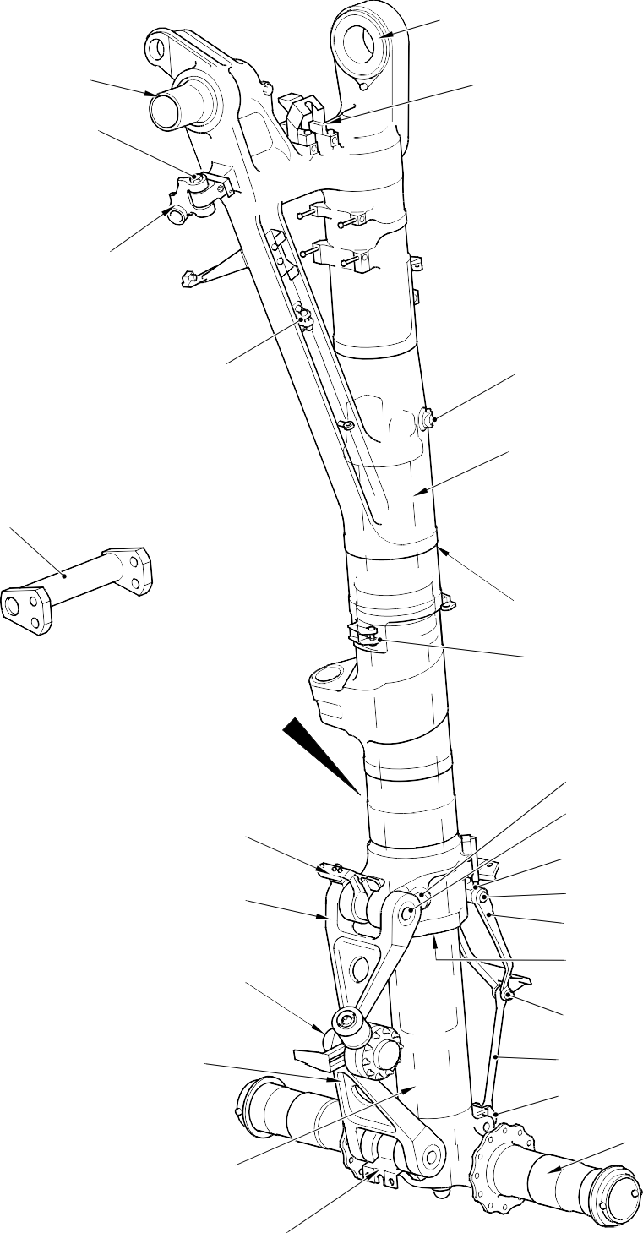
REPAIR No. 22-1

REPAIR No. 23-1
and 23-2

REPAIR No. 5-1
TRANSFER BLOCK REFER TO FIGURE 655

REPAIR No. 19-1 and 19-2

REPAIR No. 15-1 and 15-2

REPAIR No. 2-1

REPAIR No. 4-1
UPPER DIAPHRAGM TUBE REFER TO FIGURE 653

DETAIL A

A
MAIN FITTING
REFER TO FIGURE 650 REPAIR No. 8-1 and 8-2

UPPER PIVOT BRACKET REFER TO FIGURE 657

UPPER TORQUE LINK REFER TO FIGURE 651

REPAIR No. 10-1

LOWER TORQUE LINK REFER TO FIGURE 651

CYLINDER REFER TO FIGURE 654

HARNESS SUPPORT BRACKET REFER TO FIGURE 656

Approved Repairs - Key Diagram Figure 649
REPAIR No. 25-1 and 25-2
REPAIR No. 6-1, 6-2 and 6-3

REPAIR No. 17-1
REPAIR No. 3-1
REPAIR No. 13-2
REPAIR No. 1-1 and 1-2

REPAIR No. 13-1

REPAIR No. 20-1
REPAIR No. 16-1
SLIDING TUBE
REFER TO FIGURE 652

A321-S-32-12-22-008-8

REPAIR No. 11-14, 11-25 and 11-33

REPAIR No. 11-13

REPAIR No. 11-21
and 11-24
REPAIR No. 11-31
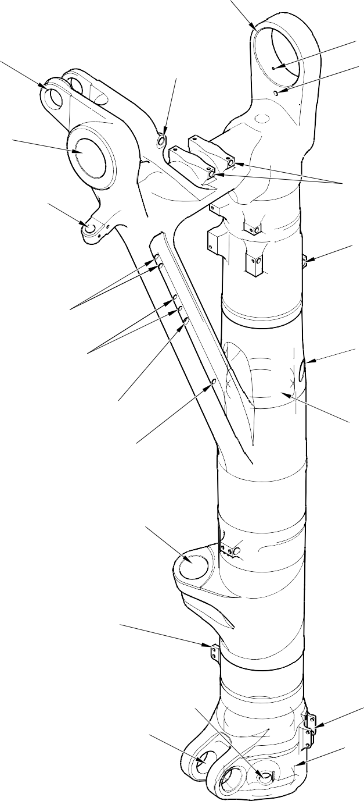
REPAIR No. 11-11

REPAIR No. 11-27

REPAIR No. 11-22 and 11-36
REPAIR No. 11-1

REPAIR No. 11-12

REPAIR No. 11-2 and 11-35

REPAIR No. 11-4, 11-19 and 11-34

REPAIR No. 11-5 and 11-18

REPAIR No.11-6 and 11-20

REPAIR No. 11-9

REPAIR No.11-17

REPAIR No. 11-3, REPAIR 11-23 and 11-32

REPAIR No. 11-15 and 11-37

REPAIR No. 11-7
REPAIR No. 11-8

REPAIR No. 11-28

REPAIR No.11-10, 11-16, 11-26,
11-29 and 11-30

A321-S-32-12-22-063-2

Main Fitting Repairs - Key Diagram Figure 650

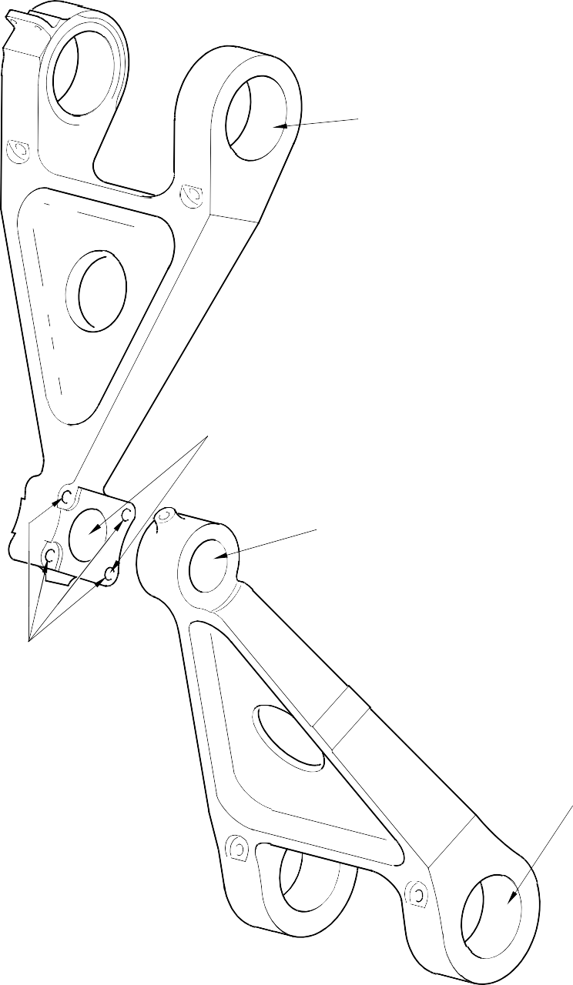
REPAIR No. 12-3

REPAIR No. 12-2

REPAIR No. 12-1

REPAIR No. 12-5

REPAIR No. 12-4

A321-S-32-12-22-029-1

Torque Link Repairs - Key Diagram Figure 651

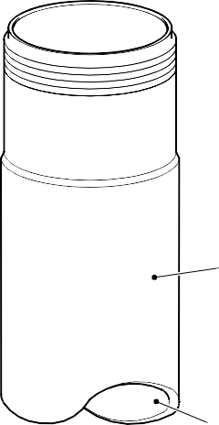
REPAIR No. 9-1

REPAIR No. 9-5 AND 9-6

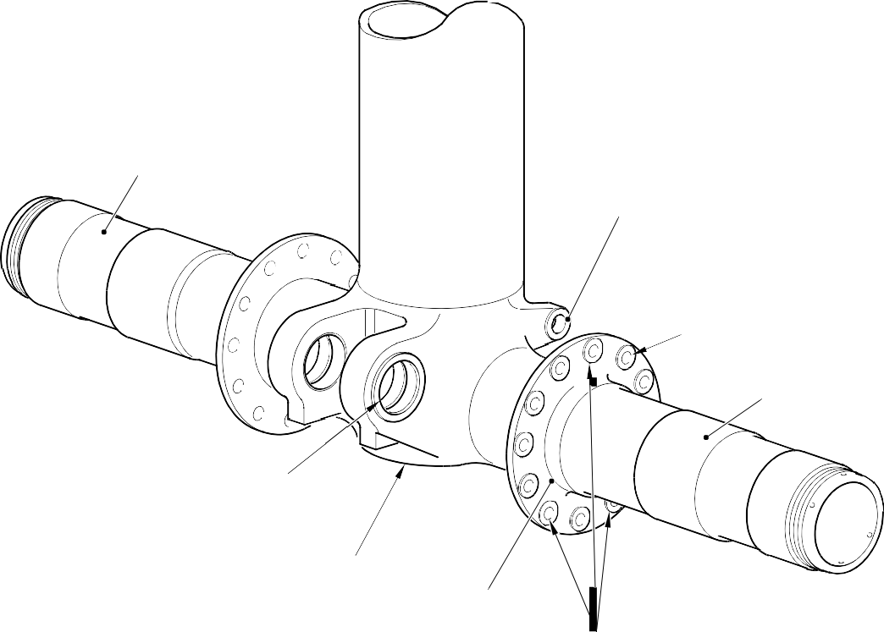
REPAIR No. 9-3 AND 9-10
REPAIR No.9-7

REPAIR No. 9-4

REPAIR No. 9-3 AND 9-10

REPAIR No. 9-8

REPAIR No. 9-9
REPAIR No. 9-2

REPAIR No. 9-11

A321-S-32-12-22-055-1

Sliding Tube Repairs - Key Diagram Figure 652

