
REPAIR No. 14-2
REPAIR No. 14-3 and 14-4
REPAIR No. 14-1

A321A5909-3

Upper Diaphragm Tube Repairs - Key Diagram Figure 653


REPAIR No. 18-1




REPAIR No. 18-5

REPAIR No. 18-3, 18-4 and 18-6

REPAIR No. 18-2
REPAIR No. 18-7 and 18-8

A321-S-32-12-22-043-2

Cylinder Repairs - Key Diagram Figure 654




REPAIR No. 21-3 and 21-6

REPAIR No. 21-1 and 21-4
REPAIR No. 21-2 and 21-5

A321-S-32-12-22-014-1

Transfer Block Repairs - Key Diagram Figure 655









REPAIR No. 24-1

Harness Support Bracket Repairs - Key Diagram Figure 656
A321-S-32-12-22-007-0



REPAIR No. 26-1

Upper Pivot Bracket Repairs - Key Diagram Figure 657

A321-S-32-12-22-057-0

- Repair No. 1-1 Lower Bearing Subassembly (16-110)
  - Specified Damage and Material Specification.
    - Specified Damage
      - Damaged or loose liner.
    - Material Specification

IPL Figure and  Item No. | Name | Material Specification
16-140 | Gland housing | Aluminium Alloy, 2024T35
  - Special Tools
    - Special tools are not necessary.
  - Materials
    - These materials are necessary:

NOTE: Alternative equivalents are permitted.

Ref. Item | Material
TBA | Accomet C
TBA | Adhesive PVC tape
TBA | Araldite, 2015
TBA | Cleaning tissues
TBA | Emery cloth, 60-100 grit
08-715 | Masking tape
08-722 | Adhesive
11-583 | Cleaning agent
13-501 | Alocrom
  - Repair Parts
    - These repair parts are necessary:

Part No. | Repair Part | Material Specification
450237823 | Repair liner | Fibreslip B40
  - Procedure (Refer to Figure 601)
    - Repair loose but undamaged liner:
      - Remove all of the adhesive from the external diameter of the gland housing and the internal diameter of the liner: refer to CLEANING.

      - Measure the diameter of the gland housing across the contact area: this must be between 211,328 and 211,368 mm (8.3200 and 8.3215 in).
      - Temporarily put the liner in position on the gland housing. If necessary, cut the liner at the scarf joints to adjust its length.
      - Remove the liner from the gland housing.
      - Clean the contact surfaces of the liner and the gland housing: use the cleaning tissues, Material Ref. Item TBA, and the cleaning agent, Material Ref. Item 11-583.
      - Apply adhesive, Material Ref. Item 08-722, to the contact surface of the liner near to the scarf joints: refer to M-DLPS724.
      - Assemble the liner to the gland housing.
      - Identify the part with the Messier-Dowty Limited repair number 450237790A adjacent to the part number: refer to PCS-6000-05.
      - Examine the part to make sure that you have obeyed all the repair instructions correctly.
    - Repair damaged liner:
      - Remove the damaged liner and remove all of the adhesive from the external diameter of the gland housing: refer to CLEANING.
      - Machine the gland housing to the dimensions given in Figure 601 with a surface finish of 3,2 micrometers (125 micro-inches).
      - Examine the gland housing for flaws: refer to M-DLNDT8.
      - Apply Alocrom, Material Ref. Item 13-501, to the machined areas: refer to PCS-2220.
      - Temporarily put the repair liner in position on the gland housing. If necessary, cut the repair liner at the scarf joints to adjust its length.
      - Apply adhesive PVC tape, Material Ref. Item TBA, around the gland housing to the sides of and touching the repair liner. Make sure that the edges of the adhesive PVC tape, Material Ref. Item TBA, bond tightly to the gland housing.
      - Remove the repair liner from the gland housing.
      - Use the Emery cloth, 60-100 grit, Material Ref. Item TBA, to roughen the surfaces to be bonded. Do not damage the edges of the adhesive PVC tape, Material Ref. Item TBA.
      - Use the cleaning agent, Material Ref. Item 11-583, and cleaning tissues, Material Ref. Item TBA, to clean the roughened surfaces.
      - Preheat an oven to between 35 and 45 oC (95 and 113 oF).
      - Prepare a surface treatment mixture of 1 part by volume of Accomet C, Material Ref. Item TBA, and 4 parts by volume of clean cold water.
      - Use a brush to apply a smooth layer of the prepared surface treatment mixture to the contact surface of the gland housing.

      - Put the gland housing in the preheated oven for a minimum of 4 minutes and until the applied surface treatment mixture is dry.
      - Alternative procedure for paragraphs (j) to (m): apply Alocrom to the contact surface of the gland housing: refer to PCS-2220, type 2.
      - Use a brush to apply Araldite, 2015, Material Ref. Item TBA, to the gland housing.
      - Assemble the repair liner to the gland housing and use masking tape, Material Ref. Item 08-715, to hold it in that position. Use one layer of masking tape, Material Ref. Item 08-715, at each side of the repair liner. The masking tape must be sufficiently wide to bond to the repair liner and the adhesive PVC tape, Material Ref. Item TBA: make sure the ends touch but do not overlap.
      - Clamp the repair liner to the gland housing using an applicable tool.
      - Put the gland housing in the preheated oven, kept at between 35 and 45 °C (95 and 113 °F), for 345 to 375 minutes.
      - Remove the gland housing from the oven and allow to cool for a minimum of 30 minutes.
      - Machine the diameter and width of the repair liner to the dimensions given in Figure 601 then remove the adhesive PVC tape, Material Ref. Item TBA.
      - Remove all of the tape and clean the parts as necessary.
      - Identify the part with the Messier-Dowty Limited repair number 450237790B adjacent to the part number: refer to PCS-6000-05.
      - Examine the part to make sure that you have obeyed all the repair instructions correctly.

A

23,05 to 23,55mm
38,85 to 39,35mm (1.530 to 1.549in)
LARGER VIEW AT A
LINER DIMENSIONS
(0.908 to 0.927in)

211,868 to 211,938mm
(8.3413 to 8.3440in)

61,137 to 61,256mm
(2.4070 to 2.4116in)

4,445mm (0.1750in) RAD.

24,384 to 24,486mm
(0.9600 to 0.9640in)

210,795 to 210,845mm
(8.2991 to 8.3009in)

LARGER VIEW AT A
MACHINING

Repair to Lower Bearing Subassembly Figure 601
0,127 to 0,178mm
(0.0050 to 0.0070in)

A3219685-1

- Repair No. 1-2 Lower Bearing Subassembly (16-110A)
  - Specified Damage and Material Specification.
    - Specified Damage
      - Loose or damaged liner.
    - Material Specification

IPL Figure and  Item No. | Name | Material Specification
16-140 | Gland housing | Aluminium Alloy, 2024T35
  - Special Tools
    - Special tools are not necessary.
  - Materials
    - These materials are necessary:

NOTE: Alternative equivalents are permitted.

Ref. Item | Material
TBA | Accomet C
TBA | Adhesive PVC tape
TBA | Araldite, 2015
TBA | Cleaning tissues
TBA | Emery cloth, 60-100 grit
08-715 | Masking tape
08-722 | Adhesive
11-583 | Cleaning agent
  - Repair Parts
    - These repair parts are necessary:

Part No. | Repair Part | Material Specification
450237823 | Repair liner | Fibreslip, B40
  - Procedure (Refer to Figure 601)
    - Repair loose but undamaged liner:
      - Remove the used adhesive from the external diameter of the gland housing and the internal diameter of the liner: refer to CLEANING.
      - Put the liner in position on the gland housing. If necessary, cut the liner at the scarf joints to adjust its length.
      - Remove the liner from the gland housing.

      - Clean the surfaces of the liner and the gland housing that will touch: use the cleaning tissues, Material Ref. Item TBA and the cleaning agent, Material Ref. Item 11-583.
      - Apply adhesive, Material Ref. Item 08-722, to the cleaned surface of the liner near to the scarf joints: refer to M-DLPS724.
      - Assemble the liner to the gland housing.
      - Identify the part with the Messier-Dowty Limited repair number 450237610A adjacent to the part number: refer to PCS-6000-05.
      - Examine the part to make sure that you have obeyed all the repair instructions correctly.
    - Repair damaged liner:
      - Remove the damaged liner and remove the used adhesive from the external diameter of the gland housing: refer to CLEANING.
      - Put the repair liner in position on the gland housing. If necessary, cut the repair liner at the scarf joints to adjust its length.
      - Apply adhesive PVC tape, Material Ref. Item TBA, around the gland housing to the sides of and touching the repair liner. Make sure that the edges of the adhesive PVC tape, Material Ref. Item TBA, bond tightly to the gland housing.
      - Remove the repair liner from the gland housing.
      - Use the Emery cloth, 60-100 grit, Material Ref. Item TBA, to make rough, the surfaces that will bond. Do not damage the edges of the adhesive PVC tape, Material Ref. Item TBA.
      - Use the cleaning agent, Material Ref. Item 11-583, and cleaning tissues, Material Ref. Item TBA, to clean the surfaces made rough.
      - Set the temperature of an oven to between 35 and 45 oC (95 and 113 oF).
      - Prepare a mixture of 1 part by volume of Accomet C, Material Ref. Item TBA, and 4 parts by volume of clean cold water.
      - Use a brush to apply a flat layer of the prepared mixture to the surfaces of the gland housing made rough.
      - Put the gland housing in the oven for a minimum of 4 minutes and until the applied mixture is dry.
      - Alternative procedure for paragraphs (g) to (j): apply Alocrom to the contact surface of the gland housing: refer to PCS-2220, type 2.
      - Use a brush to apply Araldite, 2015, Material Ref. Item TBA, to the gland housing.
      - Assemble the repair liner to the gland housing and hold it tightly with the masking tape, Material Ref. Item 08-715. Bond the masking tape, Material Ref. Item 08-715, to the adjacent adhesive PVC tape, Material Ref. Item TBA. Use one layer of the masking tape, Material Ref. Item 08-715, only at each side of the repair liner: make sure that the ends touch but do not overlap.
      - Use a clamp to attach the repair liner to the gland housing.
      - Put the gland housing in the oven, kept at between 35 and 45 oC (95 and 113 oF), for 345 to 375 minutes.
Repair No. 1-2

      - Remove the gland housing from the oven and let its temperature decrease for a minimum of 30 minutes.
      - Machine the diameter and width of the repair liner to the dimensions shown before you remove the adhesive PVC tape, Material Ref. Item TBA.
      - Remove all of the tape and clean the parts as necessary.
      - Identify the part with the Messier-Dowty Limited repair number 450237610B adjacent to the part number: refer to PCS-6000-05.
      - Examine the part to make sure that you have obeyed all the repair instructions correctly.


210,795 to 210,845mm
(8.2991 to 8.3009in) DIAMETER REF.
211,868 to 211,938mm
(8.3413 to 8.3440in) DIAMETER
38,85 to 39,35mm
(1.530 to 1.549in)
23,05 to 23,55mm
(0.908 to 0.927in)

A321A2275-1

Repair to Lower Bearing Subassembly Figure 601

Repair No. 1-2

- Repair No. 2-1 Pin (13-190 and 13-190A)
  - Specified Damage and Material Specification.
    - Specified Damage
      - Damage or wear to the diameters A and B.
    - Material Specification

IPL Figure and  Item No. | Name | Material Specification
13-190 and  13-190A | Pin | Steel, 35NCD16
  - Special Tools
    - Special tools are not necessary.
  - Materials
    - Materials are not necessary.
  - Repair Parts
    - Repair parts are not necessary.
  - Procedure (Refer to Figure 601)
    - Remove the chromium plate from diameters A and B.
    - Machine the diameters A and B to remove damage or wear after removal of the chromium plate. Remove the minimum amount of material necessary, to the dimensions shown in Figure 601, to remove the damage or wear.
    - Examine the pin for flaws: refer to PCS-3600 and PCS-3100 inclusion class 3.
    - Shot peen the machined areas: refer to M-DLPS123.
    - Apply chromium plate to the diameters A and B: refer to M-DLPS101-2. Make sure the chromium plate terminations are smooth: refer to M-DLPS1031.
    - Finish grind the pin to the dimensions shown in Figure 601.
    - Examine the pin for flaws: refer to M-DLNDT3.
    - Identify the part with the Messier-Dowty Limited repair number 450217145 adjacent to the part number: refer to PCS-6000-05.
    - Examine the part to make sure that you have obeyed all the repair instructions correctly.

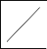
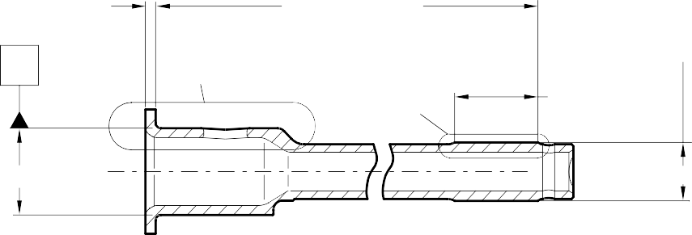
5,60 to 5,80mm 227,00 to 227,50mm
(0.220 to 0.228in)
(8.937 to 8.956in)
X
Y
Z
46,50 to 47,50mm
(1.830 to 1.870in)
A
B
0,020mm (0.0008in)
X

4,75 to 5,25mm
(0.187 to 0.206in)

1,75 to 2,25mm
(0.068 to 0.088in)
RADIUS
63,50 to 64,50mm (2.500 to 2.539in)

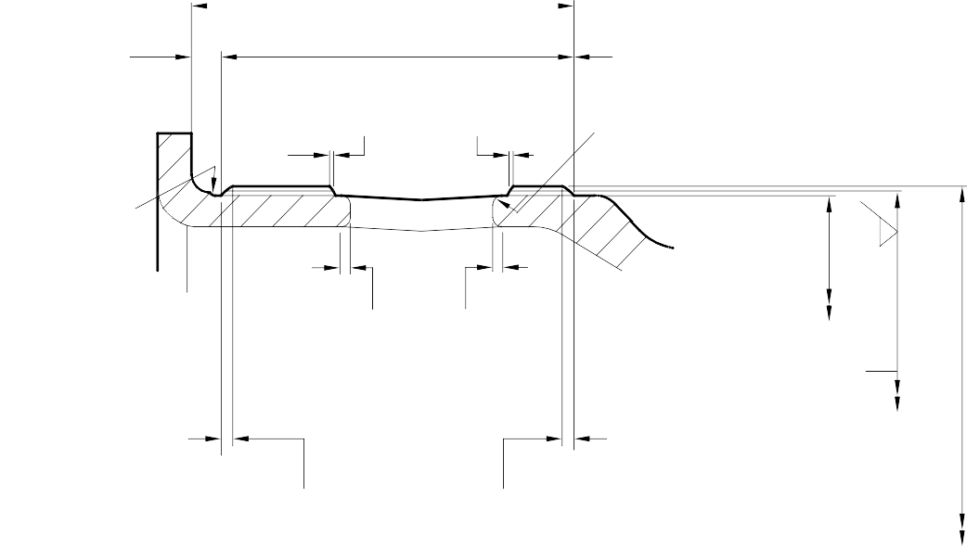
1,00mm (0.039in) MAXIMUM

2,00 to 2,50mm
(0.078 to 0.098in)

LENGTH OF CHROMIUM PLATE

1,00 to 2,00mm
(0.039 to 0.078in) RADIUS

45,300mm (1.7834in) DIAMETER MINIMUM
0,8
(32)

45,950 to 45,975mm
(1.8090 to 1.8100in) AFTER GRINDING

2,00mm
(0.078in) MAXIMUM

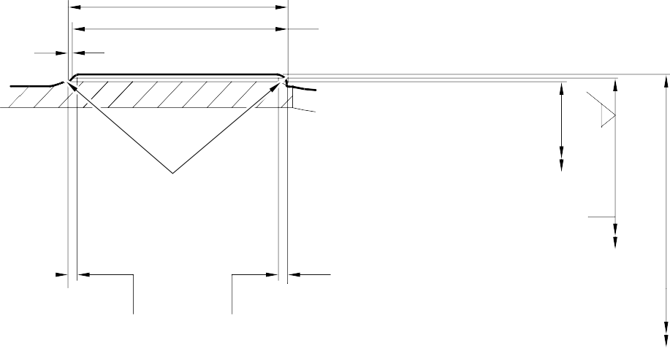
48,00 to 49,00mm

THE CHROMIUM PLATE MUST STOP IN THIS LENGTH. AN IRREGULAR LINE IS PERMITTED
2,00mm (0.078in) MAXIMUM

LARGER VIEW AT

Y

CHROMIUM DEPOSIT

(1.889 to 1.929in)

1,00 to 2,00mm
(0.039 to 0.078in)
LENGTH OF CHROMIUM PLATE

2,00mm (0.078in)

2,00 to 3,00mm
(0.078 to 0.118in) RADIUS

2,00mm (0.078in)
30,300mm (1.1929in) DIAMETER MINIMUM

30,950 to 30,975mm
0,8
(32)
(1.2186 to 1.2195in) AFTER GRINDING

CHROMIUM

MAXIMUM

THE CHROMIUM PLATE MUST STOP IN THIS LENGTH. AN IRREGULAR LINE IS PERMITTED
MAXIMUM

LARGER VIEW AT

Z
DEPOSIT

A3219755-2

Repair to Pin Figure 601

Repair No. 2-1

- Repair No. 3-1 Pivot Pin (6-90)
  - Specified Damage and Material Specification.
    - Specified Damage
      - Damage or wear to the diameter A.
    - Material Specification

IPL Figure and  Item No. | Name | Material Specification
6-90 | Pivot Pin | Steel, S99
  - Special Tools
    - Special tools are not necessary.
  - Materials
    - Materials are not necessary.
  - Repair Parts
    - Repair parts are not necessary.
  - Procedure (Refer to Figure 601)
    - Remove the chromium plate only from the diameter A to show the parent metal.
    - If the parent metal is not damaged or worn:
      - Examine the pivot pin for flaws: refer to PCS-3600 and PCS-3100, inclusion class 3.
      - Apply chromium plate to the diameter A: refer to PCS-2110 Type B. Refer to Figure 601 for chromium plate termination information.
      - Grind the diameter A to between 15,960 and 15,987 mm (0.6284 and 0.6294 in). The surface finish must be 0,8 micrometers (32 micro-inches).
      - Examine the pivot pin for flaws: refer to PCS-3002, PCS-3100, inclusion class 3 and PCS-3600.
      - Identify the part with the Messier-Dowty Limited repair number 450217385A adjacent to the part number: refer to PCS-6000-05.
      - Examine the part to make sure that you have obeyed all the repair instructions correctly.
    - If the parent metal is damaged or worn:
      - Machine the diameter A sufficiently to remove damage and wear, down to a minimum of 15,377 mm (0.6054 in).
      - Examine the pivot pin for flaws: refer to PCS-3600 and PCS-3100, inclusion class 3.
      - Apply chromium plate to the diameter A: refer to PCS-2110 Type B. Refer to Figure 601 for chromium plate termination information.

      - Grind the diameter A to between 15,960 and 15,987 mm (0.6284 and 0.6294 in). The surface finish must be 0,8 micrometers (32 micro-inches).
      - Examine the pivot pin for flaws: refer to PCS-3002, PCS-3100, inclusion class 3 and PCS-3600.
      - Identify the part with the Messier-Dowty Limited repair number 450217385B adjacent to the part number: refer to PCS-6000-05.
      - Examine the part to make sure that you have obeyed all the repair instructions correctly.


163,70 to 163,83mm
(6.445 to 6.450in)
DIA. A
X
51,75 to 52,25mm
(2.037 to 2.057in)
Y
Y
51,75 to 52,25mm
(2.037 to 2.057in)
Z

CHROMIUM PLATE CAN STOP ANYWHERE ON THE CHAMFER.
IT CAN BE FINISHED BY GRINDING
0,92 to 1,45mm
(0.036 to 0.057in)
0,120 to 0,250mm
(0.0047 to 0.0100in)
RAD.




0,80mm (0.031in)

MAKE EDGES SMOOTH
RAD. MIN.

CHROMIUM PLATE TEMINATION TO M-DLPS1031-6
DETAIL X
AFTER CHROMIUM PLATE IS APPLIED AND BEFORE GRINDING
AFTER GRINDING

BEFORE CHROMIUM PLATE IS APPLIED
BEFORE CHROMIUM PLATE IS APPLIED

AFTER GRINDING

AFTER CHROMIUM PLATE IS APPLIED AND BEFORE GRINDING
CHROMIUM PLATE TEMINATION TO M-DLPS1031-3
DETAIL Z

2,00mm (0.079in) MAX. CHROMIUM PLATE MUST STOP
IN THIS LENGTH. AN IRREGULAR LINE IS PERMITTED.

2,00mm (0.079in) MIN. LENGTH
NOT CHROMIUM PLATED
CHROMIUM PLATED LENGTH

CHROMIUM PLATE TEMINATION TO M-DLPS1031-1
DETAIL Y

AFTER CHROMIUM PLATE IS APPLIED AND BEFORE GRINDING

AFTER GRINDING

BEFORE CHROMIUM PLATE IS APPLIED

A321-S-32-12-22-099-0

Repair to Pivot Pin Figure 601

32-12-22
Repair No. 3-1
Page 603

INTENTIONALLY BLANK

- Repair No. 4-1 Uplock Pin (5-400)
  - Specified Damage and Material Specification.
    - Specified Damage
      - Damage or wear to diameter A.
    - Material Specification

IPL Figure and  Item No. | Name | Material Specification
5-400 | Uplock pin | Steel, S99
  - Special Tools
    - Special tools are not necessary.
  - Materials
    - Materials are not necessary.
  - Repair Parts
    - Repair parts are not necessary.
  - Procedure (Refer to Figure 601)
    - Remove the chromium plate from diameter A.
    - Machine diameter A to remove the damage or wear after removal of the chromium plate. The minimum diameter is 24,36 mm (0.960 in) and the surface finish must be 0,4 micrometers (16 micro-inches).
    - Examine the uplock pin for flaws: refer to PCS-3600 and PCS-3100, inclusion class 3.
    - If diameter A has been machined (see para (2)), shot peen the machined area: refer to M-DLPS123.
    - Apply chromium plate to diameter A as shown with a minimum chromium plate thickness of 0,075 mm (0.0030 in): refer to M-DLPS101-2.
    - Machine diameter A to between 24,947 and 24,980 mm (0.9822 and 0.9834 in) with a surface finish of 0,4 micrometers (16 micro-inches).
    - Examine the chromium plated surface for flaws: refer to M-DLNDT3.
    - Apply cadmium plate to the machined areas but not where chromium plated: refer to PCS-2141.
    - Spray primer paint lightly on the cadmium plated surface: refer to PCS-2500.
    - Refer to PCS-6000-07 and identify the part with the applicable Messier-Dowty Limited repair number, adjacent to the part number, after painting:
- 450237490A if only the chromium plate has been repaired, or
- 450237490B if chromium plate and parent metal have been repaired.
    - Examine the part to make sure that you have obeyed all the repair instructions correctly.

32-12-22
Repair No. 4-1
Page 601

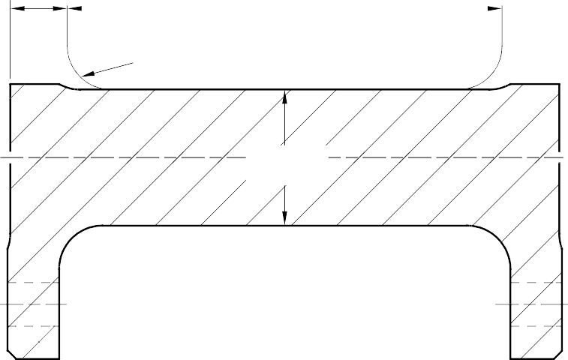
10,25 to 10,75mm
(0.404 to 0.423in)
26,75 to 27,25mm
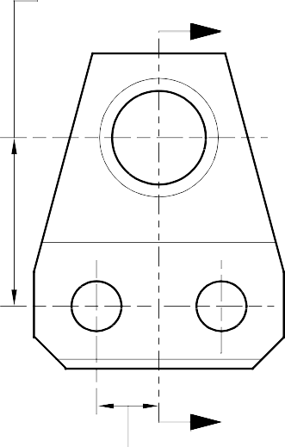
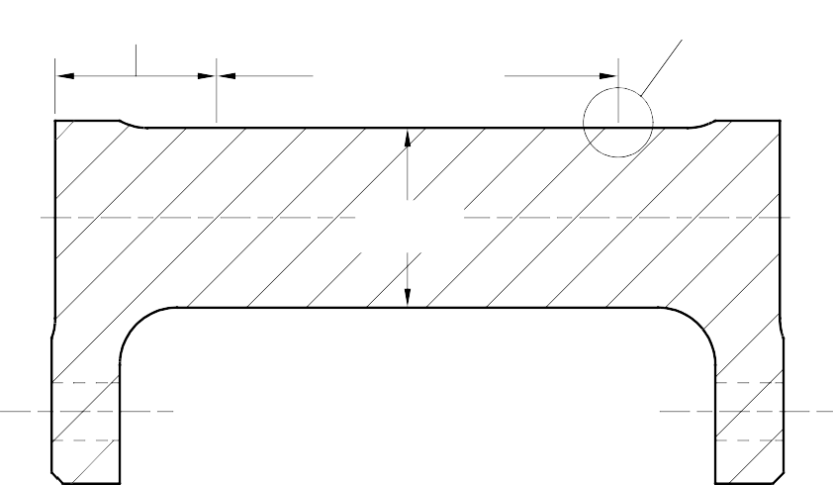
(1.054 to 1.072in)

Y
79,75 to 80,25mm
(3.140 to 3.159in)
7,00 to 8,00mm
(0.276 to 0.314in) RADIUS

DIAMETER
A

SECTION Y-Y
BEFORE CHROMIUM PLATE

Y
9,75 to 10,25mm
(0.384 to 0.403in) CENTERS TYPICAL
22,25 to 22,75mm
(0.876 to 0.895in)
55,75 to 56,25mm Z
(2.195 to 2.214in) LENGTH OF CHROMIUM PLATE

DIAMETER
A

SECTION Y-Y
AFTER CHROMIUM PLATE

LENGTH OF
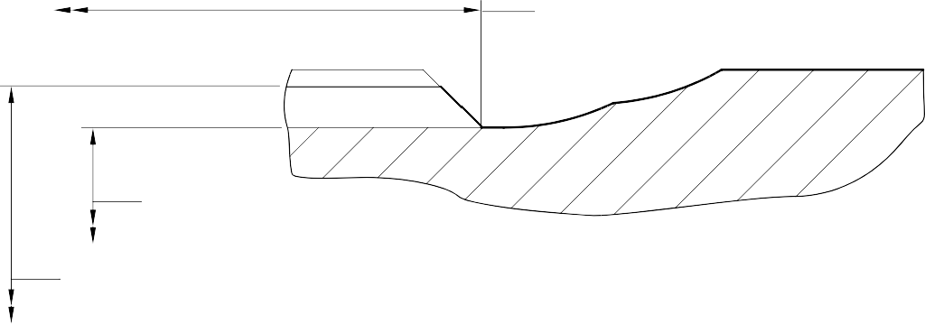
CHROMIUM PLATE M-DLPS1031-2 CHROMIUM PLATE TERMINATION CHROMIUM PLATE MUST NOT EXTENDED ONTO
7,00 to 8,00mm (0.276 to 0.314in) RADIUS

DIAMETER A
BEFORE CHROMIUM PLATE

DIAMETER A
AFTER CHROMIUM PLATE AND GRINDING

LARGER DETAIL Z
NOT TO SCALE

A321A1270-2

Repair to Uplock Pin Figure 601

32-12-22
Repair No. 4-1
Page 602

- Repair No. 5-1 Pin (3-50)
  - Specified Damage and Material Specification.
    - Specified Damage
      - Damage or wear to diameter A.
    - Material Specification

IPL Figure and  Item No. | Name | Material Specification
3-50 | Pin | Steel, S99
  - Special Tools
    - Special tools are not necessary.
  - Materials
    - Materials are not necessary.
  - Repair Parts
    - Repair parts are not necessary.
  - Procedure (Refer to Figure 601)
    - Machine diameter A sufficiently to remove the damage or wear and to the dimensions shown in Figure 601.
    - Examine the pin for flaws: refer to PCS-3600 and PCS-3100, inclusion class 2.
    - Shot peen the pin: refer to M-DLPS123.
    - Apply chromium plate to diameter A to give a minimum diameter of 20,120 mm (0.7921 in): refer to M-DLPS101-2P.
    - Grind diameter A to the dimensions shown with a surface finish of 0,4 micrometers (16 micro-inches). Refer to M-DLPS1031-3 and M-DLPS1031-6 for the chromium plate terminations where shown.
    - Examine the pin for flaws: refer to M-DLNDT3.
    - Identify the part with the Messier-Dowty Limited repair number 450217170 adjacent to the part number: refer to PCS-6000-05.
    - Apply cadmium plate all over the pin, but not on the chromium plated areas: refer to M-DLPS100-2 or PCS-2141.
    - Paint the pin all over, but not on the threads, the thread undercut and the chromium plated areas: refer to PCS-2500.
    - Examine the part to make sure that you have obeyed the repair instructions correctly.

32-12-22
Repair No. 5-1
Page 601

PIN
MACHINE TO 19,380mm (0.763in) MIN. CHROMIUM PLATE TO 20,120mm (0.7921in)



































GRIND TO 19,967 to 19,980mm (0.7861 to 0.7866mm)

SHOT PEEN

0,600 to 0,800mm
(0.0236 to 0.0315in) RADIUS 15 DEGREES

A

M-DLPS1031-3
Z
1,6 to 2,0mm
(0.063 to 0.079in)

2,0mm (0.079in)

SMOOTH BLEND M-DLPS1031-6

LENGTH OF CHROMIUM PLATE





DIAMETER BEFORE CHROMIUM PLATE

0,800 to 1,200mm
(0.0315 to 0.0472in) RADIUS

DETAIL Z

A321A2276-1

Repair to Pin Figure 601

32-12-22
Repair No. 5-1
Page 602

- Repair No. 6-1 Pin (10-80)
  - Specified Damage and Material Specification.
    - Specified Damage
      - Damage or corrosion to diameter A.
    - Material Specification

IPL Figure and  Item No. | Name | Material Specification
10-80 | Pin | UHT Steel (300M), MTL 1201
  - Special Tools
    - Special tools are not necessary.
  - Materials
    - Materials are not necessary.
  - Repair Parts
    - Repair parts are not necessary.
  - Procedure (Refer to Figure 601)
    - Remove the chromium plate from diameter A: refer to PCS-2110.
      - If the bare metal is not damaged or corroded:
        - Examine the pin for flaws: refer to PCS-3600 and PCS-3100, inclusion class 4.
        - Shot peen diameter A: refer to M-DLPS123.
        - Apply chromium plate to diameter A: refer to PCS-2110, Type C. Refer to Figure 601 for chromium plate termination information.
        - Grind diameter A to between 59,951 and 59,970 mm (2.3603 and 2.3610 in). The surface finish must be 0,8 micrometers (32 micro-inches).
        - Examine the ground chromium plate for flaws: refer to PCS-3100, inclusion class 4 and PCS-3002.
        - Identify the part with the Messier-Dowty Limited repair number 450258420A adjacent to the part number: refer to PCS-6000-04 and PCS-6000-07.
        - Examine the part to make sure that you have obeyed all the repair instructions correctly.
      - If the bare metal is damaged or corroded:
        - Machine diameter A just sufficiently to remove the damage or corrosion: refer to M-DLPS1004-4-1. The diameter must not be less than 59,370 mm
(2.3374 in). The surface finish must be 1,6 micrometers (63 micro-inches).
        - Examine the pin for flaws: refer to PCS-3600 and PCS-3100, inclusion class 4.

        - Shot peen and apply chromium plate to diameter A: refer to M-DLPS123 and PCS-2110, Type C. Refer to Figure 601 for chromium plate termination information.
        - Grind diameter A to between 59,951 and 59,970 mm (2.3603 and 2.3610 in). The surface finish must be 0,8 micrometers (32 micro-inches).
        - Examine the ground chromium plate for flaws: refer to PCS-3100, inclusion class 4 and PCS-3002.
        - Identify the part with the Messier-Dowty Limited repair number 450258420B adjacent to the part number: refer to PCS-6000-04 and PCS-6000-07.
        - Examine the part to make sure that you have obeyed all the repair instructions correctly.

32-12-22
Repair No. 6-1
Page 602

LENGTH OF CHROMIUM PLATE
DIAMETER
A
Z
Z
15
DEGREES
1,50 to 2,50mm (0.060 to 0.098in)

EDGES SMOOTHED OUT. CHROMIUM PLATE TERMINATION TO M-DLPS1031-6
CHROMIUM PLATE TERMINATION TO M-DLPS1031-7 or M-DLPS1031-8

0,50 to 0,75mm
(0.020 to 0.030in)

DIAMETER A BEFORE CHROMIUM PLATE

DIAMETER A AFTER GRINDING
PART SECTION Z-Z

A321A2936-1

Repair to Pin Figure 601

INTENTIONALLY BLANK

- Repair No. 6-2 Pin (10-80)
  - Specified Damage and Material Specification.
    - Specified Damage
      - Damage or wear to diameter A.
    - Material Specification

IPL Figure and  Item No. | Name | Material Specification
10-80 | Pin | Steel, MTL 1201
  - Special Tools
    - Special tools are not necessary.
  - Materials
    - These materials are necessary:

NOTE: Alternative equivalents are permitted.

Ref. Item | Material
08-665 | Adhesive
  - Repair Parts
    - These repair parts are necessary:

Part No. | Repair Part | Material Specification
450258261 | Repair bush (Qty 2) | Steel, S154
  - Procedure (Refer to Figure 601)
    - Machine diameter A sufficiently to remove the damage or wear and to between 15,90 and 16,50 mm (0.626 and 0.649 in): refer to M-DLPS1004-4-1. Machine a surface finish of 1,6 micrometers (63 micro-inches).
    - Examine the pin for flaws: refer to PCS-3600 and PCS-3100, inclusion class 4.
    - Shot peen the machined areas: refer to M-DLPS123.
    - Measure the new diameter A.
    - Apply cadmium plate to the machined areas: refer to PCS-2141.
    - Calculate diameter C of the repair bushes:
C = A (as measured) + 0,010 to 0,039 mm (0.0004 to 0.0015 in).
    - Machine the repair bushes to the dimensions shown and calculated. Machine a surface finish of 1,6 micrometers (63 micro-inches).
    - Examine the repair bushes for flaws: refer to PCS-3100, inclusion class 3.

    - Apply cadmium plate to all surfaces of the repair bushes: refer to M-DLPS100-1.
    - Apply adhesive, Material Ref. Item 08-665, to the outside diameter of the repair bushes: refer to M-DLPS709-6.
    - Install the repair bushes to diameter A until aligned with the outside diameter of the pin: refer to M-DLPS1011-5.
    - Machine the repair bushes to the contour of the pin and the dimensions shown.
    - Identify the part with the Messier-Dowty Limited repair number 450258260 adjacent to the part number: refer to PCS-6000-04 and PCS-6000-07.
    - Examine the part to make sure that you have obeyed all the repair instructions correctly.

Repair No. 6-2

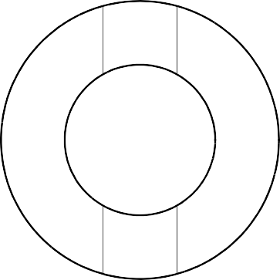
32,428 to 32,480mm
A
(1.2767 to 1.2787in) (REF)

123,00 to 123,25mm
(4.843 to 4.852in)
A
SECTION Z-Z

1,75 to 2,25mm
(0.069 to 0.088in)
12,5 to 13,00mm
(0.50 to 0.51in) DIAMETER

Z Z

14.5 to 15.5 DEGREES

18,0 to 18,5mm
(0.71 to 0.72in)

C
X REPAIR BUSH 450258261
 | 0,05mm (0,002in) DIA | X
 | 0,05mm (0,002in) DIA | X

14,2875 to 14,3205mm
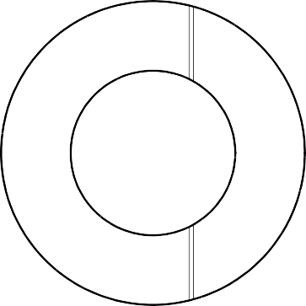


(0.56250 to 0.56379in) DIAMETER

0,50 to 0,75mm
(0.020 to 0.029in)
RADIUS 4 PLACES

SECTION Z-Z

MACHINING THE REPAIR BUSH A321A2277-1

Repair to Pin Figure 601

INTENTIONALLY BLANK

- Repair No. 6-3 Pin (10-80)
  - Specified Damage and Material Specification
    - Specified Damage
      - Damage or corrosion to diameter A.
    - Material Specification

IPL Figure and  Item No. | Name | Material Specification
10-80 | Pin | Steel, MTL1201
  - Special Tools
    - Special tools are not necessary.
  - Materials
    - Materials are not necessary.
  - Repair Parts
    - Repair parts are not necessary.
  - Procedure (Refer to Figure 601)

CAUTION: FOR DAMAGE MORE THAN THE LIMITS OF THIS REPAIR SCHEME, WRITE TO MESSIER-DOWTY LIMITED: REFER TO GUIDE-CS-001.
    - Remove the cadmium plate from the pin: refer to PCS-2100.
    - Machine the diameter A to remove the minimum amount of material necessary to remove the damage or wear, restore the 20,00 mm (0.787 in) radius in two places as shown: refer to M-DLPS1004-4-1 and Figure 601. Do not machine diameter A more than 33,99 mm (1.3383 in). Make the surface finish 1,6 micrometers (63 micro-inches).
    - Machine the radii to the dimensions as shown: refer to Figure 601.
    - Examine the part for flaws: refer to PCS-3100 inclusion class 4 and PCS-3600.
    - Shot peen the reworked areas over lapping adjacent angled surface by at least 6,35 mm (0.250 in). Almen A intensity to be 0,20 to 0,030 mm (0.008 to 0.012 in): refer to M-DLPS123.
    - Grit blast the reworked areas: refer to PCS-2610.
    - Apply sulphamate nickel plate to the reworked areas: refer to MIL STD 868A solution 2, PCS-2120 and Figure 601. The sulphamate nickel plate thickness must be sufficient to get the correct diameter after machining. Make sure that the cross hole and the lubrication holes are sufficiently masked: refer to Figure 601.

NOTE: The above procedure includes de-embrittle for 23 hours at 185oC to 195oC (366oF to 383oF).

Repair No. 6-3

    - Machine (do not grind) the sulphamate nickel plate to get the bore diameter of 32,468 to 32,500 mm (1.2783 to 1.2795 in): refer to Figure 601. Make the surface finish 1,6
micrometers (63 micro-inches).
    - Machine the 20,000 mm (0.7874 in) radii as shown: refer to Figure 601.
    - If the pin base metal has been machined, examine the machined areas for flaws: refer to PCS-3600.

NOTE: The above procedure includes de-embrittle for 4 hours at 185oC to 195oC (366oF to 383oF).
    - Grit blast the sulphamate nickel area: refer to PCS-2610. Make sure that the remainder of the pin is sufficiently masked.
    - Examine the edges of sulphamate nickel plate to make sure they are properly bonded: use 5 or 10X magnification.
    - If there is evidence of delamination, remove the sulphamate nickel plate and do the repair again.
    - Apply cadmium plate all over the pin except where chromium plated: refer to PCS-2100 and Figure 601. The cadmium plate thickness must be between 0,010 and 0,020 mm (0.0004 and 0.0008 in). Make sure the sulphamate nickel plate is fully encapsulated by cadmium plate.
    - Identify the part with the Messier-Dowty Limited repair number 450266211 adjacent to the part number: refer to PCS-6000-04.
    - Apply paint to the reworked areas: refer to REPAIR and PCS-2500.
    - Identify the part with the Messier-Dowty Limited repair number 450266211 adjacent to the part number: refer to PCS-6000-07.
    - Examine the part to make sure that you have obeyed all the repair instructions correctly.

Repair No. 6-3

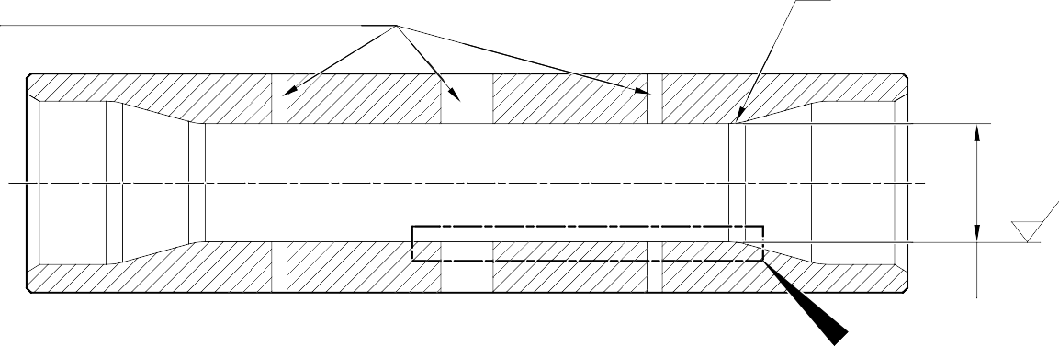
20,00mm
NICKEL PLATE MUST NOT ENTER LUBRICATION HOLES OR CROSS HOLE
(0.787in) RAD. 2 PLACES
1,6
(63)
DIA. A
X

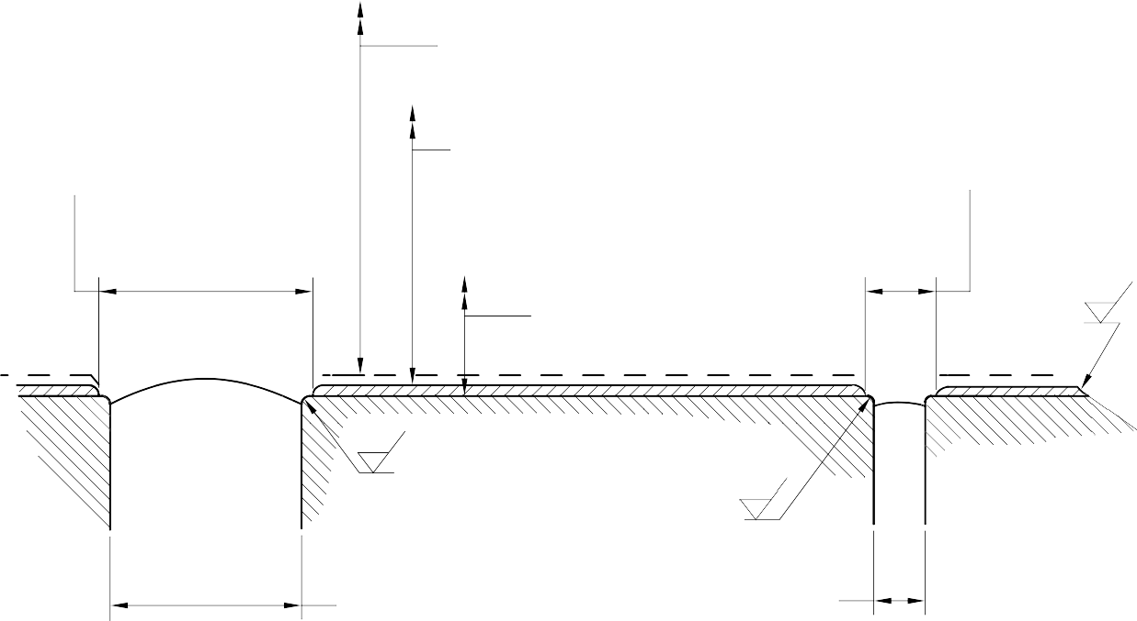
SULPHAMATE NICKEL PLATE DEPOSIT
16,30 to 17,30mm (0.642 to 0.681in) DIA.
2 PLACES
6,00 to 7,00mm 32,428 to 32,480mm (1.2767 to 1.2787in) DIA. (0.236 to 0.276in) DIA. AFTER CADMIUM PLATE 4 PLACES
32,468 to 32,500mm (1.2783 to 1.2795in) DIA. AFTER SULPHAMATE NICKEL PLATE
33,99mm (1.3383in) MAXIMUM DIA. BEFORE SULPHAMATE NICKEL PLATE
1,6
20,00mm ⁽⁶³⁾
(0.787in) RAD. 2 PLACES
0,8
(32)
0,500 to 0,750mm (0.0197 to 0.0295in) RAD.
0,500 to 0,750mm (0.0197 to 0.0295in) RAD.
0,8
(32)
14,30mm
(0.563in) DIA. REF.
4,00mm (0.157in) DIA. REF.
2 PLACES

DETAIL X

A321-S-32-12-22-001-0

Repair to Pin Figure 601

Repair No. 6-3

INTENTIONALLY BLANK

- Repair No. 7-1 Pin (11-130)
  - Specified Damage and Material Specification.
    - Specified Damage
      - Damage or corrosion to diameter A.
    - Material Specification

IPL Figure and  Item No. | Name | Material Specification
11-130 | Pin | UHT Steel (300M), MTL 1201
  - Special Tools
    - Special tools are not necessary.
  - Materials
    - Materials are not necessary.
  - Repair Parts
    - Repair parts are not necessary.
  - Procedure (Refer to Figure 601)

CAUTION: FOR DAMAGE MORE THAN THE LIMITS OF THIS REPAIR SCHEME, WRITE TO MESSIER-DOWTY LTD: REFER TO GUIDE-CS-001.
    - Remove the chromium plate from diameter A: refer to PCS-2110.
      - If the bare metal is not damaged or corroded:
        - Examine the pin for flaws: refer to PCS-3600 and PCS-3100, inclusion class 4.
        - Shot peen diameter A: refer to M-DLPS123.
        - Apply chromium plate to diameter A: refer to PCS-2110, Type C. Refer to Figure 601 for chromium plate termination information.
        - Grind diameter A to between 59,951 and 59,970 mm (2.3603 and 2.3610 in). The surface finish must be 0,8 micrometers (32 micro-inches).
        - Examine the ground chromium plate for flaws: refer to PCS-3100, inclusion class 4 and PCS-3002.
        - Identify the part with the Messier-Dowty Limited repair number 450258410A adjacent to the part number: refer to PCS-6000-04 and PCS-6000-07.
        - Examine the part to make sure that you have obeyed all the repair instructions correctly.
      - If the bare metal is damaged or corroded:
        - Machine diameter A just sufficiently to remove the damage or corrosion: refer to M-DLPS1004-4-1. The diameter must not be less than 59,370 mm
(2.3374 in). The surface finish must be 1,6 micrometers (63 micro-inches).
Repair No. 7-1

        - Examine the pin for flaws: refer to PCS-3600 and PCS-3100, inclusion class 4.
        - Shot peen and apply chromium plate to diameter A: refer to M-DLPS123 and PCS-2110, Type C. Refer to Figure 601 for chromium plate termination information.
        - Grind diameter A to between 59,951 and 59,970 mm (2.3603 and 2.3610 in). The surface finish must be 0,8 micrometers (32 micro-inches).
        - Examine the ground chromium plate for flaws: refer to PCS-3100, inclusion class 4 and PCS-3002.
        - Identify the part with the Messier-Dowty Limited repair number 450258410B adjacent to the part number: refer to PCS-6000-04 and PCS-6000-07.
        - Examine the part to make sure that you have obeyed all the repair instructions correctly.

Repair No. 7-1

LENGTH OF CHROMIUM PLATE
DIAMETER
A
Z
Z
15
DEGREES
1,50 to 2,50mm (0.060 to 0.098in)

EDGES SMOOTHED OUT. CHROMIUM PLATE TERMINATION
CHROMIUM PLATE TERMINATION TO M-DLPS1031-7 or M-DLPS1031-8


TO M-DLPS1031-6
0,50 to 0,75mm
(0.020 to 0.030in) RADIUS
DIAMETER A BEFORE CHROMIUM PLATE
DIAMETER A AFTER GRINDING
PART SECTION Z-Z

A321A2937-1

Repair to Pin Figure 601

Repair No. 7-1

INTENTIONALLY BLANK

- Repair No. 7-2 Pin (11-130)
  - Specified Damage and Material Specification.
    - Specified Damage
      - Damage or corrosion to diameter A.
    - Material Specification

IPL Figure and  Item No. | Name | Material Specification
11-130 | Pin | UHT Steel (300M), MTL 1201
  - Special Tools
    - Special tools are not necessary.
  - Materials
    - These materials are necessary:

NOTE: Alternative equivalents are permitted.

Ref. Item | Material
08-665 | Adhesive (Loctite Grade 601)
  - Repair Parts
    - These repair parts are necessary:

Part No. | Repair Part | Material Specification
450258431 | Repair sleeve (Qty 2) | Steel, S154
  - Procedure (Refer to Figure 601)

CAUTION: FOR DAMAGE MORE THAN THE LIMITS OF THIS REPAIR SCHEME, WRITE TO MESSIER-DOWTY LTD: REFER TO GUIDE-CS-001.
    - Machine diameter A just sufficiently to remove the damage or corrosion and to between 14,25 and 14,75 mm (0.561 and 0.581 in): refer to M-DLPS1004-4-1. The surface finish must be 1,6 micrometers (63 micro-inches).
    - Examine the pin for flaws: refer to PCS-3600 and PCS-3100, inclusion class 4.
    - Measure and record the new diameters A.
    - Shot peen the reworked areas: refer to M-DLPS123 and Figure 601.
    - Locally apply cadmium plate to the reworked areas: refer to PCS-2141.
    - Identify the part with the Messier-Dowty Limited repair number 450258430 adjacent to the part number: refer to PCS-6000-04.
    - Calculate diameter B of the repair sleeves:
Dia. B = Dia. A (as measured) + 0,010 to 0,039 mm (0.0004 to 0.0015 in).

    - Refer to Figure 601 and machine the repair sleeves to the dimensions shown and calculated.
    - Apply cadmium plate to the outside diameter and the chamfer of the repair sleeves: refer to PCS-2101.
    - Apply adhesive, Material Ref. Item 08-665, to the outside diameter of the repair sleeves: refer to PCS-5303.
    - Install the repair sleeves to diameters A until aligned with the outside diameter of the pin: refer to M-DLPS1011-5.
    - Machine the bores of the repair sleeves to a diameter between 12,700 and 12,733 mm (0.5000 and 0.5013 in). Machine the inner and outer ends of both sleeves to inner and outer profile of the pin. Make the radius between 0,5 and 0,75 mm (0.020 and 0.029 in) at inside and outside of both the sleeves: refer to Figure 601.
    - Locally apply cadmium plate to the reworked areas of the sleeves: refer to PCS-2141.
    - Identify the part with the Messier-Dowty Limited repair number 450258430 adjacent to the part number: refer to PCS-6000-07.
    - Examine the part to make sure that you have obeyed all the repair instructions correctly.

Repair No. 7-2

Y
DIA. A
DIA. A

123,00 to 123,25mm
(4.843 to 4.852in)

SECTION Z-Z
2,00mm (0.079in)

10,00mm (0.394in) DIAMETER

18,00mm (0.709in)
Z Z

15 DEGREES

DIA. B REPAIR SLEEVE 450258431
 | 0,05mm (0.002in) DIA. | Y
 | 0,05mm (0.002in) DIA. | Y

12,700 to 12,733mm
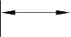

(0.5000 to 0.5013in) DIAMETER

0,50 to 0,75mm (0.020 to 0.029in) RAD.
TYPICAL BOTH REPAIR SLEEVES

SECTION Z-Z
MACHINING REPAIR SLEEVE
A321-S-32-12-22-071-0

Repair to Pin Figure 601

INTENTIONALLY BLANK

- Repair No. 8-1 Bracket (5-300)
  - Specified Damage and Material Specification.
    - Specified Damage
      - Damage or wear to the diameter A and/or the adjacent inside face.
    - Material Specification

IPL Figure and  Item No. | Name | Material Specification
5-300 | Bracket | Aluminium Alloy, L168T6511
  - Special Tools
    - These special tools are necessary:

NOTE: Alternative equivalents are permitted.

Part No. | Special Tool | Function
460004330/85 | Press Pad | Install oversize bearing
460004331/7 | Drift | Use with 460004330/85
  - Materials
    - These materials are necessary:

NOTE: Alternative equivalents are permitted.

Ref. Item | Material
09-510A | Sealant
  - Repair Parts
    - These repair parts are necessary:

Part No. | Repair Part | Material Specification
450217858 | Oversize bearing | Steel, S145
  - Procedure (Refer to Figure 601)
    - Machine the diameter A to remove the minimum amount of material necessary to remove the damage or wear: refer to Figure 601 for the dimensions. The surface finish must be 1,6 micrometers (63 micro-inches).
    - Machine the face Q as necessary to remove damage or wear: refer to Figure 601 for the dimensions. The surface finish must be 1,6 micrometers (63 micro-inches).
    - Machine the chamfer to the dimensions shown in Figure 601.
    - Measure and make a record of the new diameter A and the thickness of the lug D.
    - Examine the bracket for flaws: refer to PCS-3200.
Repair No. 8-1

    - Prepare the machined surfaces of the bracket:
- anodize the surfaces: refer to M-DLPS102-1, or
- apply Alocrom to the surfaces: refer to PCS-2220.
    - Calculate the diameter B and the dimension C of the oversize bearing:
B = A (as measured) - 0,006 to + 0,023 mm (- 0.0002 to + 0.0009 in)
C = D (as measured) - 0,15 to - 0,25 mm (- 0.006 to - 0.010 in).
    - Machine the oversize bearing to the dimensions shown and calculated: the surface finish must be 1,6 micrometers (63 micro-inches).
    - Passivate the oversize bearing: refer to M-DLPS124.
    - Apply cadmium plate to the oversize bearing, but not on the internal diameter. The thickness of the cadmium plate must be between 0,010 and 0,015 mm (0.0004 and 0.0006 in): refer to M-DLPS100-2S.
    - Use the Press Pad 460004330/85 and Drift 460004331/7 to install the oversize bearing to the bracket: refer to M-DLPS1011-14. Check line ream the oversize bearing to the dimension shown in Figure 601.
    - Apply sealant, Material Ref. Item 09-510A, to seal between the ends of the oversize bearing and the bracket: refer to M-DLPS709-19.
    - Identify the part with the Messier-Dowty Limited repair number 450217195 adjacent to the part number: refer to PCS-6000-05 and PCS-6000-07.
    - Examine the part to make sure that you have obeyed all the repair instructions correctly.

Repair No. 8-1

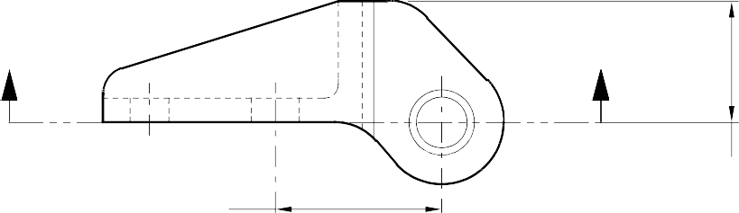
Z Z

34,750 to 35,250mm
(1.3681 to 1.3877in)
24,750 to 25,250mm
(0.9744 to 0.9940in)

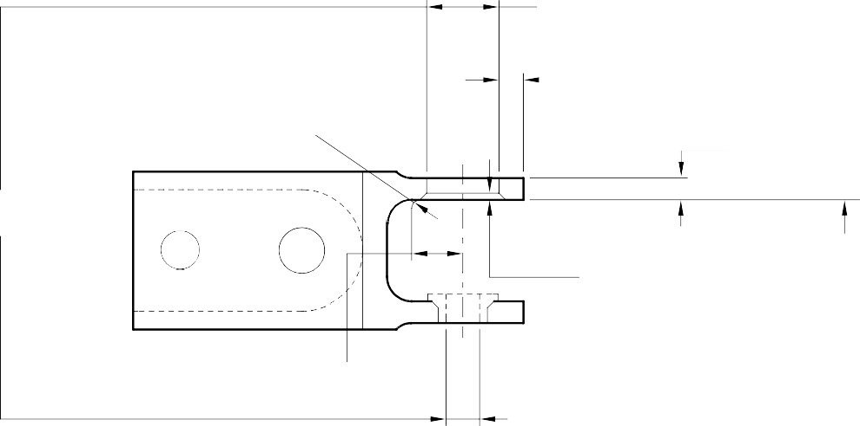
DIA. A
15,718mm (0.6188in) MAX.
1,75 to 2,25mm (0.068 to 0.088in) RAD
4,891mm (0.1925in) MIN. WALL THICKNESS
DIM. D
4,500mm (0.1771in) MIN.
0,75 to 1,25mm
(0.029 to 0.049in)
x 45 DEGREE CHAMFER
FACE
Q
11,750 to 12,250mm
(0.4625 to 0.4822in)
0,025mm (0.001in) DIA
SECTION Z-Z WITHOUT BEARING
DIM. C
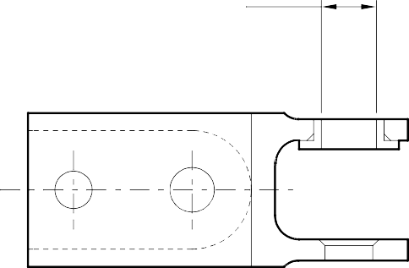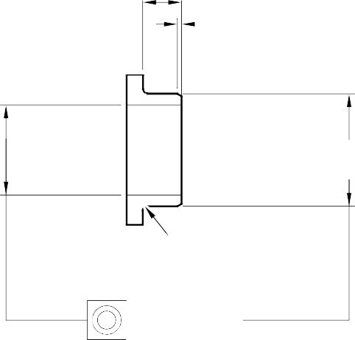
11,100 to 11,118mm
(0.4370 to 0.4372in)
0,50 to 0,75mm (0.019 to 0.029in)
x 30 DEGREE CHAMFER
DIM.
B
0,25 to 0,75mm
(0.009 to 0.029in) RAD
0,025mm (0.001in) DIA

SECTION Z-Z WITH BEARING
OVERSIZE BEARING - MACHINING

A321A3510-1

Repair to Bracket Figure 601

Repair No. 8-1

INTENTIONALLY BLANK

- Repair No. 8-2 Bracket (5-300)
  - Specified Damage and Material Specification.
    - Specified Damage
      - Damage or wear to the diameter A and/or the adjacent inside face.
    - Material Specification

IPL Figure and  Item No. | Name | Material Specification
5-300 | Bracket | Aluminium Alloy, L168T6511
  - Special Tools
    - These special tools are necessary:

NOTE: Alternative equivalents are permitted.

Part No. | Special Tool | Function
460004330/136 | Press Pad | Install the oversize bearing
460004331/7 | Drift | Use with 460004330/136
  - Materials
    - These materials are necessary:

NOTE: Alternative equivalents are permitted.

Ref. Item | Material
09-510A | Sealant
  - Repair Parts
    - These repair parts are necessary:

Part No. | Repair Part | Material Specification
450217859 | Oversize bearing | Steel, S145
  - Procedure (Refer to Figure 601)
    - Machine the diameter A sufficiently to remove the damage or wear: refer to Figure 601 for the dimensions. The surface finish must be 1,6 micrometers (63 micro-inches).
    - Machine the face Q as necessary to remove the damage or wear: refer to Figure 601 for the dimensions. The surface finish must be 1,6 micrometers (63 micro-inches).
    - Machine the chamfer to the dimensions shown in Figure 601.
    - Measure and make a record of the new diameter A and the thickness of the lug D.
    - Examine the bracket for flaws: refer to PCS-3200.

    - Prepare the machined surfaces of the bracket:
- anodize the surfaces: refer to M-DLPS102-1, or
- apply Alocrom to the surfaces: refer to PCS-2220.
    - Calculate the diameter B and the dimension C of the oversize bearing:
B = A (as measured) - 0,006 to + 0,023 mm (- 0.0002 to + 0.0009 in)
C = D (as measured) - 0,30 to - 0,40 mm (- 0.011 to - 0.015 in).
    - Machine the oversize bearing to the dimensions shown and calculated: the surface finish must be 1,6 micrometers (63 micro-inches).
    - Passivate the oversize bearing: refer to M-DLPS124.
    - Apply cadmium plate to the oversize bearing, but not on the internal diameter. The thickness of the cadmium plate must be between 0,010 and 0,015 mm (0.0004 and 0.0006 in): refer to M-DLPS100-2S.
    - Use the Press Pad 460004330/136 and Drift 460004331/7 to install the oversize bearing to the bracket: refer to M-DLPS1011-14. Check line ream the oversize bearing to the dimension shown in Figure 601.
    - Apply sealant, Material Ref. Item 09-510A, to seal between the ends of the oversize bearing and the bracket: refer to M-DLPS709-19.
    - Identify the part with the Messier-Dowty Limited repair number 450217205 adjacent to the part number: refer to PCS-6000-05.
    - Examine the part to make sure that you have obeyed all the repair instructions correctly.

Repair No. 8-2

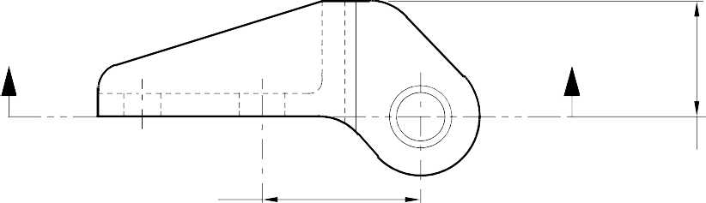
Z Z

34,750 to 35,250mm
(1.3681 to 1.3877in)
24,750 to 25,250mm
(0.09744 to 0.0940in)

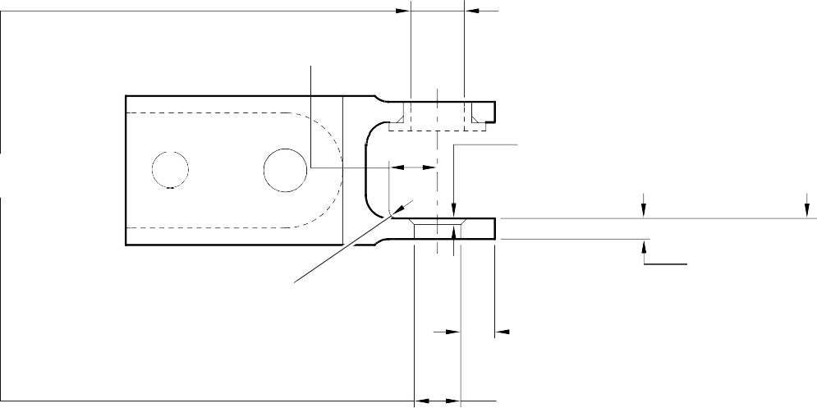
10,250 to 10,500mm
(0.4036 to 0.4133in)
0,75 to 1,25mm
(0.029 to 0.049in)
x 45 DEGREE CHAMFER
FACE
Q
1,75 to 2,25mm (0.068 to 0.088in) RAD
DIM. D
4,500mm (0.1771in) MIN.
6,39mm (0.251in)
MIN. WALL THICKNESS
DIA. A
12,718mm (0.500in) MAX.
0,025mm (0.001in) DIA
SECTION Z-Z WITHOUT BEARING

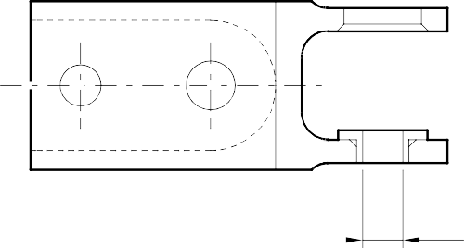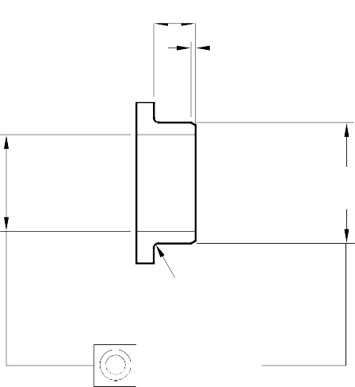

8,000 to 8,015mm
(0.3150 to 0.3155in)
DIM. C
0,50 to 0,75mm (0.019 to 0.029in)
x 30 DEGREE CHAMFER
DIA.
B
0,25 to 0,75mm
(0.009 to 0.029in) RAD.
0,025mm (0.001in) DIA

SECTION Z-Z WITH BEARING
OVERSIZE BEARING - MACHINING
A321A3511-1

Repair to Bracket Figure 601

INTENTIONALLY BLANK

