- Repair No. 9-1 Sliding Tube (18-80 and 18-80A)
  - Specified Damage and Material Specification
    - Specified Damage
      - Damage or corrosion to diameter A.
    - Material Specification
IPL Figure and  Item No. | Name | Material Specification
18-80 and  18-80A | Sliding tube | Steel, S155 (300M)

  - Special Tools
    - Special tools are not necessary.
  - Materials
    - Materials are not necessary.
  - Repair Parts
    - Repair parts are not necessary.
  - Procedure (Refer to Figures 601 and 602)
    - Remove the chromium plate from diameter A: refer to PCS-2110.
      - If the base metal is not damaged or corroded:
        - Examine the sliding tube for flaws: refer to PCS-3100, inclusion class 4 and PCS-3600.
        - Apply chromium plate to diameter A: refer to PCS-2110 Type C. Refer to Figure 601 for chromium plate termination information.
        - Grind diameter A to between 177,68 and 177,72 mm (6.995 and 6.997 in). The surface finish must be 0,25 micrometers (10 micro-inches).
        - Examine the ground chromium plate for flaws: refer to M-DLNDT3.
        - Identify the part with the Safran Landing Systems repair number 450258460A adjacent to the part number: refer to PCS-6000-19 and PCS-6000-07.
        - Examine the part to make sure that you have obeyed all the repair instructions correctly.
      - If the base metal is damaged or corroded:
        - Machine diameter A just sufficiently to remove the damage or corrosion: refer to M-DLPS1004-4-1. The diameter must not be less than 177,07 mm (6.971 in). The surface finish must be 1,6 micrometers (63 micro-inches).
        - Examine the sliding tube for flaws: refer to PCS-3100, inclusion class 4 and PCS-3600.
        - Shot peen the machined areas: refer to PCS-2300.

        - Apply chromium plate to diameter A: refer to PCS-2110 Type C. Refer to M-DLPS1031 and Figure 602 for chromium plate termination information.
        - Grind diameter A to between 177,68 and 177,72 mm (6.995 and 6.997 in). The surface finish must be 0,25 micrometers (10 micro-inches).
        - Examine the ground chromium plate for flaws: refer to M-DLNDT3.
        - Identify the part with the Safran Landing Systems repair number 450258460B adjacent to the part number: refer to PCS-6000-19 and PCS-6000-07.
        - Examine the part to make sure that you have obeyed all the repair instructions correctly.

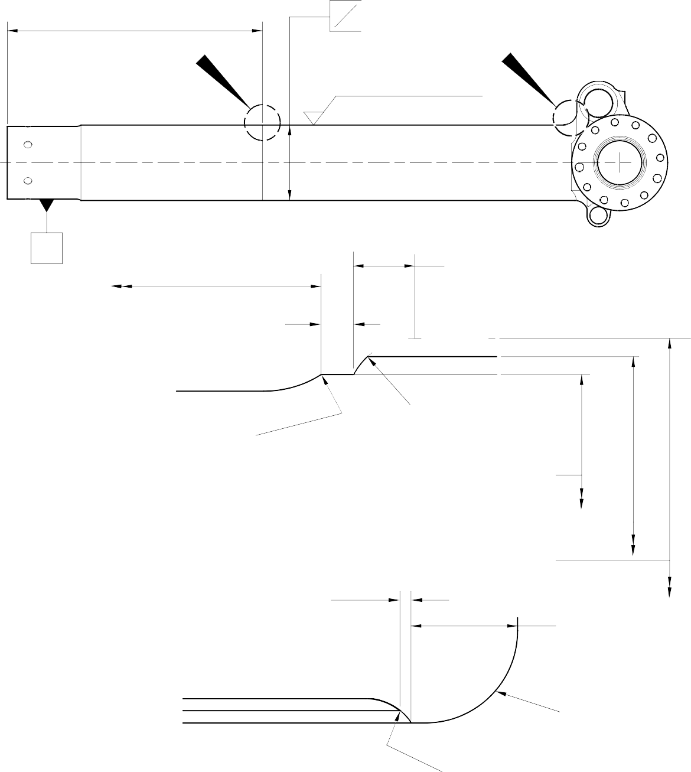
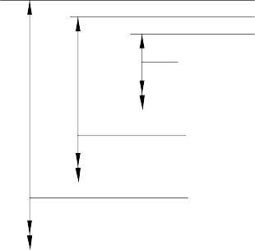
531,00 to 533,00mm
(20.906 to 20.984in)
X

DIA A

Z
0,04mm (0.0016in)

Y
1,6 BEFORE CHROMIUM
(63) PLATE
0,25 AFTER CHROMIUM
(10) PLATE

Z
531,00 to 533,00mm
(20.906 to 20.984in)

1,00mm (0.039in)
2,00mm (0.079in) CHROMIUM PLATE MUST
TERMINATE IN THIS LENGTH. WAVY OR IRREGULAR LINE IS PERMITTED

8,00 to 10,00mm (0.315 to 0.394in) RADIUS
SMOOTH EDGE
0,40 to 1,00mm
(0.016 to 0.039in) RADIUS

DETAIL X
DIAMETER BEFORE CHROMIUM PLATE

DIAMETER AFTER GRINDING OF CHROMIUM PLATE

CHROMIUM PLATE DEPOSIT

2,00mm (0.079in)
MAXIMUM CHROMIUM PLATE MUST TERMINATE IN THIS LENGTH. WAVY OR IRREGULAR LINE IS
PERMITTED

18,00mm (0.709in)

DIAMETER BEFORE CHROMIUM PLATE
15,50 to 16,50mm
(0.610 to 0.649in) RADIUS

DIAMETER AFTER GRINDING OF CHROMIUM PLATE

CHROMIUM PLATE DEPOSIT

DETAIL Y
SMOOTH EDGE

A321-S-32-12-22-025-0

Repair to Sliding Tube Figure 601

531,00 to 533,00mm

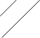

(20.906 to 20.984in) REF.

EXTENT OF SHOT PEENING

0,75 to 1,25mm (0.030 to 0.050in)
UNPLATED LENGTH

2,00mm (0.079in) MAX. CHROMIUM PLATE MUST TERMINATE IN THIS LENGTH. WAVY OR IRREGULAR
LINE IS PERMITTED
17,75 to 18,25mm
(0.699 to 0.719in)

2,00mm (0.079in) MAX. CHROMIUM PLATE MUST TERMINATE IN THIS LENGTH.
WAVY OR IRREGULAR LINE IS PERMITTED

0,40 to 1,00mm
(0.016 to 0.040in)
RADIUS

DETAIL X

DETAIL Y
1,50 to 2,00mm
(0.060 to 0.079in) RADIUS BEFORE CHROMIUM PLATE

(REFER TO FIGURE 601) (REFER TO FIGURE 601)

177,07mm (6.971in) MINIMUM DIAMETER BEFORE CHROMIUM PLATE

177,68 to 177,72mm (6.995 to 6.997in) DIAMETER AFTER GRINDING CHROMIUM PLATE

CHROMIUM PLATE DEPOSIT

A321-S-32-12-22-026-0

Repair to Sliding Tube Figure 602

- Repair No. 9-2 Sliding Tube (18-80 and 18-80A)
  - Specified Damage and Material Specification.
    - Specified Damage
      - Damage or corrosion to the chromium plate band(s) on one or both brake flanges.
    - Material Specification
IPL Figure and  Item No. | Name | Material Specification
18-80 and  18-80A | Sliding tube | Steel, S155 (300M)

  - Special Tools
    - Special tools are not necessary.
  - Materials
    - Materials are not necessary.
  - Repair Parts
    - Repair parts are not necessary.
  - Procedure (Refer to Figure 601)

CAUTION: REPAIR WILL NOT BE PERMITTED BEYOND THE LIMITS OF THIS REPAIR SCHEME.
    - Remove the chromium plate band(s) from the brake flange(s): refer to M-DLPS101.
    - Remove the Sermetel W surface treatment from the sliding tube: refer to M-DLPS637.
    - Do this procedure if there is no damage to the parent metal:
      - Examine the sliding tube for flaws: refer to M-DLNDT6 and M-DLNDT2, inclusion class 4.
      - Stress relieve the sliding tube for 4 hours at 185 to 195 oC (366 to 384 oF).
      - Apply chromium plate to make new band(s) on the flange face(s) using one of these procedures: refer to Figure 601.
        - Apply chromium plate bands to the flange(s): refer to M-DLPS101-7. Grind the chromium plate to get the dimensions shown in Figure 601: the surface finish must be 2,5 micrometers (100 micro-inches). Examine the ground chromium plate for flaws: refer to M-DLNDT3.
OR
        - Apply chromium plate bands to the flange(s) to get a deposit that agrees with the dimensions shown in Figure 601: refer to M-DLPS101-7. The surface finish must be 2,5 micrometers (100 micro-inches).
      - Apply Sermetel W protective treatment: refer to M-DLPS637 and REPAIR, Protective Treatment.
Repair No. 9-2

      - Identify the part with the Safran Landing Systems repair number 450266100A adjacent to the part number: refer to M-DLPS405-4.
      - Examine the part to make sure that you have obeyed all the repair instructions correctly.
    - Do this procedure if there is corrosion or damage to the parent metal not more than 0,25 mm (0.010 in) deep.

CAUTION: DO NOT MACHINE ALL OF THE FLANGE FACE.
      - Locally make the area smooth and polish just sufficiently to remove the corrosion or damage from the surface: the minimum flange width is 11,6 mm (0.456 in).
      - Examine the sliding tube for flaws: refer to M-DLNDT6 and M-DLNDT2, inclusion class 4.
      - Stress relieve the sliding tube for 4 hours at 185 to 195 oC (366 to 384 oF).
      - Locally shot peen the sliding tube: refer to M-DLPS123.
      - Refer to Figure 601 and M-DLPS101-7. Apply chromium plate to make new bands on the brake flange surface: make the chromium plate thicker in the areas where the corrosion or damage has been removed.
      - Grind the chromium plate to the dimension shown: refer to Figure 601. The surface finish must be 2,5 micrometers (100 micro-inches).
      - Examine the chromium plate surface: refer to M-DLNDT3.
      - Apply Sermetel W protective treatment: refer to M-DLPS637 and REPAIR, Protective Treatment.
      - Identify the part with the Safran Landing Systems repair number 450266100B adjacent to the part number: refer to M-DLPS405-4.
      - Examine the part to make sure that you have obeyed all the repair instructions correctly.
    - Do this procedure if there is corrosion or damage to the parent metal more than 0,25 mm (0.010 in) deep.

CAUTION: DO NOT MACHINE ALL OF THE FLANGE FACE.
      - Locally make the area smooth and polish just sufficiently to remove the corrosion or damage from the face, the minimum flange width is 11,6 mm (0.456 in).
      - Examine the sliding tube for flaws: refer to M-DLNDT6 and M-DLNDT2, inclusion class 4.
      - Stress relieve the sliding tube for 4 hours at 185 to 195 oC (366 to 384 oF).
      - Locally shot peen the sliding tube: refer to M-DLPS123, Almen A intensity of 0,010 to 0,014 mm (0.0004 to 0.0006 in).
      - Refer to M-DLPS200-4 and locally grit blast the sliding tube: give protection from the grit blast to the areas adjacent to the flanges.

      - Apply sulphamate nickel plate to the smoothed and polished areas. The sulphamate nickel plate must fill the smoothed and polished areas and be 0,25 mm (0.010 in) above the flange face. Refer to MIL STD 868A, solution 2.
      - De-embrittle the sliding tube for 23 hours at 185 to 195oC (366 to 384oF).
      - Machine the sulphamate nickel plate (do not grind), the machined surface must be 0,00 to 0,05 mm (0.000 to 0.002 in) above the brake flange surface. The surface finish must be 1,6 micrometers (63 micro-inches).
      - Examine the sliding tube: refer to M-DLNDT6.
      - De-embrittle the sliding tube for 4 hours at 185 to 195oC (366 to 384oF).
      - If the parent metal was machined at para (h), examine the affected area for flaws: refer to M-DLNDT2, inclusion class 4.
      - Shot peen the flange face(s) including the sulphamate nickel plated areas: refer to M-DLPS123, Almen A intensity of 0,010 to 0,014 mm (0.0004 to 0.0006 in).
      - Refer to M-DLPS200-4 and locally grit blast the sliding tube: give protection from the grit blast to the areas adjacent to the flanges.
      - Use 5 or 10 times magnification to examine the sulphamate nickel plate to make sure the bond is satisfactory: do the repair again if the bond is not satisfactory.
      - Apply chromium plate to make new band(s) on the flange face(s) using one of these procedures: refer to Figure 601.
        - Apply chromium plate to the bands: refer to M-DLPS101-7. Grind the chromium plate to get the dimensions shown: the surface finish must be 2,5 micrometers (100 micro-inches). Examine the ground chromium plate for flaws: refer to M-DLNDT3.
OR
        - Apply chromium plate to the band to the dimensions shown: refer to M-DLPS101-7. The surface finish must be 2,5 micrometers (100 micro-inches).
      - Apply Sermetel W protective treatment: refer to M-DLPS637 and REPAIR, Protective Treatment.
      - Identify the part with the Safran Landing Systems repair number 450266100C adjacent to the part number: refer to M-DLPS405-4.
      - Examine the part to make sure that you have obeyed all the repair instructions correctly.

Repair No. 9-2

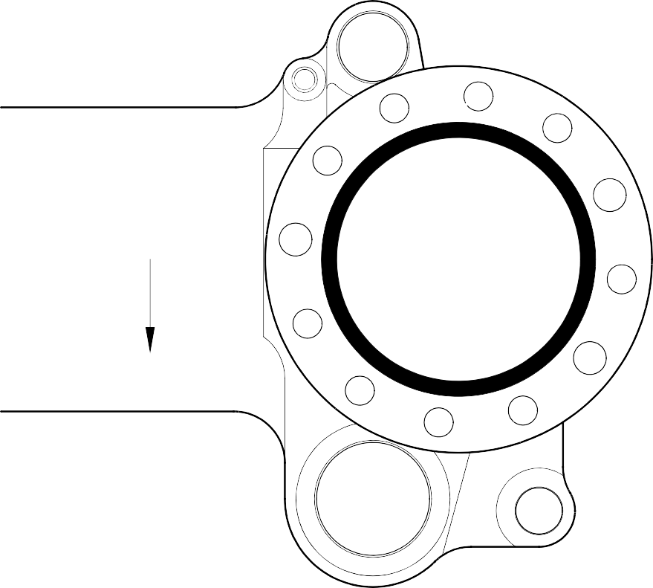
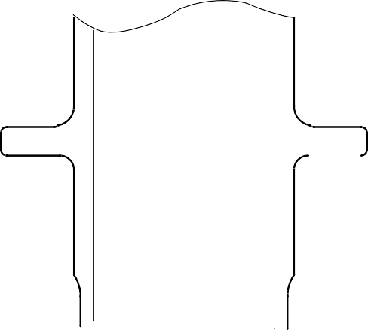
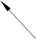
AREA OF CHROMIUM PLATE

Z Z

0,020 to 0,045mm
(0.0008 to 0.0018in) THICKNESS OF CHROMIUM PLATE ABOVE OUTER SURFACE OF FLANGE

0 to 2,00mm
(0 to 0.078in) CHROMIUM RUNOUT

149,90mm (5.901in)

160,00mm (6.299in)
SECTION Z-Z
AREA OF CHROMIUM PLATE

NOTE:
THE CHROMIUM PLATE MUST NOT EXTEND BEYOND THE DIMENSIONS SHOWN

A321A3513-1

Repair to Sliding Tube Figure 601

Repair No. 9-2

- Repair No. 9-3 Sliding Tube (18-80)
  - This Repair, Messier-Dowty Limited Repair No. 450258400, has been superseded by Repair No. 9-10, Messier-Dowty Limited Repair No. 450258401.

INTENTIONALLY BLANK

- Repair No. 9-4 Sliding Tube (18-80 and 18-80A)
  - Specified Damage and Material Specification.
    - Specified Damage
      - Damage or wear to the diameter(s) A.
    - Material Specification
IPL Figure and  Item No. | Name | Material Specification
18-80 and  18-80A | Sliding Tube | Steel, 300M

  - Special Tools
    - These special tools are necessary:

NOTE: Alternative equivalents are permitted.

Part No. | Special tool | Function
460004330/105 | Press Pad | Install the repair bush(es)
  - Material.
    - Materials are not necessary.
  - Repair Parts
    - These repair parts are necessary:

NOTE: Alternative equivalents are permitted.

Part No. | Repair Part | Material Specification
450266336 | Repair Bush (Qty 18) | Stainless Steel, AMS 5643 or 5659
  - Procedure (Refer to Figures 601 and 602).

CAUTION: FOR DAMAGE MORE THAN THE LIMITS OF THIS REPAIR SCHEME, WRITE TO SAFRAN LANDING SYSTEMS: REFER TO GUIDE-CS-001.
    - Do this procedure if there is a wear or damage to diameter(s) A:
      - Remove the paint locally from the sliding tube: refer to PCS-2700.
      - Remove the sermetel from the sliding tube: refer to M-DLPS637.
      - Remove the chromium plate locally from the sliding tube: refer to PCS-2110, type C and Figure 601.
      - Machine diameter(s) A sufficiently to remove the damage or wear: refer to
M-DLPS900, M-DL PS1000 and Figure 601. Do not make diameter(s) A more than 18,568 mm (0.7310 in). Make the surface finish 1,6 micrometers (63 micro-inches).
      - Machine the chamfers and radii to the dimensions shown: refer to Figure 601.

      - Measure and record the new diameter(s) A.
      - Examine the sliding tube for flaws: refer to PCS-3100 inclusion class 4 and PCS-3600.
      - If necessary, shot peen the machined surfaces: refer to M-DLPS123.
      - Apply chromium plate to the reworked diameter(s) A: refer to PCS-2110, type C, M-DLPS1031-5, M-DLPS1031-7 and Figure 601. Make the chromium plate thickness between 0,020 and 0,025 mm (0.0008 and 0.0010 in).
      - Apply sermetel to the sliding tube: refer to REPAIR and M-DLPS637.
      - Identify the part with the Safran Landing Systems repair number 450266290 adjacent to the part number: refer to PCS-6000-05.
      - Calculate diameter C for the repair bushes, use the formula:
Dia. C = Dia. A (as measured) + 0,034 to -0,004 mm (+ 0.0013 to -0.0002 in).
      - Machine the face B to produce a flange thickness of 2,00 to 2,05 mm (0.079 to 0.080 in): refer to Figure 602. Make the surface finish 1,6 micrometers (63 micro-inches).
      - Machine the repair bushes to the dimensions shown and calculated: refer to Figure 602. Make the surface finish 1,6 micrometers (63 micro-inches).
      - Passivate the repair bushes: refer to AMS 2700.
      - Apply IVD alloy coating with chromation yellow all over the bushes, but not to the bores: refer to ICT 40-893-01MD and Figure 602. The thickness of the coating must be between 0,007 and 0,012 mm (0.0003 and 0.0005 in).
      - Apply primer paint to the sliding tube where the bush flanges will touch: refer to PCS-2500.
      - Use the Press Pad 460004330/105 and install the repair bushes: refer to M-DLPS1011-20.
      - Check the bore diameter of the repair bushes: refer to Figure 602.
      - If necessary, hone the bore diameter of repair bushes with a surface finish of 2,5 micrometers (100 micro-inches): refer to Figure 602.
      - Apply paint locally to the sliding tube: refer to REPAIR and PCS-2500.
      - Identify the part with the Safran Landing Systems repair number 450266290 adjacent to the part number: refer to PCS-6000-07.
      - Examine the part to make sure that you have obeyed all the repair instructions correctly.

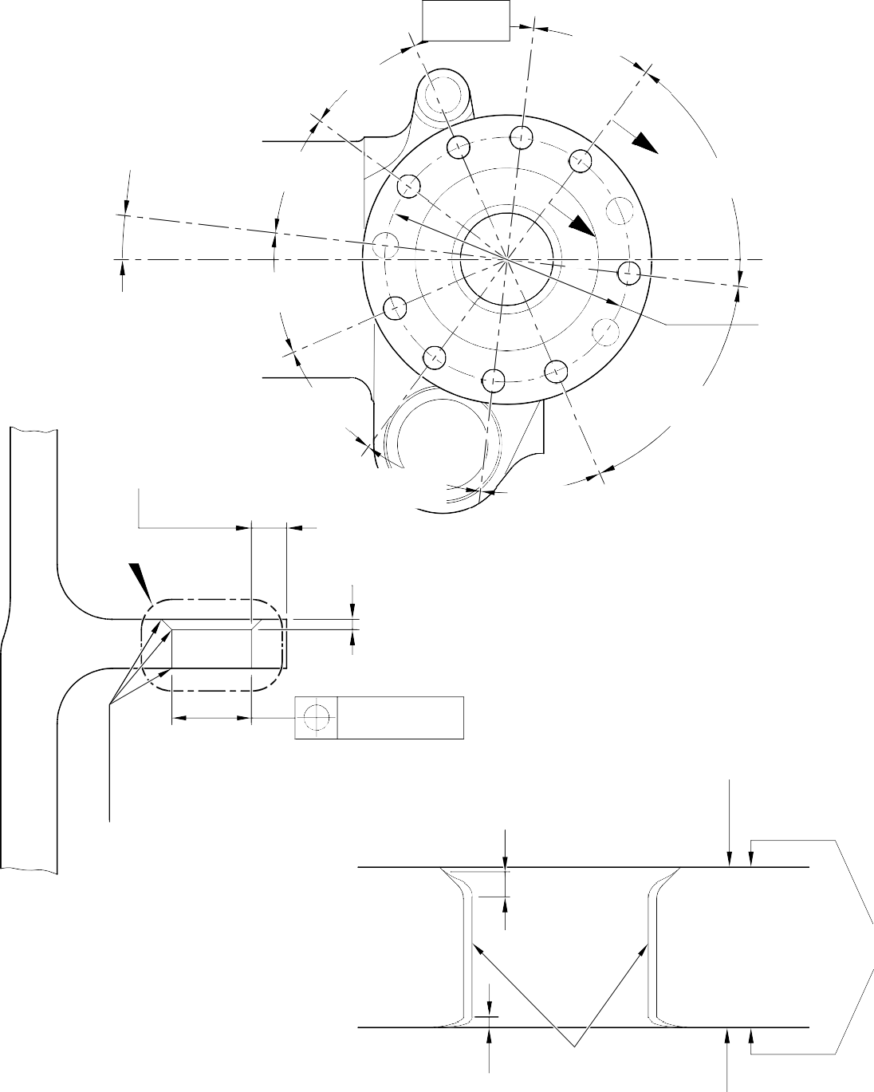
30
30
DEGREES
DEGREES
30
DEGREES

Z
30
DEGREES
60
DEGREES

Z
30
DEGREES
192,000mm (7.5591in) DIA.
30
DEGREES
60
DEGREES
30
DEGREES
30
DEGREES
6.57
DEGREES

6,85mm (0.270in) MINIMUM WALL THICKNESS

Y 2,00mm (0.080in)
x 45 DEGREES CHAMFER

DIA.
A
0,05mm (0.002in)

0,50 to 2,00mm
(0.020 to 0.080in) CHROMIUM PLATE

PRIMER PAINT WHERE BUSH FLANGE WILL TOUCH

0,40 to 1,00mm
(0.016 to 0.040in) RAD.
SECTION Z-Z
(9 PLACES)
( WITHOUT REPAIR BUSHES)
TERMINATION TO M-DLPS1031-5

SERMETEL COATING

0,00 to 0,80mm
(0.000 to 0.013in) CHROMIUM PLATE
CHROMIUM PLATE

FINISH PAINT

TERMINATION TO M-DLPS1031-7
DETAIL Y

A321A5544-2

Repair to Sliding Tube - Machining Figure 601

ALUMINIUM COAT OPTIONAL ON THESE SURFACES

REPAIR BUSH 450266336

1,6
(63)
2,00 to 2,05mm
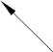
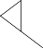
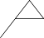

(0.079 to 0.080in) FACE B

0,50mm (0.020in)
x 30 DEGREES CHAMFER

DIA. C

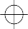 | 0,020mm (0.0008in) | A

1,45 to 1,75mm
A
(0.057 to 0.069in) RAD.
1,6
(63)

REPAIR BUSH 450266336

2,5
(100)
15,000 to 15,027mm
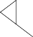
(0.5906 to 0.5916in)

 | 0,05mm (0.002in) DIA. | B

B

SECTION Z-Z
(WITH REPAIR BUSH) REFER TO FIGURE 601

A321A5545-2

Repair Bush - Machining and Installation Figure 602

- Repair No. 9-5 Sliding Tube (18-80 and 18-80A)
  - Specified Damage and Material Specification.
    - Specified Damage
      - Damage or wear to diameter A.
    - Material Specification
IPL Figure and  Item No. | Name | Material Specification
18-80 and  18-80A | Sliding tube | Steel, 300M

  - Special Tools
    - Special tools are not necessary.
  - Materials
    - Materials are not necessary.
  - Repair Parts
    - Repair parts are not necessary.
  - Procedure (Refer to Figure 601)
    - Do this procedure only if the base metal is not damaged.

CAUTION: REPAIR WILL NOT BE PERMITTED BEYOND THE LIMITS OF THIS REPAIR SCHEME.
      - Remove the chromium plate from sliding tube: refer to PCS-2110, type C.
      - Examine the sliding tube for flaws: refer to PCS-3100, inclusion class 4 and PCS-3600.

CAUTION: DO NOT USE A MECHANICAL MOP POLISHER TO GET THE SURFACE FINISH.
      - Apply chromium plate to the diameter A: refer to PCS-2110, type C and Figure 601. Make the surface finish 1,6 micrometers (64 micro-inches). The chromium plate thickness must be between 0,020 and 0,025 mm (0.0008 and 0.0010 in).
      - Identify the part with the Safran Landing Systems repair number 450237720 adjacent to the part number: refer to PCS-6000-19.
      - Examine the part to make sure that you have obeyed all the repair instructions correctly.

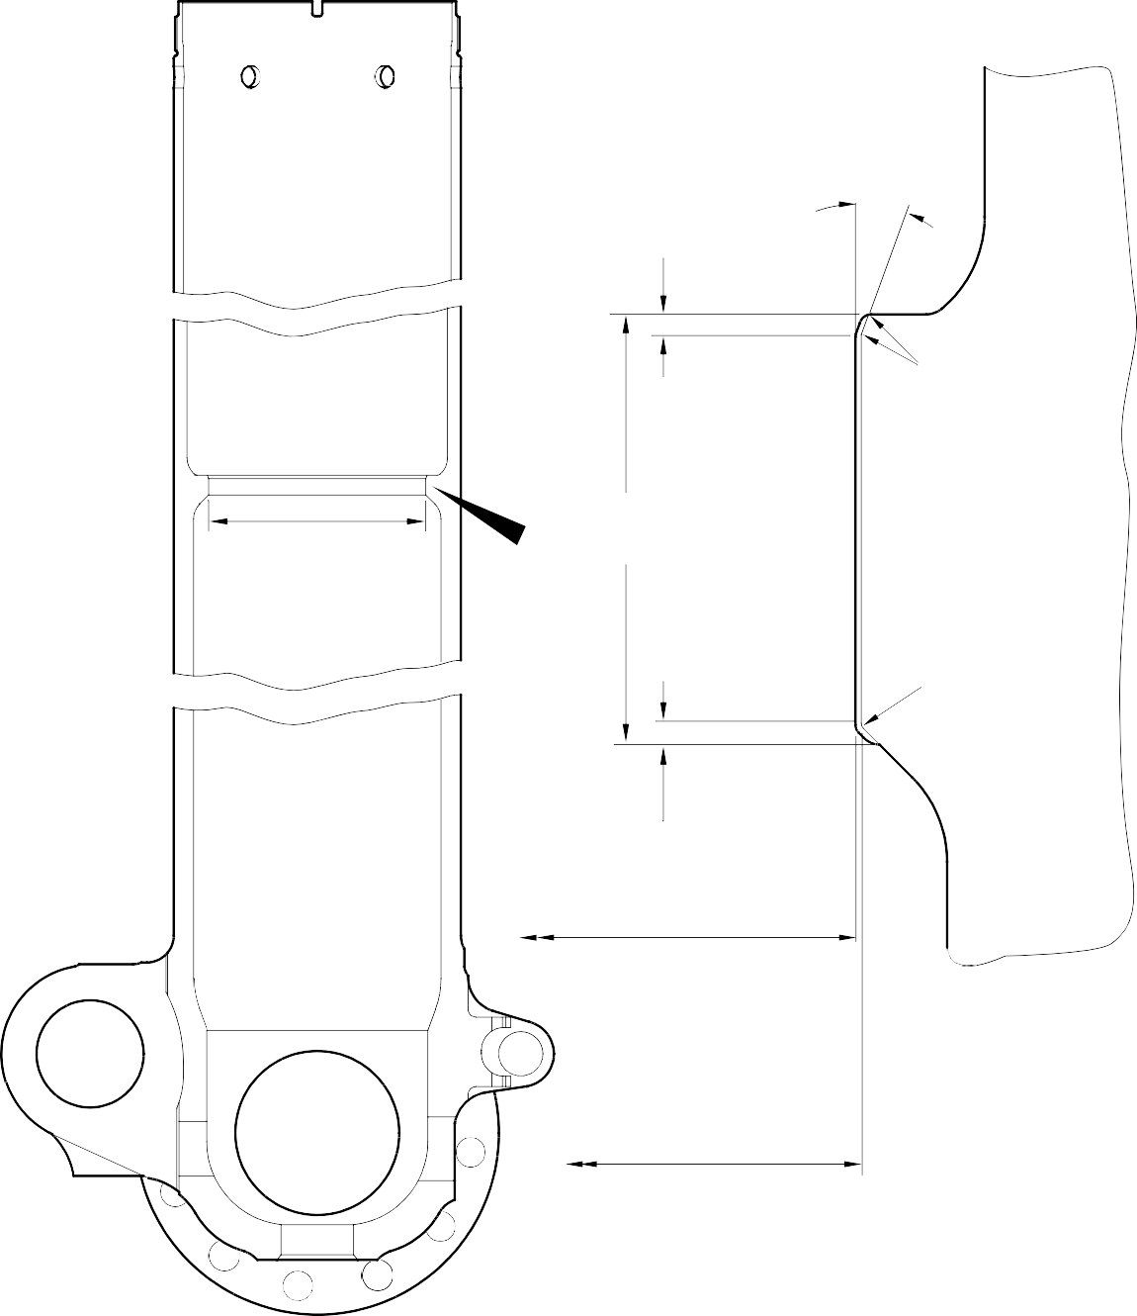
20 DEGREES REF.
3,50 to 4,50mm
(0.138 to 0.177in)
0,40 to 1,00mm
(0.015 to 0.40in) RADIUS
DIAMETER
A
LENGTH OF CHROMIUM
Z PLATE
2,00 to 3,00mm
(0.080 to 0.120in) RADIUS
1,00 to 3,00mm
(0.040 to 0.120in)
DIAMETER AFTER CHROMIUM PLATE 135,860 to 135,923mm
(5.3488 to 5.3513in)
ENLARGED DETAIL
Z

DIAMETER BEFORE CHROMIUM PLATE
A321A5714-1

Repair to Sliding Tube Figure 601

- Repair No. 9-6 Sliding Tube (18-80 and 18-80A)
  - Specified Damage and Material Specification.
    - Specified Damage
      - Damage or corrosion to diameter A.
    - Material Specification
IPL Figure and  item No. | Name | Material Specification
18-80 and  18-80A | Sliding tube | Steel, S155 (300M)

  - Special Tools
    - Special tools are not necessary.
  - Materials
    - Materials are not necessary.
  - Repair Parts
    - Repair parts are not necessary.
  - Procedure (Refer to Figure 601)
    - Do this procedure if both the chromium plate and the base metal are damaged.

NOTE: Refer to Repair No. 9-5, if only the chromium plate is damaged.
      - Machine diameter A to remove the damage or corrosion within the dimensions shown: refer to M-DLPS1004-4-1 and Figure 601.
      - Machine the radii to the dimensions as shown: refer to Figure 601.
      - Identify the part with the Safran Landing Systems repair number 450258470 adjacent to the part number: refer to PCS-6000-04.
      - Examine the reworked area for flaws: refer to PCS-3600 and PCS-3100, inclusion class 4.
      - Shot peen the machined areas: refer to M-DLPS123.
      - Apply Sulphamate Nickel plate to diameter A: refer to PCS-2120 for sequence of operations and to MIL-STD-868A solution 2 and Figure 601.

NOTE: This operation includes 23 hours de-embrittle at 177 to 205 oC (350 to 400 oF).
      - Machine (do not grind) the sulphamate nickel plate to the dimensions shown: refer to Figure 601.
      - Only required, if the parent metal was machined at step (g), examine the machined area for flaws: refer to PCS-3600.

NOTE: This operation includes 4 hours de-embrittle at 177 to 205 oC (350 to 400 oF).

- Only required, if the parent metal was machined at step (g), examine the machined area for flaws: refer to PCS-3100, inclusion class 4.
- Shot peen the machined areas: refer to M-DLPS123.
- Grit blast the shot peened area: refer to PCS-2610. Make sure that the sliding tube is correctly masked.
- Examine the edges of sulphamate nickel plate to make sure they are properly bonded: use 5 or 10X magnification.
- If there is evidence of delamination, remove the sulphamate nickel plate and do the repair again.

CAUTION: DO NOT USE A MECHANICAL MOP POLISHER TO GET THE SURFACE FINISH.
- Apply chromium plate to the diameter A: refer to PCS-2110 type C and Figure 601. Make the chromium plate thickness between 0,020 and 0,025 mm (0.0008 and 0.0010 in). Make the surface finish 1,6 micrometers (63 micro-inches).

NOTE: This operation includes 18 hours de-embrittle at 177 to 205 oC (350 to 400 oF).
- Identify the part with the Safran Landing Systems repair number 450258470 adjacent to the part number: refer to PCS-6000-07.
- Examine the part to make sure that you have obeyed all the repair instructions correctly.


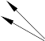



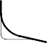


Y
DIAMETER
A

3,50 to 4,50mm
(0.138 to 0.177in)
20 DEGREES REF.

LENGTH OF NICKEL PLATE

LENGTH OF CHROMIUM PLATE

Z
0,40 to 1,00mm
(0.015 to 0.40in) RADIUS

2,00 to 3,00mm
(0.079 to 0.118in) RADIUS

1,00 to 3,00mm
(0.040 to 0.120in)

DIAMETER AFTER CHROMIUM PLATE 135,860 to 135,923mm
(5.3488 to 5.3513in)
 | 0,04mm (0.0016in) | Y

DIAMETER AFTER MACHINING NICKEL PLATE
135,910 to 135,963mm
(5.3508 to 5.3529in)

DIAMETER BEFORE NICKEL AND CHROMIUM PLATE 136,410mm (5.3700in) MAXIMUM
ENLARGED DETAIL

Z

A321A6706-1

Repair to Sliding Tube Figure 601

INTENTIONALLY BLANK

- Repair No. 9-7 Sliding Tube (18-80 and 18-80A)
  - Specified Damage and Material Specification.
    - Specified Damage
      - Damage or wear to diameter(s) A and faces D and E.
    - Material Specification
IPL Figure and  Item No. | Name | Material Specification
18-80 and  18-80A | Sliding Tube | Steel to 300M

  - Special Tools
    - These special tools are necessary:

NOTE: Alternative equivalents are permitted.

Part No. | Special Tool | Function
460004330/117 | Press Pad | Install oversize bushes
  - Materials
    - These materials are necessary:

NOTE: Alternative equivalents are permitted.

Ref. Item | Material
TBA | Zinc Powder
05-533 | Mastinox D40
09-510A | Sealant
  - Repair Parts
    - These repair parts are necessary:

Part No. | Repair Part | Material Specification
450258028 | Repair bush (Qty 2) | Aluminium Bronze
  - Procedure (Refer to Figures 601 and 602)

CAUTION: FOR DAMAGE MORE THAN THE LIMITS OF THIS REPAIR SCHEME, WRITE TO MESSIER-DOWTY LIMITED: REFER TO GUIDE-CS-001.
    - Remove the paint locally from the sliding tube: refer to PCS-2700.
    - Remove the cadmium plate locally from the sliding tube: refer to PCS-2100.

    - Machine diameter(s) A sufficiently to remove the minimum amount of material necessary to remove the wear or damage within the dimensions shown: refer to M-DLPS1004-4-1 and Figure 601. Make the surface finish 1,6 micrometers (63 micro-inches).
    - Machine the adjacent spotfaces D and E to remove any damage or wear, within the dimensions shown: refer to Figure 601. Make the surface finish 1,6 micrometers (63 micro-inches).
    - Machine the chamfers and radii to the dimensions shown: refer to Figure 601.
    - Measure and record the new diameter(s) A.
    - Examine the machined areas for flaws: refer to PCS-3600 and PCS-3100, inclusion class 4.
    - Shot peen the machined areas: refer to M-DLPS123.
    - Apply cadmium plate to the reworked areas: refer to PCS-2100 or PCS-2141.
    - Identify the part with the Messier-Dowty Limited repair number 450265140 adjacent to the part number: refer to PCS-6000-05.
    - Calculate diameter B of each repair bush (qty 2), use the formula:
B = A (as measured) - 0,006 mm (0.0002 in) to + 0,028 mm (0.0011 in).
    - Machine the repair bushes to the dimensions shown and calculated. Machine face C to get the correct dimensions after installation: refer to Figure 602. Make the surface finish 1,6 micrometers (63 micro-inches). The bushes must not protrude through the lug after installation.
    - Apply cadmium to the repair bushes, but not to the bores and the flange faces: refer to PCS-2101 and Figure 602. The cadmium plate thickness must be between 0,010 and 0,015 mm (0.0004 and 0.0006 in).
    - Apply primer paint to the sliding tube where the bush flanges will touch: refer to PCS-2500.
    - Use Press Pad 460004330/117 and install the repair bushes: refer to M-DLPS1011-20. Use electrically conducting Mastinox (made from Mastinox D40, Material Ref. Item 05-533 and Zinc powder, Material Ref. Item TBA): refer to M-DLPS709-14.
    - Check the bores of the repair bushes: refer to Figure 602.
    - If necessary, hone the bores of the repair bushes to the dimensions shown: refer to Figure 602. Make the surface finish 2,5 micrometers (100 micro-inches).
    - Apply paint to the repaired area, but not to the bushes: refer to PCS-2500.
    - Apply sealant, Material Ref. Item 09-510A, around the joints between the repair bushes and the sliding tube: refer to PCS-7200 and Figure 602.
    - Identify the part with the Messier-Dowty Limited repair number 450265140 adjacent to the part number: refer to PCS-6000-07.
    - Examine the part to make sure that you have obeyed all the repair instructions correctly.

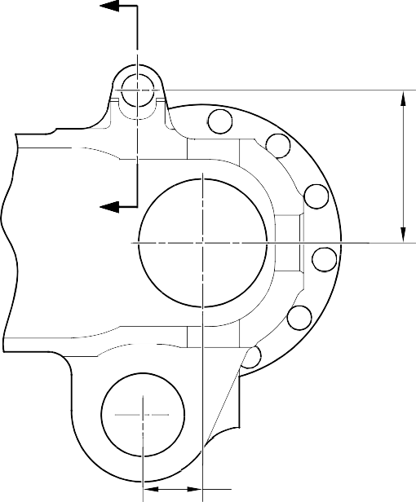
Z

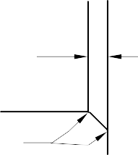
124,00mm (4.8819in) REF.

Z
1,20mm (0.047in) x 45 DEGREES CHAMFER

0.4 to 1,0mm
(0.015 to 0.04in)
RAD.
DETAIL W

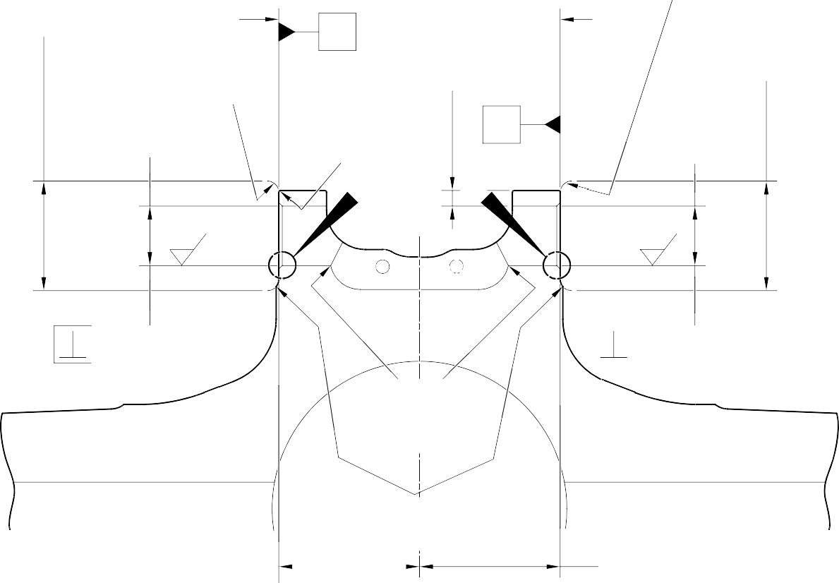
49,50 to 50,50mm
(1.949 to 1.988in) SPOTFACE TO DIAMETER
FACE D
Y
FACE E
4,50 to 5,50mm
(0.177 to 0.217in)
RAD.
28,521mm (1.1229in) MAXIMUM
5,75mm (0.226in) MINIMUM WALL THICKNESS
49,50 to 50,50mm
(1.949 to 1.988in) SPOTFACE TO DIAMETER
2,0 to 3,0mm
(0.08 to 0.118in) RAD.
2 PLACES
W
X
28,521mm (1.1229in) MAXIMUM
W
DIA. A
1,6
(63)
1,6
(63)
DIA. A
(
0,4 to 1,00mm (0.015 to 0.040in) RAD.
DEBURR
63,875mm (2.515mm) MINIMUM
63,875mm (2.515mm) MINIMUM
2,0mm 0.08in)
.
1,0 to
0.04 to
RAD
Y
0,020mm (0.0008in)

50,00mm (1.9685in) REF.
4,50 to 5,50mm
(0.177 to 0.217in) RAD.

 | 0,020mm (0.0008in) | X

SECTION Z-Z (WITHOUT BUSHES)

A321-S-32-12-22-038-1

Repair to Sliding Tube - Machining Figure 601

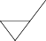
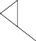
1,6
(63)
0,02mm (0.0008in)

FACE C

0,55 to 1,05mm
(0.020 to 0.040in) RAD.

1,6
(63)

DO NOT CADMIUM PLATE
DIA. B

DO NOT CADMIUM PLATE

REPAIR BUSH 450258028

0,5mm (0.02in)
x 45 DEGREES CHAMFER

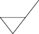
135,344 to 134,980mm
(5.3285 to 5.3142in)
2,5
(100)
22,00 to 22,033mm (0.8661 to 0.8674in) DIA.
APPLY SEALANT TO PCS-7200 4 PLACES
0,20mm (0.008in)

SECTION Z-Z
(WITH BUSHES)

A321-S-32-12-22-039-1

Repair Bushes - Machining and Installation Figure 602

- Repair No. 9-8 Sliding Tube (18-80 and 18-80A)
  - Specified Damage and Material Specification.
    - Specified Damage
      - Damage or wear to diameter(s) A and/or the adjacent face(s) B.
    - Material Specification
IPL Figure and  Item No. | Name | Material Specification
18-80 and  18-80A | Sliding Tube | Steel, 300M

  - Special Tools
    - These special tools are necessary:

Part No. | Special Tool | Function
460006246 | Alignment bar | Install the repair bushes
460006250 | Press Pad Assembly
460006251 | Guide Bush
460006252 | Guide Bush
  - Materials
    - These materials are necessary:

NOTE: Alternative equivalents are permitted.

Ref. Item | Material
TBA | Zinc Powder
04-512 | Molykote 111
09-510A | Sealant
09-581 | Sealant
    - These repair parts are necessary:

Part No. | Repair Part | Material Specification
450217855 | Repair bush (Qty 2) | Bronze, UZ 19A6

CAUTION : FOR DEVIATIONS OUTSIDE THE LIMITS OF THIS REPAIR SCHEME CONTACT SAFRAN LANDING SYSTEMS.
  - Procedure (Refer to Figures 601 and 602)
    - Do this procedure if there is damage or wear to diameter(s) A and or adjacent face(s) B:
      - Machine diameter(s) A sufficiently to remove the damage or wear within the dimensions shown: refer to M-DLPS1004-4-1 and Figure 601. Make the surface finish 1,6 micrometers (63 micro-inches).
      - Machine the adjacent face(s) B using spotface cutter sufficiently to remove the damage or wear within the dimensions shown: refer to M-DLPS1004-4-1 and Figure 601. Make the surface finish 1,6 micrometers (63 micro-inches).
      - Machine the chamfers and radii to the dimensions shown: refer to Figure 601.
      - Measure and record the new diameter(s) A.
      - Examine the machined areas for flaws: refer to PCS-3600 and PCS-3100, inclusion class 4.
      - Shot peen the machined areas: refer to M-DLPS123.
      - Identify the part with the Safran Landing Systems repair number 450266310 adjacent to the part number: refer to PCS-6000-05 or PCS-6000-06.
      - Apply cadmium plate to the reworked areas: refer to PCS-2141.
      - Calculate diameter C and dimension H of each repair bush (qty 2):
Dia. C = Dia. A (as measured) + 0,090 to + 0,139 mm (+ 0.0035 to + 0.0055 in). Dim. H = Dim. G (as measured) (spotface to grease hole center line)
- 0,10 to + 0,10 mm (- 0.004 to + 0.004 in).
      - Machine face D of the repair bush to get the correct dimensions: refer to Figure 602. Make the surface finish 1,6 micrometers (63 micro-inches).
      - Machine the repair bush to the dimensions shown and calculated: refer to M-DLPS900 and Figure 602.
      - Apply cadmium plate to the repair bushes, but not to the bores and the flange faces: refer to PCS-2101 or PCS-2141.
      - Apply primer paint to the sliding tube where the bush flanges will touch: refer to PCS-2500.
      - Apply the electrically conducting Molykote or rubberised sealant to the oversize bushes and the sliding tube over the dimensions shown: refer to Figure 602. Use electrically conducting Molykote (made from Molykote 111, Material Ref. Item 04-512 and Zinc powder, Material Ref. Item TBA): refer to PCS-7304. Or use electrically conducting rubberised sealant, Material Ref. Item 09-581: refer to IFC30-145-03MD.
      - Use the alignment bar 460006246, the press pad assembly 460006250 and the guide bushes 460006251 and 460006252 and install the oversize bushes: refer to PCS-5105-2.

      - Machine the dimension across the bush flanges between 150,917 and 150,957 mm (5.9416 and 5.9432 in). The symmetry must be as shown: refer to Figure 602.
      - Machine the chamfers to the dimensions shown: refer to Figure 602.
      - Check the bore diameters of the repair bushes: refer to Figure 602.
      - If necessary, hone the bore diameters of the repair bushes to the dimensions shown: refer to Figure 602. Make the surface finish 2,6 micrometers (100 micro-inches).
      - Apply sealant, Material Ref. Item 09-510A, around the joints between the repair bushes and the sliding tube: refer to PCS-7200 and Figure 602.
      - Apply paint to the repaired area: refer to REPAIR and PCS-2500.
      - Identify the part with the Safran Landing Systems repair number 450266310 adjacent to the part number: refer to PCS-6000-07.
      - Examine the part to make sure that you have obeyed all the repair instructions correctly.

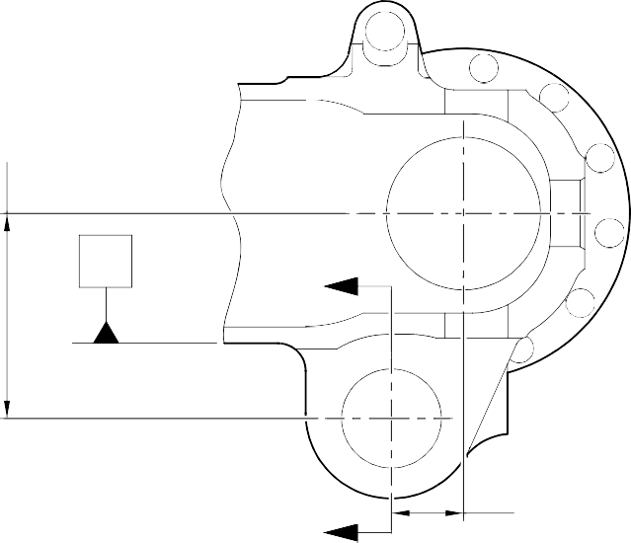
139,75 to 140,25mm (5.502 to 5.522in) REF.

Y Z

49,75 to 50,25mm
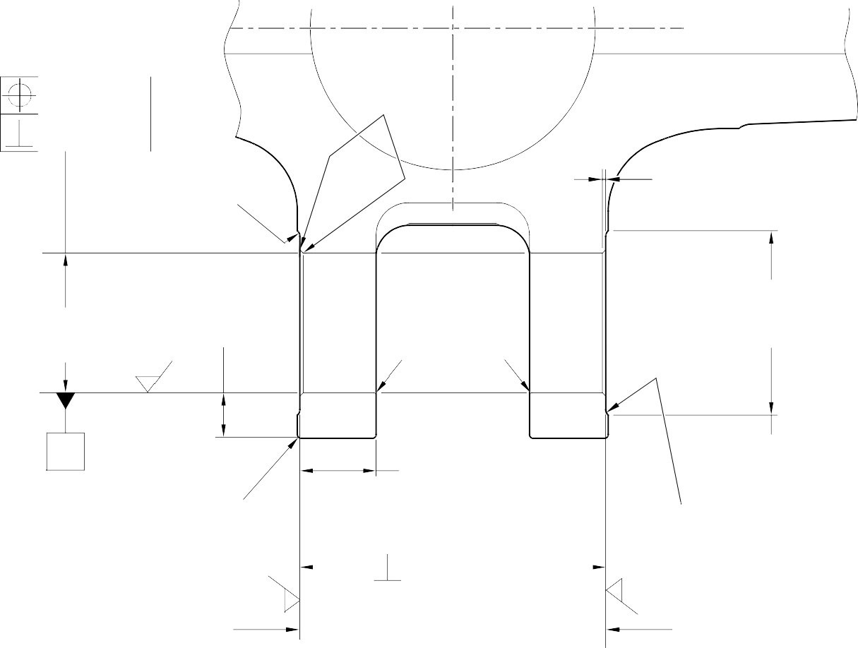

Z (1.958 to 1.978in) REF.
0,40 to 1,00mm
(0.016 to 0.040in) RAD.
TYP. 2 PLACES
4,50 to 5,50mm (0.177 to 0.217in) RAD.
TYP. 2 PLACES
1,2mm (0.047in)
x 45 DEGREES CHAMFER TYP. 2 PLACES
DIA . A
68,130mm (2.6823in)
89,50 to 90,50mm
(3.524 to 3.563in) SPOTFACE DIA. TYP. 2 PLACES
MAXIMUM
19,78mm (0.779in) MINIMUM WALL THICKNESS
TYP. 2 PLACES
1,6
(63)
X
2,00 to 3,00mm
(0.080 to 0.118in)
RAD. TYP. 2 PLACES
35,95mm (1.415in) MINIMUM LUG WIDTH TYP. 2 PLACES
1,00 to 2,00mm
(0.040 to 0.080in) RAD. TYP. 2 PLACES
1,6
(63)
1,6
(63)
FACE B
SECTION Z-Z
(WITHOUT BUSHES)
FACE B
A321A5899-3

0,40 to 1,00mm
(0.016 to 0.040in) RAD.
0,075mm (0.0030in)
Y
0,5mm (0.02in) DIA.

 | 0,40mm (0.016in) DIA. | X

 |  | 0,05mm (0.002in) | X

Repair to Sliding Tube - Machining Figure 601

W
0,04mm (0.0016in)

1,6
(63)
FACE D

DIM. H
1,00mm (0.040in)
x 45 DEGREES CHAMFER

30
DEGREES REF.
E
30
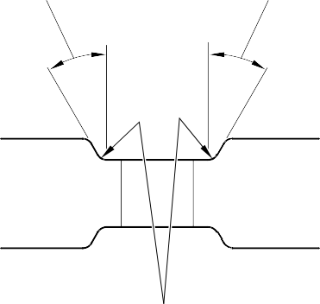
DEGREES REF.

DIA . C
 | 0,020mm (0.0008in) DIA. | W

W

REPAIR BUSH 450217855

1,00mm (0.039in) CHAMFER (2 PLACES)

0,65 to 0,95mm
(0.026 to 0.037in) RAD.
1,6
(63)

0,15 to 0,65mm (0.006 to 0.026in) RAD.
DETAIL E
TYP . 4 PLACES

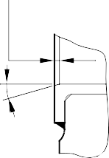
30 DEGREES CHAMFER (2 PLACES)
DETAIL X 60,00 to 60,03mm
(2.362 to 2.363in)
2,6
(100)

X
DIM.G

 | 0,1mm (0.04in) | Y

REPAIR BUSH 450217855

150,917 to 150,957mm
(5.9416 to 5.9432in)
SECTION Z-Z
(WITH BUSHES)
14,00 to 16,00mm
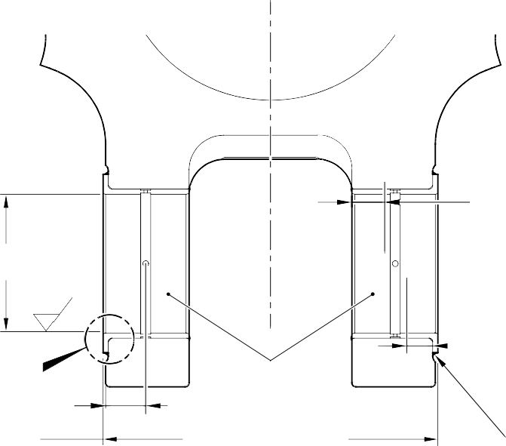
(0.551 to 0.630in) APPLY ELECTRICALLY
CONDUCTING MOLYKOTE 111 OR RUBBERISED SEALANT
IN THE BORES TO
IFC30-145-03MD OR PCS-7304 TYP. 2 PLACES
12,00 to 14,00mm
(0.472 to 0.551in) APPLY ELECTRICALLY
CONDUCTING MOLYKOTE 111 OR RUBBERISED SEALANT ON BOTH BUSHES TO
IFC30-145-03MD OR PCS-7304 TYP. 2 PLACES
APPLY SEALANT TO PCS-7200
WITHOUT OVERFLOW ON FACES OF THE BUSHES

4 PLACES
A321A5900-4

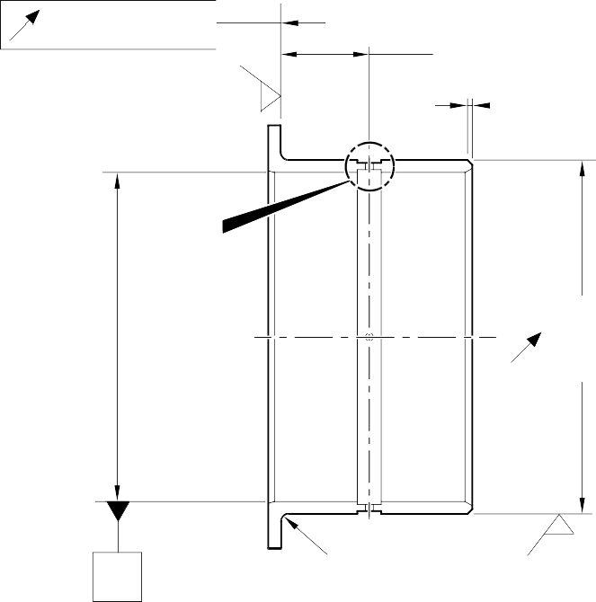
Repair Bushes - Machining and Installation Figure 602

INTENTIONALLY BLANK

- Repair No. 9-9 Sliding Tube (18-80 and 18-80A)
  - Specified Damage and Material Specification.
    - Specified Damage
      - Damage or wear to diameter A and/or adjacent face.
    - Material Specification
IPL Figure and  Item No. | Name | Material Specification
18-80 and  18-80A | Sliding Tube | Steel, 300M

  - Special Tools
    - These special tools are necessary:

NOTE: Alternative equivalents are permitted.

Tool Part No. | Special Tool | Function
460004330/131 | Press Pad | Install the repair bush
  - Materials
    - These materials are necessary:

NOTE: Alternative equivalents are permitted.

Ref. Item | Material
TBA | Zinc Powder
04-512 | Molykote 111
09-510A | Sealant
  - Repair Parts
    - These repair parts are necessary:

Part No. | Repair Part | Material Specification
450258015 | Repair Bush | Bronze, UZ19A6
  - Procedure (Refer to Figures 601 and 602)

CAUTION: FOR DAMAGE MORE THAN THE LIMITS OF THIS REPAIR SCHEME, WRITE TO SAFRAN LANDING SYSTEMS: REFER TO GUIDE-CS-001.
    - Machine the diameter A and/or the adjacent face to remove the damage or wear within the dimensions shown: refer to M-DLPS1004-4-1 and Figure 601. Do not increase diameter A more than 48,125 mm (1.8947 in). Make the surface finish 1,6 micrometers (63 micro-inches).

    - Machine the chamfer and radii to the dimensions shown: refer to Figure 601.
    - Measure and record the new diameter A.
    - Examine the machined areas for flaws: refer to PCS-3600 and PCS-3100, inclusion class 4.
    - Shot peen the machined areas: refer to M-DLPS123.
    - Identify the part with the Safran Landing Systems repair number 450265180 adjacent to the part number: refer to PCS-6000-19.
    - Apply cadmium plate to the reworked areas: refer to PCS-2100. The cadmium plate thickness must be between 0,010 and 0,015 mm (0.0004 and 0.0006 in).
    - Calculate the diameter C for the repair bush, use the formula:
C = A (as measured) + 0,018 to 0,059 mm (0.0007 to 0.0023 in).
    - Machine the repair bush to the dimensions shown and calculated. Machine face D to get the correct dimension after installation: refer to M-DLPS900 and Figure 602. Make the surface finish 1,6 micrometers (63 micro-inches).
    - Apply cadmium plate all over to the repair bush: refer to PCS-2101. The cadmium plate thickness must be between 0,005 and 0,009 mm (0.0002 and 0.0004 in).
    - Apply primer paint to the repair bush but not to the areas shown: refer to PCS-2500 and Figure 602.
    - Use the Press Pad 460004330/131 and install the repair bush: refer to M-DLPS1011-14. Use zinc loaded Molykote (made from Molykote 111, Material Ref. Item 04-512 and Zinc powder, Material Ref. Item TBA): refer to PCS-7304. The slot in the repair bush must be in the correct angular position: refer to Figure 602.
    - Check the bore of the repair bush: refer to Figure 602.
    - If necessary, hone the repair bush bore to the dimensions shown: refer to Figure 602.
    - Apply a bead of sealant, Material Ref. Item 09-510A, to the joints between the repair bush and the sliding tube: refer to PCS-7200 and Figure 602.
    - Apply paint locally to the sliding tube: refer to REPAIR and PCS-2500.
    - Identify the part with the Safran Landing Systems repair number 450265180 adjacent to the part number: refer to PCS-6000-07.
    - Examine the part to make sure that you have obeyed all the repair instructions correctly.

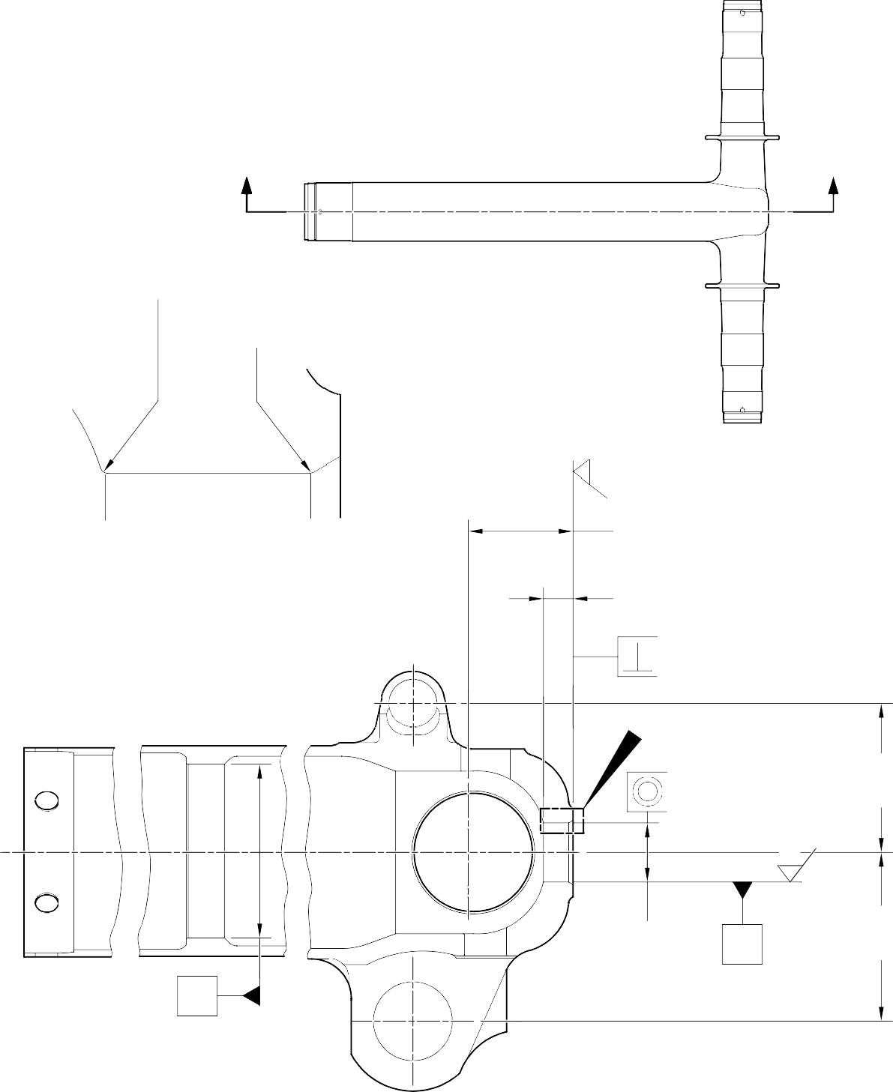
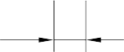
Z Z

2,00 to 3,00mm (0.080 to 0.118in) RAD.
1,00 to 2,00mm (0.040 to 0.080in) RAD.

1,6
(63)

2,50 to 3,50mm
(0.098 to 0.138in) x 60 DEGREES INCLUSIVE
CHAMFER
77,80mm (3.063in) MINIMUM 20,25mm (0.797in)
MINIMUM LUG WIDTH

Y
0,04mm (0.002in)
DETAIL W

W

124,00mm (4.882in) REF.
X
0,30mm (0.012in) DIA.

1,6
(63)

DIA. A
48,125mm Y
(1.8947in)
X MAXIMUM
140,00mm (5.512in) REF.

SECTION Z-Z
(WITHOUT BUSH)

A321-S-32-12-22-040-1

Repair to Sliding Tube - Machining Figure 601

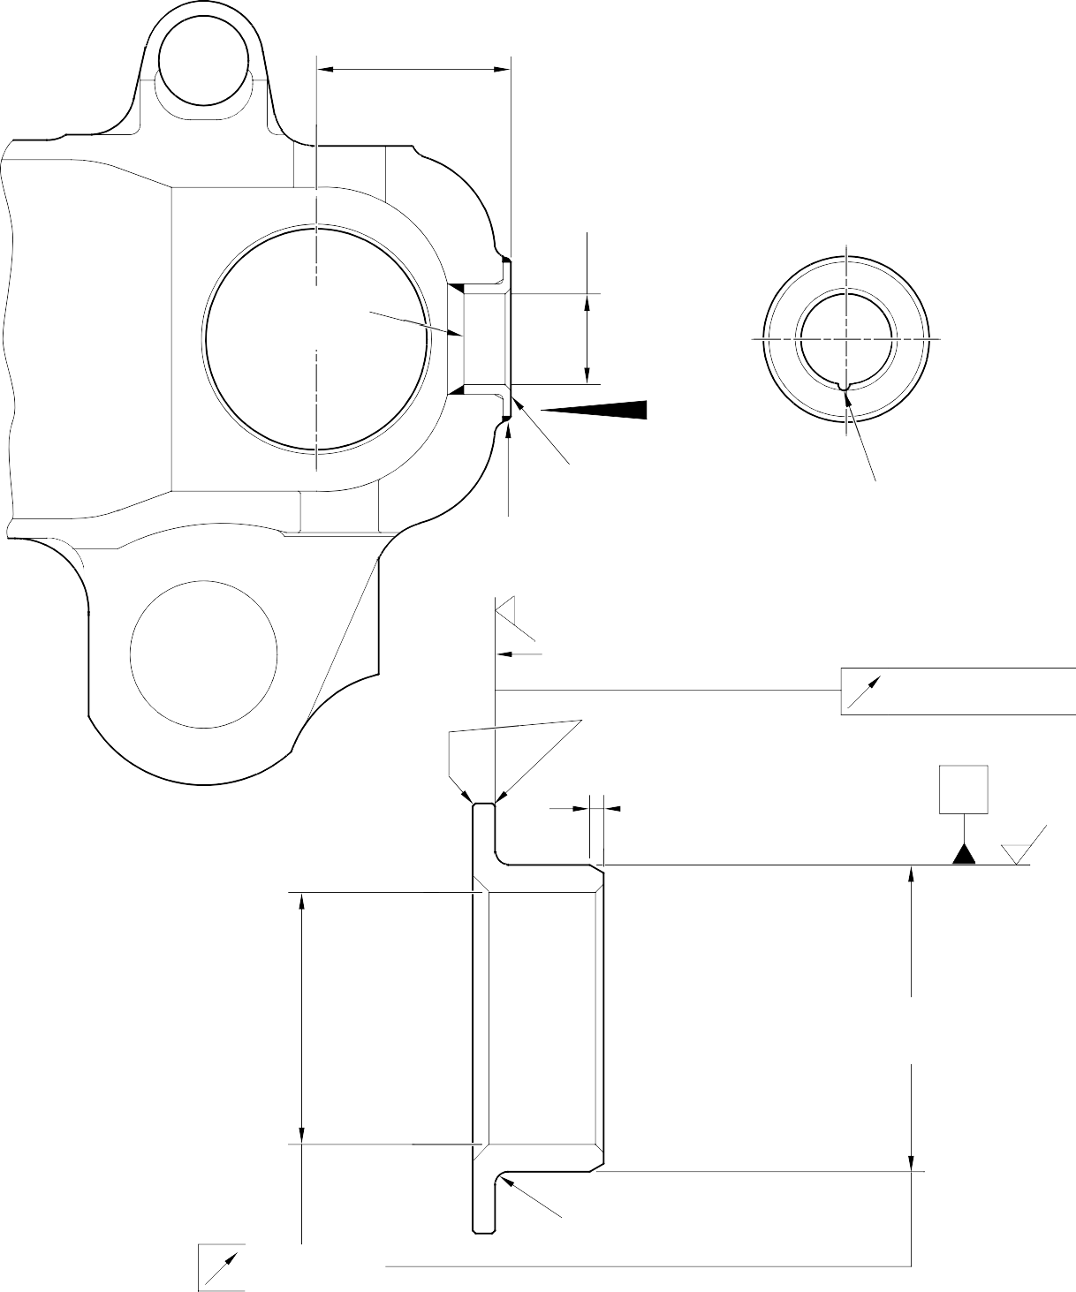
83,00 to 83,50mm
(3.268 to 3.287in)

SECTION Z-Z
(WITH BUSH)
REFER TO FIGURE 601

35,40 to 35,60mm (1.394 to 1.402in) DIA.

TRACES OF
PAINT PERMITTED

Y

REPAIR BUSH 450258015
APPLY SEALANT TO PCS-7200 2 PLACES

VIEW Y
-3 to 3 DEGREES ORIENTATION IS IMPORTANT

1,6
(63)

FACE D
DO NOT PRIMER PAINT
X
0,03mm
(0.001in)
0,50mm (0.020in)
x 45 DEGREES CHAMFER

1,00mm (0.040in)
x 60 DEGREES INCLUSIVE CHAMFER

X
1,6
(63)

DIA. C
DO NOT PRIMER PAINT

1,35 to 1,85mm
(0.053 to 0.073in) RAD.
0,05mm (0.002in)

REPAIR BUSH 450258015

A321-S-32-12-22-041-1

Repair Bush - Machining and Installation Figure 602

- Repair No. 9-10 Sliding Tube (18-80 and 18-80A)
  - Specified Damage and Material Specification.
    - Specified Damage
      - Damage or wear to diameters A and/or B and/or C.
    - Material Specification
IPL Figure and  Item No. | Name | Material Specification
18-80 and  18-80A | Sliding Tube | Steel, S155 (300M)

  - Special Tools
    - Special tools are not necessary.
  - Materials
    - Materials are not necessary.
  - Repair Parts
    - Repair parts are not necessary.

CAUTION: FOR DEVIATIONS OUTSIDE THE LIMITS OF THIS REPAIR SCHEME CONTACT SAFRAN LANDING SYSTEMS.
  - Procedure (Refer to Figures 601 and 602)
    - Do this procedure, if diameter(s) A is damaged or worn:
      - Remove the paint from the sliding tube, if necessary: refer to PCS-2700 and Figure 601.
      - Remove the Sermetel from the sliding tube, if necessary: refer to M-DLPS637.
      - Remove the cadmium plate from the sliding tube, if necessary: refer to PCS-2100.
      - Remove the chromium plate from diameter(s) A: refer to PCS-2110 Type C.
      - If the base metal is not damaged or worn:
        - Examine the sliding tube for flaws: refer to PCS-3600 and PCS-3100, inclusion class 4.
        - Apply chromium plate to diameter(s) A: refer to PCS-2110 Type C, M-DLPS1031-1, M-DLPS1031-6 and Figure 601. The chromium plate thickness must be sufficient to give a minimum thickness of 0,10 mm (0.004 in) after grinding.
        - Finish grind diameter A: refer to M-DLPS1004-4-1 and Figure 601. Make the surface finish 0,8 micrometers (32 micro-inches).
        - Examine the ground chromium plate for flaws: refer to M-DLNDT3.
        - Identify the part with the Safran Landing Systems repair number 450258401A adjacent to the part number: refer to PCS-6000-05 or PCS-6000-19.

      - If the base metal is damaged or worn:
        - Machine the diameter(s) A to remove the damage or wear within the dimensions shown: refer to M-DLPS1004-4-1 and Figure 601. Make the surface finish 0,8 micrometers (32 micro-inches).
        - Examine the machined area for flaws: refer to PCS-3600 and PCS-3100, inclusion class 4.
        - Shot peen the machined area: refer to M-DLPS123.
        - Apply chromium plate to diameter(s) A: refer to PCS-2110 Type C, M-DLPS1031-1, M-DLPS1031-6 and Figure 601. The chromium plate thickness must be sufficient to give a minimum thickness of 0,10 mm (0.004 in) after grinding.
        - Finish grind diameter A: refer to M-DLPS1004-4-1 and Figure 601. Make the surface finish 0,8 micrometers (32 micro-inches).
        - Examine the ground chromium plate for flaws: refer to M-DLNDT3.
        - Identify the part with the Safran Landing Systems repair number 450258401B adjacent to the part number: refer to PCS-6000-05 or PCS-6000-19.
      - Apply cadmium plate to the sliding tube but not on the chromium plated areas: refer to REPAIR and PCS-2100. Make the cadmium plate thickness between 0,010 and 0,020 mm (0.0004 and 0.0008 in).
      - Apply Sermetel to the sliding tube but not on the chromium plated or the cadmium plated areas: refer to REPAIR and M-DLPS637.
      - Apply paint to the sliding tube but not on the chromium plated areas: refer to REPAIR and PCS-2500.
      - Identify the part with the Safran Landing Systems repair number adjacent to the part number: refer to PCS-6000-07.
- Use the repair number 450258401A if there was no damage to the base metal or
- Use the repair number 450258401B if there was damage to the base metal.
      - Examine the part to make sure that you have obeyed all the repair instructions correctly.
    - Do this procedure, if diameter(s) B is damaged or worn:
      - Remove the paint from the sliding tube, if necessary: refer to PCS-2700 and Figure 601.
      - Remove the Sermetel from the sliding tube, if necessary: refer to M-DLPS637.
      - Remove the cadmium plate from the sliding tube, if necessary: refer to PCS-2100.
      - Remove the chromium plate from diameter(s) B: refer to PCS-2110 Type C and Figure 601.
      - If the base metal is not damaged or worn:
        - Examine the sliding tube for flaws: refer to PCS-3600 and PCS-3100, inclusion class 4.

        - Apply chromium plate to diameter(s) B: refer to PCS-2110 Type C, M-DLPS1031-1, M-DLPS1031-6 and Figure 601. The chromium plate thickness must be sufficient to give a minimum thickness of 0,10 mm (0.004 in) after grinding.
        - Finish grind diameter B: refer to M-DLPS1004-4-1 and Figure 601. Make the surface finish 0,8 micrometers (32 micro-inches).
        - Examine the ground chromium plate for flaws: refer to M-DLNDT3.
        - Identify the part with the Safran Landing Systems repair number 450258401C adjacent to the part number: refer to PCS-6000-05 or PCS-6000-19.
      - If the base metal is damaged or worn:
        - Machine the diameter(s) B to remove the damage or wear within the dimensions shown: refer to M-DLPS1004-4-1 and Figure 601. Make the surface finish 0,8 micrometers (32 micro-inches).
        - Examine the machined area for flaws: refer to PCS-3600 and PCS-3100, inclusion class 4.
        - Shot peen the machined area: refer to M-DLPS123.
        - Apply chromium plate to diameter(s) B: refer to PCS-2110 Type C, M-DLPS1031-1, M-DLPS1031-6 and Figure 601. The chromium plate thickness must be sufficient to give a minimum thickness of 0,10 mm (0.004 in) after grinding.
        - Finish grind diameter B: refer to M-DLPS1004-4-1 and Figure 601. Make the surface finish 0,8 micrometers (32 micro-inches).
        - Examine the ground chromium plate for flaws: refer to M-DLNDT3.
        - Identify the part with the Safran Landing Systems repair number 450258401D adjacent to the part number: refer to PCS-6000-05 or PCS-6000-19.
      - Apply cadmium plate to the sliding tube but not on the chromium plated areas: refer to REPAIR and PCS-2100. Make the cadmium plate thickness between 0,010 and 0,020 mm (0.0004 and 0.0008 in).
      - Apply Sermetel to the sliding tube but not on the chromium plated or the cadmium plated areas: refer to REPAIR and M-DLPS637.
      - Apply paint to the sliding tube but not on the chromium plated areas: refer to REPAIR and PCS-2500.
      - Identify the part with the Safran Landing Systems repair number adjacent to the part number: refer to PCS-6000-07.
- Use the repair number 450258401C if there was no damage to the base metal or
- Use the repair number 450258401D if there was damage to the base metal.
      - Examine the part to make sure that you have obeyed all the repair instructions correctly.

    - Do this procedure, if diameter(s) C is damaged or worn:
      - Remove the paint from the sliding tube, if necessary: refer to PCS-2700 and Figure 601.
      - Remove the Sermetel from the sliding tube, if necessary: refer to M-DLPS637.
      - Remove the cadmium plate from the sliding tube, if necessary: refer to PCS-2100.
      - Remove the chromium plate from diameter(s) C: refer to PCS-2110 Type C and Figure 602.
      - If the base metal is not damaged or worn:
        - Apply chromium plate to diameter(s) C: refer to PCS-2110 Type C, M-DLPS1031-6, Figure 601 and Figure 602. The chromium plate thickness must be sufficient to give a minimum thickness of 0,10 mm (0.004 in) after grinding.
        - Finish grind diameter C: refer to M-DLPS1004-4-1 and Figure 602. Make the surface finish 0,8 micrometers (32 micro-inches).
        - Examine the ground chromium plate for flaws: refer to M-DLNDT3.
        - Identify the part with the Safran Landing Systems repair number 450258401E adjacent to the part number: refer to PCS-6000-05 or PCS-6000-19.
      - If the base metal is damaged or worn:
        - Machine the diameter(s) C to remove the damage or wear within the dimensions shown: refer to M-DLPS1004-4-1 and Figure 602. Make the surface finish 0,8 micrometers (32 micro-inches).
        - Examine the machined area for flaws: refer to PCS-3600 and PCS-3100, inclusion class 4.
        - Shot peen the machined area: refer to M-DLPS123.
        - Apply chromium plate to diameter(s) C: refer to PCS-2110 Type C, M-DLPS1031-2, M-DLPS1031-6 and Figure 602. The chromium plate thickness must be sufficient to give a minimum thickness of 0,10 mm (0.004 in) after grinding.
        - Finish grind diameter C: refer to M-DLPS1004-4-1 and Figure 602. Make the surface finish 0,8 micrometers (32 micro-inches).
        - Examine the ground chromium plate for flaws: refer to M-DLNDT3.
        - Identify the part with the Safran Landing Systems repair number 450258401F adjacent to the part number: refer to PCS-6000-05 or PCS-6000-19.
      - Apply cadmium plate to the sliding tube but not on the chromium plated areas: refer to REPAIR and PCS-2100. Make the cadmium plate thickness between 0,010 and 0,020 mm (0.0004 and 0.0008 in).
      - Apply Sermetel to the sliding tube but not on the chromium plated or the cadmium plated areas: refer to REPAIR and M-DLPS637.

      - Apply paint to the sliding tube but not on the chromium plated areas: refer to REPAIR and PCS-2500.
      - Identify the part with the Safran Landing Systems repair number adjacent to the part number: refer to PCS-6000-07.
- Use the repair number 450258401E if there was no damage to the base metal or
- Use the repair number 450258401F if there was damage to the base metal.
      - Examine the part to make sure that you have obeyed all the repair instructions correctly.

1,00 to 3,00mm
(0.039 to 0.118in) CHROMIUM PLATE
TERMINATION TO M-DLPS1031-1
SLIDING TUBE OUTSIDE DIAMETER

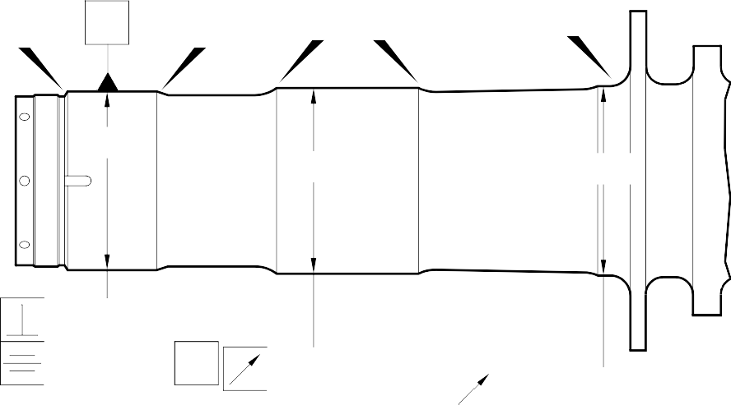
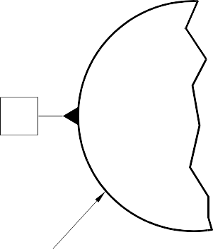
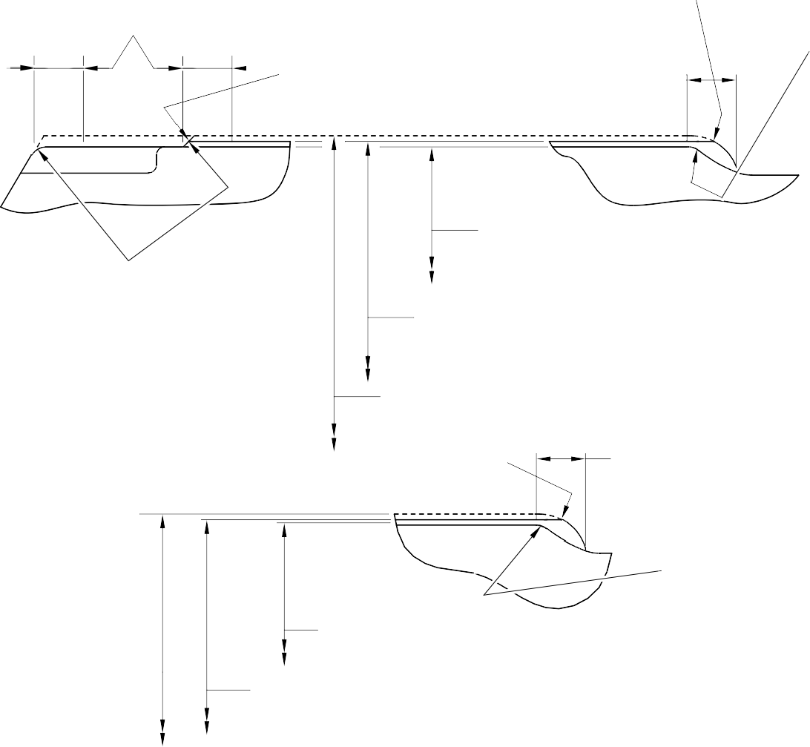
EDGE SMOOTHED OUT
W
V
X
Y
Z
DIA A
DIA B
DIA C
V
0,040mm (0.0016in)
T
0,060mm
(0.0024in)
T
0,060mm (0.0024in)
T
 | 0,040mm (0.0016in) | V

2,00 to 3,00mm

EDGE SMOOTHED OUT
1,00 to 3,00mm (0.039 to 0.118in)
CHROMIUM PLATE
(0.079 to 0.118in) RADIUS

TERMINATION TO M-DLPS1031-6

DETAIL X

CHROMIUM PLATE TERMINATION TYPICAL AROUND 4 SLOTS. IRREGULAR LINE IS PERMITTED

DIA A
119,319mm (4.6976in) MINIMUM DIAMETER BEFORE CHROMIUM PLATE

DETAIL W
119,929 to 119,964mm (4.7216 to 4.7230in)
DIAMETER AFTER GRINDING THE CHROMIUM PLATE

CHROMIUM PLATE DEPOSIT

EDGE SMOOTHED
OUT

1,00 to 3,00mm
(0.039 to 0.118in) CHROMIUM PLATE
TERMINATION TO M-DLPS1031-6. IRREGULAR LINE IS PERMITTED

CHROMIUM PLATE
DEPOSIT

DIA B

126,307mm (4.9727in) MINIMUM DIAMETER BEFORE CHROMIUM PLATE
2,00 to 3,00mm
(0.079 to 0.118in) RADIUS

DETAIL Y

126,917 to 126,957mm (4.9967 to 4.9983in)
DIAMETER AFTER GRINDING THE CHROMIUM PLATE

A321A6875-1

Repair to Sliding Tube Figure 601

Repair No. 9-10

0,0 to 2,0mm (0.00 to 0.08in) CHROMIUM PLATE MUST TERMINATE WITHIN THIS LENGTH.
WAVY OR IRREGULAR LINE IS PERMITTED.

1,0 to 3,00mm (0.04 to 0.118in) CHROMIUM PLATE MUST TERMINATE WITHIN THIS LENGTH. WAVY OR IRREGULAR LINE IS PERMITTED.
14,500mm (0.5708in) REF.
17,750 to 18,250mm
(0.6988 to 0.7185in) REF.

EDGE SMOOTHED OUT
8,00mm (0.315in) REF.

2,0 to 3,00mm
(0.08 to 0.118in) RAD.
DIAMETER BEFORE CHROMIUM PLATE DIA C
131,294 to 131,357mm (5.1690 to 5.1715in) AFTER GRINDING
30,00mm (1.181in) RAD. REF.

DETAIL Z
(REFER TO FIGURE 601)
IF THE BASE METAL IS NOT DAMAGED

CHROMIUM PLATE DEPOSIT

2,00 to 3,00mm (0.079 to 0.118in) RAD.

1,0 to 3,00mm (0.04 to 0.118in) CHROMIUM PLATE TERMINATION TO M-DLPS1031-6
CHROMIUM PLATE MUST TERMINATE WITHIN THIS LENGTH.
WAVY IRREGULAR LINE IS PERMISSIBLE.
0,0 to 2,00mm (0.00 to 0.079in)
CHROMIUM PLATE TERMINATION TO M-DLPS1031-2
CHROMIUM PLATE MUST TERMINATE WITHIN THIS LENGTH.
WAVY OR IRREGULAR LINE IS PERMISSIBLE.

1,750 to 2,250mm
(0.0689 to 0.0886in) 16,25mm (0.640in)
14,500mm (0.5708in) REF.

8,00mm (0.315in) RAD. REF.

2,00 to 3,00mm

1,0 to 2,0mm
30,00mm (1.181in)
RAD. REF.

(0.079 to 0.118in) RAD.
130,683mm (5.145in) MINIMUM DIAMETER
(0.04 to 0.08in) RAD.
DETAIL Z

BEFORE CHROMIUM PLATE
DIA C
131,294 to 131,357mm (5.1690 to 5.1715in) AFTER GRINDING CHROMIUM PLATE DEPOSIT
(REFER TO FIGURE 601)
IF THE BASE METAL IS DAMAGED
A321A6876-2

Repair to Sliding Tube Figure 602

INTENTIONALLY BLANK

- Repair No. 9-11 Sliding Tube (18-80 and 18-80A)
  - Specified Damage and Material Specification.
    - Specified Damage
      - Damage or wear to the diameter A.
    - Material Spcification
IPL Figure and  Item No. | Name | Material Specification
18-80 and  18-80A | Sliding Tube | Steel, 300M

  - Special Tools
    - These special tools are necessary:

NOTE: Alternative equivalents are permitted.

Tool Part No. | Special Tool | Function
460004330/105 | Press Pad | To install the repair bush 450266800
  - Materials
    - Materials are not necessary.
  - Repair Parts
    - These repair parts are necessary:
Part No. | Repair Part | Material Specification
450266800 | Repair Bush | Stainless Steel, AMS5643 or  AMS5659

  - Procedure (Refer to Figures 601 to 603)

CAUTION: FOR DAMAGE MORE THAN THE LIMITS OF THIS REPAIR SCHEME, WRITE TO SAFRAN LANDING SYSTEMS: REFER TO GUIDE-CS-001.
    - Do this procedure if there is wear or damage to diameter A:
      - Locally remove the Sermetel layer from the sliding tube: refer to REPAIR and M-DLPS637.
      - Locally remove the chromium plate from the sliding tube: refer to REPAIR PCS-2110 and Figures 601 and 602.
      - If necessary, machine the diameter(s) A to remove the minimum amount of material necessary to remove the damage or wear: refer to M-DLPS1004-4-1 and Figure 602. Do not make the diameter A more than 21,073 mm (0.8296 in). Make the surface finish 1,6 micrometers (63 micro-inches) or better.
      - Measure and record the new diameter(s) A.
      - Machine the chamfers and radii as shown: refer to Figure 602.
Repair No. 9-11

      - Examine the bare metal for flaws: refer to PCS-3100, inclusion class 4 and PCS-3600.
      - Shot peen the reworked areas: refer to M-DLPS123.
      - Apply chromium plate to diameter(s) A: refer to PCS-2110 Type C, M-DLPS1031-5 and Figure 602. The chromium plate thickness must be between 0,020 and 0,025 mm (0.0008 and 0.0010 in).
      - Apply Sermetel to the repaired area: refer to M-DLPS637 and Figure 602.
      - Identify the part with the Safran Landing Systems repair number 450266295 adjacent to the part number: refer to PCS-6000-05.
      - Machine diameter B of the repair bush(es), use formula:
Dia. B = Dia. A (as measured) - 0,005 to + 0,041 mm (- 0.0002 to + 0.0016 in).
      - Machine the face R to get the flange thickness of between 2,00 and 2,05 mm (0.079 and 0.081 in).
      - Passivate the repair bush(es): refer to AMS-2700.
      - Apply a layer of IVD alloy with elecromation yellow all over the repair bush(es) but not in the bores: refer to ICT 40-893-01MD and Figure 603. The thickness of the IVD layer must be between 0,0075 and 0,0125 mm (0.0003 and 0.0005 in).
      - Apply primer paint to the sliding tube where the repair bush flanges will touch: refer to PCS-2500.
      - Install the repair bush(es): refer to M-DLPS1011-20 and Figure 603.
      - Apply paint to the repaired area: refer to PCS-2500 and REPAIR.
      - Identify the part with the Safran Landing Systems repair number 450266295 adjacent to the part number: refer to PCS-6000-07.
      - Examine the part to make sure that you have obeyed all the repair instructions correctly.

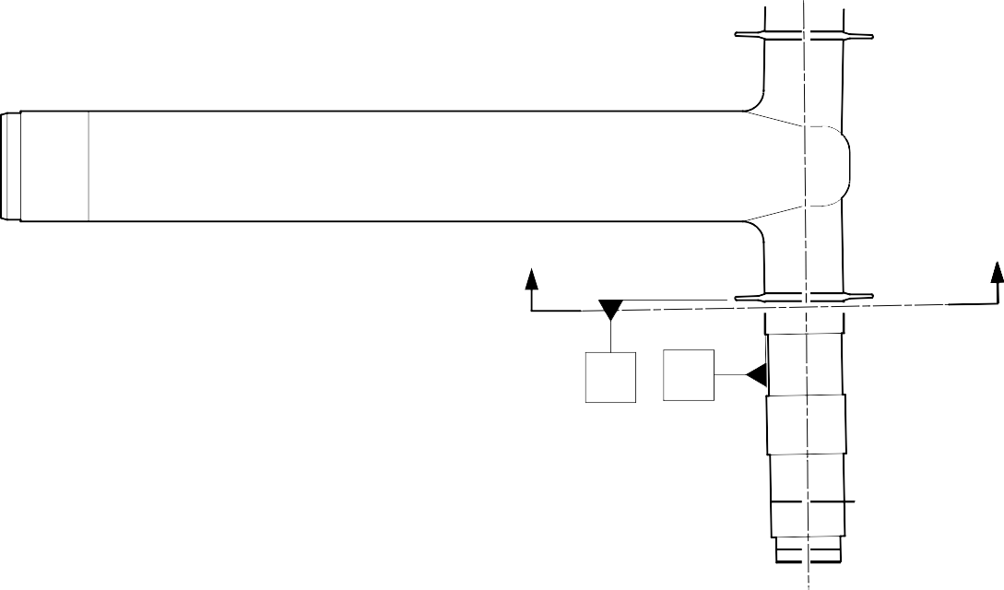
Z
Z
X
Y
150 DEGREES

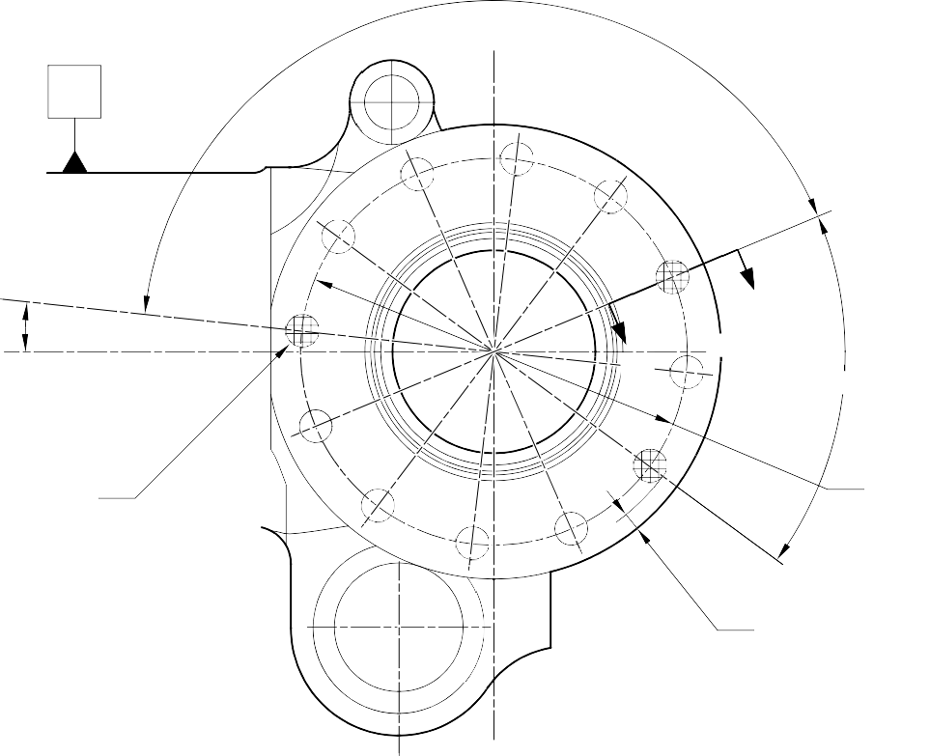
V

6 DEGREES
57 MINUTES

DIA. A
(3 PLACES)
(BOTH FLANGES)

 |  | 1,60mm (0.063in) |  | V
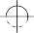 | 0,20mm (0.008in) DIA. |  | X | Y
W
SEE FIG. 602
W 60 DEGREES

192,000mm (7.5591in) DIA.

6,140mm (0.2417in) MINIMUM WALL THICKNESS

SECTION Z-Z

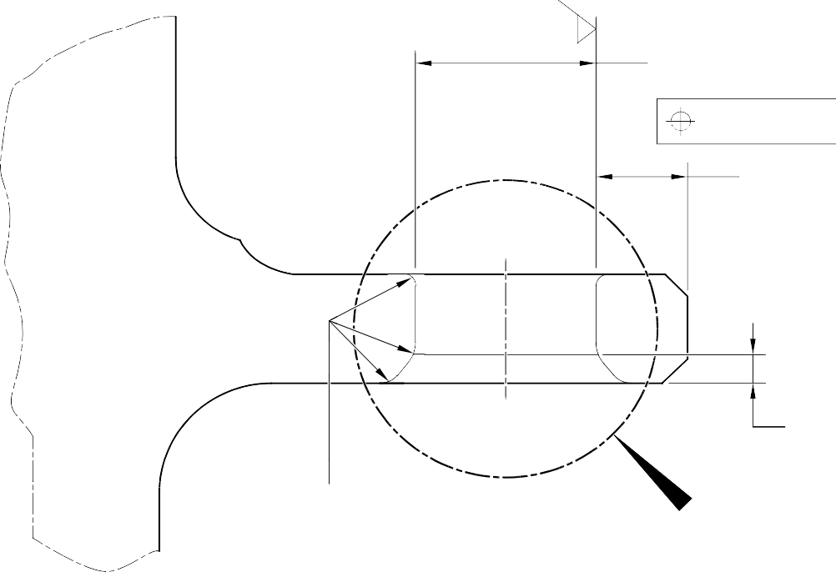
DIA. A 6 HOLES MAXIMUM
0,20mm (0.008in) DIA.
1,6
(63)
6,140mm (0.2417in) REF. MINIMUM WALL THICKNESS

2 ,00 mm (0.080in)
x 45 DEGREES CHAMFER

0,40 to 1,00 mm
(0.016 to 0.040 in) RADIUS
U
SECTION W-W

(WITHOUT BUSHES)

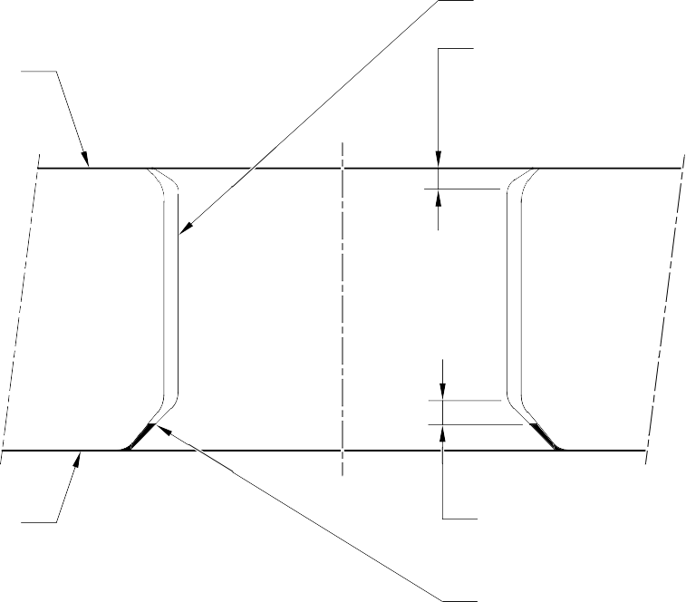
CHROMIUM PLATING

SERMETAL COATING AND
FINISH PAINT
0,0 to 0,8mm (0.00 to 0.03in) CHROMIUM PLATE TO TERMINATE OVER THIS LENGTH

SERMETEL COATING AND PRIMER PAINT

DETAIL U
0,50 to 2,00mm (0.020 to 0.080in) CHROMIUM PLATE TO TERMINATE OVER THIS LENGTH
CHROMIUM PLATE TERMINATION TO M-DLPS1031-5
A321-S-32-12-22-053-1

Repair to Sliding Tube - Machining Figure 602


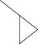
16,80 to 17,20mm (0.661 to 0.677in) DIA.
2,5
(100)

SECTION W-W
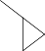
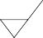
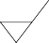
(WITH BUSHES)
1,6
(63)

 |  |  | 0,015mm (0.0006in) | S

11,90 to 12,30mm
(0.469 to 0.484in)
2,00 to 2,05mm (0.079 to 0.081in)
FACE R

IVD COATING OPTIONAL IN END FACE

APPLY COAT OF ALUMINIUM (IVD)
28,75 to 29,25mm (1.132 to 1.152in) DIA. REF.
APPLY COAT OF ALUMINIUM (IVD)
0,5mm (0.020in) x 60 DEGREES INCLUSIVE CHAMFER
IVD COATING OPTIONAL

T
S

IVD COATING OPTIONAL

2,5
(100)

1,6
(63)
DIA . B
APPLY COAT OF ALUMINIUM (IVD)

 | 0,100mm (0.0040in) | T

16,80 to 17,20mm
(0.661 to 0.677in) DIA. REF.

RADIUS 1,45 to 1,75mm (0.057 to 0.069in)
APPLY COAT OF ALUMINIUM (IVD)

REPAIR BUSH 450266800

INTENTIONALLY BLANK

- Repair No. 10-1 Pin (9-70)
  - Specified Damage and Material Specification.
    - Specified Damage
      - Damage or corrosion to diameter A.
    - Material Specification

IPL Figure and  Item No. | Name | Material Specification
9-70 | Pin | UHT Steel, MTL1201
  - Special Tools
    - Special tools are not necessary.
  - Materials
    - Materials are not necessary.
  - Repair Parts
    - Repair parts are not necessary.
  - Procedure (Refer to Figure 601)
    - Remove the chromium plate from diameter A: refer to PCS-2110.
      - If the base metal is not damaged or corroded:
        - Examine the pin for flaws: refer to PCS-3600 and PCS-3100, inclusion class 4.
        - Apply chromium plate to diameter A: refer to PCS-2110, type C: refer to Figure 601.
        - Grind diameter A to between 30,950 and 30,975 mm (1.2185 and 1.2194 in). The surface finish must be 0,8 micrometers (31 micro-inches).
        - Examine the ground chromium plate for flaws: refer to PCS-3100 and PCS-3002.
        - Apply cadmium plate to the areas that do not have chromium plate: refer to PCS-2141.
        - Identify the part with the Messier-Dowty Limited repair number 450266210A adjacent to the part number: refer to PCS-6000-04, PCS-6000-06 and PCS-6000-07.
        - Examine the part to make sure that you have obeyed all the repair instructions correctly.

Repair No. 10-1

      - If the bare metal is damaged or corroded:
        - Refer to M-DLPS1004-4-1 and machine diameter A just sufficiently to remove the damage or corrosion: the diameter must not be less than 30,365 mm (1.1956 in). The surface finish must be 1,6 micrometers (63 micro-inches).
        - Examine the pin for flaws: refer to PCS-3600 and PCS-3100, inclusion class 4.
        - Shot peen the machined areas: refer to M-DLPS123.
        - Apply chromium plate to diameter A: refer to PCS-2110, type C and Figure 601.
        - Grind diameter A to between 30,950 and 30,975 mm (1.2185 and 1.2194 in). The surface finish must be 0,8 micrometers (31 micro-inches).
        - Examine the ground chromium plate for flaws: refer to PCS-3100 and PCS-3002.
        - Apply cadmium plate to the areas that do not have chromium plate: refer to PCS-2141.
        - Identify the part with the Messier-Dowty Limited repair number 450266210B adjacent to the part number: refer to PCS-6000-04, PCS-6000-06 and PCS-6000-07.
        - Examine the part to make sure that you have obeyed all the repair instructions correctly.

Repair No. 10-1

