Z
1,00mm (0.039in) RADIUS



REF.
DIAMETER
A
0,50 to 0,75mm (0.020 to 0.030in)

x 45 DEGREE CHAMFER
REF.

CHROMIUM PLATE TERMINATION TO M-DLPS1031-1
CHROMIUM PLATE TERMINATION TO
M-DLPS1031-6 or M-DLPS1031-5

DIAMETER A BEFORE CHROMIUM PLATE
DIAMETER A AFTER GRINDING
DIAMETER A AFTER CHROMIUM PLATE DEPOSIT
DETAIL Z

A321A3760-1

Repair to Pin Figure 601

Repair No. 10-1

INTENTIONALLY BLANK

- Repair No. 11-1 Main Fitting (20-410, 20-410A, 20-420 and 20-420A)
  - Specified Damage and Material Specification.
    - Specified Damage
      - Damage or wear to the diameter A and/or the adjacent face(s).
    - Material Specification
IPL Figure and  Item No. | Name | Material Specification
20-410, 20-410A,  20-420 and 20-420A | Main fitting | Steel, MAT135, 35NCD16THQ

  - Special Tools
    - Special tools are not necessary.
  - Materials
    - These materials are necessary:

NOTE: Alternative equivalents are permitted.

Ref. Item | Material
TBA | Electrically conducting Mastinox to M-DLPS709-14
09-510A | Sealant
  - Repair Parts
    - These repair parts are necessary:

Part No. | Repair Part | Material Specification
450266061 | Blank bushes | Aluminium Bronze, DTD197
  - Procedure (Refer to Figures 601 and 602)
    - Machine the diameter A sufficiently only to remove the damage or wear: refer to M-DLPS1004-4-1. The machined diameter A must not be more than 26,921 mm (1.0599 in). The surface finish must be 1,6 micrometers (63 micro-inches). Remove the sharp edge at the intersection of the lubrication hole with a 0,50 to 2,00 mm (0.020 to 0.079 in) radius.
    - Machine the adjacent face(s) sufficiently only to remove the damage or wear: refer to M-DLPS1004-4-1. Do not remove more than 1,00 mm (0.039 in) from each face. The surface finish must be 1,6 micrometers (63 micro-inches).
    - Machine the chamfers and radii to the dimensions shown in Figure 601.
    - Examine the machined areas for flaws: refer to PCS-3600 and PCS-3100, inclusion class 4.

    - Measure and make a record of the new diameter A and the dimensions B and E.
    - Shot peen the machined areas: refer to M-DLPS123.
    - Apply cadmium plate to the machined areas: refer to PCS-2141.
    - Identify the part with the Safran Landing Systems repair number 450266060 adjacent to the part number: refer to PCS-6000-04, an alternative reference is PCS-6000-06. If the alternative reference is used, the characters must be 0,051 to 0,102 mm (0.0020 to 0.0040 in) deep and approximately 3,00 mm (0.118 in) high.
    - Calculate the diameters F and the dimensions D of the oversize bushes: F = A (as measured) + 0,007 to 0,041 mm (0.0003 to 0.0016 in)
D (for Bush 1) = B (as measured) - 2,50 to - 2,55 mm (- 0.098 to - 0.100 in)
D (for Bush 2) = 45,733 to 45,820 mm (1.8005 to 1.8039 in) - E (as measured).
    - Machine the blank bushes to the dimensions shown and calculated: the surface finish must be 1,6 micrometers (63 micro-inches). Identify each oversize bush for reference.
    - Apply cadmium plate to the oversize bushes, but not on the internal diameter and where shown: refer to Figure 602 and PCS-2101 or PCS-2141 but do not de-embrittle. The thickness of the cadmium plate must be between 0,010 and 0,015 mm (0.0004 and 0.0006 in).
    - Install the oversize bushes to their correct locations: refer to M-DLPS1011-20 and use the electrically conducting Mastinox to M-DLPS709-14. Primer paint the gap between the internal ends of the oversize bushes and keep it free from sealant.
    - Check line ream the oversize bushes to the dimension shown in Figure 602.
    - Apply sealant, Material Ref. Item 09-510A, around the flanges of the oversize bushes: refer to PCS-7200.
    - Identify the part with the Safran Landing Systems repair number 450266060 adjacent to the part number: refer to PCS-6000-07.
    - Examine the part to make sure that you have obeyed all the repair instructions correctly.

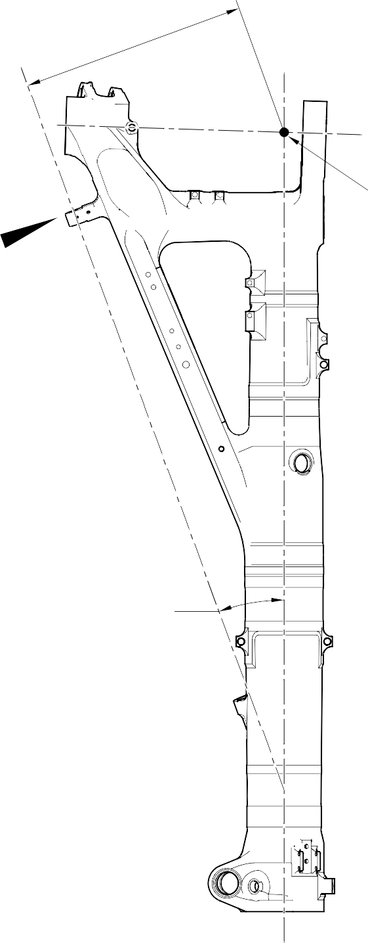
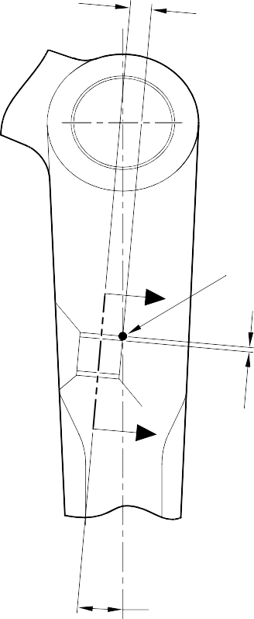
23,50 to 24,50mm
656,085mm (25.8301in)
(0.925 to 0.965in)

POINT C

Z
Y POINT C

DIMENSION B
6,50mm (0.256in)
- MAXIMUM (REFERENCE)

4 DEGREES 57 MINUTES
31 SECONDS (REFERENCE)
VIEW ON ARROW Z

DIMENSION B
20 DEGREES
4 MINUTES
27 SECONDS
6,50mm (0.256in)
MAXIMUM

3,00 to 4,00mm (0.118 to 0.157in) RADIUS TYPICAL AROUND LUG
DIMENSION E

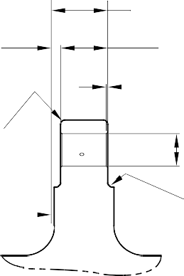
35,90mm (1.413in) MINIMUM
0,25 to 0,75mm (0.010 to 0.030in)
x 45 DEGREE CHAMFER DIAMETER A

PLANE PASSES THROUGH
POINT C
SMOOTH TO RADIUS. 2 PLACES
SECTION Y-Y
WITHOUT BUSHES

A321A4812-1

Repair to Main Fitting Figure 601

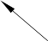
MACHINE THIS FACE
DIMENSION D
0,25 to 0,75mm (0.010 to 0.030in)
45
DEGREES
DIAMETER
F
DO NOT APPLY CADMIUM PLATE
0,30 to 0,50mm
(0.012 to 0.020in) RADIUS
0,025mm (0.0010in)
0,01mm (0.0004in)

43,233 to 43,270mm (1.7021 to 1.7035in)

2,50 to 2,55mm (0.098 to 0.100in)

BUSH 1

PLANE PASSES
THROUGH POINT C
20,00 to 20,021mm
(0.7874 to 0.7882in)

BUSH 2

PCS-7200

SECTION Y-Y
WITH BUSHES

A321A4813-1

Oversize Bushes - Machining and Installation Figure 602

- Repair No. 11-2 Main Fitting (20-410, 20-410A, 20-420 and 20-420A)
  - Specified Damage and Material Specification.
    - Specified Damage
      - Damage or corrosion to the diameter(s) A.
    - Material Specification
IPL Figure and  Item No. | Name | Material Specification
20-410, 20-410A,  20-420 and 20-420A | Main fitting | Steel, MAT135, 35NCD16THQ

  - Special Tools
    - These special tools are necessary:

NOTE: Alternative equivalents are permitted.

Part No. | Special Tool | Function
460007257 | Press Pad | Install the oversize bush(es)
  - Materials
    - These materials are necessary:

NOTE: Alternative equivalents are permitted.

Ref. Item | Material
TBA | Electrically conducting Mastinox to M-DLPS709-14
09-510A | Sealant
  - Repair Parts
    - These repair parts are necessary:

Part No. | Repair Part | Material Specification
450258808 | Blank bush | Aluminium Bronze, BSB23 or  AMS4640
  - Procedure (Refer to Figures 601 and 602)
    - Machine the diameter(s) A sufficiently to remove the damage or corrosion: refer to M-DLPS1004-4-1 and to Figure 601 for the dimensions. The surface finish must be 1,6 micrometers (63 micro-inches).
    - Examine the part for flaws: refer to PCS-3600 and PCS-3100, inclusion class 4.
    - Measure and make a record of the new diameter A.
    - Shot peen the machined areas: refer to M-DLPS123.

    - Apply cadmium plate to the machined areas: refer to PCS-2141.
    - Identify the part with the Safran Landing Systems repair number 450266070 adjacent to the part number: refer to PCS-6000-04, an alternative reference is PCS-6000-06. If the alternative reference is used, the characters must be 0,051 to 0,102 mm (0.0020 to 0.0040 in) deep and approximately 3,00 mm (0.118 in) high.
    - Calculate the diameter D of the oversize bush(es):
D = A (as measured) - 0,009 to + 0,029 mm (- 0.0003 to + 0.0012 in).
    - Machine the oversize bush(es) from the blank bush(es) to the dimensions shown and calculated: the surface finish must be 1,6 micrometers (63 micro-inches).
    - Apply cadmium plate to the oversize bush(es). The thickness of the cadmium plate must be between 0,010 and 0,015 mm (0.0004 and 0.0006 in): refer to PCS-2101 or PCS-2141 and do not de-embrittle.
    - Use the Press Pad 460007257 to install the oversize bush(es): refer to M-DLPS1011-20 and use the electrically conducting Mastinox to M-DLPS709-14, Material Ref Item TBA.
    - Check the internal diameter(s) of the installed oversize bush(es) to the dimension shown in Figure 602.
    - Apply sealant, Material Ref. Item 09-510A, around the flanges of the oversize bush(es): refer to PCS-7200.
    - Identify the part with the Safran Landing Systems repair number 450266070 adjacent to the part number: refer to PCS-6000-07.
    - Examine the part to make sure that you have obeyed all the repair instructions correctly.

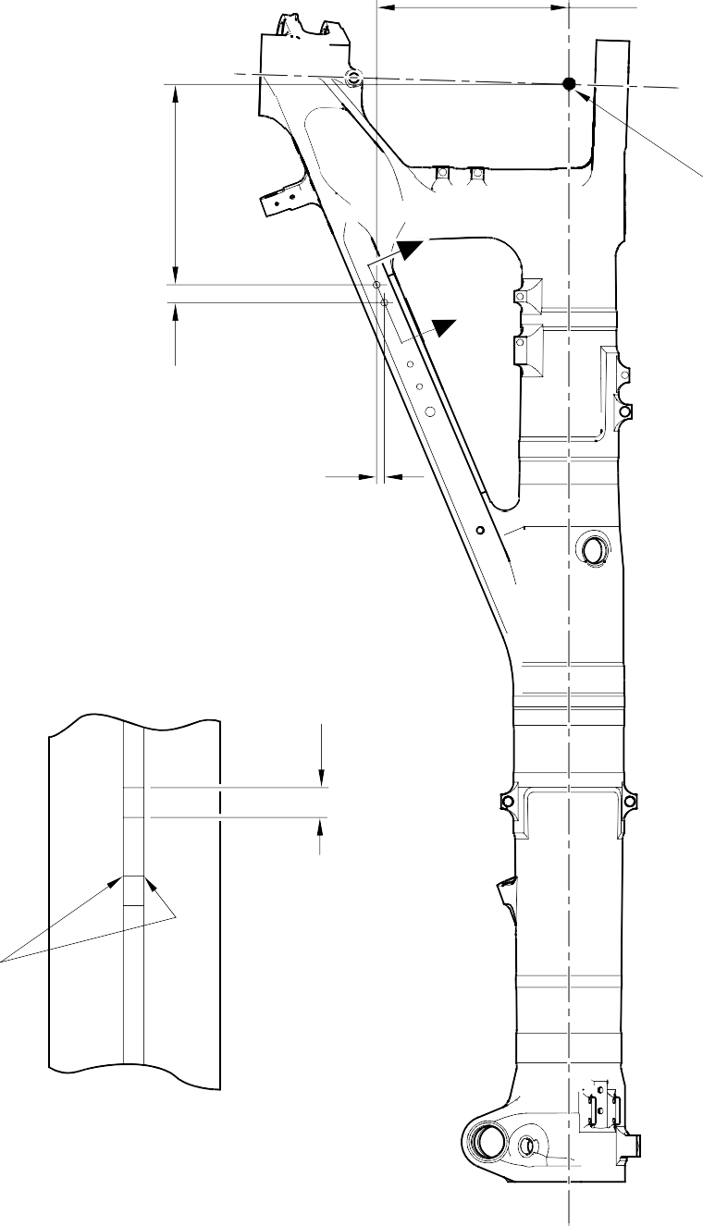
396,37 to 397,37mm
(15.605 to 15.644in)

412,50 to 413,50mm
(16.240 to 16.280in)

POINT C

Z
Z

36,86mm (1.451in)
15,54mm (0.612in)

DIAMETER A 15,727mm (0.6192in) MAXIMUM
TYPICAL BOTH BORES

0,80 to 1,20mm
(0.032 to 0.047in) TYPICAL BOTH BORES

SECTION Z-Z
WITHOUT BUSHES

A321A4810-1

Repair to Main Fitting Figure 601

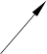
0,75 to 1,25mm (0.030 to 0.049in)

DIAMETER
D

15
DEGREES

REPAIR BUSH 450258808

0,30 to 0,50mm
(0.012 to 0. 020in) RADIUS

PCS-7200 4 PLACES
INTENTIONALLY BLANK

9,75 to 10,25mm
(0.384 to 0.404in) DIAMETER CHECK

SECTION Z-Z
WITH BUSHES
A321A4811-1

Oversize Bush(es) - Machining and Installation Figure 602

- Repair No. 11-3 Main Fitting (20-410, 20-410A, 20-420 and 20-420A)
  - Specified Damage and Material Specification.
    - Specified Damage
      - Damage or corrosion to the diameter A and/or faces B and C (Refer to Figure 601).
    - Material Specification
IPL Figure and  Item No. | Name | Material Specification
20-410, 20-410A,  20-420 and 20-420A | Main fitting | Steel, MAT135, 35NCD16THQ

  - Special Tools
    - These special tools are necessary:

Part No. | Special Tool | Function
460004330/259 | Press Pad | Install the repair bush 450258811
460004330/260 | Press Pad | Install the repair bush 450258812
  - Materials
    - These materials are necessary:

NOTE: Alternative equivalents are permitted.

Ref. Item | Material
09-510A | Sealant: refer to PCS-7200
TBA | Electrically conducting zinc loaded Mastinox D40: refer to M-DLPS709-14
  - Repair Parts
    - These repair parts are necessary:

Part No. | Repair Part | Material Specification
450258811 | Repair bush | Aluminium bronze AMS4590 or  AMS4881 centrifugally cast
450258812 | Repair bush | Aluminium bronze AMS4590 or AMS4881 centrifugally cast

  - Procedure (Refer to Figures 601, 602 and 603)
    - Machine the diameter A, sufficiently only to remove the damage or corrosion: refer to M-DLPS1004-4-1. Diameter A must not be more than 77,13 mm (3.037 in). The minimum wall dimension F must not be less than 17,385 mm (0.6844 in). The minimum wall dimension G must not be less than 11,935 mm (0.4699 in). The surface finish must be 1,6 micrometers (63 micro-inches): refer to Figure 602.
    - Measure and make a record of the new diameter A.
    - Measure and make a record of the dimension D1.
    - Machine the face B, sufficiently only to remove the damage or corrosion: refer to M-DLPS1004-4-1. Do not remove more than 1,00 mm (0.039 in) of material from the face B. The surface finish must be 1,6 micrometers (63 micro-inches).
    - Measure and make a record of the dimension D2.
    - Measure and make a record of the dimension E.
    - Machine the face C, sufficiently only to remove the damage or corrosion: refer to M-DLPS1004-4-1. Do not remove more than 1,00 mm (0.039 in) of material from the face C. The surface finish must be 1,6 micrometers (63 micro-inches). Dimension E must not be less than 128,00 mm (5.039 in).
    - Measure and make a record of the new dimension E. Calculate the amount of material, K, removed from the face C, as follows:
      - K = Dimension E (as measured in para (6)) - Dimension E (as measured in para (8)).
    - Machine the chamfers and radii as shown: refer to Figure 602.
    - Examine the bare metal for flaws: refer to PCS-3600 and PCS-3100, inclusion class 4.
    - Shot peen the machined area: refer to M-DLPS123.
    - Apply cadmium plate to the machined area: refer to PCS-2141.
    - Identify the part with the Safran Landing Systems repair number 450266020 adjacent to the part number: refer to PCS-6000-04, an alternative reference is PCS-6000-06. If the alternative reference is used, the characters must be 0,051 to 0,102 mm (0.0020 to 0.0040 in) deep and approximately 3,00 mm (0.118 in) high.
    - Prepare the repair bush 450258812 for installation: refer to Figure 603:
      - Machine diameter H of the repair bush to the diameter from this formula:
H = A (as measured in para (2)) + 0,029 to 0,078 mm (+ 0.0012 to 0.0030 in) The surface finish must be 1,6 micrometers (63 micro-inches).
      - Machine face L to get the dimension J from this formula: J = 12,5 mm (0.492 in) - K (as measured in para (8) (a))
The surface finish must be 1,6 micrometers (63 micro-inches).
      - Apply cadmium plate to the repair bush, but not in the bore and internal grooves: refer to PCS-2101. The cadmium plate thickness must be between 0,010 and 0,015 mm (0.0004 and 0.0006 in).

    - Prepare the repair bush 450258811 for installation: refer to Figure 603:
      - Machine diameter M of the repair bush to the diameter from this formula:
M = A (as measured in para (2)) + 0,029 to 0,078 mm (0.0012 to +0.0030 in) The surface finish must be 1,6 micrometers (63 micro-inches).
      - Machine face N to get the dimension P from this formula:
P = 25,25 mm (0.994 in) - (D1 + D2) (as measured in para (3) and (5)) The surface finish must be 1,6 micrometers (63 micro-inches).
      - Apply cadmium plate to the repair bush, but not in the bore and internal grooves: refer to PCS-2101. The cadmium plate thickness must be between 0,010 and 0,015 mm (0.0004 and 0.0006 in).
    - Use jointing compound, electrically conducting zinc loaded Mastinox D40, Material Ref. Item, TBA and the Press Pad 460004330/259 to install the repair bush 450258811. Use jointing compound, electrically conducting zinc loaded Mastinox D40, Material Ref. Item, TBA and the Press Pad 460004330/260 to install the repair bush 450258812. Refer to M-DLPS709-14, M-DLPS1011-20 and Figure 603.
    - Machine the flange face Q of the repair bush 450258812 to get a dimension R of between 137,917 and 137,957 mm (5.4298 and 5.4314 in). Do not machine face S of the repair bush 450258811. The surface finish must be 1,6 micrometers (63 micro-inches).
    - Check line ream the bores of the repair bushes to between 70,00 and 70,03 mm (2.756 and 2.757 in).
    - Apply sealant, Material Ref. Item 09-510A, between the repair bushes and the main fitting: refer to PCS-7200: refer to Figure 603.
    - Identify the part with the Safran Landing Systems repair number 450266020 adjacent to the part number: refer to PCS-6000-07.
    - Examine the part to make sure that you have obeyed all the repair instructions correctly.

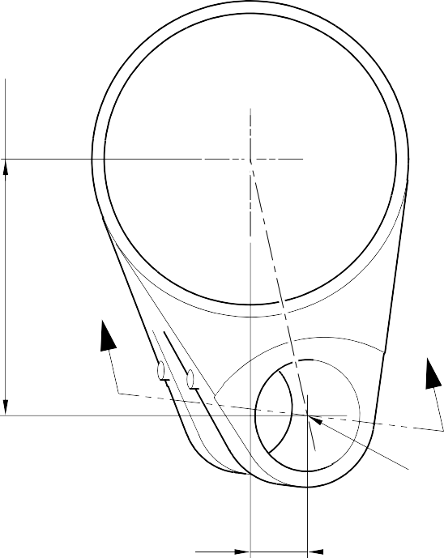
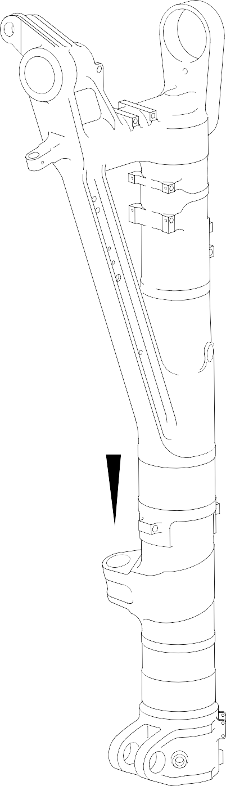
153,194mm (6.0313in) REFERENCE

Y

Z
Z
(REFER TO FIGURE 602)

POINT D

100,616mm (3.9613in) REFERENCE

DETAIL Y

A321A5064-1

Repair to Main Fitting Figure 601



20.653
DEGREES
V DIAMETER A

D1 BEFORE MACHINING
D2 AFTER MACHINING

2,00 to 4,00mm
(0.079 to 0.157in) RADIUS ALL AROUND AT ENTRY OF LUBRICATION BORE INTO DIAMETER A.
(2 PLACES)

4,00 to 5,00mm
(0.157 to 0.197in) CORNER RADIUS
(2 PLACES)

1,25 to 1,75mm
(0.049 to 0.069in)
X
FACE B
 | 0,05mm (0.002in) | X

E

FACE C

x 45 DEGREE CHAMFER
 | 0,05mm (0.002in) | X

(2 PLACES) W

51,00 to 52,00mm
(2.008 to 2.047in) OVER RADIUS.


100,00mm (3.937in) RADIUS MINIMUM
SMOOTH BLEND TO LARGER RADIUS
G
VIEW ON W
56,00 to 57,00mm
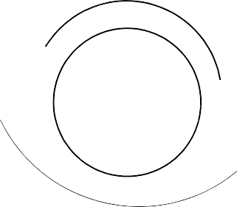

(2.2047 to 2.2440in) OVER RADIUS.
SMOOTH BLEND TO LARGER RADIUS

VIEW ON V

100,00mm (3.937in) RADIUS MINIMUM

F

A321A5065-1

Repair to Main Fitting Figure 602

FACE S
REPAIR BUSH 450258811

SEALANT TO PCS-7200

R

FACE Q

REPAIR BUSH 450258812




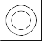


FACE L
FACE N
P
15
DEGREES
M
0,95 to 1,45mm
(0.037 to 0.057in)
0,80 to 1,20mm
(0.031 to 0.147in) RADIUS
0,025mm (0.0010in) DIA
0,025mm (0.0010in)
0,025mm (0.0010in)

J

15
DEGREES

H

0,75 to 1,25mm
(0.030 to 0.049in)
RADIUS

0,95 to 1,45mm
(0.037 to 0.057in)

0,025mm (0.0010in) DIA
REPAIR BUSH 450258812 MACHINING REPAIR BUSH 450258811 MACHINING
A321A5066-1

Repair to Main Fitting - Repair Bush Machining and Installation Figure 603

- Repair No. 11-4 Main Fitting (20-410, 20-410A, 20-420 and 20-420A)
  - Specified Damage and Material Specification.
    - Specified Damage
      - Damage or corrosion to diameter(s) A (Refer to Figure 601).
    - Material Specification
IPL Figure and  Item No. | Name | Material Specification
20-410, 20-410A,  20-420 and 20-420A | Main fitting | Steel, MAT135, 35NCD16THQ

  - Special Tools
    - These special tools are necessary:

NOTE: Alternative equivalents are permitted.

Part No. | Special Tool | Function
460004330/110 | Press Pad | Install the repair bush 450237819
  - Materials
    - These materials are necessary:

NOTE: Alternative equivalents are permitted.

Ref. Item | Material
TBA | Electrically conducting Mastinox D40: refer to  M-DLPS709-14
09-510A | Sealant: refer to PCS-7200
  - Repair Parts
    - These repair parts are necessary:

Part No. | Repair Part | Material Specification
450237819 | Blank bush | Aluminium Bronze, DTD197
  - Procedure (Refer to Figures 601 and 602)
    - Machine the diameter(s) A, sufficiently only to remove the damage or corrosion, do not make diameter A larger than 13,727 mm (0.5404 in): refer to M-DLPS1004-4-1. The surface finish must be 1,6 micrometers (63 micro-inches).
    - Measure and record the new diameter(s) A.
    - Examine the bare metal for flaws: refer to PCS-3600 and PCS-3100, inclusion class 4.
    - Shot peen the machined area(s): refer to M-DLPS123.

    - Apply cadmium plate to the machined area(s): refer to PCS-2141.
    - Identify the part with the Safran Landing Systems repair number 450266075 adjacent to the part number: refer to PCS-6000-04, an alternative reference is PCS-6000-06. If the alternative reference is used, the characters must be 0,051 to 0,102 mm (0.0020 to 0.0040 in) deep and approximately 3,00 mm (0.118 in) high.
    - Calculate diameter B of the repair bush(es):
B = A (as measured) + 0,009 to 0,029 mm (0.0003 to 0.0011 in).
    - Machine the repair bush to the dimensions shown and calculated with a surface finish of 1,6 micrometers (63 micro-inches): refer to Figure 602. Diameter B must make a smooth joint with the adjacent corner radius.
    - Apply cadmium plate to the repair bush: refer to PCS-2101. The cadmium plate thickness must be between 0,010 and 0,015 mm (0.0004 and 0.0006 in).
    - Install the repair bush(es): refer to M-DLPS1011-20. Use electrically conducting Mastinox D40, Material Ref. Item. TBA: refer to M-DLPS709-14,.
    - Apply sealant, Material Ref. Item 09-510A, between the repair bush and the main fitting: refer to PCS-7200.
    - Identify the part with the Safran Landing Systems repair number 450266075 adjacent to the part number: refer to PCS-6000-07 and Figure 602.
    - Examine the part to make sure that you have obeyed all the repair instructions correctly.

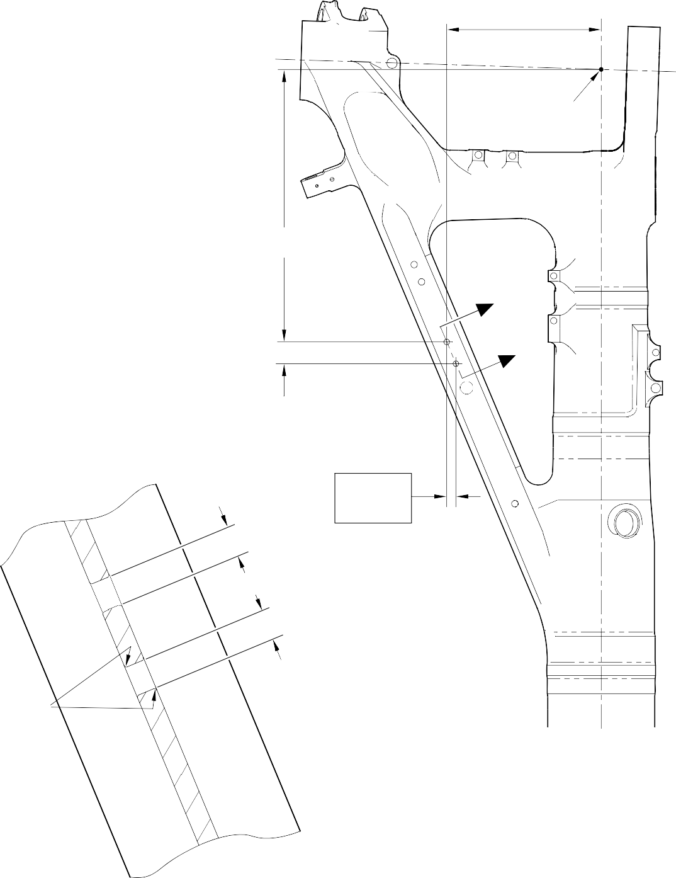
327,22 to 328,22mm
(12.883 to 12.922in)

POINT C

576,50 to 577,50mm
(22.697 to 22.736in)

Z

Z
46,07mm (1.814in) CRS

DIAMETER
19,425mm (0.7648in) CRS
A

0,80 to 1,20mm
(0.032 to 0.047in)
RADIUS TYPICAL BOTH BORES
DIAMETER
A

SECTION Z-Z
MACHINING

A321A5058-1

Repair to Main Fitting Figure 601

0,75 to 1,25mm
(0.030 to 0.049in)

B

0,50 to 0,80mm
15
DEGREES

(0.020 to 0.032in) RAD.
REPAIR BUSH 450237819



SEALANT TO
PCS 7200
4 PLACES
PART SECTION Z-Z
WITH REPAIR BUSHES

A321A5059-1

Repair Bush - Machining and Installation Figure 602

- Repair No. 11-5 Main Fitting (20-410, 20-410A, 20-420 and 20-420A)
  - Specified Damage and Material Specification.
    - Specified Damage
      - Damage or corrosion to diameter A (Refer to Figure 601).
    - Material Specification
IPL Figure and  Item No. | Name | Material Specification
20-410, 20-410A,  20-420 and 20-420A | Main fitting | Steel, MAT135, 35NCD16THQ

  - Special Tools
    - These special tools are necessary:

NOTE: Alternative equivalents are permitted.

Part No. | Special Tool | Function
460006267 | Press Pad | Install the repair bearing 450266081
  - Materials
    - These materials are necessary:

NOTE: Alternative equivalents are permitted.

Ref. Item | Material
TBA | Electrically conducting Mastinox D40: refer to  M-DLPS709-14
09-510A | Sealant: refer to PCS-7200
  - Repair Parts
    - These repair parts are necessary:

Part No. | Repair Part | Material Specification
450266081 | Blank bearing | Aluminium Bronze, DTD197
  - Procedure (Refer to Figures 601 and 602)
    - Machine the diameter A, sufficiently only to remove the damage or corrosion, do not make diameter A larger than 21,933 mm (0.8635 in): refer to M-DLPS1004-4-1. The surface finish must be 1,6 micrometers (63 micro-inches).
    - Machine the radii as shown.
    - Measure and record the new diameter A.
    - Examine the bare metal for flaws: refer to PCS-3600 and PCS-3100, inclusion class 4.

    - Shot peen the machined area: refer to M-DLPS123.
    - Apply cadmium plate to the machined area: refer to PCS-2141.
    - Identify the part with the Safran Landing Systems repair number 450266080 adjacent to the part number: refer to PCS-6000-04, an alternative reference is PCS-6000-06. If the alternative reference is used, the characters must be 0,051 to 0,102 mm (0.0020 to 0.0040 in) deep and approximately 3,00 mm (0.118 in) high.
    - Calculate diameter B of the repair bearing:
B = A (as measured) + 0,002 to 0,048 mm (0.0008 to 0.0019 in).
    - Machine the repair bearing to the dimensions shown and calculated with a surface finish of 1,6 micrometers (63 micro-inches): refer to Figure 602.
    - Apply cadmium plate to the repair bearing: refer to PCS-2101. The cadmium plate thickness must be between 0,010 and 0,015 mm (0.0004 and 0.0006 in).
    - Install the repair bearing: refer to M-DLPS1011-20. Use electrically conducting Mastinox D40, Material Ref. Item. TBA: refer to M-DLPS709-14.
    - Check line ream the repair bearing to the dimension shown: refer to Figure 602.
    - Apply sealant, Material Ref. Item 09-510A, between the repair bearing and the main fitting: refer to PCS-7200 and Figure 602.
    - Identify the part with the Safran Landing Systems repair number 450266080 adjacent to the part number: refer to PCS-6000-07.
    - Examine the part to make sure that you have obeyed all the repair instructions correctly.

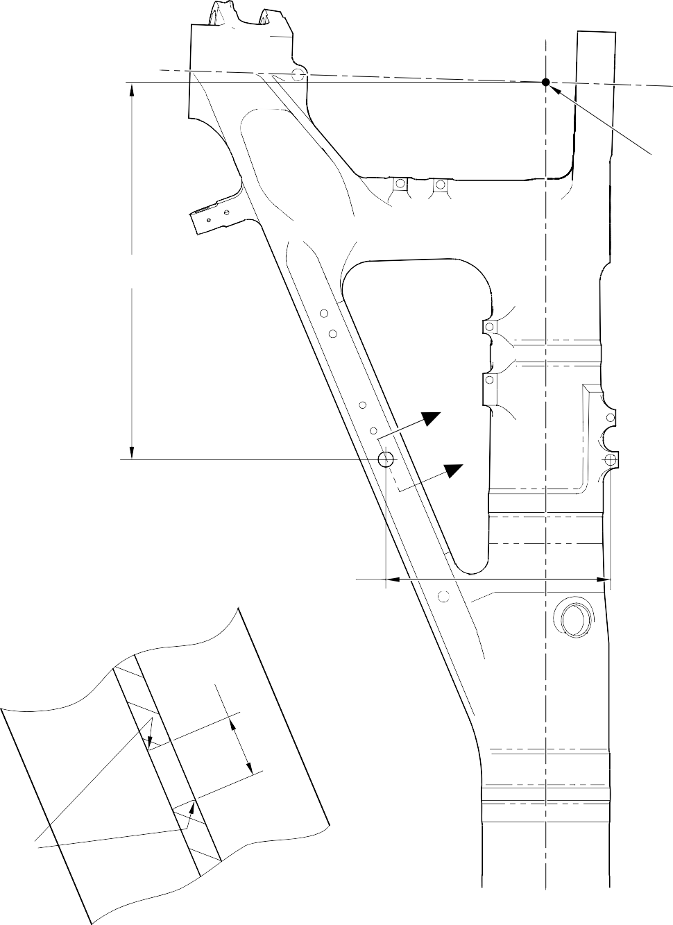
POINT C

674,50 to 675,50mm
(26.555 to 26.595in)

Z
Z

402,15mm (15.833in)

A

0,80 to 1,20mm
(0.032 to 0.047in) RADIUS

SECTION Z-Z MACHINING

A321A5060-1

Repair to Main Fitting Figure 601

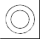
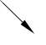
8,00mm (0.315in)
0,025mm (0.0010in)

B

1,20mm (0.047in) X 60 DEGREES INCLUSIVE
BOTH ENDS
15 DEGREES
1,20mm (0.047in) CHAMFER BOTH ENDS

INSTALL BEARING
0,50 to 0,75mm

(0.020 to 0.030in) BELOW THIS SURFACE

16,25 to 16,75mm
(0.640 to 0.659in)

SEALANT TO PCS-7200

PART SECTION Z-Z
WITH BEARING
A321A5061-1

Repair Bush - Machining and Installation Figure 602

- Repair No. 11-6 Main Fitting (20-410, 20-410A, 20-420 and 20-420A)
  - Specified Damage and Material Specification
    - Specified Damage
      - Damage or corrosion to diameter A.
    - Material Specification
IPL Figure and  Item No. | Name | Material Specification
20-410, 20-410A,  20-420 and 20-420A | Main fitting | Steel, MAT135, 35NCD16THQ

  - Special Tools
    - These special tools are necessary:

NOTE: Alternative equivalents are permitted.

Part No. | Special Tool | Function
460004330/169 | Press Pad | Install the blank bush 450237817
  - Materials
    - These materials are necessary:

NOTE: Alternative equivalents are permitted.

Ref. Item | Material
TBA | Electrically conducting Mastinox D40
09-510A | Sealant
  - Repair Parts
    - These repair parts are necessary:

Part No. | Repair Part | Material Specification
450237817 | Blank bush | Aluminium Bronze, BSB23 or  AMS4640
  - Procedure (Refer to Figures 601 and 602)
    - Machine the diameter A, sufficiently only to remove the damage or corrosion, do not make diameter A larger than 15,727 mm (0.6192 in): refer to M-DLPS1004-4-1
and Figure 601. The surface finish must be 1,6 micrometers (63 micro-inches).
    - Measure and record the new diameter A.
    - Examine the bare metal for flaws: refer to PCS-3100, inclusion class 4 and PCS-3600.
    - Locally cadmium plate the reworked areas: refer to PCS-2141.

    - Identify the part with the Safran Landing Systems repair number 450266085 adjacent to the part number: refer to PCS-6000-04, an alternative reference is PCS-6000-06. If the alternative reference is used, the characters must be 0,051 to 0,102 mm (0.0020 to 0.0040 in) deep and approximately 3,00 mm (0.118 in) high.
    - Calculate diameter B of the repair bush:
Dia. B = Dia. A (as measured) + 0,029 to - 0,009 mm (+ 0.0012 to - 0.0003 in).
    - Machine the blank bush 450237817 to the dimensions shown and calculated. Machine face C to get a dimension D of between 1,75 and 2,00 mm (0.069 and 0.078 in). The surface finish must be 1,6 micrometers (63 micro-inches) all over the bush: refer
to Figure 602.
    - Apply cadmium plate all over the oversize bush: refer to PCS-2101. The cadmium plate thickness must be between 0,010 and 0,015 mm (0.0004 and 0.0006 in).
    - Install the oversize bush: refer to M-DLPS1011-20. Use electrically conducting Mastinox D40, Material Ref. Item. TBA: refer to PCS-7304 and Figure 602.
    - Apply a bead of sealant, Material Ref. Item 09-510A, to the oversize bush: refer to PCS-7200 and Figure 602.
    - Identify the part with the Safran Landing Systems repair number 450266085 adjacent to the part number: refer to PCS-6000-07.
    - Examine the part to make sure that you have obeyed all the repair instructions correctly.

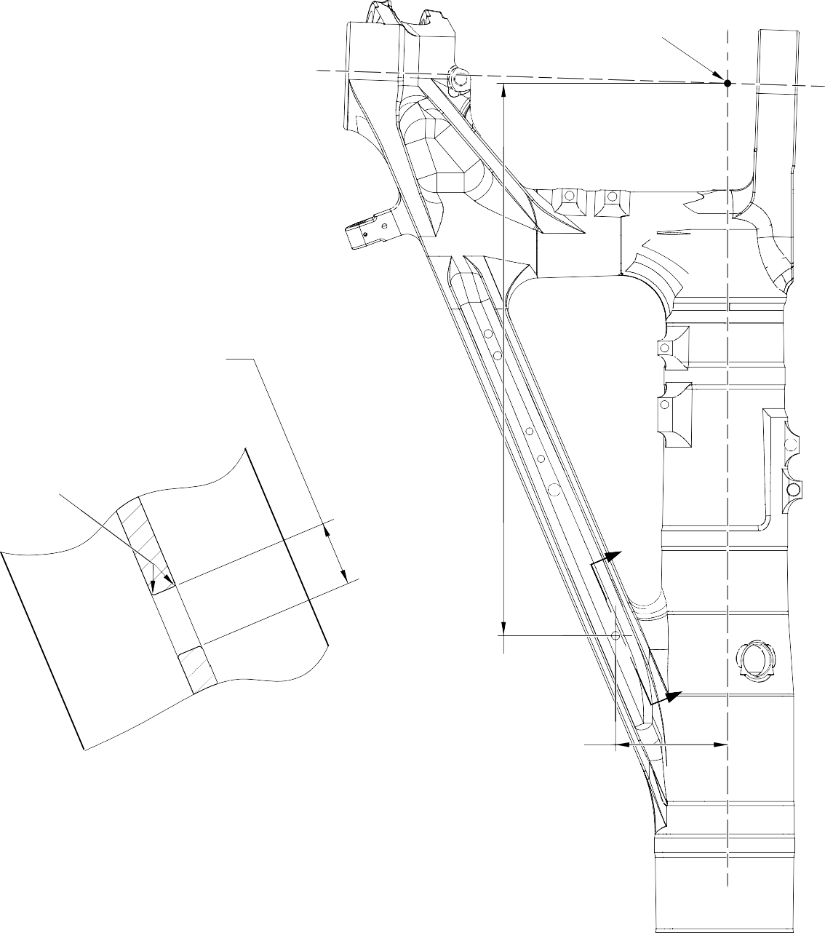
POINT C
DIAMETER A
15,727mm (0.6192in)
MAXIMUM
0,80 to 1,20mm
(0.032 to 0.047in) RADIUS
Z
919,50 to 920,50mm
(36.201 to 36.240in)
Z
SECTION Z-Z
WITHOUT BUSH
182,61 to 183,61mm
(7.189 to 7.229in)

A321-S-32-12-22-022-0

Repair to Main Fitting Figure 601

15
DEGREES



REPAIR BUSH 450237817 MACHINING
0,50 to 0,80mm (0.020 to 0.032in) RADIUS
DIAMETER 25,00mm (0.984in)
DIAMETER
B
15
DEGREES
1,00mm (0.039in)

0,40mm (0.016in) REF.

DIMENSION D
MACHINE THIS FACE C ONLY

APPLY SEALANT TO PCS-7200
SECTION Z-Z
WITH BUSH

A321-S-32-12-22-023-0

Repair Bush - Machining and Installation Figure 602

- Repair No. 11-7 Main Fitting (20-410, 20-410A, 20-420 and 20-420A)
  - Specified Damage and Material Specification.
    - Specified Damage
      - Damage or wear to the diameter(s) A, B or C or spotface(s) D, E or F or faces G, H and/or J.
    - Material Specification
IPL Figure and  Item No. | Name | Material Specification
20-410, 20-410A,  20-420 and 20-420A | Main fitting | Steel, MAT135, 35NCD16THQ

  - Special Tools
    - These special tools are necessary:

NOTE: Alternative equivalents are permitted.

Part No. | Special Tool | Function
460007258 | Press Pad and Drawbolt | Install the repair bush 450258800
  - Materials
    - These materials are necessary:

NOTE: Alternative equivalents are permitted.

Ref. Item | Material
TBA | Zinc Powder
05-533 | Mastinox D40
09-510A | Sealant
  - Repair Parts
    - These repair parts are necessary:

Part No. | Repair Part | Material Specification
450258800 | Repair bush (Qty 3) | Stainless Steel,S145
  - Procedure (Refer to Figures 601, 602 and 603)

CAUTION: FOR DAMAGE MORE THAN THE LIMITS OF THIS REPAIR SCHEME, WRITE TO SAFRAN LANDING SYSTEMS: REFER TO GUIDE-CS-001.
    - Machine the diameter A and/or diameter B and/or diameter C, sufficiently only to remove the damage or wear: refer to M-DLPS1004-4-1. Diameter A and/or diameter B and/or diameter C must not be more than 33,925 mm (1.3356 in). The surface finish must be 1,6 micrometers (63 micro-inches).

    - Use a 45,75 to 46,50 mm (1.801 to 1.831 in) spotface cutter with a 2,50 mm (0.1 in) corner radius and machine the spotfaces D and/or E and/or F, suffciently to remove the damage or corrosion: refer to M-DLPS1004-4-1 and Figure 602. Make the surface finish 1,6 micrometers (63 micro-inches).
    - Machine the faces G and/or H and/or J to get the lug width dimensions the lug widths K or L or M: refer to M-DLPS1004-4-1 and Figure 602. Do not make the lug widths K or L or M less than 21,50 mm (0.846 in). Make the surface finish 1,6 micrometers
(63 micro-inches).
    - Machine the radii to the dimensions shown: refer to M-DLPS1004-4-1 and Figure 602. If necessary, blend any generated sharp edges to the adjacent surface.
    - Measure and record the new diameter(s) A, B and C and the lug widths K, L and M.
    - Examine the machined areas for flaws: refer to PCS-3100, inclusion Class 4 and PCS-3600.
    - Shot peen the machined area: refer to M-DLPS123.
    - Identify the part with the Safran Landing Systems repair number 450266045 adjacent to the part number: refer to PCS-6000-04.
    - Apply cadmium plate to the machined area: refer to PCS-2100 or PCS-2141. The cadmium plate thickness must be between 0,010 to 0,020 mm (0.0004 and 0.0008 in).
    - Apply primer paint to the main fitting, where the bush flanges will touch: refer to PCS-2500.
    - Calculate the dimensions for each repair bush (qty 3), use formula:
Dia N = Dia A or B or C (as measured) + 0,018 to 0,059 mm (0.0007 to 0.0023 in).
Dim P= Lug width K or L or M (as measured) - 0,1 mm (- 0.004 in) to - 0,5 mm (- 0.019 in).
    - Machine the repair bushes to the dimensions as calculated and as shown. Machine the face Q of repair bushes to get the correct dimension P: refer to Figure 603. Make the surface finish 1,6 micrometers (63 micro-inches).
    - Examine the machined areas: refer to PCS-3100, inclusion class 3.
    - Passivate the repair bushs: refer to AMS 2700.
    - Use Press Pad and Drawbolt 460007258 and install the repair bushes: refer to M-DLPS1011-20. Use electrically conducting Mastinox (made from Mastinox D40, Material Ref. Item 05-533 and Zinc powder, Material Ref. Item TBA).
    - Check the bore diameters of the repair bushes: refer to Figure 603.
    - If necessary hone or ream the repair bushes to the dimensions shown: refer to Figure 603. Make the surface finish 1,6 micrometers (63 micro-inches).
    - Apply a bead of sealant, Material Ref. Item 09-510A, between the repair bush(es) and the main fitting: refer to PCS-7200 and Figure 603.
    - Apply paint to the repaired areas, but not to the bores of the repair bushes: refer to PCS-2500.
    - Identify the part with the Safran Landing Systems repair number 450266045 adjacent to the part number: refer to PCS-6000-07.
    - Examine the part to make sure that you have obeyed all the repair instructions correctly.

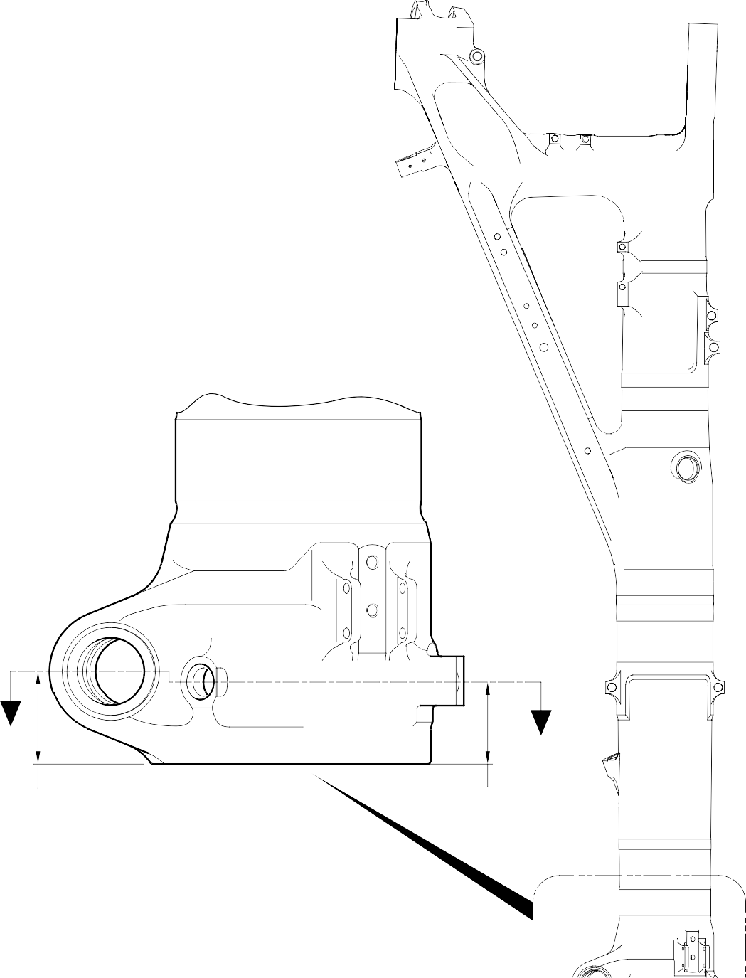
Z
Z
82,00 to 83,00mm
(3.228 to 3.268in) REF.
73,00mm (2.874in) REF.

Repair to Main Fitting Figure 601

FACE G
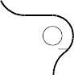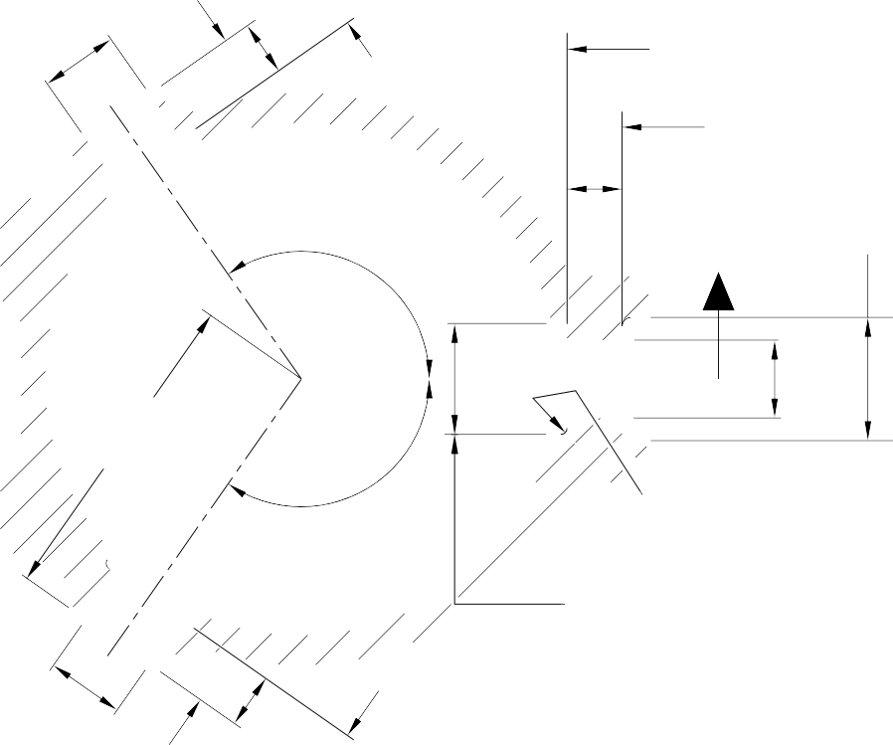
DIA B
L
FACE E
TO SPOTFACE
FACE D
TO SPOTFACE
K
Y
125
DEGREES
FACE J
50,00mm (1.969in) DIA
SPOTFACE WITH 5,00mm (0.197in) CORNER RADIUS
Y
DIA A
132,35mm (5.211in) REF.
125
DEGREES
2,50mm (0.098in) RADIUS TYPICAL 3 PLACES
45,75 to 46,50mm
SECTION Z-Z (1.801 to 1.831in) DIA. SPOTFACE.
TYPICAL 3 PLACES
(REFER TO FIGURE 601)
WITHOUT REPAIR BUSHES
DIA C
M
FACE F
TO SPOTFACE
FACE H







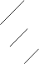
1,00mm (0.040in) RADIUS OR
X 45 DEGREES CHAMFER
0,5 to 1,0mm (0.02 to 0.04in) RADIUS OR
X X 45 DEGREES CHAMFER

DIA A TYPICAL DIA B AND DIA C

 | 0,05mm (0.002in) | W
 | 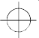  0,14mm (0.006in) DIA | X

W
SECTION Y-Y

A321A5149-2

Repair to Main Fitting Figure 602

Repair No. 11-7

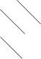


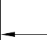

DIM P
U
0,010mm (0.0004in)
V
0,05mm (0.002in) DIA

U FACE Q

DIAMETER N

V

0,30 to 0,70mm
(0.012 to 0.028in) RADIUS
REPAIR BUSH 450258800
1,50mm (0.059in) X 15 DEGREES CHAMFER

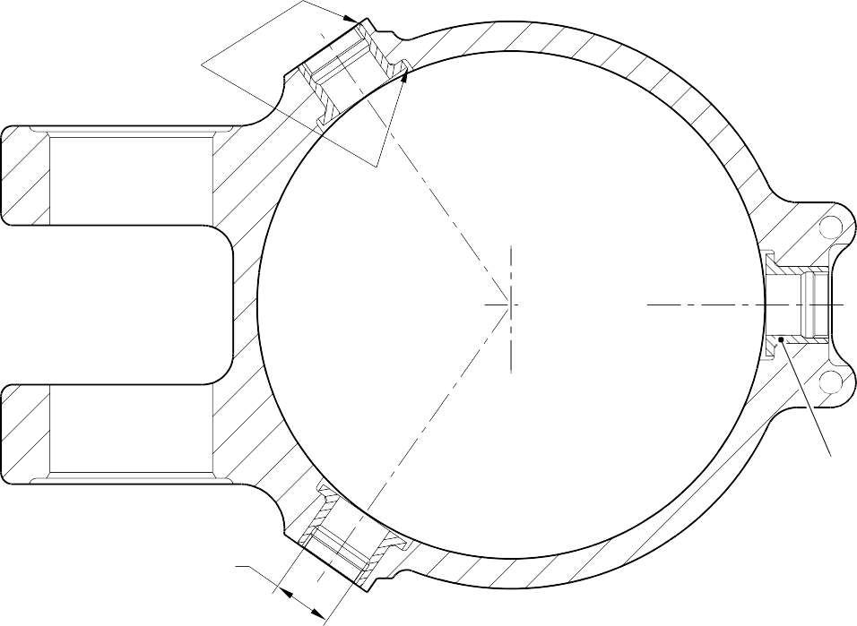
APPLY SEALANT TO PCS-7200 TYPICAL 6 PLACES

26,000 to 26,021mm
(1.0236 to 1.0244in)
DIAMETER TYPICAL 3 PLACES

SECTION Z-Z
(REFER TO FIGURE 601) WITH REPAIR BUSHES INSTALLED
REPAIR BUSH 450258800
(3 OFF)

A321A5150-2

Repair to Main Fitting - Repair Bush Machining and Installation Figure 603

INTENTIONALLY BLANK

- Repair No. 11-8 Main Fitting (20-410, 20-410A, 20-420 and 20-420A)
  - Specified Damage and Material Specification.
    - Specified Damage
      - Damage or corrosion to the diameter A and/or the adjacent face(s) B. (Refer to Figure 601).
    - Material Specification
IPL Figure and  Item No. | Name | Material Specification
20-410, 20-410A,  20-420 and 20-420A | Main fitting | Steel, MAT135, 35NCD16THQ

  - Special Tools
    - These special tools are necessary:

Part No. | Special Tool | Function
460006246 | Alignment Bar | Install the repair bush 450258806
460006249/1 | Cutter | Finish machine the repair bush 450258806
460006250 | Press Pad | Install the repair bush 450258806
  - Materials
    - These materials are necessary:

NOTE: Alternative equivalents are permitted.

Ref. Item | Material
- | Electrically conducting zinc loaded Molykote 111: refer to  PCS-7304
09-510A | Sealant: refer to PCS-7200
  - Repair Parts
    - These repair parts are necessary:

Part No. | Repair Part | Material Specification
450258806 | Repair bush (Qty 2) | TBA
  - Procedure (Refer to Figures 601 and 602)

CAUTION: FOR DAMAGE MORE THAN THE LIMITS OF THIS REPAIR SCHEME, WRITE TO SAFRAN LANDING SYSTEMS: REFER TO GUIDE-CS-001.
    - Machine the diameter A, sufficiently only to remove the damage or corrosion: refer to M-DLPS1004-4-1. Diameter A must not be more than 68,13 mm (2.682 in). Dimension C must not be less than 22,15 mm (0.872 in). The surface finish must be 1,6 micrometers (63 micro-inches): refer to Figure 601.

    - Measure and record the diameter A.
    - If necessary, machine the spotface(s) sufficiently to remove the damage or corrosion: refer to M-DLPS1004-4-1. Do not remove more than 1,00 mm (0.040 in) of material from each face. Make the chamfers and radii as shown, do not reduce the dimension(s) D to less than 71,250 mm (2.805 in): refer to Figure 601. The surface finish must be 1,6 micrometers (63 micro-inches).
    - Measure and record the dimension(s) D.
    - Examine the bare metal for flaws: refer to PCS-3600 and PCS-3100, inclusion class 4.
    - Shot peen the machined areas: refer to M-DLPS123.
    - Apply cadmium plate locally to the machined areas: refer to PCS-2141.
    - Identify the part with the Safran Landing Systems repair number 450266010 adjacent to the part number: refer to PCS-6000-04, an alternative reference is PCS-6000-06. If the alternative reference is used, the characters must be 0,051 to 0,102 mm (0.0020 to 0.0040 in) deep and approximately 3,00 mm (0.118 in) high.
    - Prepare the repair bush(es) 450258806 for installation: refer to Figure 602:
      - Machine diameter G of the repair bush to the diameter from this formula:
Dia. G = Dia. A (as measured in para (2)) + 0,029 to 0,078 mm (+ 0.0011 to 0.0030 in). The surface finish must be 1,6 micrometers (63 micro-inches).
      - Machine face H of the repair bush to get a dimension J from this formula:
Dim. J = Dim. D (as measured in para (4)) - 29,745 mm to 30,00 mm (1.171 to 1.181 in). The surface finish must be 1,6 micrometers (63 micro-inches).
      - Locally apply cadmium plate all over the repair bush(es) but not to the bore, internal grooves and face M: refer to PCS-2101 or PCS-2141. The cadmium plate thickness must be between 0,010 and 0,015 mm (0.0004 and 0.0006 in).
    - Use zinc loaded molykote 111 and the Alignment Bar 460006246 and Press Pad 460006250 to install the repair bush(es): refer to PCS-5105, PCS-7304 and Figure 602.
    - If necessary, hand ream or hone the bore of the repair bushes to between 60,00 and 60,03 mm (2.362 and 2.363 in). Do not machine: refer to Figure 602.
    - If necessary, use the Cutter 460006249/1 to machine the flange face(s) M of the repair bushes to get a dimension K of between 75,459 and 75,479 mm (2.9708 and 2.9716 in) and a dimension L of between 150,917 and 150,957 mm (5.9416 and 5.9432 in): refer to Figure 602. The surface finish must be 1,6 micrometers (63 micro-inches).
    - If necessary, machine the internal chamfers of the repair bushes as shown: refer to Figure 602. The surface finish must be 1,6 micrometers (63 micro-inches).
    - Apply sealant, Material Ref. Item 09-510A, between the repair bush(es) and the main fitting: refer to PCS-7200 and Figure 602.
    - Identify the part with the Safran Landing Systems repair number 450266010 adjacent to the part number: refer to PCS-6000-07.
    - Examine the part to make sure that you have obeyed all the repair instructions correctly.

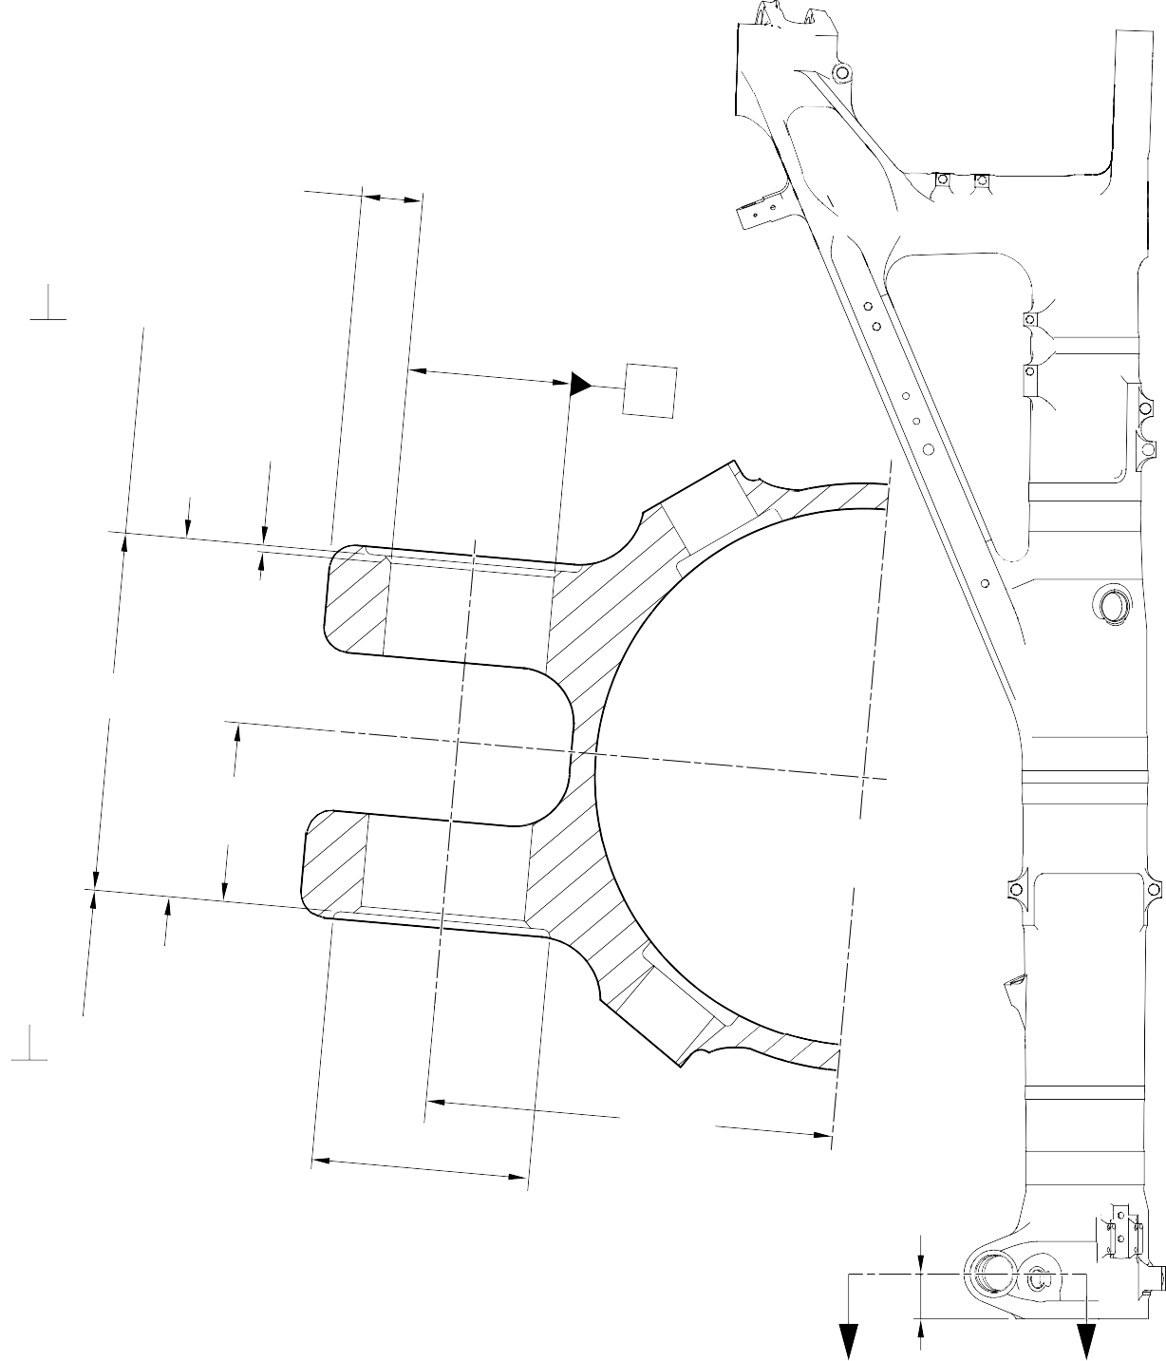
DIM . C MINIMUM WALL
THICKNESS

 | 0,05mm (0.002in) | X
1,75 to 2,25mm
(0.069 to 0.089in)
X 45 DEGREES
CHAMFER (2 PLACES)
FACE
B

DIA. A 68,13mm (2.682in) MAXIMUM

X

142,75mm (5.620in) MIN. BETWEEN SPOTFACES

DIM. D 71,250mm (2.805in) MIN.

PART SECTION Z-Z
WITHOUT REPAIR BUSHES
FACE
B

 | 0,05mm (0.002in) | X

88,75 to 89,25mm
(3.494 to 3.514in) DIAMETER SPOTFACE WITH
4,75 to 5,25mm
(0.187 to 0.207in) CORNER RADIUS (2 PLACES)
160,00mm (6.299in) REF.

82,00 to 83mm
(3.228 to 3.268in) REF.

Z Z

A321-S-32-12-22-080-1

Repair to Main Fitting Figure 601

DIM. K

FACE M
BORE
0,95 to 1,45mm
(0.037 to 0.057in)
RADIUS
FACE
H
DIM. J
1,25 to 1,75mm
(0.049 to 0.069in)
X 15 DEGREES
CHAMFER
DIA. G
0,01mm (0.0004in)
0,025mm (0.001in)
REPAIR BUSH 450258806 MACHINING



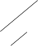

SEALANT TO PCS-7200 (BOTH BUSHES)
DIM. K
DIM. L
REPAIR BUSH 450258806
0,95 to 1,45mm
(0.037 to 0.057in)
X 60 DEGREES INCLUSIVE CHAMFER
(2 PLACES)
PART SECTION Z-Z
WITH REPAIR BUSHES INSTALLED
A321-S-32-12-22-081-1

Repair to Main Fitting - Repair Bush Machining and Installation Figure 602

- Repair No. 11-9 Main Fitting (20-410, 20-410A, 20-420 and 20-420A)
  - Specified Damage and Material Specification.
    - Specified Damage
      - Damage or corrosion to the diameter(s) A and the adjacent face(s) B. (Refer to Figure 601).
    - Material Specification
IPL Figure and  Item No. | Name | Material Specification
20-410, 20-410A,  20-420 and 20-420A | Main fitting | Steel, MAT135, 35NCD16THQ

  - Special Tools
    - These special tools are necessary:

Part No. | Special Tool | Function
460004330/122 | Press Pad | Install the repair bush 450217852
460004330/123 | Press Pad | Install the repair bush 450217851
  - Materials
    - These materials are necessary:

NOTE: Alternative equivalents are permitted.

Ref. Item | Material
09-510A | Sealant: refer to PCS-7200
TBA | Jointing Compound, zinc loaded Mastinox D40: refer to M-DLPS709-14
  - Repair Parts
    - These repair parts are necessary:

Part No. | Repair Part | Material Specification
450217851 | Repair bush | Aluminium Bronze, DTD197
450217852 | Repair bush | Aluminium Bronze, DTD197
  - Procedure (Refer to Figures 601, 602 and 603)
    - Machine the diameter(s) A, sufficiently only to remove the damage or corrosion: refer to M-DLPS1004-4-1. Diameter A must not be more than 54,130 mm (2.1311 in). The surface finish must be 1,6 micrometers (63 micro-inches).

    - Machine the face(s) B, sufficiently only to remove the damage or wear: refer to M-DLPS1004-4-1. Do not remove more than 1,00 mm (0.039 in) of material from the face(s) B. The surface finish must be 1,6 micrometers (63 micro-inches).
    - Machine the chamfers and radii as shown: refer to Figure 602.
    - Measure and record the new diameter(s) A and the dimensions C1 and C2.
    - Examine the bare metal for flaws: refer to PCS-3600 and PCS-3100, inclusion class 4.
    - Shot peen the machined area: refer to M-DLPS123.
    - Apply cadmium plate to the machined area: refer to PCS-2141.
    - Identify the part with the Safran Landing Systems repair number 450266030 adjacent to the part number: refer to PCS-6000-04, an alternative reference is PCS-6000-06. If the alternative reference is used, the characters must be 0,051 to 0,102 mm (0.0020 to 0.0040 in) deep and approximately 3,00 mm (0.118 in) high.
    - Prepare the repair bush(es) 450217851 and 450217852 for installation: refer to Figure 602:
      - Calculate diameter D1 of the repair bush 450217851 from this formula:
D1 = A (as measured in para (4)) + 0,023 to 0,072 mm (+ 0.0009 to 0.0028 in).
      - Calculate dimension F1 of the repair bush 450217851 from this formula: F1 = C1 (as measured in para (4)) + 0,00 to 1,25 mm (+ 0.000 to 0.049 in).
      - Calculate diameter D2 of the repair bush 450217852 from this formula:
D2 = A (as measured in para (4)) + 0,023 to 0,072 mm (+ 0.0009 to 0.0028 in).
      - Calculate dimension F2 of the repair bush 450217852 from this formula: F2 = C2 (as measured in para (4)) + 0,00 to 1,25 mm (+ 0.000 to 0.049 in).
      - Machine the repair bushes to the dimensions shown and calculated. Make the surface finish 1,6 micrometers (63 micro-inches).
      - Apply cadmium plate to the repair bush(es): refer to PCS-2101 or PCS-2141. Do not apply cadmium plate to the bores of the bush(es). The cadmium plate thickness must be between 0,010 and 0,015 mm (0.0004 and 0.0006 in).
    - Use jointing compound, zinc loaded Mastinox D40, Material Ref. Item, TBA and the Press Pads 460004330/122 and 460004330/123 to install the repair bush(es): refer to M-DLPS709-14, M-DLPS1011-20 and Figure 603. Make sure that the drain hole J is free from jointing compound: refer to Figure 603.
    - Machine the flanges of the bush(es) to get:
      - A dimension H of between 111,25 and 111,45 mm (4.380 and 4.388 in): refer to Figure 603. The surface finish must be 1,6 micrometers (63 micro-inches).
      - A dimension G of between 222,50 and 222,75 mm (8.760 and 8.770 in): refer to Figure 603. The surface finish must be 1,6 micrometers (63 micro-inches).
    - Machine the chamfers of the repair bush(es) to the dimensions shown. The surface finish must be 1,6 micrometers (63 micro-inches).

    - If necessary, check line ream the bore of the bush 450217851 to between 36,000 and 36,025 mm (1.4170 and 1.4180 in).
    - If necessary, check line ream the bore of the bush 450217852 to between 46,825 and 46,864 mm (1.8440 and 1.8450 in).
    - Apply sealant, Material Ref. Item 09-510A, between the repair bush(es) and the main fitting: refer to PCS-7200 and Figure 603.
    - Identify the part with the Safran Landing Systems repair number 450266030 adjacent to the part number: refer to PCS-6000-07.
    - Examine the part to make sure that you have obeyed all the repair instructions correctly.

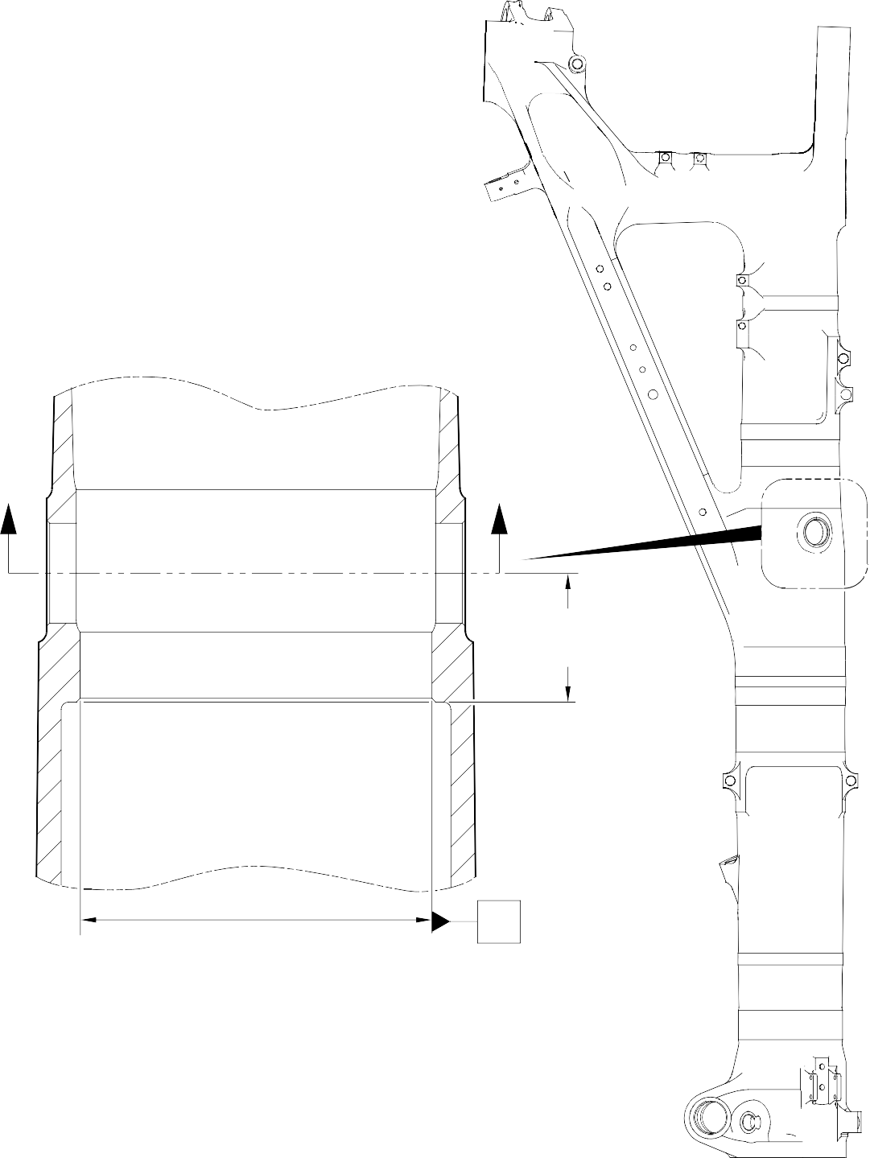
Z
Z REFER TO
FIGURE 602
66,30 to 66,70mm
(2.650 to 2.626in) REF.
X
A321A5153-1

Repair to Main Fitting Figure 601

215,50mm (8.484in) MINIMUM
 | 0,030mm (0.0012in) | Y
FACE B Y
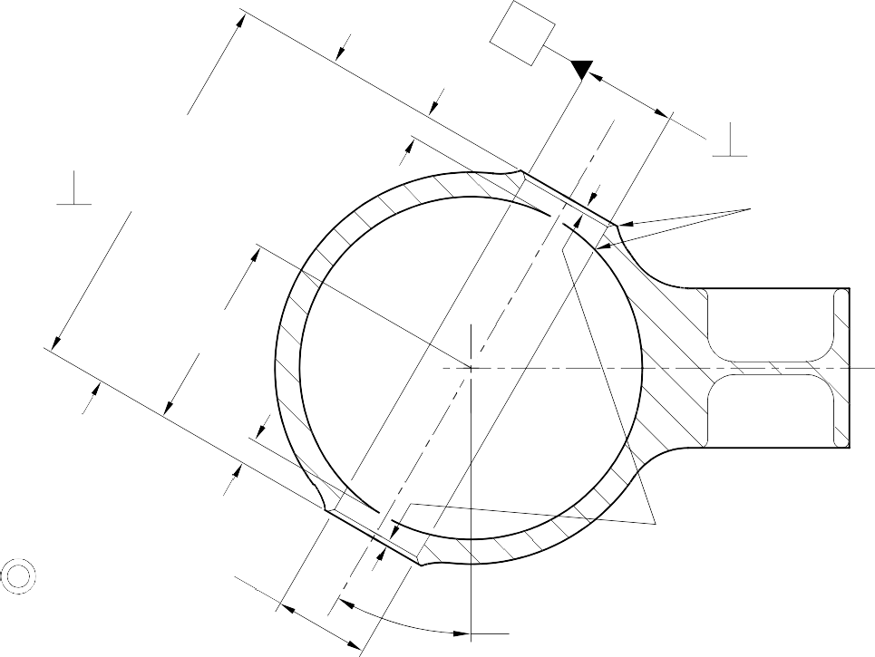
C2

DIAMETER
A

 | 0,025mm (0.0010in) | X

1,00 to 2,00mm
(0.039 to 0.079in) RADIUS TYPICAL

(4.242in)
107,75mm

FACE B

C1
1,25 to 1,75mm (0.049 to 0.069in)
X 44.5 to 45.5 DEGREES CHAMFER
 | 0,05mm (0.002in) | Y

SECTION Z-Z

DIAMETER
A
29.5 to 30.5 DEGREES
WITHOUT BUSHES

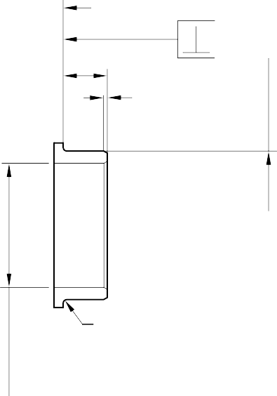

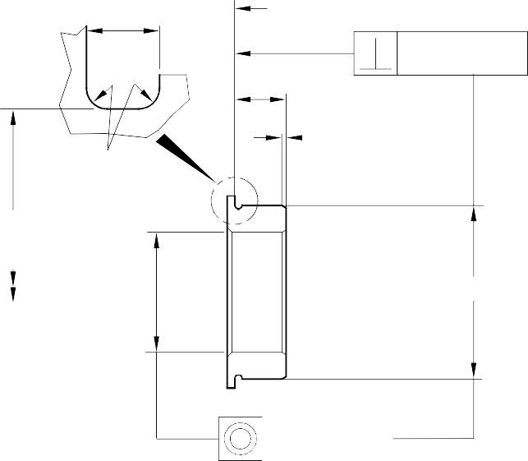
1,75 to 2,25mm
MACHINE THIS FACE
F2
0,95 to 1,45mm
(0.037 to 0.057in)
X 15 DEGREES CHAMFER
D2
0,02mm (0.001in)
(0.069 to 0.088in)
MACHINE THIS FACE
0,02mm (0.001in)
F1
0,50 to 1,00mm
(0.020 to 0.039in) RADIUS
50,00mm
(1.969in) DIA.
0,95 to 1,45mm (0.037 to 0.057in)
x 15 DEGREES CHAMFER
D1
0,025mm (0.0010in)

0,75 to 1,25mm
(0.030 to 0.049in) RADIUS
0,025mm (0.0010in)

REPAIR BUSH 450217851
REPAIR BUSH 450217852

A321A5154-1

Repair to Main Fitting - Machining Figure 602

32-12-22
Repair No. 11-9
Page 605

0,95 to 1,45mm
(0.037 to 0.057in)
x 30 DEGREES CHAMFER
REPAIR BUSH 450217852

G
SEALANT TO PCS-7200

H

REPAIR BUSH 450217851
INTENTIONALLY BLANK

W

0,95 to 1,45mm
(0.037 to 0.057in)
x 30 DEGREES CHAMFER

SEALANT TO PCS-7200

SECTION Z-Z
WITH REPAIR BUSHES

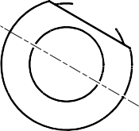












DRAIN HOLE J

VIEW W
REFERENCE BOTTOM OF MAIN FITTING

A321A5155-1

Repair to Main Fitting - Repair Bush Installation Figure 603

- Repair No. 11-10 Main Fitting (20-410 and 20-420 Only)
  - This repair, Messier-Dowty Limited Repair No. 450267270, has been withdrawn from use. It is superseded by Repair No. 11-29 (450267275) or Repair No. 11-30 (450267385).

Repair No. 11-10

32-12-22
Page 601

INTENTIONALLY BLANK

- Repair No. 11-11 Main Fitting (20-410, 20-410A, 20-420 and 20-420A)
  - Specified Damage and Material Specification
    - Specified Damage
      - Damage or corrosion to the diameter A.
    - Material Specification
IPL Figure and  Item No. | Name | Material Specification
20-410, 20-410A,  20-420 and 20-420A | Main Fitting | Steel, MAT135, 35NCD16THQ

  - Special Tools
    - These special tools are necessary:

NOTE: Alternative equivalents are permitted.

Part No. | Special Tool | Function
460004330/91 | Press Pad | Install the repair bearing
  - Materials
    - These materials are necessary:

NOTE: Alternative equivalents are permitted.

Ref. Item | Material
04-512 | Molykote 111
09-510A | Sealant
  - Repair Parts
    - These repair parts are necessary:

Part No. | Repair Part | Material Specification
450237824 | Repair Bearing | Aluminium Bronze, DTD197
  - Procedure (Refer to Figures 601 and 602)

CAUTION: FOR DAMAGE MORE THAN THE LIMITS OF THIS REPAIR SCHEME, WRITE TO SAFRAN LANDING SYSTEMS: REFER TO GUIDE-CS-001.
    - Machine diameter A sufficiently to remove the damage or wear and to between 14,018 and 14,485 mm (0.5519 and 0.5703 in): refer to M-DLPS914, M-DLPS1004-4-1
and Figure 601. Make the surface finish 1,6 micrometers (63 micro-inches) or better.
    - Examine the main fitting for flaws: refer to PCS-3100, inclusion class 4 and PCS-3600.
    - Measure and record the new diameter A.

    - Identify the part with the Safran Landing Systems repair number 450266015 adjacent to the part number: refer to PCS-6000-04 or PCS-6000-06.
    - Apply cadmium plate to the reworked area: refer to PCS-2100 and PCS-2141. Fadeout of cadmium plate is permitted in bore.
    - Apply primer paint to reworked areas: refer to PCS-2500.
    - Calculate the diameter B of the repair bearing, use formula:
Dia. B = Dia. A (as measured) - 0,006 to + 0,023 mm (- 0.0002 to + 0.0009 in).
    - Machine the repair bearing to the diameter calculated and as shown: refer to Figure 602. Make the surface finish 1,6 micrometers (63 micro-inches).
    - Apply cadmium plate all over the repair bearing: refer to PCS-2101 or PCS-2141. The cadmium plate thickness must be between 0,010 and 0,015 mm (0.0004 and 0.0006 in).
    - Use the press pad 460004330/91 to install the repair bearing. Use Molykote 111, Material Ref. Item 04-512: refer to PCS-7304. The ends of the bearing must be below the end of the bearing hole: refer to Figure 602.
    - Check the bore diameters of the repair bearing: refer to Figure 602.
    - Do not machine the repair bearing. If necessary, hone the bore diameters of the repair bearing to the dimensions shown: refer to Figure 602.
    - Apply sealant, Material Ref. Item 09-510A, to the joints between the repair bearing and main fitting: refer to PCS-7200 and Figure 602.
    - Apply paint to the repaired area, except where indicated: refer to PCS-2500, REPAIR and Figure 602.
    - Identify the part with the Safran Landing Systems repair number 450266015 adjacent to the part number: refer to PCS-6000-07.
    - Examine the part to make sure that you have obeyed all the repair instructions correctly.

1,6
(63)

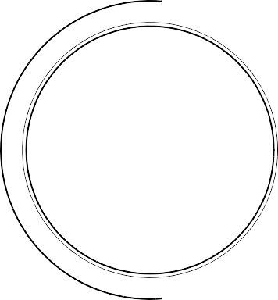
Z
Z

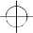 | 0,30mm (0.0118in) DIA. | X



SECTION Z-Z
DIA. A NO PAINT
X
113,00mm (4.449in) REF.
(WITHOUT BEARING)

A321-S-32-12-22-018-1

Repair to Main Fitting - Machining Figure 601

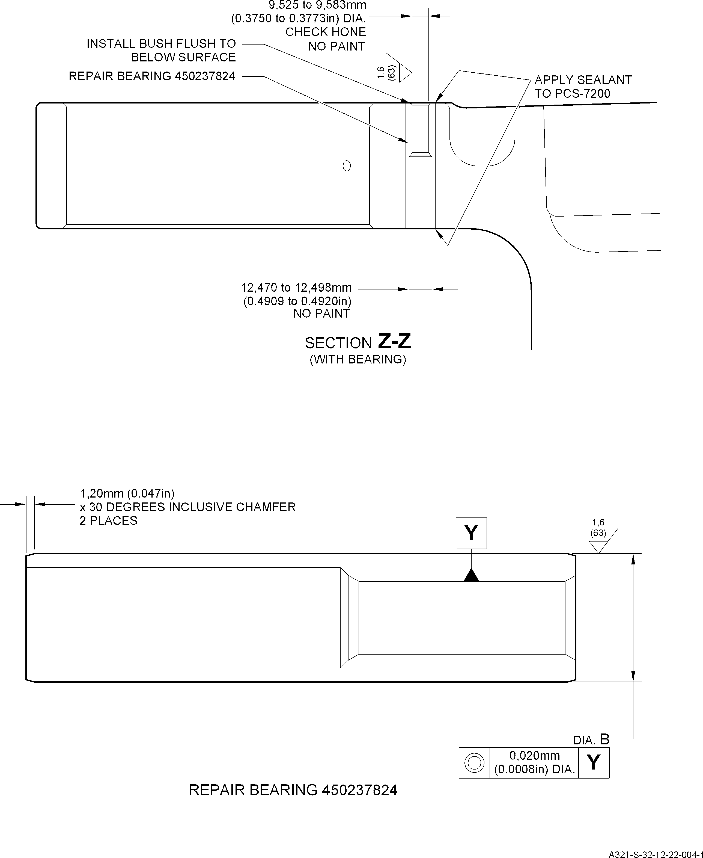

Repair Bearing - Machining and Installation Figure 602

