- Repair No. 11-12 Main Fitting (20-410, 20-410A, 20-420 and 20-420A)
  - Specified Damage and Material Specification.
    - Specified Damage
      - Damage or wear to the diameter A.
    - Material Specification
IPL Figure and  Item No. | Name | Material Specification
20-410, 20-410A,  20-420 and 20-420A | Main fitting | Steel, MAT135, 35NCD16THQ

  - Special Tools
    - These special tools are necessary:

NOTE: Alternative equivalents are permitted.

Part No. | Special Tool | Function
460006265 | Press Pad | Install the bush 450237800
  - Materials
    - These materials are necessary:

NOTE: Alternative equivalents are permitted.

Ref. Item | Material
08-704 | Adhesive
09-510A | Sealant
  - Repair Parts
    - These repair parts are necessary:

Part No. | Repair Part | Material Specification
450237800 | Blank bush | Aluminium Bronze, DTD197
  - Procedure (Refer to Figures 601 and 602)

CAUTION: FOR DAMAGE MORE THAN THE LIMITS OF THIS REPAIR SCHEME, WRITE TO SAFRAN LANDING SYSTEMS: REFER TO GUIDE-CS-001.
    - Remove the paint locally from the main fitting: refer to PCS-2700.
    - Remove the cadmium plate locally from the main fitting: refer to PCS-2100.
    - Machine diameter A sufficiently to remove the wear or damage within the dimensions shown: refer to M-DLPS914, M-DLPS1004-4-1 and Figure 601. Make the surface finish 1,6 micrometers (63 micro-inches) or better.

    - Measure and record the new diameter A.
    - Examine the main fitting for flaws: refer to PCS-3600 and PCS-3100, inclusion class 4.
    - Shot peen the reworked areas: refer to M-DLPS123.
    - Identify the part with the Safran Landing Systems repair number 450266035 adjacent to the part number: refer to PCS-6000-04 or PCS-6000-06.
    - Apply cadmium plate to the reworked area: refer to PCS-2100 and PCS-2141. Fadeout of cadmium plate is permitted in bore.
    - Calculate the diameter of the blank bush, use formula:
B = A (as measured) - 0,265 to -0,350 mm (-0.0104 to -0.0138 in).
    - Machine the blank bush to the diameter calculated and as shown: refer to Figure 602.
    - Apply cadmium plate all over the repair bush: refer to PCS-2101. The cadmium plate thickness must be between 0,003 and 0,005 mm (0.00015 and 0.00020 in).
    - Apply adhesive, Material Ref. Item 08-704, to the outside diameter of the repair bush and to the hole of the main fitting where you will install the repair bush: refer to PCS-5303.
    - Use Press Pad 460006265 and install the repair bush: refer to Figure 602. The ends of the bush must be below the main fitting surface after installation.
    - Check the bore diameter of the repair bush: refer to Figure 602.
    - If necessary, hone the bore diameter of the repair bush to the dimensions shown: refer to Figure 602.
    - Apply sealant, Material Ref. Item 09-510A, to the joints between the repair bush and main fitting: refer to PCS-7200 and Figure 602.
    - Apply paint locally to the repaired area, but not to the repair bush bore: refer to PCS-2500 and Figure 602.
    - Identify the part with the Safran Landing Systems repair number 450266035 adjacent to the part number: refer to PCS-6000-07.
    - Examine the part to make sure that you have obeyed all the repair instructions correctly.

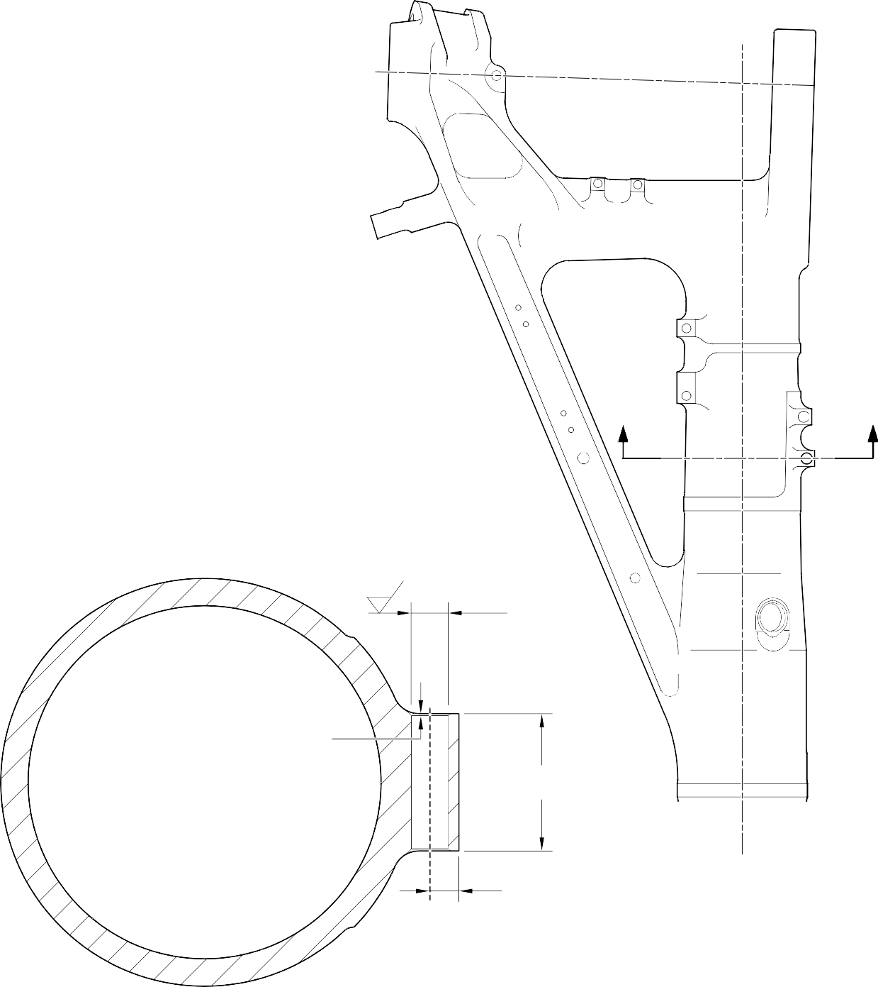
- Z

1,6
(63)

DIA. A 21,50mm (0.8465in) MAXIMUM NO PAINT

1,00mm (0.039in) x 45 DEGREES CHAMFER
(2 PLACES)

SECTION Z-Z
(WITHOUT BUSH)

69,75 to 71,75mm
(2.7461 to 2.8248in)

14,25mm (0.5610in) REF.

A321-S-32-12-22-036-1

Repair to Main Fitting - Machining Figure 601


1,6
(63)

DIA. B

1,20mm (0.047in)
x 30 DEGREES INCLUSIVE CHAMFER BOTH ENDS

REPAIR BUSH 450237800

1,6
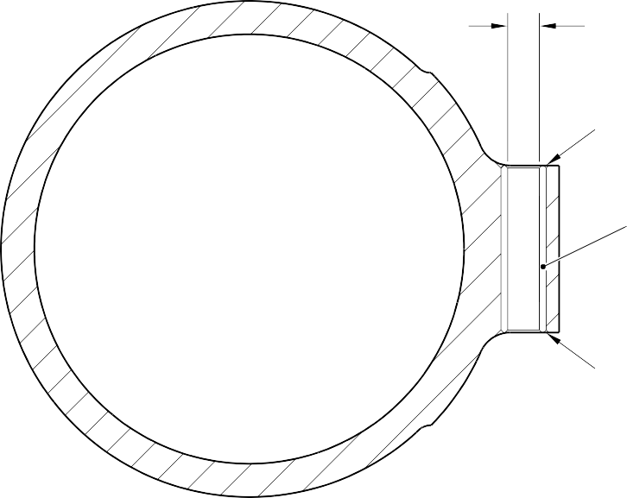

(63)

16,50mm (0.650in) DIA. CHECK HONE
NO PAINT

APPLY SEALANT TO PCS-7200

REPAIR BUSH 450237800

APPLY SEALANT TO PCS-7200

SECTION Z-Z
(REFER TO FIGURE 601) WITH REPAIR BUSH

A321-S-32-12-22-037-1

Repair Bush - Machining and Installation Figure 602

- Repair No. 11-13 Main Fitting (20-410, 20-410A, 20-420 and 20-420A)
  - Specified Damage and Material Specification.
    - Specified Damage
      - Damage or corrosion to the diameters A and/or B and/or adjacent internal faces.
    - Material Specification
IPL Figure and  Item No. | Name | Material Specification
20-410, 20-410A,  20-420 and 20-420A | Main fitting | Steel, MAT135, 35NCD16THQ

  - Special Tools
    - These special tools are necessary:

NOTE: Alternative equivalents are permitted.

Part No. | Special Tool | Function
460006600 | Press Pad Assembly | Install the repair bush 450237810
460006601 | Alignment Bar | Use with Press Pad 460006600
460006602 | Cutter | To get the correct dimension across the repair bushes
460006603 | Press Pad Assembly | Install the bush made from 450237811
460006604 | Guide Bush | Use with Press Pad 460006603
  - Materials
    - These materials are necessary:

NOTE: Alternative equivalents are permitted.

Ref. Item | Material
TBA | Mastinox, D40
TBA | Zinc Powder
09-510A | Sealant

  - Repair Parts
    - These repair parts are necessary:

Part No. | Repair Part | Material Specification
450237810 | Blank Bush | Aluminium Bronze, DTD197 or  AMS4-880C
450237811 | Blank Bush  (Refer to Table 1 for oversize bushes) | Steel, S132
  - Procedure (Refer to Figures 601 and 602)
    - Machine diameters A and/or B sufficiently to remove the damage or corrosion within the dimensions shown: refer to M-DLPS1004-4-1 and Figure 601. Make the surface finish 1,6 micrometers (63 micro-inches).
    - Machine the adjacent internal faces sufficiently to remove the damage or corrosion within the dimensions shown: refer to M-DLPS1004-4-1 and Figure 601. Make the surface finish 1,6 micrometers (63 micro-inches).
    - Machine the radii and chamfers to the dimensions shown: refer to Figure 601.
    - Measure and record the new diameters A and B and dimensions D and E.
    - Examine the main fitting for flaws: refer to PCS-3600 and PCS-3100, inclusion class 4.
    - Shot peen the machined areas: refer to M-DLPS123.
    - Apply cadmium plate to the reworked areas: refer to PCS-2141.
    - Identify the part with the Safran Landing Systems repair number 450266050 adjacent to the part number: refer to PCS-6000-04 or PCS-6000-06. If the PCS-6000-06 is used, the letters must have a depth of 0,051 to 0,102 mm (0.0020 to 0.0040 in) and an approximate height of 3,00 mm (0.118 in).
    - Calculate the dimensions to machine the repair bush 450237810 for diameter A:
F = A (as measured) + 0,023 to 0,072 mm (0.0009 to 0.0028 in),
G = D (as measured) + 0,65 to 1,35 mm (0.026 to 0.053 in).
    - Machine the repair bush 450237810 to the dimensions shown and calculated: refer to Figure 602. Make the surface finish 1,6 micrometers (63 micro-inches).
    - With the measured dimension E, select the applicable oversize bush from Table 1.
    - Calculate the diameter of the oversize bush for diameter B:
H = B (as measured) + 0,023 to 0,072 mm (0.0009 to 0.0028 in).
    - Machine the oversize bush to the dimensions shown and calculated: refer to Figure 602. Make the surface finish 1,6 micrometers (63 micro-inches).
    - If necessary machine the flange face of the repair bush (450237810) to get the correct dimension between the bush faces on assembly as shown: refer to Figure 602.
    - Restore the chamfers to the dimensions as shown: refer to Figure 602.

    - Apply cadmium plate all over the repair bush (450237810) and only to the reworked areas of selected oversize bush: refer to PCS-2101 and PCS-2141. Do not apply cadmium plate to the bush bores. Make the cadmium plate thickness between 0,010 and 0,015 mm (0.0004 to 0.0006 in).
    - Use press pad assembly 460006600 and alignment bar 460006601 and install the repair bush. Use press pad assembly 460006603, alignment bar 460006601 and guide bush 460006604 and install the oversize bush: refer to M-DLPS1011-20. Use electrically conducting mastinox (make from Mastinox D40, Material Ref. Item TBA and Zinc powder, Material Ref. Item TBA): refer to M-DLPS709-14.
    - Check line ream the repair bushes to the dimensions shown: refer to Figure 602.
    - Apply sealant, Material Ref. Item 09-510A to the joints between the repair bushes and the main fitting: refer to PCS-7200 and Figure 602.
    - Identify the main fitting with the Safran Landing Systems repair number 450266050 adjacent to the part number: refer to PCS-6000-07.
    - Examine the part to make sure that you have obeyed all the repair instructions correctly.
Table 1
Oversize Bushes For Diameter B

Oversize | Step  mm (in) | Oversize  Bush | Dimension E  (as measured) mm (in) | Dimension J  mm (in)
- | Std | 450237351 | 27,75 to 28,25  (1.093 to 1.112) | 2,45 to 2,55  (0.096 to 0.100)
1 | 0,127  (0.005) | 450237352 | 27,62 to 28,12  (1.087 to 1.107) | 2,58 to 2,68  (0.102 to 0.106)
2 | 0,254  (0.010) | 450237353 | 27,50 to 28,00  (1.083 to 1.102) | 2,70 to 2,80  (0.106 to 0.110)
3 | 0,381  (0.015) | 450237354 | 27,37 to 27,87  (1.078 to 1.097) | 2,83 to 2,93  (0.111 to 0.115)
4 | 0,508  (0.020) | 450237355 | 27,24 to 27,74  (1.072 to 1.092) | 2,96 to 3,06  (0.117 to 0.120)

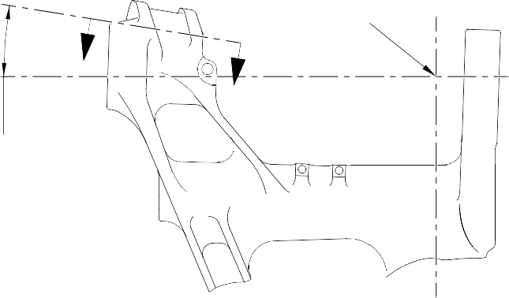
POINT C
Z
Z
9 DEGREES
11 MINUTES
38 SECONDS REF.
262,01mm (10.315in) TO POINT 'C'
DIA. A
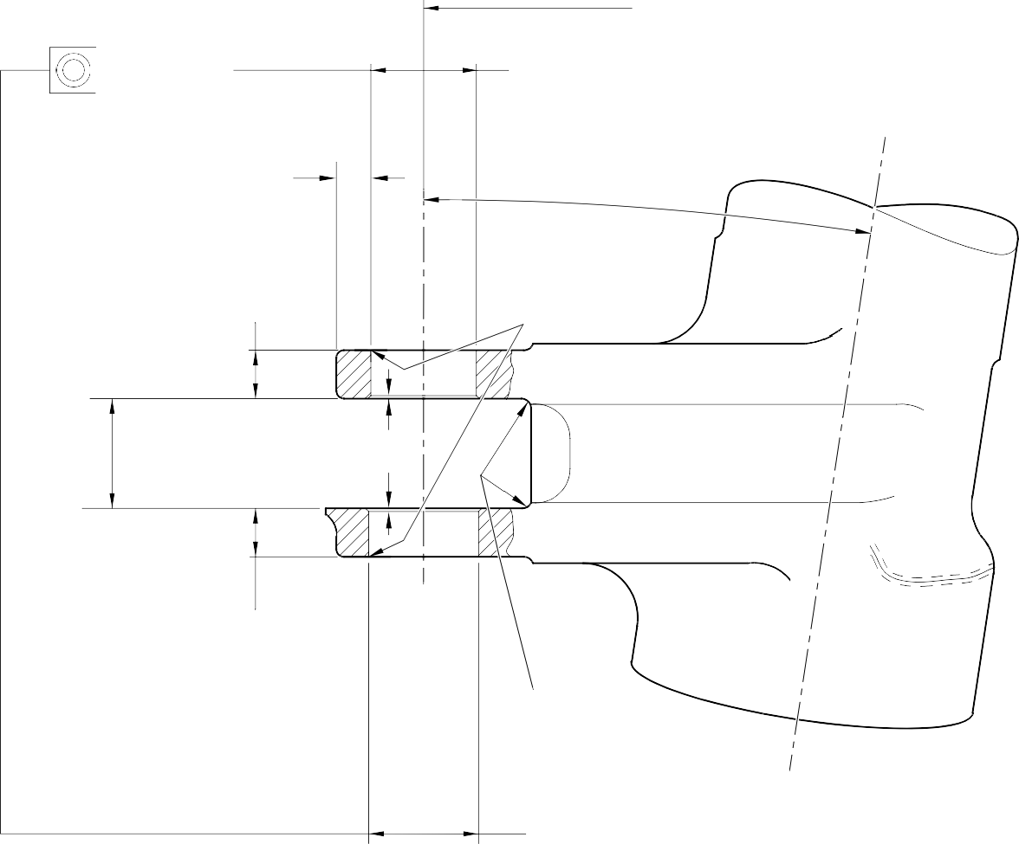
58,13mm (2.2886in) MAXIMUM
0,05mm (0.002in) DIA.

8 DEGREES 13 MINUTES
14,515mm (0.5714in) MIN. WALL THICKNESS
17 SECONDS REF.

DIM. D
27,25mm (1.072in) MIN.
1,00 to 2,00mm
(0.039 to 0.079in) RAD.

DIM. C 62,760mm (2.4709in) MAX.

1,25 to 1,75mm (0.049 to 0.069in) x 45 DEGREES CHAMFER

DIM. E
27,25mm (1.072in) MIN.

PART SECTION Z-Z
WITHOUT BUSHES
BLEND SMOOTHLY TO EXISTING RADIUS
4,00 to 5,00mm
(0.157 to 0.197in) RAD.

DIA. B
59,130mm (2.3279in) MAX.

A321-S-32-12-22-100-0

Repair to Main Fitting Figure 601

0,010mm (0.0004in)

0,95 to 1,45mm
(0.037 to 0.057in)
X 30 DEGREES CHAMFER
DIM. J

DIA.
H

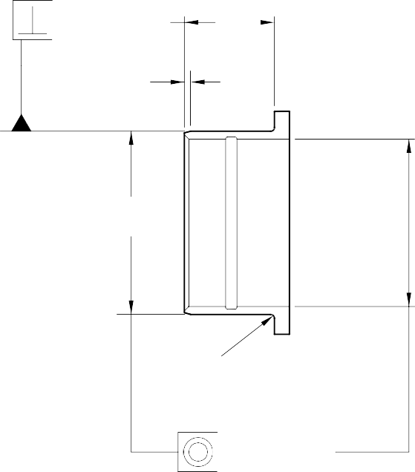
65,00 to 75,00mm
DIM.
G
0,95 to 1,45mm
(0.037 to 0.057in)
x 15 DEGREES CHAMFER
DIA.
F
0,55 to 1,05mm (0.022 to 0.041in) RAD.
0,025mm (0.0010in) DIA.
0,010mm (0.0004in)

0,55 to 1,05mm (0.022 to 0.041in) RAD.
0,95 to 1,45mm
(0.037 to 0.057in)
X 15 DEGREES CHAMFER
0,025mm (0.0010in) DIA.

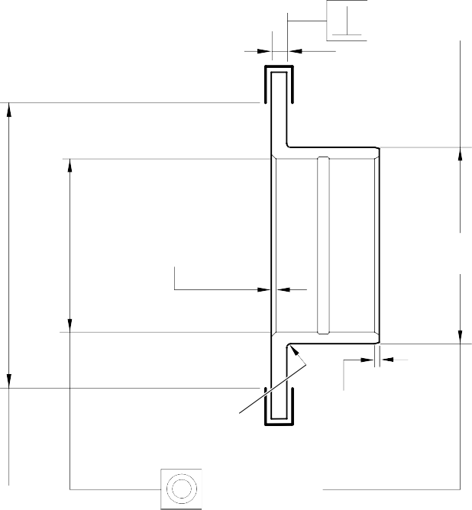
OVERSIZE BUSH 450237810
(2.559 to 2.953in) DIA. OVERSIZE BUSH
(REFER TO TABLE 1)

NITRIDING DEPTH 0,18 to 0,23mm (0.007 to 0.009in), 0,02 to 0,04mm (0.0008 TO 0.0016in) REMOVAL OVER AREA SHOWN 750HV MIN.
NOTE: REPAIR BUSHES 450237351, 450237352, 450237353, 450237354 AND 450237355 ARE TO BE NITRIDED BEFORE DESPATCH TO OVERHAUL AGENCY. DIAMETER H AND CORNER RADIUS ARE TO BE MACHINED ON RECEIPT
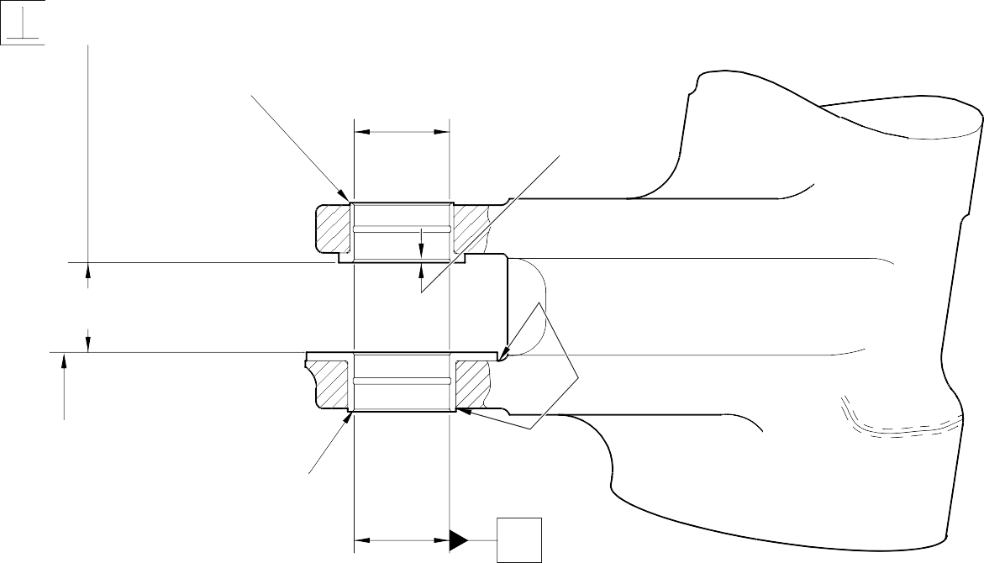
BY OVERHAUL AGENCY TO SUIT INDIVIDUAL BORE OF MAIN FITTING. LOCALLY APPLY CADMIUM PLATE TO THE REWORKED OUTER DIAMETER OF THE BUSHES: REFER TO PCS-2141.
W
0,050mm (0.0020in)

450237810
51,00 to 51,03mm
0,95 to 1,45mm

56,00 to 56,074mm
(2.205 to 2.208in)
(2.008 to 2.009in DIA. (0.037 to 0.057in)
x 29.75 to 30.25 DEGREES CHAMFER

DO NOT MACHINE THIS FACE
PART SECTION Z-Z
WITH BUSHES
(REFER TO FIGURE 601)

REFER TO TABLE 1

APPLY SEALANT TO PCS-7200
- PLACES

W

A321-S-32-12-22-098-0

Repair Bushes - Machining and Installation Figure 602

INTENTIONALLY BLANK

  - Repair No. 11-14 Main Fitting (20-410, 20-410A, 20-420 and 20-420A)
    - Specified Damage and Material Specification.
      - Specified Damage
        - Damage or corrosion to the diameter A and/or adjacent faces B.
      - Material Specification
IPL Figure and  Item No. | Name | Material Specification
20-410, 20-410A,  20-420 and 20-420A | Main fitting | Steel, MAT135, 35NCD16THQ

    - Special Tools
      - Special tools are not necessary.
    - Materials
      - These materials are necessary:

NOTE: Alternative equivalents are permitted.

Ref. Item | Material
TBA | Mastinox, D40
TBA | Zinc Powder
09-510A | Sealant
    - Repair Parts
      - These repair parts are necessary:

Part No. | Repair Part | Material Specification
Refer to Table 1 for oversize bearing
    - Procedure (Refer to Figure 601)
      - Machine the diameter A to the smallest oversize shown in Table 1 to remove the damage or corrosion: refer to M-DLPS1004-4-1 and Figure 601. Do not make diameter A more than 167,587 mm (6.598 in). Make the surface finish 1,6 micrometers (63 micro-inches).
      - Machine the face(s) B, sufficiently only to remove the damage or corrosion within the dimensions shown: refer to M-DLPS1004-4-1 and Figure 601. Do not machine more than 0,75 mm (0.0295 in) from each of the faces. Make the surface finish 1,6 micrometers (63 micro-inches).
      - Machine the radii and chamfers to the dimensions shown: refer to Figure 601.
      - Examine the main fitting for flaws: refer to PCS-3600 and PCS-3100, inclusion class 4.

      - Shot peen the machined area: refer to M-DLPS123.
      - Apply cadmium plate locally to the reworked area: refer to PCS-2141.
      - Use the selected spherical bearing assembly in the place of (19-50): refer to ASSEMBLY.
      - Identify the part with the Safran Landing Systems repair number 450266110 adjacent to the part number: refer to PCS-6000-07.
      - Examine the part to make sure that you have obeyed all the repair instructions correctly.
Table 1

Oversize | Step  mm (in) | Diameter A  mm (in) | Housing O/D (Ref.)  mm (in) | Oversize Bearing  Assembly
- | Std | 166,000 to 166,063  (6.5354 to 6.5378) | 165,934 to165,959  (6.5328 to 6.5337) | -
1 | 0,127  (.005) | 166,127 to 166,190  (6.5404 to 6.5428) | 166,061 to166,086  (6.5378 to 6.5387) | 450258301
2 | 0,254  (.010) | 166,254 to 166,317  (6.5454 to 6.5478) | 166,188 to 166,213  (6.5428 to 6.5437) | 450258302
3 | 0,381  (.015) | 166,381 to 166,444  (6.5504 to 6.5528) | 166,315 to 166,340  (6.5478 to 6.5487) | 450258303
4 | 0,508  (.020) | 166,508 to 166,571  (6.5554 to 6.5578) | 166,442 to 166,467  (6.5528 to 6.5537) | 450258304
5 | 0,635  (.025) | 166,635 to 166,698  (6.5604 to 6.5628) | 166,569 to 166,594  (6.5578 to 6.5587) | 450258305
6 | 0,762  (.030) | 166,762 to 166,825  (6.5654 to 6.5678) | 166,696 to 166,721  (6.5628 to 6.5637) | 450258306
7 | 0,889  (.035) | 166,889 to 166,952  (6.5704 to 6.5728) | 166,823 to 166,848  (6.5678 to 6.5687) | 450258307
8 | 1,016  (.040) | 167,016 to 167,079  (6.5754 to 6.5778) | 166,950 to 166,975  (6.5728 to 6.5737) | 450258308
9 | 1,143  (.045) | 167,143 to 167,206  (6.5804 to 6.5828) | 167,077 to 167,102  (6.5778 to 6.5787) | 450258309
10 | 1,270  (.050) | 167,270 to 167,333  (6.5854 to 6.5878) | 167,204 to 167,229  (6.5828 to 6.5837) | 450258310
11 | 1,397  (.055) | 167,397 to 167,460  (6.5904 to 6.5928) | 167,331 to 167,356  (6.5878 to 6.5887) | 450258311
12 | 1,524  (.060) | 167,524 to 167,587  (6.5954 to 6.5978) | 167,458 to 167,483  (6.5928 to 6.5937) | 450258312

Repair No. 11-14

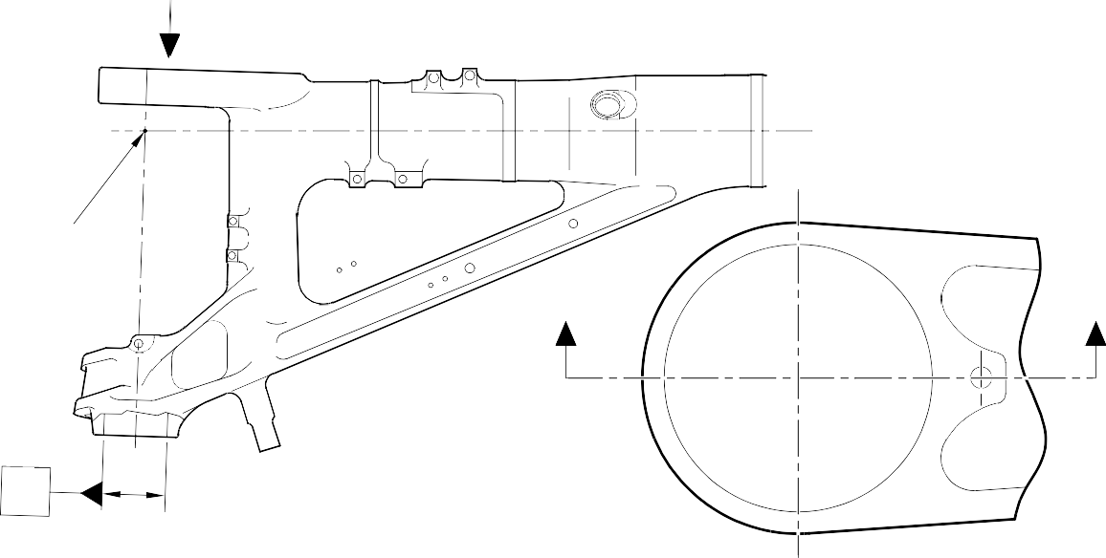
Z
POINT
C
Y
Y
X

PART VIEW ON ARROW Z

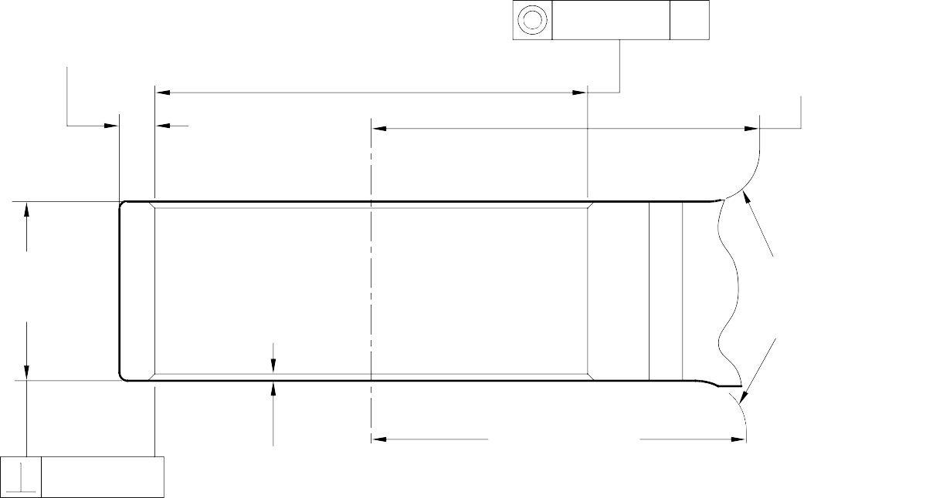
14,587mm (0.574in) MINIMUM
WALL THICKNESS

DIA A
(SEE TABLE 1)

0,125mm (0.0049in) DIA

144,75 to 145,25mm
X
(5.699 to 5.718in) RADIUS

66,50mm (2.618in) MINIMUM
18,80 to 19,30mm (0.740 to 0.760in) RAD BLEND SMOOTHLY TO ADJACENT SURFACES

0,05mm (0.002in)

2,50mm (0.098in)
x 45 DEGREES CHAMFER 2 PLACES
130,00 to 132,00mm
(5.118 to 5.197in) RADIUS
PART SECTION Y-Y
(WITHOUT OVERSIZE BEARING) ^{A321A5543-1}

Repair to Main Fitting - Machining Figure 601

Repair No. 11-14

32-12-22
Page 603

INTENTIONALLY BLANK

- Repair No. 11-15 Main Fitting (20-410 and 20-420 Only)
  - Specified Damage and Material Specification.
    - Specified Damage
      - Damage or corrosion to the diameter(s) A and/or adjacent faces B and/or C.
    - Material Specification
IPL Figure and  Item No. | Name | Material Specification
20-410 and  20-420 Only | Main fitting | Steel, MAT135, 35NCD16THQ

  - Special Tools
    - Special tools are not necessary.
  - Materials
    - These materials are necessary:

NOTE: Alternative equivalents are permitted.

Ref. Item | Material
TBA | Mastinox, D40
TBA | Zinc Powder
08-665 | Adhesive
09-510A | Sealant
  - Repair Parts
    - These repair parts are necessary:

Part No. | Repair Part | Material Specification
450237825 | Repair Bush (Qty 4) | Steel, S154
  - Procedure (Refer to Figures 601 to 603).

CAUTION: REPAIR WILL NOT BE PERMITTED BEYOND THE LIMITS OF THIS REPAIR SCHEME.
CAUTION: USE THIS PROCEDURE IF THE DAMAGE OR CORROSION TO FACES B OR C IS MORE THAN A DEPTH OF 0,75 MM (0.030 IN).
    - Remove the paint locally from the main fitting: refer to PCS-2700.
    - Remove the cadmium plate locally from the main fitting: refer to PCS-2100.
    - Machine diameter A sufficiently to remove the damage or corrosion: refer to M-DLPS1004-4-1 and Figure 602. Diameter(s) A must be between 9,60 and 10,00 mm (0.378 and 0.394 in). Make the surface finish 1,6 micrometers (63 micro-inches).

Repair No. 11-15

32-12-22
Page 601

    - Machine the faces B and/or C sufficiently to remove the damage or corrosion: refer to Figure 602. Do not remove more than 1,0 mm (0.040 in) from each of the faces. Lug width D must not be less than 8,75 mm (0.344 in). Make the surface finish 1,6 micrometers (63 micro-inches).
    - Machine the radii as shown: refer to Figure 602.
    - Measure and record the new diameters A.
    - Examine the main fitting for flaws: refer to PCS-3600 and PCS-3100, inclusion class 4.
    - Shot peen the machined areas: refer to M-DLPS123.
    - Apply cadmium plate to the reworked areas: refer to PCS-2100 or PCS-2141.
    - Identify the part with the Messier-Dowty Limited repair number 450267230 adjacent to the part number: refer to PCS-6000-04.
    - Calculate the diameter of each repair bush, use formula:
E = A (as measured) + 0,008 to 0,032 mm (0.0004 to 0.0012 in).
    - Machine the repair bush(es) to the diameter(s) calculated and as shown. Machine the face F to get the correct dimensions after installation: refer to Figure 603.
    - Apply cadmium plate all over the repair bushes: refer to PCS-2101 or PCS-2141. The cadmium plate thickness must be between 0,010 and 0,015 mm (0.0004 and 0.0006 in).
    - Apply primer paint to main fitting, where the bush flanges will touch: refer to PCS-2500.
    - Apply zinc loaded mastinox (made from Mastinox D40, Material Ref. Item TBA and Zinc Powder, Material Ref. Item TBA) to the inner side of bush flanges. Apply adhesive, Material Ref. Item 08-665 to the machined diameter of bushes: refer to PCS-5303.
    - Install the repair bushes: refer to M-DLPS1011-5, M-DLPS1011-20 and Figure 603.
    - If necessary, machine the bush flange faces and bores to get the dimensions as shown: refer to Figure 603.
    - If necessary, apply cadmium plate to the reworked area of repair bushes: refer to PCS-2141.
    - Apply sealant Material Ref. Item 09-510A to the joints between the repair bushes and the main fitting: refer to PCS-7200.
    - Apply paint to the repaired area: refer to REPAIR and PCS-2500.
    - Identify the part with the Messier-Dowty Limited repair number 450267230 adjacent to the part number: refer to PCS-6000-07.
    - Examine the part to make sure that you have obeyed all the repair instructions correctly.

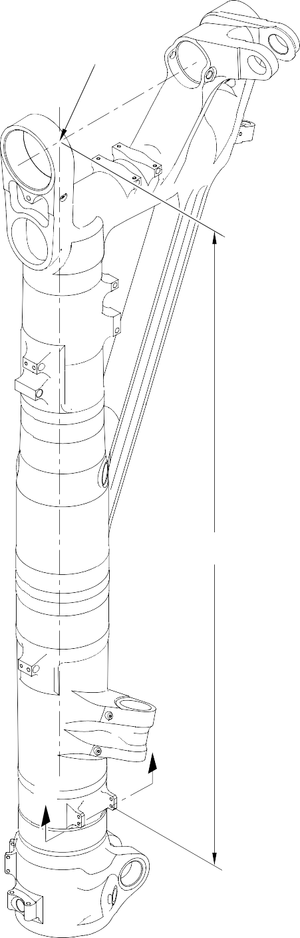
A321A5549-1
POINT Y
1923,75 to 1924,25mm
(75.738 to 75.758in)
Z
Z

Repair to Main Fitting Figure 601


DIA A (4 PLACES)

LUG WIDTH D 8,75mm (0.344in) MINIMUM
4,75 to 5,25mm
(0.187 to 0.207in)
RADIUS (2 PLACES)
0.5 DEGREES
X
FACE
C
X
LUG WIDTH D 8,75mm (0.344in) MINIMUM

1,00 to 2,00mm
(0.040 to 0.080in)
RADIUS (2 PLACES)
14,75 to 15,25mm
(0.581 to 0.600in)
118,000mm (4.6456in)
FACE
B
SECTION Z-Z
(WITHOUT BUSHES)





1923,75 to 1924,25mm
20,00mm (0.787in)
(75.738 to 75.758in)

4,425mm (0.174in) MINIMUM WALL

SECTION X-X
(WITHOUT BUSHES)

A321A5550-2

Repair to Main Fitting - Machining Figure 602

0,25 to 0,75mm
(0.010 to 0.030in)
RADIUS

DIA E

1,00mm(0.040in) X 15 DEGREES CHAMFER

FACE F

REPAIR BUSH 450237825

M-DLPS1011-5 and M-DLPS709-6 (4 PLACES)
8,00 to 8,15mm (0.315 to 0.321in) DIAMETER
0,030mm (0.012in)

M-DLPS1011-20 (4 PLACES)

9,75 to 10,25mm
(0.384 to 0.404in)

102,00 to 102,127mm
(4.016 to 4.021in)

X X
9,75 to 10,25mm
(0.384 to 0.404in)

1,00 to 2,00mm
(0.040 to 0.080in)
RADIUS (8 PLACES)

SECTION Z-Z
(WITH BUSHES)
REPAIR BUSH 450237825
(4 PLACES)

FLANGES OF REPAIR BUSHES MAY BE LOCALLY REMOVED IF NECESSARY

SECTION X-X
(WITH BUSHES)


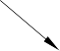


A321A5551-1

Repair Bush - Machining and Installation Figure 603

INTENTIONALLY BLANK

- Repair No. 11-16 Main Fitting (20-410 and 20-420 Only)
  - Specified Damage and Material Specification.
    - Specified Damage
      - Damage or corrosion to the chromium plate on diameter A and/or diameter B.
    - Material Specification
IPL Figure and  Item No. | Name | Material Specification
20-410 and  20-420 Only | Main fitting | Steel, MAT135, 35NCD16THQ

  - Special Tools
    - Special tools are not necessary.
  - Materials
    - Materials are not necessary.
  - Repair Parts
    - Repair parts are not necessary.
  - Procedure (Refer to Figure 601)

CAUTION: REPAIR WILL NOT BE PERMITTED BEYOND THE LIMITS OF THIS REPAIR SCHEME.
    - Chemically remove the chromium plate from diameters A and/or B: refer to PCS-2110 and Figure 601.
    - Examine the base metal for damage or corrosion:
      - If there is no damage or corrosion to the base metal proceed with the repair.
      - If there is damage or corrosion to the base metal, use another applicable repair or apply for a concession.

CAUTION: DO NOT USE A MECHANICAL MOP POLISHER TO GET THE SURFACE FINISH.
CAUTION: DO NOT USE HARD CHROMIUM PLATING TO DIAMETERS A AND B.
    - Apply flash chromium plate to diameters A and/or B to a thickness of between 0,0075 and 0,0125 mm (0.0003 and 0.0005 in): refer to PCS-2110, type C. The new diameters must be:
Diameter A = 212,000 to 212,072 mm (8.3465 to 8.3493 in) with a surface finish of 1,6 micrometers (64 micro-inches)
Diameter B = 208,890 to 208,966 mm (8.2240 to 8.2270 in) with a surface finish of 0,8 micrometers (32 micro-inches).
    - Examine the reworked area for flaws: refer to PCS-3100, inclusion class 4.
    - Identify the part with the Messier-Dowty Limited repair number 450237690 adjacent to the part number: refer to PCS-6000-04.
    - Examine the part to make sure that you have obeyed all the repair instructions correctly.
Repair No. 11-16

32-12-22
Page 601

Z Z
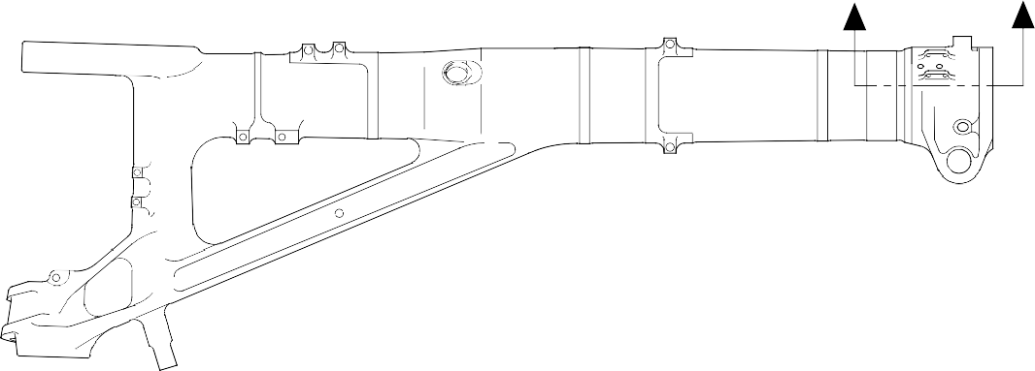

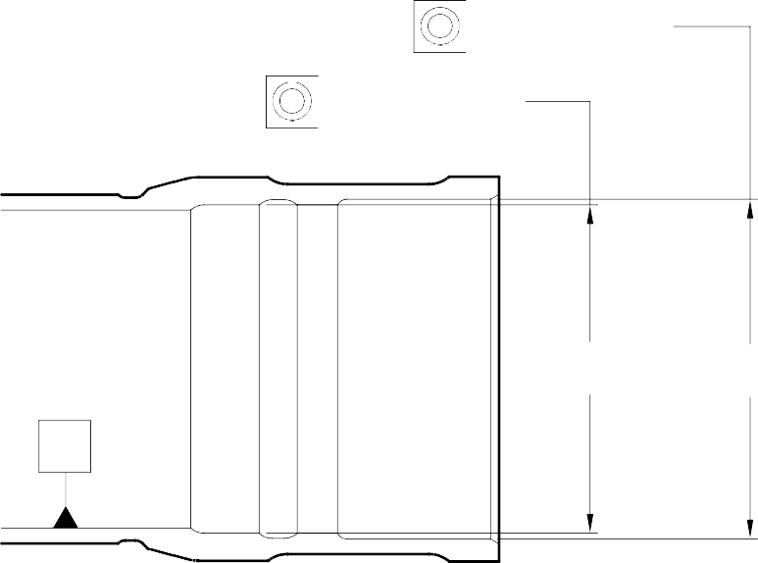
DIA
B
DIA
A
Y
Y
0,05mm (0.002in)
Y
0,05mm (0.002in)

SECTION Z-Z

A321A5695-1

- Specified Damage and Material Specification.
  - Specified Damage
    - Damage or corrosion to the chromium plate on diameter A.
  - Material Specification
IPL Figure and  Item No. | Name | Material Specification
20-410, 20-410A,  20-420 and 20-420A | Main fitting | Steel, MAT135, 35NCD16THQ

- Special Tools
  - Special tools are not necessary.
- Materials
  - Materials are not necessary.
- Repair Parts
  - Repair parts are not necessary.
- Procedure (Refer to Figure 601)
  - Chemically remove the chromium plate from diameter A: refer to PCS-2110 and Figure 601.
  - Examine the base metal for damage or corrosion:
    - If there is no damage or corrosion to the base metal proceed with the repair.
    - If there is damage or corrosion to the base metal, use another applicable repair or apply for a concession.

CAUTION: DO NOT USE A MECHANICAL MOP POLISHER TO GET THE SURFACE FINISH.
CAUTION: HARD CHROMIUM PLATE MUST NOT BE USED ON THIS DIAMETER.
  - Apply flash chromium plate to diameter A as shown: refer to PCS-2110, type C and Figure 601. The chromium plate thickness must be between 0,0075 and 0,0120 mm (0.0003 and 0.0005 in). Make the surface finish 0,8 micrometers (32 micro-inches). Make the surface finish on the chamfer 1,6 micrometers (63 micro-inches).
  - Examine the reworked area for flaws: refer to PCS-3100, inclusion class 4.
  - Identify the part with the Safran Landing Systems repair number 450237695 adjacent to the part number: refer to PCS-6000-04.
  - Examine the part to make sure that you have obeyed all the repair instructions correctly.

183,490 to 183,566mm
(7.224 to 7.227in)
2,00mm (0.079in) CHROMIUM PLATE RUNOUT

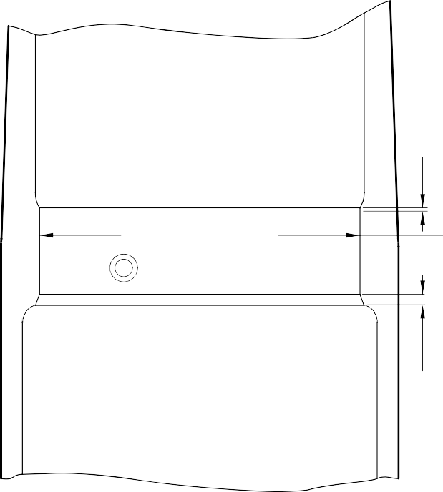
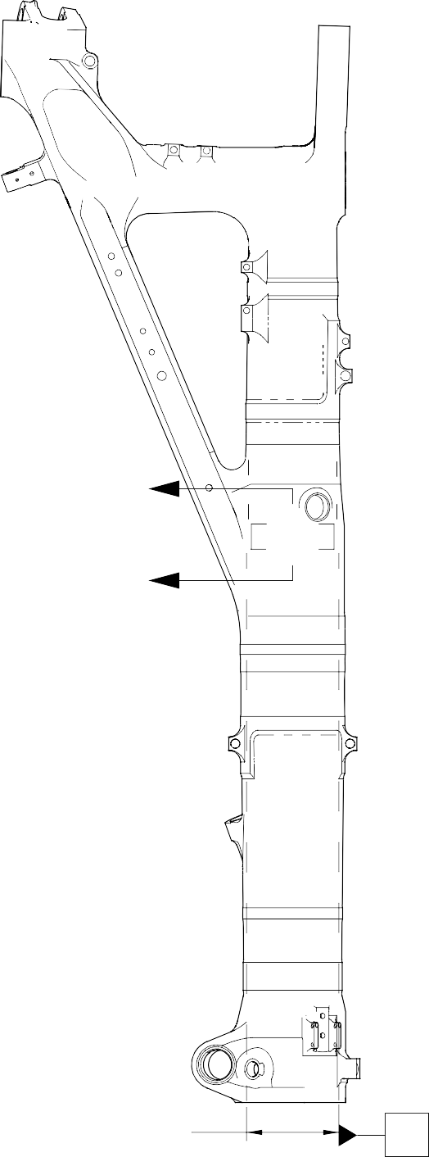
X
DIAMETER A
 | DIA 0,075mm  (0.0030in) | Z

X

SECTION X-X
5,00mm (0.197in) X 30 DEGREES
INCLUSIVE CHAMFER CHROMIUM PLATE TO RUN OUT
ON CHAMFER

212,000 to 212,072mm
(8.3464 to 8.3492in) DIAMETER REF.
Z

A321A5708-2

- Repair No. 11-18 Main Fitting (20-410, 20-410A, 20-420 and 20-420A)
  - Specified Damage and Material Specification.
    - Specified Damage
      - Damage or wear to diameter A.
    - Material Specification
IPL Figure and  Item No. | Name | Material Specification
20-410, 20-410A,  20-420 and 20-420A | Main fitting | Steel, MAT135, 35NCD16THQ

  - Special Tools
    - These special tools are necessary:

NOTE: Alternative equivalents are permitted.

Part No. | Special Tool | Function
460006267 | Press Pad Assembly | Install the repair bearing
  - Materials
    - These materials are necessary:

NOTE: Alternative equivalents are permitted.

Ref. Item | Material
09-510A | Sealant
  - Repair Parts
    - These repair parts are necessary:

Part No. | Repair Part | Material Specification
- | Repair bearing | Aluminium Bronze, DTD197
  - Procedure (Refer to Figures 601 and 602)
    - Machine diameter A sufficiently to remove the damage or wear within the dimensions shown: refer to M-DLPS1004-4-1 and Figure 601. Make the surface finish 1,6 micrometers (63 micro-inches).
    - Machine the radius to the dimensions shown: refer to Figure 601.
    - Measure and record the new diameter A.
    - Examine the machined area for flaws: refer to PCS-3600 and PCS-3100, inclusion class 4.

    - Apply cadmium plate to the reworked area: refer to PCS-2100 or PCS-2141.
    - Identify the part with the Messier-Dowty Limited repair number 450217235 adjacent to the part number: refer to PCS-6000-04.
    - Calculate the diameter B for the repair bearing, use the formula:
B = A (as measured) + 0,0020 to 0,0480 mm (0.00008 to 0.00190 in).
    - Machine the repair bearing to the dimensions shown and calculated: refer to Figure 602. Make the surface finish 3,2 micrometers (125 micro-inches).
    - Examine the repair bearing for flaws: refer to PCS-3200.
    - Apply cadmium plate all over the repair bearing: refer to M-DLPS100-1. The cadmium plate thickness must be between 0,010 and 0,015 mm (0.0004 and 0.0006 in).
    - Use press pad assembly 460006267 and install the repair bearing: refer to M-DLPS1011-14. The bearing must be flush or up to 0,250 mm (0.010 in) below the surface of main fitting.
    - Apply sealant, Material Ref. Item 09-510A, to the joints between the repair bearing and the main fitting: refer to PCS-7200 and Figure 602.
    - Identify the part with the Messier-Dowty Limited repair number 450217235 adjacent to the part number: refer to PCS-6000-07.
    - Examine the part to make sure that you have obeyed all the repair instructions correctly.

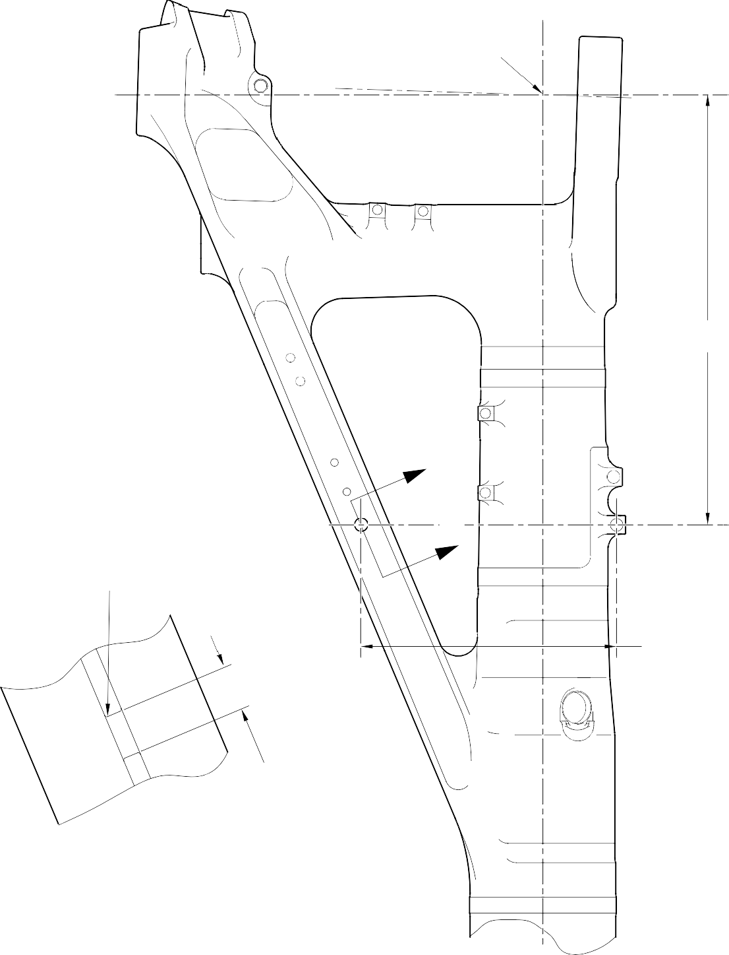
POINT C

674,75 to 675,25mm
(26.565 to 26.585in)

Z

Z
0,75 to 1,25mm
(0.030 to 0.050in) RADIUS

401,90 to 402,40mm
(15.823 to 15.843in)

DIA A
21,933mm (0.8635in) MAXIMUM

PART SECTION Z-Z
(WITHOUT REPAIR BEARING)

A321A5860-1

Repair to Main Fitting - Machining Figure 601

7,75 to 8,25mm
(0.305 to 0.325in)
0,95 to 1,45mm
(0.037 to 0.057in) x 15DEGREES CHAMFER
(2 PLACES)

0,95 to 1,45mm
DIA
B
(0.037 to 0.057in)
x 30 DEGREES CHAMFER
(2 PLACES)

REPAIR BEARING

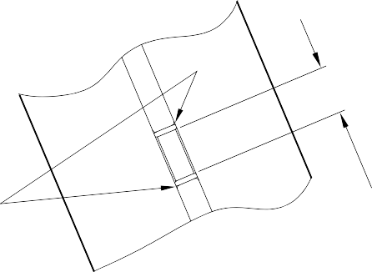
APPLY SEALANT TO PCS-7200
16,25 to 16,75mm (0.640 to 0.659in) DIA

PART SECTION Z-Z
(WITH REPAIR BEARING)

A321A5991-1

Repair Bearing - Machining and Installation Figure 602

- Repair No. 11-19 Main Fitting (20-410, 20-410A, 20-420 and 20-420A)
  - Specified Damage and Material Specification.
    - Specified Damage
      - Damage or wear to diameter(s) A.
    - Material Specification
IPL Figure and  Item No. | Name | Material Specification
20-410, 20-410A,  20-420 and 20-420A | Main fitting | Steel, MAT135, 35NCD16THQ

  - Special Tools
    - These special tools are necessary:

NOTE: Alternative equivalents are permitted.

Tool Part No. | Special Tool | Function
460004330/110 | Press Pad | Install the repair bushes
460004331/2 | Drift
  - Materials
    - These materials are necessary:

NOTE: Alternative equivalents are permitted.

Ref. Item | Material
TBA | Zinc powder
05-533 | Mastinox, D40
09-510A | Sealant
  - Repair Parts
    - These repair parts are necessary:

Part No. | Repair Part | Material Specification
450237819 | Repair bush (Qty 2) | Aluminium Bronze, DTD197
  - Procedure (Refer to Figures 601 and 602)
    - Machine diameter(s) A sufficiently to remove the damage or wear within the dimensions shown: refer to M-DLPS1004-4-1 and Figure 602. Make the surface finish 3,2 micrometers (125 micro-inches).
    - Machine the radii to the dimensions shown: refer to Figure 602.

    - Measure and record the new diameter(s) A.
    - Examine the machined area for flaws: refer to PCS-3600 and PCS-3100, inclusion class 4.
    - Shot peen the machined areas: refer to M-DLPS123.
    - Identify the part with the Messier-Dowty Limited repair number 450258210 adjacent to the part number: refer to PCS-6000-05.
    - Apply cadmium plate to the reworked areas: refer to PCS-2141.
    - Apply primer paint to the reworked areas: refer to PCS-2500.
    - Calculate the diameter B for the repair bush(es) (qty 2), use the formula: B = A (as measured) - 0,009 mm (0.0004 in) to + 0,029 mm (0.0011 in).
    - Machine the repair bush(es) to the dimensions shown and calculated: refer to Figure 602. Make the surface finish 1,6 micrometers (63 micro-inches).
    - Apply cadmium plate all over the repair bush(es): refer to M-DLPS100-1. The cadmium plate thickness must be between 0,010 and 0,015 mm (0.0004 and 0.0006 in).
    - Use the Press Pad 460004330/110 and Drift 460004331/2 and install the repair bush(es): refer to M-DLPS1011-20. Use electrically conducting Mastinox (made from Mastinox D40, Material Ref. Item 05-533 and Zinc powder, Material Ref. Item TBA): refer to M-DLPS709-14.
    - Apply sealant, Material Ref. Item 09-510A, to the joints between the repair bush(es) and the main fitting: refer to PCS-7200 and Figure 602.
    - Identify the part with the Messier-Dowty Limited repair number 450258210 adjacent to the part number: refer to PCS-6000-07.
    - Examine the part to make sure that you have obeyed all the repair instructions correctly.

327,47 to 327,97mm
(12.893 to 12.912in)

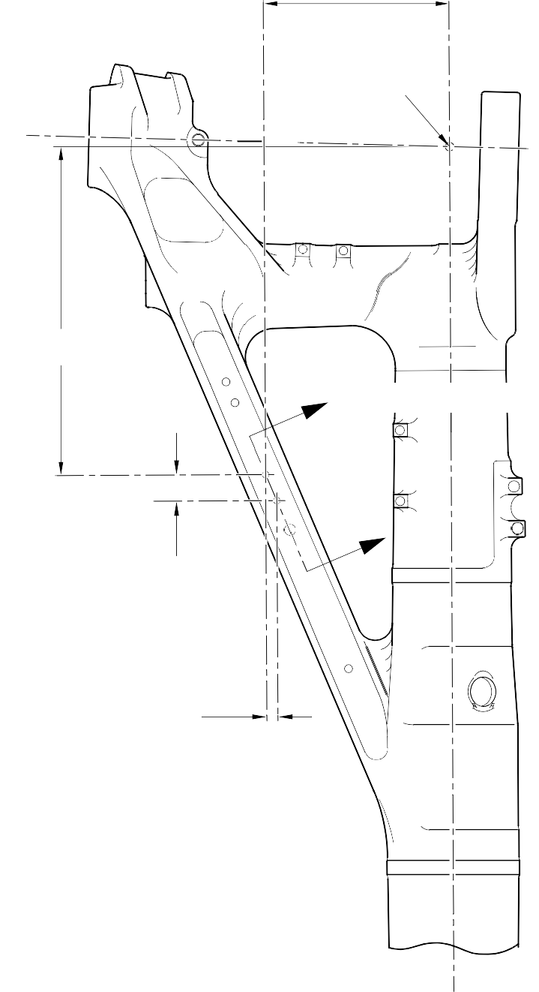
A321A5861-1
POINT C
576,75 to 577,25mm
(22.707 to 22.726in)
Z REFER TO FIGURE 602
Z
46,07mm (1.814in) (REF)
19,425mm (0.7648in) CRS
(REF)

Repair to Main Fitting - Machining Figure 601

DIAMETER A
13,727mm
(0.5404in) MAXIMUM
DIAMETER A 13,727mm (0.5404in) MAXIMUM

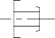
REPAIR BUSH

0,80 to 1,20mm
(0.032 to 0.047in) RADIUS 2 PLACES
APPLY SEALANT TO PCS-7200

PART SECTION Z-Z REFER TO FIGURE 601 (WITHOUT REPAIR BUSHES)
PART SECTION Z-Z REFER TO FIGURE 601 (WITH REPAIR BUSHES)

8,25 to 8,75mm
(0.325 to 0.344in)
(REF)

0,75 to 1,25mm (0.030 to 0.049in)
x 15 DEGREES CHAMFER

DIAMETER
B

0,50 to 0,80mm
(0.020 to 0.031in) RAD

REPAIR BUSH

A321A5992-1

Repair Bushes - Machining and Installation Figure 602

1. Repair No. 11-20 Main Fitting (20-410 and 20-420 Only)
A. This Repair, Safran Landing Systems Repair No. 450265100, has been withdrawn from use.

INTENTIONALLY BLANK

- Repair No. 11-21 Main Fitting (20-410, 20-410A, 20-420 and 20-420A)
  - Specified Damage and Material Specification.
    - Specified Damage
      - Damage or wear to diameters A and/or B and/or adjacent spotfaces.
    - Material Specification
IPL Figure and  Item No. | Name | Material Specification
20-410, 20-410A,  20-420 and 20-420A | Main fitting | Steel, MAT135, 35NCD16THQ

  - Special Tools
    - These special tools are necessary:

NOTE: Alternative equivalents are permitted.

Part No. | Special Tool | Function
460004330/257 | Press Pad | Install the oversize bearing  450258809
460004330/258 | Press Pad | Install the oversize bearing 450258810
  - Materials
    - These materials are necessary:

NOTE: Alternative equivalents are permitted.

Ref. Item | Material
09-510A | Sealant
  - Repair Parts
    - These repair parts are necessary:

Part No. | Repair Part | Material Specification
450258809 | Oversize bearing | Aluminium Bronze, DTD197
450258810 | Oversize bearing | Aluminium Bronze, DTD197
  - Procedure (Refer to Figures 601 and 602)
    - Machine diameter(s) A and/or B sufficiently to remove damage or wear within the dimensions shown: refer to M-DLPS1004-4-1, M-DLPS914 and Figure 601. Make the surface finish 1,6 micrometers (63 micro-inches).

    - Machine the adjacent spotfaces, sufficiently to remove the damage or wear within the dimensions shown: refer to M-DLPS1004-4-1, M-DLPS914 and Figure 601. Do not machine below the minimum dimensions C and D. Make the surface finish 1,6 micrometers (63 micro-inches).
    - Machine the chamfers and radii as shown: refer to Figure 601.
    - Measure and record the new diameters A and B and dimensions C and D.
    - Examine the machined areas for flaws: refer to PCS-3600 and PCS-3100, inclusion class 4.
    - Shot peen the machined areas: refer to M-DLPS123.
    - Apply cadmium plate to the machined areas: refer to PCS-2141.
    - Identify the part with the Messier-Dowty Limited repair number 450258230 adjacent to the part number: refer to PCS-6000-05.
    - Calculate the dimensions of the oversize bearing 450258809, use formulae:
E = A (as measured) - 0,006 (0.0002 in) to + 0,028 mm (0.0011 in).
F = C (as measured) - 57,25 to 57,75 mm (2.254 to 2.273 in).
    - Calculate the dimensions of the oversize bearing 450258810, use formulae:
G = B (as measured) - 0,006 (0.0002 in) to + 0,028 mm (0.0011 in).
H = C (as measured) - 57,25 to 57,75 mm (2.254 to 2.273 in).
    - Machine the oversize bearings to the dimensions shown and calculated: refer to Figure 601. Make the surface finish 1,6 micrometers (63 micro-inches).
    - Apply cadmium plate to the oversize bearings all over, but not to the bores: refer to M-DLPS100-1. The cadmium plate thickness must be between 0,010 and 0,015 mm (0.0004 and 0.0006 in).
    - Use the Press Pad 460004330/257 and install the oversize bearing 450258809 to diameter A: refer to M-DLPS1011-20.
    - Use the Press Pad 460004330/258 and install the oversize bearing 450258810 to diameter B: refer to M-DLPS1011-20.
    - Check the bores of oversize bearings to the dimensions shown: refer to Figure 602.
    - Apply sealant, Material Ref. Item 09-510A, to the joints between the oversize bearings and main fitting: refer to PCS-7200 and Figure 602.
    - Apply paint to the reworked areas: refer to REPAIR.
    - Identify the part with the Messier-Dowty Limited repair number 450258230 adjacent to the part number: refer to PCS-6000-07.
    - Examine the part to make sure that you have obeyed all the repair instructions correctly.


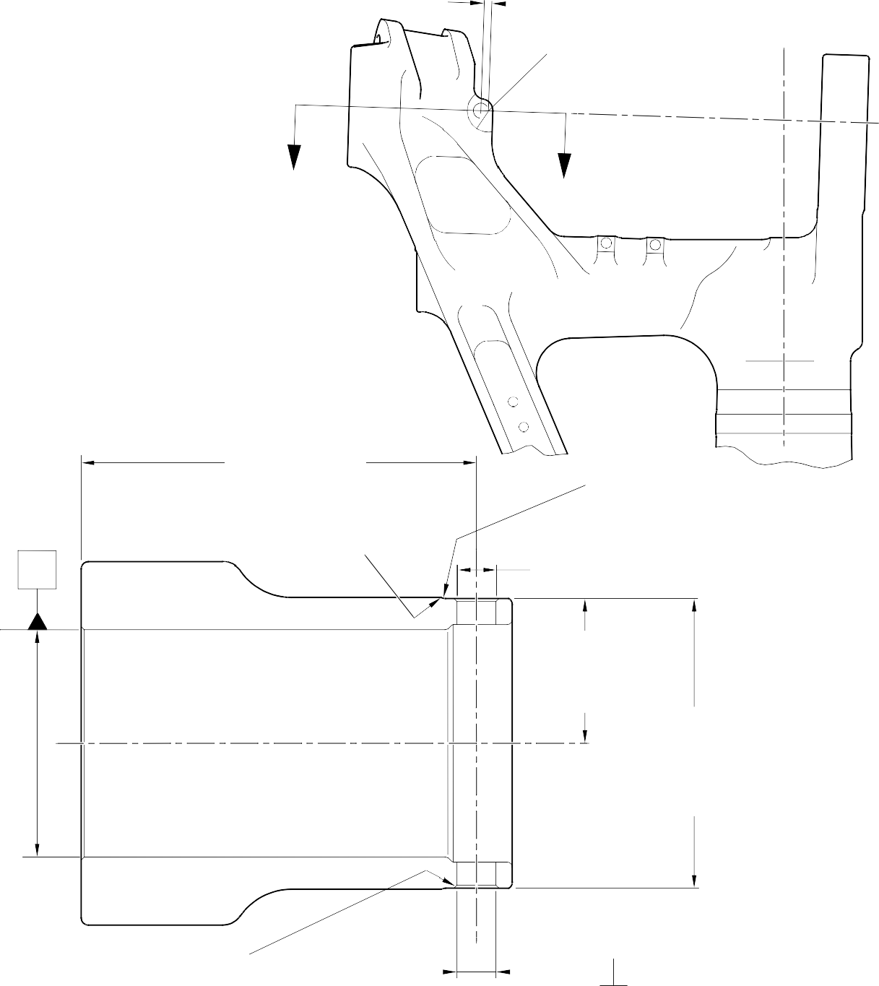
10,75 to 11,25mm (0.423 to 0.443in)
30,75 to 31,25mm
(1.211 to 1.230in) RADIUS

Z Z

192,75 to 193,25mm
(7.589 to 7.608in)

2,00 to 3,00mm (0.079 to 0.118in) REMOVE SHARP EDGES
RADIUS (TYP)

Y

5,00 to 6,00mm (0.197 to 0.236in) SPOTFACE CORNER RADIUS (TYP)

DIA A 20,721mm (0.8157in) MAXIMUM

DIM. C 69,50mm (2.736in) MINIMUM

DIM. D 139,25mm (5.482in) MINIMUM

ACROSS SPOTFACES

1,25 to 1,75mm (0.049 to 0.069in)
x 44.5 to 45.5 DEGREES
CHAMFER 2 PLACES

DIA B
20,721mm (0.8157in)
 |  | 0,05mm (0.002in) DIA | Y
 |  | 0,05mm (0.002in) DIA | Y

MAXIMUM

SECTION Z-Z

A321A6383-1

Repair to Main Fitting - Machining Figure 601

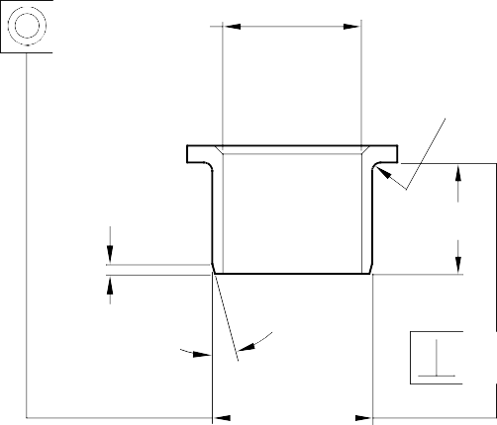
14.5 to 15.5 DEGREES
0,75 to 1,25mm
(0.030 to 0.049in) RADIUS
0,95 to 1,45mm
(0.037 to 0.057in)
DIM. F
14.5 to 15.5 DEGREES
DIA.
E
0,010mm (0.0004in)
0,025mm (0.0009in) DIA
DIA.
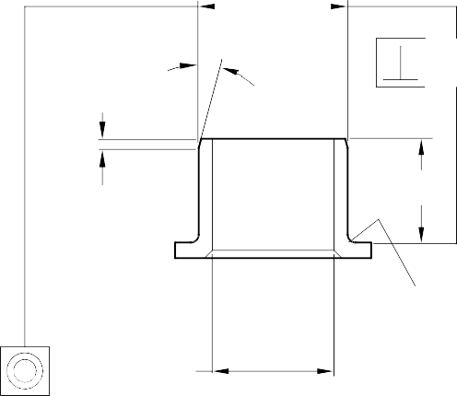
G

0,010mm (0.0004in)

0,95 to 1,45mm
(0.037 to 0.057in)
DIM. H

0,75 to 1,25mm
(0.030 to 0.049in) RADIUS
0,025mm (0.0009in) DIA

OVERSIZE BEARING 450258809
OVERSIZE BEARING 450258810

OVERSIZE BEARING
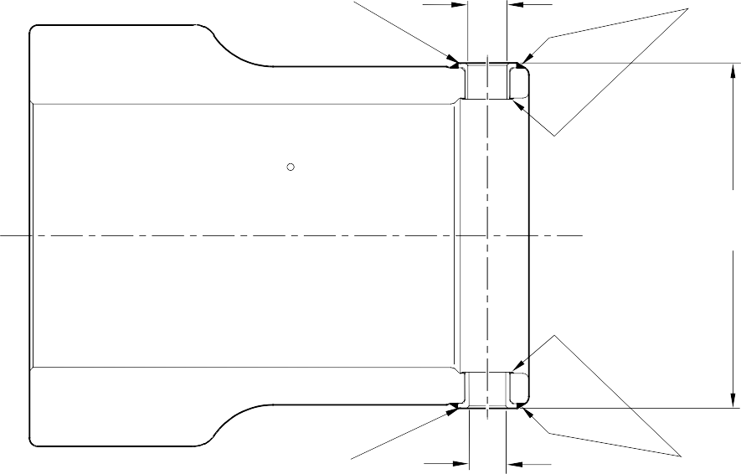
450258809
16,500 to 16,527mm (0.6496 to 0.6507in) DIA.

APPLY SEALANT TO PCS-7200

145,25 to 146,15mm
(5.718 to 5.754in) REF

OVERSIZE BEARING
450258810

SECTION Z-Z
(REFER TO FIGURE 601)

15,500 to 15,527mm (0.6102 to 0.6113in) DIA.
APPLY SEALANT TO PCS-7200

A321A6384-2

Oversize Bearings - Machining and Installation Figure 602

- Specified Damage and Material Specification
  - Specified Damage
    - Damage or wear to the diameter A.
  - Material Specification
IPL Figure and  Item No. | Name | Material Specification
20-410, 20-410A,  20-420 and 20-420A | Main Fitting | Steel, MAT135, 35NCD16THQ

- Special Tools
  - Special tools are not necessary.
- Materials
  - Materials are not necessary.
- Repair Parts
  - Repair parts are not necessary.
- Procedure (Refer to Figure 601)

CAUTION: FOR DAMAGE MORE THAN THE LIMITS OF THIS REPAIR SCHEME, WRITE TO SAFRAN LANDING SYSTEMS: REFER TO GUIDE-CS-001.
  - Machine diameter A to remove the damage or wear, removing the minimum amount of material to a maximum diameter of 16,170 mm (0.6366 in) and a minimum wall thickness of 1,915 mm (0.0754 in): refer to M-DLPS1004-4-1 and Figure 601. Make the surface finish 1,6 micrometers (63 micro-inches) or better.
  - Examine the bare metal for flaws: refer to PCS-3100, inclusion class 4 and PCS-3600.
  - Identify the main fitting with the Safran Landing Systems repair number 450266450 adjacent to the part number: refer to PCS-6000-04 or PCS-6000-06.
  - Apply cadmium plate to the repaired areas. The cadmium plate thickness must be between 0,010 and 0,020 mm (0.0004 and 0.0008 in): refer to PCS-2141.
  - If necessary, apply paint around the repaired areas, except where shown: refer to PCS-2500 and Figure 601.
  - Identify the main fitting with the Safran Landing Systems repair number 450266450 adjacent to the part number: refer to PCS-6000-07.
  - Examine the part to make sure that you have obeyed all the repair procedure instructions correctly.

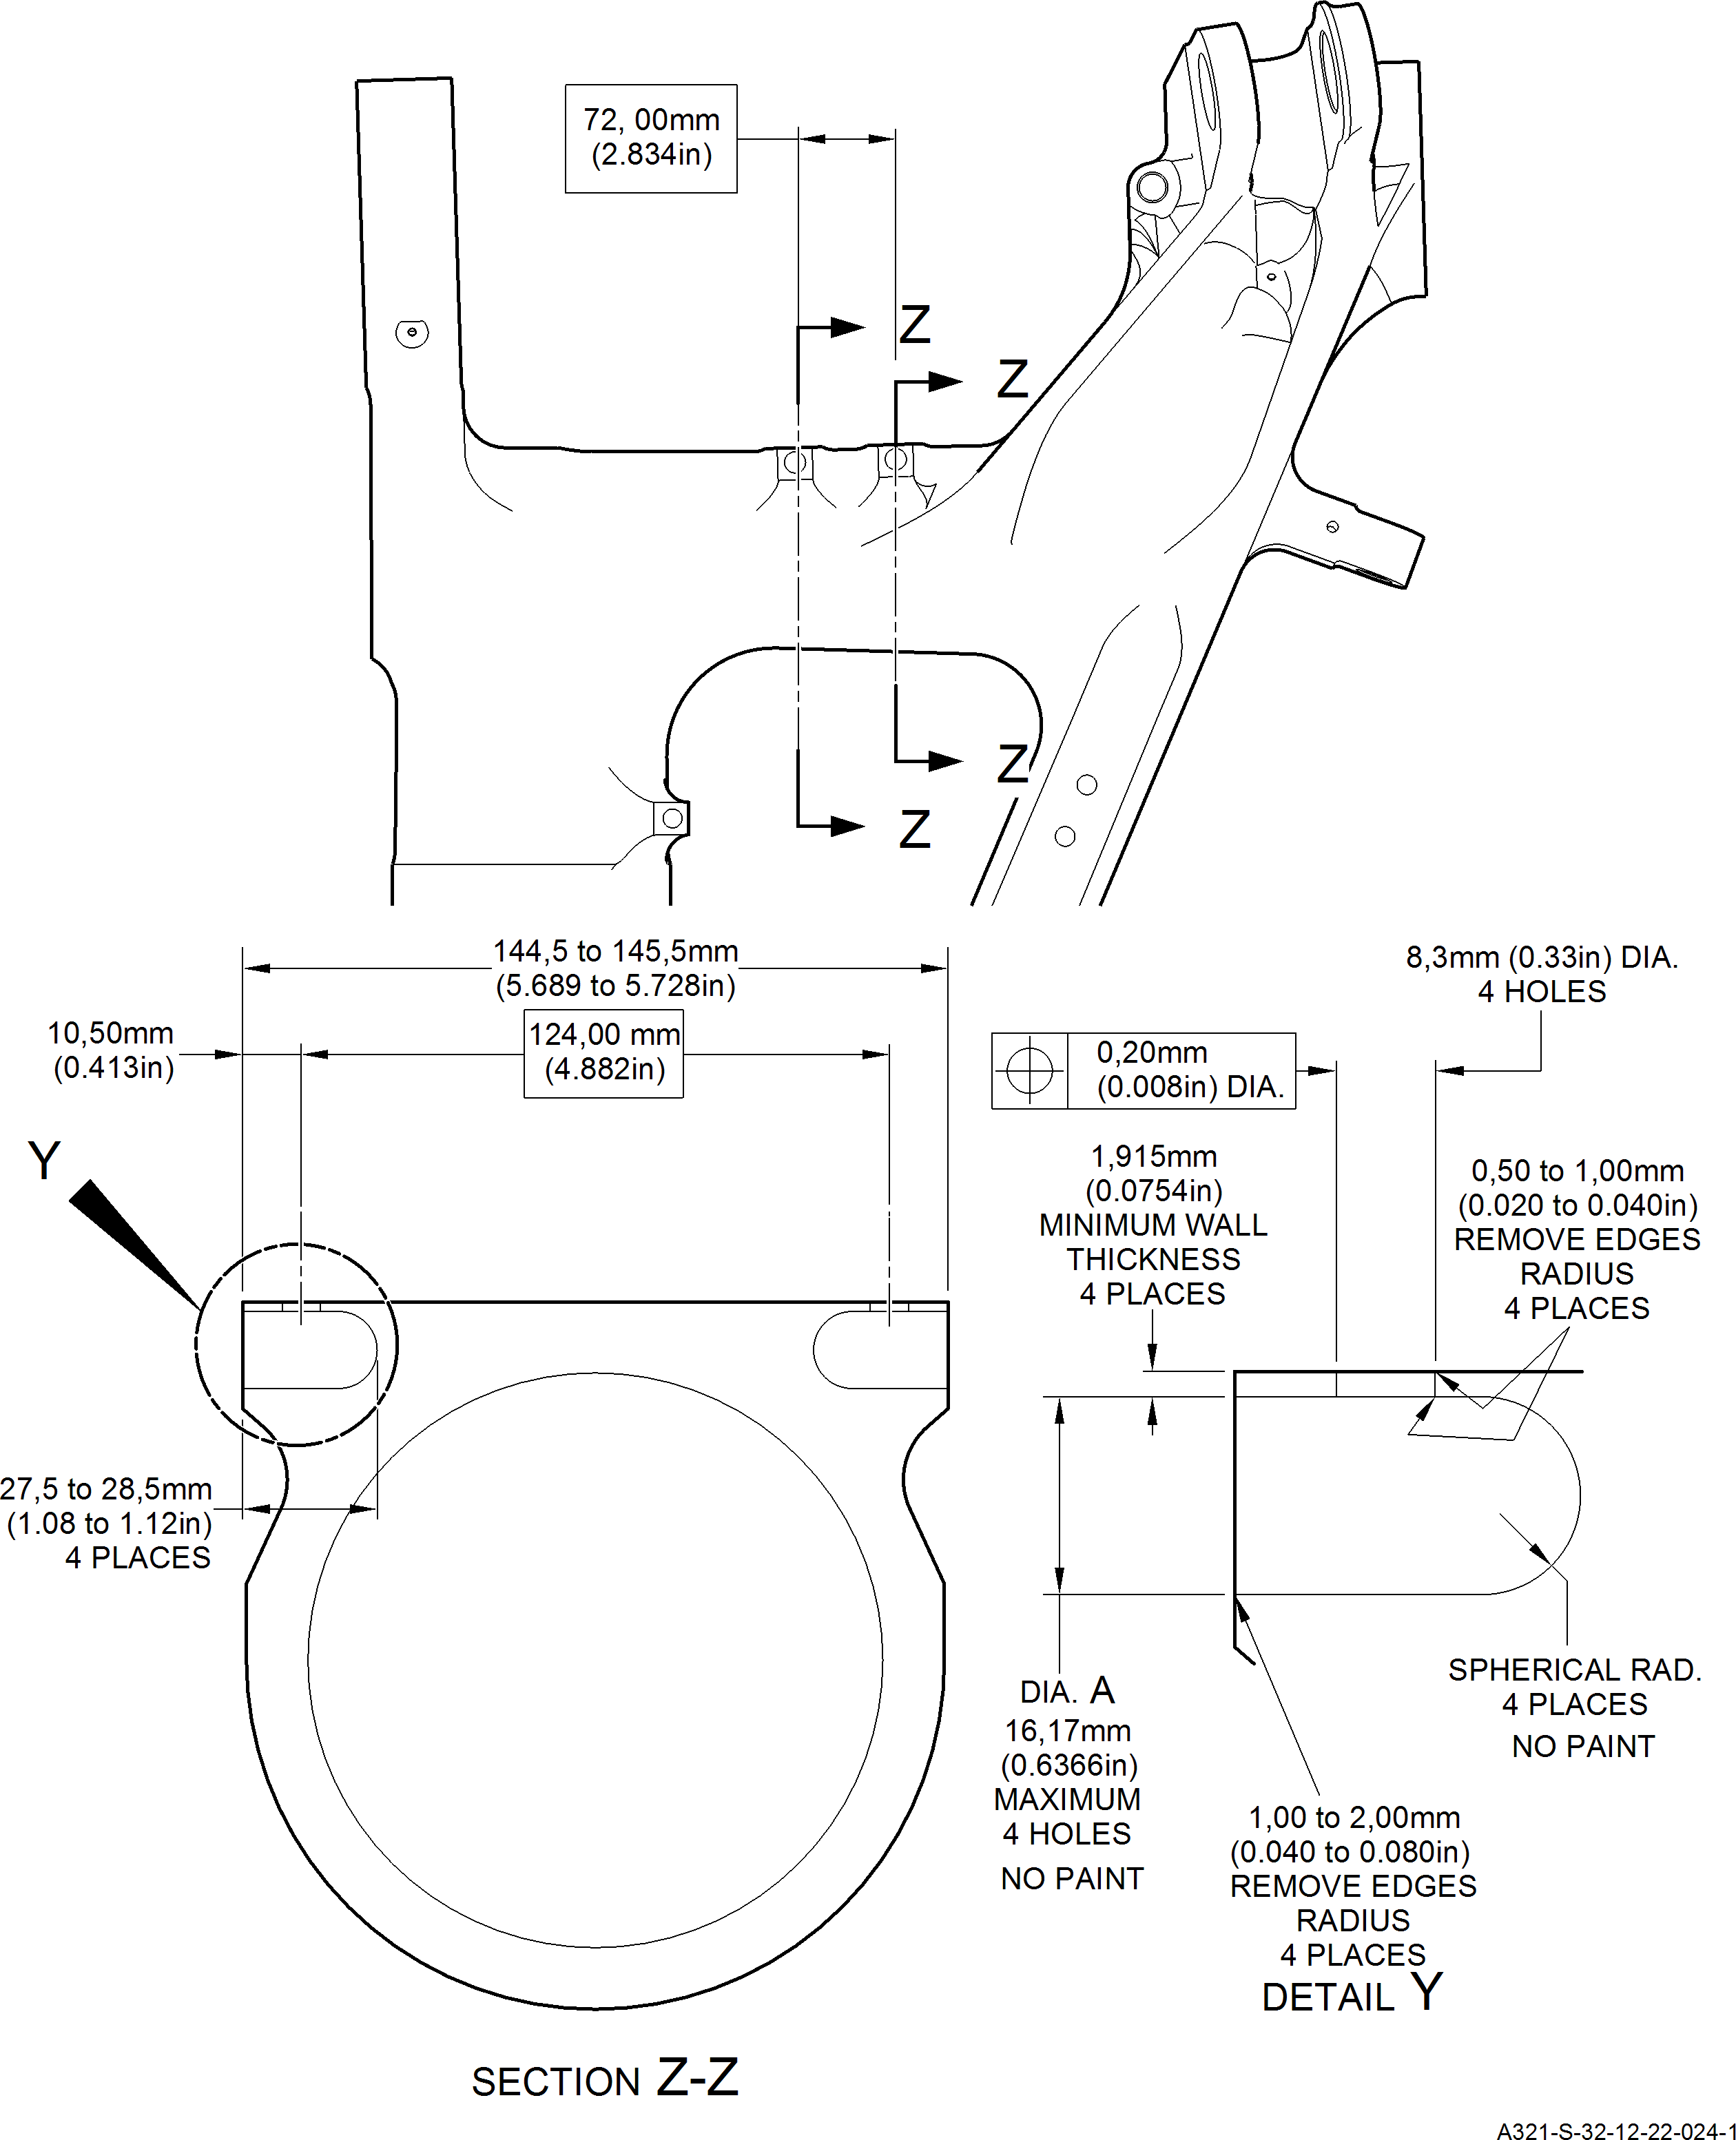
Repair to Main Fitting Figure 601

Repair No. 11-22

32-12-22
Page 602

- Repair No. 11-23 Main Fitting (20-410, 20-410A, 20-420 and 20-420A)
  - Specified Damage and Material Specification.
    - Specified Damage
      - Damage or wear to the diameter A and/or B.
    - Material Specification
IPL Figure and  Item No. | Name | Material Specification
20-410, 20-410A,  20-420 and 20-420A | Main Fitting | Steel, MAT135, 35NCD16THQ

  - Special Tools
    - These special tools are necessary:

NOTE: Alternative equivalents are permitted.

Tool Part No. | Special Tool | Function
460006268 | Press Pad | Install the oversize lubrication  adapters
  - Materials
    - These materials are necessary:

NOTE: Alternative equivalents are permitted.

Ref. Item | Material
08-558 | Adhesive
  - Repair Parts
    - Refer to Table 1.
  - Procedure (Refer to Figures 601, 602 and 603)

CAUTION: FOR DAMAGE MORE THAN THE LIMITS OF THIS REPAIR SCHEME, WRITE TO SAFRAN LANDING SYSTEMS.
    - Machine diameter A and/or diameter B to the smallest oversize dimensions shown in Table 1 to remove the damage or wear: refer to M-DLPS1004-4-1. Make the surface finish 1,6 micrometers (63 micro-inches).
    - Machine the chamfers to the dimensions shown: refer to Figure 602.
    - Examine the machined areas for flaws: refer to PCS-3600 and PCS-3100 inclusion class 4.
    - Identify the part with the Safran Landing Systems repair number 450266400 adjacent to the part number: refer to PCS-6000-04 or PCS-6000-06.

    - Apply cadmium plate to repaired areas. The cadmium plate thickness must be between 0,010 and 0,020 mm (0.0004 and 0.0008 in): refer to PCS-2141.
    - Select the applicable oversize lubrication adaptor (Qty 2) for diameter A and/or diameter B from Table 1.
    - Install the selected lubrication adaptors to the related diameter: refer to PCS-7310. Use adhesive, Material Ref. Item 08-558: refer to PCS-5303.
    - Apply paint to the repaired areas: refer to REPAIR.
    - Identify the part with the Safran Landing Systems repair number 450266400 adjacent to the part number: refer to PCS-6000-07.
    - Examine the part to make sure that you have obeyed all the repair instructions correctly. Oversize Lubrication Adaptor
Table 1

Oversize | Diameter A or B  mm (in) | Oversize Lubrication Adaptor  Part No.
1 | 4,986 to 5,052  (0.1963 to 0.1989) | 450250161
2 | 5,113 to 5,179  (0.2013 to 0.2039) | 450250162
3 | 5,240 to 5,306  (0.2063 to 0.2089) | 450250163
4 | 5,367 to 5,433  (0.2113 to 0.2139) | 450250164
5 | 5,494 to 5,560  (0.2163 to 0.2189) | 450250165
6 | 5,621 to 5,687  (0.2213 to 0.2239) | 450250166
7 | 5,748 to 5,814  (0.2263 to 0.2289) | 450250241
8 | 5,875 to 5,941  (0.2313 to 0.2339) | 450250242
9 | 6,002 to 6,068  (0.2363 to 0.2389) | 450250243
10 | 6,129 to 6,195  (0.2413 to 0.2439) | 450250244
11 | 6,256 to 6,322  (0.2463 to 0.2489) | 450250245
12 | 6,383 to 6,449  (0.2513 to 0.2539) | 450250246

Repair No. 11-23

32-12-22
Page 602

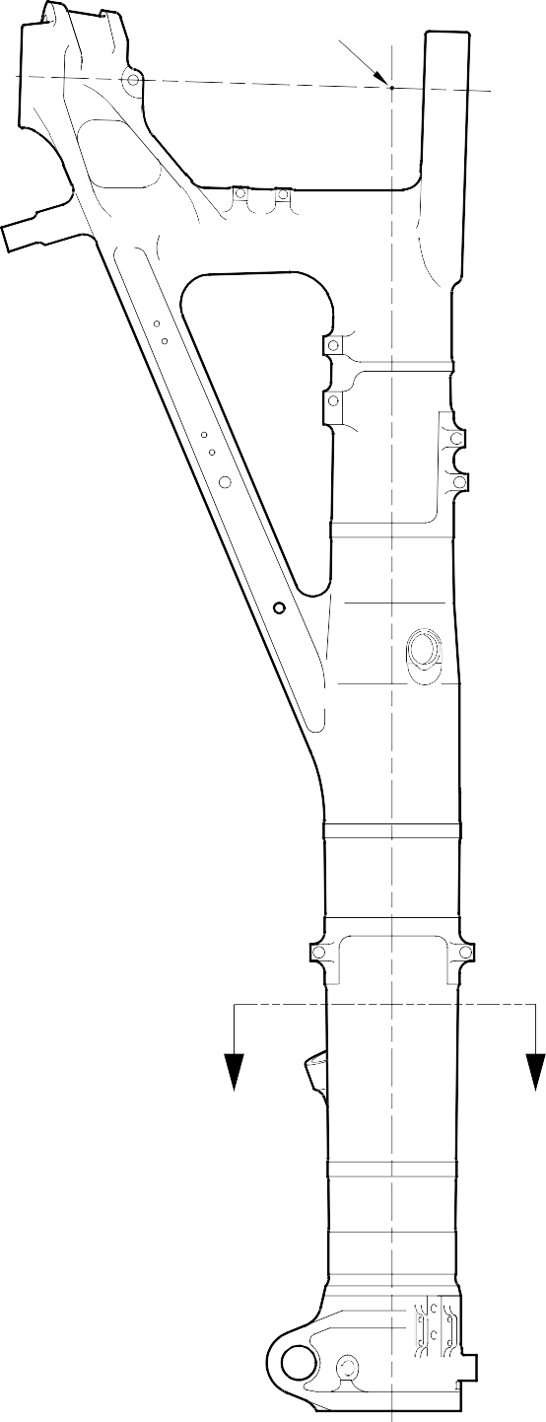
POINT C

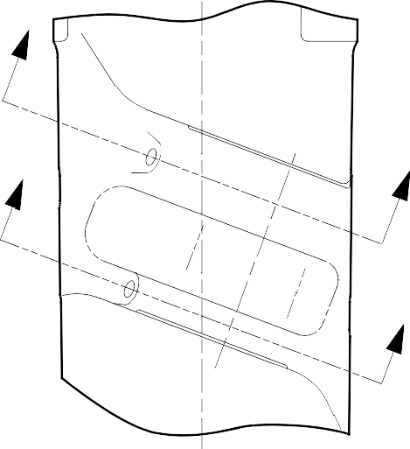
W

X W
(REFER TO FIGURE 602)

X
(REFER TO FIGURE 602)

VIEW ON

Y
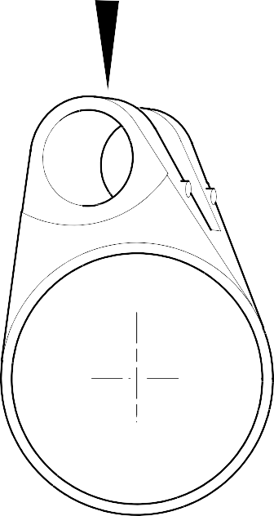
Y

SECTION Z-Z
Z Z

A321A6769-1

Repair to Main Fitting Figure 601

11,20 to 12,80mm (0.441 to 0.503in) REF

DIAMETER A 8,00mm (0.315in) DEEP WITH 0,5mm (0.020in)
x 45 DEGREES CHAMFER

- DEGREES REF

SECTION W-W
(WITHOUT LUBRICATION ADAPTOR)

95,200 to 96,800mm
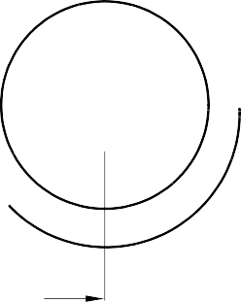

(3.7480 to 3.8110in) REF.

NOTE:
DIAMETERS A MUST FOLLOW THE LINE OF EXISTING BORES

28,75 to 30,25mm (1.132 to 1.191in) REF

DIAMETER B 8,00mm (0.315in) DEEP WITH 0,5mm (0.020in)
x 45 DEGREES CHAMFER

5 DEGREES REF

87,20 to 88,80mm (3.433 to 3.496in)
REF.
SECTION X-X
(WITHOUT LUBRICATION ADAPTOR)
A321A6770-1

Repair to Main Fitting - Machining Figure 602

Repair No. 11-23



REPAIR LUBRICATION
ADAPTOR

SECTION W-W
(WITH LUBRICATION ADAPTOR)

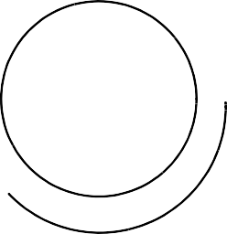


REPAIR LUBRICATION
ADAPTOR

SECTION X-X
(WITH LUBRICATION ADAPTOR)

A321A6771-1

Oversize Lubrication adapter - Installation Figure 603

INTENTIONALLY BLANK

- Repair No. 11-24 Main Fitting (20-410, 20-410A, 20-420 and 20-420A)
  - Specified Damage and Material Specification.
    - Specified Damage
      - Damage or wear to the diameter A.
    - Material Specification
IPL Figure and  Item No. | Name | Material Specification
20-410, 20-410A,  20-420 and 20-420A | Main Fitting | Steel, MAT135, 35NCD16THQ

  - Special Tools
    - These special tools are necessary:

NOTE: Alternative equivalents are permitted.

Tool Part No. | Special Tool | Function
460006268 | Press Pad | Install the oversize lubrication  adaptor
  - Materials
    - These materials are necessary:

NOTE: Alternative equivalents are permitted.

Ref. Item | Material
08-558 | Adhesive
  - Repair Parts
    - Refer to Table 1.

CAUTION: FOR DEVIATIONS OUTSIDE THE LIMITS OF THIS REPAIR SCHEME CONTACT SAFRAN LANDING SYSTEMS.
  - Procedure (Refer to Figures 601 and 602)
    - Machine diameter A to the smallest oversize dimensions shown in Table 1 to remove the damage or wear: refer to M-DLPS1004-4-1 and Figure 602. Make the surface finish 1,6 micrometers (63 micro-inches).
    - Machine the chamfers to the dimensions shown: refer to Figure 602.
    - Examine the machined areas for flaws: refer to PCS-3600 and PCS-3100 inclusion class 4.
    - Identify the part with the Safran Landing Systems repair number 450266390 adjacent to the part number: refer to PCS-6000-04 or PCS-6000-06.

    - Apply cadmium plate to the machined areas: refer to PCS-2141. The cadmium plate thickness must be between 0,010 and 0,020 mm (0.0004 and 0.0008 in).
    - Select the applicable oversize lubrication adaptor for diameter A from Table 1.
    - Install the selected lubrication adaptor: refer to PCS-7310. Use adhesive, Material Ref. Item 08-558: refer to PCS-5303.
    - Apply paint to the repaired areas: refer to PCS-2500 and REPAIR.
    - Identify the part with the Safran Landing Systems repair number 450266390 adjacent to the part number: refer to PCS-6000-07.
    - Examine the part to make sure that you have obeyed all the repair instructions correctly. Oversize Lubrication Adaptors
Table 1

Oversize | Diameter A  mm (in) | Oversize Lubrication Adaptor  Part No.
1 | 4,986 to 5,052  (0.1963 to 0.1989) | 450250161
2 | 5,113 to 5,179  (0.2013 to 0.2039) | 450250162
3 | 5,240 to 5,306  (0.2063 to 0.2089) | 450250163
4 | 5,367 to 5,433  (0.2113 to 0.2139) | 450250164
5 | 5,494 to 5,560  (0.2163 to 0.2189) | 450250165
6 | 5,621 to 5,687  (0.2213 to 0.2239) | 450250166
7 | 5,748 to 5,814  (0.2263 to 0.2289) | 450250241
8 | 5,875 to 5,941  (0.2313 to 0.2339) | 450250242
9 | 6,002 to 6,068  (0.2363 to 0.2389) | 450250243
10 | 6,129 to 6,195  (0.2413 to 0.2439) | 450250244
11 | 6,256 to 6,322  (0.2463 to 0.2489) | 450250245
12 | 6,383 to 6,449  (0.2513 to 0.2539) | 450250246

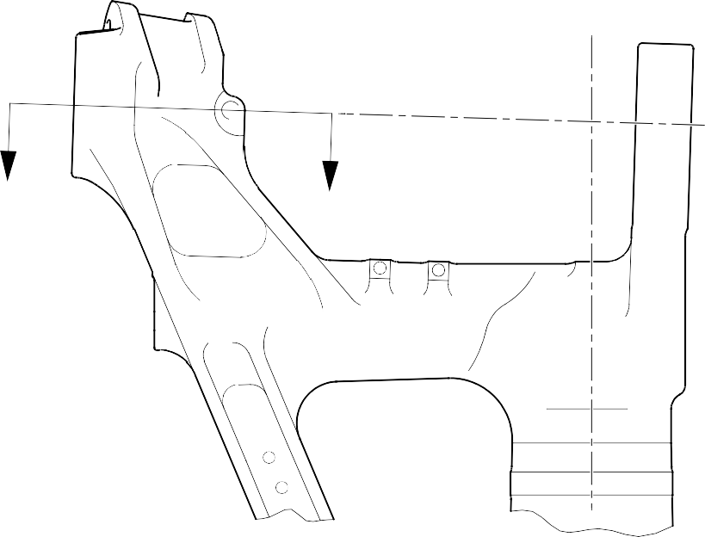
Z
Z

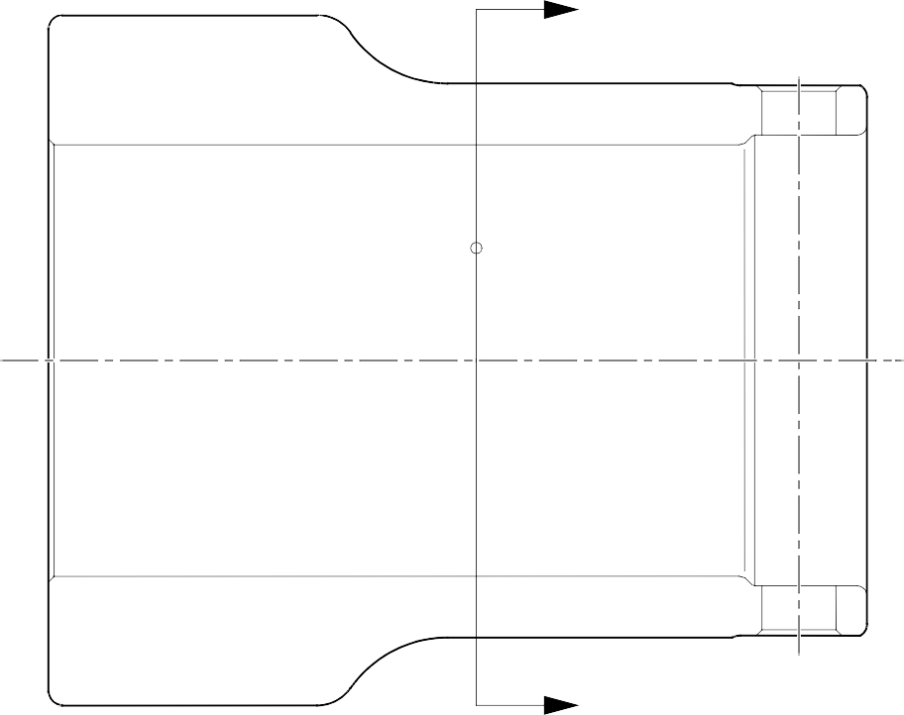
Y
Y

SECTION Z-Z

A321A6877-1

Repair to Main Fitting Figure 601






49.5 to 50.5 DEGREES REF.

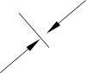
80,00 to 81,60mm
(3.150 to 3.213in) REF.

18,20 to 19,80mm (0.716 to 0.779in) REF.

DIA. A
x 8,00mm (0.315in) DEEP

X
NOTE:-

SECTION Y-Y

0,50mm (0.020in)
x 45 DEGREES CHAMFER
DETAIL X

DIAMETER A MUST FOLLOW THE LINE OF EXISTING BORE
REFER TO FIGURE 601 (WITHOUT LUBRICATION ADAPTOR)

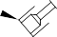
PCS-5303

REPAIR LUBRICATION
ADAPTOR

SECTION Y-Y
REFER TO FIGURE 601
(WITH LUBRICATION ADAPTOR) _{A321A6878-1}

Repair to Main Fitting Figure 602

