- Repair No. 11-25 Main Fitting (20-410, 20-410A, 20-420 and 20-420A)
  - Specified Damage and Material Specification.
    - Specified Damage
      - Damage or wear to the diameter A.
    - Material Specification
IPL Figure and  Item No. | Name | Material Specification
20-410, 20-410A,  20-420 and 20-420A | Main Fitting | Steel, MAT135, 35NCD16THQ

  - Special Tools
    - These special tools are necessary:

NOTE: Alternative equivalents are permitted.

Tool Part No. | Special Tool | Function
460006268 | Press Pad | Install the oversize lubrication  adaptor
  - Materials
    - These materials are necessary:

NOTE: Alternative equivalents are permitted.

Ref. Item | Material
08-558 | Adhesive
  - Repair Parts
    - Refer to Table 1.

CAUTION: FOR DEVIATIONS OUTSIDE THE LIMITS OF THIS REPAIR SCHEME CONTACT SAFRAN LANDING SYSTEMS.
  - Procedure (Refer to Figure 601)
    - Machine diameter A to the smallest oversize dimensions shown in Table 1 to remove the damage or wear: refer to M-DLPS1004-4-1. Make the surface finish 1,6 micrometers (63 micro-inches).
    - Machine the chamfer to the dimensions shown: refer to Figure 601.
    - Examine the machined areas for flaws: refer to PCS-3600 and PCS-3100 inclusion class 4.
    - Identify the part with the Safran Landing Systems repair number 450266395 adjacent to the part number: refer to PCS-6000-04 or PCS-6000-06.

    - Apply cadmium plate to the machined areas. The cadmium plate thickness must be between 0,010 and 0,020 mm (0.0004 and 0.0008 in): refer to PCS-2141.
    - Select the applicable oversize lubrication adaptor for diameter A from Table 1.
    - Install the selected lubrication adaptor: refer to PCS-7310. Use adhesive, Material Ref. Item 08-558: refer to PCS-5303.
    - Apply paint to the repaired areas: refer to REPAIR.
    - Identify the part with the Safran Landing Systems repair number 450266395 adjacent to the part number: refer to PCS-6000-07.
    - Examine the part to make sure that you have obeyed all the repair instructions correctly. Oversize Lubrication Adaptor
Table 1

Oversize | Diameter A  mm (in) | Oversize Lubrication Adaptor  Part No.
1 | 4,986 to 5,052  (0.1963 to 0.1989) | 450250161
2 | 5,113 to 5,179  (0.2013 to 0.2039) | 450250162
3 | 5,240 to 5,306  (0.2063 to 0.2089) | 450250163
4 | 5,367 to 5,433  (0.2113 to 0.2139) | 450250164
5 | 5,494 to 5,560  (0.2163 to 0.2189) | 450250165
6 | 5,621 to 5,687  (0.2213 to 0.2239) | 450250166
7 | 5,748 to 5,814  (0.2263 to 0.2289) | 450250241
8 | 5,875 to 5,941  (0.2313 to 0.2339) | 450250242
9 | 6,002 to 6,068  (0.2363 to 0.2389) | 450250243
10 | 6,129 to 6,195  (0.2413 to 0.2439) | 450250244
11 | 6,256 to 6,322  (0.2463 to 0.2489) | 450250245
12 | 6,383 to 6,449  (0.2513 to 0.2539) | 450250246

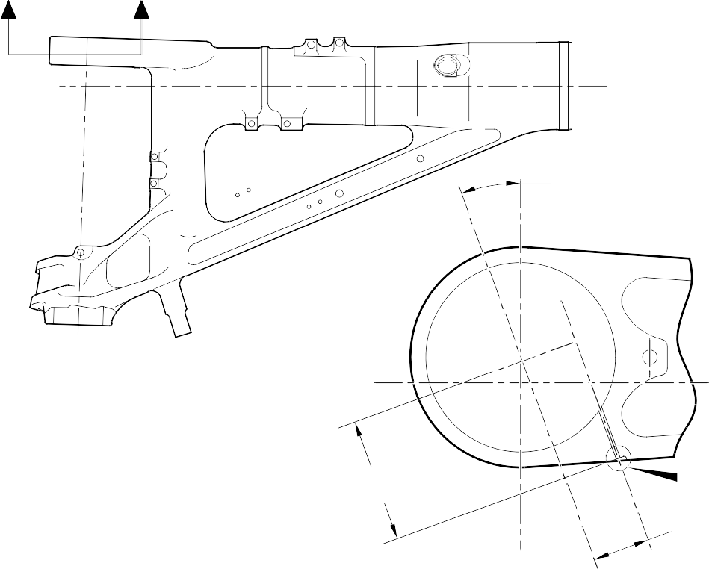
Z Z

20
DEGREES REF.

110,00 to 111,60mm (4.330 to 4.393in) REF.
Y
51,20 to 52,08mm (2.015 to 2.078in) REF.

SECTION Z-Z

NOTE:-
DIAMETER A MUST FOLLOW THE LINE OF EXISTING BORE

REPAIR LUBRICATION ADAPTOR

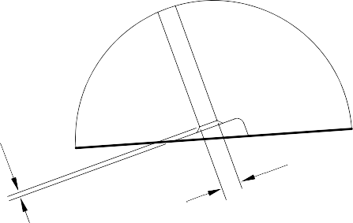
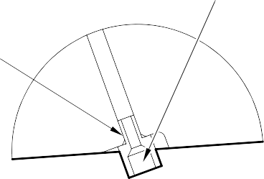
ADHESIVE TO PCS-5303

0,5mm (0.020in) x 45 DEGREES CHAMFER

DIA. A
x 8,00mm (0.315in) DEEP

DETAIL Y
(WITHOUT LUBRICATION ADAPTOR)
DETAIL Y
(WITH LUBRICATION ADAPTOR)

A321A6879-1

Repair to Main Fitting Figure 601

Repair No. 11-25

32-12-22
Page 603

INTENTIONALLY BLANK

- Repair No. 11-26 Main Fitting (20-410 and 20-420 Only)
  - Specified Damage and Material Specification.
    - Specified Damage
      - Damage or wear to diameter(s) A and B.
    - Material Specification
IPL Figure and  Item No. | Name | Material Specification
20-410 and  20-420 Only | Main Fitting | Steel, MAT135, 35NCD16THQ

  - Special Tools
    - These special tools are necessary:

NOTE: Alternative equivalents are permitted.

Tool Part No. | Special Tool | Function
460006405 | Assembly sleeve | Install the lower bearing  subassembly
  - Materials
    - These materials are necessary:

NOTE: Alternative equivalents are permitted.

Ref. Item | Material
04-512 | Molykote 111
  - Repair Parts
    - These repair parts are necessary:

NOTE: Alternative equivalents are permitted.

Part No. | Repair Part | Material Specification
450266371 to 383 | Repair lower bearing  subassembly | -
201646300 | Repair inner liner | -

Repair No. 11-26

32-12-22
Page 601

CAUTION: FOR DEVIATIONS OUTSIDE THE LIMITS OF THIS REPAIR SCHEME CONTACT M-DL GLOUCESTER.
  - Procedure (Refer to Figures 601, 602 and 603)

CAUTION: USE THIS PROCEDURE ONLY FOR POST SB 201-32-58 UNITS AND REQUIREMENTS OF THESE SB MUST BE FOLLOWED FULLY. FOR PRE SB 201-32-58 UNITS REFER TO REPAIR NO. 11-10.
    - Machine diameters A and B to the nearest oversize dimensions shown in Table 1 to remove the damage or wear: refer to M-DLPS1004-4-1 and Figure 602. Blend any sharp edges smoothly into the adjacent surfaces. Make the surface finish for diameter A, 1,6 micrometers (63 micro-inches) and the surface finish for diameter B, 0,8 micrometers (32 micro-inches).
    - Measure and record the new diameters A and B for information at para (8).
    - Machine the chamfers and radii as shown: refer to Figure 602.
    - Examine the machined areas for flaws: refer to PCS-3600 and PCS-3100 inclusion class 4.
    - Shot peen the machined areas in the main fitting: refer to M-DLPS123.
    - Hone the shot peened diameters A and B to the recorded diameters at para (2) +0,00 to 0,025 mm (0.000 to 0.001 in).

CAUTION: DO NOT USE A MECHANICAL MOP POLISHER TO GET THE SURFACE FINISH.
    - Apply thin chromium plate to diameters A and B to the dimensions shown in Table 1: refer to PCS-2110 Type C. The chromium plate thickness must be between 0,0075 and 0,0125 mm (0.00030 and 0.00050 in).
    - Select the applicable oversize lower bearing subassembly for diameters A and B from Table 1.

NOTE: The oversize lower bearing subassembly can be made from the related PRE SB 201-32-58 lower bearing subassembly: refer to Table 2.
    - If necessary, machine the inner diameter of bronze liner: Figure 603.

NOTE: The lower bearing 201522662 can only be machined when it is installed in the lower bearing subassembly.
    - If necessary, examine the reworked area of inner liner for flaws: refer to PCS-3200.
    - If necessary, apply Molykote 111, Material Ref. Item 04-521 to the outside diameter of liner. Install the inner liner into the oversize lower bearing subassembly: refer to PCS-7303. The holes in the inner liner must align with the holes in the oversize lower bearing subassembly.
    - If necessary, strike through the old part number and re-identify the new lower bearing subassembly with the new inner liner with part number identified in Table 2: refer to PCS-6000-07.
    - Use the Assembly Sleeve 460006405 to install the oversize lower bearing subassembly on the sliding tube subassembly at the applicable assembly stage: refer to ASSEMBLY.

    - Apply paint locally to the main fitting: refer to PCS-2500 and REPAIR.
    - Install the repaired shock absorber subassembly in the main fitting at the applicable assembly stage: refer to ASSEMBLY.
    - Identify the main fitting with the Messier-Dowty Limited repair number 450267370 adjacent to the part number: refer to PCS-6000-04.
    - Examine the part to make sure that you have obeyed all the repair instructions correctly
Lower Bearing Subassembly Details Table 1

 | Bore Diameter A |  | Bore Diameter B
 | Machined Diameter  A  mm (in) | After honing and  chromium plating mm (in) | Machined Diameter  B  mm (in) | After honing and  chromium plating mm (in) | Lower bearing subassembly
1 | 212,138 to 212,194  (8.3519 to 8.3541) | 212,122 to 212,194  (8.3513 to 8.3541) | 209,027 to 209,088  (8.2294 to 8.2318) | 209,012 to 209,088  (8.2288 to 8.2318) | 450267371
2 | 212,288 to 212,344  (8.3578 to 8.3600) | 212,272 to 212,344  (8.3572 to 8.3600) | 209,177 to 209,238  (8.2353 to 8.2377) | 209,162 to 209,238  (8.2347 to 8.2377) | 450267373
3 | 212,438 to 212,494  (8.3637 to 8.3659) | 212,422 to 212,494  (8.3631 to 8.3659) | 209,327 to 209,388  (8.2412 to 8.2436) | 209,312 to 209,388  (8.2406 to 8.2436) | 450267375
4 | 212,588 to 212,644  (8.3696 to 8.3718) | 212,572 to 212,644  (8.3690 to 8.3718) | 209,477 to 209,538  (8.2471 to 8.2495) | 209,462 to 209,538  (8.2465 to 8.2495) | 450267377
5 | 212,738 to 212,794  (8.3755 to 8.3777) | 212,722 to 212,794  (8.3749 to 8.3777) | 209,627 to 209,688  (8.2530 to 8.2554) | 209,612 to 209,688  (8.2524 to 8.2554) | 450267379
6 | 213,129 to 213,185  (8.3909 to 8.3931) | 213,113 to 213,185  (8.3902 to 8.3931) | 209,627 to 209,688  (8.2530 to 8.2554) | 209,612 to 209,688  (8.2524 to 8.2554) | 450267381
7 | 213,429 to 213,485  (8.4027 to 8.4049) | 213,413 to 213,485  (8.4020 to 8.4049) | 209,627 to 209,688  (8.2530 to 8.2554) | 209,612 to 209,688  (8.2524 to 8.2554) | 450267383

Oversize Lower Bearing Subassembly Table 2

PRE SB 200-32-58  Part Number | POST SB  200-32-58  Part Number
450266261 | 450267371
450266262 | 450267373
450266263 | 450267375
450266264 | 450267377
450266265 | 450267379
450266266 | 450267381
450266267 | 450267383

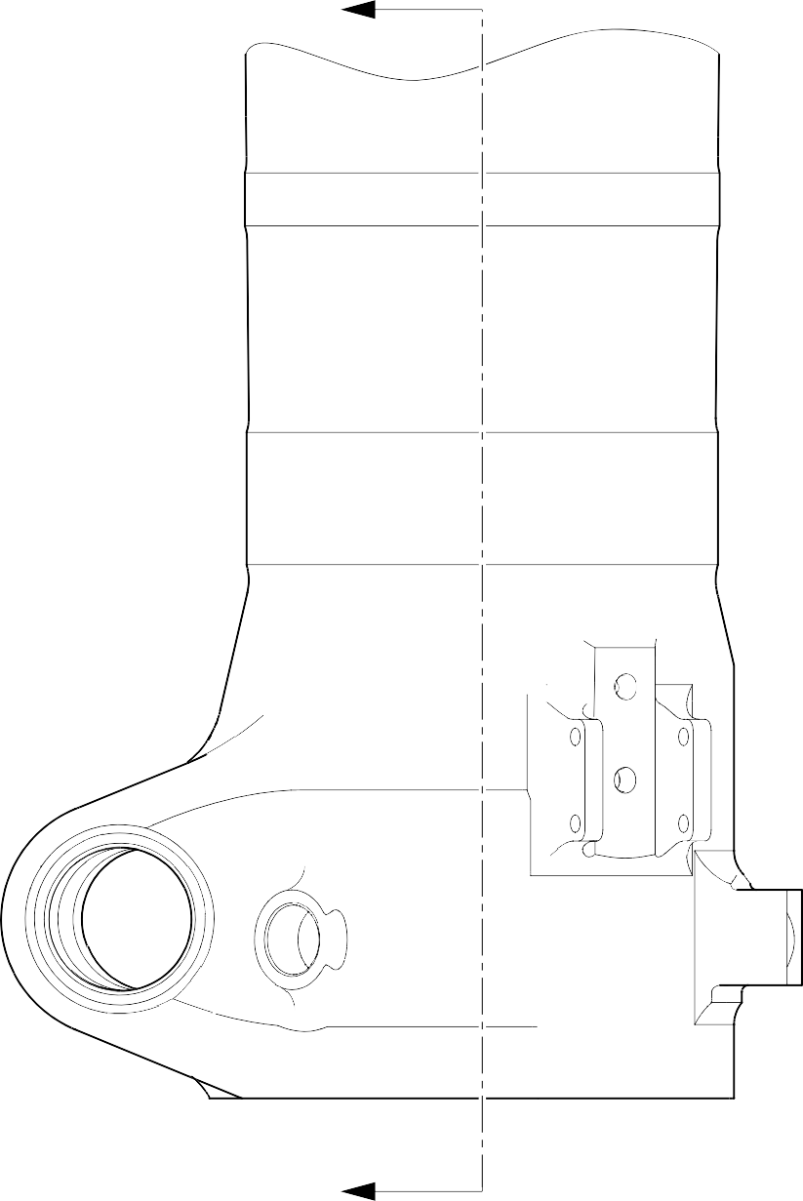
Z
Z
A321A6881-1

Repair to Main Fitting Figure 601









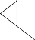

5,00 to 10,00mm
(0.197 to 0.394in) EXTENT OF CHROMIUM PLATE FADE OUT
183,00mm (7.205in) MIN.EXTENT OF FINE LIMIT REMAINDER MAY BE
DIA. B -0,254mm (0.010 0 in)
19,75 to 20,25mm
(0.778 to 0.797 in)
RADIUS
Y
DIA. B
9,00 to 11,00mm
(0.354 to 0.433in) RADIUS
15
DEGREES
0,50mm 3.957in)
55,00mm (2.165in) MIN. EXTENT OF FINE LIMIT REMAINDER MAY BE
DIA. A -0,254mm (0.0100in)
0,8
(32)
5,60mm (0.220in) X 15 DEGREES
1,6 CHAMFER
(63)
198,25 to 199,00mm
(7.805 to 7.835in) THIN CHROMIUM PLATE
DIA. A

99,75 to 10
(3.927 to

 | 0,05mm (0.002in) | Y

A321A6882-2

Repair to Main Fitting - Machining Figure 602

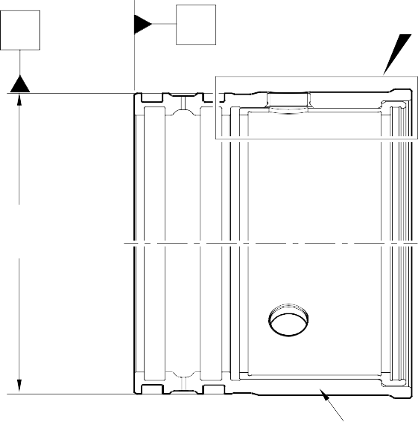
V W Y

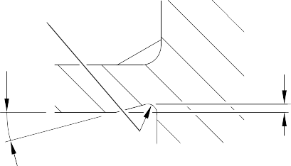
208,50 to 208,55mm (8.209 to 8.211in) DIA (REF)
0,50mm (0.020in) RAD
15
DEGREES
0,50mm (0.020in)

DETAIL X

CORRECT OVERSIZE BEARING AS LISTED IN TABLE 1

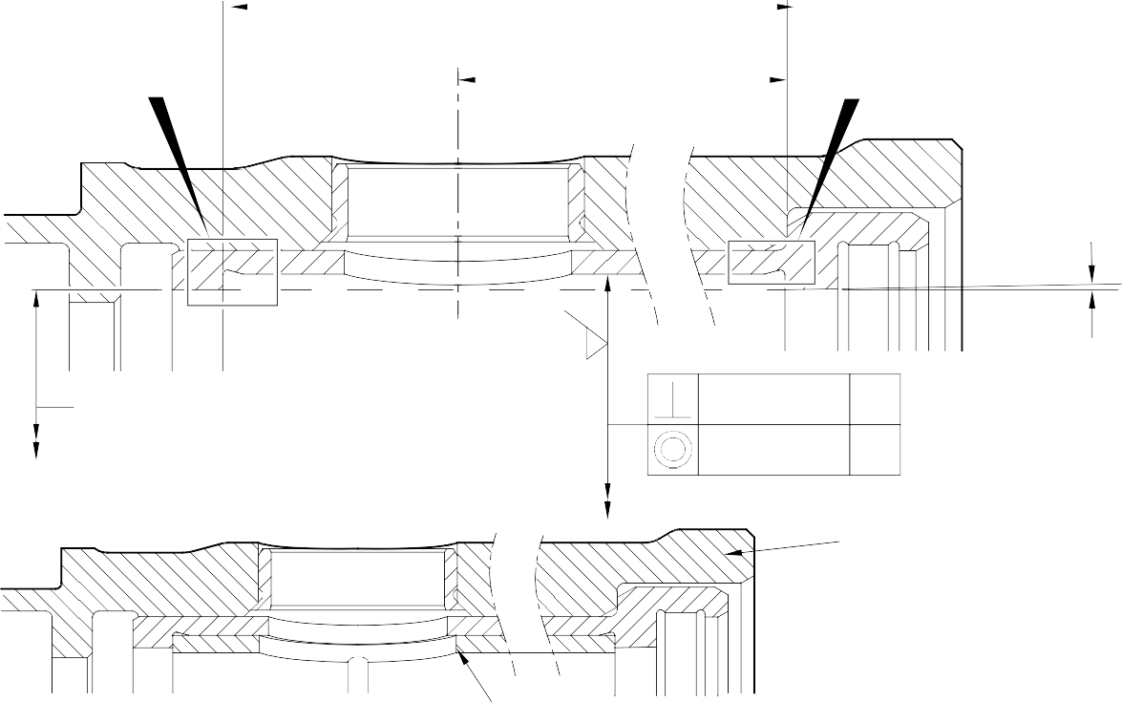
92,85 to 93,00mm (3.656 to 3.661in)

64,650 to 64,775mm (2.5453 to 2.5502in)
X
X

178,87 to 179,07mm (7.042 to 7.050in) DIA
1,6
(63)

182,453 to 182,516mm (7.1832 to 7.1857in) DIA
DETAIL Y

0,025mm (0.0010in)
0,040mm (0.0015in) DIA
W
V

0.333 to 0.867 DEGREES

MODIFIED REPAIR LOWER BEARING SUBASSEMBLY

NEW INNER LINER 201646300
DETAIL Y
WITH INNER LINER

A321A6964-2

Lower Bearing Subassembly Machining and Liner Installation Figure 603
Repair No. 11-26

32-12-22
Page 606

- Repair No. 11-27 Main Fitting (20-410, 20-410A, 20-420 and 20-420A)
  - Specified Damage and Material Specification
    - Specified Damage
      - Damage or wear to diameter A and/or face B.
    - Material Specification
IPL Figure and  Item No. | Name | Material Specification
20-410, 20-410A,  20-420 and 20-420A | Main Fitting | Steel, MAT135, 35NCD16THQ

  - Special Tools
    - These special tools are necessary:

NOTE: Alternative equivalents are permitted.

Tool Part No. | Special Tool | Function
460006614 | Assembly tool | Install the bearing
  - Materials
    - These materials are necessary:

NOTE: Alternative equivalents are permitted.

Ref. Item | Material
TBA | Zinc
05-533 | MastinoxD40
09-510A | Sealant
  - Repair Parts
    - These repair parts are necessary:

NOTE: Alternative equivalents are permitted.

Part No. | Repair Part | Material Specification
450266337 | Repair Bearing | AMS 4881 or AMS 4590
  - Procedure (Refer to Figures 601 and 602)

CAUTION: FOR DAMAGE MORE THAN THE LIMITS OF THIS REPAIR SCHEME, WRITE TO SAFRAN LANDING SYSTEMS: REFER TO GUIDE-CS-001.
    - Machine diameter A and/or face B sufficiently to remove the damage or wear within the dimensions shown: refer to M-DLPS1004-4-1 and Figure 601. Make the surface finish 1,6 micrometers (63 micro-inches).

Repair No. 11-27

32-12-22
Page 601

    - Machine the radii and chamfer as the dimensions shown: refer to Figure 601.
    - Measure and record the new diameter A and length C.
    - Examine the reworked area for flaws: refer to PCS-3600 and PCS-3100, inclusion class 4.
    - Shot peen the machined surfaces: refer to M-DLPS123.
    - Apply cadmium plate to the machined areas: refer to PCS-2100 or PCS-2141.The cadmium plate thickness must be between 0,01 and 0,02 mm (0.004 and 0.008 in).
    - Identify the part with the Safran Landing Systems repair number 450266040 adjacent to the part number: refer to PCS-6000-04, an alternative reference is PCS-6000-06. If the alternative reference is used, the characters must be 0,051 to 0,102 mm (0.0020 to 0.0040 in) deep and approximately 3,00 mm (0.118 in) high.
    - Calculate the dimensions for the repair bush, use formula:
Diameter D = Diameter A (as measured) + 0.069 to 0.126 mm (0.0027 to 0.0049 in) Length E = Length C (as measured) + 2,25 to 3,00 mm (0.089 to 0.118 in).
    - Machine the repair bearing to the dimensions shown and calculated: refer to Figure 602. Make the surface finish 1,6 micrometers (63 micro-inches).
    - Apply cadmium plate all over the repair bearing except the bore and the internal grooves: refer to PCS-2101. The cadmium plate thickness must be between 0,01 and 0,015 mm (0.0004 and 0.0006 in).
    - Use Assembly Tool 460006614 and install the repair bearing: refer to PCS-5100. Use electrically conducting Mastinox (made from Mastinox D40, Material Ref. Item 05-533 and Zinc powder, Material Ref. Item TBA).
    - Check ream the repair bearing bore to the dimensions shown: refer to Figure 602.
    - Apply a bead of sealant, Material Ref. Item 09-510A to joints between the repair bearing and the main fititng: refer to PCS-7200 and Figure 602.
    - Identify the part with the Safran Landing Systems repair number 450266040 adjacent to the part number: refer to PCS-6000-07.
    - Examine the part to make sure that you have obeyed all the repair instructions correctly.

Repair No. 11-27

32-12-22
Page 602

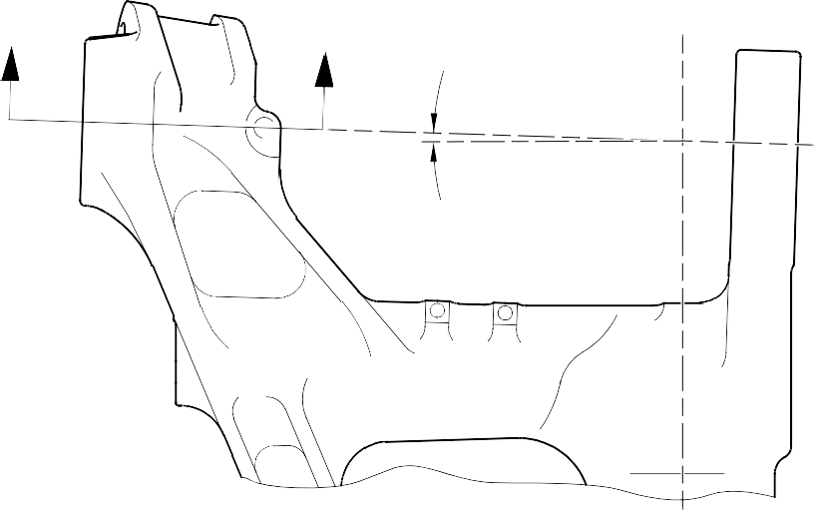
Z
Z
1 DEGREE
48 MINUTES
30 SECONDS
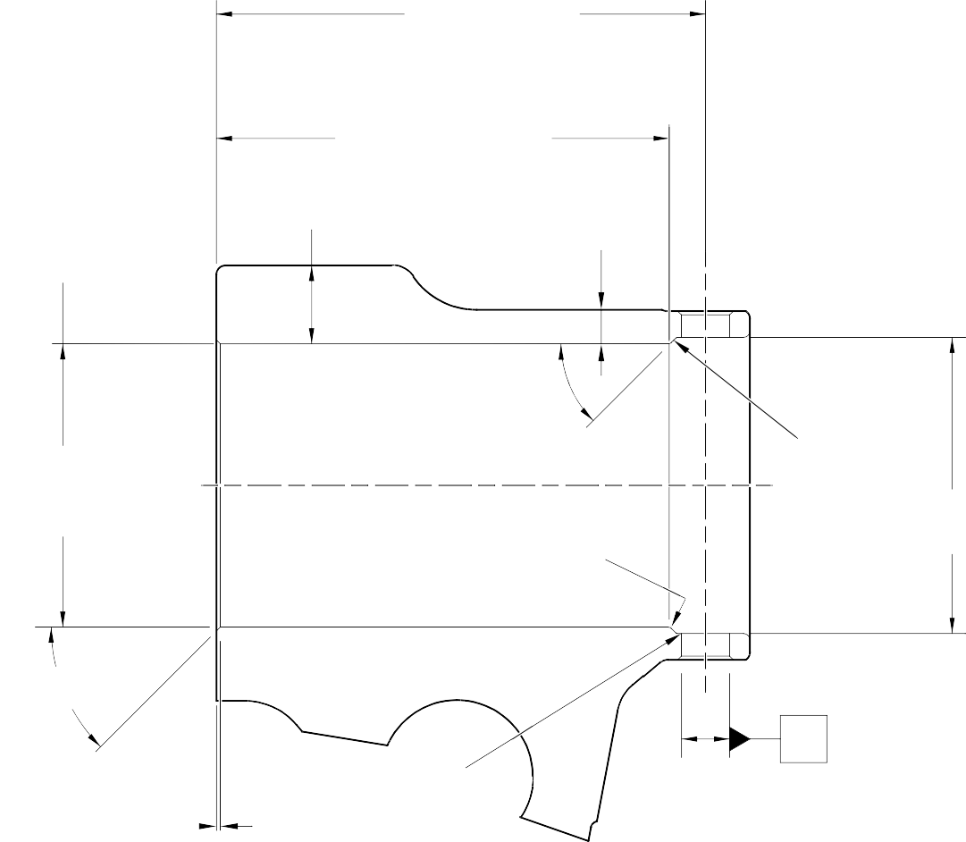

192,75 to 193,25mm
0,05mm (0.002in) DIA.
Y
0,05mm (0.002in) DIA.
0,15mm
(0.006in) DIA.
(7.589 to 7.608in) REF.

LENGTH C
177,00mm (6.968in) MIN. TO INTERSECTION

33,71mm (1.327in)

15,46mm

MIN.
Y
(0.609in) MIN.

DIA. A 113,335mm (4.4620in) MAXIMUM
44.5 to 45.5 DEGREES

1,00 to 2,00mm (0.039 to 0.079in) RAD.

FACE B

116,00 to 116,25mm (4.567 to 4.577in) DIA. REF.

44.5 to 45.5 DEGREES

1,25 to 1,75mm (0.049 to 0.069in)

0,50 to 1,00mm (0.020 to 0.039in) RAD.

Y

SECTION Z-Z

A321-S-32-12-22-091-0

Repair to Main Fitting Figure 601

Repair No. 11-27

32-12-22
Page 603

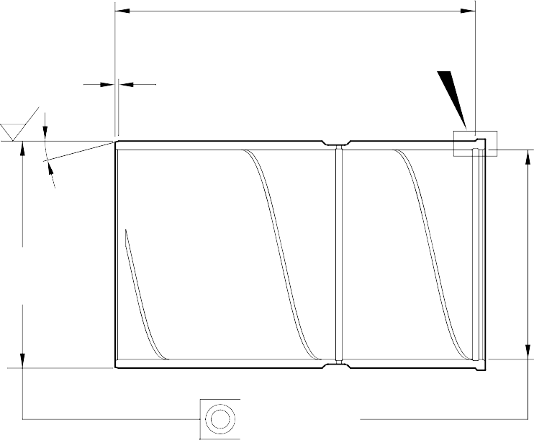
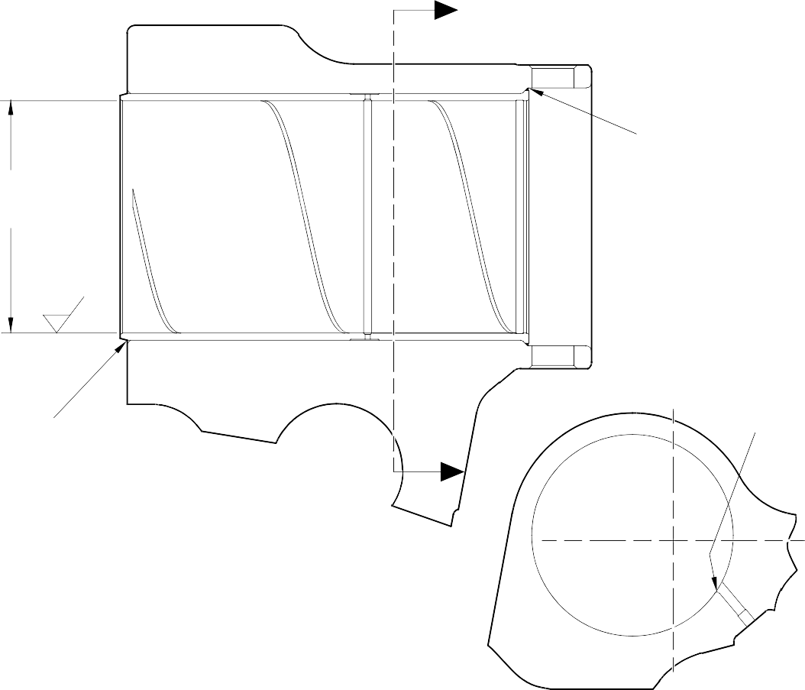
W
0,025mm (0.001in) DIA.
LENGTH E
1,6
(63)
1,25 to 1,75mm
(0.049 to 0.069in) CHAMFER
V
15
DEGREES
DIA.
D

105,00 to 105,035mm
(4.1339 to 4.13522in) DIA.
SEALANT TO PCS 7200

1,6
(63)

SEALANT TO PCS 7200

W
SECTION Z-Z
(WITH BUSH)
0,50 to 2,00mm
(0.020 to 0.079in) RAD.

SECTION W-W
(WITHOUT BUSH)

LENGTH E
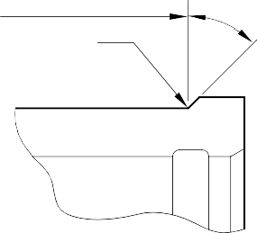
TO INTERSECTION
0,50 to 0,80mm
(0.020 to 0.032in) RAD.

DETAIL V

44.5 to 45.5 DEGREES

Repair Bearing - Machining and Installation Figure 602
A321-S-32-12-22-095-0

Repair No. 11-27

32-12-22
Page 604

- Repair No. 11-28 Main Fitting (20-410, 20-410A, 20-420 and 20-420A)
  - Specified Damage and Material Specification
    - Specified Damage
      - Damage or wear to diameters A and/or C.
    - Material Specification
IPL Figure and  Item No. | Name | Material Specification
20-410, 20-410A,  20-420 and 20-420A | Main Fitting | Steel, MAT135, 35NCD16THQ

  - Special Tools
    - Special tools are not necessary.
  - Materials
    - Materials are not necessary.
  - Repair Parts
    - These repair parts are necessary:

NOTE: Alternative equivalents are permitted.

Part No. | Repair Part | Material Specification
MS28774-012 | 1st Oversize backing ring | -
MS28774-013 | 2nd Oversize backing ring | -
MS28775-012 | 1st Oversize O-ring | -
MS28775-013 | 2nd Oversize O-ring | -
450239351 | 1st Oversize transfer dowel | Aluminium alloy L168-T6511
450239352 | 2nd Oversize transfer dowel | Aluminium alloy L168-T6511
  - Procedure (Refer to Figures 601 and 602)

CAUTION: FOR DAMAGE MORE THAN THE LIMITS OF THIS REPAIR SCHEME, WRITE TO SAFRAN LANDING SYSTEMS: REFER TO GUIDE-CS-001.
    - Do this procedure if there is damage or wear to diameter A:
      - Machine diameter A sufficiently to remove the damage or wear to the nearest possible dimensions as shown in Table 601: refer to M-DLPS1004-4-1 and Figure 602. Make the surface finish 1,6 micrometers (63 micro-inches).
      - Examine the reworked area for flaws: refer to PCS-3100, inclusion class 4 and PCS-3600.
Repair No. 11-28

32-12-22
Page 601

      - Identify the part with Safran Landing Systems repair number 450266405A for 1st oversize or 450266405B for 2nd oversize adjacent to the part number: refer to PCS-6000-04 or PCS-6000-06.
      - Select the applicable oversize transfer dowel, oversize O-ring and oversize backing ring: refer to Table 601.
      - Install the selected oversize parts to the main fitting: refer to Figure 603.
      - Apply paint to external surfaces, but not to the dowel bores: refer to PCS-2500.
      - Identify the part with Safran Landing Systems repair number 450266405A for 1st oversize or 450266405B for 2nd oversize adjacent to the part number: refer to PCS-6000-07.
      - Examine the part to make sure that you have obeyed all the repair instructions correctly.
Oversize dimensions Table 601

Oversize | Diameter A mm (in) | Diameter B mm (in) | Oversize  Transfer dowel Part No. | Oversize O-ring Part No. | Oversize  Backing ring Part No.
1 | 12,3190 to 12,3444 | 13,65 | 450239351 | MS28775-012 | MS28774-012
 | (0.4850 to 0.4860) | (0.537)
2 | 13,9700 to 14,0208 | 15,37 | 450239352 | MS28775-013 | MS28774-013
 | (0.5500 to 0.5520) | (0.605)
    - Do this procedure, if there is damage or wear to diameter C:
      - Machine diameter C sufficiently to remove the damage or wear to the nearest possible dimensions as shown in Table 602: refer to M-DLPS1004-4-1 and Figure 602. Make the surface finish 1,6 micrometers (63 micro-inches).
      - Examine the reworked area for flaws: refer to PCS-3100, inclusion class 4 and PCS-3600.
      - Identify the part with Safran Landing Systems repair number 450266405D for 1st oversize or 450266405E for 2nd oversize adjacent to the part number: refer to PCS-6000-04 or PCS-6000-06.
      - Select the applicable oversize transfer dowel, oversize O-ring and oversize backing ring: refer to Table 602.
      - Install the selected oversize parts to the main fitting: refer to Figure 603.
      - Apply paint to external surfaces, but not to the dowel bores: refer to PCS-2500.
      - Identify the part with Safran Landing Systems repair number 450266405D for 1st oversize or 450266405E for 2nd oversize adjacent to the part number: refer to PCS-6000-07.

Repair No. 11-28
32-12-22 Page 602

      - Examine the part to make sure that you have obeyed all the repair instructions correctly.
Oversize dimensions Table 602

Oversize | Diameter C mm (in) | Diameter D mm (in) | Oversize  Transfer dowel Part No. | Oversize O-ring Part No. | Oversize  Backing ring Part No.
1 | 12,3190 to 12,3444 | 13,65 | 450239351 | MS28775-012 | MS28774-012
 | (0.4850 to 0.4860) | (0.537)
2 | 13,9700 to 14,0208 | 15,37 | 450239352 | MS28775-013 | MS28774-013
 | (0.5500 to 0.5520) | (0.605)

43,00mm (1.693in) CRS

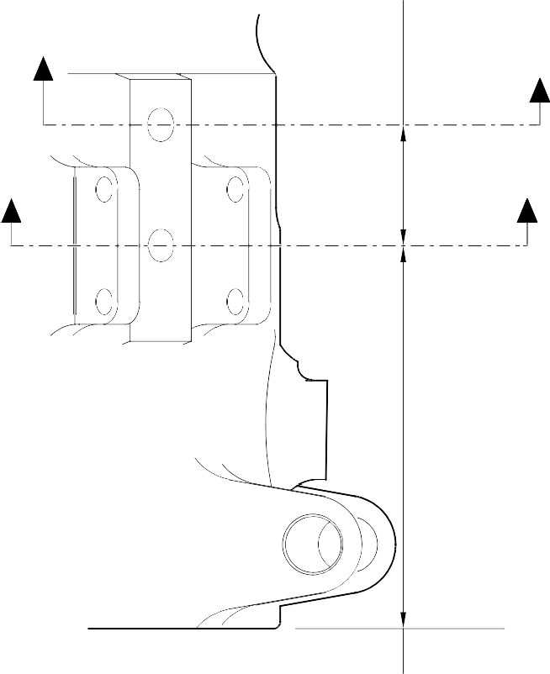
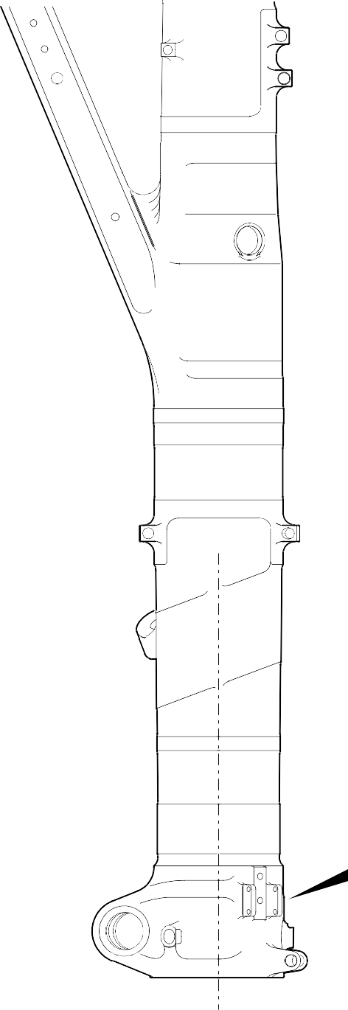
Y
(REFER TO FIGURE 602) Y

X
X (REFER TO FIGURE 602)

146,00 to 147,00mm
(5.748 to 5.787in)
Z DETAIL Z

A321A7163-1

Repair to Main Fitting Figure 601

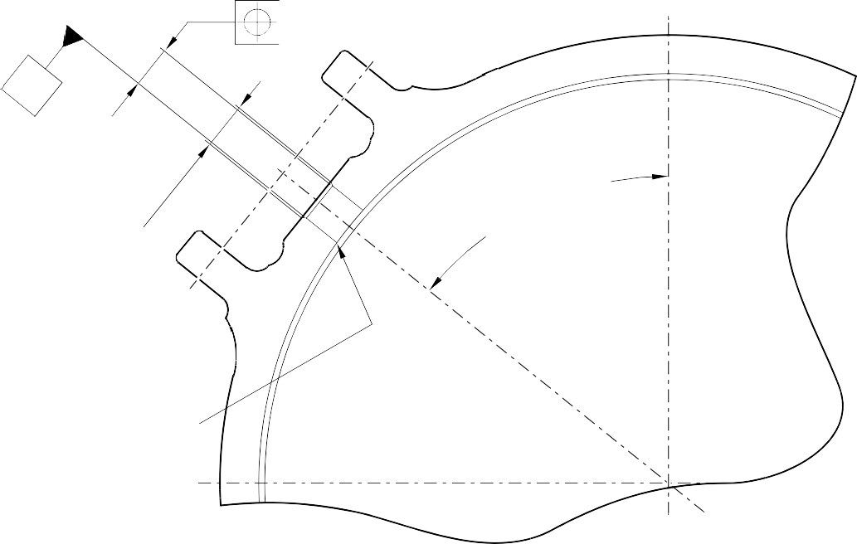
V
DIA A
50 DEGREES REF
DIA B x 60 DEGREES INCL. CHAMFER
REMOVE EDGE
0,5 to 1,0mm (0.02 to 0.04in) RAD
W
0,05mm
(0.002in) DIA
SECTION X-X

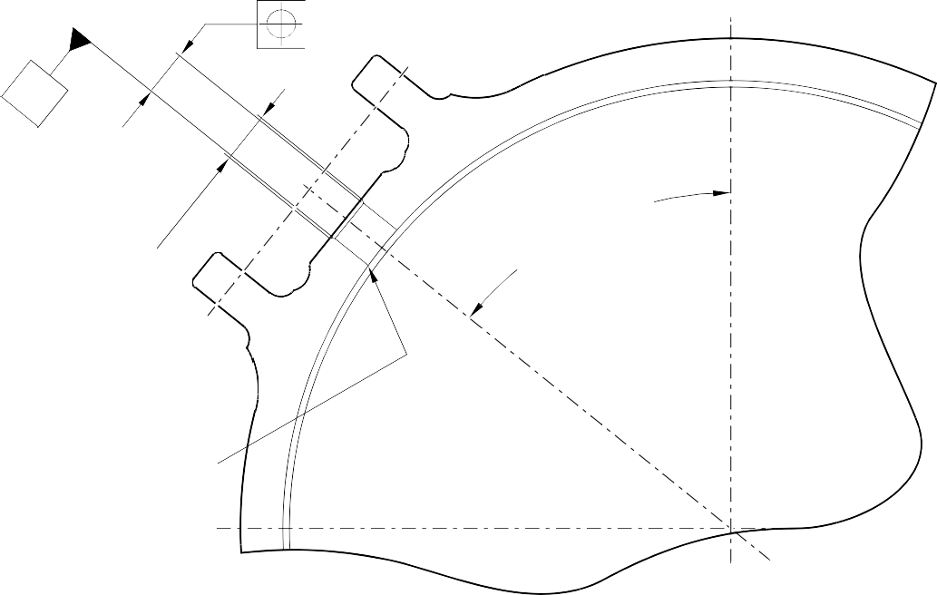
A321A7164-1
W
DIA C
DIA D x 60 DEGREES INCL. CHAMFER
50 DEGREES REF
REMOVE EDGE
0,5 to 1,0mm (0.02 to 0.04in) RAD
SECTION Y-Y
V
0,05mm
(0.002in) DIA

Repair to Main Fitting Figure 602

OVERSIZE TRANSFER DOWEL




OVERSIZE BACKING RING

OVERSIZE O RING

TYPICAL INSTALLATION OF OVERSIZE COMPONENTS

A321A7181-1

Oversize Transfer Dowel - Installation Figure 603

- Repair No. 11-29 Main Fitting (20-410A and 20-420A Only)
  - Specified Damage and Material Specification.
    - Specified Damage
      - Damage or corrosion to the diameter(s) A and/or B.
    - Material Specification

IPL Figure and  Item No. | Name | Material Specification
20-410A and  20-420A Only | Main fitting | Steel, MAT135, 35NCD16THQ
  - Special Tools
    - These special tools are necessary:

NOTE: Alternative equivalents are permitted.

Part No. | Special Tool | Function
460006405 | Assembly Sleeve | Install the lower bearing  subassembly
  - Materials
    - None.
  - Repair Parts
    - These repair parts are necessary:
Part No. | Repair Part | Material Specification
450266221 to  450266225 | Lower bearing  subassembly (Option 1 - Pre SB 201-32-49) | -
450266261 to  450266267 | Lower bearing subassembly (Option 2 - Post SB 201-32-49) | -

  - Procedure (Refer to Figures 601, 602 and 603)

CAUTION: FOR DAMAGE MORE THAN THE LIMITS OF THIS REPAIR SCHEME, WRITE TO MESSIER-DOWTY LIMITED: REFER TO GUIDE-CS-001.
    - Do this procedure if there is damage or corrosion to the chromium plate on diameter(s) A and/or B. The bare metal must not be damaged.
      - Remove the paint from the main fitting as necessary: refer to PCS-2700 and REPAIR.
      - Locally remove the chromium plate from diameter(s) A and/or B: refer to PCS-2110.

Repair No. 11-29

32-12-22
Page 601

      - Examine the bare metal for flaws: refer to PCS-3100, inclusion class 4 and PCS-3600.

CAUTION: DO NOT USE A MECHANICAL MOP POLISHER TO GET THE SURFACE FINISH. USE HONING OR LAPPING TOOLS.
      - Apply chromium plate to diameter A to between 212,000 and 212,072 mm (8.3465 and 8.3493 in) with a surface finish of 1,6 micrometers (63 micro-inches) and to diameter B between 208,890 and 208,966 mm (8.2240 and 8.2270 in) with a surface finish of 0,8 micrometers (32 micro-inches): refer to PCS-2110 and Figures 601, 602 and 603. The plating thickness must be between 0,040 and 0,060 mm (0.0016 and 0.0024 in).
      - Examine the reworked areas for flaws: refer to PCS-3100, inclusion class 4.
      - Apply wet primer to diameters A and B: refer to PCS-2804.
      - Identify the part with the Messier-Dowty Limited repair number 450267275A adjacent to the part number: refer to PCS-6000-04, maximum depth 0,13 mm (0.005 in).
      - Restore all protective treatments to the main fitting: refer to REPAIR.
      - Identify the part with the Messier-Dowty Limited repair number 450267275A adjacent to the part number: refer to PCS-6000-07.
      - Examine the part to make sure that you have obeyed all the repair instructions correctly.
    - Do this procedure to diameter A and/or B if there is damage to the bare metal.
      - Remove the paint from the main fitting as necessary: refer to PCS-2700 and REPAIR.
      - Remove the chromium plate from diameter(s) A and/or B: refer to PCS-2110.
      - Machine diameters A and B, as a matched pair to remove the wear or damage. Remove the minimum amount of material to get the nearest oversize pair of bores given in Table 601 (Option 1 and 2). Blend any sharp edges smoothly into the adjacent surfaces. The surface finish for diameter A must be 1,6 micrometers (63 micro-inches) and the surface finish for diameter B must be 0,8 micrometers (32 micro-inches): refer to M-DLPS1004-4-1 and Figure 601.

      - Measure and record the machined diameter(s) A and/or B.
      - Examine the bare metal for flaws: refer to PCS-3100, inclusion class 4 and PCS-3600.
      - Shot peen the reworked areas of the main fitting: refer to M-DLPS123.
      - Hone diameters A and B shot peened areas to the recorded diameters +0,00 to 0,05 mm (0.000 to 0.002 in).

CAUTION: DO NOT USE A MECHANICAL MOP POLISHER TO GET THE SURFACE FINISH. USE HONING OR LAPPING TOOLS.
      - Apply chromium plate to diameters A and B to the nearest dimensions shown in Table 601 (Option 1 and 2): refer to PCS-2110, Figures 601, 602 and 603. The
plating thickness must be between 0,040 and 0,060 mm (0.0016 and 0.0024 in). Refer to Figure 601 for the surface finish of diameters A and B.
      - Examine the reworked areas for flaws: refer to PCS-3100, inclusion class 4.
      - Apply wet primer to diameters A and B: refer to PCS-2804.
      - Identify the part with the Messier-Dowty Limited repair number 450267275B adjacent to the part number: refer to PCS-6000-04, maximum depth 0,13 mm (0.005 in).
      - Restore all protective treatments to the main fitting: refer to REPAIR.
      - Use the correct lower bearing subassembly from the Table 601 (Option 1 or 2).
      - Use the Assembly Sleeve 460006405 to install the lower bearing subassembly.

NOTE: If you use an Option 2 Lower bearing subassembly you must use the sealant procedure Post SB 201-32-49 at installation of the sliding tube subassembly to the main fitting.
      - Identify the part with the Messier-Dowty Limited repair number 450267275B adjacent to the part number: refer to PCS-6000-07.
      - Examine the part to make sure that you have obeyed all the repair instructions correctly.

Repair No. 11-29

32-12-22
Page 603

Table 601 (Option 1 - Pre SB 201-32-49)

 | Bore Diameter A |  | Bore Diameter B
 | Before chromium  plate mm (in) | After chromium  plate mm (in) | Before chromium  plate mm (in) | After chromium  plate mm (in) | Lower  bearing subassembly
1 | 212,242 to 212,274 | 212,122 to 212,194 | 209,132 to 209,168 | 209,012 to 209,088 | 450266221
 | (8.3560 to 8.3572) | (8.3513 to 8.3541) | (8.2335 to 8.2350) | (8.2288 to 8.2318)
2 | 212,392 to 212,424 | 212,272 to 212,344 | 209,282 to 209,318 | 209,162 to 209,238 | 450266222
 | (8.3619 to 8.3631) | (8.3572 to 8.3600) | (8.2394 to 8.2409) | (8.2347 to 8.2377)
3 | 212,542 to 212,574 | 212,422 to 212,494 | 209,432 to 209,468 | 209,312 to 209,388 | 450266223
 | (8.3678 to 8.3691) | (8.3631 to 8.3659) | (8.2454 to 8.2468) | (8.2406 to 8.2436)
4 | 212,692 to 212,724 | 212,572 to 212,644 | 209,582 to 209,618 | 209,462 to 209,538 | 450266224
 | (8.3737 to 8.3750) | (8.3690 to 8.3718) | (8.2513 to 8.2527) | (8.2465 to 8.2495)
5 | 212,842 to 212,874 | 212,722 to 212,794 | 209,732 to 209,768 | 209,612 to 209,688 | 450266225
 | (8.3796 to 8.3809) | (8.3749 to 8.3777) | (8.2572 to 8.2586) | (8.2524 to 8.2554)

Table 601 (Option 2 - Post SB 201-32-49)
 | Bore Diameter A |  | Bore Diameter B |  | Lower bearing subassembly
 | Before  chromium plate mm (in) | After  chromium plate mm (in) | Before  chromium plate mm (in) | After  chromium plate mm (in)
 | 212,242 to | 212,122 to | 209,132 to | 209,012 to
1 | 212,274  (8.3560 to | 212,194  (8.3513 to | 209,168  (8.2335 to | 209,088  (8.2288 to | 450266261
 | 8.3572) | 8.3541) | 8.2350) | 8.2318)
 | 212,392 to | 212,272 to | 209,282 to | 209,162 to
2 | 212,424  (8.3619 to | 212,344  (8.3572 to | 209,318  (8.2394 to | 209,238  (8.2347 to | 450266262
 | 8.3631) | 8.3600) | 8.2409) | 8.2377)
 | 212,542 to | 212,422 to | 209,432 to | 209,312 to
3 | 212,574  (8.3678 to | 212,494  (8.3631 to | 209,468  (8.2454 to | 209,388  (8.2406 to | 450266263
 | 8.3691) | 8.3659) | 8.2468) | 8.2436)
 | 212,692 to | 212,572 to | 209,582 to | 209,462 to
4 | 212,724  (8.3737 to | 212,644  (8.3690 to | 209,618  (8.2513 to | 209,538  (8.2465 to | 450266264
 | 8.3750) | 8.3718) | 8.2527) | 8.2495)
 | 212,842 to | 212,722 to | 209,732 to | 209,612 to
5 | 212,874  (8.3796 to | 212,794  (8.3749 to | 209,768  (8.2572 to | 209,688  (8.2524 to | 450266265
 | 8.3809) | 8.3777) | 8.2586) | 8.2554)

Table 601 (Option 2 - Post SB 201-32-49) (Continued)
 | Bore Diameter A |  | Bore Diameter B |  | Lower bearing subassembly
 | Before  chromium plate mm (in) | After  chromium plate mm (in) | Before  chromium plate mm (in) | After  chromium plate mm (in)
 | 213,233 to | 213,113 to | 209,732 to | 209,612 to
6 | 213,265  (8.3950 to | 213,185  (8.3903 to | 209,768  (8.2572 to | 209,688  (8.2524 to | 450266266
 | 8.3963) | 8.3931) | 8.2586) | 8.2554)
 | 213,533 to | 213,413 to | 209,732 to | 209,612 to
7 | 213,565  (8.4068 to | 213,485  (8.4020 to | 209,768  (8.2572 to | 209,688  (8.2524 to | 450266267
 | 8.4081) | 8.4049) | 8.2586) | 8.2554)

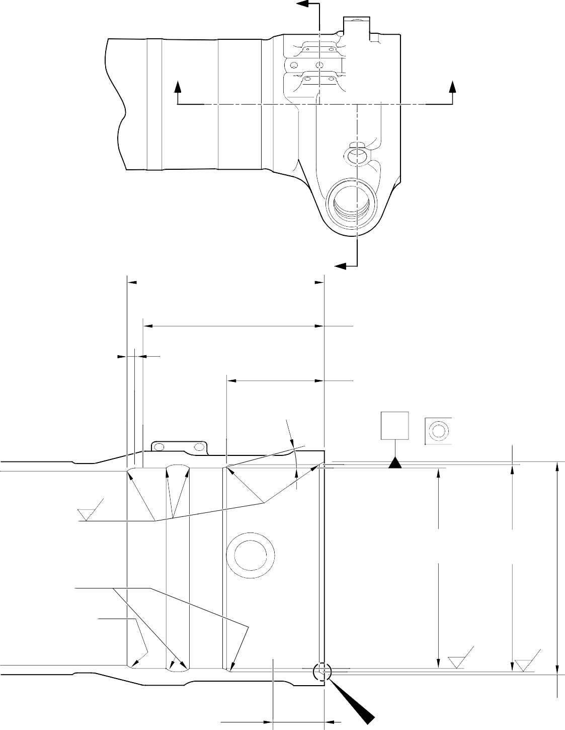
Y

Z Z

5,00 to 10,00mm
(0.2 to 0.4in) EXTENT OF
CHROME FADE OUT
198,25 to 199,00mm Y
(7.805 to 7.835in)
CHROMIUM PLATE

15
DEGREES

18 3,00mm ( 7 .205 in)
MINIMUM EXTENT OF FINE LIMIT DIA. REMAINDER MAY BE
BORE DIA. B -0,254mm (-0.010in)

99,75 to 100,5mm
(3.927 to 3.957in)

X
X
0,05mm (0.002in) DIA.

9,00 to 11,00mm (0.354 to 0.433in) RAD.
0,8
(32)

DIA . B

DIA . A

20,00mm (0.787in) RAD.

20,00mm (0.787in) RAD. CHROMIUM PLATE MAY TERMINATE ANYWHERE
ON THIS RADIUS

0,8
(32)

1,6
(63)

55,00mm (2.165in) MINIMUM EXTENT
OF FINE LIMIT DIA. REMAINDER MAY BE
BORE DIA. A -0,254mm (-0.010in)

W
SECTION Z-Z
215,00mm (8.465in) DIA.
x 30 DEGREES CHAMFER INCLUSIVE
A321-S-32-12-22-060-2

Repair to Main Fitting - Machining Figure 601

CHROMIUM PLATE DEPOSIT
PAINT MUST OVERLAP CADMIUM PLATE NO BARE METAL PERMISSIBLE


NO CADMIUM OR PAINT DEPOSIT TO ENTER OR STAND PROUD OF CHROMIUM PLATED BORE

CADMIUM PLATE MUST OVERLAP CHROMIUM PLATE

1,00 to 3,00mm (0.039 to 0.118in) RAD.
CHROMIUM PLATE MAY TERMINATE ANYWHERE ON THIS RADIUS

CADMIUM PLATE

DETAIL W
CHROMIUM PLATE TERMINATION LOWER BARREL

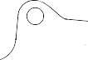
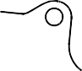
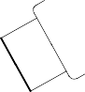
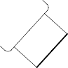





U
V
V
U

SECTION Y-Y

A321-S-32-12-22-061-1

Repair to Main Fitting Figure 602

10,7186 to 10,7597mm (0.422 to 0.424in) DIA.

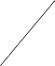

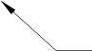
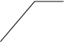

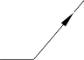
CHROMIUM PLATE

CHROMIUM PLATE

CHROMIUM PLATE MUST TERMINATE WITHIN THIS BAND. 1,00mm (0.039in) MAXIMUM RUNOUT
SECTION V-V
CHROMIUM PLATE TERMINATION AROUND CHANGEOVER VALVE HOLES TYPICAL 2 POSITIONS


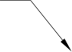
1,00mm (0.039in) MAXIMUM
CHROMIUM PLATE PERMISSIBLE FADE OUT
12,757mm (0.502in) DIA. MINIMUM NO PLATING
16,757mm (0.66in) DIA. MAXIMUM

CADMIUM PLATE

1,00 to 3,00mm
(0.039 to 0.118in) RAD.
CHROMIUM PLATE MAY TERMINATE ANYWHERE ON THIS RADIUS

CADMIUM PLATE MUST OVERLAP
CHROMIUM PLATE NO BARE METAL PERMISSIBLE NO CADMIUM PLATE TO
ENTER OR STAND PROUD OF CHROMIUM
PLATED DIAMETER
CHROMIUM PLATE

50,50mm (1.988in) DIA. MAXIMUM EXTENT OF CADMIUM FADE OUT

SECTION U-U
CHROMIUM PLATE TERMINATION AROUND DOWEL HOLES TYPICAL 3 POSITIONS

A321-S-32-12-22-062-1

Repair to Main Fitting - Chromium Plate Termination Figure 603

Repair No. 11-29

32-12-22
Page 608

- Repair No. 11-30 Main Fitting (20-410A and 20-420A Only)

CAUTION: THIS REPAIR IS FOR THE POST SB 201-32-58 UNITS ONLY. FOLLOW THE REQUIREMENTS OF SB 201-32-58 COMPLETELY. FOR PRE SB 201-32-58, REFER TO REPAIR NO. 11-29 (450267275).
  - Specified Damage and Material Specification.
    - Specified Damage
      - Damage or corrosion to the diameter(s) A and/or B.
    - Material Specification
IPL Figure and  Item No. | Name | Material Specification
20-410A and  20-420A Only | Main fitting | Steel to MAT135 (35NCD16THQ)

  - Special Tools
    - These special tools are necessary:

NOTE: Alternative equivalents are permitted.

Part No. | Special Tool | Function
460006405 | Assembly Sleeve | Install the lower bearing  subassembly
  - Materials
    - This material is necessary:

NOTE: Alternative equivalents are permitted.

Ref. Item | Material
TBA | Molykote 111, PCS-7303
  - Repair Parts
    - These repair parts are necessary:

Part No. | Repair Part | Material Specification
450267371 to  450267383  Refer to Table 601 | Lower bearing subassembly | -
201646300 | Inner liner | -

Repair No. 11-30

32-12-22
Page 601

  - Procedure (Refer to Figures 601, 602, 603 and 604)

CAUTION: FOR DAMAGE MORE THAN THE LIMITS OF THIS REPAIR SCHEME, WRITE TO MESSIER-DOWTY LIMITED: REFER TO GUIDE-CS-001.
    - Do this procedure if there is damage or corrosion to the chromium plate on diameter(s) A and/or B. The bare metal must not be damaged.
      - Remove the paint from the main fitting as necessary: refer to PCS-2700.
      - Locally remove the chromium plate from diameter(s) A and/or B: refer to PCS-2110.

CAUTION: DO NOT USE A MECHANICAL MOP POLISHER TO GET THE SURFACE FINISH. USE HONING OR LAPPING TOOLS.
      - Apply chromium plate to diameter A to between 212,000 and 212,072 mm (8.3465 and 8.3493 in) with a surface finish of 1,6 micrometers (63 micro-inches) and to diameter B to between 208,890 and 208,966 mm (8.2240 and 8.2270 in) with a surface finish of 0,8 micrometers (32 micro-inches): refer to PCS-2110 and Figures 601, 602 and 603. The plating thickness must be between 0,040 and 0,060
mm (0.0016 and 0.0024 in).
      - Examine the reworked areas for flaws: refer to PCS-3100, inclusion class 4.
      - Apply wet primer to diameters A and B: refer to PCS-2804.
      - Identify the part with the Messier-Dowty Limited repair number 450267385A adjacent to the part number: refer to PCS-6000-04, maximum depth 0,13 mm (0.005 in).
      - Restore all protective treatments to the main fitting: refer to REPAIR.
      - Identify the part with the Messier-Dowty Limited repair number 450267385A adjacent to the part number: refer to PCS-6000-07.
      - Examine the part to make sure that you have obeyed all the repair instructions correctly.
    - Do this procedure to diameter(s) A and/or B if there is damage to the bare metal.
      - Remove the paint from the main fitting as necessary: refer to PCS-2700.
      - Locally remove the chromium plate from diameter(s) A and B: refer to PCS-2110.
      - Machine diameters A and B, as a matched pair to remove the wear or damage. Remove the minimum amount of material to get the nearest oversize pair of bores given in Table 601. Blend any sharp edges smoothly into the adjacent surfaces. The surface finish for diameter A must be 1,6 micrometers (63 micro-inches) and the surface finish for diameter B must be 0,8 micrometers (32 micro-inches): refer to M-DLPS1004-4-1 and Figure 601.
      - Machine the chamfers and radii as shown: refer to Figures 601, 602 and 603. Blend all sharp edges smoothly into the adjacent surface. Make the surface finish for the radii 0,8 micrometers (32 micro-inches).
      - Measure and record the machined diameter(s) A and/or B.

      - Examine the bare metal for flaws: refer to PCS-3100, inclusion class 4 and PCS-3600.
      - Shot peen the reworked areas of the main fitting: refer to M-DLPS123.
      - Hone diameters A and B shot peened areas to the recorded diameters +0,00 to 0,025 mm (0.000 to 0.001 in).

CAUTION: DO NOT USE A MECHANICAL MOP POLISHER TO GET THE SURFACE FINISH. USE HONING OR LAPPING TOOLS.
      - Apply chromium plate to diameters A and B to the nearest dimensions shown in Table 601. The plating thickness must be between 0,040 and 0,060 mm (0.0016 and 0.0024 in). To get the necessary surface finish hone or lap diameters A and B: refer to PCS-2110 and Figures 601 to 603.
      - Examine the reworked areas for flaws: refer to PCS-3100, inclusion class 4.
      - Apply wet primer to diameters A and B: refer to PCS-2804.
      - Identify the part with the Messier-Dowty Limited repair number 450267385B adjacent to the part number on the main fitting: refer to PCS-6000-04, maximum depth 0,13 mm (0.005 in).
      - Restore all protective treatments to the main fitting. Make sure that the cadmium plate overlaps the chromium plate terminations: refer to REPAIR, Figures 602 and 603.
      - Select the correct oversize lower bearing subassembly from the Table 601 for the repaired diameters A and B.

NOTE: Each POST oversize lower bearing subassembly can be made from the related PRE SB 201-32-58 lower bearing subassembly: refer to Table 602.
      - If necessary, machine the inner bore of the bronze liner: refer to Figure 604.

NOTE: The lower bearing (16-150) bore can only be machined when it is installed in the lower bearing subassembly.
      - If necessary, examine the machined area for flaws: refer to PCS-3200.
      - If necessary, apply a small quantity of Molykote 111, Material Ref. Item TBA, to the outside diameter of inner liner (16A-117) and install it in the lower bearing subassembly: refer to PCS-7303 and Figure 604. Make sure that the holes in the new inner liner align with the holes in the lower bearing subassembly.
      - If necessary, strike through the old part number and re-identify the new lower bearing subassembly with the new inner liner with a part number given in Table 602: refer to PCS-6000-04 and PCS-6000-07.
      - At the applicable assembly step, use the Assembly Sleeve 460006405 and install the lower bearing subassembly on the sliding tube subassembly: refer to ASSEMBLY (INLUDING STORAGE).
      - At the applicable assembly step, install the repaired shock absorber subassembly in the main fitting: refer to ASSEMBLY (INLUDING STORAGE).
Repair No. 11-30

      - Identify the part with the Messier-Dowty Limited repair number 450267385B adjacent to the part number: refer to PCS-6000-07.
      - Examine the part to make sure that you have obeyed all the repair instructions correctly.
Oversize Lower Bearing Subassembly Dimensions (Post SB 201-32-58) Table 601

 | Bore Diameter A |  | Bore Diameter B
 | Before chromium  plate mm (in) | After chromium  plate mm (in) | Before chromium  plate mm (in) | After chromium  plate mm (in) | Lower bearing subassembly
1 | 212,242 to 212,274 | 212,122 to 212,194 | 209,132 to 209,168 | 209,012 to 209,088 | 450267371
 | (8.3560 to 8.3572) | (8.3513 to 8.3541) | (8.2335 to 8.2350) | (8.2288 to 8.2318)
2 | 212,392 to 212,424 | 212,272 to 212,344 | 209,282 to 209,318 | 209,162 to 209,238 | 450267373
 | (8.3619 to 8.3631) | (8.3572 to 8.3600) | (8.2394 to 8.2409) | (8.2347 to 8.2377)
3 | 212,542 to 212,574 | 212,422 to 212,494 | 209,432 to 209,468 | 209,312 to 209,388 | 450267375
 | (8.3678 to 8.3691) | (8.3631 to 8.3659) | (8.2454 to 8.2468) | (8.2406 to 8.2436)
4 | 212,692 to 212,724 | 212,572 to 212,644 | 209,582 to 209,618 | 209,462 to 209,538 | 450267377
 | (8.3737 to 8.3750) | (8.3690 to 8.3718) | (8.2513 to 8.2527) | (8.2465 to 8.2495)
5 | 212,842 to 212,874 | 212,722 to 212,794 | 209,732 to 209,768 | 209,612 to 209,688 | 450267379
 | (8.3796 to 8.3809) | (8.3749 to 8.3777) | (8.2572 to 8.2586) | (8.2524 to 8.2554)
6 | 213,233 to 213,265 | 213,113 to 213,185 | 209,732 to 209,768 | 209,612 to 209,688 | 450267381
 | (8.3950 to 8.3963) | (8.3903 to 8.3931) | (8.2572 to 8.2586) | (8.2524 to 8.2554)
7 | 213,533 to 213,565 | 213,413 to 213,485 | 209,732 to 209,768 | 209,612 to 209,688 | 450267383
 | (8.4068 to 8.4081) | (8.4020 to 8.4049) | (8.2572 to 8.2586) | (8.2524 to 8.2554)

Oversize Lower Bearing Subassembly Table 602

Pre SB 201-32-58  Part number | Post SB 201-32-58  Part number  (fitted with inner liner 201646300)
450266261 | 450267371
450266262 | 450267373
450266263 | 450267375
450266264 | 450267377
450266265 | 450267379
450266266 | 450267381
450266267 | 450267383

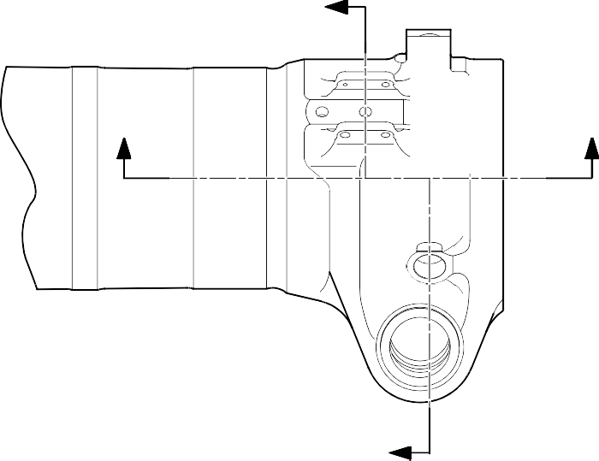
Y

Z Z

198,25 to 199,00mm Y

5,00 to 10,00mm
(0.2 to 0.4in) EXTENT OF CHROMIUM FADE OUT
(7.805 to 7.835in) CHROMIUM PLATE

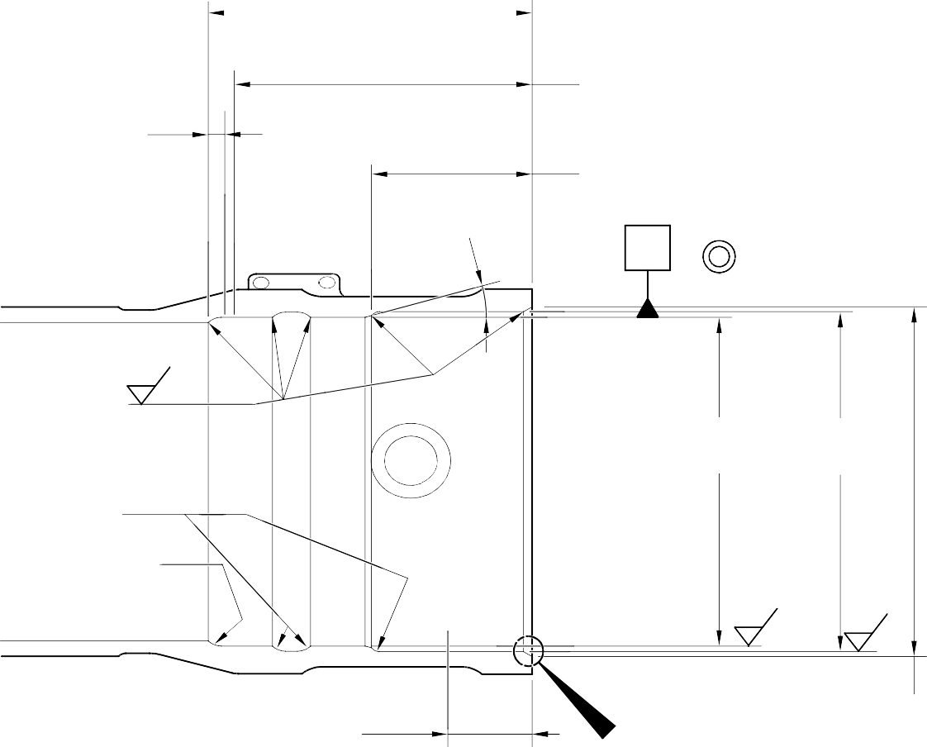
15
DEGREES

183,00mm (7.205in)
MINIMUM EXTENT OF FINE LIMIT DIA. REMAINDER MAY BE
BORE DIA. B -0,254mm (-0.010in)

99,75 to 100,5mm
(3.927 to 3.957in)

X
 | 0,05mm (0.002in) DIA. |  | X

9,00 to 11,00mm (0.354 to 0.433in) RAD.
0,8
(32)

DIA. B

DIA. A

20,00mm (0.787in) RAD.

20,00mm (0.787in) RAD. CHROMIUM PLATE MAY TERMINATE ANYWHERE
ON THIS RADIUS

0,8
(32)

1,6
(63)

55,00mm (2.165in) MINIMUM EXTENT
OF FINE LIMIT DIA. REMAINDER MAY BE
BORE DIA. A -0,254mm (-0.010in)

W
SECTION Z-Z
215,00mm (8.4645in) DIA. x 30 DEGREES CHAMFER
INCLUSIVE
A321-S-32-12-22-064-0

Repair to Main Fitting - Machining Figure 601

Repair No. 11-30

CHROMIUM PLATE DEPOSIT
PAINT MUST OVERLAP CADMIUM PLATE NO BARE METAL PERMISSIBLE

NO CADMIUM OR PAINT DEPOSIT TO ENTER OR STAND PROUD OF CHROMIUM PLATED BORE

CADMIUM PLATE MUST OVERLAP CHROMIUM PLATE

1,00 to 3,00mm (0.039 to 0.118in) RAD.
CHROMIUM PLATE MAY TERMINATE ANYWHERE ON THIS RADIUS

CADMIUM PLATE

DETAIL W

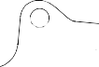
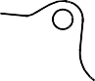
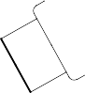
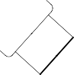




U
V
V
U

SECTION Y-Y

A321-S-32-12-22-065-0

Repair to Main Fitting Figure 602

10,7186 to 10,7597mm (0.422 to 0.424in) DIA.

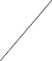

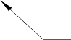


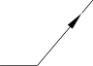
CHROMIUM PLATE

CHROMIUM PLATE

CHROMIUM PLATE MUST TERMINATE WITHIN THIS BAND. 1,00mm (0.039in) MAXIMUM RUNOUT
SECTION V-V
CHROMIUM PLATE TERMINATION AROUND CHANGEOVER VALVE HOLES TYPICAL 2 POSITIONS
12,757mm (0.502in) DIA. MINIMUM NO PLATING
16,757mm (0.66in) DIA. MAXIMUM

1,00mm (0.039in) MAXIMUM
CHROMIUM PLATE PERMISSIBLE FADE OUT

CADMIUM PLATE

1,00 to 3,00mm
(0.039 to 0.118in) RAD.
CHROMIUM PLATE MAY TERMINATE ANYWHERE ON THIS RADIUS

CADMIUM PLATE MUST OVERLAP
CHROMIUM PLATE NO BARE METAL PERMISSIBLE NO CADMIUM PLATE TO
ENTER OR STAND PROUD OF CHROMIUM
PLATED DIAMETER
CHROMIUM PLATE

50,50mm (1.988in)MAXIMUM EXTENT OF CADMIUM FADE OUT

SECTION U-U
CHROMIUM PLATE TERMINATION AROUND DOWEL HOLES TYPICAL 3 POSITIONS

A321-S-32-12-22-066-0

Repair to Main Fitting - Chromium Plate Termination Figure 603

Repair No. 11-30

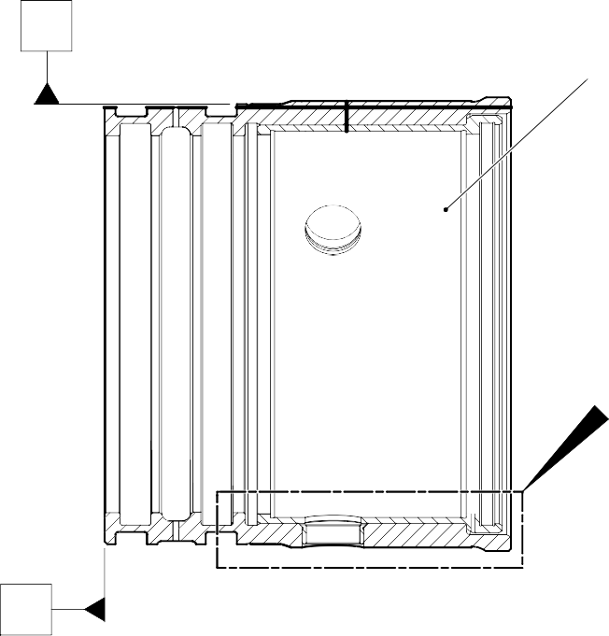
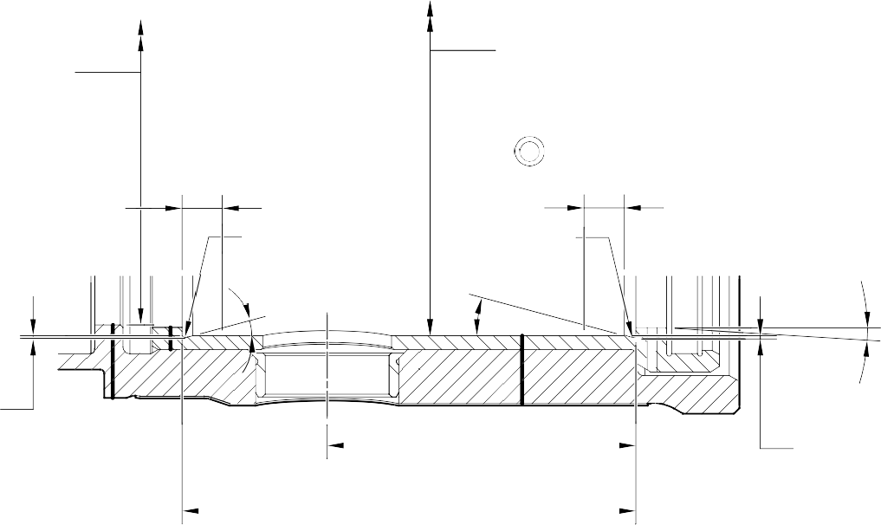
X CORRECT OVERSIZE
AS IN TABLE 602

Z

Y
178,87 to 179,07mm (7.042 to 7.050in) DIA.

182,453 to 182,516mm (7.183 to 7.186in) DIA.
 |  | 0,025mm (0.001in) | Y
 |  | 0,04mm (0.0016in) DIA. | X

10,00mm (0.394in)

0,5mm (0.02in) RAD.
15 DEGREES

0,5mm (0.02in)
RAD. 15 DEGREES
10,00mm (0.394in)
0.333 to 0.667 DEGREES REF.

0,5mm (0.02in)

64,65 to 64,775mm (2.545 to 2.550in)

0,5mm (0.02in)

92,85 to 93,00mm (3.656 to 3.661in)

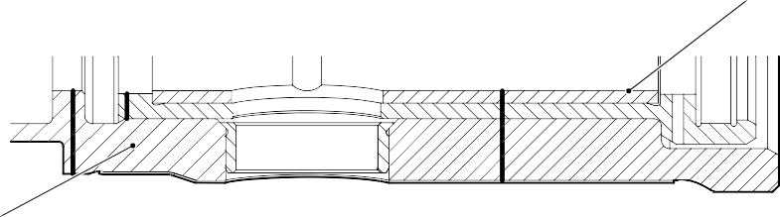
NEW INNER LINER (16A-117)
DETAIL Z

MODIFIED REPAIR LOWER BEARING SUBASSEMBLY

A321-S-32-12-22-067-0

Lower Bearing Subassembly - Machining and Inner Liner Installation Figure 604

Repair No. 11-30

- Repair No. 11-31 Main Fitting (20-410B, 20-410C, 20-410D, 20-420B, 20-420C and 20-420D)
  - Specified Damage and Material Specification
    - Specified Damage
      - Wear or damage or corrosion to diameter A.
    - Material Specification

IPL Figure and  Item No. | Name | Material Specification
20-410B and  20-420B | Main fitting | UHT Steel E35NCD16THQ to MTL-1203  with UTS 1800 MPa (261.0 ksi)
20-410C,  20-410D,  20-420C and 20-420D | Main fitting | UHT Steel 300M to MTL-1201 with UTS 1930 MPa (279.9 ksi)
  - Special Tools
    - Special tools are not necessary.
  - Materials
    - This material is necessary:

NOTE: Alternative equivalents are permitted.

Ref. Item | Material
TBA | Loctite Grade 270
  - Repair Parts
    - These repair parts are necessary:

Part No. | Repair Part | Material Specification
450250161 to  450250166 | Oversize lubrication adaptor | Steel, S154 or 4340 to  AMS6409 and heat treated to S154
450250241 to  450250246 | Oversize lubrication adaptor | Steel, S154 or 4340 to AMS6409 and heat treated to S154

  - Procedure (Refer to Figure 601)

CAUTION: FOR DAMAGE MORE THAN THE LIMITS OF THIS REPAIR SCHEME, WRITE TO SAFRAN LANDING SYSTEMS: REFER TO GUIDE-CS-001.
CAUTION: APPLY TEMPORARY CORROSION AND DAMAGE PROTECTION: REFER TO PCS-2800.
    - Do this procedure if there is wear or damage or corrosion to diameter A: refer to Figure 601.
      - Remove the paint from the main fitting: refer to PCS-2700.
      - Remove the cadmium plate from the main fitting: refer to PCS-2100.
      - Machine diameter A to the nearest dimensions shown in Table 601 to remove the damage or wear or corrosion. Do not increase diameter A to more than 6,449 mm (0.2539 in). The surface finish must be 1,6 micrometers (63 micro-inches) or better: refer to PCS-4100 and Figure 601.
      - Measure and record the diameter A.
      - Machine the chamfer(s) and/or radii as shown: refer to PCS-4100 and Figure 601.
      - Examine the machined area for flaws: refer to PCS-3100, inclusion Class 4 and PCS-3600.
      - Apply cadmium plate all over but not to the areas shown. The cadmium plate thickness must be between 0,010 and 0,020 mm (0.0004 and 0.0008 in): refer to PCS-2100 and Figure 601.
      - Select the correct oversize lubrication adaptor from Table 601 applicable for diameter A.
      - Use Loctite Grade 270, Material Ref. Item TBA, to install the correct oversize lubrication adaptor from Table 601: refer to PCS-5303 and Figure 601.
      - Apply primer and top coat paint all over but not to the areas shown: refer to PCS-2500 and Figure 601.
      - Record the repair number onto the documentation which is attached to the part. Optionally, identify the part with the Safran Landing Systems repair number 64-4505236-00 adjacent to the existing part number: refer to PCS-6000-07.
      - Examine the part to make sure that you have obeyed all the repair instructions correctly.

Oversize Lubrication Adaptors Table 601

Oversize | Oversize Step mm (in) | Bore Diameter A mm (in) | Oversize  Lubrication Adaptor Number
- | Production | 4,859 to 4,925  (0.1913 to 0.1939) | 899005010
1st | 0,127  (0.0050) | 4,986 to 5,052  (0.1963 to 0.1989) | 450250161
2nd | 0,127  (0.0050) | 5,113 to 5,179  (0.2013 to 0.2039) | 450250162
3rd | 0,127  (0.0050) | 5,240 to 5,306  (0.2063 to 0.2089) | 450250163
4th | 0,127  (0.0050) | 5,367 to 5,433  (0.2113 to 0.2139) | 450250164
5th | 0,127  (0.0050) | 5,494 to 5,560  (0.2163 to 0.2189) | 450250165
6th | 0,127  (0.0050) | 5,621 to 5,687  (0.2213 to 0.2239) | 450250166
7th | 0,127  (0.0050) | 5,748 to 5,814  (0.2263 to 0.2289) | 450250241
8th | 0,127  (0.0050) | 5,875 to 5,941  (0.2313 to 0.2339) | 450250242
9th | 0,127  (0.0050) | 6,002 to 6,068  (0.2363 to 0.2389) | 450250243
10th | 0,127  (0.0050) | 6,129 to 6,195  (0.2413 to 0.2439) | 450250244
11th | 0,127  (0.0050) | 6,256 to 6,322  (0.2463 to 0.2489) | 450250245
12th | 0,127  (0.0050) | 6,383 to 6,449  (0.2513 to 0.2539) | 450250246

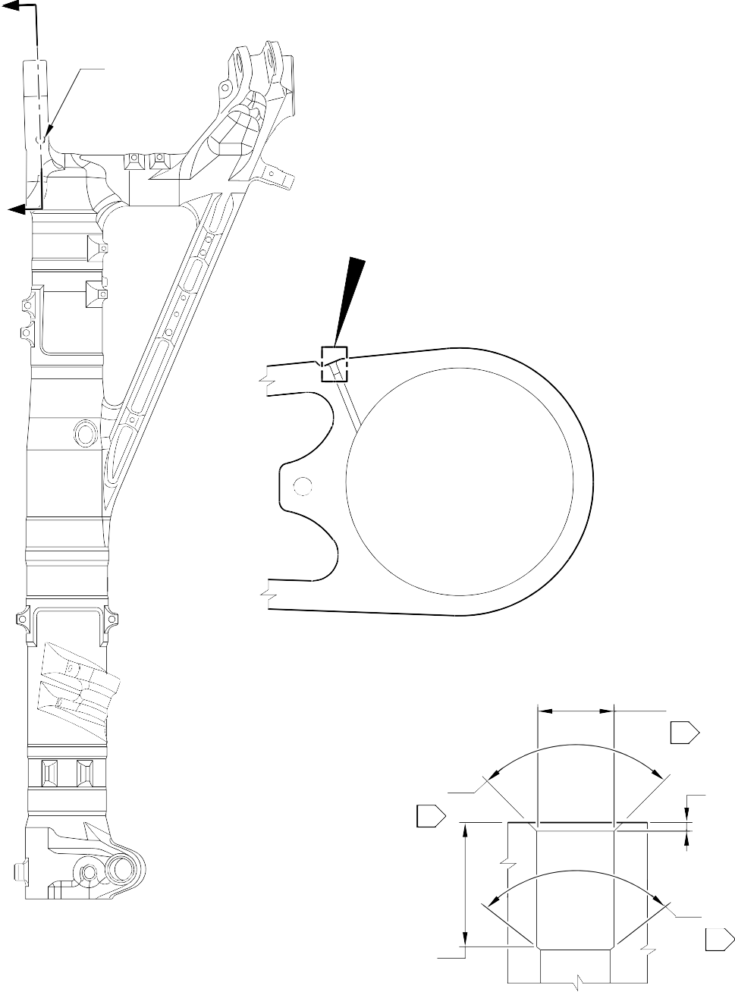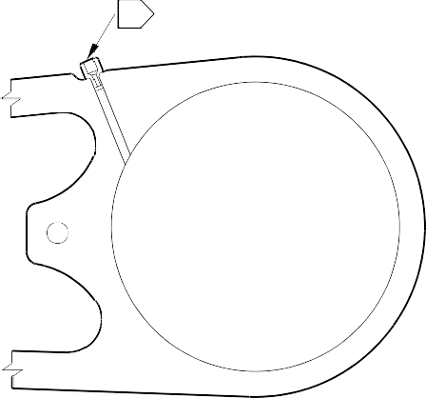
Z
01 02
DIA. A
Z
A
SECTION Z-Z
(WITH LUBRICATION ADAPTOR)
SECTION Z-Z
(WITHOUT LUBRICATION ADAPTOR)
DIA. A
03
89 to 91 DEGREES
03
0,250 to 0,750mm
(0.0098 to 0.0295in)
89 to 91 DEGREES
03
7,000 to 9,000mm
(0.2756 to 0.3150in)

NOTE:

1,6
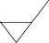
(63)
DETAIL A

THE SURFACE FINISH MUST BE OR BETTER UNLESS GIVEN DIFFERENTLY. DIAMETER A MUST BE FOLLOW THE LINE OF EXISTING BORE.

APPLY LOCTITE GRADE 270 TO ADAPTOR INTERFACE WITH MAIN FITTING: REFER TO PCS-5303. INSTALL THE APPLICABLE LUBRICATION ADAPTOR: REFER TO TABLE 601.
01
02
03
CADMIUM PLATE OPTIONAL AND NO PAINT.
Repair to Main Fitting Figure 601

A321-T-32-12-22-111-0

- Repair No. 11-32 Main Fitting (20-410B, 20-410C, 20-410D, 20-420B, 20-420C and 20-420D)
  - Specified Damage and Material Specification
    - Specified Damage
      - Wear or damage or corrosion to diameter(s) A and/or B.
    - Material Specification

IPL Figure and  Item No. | Name | Material Specification
20-410B and  20-420B | Main fitting | UHT Steel E35NCD16THQ to MTL-1203  with UTS 1800 MPa (261.0 ksi)
20-410C,  20-410D,  20-420C and 20-420D | Main fitting | UHT Steel 300M to MTL-1201 with UTS 1930 MPa (279.9 ksi)
  - Special Tools
    - Special tools are not necessary.
  - Materials
    - This material is necessary:

NOTE: Alternative equivalents are permitted.

Ref. Item | Material
TBA | Loctite Grade 270
  - Repair Parts
    - These repair parts are necessary:

Part No. | Repair Part | Material Specification
450250161 to  450250166 | Oversize lubrication adaptor | Steel, S154 or 4340 to  AMS6409 and heat treated to S154
450250241 to  450250246 | Oversize lubrication adaptor | Steel, S154 or 4340 to AMS6409 and heat treated to S154

  - Procedure (Refer to Figure 601)

CAUTION: FOR DAMAGE MORE THAN THE LIMITS OF THIS REPAIR SCHEME, WRITE TO SAFRAN LANDING SYSTEMS: REFER TO GUIDE-CS-001.
CAUTION: APPLY TEMPORARY CORROSION AND DAMAGE PROTECTION: REFER TO PCS-2800.
    - Do this procedure if there is wear or damage or corrosion to diameter(s) A and/or B: refer to Figure 601.
      - Remove the paint from the main fitting: refer to PCS-2700.
      - Remove the cadmium plate from the main fitting: refer to PCS-2100.
      - Machine diameter(s) A and/or B to the nearest dimensions shown in Table 601 to remove the damage or wear or corrosion. Do not increase the diameter(s) A and/or B to more than 6,449 mm (0.2539 in). The surface finish must be 1,6 micrometers (63 micro-inches) or better: refer to PCS-4100 and Figure 601.
      - Measure and record the diameter(s) A and/or B. Refer to Table 601 for the oversize lubrication adaptor.
      - Machine the chamfer(s) and/or radii as shown: refer to PCS-4100 and Figure 601.
      - Examine the machined area(s) for flaws: refer to PCS-3100, inclusion Class 4 and PCS-3600.
      - Apply cadmium plate all over but not to the areas shown. The cadmium plate thickness must be between 0,010 and 0,020 mm (0.0004 and 0.0008 in): refer to PCS-2100 and Figure 601.
      - Select the correct oversize lubrication adaptor from Table 601 applicable for diameter(s) A and/or B.
      - Use Loctite Grade 270, Material Ref. Item TBA, to install the correct oversize lubrication adaptor from Table 601 (qty 1 to 2 as necessary): refer to PCS-5303 and Figure 601.
      - Apply primer and top coat paint all over but not to the areas shown: refer to PCS-2500 and Figure 601.
      - Record the repair number onto the documentation which is attached to the part. Optionally, identify the part with the Safran Landing Systems repair number 64-4505233-00 adjacent to the existing part number: refer to PCS-6000-07.
      - Examine the part to make sure that you have obeyed all the repair instructions correctly.

Oversize Lubrication Adaptors Table 601

Oversize | Oversize Step mm (in) | Bore Diameter(s)  A and/or B mm (in) | Oversize  Lubrication Adaptor Number
- | Production | 4,859 to 4,925  (0.1913 to 0.1939) | 899005010
1st | 0,127  (0.0050) | 4,986 to 5,052  (0.1963 to 0.1989) | 450250161
2nd | 0,127  (0.0050) | 5,113 to 5,179  (0.2013 to 0.2039) | 450250162
3rd | 0,127  (0.0050) | 5,240 to 5,306  (0.2063 to 0.2089) | 450250163
4th | 0,127  (0.0050) | 5,367 to 5,433  (0.2113 to 0.2139) | 450250164
5th | 0,127  (0.0050) | 5,494 to 5,560  (0.2163 to 0.2189) | 450250165
6th | 0,127  (0.0050) | 5,621 to 5,687  (0.2213 to 0.2239) | 450250166
7th | 0,127  (0.0050) | 5,748 to 5,814  (0.2263 to 0.2289) | 450250241
8th | 0,127  (0.0050) | 5,875 to 5,941  (0.2313 to 0.2339) | 450250242
9th | 0,127  (0.0050) | 6,002 to 6,068  (0.2363 to 0.2389) | 450250243
10th | 0,127  (0.0050) | 6,129 to 6,195  (0.2413 to 0.2439) | 450250244
11th | 0,127  (0.0050) | 6,256 to 6,322  (0.2463 to 0.2489) | 450250245
12th | 0,127  (0.0050) | 6,383 to 6,449  (0.2513 to 0.2539) | 450250246

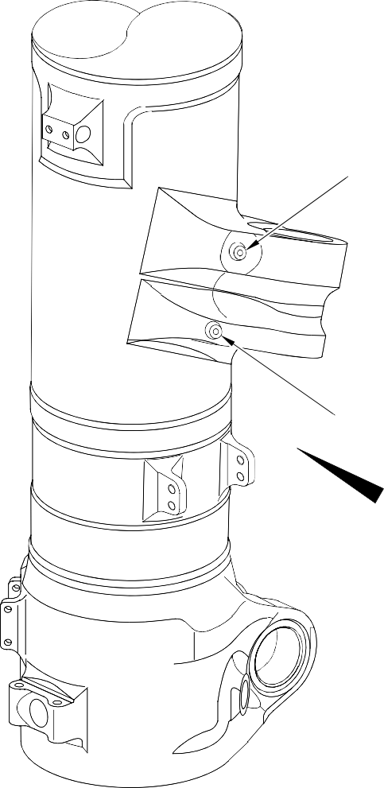
A
DIA.
DIA. B

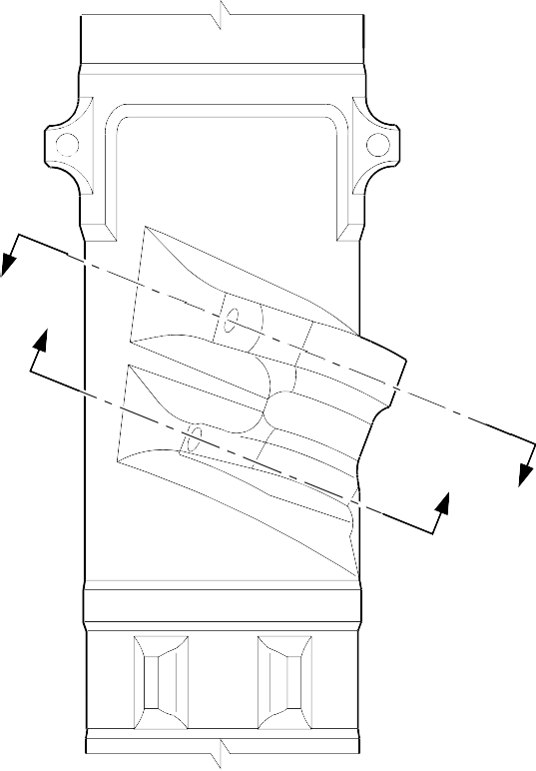
A
Y
Z
Z
Y

Repair to Main Fitting Figure 601 - Sheet 1

VIEW A

A321-T-32-12-22-112-0


B

DIA. B
01

SECTION Z-Z
(WITHOUT LUBRICATION ADAPTOR)

7,000 to 9,000mm
(0.2756 to 0.3150in)

DETAIL B
89 to 91 DEGREES
01
89 to 91 DEGREES
01

0,250 to 0,750mm
(0.0098 to 0.0295in)



DIA. A
C
01

SECTION Y-Y
(WITHOUT LUBRICATION ADAPTOR)
89 to 91 DEGREES
01
89 to 91 DEGREES
01

0,250 to 0,750mm
(0.0098 to 0.0295in)

DETAIL C
7,000 to 9,000mm
(0.2756 to 0.3150in)

NOTE:

1,6
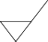
(63)

THE SURFACE FINISH MUST BE OR BETTER UNLESS GIVEN DIFFERENTLY. DIAMETER(S) A AND/OR B MUST FOLLOW THE LINE OF EXISTING BORES.
CADMIUM PLATE OPTIONAL AND NO PAINT.
01

A321-T-32-12-22-113-0

Repair to Main Fitting Figure 601 - Sheet 2

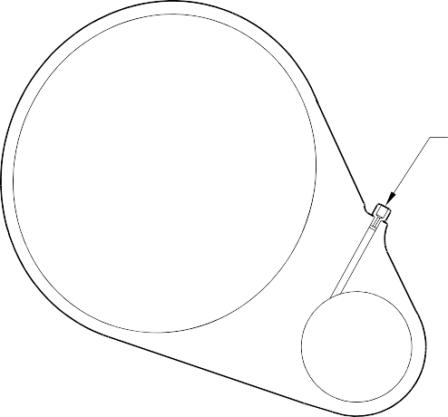
02 03

SECTION Z-Z
(WITH LUBRICATION ADAPTOR)

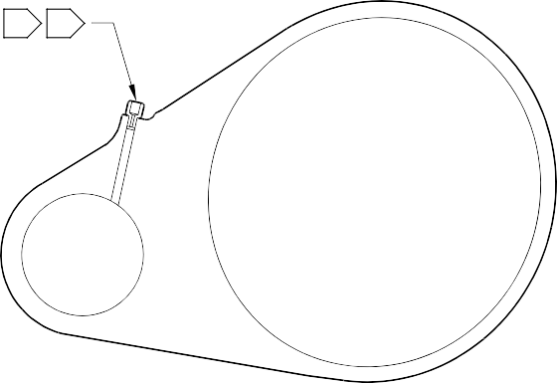
02 03

SECTION Y-Y
(WITH LUBRICATION ADAPTOR)

NOTE:
APPLY LOCTITE GRADE 270 TO ADAPTOR INTERFACE WITH MAIN FITTING: REFER TO PCS-5303. INSTALL THE APPLICABLE LUBRICATION ADAPTOR: REFER TO TABLE 601.
02
03

A321-T-32-12-22-114-0

Repair to Main Fitting Figure 601 - Sheet 3

Repair No. 11-32

- Repair No. 11-33 Main Fitting (20-410B, 20-410C, 20-410D, 20-420B, 20-420C and 20-420D)
  - Specified Damage and Material Specification
    - Specified Damage
      - Wear or damage or corrosion to diameter A.
    - Material Specification

IPL Figure and  Item No. | Name | Material Specification
20-410B and  20-420B | Main fitting | Steel 35NCD16THQ to MTL-1203 with  UTS 1800 MPa (261.0 ksi)
20-410C,  20-410D,  20-420C and 20-420D | Main fitting | UHT steel, 300M to MTL-1201 with UTS 1930 MPa (279.9 ksi)
  - Special Tools
    - Special tools are not necessary.
  - Materials
    - These materials are necessary:

NOTE: Alternative equivalents are permitted.

Ref. Item | Material
TBA | Zinc loaded Molykote 111
TBA | Sealant
  - Repair Parts
    - These repair parts are necessary:

Part No. | Repair Part | Material Specification
Refer to Table 601 for the correct oversize  spherical bearing assembly |  | -
  - Procedure (Refer to Figure 601)

CAUTION: FOR DAMAGE MORE THAN THE LIMITS OF THIS REPAIR SCHEME, WRITE TO SAFRAN LANDING SYSTEMS: REFER TO GUIDE-CS-001.
    - Do this procedure if there is wear or damage to diameter A: refer to Figure 601.
      - Remove the paint from the main fitting: refer to PCS-2700.
      - Remove the cadmium plate from the main fitting: refer to PCS-2100.

      - Machine diameter A to the nearest dimensions shown in Table 601 to remove the damage or wear. Do not increase diameter A to more than 167,587 mm
(6.5979 in). The surface finish must be 1,6 micrometers (63 micro-inches) or better. The minimum wall thickness must not be between 15,382 mm (0.6056 in) and 15,582 mm (0.6134 in): refer to PCS-4100 and Figure 601.
      - Measure and record diameter A. Refer to Table 601 for correct oversize spherical bearing assembly.
      - Machine the chamfer(s) and/or radii as shown: refer to PCS-4100 and Figure 601.
      - Examine the machined areas for flaws: refer to PCS-3100, inclusion Class 4 and PCS-3600.
      - Shot peen the reworked areas only: refer to PCS-2300.
      - Apply cadmium plate all over but not to the areas shown. The cadmium plate thickness must be between 0,010 and 0,020 mm (0.0004 and 0.0008 in): refer to PCS-2100. No bare metal is permitted.
      - Apply primer paint where shown: refer to PCS-2500 and Figure 601.
      - Select the correct oversize spherical bearing assembly from Table 601 applicable for diameter A.
      - Install the spherical bearing assembly to the main fitting.
      - Use Zinc loaded Molykote 111, Material Ref. Item TBA, to install the oversize spherical bearing assembly from Table 601 (qty 1 as necessary): refer to PCS-7303 and Figure 601.
      - Apply fillet of Sealant, Material Ref. Item TBA, to the oversize spherical bearing assembly: refer to PCS-7200 and Figure 601.
      - Apply top coat paint all over but not to the areas shown: refer to PCS-2500 and Figure 601.
      - Record the repair number onto the documentation which is attached to the part. Optionally, identify the part with the Safran Landing Systems repair number 64-4505109-00 adjacent to the existing part number: refer to PCS-6000-07.
      - Examine the part to make sure that you have obeyed all the repair instructions correctly.

Oversize Lubrication Adaptors Table 601

Oversize | Oversize Step mm (in) | Inner Diameter A Before Plating mm (in) | Oversize Bearing Housing Outer Diameter Ref. mm (in) | Oversize  Spherical Bearing Assembly Number
- | Production | 166,000 to 166,063 | 165,934 to 165,959 | -
 |  | (6.5354 to 6.5379) | (6.5328 to 6.5338)
1st | 0,127 | 166,127 to 166,190 | 166,061 to 166,086 | 450258301
 | (0.0050) | (6.5404 to 6.5429) | (6.5378 to 6.5388)
2nd | 0,254 | 166,254 to 166,317 | 166,188 to 166,213 | 450258302
 | (0.0100) | (6.5454 to 6.5479) | (6.5428 to 6.5438)
3rd | 0,381 | 166,381 to 166,444 | 166,315 to 166,340 | 450258303
 | (0.0150 | (6.5504 to 6.5529) | (6.5478 to 6.5488)
4th | 0,508 | 166,508 to 166,571 | 166,442 to 166,467 | 450258304
 | (0.0200) | (6.5554 to 6.5579) | (6.5528 to 6.5538)
5th | 0,635 | 166,635 to 166,698 | 166,569 to 166,594 | 450258305
 | (0.0250) | (6.5604 to 6.5629) | (6.5578 to 6.5588)
6th | 0,762 | 166,762 to 166,825 | 166,696 to 166,721 | 450258306
 | (0.0300) | (6.5654 to 6.5679) | (6.5628 to 6.5638)
7th | 0,889 | 166,889 to 166,952 | 166,823 to 166,848 | 450258307
 | (0.0350) | (6.5704 to 6.5729) | (6.5678 to 6.5688)
8th | 1,016 | 167,016 to 167,079 | 166,950 to 166,975 | 450258308
 | (0.0400) | (6.5754 to 6.5779) | (6.5728 to 6.5738)
9th | 1,143 | 167,143 to 167,206 | 167,077 to 167,102 | 450258309
 | (0.0450) | (6.5804 to 6.5829) | (6.5778 to 6.5788)
10th | 1,270 | 167,270 to 167,333 | 167,204 to 167,229 | 450258310
 | (0.0500) | (6.5854 to 6.5879) | (6.5828 to 6.5838)
11th | 1,397 | 167,397 to 167,460 | 167,331 to 167,356 | 450258311
 | (0.0550) | (6.5904 to 6.5929) | (6.5878 to 6.5888)
12th | 1,524 | 167,524 to 167,587 | 167,458 to 167,483 | 450258312
 | (0.0600) | (6.5954 to 6.5979) | (6.5928 to 6.5938)

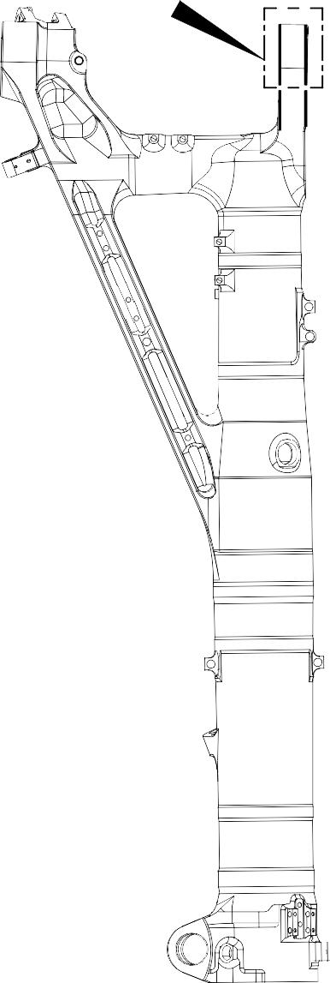
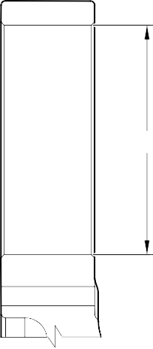
B
A
DIA.

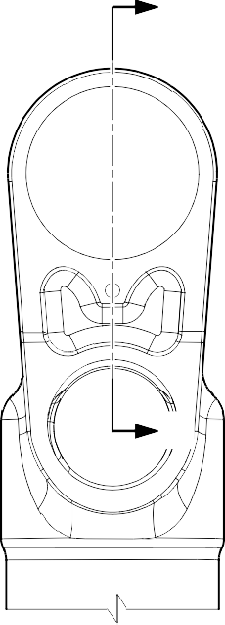
DETAIL A
Z
Z

VIEW B

A

A321-T-32-12-22-146-0

Repair to Main Fitting Figure 601 - Sheet 1

