, SAFRAN
SAFRAN LANDING SYSTEMS UK Ltd
CAGE: K0654
Cheltenham Road, Gloucester, GL2 9QH, England
Telephone: +44 (0) 1452 712424
www.safran-landing-systems.com

MAIN LANDING GEAR LEG
PART NUMBER
201587001, 201587002
201587003, 201587004
201587005, 201587006
201587007, 201587008
COMPONENT MAINTENANCE MANUAL
WITH
ILLUSTRATED PARTS LIST
STATEMENT OF INITIAL CERTIFICATION
This manual complies with British Civil Airworthiness Requirements, Section A, Chapter A5-3.
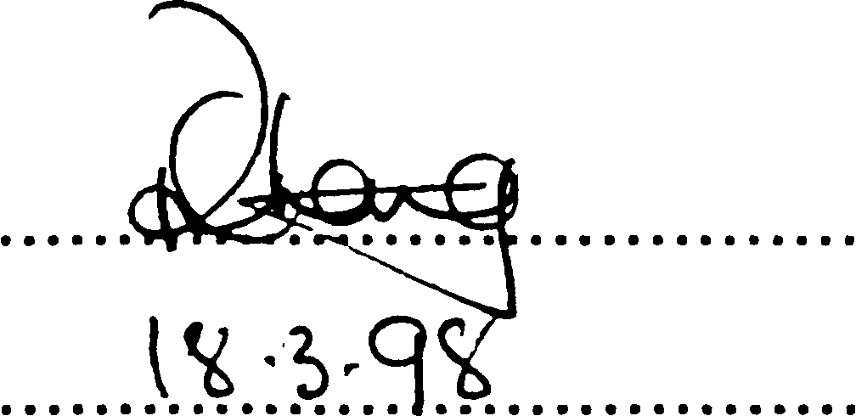
CAA Approval No. DAI/1018/39
NOTE: The above certification does not apply to revisions or amendments made after the date of initial certification by other Approved
Organisations. Revisions or Amendments made by other Approved Organisations must each be separately certified and recorded
on separate record sheets.
The technical data in this document (or file) may contain US data and be controlled for export under the Export Administration
Regulations (EAR), 15 CFR Parts 730-774, ECCN: 9E991. Violations of these laws may be subject to fines and penalties under the Export
Administration Act.
©
SAFRAN LANDING SYSTEMS 2016 (AND SUBSEQUENT REVISION PAGE DATES)
This document and all information contained herein is the sole property of Safran Landing Systems (and/or its affiliated companies).
No intellectual property rights are granted by the delivery of this document or the disclosure of its content. This document shall not be
reproduced to a third party without the express written consent of Safran Landing Systems (and/or the appropriate affiliated company).
TITLE PAGE
32⁻12⁻22 Sep 16/2016

SAFRAN LANDING SYSTEMS UK Ltd
CAGE: K0654

PART No. 201587001 AND 201587002 COMPONENT MAINTENANCE MANUAL
MAIN LANDING GEAR LEG
INTENTIONALLY BLANK
32-12-22

SAFRAN LANDING SYSTEMS UK Ltd

CAGE: K0654
Cheltenham Road, Gloucester, GL2 9QH, England
Telephone: +44 (0) 1452 712424
www.safran-landing-systems.com
РУКОВОДСТВО ПО ТЕХНИЧЕСКОМУ ОБСЛУЖИВАНИЮ КОМПОНЕНТА 32-12-22
ОСНОВНАЯ СТОЙКА ШАССИ
СОПРОВОДИТЕЛЬНОЕ ПИСЬМО К РЕВИЗИИ № 69
- ПОСТОЯННЫЕ РЕВИЗИИ
A. Убедиться, что ревизия № 68 внесена в руководство и зарегистрирована как
вставленная..
- NEW/REVISED PAGES
Subject Reference | Remove and  Destroy Pages | Insert New/Revised |  | Reason for Change
 |  | Pages | Dated
Record of Revisions | 1 | 1 | Mar 18/2025 | Updated revision status
Unit Identification  Chart | 1 to 4 | 1 to 8 | Mar 18/2025 | Added Ref. Codes 2253  and 2255 details
List of Effective  Pages | 1 to 14 | 1 to 16 | Mar 18/2025 | Updated pages
Table of Contents | 1 to 12 | 1 to 14 | Mar 18/2025 | Added content.  Updated page numbers.  Updated figure numbers
Disassembly | 314 to 316 | 314 to 316 | Mar 18/2025 | Added para 2.P.(31)
Check | 504, 507 to 512 | 504, 507 to 514 | Mar 18/2025 | Updated tables 501 and  502
Repair | 606 to 684 | 606 to 698.2 | Mar 18/2025 | Updated table 601.  Updated caution at para  3.C. Updated figure  titles. Deleted figures  626, 627, 649, 650, 653  and 654. Updated figure  626. Added figures 642  648. Updated table 602.  Updated figure numbers
Repair No. 9-1 | 601 and 602 | 601 and 602 | Mar 18/2025 | Added fig-item (18-80A)  in para 1. Updated  Messier-Dowty Limited  to Safran Landing  Systems
Repair No. 9-2 | 601 to 603 | 601 to 603 | Mar 18/2025 | Added fig-item (18-80A)  in para 1. Updated  Messier-Dowty Limited  to Safran Landing  Systems
Letter of Transmittal No. 69
Page 1 of 8
Mar 18/2025

SAFRAN LANDING SYSTEMS UK Ltd
CAGE: K0654

COMPONENT MAINTENANCE MANUAL 32-12-22
MAIN LANDING GEAR LEG
Subject Reference | Remove and  Destroy Pages | Insert New/Revised |  | Reason for Change
 |  | Pages | Dated
Repair No. 9-4 | 601 and 602 | 601 and 602 | Mar 18/2025 | Added fig-item (18-80A)  in para 1. Updated  Messier-Dowty Limited  to Safran Landing  Systems
Repair No. 9-5 | 601 | 601 | Mar 18/2025 | Added fig-item (18-80A)  in paras 1. Updated  Messier-Dowty Limited  to Safran Landing  Systems
Repair No. 9-6 | 601 and 602 | 601 and 602 | Mar 18/2025 | Added fig-item (18-80A)  in para 1. Updated  Messier-Dowty Limited  to Safran Landing  Systems
Repair No. 9-7 | 601 and 602 | 601 and 602 | Mar 18/2025 | Added fig-item (18-80A)  in paras 1. and 1.A.(2)
Repair No. 9-8 | 601 to 603 and  605 | 601 to 603 and  605 | Mar 18/2025 | Added fig-item (18-80A)  in para 1. Updated  Messier-Dowty Limited  to Safran Landing  Systems. Updated  conversion value in  figure 602
Repair No. 9-9 | 601 and 602 | 601 and 602 | Mar 18/2025 | Added fig-item (18-80A)  in para 1. Updated  Messier-Dowty Limited  to Safran Landing  Systems
Repair No. 9-10 | 601 to 606 | 601 to 608 | Mar 18/2025 | Added fig-item (18-80A)  in para 1. Updated  Messier-Dowty Limited  to Safran Landing  Systems
Repair No. 9-11 | 601, 602 and 605 | 601, 602 and 605 | Mar 18/2025 | Added fig-item (18-80A)  in para 1. Updated  material specification in  para 1.D.(1). Updated  Messier-Dowty Limited  to Safran Landing  System. Updated  figure 603
Letter of Transmittal No. 69
Page 2 of 8
Mar 18/2025

sSAFRAN SAFRAN LANDING SYSTEMS UK Ltd
CAGE: K0654
COMPONENT MAINTENANCE MANUAL 32-12-22
MAIN LANDING GEAR LEG
Subject Reference | Remove and  Destroy Pages | Insert New/Revised |  | Reason for Change
 |  | Pages | Dated
Repair No. 11-1 | 601 and 602 | 601 and 602 | Mar 18/2025 | Updated fig-items in  para 1. Updated  Messier-Dowty Limited  to Safran Landing  Systems
Repair No. 11-2 | 601 and 602 | 601 and 602 | Mar 18/2025 | Updated fig-items in  para 1. Updated  Messier-Dowty Limited  to Safran Landing  Systems
Repair No. 11-3 | 601 to 603 | 601 to 603 | Mar 18/2025 | Updated fig-items in  para 1. Updated  Messier-Dowty Limited  to Safran Landing  Systems
Repair No. 11-4 | 601 and 602 | 601 and 602 | Mar 18/2025 | Updated fig-items in  para 1. Updated  Messier-Dowty Limited  to Safran Landing  Systems
Repair No. 11-5 | 601 and 602 | 601 and 602 | Mar 18/2025 | Updated fig-items in  para 1. Updated  Messier-Dowty Limited  to Safran Landing  Systems
Repair No. 11-6 | 601 and 602 | 601 and 602 | Mar 18/2025 | Updated fig-items in  para 1. Updated  Messier-Dowty Limited  to Safran Landing  Systems
Repair No. 11-7 | 601 and 602 | 601 and 602 | Mar 18/2025 | Updated fig-items in  para 1. Updated  Messier-Dowty Limited  to Safran Landing  Systems
Repair No. 11-8 | 601 and 602 | 601 and 602 | Mar 18/2025 | Updated fig-items in  para 1. Updated  Messier-Dowty Limited  to Safran Landing  Systems
Mar 18/2025
Letter of Transmittal No. 69
Page 3 of 8

SAFRAN LANDING SYSTEMS UK Ltd
CAGE: K0654

COMPONENT MAINTENANCE MANUAL 32-12-22
MAIN LANDING GEAR LEG
Subject Reference | Remove and  Destroy Pages | Insert New/Revised |  | Reason for Change
 |  | Pages | Dated
Repair No. 11-9 | 601 to 603 | 601 to 603 | Mar 18/2025 | Updated fig-items in  para 1. Updated  Messier-Dowty Limited  to Safran Landing  Systems
Repair No. 11-11 | 601 and 602 | 601 and 602 | Mar 18/2025 | Updated fig-items in  para 1. Updated  Messier-Dowty Limited  to Safran Landing  Systems
Repair No. 11-12 | 601 and 602 | 601 and 602 | Mar 18/2025 | Updated fig-items in  para 1. Updated  Messier-Dowty Limited  to Safran Landing  Systems
Repair No. 11-13 | 601 to 603 | 601 to 603 | Mar 18/2025 | Updated fig-items in  para 1. Updated  Messier-Dowty Limited  to Safran Landing  Systems
Repair No. 11-14 | 601 and 602 | 601 and 602 | Mar 18/2025 | Updated fig-items in  para 1. Updated  Messier-Dowty Limited  to Safran Landing  Systems
Repair No. 11-17 | 601 | 601 | Mar 18/2025 | Updated fig-items in  para 1. Updated  Messier-Dowty Limited  to Safran Landing  Systems
Repair No. 11-18 | 601 and 602 | 601 and 602 | Mar 18/2025 | Updated fig-items in  para 1
Repair No. 11-19 | 601 and 602 | 601 and 602 | Mar 18/2025 | Updated fig-items in  para 1
Repair No. 11-20 | 601 | 601 | Mar 18/2025 | Updated Messier-Dowty  Limited to Safran  Landing Systems
Repair No. 11-21 | 601 | 601 | Mar 18/2025 | Updated fig-items in  para 1
Letter of Transmittal No. 69
Page 4 of 8
Mar 18/2025

SAFRAN LANDING SYSTEMS UK Ltd
CAGE: K0654

COMPONENT MAINTENANCE MANUAL 32-12-22
MAIN LANDING GEAR LEG
Subject Reference | Remove and  Destroy Pages | Insert New/Revised |  | Reason for Change
 |  | Pages | Dated
Repair No. 11-22 | 601 | 601 | Mar 18/2025 | Updated fig-items in  para 1. Updated  Messier-Dowty Limited  to Safran Landing  Systems
Repair No. 11-23 | 601 and 602 | 601 and 602 | Mar 18/2025 | Updated fig-items in  para 1. Added caution at  para 1.E. Updated  Messier-Dowty Limited  to Safran Landing  Systems
Repair No. 11-24 | 601 and 602 | 601 and 602 | Mar 18/2025 | Updated fig-items in  para 1. Updated  Messier-Dowty Limited  to Safran Landing  Systems
Repair No. 11-25 | 601 and 602 | 601 and 602 | Mar 18/2025 | Updated fig-items in  para 1. Updated  Messier-Dowty Limited  to Safran Landing  Systems
Repair No. 11-27 | 601 and 602 | 601 and 602 | Mar 18/2025 | Updated fig-items in  para 1. Updated  Messier-Dowty Limited  to Safran Landing  Systems
Repair No. 11-28 | 601 and 602 | 601 and 602 | Mar 18/2025 | Updated fig-items in  para 1. Updated  Messier-Dowty Limited  to Safran Landing  Systems
Repair No. 11-31 | - | 601 to 604 | Mar 18/2025 | Added repair no. 11-31
Repair No. 11-32 | - | 601 to 606 | Mar 18/2025 | Added repair no. 11-32
Repair No. 11-33 | - | 601 to 606 | Mar 18/2025 | Added repair no. 11-33
Repair No. 11-34 | - | 601 to 606 | Mar 18/2025 | Added repair no. 11-34
Repair No. 11-35 | - | 601 to 606 | Mar 18/2025 | Added repair no. 11-35
Repair No. 11-36 | - | 601 to 604 | Mar 18/2025 | Added repair no. 11-36
Repair No. 11-37 | - | 601 to 606 | Mar 18/2025 | Added repair no. 11-37
Repair No. 14-4 | - | 601 to 606 | Mar 18/2025 | Added repair no. 14-4
Mar 18/2025
Letter of Transmittal No. 69
Page 5 of 8

SAFRAN LANDING SYSTEMS UK Ltd
CAGE: K0654

COMPONENT MAINTENANCE MANUAL 32-12-22
MAIN LANDING GEAR LEG
Subject Reference | Remove and  Destroy Pages | Insert New/Revised |  | Reason for Change
 |  | Pages | Dated
Repair No. 17-1 | 601 and 602 | 601 and 602 | Mar 18/2025 | Updated Messier-Dowty  Limited to Safran  Landing Systems.  Updated table 601
Repair No. 18-8 | - | 601 to 604 | Mar 18/2025 | Added repair no. 18-8
Repair No. 21-1 | 601 | 601 | Mar 18/2025 | Updated fig-item (2-340)  only in para 1
Repair No. 21-2 | 601 | 601 | Mar 18/2025 | Updated fig-item (2-340)  only in para 1
Repair No. 21-3 | 601 | 601 | Mar 18/2025 | Updated fig-item (2-340)  only in para 1
Repair No. 21-4 | 601 | 601 | Mar 18/2025 | Updated fig-item (2-350)  only in para 1
Repair No. 21-5 | 601 | 601 | Mar 18/2025 | Updated fig-item (2-350)  only in para 1
Repair No. 21-6 | 601 | 601 | Mar 18/2025 | Updated fig-item (2-350)  only in para 1
Assembly (Including  Storage) | 701, 702, 704 to  709 and 729 to  798.6 | 701, 702, 704 to  709 and 729 to  798.12 | Mar 18/2025 | Updated paras 1.H.(1),  1.I.(1), 2.E, 2.F, 2.G,  2.H, 2.J, 2.K, 2.M, 2.N  and 2.O. Added paras  2.I and 2.L. Added  figure 713. Updated  figures 705, 706, 707,  708 and 710. Updated  figure numbers
Fits and Clearances | 836 to 868 | 836 to 872 | Mar 18/2025 | Updated figure 815.  Updated tables 813,  814, 818 and 823
Special Tools,  Fixtures and  Equipment | 901 to 906 | 901 to 906 | Mar 18/2025 | Updated para 1.A
Illustrated Parts List | 1020 to 1098.36 | 1020 to 1098.48 | Mar 18/2025 | Updated IPL figs 13  to 18 to include Ref.  Codes: 2253 and 2255.  Updated IPL fig 15.
Letter of Transmittal No. 69
Page 6 of 8
Mar 18/2025

SAFRAN LANDING SYSTEMS UK Ltd
CAGE: K0654

COMPONENT MAINTENANCE MANUAL 32-12-22
MAIN LANDING GEAR LEG
- REVISION RECORD
A. Record the issue date and insertion date of this revision in the Record of Revisions and retain
this Letter of Transmittal.
© SAFRAN LANDING SYSTEMS 2025 (AND SUBSEQUENT REVISION PAGE DATES)
This document and all information contained herein is the sole property of Safran Landing Systems (and/or its affiliated companies).
No intellectual property rights are granted by the delivery of this document or the disclosure of its content. This document shall not be
reproduced to a third party without the express written consent of Safran Landing Systems (and/or the appropriate affiliated company).
Issued by
Safran Landing Systems UK Ltd
Cheltenham Road, Gloucester, GL2 9QH, England
Telephone: +44 (0) 1452 712424 Fax: +44 (0) 1452 713821
Mar 18/2025
Letter of Transmittal No. 69
Page 7 of 8

SAFRAN LANDING SYSTEMS UK Ltd
CAGE: K0654

COMPONENT MAINTENANCE MANUAL 32-12-22
MAIN LANDING GEAR LEG
INTENTIONALLY BLANK
Letter of Transmittal No. 69
Page 8 of 8
Mar 18/2025

SAFRAN LANDING SYSTEMS UK Ltd
CAGE: K0654
PART No. 201587001 AND 201587002 COMPONENT MAINTENANCE MANUAL
MAIN LANDING GEAR LEG
RECORD OF REVISIONS
REV  NO. | ISSUE  DATE | INSERTION  DATE | BY | REV  NO. | ISSUE  DATE | INSERTION  DATE | BY
1-15 | INCORPORATED |  | M-D | 46 | Jun 17/2016 | Jun 17/2016 | M-D
16 | Aug 1/2006 | Aug 1/2006 | M-D | 47 | Sep 16/2016 | Sep 16/2016 | SAFRAN
17 | Apr 2/2007 | Apr 2/2007 | M-D | 48 | Dec 9/2016 | Dec 9/2016 | SAFRAN
18 | Oct 1/2007 | Oct 1/2007 | M-D | 49 | Mar 24/2017 | Mar 24/2017 | SAFRAN
19 | Jan 1/2008 | Jan 1/2008 | M-D | 50 | Jun 23/2017 | Jun 23/2017 | SAFRAN
20 | Jul 1/2008 | Jul 1/2008 | M-D | 51 | Dec 8/2017 | Dec 8/2017 | SAFRAN
21 | Jan 1/2009 | Jan 1/2009 | M-D | 52 | Mar 23/2018 | Mar 23/2018 | SAFRAN
22 | Feb 1/2009 | Feb 1/2009 | M-D | 53 | Dec 21/2018 | Dec 21/2018 | SAFRAN
23 | Jul 1/2009 | Jul 1/2009 | M-D | 54 | May 31/2019 | May 31/2019 | SAFRAN
24 | Oct 1/2009 | Oct 1/2009 | M-D | 55 | Dec 6/2019 | Dec 6/2019 | SAFRAN
25 | Jan 1/2010 | Jan 1/2010 | M-D | 56 | Mar 20/2020 | Mar 20/2020 | SAFRAN
26 | Jul 1/2010 | Jul 1/2010 | M-D | 57 | Sep 18/2020 | Sep 18/2020 | SAFRAN
27 | Oct 1/2010 | Oct 1/2010 | M-D | 58 | Dec 4/2020 | Dec 4/2020 | SAFRAN
28 | Jan 1/2011 | Jan 1/2011 | M-D | 59 | Mar 19/2021 | Mar 19/2021 | SAFRAN
29 | Mar 31/2011 | Mar 31/2011 | M-D | 60 | Jun 18/2021 | Jun 18/2021 | SAFRAN
30 | Jul 1/2011 | Jul 1/2011 | M-D | 61 | Sep 17/2021 | Sep 17/2021 | SAFRAN
31 | Jul 8/2011 | Jul 8/2011 | M-D | 62 | Mar 18/2022 | Mar 18/2022 | SAFRAN
32 | Oct 1/2011 | Oct 1/2011 | M-D | 63 | Jun 17/2022 | Jun 17/2022 | SAFRAN
33 | Apr 2/2012 | Apr 2/2012 | M-D | 64 | Dec 9/2022 | Dec 9/2022 | SAFRAN
34 | Oct 1/2012 | Oct 1/2012 | M-D | 65 | Dec 23/2022 | Dec 23/2022 | SAFRAN
35 | Jun 28/2013 | Jun 28/2013 | M-D | 66 | Jun 16/2023 | Jun 16/2023 | SAFRAN
36 | Dec 24/2013 | Dec 24/2013 | M-D | 67 | Aug 11/2023 | Aug 11/2023 | SAFRAN
37 | Mar 28/2014 | Mar 28/2014 | M-D | 68 | Mar 15/2024 | Mar 15/2024 | SAFRAN
38 | May 14/2014 | May 14/2014 | M-D | 69 | Mar 18/2025 | Mar 18/2025 | SAFRAN
39 | Sep 26/2014 | Sep 26/2014 | M-D
40 | Oct 10/2014 | Oct 10/2014 | M-D
41 | Oct 14/2014 | Oct 14/2014 | M-D
42 | Mar 20/2015 | Mar 20/2015 | M-D
43 | Jun 19/2015 | Jun 19/2015 | M-D
44 | Sep 18/2015 | Sep 18/2015 | M-D
45 | Dec 11/2015 | Dec 11/2015 | M-D
RECORD OF REVISIONS
32-12-22
Page 1
Mar 18/2025

SAFRAN LANDING SYSTEMS UK Ltd
CAGE: K0654

PART No. 201587001 AND 201587002 COMPONENT MAINTENANCE MANUAL
MAIN LANDING GEAR LEG
INTENTIONALLY BLANK
RECORD OF REVISIONS
32-12-22 ^{Page 2}

SAFRAN LANDING SYSTEMS UK Ltd
CAGE: K0654

PART No. 201587001 AND 201587002 COMPONENT MAINTENANCE MANUAL
MAIN LANDING GEAR LEG
RECORD OF TEMPORARY REVISIONS
REV.  No. | ISSUE  DATE | DATE  INSERTED | PAGE  NUMBER | BY | DATE  REMOVED | BY
32-12-22
RECORD OF TEMPORARY REVISIONS
Page 1
Dec 6/2019

SAFRAN LANDING SYSTEMS UK Ltd
CAGE: K0654

PART No. 201587001 AND 201587002 COMPONENT MAINTENANCE MANUAL
MAIN LANDING GEAR LEG
INTENTIONALLY BLANK
32-12-22
RECORD OF TEMPORARY REVISIONS
Page 2

SAFRAN LANDING SYSTEMS UK Ltd
CAGE: K0654

PART No. 201587001 AND 201587002 COMPONENT MAINTENANCE MANUAL
MAIN LANDING GEAR LEG
LIST OF SERVICE BULLETINS
SB NUMBER | SB TITLE | SB  REVISION  NUMBER | DATE  INCORPORATED  INTO MANUAL | COVER SB NO.
201-32-22 | MLG - Installation of stub  bolt subassembly for the  forward pintle pin in  place of the cross bolt. | Initial Issue | Aug 1/2000 | A320-32-1213
 |  | 1 | No effect
201-32-24 | MLG - To allow an  increase in aircraft  maximum take-off weight  to 93 tonne. | Initial Issue | Aug 1/2000 | -
201-32-29 | MLG -To add tracking  numbers to parts listed in  Airbus Airworthiness  Limitations Section  (ALS). | Initial Issue | Apr 2/2007 | -
 |  | 1 | No effect
201-32-31 | MLG - Installation of a  201585 series MLG Leg  and Dressings where a  201387 MLG Leg and  Dressings has been  installed. | Initial Issue | Apr 2/2007 | -
201-32-39 | MLG -To add tracking  numbers to parts listed in  Airbus Maintenance  Planning Document,  Section 9-1. (Torque link  apex pin nut) | Initial Issue | Nov 1/2004 | A320-32-1265
 |  | 1 | No effect
201-32-49 | MLG - Introduction of a  new lower bearing  subassembly. | Initial Issue | Jan 1/2009 | A320-32-1340
 |  | 1 | No effect
201-32-53 | MLG - Introduction of  new charging labels | Initial Issue | Apr 2/2012 | -
201-32-54 | MLG - Introduction of  new 1M and 2M Axle  harnesses | Initial Issue | Mar 28/2014 | A320-32-1395
 |  | 1 | No effect
 |  | 2 | No effect
201-32-55 | MLG - Introduction of  new 1M and 2M Leg  Harness and of new 1M  and 2M Axle Harnesses | Initial Issue | Jan 1/2011 | -
32-12-22
LIST OF SERVICE BULLETINS
Page 1
Dec 6/2019

SAFRAN LANDING SYSTEMS UK Ltd
CAGE: K0654
PART No. 201587001 AND 201587002 COMPONENT MAINTENANCE MANUAL
MAIN LANDING GEAR LEG
LIST OF SERVICE BULLETINS (Continued)
SB NUMBER | SB TITLE | SB  REVISION  NUMBER | DATE  INCORPORATED  INTO MANUAL | COVER SB NO.
201-32-58 | MLG Leg-Introduction of  new retaining pins and a  new lower bearing  subassembly with a new  self lubricating liner | Initial Issue | Oct 1/2011 | A320-32-1374  A320-32-1386
201-32-59 | MLG Leg - Introduction  of new retaining pins for  the lower bearing  subassembly | Initial Issue | Dec 24/2013 | -
201-32-60 | MLG Leg - Introduction  of a new lower bearing  subassembly with a new  low friction inner liner | Initial Issue | May 14/2014 | A320-32-1414
201-32-62 | MLG Leg - Barkhausen  Noise Inspection of Main  Landing Gear Sliding  Tube Axles. | Initial Issue | No effect | -
201-32-65 | MLG Leg - Introduction  of a new Main Fitting | Initial Issue | Mar 20/2015 | A320-32-1428
201-32-70 | MLG Leg - Introduction  of a new torque link  damper unit | 1 | Dec 21/2018 | A320-32-1446
201-32-72 | MLG Leg - Introduction  of a new main fitting  subassembly and related  parts | Initial Issue | Mar 20/2020 | A320-32-1488
201-32-76 | MLG - Introduction of a  new upper pivot bracket | Initial Issue | Dec 4/2020
201-32-77 | MLG - Introduction of a  new changeover valve  stem and housing | Initial Issue | Dec 4/2020 | -
201-32-80 | MLG Complete -  Modification of the  transfer block  subassembly | Initial Issue | Dec 4/2020 | A320-32-1494  A320-32-1495
32-12-22
LIST OF SERVICE BULLETINS
Page 2
Dec 4/2020

SAFRAN LANDING SYSTEMS UK Ltd
CAGE: K0654

PART No. 201587001 AND 201587002 COMPONENT MAINTENANCE MANUAL
MAIN LANDING GEAR LEG
LIST OF SERVICE BULLETINS (Continued)
SB NUMBER | SB TITLE | SB  REVISION  NUMBER | DATE  INCORPORATED  INTO MANUAL | COVER SB NO.
201-32-78 | MLG - Conversion of  low - friction lower -  bearing MLG to standard  lower - bearing MLG | Initial Issue | Mar 19/2021 | -
201-32-81 | MLG complete -  Introduction of a new  transfer block  subassembly | Initial Issue | Mar 19/2021 | A321-32-1502  A321-32-1503
32-12-22
LIST OF SERVICE BULLETINS
Page 3
Mar 19/2021

SAFRAN LANDING SYSTEMS UK Ltd
CAGE: K0654

PART No. 201587001 AND 201587002 COMPONENT MAINTENANCE MANUAL
MAIN LANDING GEAR LEG
INTENTIONALLY BLANK
32-12-22
LIST OF SERVICE BULLETINS
Page 4

sSAFRAN SAFRAN LANDING SYSTEMS UK Ltd
CAGE: K0654
№ детали 201587001 и 201587002
РУКОВОДСТВО ПО ТЕХНИЧЕСКОМУ ОБСЛУЖИВАНИЮ КОМПОНЕНТА
ОСНОВНАЯ СТОЙКА ШАССИ
ТАБЛИЦА ИДЕНТИФИКАЦИИ АГРЕГАТА
PART NUMBER | DASH  NO. | SAFRAN LANDING  SYSTEMS  MODIFICATION  NUMBER | SAFRAN LANDING  SYSTEMS  SERVICE BULLETIN  NUMBER | MOD.  STRIKE  NO.
201587001 | - | - | - | -
201587002 | - |  |  | -
201587001 | - | EDES2-0005-2542 | - | -
201587002 | - |  |  | -
201587001 | - | EDES2-0005-2253 | - | -
201587002 | - |  |  | -
201587001 | - | EDES2-0005-2255 | - | -
201587002 | - |  |  | -
201587001 | 010 | (c)AC12221 | 201-32-22 | -
201587002 | 010 |  |  | -
201587001 | 010 | EDES2-0005-2253 | - | -
201587002 | 010 |  |  | -
201587001 | 010 | EDES2-0005-2255 | - | -
201587002 | 010 |  |  | -
201587001 | 020 | (c)AC12454 | 201-32-29 | -
201587002 | 020 |  |  | -
201587001 | 020 | EDES2-0005-2253 | - | -
201587002 | 020 |  |  | -
201587001 | 020 | EDES2-0005-2255 | - | -
201587002 | 020 |  |  | -
201587001 | 030 | (c)AC12492 | 201-32-39 | -
201587002 | 030 |  |  | -
201587001 | 030 | (c)AC12636 | 201-32-49 | -
201587002 | 030 |  |  | -
201587001 | 030 | MAF1-0005-2157 | 201-32-55 | -
201587002 | 030 |  |  | -
32-12-22
UNIT IDENTIFICATION CHART
Page 1
Mar 18/2025

sSAFRAN SAFRAN LANDING SYSTEMS UK Ltd
CAGE: K0654
PART No. 201587001 AND 201587002 COMPONENT MAINTENANCE MANUAL
MAIN LANDING GEAR LEG
UNIT IDENTIFICATION CHART (Continued)
PART NUMBER | DASH  NO. | SAFRAN LANDING  SYSTEMS  MODIFICATION  NUMBER | SAFRAN LANDING  SYSTEMS  SERVICE BULLETIN  NUMBER | MOD.  STRIKE  NO.
201587001 | 030 | MAF1-0005-2156 | 201-32-53 | -
201587002 | 030 |  |  | -
201587001 | 030 | MAF1-0005-2155 | 201-32-54 | -
201587002 | 030 |  |  | -
201587001 | 030 | MAF1-0005-2161 | 201-32-59 | -
201587002 | 030 |  |  | -
201587001 | 030 | MAF1-0005-2164 | 201-32-60 | -
201587002 | 030 |  |  | -
201587001 | 030 | MAF1-0005-2162 | - | -
201587002 | 030 |  |  | -
201587001 | 030 | MAF1-0005-2180 | 201-32-65 | -
201587002 | 030 |  |  | -
201587001 | 030 | MAF1-0005-2207 | 201-32-70 | -
201587002 | 030 |  |  | -
201587001 | 030 | EDES2-0005-2253 | - | -
201587002 | 030 |  |  | -
201587001 | 030 | EDES2-0005-2255 | - | -
201587002 | 030 |  |  | -
201587003 | - | (c)AC12229 | 201-32-24 | -
201587004 | - |  |  | -
201587003 | - | EDES2-0005-2542 | - | -
201587004 | - |  |  | -
201587003 | - | EDES2-0005-2253 | - | -
201587004 | - |  |  | -
32-12-22
UNIT IDENTIFICATION CHART
Page 2
Mar 18/2025

sSAFRAN SAFRAN LANDING SYSTEMS UK Ltd
CAGE: K0654
PART No. 201587001 AND 201587002 COMPONENT MAINTENANCE MANUAL
MAIN LANDING GEAR LEG
UNIT IDENTIFICATION CHART (Continued)
 | PART NUMBER | DASH  NO. | SAFRAN LANDING  SYSTEMS  MODIFICATION  NUMBER | SAFRAN LANDING  SYSTEMS  SERVICE BULLETIN  NUMBER | MOD.  STRIKE  NO.
1 | 201587003 | - | EDES2-0005-2255 | - | -
1 | 201587004 | - |  |  | -
 | 201587003 | 010 | (c)AC12454 | 201-32-29 | -
 | 201587004 | 010 |  |  | -
1 | 201587003 | 010 | EDES2-0005-2253 | - | -
1 | 201587004 | 010 |  |  | -
1 | 201587003 | 010 | EDES2-0005-2255 | - | -
1 | 201587004 | 010 |  |  | -
 | 201587003 | 020 | (c)AC12492 | 201-32-39 | -
 | 201587004 | 020 |  |  | -
1 | 201587003 | 020 | EDES2-0005-2253 | - | -
1 | 201587004 | 020 |  |  | -
1 | 201587003 | 020 | EDES2-0005-2255 | - | -
1 | 201587004 | 020 |  |  | -
 | 201587003 | 030 | (c)AC12636 | 201-32-49 | -
 | 201587004 | 030 |  |  | -
 | 201587003 | 030 | MAF1-0005-2155 | 201-32-54 | -
 | 201587004 | 030 |  |  | -
1 | 201587003 | 030 | EDES2-0005-2253 | - | -
1 | 201587004 | 030 |  |  | -
1 | 201587003 | 030 | EDES2-0005-2255 | - | -
1 | 201587004 | 030 |  |  | -
 | 201587003 | 040 | MAF1-0005-2157 | 201-32-55 | -
 | 201587004 | 040 |  |  | -
 | 201587003 | 040 | MAF1-0005-2160 | 201-32-58 | -
 | 201587004 | 040 |  |  | -
32-12-22
UNIT IDENTIFICATION CHART
Page 3
Mar 18/2025

sSAFRAN SAFRAN LANDING SYSTEMS UK Ltd
CAGE: K0654
PART No. 201587001 AND 201587002 COMPONENT MAINTENANCE MANUAL
MAIN LANDING GEAR LEG
UNIT IDENTIFICATION CHART (Continued)
 | PART NUMBER | DASH  NO. | SAFRAN LANDING  SYSTEMS  MODIFICATION  NUMBER | SAFRAN LANDING  SYSTEMS  SERVICE BULLETIN  NUMBER | MOD.  STRIKE  NO.
1 | 201587003 | 040 | EDES2-0005-2253 | - | -
1 | 201587004 | 040 |  |  | -
1 | 201587003 | 040 | EDES2-0005-2255 | - | -
1 | 201587004 | 040 |  |  | -
 | 201587003 | 050 | MAF1-0005-2156 | 201-32-53 | -
 | 201587004 | 050 |  |  | -
1 | 201587003 | 050 | EDES2-0005-2253 | - | -
1 | 201587004 | 050 |  |  | -
1 | 201587003 | 050 | EDES2-0005-2255 | - | -
1 | 201587004 | 050 |  |  | -
 | 201587003 | 060 | MAF1-0005-2161 | 201-32-59 | -
 | 201587004 | 060 |  |  | -
1 | 201587003 | 060 | EDES2-0005-2253 | - | -
1 | 201587004 | 060 |  |  | -
1 | 201587003 | 060 | EDES2-0005-2255 | - | -
1 | 201587004 | 060 |  |  | -
 | 201587003 | 070 | MAF1-0005-2162 | - | -
 | 201587004 | 070 |  |  | -
1 | 201587003 | 070 | EDES2-0005-2253 | - | -
1 | 201587004 | 070 |  |  | -
1 | 201587003 | 070 | EDES2-0005-2255 | - | -
1 | 201587004 | 070 |  |  | -
 | 201587003 | 080 | MAF1-0005-2180 | 201-32-65 | -
 | 201587004 | 080 |  |  | -
 | 201587003 | 080 | MAF1-0005-2207 | 201-32-70 | -
 | 201587004 | 080 |  |  | -
UNIT IDENTIFICATION CHART
32
Page 4
-12-22 Mar 18/2025

SAFRAN LANDING SYSTEMS UK Ltd
CAGE: K0654
3» SAFRAN
PART No. 201587001 AND 201587002 COMPONENT MAINTENANCE MANUAL
MAIN LANDING GEAR LEG
UNIT IDENTIFICATION CHART (Continued)
 | PART NUMBER | DASH  NO. | SAFRAN LANDING  SYSTEMS  MODIFICATION  NUMBER | SAFRAN LANDING  SYSTEMS  SERVICE BULLETIN  NUMBER | MOD.  STRIKE  NO.
1 | 201587003 | 080 | EDES2-0005-2253 | - | -
1 | 201587004 | 080 |  |  | -
1 | 201587003 | 080 | EDES2-0005-2255 | - | -
1 | 201587004 | 080 |  |  | -
 | 201587005 | - | (c)AC12332 | 201-32-31 | -
 | 201587006 | - |  |  | -
1 | 201587005 | - | EDES2-0005-2253 | - | -
1 | 201587006 | - |  |  | -
1 | 201587005 | - | EDES2-0005-2255 | - | -
1 | 201587006 | - |  |  | -
 | 201587005 | 010 | (c)AC12454 | 201-32-29 | -
 | 201587006 | 010 |  |  | -
1 | 201587005 | 010 | EDES2-0005-2253 | - | -
1 | 201587006 | 010 |  |  | -
1 | 201587005 | 010 | EDES2-0005-2255 | - | -
1 | 201587006 | 010 |  |  | -
 | 201587005 | 020 | (c)AC12492 | 201-32-39 | -
 | 201587006 | 020 |  |  | -
 | 201587005 | 020 | (c)AC12636 | 201-32-49 | -
 | 201587006 | 020 |  |  | -
 | 201587005 | 020 | MAF1-0005-2157 | 201-32-55 | -
 | 201587006 | 020 |  |  | -
 | 201587005 | 020 | MAF1-0005-2156 | 201-32-53 | -
 | 201587006 | 020 |  |  | -
32-12-22
UNIT IDENTIFICATION CHART
Page 5
Mar 18/2025

sSAFRAN SAFRAN LANDING SYSTEMS UK Ltd
CAGE: K0654
PART No. 201587001 AND 201587002 COMPONENT MAINTENANCE MANUAL
MAIN LANDING GEAR LEG
UNIT IDENTIFICATION CHART (Continued)
PART NUMBER | DASH  NO. | SAFRAN LANDING  SYSTEMS  MODIFICATION  NUMBER | SAFRAN LANDING  SYSTEMS  SERVICE BULLETIN  NUMBER | MOD.  STRIKE  NO.
201587005 | 020 | MAF1-0005-2155 | 201-32-54 | -
201587006 | 020 |  |  | -
201587005 | 020 | MAF1-0005-2161 | 201-32-59 | -
201587006 | 020 |  |  | -
201587005 | 020 | MAF1-0005-2164 | 201-32-60 | -
201587006 | 020 |  |  | -
201587005 | 020 | MAF1-0005-2162 | - | -
201587006 | 020 |  |  | -
201587005 | 020 | MAF1-0005-2180 | 201-32-65 | -
201587006 | 020 |  |  | -
201587005 | 020 | MAF1-0005-2207 | 201-32-70 | -
201587006 | 020 |  |  | -
201587005 | 020 | EDES2-0005-2253 | - | -
201587006 | 020 |  |  | -
201587005 | 020 | EDES2-0005-2255 | - | -
201587006 | 020 |  |  | -
201587007 | - | MAF1-0005-2160 | 201-32-58 | -
201587008 | - |  |  | -
201587007 | - | EDES2-0005-2542 | - | -
201587008 | - |  |  | -
201587007 | - | EDES2-0005-2253 | - | -
201587008 | - |  |  | -
201587007 | - | EDES2-0005-2255 | - | -
201587008 | - |  |  | -
32-12-22
UNIT IDENTIFICATION CHART
Page 6
Mar 18/2025

SAFRAN LANDING SYSTEMS UK Ltd
CAGE: K0654
PART No. 201587001 AND 201587002 COMPONENT MAINTENANCE MANUAL
MAIN LANDING GEAR LEG
UNIT IDENTIFICATION CHART (Continued)
PART NUMBER | DASH  NO. | SAFRAN LANDING  SYSTEMS  MODIFICATION  NUMBER | SAFRAN LANDING  SYSTEMS  SERVICE BULLETIN  NUMBER | MOD.  STRIKE  NO.
201587007 | 010 | MAF1-0005-2156 | 201-32-53 | -
201587008 | 010 |  |  | -
201587007 | 010 | EDES2-0005-2253 | - | -
201587008 | 010 |  |  | -
201587007 | 010 | EDES2-0005-2255 | - | -
201587008 | 010 |  |  | -
201587007 | 020 | MAF1-0005-2162 | - | -
201587008 | 020 |  |  | -
201587007 | 020 | MAF1-0005-2180 | 201-32-65 | -
201587008 | 020 |  |  | -
201587007 | 020 | MAF1-0005-2207 | 201-32-70 | -
201587008 | 020 |  |  | -
201587007 | 020 | EDES2-0005-2253 | - | -
201587008 | 020 |  |  | -
201587007 | 020 | EDES2-0005-2255 | - | -
201587008 | 020 |  |  | -
201587007 | 030 | EDES2-0005-2253 | - | -
201587008 | 030 |  |  | -
201587007 | 030 | EDES2-0005-2255 | - | -
201587008 | 030 |  |  | -
32-12-22
UNIT IDENTIFICATION CHART
Page 7
Mar 18/2025

SAFRAN LANDING SYSTEMS UK Ltd
CAGE: K0654

PART No. 201587001 AND 201587002 COMPONENT MAINTENANCE MANUAL
MAIN LANDING GEAR LEG
INTENTIONALLY BLANK
32-12-22
Page 8
UNIT IDENTIFICATION CHART

SAFRAN LANDING SYSTEMS UK Ltd
CAGE: K0654

PART No. 201587001 AND 201587002 COMPONENT MAINTENANCE MANUAL
MAIN LANDING GEAR LEG
LIST OF EFFECTIVE PAGES
Subject | Page | Date | Subject | Page | Date
Title Page | 1 | Sep 16/2016 | List of Effective | 13 | Mar 18/2025
 | 2 | Blank | Pages (Continued) | 14 | Mar 18/2025
 |  |  |  | 15 | Mar 18/2025
Record of Revisions | 1 | Mar 18/2025 |  | 16 | Mar 18/2025
 | 2 | Blank
 |  |  | Table of Contents | 1 | Mar 18/2025
Record of Temporary | 1 | Dec 6/2019 |  | 2 | Mar 18/2025
Revisions | 2 | Blank |  | 3 | Mar 18/2025
 |  |  |  | 4 | Mar 18/2025
List of Service Bulletins | 1 | Dec 6/2019 |  | 5 | Mar 18/2025
 | 2 | Dec 4/2020 |  | 6 | Mar 18/2025
 | 3 | Mar 19/2021 |  | 7 | Mar 18/2025
 | 4 | Blank |  | 8 | Mar 18/2025
 |  |  |  | 9 | Mar 18/2025
Unit Identification | 1 | Mar 18/2025 |  | 10 | Mar 18/2025
 |  |  |  | 11 | Mar 18/2025
Chart | 2 | Mar 18/2025
 | 3 | Mar 18/2025 |  | 12 | Mar 18/2025
 |  |  |  | 13 | Mar 18/2025
 | 4 | Mar 18/2025
 |  |  |  | 14 | Blank
 | 5 | Mar 18/2025
 | 6 | Mar 18/2025
 | 7 | Mar 18/2025 | Introduction | 1 | Mar 18/2022
 |  |  |  | 2 | Blank
 | 8 | Blank
List of Effective | 1 | Mar 18/2025 | Description and | 1 | Dec 6/2019
Pages | 2 | Mar 18/2025 | Operation | 2 | Dec 6/2019
 | 3 | Mar 18/2025 |  | 3 | Dec 6/2019
 |  |  |  | 4 | Dec 6/2019
 | 4 | Mar 18/2025
 | 5 | Mar 18/2025
 | 6 | Mar 18/2025 | Testing and Fault | 101 | Dec 6/2019
 | 7 | Mar 18/2025 | Isolation | 102 | Dec 6/2019
 |  |  |  | 103 | Dec 6/2019
 | 8 | Mar 18/2025
 | 9 | Mar 18/2025 |  | 104 | Dec 6/2019
 |  |  |  | 105 | Dec 6/2019
 | 10 | Mar 18/2025
 |  |  |  | 106 | Dec 6/2019
 | 11 | Mar 18/2025
 |  |  |  | 107 | Dec 6/2019
 | 12 | Mar 18/2025
32-12-22
LIST OF EFFECTIVE PAGES
Page 1
Mar 18/2025

sSAFRAN SAFRAN LANDING SYSTEMS UK Ltd
CAGE: K0654
PART No. 201587001 AND 201587002 COMPONENT MAINTENANCE MANUAL
MAIN LANDING GEAR LEG
LIST OF EFFECTIVE PAGES (Continued)
Subject | Page | Date | Subject | Page | Date
Testing and Fault | 108 | Dec 6/2019 | Check | 512 | Mar 18/2025
Isolation (Continued) | 109 | Dec 6/2019 | (Continued) | 513 | Mar 18/2025
 | 110 | Blank |  | 514 | Blank
Disassembly | 301 | Dec 6/2019 | Repair | 601 | Dec 6/2019
 | 302 | Mar 15/2024 |  | 602 | Dec 6/2019
 | 303 | Mar 15/2024 |  | 603 | Mar 19/2021
 | 304 | Mar 20/2020 |  | 604 | Mar 15/2024
 | 305 | Mar 20/2020 |  | 605 | Mar 15/2024
 | 306 | Mar 20/2020 |  | 606 | Mar 18/2025
 | 307 | Mar 19/2021 |  | 607 | Mar 18/2025
 | 308 | Mar 19/2021 |  | 608 | Mar 18/2025
 | 309 | Mar 20/2020 |  | 609 | Mar 18/2025
 | 310 | Mar 20/2020 |  | 610 | Mar 18/2025
 | 311 | Mar 20/2020 |  | 611 | Mar 18/2025
 | 312 | Mar 20/2020 |  | 612 | Mar 18/2025
 | 313 | Mar 15/2024 |  | 613 | Mar 18/2025
 | 314 | Mar 18/2025 |  | 614 | Mar 18/2025
 | 315 | Mar 18/2025 |  | 615 | Mar 18/2025
 | 316 | Mar 18/2025 |  | 616 | Mar 18/2025
 |  |  |  | 617 | Mar 18/2025
Cleaning | 401 | Dec 6/2019 |  | 618 | Mar 18/2025
 | 402 | Blank |  | 619 | Mar 18/2025
 |  |  |  | 620 | Mar 18/2025
Check | 501 | Sep 18/2020 |  | 621 | Mar 18/2025
 | 502 | Mar 18/2022 |  | 622 | Mar 18/2025
 | 503 | Mar 19/2021 |  | 623 | Mar 18/2025
 | 504 | Mar 18/2025 |  | 624 | Mar 18/2025
 | 505 | Mar 19/2021 |  | 625 | Mar 18/2025
 | 506 | Mar 19/2021 |  | 626 | Mar 18/2025
 | 507 | Mar 18/2025 |  | 627 | Mar 18/2025
 | 508 | Mar 18/2025 |  | 628 | Mar 18/2025
 | 509 | Mar 18/2025 |  | 629 | Mar 18/2025
 | 510 | Mar 18/2025 |  | 630 | Mar 18/2025
 | 511 | Mar 18/2025 |  | 631 | Mar 18/2025
32-12-22
LIST OF EFFECTIVE PAGES
Page 2
Mar 18/2025

SAFRAN LANDING SYSTEMS UK Ltd
CAGE: K0654

PART No. 201587001 AND 201587002 COMPONENT MAINTENANCE MANUAL
MAIN LANDING GEAR LEG
LIST OF EFFECTIVE PAGES (Continued)
Subject | Page | Date | Subject | Page | Date
Repair (Continued) | 632 | Mar 18/2025 | Repair (Continued) | 667 | Mar 18/2025
 | 633 | Mar 18/2025 |  | 668 | Mar 18/2025
 | 634 | Mar 18/2025 |  | 669 | Mar 18/2025
 | 635 | Mar 18/2025 |  | 670 | Mar 18/2025
 | 636 | Mar 18/2025 |  | 671 | Mar 18/2025
 | 637 | Mar 18/2025 |  | 672 | Mar 18/2025
 | 638 | Mar 18/2025 |  | 673 | Mar 18/2025
 | 639 | Mar 18/2025 |  | 674 | Mar 18/2025
 | 640 | Mar 18/2025 |  | 675 | Mar 18/2025
 | 641 | Mar 18/2025 |  | 676 | Mar 18/2025
 | 642 | Mar 18/2025 |  | 677 | Mar 18/2025
 | 643 | Mar 18/2025 |  | 678 | Mar 18/2025
 | 644 | Mar 18/2025 |  | 679 | Mar 18/2025
 | 645 | Mar 18/2025 |  | 680 | Mar 18/2025
 | 646 | Mar 18/2025 |  | 681 | Mar 18/2025
 | 647 | Mar 18/2025 |  | 682 | Mar 18/2025
 | 648 | Mar 18/2025 |  | 683 | Mar 18/2025
 | 649 | Mar 18/2025 |  | 684 | Mar 18/2025
 | 650 | Mar 18/2025 |  | 685 | Mar 18/2025
 | 651 | Mar 18/2025 |  | 686 | Mar 18/2025
 | 652 | Mar 18/2025 |  | 687 | Mar 18/2025
 | 653 | Mar 18/2025 |  | 688 | Mar 18/2025
 | 654 | Mar 18/2025 |  | 689 | Mar 18/2025
 | 655 | Mar 18/2025 |  | 690 | Mar 18/2025
 | 656 | Mar 18/2025 |  | 691 | Mar 18/2025
 | 657 | Mar 18/2025 |  | 692 | Mar 18/2025
 | 658 | Mar 18/2025 |  | 693 | Mar 18/2025
 | 659 | Mar 18/2025 |  | 694 | Mar 18/2025
 | 660 | Mar 18/2025 |  | 695 | Mar 18/2025
 | 661 | Mar 18/2025 |  | 696 | Mar 18/2025
 | 662 | Mar 18/2025 |  | 697 | Mar 18/2025
 | 663 | Mar 18/2025 |  | 698 | Mar 18/2025
 | 664 | Mar 18/2025 |  | 698.1 | Mar 18/2025
 | 665 | Mar 18/2025 |  | 698.2 | Mar 18/2025
 | 666 | Mar 18/2025
32-12-22
LIST OF EFFECTIVE PAGES
Page 3
Mar 18/2025

sSAFRAN SAFRAN LANDING SYSTEMS UK Ltd
CAGE: K0654
PART No. 201587001 AND 201587002 COMPONENT MAINTENANCE MANUAL
MAIN LANDING GEAR LEG
LIST OF EFFECTIVE PAGES (Continued)
Subject | Page | Date | Subject | Page | Date
Repair No. 1-1 | 601 | Dec 6/2019 | Repair No. 6-3 | 602 | Dec 6/2019
 | 602 | Dec 6/2019 | (Continued) | 603 | Dec 6/2019
 | 603 | Dec 6/2019 |  | 604 | Blank
 | 604 | Dec 6/2019
 |  |  | Repair No. 7-1 | 601 | Dec 6/2019
Repair No. 1-2 | 601 | Dec 6/2019 |  | 602 | Dec 6/2019
 | 602 | Dec 6/2019 |  | 603 | Dec 6/2019
 | 603 | Dec 6/2019 |  | 604 | Blank
 | 604 | Dec 6/2019
 |  |  | Repair No. 7-2 | 601 | Dec 6/2019
Repair No. 2-1 | 601 | Dec 6/2019 |  | 602 | Dec 6/2019
 | 602 | Dec 6/2019 |  | 603 | Dec 6/2019
 |  |  |  | 604 | Blank
Repair No. 3-1 | 601 | May 31/2019
 | 602 | May 31/2019 | Repair No. 8-1 | 601 | Dec 6/2019
 | 603 | Dec 8/2017 |  | 602 | Dec 6/2019
 | 604 | Blank |  | 603 | Dec 6/2019
 |  |  |  | 604 | Blank
Repair No. 4-1 | 601 | Dec 6/2019
 | 602 | Dec 6/2019 | Repair No. 8-2 | 601 | Dec 6/2019
 |  |  |  | 602 | Dec 6/2019
Repair No. 5-1 | 601 | Dec 9/2016 |  | 603 | Dec 6/2019
 | 602 | Dec 9/2016 |  | 604 | Blank
Repair No. 6-1 | 601 | Dec 6/2019 | Repair No. 9-1 | 601 | Mar 18/2025
 | 602 | Dec 6/2019 |  | 602 | Mar 18/2025
 | 603 | Dec 6/2019 |  | 603 | Dec 6/2019
 | 604 | Blank |  | 604 | Dec 6/2019
Repair No. 6-2 | 601 | Dec 6/2019 | Repair No. 9-2 | 601 | Mar 18/2025
 | 602 | Dec 6/2019 |  | 602 | Mar 18/2025
 | 603 | Dec 6/2019 |  | 603 | Mar 18/2025
 | 604 | Blank |  | 604 | Dec 9/2016
Repair No. 6-3 | 601 | Dec 6/2019 | Repair No. 9-3 | 601 | Dec 6/2019
32-12-22
LIST OF EFFECTIVE PAGES
Page 4
Mar 18/2025

sSAFRAN SAFRAN LANDING SYSTEMS UK Ltd
CAGE: K0654
PART No. 201587001 AND 201587002 COMPONENT MAINTENANCE MANUAL
MAIN LANDING GEAR LEG
LIST OF EFFECTIVE PAGES (Continued)
Subject | Page | Date | Subject | Page | Date
Repair No. 9-3 | 602 | Blank | Repair No. 9-10 | 603 | Mar 18/2025
(Continued) |  |  | (Continued) | 604 | Mar 18/2025
 |  |  |  | 605 | Mar 18/2025
Repair No. 9-4 | 601 | Mar 18/2025 |  | 606 | Mar 18/2025
 | 602 | Mar 18/2025 |  | 607 | Mar 18/2025
 | 603 | Aug 11/2023 |  | 608 | Blank
 | 604 | Aug 11/2023
 |  |  | Repair No. 9-11 | 601 | Mar 18/2025
Repair No. 9-5 | 601 | Mar 18/2025 |  | 602 | Mar 18/2025
 | 602 | Dec 6/2019 |  | 603 | Dec 6/2019
 |  |  |  | 604 | Aug 11/2023
Repair No. 9-6 | 601 | Mar 18/2025 |  | 605 | Mar 18/2025
 | 602 | Mar 18/2025 |  | 606 | Blank
 | 603 | Dec 6/2019
 | 604 | Blank | Repair No. 10-1 | 601 | Dec 6/2019
 |  |  |  | 602 | Dec 6/2019
Repair No. 9-7 | 601 | Mar 18/2025 |  | 603 | Dec 6/2019
 | 602 | Mar 18/2025 |  | 604 | Blank
 | 603 | Dec 6/2019
 | 604 | Dec 6/2019 | Repair No. 11-1 | 601 | Mar 18/2025
 |  |  |  | 602 | Mar 18/2025
Repair No. 9-8 | 601 | Mar 18/2025 |  | 603 | Dec 6/2019
 | 602 | Mar 18/2025 |  | 604 | Dec 6/2019
 | 603 | Mar 18/2025
 | 604 | Aug 11/2023 | Repair No. 11-2 | 601 | Mar 18/2025
 | 605 | Mar 18/2025 |  | 602 | Mar 18/2025
 | 606 | Blank |  | 603 | Dec 6/2019
 |  |  |  | 604 | Dec 6/2019
Repair No. 9-9 | 601 | Mar 18/2025
 | 602 | Mar 18/2025 | Repair No. 11-3 | 601 | Mar 18/2025
 | 603 | Dec 6/2019 |  | 602 | Mar 18/2025
 | 604 | Dec 6/2019 |  | 603 | Mar 18/2025
 |  |  |  | 604 | Dec 6/2019
Repair No. 9-10 | 601 | Mar 18/2025 |  | 605 | Dec 6/2019
 | 602 | Mar 18/2025 |  | 606 | Dec 6/2019
32-12-22
LIST OF EFFECTIVE PAGES
Page 5
Mar 18/2025

3» SAFRAN |  |  | SAFRAN LANDING SYSTEMS UK Ltd
 |  |  |  |  | CAGE: K0654
PART No. 201587001 AND 201587002 COMPONENT MAINTENANCE MANUAL
 |  | MAIN LANDING GEAR LEG
 | LIST OF EFFECTIVE PAGES (Continued)
Subject | Page | Date | Subject | Page | Date
Repair No. 11-4 | 601 | Mar 18/2025 | Repair No. 11-10 | 602 | Blank
 | 602 | Mar 18/2025 | (Continued)
 | 603 | Dec 6/2019
 | 604 | Dec 6/2019 | Repair No. 11-11 | 601 | Mar 18/2025
 |  |  |  | 602 | Mar 18/2025
Repair No. 11-5 | 601 | Mar 18/2025 |  | 603 | Dec 6/2019
 | 602 | Mar 18/2025 |  | 604 | Dec 6/2019
 | 603 | Dec 6/2019
 | 604 | Dec 6/2019 | Repair No. 11-12 | 601 | Mar 18/2025
 |  |  |  | 602 | Mar 18/2025
Repair No. 11-6 | 601 | Mar 18/2025 |  | 603 | Dec 6/2019
 | 602 | Mar 18/2025 |  | 604 | Dec 6/2019
 | 603 | Dec 6/2019
 | 604 | Dec 6/2019 | Repair No. 11-13 | 601 | Mar 18/2025
 |  |  |  | 602 | Mar 18/2025
Repair No. 11-7 | 601 | Mar 18/2025 |  | 603 | Mar 18/2025
 | 602 | Mar 18/2025 |  | 604 | Dec 8/2017
 | 603 | Dec 6/2019 |  | 605 | Dec 8/2017
 | 604 | Dec 6/2019 |  | 606 | Blank
 | 605 | Dec 6/2019
 | 606 | Blank | Repair No. 11-14 | 601 | Mar 18/2025
 |  |  |  | 602 | Mar 18/2025
Repair No. 11-8 | 601 | Mar 18/2025 |  | 603 | Dec 6/2019
 | 602 | Mar 18/2025 |  | 604 | Blank
 | 603 | May 31/2019
 | 604 | May 31/2019 | Repair No. 11-15 | 601 | Dec 4/2020
 |  |  |  | 602 | Dec 6/2019
Repair No. 11-9 | 601 | Mar 18/2025 |  | 603 | Dec 6/2019
 | 602 | Mar 18/2025 |  | 604 | Dec 6/2019
 | 603 | Mar 18/2025 |  | 605 | Dec 6/2019
 | 604 | Dec 6/2019 |  | 606 | Blank
 | 605 | Dec 6/2019
 | 606 | Dec 6/2019 | Repair No. 11-16 | 601 | Dec 4/2020
 |  |  |  | 602 | Dec 6/2019
Repair No. 11-10 | 601 | Dec 4/2020
 |  |  | LIST OF EFFECTIVE PAGES
 |  |  | 32-12-22 |  | Page 6  Mar 18/2025

^ SAFRAN |  |  | SAFRAN LANDING SYSTEMS UK Ltd  CAGE: K0654
PART No. 201587001 AND 201587002 COMPONENT MAINTENANCE MANUAL
MAIN LANDING GEAR LEG
 |  | LIST OF EFFECTIVE PAGES (Continued)
Subject | Page | Date | Subject | Page | Date
Repair No. 11-17 | 601 | Mar 18/2025 | Repair No. 11-25 | 601 | Mar 18/2025
 | 602 | May 31/2019 |  | 602 | Mar 18/2025
 |  |  |  | 603 | Dec 6/2019
Repair No. 11-18 | 601 | Mar 18/2025 |  | 604 | Blank
 | 602 | Mar 18/2025
 | 603 | Dec 6/2019 | Repair No. 11-26 | 601 | Dec 4/2020
 | 604 | Dec 6/2019 |  | 602 | Mar 15/2024
 |  |  |  | 603 | Mar 15/2024
Repair No. 11-19 | 601 | Mar 18/2025 |  | 604 | Dec 6/2019
 | 602 | Mar 18/2025 |  | 605 | Mar 15/2024
 | 603 | Dec 6/2019 |  | 606 | Mar 15/2024
 | 604 | Dec 6/2019 | Repair No. 11-27 | 601 | Mar 18/2025
Repair No. 11-20 | 601 | Mar 18/2025 |  | 602 | Mar 18/2025
 | 602 | Blank |  | 603 | Mar 24/2017
 |  |  |  | 604 | Mar 24/2017
Repair No. 11-21 | 601 | Mar 18/2025
 | 602 | Dec 6/2019 | Repair No. 11-28 | 601 | Mar 18/2025
 | 603 | Dec 6/2019 |  | 602 | Mar 18/2025
 | 604 | Dec 6/2019 |  | 603 | Dec 6/2019
 |  |  |  | 604 | Dec 6/2019
Repair No. 11-22 | 601 | Mar 18/2025 |  | 605 | Dec 6/2019
 | 602 | Mar 24/2017 |  | 606 | Dec 6/2019
Repair No. 11-23 | 601 | Mar 18/2025 | Repair No. 11-29 | 601 | Dec 23/2022
 | 602 | Mar 18/2025 |  | 602 | Dec 23/2022
 | 603 | Dec 6/2019 |  | 603 | Dec 6/2019
 | 604 | Dec 6/2019 |  | 604 | Dec 23/2022
 | 605 | Dec 6/2019 |  | 605 | Dec 23/2022
 | 606 | Blank |  | 606 | Dec 23/2022
 |  |  |  | 607 | Dec 23/2022
Repair No. 11-24 | 601 | Mar 18/2025 |  | 608 | Dec 9/2022
 | 602 | Mar 18/2025
 | 603 | Dec 6/2019 | Repair No. 11-30 | 601 | Dec 4/2020
 | 604 | Dec 6/2019 |  | 602 | Dec 6/2019
LIST OF EFFECTIVE PAGES
Page 7
3-- Mar 18/2025

sSAFRAN SAFRAN LANDING SYSTEMS UK Ltd
CAGE: K0654
PART No. 201587001 AND 201587002 COMPONENT MAINTENANCE MANUAL
MAIN LANDING GEAR LEG
LIST OF EFFECTIVE PAGES (Continued)
Subject | Page | Date | Subject | Page | Date
Repair No. 11-30 | 603 | Dec 6/2019 | Repair No. 11-35 | 603 | Mar 18/2025
(Continued) | 604 | Dec 6/2019 | (Continued) | 604 | Mar 18/2025
 | 605 | Dec 6/2019 |  | 605 | Mar 18/2025
 | 606 | Dec 6/2019 |  | 606 | Blank
 | 607 | Dec 6/2019
 | 608 | Dec 6/2019 | Repair No. 11-36 | 601 | Mar 18/2025
 |  |  |  | 602 | Mar 18/2025
Repair No. 11-31 | 601 | Mar 18/2025 |  | 603 | Mar 18/2025
 | 602 | Mar 18/2025 |  | 604 | Mar 18/2025
 | 603 | Mar 18/2025
 | 604 | Mar 18/2025 | Repair No. 11-37 | 601 | Mar 18/2025
 |  |  |  | 602 | Mar 18/2025
Repair No. 11-32 | 601 | Mar 18/2025 |  | 603 | Mar 18/2025
 | 602 | Mar 18/2025
 |  |  |  | 604 | Mar 18/2025
 | 603 | Mar 18/2025
 |  |  |  | 605 | Mar 18/2025
 | 604 | Mar 18/2025
 |  |  |  | 606 | Mar 18/2025
 | 605 | Mar 18/2025
 | 606 | Mar 18/2025
 |  |  | Repair No. 12-1 | 601 | Dec 6/2019
 |  |  |  | 602 | Dec 6/2019
Repair No. 11-33 | 601 | Mar 18/2025
 |  |  |  | 603 | Dec 6/2019
 | 602 | Mar 18/2025
 |  |  |  | 604 | Dec 6/2019
 | 603 | Mar 18/2025
 | 604 | Mar 18/2025
 | 605 | Mar 18/2025 | Repair No. 12-2 | 601 | Dec 6/2019
 | 606 | Mar 18/2025 |  | 602 | Dec 6/2019
 |  |  |  | 603 | Dec 6/2019
Repair No. 11-34 | 601 | Mar 18/2025 |  | 604 | Dec 6/2019
 | 602 | Mar 18/2025 |  | 605 | Dec 6/2019
 | 603 | Mar 18/2025 |  | 606 | Dec 6/2019
 | 604 | Mar 18/2025
 | 605 | Mar 18/2025 | Repair No. 12-3 | 601 | Dec 6/2019
 | 606 | Blank |  | 602 | Dec 6/2019
 |  |  |  | 603 | Dec 6/2019
Repair No. 11-35 | 601 | Mar 18/2025 |  | 604 | Dec 6/2019
 | 602 | Mar 18/2025
32-12-22
LIST OF EFFECTIVE PAGES
Page 8
Mar 18/2025

SAFRAN LANDING SYSTEMS UK Ltd
CAGE: K0654

PART No. 201587001 AND 201587002 COMPONENT MAINTENANCE MANUAL
MAIN LANDING GEAR LEG
LIST OF EFFECTIVE PAGES (Continued)
Subject | Page | Date | Subject | Page | Date
Repair No. 12-4 | 601 | Dec 6/2019 | Repair No. 14-3 | 602 | Dec 6/2019
 | 602 | Dec 6/2019 | (Continued) | 603 | Dec 6/2019
 | 603 | Dec 6/2019 |  | 604 | Dec 6/2019
 | 604 | Dec 6/2019 |  | 605 | Dec 6/2019
 |  |  |  | 606 | Blank
Repair No. 12-5 | 601 | Dec 6/2019
 | 602 | Dec 6/2019 | Repair No. 14-4 | 601 | Mar 18/2025
 | 603 | Dec 6/2019 |  | 602 | Mar 18/2025
 | 604 | Dec 6/2019 |  | 603 | Mar 18/2025
 |  |  |  | 604 | Mar 18/2025
Repair No. 13-1 | 601  602 | Dec 6/2019  Dec 6/2019 |  | 605 | Mar 18/2025  Mar 18/2025
 |  |  |  | 606
 | 603 | Dec 6/2019
 | 604 | Dec 6/2019 | Repair No. 15-1 | 601 | Dec 6/2019
 | 605 | Dec 6/2019 |  | 602 | Dec 6/2019
 | 606 | Dec 9/2022
 |  |  |  | 603 | Dec 6/2019
 |  |  |  | 604 | Dec 6/2019
Repair No. 13-2 | 601 | Dec 6/2019
 | 602 | Dec 6/2019  Dec 6/2019 | Repair No. 15-2 | 601 | Dec 6/2019
 | 603 |  |  | 602 | Dec 6/2019
 | 604 | Dec 6/2019
 |  |  |  | 603 | Dec 6/2019
 |  |  |  | 604 | Dec 6/2019
Repair No. 14-1 | 601 | May 31/2019
 | 602 | Jun 23/2017 | Repair No. 16-1 | 601 | Dec 6/2019
 | 603 | Jun 23/2017 |  | 602 | Mar 20/2020
 | 604 | Jun 23/2017
 |  |  |  | 603 | Dec 6/2019
 |  |  |  | 604 | Mar 20/2020
Repair No. 14-2 | 601 | May 31/2019
 | 602 | May 31/2019 | Repair No. 17-1 | 601 | Mar 18/2025
 | 603 | May 31/2019 |  | 602 | Mar 18/2025
 | 604 | May 31/2019 |  | 603 | Dec 6/2019
 |  |  |  | 604 | Blank
Repair No. 14-3 | 601 | Dec 6/2019
 |  |  |  | LIST OF EFFECTIVE PAGES
 |  |  | 32-12-22 |  | Page 9  Mar 18/2025

SAFRAN LANDING SYSTEMS UK Ltd
CAGE: K0654

PART No. 201587001 AND 201587002 COMPONENT MAINTENANCE MANUAL
MAIN LANDING GEAR LEG
LIST OF EFFECTIVE PAGES (Continued)
Subject | Page | Date | Subject | Page | Date
Repair No. 18-1 | 601 | Dec 6/2019 | Repair No. 19-1 | 602 | May 31/2019
 | 602 | Dec 6/2019 | (Continued) | 603 | May 31/2019
 |  |  |  | 604 | May 31/2019
Repair No. 18-2 | 601 | Dec 6/2019 |  | 605 | May 31/2019
 | 602 | Dec 6/2019 |  | 606 | Blank
 | 603 | Dec 6/2019
 | 604 | Dec 6/2019 | Repair No. 19-2 | 601 | Dec 6/2019
 |  |  |  | 602 | Dec 6/2019
Repair No. 18-3 | 601 | Dec 6/2019 |  | 603 | Dec 6/2019
 | 602 | Blank |  | 604 | Dec 6/2019
Repair No. 18-4 | 601 | Dec 6/2019 | Repair No. 20-1 | 601 | Dec 6/2019
 | 602 | Dec 6/2019 |  | 602 | Dec 6/2019
 |  |  |  | 603 | Dec 6/2019
Repair No. 18-5 | 601 | Dec 6/2019 |  | 604 | Blank
 | 602 | Dec 6/2019
 | 603 | Dec 6/2019 | Repair No. 21-1 | 601 | Mar 18/2025
 | 604 | Blank |  | 602 | Dec 6/2019
 |  |  |  | 603 | Dec 6/2019
Repair No. 18-6 | 601 | Dec 6/2019 |  | 604 | Dec 6/2019
 | 602 | Dec 6/2019
 | 603 | Dec 6/2019 | Repair No. 21-2 | 601 | Mar 18/2025
 | 604 | Blank  Dec 6/2019 |  | 602  603  604 | Mar 20/2020  Mar 20/2020  Dec 6/2019
Repair No. 18-7 | 601
 | 602 | Dec 6/2019 | Repair No. 21-3 | 601  602 | Mar 18/2025  Sep 16/2016
Repair No. 18-8 | 601 | Mar 18/2025
 | 602 | Mar 18/2025 |  | 603 | Sep 16/2016
 | 603  604 | Mar 18/2025  Mar 18/2025 |  | 604 | Sep 16/2016
 |  |  |  |  | Mar 18/2025
 |  |  | Repair No. 21-4 | 601
 |  |  |  | 602 | Dec 6/2019
Repair No. 19-1 | 601 | May 31/2019 |  | 603 | Dec 6/2019
 |  |  |  | 604 | Dec 6/2019
 |  |  |  | LIST OF EFFECTIVE PAGES
 |  |  | 32-12-22 |  | Page 10  Mar 18/2025

SAFRAN LANDING SYSTEMS UK Ltd
CAGE: K0654

PART No. 201587001 AND 201587002 COMPONENT MAINTENANCE MANUAL
MAIN LANDING GEAR LEG
Subject | Page | LIST OF EFFECTIVE PAGES (Continued)
 |  | Date | Subject | Page | Date
Repair No. 21-5 | 601 | Mar 18/2025 | Repair No. 25-2 | 604 | Blank
 | 602 | Dec 6/2019 | (Continued)
 | 603 | Dec 6/2019
 | 604 | Dec 6/2019 | Repair No. 26-1 | 601 | Dec 6/2019
 |  |  |  | 602 | Dec 6/2019
Repair No. 21-6 | 601 | Mar 18/2025 |  | 603 | Dec 6/2019
 | 602 | Dec 6/2019 |  | 604 | Dec 6/2019
 | 603 | Dec 6/2019
 | 604 | Dec 6/2019 | Assembly (Including | 701 | Mar 18/2025
 |  |  | Storage) | 702 | Mar 18/2025
Repair No. 22-1 | 601 | Dec 6/2019 |  | 703 | Mar 20/2020
 | 602 | Dec 6/2019 |  | 704 | Mar 18/2025
 |  |  |  | 705 | Mar 18/2025
Repair No. 23-1 | 601 | Dec 9/2016 |  | 706 | Mar 18/2025
 | 602 | Dec 9/2016 |  | 707 | Mar 18/2025
 | 603 | Dec 9/2016 |  | 708 | Mar 18/2025
 | 604 | Blank |  | 709 | Mar 18/2025
Repair No. 23-2 | 601 | Dec 6/2019 |  | 710 | Mar 15/2024
 | 602 | Dec 6/2019 |  | 711 | Mar 20/2020
 | 603 | Dec 6/2019 |  | 712 | Mar 20/2020
 | 604 | Dec 6/2019 |  | 713 | Mar 20/2020
 |  |  |  | 714 | Sep 17/2021
Repair No. 24-1 | 601 | Dec 6/2019 |  | 715 | Sep 17/2021
 | 602 | Dec 6/2019 |  | 716 | Sep 17/2021
 | 603 | Dec 6/2019 |  | 717 | Sep 17/2021
 | 604 | Dec 6/2019 |  | 718 | Sep 17/2021
 |  |  |  | 719 | Sep 17/2021
Repair No. 25-1 | 601 | Dec 6/2019 |  | 720 | Mar 15/2024
 | 602 | Dec 6/2019 |  | 721 | Mar 15/2024
 | 603 | Dec 6/2019 |  | 722 | Sep 17/2021
 | 604 | Blank |  | 723 | Sep 17/2021
 |  |  |  | 724 | Sep 17/2021
Repair No. 25-2 | 601 | Dec 6/2019 |  | 725 | Sep 17/2021
 | 602 | Dec 6/2019 |  | 726 | Sep 17/2021
 | 603 | Dec 6/2019 |  | 727 | Sep 17/2021
LIST OF EFFECTIVE PAGES
Page 11
3-- Mar 18/2025

sSAFRAN SAFRAN LANDING SYSTEMS UK Ltd
CAGE: K0654
PART No. 201587001 AND 201587002 COMPONENT MAINTENANCE MANUAL
MAIN LANDING GEAR LEG
LIST OF EFFECTIVE PAGES (Continued)
Subject | Page | Date | Subject | Page | Date
Assembly (Including | 728 | Sep 17/2021 | Assembly (Including | 763 | Mar 18/2025
Storage) (Continued) | 729 | Mar 18/2025 | Storage) (Continued) | 764 | Mar 18/2025
 | 730 | Mar 18/2025 |  | 765 | Mar 18/2025
 | 731 | Mar 18/2025 |  | 766 | Mar 18/2025
 | 732 | Mar 18/2025 |  | 767 | Mar 18/2025
 | 733 | Mar 18/2025 |  | 768 | Mar 18/2025
 | 734 | Mar 18/2025 |  | 769 | Mar 18/2025
 | 735 | Mar 18/2025 |  | 770 | Mar 18/2025
 | 736 | Mar 18/2025 |  | 771 | Mar 18/2025
 | 737 | Mar 18/2025 |  | 772 | Mar 18/2025
 | 738 | Mar 18/2025 |  | 773 | Mar 18/2025
 | 739 | Mar 18/2025 |  | 774 | Mar 18/2025
 | 740 | Mar 18/2025 |  | 775 | Mar 18/2025
 | 741 | Mar 18/2025 |  | 776 | Mar 18/2025
 | 742 | Mar 18/2025 |  | 777 | Mar 18/2025
 | 743 | Mar 18/2025 |  | 778 | Mar 18/2025
 | 744 | Mar 18/2025 |  | 779 | Mar 18/2025
 | 745 | Mar 18/2025 |  | 780 | Mar 18/2025
 | 746 | Mar 18/2025 |  | 781 | Mar 18/2025
 | 747 | Mar 18/2025 |  | 782 | Mar 18/2025
 | 748 | Mar 18/2025 |  | 783 | Mar 18/2025
 | 749 | Mar 18/2025 |  | 784 | Mar 18/2025
 | 750 | Mar 18/2025 |  | 785 | Mar 18/2025
 | 751 | Mar 18/2025 |  | 786 | Mar 18/2025
 | 752 | Mar 18/2025 |  | 787 | Mar 18/2025
 | 753 | Mar 18/2025 |  | 788 | Mar 18/2025
 | 754 | Mar 18/2025 |  | 789 | Mar 18/2025
 | 755 | Mar 18/2025 |  | 790 | Mar 18/2025
 | 756 | Mar 18/2025 |  | 791 | Mar 18/2025
 | 757 | Mar 18/2025 |  | 792 | Mar 18/2025
 | 758 | Mar 18/2025 |  | 793 | Mar 18/2025
 | 759 | Mar 18/2025 |  | 794 | Mar 18/2025
 | 760 | Mar 18/2025 |  | 795 | Mar 18/2025
 | 761 | Mar 18/2025 |  | 796 | Mar 18/2025
 | 762 | Mar 18/2025 |  | 797 | Mar 18/2025
32-12-22
LIST OF EFFECTIVE PAGES
Page 12
Mar 18/2025

SAFRAN LANDING SYSTEMS UK Ltd
CAGE: K0654
PART No. 201587001 AND 201587002 COMPONENT MAINTENANCE MANUAL
MAIN LANDING GEAR LEG
LIST OF EFFECTIVE PAGES (Continued)
Subject | Page | Date | Subject | Page | Date
Assembly (Including | 798 | Mar 18/2025 | Fits and Clearances | 822 | Dec 6/2019
Storage) (Continued) | 798.1 | Mar 18/2025 | (Continued) | 823 | Dec 6/2019
 | 798.2 | Mar 18/2025 |  | 824 | Dec 6/2019
 | 798.3 | Mar 18/2025 |  | 825 | Dec 6/2019
 | 798.4 | Mar 18/2025 |  | 826 | Dec 6/2019
 | 798.5 | Mar 18/2025 |  | 827 | Dec 6/2019
 | 798.6 | Mar 18/2025 |  | 828 | Dec 6/2019
 | 798.7 | Mar 18/2025 |  | 829 | Dec 6/2019
 | 798.8 | Mar 18/2025 |  | 830 | Dec 6/2019
 | 798.9 | Mar 18/2025 |  | 831 | Dec 6/2019
 | 798.10 | Mar 18/2025 |  | 832 | Dec 6/2019
 | 798.11 | Mar 18/2025 |  | 833 | Dec 6/2019
 | 798.12 | Mar 18/2025 |  | 834 | Dec 6/2019
 |  |  |  | 835 | Dec 6/2019
Fits and Clearances | 801 | Dec 6/2019 |  | 836 | Mar 18/2025
 | 802 | Dec 6/2019 |  | 837 | Mar 18/2025
 | 803 | Dec 6/2019 |  | 838 | Mar 18/2025
 | 804 | Dec 6/2019 |  | 839 | Mar 18/2025
 | 805 | Dec 6/2019 |  | 840 | Mar 18/2025
 | 806 | Dec 6/2019 |  | 841 | Mar 18/2025
 | 807 | Dec 6/2019 |  | 842 | Mar 18/2025
 | 808 | Dec 6/2019 |  | 843 | Mar 18/2025
 | 809 | Dec 6/2019 |  | 844 | Mar 18/2025
 | 810 | Dec 6/2019 |  | 845 | Mar 18/2025
 | 811 | Dec 6/2019 |  | 846 | Mar 18/2025
 | 812 | Dec 6/2019 |  | 847 | Mar 18/2025
 | 813 | Dec 6/2019 |  | 848 | Mar 18/2025
 | 814 | Dec 6/2019 |  | 849 | Mar 18/2025
 | 815 | Dec 6/2019 |  | 850 | Mar 18/2025
 | 816 | Dec 6/2019 |  | 851 | Mar 18/2025
 | 817 | Dec 6/2019 |  | 852 | Mar 18/2025
 | 818 | Dec 6/2019 |  | 853 | Mar 18/2025
 | 819 | Dec 6/2019 |  | 854 | Mar 18/2025
 | 820 | Dec 6/2019 |  | 855 | Mar 18/2025
 | 821 | Dec 6/2019 |  | 856 | Mar 18/2025
LIST OF EFFECTIVE PAGES
32-12-22
Page 13
Mar 18/2025

sSAFRAN SAFRAN LANDING SYSTEMS UK Ltd
CAGE: K0654
PART No. 201587001 AND 201587002 COMPONENT MAINTENANCE MANUAL
MAIN LANDING GEAR LEG
LIST OF EFFECTIVE PAGES (Continued)
Subject | Page | Date | Subject | Page | Date
Fits and Clearances | 857 | Mar 18/2025 | Illustrated Parts List | 1010 | Mar 19/2021
(Continued) | 858 | Mar 18/2025 | (Continued) | 1011 | Mar 19/2021
 | 859 | Mar 18/2025 |  | 1012 | Mar 19/2021
 | 860 | Mar 18/2025 |  | 1013 | Dec 4/2020
 | 861 | Mar 18/2025 |  | 1014 | Mar 19/2021
 | 862 | Mar 18/2025 |  | 1015 | Mar 19/2021
 | 863 | Mar 18/2025 |  | 1016 | Mar 19/2021
 | 864 | Mar 18/2025 |  | 1017 | Mar 19/2021
 | 865 | Mar 18/2025 |  | 1018 | Mar 19/2021
 | 866 | Mar 18/2025 |  | 1019 | Mar 19/2021
 | 867 | Mar 18/2025 |  | 1020 | Mar 18/2025
 | 868 | Mar 18/2025 |  | 1021 | Mar 18/2025
 | 869 | Mar 18/2025 |  | 1022 | Mar 18/2025
 | 870 | Mar 18/2025 |  | 1023 | Mar 18/2025
 | 871 | Mar 18/2025 |  | 1024 | Mar 18/2025
 | 872 | Mar 18/2025 |  | 1025 | Mar 18/2025
 |  |  |  | 1026 | Mar 18/2025
Special Tools, Fixtures | 901 | Mar 18/2025 |  | 1027 | Mar 18/2025
and Equipment | 902 | Mar 18/2025 |  | 1028 | Mar 18/2025
 | 903 | Mar 18/2025 |  | 1029 | Mar 18/2025
 | 904 | Mar 18/2025 |  | 1030 | Mar 18/2025
 | 905 | Mar 18/2025 |  | 1031 | Mar 18/2025
 | 906 | Mar 18/2025 |  | 1032 | Mar 18/2025
 | 907 | Mar 20/2020 |  | 1033 | Mar 18/2025
 | 908 | Blank |  | 1034 | Mar 18/2025
 |  |  |  | 1035 | Mar 18/2025
Illustrated Parts List | 1001 | Dec 9/2016 |  | 1036 | Mar 18/2025
 | 1002 | Dec 9/2016 |  | 1037 | Blank
 | 1003 | Dec 6/2019 |  | 1038 | Mar 18/2025
 | 1004 | Dec 6/2019 |  | 1039 | Mar 18/2025
 | 1005 | Dec 6/2019 |  | 1040 | Mar 18/2025
 | 1006 | May 31/2019 |  | 1041 | Mar 18/2025
 | 1007 | Mar 20/2020 |  | 1042 | Mar 18/2025
 | 1008 | Mar 19/2021 |  | 1043 | Blank
 | 1009 | Mar 19/2021 |  | 1044 | Mar 18/2025
32-12-22
LIST OF EFFECTIVE PAGES
Page 14
Mar 18/2025

sSAFRAN SAFRAN LANDING SYSTEMS UK Ltd
CAGE: K0654
PART No. 201587001 AND 201587002 COMPONENT MAINTENANCE MANUAL
MAIN LANDING GEAR LEG
LIST OF EFFECTIVE PAGES (Continued)
Subject | Page | Date | Subject | Page | Date
Illustrated Parts List | 1045 | Mar 18/2025 | Illustrated Parts List | 1080 | Mar 18/2025
(Continued) | 1046 | Mar 18/2025 | (Continued) | 1081 | Mar 18/2025
 | 1047 | Blank |  | 1082 | Mar 18/2025
 | 1048 | Mar 18/2025 |  | 1083 | Mar 18/2025
 | 1049 | Mar 18/2025 |  | 1084 | Mar 18/2025
 | 1050 | Mar 18/2025 |  | 1085 | Mar 18/2025
 | 1051 | Mar 18/2025 |  | 1086 | Mar 18/2025
 | 1052 | Mar 18/2025 |  | 1087 | Mar 18/2025
 | 1053 | Blank |  | 1088 | Mar 18/2025
 | 1054 | Mar 18/2025 |  | 1089 | Blank
 | 1055 | Mar 18/2025 |  | 1090 | Mar 18/2025
 | 1056 | Mar 18/2025 |  | 1091 | Mar 18/2025
 | 1057 | Mar 18/2025 |  | 1092 | Mar 18/2025
 | 1058 | Mar 18/2025 |  | 1093 | Mar 18/2025
 | 1059 | Mar 18/2025 |  | 1094 | Mar 18/2025
 | 1060 | Mar 18/2025 |  | 1095 | Mar 18/2025
 | 1061 | Mar 18/2025 |  | 1096 | Mar 18/2025
 | 1062 | Mar 18/2025 |  | 1097 | Blank
 | 1063 | Mar 18/2025 |  | 1098 | Mar 18/2025
 | 1064 | Mar 18/2025 |  | 1098.1 | Mar 18/2025
 | 1065 | Mar 18/2025 |  | 1098.2 | Mar 18/2025
 | 1066 | Mar 18/2025 |  | 1098.3 | Mar 18/2025
 | 1067 | Mar 18/2025 |  | 1098.4 | Mar 18/2025
 | 1068 | Mar 18/2025 |  | 1098.5 | Mar 18/2025
 | 1069 | Blank |  | 1098.6 | Mar 18/2025
 | 1070 | Mar 18/2025 |  | 1098.7 | Mar 18/2025
 | 1071 | Mar 18/2025 |  | 1098.8 | Mar 18/2025
 | 1072 | Mar 18/2025 |  | 1098.9 | Mar 18/2025
 | 1073 | Blank |  | 1098.10 | Mar 18/2025
 | 1074 | Mar 18/2025 |  | 1098.11 | Mar 18/2025
 | 1075 | Mar 18/2025 |  | 1098.12 | Mar 18/2025
 | 1076 | Mar 18/2025 |  | 1098.13 | Mar 18/2025
 | 1077 | Mar 18/2025 |  | 1098.14 | Mar 18/2025
 | 1078 | Mar 18/2025 |  | 1098.15 | Mar 18/2025
 | 1079 | Mar 18/2025 |  | 1098.16 | Mar 18/2025
LIST OF EFFECTIVE PAGES
32-12-22
Page 15
Mar 18/2025

SAFRAN LANDING SYSTEMS UK Ltd
CAGE: K0654

PART No. 201587001 AND 201587002 COMPONENT MAINTENANCE MANUAL
MAIN LANDING GEAR LEG
LIST OF EFFECTIVE PAGES (Continued)
Subject | Page | Date
Illustrated Parts List | 1098.17 | Mar 18/2025
(Continued) | 1098.18 | Mar 18/2025
1098.19 Mar 18/2025
1098.20 Mar 18/2025
1098.21 Mar 18/2025
1098.22 Mar 18/2025
1098.23 Mar 18/2025
1098.24 Mar 18/2025
1098.25 Mar 18/2025
1098.26 Mar 18/2025
1098.27 Mar 18/2025
1098.28 Mar 18/2025
1098.29 Mar 18/2025
1098.30 Mar 18/2025
1098.31 Mar 18/2025
1098.32 Mar 18/2025
1098.33 Mar 18/2025
1098.34 Mar 18/2025
1098.35 Mar 18/2025
1098.36 Mar 18/2025
1098.37 Blank
1098.38 Mar 18/2025
1098.39 Mar 18/2025
1098.40 Mar 18/2025
1098.41 Blank
1098.42 Mar 18/2025
1098.43 Mar 18/2025
1098.44 Mar 18/2025
1098.45 Mar 18/2025
1098.46 Mar 18/2025
1098.47 Mar 18/2025
1098.48 Mar 18/2025
32-12-22
LIST OF EFFECTIVE PAGES
Page 16
Mar 18/2025

SAFRAN LANDING SYSTEMS UK Ltd
CAGE: K0654
>SAFRAN
PART No. 201587001 AND 201587002 COMPONENT MAINTENANCE MANUAL
MAIN LANDING GEAR LEG
TABLE OF CONTENTS
Page
Description and Operation 1
General 1
Description 1
Operation 1
Data 2
Testing and Fault Isolation 101
Equipment and Materials 101
Test Conditions 102
Procedure 102
Fault Isolation 109
Disassembly 301
General 301
Procedure 307
Cleaning 401
General 401
Procedure 401
Check 501
General 501
Detailed Inspection 501
Special Detailed Inspection 501
Repair 601
General 601
Repair Procedure Conditions 602
Protective Treatment 602
Approved Repairs 689
Repair No. 1-1 Lower Bearing Subassembly Repair No. 1-1 601
Repair No. 1-2 Lower Bearing Subassembly Repair No. 1-2 601
Repair No. 2-1 Pin Repair No. 2-1 601
Repair No. 3-1 Pivot Pin Repair No. 3-1 601
Repair No. 4-1 Uplock Pin Repair No. 4-1 601
Repair No. 5-1 Pin Repair No. 5-1 601
Repair No. 6-1 Pin Repair No. 6-1 601
Repair No. 6-2 Pin Repair No. 6-2 601
Repair No. 6-3 Pin Repair No. 6-3 601
Repair No. 7-1 Pin Repair No. 7-1 601
Repair No. 7-2 Pin Repair No. 7-2 601
Repair No. 8-1 Bracket Repair No. 8-1 601
Repair No. 8-2 Bracket Repair No. 8-2 601
Repair No. 9-1 Sliding Tube Repair No. 9-1 601
Repair No. 9-2 Sliding Tube Repair No. 9-2 601
Repair No. 9-3 Sliding Tube (Superseded) Repair No. 9-3 601
Repair No. 9-4 Sliding Tube Repair No. 9-4 601
Repair No. 9-5 Sliding Tube Repair No. 9-5 601

TABLE OF CONTENTS
32
Page 1
-- Mar 18/2025

SAFRAN LANDING SYSTEMS UK Ltd
CAGE: K0654

PART No. 201587001 AND 201587002 COMPONENT MAINTENANCE MANUAL
MAIN LANDING GEAR LEG
TABLE OF CONTENTS (Continued)
Page
Repair No. 9-6 Sliding Tube Repair No. 9-6 601
Repair No. 9-7 Sliding Tube Repair No. 9-7 601
Repair No. 9-8 Sliding Tube Repair No. 9-8 601
Repair No. 9-9 Sliding Tube Repair No. 9-9 601
Repair No. 9-10 Sliding Tube Repair No. 9-10 601
Repair No. 9-11 Sliding Tube Repair No. 9-11 601
Repair No. 10-1 Pin Repair No. 10-1 601
Repair No. 11-1 Main Fitting Repair No. 11-1 601
Repair No. 11-2 Main Fitting Repair No. 11-2 601
Repair No. 11-3 Main Fitting Repair No. 11-3 601
Repair No. 11-4 Main Fitting Repair No. 11-4 601
Repair No. 11-5 Main Fitting Repair No. 11-5 601
Repair No. 11-6 Main Fitting Repair No. 11-6 601
Repair No. 11-7 Main Fitting Repair No. 11-7 601
Repair No. 11-8 Main Fitting Repair No. 11-8 601
Repair No. 11-9 Main Fitting Repair No. 11-9 601
Repair No. 11-10 Main Fitting (Withdrawn) Repair No. 11-10 601
Repair No. 11-11 Main Fitting Repair No. 11-11 601
Repair No. 11-12 Main Fitting Repair No. 11-12 601
Repair No. 11-13 Main Fitting Repair No. 11-13 601
Repair No. 11-14 Main Fitting Repair No. 11-14 601
Repair No. 11-15 Main Fitting Repair No. 11-15 601
Repair No. 11-16 Main Fitting Repair No. 11-16 601
Repair No. 11-17 Main Fitting Repair No. 11-17 601
Repair No. 11-18 Main Fitting Repair No. 11-18 601
Repair No. 11-19 Main Fitting Repair No. 11-19 601
Repair No. 11-20 Main Fitting (Withdrawn) Repair No. 11-20 601
Repair No. 11-21 Main Fitting Repair No. 11-21 601
Repair No. 11-22 Main Fitting Repair No. 11-22 601
Repair No. 11-23 Main Fitting Repair No. 11-23 601
Repair No. 11-24 Main Fitting Repair No. 11-24 601
Repair No. 11-25 Main Fitting Repair No. 11-25 601
Repair No. 11-26 Main Fitting Repair No. 11-26 601
Repair No. 11-27 Main Fitting Repair No. 11-27 601
Repair No. 11-28 Main Fitting Repair No. 11-28 601
Repair No. 11-29 Main Fitting Repair No. 11-29 601
Repair No. 11-30 Main Fitting Repair No. 11-30 601
Repair No. 11-31 Main Fitting Repair No. 11-31 601
Repair No. 11-32 Main Fitting Repair No. 11-32 601
Repair No. 11-33 Main Fitting Repair No. 11-33 601
Repair No. 11-34 Main Fitting Repair No. 11-34 601
Repair No. 11-35 Main Fitting Repair No. 11-35 601
Repair No. 11-36 Main Fitting Repair No. 11-36 601
32-12-22
TABLE OF CONTENTS
Page 2
Mar 18/2025

SAFRAN LANDING SYSTEMS UK Ltd
CAGE: K0654

PART No. 201587001 AND 201587002 COMPONENT MAINTENANCE MANUAL
MAIN LANDING GEAR LEG
TABLE OF CONTENTS (Continued)
Page
I Repair No. 11-37 Main Fitting Repair No. 11-37 601
Repair No. 12-1 Lower Torque Link Repair No. 12-1 601
Repair No. 12-2 Upper Torque Link Repair No. 12-2 601
Repair No. 12-3 Upper Torque Link Repair No. 12-3 601
Repair No. 12-4 Lower Torque Link Repair No. 12-4 601
Repair No. 12-5 Upper Torque Link Repair No. 12-5 601
Repair No. 13-1 Upper Slave Link Repair No. 13-1 601
Repair No. 13-2 Upper Slave Link Repair No. 13-2 601
Repair No. 14-1 Upper Diaphragm Tube Repair No. 14-1 601
Repair No. 14-2 Upper Diaphragm Tube Repair No. 14-2 601
Repair No. 14-3 Upper Diaphragm Tube Repair No. 14-3 601
I Repair No. 14-4 Upper Diaphragm Tube Repair No. 14-4 601
Repair No. 15-1 Bracket Repair No. 15-1 601
Repair No. 15-2 Bracket Repair No. 15-2 601
Repair No. 16-1 Bracket Repair No. 16-1 601
Repair No. 17-1 Pivot Bracket Repair No. 17-1 601
Repair No. 18-1 Cylinder Repair No. 18-1 601
Repair No. 18-2 Cylinder Repair No. 18-2 601
Repair No. 18-3 Cylinder (Withdrawn) Repair No. 18-3 601
Repair No. 18-4 Cylinder Repair No. 18-4 601
Repair No. 18-5 Cylinder Repair No. 18-5 601
Repair No. 18-6 Cylinder Repair No. 18-6 601
Repair No. 18-7 Cylinder Repair No. 18-7 601
I Repair No. 18-8 Cylinder Repair No. 18-8 601
Repair No. 19-1 Lock Stay Cardan Repair No. 19-1 601
Repair No. 19-2 Lock Stay Cardan Repair No. 19-2 601
Repair No. 20-1 Lower Slave Link Repair No. 19-2 601
Repair No. 21-1 Transfer Block Repair No. 21-1 601
Repair No. 21-2 Transfer Block Repair No. 21-2 601
Repair No. 21-3 Transfer Block Repair No. 21-3 601
Repair No. 21-4 Transfer Block Repair No. 21-4 601
Repair No. 21-5 Transfer Block Repair No. 21-5 601
Repair No. 21-6 Transfer Block Repair No. 21-6 601
Repair No. 22-1 Spherical Bearing Repair No. 22-1 601
Repair No. 23-1 Pintle pin Repair No. 23-1 601
Repair No. 23-2 Pintle Pin Repair No. 23-2 601
Repair No. 24-1 Harness Support Bracket Repair No. 24-1 601
Repair No. 25-1 Retaining Pin Repair No. 25-1 601
Repair No. 25-2 Retaining Pin Repair No. 25-2 601
Repair No. 26-1 Upper Pivot Bracket Repair No. 26-1 601
Assembly (Including Storage) 701
General 701
Procedure 706
TABLE OF CONTENTS
32-12-22
Page 3
Mar 18/2025

SAFRAN LANDING SYSTEMS UK Ltd
CAGE: K0654

PART No. 201587001 AND 201587002 COMPONENT MAINTENANCE MANUAL
MAIN LANDING GEAR LEG
TABLE OF CONTENTS (Continued)
Page
Storage 798.12
Fits and Clearances 801
Fits and Clearances Definitions 801
Remarks 869
Torque Data 869
Special Tools, Fixtures and Equipment 901
General 901
Illustrated Parts List 1001
Introduction 1002
How To Use This Illustrated Parts List 1003
Vendor Codes, Names and Addresses 1004
Numerical Index 1005
Detailed Parts List 1031
ILLUSTRATIONS
Fig. Page
- Main Landing Gear Leg 3
- Diagram of Operation 4
101 Main Landing Gear Leg (1-1) 105
102 Electrical Bonding Resistance Test Points (Tables 101 and 102) 108
601 Bracket (2-120 and 2-130) - Protective Treatment 622
602 Transfer Block (2-340, 2-340A, 2-350 and 2-350A) - Protective Treatment 623
603 Bracket (4-140 and 4-150) - Protective Treatment 624
604 Bracket (5-160) - Protective Treatment 625
605 Bracket (6-170 and 6-180) - Protective Treatment 626
606 Slave Link (6-230) - Protective Treatment 627
607 Slave Link (6-230A) - Protective Treatment 628
608 Pin (10-80) - Protective Treatment 629
609 630
610 Pin (11-130) - Protective Treatment 631
611 632
612 Valve Stem (12-90) - Protective Treatment 633
613 Retaining Pin (13-10) - Protective Treatment 633
614 Inflation Valve (13-110A) - Protective Treatment 634
615 Pin (13-190 and 13-190A) - Protective Treatment 635
616 Upper Diaphragm Tube (15-390) - Protective Treatment 636
617 Cylinder (17-230) - Protective Treatment 637
618 Sliding Tube (18-80) or (18-80A) - Protective Treatment (Sheet 1) 638
618 Sliding Tube (18-80) or (18-80A) - Protective Treatment (Sheet 2) 639
619 Main Fitting Subassembly (20-90, 20-90A, 20-100 and 20-100A)
- Protective Treatment (Sheet 1) 640
619 Main Fitting Subassembly (20-90, 20-90A, 20-100 and 20-100A)
- Protective Treatment (Sheet 2) 641
620 Main Fitting (20-410) and (20-420) - Protective Treatment 642
32-12-22
TABLE OF CONTENTS
Page 4
Mar 18/2025

SAFRAN LANDING SYSTEMS UK Ltd
CAGE: K0654

PART No. 201587001 AND 201587002 COMPONENT MAINTENANCE MANUAL
MAIN LANDING GEAR LEG
TABLE OF CONTENTS (Continued)
ILLUSTRATIONS (Continued)
Fig.
Page
621 Main Fitting (20-410) and (20-420) - Protective Treatment 643
622 Main Fitting (20-410A) and (20-420A) - Protective Treatment (Sheet 1) 644
622 Main Fitting (20-410A) and (20-420A) - Protective Treatment (Sheet 2) 645
623 Upper Diaphragm Tube (15-390A) - Protective Treatment 646
624 Cylinder (17-230A) - Protective Treatment 647
625 Sliding Tube (18-80B) - Protective Treatment (Sheet 1) 648
625 Sliding Tube (18-80B) - Protective Treatment (Sheet 2) 649
625 Sliding Tube (18-80B) - Protective Treatment (Sheet 3) 650
625 Sliding Tube (18-80B) - Protective Treatment (Sheet 4) 651
626 Upper Pivot Bracket (10-160) Only - Protective Treatment 652
627 Upper Pivot Bracket (10-160A) - Protective Treatment 653
628 Valve Stem (12-90A) - Protective Treatment 654
629 Upper Diaphragm Tube Subassembly (15-360) - Protective Treatment 655
630 Upper Diaphragm Tube Subassembly (15-360A) - Protective Treatment 656
631 Bracket (2-80 and 2-90) - Protective Treatment 657
632 Harness Support Bracket (7-100, 7-100A, 7-110 and 7-110A) - Protective Treatment 658
633 Bracket (8-170) - Protective Treatment 659
634 Harness Support Bracket (11-140) - Protective Treatment 660
635 Transfer block (2-310B and 2-320B) - Protective Treatment - Sheet 1 661
635 Transfer block (2-310B and 2-320B) - Protective Treatment - Sheet 2 662
636 Main Fitting (20-410B, 20-420B, 20-410C, 20-420C, 20-410D and 20-420D) -
Protective Treatment - Sheet 1 663
636 Main Fitting (20-410B, 20-420B, 20-410C, 20-420C, 20-410D and 20-420D) -
Protective Treatment - Sheet 2 664
636 Main Fitting (20-410B, 20-420B, 20-410C, 20-420C, 20-410D and 20-420D) -
Protective Treatment - Sheet 3 665
636 Main Fitting (20-410B, 20-420B, 20-410C, 20-420C, 20-410D and 20-420D) -
Protective Treatment - Sheet 4 666
636 Main Fitting (20-410B, 20-420B, 20-410C, 20-420C, 20-410D and 20-420D) -
Protective Treatment - Sheet 5 667
636 Main Fitting (20-410B, 20-420B, 20-410D and 20-420D) -
Protective Treatment - Sheet 6 668
636
637
638
638
639
640
641
642
643
644
645
Main Fitting (20-410B, 20-420B, 20-410D and 20-420D) -
Protective Treatment - Sheet 7 669
Uplock Pin ain Fitting (5-400A) - Protective Treatment 670
Main Fitting (20-90B) and (20-100B) - Protective Treatment - Sheet 1 671
Main Fitting (20-90B) and (20-100B) - Protective Treatment - Sheet 2 672
Forward Pintle Pin (1-60A) - Protective Treatment 673
Spacer (4-180) Only - Protective Treatment 674
Drag-arm Spacer (4-180A) - Protective Treatment 674
Bracket (4-210) - Protective Treatment 675
Bracket (9-150) - Protective Treatment 676
Bracket (9-150A) - Protective Treatment 677
Spacer (9-190) - Protective Treatment 678
TABLE OF CONTENTS
32-12-22
Page 5
Mar 18/2025

SAFRAN LANDING SYSTEMS UK Ltd
CAGE: K0654
PART No. 201587001 AND 201587002 COMPONENT MAINTENANCE MANUAL
MAIN LANDING GEAR LEG
TABLE OF CONTENTS (Continued)
ILLUSTRATIONS (Continued)
Fig.
Page
646
647
648
648
648
648
648
648
648
648
649
650
651
652
653
654
655
656
657
601
601
601
601
601
601
601
601
601
601
601
601
Spacer (9-190A) - Protective Treatment 679
Spacer (11-30) - Protective Treatment 680
Sliding tube (18-80D, 18-80E, 18-80F and 18-80G) -
Protective Treatment - Sheet 1 681
Sliding tube (18-80D, 18-80E, 18-80F and 18-80G) -
Protective Treatment - Sheet 2 682
Sliding tube (18-80D, 18-80E, 18-80F and 18-80G) -
Protective Treatment - Sheet 3 683
Sliding tube (18-80D, 18-80E, 18-80F and 18-80G) -
Protective Treatment - Sheet 4 684
Sliding tube (18-80D, 18-80E, 18-80F and 18-80G) -
Protective Treatment - Sheet 5 685
Sliding tube (18-80D, 18-80E, 18-80F and 18-80G) -
Protective Treatment - Sheet 6 686
Sliding tube (18-80D, 18-80E, 18-80F and 18-80G) -
Protective Treatment - Sheet 7 687
Sliding tube (18-80D, 18-80E, 18-80F and 18-80G) -
Protective Treatment - Sheet 8 688
Approved Repairs - Key Diagram 693
Main Fitting Repairs - Key Diagram 694
Torque Link Repairs - Key Diagram 695
Sliding Tube Repairs - Key Diagram 696
Upper Diaphragm Tube Repairs - Key Diagram 697
Cylinder Repairs - Key Diagram 698
Transfer Block Repairs - Key Diagram 698.1
Harness Support Bracket Repairs - Key Diagram 698.2
Upper Pivot Bracket Repairs - Key Diagram 698.2
Repair to Lower Bearing Subassembly Repair No. 1-1 604
Repair to Lower Bearing Subassembly Repair No. 1-2 604
Repair to Pin Repair No. 2-1 602
Repair to Pivot Pin Repair No. 3-1 603
Repair to Uplock Pin Repair No. 4-1 602
Repair to Pin Repair No. 5-1 602
Repair to Pin Repair No. 6-1 603
Repair to Pin Repair No. 6-2 603
Repair to Pin Repair No. 6-3 603
Repair to Pin Repair No. 7-1 603
Repair to Pin Repair No. 7-2 603
Repair to Bracket Repair No. 8-1 603
32-12-22
TABLE OF CONTENTS
Page 6
Mar 18/2025

^SAFRAN
SAFRAN LANDING SYSTEMS UK Ltd
CAGE: K0654
PART No. 201587001 AND 201587002 COMPONENT MAINTENANCE MANUAL
MAIN LANDING GEAR LEG
TABLE OF CONTENTS (Continued)
ILLUSTRATIONS (Continued)
Fig. Page
601 Repair to Bracket Repair No. 8-2 603
601 Repair to Sliding Tube Repair No. 9-1 603
602 Repair to Sliding Tube Repair No. 9-1 604
601 Repair to Sliding Tube Repair No. 9-2 604
601 Repair to Sliding Tube - Machining Repair No. 9-4 603
602 Repair Bush - Machining and Installation Repair No. 9-4 604
601 Repair to Sliding Tube Repair No. 9-5 602
601 Repair to Sliding Tube Repair No. 9-6 603
601 Repair to Sliding Tube - Machining Repair No. 9-7 603
602 Repair Bushes - Machining and Installation Repair No. 9-7 604
601 Repair to Sliding Tube - Machining Repair No. 9-8 604
602 Repair Bushes - Machining and Installation Repair No. 9-8 605
601 Repair to Sliding Tube - Machining Repair No. 9-9 603
602 Repair Bushes - Machining and Installation Repair No. 9-9 604
601 Repair to Sliding Tube Repair No. 9-10 605
602 Repair to Sliding Tube Repair No. 9-10 606
601 Repair to Sliding Tube Repair No. 9-11 603
602 Repair to Sliding Tube - Machining Repair No. 9-11 604
603 Repair Bushes - Machining and Installation Repair No. 9-11 605
601 Repair to Pin Repair No. 10-1 603
601 Repair to Main Fitting Repair No. 11-1 603
602 Oversize Bushes - Machining and Installation Repair No. 11-1 604
601 Repair to Main Fitting Repair No. 11-2 603
602 Oversize Bush(es) - Machining and Installation Repair No. 11-2 604
601 Repair to Main Fitting Repair No. 11-3 604
602 Repair to Main Fitting Repair No. 11-3 605
603 Repair to Main Fitting - Repair Bush Machining and Installation Repair No. 11-3 606
601 Repair to Main Fitting Repair No. 11-4 603
602 Repair Bush - Machining and Installation Repair No. 11-4 604
601 Repair to Main Fitting Repair No. 11-5 603
602 Repair Bush - Machining and Installation Repair No. 11-5 604
601 Repair to Main Fitting Repair No. 11-6 603
602 Repair Bush - Machining and Installation Repair No. 11-6 604
601 Repair to Main Fitting Repair No. 11-7 603
602 Repair to Main Fitting Repair No. 11-7 604
603 Repair to Main Fitting - Repair Bush Machining and Installation Repair No. 11-7 605
601 Repair to Main Fitting Repair No. 11-8 603
602 Repair to Main Fitting - Repair Bush Machining and Installation Repair No. 11-8 604
601 Repair to Main Fitting Repair No. 11-9 604
602 Repair to Main Fitting - Machining Repair No. 11-9 605
603 Repair to Main Fitting - Repair Bush Installation Repair No. 11-9 606
601 Repair to Main Fitting - Machining Repair No. 11-11 603
602 Repair Bearing - Machining and Installation Repair No. 11-11 604
601 Repair to Main Fitting - Machining Repair No. 11-12 603
602 Repair Bush - Machining and Installation Repair No. 11-12 604
601 Repair to Main Fitting - Machining Repair No. 11-13 604
TABLE OF CONTENTS
32
Page 7
-- Mar 18/2025

^SAFRAN
SAFRAN LANDING SYSTEMS UK Ltd
CAGE: K0654
PART No. 201587001 AND 201587002 COMPONENT MAINTENANCE MANUAL
MAIN LANDING GEAR LEG
TABLE OF CONTENTS (Continued)
ILLUSTRATIONS (Continued)
Fig. Page
602 Repair to Bushes - Machining and Installation Repair No. 11-13 605
601 Repair to Main Fitting - Machining Repair No. 11-14 603
601 Repair to Main Fitting Repair No. 11-15 603
602 Repair to Main Fitting - Machining Repair No. 11-15 604
603 Repair Bush - Machining and installation Repair No. 11-15 605
601 Repair to Main Fitting Repair No. 11-16 602
601 Repair to Main Fitting Repair No. 11-17 602
601 Repair to Main Fitting - Machining Repair No. 11-18 603
602 Repair Bearing - Machining and Installation Repair No. 11-18 604
601 Repair to Main Fitting - Machining Repair No. 11-19 603
602 Repair Bushes - Machining and Installation Repair No. 11-19 604
601 Repair to Main Fitting - Machining Repair No. 11-21 603
602 Repair Bush - Machining and Installation Repair No. 11-21 604
601 Repair to Main Fitting Repair No. 11-22 602
601 Repair to Main Fitting Repair No. 11-23 603
602 Repair to Main Fitting - Machining Repair No. 11-23 604
603 Oversize Lubrication adapter - Installation Repair No. 11-23 605
601 Repair to Main Fitting Repair No. 11-24 603
602 Repair to Main Fitting Repair No. 11-24 604
601 Repair to Main Fitting Repair No. 11-25 603
601 Repair to Main Fitting Repair No. 11-26 604
602 Repair to Main Fitting - Machining Repair No. 11-26 605
603 Lower Bearing Subassembly Machining and Liner Installation Repair No. 11-26 606
601 Repair to Main Fitting Repair No. 11-27 603
602 Repair Bearing - Machining and Installation Repair No. 11-27 604
601 Repair to Main Fitting Repair No. 11-28 604
602 Repair to Main Fitting Repair No. 11-28 605
603 Oversize Transfer Dowel - Installation Repair No. 11-28 606
601 Repair to Main Fitting - Machining Repair No. 11-29 606
602 Repair to Main Fitting Repair No. 11-29 607
603 Repair to Main Fitting - Chromium Plate Termination Repair No. 11-29 608
601 Repair to Main Fitting - Machining Repair No. 11-30 605
602 Repair to Main Fitting Repair No. 11-30 606
603 Repair to Main Fitting - Chromium Plate Termination Repair No. 11-30 607
604 Lower Bearing Subassembly - Machining and Inner Liner InstallationRepair No. 11-30 608
601 Repair to Main Fitting Repair No. 11-31 604
601 Repair to Main Fitting - Sheet 1 Repair No. 11-32 604
601 Repair to Main Fitting - Sheet 2 Repair No. 11-32 605
601 Repair to Main Fitting - Sheet 3 Repair No. 11-32 606
601 Repair to Main Fitting - Sheet 1 Repair No. 11-33 604
601 Repair to Main Fitting - Sheet 2 Repair No. 11-33 605
601 Repair to Main Fitting - Sheet 3 Repair No. 11-33 606
TABLE OF CONTENTS
32
Page 8
-- Mar 18/2025

♦ SAFRAN
SAFRAN LANDING SYSTEMS UK Ltd
CAGE: K0654
PART No. 201587001 AND 201587002 COMPONENT MAINTENANCE MANUAL
MAIN LANDING GEAR LEG
TABLE OF CONTENTS (Continued)
ILLUSTRATIONS (Continued)
Fig. Page
601 Repair to Main Fitting - Sheet 1 Repair No. 11-34 603
601 Repair to Main Fitting - Sheet 2 Repair No. 11-34 604
602 Repair to Main Fitting - Bush Repair No. 11-34 605
601 Repair to Main Fitting - Sheet 1 Repair No. 11-35 603
601 Repair to Main Fitting - Sheet 2 Repair No. 11-35 604
602 Repair to Main Fitting - Bush Repair No. 11-35 605
601 Repair to Main Fitting - Sheet 1 Repair No. 11-36 603
601 Repair to Main Fitting - Sheet 2 Repair No. 11-36 604
601 Repair to Main Fitting - Sheet 1 Repair No. 11-37 603
601 Repair to Main Fitting - Sheet 2 Repair No. 11-37 604
601 Repair to Main Fitting - Sheet 3 Repair No. 11-37 605
602 Repair sleeve Repair No. 11-37 606
601 Repair to Lower Torque Link - Machining Repair No. 12-1 603
602 Repair Bushes - Machining and Installation Repair No. 12-1 604
601 Repair to Upper Torque Link - Machining Repair No. 12-2 604
602 Repair Bushes - Machining and Installation Repair No. 12-2 605
603 Repair Sleeves - Machining and Installation Repair No. 12-2 606
601 Repair to Upper Torque Link - Machining Repair No. 12-3 603
602 Repair Bushes - Machining and Installation Repair No. 12-3 604
601 Repair to Lower Torque Link - Machining Repair No. 12-4 603
602 Repair Bushes - Machining and Installation Repair No. 12-4 604
601 Repair to Upper Torque Link - Machining Repair No. 12-5 603
602 Repair Sleeves - Machining and Installation Repair No. 12-5 604
601 Repair to Upper Slave Link - Machining Repair No. 13-1 604
602 Repair to Upper Slave Link - Machining Repair No. 13-1 605
603 Repair Bushes - Machining and Installation Repair No. 13-1 606
601 Repair to Upper Slave Link - Machining Repair No. 13-2 603
602 Repair Bushes - Installation Repair No. 13-2 604
601 Repair to Upper Diaphragm Tube - Machining Repair No. 14-1 603
602 Repair Bush - Machining and Installation Repair No. 14-1 604
601 Repair to Upper Diaphragm Tube - Machining Repair No. 14-2 603
602 Repair Bush - Machining and Installation Repair No. 14-2 604
601 Repair to Upper Diaphragm Tube Repair No. 14-3 604
602 Repair to Upper Diaphragm Tube Repair No. 14-3 605
601 Repair to Upper Diaphragm Tube - Sheet 1 Repair No. 14-4 605
601 Repair to Upper Diaphragm Tube - Sheet 2 Repair No. 14-4 606
601 Repair to Bracket - Machining Repair No. 15-1 603
602 Repair Bearing - Machining and Installation Repair No. 15-1 604
601 Repair to Bracket - Machining Repair No. 15-2 603
602 Repair Bearing - Machining and Installation Repair No. 15-2 604
601 Repair to Bracket - Machining Repair No. 16-1 603
602 Repair Bushes - Machining and Installation Repair No. 16-1 604
TABLE OF CONTENTS
32
Page 9
-- Mar 18/2025

^SAFRAN
SAFRAN LANDING SYSTEMS UK Ltd
CAGE: K0654
PART No. 201587001 AND 201587002 COMPONENT MAINTENANCE MANUAL
MAIN LANDING GEAR LEG
TABLE OF CONTENTS (Continued)
ILLUSTRATIONS (Continued)
Fig. Page
601 Repair to Pivot Bracket Repair No. 17-1 603
601 Repair to Cylinder Repair No. 18-1 602
601 Repair to Cylinder - Machining Repair No. 18-2 603
602 Oversize Thread Insert - Installation Repair No. 18-2 604
601 Repair to Cylinder Repair No. 18-4 602
601 Repair to Cylinder Repair No. 18-5 603
601 Repair to Cylinder Repair No. 18-6 603
601 Repair to Cylinder Repair No. 18-7 602
601 Repair to Cylinder Repair No. 18-8 603
602 Repair to Cylinder Repair No. 18-8 604
601 Repair to Lock Stay Cardan Repair No. 19-1 603
602 Repair to Lock Stay Cardan - Machining Repair No. 19-1 604
603 Repair Bushes - Machining and Installation Repair No. 19-1 605
601 Repair to Lock Stay Cardan - Machining Repair No. 19-2 603
602 Repair Bushes - Machining and Installation Repair No. 19-2 604
601 Repair to Lower Slave Link Repair No. 20-1 603
601 Repair to Transfer Block - Machining Repair No. 21-1 603
602 Repair Bush - Machining and Installation Repair No. 21-1 604
601 Repair to Transfer Block - Machining Repair No. 21-2 603
602 Repair Bush - Machining and Installation Repair No. 21-2 604
601 Repair to Transfer Block - Machining Repair No. 21-3 603
602 Repair Threaded Insert - Machining and Installation Repair No. 21-3 604
601 Repair to Transfer Block - Machining Repair No. 21-4 603
602 Repair Bush - Machining and Installation Repair No. 21-4 604
601 Repair to Transfer Block - Machining Repair No. 21-5 603
602 Repair Bush - Machining and Installation Repair No. 21-5 604
601 Repair to Transfer Block - Machining Repair No. 21-6 603
602 Repair Threaded Insert - Machining and Installation Repair No. 21-6 604
601 Repair to Spherical Bearing Repair No. 22-1 602
601 Repair to Pintle Pin Repair No. 23-1 603
601 Repair to Pintle Pin Repair No. 23-2 603
602 Repair Bushes - Machining and Installation Repair No. 23-2 604
601 Repair to Harness Support Bracket Repair No. 24-1 603
602 Repair Bushes - Machining and Installation Repair No. 24-1 604
601 Repair to Retaining Pin Repair No. 25-1 603
601 Repair to Retaining Pin Repair No. 25-2 603
601 Repair to Upper Pivot Bracket - Machining Repair No. 26-1 603
602 Repair Sleeve - Machining and Installation Repair No. 26-1 604
701 Main Fitting Subassembly (20-90) - Bearing (20-300) - Installation (Sheet 1 of 2) 711
701 Main Fitting Subassembly (20-90) - Ardrox Application (Sheet 2 of 2) 712
702 Labels (20-10, 20-30, 20-40, 20-60 and 20-80) and wiring diagram plate (1-110)
- Installation 713
TABLE OF CONTENTS
32
Page 10
-- Mar 18/2025

^SAFRAN
SAFRAN LANDING SYSTEMS UK Ltd
CAGE: K0654
PART No. 201587001 AND 201587002 COMPONENT MAINTENANCE MANUAL
MAIN LANDING GEAR LEG
TABLE OF CONTENTS (Continued)
ILLUSTRATIONS (Continued)
Fig. Page
703 Main Fitting Subassembly (20-90B) or (20-90C) - Installation (Sheet 1 of 6) 722
703 Main Fitting Subassembly (20-90B) or (20-90C) - Installation (Sheet 2 of 6) 723
703 Main Fitting Subassembly (20-90B) or (20-90C) - Installation (Sheet 3 of 6) 724
703 Main Fitting Subassembly (20-90B) or (20-90C) - Installation (Sheet 4 of 6) 725
703 Main Fitting Subassembly (20-90B) or (20-90C) - Installation (Sheet 5 of 6) 726
703 Main Fitting Subassembly (20-90B) or (20-90C) - Installation (Sheet 6 of 6) 727
704 Installation of Labels 728
705 Label (18-70) - Installation 731
706 Label (17-290) Only and Bush (18-50) Only - Installation 732
707 Sliding Tube Subassembly (17-240B or 17-240G) - Installation of Bushes (Sheet 1 of 5) 737
707 Sliding Tube Subassembly (17-240B or 17-240G) - Installation of Bushes (Sheet 2 of 5) 738
707 Sliding Tube Subassembly (17-240B or 17-240C or 17-240F) -
Installation of Bushes (Sheet 3 of 5) 739
707 Sliding Tube Subassembly (17-240C or 17-240F) - Installation of Bushes (Sheet 4 of 5) 740
707 Sliding Tube Subassembly (17-240C or 17-240F) - Installation of Bushes (Sheet 5 of 5) 741
708 Bushes (18-20 and 18-30) - Installation 743
709 Label (17-250) - Installation 743
710 Application of Jointing Compound 751
711 Pre SB 201-32-49 or Pre SB 201-32-58 or Pre SB 201-32-60 Lower Bearing (16-150)
or (16A-150) Grease Groove Dimensions After Installation in the Gland Housing (16-140)
or (16A-140) or (16A-140A) 752
712 Post SB-201-32-58 - Lower Bearing Subassembly Machining and Liner Installation .
(Sheet 1 of 2) 757
712 Assembly of Lower Bearing Subassembly (16A-110C) (Sheet 2 of 2) 758
713 Assembly of Lower Bearing Subassembly (16-110D or 16A-110E) 759
714 Seal Configuration (Sheet 1 of 2) 760
714 Seal Configuration (Sheet 2 of 2) 761
715 Upper Diaphragm Tube Subassembly (15-360 only) 768
716 Crimping of the Pin (15-120) 769
717 Upper Diaphragm Tube Subassembly (15-360A) 776
718 Locking Plate (15-80) - Hole Locations 777
719 Application of Ardrox AV100D to the Upper Diaphragm Tube (15-390) (Sheet 1 of 3) 778
719 Application of Ardrox AV100D to the Upper Diaphragm Tube (15-390A) (Sheet 2 of 3) 779
719 Application of Ardrox AV100D to the Pin (13-190) (Sheet 3 of 3) 780
720 Bushes (10-240, 10-250, 11-220 and 11-230) - Installation 785
721 1M Electrical Axle Harness (11-40) and 2M Electrical Axle Harness (11-50)-
Installation 787
722 Assembly of Damper (9-160) 789
723 Bracket Subassembly (5-270) - Installation 797
724 Bracket Subassembly (5-90) - Installation 798
725 Bushes (3-150 and 3-160) - Installation 798.3
726 Bolt Subassembly (1-40A) - Assembly 798.7
TABLE OF CONTENTS
32
Page 11
-- Mar 18/2025

SAFRAN LANDING SYSTEMS UK Ltd
CAGE: K0654

PART No. 201587001 AND 201587002 COMPONENT MAINTENANCE MANUAL
MAIN LANDING GEAR LEG
TABLE OF CONTENTS (Continued)
ILLUSTRATIONS (Continued)
Fig.
Page
727
728
801
802
803
804
805
806
807
808
809
810
811
812
813
814
815
816
817
818
819
820
821
822
823
824
IPL 1
IPL 2
IPL 2
IPL 3
IPL 4
IPL 5
IPL 6
IPL 7
IPL 8
IPL 9
PL 10
IPL 11
IPL 12
IPL 13
IPL 14
IPL 15
IPL 16
Proximity Switch (7-230) and Target (7-180) - Adjustment 798.11
Proximity Switch (7-40) and Target (6-130) - Adjustment 798.11
Fits and Clearances - Key Diagram 802
Fits and Clearances - Key Diagram 803
Fits and Clearances (Table 801) 804
Fits and Clearances (Table 802) 807
Fits and Clearances (Table 803) 810
Fits and Clearances (Table 804) 814
Fits and Clearances (Table 805) 817
Fits and Clearances (Table 806) 819
Fits and Clearances (Table 807) 821
Fits and Clearances (Table 808) 823
Fits and Clearances (Table 809) 826
Fits and Clearances (Table 810) 828
Fits and Clearances (Table 811) 830
Fits and Clearances (Table 812) 832
Fits and Clearances (Table 813) 836
Fits and Clearances (Table 814) 840
Fits and Clearances (Table 815) 845
Fits and Clearances (Table 816) 849
Fits and Clearances (Table 817) 852
Fits and Clearances (Table 818) 855
Fits and Clearances (Table 819) 858
Fits and Clearances (Table 820) 860
Fits and Clearances (Table 821) 864
Fits and Clearances (Table 822) 867
Main Landing Gear Leg 1032
Main Landing Gear Leg (Sheet 1) 1036
Main Landing Gear Leg (Sheet 2) 1038
Main Landing Gear Leg 1044
Main Landing Gear Leg 1048
Main Landing Gear Leg 1054
Main Landing Gear Leg 1060
Main Landing Gear Leg 1064
Main Landing Gear Leg 1070
Main Landing Gear Leg 1074
Main Landing Gear Leg 1078
Main Landing Gear Leg 1082
Main Landing Gear Leg 1086
Main Landing Gear Leg 1090
Main Landing Gear Leg 1098
Main Landing Gear Leg 1098.4
Main Landing Gear Leg (Pre SB-201-32-58) (Post SB-201-32-78) 1098.12
32-12-22
TABLE OF CONTENTS
Page 12
Mar 18/2025

SAFRAN LANDING SYSTEMS UK Ltd
CAGE: K0654

PART No. 201587001 AND 201587002 COMPONENT MAINTENANCE MANUAL
MAIN LANDING GEAR LEG
TABLE OF CONTENTS (Continued)
ILLUSTRATIONS (Continued)
Fig.
Page
IPL 16AMain Landing Gear Leg (Post SB-201-32-58) (Pre SB-201-32-78) 1098.18
IPL 17 Main Landing Gear Leg 1098.26
IPL 18 Sliding Tube Subassembly 1098.34
IPL 19 Main Landing Gear Leg 1098.38
IPL 20 Main Landing Gear Leg 1098.42
TABLE OF CONTENTS
32-12-22
Page 13
Mar 18/2025

SAFRAN LANDING SYSTEMS UK Ltd
CAGE: K0654

PART No. 201587001 AND 201587002 COMPONENT MAINTENANCE MANUAL
MAIN LANDING GEAR LEG
INTENTIONALLY BLANK
32-12-22
Page 14
TABLE OF CONTENTS

^SAFRAN SAFRAN LANDING SYSTEMS UK Ltd
CAGE: K0654
PART No. 201587001 AND 201587002 COMPONENT MAINTENANCE MANUAL
MAIN LANDING GEAR LEG
INTRODUCTION
- General
- AECMA Simplified English to PSC-85-16598 is used in this manual.
- This manual contains Description, Operation, Maintenance procedures and an Illustrated
Parts List (IPL). IPL Figure and Item numbers in parentheses follow the part name to identify
them.
- A Unit Identification Chart is included to show the modification status of the unit. The
modification status is related to the unit part number by the dash number: the dash number is
marked on the unit name plate adjacent to the part number.
- All references in this manual are to the left configuration of the unit unless the instructions tell
you differently.
- All dimensions and quantities in this manual are in SI units with Imperial units in parentheses.
A comma shows a decimal part of an SI unit. A full point shows a decimal part of an Imperial
unit.
- This manual refers to Process Specifications (M-DLPS and PCS) and Non-destructive Tests
(M-DLNDT). These are available within the Safran Landing Systems Technical Publications
on-line service.
- All the materials in this manual have a Ref. Item identification. This is the reference item
number of the material in the Aircraft Manufacturer’s Consumable Materials List.
- Use approved persons and good aircraft engineering practice for all procedures in this
manual.
- The repairs in this CMM have been approved under Airbus’ EASA Design Organisation
Approval No. EASA.21J.031.
- On occasion a REF. CODE can be identified in the NOMENCLATURE column in the
DETAILED PARTS LIST. This is a Safran Landing Systems reference code and is used for
cross-reference purposes only.
- The accuracy and the adequacy of the instructions in this CMM have been technically verified
by shop verification (performed or simulated) or by similarity with manufacturing instructions
or with component maintenance manuals instructions from other programs that have been
verified in shop.
- Reference Publications
- Safran Landing Systems UK Ltd Component Maintenance Manual, Main Landing Gear Leg
and Dressings, 32-12-21.
- Safran Landing Systems UK Ltd Component Maintenance Manual, Axle Harness 1M and 2M,
32-12-29.
- Safran Landing Systems UK Ltd Component Maintenance Manual, Damper, 32-11-93.
- Safran Landing Systems UK Ltd Component Maintenance Manual, Damper, 32-12-85.

INTRODUCTION
Page 1
Mar 18/2022
32-12-22

SAFRAN LANDING SYSTEMS UK Ltd
CAGE: K0654

PART No. 201587001 AND 201587002 COMPONENT MAINTENANCE MANUAL
MAIN LANDING GEAR LEG
INTENTIONALLY BLANK
32-12-22
INTRODUCTION
Page 2

^SAFRAN SAFRAN LANDING SYSTEMS UK Ltd
CAGE: K0654
PART No. 201587001 AND 201587002 COMPONENT MAINTENANCE MANUAL
MAIN LANDING GEAR LEG

DESCRIPTION AND OPERATION
- General
A. The main landing gear leg is a two stage, telescopic shock absorber.
- Description (Refer to Figures 1 and 2)
- The main landing gear leg has a sliding tube subassembly that operates in a main fitting
subassembly. The sliding tube subassembly operates through a lower bearing subassembly.
The lower bearing subassembly also seals the sliding tube subassembly in the main fitting
subassembly.
- An upper torque link subassembly attaches to the main fitting subassembly. A lower torque
link subassembly attaches to the sliding tube subassembly. A damper attaches to the upper
torque link subassembly. A pin installs through the damper and connects the upper and lower
torque link subassemblies.
- A slave link subassembly and a lower slave link subassembly attach opposite the upper and
lower torque link subassemblies.
- A rod and a cylinder install in the sliding tube subassembly. A piston installs in the cylinder.
An upper diaphragm tube subassembly installs in the main fitting subassembly. A baffle, a
compression orifice plate and a diaphragm subassembly install in the upper diaphragm tube
subassembly. The rod goes through the baffle.
- An upper bearing housing installs between the top of the sliding tube subassembly and the
main fitting subassembly. A recoil orifice plate operates in the upper bearing housing.
- Operation (Refer to Figure 2)
- Compression
- The sliding tube subassembly moves into the main fitting subassembly. The subsequent
decrease in volume causes hydraulic fluid to flow through the upper bearing housing:
the recoil orifice plate moves and slows the flow of hydraulic fluid. The decrease in
volume also causes hydraulic fluid to move through the diaphragm and lift the
compression orifice plate: the hydraulic fluid flows through the baffle and into the upper
diaphragm tube subassembly. This slows the speed of the compression.
- Hydraulic fluid that moves into the upper diaphragm tube compresses the nitrogen in the
main fitting subassembly and the upper diaphragm tube subassembly. As the pressure
of the nitrogen increases, the hydraulic fluid in the rod moves against the piston. The
piston is pushed into the cylinder and compresses the nitrogen in it. This slows the
speed of the compression more.
- Recoil
- After compression, the nitrogen pressure in the cylinder pushes the piston to the end of
the cylinder: hydraulic fluid moves out of the cylinder and into the rod. The nitrogen
pressure in the main fitting subassembly and the upper diaphragm subassembly pushes
the hydraulic fluid through the baffle: the compression orifice plate is pushed against the
diaphragm subassembly and limits the flow of hydraulic fluid through it. This slows the
speed of the recoil. The sliding tube subassembly moves out of the main fitting
subassembly.
32-12-22
Page 1
Dec 6/2019

SAFRAN LANDING SYSTEMS UK Ltd
CAGE: K0654

PART No. 201587001 AND 201587002 COMPONENT MAINTENANCE MANUAL
MAIN LANDING GEAR LEG
- The Upper and Lower Torque Link Subassemblies
- The upper and lower torque link subassemblies prevent the sliding tube subassembly
from turning in the main fitting subassembly.
- The damper controls the movement of the upper and lower torque link subassemblies.
- Data
522 kg (1151 lb) approximately
505 kg (1113 lb) approximately
Material Ref. Item 02-501
Weight with hydraulic fluid
Weight without hydraulic fluid
Hydraulic fluid
32-12-22
Page 2
Dec 6/2019

SAFRAN LANDING SYSTEMS UK Ltd
CAGE: K0654

PART No. 201587001 AND 201587002 COMPONENT MAINTENANCE MANUAL
MAIN LANDING GEAR LEG
SLIDING TUBE
SUBASSEMBLY
MAIN FITTING
SUBASSEMBLY
SLAVE LINK
SUBASSEMBLY
UPPER TORQUE LINK
SUBASSEMBLY
DAMPER
LOWER TORQUE LINK
SUBASSEMBLY
LOWER SLAVE LINK
SUBASSEMBLY
A3219168-1
Main Landing Gear Leg
Figure 1
32-12-22
Page 3
Dec 6/2019

SAFRAN LANDING SYSTEMS UK Ltd
CAGE: K0654

PART No. 201587001 AND 201587002 COMPONENT MAINTENANCE MANUAL
MAIN LANDING GEAR LEG
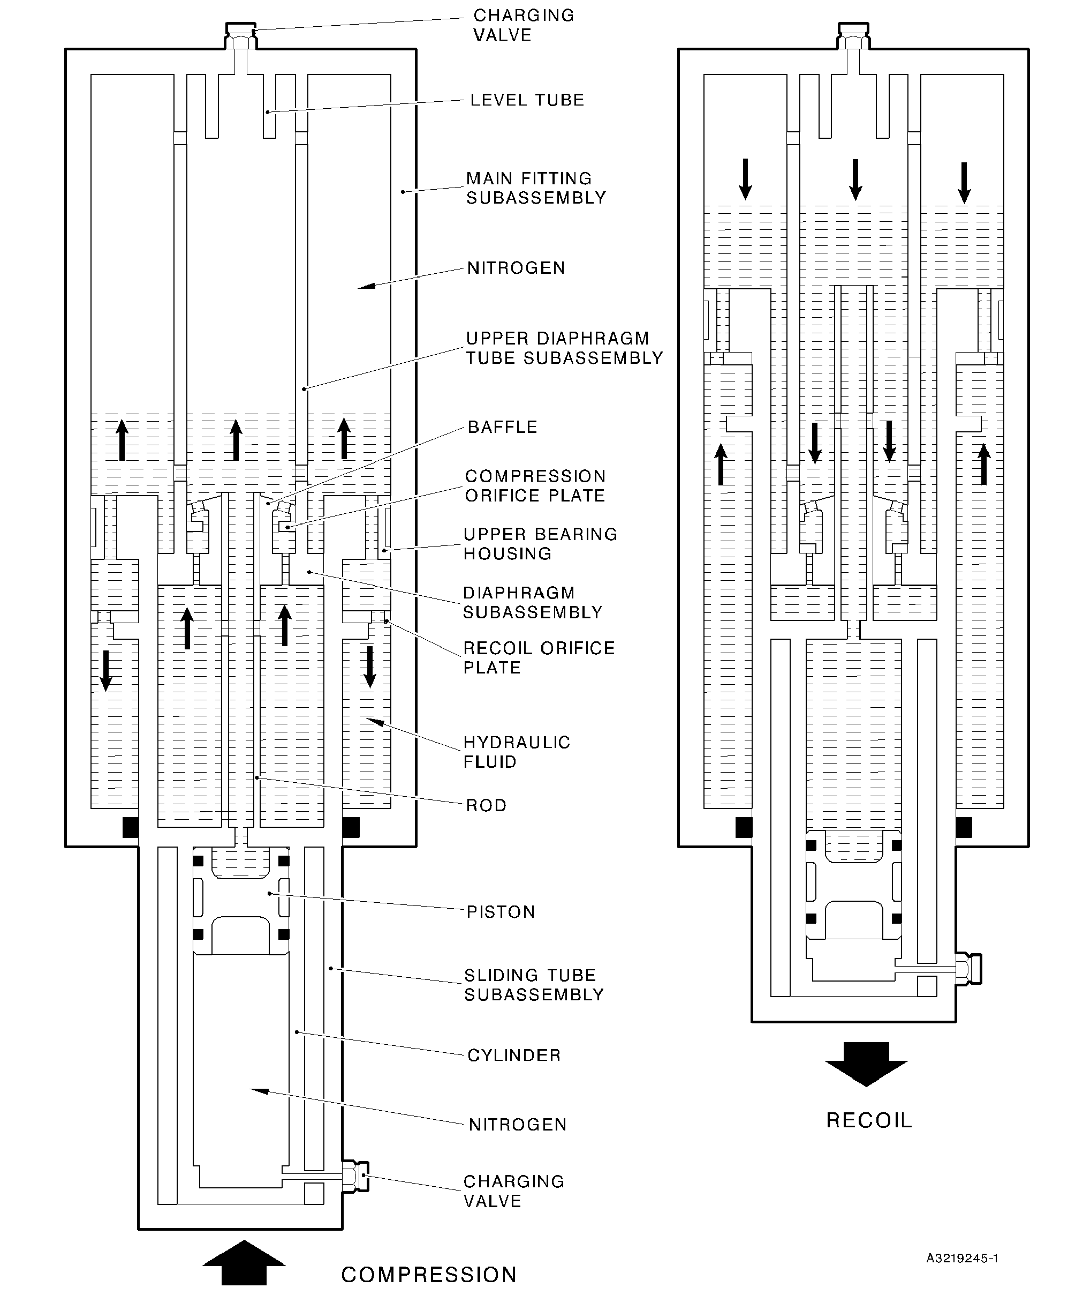
Diagram of Operation
Figure 2
32-12-22
Page 4
Dec 6/2019

sSAFRAN SAFRAN LANDING SYSTEMS UK Ltd
CAGE: K0654
PART No. 201587001 AND 201587002 COMPONENT MAINTENANCE MANUAL
MAIN LANDING GEAR LEG
TESTING AND FAULT ISOLATION
- Equipment and Materials
- Equipment
- This equipment is necessary:
NOTE: Alternative equivalents are permitted.
Part No. | Equipment | Function
- | Hydraulic Test Rig
- | Nitrogen Supply | Main landing gear leg (1-1) tests
- | Loading Press
 | Milliohmmeter Megger, | Electrical bonding resistance
 | Type BT51 | tests
- | 28 VDC Power Supply | Proximity switch and target tests
T14218 | Turner Inflation Equipment | Main landing gear leg (1-1) tests
T14500 | Crowfoot Wrench | Close the charging valves  (13-60 and 17-20)
460002502 | Charging Adapter | Main landing gear leg (1-1) tests
460005842 | Lampbox | Proximity switch and target tests
460006231 | Holding Fixture
460006232 | Load Cell and Adapter
460006233 | Press Adapter | Main landing gear leg (1-1) tests
460006234 | Offset Adapter
460007260 | Bottom Press Adapter
- Materials
- These materials are necessary:
NOTE: Alternative equivalents are permitted.
Ref. Item | Material
TBA | Nitrogen
02-501 | Hydraulic fluid
32-12-22
Page 101
Dec 6/2019

SAFRAN LANDING SYSTEMS UK Ltd
CAGE: K0654
PART No. 201587001 AND 201587002 COMPONENT MAINTENANCE MANUAL
MAIN LANDING GEAR LEG
- Test Conditions
WARNING: DO NOT GET HYDRAULIC FLUID ON YOUR SKIN OR IN YOUR EYES. DO NOT
BREATHE THE FUMES. ONLY USE IN A LOCATION THAT HAS A CONTINUOUS
FLOW OF CLEAN AIR. HYDRAULIC FLUID IS POISONOUS AND DANGEROUS.
A. General
- The hydraulic test rig must have a hand pump and a power pump. The power pump
must have a controlled flow of not less than 4,5 l/min (4.62 in³/sec).
- The inflation equipment must be to MIL-G-8348.
- The temperature of the test fluid must be between 20 and 40 °C (68 and 104 °F).
- The test fluid must be clean: refer to M-DLPS910-1.
- During all hydraulic tests, the unit and the test circuit must be hydraulically full.
- Examine the unit for damage before you start the tests.
- During the proximity switch tests the ambient temperature must be between 15 and
25 °C (59 and 77 °F).
- Procedure
- Piston (17-200) Leakage Tests
- Use the Charging Adapter 460002502 and the Turner Inflation Equipment T14218:
connect the charging valve (17-20) to the nitrogen supply. Open the charging valve
(17-20).
- Slowly increase the nitrogen pressure to between 9,32 and 10,68 bar (135 and
155 lbf/in²). Make a record of the pressure. Close the charging valve (17-20) and hold
the nitrogen pressure for 15 minutes.
- Open the charging valve (17-20) and measure the nitrogen pressure: it must be the
same as the record in para (2). Leakage must not occur.
- Release the nitrogen pressure.
- Disconnect the nitrogen supply and remove the Turner Inflation Equipment T14218 and
the Charging Adapter 460002502.
- Make sure that all of the nitrogen pressure has been released: remove the charging
valve (17-20).
- Refer to ASSEMBLY: install the charging valve (17-20) and complete the assembly
procedure.
- Main Landing Gear Leg (1-1) Tests
- Initial Operations
- Use these special tools to install the main landing gear leg (1-1) vertically in the
loading press:
1 The Holding Fixture 460006231.
2 The Press Adapter 460006233.
32-12-22
Page 102
Dec 6/2019

sSAFRAN SAFRAN LANDING SYSTEMS UK Ltd
CAGE: K0654
PART No. 201587001 AND 201587002 COMPONENT MAINTENANCE MANUAL
MAIN LANDING GEAR LEG
3 The Bottom Press Adapter 460007260.
- Assemble the Load Cell and Adapter 460006232 and the Offset Adapter
460006234 to the main landing gear leg (1-1).
- Procedure to Fill and Pressurize the Main Landing Gear Leg (1-1)
CAUTION: DO NOT PUT AN END LOAD OF MORE THAN 5,08 TONNES (5 TONS)
ON THE MAIN LANDING GEAR LEG (1-1).
- Make sure that there is no pressure in the main landing gear leg (1-1): open the
charging valves (13-60 and 17-20).
- Use the Charging Adapter 460002502 to connect the hydraulic test rig to the
charging valve (13-60).
- Slowly increase the hydraulic pressure to between 13,11 and 14,48 bar (190 and
210 lbf/in²) and let the unit extend fully.
- Release the hydraulic pressure and fully close the unit.
- Do para (c) and (d) until the hydraulic fluid that comes out of the unit does not have
air in it.
- Fully close the unit and disconnect the hydraulic test rig.
- Use the Charging Adapter 460002502 and the Turner Inflation Equipment T14218
to connect the nitrogen supply to the charging valve (13-60).
CAUTION: DO NOT USE A PRESSURE OF MORE THAN 7,58 BAR (110 LBF/IN²).
- Slowly increase the nitrogen pressure until the unit starts to extend. Hold the
pressure and fully extend the unit. The pressure must not be more than 7,58 bar
(110 lbf/in²).
NOTE: The charging valve (17-20) must be open to let the unit extend fully.
- Refer to Figure 101 and measure the dimension X: it must be between 483,05 and
487,85 mm (19.017 and 19.207 in).
- Disconnect the nitrogen supply and remove the Turner Inflation Equipment T14218
and the Charging Adapter 460002502.
- Open the charging valve (13-60) and release the nitrogen pressure. Do not close
the charging valve (13-60).
- Use the Charging Adapter 460002502 and the Turner Inflation Equipment T14218
to connect the charging valve (17-20) to the nitrogen supply.
- Slowly increase the nitrogen pressure to between 13,11 and 14,48 bar (190 and
210 lbf/in²).
NOTE: Nitrogen will be released through the charging valve (13-60) as the
piston (17-200) moves.
- Slowly increase the nitrogen pressure to between 67,59 and 70,34 bar (980
and1020 lbf/in²).
32-12-22
Page 103
Dec 6/2019

SAFRAN LANDING SYSTEMS UK Ltd
CAGE: K0654
PART No. 201587001 AND 201587002 COMPONENT MAINTENANCE MANUAL
MAIN LANDING GEAR LEG
- Close the charging valve (17-20); use the Crowfoot Wrench T14500 to torque it to
between 5,7 and 7,9 N m (50 and 70 lbf in).
- Disconnect the nitrogen supply and remove the Turner Inflation Equipment T14218
and the Charging Adapter 460002502.
- Use the Turner Inflation Equipment T14218 and the Charging Adapter 460002502
to connect the nitrogen supply to the charging valve (13-60).
- Slowly increase the nitrogen pressure to between 6,90 and 8,27 bar (100 and
120 lbf/in²).
- Close the charging valve (13-60); use the Crowfoot Wrench T14500 to torque it to
between 5,7 and 7,9 N m (50 and 70 lbf in).
- Disconnect the nitrogen supply and remove the Turner Inflation Equipment T14218
and the Charging Adapter 460002502.
- Leakage Tests
- Make a record of the nitrogen pressure at the charging valve (13-60), (P1A) and
the charging valve (17-20), (P1B).
- Make a record of the ambient temperature, (T1).
- Keep the unit in this condition for a minimum of six hours.
- Measure the nitrogen pressure at the charging valve (13-60), (P2A) and the
charging valve (17-20), (P2B).
- Measure the ambient temperature, (T2).
- Compare the pressures P1A and P2A and compare the pressures P1B and P2B.
The pressures P1A and P2A must be the same and the pressures P1B and P2B
must be the same, unless:
- There is a difference between the temperatures T1 and T2
- There is an error because of the pressure gauge capacity.
- If there is a difference between the temperatures T1 and T2, calculate the correct
value for the nitrogen pressures (these will be P3A and P3B) and adjust the
pressures to the corrected values. Use the formula:
_{P3A =} (P2A + Z) x (T1 + K) _{- Z}
(T2 + K)
OR
(P2B + Z) x (T1 + K)
P3B = - Z
(T2 + K)
Where K = 273 for temperatures in °C
(459 for temperatures in °F)
Z = 1 for pressures in bar
(15 for pressures in lbf/in²)
32-12-22
Page 104
Dec 6/2019

SAFRAN LANDING SYSTEMS UK Ltd
CAGE: K0654

PART No. 201587001 AND 201587002 COMPONENT MAINTENANCE MANUAL
MAIN LANDING GEAR LEG
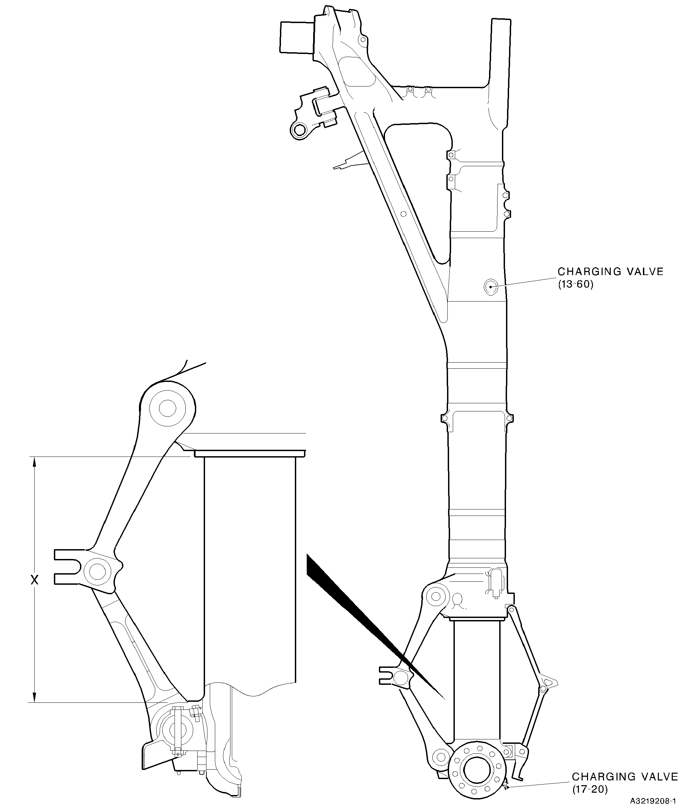
Main Landing Gear Leg (1-1)
Figure 101
32-12-22
Page 105
Dec 6/2019

sSAFRAN SAFRAN LANDING SYSTEMS UK Ltd
CAGE: K0654
PART No. 201587001 AND 201587002 COMPONENT MAINTENANCE MANUAL
MAIN LANDING GEAR LEG
- If there is an error because of the gauge capacity:
- Close the charging valve (13-60).
- Release the pressure in the gauge.
3 Open the charging valve (13-60) and measure the nitrogen pressure, (P4A).
- Close the charging valve (13-60).
- Close the charging valve (17-20).
- Release the pressure in the gauge.
7 Open the charging valve (17-20) and measure the nitrogen pressure, (P4B).
- Calculate the correct values for the nitrogen pressures (these will be P5A and
P5B) and adjust the pressures to the corrected values. Use the formula:
P5A = P1A + (P2A - P4A)
OR
P5B = P1B + (P2B - P4B)
- Prepare for Transport and Storage
- Open the charging valve (13-60) and reduce the nitrogen pressure to between 3,45
and 4,82 bar (50 and 70 lbf/in²).
- Close the charging valve (13-60); use the Crowfoot Wrench T14500 to torque it to
between 5,7 and 7,9 N m (50 and 70 lbf in).
- Open the charging valve (17-20) and reduce the nitrogen pressure to between 3,45
and 4,82 bar (50 and 70 lbf/in²).
- Close the charging valve (17-20); use the Crowfoot Wrench T14500 to torque it to
between 5,7 and 7,9 N m (50 and 70 lbf in).
- Write this data on a label and attach it to the unit: THE GEAR MUST BE INFLATED
TO THE APPROPRIATE PRESSURES BEFORE BEING PLACED IN SERVICE.
- Complete the torque procedure for the retaining pins (13-10): refer to ASSEMBL .
- Proximity Switches (7-40 and 7-230) Adjustments and Tests
- Use the loading press: set the dimension between the pins (10-80 and 11-130) to
between 632,80 and 636,95 mm (24.9134 and 25.0767 in).
- Adjust the spacers (6-140, 7-50, 7-190 and 7-240) or laminated shims (6-140A, 7-50A,
7-90A and 7-240A): refer to ASSEMBLY.
NOTE: If the calculated gap is in the tolerance, the spacers (6-140, 7-50, 7-190
and 7-240) or laminated shims (6-140A, 7-50A, 7-90A and 7-240A) are not
necessary.
- Connect the 28 VDC power supply, the Lampbox 460005842 and the main landing gear
leg (1-1).
32-12-22
Page 106
Dec 6/2019

sSAFRAN SAFRAN LANDING SYSTEMS UK Ltd
CAGE: K0654
PART No. 201587001 AND 201587002 COMPONENT MAINTENANCE MANUAL
MAIN LANDING GEAR LEG
- Use the loading press to fully extend the main landing gear leg (1-1).
- Use the loading press to slowly close the main landing gear leg (1-1):
- The proximity switch (7-230) must operate before the main landing gear leg (1-1)
has closed by 26,00 mm (1.0236 in).
- The proximity switch (7-40) must operate before the main landing gear leg (1-1)
has closed by 29,30 mm (1.1535 in).
- Do para (4) and (5) again.
- Disconnect the 28 VDC supply and the Lampbox 460005842.
- Remove the main landing gear leg (1-1) from the loading press.
- Electrical Bonding Resistance Tests (Refer to Figure 102)
CAUTION: DO NOT CAUSE DAMAGE TO THE PAINT FINISH.
NOTE: Make sure that the main landing gear leg (1-1) is electrically isolated from the
equipment that is used to hold it.
- Use the Milliohmmeter Megger, Type BT51, to measure the electrical bonding
resistance.
- Measure between the bearing (20-250) and the test points given in Table 101. The
electrical bonding resistance must not be more than the limit given in Table 101.
- Measure between the axle of the sliding tube subassembly (17-240) and the test
points given in Table 102. The electrical bonding resistance must not be more than
the limit given in Table 102.
32-12-22
Page 107
Dec 6/2019

SAFRAN LANDING SYSTEMS UK Ltd
CAGE: K0654
PART No. 201587001 AND 201587002 COMPONENT MAINTENANCE MANUAL
MAIN LANDING GEAR LEG
BEARING (20-250)
3
8
AXLE OF SLIDING TUBE
SUBASSEMBLY (17-240)
A3219209-2
Electrical Bonding Resistance Test Points (Tables 101 and 102)
Figure 102
32-12-22
Page 108
Dec 6/2019
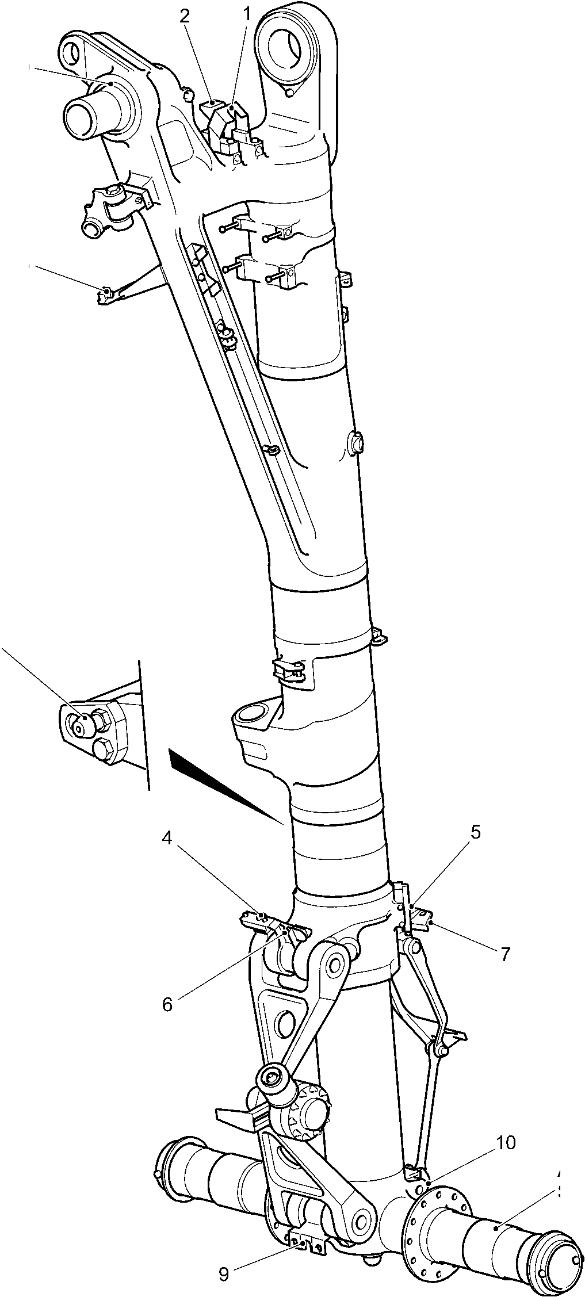

sSAFRAN SAFRAN LANDING SYSTEMS UK Ltd
CAGE: K0654
PART No. 201587001 AND 201587002 COMPONENT MAINTENANCE MANUAL
MAIN LANDING GEAR LEG
Electrical Bonding Resistance Tests
Table 101 (Refer to Figure 102)
TEST  POINT | IPL FIGURE  AND ITEM No. | NAME | LIMIT VALUE  MILLIOHMS
1 | 2-80 | Bracket | 10
2 | 2-120 | Bracket | 10
3 | 4-100 | Proximity switch connector shell | 20
4 | 7-230 | Proximity switch connector shell | 20
5 | 7-100 | Harness support bracket | 20
6 | 10-160 | Upper pivot bracket | 20
7 | 7-40 | Proximity switch connector shell | 20
8 | 5-390 | Static discharge connector | 10
Electrical Bonding Resistance Tests
Table 102 (Refer to Figure 102)
TEST  POINT | IPL FIGURE  AND ITEM No. | NAME | LIMIT VALUE  MILLIOHMS
9 | 11-140 | Harness support bracket | 20
10 | 8-170 | Bracket | 20
- Fault Isolation
A. To be given subsequently.
32-12-22
Page 109
Dec 6/2019

SAFRAN LANDING SYSTEMS UK Ltd
CAGE: K0654

PART No. 201587001 AND 201587002 COMPONENT MAINTENANCE MANUAL
MAIN LANDING GEAR LEG
INTENTIONALLY BLANK
32-12-22
Page 110

sSAFRAN SAFRAN LANDING SYSTEMS UK Ltd
CAGE: K0654
PART No. 201587001 AND 201587002 COMPONENT MAINTENANCE MANUAL
MAIN LANDING GEAR LEG
DISASSEMBLY
- General
WARNING: DO NOT GET HYDRAULIC FLUID ON YOUR SKIN OR IN YOUR EYES. DO NOT
BREATHE THE FUMES. ONLY USE IN A LOCATION THAT HAS A CONTINUOUS
FLOW OF CLEAN AIR. HYDRAULIC FLUID IS POISONOUS AND DANGEROUS.
NOTE: Refer to TESTING AND FAULT ISOLATION to find the necessary level of
disassembly. This will give the condition of the component or the possible cause of
its malfunction.
- Make sure that the work area, the tools and the equipment are clean.
- Discard parts that you must not use again. These include:
IPL Fig/Item  No. | Part Name
1-10 | Split pin
1-41 | Heat shrink sleeve
1-43 | Ferrule
1-45 | Bowden cable
1-80 | Tab washers
2-70 | Tab washers
2-150 | Tab washer
2-180 | Tab washers
2-200 | Tab washer
2-230 | Split pins
3-20 | Split pin
3-180 | Split pin
4-20 | Split pin
4-110 | Split pins
4-170 | Tab washers
4-200 | Tab washers
4-220 | Split pin
4-270 | Split pins
5-170 | Split pin
5-320 | Split pins
5-360 | Split pin
6-60 | Split pin
6-240 | Split pin
7-60 | Split pins
8-40 | Split pins
32-12-22
Page 301
Dec 6/2019

SAFRAN LANDING SYSTEMS UK Ltd
CAGE: K0654

PART No. 201587001 AND 201587002 COMPONENT MAINTENANCE MANUAL
MAIN LANDING GEAR LEG
IPL Fig/Item  No. | Part Name
8-100 | Split pins
9-10 | Split pin
10-20 | Tab washers
10-40 | Split pin
10-100 | Tab washers
10-150 | O-ring seals
11-70 | Tab washers
11-90 | Split pin
12-10 | Split pins
12-50 | Split pins
12-100 | O-ring seal
12-110 | Backing ring
12-130 | O-ring seals
12-140 | Backing rings
12-150 | O-ring seals
12-160 | Backing rings
13-67 | O-ring seal
13-120 | O-ring seal
13-140 | Split pin
14-20 | Split pins
15-80 | Locking plate
15-90 | Screws
15-100 | Tab washers
15-120 | Pin
15-170 | Tab washers
15-250 | O-ring seal
15-260 | Backing rings
15-280 | Seal
15-290 | Seal
15-310 | O-ring seal
15-320 | Split pin
16-20 | O-ring seal
16-30 | Backing rings
16-40 | O-ring seal
16-50 | Backing rings
16-60 | Seal
32-12-22
Page 302
Mar 15/2024

sSAFRAN SAFRAN LANDING SYSTEMS UK Ltd
CAGE: K0654
PART No. 201587001 AND 201587002 COMPONENT MAINTENANCE MANUAL
MAIN LANDING GEAR LEG
IPL Fig/Item  No. | Part Name
16-70 | Seal
16-80 | Joint seal
16-90 | Sealing ring
16-100 | Wiper ring
16A-117 | Inner liner
17-27 | O-ring seal
17-60 | O-ring seal
17-70 | Backing ring
17-90 | Lock washer
17-110 | Tab washers
17-190 | Seal
17-210 | O-ring seal
17-220 | Backing ring
19-10 | Split pin
- Wire Thread Inserts
- If necessary, remove the wire thread inserts:
- Bend the outer coil of the wire thread insert to the centre of the hole.
- Remove the wire thread insert. Make sure that broken pieces do not stay in the
hole.
- Special Tools
- These special tools are necessary:
NOTE: Alternative equivalents are permitted.
Part No. | Special Tool | Function
MT1025 | Bench Clamp | Use with MT1026/63 and 460006406
MT1026/63 | Holding Blocks | Hold the cylinder (17-230)
T14500 | Crowfoot Wrench | Remove the charging valves (13-60  and 17-20)
T14544 | Torque Adapter | Remove the nut (9-50)
460001355 | Extractor | Remove the lubrication adapters  (18-60), (20-130), (20-160), (20-190)  and (20-220)
460004331/1 | Drift | Use with 460006151/47
460004331/7 | Drift | Use with 460006151/24,  460006151/25, 460006151/26 and  460006151/51
32-12-22
Page 303
Mar 15/2024

SAFRAN LANDING SYSTEMS UK Ltd
CAGE: K0654

PART No. 201587001 AND 201587002 COMPONENT MAINTENANCE MANUAL
MAIN LANDING GEAR LEG
Part No. | Special Tool | Function
460004331/8 | Drift | Use with 460006151/7,  460006151/20, 460006151/30 and  460006151/31
460004331/9 | Drift | Use with 460006151/47,  460006151/87 and 460006151/88
460004331/20 | Drift | Use with 460006151/21 and  460006151/22
460004331/21 | Drift | Use with 460006151/9,  460006151/10 and 460007259
460004680 | Extraction Tube | Remove the forward pintle bush  (20-250A)
460006151/7 | Extractor | Remove the bushes (18-30)
460006151/9 | Extractor | Remove the bushes (20-340) and  (20-350)
460006151/10 | Extractor | Remove the bushes (10-250,  11-230, 18-40 and 20-330)
460006151/20 | Extractor | Remove the bushes (18-20)
460006151/21 | Extractor | Remove the bush (15-370)
460006151/22 | Extractor | Remove the bush (15-380)
460006151/24 | Extractor | Remove the bearings (5-280 and  5-290) and the bushes (20-380)
460006151/25 | Extractor | Remove the bearing (4-340) and the  bush (20-360)
460006151/26 | Extractor | Remove the bearing (4-350)
460006151/30 | Extractor | Remove the bush (6-210 and 8-160)
460006151/31 | Extractor | Remove the bush (6-220 and 8-150)
460006151/47 | Extractor | Remove the bearings (20-230,  20-240 and 20-290)
460006151/48 | Extractor | Remove the bearing (20-290)
460006151/51 | Extractor | Remove the bushes (20-390)
460006151/86 | Extractor | Remove the bushes (20-320)
460006151/87 | Extractor | Remove the bearing (20-270)
460006151/88 | Extractor | Remove the bearing (20-260)
460006208 | Lifting Bar Assembly | Hold the main landing gear leg (1-1),  use with 460007281 and 460007282
460006211 | Lifting Tackle | Lift the sliding tube subassembly  (17-240) and related parts
32-12-22
Page 304
Mar 20/2020

sSAFRAN SAFRAN LANDING SYSTEMS UK Ltd
CAGE: K0654
PART No. 201587001 AND 201587002 COMPONENT MAINTENANCE MANUAL
MAIN LANDING GEAR LEG
Part No. | Special Tool | Function
460006213 | Transport and Build  Trolley
460006215 | Support Arms
460006216 | Towing Frame | Hold the main landing gear leg (1-1)
460006223 | Jacking Dome  Adapter
460006237 | Adapter
460006232 | Extraction Pad | Remove the bearing (20-300)
460006253 | Extractor | Remove the bearing (20-280)
460006261 | Extraction Pad | Remove the bearing (20-310)
460006262 | Extraction Bar | Use with 460006232, 460006263  and 460006261
460006263 | Extraction Pad | Remove the bearing (20-300)
460006267 | Press Pad Assembly | Remove drag arm sleeve (20-370A)
460006404 | Torque Adapter | Remove the jacking dome (17-80)
460006406 | Holding Blocks | Hold the upper diaphragm tube  (15-390)
460006410 | Assembly/Extraction  Tool | Remove the level tube (15-300)
460006413 | Extractor | Remove the bushes (7-130)
460006415 | Extractor Pad and  Drawbolt | Remove the bush (2-310)
460006416 | Extractor | Remove the bush (2-320)
460006497 | Hydraulic-Pneumatic  Pump Set | To remove the forward pintle bush
460006498/7 | Bolt | (2-250A)
460006499/25 | Press Pad
460007230 | Torque Adapter | Remove the nuts (14-60)
460007231 | Spacer | Use with 460007282
460007232 | Torque Adapter | Remove the locking nut (19-52)
460007234 | Location Frame | Hold the main landing gear leg (1-1)  (left configuration)
OR  460007235 | Location Frame | Hold the main landing gear leg (1-2)  (right configuration)
460007240 | Build Trolley | Hold the sliding tube subassembly  (17-240) and related parts
32-12-22
Page 305
Mar 20/2020

sSAFRAN SAFRAN LANDING SYSTEMS UK Ltd
CAGE: K0654
PART No. 201587001 AND 201587002 COMPONENT MAINTENANCE MANUAL
MAIN LANDING GEAR LEG
Part No. | Special Tool | Function
460007242 | Torque Reaction  Adapter | Hold the pin (9-70)
460007254 | Extractor | Remove the bush (18-50)
460007259 | Extractor Plate | Remove the bushes (20-340 and  20-350)
460007278 | Torque Reactor | Use with 460006406
460007279 | Pin Spanner | Remove the upper bearing housing  (15-40)
460007281 | Pintle Location  Assembly | Hold the main landing gear leg (1-1),
460007282 | Spherical Bearing  Locator | use with 460006208
460007283 | Torque Adapter | Remove the diaphragm  subassembly (15-190)
460007284 | Pin Spanner | Remove the nut subassembly  (17-130)
32-12-22
Page 306
Mar 20/2020

^SAFRAN SAFRAN LANDING SYSTEMS UK Ltd
CAGE: K0654
PART No. 201587001 AND 201587002 COMPONENT MAINTENANCE MANUAL
MAIN LANDING GEAR LEG
- Procedure (Refer to IPL Figures 1 to 20)
- Initial Operations
- Use these special tools as necessary during the procedure to lift and to hold the unit:
- The Lifting Bar Assembly 460006208
- The Spherical Bearing Locator 460007282
- The Pintle Location Assembly 460007281
- The Transport and Build Trolley 460006213
- The Support Arms 460006215
- The Towing Frame 460006216
- The Jacking Dome Adapter 460006223
- The Adapter 460006237
- The Spacer 460007231
- The Location Frame 460007234 (for left configuration units)
- The Location Frame 460007235 (for right configuration units).
- Pintle Pin (1-60)
- Pre SB 201-32-22: remove the split pin (1-10), the nut (1-20), the washer (1-30), the bolt
(1-40) and the washer (1-50).
- Post SB 201-32-22: remove the split pins (1-10A), the nuts (1-20A), the spacers (1-25),
the washers (1-30A), the shims (1-35), the bolt subassembly (1-40A) and the washers
(1-50A).
- Post SB 201-32-22: cut the Bowden cable (1-45) and remove the cross bolts (1-47 and
1-49).
- Remove the pintle pin (1-60).
- Remove the bolts (1-70), tab washers (1-80), nuts (1-90) and retainers (1-100).
- Remove the wiring diagram plate (1-110).
- PRE SB 201-32-81: Transfer Block Subassembly (2-290 and 2-290A)
- Remove the bolt (2-10), the washer (2-20), the pin (2-30), the spacer (2-40) and the
threaded insert (2-50).
- Release the tab washers (2-70). Remove the bolts (2-60), the tab washers (2-70) and
the bracket (2-80).
- Remove the bolts (2-100), the washers (2-110) and the bracket (2-120).
- Release the tab washer (2-150). Remove the bolt (2-140), the tab washer (2-150) and
the bonding cable (2-160).
- Release the tab washers (2-180 and 2-200). Remove the bolts (2-170 and 2-190) and
the tab washers (2-180 and 2-200).
32-12-22
Page 307
Mar 19/2021

sSAFRAN SAFRAN LANDING SYSTEMS UK Ltd
CAGE: K0654
PART No. 201587001 AND 201587002 COMPONENT MAINTENANCE MANUAL
MAIN LANDING GEAR LEG
- Remove the nuts (2-210) and retainers (2-220).
- Remove the split pins (2-230), the nuts (2-240), the washers (2-250), the bolts (2-260)
and the bracket (2-270).
- Remove the transfer block subassembly (2-290 and 2-290A).
- Use the Extractor Pad and Drawbolt 460006415 to remove the bush (2-310) and the
Extractor 460006416 to remove the bush (2-320) from the transfer block (2-340 and
2-340A).
- POST SB 201-32-81: Transfer Block Subassembly (2-290B)
- Remove the bolt (2-10), the washer (2-20), the pin (2-30), the spacer (2-40) and the
threaded insert (2-50).
- Release the tab washer (2-150). Remove the bolt (2-140), the tab washer (2-150) and
the bonding cable (2-160).
- Release the tab washers (2-180 and 2-200). Remove the bolts (2-170 and 2-190A) and
the tab washers (2-180 and 2-200).
- Remove the nuts (2-210) and retainers (2-220).
- Remove the transfer block subassembly (2-290B).
- Use the Extractor Pad and Drawbolt 460006415 to remove the bush (2-310) and the
Extractor 460006416 to remove the bush (2-320) from the transfer block (2-340B).
- Cardan Assembly (3-10)
- Remove the split pin (3-20), the nut (3-30), the washer (3-40), the pin (3-50), the spacers
(3-60 and 3-70) and the cardan assembly (3-10).
- Remove the lubrication fittings (3-80, 3-100 and 3-120) and the identification washers
(3-90, 3-110 and 3-130) from the lock stay cardan subassembly (3-140).
- Remove the bushes (3-150 and 3-160) from the lock stay cardan (3-170).
- Remove the split pin (3-180), the nut (3-190), the washer (3-200), the bolt (3-210) and
the bracket (3-220).
- Rod End Assembly (4-10), Proximity Switch (4-100) and Bracket Subassembly (4-330)
- Remove the split pin (4-20), the nut (4-30), the washer (4-40) and the rod end assembly
(4-10).
- Remove the spherical bearing (4-50) from the rod end (4-60).
- Remove the nuts (4-70), the washers (4-80), the cap screws (4-90) and the proximity
switch (4-100).
- Remove the split pins (4-110), the nuts (4-120), the washers (4-130) and the bracket
(4-140).
- Release the tab washers (4-170 and 4-200). Remove the nuts (4-160), the tab washers
(4-170), the spacer (4-180), the bolts (4-190), the tab washers (4-200) and the bracket
(4-210).
- Remove the split pin (4-220), the nut (4-230), the washer (4-240), the bolt (4-250) and
the sleeve (4-260).
32-12-22
Page 308
Mar 19/2021

sSAFRAN SAFRAN LANDING SYSTEMS UK Ltd
CAGE: K0654
PART No. 201587001 AND 201587002 COMPONENT MAINTENANCE MANUAL
MAIN LANDING GEAR LEG
- Remove the split pins (4-270), the nuts (4-280), the washers (4-290) and the bolts
(4-300).
- Remove the bonding cable (4-310) and the washer (4-320).
- Remove the bracket subassembly (4-330).
- Use the Drift 460004331/7 and the Extractor 460006151/25 to remove the bearing
(4-340) from the bracket (4-360).
- Use the Drift 460004331/7 and the Extractor 460006151/26 to remove the bearing
(4-350) from the bracket (4-360).
- Bracket Assembly (5-10), Bracket Subassemblies (5-90 and 5-270) and Uplock Pin (5-400)
- Remove the bolts (5-20 and 5-40), the washers (5-30 and 5-50), the nut (5-60) and the
bracket assembly (5-10).
- Remove the spherical bearing (5-70) from the bracket (5-80): refer to M-DLPS1014-2.
- Remove the bolts (5-100 and 5-120), the washers (5-110 and 5-130), the nut (5-140)
and the bracket subassembly (5-90).
- Remove the spherical bearing (5-150) from the bracket (5-160): refer to M-DLPS1014-2.
- Remove the split pin (5-170), the nut (5-180), the washer (5-190), the bolt (5-200) and
the sleeve (5-210).
- Remove the bolt (5-220), the washer (5-230) and the bonding cable (5-240).
- Remove the bolt (5-250), the washer (5-260), the bracket subassembly (5-270) and the
nut (5-310).
- Use the Drift 460004331/7 and the Extractor 460006151/24 to remove the bearings
(5-280 and 5-290) from the bracket (5-300).
- PRE SB 201-32-72:
- Remove the split pins (5-320), the nuts (5-330), the washers (5-340) and the bolts
(5-350).
- Remove the split pin (5-360), the nut (5-370), the washer (5-380), the static
discharge connector (5-390) and the uplock pin (5-400).
- POST SB 201-32-72:
- Remove the split pins (5-320A), the nuts (5-330A), the washers (5-340B) and the
bolts (5-350A).
- Remove the ground stud subassembly (5-390A), the washer (5-380B), the
bolt (5-395) and the uplock pin (5-400A).
- Slave Link Subassembly (6-190) and Lower Slave Link Subassembly (6-290)
- Remove the split pin (6-10), the nut (6-20), the washer (6-30), the bolt (6-40) and the
spacer (6-50).
- Remove the split pin (6-60), the slotted nut (6-70), the washer (6-80) and the pivot pin
(6-90).
- Remove the slave link subassembly (6-190) and its attached parts.
32-12-22
Page 309
Mar 20/2020

sSAFRAN SAFRAN LANDING SYSTEMS UK Ltd
CAGE: K0654
PART No. 201587001 AND 201587002 COMPONENT MAINTENANCE MANUAL
MAIN LANDING GEAR LEG
- Remove the nuts (6-100), the washers (6-110), the cap screws (6-120), the
target (6-130) and the spacers (6-140) or the laminated shim (6-140A).
NOTE: If the calculated gap is in the tolerance, the spacers (6-140) or the
laminated shim (6-140A) is not installed.
- Remove the bolts (6-150), the washers (6-160) and the bracket (6-170).
- Remove the bushes (6-200) from the slave link (6-230).
- Use the Drift 460004331/8 and the Extractor 460006151/30 to remove the bush (6-210)
from the slave link (6-230).
- Use the Drift 460004331/8 and the Extractor 460006151/31 to remove the bush (6-220)
from the slave link (6-230).
- Remove the split pin (6-240), the nut (6-250), the washer (6-260), the bolt (6-270) and
the spacer (6-280): remove the lower slave link subassembly (6-290).
- Remove the grooved spherical bearing (6-300) or the self lubricating bearing (6-300A)
from the lower slave link (6-310).
- Proximity Switches (7-40 and 7-230) and Harness Support Bracket (7-100)
- Remove the nuts (7-10), the washers (7-20), the cap screws (7-30), the proximity switch
(7-40) and the spacer (7-50) or the laminated shim (7-50A).
NOTE: If the calculated gap is in the tolerance, the spacer (7-50) or the laminated
shim (7-50A) is not installed.
- Remove the split pins (7-60), the nuts (7-70), the washers (7-80), the bolts (7-90) and
the harness support bracket (7-100).
- Remove the pivot bracket subassembly (7-120).
- Use the Extractor 460006413 to remove the bushes (7-130) from the pivot bracket
(7-140).
- Remove the nuts (7-150), the washers (7-160), the cap screws (7-170), the target
(7-180) and the spacer (7-190) or the laminated shim (7-190A).
NOTE: If the calculated gap is in the tolerance, the spacer (7-190) or the
laminated shim (7-190A) is not installed.
- Remove the nuts (7-200), the washers (7-210), the cap screws (7-220), the proximity
switch (7-230) and the spacer (7-240) or the laminated shim (7-240A).
- Bracket Subassembly (8-90)
- Remove the nuts (8-10), the washers (8-20) and the bolts (8-30).
- Remove the split pins (8-40), the nuts (8-50), the washers (8-60), the bolts (8-70) and
the bracket (8-80).
- Remove the split pin (8-100), the nut (8-110), the washer (8-120), the sleeves (8-130)
and the bolt (8-140). Remove the bracket subassembly (8-90).
- Use the Extractor 460006151/31 and the Drift 460004331/8 to remove the bush (8-150).
- Use the Extractor 460006151/30 and the Drift 460004331/8 to remove the bush (8-160).
32-12-22
Page 310
Mar 20/2020

sSAFRAN SAFRAN LANDING SYSTEMS UK Ltd
CAGE: K0654
PART No. 201587001 AND 201587002 COMPONENT MAINTENANCE MANUAL
MAIN LANDING GEAR LEG

K. Damper (9-160)
- Remove the split pin (9-10), the nut (9-20), the washer(s) (9-30) and the bolt (9-40).
- Remove the clamp (9-165) and the dust cap (9-170).
- Use the Torque Reaction Adapter 460007242 to hold the pin (9-70) and use the Torque
Adapter T14544 to remove the nut (9-50). Remove the spacer (9-60), the pin (9-70), the
spacer (9-80) and the sleeve (9-90).
- Remove the bolts (9-100), the washers (9-110), the bolts (9-120), the washers (9-130),
the bolts (9-140), the washers (9-145) and the bracket (9-150).
- Remove the damper (9-160), the spacers (9-180 and 9-190) and the sleeve (9-200).
- Upper Torque Link Subassembly (10-170)
- Release the tab washers (10-20). Remove the bolts (10-10), the tab washers (10-20)
and the wedge (10-30).
- Remove the split pin (10-40), the nut (10-50), the washers (10-60), the bolt (10-70) and
the pin (10-80).
- Remove the upper torque link subassembly (10-170), the upper pivot bracket (10-160)
and the spacers (10-270).
- Remove the lubrication shaft subassembly (10-90) from the pin (10-80).
- Remove the O-ring seals (10-150) from the lubrication shaft subassembly (10-90).
- Remove the lubrication fittings (10-120) and the identification washers (10-130).
- Release the tab washers (10-100). Remove the lubrication adapters (10-110) and the
tab washers (10-100).
- Remove the lubrication fittings (10-180 and 10-210) and the identification washers
(10-190 and 10-220). Remove the lubrication adapters (10-200 and 10-230).
- Remove the bushes (10-240).
- Use the Extractor 460006151/10 to remove the bushes (10-250) from the upper torque
link (10-260).
- 1M Electrical Axle Harness (11-40) and 2M Electrical Axle Harness (11-50)
- Remove the cap screws (11-10), the washers (11-20) and the harness support (11-30).
- Remove the 2M electrical axle harness (11-50).
- Remove the 1M electrical axle harness (11-40).
- Lower Torque Link Subassembly (11-150)
- Release the tab washers (11-70).
- Remove the bolts (11-60), the tab washers (11-70) and the wedge (11-80).
- Remove the split pin (11-90), the nut (11-100), the washer (11-110) and the bolt (11-120).
- Remove the pin (11-130), the harness support bracket (11-140), the lower torque link
subassembly (11-150) and the spacers (11-250).
32-12-22
Page 311
Mar 20/2020

sSAFRAN SAFRAN LANDING SYSTEMS UK Ltd
CAGE: K0654
PART No. 201587001 AND 201587002 COMPONENT MAINTENANCE MANUAL
MAIN LANDING GEAR LEG
- Remove the lubrication fittings (11-160 and 11-190) and the identification washers
(11-170 and 11-200). Remove the lubrication adapters (11-180 and 11-210).
- Remove the bushes (11-220).
- Use the Extractor 460006151/10 to remove the bushes (11-230) from the lower torque
link (11-240).

O. Housing (12-170)
- Remove the split pins (12-10), the nuts (12-20), the washers (12-30) and the bolts
(12-40).
- Remove the housing (12-170) and its related parts.
- Remove the split pins (12-50), the washers (12-60), the pin (12-70) and the cap screw
(1).
- Remove the valve stem (12-90).
- Remove the O-ring seal (12-100) and the backing ring (12-110).
- Remove the transfer dowels (12-120).
- Remove the O-ring seals (12-130 and 12-150) and the backing rings (12-140 and
12-160).

P. Shock Absorber Subassembly (13-50) and Related Parts
- Remove the split pins (14-20), the nuts (14-30), the washers (14-40) and the bolts
(14-50).
- Use the Torque Adapter 460007230 to remove the nuts (14-60).
- Remove the stop rings (14-70).
WARNING: RELEASE ALL NITROGEN PRESSURE BEFORE YOU REMOVE THE
CHARGING VALVES (13-60 AND 17-20).
- Slowly open the charging valve (17-20) and release all of the second stage nitrogen
pressure.
- Slowly open the charging valve (13-60) and release all of the first stage nitrogen
pressure.
- Release the cup washers (13-20).
- Remove the retaining pins (13-10) and the cup washers (13-20).
- Remove the lubrication fittings (13-30) and the identification washers (13-40).
- Use the Crowfoot Wrench T14500 to remove the charging valve (13-60). Remove the
O-ring seal (13-67) from the charging valve (13-60).
- Remove the bolts (13-70), the spacers (13-80) and the inflation valve subassembly
(13-90).
- Remove the plate (13-100) from the inflation valve (13-110).
- Remove the O-ring seal (13-120) and the backing rings (13-130).
- Remove the split pin (13-140), the nut (13-150), the washers (13-160), the bolt (13-170)
and the stop ring (13-180).
- Remove the pin (13-190), the washer subassembly (13-200) and the bush (13-230).
32-12-22
Page 312
Mar 20/2020

sSAFRAN SAFRAN LANDING SYSTEMS UK Ltd
CAGE: K0654
PART No. 201587001 AND 201587002 COMPONENT MAINTENANCE MANUAL
MAIN LANDING GEAR LEG
- Remove the shock absorber subassembly (13-50) and its related parts from the main
fitting subassembly (20-90).
- Use the Lifting Tackle 460006211 and install the sliding tube subassembly (17-240) in
the Build Trolley 460007240.
- Remove the bearings (15-20 and 15-30).
- Remove the upper bearing housing (15-40) and related parts as follows:
- Release the tab washers (15-100).
CAUTION: DISCARD THE SCREWS (15-90) AND THE LOCKING PLATES (15-80)
WHEN REMOVED.
- Remove the screws (15-90) and the tab washers (15-100).
- Remove the locking plate (15-80).
- Use Pin Spanner 460007279 to remove the upper bearing housing (15-40).
- Remove and discard the pins (15-120).
- Remove the two piece stop with inserts (15-130).
- Remove the locking pins (15-50), the retaining ring (15-60) and the recoil orifice plate
(15-70).
- Remove the upper diaphragm tube subassembly (15-360) and its related parts.
- Release the tab washers (15-170). Remove the bolts (15-160), the tab washers (15-170)
and the lock plate (15-180).
- Use the Torque Adapter 460007283, the Torque Reactor 460007278, the Holding Blocks
460006406 and the Bench Clamp MT1025 to remove the diaphragm subassembly
(15-190), the compression orifice plate (15-220), the clapper seat (15-230) and the
baffle (15-240).
- Remove the O-ring seal (15-250) and the backing rings (15-260).
- Remove the bearing (15-270) and the seals (15-280 and 15-290).
- Use the Assembly/Extraction Tool 460006410 to remove the level tube (15-300) and
remove the O-ring seal (15-310).
- Remove the split pin (15-320), the nut (15-330), the washer (15-340) and the bolt
(15-350).
- Use the Extractor 460006151/21 and the Drift 460004331/20 to remove the bush
(15-370).
- Use the Extractor 460006151/22 and the Drift 460004331/20 to remove the bush
(15-380) from the upper diaphragm tube (15-390).
- Lower Bearing Subassembly (16-110) Pre SB 201-32-58
- Remove the lower bearing subassembly (16-110) and its related parts from the
sliding tube subassembly (17-240).
- Remove the O-ring seal (16-20), the backing rings (16-30), the O-ring seal (16-40)
and the backing rings (16-50).
- Remove the seals (16-60 and 16-70).
32-12-22
Page 313
Mar 15/2024

sSAFRAN SAFRAN LANDING SYSTEMS UK Ltd
CAGE: K0654
PART No. 201587001 AND 201587002 COMPONENT MAINTENANCE MANUAL
MAIN LANDING GEAR LEG
- Remove the joint seal (16-80), the sealing ring (16-90) and the wiper ring (16-100).
- Remove the lower bearing (16-150) from the lower bearing housing subassembly
(16-120).
- Remove the bushes (16-130) from the gland housing (16-140).
- Lower Bearing Subassembly (16A-110D) Post SB 201-32-58
- Remove the lower bearing subassembly (16A-110D) and its related parts from the
sliding tube subassembly (17-240).
- Remove the O-ring seal (16A-20), the backing rings (16A-30), the O-ring seal
(16A-40) and the backing rings (16A-50).
- Remove the seals (16A-60 and 16A-70).
- Remove the joint seal (16A-80), the sealing ring (16A-90) and the wiper ring
(16A-100).
- Remove the inner liner (16A-117) from the lower bearing subassembly (16A-110D)
and discard it.
- Remove the lower bearing (16A-150A) from the lower bearing housing
subassembly (16A-120B). Discard the machined lower bearing (16A-150A).
- Remove the bushes (16A-130A) from the gland housing (16A-140B).
- Lower Bearing Subassembly (16-110D or 16A-110E) Post Ref. Code: 2253
- Remove the lower bearing subassembly (16-110D or 16A-110E) and its related
parts from the sliding tube subassembly (17-240).
- Remove the O-ring seal (16-20A or 16A-20A), the backing rings (16-30
or 16A-30), the O-ring seal (16-40A or 16A-40A) and the backing
rings (16-50 or 16A-50).
- Remove the seals (16-60 or 16A-60) and (16-70 or 16A-70).
- Remove the joint seal (16-80 or 16A-80), the sealing ring (16-90 or 16A-90) and
the wiper ring (16-100 or 16A-100).
- Remove the common lower bearing bushes (16-130A or 16A-130B) from the lower
bearing housing (16-140B or 16A-140C).
- Use the Crowfoot Wrench T14500 to remove the charging valve (17-20). Remove the
O-ring seal (17-27) from the charging valve (17-20).
- Remove the cap screws (17-30), the washers (17-40) and the valve support (17-50).
- Remove the O-ring seal (17-60) and the backing ring (17-70).
- Release the lock washer (17-90) and use the Torque Adapter 460006404 to remove the
jacking dome (17-80). Remove the lock washer (17-90).
- Remove the cylinder (17-230) and its related parts from the sliding tube subassembly
(17-240).
- Hold the cylinder (17-230) in the Bench Clamp MT1025 and Holding Blocks MT1026/63.
- Release the tab washer (17-110) and remove the bolts (17-100). Remove the tab
washers (17-110).
32-12-22
Page 314
Mar 18/2025

sSAFRAN SAFRAN LANDING SYSTEMS UK Ltd
CAGE: K0654
PART No. 201587001 AND 201587002 COMPONENT MAINTENANCE MANUAL
MAIN LANDING GEAR LEG
- Remove the lock plate (17-120) and use the Pin Spanner 460007284 to remove the nut
subassembly (17-130). Remove the rod (17-160) and the washer (17-170).
- Remove the piston (17-200) and remove the bearing (17-180) and the seal (17-190).
- Remove the O-ring seal (17-210) and the backing ring (17-220) from the cylinder
(17-230).
- Remove the cylinder (17-230) from the Bench Clamp MT1025 and Holding Blocks
MT1026/63.
- Remove the labels (17-250 and 17-290).
- Remove the lubrication fittings (17-270) and the identification washers (17-280) from the
sliding tube subassembly (17-240).
- Remove the sliding tube subassembly (17-240) from the Build Trolley 460007240.
- Sliding Tube Subassembly (17-240)
- Remove the bushes (18-10).
- Use the Extractor 460006151/20 and the Drift 460004331/8 to remove the bushes
(18-20).
- Use the Extractor 460006151/7 and the Drift 460004331/8 to remove the bushes
(18-30).
- Use the Extractor 460006151/10 and the Drift 460004331/21 to remove the bushes
(18-40).
- Use the Extractor 460007254 to remove the bush (18-50).
- Remove the lubrication fittings (18-52) and identification washers (18-54).
- Remove the label (18-70) from the sliding tube (18-80).

Q. Spherical Bearing (19-50) and Bung (19-60)
- Remove the split pin (19-10), the nut (19-20), the washers (19-30) and the bolt (19-40).
- Release the lock indentations of the locking washer (19-54).
- Use the Torque Adapter 460007232 to remove the locking nut (19-52). Remove the
locking washer (19-54) and the outer race and the ball of the spherical bearing (19-50).
NOTE: The outer race and the ball are parts of the spherical bearing (19-550).
They are a set: keep them together.
- Remove the bung (19-60).

R. Main Fitting Subassembly (20-90)
- Remove the labels (20-10, 20-30, 20-40, 20-60 and 20-80).
- Remove the lubrication fitting (20-110) and the identification washer (20-120). Remove
the lubrication adapter (20-130).
- Remove the lubrication fitting (20-140) and the identification washer (20-150). Remove
the lubrication adapter (20-160).
- Remove the lubrication fitting (20-170) and the identification washer (20-180). Remove
the lubrication adapter (20-190).
32-12-22
Page 315
Mar 18/2025

sSAFRAN SAFRAN LANDING SYSTEMS UK Ltd
CAGE: K0654
PART No. 201587001 AND 201587002 COMPONENT MAINTENANCE MANUAL
MAIN LANDING GEAR LEG
- Remove the lubrication fittings (20-200) and identification washers (20-210). Remove
the lubrication adapters (20-220).
- Use the Extractor 460001355 and remove the lubrication adapters (20-130), (20-160)
(20-190) and (20-220).
- Use the Extractor 460006151/47 and the Drift 460004331/1 to remove the bearings
(20-230 and 20-240).
- Remove the bearing (20-250 only).
- Use the Hydraulic-Pneumatic Pump Set 460006497, the Bolt 460006498/7, the Press
Pad 460006499/25 and the Extraction Tube 460004680 and remove the forward pintle
bush (20-250A).
- Use the Extractor 460006151/88 and the Drift 460004331/9 to remove the bearing
(20-260).
- Use the Extractor 460006151/87 and the Drift 460004331/9 to remove the
bearing (20-260 and 20-270).
- Use the Extractor 460006253 to remove the bearing (20-280).
- Use the Extractor 460006151/47/48 and the Drift 460004331/9 to remove the
bearing (20-290).
- Use the Extraction Pad 460006263/460006232 and the Extraction Bar 460006262 to
remove the bearing (20-300).
- Use the Extraction Pad 460006261 and the Extraction Bar 460006262 to remove the
bearing (20-310).
- Use the Extractor 460006151/86 to remove the bushes (20-320).
- Use the Extractor 460006151/10 and the Drift 460004331/21 to remove the bushes
(20-330).
- Use the Extractor Plate 460007259/460006151/9 and the Drift 460004331/21 to remove
the bushes (20-340 and 20-350).
- Use the Extractor 460006151/25 and the Drift 460004331/7 to remove the bush
(20-360).
- Remove the bearing (20-370 only).
- Use the Press Pad Assembly 460006267 and remove the drag arm sleeve (20-370A
only).
- Use the Extractor 460006151/24 and the Drift 460004331/7 to remove the bushes
(20-380).
- Use the Extractor 460006151/51 and the Drift 460004331/7 to remove the bushes
(20-390).
- Remove the bearings (20-400).
32-12-22
Page 316
Mar 18/2025

SAFRAN LANDING SYSTEMS UK Ltd
CAGE: K0654

PART No. 201587001 AND 201587002 COMPONENT MAINTENANCE MANUAL
MAIN LANDING GEAR LEG

CLEANING
- General
A. Materials
- These materials are necessary:
NOTE: Alternative equivalents are permitted.
Ref. Item | Material
11-524 | White spirit
- Procedure
- Cleaning
WARNING: DO NOT GET CLEANING AGENTS ON YOUR SKIN, IN YOUR EYES OR
NEAR A FLAME. DO NOT BREATHE THE FUMES. ONLY USE IN A
LOCATION THAT HAS A CONTINUOUS FLOW OF CLEAN AIR. CLEANING
AGENTS ARE POISONOUS AND FLAMMABLE.
CAUTION: DO NOT USE CHLORINATED SOLVENTS. CHLORINATED SOLVENTS CAN
MIX WITH VERY SMALL QUANTITIES OF WATER IN HYDRAULIC SYSTEMS
TO MAKE HYDROCHLORIC ACID. HYDROCHLORIC ACID WILL CAUSE
CORROSION ON METAL SURFACES.
- Clean all the metal parts with white spirit, Material Ref. Item 11-524. Make sure that you
fully remove all sealants, adhesives and jointing compounds.
- Dry all the metal parts.
- Use clean PVC or polythene gloves to prevent corrosion of metal parts.
- Prevent corrosion of the metal parts that you do not immediately use for assembly
procedures: refer to PCS-2800.
- Paint Removal
WARNING: DO NOT GET PAINT STRIPPER ON YOUR SKIN, IN YOUR EYES OR NEAR
A FLAME. DO NOT BREATHE THE FUMES. ONLY USE IN A LOCATION
THAT HAS A CONTINUOUS FLOW OF CLEAN AIR. PAINT STRIPPER IS
POISONOUS AND FLAMMABLE.
- Remove the damaged paint: refer to PCS-2700.
- Clean the part: refer to para 2.A.
- Paint the part: refer to REPAIR.
32-12-22
Page 401
Dec 6/2019

SAFRAN LANDING SYSTEMS UK Ltd
CAGE: K0654

PART No. 201587001 AND 201587002 COMPONENT MAINTENANCE MANUAL
MAIN LANDING GEAR LEG
INTENTIONALLY BLANK
32-12-22
Page 402

^SAFRAN SAFRAN LANDING SYSTEMS UK Ltd
CAGE: K0654
PART No. 201587001 AND 201587002 COMPONENT MAINTENANCE MANUAL
MAIN LANDING GEAR LEG
CHECK
- General
A. The procedure to examine the parts is in two levels:
- Detailed Inspection.
- Special Detailed Inspection.
- Detailed Inspection
- Examine Parts Visually
- Visually examine each part. Carefully examine changes of section and areas which
contact sealing rings.
- Examine each part for these types of damage:
- Corrosion.
- Deterioration of protective treatment.
- Distortion and/or cracks.
- Wear or fretting.
- Scores, dents or burrs.
- Unserviceable screw threads.
- Parts of permanent assemblies that are not correctly attached.
- Examine Dimensions
- Measure all the parts that are in FITS AND CLEARANCES and compare with the
dimensions in the table.
- Spring Data
(a) Not applicable.
- Special Detailed Inspection
- Special Dimension Check:
- Examine the rod (17-160) for the diameter of radial damping holes. The diameter of
each hole must be between 5,40 and 5,60 mm (0.213 and 0.220 in).
- Examine the thread form of the diaphragm subassembly (15-190) and
diaphragm (15-210A) with shadow graph projection.
NOTE: The thread size is M142 x 1.5 pitch - 5h6h to BS3643.
- Examine the 4 holes in the sliding tube (18-80) where the bracket (8-170) installs, for
burrs. If you find burrs contact Safran Landing Systems who will supply an applicable
repair.
NOTE: Use a good light source and 10x magnification to view the area, to look
for burrs.
- Unless instructions are different:
- Examine all parts shown in Tables 501 and 502 to the applicable NDT and information
given.
32-12-22
Page 501
Sep 18/2020

sSAFRAN SAFRAN LANDING SYSTEMS UK Ltd
CAGE: K0654
PART No. 201587001 AND 201587002 COMPONENT MAINTENANCE MANUAL
MAIN LANDING GEAR LEG
CAUTION: YOU MUST DISASSEMBLE ALL PARTS, THIS WILL INCLUDE THE
BUSHES, THEY MUST BE REMOVED AND DISCARDED. YOU MUST
APPLY THE NDT INSPECTION TO THE DETAIL LEVEL PART ONLY AS
IDENTIFIED IN TABLES 501 AND 502. IF THE BUSHES ARE NOT
REMOVED THE INSPECTION IS NOT COMPLETE FOR THE DETAIL PART
AND DAMAGE CAN OCCUR.
- Parts that are included in Tables 501 and 502 must be fully disassembled to the lowest
detail level for NDT inspection. This includes the removal of all of the bushes.
Examination of Magnetic Steel Parts by Non-destructive Testing
Table 501
Fig Item No. | Name | Material Type | M-D  Spec | Remarks
1-40 | Bolt | Steel, S99 | PCS-3100  and  M-DLNDT3  Parts 1  and 2 | - Inclusion class 4  on areas without  chromium plate  - Chromium  plated areas
1-47, 1-47A,  1-49, and  1-49A, | Cross Bolt | Steel, S99 | PCS-3100  and  M-DLNDT3  Parts 1  and 2 | - Inclusion class 4  on areas without  chromium plate  - Chromium  plated areas
1-60 | Pintle pin | Steel, S155 or  300M to  MTL1201 | PCS-3100  and  M-DLNDT3  Parts 1  and 2 | - Inclusion class 4  on areas without  chromium plate  - Chromium  plated areas
1-60A | Pintle pin | Steel, 300M  to MTL1201 | PCS-3100  and  PCS-3002 | - Inclusion class 4  on areas without  chromium plate  - Chromium  plated areas
2-30 | Pin | Stainless Steel,  17-4PH to  AMS5643 | PCS-3100 | Inclusion class 4
2-40 | Spacer | Stainless Steel,  S80 | PCS-3100 | Inclusion class 3
2-50 | Threaded  insert | Steel, S154 | PCS-3100 | Inclusion class 3
32-12-22
Page 502
Mar 18/2022

SAFRAN LANDING SYSTEMS UK Ltd
CAGE: K0654

PART No. 201587001 AND 201587002 COMPONENT MAINTENANCE MANUAL
MAIN LANDING GEAR LEG
Fig Item No. | Name | Material Type | M-D  Spec | Remarks
3-50 | Pin | Steel, S99 | PCS-3100  and  M-DLNDT3  Parts 1  and 2 | - Inclusion class 3  on areas without  chromium plate  - Chromium  plated areas
3-60 | Spacer | Stainless Steel,  S80 | PCS-3100 | Inclusion class 3
3-70 | Spacer | Stainless Steel,  S80 | PCS-3100 | Inclusion class 3
4-60 | Rod end | Steel, S154 | PCS-3100 | Inclusion class 3
4-190 | Bolt | Steel, S154 | PCS-3100 | Inclusion class 3
4-190A | Special Bolt | Steel 4340 to  MTL-1101 | PCS-3100 | Inclusion class 3
5-160 | Bracket | Steel, S99 | PCS-3100 | Inclusion class 4
5-200 | Bolt | Steel, S154 | PCS-3100 | Inclusion class 3
5-390 | Static dis-  charge con-  nector | Stainless Steel,  MAT130 or  AMS5659  Cond H1025 | PCS-3100 | Inclusion class 4
5-400 | Uplock pin | Steel, S99 | PCS-3100  and  M-DLNDT3  Parts 1  and 2 | - Inclusion class 4  on areas without  chromium plate  - Chromium  plated areas
5-400A | Uplock pin | Steel, 4340 to  MTL-1101 | PCS-3100  and  PCS-3002 | - Inclusion class 3  - Chromium  plated areas
6-90 | Pin | Steel, S99 | PCS-3100  and  M-DLNDT3  Parts 1  and 2 | - Inclusion class 4  on areas without  chromium plate  - Chromium  plated areas
9-50 | Nut | Steel, S99 to  MAT123 | PCS-3100 | Inclusion class 3
32-12-22
Page 503
Mar 19/2021

SAFRAN LANDING SYSTEMS UK Ltd
CAGE: K0654

PART No. 201587001 AND 201587002 COMPONENT MAINTENANCE MANUAL
MAIN LANDING GEAR LEG
Fig Item No. | Name | Material Type | M-D  Spec | Remarks
9-70 | Pin | Steel, S155  or MTL1201 | PCS-3100  and  M-DLNDT3  Parts 1  and 2 | - Inclusion class 4  on areas without  chromium plate  - Chromium  plated areas
9-90 | Spacer | Steel, S99 | PCS-3100  and  M-DLNDT3  Parts 1  and 2 | - Inclusion class 4  on areas without  chromium plate  - Chromium  plated areas
9-180 | Spacer | Stainless Steel,  S145 | PCS-3100 | Inclusion class 3
9-200 | Sleeve | Stainless Steel,  S145 | PCS-3100 | Inclusion class 3
10-80 | Pin | Steel, S155  or MTL1201 | PCS-3100  and  M-DLNDT3  Parts 1  and 2 | - Inclusion class 4  on areas without  chromium plate  - Chromium  plated areas
10-260 and  10-260A | Upper torque  link | Steel, MAT125 | PCS-3100 | Inclusion class 3
10-270 | Spacer | Stainless Steel,  S80 | PCS-3100 | Inclusion class 2
11-130 | Pin | Steel, S155  or MTL1201 | PCS-3100  and  M-DLNDT3  Parts 1  and 2 | - Inclusion class 4  on areas without  chromium plate  - Chromium  plated areas
11-240 and  11-240A | Lower torque  link | Steel, MAT125 | PCS-3100 | Inclusion class 3
12-70 | Pin | Steel, S154 | PCS-3100 | Inclusion class 3
12-90 | Valve stem | Steel, S99 | PCS-3100 | Inclusion class 3
12-90A | Valve stem | Steel, S99 or  4340 to AMS  6414 | PCS-3100 | Inclusion class 3
32-12-22
Page 504
Mar 18/2025

SAFRAN LANDING SYSTEMS UK Ltd
CAGE: K0654

PART No. 201587001 AND 201587002 COMPONENT MAINTENANCE MANUAL
MAIN LANDING GEAR LEG
Fig Item No. | Name | Material Type | M-D  Spec | Remarks
13-10  13-10A | Retaining pin | Steel S99 | PCS-3100  and  M-DLNDT3  Parts 1  and 2 | - Inclusion class 2  on areas without  chromium plate  - Chromium  plated areas
13-10B | Retaining pin | Steel, 4340 to  MTL-1101 | PCS-3100  and  PCS-3002 | - Inclusion class 3  on areas without  chromium plate  - Chromium  plated areas
13-70 | Bolt | Steel | PCS-3100 | Inclusion class 2
13-110 | Inflation valve | Stainless Steel,  Z8CND17-04 | PCS-3100 | Inclusion class 3
13-110A | Inflation valve | Stainless Steel,  Z8CND17-04T1 | PCS-3100 | Inclusion class 3
13-190  13-190A | Pin | Steel, 35NCD16 | PCS-3100  and  M-DLNDT3  Parts 1  and 2 | - Inclusion class 4  on areas without  chromium plate  - Chromium  plated areas
14-60 | Nut | Steel, 35CD4 | PCS-3100 | Inclusion class 4
15-50 | Locking pin | Steel, 35CD4 or  4340 to  AMS6414 or  35NCD16 to  NCT 10-123-11  MD | PCS-3100 | Inclusion class 3
15-60 | Retaining ring | Steel, 35CD4 or  4340 to  AMS6414 or  35NCD16 to  NCT 10-123-11  MD | PCS-3100 | Inclusion class 3
15-70 | Recoil orifice  plate | Steel, 35CD4 or  4340 to  AMS6414 or  35NCD16 to  NCT 10-123-11  MD | PCS-3100 | Inclusion class 2
15-180 | Lock plate | Steel, 25CD4S | PCS-3100 | Inclusion class 2
32-12-22
Page 505
Mar 19/2021

sSAFRAN SAFRAN LANDING SYSTEMS UK Ltd
CAGE: K0654
PART No. 201587001 AND 201587002 COMPONENT MAINTENANCE MANUAL
MAIN LANDING GEAR LEG
Fig Item No. | Name | Material Type | M-D  Spec | Remarks
15-220 | Compression  orifice plate | Steel, 35CD4 or  4340 to  AMS6414 or  35NCD16 to  NCT 10-123-11  MD | PCS-3100 | Inclusion class 2
15-230 | Clapper seat | Steel, 35CD4 or  4340 to  AMS6414 or  35NCD16 to  NCT 10-123-11  MD | PCS-3100 | Inclusion class 2
15-300 | Level tube | Stainless Steel,  Z15CN17-03  Type 1 or  17-4PH to  AMS 5604/5643 | PCS-3100 | Inclusion class 2
15-350 | Bolt | Stainless Steel,  Z6CNU17-04 | PCS-3100 | Inclusion class 3
15-390 | Upper dia-  phragm tube | Steel, 4340 | PCS-3100 | Inclusion class 4
15-390A | Upper dia-  phragm tube | Steel, 4340 to  MTL-1101 | PCS-3100 | Inclusion class 3
17-80 | Jacking dome | Steel, 35NCD16 | PCS-3100 | Inclusion class 4
17-120 | Lock plate | Steel, 25CD4S  or MTL1101 | PCS-3100 | Inclusion class 2
17-170 | Washer | Steel, 35NCD16 | PCS-3100 | Inclusion class 3
17-230 | Cylinder | Steel, 35NCD16 | PCS-3100  and  M-DLNDT3  Parts 1  and 2 | - Inclusion class 4  on areas without  chromium plate  - Chromium  plated areas
17-230A | Cylinder | Steel, 35NCD16  to NCT  10-123-11MD or  Steel, 4340 to  AMS6414 | PCS-3100 | - Inclusion class 3
32-12-22
Page 506
Mar 19/2021

SAFRAN LANDING SYSTEMS UK Ltd
CAGE: K0654

PART No. 201587001 AND 201587002 COMPONENT MAINTENANCE MANUAL
MAIN LANDING GEAR LEG
Fig Item No. | Name | Material Type | M-D  Spec | Remarks
18-80  and  18-80A | Sliding tube | Steel, 300M | PCS-3100  and  M-DLNDT3  Parts 1  and 2 | - Inclusion class 4  on areas without  chromium plate  - Chromium  plated areas
18-80B | Sliding tube | Steel, 300M to  MTL1201 | PCS-3100  and  PCS-3002 | - Inclusion class 4  on areas without  chromium plate  - Chromium  plated areas
18-80D,  18-80E,  18-80F and  18-80G | Sliding tube | Steel, 300M to  MTL-1201 | PCS-3100 | - Inclusion class 4
19-40 | Bolt | Steel, S154 | PCS-3100 | - Inclusion class 3
20-410  20-410A | Main fitting | Steel, MAT135  (35NCD16THQ) | PCS-3100 | - Inclusion class 4
20-420  20-420A | Main fitting | Steel, MAT135  (35NCD16THQ) | PCS-3100 | - Inclusion class 4
20-410B  20-420B | Main fitting | Steel,  35NCD16THQ  to MTL1203 | PCS-3100 | - Inclusion class 4
20-410C,  20-410D,  20-420C and  20-420D | Main fitting | Steel, 300M to  MTL1201 | PCS-3100 | - Inclusion class 4
Examination of Non-Magnetic Parts by Non-destructive Testing
Table 502
Fig Item  No. | Name | Material Type | M-D  Spec | Remarks
2-80 | Bracket | Aluminium Alloy,  L113 or  L168-T6511 | PCS-3200 | -
2-90 | Bracket | Aluminium Alloy,  L113 or  L168-T6511 | PCS-3200 | -
2-120 | Bracket | Aluminium Alloy,  L113 | PCS-3200 | -
2-130 | Bracket | Aluminium Alloy,  L113 | PCS-3200 | -
32-12-22
Page 507
Mar 18/2025

SAFRAN LANDING SYSTEMS UK Ltd
CAGE: K0654

PART No. 201587001 AND 201587002 COMPONENT MAINTENANCE MANUAL
MAIN LANDING GEAR LEG
Fig Item  No. | Name | Material Type | M-D  Spec | Remarks
2-270 | Bracket | Aluminium Alloy,  L113 | PCS-3200 | -
2-280 | Bracket | Aluminium Alloy,  L113 | PCS-3200 | -
2-340  Only,  2-340A | Transfer block | Aluminium Alloy,  L168T6511 | PCS-3200 | -
2-340B | Transfer block | Aluminium Alloy,  BS L168-T6511  or BS 2L93 or  7075-T73  T7351, T7310 or  T73511 to  MTL-2701 or  7050 T7451 to  MTL-2712 | PCS-3200 | -
2-350  Only,  2-350A | Transfer block | Aluminium Alloy,  L168T6511 | PCS-3200 | -
2-350B | Transfer block | Aluminium Alloy,  BS L168-T6511  or BS 2L93 or  7075-T73  T7351, T7310 or  T73511 to  MTL-2701 or  7050 T7451 to  MTL-2712 | PCS-3200 | -
3-170 | Lock stay cardan | Aluminium Alloy,  7010T736 | PCS-3200 | -
4-140 | Bracket | Aluminium Alloy,  BS L168-T6511  or BS 2L93 or  7075-T73,  T7351, T73510  or T73511 to  MTL-2701 | PCS-3200 | -
32-12-22
Page 508
Mar 18/2025

sSAFRAN SAFRAN LANDING SYSTEMS UK Ltd
CAGE: K0654
PART No. 201587001 AND 201587002 COMPONENT MAINTENANCE MANUAL
MAIN LANDING GEAR LEG
Fig Item  No. | Name | Material Type | M-D  Spec | Remarks
4-150 | Bracket | Aluminium Alloy,  BS L168-T6511  or BS 2L93  or 7075-T73,  T7351, T73510  or T73511 to  MTL-2701 | PCS-3200 | -
4-180A | Drag-arm Spacer | Aluminium Alloy,  7075-T73 to  AMS  QQ-A-250/12 or  to MTL-2701 | PCS-3200 | -
4-210 | Bracket | Aluminium Alloy,  6082 to  BS EN 4007  (MAT206)  or  Aluminium Alloy,  2014A to BS  L168 or 6082 to  BS EN 2326 or  BS 2L93 or  7075-T73,  T7351, T73510  or T73511 to  MTL-2701 | PCS-3200 | -
4-360 | Bracket | Aluminium Alloy,  L168T6511 | PCS-3200 | -
5-80 | Bracket | Aluminium Alloy,  L168T6511 | PCS-3200 | -
5-300 | Bracket | Aluminium Alloy,  L168T6511 or  L93T651 | PCS-3200 | -
6-50 | Spacer | Stainless Steel,  S130 | PCS-3200 | -
6-170 | Bracket | Aluminium Alloy,  BS L168-T6511  or BS 2L93 or  7075-T73,  T7351, T73510  or T73511 to  MTL-2701 | PCS-3200 | -
32-12-22
Page 509
Mar 18/2025

SAFRAN LANDING SYSTEMS UK Ltd
CAGE: K0654

PART No. 201587001 AND 201587002 COMPONENT MAINTENANCE MANUAL
MAIN LANDING GEAR LEG
Fig Item  No. | Name | Material Type | M-D  Spec | Remarks
6-180 | Bracket | Aluminium Alloy,  BS L168-T6511  or BS 2L93 or  7075-T73,  T7351, T73510  or T73511 to  MTL-2701 | PCS-3200 | -
6-230  Only | Slave link | Aluminium Alloy,  L99 | PCS-3200 | -
6-280 | Spacer | Stainless Steel,  S130 | PCS-3200 | -
6-310 | Lower slave link | Aluminium Alloy,  BS L168 or  BS 2L93 or  7075-T73,  T7351, T73510  or T73511 to  MTL-2701 | PCS-3200 | -
7-50 | Spacer | Aluminium Alloy,  L70 | PCS-3200 | -
7-100 | Harness support  bracket | Aluminium Alloy,  L99 | PCS-3200 | -
7-100A | Harness support  bracket | Aluminium Alloy,  L168 or L93 | PCS-3200 | -
7-110 | Harness support  bracket | Aluminium Alloy,  L99 | PCS-3200 | -
7-110A | Harness support  bracket | Aluminium Alloy,  L168 or L93 | PCS-3200 | -
7-140 | Pivot bracket | Aluminium Alloy,  BS L168-T6511  or BS 2L93 or  7075-T73,  T7351, T73510  or T73511 to  MTL-2701 | PCS-3200 | -
8-170 | Bracket | Aluminium Alloy,  L168 or L93 | PCS-3200 | -
32-12-22
Page 510
Mar 18/2025

sSAFRAN SAFRAN LANDING SYSTEMS UK Ltd
CAGE: K0654
PART No. 201587001 AND 201587002 COMPONENT MAINTENANCE MANUAL
MAIN LANDING GEAR LEG
Fig Item  No. | Name | Material Type | M-D  Spec | Remarks
9-150  Only | Bracket | Aluminium Alloy,  L113  or  Aluminium Alloy,  BS L168-T6511  or BS 2L93 or  7075-T73,  T7351, T73510  or T73511 to  MTL-2701 | PCS-3200 | -
9-150A | Bracket | Aluminium Alloy,  L168-T6511  7075-T73,  T7351, T73510  or T73511 to  MTL-2701 | PCS-3200 | -
9-190  Only | Spacer | Aluminium Alloy,  BS L168-T6511  or BS 2L93 or  7075-T73,  T7351, T73510  or T73511 to  MTL-2701 | PCS-3200 | -
9-190A | Spacer | Aluminium Alloy,  L168-T6511 or  7075-T73,  T7351, T73510  or T73511 to  MTL-2701 | PCS-3200 | -
10-30 | Wedge | Aluminium Alloy,  BS L168-T6 or  BS 2L93 or  7075-T73,  T7351, T73510  or T73511 to  MTL-2701 | PCS-3200 | -
11-30 | Harness support | Aluminium Alloy,  BS L168-T6 or  BS 2L93 or  7075-T73,  T7351, T73510  or T73511 to  MTL-2701 | PCS-3200 | -
32-12-22
Page 511
Mar 18/2025

sSAFRAN SAFRAN LANDING SYSTEMS UK Ltd
CAGE: K0654
PART No. 201587001 AND 201587002 COMPONENT MAINTENANCE MANUAL
MAIN LANDING GEAR LEG
Fig Item  No. | Name | Material Type | M-D  Spec | Remarks
11-80 | Wedge | Aluminium Alloy,  BS L168-T6 or  BS 2L93 or  7075-T73,  T7351, T73510  or T73511 to  MTL-2701 | PCS-3200 | -
11-140 | Harness support  bracket | Aluminium Alloy,  L168 or L93 | PCS-3200 | -
12-120 | Transfer dowel | Aluminium Alloy,  L168-T6511 | M-DLNDT8 | -
12-170  Only | Housing | Aluminium Alloy,  L168T6511 | PCS-3200 | -
12-170A | Housing | Aluminium Alloy,  L168-T6511 or  7075-T73,  T7351, T73510  or T73511 to  MTL-2701 | PCS-3200 | -
13-220 | Washer | Aluminium Alloy,  2024T4 or T351 | PCS-3200 | -
14-70 | Stop ring | Stainless Steel,  Z12CN18-10 | PCS-3200 | -
15-40 | Upper bearing  housing | Aluminium Alloy,  2024T3511 | PCS-3200 | -
15-140 | Two piece stop | Aluminium Alloy,  2024T4 or T351 | PCS-3200 | -
15-210 | Diaphragm | Aluminium Alloy,  2024T3511 | PCS-3200 | -
15-210A | Diaphragm | Aluminium Alloy,  7050-T7451 to  AMS 4050 | PCS-3200 | -
15-240 | Baffle | Aluminium Alloy,  2024T4 or T351 | PCS-3200 | -
16-140 | Gland housing | Aluminium Alloy,  2024T3 | PCS-3200 | -
17-50 | Valve support | Aluminium Alloy,  2024T4 or T452 | PCS-3200 | -
17-50A | Valve support | Aluminium Alloy,  2024T351 or T3 | PCS-3200 | -
32-12-22
Page 512
Mar 18/2025

sSAFRAN SAFRAN LANDING SYSTEMS UK Ltd
CAGE: K0654
PART No. 201587001 AND 201587002 COMPONENT MAINTENANCE MANUAL
MAIN LANDING GEAR LEG
Fig Item  No. | Name | Material Type | M-D  Spec | Remarks
17-150 | Nut | Aluminium Alloy,  2024T3511 | PCS-3200 | -
17-160 | Rod | Aluminium Alloy,  2024T3 or T351 | PCS-3200 | -
17-200 | Piston | Aluminium Alloy,  7175T7351 | PCS-3200 | -
32-12-22
Page 513
Mar 18/2025

SAFRAN LANDING SYSTEMS UK Ltd
CAGE: K0654

PART No. 201587001 AND 201587002 COMPONENT MAINTENANCE MANUAL
MAIN LANDING GEAR LEG
INTENTIONALLY BLANK
32-12-22
Page 514

sSAFRAN SAFRAN LANDING SYSTEMS UK Ltd
CAGE: K0654
PART No. 201587001 AND 201587002 COMPONENT MAINTENANCE MANUAL
MAIN LANDING GEAR LEG

REPAIR
- General
- Repair Levels
- There are two levels of repair procedure for parts that are found to be unserviceable
after inspection: refer to CHECK.
- Repair of surface damage.
- Repair of wear or damage with an approved Messier-Dowty Limited or Safran
Landing Systems repair.
- Surface Damage
- Repair isolated external scores, smooth dents and abrasions, that have no cracks and
no effect on internal dimensions: refer to para (2). Such damage must not be:
- More than 19,00 mm (0.750 in) in length
- More than 0,76 mm (0.030 in) in depth
- Less than one diameter from a hole and less than 6,35 mm (0.250 in) from a
bearing surface
- On a radius.
- Remove burrs, corrosion and sharp edges: the area of damage must not be more than
645 mm² (1.0 in²) for each 6450 mm² (10.0 in²). Subsequently, remove 0,127 mm
(0.0050 in) more of the material and repair the protective treatment.
- In a bore that will not seal, ignore abrasions and small scores that have no burrs. If there
are burrs, remove them plus 0,127 mm (0.0050 in) of material from the area. Repair the
protective treatment.
- In a bore that will seal, polish scores to remove them. Make sure that the surface finish,
concentricity and fits and clearances do not change.
- Remove burrs from external screw threads.
- Approved Repairs
CAUTION: DO NOT REPAIR A PART WITH A PROCEDURE THAT IS NOT APPROVED.
- Approved repairs are in para 4. The repairs in this CMM have been approved under
Airbus’ EASA Design Organisation Approval No. EASA.21J.031.
- Unless instructions are different in the approved repair, the applicable tolerances are:
- General tolerance: + or - 0,25 mm (0.010 in)
- Holes that are drilled or machined: + 0,25 to - 0,05 mm (+ 0.010 to - 0.002 in)
- Angular tolerance: + or - 0,5 degree.
- Before you repair a part that is identified with a concession, salvage or repair number,
write to Safran Landing Systems for approval. Such numbers are adjacent to the part
number, for example:
- Concession - CON 14235
- Salvage - 440015644
- Repair - 450213024.
32-12-22
Page 601
Dec 6/2019

SAFRAN LANDING SYSTEMS UK Ltd
CAGE: K0654

PART No. 201587001 AND 201587002 COMPONENT MAINTENANCE MANUAL
MAIN LANDING GEAR LEG
- If the repairs in this manual cannot correct the wear or damage to the part, write to
Safran Landing Systems: refer to M-DLPS3002.
- Repair Procedure Conditions
- Cleaning
- Clean the parts after repair: refer to CLEANING.
- Identification
- Identify the parts after repair with the Messier-Dowty Limited or Safran Landing Systems
Repair Number: refer to the applicable repair for instructions.
- Protective Treatment
- Protective Treatment Repair
- Cadmium Plated Surfaces
(a) Repair damage to small areas of cadmium plated surfaces: refer to PCS-2141.
- Anodized Surfaces
(a) Repair damage to small areas of anodized surfaces: refer to PCS-2220.
- Paint Finish
(a) Repair damage to small areas of paint finish: refer to M-DLPS1003-1, use paint to
PCS-2500.
- Sermetel W
(a) Chip damage of less than 10,0 mm² (0.015 in²) can be restored with Sermetel 249
with Sermetel 273 catalyst: refer to M-DLPS637 (cold rework only).
- Protective Treatment Replacement
- Protective treatment replacement procedures and the applicable parts are given in
Table 601.
Protective Treatment
Table 601
IPL Figure and  Item No. | Name | Material  Specification | Protective Treatment
1-40 | Bolt | Steel, S99 | Apply cadmium plate: refer to  M-DLPS100-2. Do not include areas  that have chromium plate. Paint:  refer to M-DLPS1003-1 and  PCS-2500. Do not paint:  - areas that have chromium plate  - the thread and undercut  - the split pin hole.
32-12-22
Page 602
Dec 6/2019

SAFRAN LANDING SYSTEMS UK Ltd
CAGE: K0654

PART No. 201587001 AND 201587002 COMPONENT MAINTENANCE MANUAL
MAIN LANDING GEAR LEG
IPL Figure and  Item No. | Name | Material  Specification | Protective Treatment
1-47, 1-47A, 1-49  and 1-49A | Cross bolt | Steel, S99 | Apply cadmium plate, but not to the  chromium plated areas: refer to  M-DLPS100-2.  Apply paint: refer to M-DLPS1003-1  and PCS-2500. Do not paint:  - the thread  - chromium plated areas  - the 1,5 mm (0.060 in) hole for the  Bowden cable(1-45).
1-60 | Pintle pin | Steel, S155 or  300M to MTL1201 | Apply cadmium plate: refer to  PCS-2100. Do not include areas that  have chromium plate. Paint: refer to  M-DLPS1003-1 and  PCS-2500. Do not paint:  - areas that have chromium plate  - the two holes through the end.  Apply a thin coat of primer paint to  the holes through the end: refer to  PCS-2500.
1-60A | Pintle pin | Steel, 300M  or MTL1201 | Refer to Figure 639. Apply cadmium  plate: refer to PCS-2100. Do not  include areas that have chromium  plate. Make the cadmium plate  thickness between 0,010 and 0,020  mm (0.0004 and 0.00078 in). The  cadmium plate must overlap the  chromium plate run out. Bare metal  not permitted.  Apply primer paint to the areas A:  refer to PCS-2500. Apply paint all  over: refer to PCS-2500. Do not  apply paint to:  - areas that have chromium plate  - the areas A.
2-30 | Pin | Stainless steel, 17-  4PH to AMS5643 | Passivate: refer to AMS2700
2-40 | Spacer | Stainless steel, S80 | Passivate: refer to AMS2700
2-50 | Threaded insert | Steel, S154 | Apply cadmium plate all over: refer to  M-DLPS100-1. The cadmium plate  must be 0,010 to 0,015 mm (0.0004  to 0.0006 in) thick. Apply paint all  over: refer to PCS-2500. Do not  apply paint to the thread or to the  surfaces that enter the transfer block  (2-340 and 2-350)
32-12-22
Page 603
Mar 19/2021

SAFRAN LANDING SYSTEMS UK Ltd
CAGE: K0654

PART No. 201587001 AND 201587002 COMPONENT MAINTENANCE MANUAL
MAIN LANDING GEAR LEG
IPL Figure and  Item No. | Name | Material  Specification | Protective Treatment
2-80 and 2-90 | Bracket | Aluminium Alloy,  L113 or L168-T6511 | Refer to Figure 631. Chromic acid  anodise all over, but not the spotface  A and area B: refer to M-DLPS102-1.  Apply Alocrom 1200 to the spotface  A and area B: refer to M-DLPS114.  Apply paint all over but not to the  spotface A, areas B and holes C.  Apply only primer paint to the holes  C: refer to PCS-2500.
2-120 and 2-130 | Bracket | Aluminium Alloy,  L113 | Refer to Figure 601. Anodise all over,  but not areas A. Apply Alocrom 1200  to areas A: refer to PCS-2220. Paint  all over but do not include on areas A  and bores B. Apply primer to bores B:  refer to PCS-2500.
2-340 Only and  2-350 Only | Transfer block | Aluminium alloy,  L168 - T6511 | Chromic acid anodize: refer to  M-DLPS102-1. Do not include areas  A. Alocrom areas A: refer to  M-DLPS114. Paint: refer to  M-DLPS1003-1 and PCS-2500. Do  not paint the holes and areas A, B  and C. Apply primer to areas C: refer  to PCS-2500. Refer to Figure 602.
2-340A and  2-350A | Transfer block | Aluminium alloy,  L168 - T6511 | Refer to Figure 602. Chromic acid  anodize: refer to MIL-A-8625 Type  1B, Class 1, do not include areas A.  Apply Alocrom to areas A: refer to  PCS-2220, Type 2.  Paint: refer to M-DLPS1003-1 and  PCS-2500. Do not paint:  - the holes  - areas A  - areas B  - areas C.  Apply primer to areas C: refer to  PCS-2500.
32-12-22
Page 604
Mar 15/2024

SAFRAN LANDING SYSTEMS UK Ltd
CAGE: K0654

PART No. 201587001 AND 201587002 COMPONENT MAINTENANCE MANUAL
MAIN LANDING GEAR LEG
IPL Figure and  Item No. | Name | Material  Specification | Protective Treatment
2-340B and  2-350B | Transfer block | Aluminium Alloy,  BS L168-T6511 or  BS 2L93 or 7075-  T73 T7351, T7310  or T73511 to  MTL-2701 or 7050  T7451 to MTL-2712 | Refer to Figure 635. Chromic acid  anodize all over, but not the  spotfaces A: refer to MIL-A-8625  Type 1B, Class 1. Apply Alocrom to  spotfaces A: refer to PCS-2220, Type  2. Paint all over: refer to PCS-2500.  Do not paint:  - The threads  - areas A  - areas B  - areas C.  Apply primer to areas C: refer to  PCS-2500.
3-50 | Pin | Steel, S99 | Apply cadmium plate: refer to  M-DLPS100-2. Do not include areas  that have chromium plate. Paint:  refer to M-DLPS1003-1 and  PCS-2500. Do not paint:  - areas that have chromium plate  - the threads  - the thread undercut  - the hole through the threads.
3-60 | Spacer | Stainless steel, S80 | Passivate: refer to AMS2700
3-70 | Spacer | Stainless steel, S80 | Passivate: refer to AMS2700
3-140 | Lock stay cardan  subassembly | - | Paint: refer to M-DLPS1003-1 and  PCS-2500. Apply primer only to the  flanges of the bushes. Do not paint:  - the bushes  - the holes for the lubrication fittings.
3-170 | Lock stay cardan | Aluminium alloy,  7010T736 | Chromic acid anodize: refer to  M-DLPS102-1. Apply primer: refer to  PCS-2500. Do not include the holes  for lubrication
4-60 | Rod end | Steel, S154 | Apply cadmium plate: refer to  M-DLPS100-1. The cadmium plate  must be 0,004 to 0,005 mm (0.00015  to 0.0002 in) thick. Paint to  PCS-2500 but not on the threaded  diameter, shank and the adjacent  flange face. Apply a light coat of  primer paint only to the bore for the  spherical bearing (4-50).
32-12-22
Page 605
Mar 15/2024

SAFRAN LANDING SYSTEMS UK Ltd
CAGE: K0654

PART No. 201587001 AND 201587002 COMPONENT MAINTENANCE MANUAL
MAIN LANDING GEAR LEG
IPL Figure and  Item No. | Name | Material  Specification | Protective Treatment
4-140 and 4-150 | Bracket | Aluminium Alloy, BS  L168-T6511 or BS  2L93 or 7075-T73,  T7351, T73510 or  T73511 to  MTL-2701 | Refer to Figure 603. Chromic acid  anodise all over but not to the  areas A: refer to M-DLPS102-1.  Apply Alocrom 1200 to the areas A:  refer to M-DLPS114. Apply a light  coat of primer paint only to the  holes B: refer to PCS-2500. Paint all  over but not to the areas A and  holes B: refer to PCS-2500.
4-180 Only | Spacer | Aluminium Alloy,  L156 | Refer to Figure 640. Chromic acid  anodise all over: refer to  M-DLPS102-1. Paint all over but not  to the areas A: refer to PCS-2500.  Apply primer to areas A: refer to  PCS-2500.
4-180A | Drag-arm Spacer | Aluminium Alloy,  7075-T73 to AMS  QQ-A-250/12 or to  MTL-2701 | Refer to Figure 641. chromic acid  anodise all over: refer to MIL-A-8625,  Type IB class 1. Paint all over but not  to the areas A: refer to PCS-2500.  Apply primer to areas A: refer to  PCS-2500.
4-190 | Bolt | Steel, S154 | Apply cadmium plate all over: refer to  M-DLPS100-1.
4-190A | Special Bolt | Steel, 4340 to  MTL-1101 | Apply cadmium plate all over: refer to  PCS-2101. Make the cadmium plate  thickness between 0,010 and  0,015 mm (0.0004 and 0.00059 in).
4-210 | Bracket | Aluminium Alloy,  6082 to BS EN 4007  (MAT206)  or  Aluminium Alloy,  2014A to BS L168  or  6082 to BS EN 2326  or  BS 2L93 OR  7075-T73, T7351,  T73510 or T73511  to MTL-2701 | Refer to Figure 642. Anodise all over:  refer to MIL-A-8625 Type 1B,  Class 1. Apply Alocrom 1200 to the  spotfaces A: refer to PCS-2220.  Apply paint all over but not to the  spotfaces A and areas B: refer to  PCS-2500. Apply primer paint only to  areas B. Do not paint spotfaces A.
32-12-22
Page 606
Mar 18/2025

SAFRAN LANDING SYSTEMS UK Ltd
CAGE: K0654

PART No. 201587001 AND 201587002 COMPONENT MAINTENANCE MANUAL
MAIN LANDING GEAR LEG
IPL Figure and  Item No. | Name | Material  Specification | Protective Treatment
5-160 | Bracket | Steel, S99 | Apply cadmium plate: refer to  M-DLPS100-2. The cadmium plate  must be 0,010 to 0,015 mm (0.0004  to 0.0006 in) thick. Paint: refer to  M-DLPS1003-1 and PCS-2500. Do  not paint areas A and B. Apply primer  to area A: refer to Figure 604.
5-200 | Bolt | Steel, S154 | Apply cadmium plate all over: refer to  M-DLPS100-1.
5-390 | Static discharge  connector | Stainless steel,  MAT130 or  AMS5659 condition  H1025 | Apply cadmium plate all over: refer to  M-DLPS100-2S. The cadmium plate  must be 0,010 to 0,015 mm (0.0004  to 0.0006 in) thick.
5-400 | Uplock pin | Steel, S99 | Apply cadmium plate: refer to  M-DLPS100-2. Do not include the  area that has chromium plate. Paint:  refer to M-DLPS1003-1 and  PCS-2500. Apply primer paint only to  the contact faces of the flanges. Do  not paint:  - the area that has chromium plate  - 15,00 mm (0.591 in) diameter areas  around the holes on the inside face of  one flange.
5-400A | Uplock pin | Steel, 4340 to  MTL-1101 | Refer to Figure 637.  Apply cadmium plate all over but not  to the chromium plated areas: refer  to PCS-2101. Make the cadmium  plate thickness between 0,010 and  0,015 mm (0.0004 and 0.00059 in).  The cadmium plate must overlap the  chromium plate run out. Bare metal  not permitted.  Apply one layer of primer paint only  to the areas A: refer to PCS-2500.  Apply paint all over as per PCS-2500  but not to:  - Chromium plated areas,  - Areas A and B.
6-50 | Spacer | Stainless steel,  S130 | Passivate: refer to AMS2700.
32-12-22
Page 607
Mar 18/2025

SAFRAN LANDING SYSTEMS UK Ltd
CAGE: K0654

PART No. 201587001 AND 201587002 COMPONENT MAINTENANCE MANUAL
MAIN LANDING GEAR LEG
IPL Figure and  Item No. | Name | Material  Specification | Protective Treatment
6-90 | Pivot pin | Steel, S99 | Apply cadmium plate: refer to  M-DLPS100-2. Do not include areas  that have chromium plate and the  9,00 mm (0.354 in) bore. Paint: refer  to PCS-2500. Do not include areas  that have chromium plate, the thread  and the thread undercut.
6-170 and 6-180 | Bracket | Aluminium Alloy,  BS L168-T6511 or  BS 2L93 or 7075-  T73, T7351, T73510  or T73511 to  MTL-2701 | Refer to Figure 605. Anodise all over,  but not the spotfaces A: refer to  M-DLPS102-1. Apply Alocrom 1200  to the spotfaces A: refer to  PCS-2220. Apply paint all over, but  not to spotfaces A and bores B.  Apply primer paint to bores B: refer to  PCS-2500.
6-230 Only | Slave link | Aluminium Alloy,  L99 | Refer to Figure 606. Anodise all over:  refer to M-DLPS102-1. Apply paint all  over but not on areas A and B. Apply  a thin coat of primer paint to areas A:  refer to PCS-2500.
6-230A | Slave link | Aluminium Alloy,  L168 or L93 | Refer to Figure 607. Anodise all over:  refer to M-DLPS102-1. Apply paint all  over but not on areas A and B. Apply  a thin coat of primer paint to areas A:  refer to PCS-2500.
6-280 | Spacer | Stainless steel,  S130 | Passivate: refer to AMS2700.
7-100 and 7-110 | Harness support  bracket | Aluminium Alloy,  L99 | Refer to Figure 632. Chromic acid  anodise all over but not the spotfaces  A, B, C and F: refer to M-DLPS102-1.  Apply Alocrom 1200 to the spotfaces  A, B, C and F: refer to M-DLPS114.  Apply paint all over but not to the  spotfaces A, B, C, F and holes E, D.  Apply a coat of primer to the holes D:  refer to PCS-2500.
7-100A and  7-110A | Harness support  bracket | Aluminium Alloy,  L168 or L93 | Refer to Figure 632. Chromic acid  anodise all over but not the spotfaces  A, B, C and F: refer to M-DLPS102-1.  Apply Alocrom 1200 to the spotfaces  A, B, C and F: refer to M-DLPS114.  Apply paint all over but not to the  spotfaces A, B, C, F and holes E, D.  Apply a coat of primer to the holes D:  refer to PCS-2500.
32-12-22
Page 608
Mar 18/2025

SAFRAN LANDING SYSTEMS UK Ltd
CAGE: K0654

PART No. 201587001 AND 201587002 COMPONENT MAINTENANCE MANUAL
MAIN LANDING GEAR LEG
IPL Figure and  Item No. | Name | Material  Specification | Protective Treatment
8-170 | Bracket | Aluminium Alloy,  L168 or L93 | Refer to Figure 633. Chromic acid  anodise all over but not the spotfaces  A: refer to M-DLPS102-1. Apply  Alocrom 1200 to the spotfaces A:  refer to M-DLPS114.  Apply paint all over but not to the  areas A, B and C: refer to PCS-2500.  Apply only primer to areas B: refer to  PCS-2500.
9-50 | Nut | Steel, S99 MAT123 | Apply cadmium plate: refer to  M-DLPS100-2. Paint: refer to  M-DLPS1003-1 and PCS-2500. Do  not include the load bearing face and  the thread.
9-70 | Pin | Steel, S155  or MTL1201 | Apply cadmium plate: refer to  M-DLPS131. Do not include areas  that have chromium plate. Paint the  head of the pin only: refer to  M-DLPS1003-1 and PCS-2500. Do  not paint the undercut below the  head.
9-90 | Sleeve | Steel, S99 Mat123 | Apply cadmium plate: refer to  M-DLPS100-2. The cadmium plate  must be 0,0035 to 0,005 mm  (0.00014 to 0.00020 in) thick. Do not  include areas that have chromium  plate.
9-150 Only | Bracket | Aluminium Alloy,  L113  or  Aluminium Alloy,  BS L168-T6511  or BS 2L93 or  7075-T73, T7351,  T73510 or T73511  to MTL-2701 | Refer to Figure 643. Chromic acid  anodise all over: refer to  M-DLPS102-1. Apply Alocrom 1200  to the spotfaces A: refer to  M-DLPS114.  Apply paint all over but not to the  spotfaces A and areas B: refer to  PCS-2500. Apply primer paint only to  areas B. Do not paint spotfaces A.
9-150A | Bracket | Aluminium Alloy,  L168-T6511  7075-T73, T7351,  T73510 OR T73511  to MTL-2701 | Refer to Figure 644. Chromic acid  anodise all over: refer to MIL-A-8625  Type IB, Class 1. Apply  Alocrom 1200 to the spotfaces A:  refer to PCS-2220 Type 2.  Apply paint all over but not to the  spotface A and areas B: refer to  PCS-2500. Apply primer paint only to  areas B. Do not paint spotface A.
32-12-22
Page 609
Mar 18/2025

SAFRAN LANDING SYSTEMS UK Ltd
CAGE: K0654

PART No. 201587001 AND 201587002 COMPONENT MAINTENANCE MANUAL
MAIN LANDING GEAR LEG
IPL Figure and  Item No. | Name | Material  Specification | Protective Treatment
9-180 | Spacer | Stainless steel,  S145 | Passivate: refer to AMS2700
9-190 Only | Spacer | Aluminium Alloy,  BS L168-T6511 or  BS 2L93 or  7075-T73, T7351,  T73510 or T73511  to MTL-2701 | Refer to Figure 645. Chromic acid  anodise all over: refer to  M-DLPS102-1. Apply paint all over  but not to the areas A: refer to  PCS-2500. Apply primer paint only to  the areas A.
9-190A | Spacer | Aluminium Alloy,  L168-T6511 or  7075-T73, T7351,  T73510 or T73511  to MTL-2701 | Refer to Figure 646. Chromic acid  anodise all over: refer to  MIL-A-8625 Type IB, Class 1.  Apply paint all over but not to the  areas A and B: refer to PCS-2500.  Apply primer paint only to areas A.  Do not paint areas B.
9-200 | Sleeve | Stainless steel,  S145 | Passivate: refer to AMS2700
10-80 | Pin | Steel, S155  or MTL1201 | Apply cadmium plate: refer to  M-DLPS131. Do not include areas  that have chromium plate. Paint:  refer to M-DLPS1003-1 and  PCS-2500. Do not paint areas A and  areas that have chromium plate: refer  to Figure 608.
10-160 Only | Upper Pivot Bracket | Aluminium Alloy,  L168 or L93 | Refer to Figure 626. Chromic acid  anodise all over but not the spotfaces  A: refer to M-DLPS102-1. Apply  Alocrom 1200 to the areas A: refer to  M-DLPS114. Apply paint all over but  not to the areas A, B, C and D: refer  to PCS-2500. Primer paint only on  faces D. Apply light coat of primer to  area B.
10-160A | Upper Pivot Bracket | Aluminium Alloy,  L168, L93 or  7075-T73, T7351,  T73510 or T73511  to MTL-2701 | Refer to Figure 627. Chromic acid  anodise all over but not the spotfaces  A: refer to MIL-A-8625 Type 1B,  Class 1. Apply Alocrom 1200 to the  areas A: refer to PCS-2220 Type 2.  Apply one coat of primer to the areas  B: refer to PCS-2500. Apply primer  only to the areas D: refer to  PCS-2500.  Apply paint all over but not to the  areas A, C and D: refer to PCS-2500.
32-12-22
Page 610
Mar 18/2025

SAFRAN LANDING SYSTEMS UK Ltd
CAGE: K0654

PART No. 201587001 AND 201587002 COMPONENT MAINTENANCE MANUAL
MAIN LANDING GEAR LEG
IPL Figure and  Item No. | Name | Material  Specification | Protective Treatment
10-170 and  10-170A | Upper torque link  subassembly | - | Paint: refer to M-DLPS1003-1 and  PCS-2500. Do not paint:  - the bushes  - the lubrication fittings  - the identification washers.
10-170B | Upper torque link  subassembly | - | Paint: refer to PCS-2500. Do not  paint:  - the bushes  - the lubrication fittings  - the identification washers  - lubrication adapters.
10-260 and  10-260A | Upper torque link | Steel, MAT125 | Apply cadmium plate all over: refer  to M-DLPS100-2. Make the cadmium  plate thickness between 0,010  and 0,015 mm (0.0004  and 0.0005 in).
10-270 | Spacer | Stainless steel, S80 | Passivate: refer to AMS2700
11-30 | Harness support | Aluminium Alloy,  BS L168-T6 or  BS 2L93 or  7075-T73, T7351,  T73510 or T73511  to MTL-2701 | Refer to Figure 647. Chromic acid  anodise all over: refer to  M-DLPS102-1.  Apply paint all over but not to the  areas A: refer to PCS-2500. Do not  paint areas A.
11-130 | Pin | Steel, S155  or MTL1201 | Refer to Figure 610. Apply cadmium  plate: refer to M-DLPS131. Do not  include areas that have chromium  plate. Paint: refer to M-DLPS1003-1  and PCS-2500. Do not paint areas A  and areas that have chromium plate.
11-140 | Harness support  bracket | Aluminium Alloy,  L168 or L93 | Refer to Figure 634. Chromic acid  anodise all over but not the spotface  A: refer to M-DLPS102-1. Apply  Alocrom 1200 to the areas A: refer to  M-DLPS114. Apply paint all over but  not to the areas A, B, C and D: refer  to PCS-2500. Apply a light coat of  primer to the hole B: refer to  PCS-2500. Apply only primer to  face D: refer to PCS-2500.
11-150 and  11-150A | Lower torque link  subassembly | - | Paint: refer to M-DLPS1003-1 and  PCS-2500. Do not paint:  - the bushes  - the lubrication fittings  - the identification washers.
32-12-22
Page 611
Mar 18/2025

SAFRAN LANDING SYSTEMS UK Ltd
CAGE: K0654

PART No. 201587001 AND 201587002 COMPONENT MAINTENANCE MANUAL
MAIN LANDING GEAR LEG
IPL Figure and  Item No. | Name | Material  Specification | Protective Treatment
11-150B | Lower torque link  subassembly | - | Paint: refer to PCS-2500. Do not  paint:  - the bushes  - the lubrication fittings  - the identification washers  - lubrication adapters.
11-240 and  11-240A | Lower torque link | Steel, MAT125 | Apply cadmium plate all over: refer to  M-DLPS100-2. Make the cadmium  plate thickness between 0,010  and 0,015 mm (0.0004  and 0.0005 in).
12-70 | Pin | Steel, S154 | Apply cadmium plate all over: refer to  M-DLPS100-1.
12-90 | Valve stem | Steel, S99 | Refer to Figure 612. Apply cadmium  plate to where shown: refer to  PCS-2101. The cadmium plate must  be 0,010 to 0,015 mm (0.0004 to  0.0006 in) thick.
12-90A | Valve stem | Steel, S99 or 4340  to AMS 6414 | Refer to Figure 628. Apply cadmium  plate to the area A: refer to  PCS-2101. Make the cadmium plate  thickness between 0,010 and 0,015  mm (0.0004 and 0.0005 in).  Apply paint all over but not to the  areas B, C and D: refer to PCS-2500.  Use three coat process to apply red  paint to the area B as given below:  (refer to PCS-2500)  - Apply primer 463-12-8.  - Apply top coat with Aerodur SGL  ALUM.  - Apply over layer with red color paint  AVIOX 77702  Make sure that the outer diameter is  not more than 12,540 mm (0.493 in)  after the paint.  Apply green color paint FED-STD-  595-14062 only to the area C: refer to  PCS-2500.
12-120 | Transfer dowel | Aluminium Alloy,  L168-T6511 | Chromic acid anodise all over: refer  to M-DLPS102-1.
12-170 Only | Housing | Aluminium alloy,  L168T6511 | Paint external areas only: refer to  M-DLPS1003-1 and PCS-2500.  Apply primer paint only to the contact  face. Paint must not go in the bores.
32-12-22
Page 612
Mar 18/2025

SAFRAN LANDING SYSTEMS UK Ltd
CAGE: K0654

PART No. 201587001 AND 201587002 COMPONENT MAINTENANCE MANUAL
MAIN LANDING GEAR LEG
IPL Figure and  Item No. | Name | Material  Specification | Protective Treatment
12-170A | Housing | Aluminium alloy,  L168-T6511 or  7075-T73, T7351,  T73510 or T73511  to MTL-2701 | Paint external areas only: refer to  M-DLPS1003-1 and PCS-2500.  Apply primer paint only to the contact  face. Paint must not go in the bores.
13-10 and  13-10A | Retaining pin | Steel, S99 | Refer to Figure 613. Apply cadmium  plate: refer to M-DLPS100-2. Do not  include areas that have chromium  plate. Paint area A: refer to  M-DLPS1003-1 and PCS-2500.
13-10B | Retaining pin | Steel, 4340 to  MTL-1101 | Refer to Figure 613. Apply cadmium  plate: refer to PCS-2101. Make the  cadmium plate thickness between  0,010 and 0,015 mm (0.0004 and  0.0005 in). Do not include areas that  have chromium plate. Paint area A:  refer to PCS-2500.
13-110 | Inflation valve | Stainless steel,  Z8CND17-04 | Refer to Figure 614. Passivate all  over: refer to AMS 2700. Apply paint  all over externally but not on areas A.  Apply primer paint to areas B: refer to  PCS-2500.
13-110A | Inflation valve | Stainless steel,  Z8CND17-04T1 | Refer to Figure 614. Passivate all  over: refer to AMS 2700. Apply paint  all over externally but not on areas A.  Apply primer paint to areas B: refer to  PCS-2500
13-190 and  13-190A | Pin | Steel, 35NCD16 | Refer to Figure 615. Apply cadmium  plate: refer to M-DLPS100-2. Do not  include areas that have chromium  plate. Paint: refer to M-DLPS1003-1  and PCS-2500. Do not paint areas  that have chromium plate and areas  A and B. Apply primer to areas B.
14-60 | Nut | Steel, 35CD4 | Apply cadmium plate: refer to  M-DLPS100-2. Paint: refer to  M-DLPS1003-1 and PCS-2500. Do  not paint the screw threads and the  face that touches the wheel bearings.
14-70 | Stop ring | Stainless steel,  Z12CN18-10 | Passivate: refer to AMS2700
32-12-22
Page 613
Mar 18/2025

SAFRAN LANDING SYSTEMS UK Ltd
CAGE: K0654

PART No. 201587001 AND 201587002 COMPONENT MAINTENANCE MANUAL
MAIN LANDING GEAR LEG
IPL Figure and  Item No. | Name | Material  Specification | Protective Treatment
15-50 | Locking pin | Steel, 35CD4 or  4340 to AMS6414 or  35NCD16 to  NCT 10-123-11MD | Protective treatment is not necessary
15-60 | Retaining ring | Steel, 35CD4 or  4340 to AMS6414 or  35NCD16 to  NCT 10-123-11MD | Protective treatment is not necessary
15-180 | Lock plate | Steel, 25CD4S | Protective treatment is not necessary
15-220 | Compression orifice  plate | Steel, 35CD4 or  4340 to AMS6414 or  35NCD16 to  NCT 10-123-11MD | Protective treatment is not necessary
15-230 | Clapper seat | Steel, 35CD4 or  4340 to AMS6414 or  35NCD16 to  NCT 10-123-11MD | Protective treatment is not necessary
15-300 | Level tube | Stainless Steel,  Z15CN17-03 Type1  or 17-4PH to  AMS 5604/5643 | Passivate: refer to AMS2700
15-350 | Bolt | Stainless steel,  Z6CNU17-04 | Protective treatment is not necessary
15-360 | Upper diaphragm  tube sub-assembly | - | Refer to Figure 629. Before  installation of bushes: Apply primer  paint to the areas A: refer to  IFC 30-117-05.  After installation of bushes: Apply  paint to the areas B but not to the  bushes: refer to IFC 30-117-05.
15-360A | Upper diaphragm  tube sub-assembly | - | Refer to Figure 630. Before  installation of bushes: Apply primer  paint to areas A but not to the areas  B: refer to PCS-2500.  After installation of bushes: Apply  paint to the areas C but not to the  areas D: refer to PCS-2500.
15-390 | Upper diaphragm  tube | Steel, NCT10-123-  21MD | Refer to Figure 616. Apply cadmium  plate internally and externally on area  A: refer to M-DLPS100-2. Do not  apply cadmium plate to bores B  and C
32-12-22
Page 614
Mar 18/2025

SAFRAN LANDING SYSTEMS UK Ltd
CAGE: K0654

PART No. 201587001 AND 201587002 COMPONENT MAINTENANCE MANUAL
MAIN LANDING GEAR LEG
IPL Figure and  Item No. | Name | Material  Specification | Protective Treatment
15-390A | Upper diaphragm  tube | Steel, 4340 to  MTL-1101 | Refer to Figure 623. Apply cadmium  plate internally and externally over  area A: refer to PCS-2101. Make the  cadmium plate thickness between  0,010 and 0,015 mm (0.0004 and  0.0006 in).
17-80 | Jacking dome | Steel, 35NCD16 | Apply cadmium plate: refer to  PCS-2100. Make the cadmium plate  thickness 0,010 to 0,015 mm  (0.0004 to 0.0006 in).  Paint: refer to M-DLPS1003-1 and  PCS-2500. Do not paint:  - the threads  - the axial hole and chamfers  - the two radial holes.
17-120 | Lock plate | Steel, 25CD4S  or MTL011 | Protective treatment is not necessary
17-170 | Washer | Steel, 35NCD16 | Protective treatment is not necessary
17-230 | Cylinder | Steel, 35NCD16 | Refer to Figure 617. Cadmium plate  all over to M-DLPS100-2. Make  cadmium plate thickness 0,010 to  0,015 mm (0.0004 to 0.0006 in). Do  not cadmium plate:  - the area B  - chromium plated area C  - the 3 holes in face D  Paint areas A: refer to PCS-2500.  Primer paint only on face D and  areas E and F including the chamfer.  Do not paint:  - chromium plated area C  - the 3 holes in face D.
17-230A | Cylinder | Steel, 35NCD16 to  NCT 10-123-11MD  or Steel, 4340 to  AMS6414 | Refer to Figure 624. Apply cadmium  plate all over but not to the areas A:  refer to PCS-2101. Cadmium plate is  optional on radii and chamfer B.  Make the cadmium plate thickness  between 0,010 and 0,015 mm  (0.0004 and 0.0006 in).  Apply only primer paint to areas C  including chamfer: refer to  PCS-2500. Apply paint to areas D:  refer to PCS-2500. No bare cadmium  permitted.
32-12-22
Page 615
Mar 18/2025

SAFRAN LANDING SYSTEMS UK Ltd
CAGE: K0654

PART No. 201587001 AND 201587002 COMPONENT MAINTENANCE MANUAL
MAIN LANDING GEAR LEG
IPL Figure and  Item No. | Name | Material  Specification | Protective Treatment
18-80 and 18-80A | Sliding tube | Steel, 300M | Refer to para 3.C. and Figure 618.  Apply cadmium plate to PCS-2100.  The cadmium plate thickness should  be between 0,010 and 0,015 mm  (0.0004 and 0.0006 in). Do not apply  cadmium plate:  - to the areas where Sermetel W is  applied  - to the chromium plated areas  - where identified on Figure 618.  Apply Sermetel W where shown:  refer to IFC 40-860-03MD. Apply  primer as shown and finish paint to  PCS-2500. Do not apply paint:  - where identified on Figure 618  - to the chromium plated areas.  - to the threaded surfaces.
18-80B | Sliding tube | Steel, 300M to  MTL-1201 | Refer to Figure 625. Apply cadmium  plate all over but not to the chromium  plated areas A and areas B and C:  refer to PCS-2100. Make the  cadmium plate thickness between  0,010 and 0,020 mm (0.0004 and  0.0008 in).  Apply sermetel W only to the areas  C: refer to IFC 40-860-03MD.  Sermetel is optional in areas D. If  sermetel is not applied in areas D,  apply cadmium plate to areas D.  Make the sermetel W coating  thickness between 0,025 and  0,050 mm (0.001 and 0.002 in). The  Sermetel W coating must overlap the  chromium plated areas and cadmium  plated areas.  Apply primer paint only to the areas  E. Apply paint all over but not to the  chromium plated areas A, areas E  and F: refer to PCS-2500.  Do not paint areas F.
32-12-22
Page 616
Mar 18/2025

SAFRAN LANDING SYSTEMS UK Ltd
CAGE: K0654

PART No. 201587001 AND 201587002 COMPONENT MAINTENANCE MANUAL
MAIN LANDING GEAR LEG
IPL Figure and  Item No. | Name | Material  Specification | Protective Treatment
18-80D, 18-80E,  18-80F and  18-80G | Sliding tube | Steel, 300M to  MTL-1201 | Refer to Figure 648. Apply zinc-nickel  plate all over but not to the chromium  plated areas A and areas B, C, D, E  and F: refer to PCS-2133.  Make the zinc-nickel plate thickness  between 0,010 and 0,030 mm  (0.0004 and 0.0011 in). Zinc-nickel  plate must extend onto the chrome  surfaces completely covering the  base material. Apply zinc-nickel plate  to the areas B, C and D: refer to  PCS-2133. Make the zinc-nickel  plate thickness in areas B, C and D  as below:  - In areas B between 0,0250  and 0,0375 mm (0.00100  and 0.00147 in). Zinc-nickel plate  must extend onto the chrome  surfaces completely covering the  base material  - In areas C between 0,010 and  0,020 mm (0.0004 and 0.0008 in)  - In areas D between 0,025 and  0,050 mm (0.0010 and 0.0020 in).  Zinc-nickel plate must extend onto  the chrome surfaces completely  covering the base material.  Zinc-nickel plate is optional on areas  E. Do not apply zinc-nickel plate in  areas F.  Apply two coat of paint all over but  not to the areas G, H and J. Paint  must extend onto the chrome  surfaces completely covering the  zinc-nickel plate areas. Apply primer  paint only to the areas G. Primer  paint is optional on areas H: refer to  PCS-2500. Do not paint areas J.
19-40 | Bolt | Steel, S154 | Apply cadmium plate all over: refer to  M-DLPS100-1
19-50 | Spherical bearing | Steel, S99 | Apply cadmium plate to the split  housing (cadmium plate is not per-  mitted inside the housing or the outer  race split line): refer to PCS-2101,  PCS-2141 or DEF STAN 03-19.
32-12-22
Page 617
Mar 18/2025

SAFRAN LANDING SYSTEMS UK Ltd
CAGE: K0654

PART No. 201587001 AND 201587002 COMPONENT MAINTENANCE MANUAL
MAIN LANDING GEAR LEG
IPL Figure and  Item No. | Name | Material  Specification | Protective Treatment
19-52 | Locking nut | Steel,S99 | Apply cadmium plate: refer to  M-DLPS100-2, M-DLPS137 or  DEF STAN 03-19.
19-54 | Locking washer | Stainless steel,  S526/S527 | Apply cadmium plate: refer to  M-DLPS100-2, M-DLPS137 or  DEF STAN 03-19.
20-90, 20-90A  20-100,  20-100A | Main fitting  subassembly | - | Refer to Figure 619. Apply primer  paint only to the areas D: refer to  Figure 619 and PCS-2500.  Refer to PCS-2500 and apply paint  all over externally, but not to:  - the bearings, bush bores and  flanges  - the lubrication fittings and their  identification washers  - the holes (with or without threads)  - the areas A and D.  Refer to PCS-2500 and apply paint  internally along surface B, but not  along surface C.
20-90B and  20-100B | Main fitting  subassembly |  | Refer to Figure 638. Apply paint all  over externally, but not to areas A:  refer to PCS-2500.
20-410 and  20-420 | Main fitting | Steel, MAT135 | Refer to Figures 620 and 621. Apply  cadmium plate to M-DLPS131, do  not apply cadmium plate to areas A.  Primer paint all over but not in holes  and on areas identified B and the  22,0 mm (0.87 in) diameters C: refer  to PCS-2500.
20-410A and  20-420A | Main fitting | Steel, MAT135 or  35NCD16THQ | Refer to Figure 622. Apply cadmium  plate all over but not to the chromium  plated areas and areas A: refer to  M-DLPS131. Apply brush cadmium  plate to the areas D: refer to  M-DLPS137. Paint all over externally  and internally to areas B but not to  the chromium plated areas, the bush  and bearing bores, the chamfers, the  lubrication fitting bores and areas C  and D: refer to PCS-2500.
32-12-22
Page 618
Mar 18/2025

SAFRAN LANDING SYSTEMS UK Ltd
CAGE: K0654

PART No. 201587001 AND 201587002 COMPONENT MAINTENANCE MANUAL
MAIN LANDING GEAR LEG
IPL Figure and  Item No. | Name | Material  Specification | Protective Treatment
20-410B and  20-420B only | Main fitting | Steel,  E35NCD16THQ to  MTL-1203 | Refer to Figure 636. Apply cadmium  plate all over including the holes less  than diameter 10 mm (0.393 in) but  not to the chromium plated areas and  areas A: refer to PCS-2100. Make  the cadmium plate thickness  between 0,010 and 0,020 mm  (0.0004 and 0.0008 in). The  cadmium plate must overlap the  chromium plate run out. The  cadmium plate is optional on the  lubrication fitting bores where the  lubrication adaptors (20-130),  (20-160), (20-190) and (20-220) will  install.  Apply primer paint only to areas B:  refer to PCS-2500.  Apply wet primer to PCS-2804 or  apply resin to PCS-2802 to the  area D.  Apply paint all over but not on the  chromium plated areas, the areas A,  B, C and on the lubrication fitting  bores where the lubrication  adaptors (20-130), (20-160),  (20-190) and (20-220) will install:  refer to PCS-2500. Paint finish is  optional in areas E.
32-12-22
Page 619
Mar 18/2025

SAFRAN LANDING SYSTEMS UK Ltd
CAGE: K0654

PART No. 201587001 AND 201587002 COMPONENT MAINTENANCE MANUAL
MAIN LANDING GEAR LEG
IPL Figure and  Item No. | Name | Material  Specification | Protective Treatment
20-410C and  20-420C | Main fitting | Steel,  300M to MTL-1201 | Refer to Figure 636. Apply cadmium  plate all over including the holes less  than diameter 10 mm (0.393 in) but  not to the chromium plated areas and  areas A: refer to PCS-2100. Make  the cadmium plate thickness  between 0,010 and 0,020 mm  (0.0004 and 0.0008 in). The  cadmium plate must overlap the  chromium plate run out. The  cadmium plate is optional on the  lubrication fitting bores where the  lubrication adaptors (20-130),  (20-160), (20-190) and (20-220) will  install.  Apply primer paint only to areas B:  refer to PCS-2500.  Apply wet primer to PCS-2804 or  apply resin to PCS-2802 to the  area D.  Apply paint all over but not on the  chromium plated areas, the areas A,  B, C and on the lubrication fitting  bores where the lubrication  adaptors (20-130), (20-160), (20-  190) and (20-220) will install: refer to  PCS-2500.
32-12-22
Page 620
Mar 18/2025

SAFRAN LANDING SYSTEMS UK Ltd
CAGE: K0654

PART No. 201587001 AND 201587002 COMPONENT MAINTENANCE MANUAL
MAIN LANDING GEAR LEG
IPL Figure and  Item No. | Name | Material  Specification | Protective Treatment
20-410D and  20-420D only | Main fitting | Steel,  300M to MTL-1201 | Refer to Figure 636. Apply cadmium  plate all over including the holes less  than diameter 10 mm (0.393 in) but  not to the chromium plated areas and  areas A: refer to PCS-2100. Make  the cadmium plate thickness  between 0,010 and 0,020 mm  (0.0004 and 0.0008 in). The  cadmium plate must overlap the  chromium plate run out. The  cadmium plate is optional on the  lubrication fitting bores where the  lubrication adaptors (20-130),  (20-160), (20-190) and (20-220) will  install.  Apply primer paint only to areas B:  refer to PCS-2500.  Apply wet primer to PCS-2804 or  apply resin to PCS-2802 to the  area D.  Apply paint all over but not on the  chromium plated areas, the areas A,  B, C and on the lubrication fitting  bores where the lubrication  adaptors (20-130), (20-160), (20-  190) and (20-220) will install: refer to  PCS-2500. Paint finish is optional in  areas E.
- Protective Treatment - Sequence of Application
CAUTION: YOU MUST COMPLETE THE PROCESSES THAT FOLLOW IN THE
SEQUENCE SHOWN. FAILURE TO DO THE PROCESSES IN THE CORRECT
SEQUENCE CAN DAMAGE THE SLIDING TUBE (18-80) OR (18-80A) OR
(18-80B) OR REDUCE THE EFFECT OF THE PROTECTIVE TREATMENTS.
- If you apply protective treatment processes that include Sermetel W to any ultra high
tensile (UHT) steel part, the sequence of the processes is important. The sequence of
the protective treatment processes must be as follows:
- Chromium plate processes.
- Cadmium plate processes.
- Sermetel W processes.
- Paint processes.
32-12-22
Page 621
Mar 18/2025

SAFRAN LANDING SYSTEMS UK Ltd
CAGE: K0654

PART No. 201587001 AND 201587002 COMPONENT MAINTENANCE MANUAL
MAIN LANDING GEAR LEG
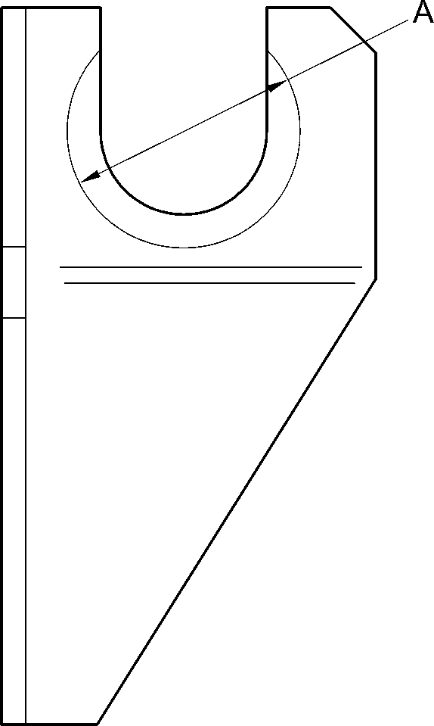
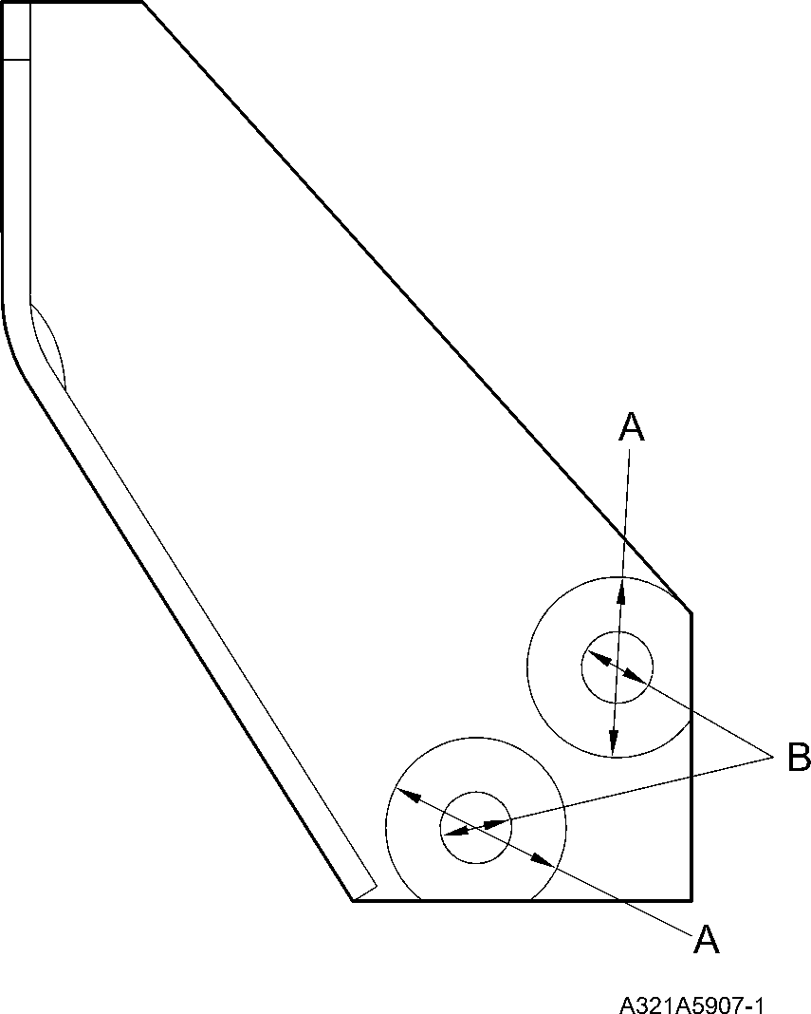
Bracket (2-120 and 2-130) - Protective Treatment
Figure 601
32-12-22
Page 622
Mar 18/2025

SAFRAN LANDING SYSTEMS UK Ltd
CAGE: K0654

PART No. 201587001 AND 201587002 COMPONENT MAINTENANCE MANUAL
MAIN LANDING GEAR LEG
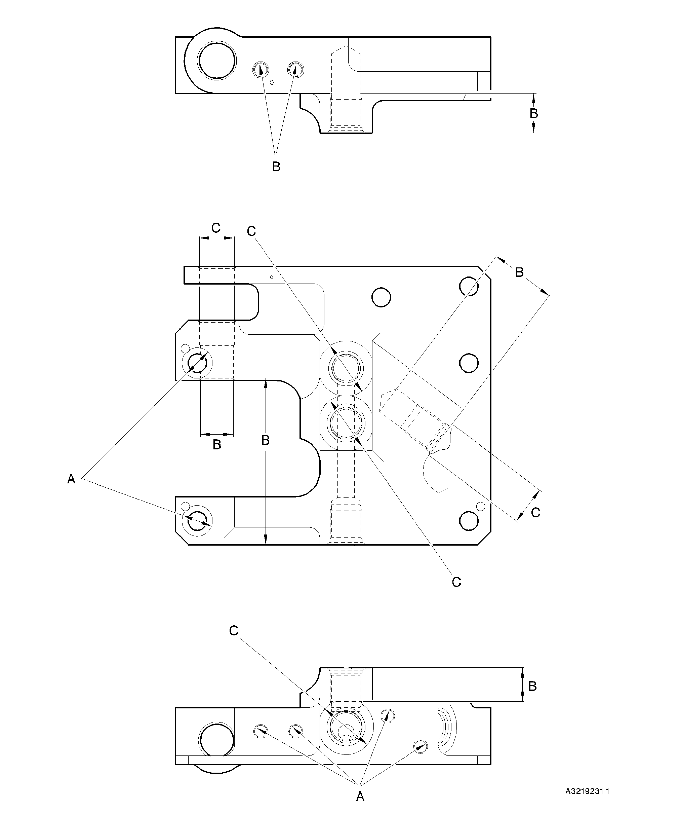
Transfer Block (2-340, 2-340A, 2-350 and 2-350A) - Protective Treatment
Figure 602
32-12-22
Page 623
Mar 18/2025

SAFRAN LANDING SYSTEMS UK Ltd
CAGE: K0654

PART No. 201587001 AND 201587002 COMPONENT MAINTENANCE MANUAL
MAIN LANDING GEAR LEG
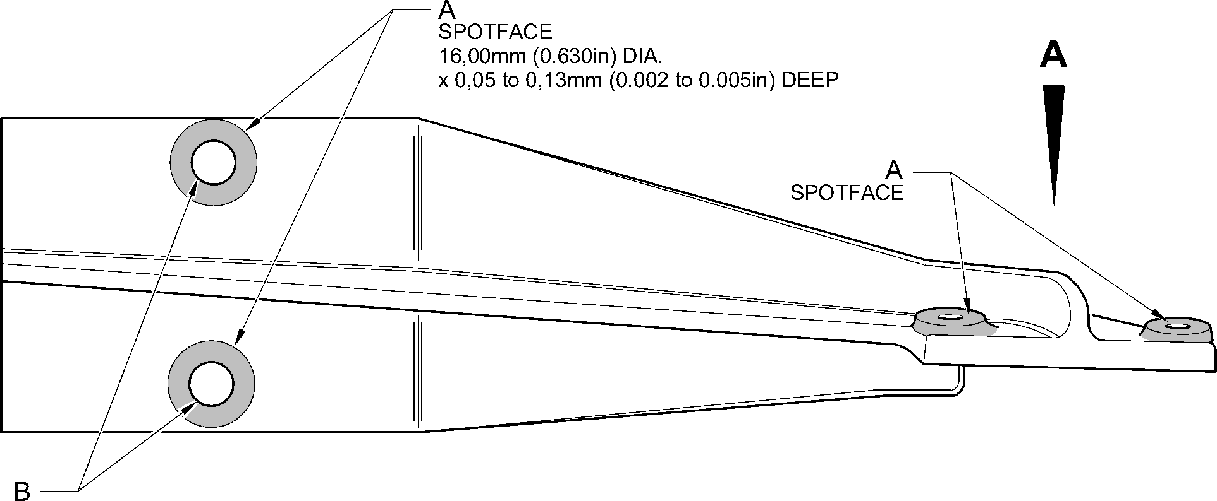
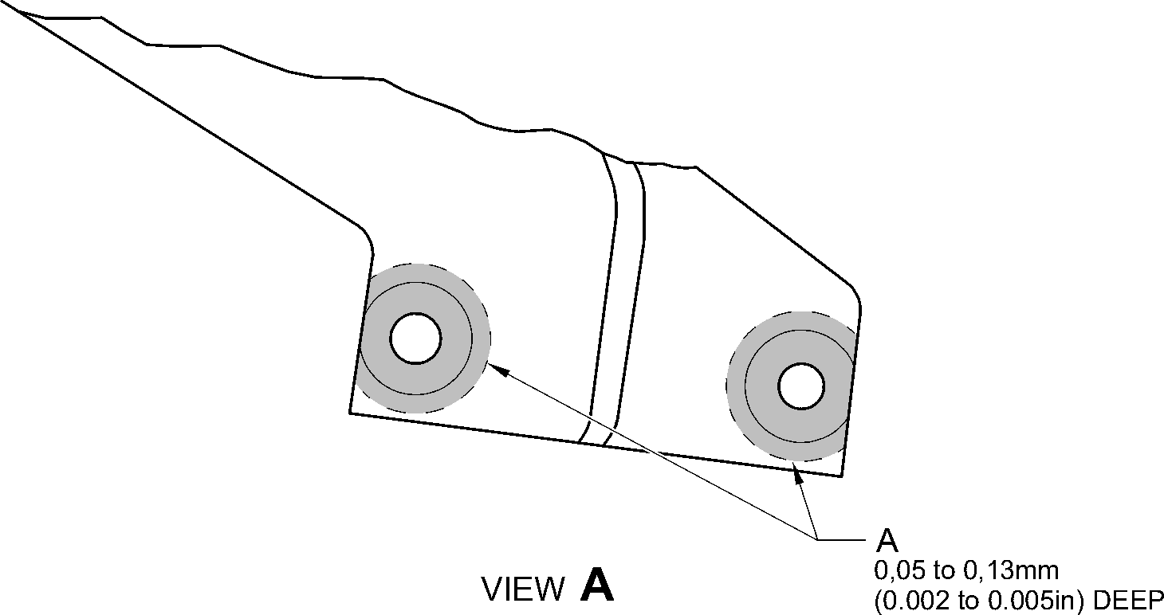
A321-S-32-12-22-096-0
Bracket (4-140 and 4-150) - Protective Treatment
Figure 603
32-12-22
Page 624
Mar 18/2025

SAFRAN LANDING SYSTEMS UK Ltd
CAGE: K0654

PART No. 201587001 AND 201587002 COMPONENT MAINTENANCE MANUAL
MAIN LANDING GEAR LEG
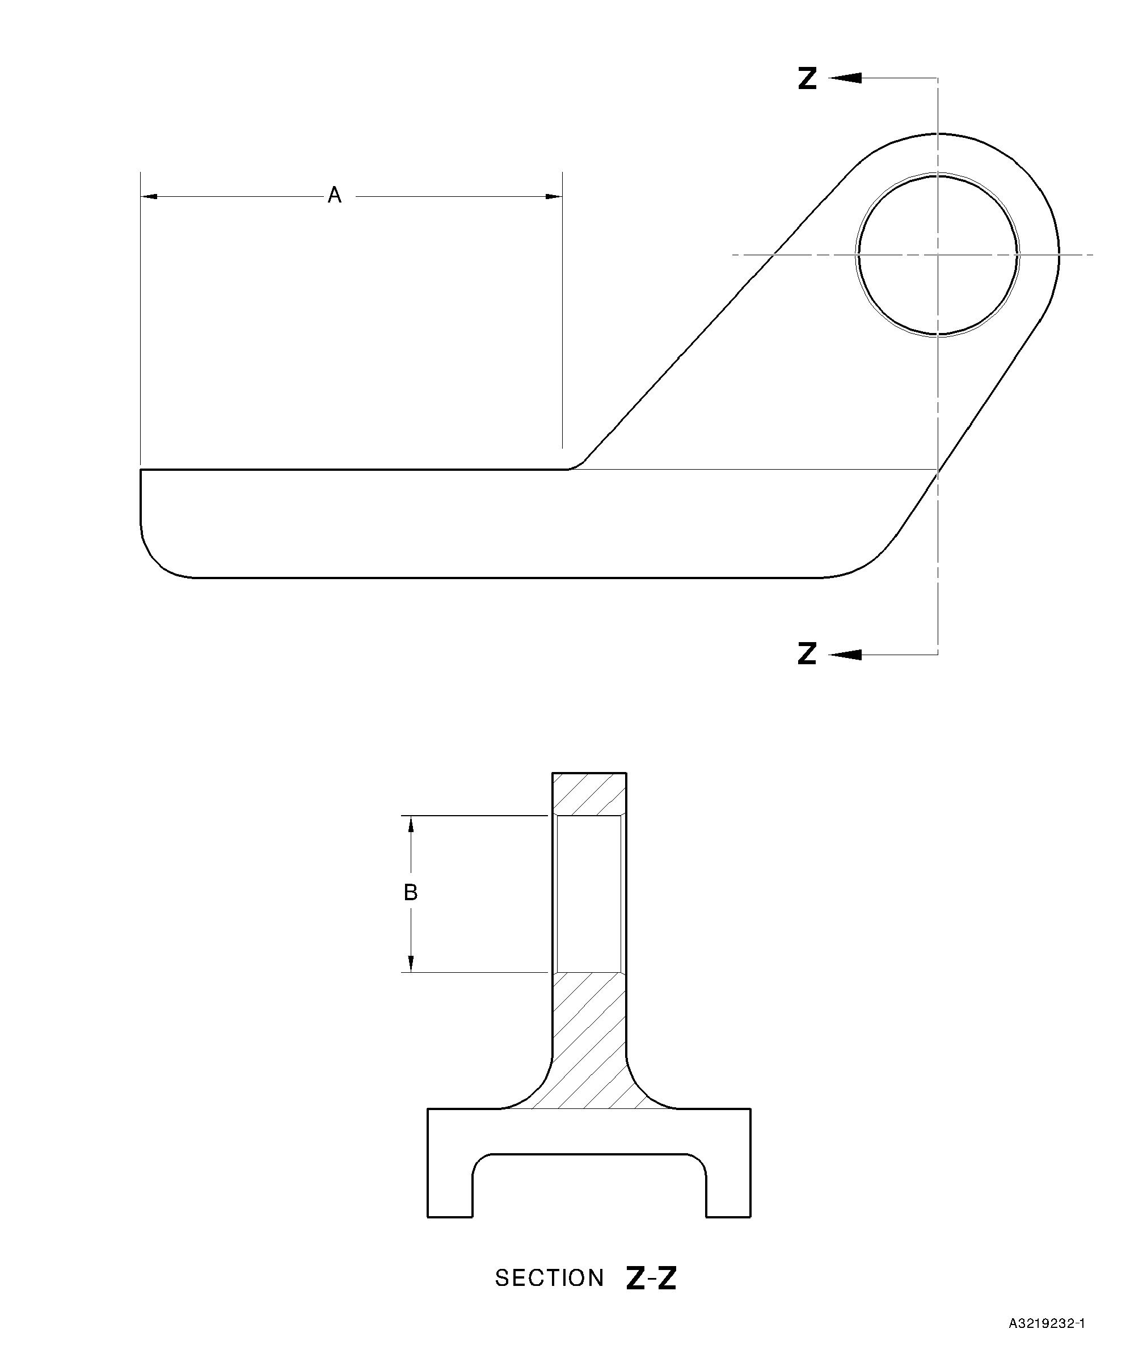
Bracket (5-160) - Protective Treatment
Figure 604
32-12-22
Page 625
Mar 18/2025

SAFRAN LANDING SYSTEMS UK Ltd
CAGE: K0654

PART No. 201587001 AND 201587002 COMPONENT MAINTENANCE MANUAL
MAIN LANDING GEAR LEG
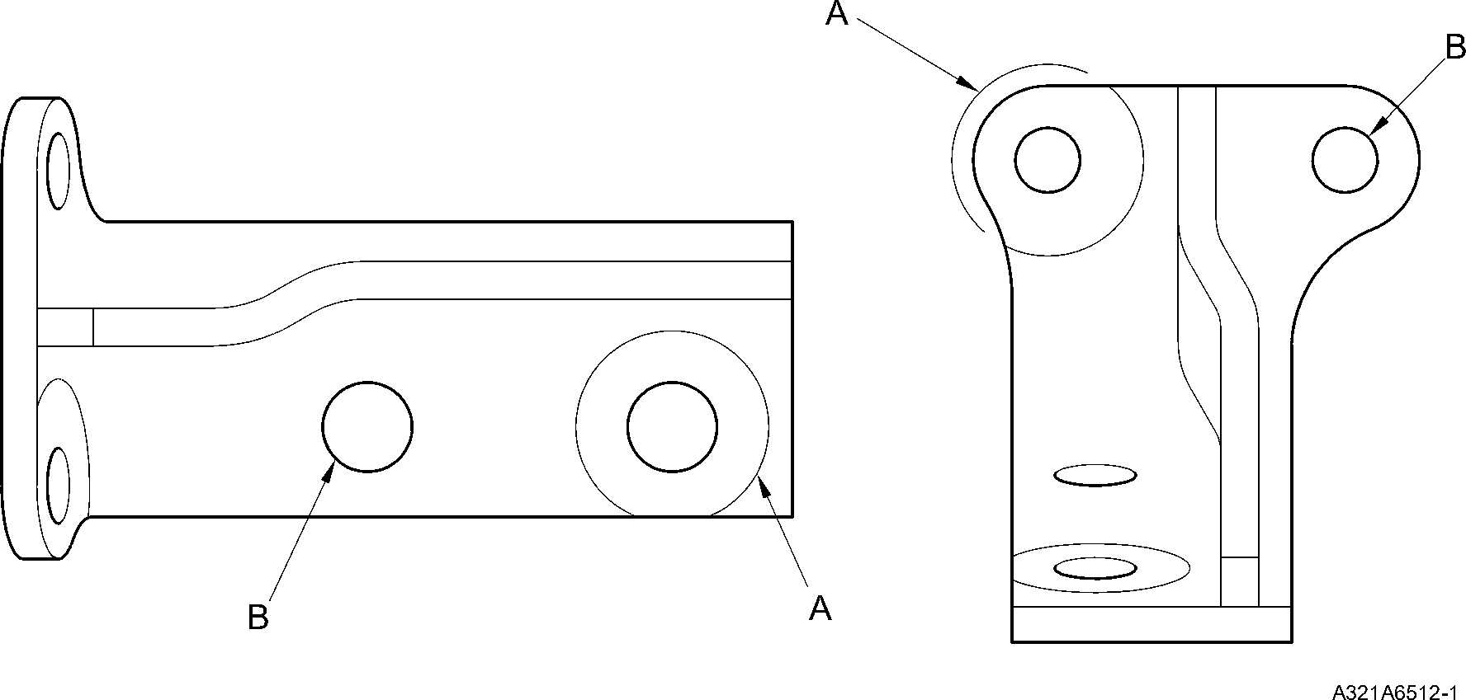
Bracket (6-170 and 6-180) - Protective Treatment
Figure 605
32-12-22
Page 626
Mar 18/2025

SAFRAN LANDING SYSTEMS UK Ltd
CAGE: K0654
PART No. 201587001 AND 201587002 COMPONENT MAINTENANCE MANUAL
MAIN LANDING GEAR LEG
section Z-Z
A
B
B
Z
Z
(BOTH HOLES) 27,00mm
(1.062in)
DIA
27,00mm (1.062in) DIA
(4 PLACES)
(BOTH HOLES)
A321A6405-1
Slave Link (6-230) Only - Protective Treatment
Figure 606
32-12-22
Page 627
Mar 18/2025
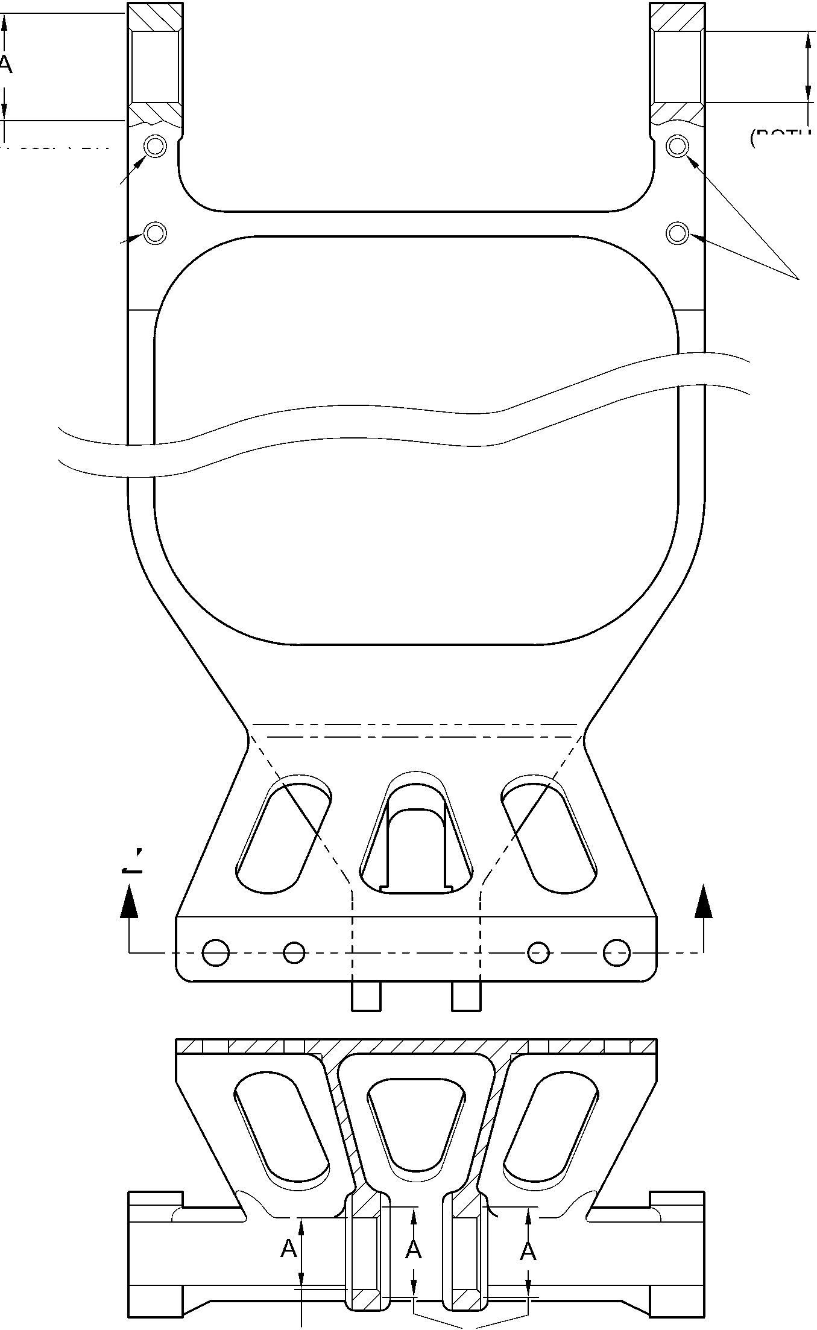

SAFRAN LANDING SYSTEMS UK Ltd
CAGE: K0654

PART No. 201587001 AND 201587002 COMPONENT MAINTENANCE MANUAL
MAIN LANDING GEAR LEG
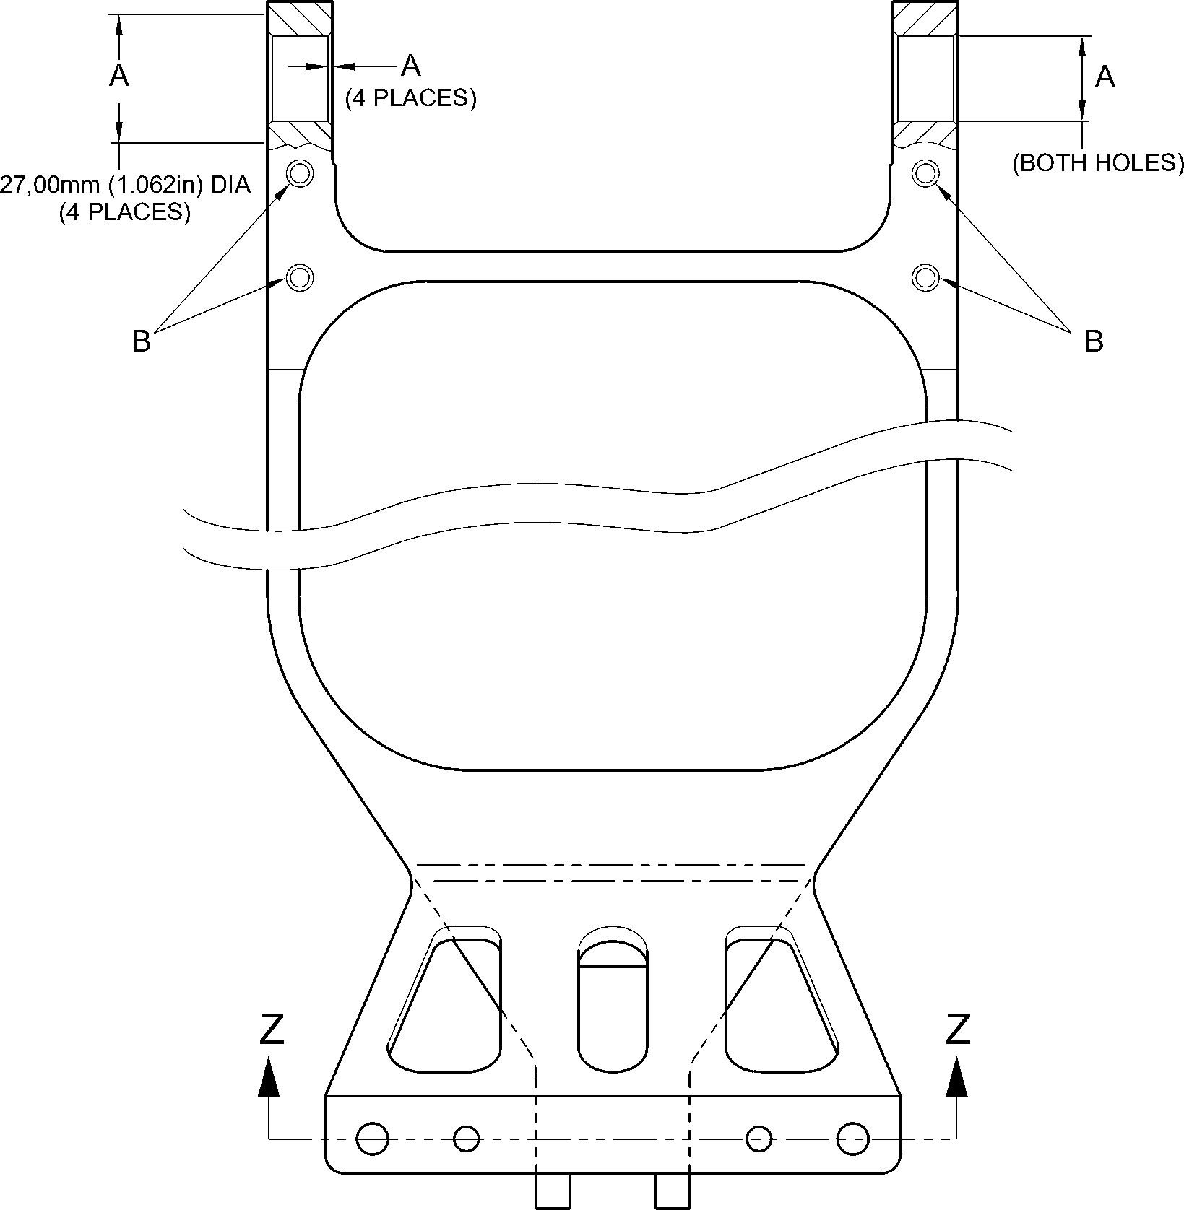
section Z-Z
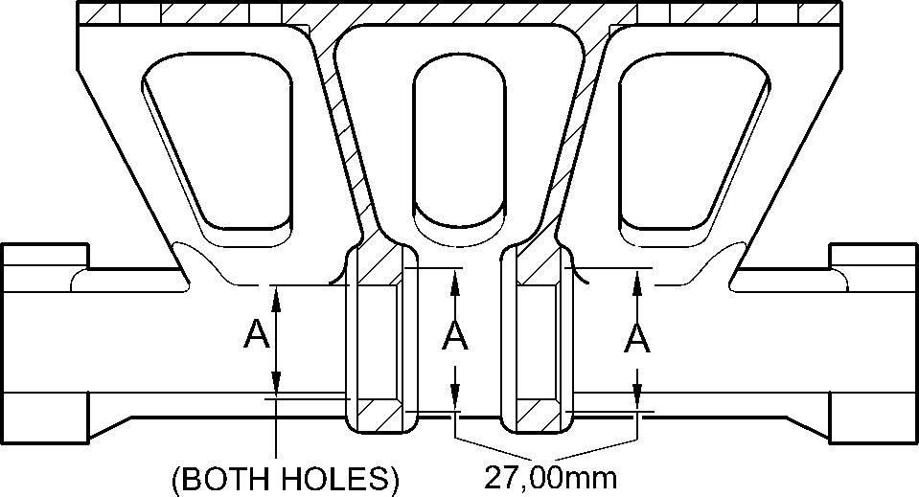
(1.062in)
DIA
A321A6406-1
Slave Link (6-230A) - Protective Treatment
Figure 607
32-12-22
Page 628
Mar 18/2025

SAFRAN LANDING SYSTEMS UK Ltd
CAGE: K0654
PART No. 201587001 AND 201587002 COMPONENT MAINTENANCE MANUAL
MAIN LANDING GEAR LEG
Pin (10-80) - Protective Treatment
Figure 608
32-12-22
Page 629
Mar 18/2025
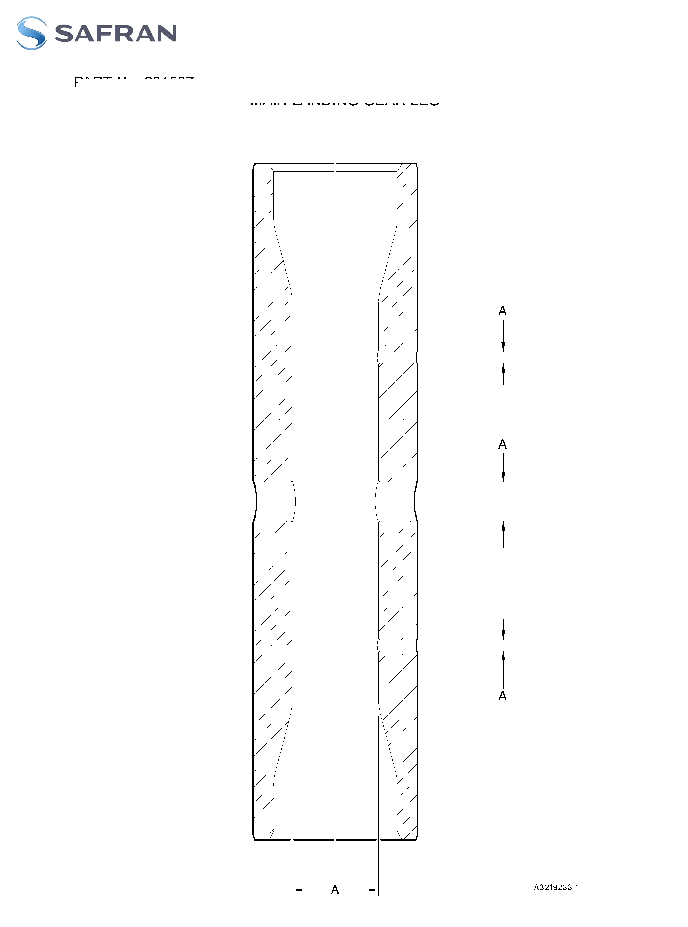

SAFRAN LANDING SYSTEMS UK Ltd
CAGE: K0654

PART No. 201587001 AND 201587002 COMPONENT MAINTENANCE MANUAL
MAIN LANDING GEAR LEG
Figure Deleted
Figure 609
32-12-22
Page 630
Mar 18/2025

SAFRAN LANDING SYSTEMS UK Ltd
CAGE: K0654

PART No. 201587001 AND 201587002 COMPONENT MAINTENANCE MANUAL
MAIN LANDING GEAR LEG
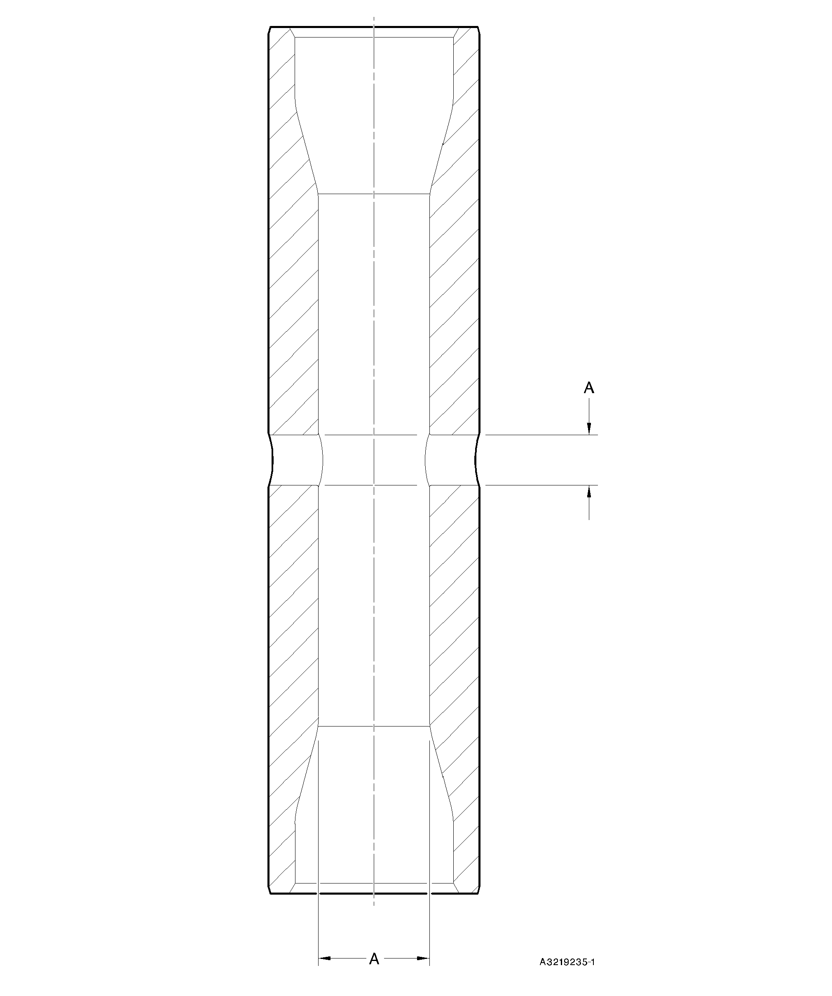
Pin (11-130) - Protective Treatment
Figure 610
32-12-22
Page 631
Mar 18/2025

SAFRAN LANDING SYSTEMS UK Ltd
CAGE: K0654

PART No. 201587001 AND 201587002 COMPONENT MAINTENANCE MANUAL
MAIN LANDING GEAR LEG
Figure Deleted
Figure 611
32-12-22
Page 632
Mar 18/2025

SAFRAN LANDING SYSTEMS UK Ltd
CAGE: K0654

PART No. 201587001 AND 201587002 COMPONENT MAINTENANCE MANUAL
MAIN LANDING GEAR LEG
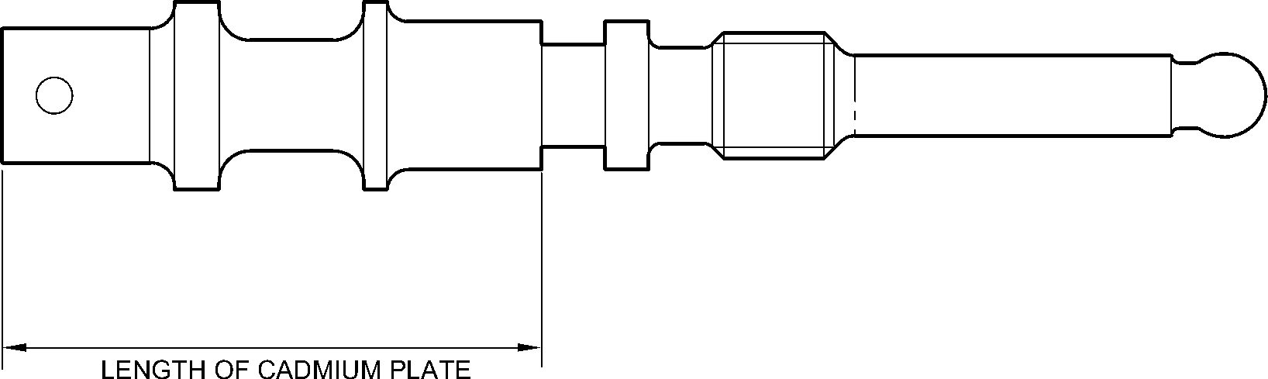
A321A4849-1
Valve Stem (12-90) - Protective Treatment
Figure 612
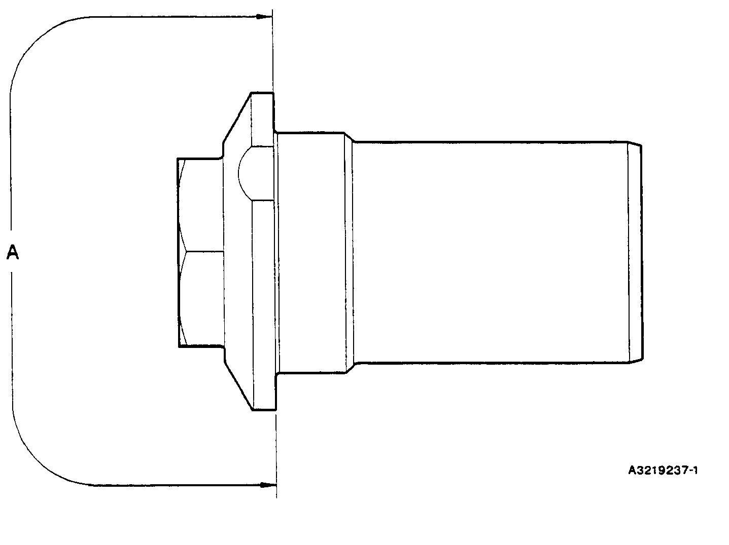
Retaining Pin (13-10) - Protective Treatment
Figure 613
32-12-22
Page 633
Mar 18/2025

SAFRAN LANDING SYSTEMS UK Ltd
CAGE: K0654

PART No. 201587001 AND 201587002 COMPONENT MAINTENANCE MANUAL
MAIN LANDING GEAR LEG
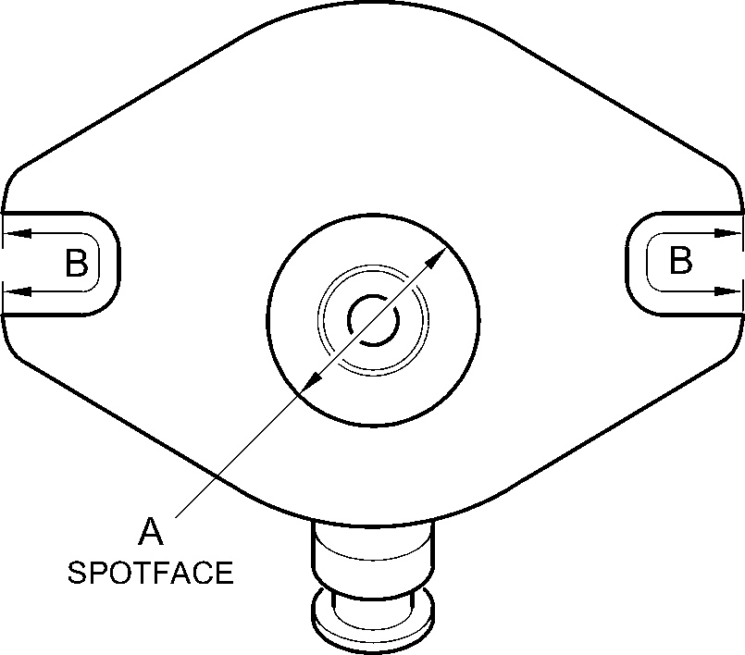
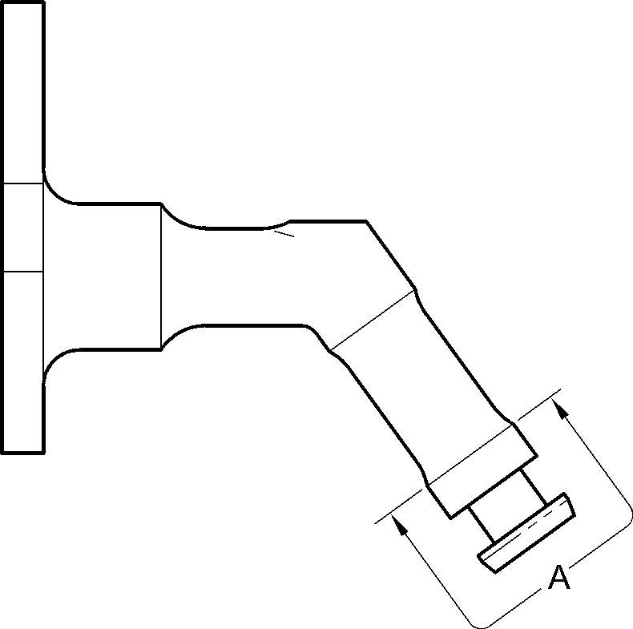
A321A4850-2
Inflation Valve (13-110 and 13-110A) - Protective Treatment
Figure 614
32-12-22
Page 634
Mar 18/2025

SAFRAN LANDING SYSTEMS UK Ltd
CAGE: K0654

PART No. 201587001 AND 201587002 COMPONENT MAINTENANCE MANUAL
MAIN LANDING GEAR LEG
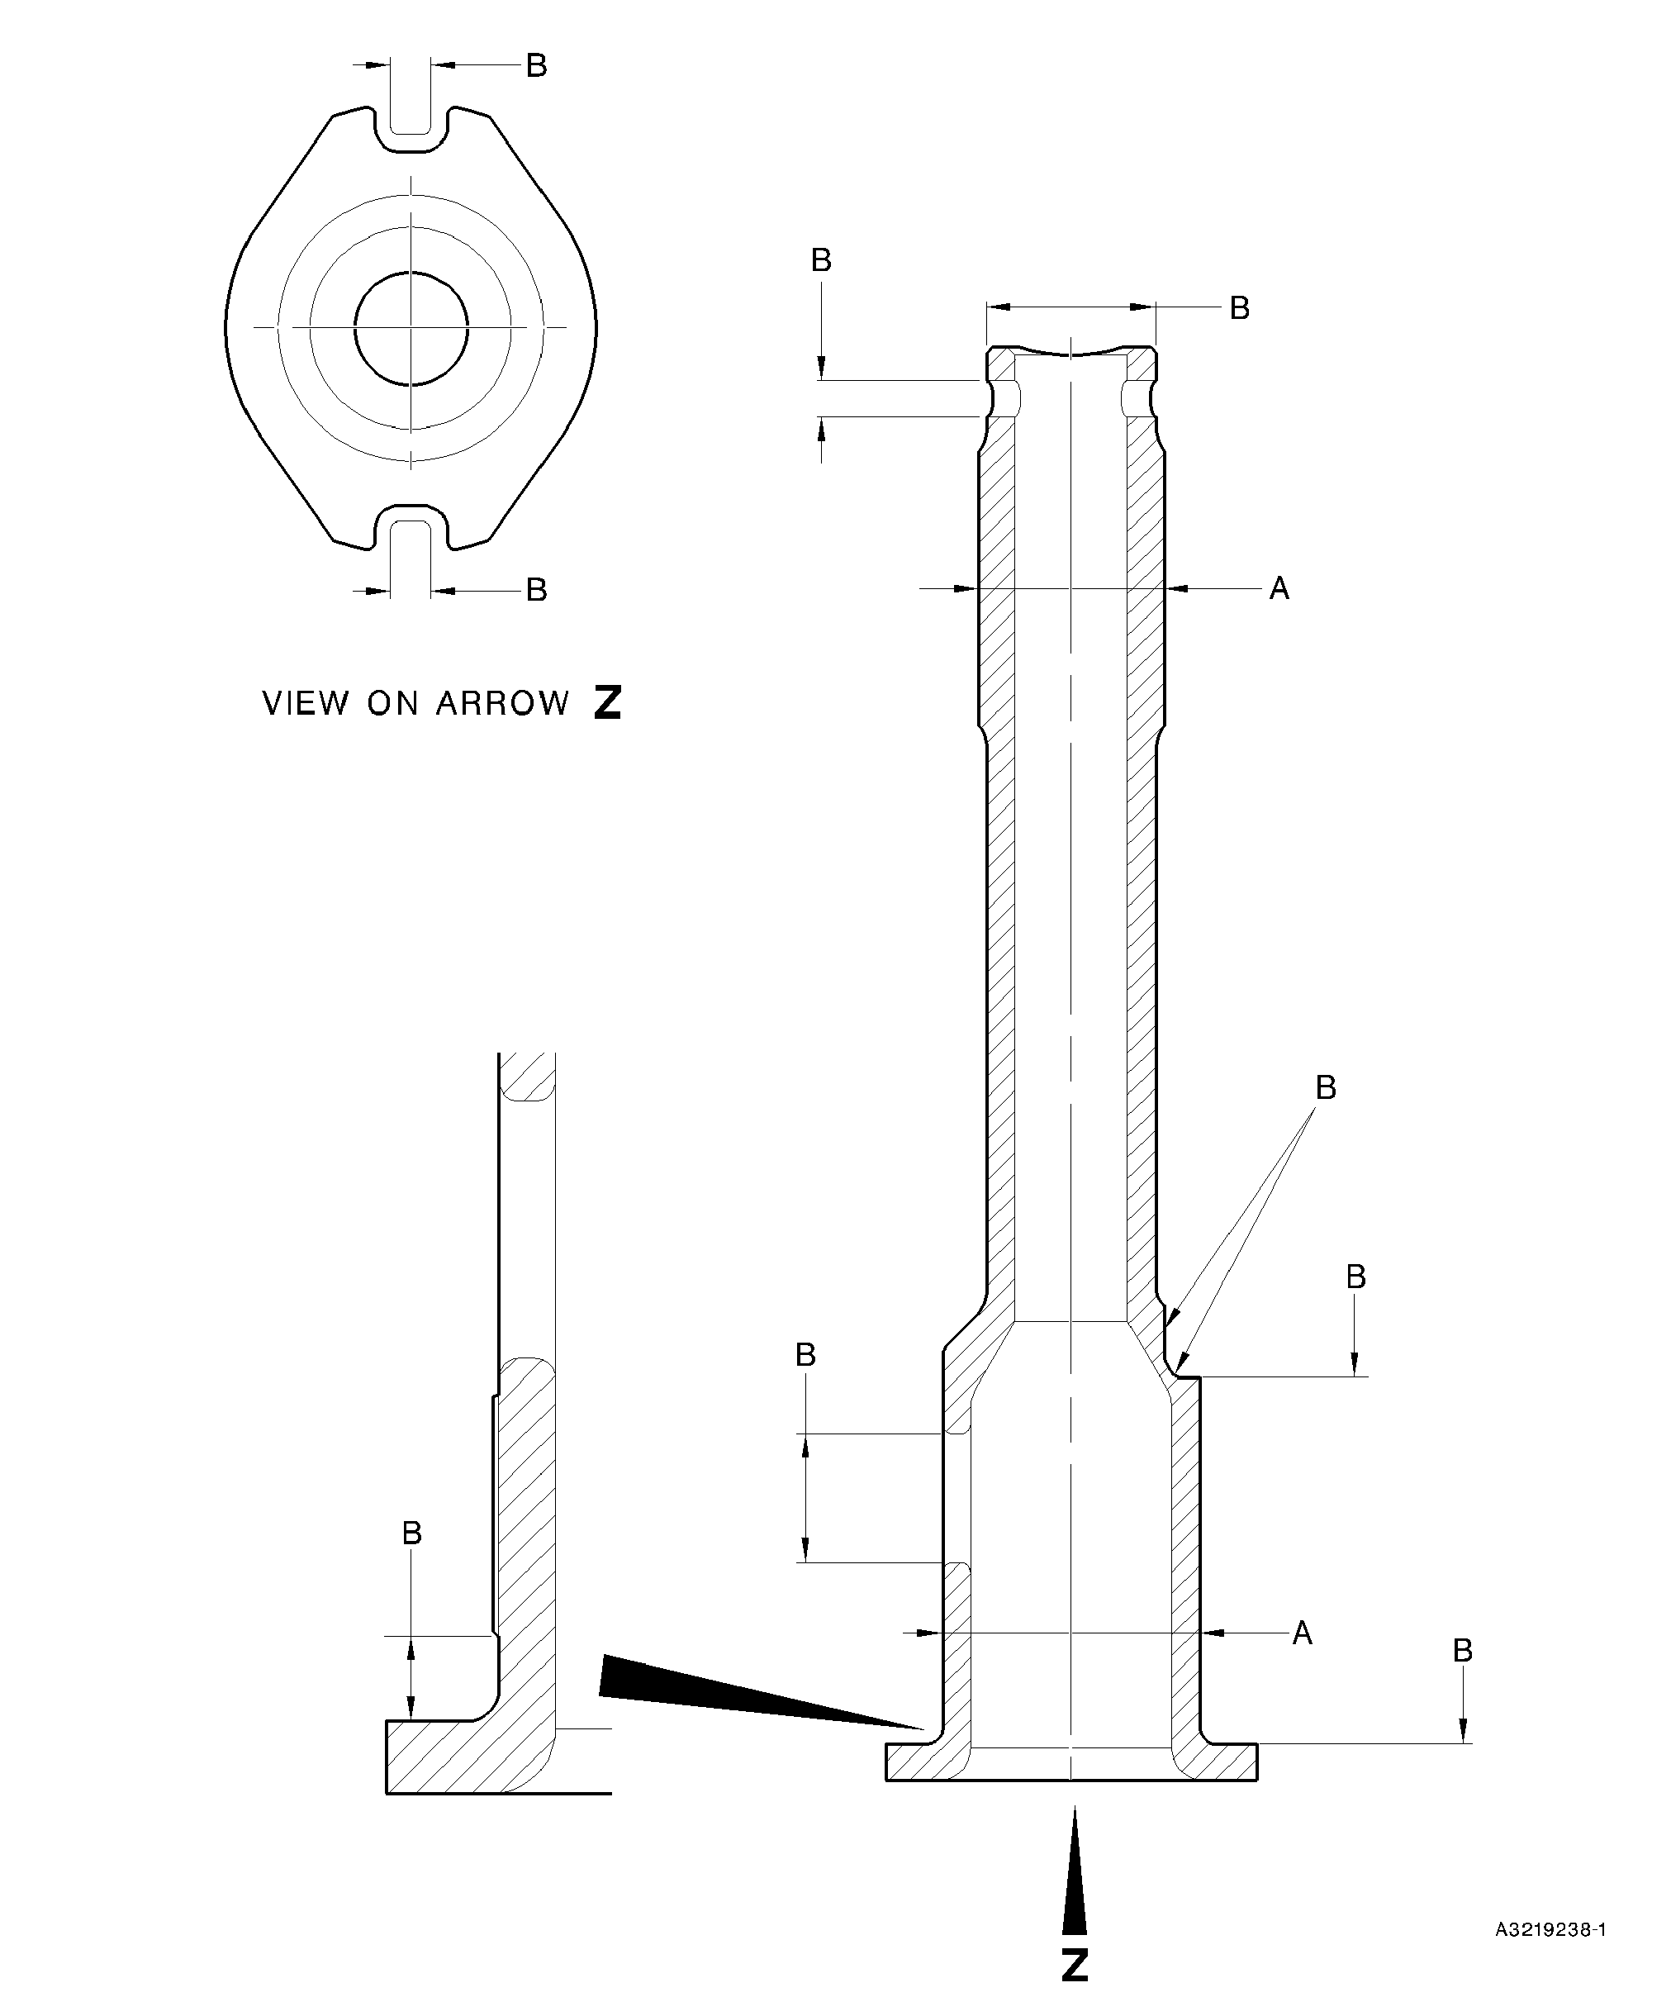
Pin (13-190 and 13-190A) - Protective Treatment
Figure 615
32-12-22
Page 635
Mar 18/2025

SAFRAN LANDING SYSTEMS UK Ltd
CAGE: K0654

PART No. 201587001 AND 201587002 COMPONENT MAINTENANCE MANUAL
MAIN LANDING GEAR LEG
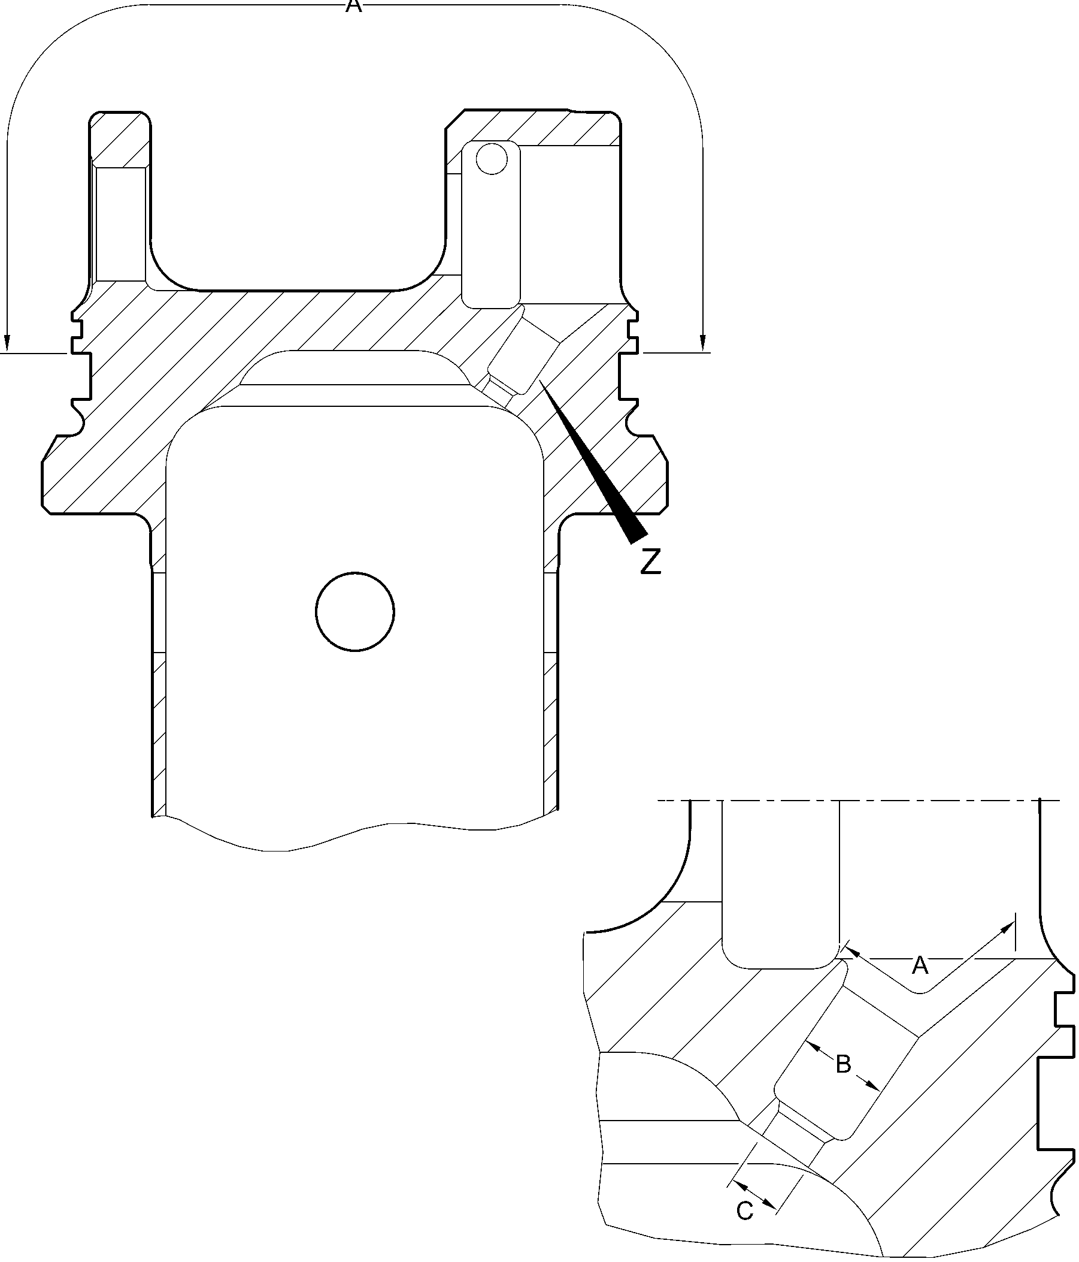
detail Z
A321A3758-1
Upper Diaphragm Tube (15-390) - Protective Treatment
Figure 616
32-12-22
Page 636
Mar 18/2025

SAFRAN LANDING SYSTEMS UK Ltd
CAGE: K0654

PART No. 201587001 AND 201587002 COMPONENT MAINTENANCE MANUAL
MAIN LANDING GEAR LEG
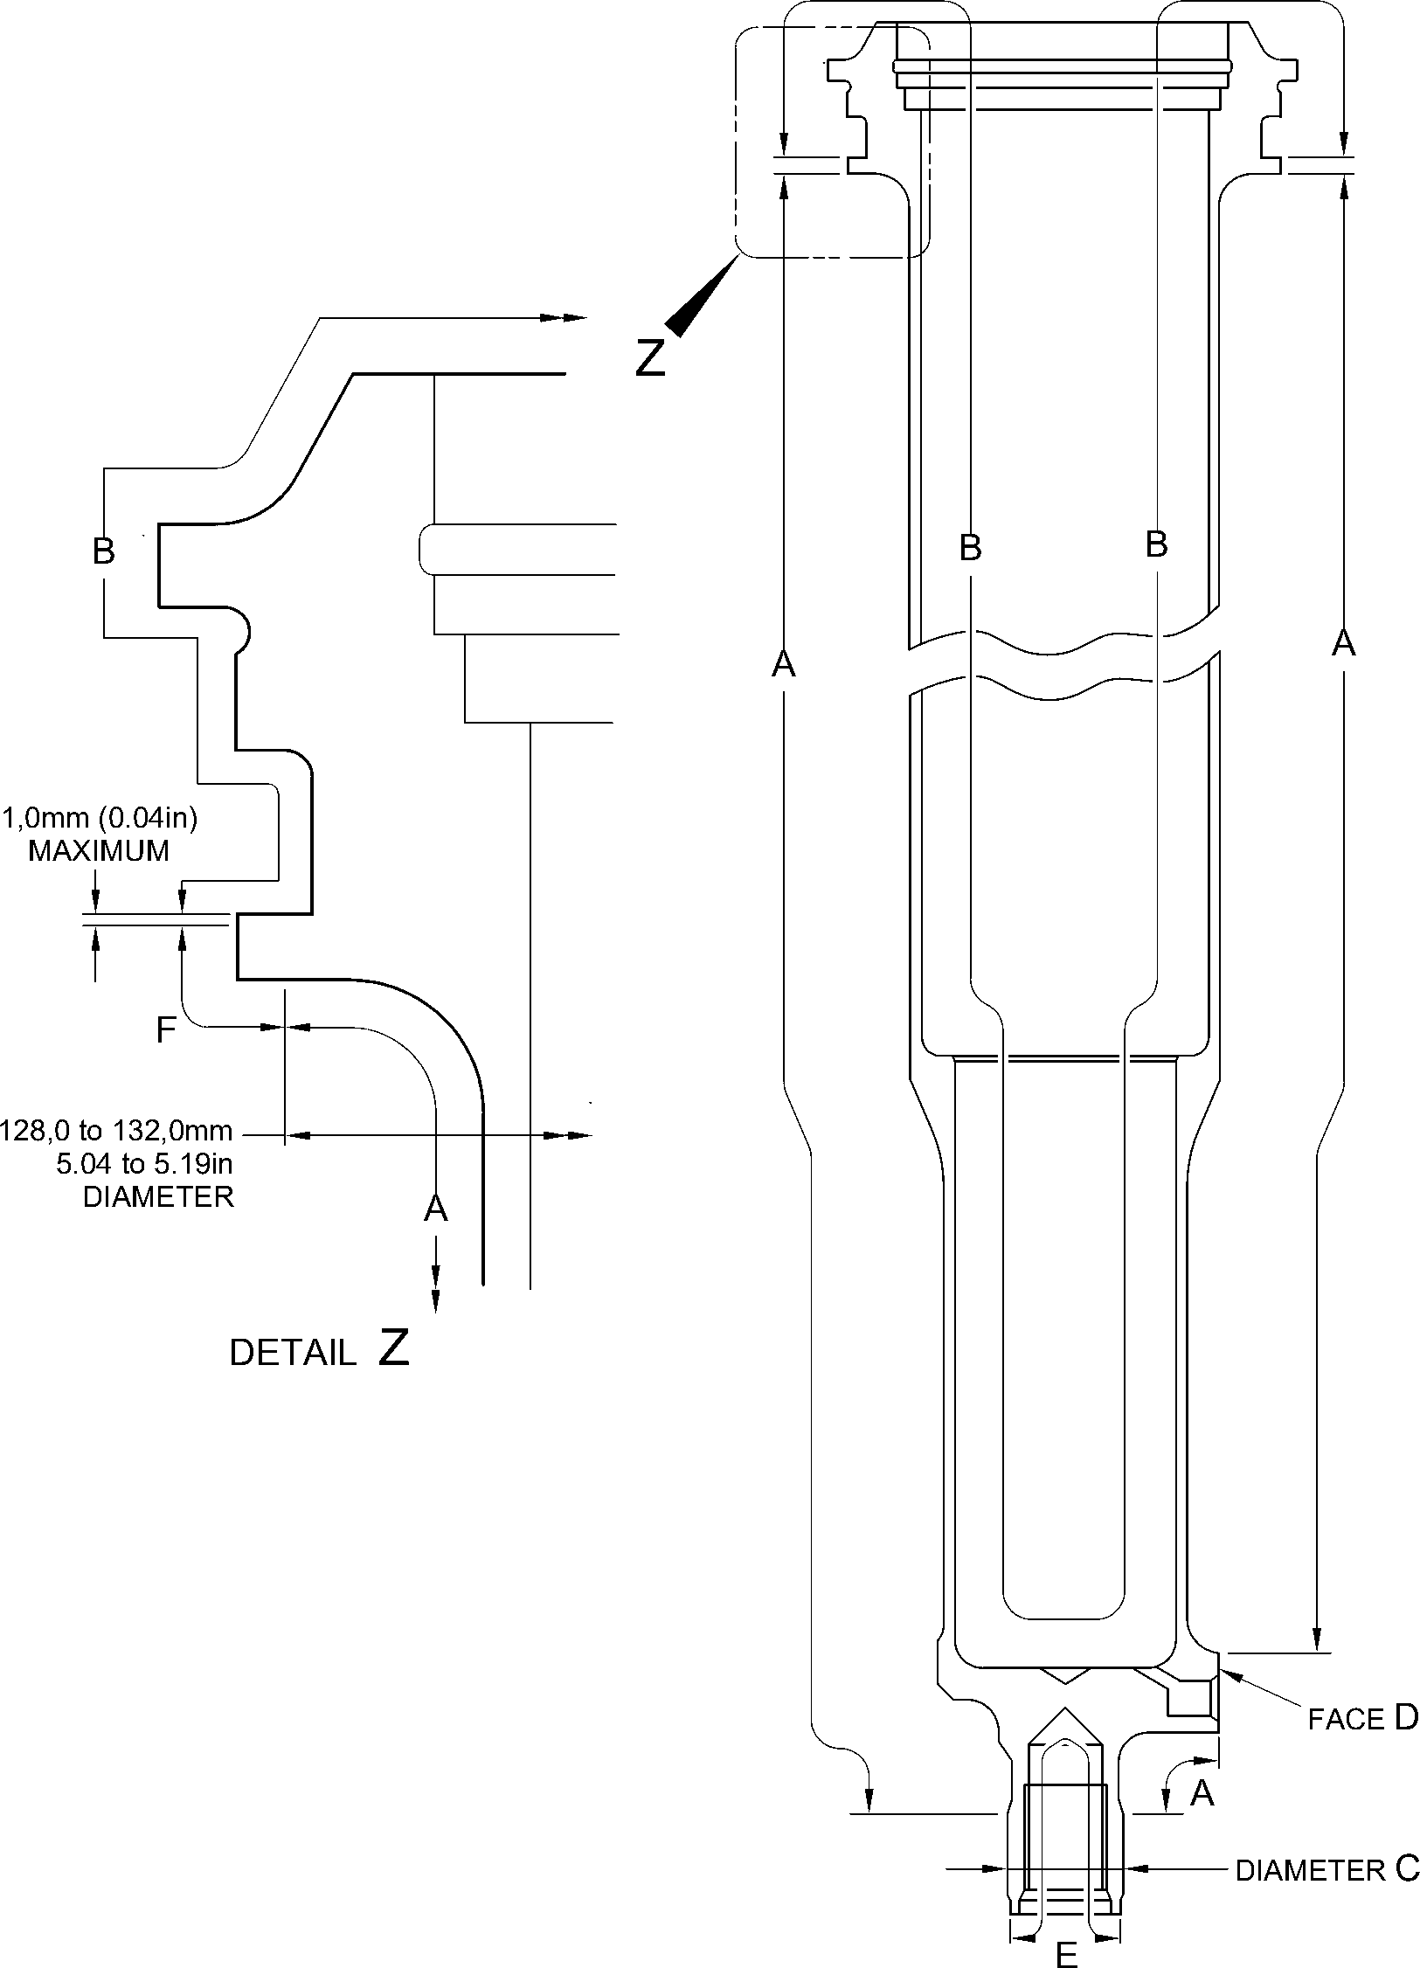
A321A5553-1
Cylinder (17-230) - Protective Treatment
Figure 617
32-12-22
Page 637
Mar 18/2025

SAFRAN LANDING SYSTEMS UK Ltd
CAGE: K0654

PART No. 201587001 AND 201587002 COMPONENT MAINTENANCE MANUAL
MAIN LANDING GEAR LEG
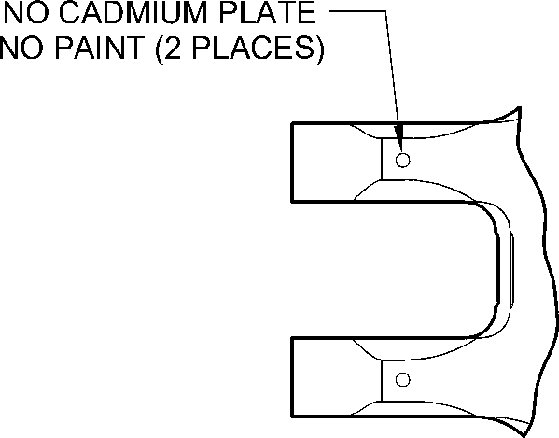
NO CADMIUM PLATE
NO PAINT
IN HOLES (Qty 6)
NO CADMIUM PLATE
NO PAINT
(2 PLACES)
VIEW W
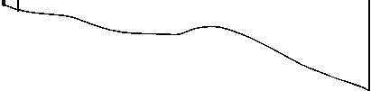
Z-Z
Z
NO CADMIUM PLATE
NO PAINT
NO PAINT
39,00 to 40,00mm
(1.535 to 1.575in) DIA.
NO PAINT
80,00 to 81,00mm
(3.150 to 3.188in) DIA.
NO PAINT
NO PAINT
SECTION
Z
VIEW V
W
PAINT TO
PCS-2500
UP TO BUSH
FLANGES
NO PAINT
(Qty 24)
PRIMER PAINT TO PCS-2500
6,50 to 6,70mm (0.256 to 0.263in) DIA. for (18-80)
6,60 to 6,80mm (0.259 to 0.268in) DIA. for (18-80A)
(4 PLACES)
NO PAINT
80,00 to 81,00mm
(3.150 to 3.188in) DIA.
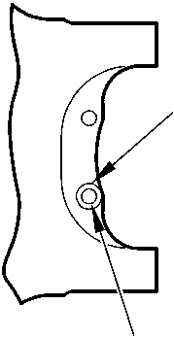
NO PAINT
13,00mm
(0.512in) DIA.
NO PAINT
39,00 to 40,00mm
(1.535 to 1.575in) DIA.
A321-S-32-12-22-088-0
Sliding Tube (18-80) or (18-80A) - Protective Treatment
Figure 618 - Sheet 1
32-12-22
Page 638
Mar 18/2025
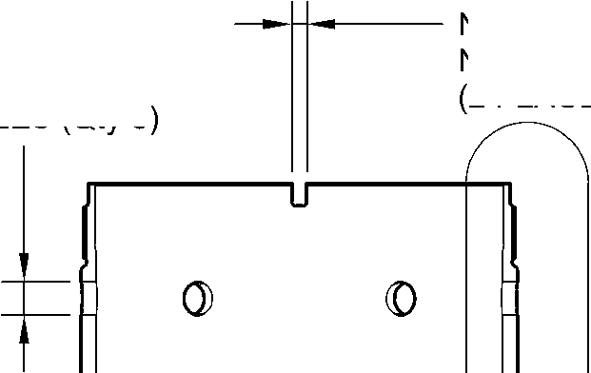
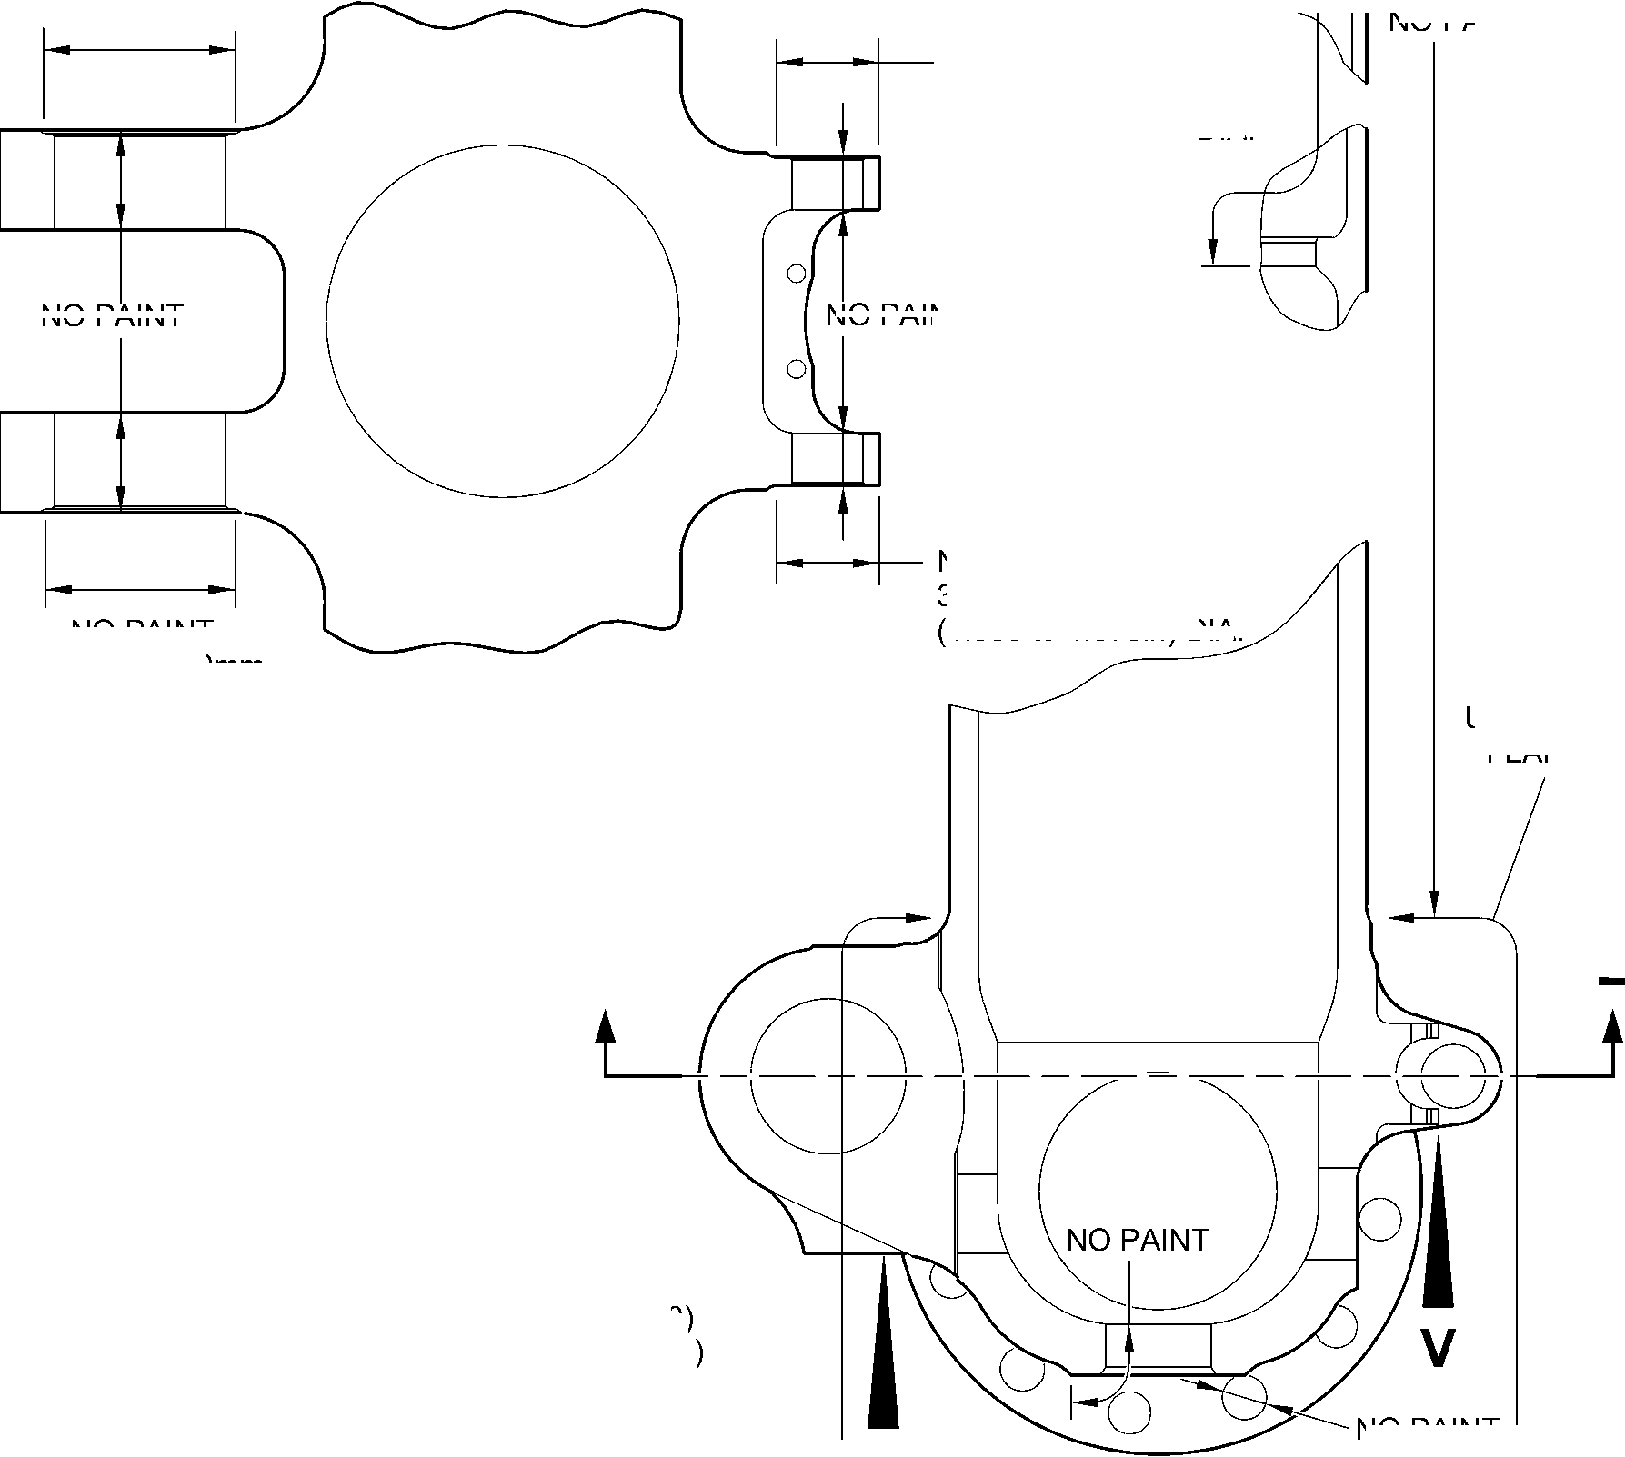

SAFRAN LANDING SYSTEMS UK Ltd
CAGE: K0654

PART No. 201587001 AND 201587002 COMPONENT MAINTENANCE MANUAL
MAIN LANDING GEAR LEG
PRIMER PAINT TO PCS-2500
OVER SERMETEL W TO LENGTH
305,00mm (12.000in) for (18-80)
220,00mm (8.661in) for (18-80A)
SERMETEL W
TO
IFC 40-860-03MD
0
©
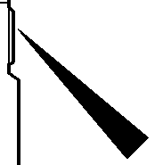
B
SERMETEL W
TO
IFC 40-860-03MD
PAINT TO
PCS-2500
DETAIL B
NOTE:-
SERMETEL W ON INTERNAL
DIAMETER OVER LENGTH A
TO IFC 40-860-03MD
A
SERMETEL W
TO
IFC 40-860-03MD
PRIMER PAINT TO
PCS-2500
29,50 to 30,50mm
(1.161 to 1.200in) DIA.
SPOTFACE (Qty. 24)
SERMETEL W
TO
IFC 40-860-03MD
CHROMIUM
PLATE
0 to 2,00mm
(0 to 0.078in)
RUNOUT
(BOTH SIDES)
SERMETEL W
TO
IFC 40-860-03MD
149,90mm (5.901in)
DIAMETER
SERMETEL W
TO IFC 40-860-03MD
160,00mm (6.299in)
DIAMETER
0 to 2,00mm
(0 to 0.078in)
RUNOUT
(BOTH SIDES)
LIMIT OF SERMETEL W
TERMINATION FROM CENTER
84,00 to 96,00mm
(3.307 to 3.779in)
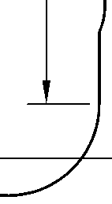

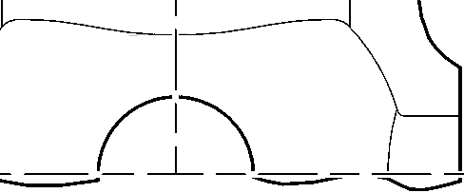
CENTERLINE OF
SLIDING TUBE
SERMETEL W
TO IFC 40-860-03MD
LIMIT OF SERMETEL W
TERMINATION FROM CENTER
95,50 TO 107,50MM
(3.759 TO 4.232IN)
A321-S-32-12-22-089-0
Sliding Tube (18-80) or (18-80A) - Protective Treatment
Figure 618 - Sheet 2
32-12-22
Page 639
Mar 18/2025
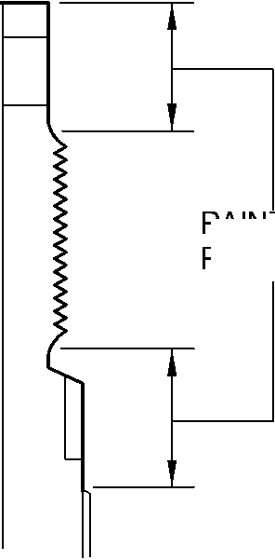
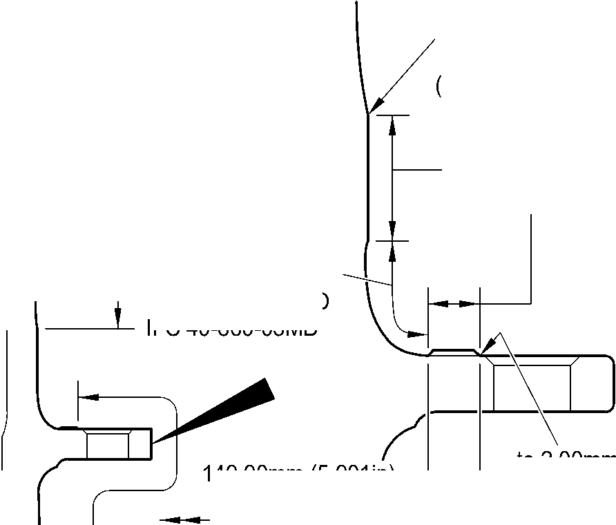

SAFRAN LANDING SYSTEMS UK Ltd
CAGE: K0654
PART No. 201587001 AND 201587002 COMPONENT MAINTENANCE MANUAL
MAIN LANDING GEAR LEG
M
N
W
W
W
X
Z
B
INTERNALLY
W
U
DETAIL U
Q
W
S
Y
VIEW Y
A
PLACES
W
V
2 PLACES
22,00mm (0.866in) DIA.
THIS FACE ONLY
W
W
W
W
DETAIL W
14 PLACES
W
C
INTERNALLY
DETAIL V
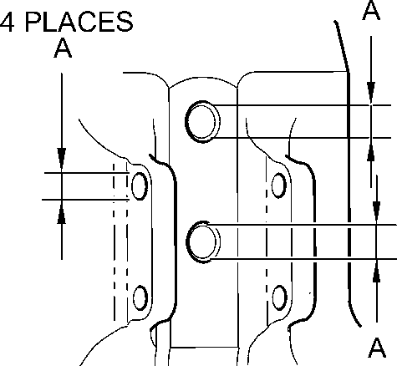
_{A} DETAIL X
4 PLACES
16,0mm
(0,63in) DIA.
THIS FACE
ONLY
FOR ALL SECTION VIEWS SEE SHEET 2
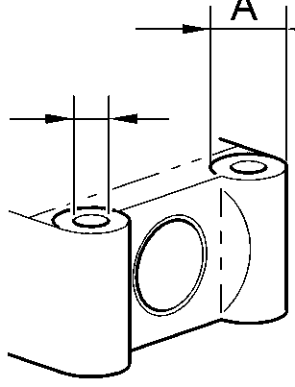
DETAIL Z
T
A321-S-32-12-22-033-1
Main Fitting Subassembly (20-90, 20-90A, 20-100 and 20-100A) - Protective Treatment
Figure 619 - Sheet 1
32
Page 640
⁻12⁻22 Mar 18/2025
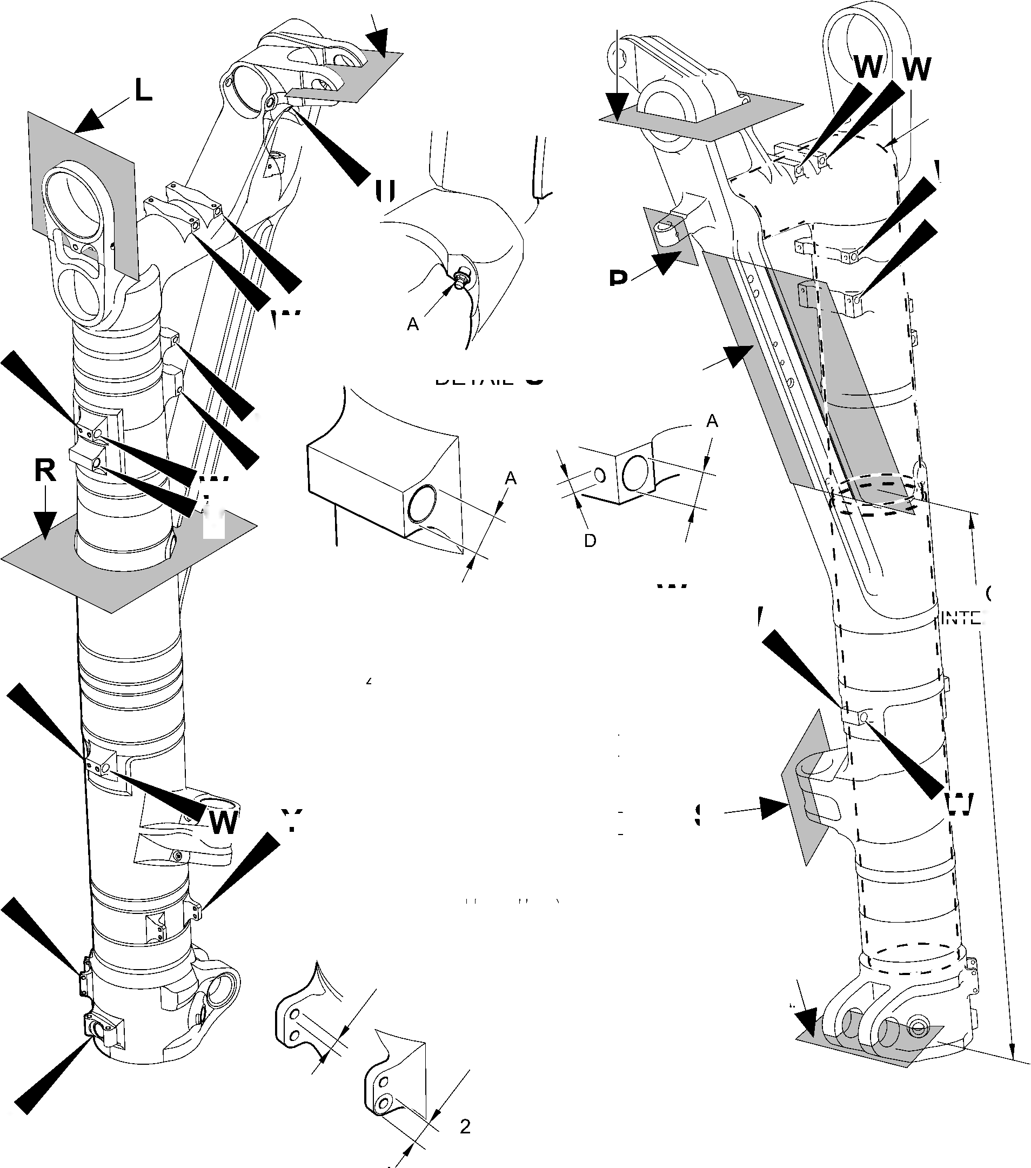

SAFRAN LANDING SYSTEMS UK Ltd
CAGE: K0654
PART No. 201587001 AND 201587002 COMPONENT MAINTENANCE MANUAL
MAIN LANDING GEAR LEG
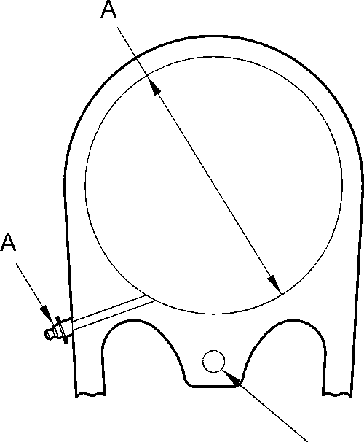
SECTION L
M
A
3 PLACES
A
SECTION
SECTION N
P
SECTION
SECTION R
SECTION Q
SECTION S
SECTION T
A321-S-32-12-22-087-0
A
Main Fitting Subassembly (20-90, 20-90A, 20-100 and 20-100A) - Protective Treatment
Figure 619 - Sheet 2
32-12-22
Page 641
Mar 18/2025
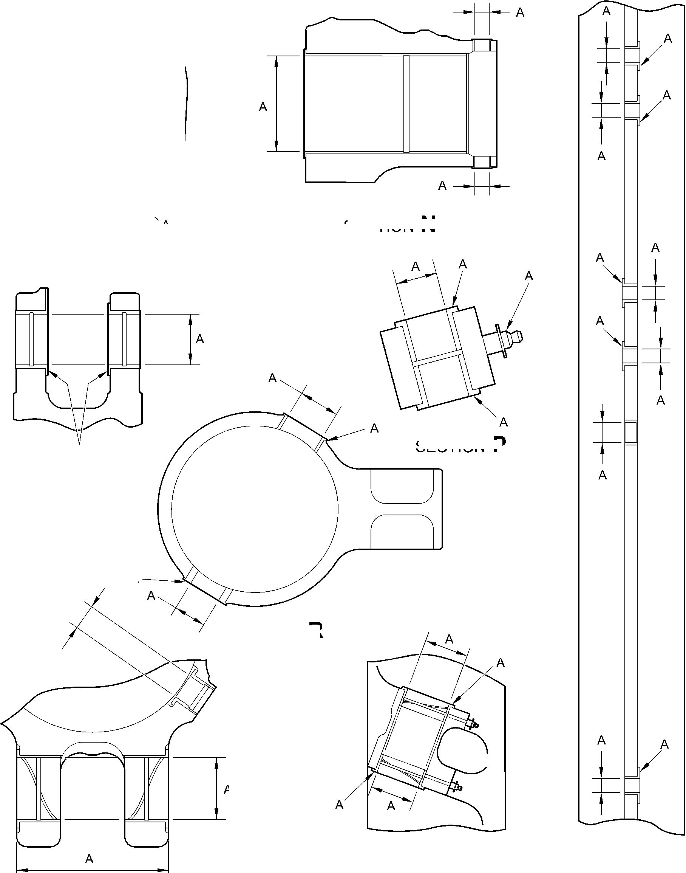

SAFRAN LANDING SYSTEMS UK Ltd
CAGE: K0654

PART No. 201587001 AND 201587002 COMPONENT MAINTENANCE MANUAL
MAIN LANDING GEAR LEG
Z
B (2 hOleS)
B (4 holes)
VIEW ON ARROW
Z
A and B
(INNER DIAMETER)
B (2 hOleS)
C (2 diameters)
A3219241-4
Main Fitting (20-410) and (20-420) - Protective Treatment
Figure 620
32-12-22
Page 642
Mar 18/2025
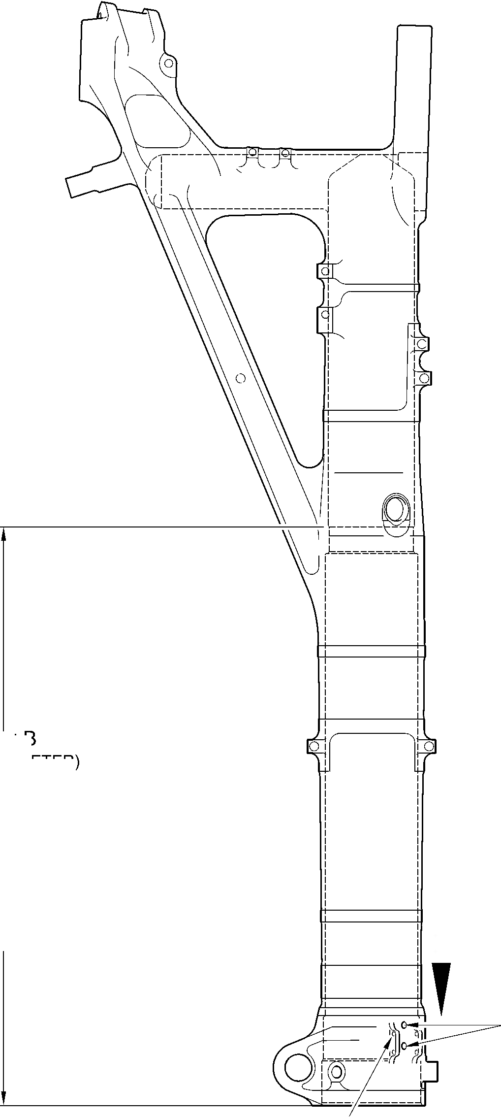
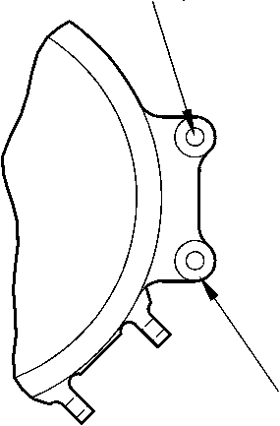

SAFRAN LANDING SYSTEMS UK Ltd
CAGE: K0654
PART No. 201587001 AND 201587002 COMPONENT MAINTENANCE MANUAL
MAIN LANDING GEAR LEG
B
B
(DIAMETER)
B
(HOLE TO DEPTH OF
16,0mm (0.63in)
FROM THIS SURFACE)
B (DIAMETER)
Z
B
B
(CHAMFER)
B (DIAMETER)
B
(DIAMETER)
B
(DIAMETER)
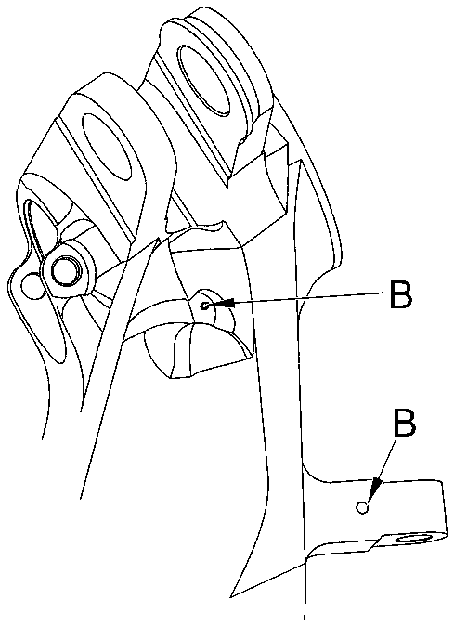
view on arrow Z
B (DIAMETER)
B
(DIAMETER)
B (DIAMETER)
B
(DIAMETER)
B
(DIAMETER)
A321A3506-1
Main Fitting (20-410) and (20-420)- Protective Treatment
Figure 621
32-12-22
Page 643
Mar 18/2025
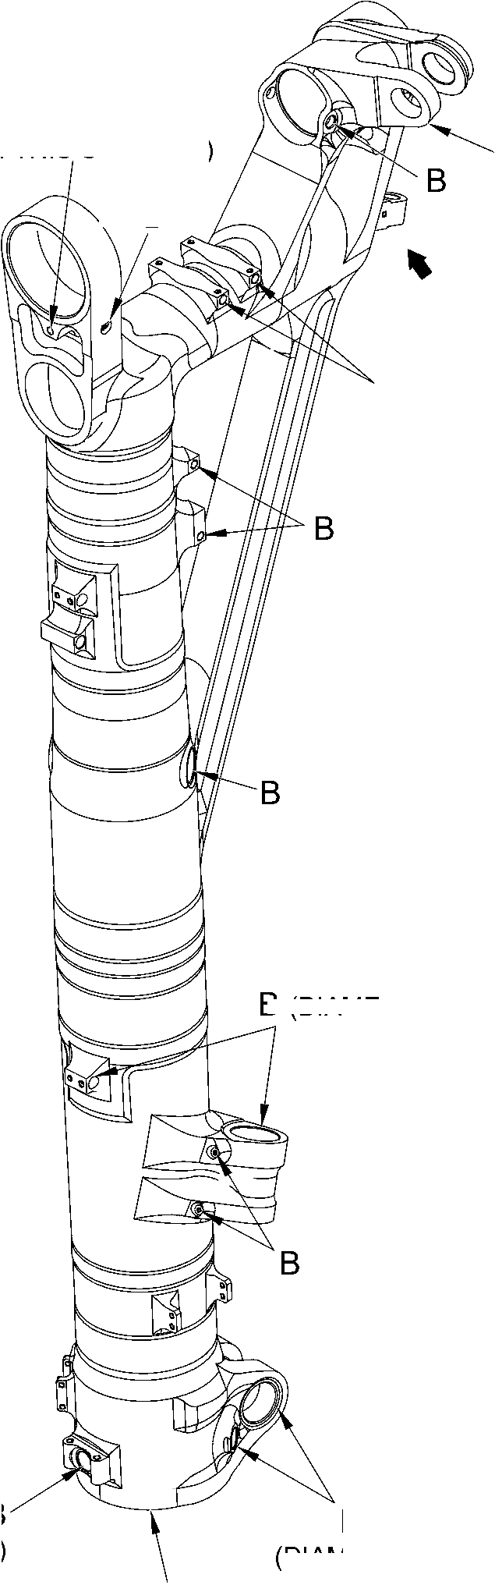
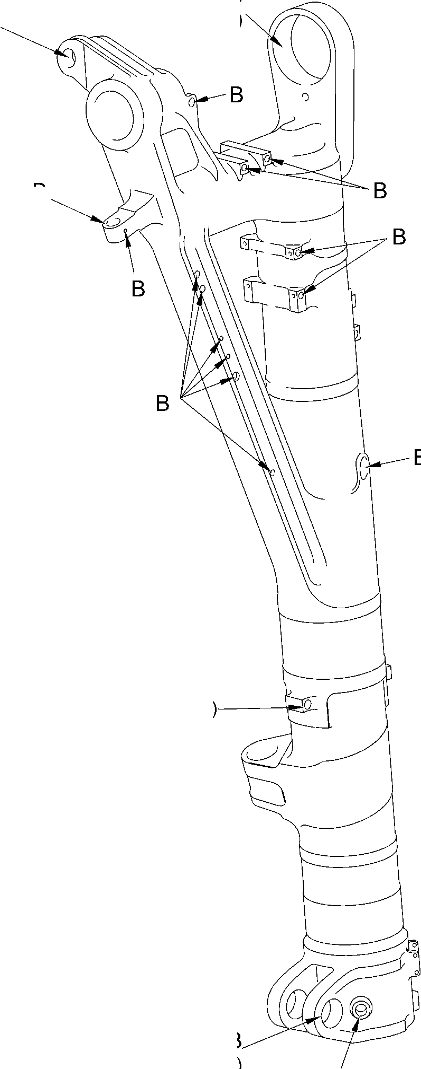

SAFRAN LANDING SYSTEMS UK Ltd
CAGE: K0654
PART No. 201587001 AND 201587002 COMPONENT MAINTENANCE MANUAL
MAIN LANDING GEAR LEG
B INTERNALLY
W
X
U
B
INTERNALLY
C
INTERNALLY
C
16,000mm
(0.6299in)
1 POSITION ONLY
C
19,800 to 20,000mm
0.7795 to 0.7873in) DIA.
SECTION Y-Y
X
A
U
Z
3 BORES
C
section X-X
section U-U
A321-S-32-12-22-085-0
52,000mm
(2.0472in) C
THROUGH DIA.
detail W
TYPICAL 2 PLACES
section Z-Z
C
2 HOLES
9,700 to 10,000mm
(0.3818 to 0.3936in) DIA.
Main Fitting (20-410A) and (20-420A) - Protective Treatment
Figure 622 - Sheet 1
32-12-22
Page 644
Mar 18/2025
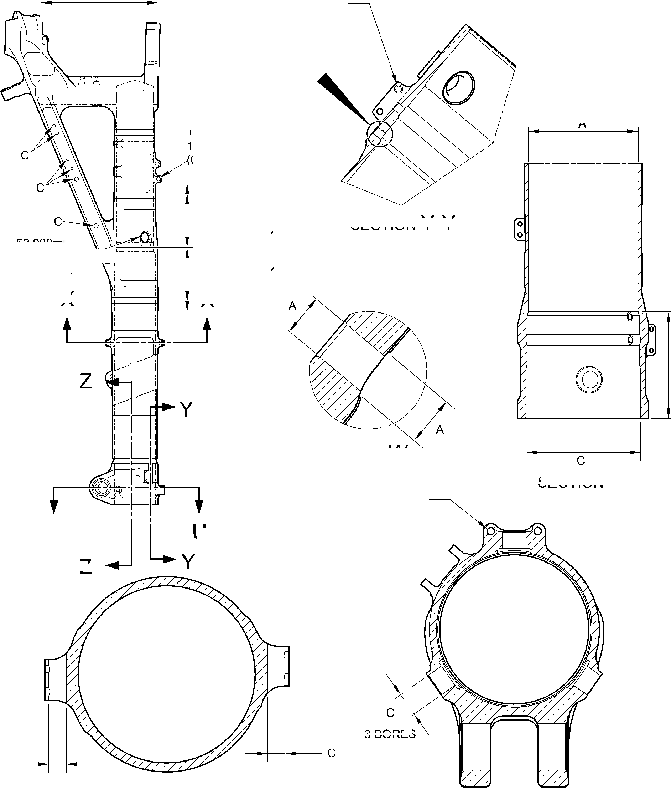

SAFRAN LANDING SYSTEMS UK Ltd
CAGE: K0654
C
22,000mm
(0.8661in) DIA.
2 POSITIONS
IN THIS FACE ONLY
W
SECTION V-V
C
V
SECTION W-W
SECTION Z-Z
U
U
SECTION Y-Y
A321-S-32-12-22-086-0
C
RAD.
4 PLACES
D
4 PLACES
C
TO A DEPTH
OF 16,000mm
(0.6299in)
FROM OUTSIDE
FACE
D
RAD.
4 PLACES
C
4 HOLES
PART No. 201587001 AND 201587002 COMPONENT MAINTENANCE MANUAL
MAIN LANDING GEAR LEG
SECTION U-U

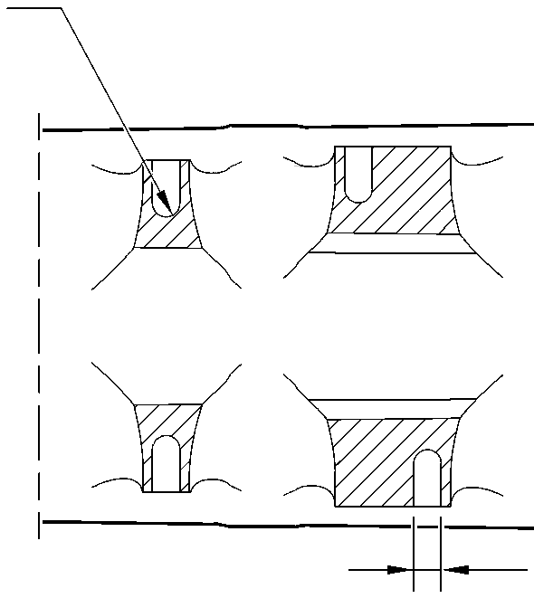
SECTION X-X
Main Fitting (20-410A) and (20-420A) - Protective Treatment
Figure 622 - Sheet 2
32-12-22
Page 645
Mar 18/2025
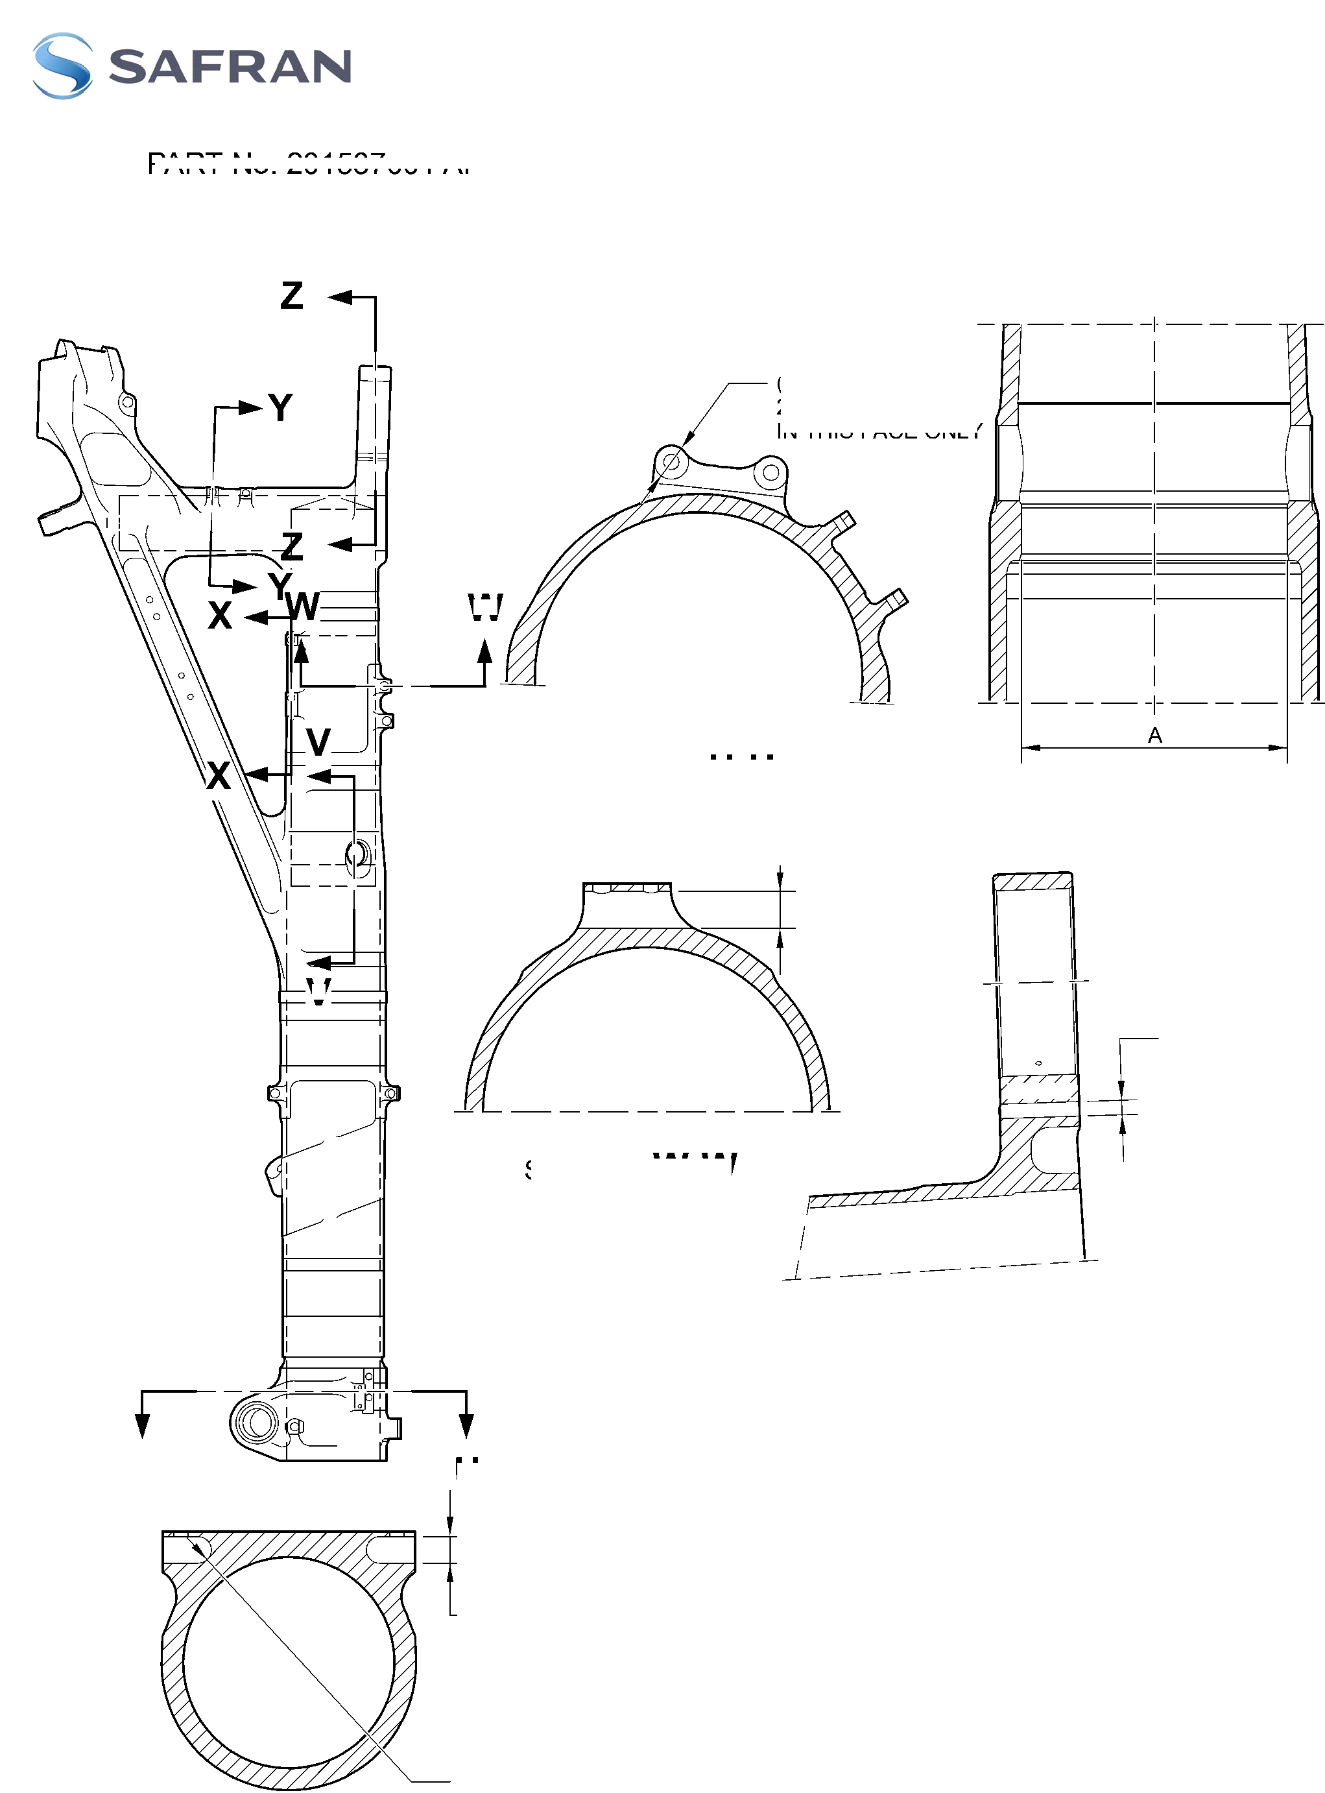

SAFRAN LANDING SYSTEMS UK Ltd
CAGE: K0654

PART No. 201587001 AND 201587002 COMPONENT MAINTENANCE MANUAL
MAIN LANDING GEAR LEG
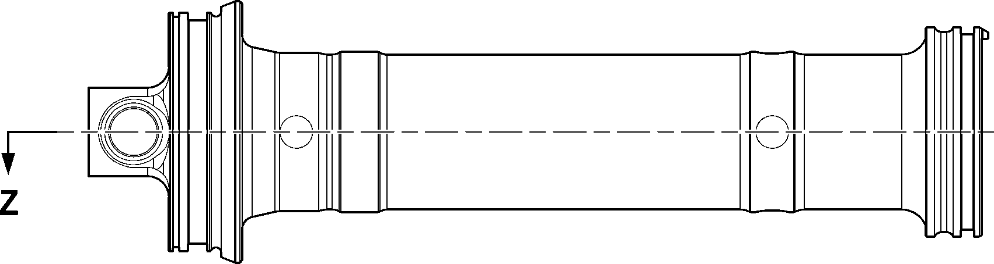
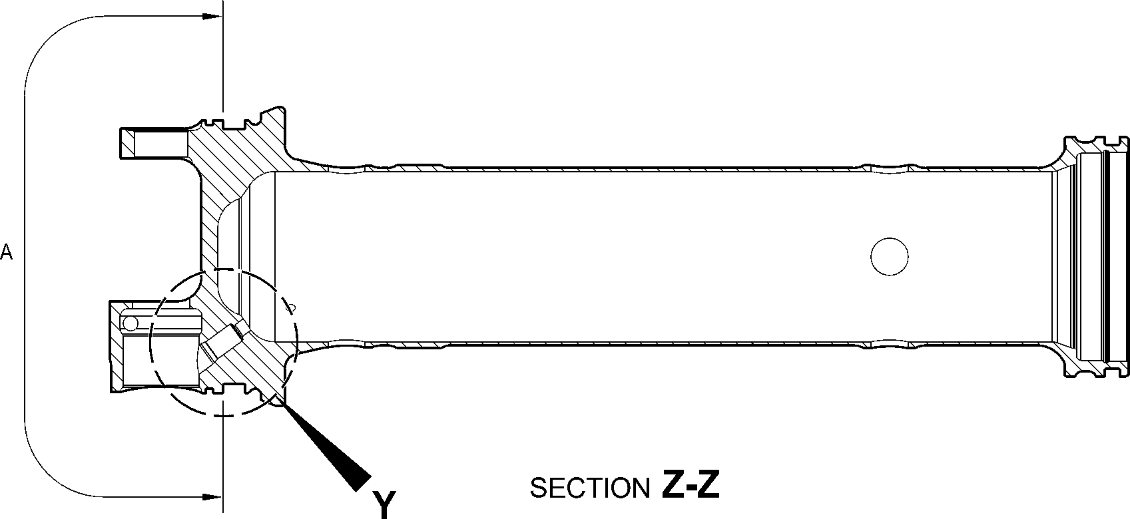
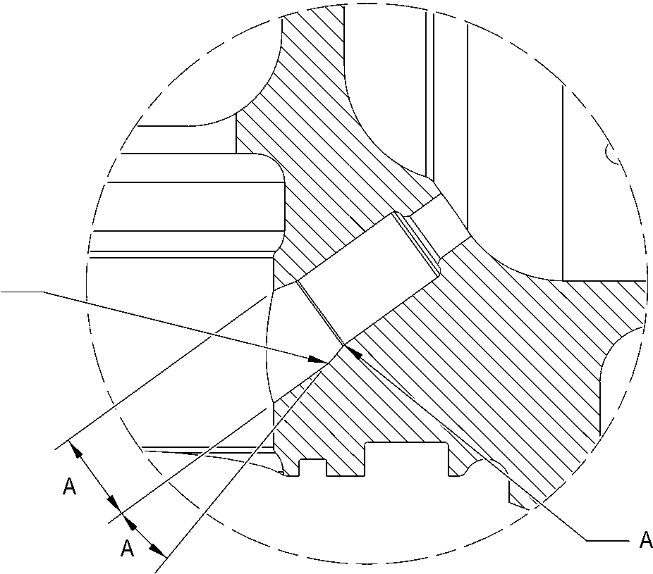
DETAIL Y
A321-T-32-12-22-109-0
Upper Diaphragm Tube (15-390A) - Protective Treatment
Figure 623
32-12-22
Page 646
Mar 18/2025

SAFRAN LANDING SYSTEMS UK Ltd
CAGE: K0654

PART No. 201587001 AND 201587002 COMPONENT MAINTENANCE MANUAL
MAIN LANDING GEAR LEG
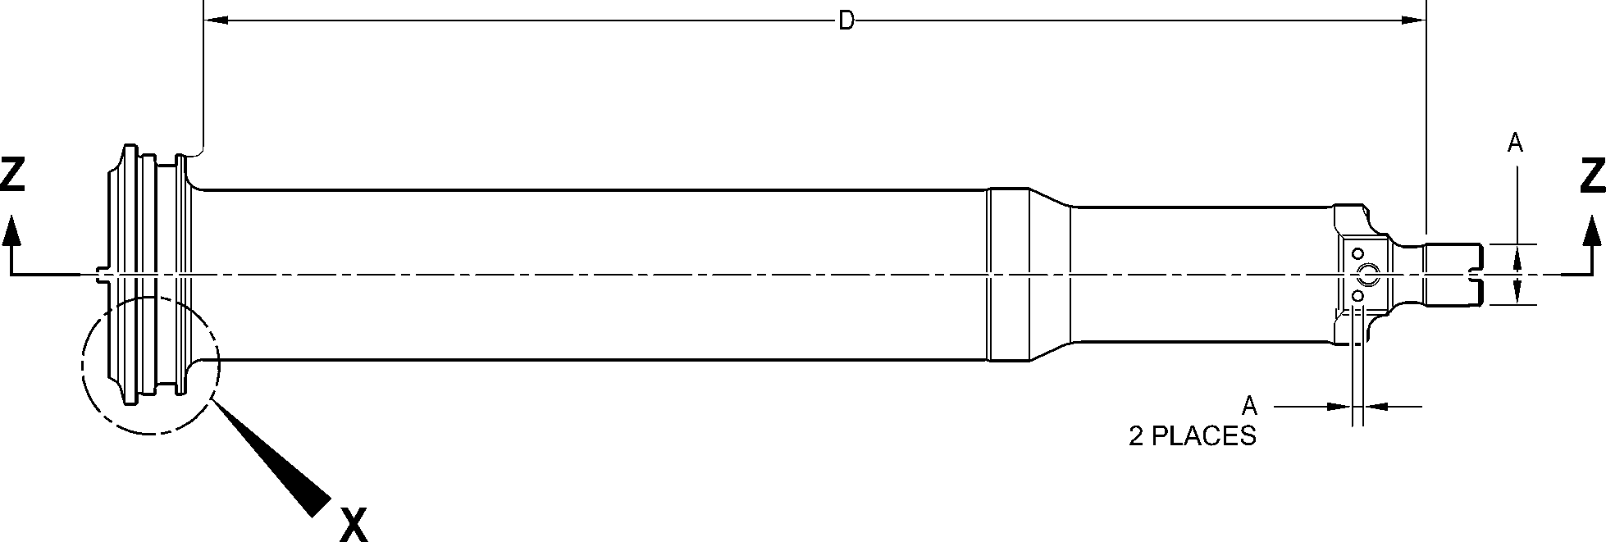
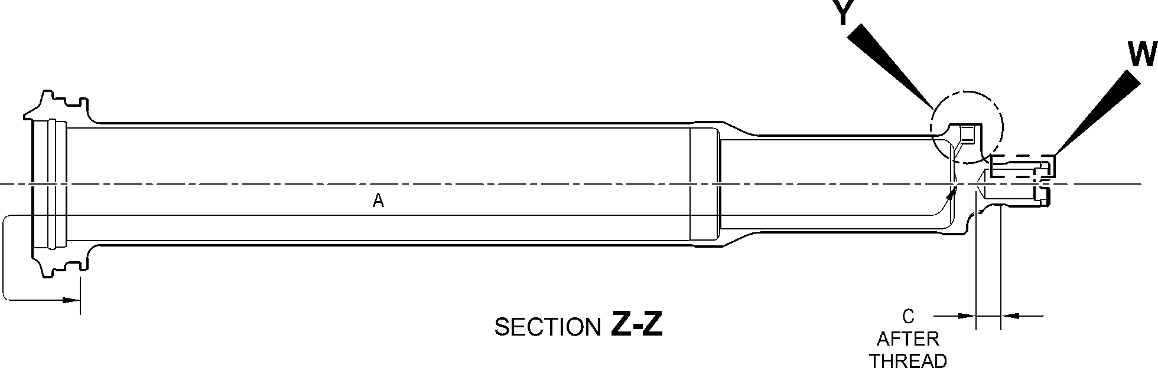
D
128,00 to 132,00mm
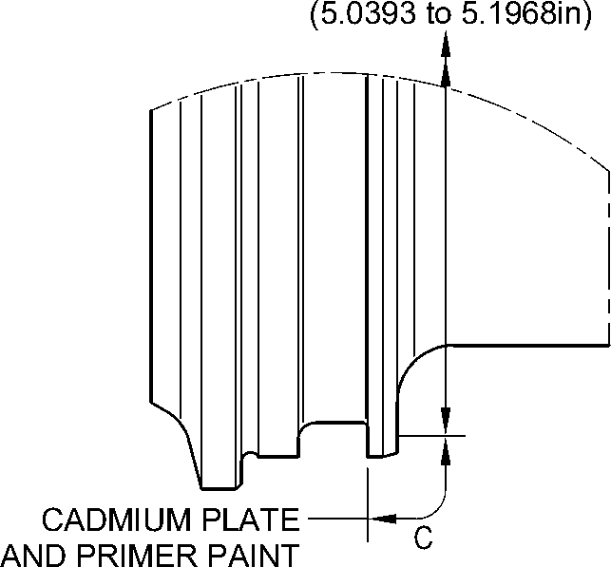
DETAIL X
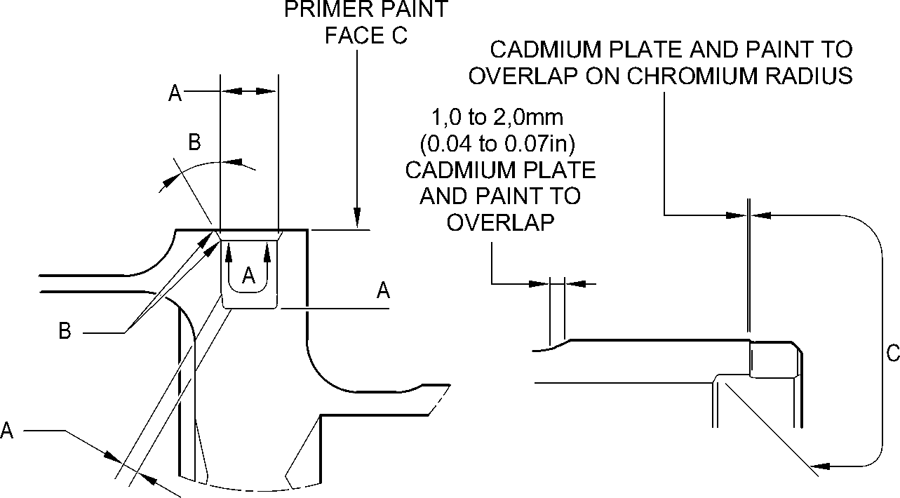
DETAIL Y
DETAIL W
A321-T-32-12-22-110-0
Cylinder (17-230A) - Protective Treatment
Figure 624
32-12-22
Page 647
Mar 18/2025

SAFRAN LANDING SYSTEMS UK Ltd
CAGE: K0654

PART No. 201587001 AND 201587002 COMPONENT MAINTENANCE MANUAL
MAIN LANDING GEAR LEG
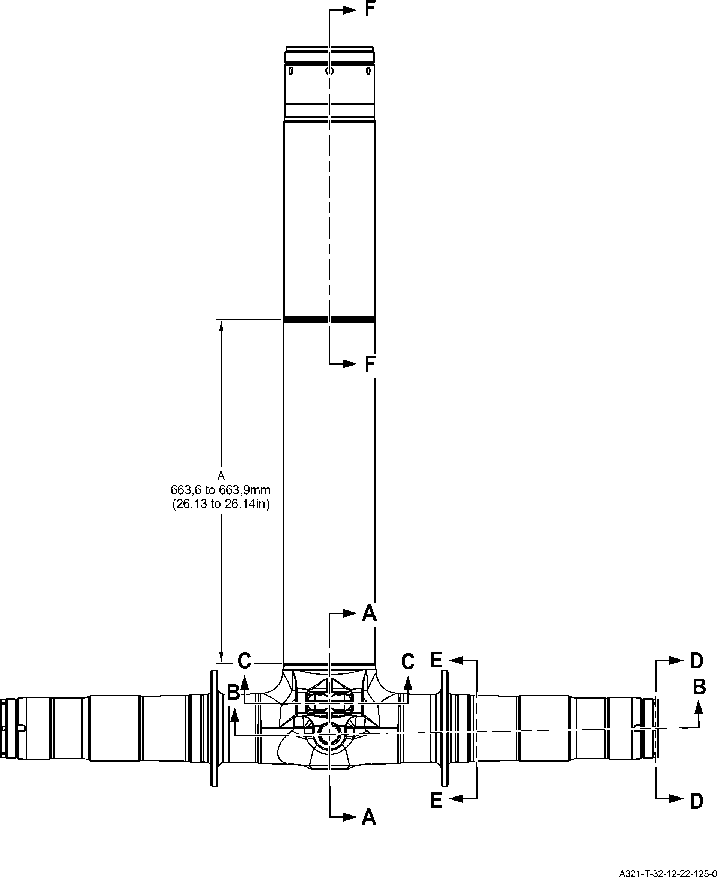
Sliding Tube (18-80B) - Protective Treatment
Figure 625 - Sheet 1
32-12-22
Page 648
Mar 18/2025

SAFRAN LANDING SYSTEMS UK Ltd
CAGE: K0654

PART No. 201587001 AND 201587002 COMPONENT MAINTENANCE MANUAL
MAIN LANDING GEAR LEG
F
SECTION A-A
KNUCKLE BORES
16,75 to 17,25mm
(0.6594 to 0.6791in)
SECTION G-G
KNUCKLE TOOLING LUG
GREASE HOLES
E
17,750 to 18,250mm
(0.6988 to 0.7185in)
E
71,750 to 72,250mm
(2.8248 to 2.8445in) DIA.
A
119,929 to 119,964mm
(4.7216 to 4.7230in) DIA.
220.00mm
(8.6614in) MIN.

G
G
A
126,917 to 126,957mm
(4.9967 to 4.9983in) DIA.
A
131,294 to 131,357mm
(5.1690 to 5.1715in) DIA.
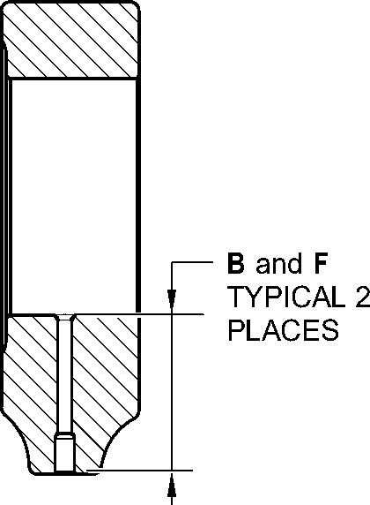
C
19,500 to 20,500mm
(0.7677 to 0.8071in)
95,500 to 107,500mm
(3.7598 to 4.2323in)
EXTERNAL
SERMETEL LIMIT
SECTION B-B
(BOTH SIDES)
AXLE BORE
84,000 to 96,000mm
(3.3071 to 3.7795in)
INTERNAL
SERMETEL LIMIT
A321-T-32-12-22-126-0
Sliding Tube (18-80B)- Protective Treatment
Figure 625 - Sheet 2
32-12-22
Page 649
Mar 18/2025
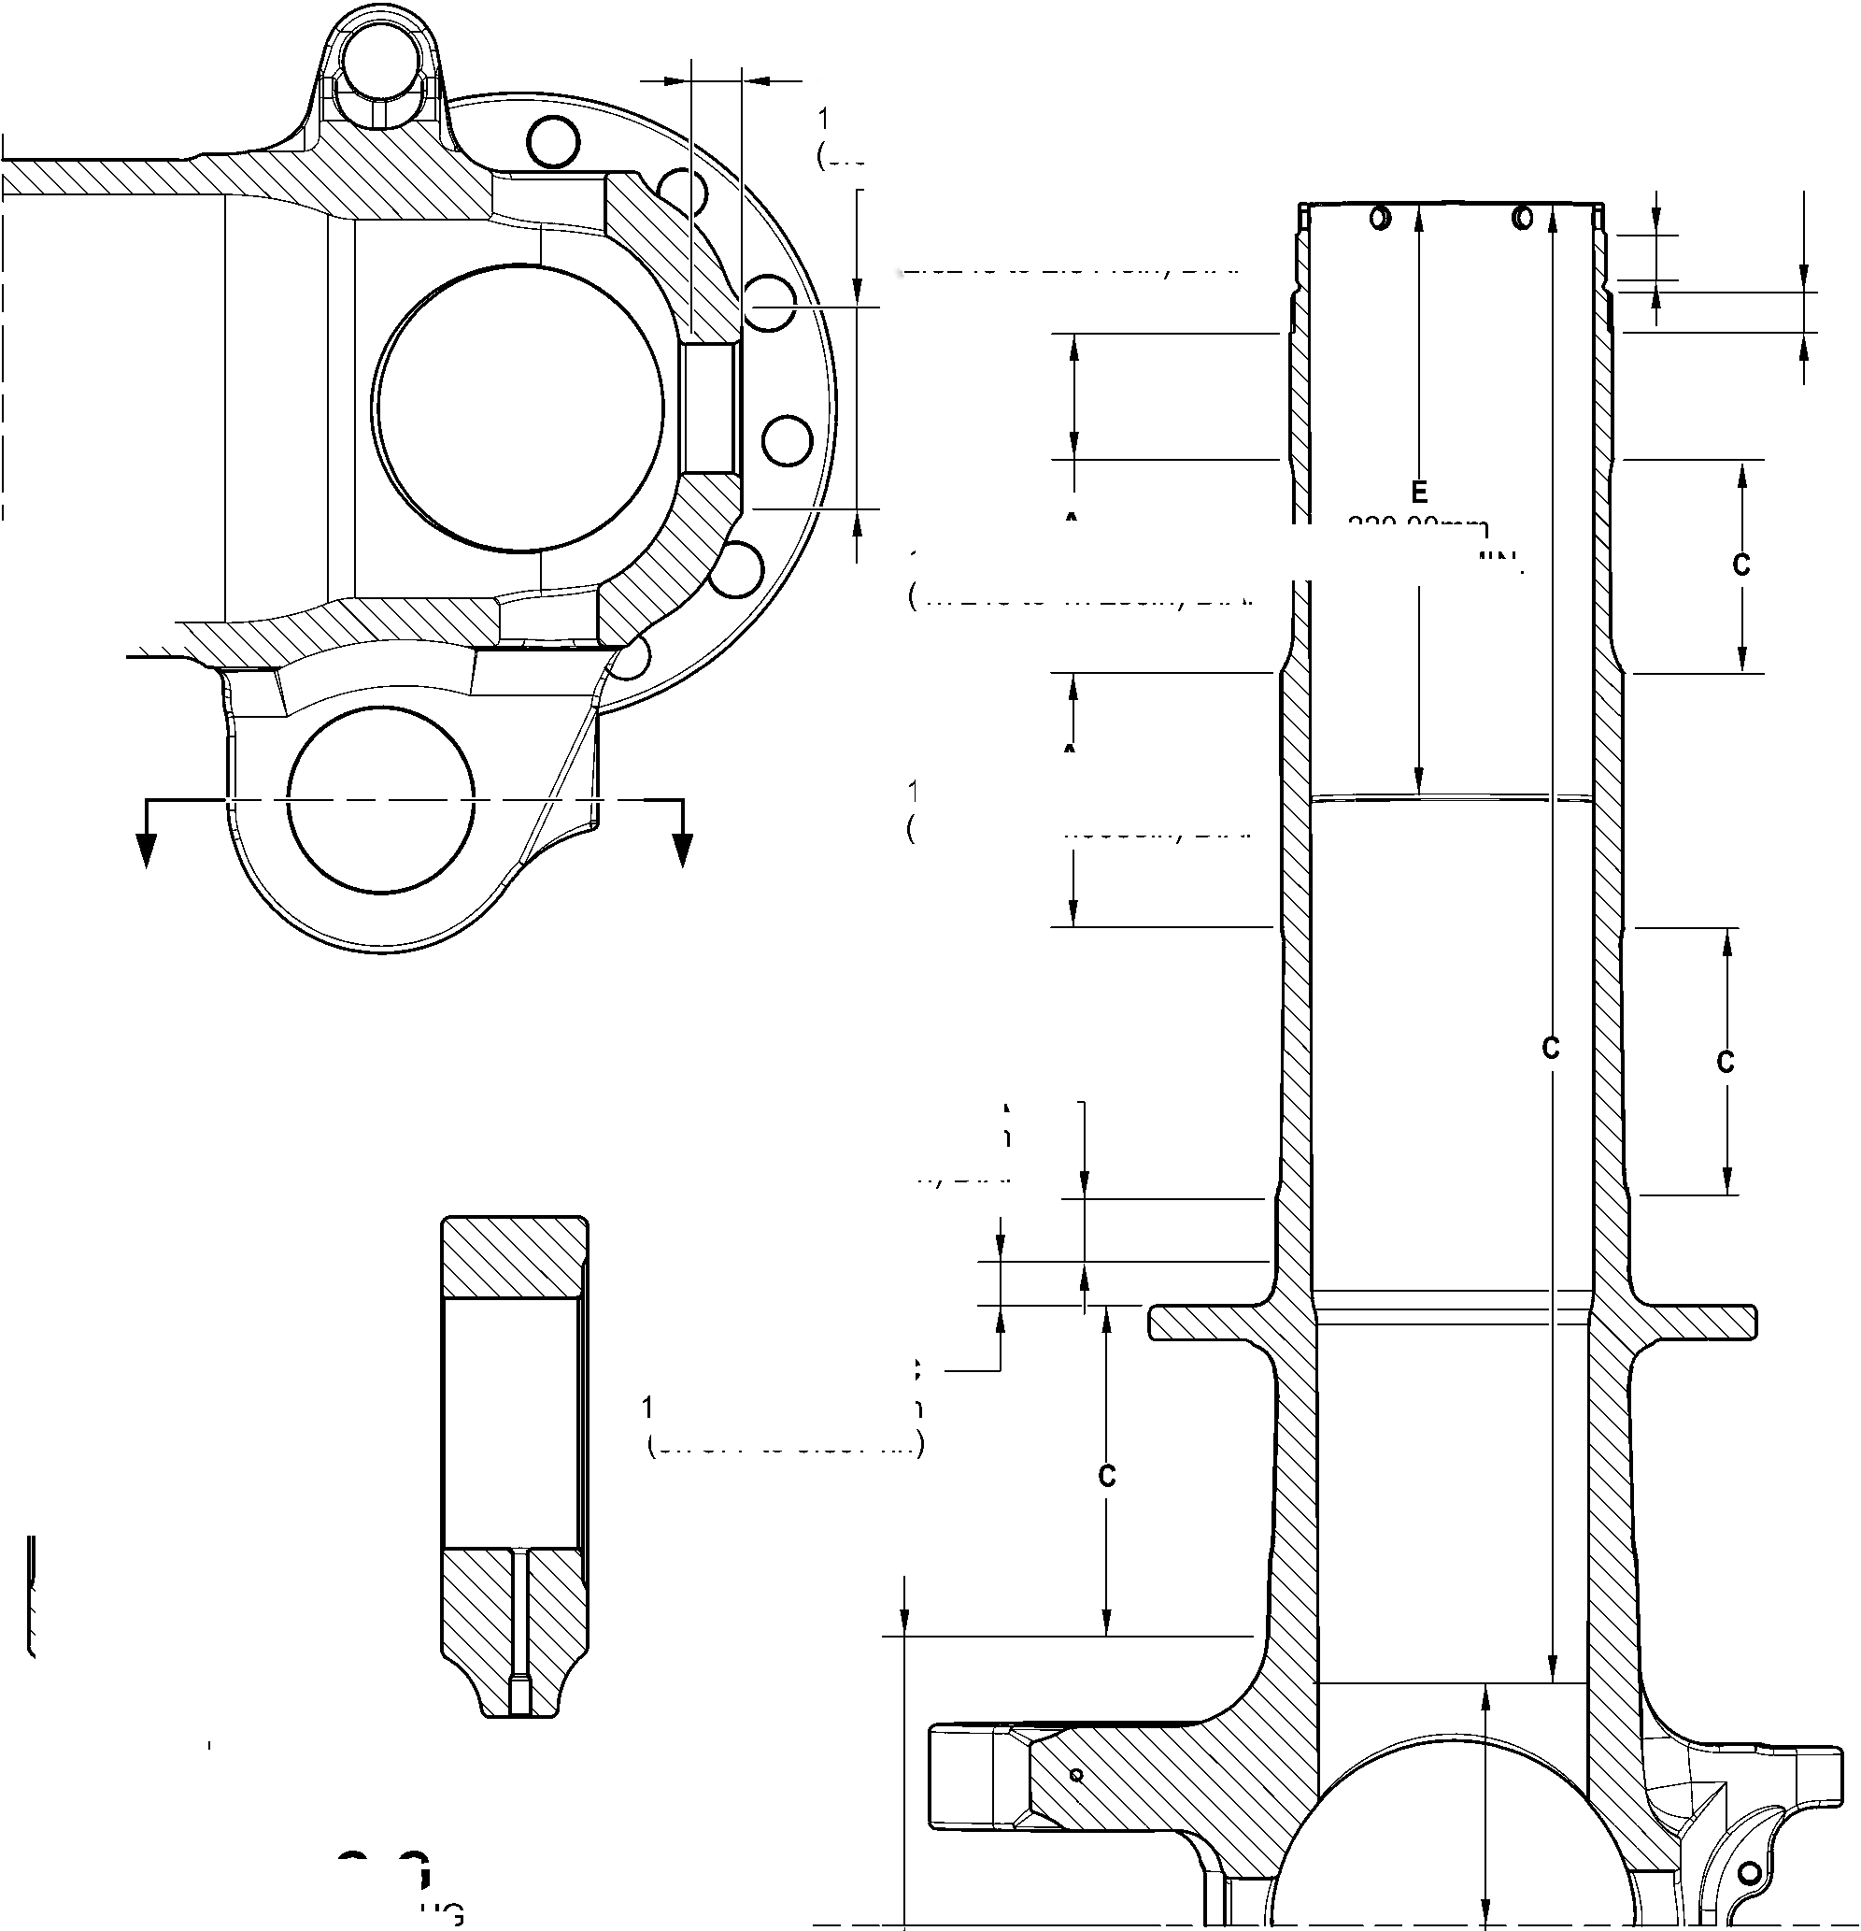

SAFRAN LANDING SYSTEMS UK Ltd
CAGE: K0654
PART No. 201587001 AND 201587002 COMPONENT MAINTENANCE MANUAL
MAIN LANDING GEAR LEG
E
69,750 to 70,250mm
(2.7461 to 2.7657in) DIA.
SPOTFACE TYPICAL
2 PLACES
F
5,000 to 7,000mm
(0.1968 to 0.2755in)
TYPICAL 2 PLACES
E
23,400mm
(0.9213in) MIN.
TYPICAL 2
PLACES
E
6,50 to 6,70mm
(0.256 to 0.264in) DIA.
TYPICAL 4 PLACES
19,000 to 21,000mm
(0.7481 to 0.8268in)
TYPICAL 2 PLACES
E
81,750 to 82,250mm
(3.2185 to 3.2382in) DIA.
SPOTFACE TYPICAL
2 PLACES
SECTION D-D
(BOTH SIDES)
AXLE NUT CROSS
BOLT HOLES
D
6,70 to 6,90mm
(0.2638 to 0.2717in) DIA.
TYPICAL 6 PLACES
E
38,750 to 39,250mm
(1.5256 to 1.5453in) DIA.
SPOTFACE TYPICAL
2 PLACES INCLUDING
CHAMFER
F
13,000mm
(0.5118in) DIA.
SPOTFACE TYPICAL 4 PLACES
INCLUDING CHAMFER
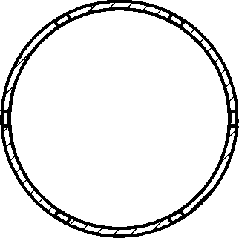
SECTION
LUG BORES
C-C
SECTION E-E
(BOTH SIDES)
BRAKE FLANGE
E
30,750 to 31,250mm
(1.2106 to 1.2303in) DIA.
SPOTFACE TYPICAL
12 PLACES INCLUDING
CHAMFER
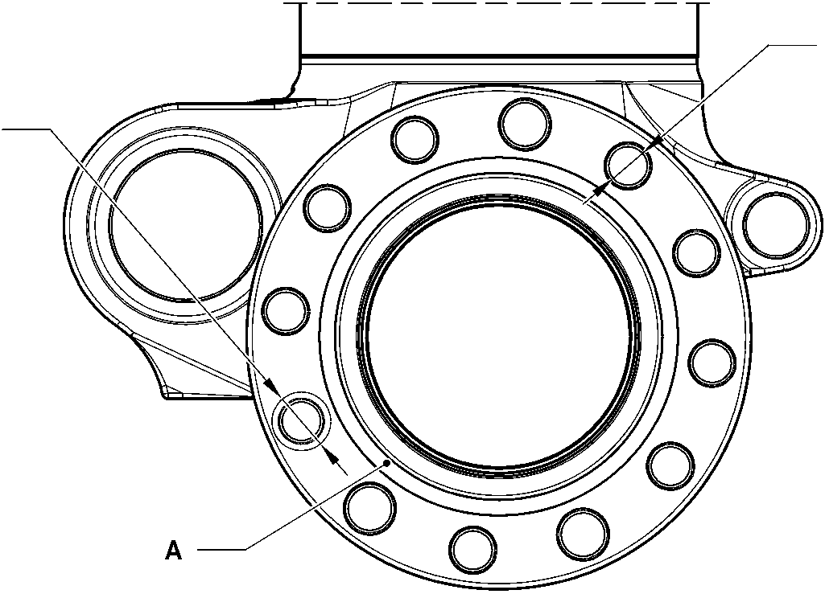
A
TYPICAL 12 PLACES
A321-T-32-12-22-127-0
Sliding Tube (18-80B)- Protective Treatment
Figure 625 - Sheet 3
32-12-22
Page 650
Mar 18/2025
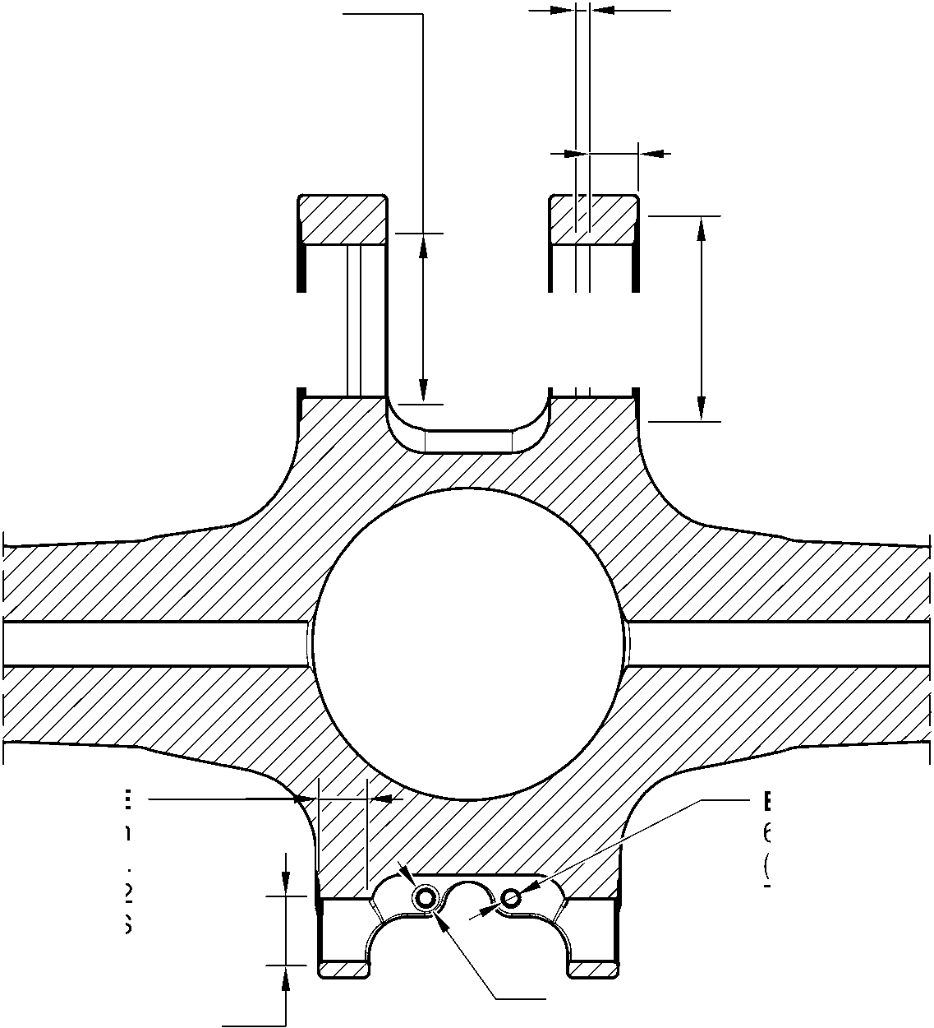

SAFRAN LANDING SYSTEMS UK Ltd
CAGE: K0654

PART No. 201587001 AND 201587002 COMPONENT MAINTENANCE MANUAL
MAIN LANDING GEAR LEG
B and F
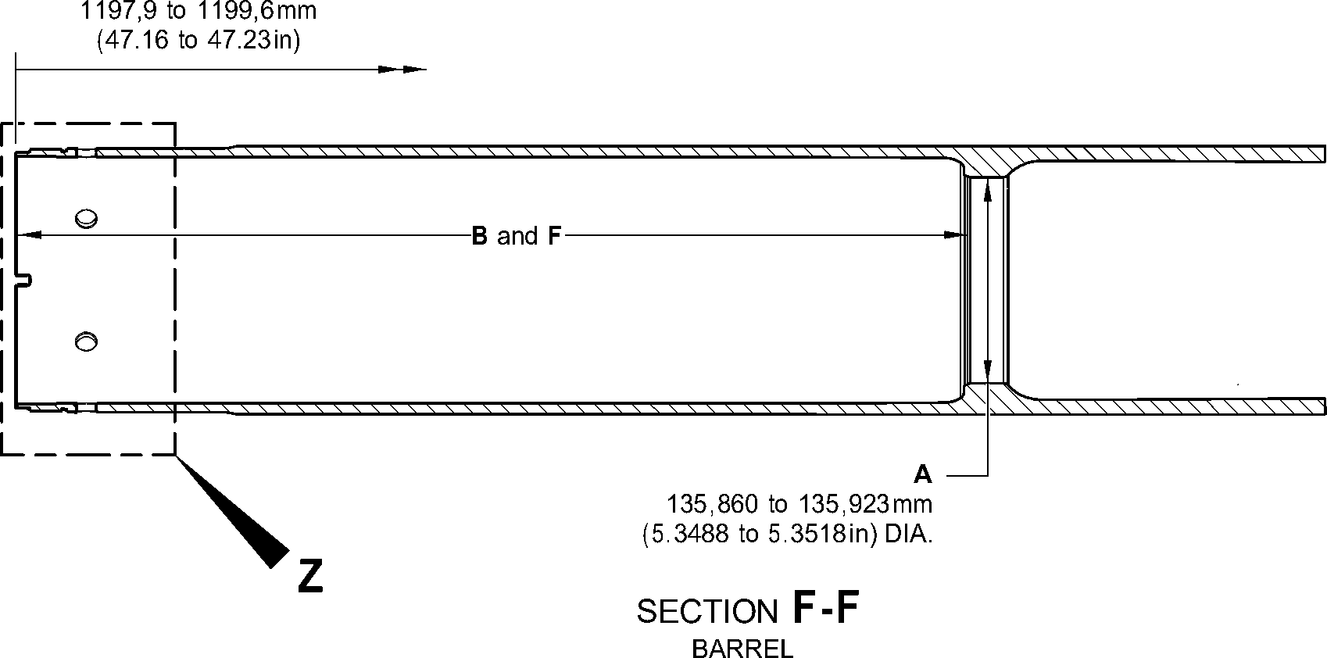
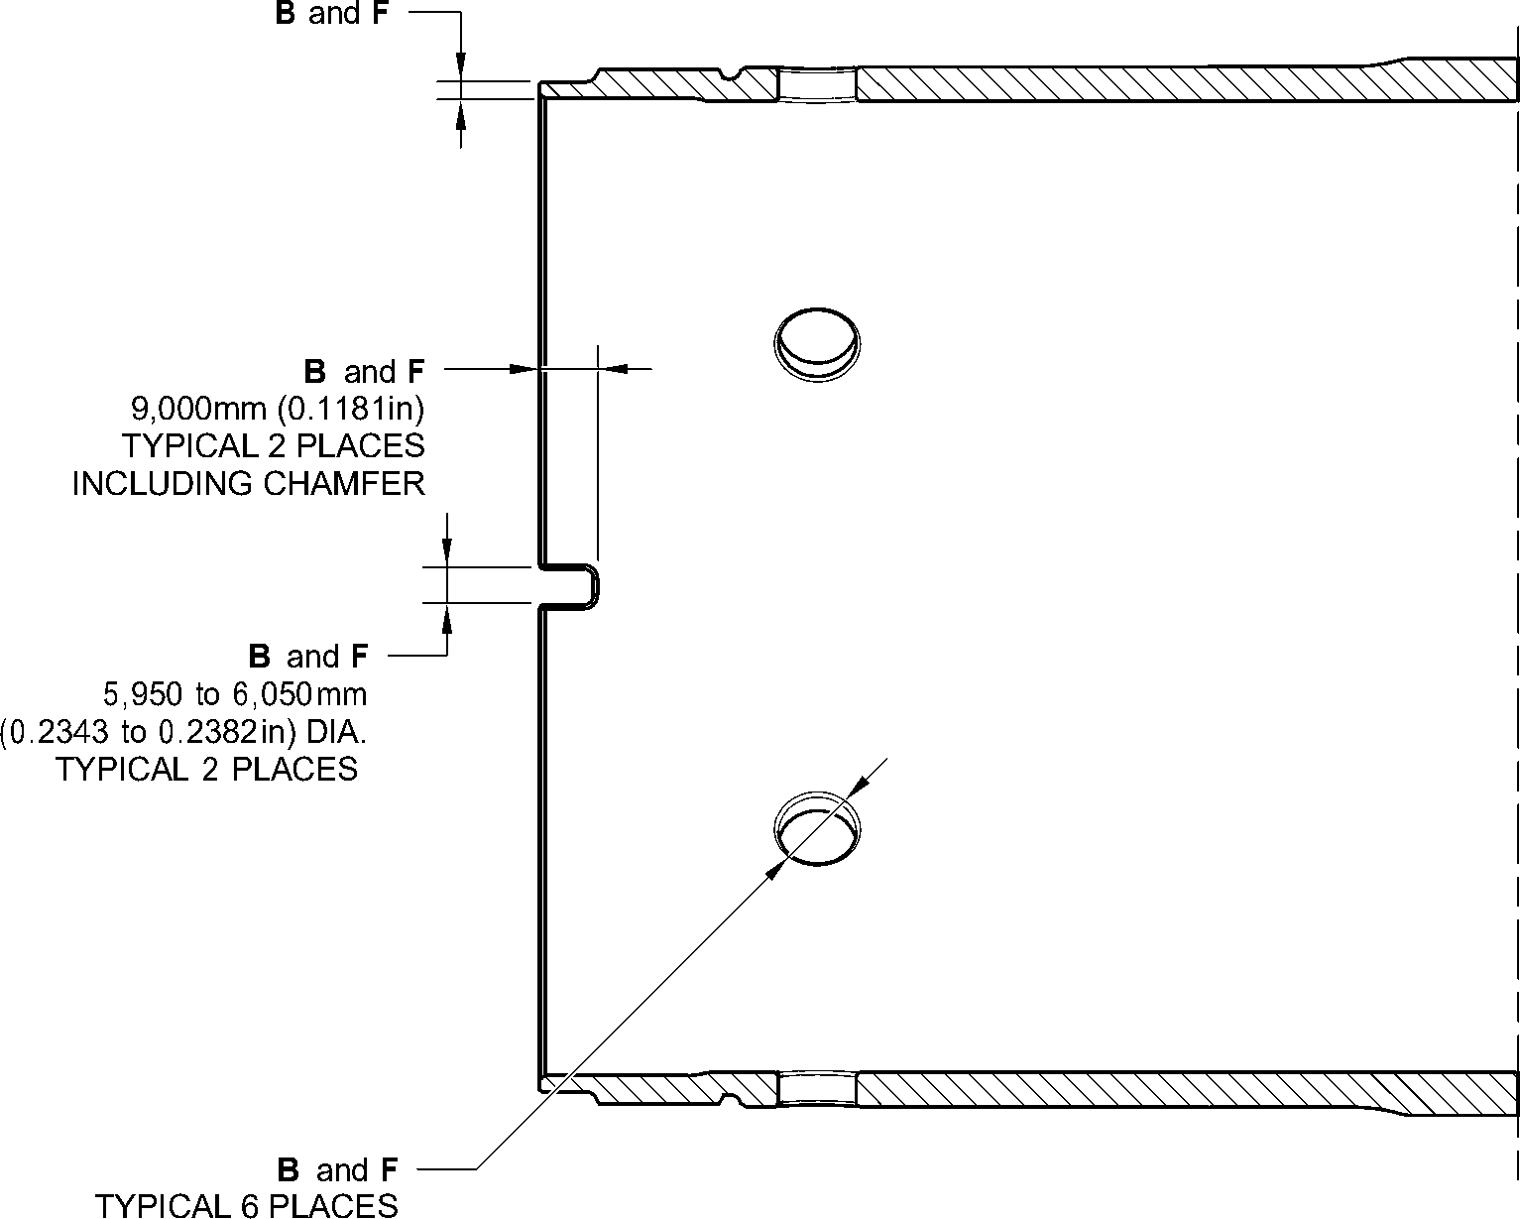
INCLUDING CHAMFER
DETAIL Z
A321-T-32-12-22-128-0
Sliding Tube (18-80B)- Protective Treatment
Figure 625 - Sheet 4
32-12-22
Page 651
Mar 18/2025

SAFRAN LANDING SYSTEMS UK Ltd
CAGE: K0654

PART No. 201587001 AND 201587002 COMPONENT MAINTENANCE MANUAL
MAIN LANDING GEAR LEG
A
SPOTFACE
(BOTH SIDES)
A
SPOTFACE
(BOTH SIDES)
D
A
SPOTFACE
(BOTH SIDES)
A
SPOTFACE
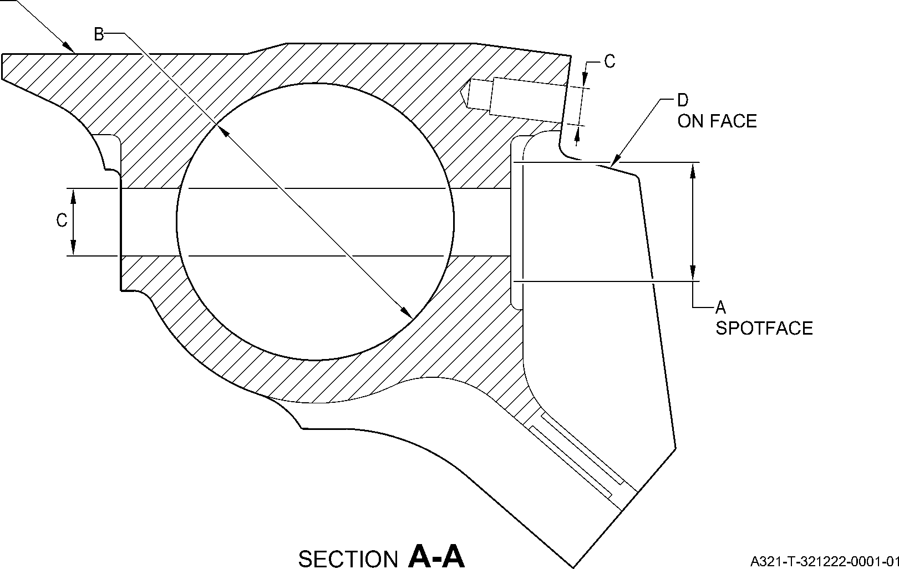
Upper Pivot Bracket (10-160) Only - Protective Treatment
Figure 626
32-12-22
Page 652
Mar 18/2025
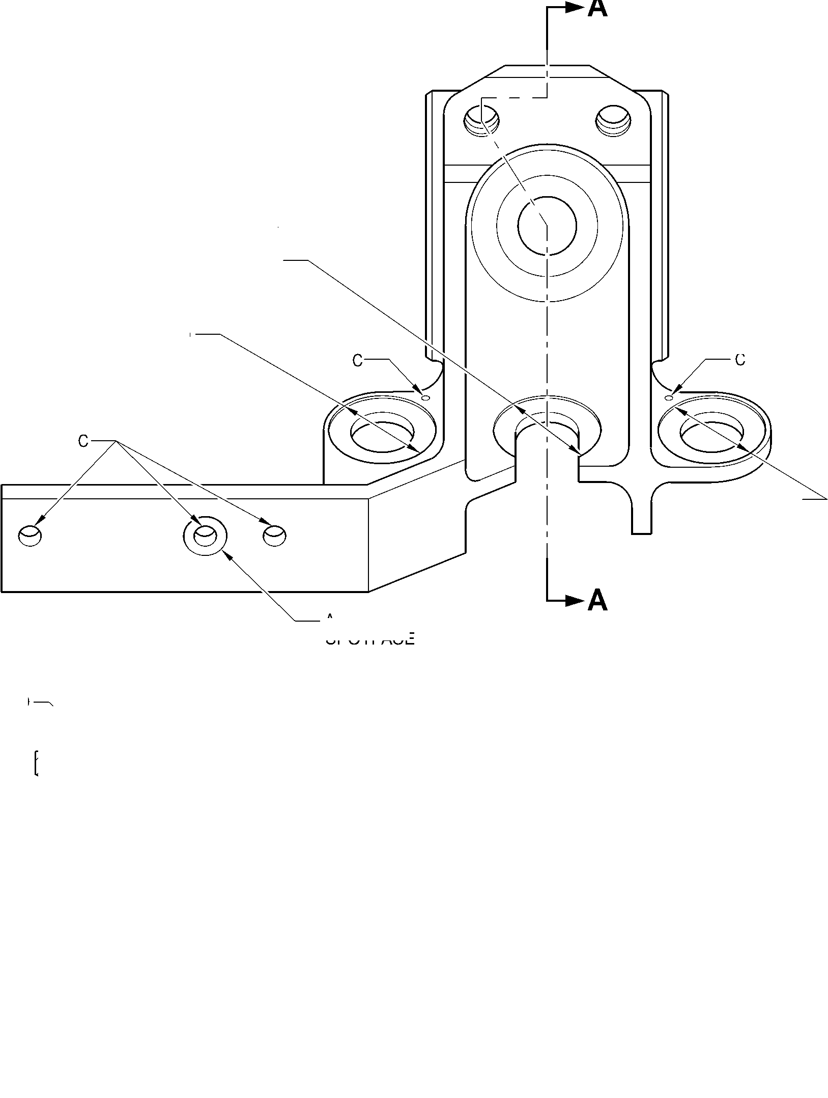

SAFRAN LANDING SYSTEMS UK Ltd
CAGE: K0654

PART No. 201587001 AND 201587002 COMPONENT MAINTENANCE MANUAL
MAIN LANDING GEAR LEG
A
SPOTFACE
(BOTH SIDES)
A
A
SPOTFACE
(BOTH SIDES)
A
SPOTFACE
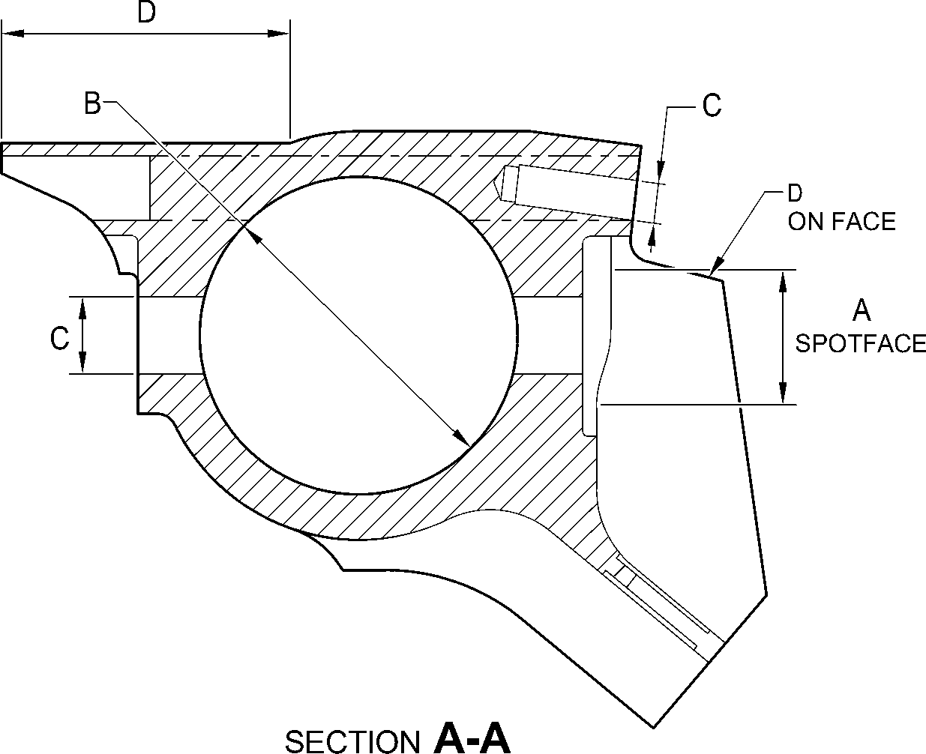
A321-T-321222-0002-01
Upper Pivot Bracket (10-160A) - Protective Treatment
Figure 627
32-12-22
Page 653
Mar 18/2025
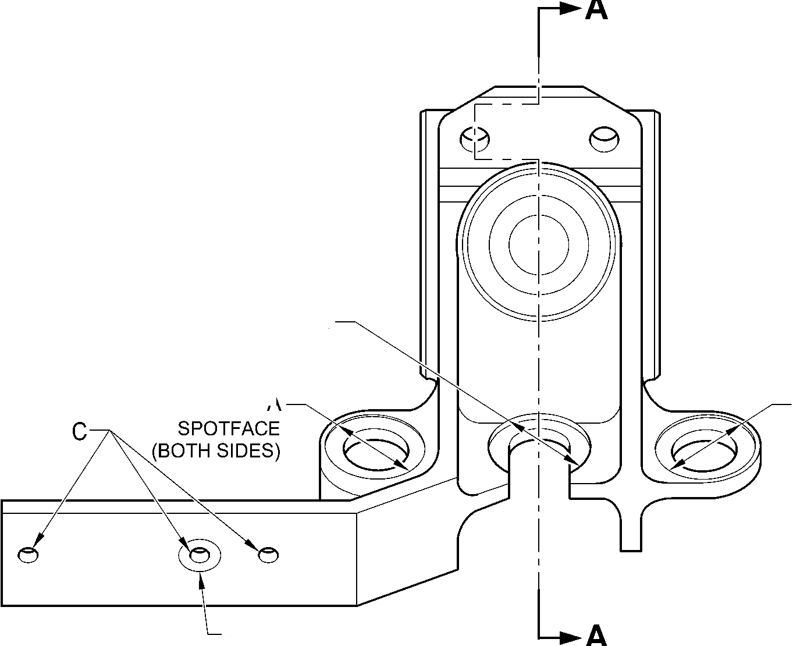

SAFRAN LANDING SYSTEMS UK Ltd
CAGE: K0654

PART No. 201587001 AND 201587002 COMPONENT MAINTENANCE MANUAL
MAIN LANDING GEAR LEG
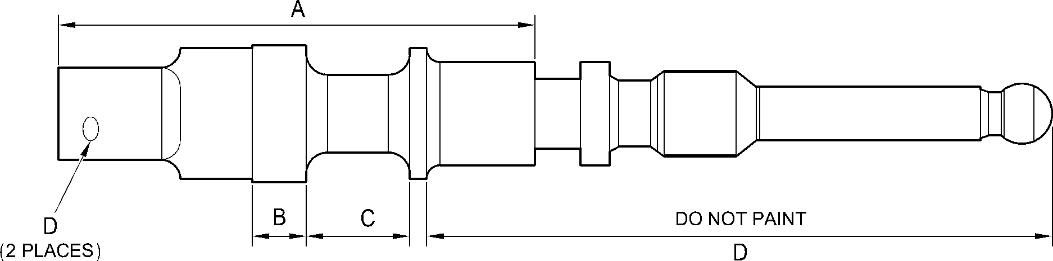
A321-T-321222-0003-00
Valve Stem (12-90A) - Protective Treatment
Figure 628
32-12-22
Page 654
Mar 18/2025

SAFRAN LANDING SYSTEMS UK Ltd
CAGE: K0654

PART No. 201587001 AND 201587002 COMPONENT MAINTENANCE MANUAL
MAIN LANDING GEAR LEG
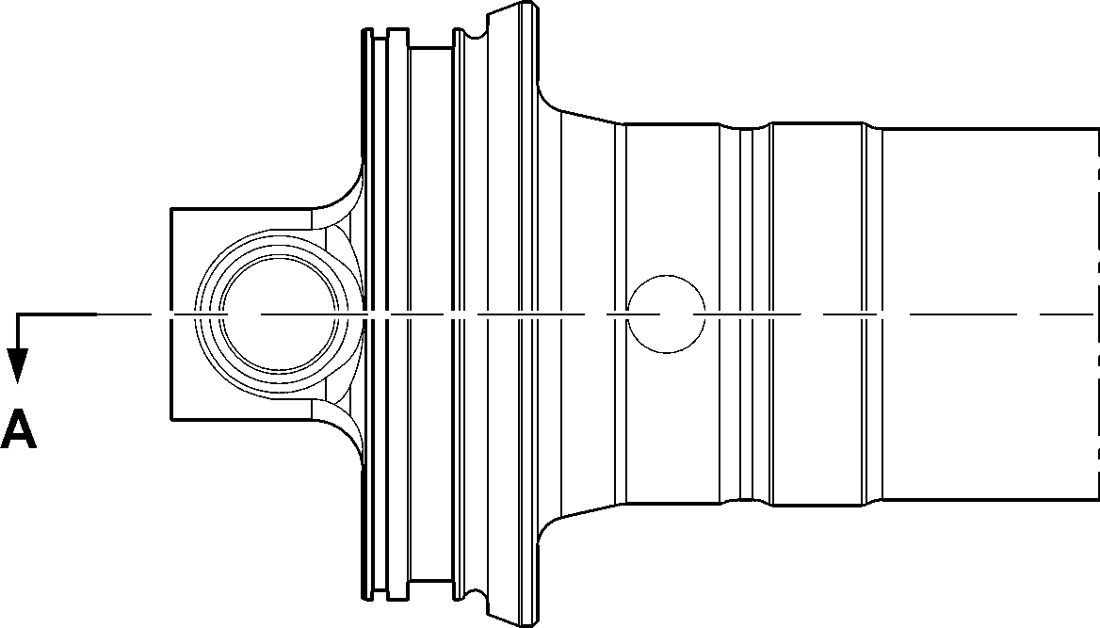
B
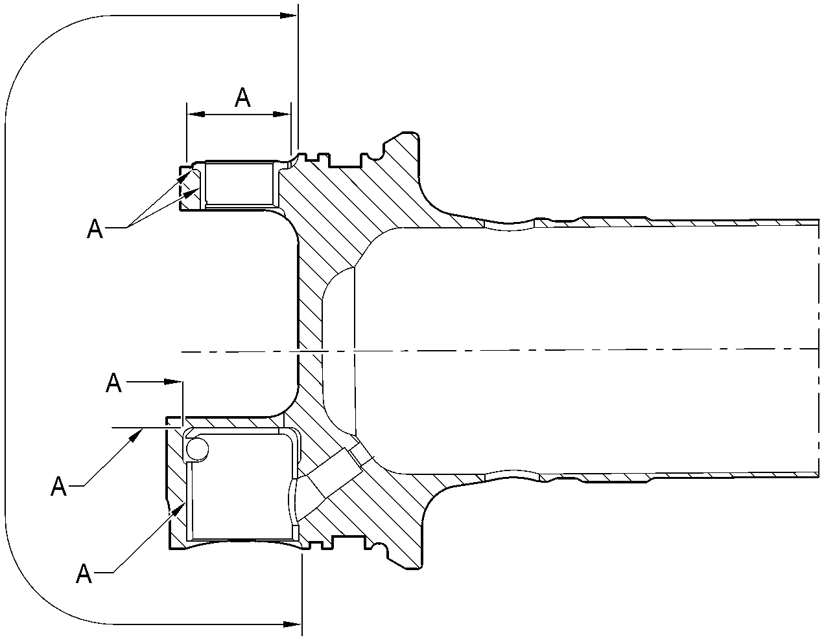
SECTION A-A
A321-T-321222-0004-00
Upper Diaphragm Tube Subassembly (15-360) - Protective Treatment
Figure 629
32-12-22
Page 655
Mar 18/2025

SAFRAN LANDING SYSTEMS UK Ltd
CAGE: K0654
PART No. 201587001 AND 201587002 COMPONENT MAINTENANCE MANUAL
MAIN LANDING GEAR LEG
A
A
A and C
A
B and D
SECTION A-A
Z
C
B and D
B and D
D
DETAIL A
DETAIL B
SECTION Z-Z
A321-T-321222-0005-00
Upper Diaphragm Tube Subassembly (15-360A) - Protective Treatment
Figure 630
32-12-22
Page 656
Mar 18/2025
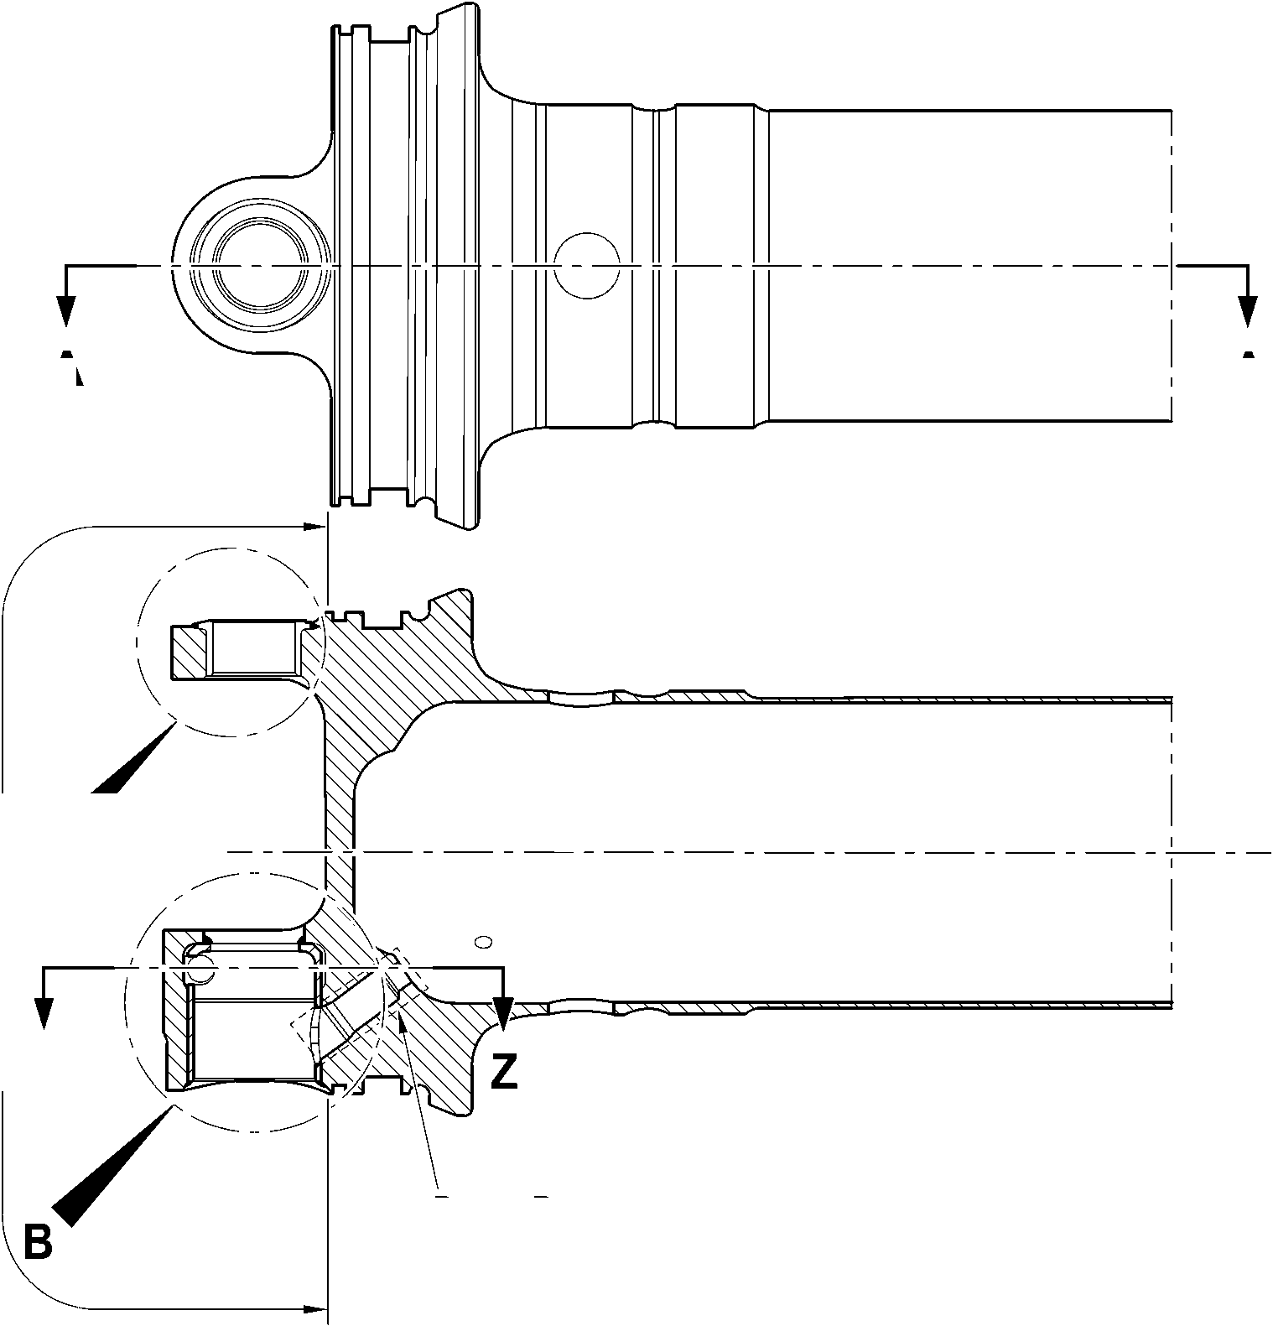
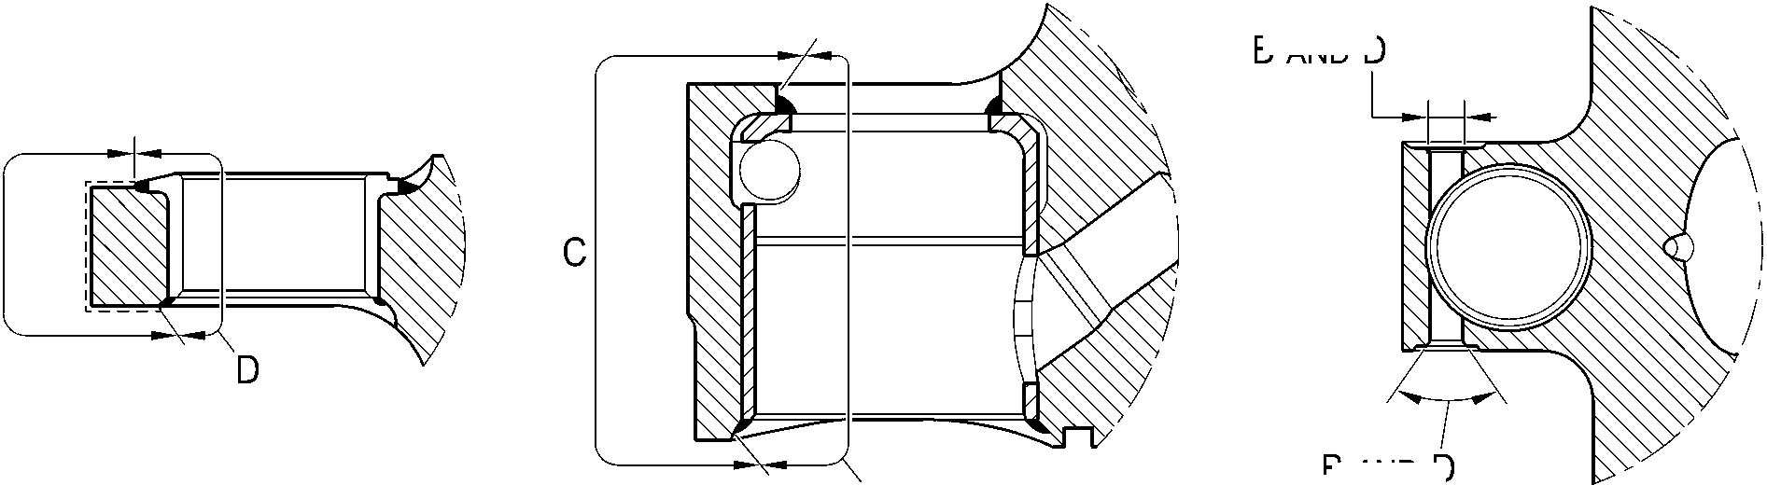

SAFRAN LANDING SYSTEMS UK Ltd
CAGE: K0654

PART No. 201587001 AND 201587002 COMPONENT MAINTENANCE MANUAL
MAIN LANDING GEAR LEG
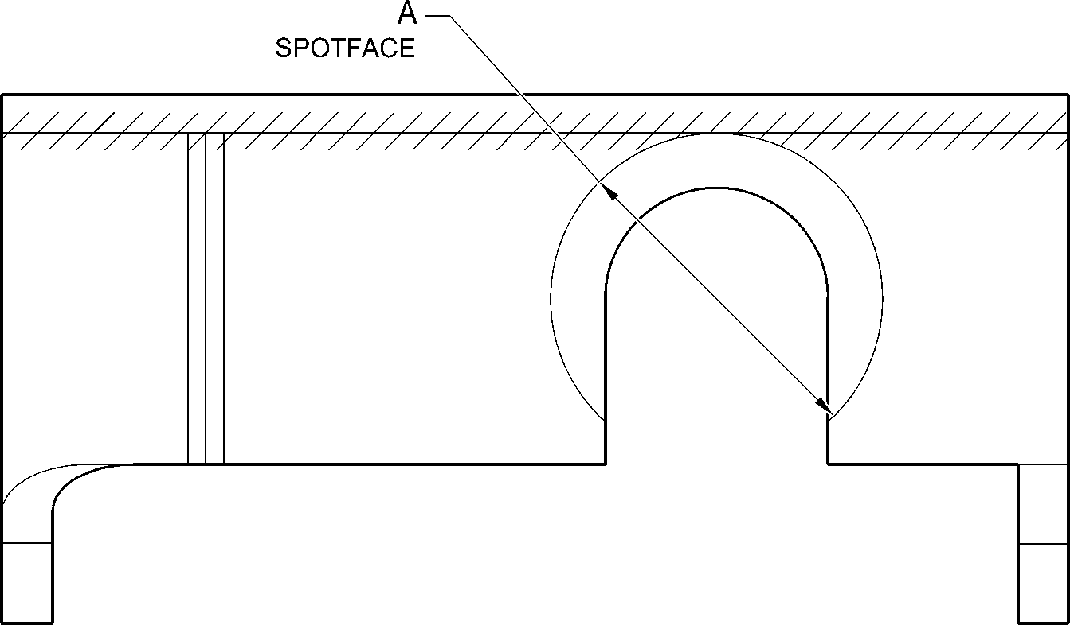
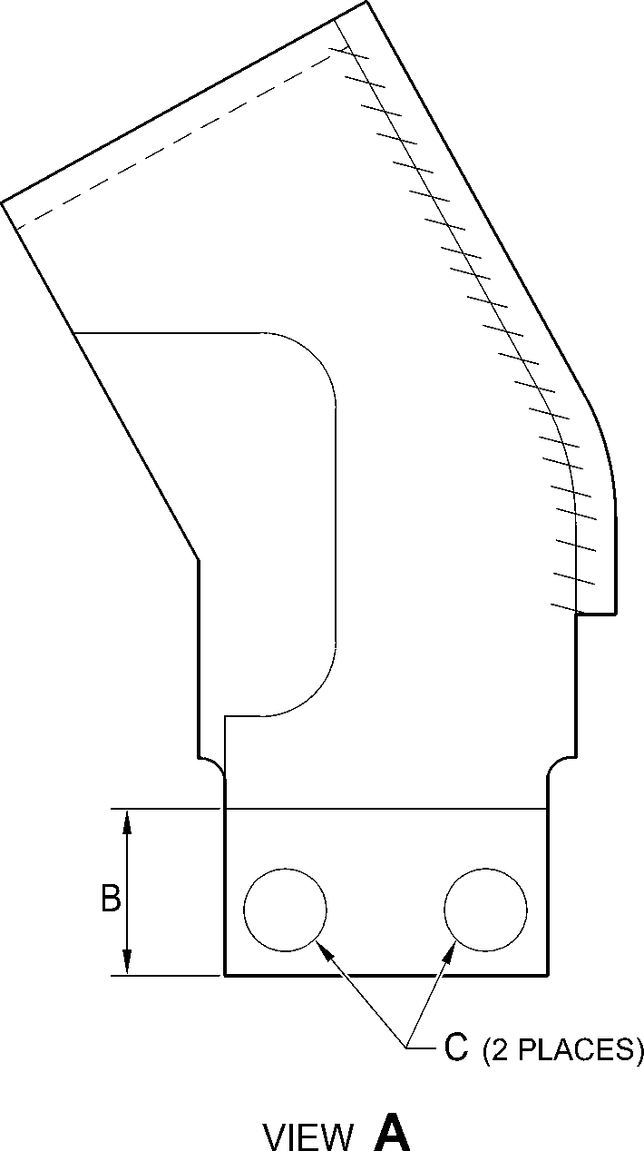
A321-T-321222-0006-00
Bracket (2-80 and 2-90) - Protective Treatment
Figure 631
32-12-22
Page 657
Mar 18/2025

SAFRAN LANDING SYSTEMS UK Ltd
CAGE: K0654

PART No. 201587001 AND 201587002 COMPONENT MAINTENANCE MANUAL
MAIN LANDING GEAR LEG
A
F
SPOTFACE
(BOTH SIDES)
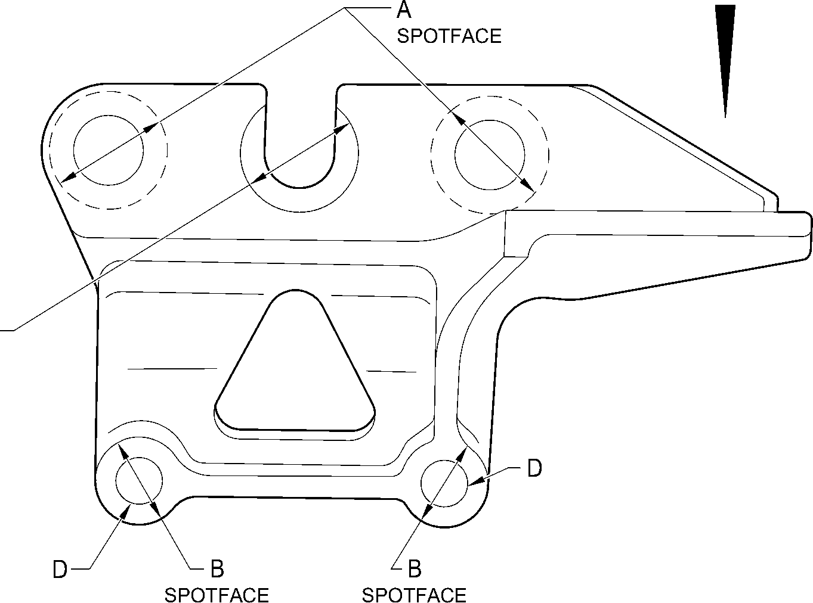
(BOTH SIDES)
(BOTH SIDES)
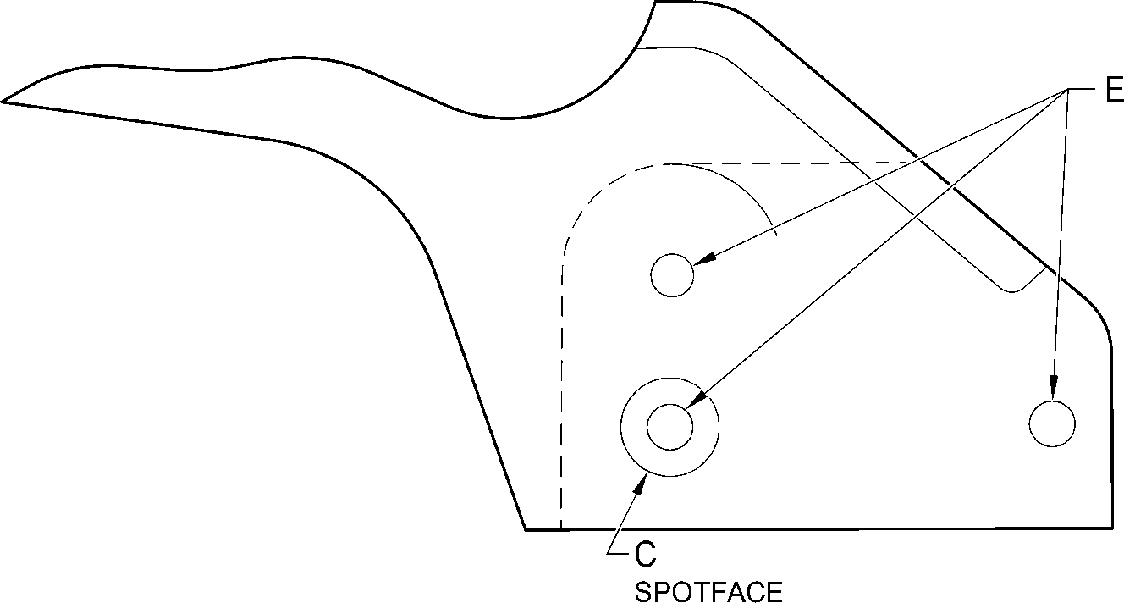
VIEW A
A321-T-321222-0007-00
Harness Support Bracket (7-100, 7-100A, 7-110 and 7-110A) - Protective Treatment
Figure 632
32-12-22
Page 658
Mar 18/2025

SAFRAN LANDING SYSTEMS UK Ltd
CAGE: K0654

PART No. 201587001 AND 201587002 COMPONENT MAINTENANCE MANUAL
MAIN LANDING GEAR LEG
Y
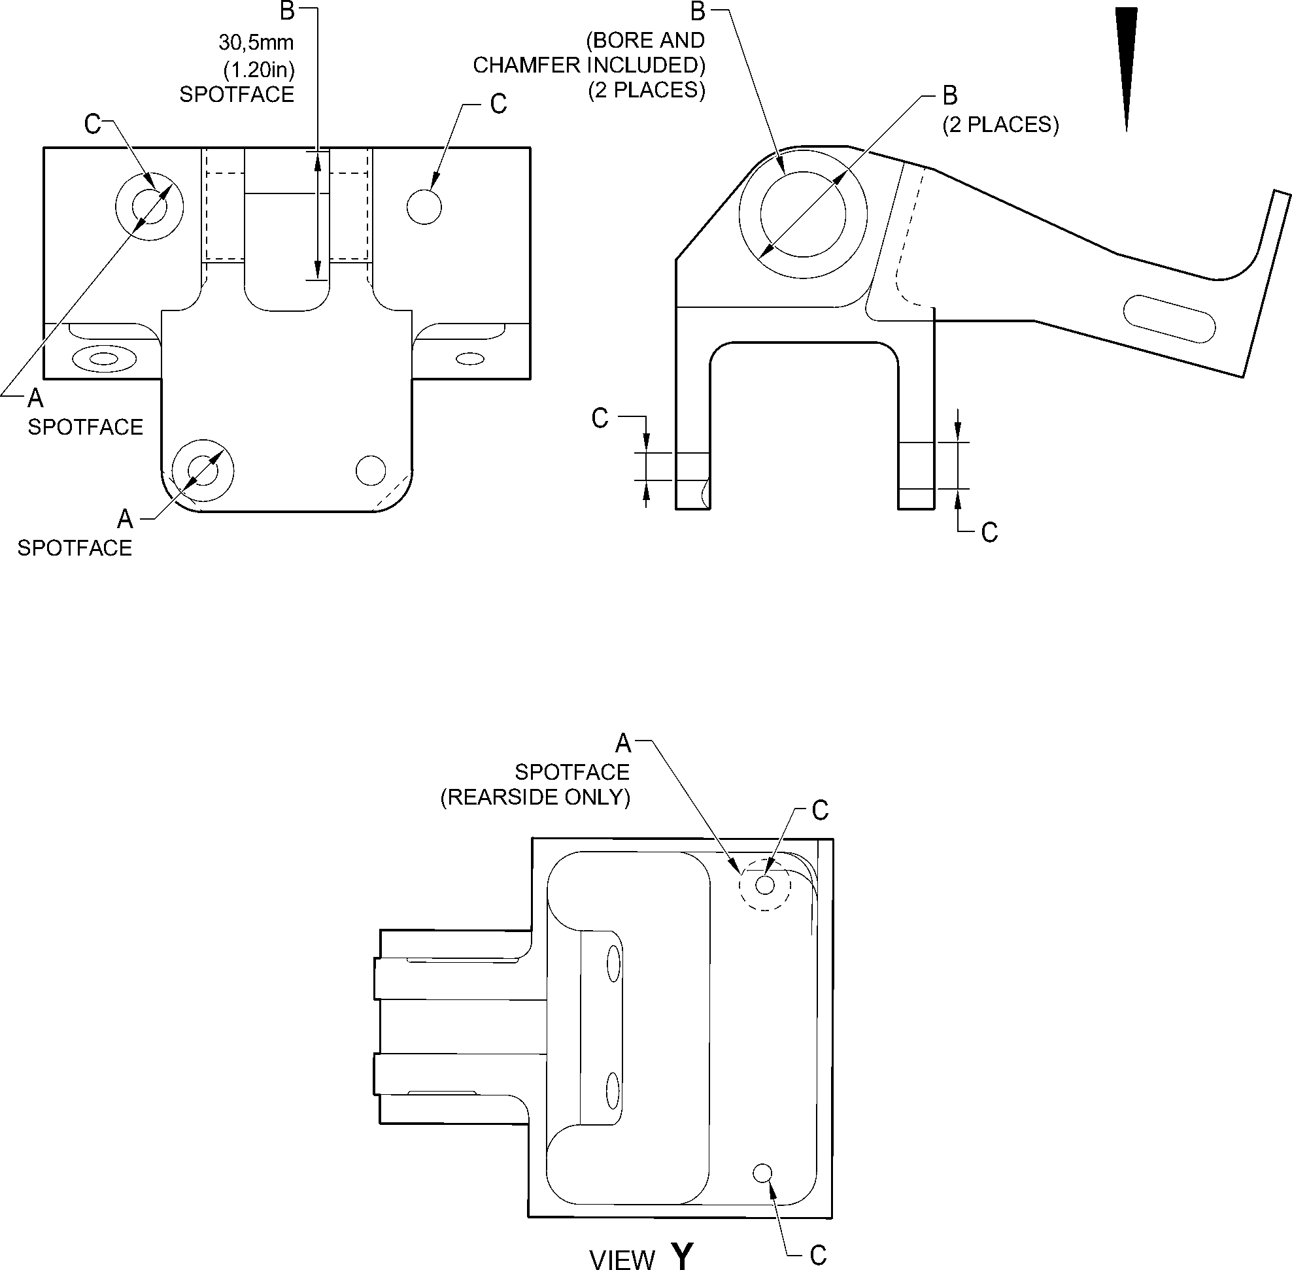
A321-T-321222-0009-00
Bracket (8-170) - Protective Treatment
Figure 633
32-12-22
Page 659
Mar 18/2025

SAFRAN LANDING SYSTEMS UK Ltd
CAGE: K0654

PART No. 201587001 AND 201587002 COMPONENT MAINTENANCE MANUAL
MAIN LANDING GEAR LEG
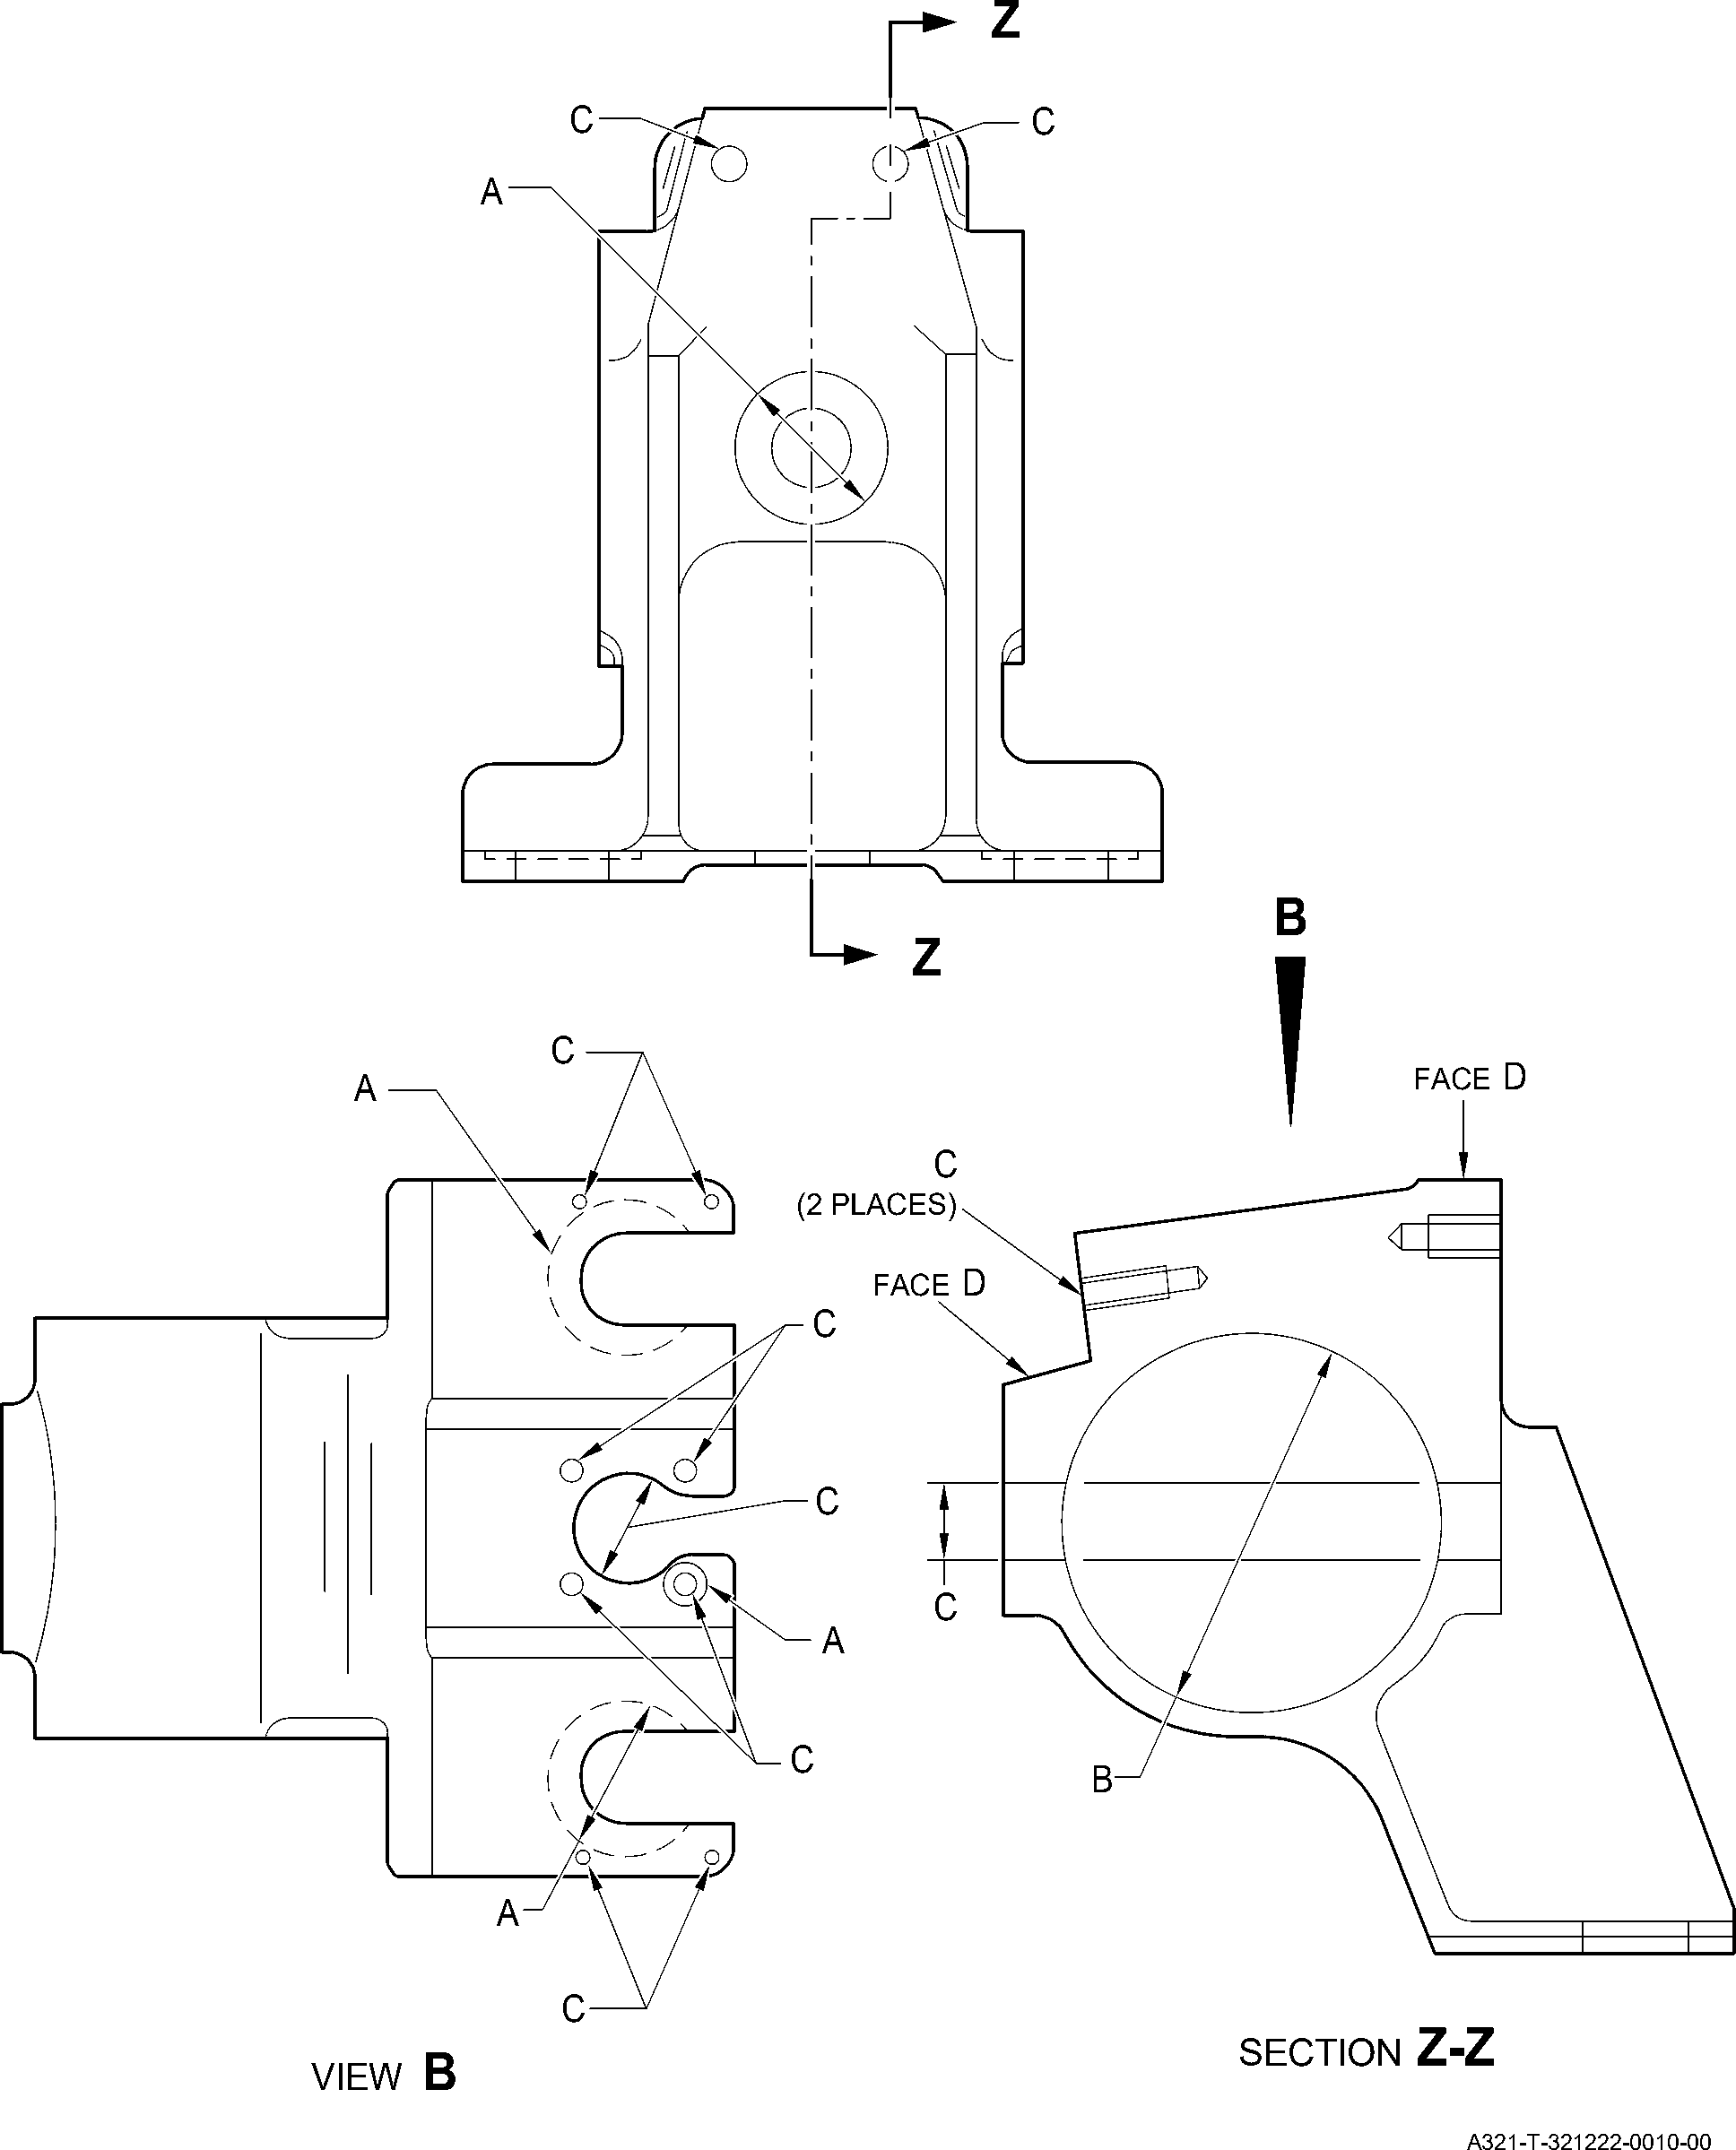
Harness Support Bracket (11-140) - Protective Treatment
Figure 634
32-12-22
Page 660
Mar 18/2025

SAFRAN LANDING SYSTEMS UK Ltd
CAGE: K0654

PART No. 201587001 AND 201587002 COMPONENT MAINTENANCE MANUAL
MAIN LANDING GEAR LEG
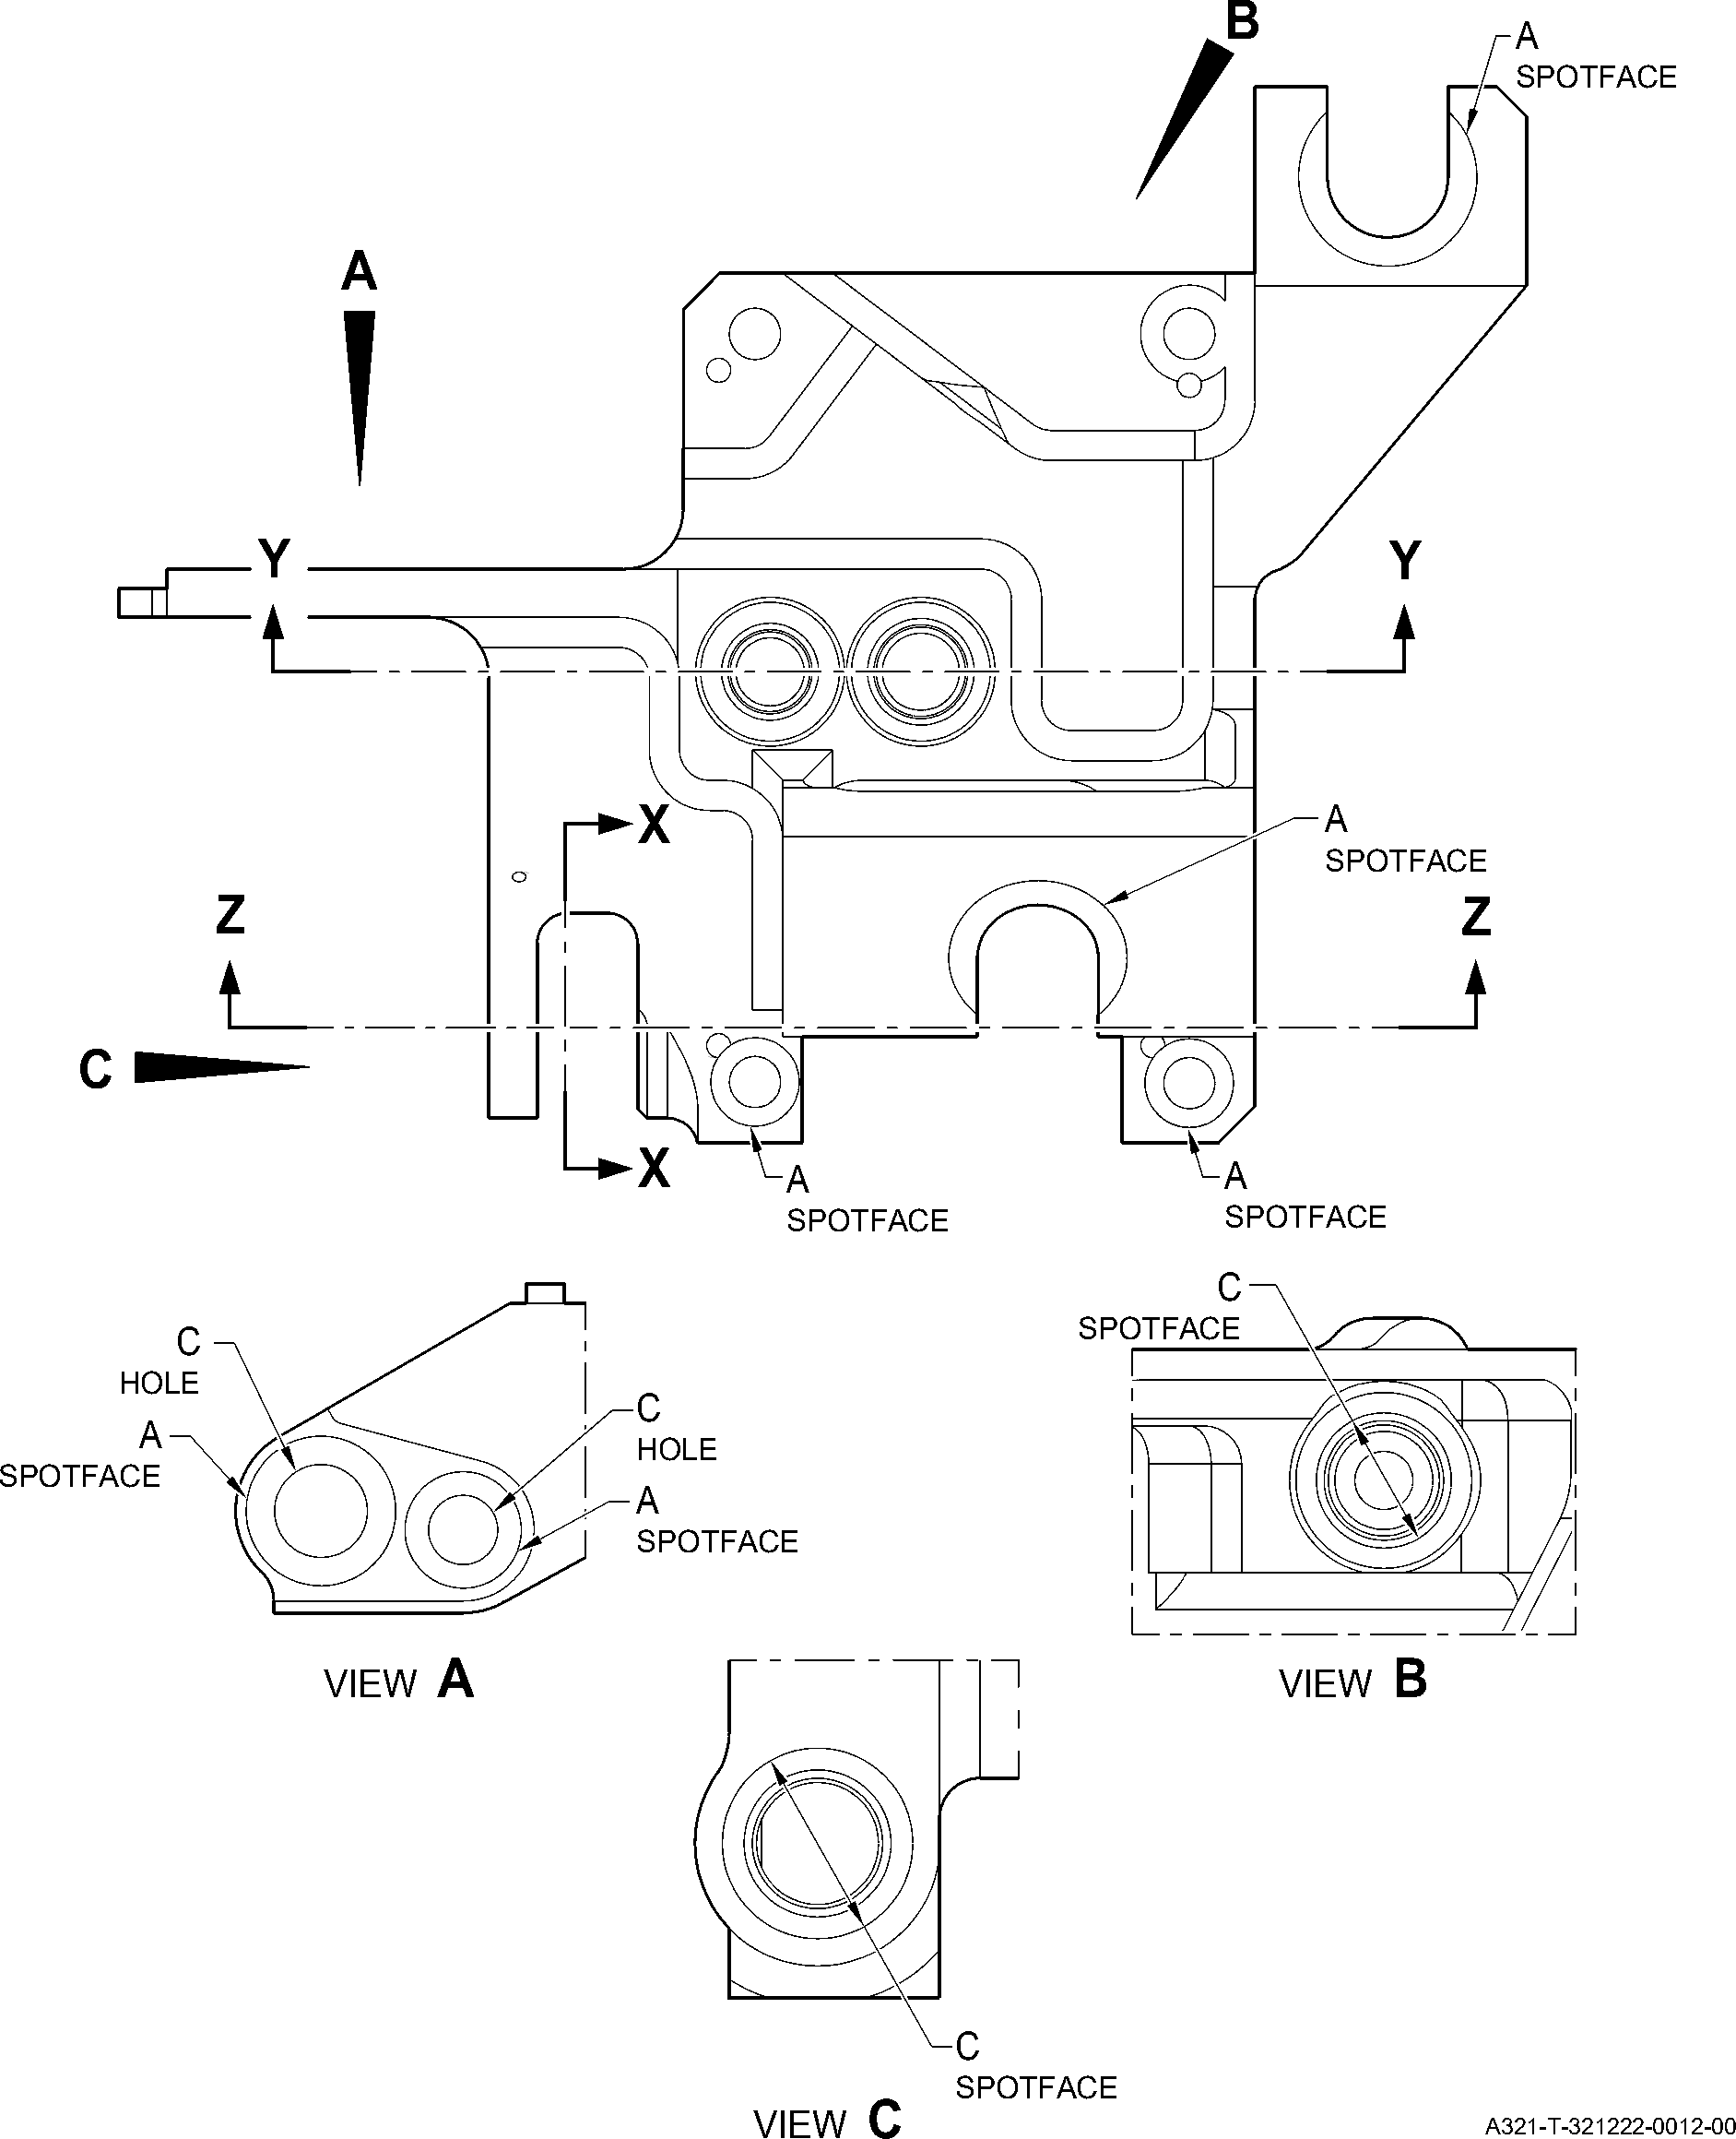
Transfer Block (2-340B and 2-350B) - Protective Treatment
Figure 635 - Sheet 1
32-12-22
Page 661
Mar 18/2025

SAFRAN LANDING SYSTEMS UK Ltd
CAGE: K0654

PART No. 201587001 AND 201587002 COMPONENT MAINTENANCE MANUAL
MAIN LANDING GEAR LEG
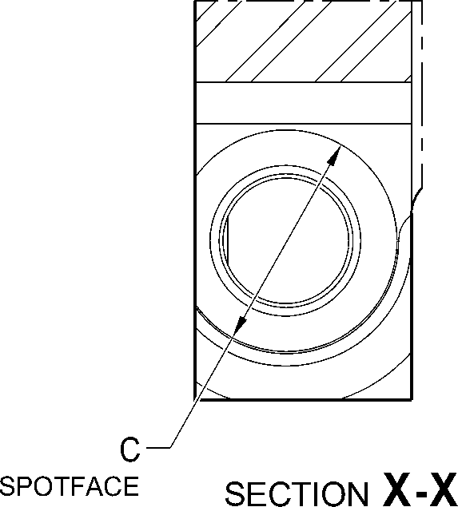
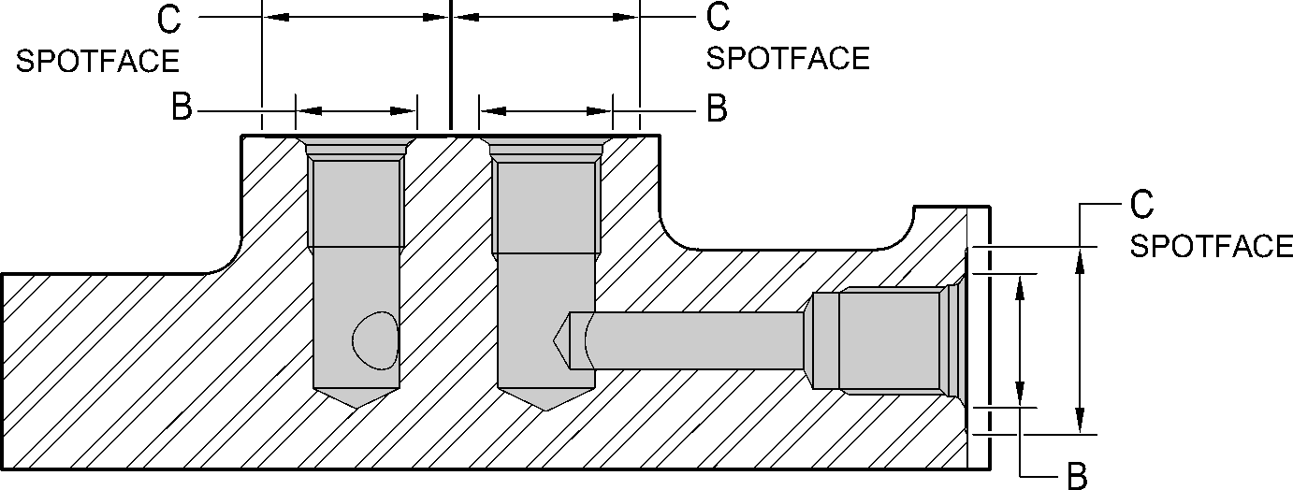
SECTION Y-Y
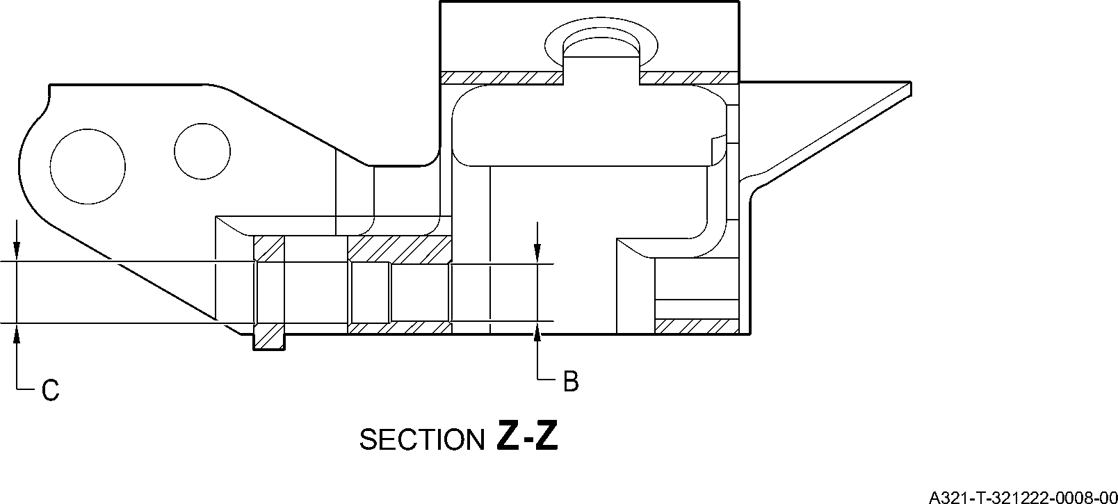
Transfer Block (2-340B and 2-350B) - Protective Treatment
Figure 635 - Sheet 2
32-12-22
Page 662
Mar 18/2025

SAFRAN LANDING SYSTEMS UK Ltd
CAGE: K0654

PART No. 201587001 AND 201587002 COMPONENT MAINTENANCE MANUAL
MAIN LANDING GEAR LEG
A
H
N
D
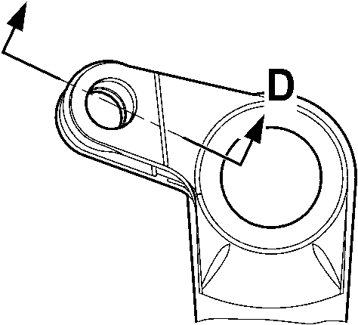
VIEW A
M
M
VIEW B
A321-T-321222-0020-00
Main Fitting (20-410B, 20-420B, 20-410C, 20-420C, 20-410D and 20-420D) - Protective Treatment
Figure 636 - Sheet 1
32-12-22
Page 663
Mar 18/2025
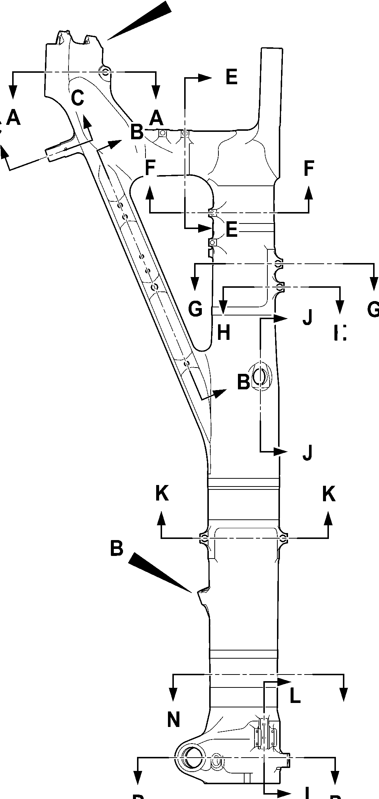
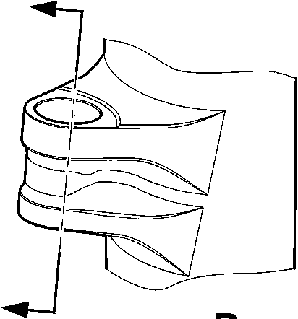

SAFRAN LANDING SYSTEMS UK Ltd
CAGE: K0654
PART No. 201587001 AND 201587002 COMPONENT MAINTENANCE MANUAL
MAIN LANDING GEAR LEG
C
C
5,000 to 7,000mm
0.1968 to 0.2755in)
40,000 to 50,000mm
(1.5747 to 1.9684in)
REF.
B
INCLUDING
CHAMFERS
B
INCLUDING
CHAMFERS
70,000 to 80,000mm
(2.7558 to 3.1495in)
REF.
C
5,000 to 7,000mm
(0.1968 to 0.2755in)
2 PLACES
B
B
RADIUS
TYPICAL
C
DIAMETER
THRU BORE
(0.7086 to 0.7480in) RAD.
INCLUDING CHAMFERS
TYPICAL 2 PLACES
B
SPOTFACE 18,000 to 19,000mm
B
SPOTFACE 14,000 to 15,000mm
(0.5511 to 0.5905in) RAD.
INCLUDING CHAMFERS
TYPICAL 2 PLACES
PINTLE BORES
FOR MAIN FITTING (20-410C
AND 20-420C) ONLY

B
RADIUS

SECTION A-A
PINTLE CROSS BORES
SECTION C-C
LOCK LINK BORE
C
B
11,500 to 12,500mm
(0.4527 to 0.4921in) RAD.
TYPICAL 2 PLACES
B
11,750 to 12,750mm
(0.4626 to 0.5019in) RAD.
B
10,750 to 11,750mm
(0.4232 to 0.462in) RAD.
TYPICAL 2 PLACES
C
TYPICAL
2 HOLES
C
TYPICAL
2 HOLES
SECTION B-B
DRAG ARM HOLES
FOR MAIN FITTING (20-410C, 20-420C) ONLY
A321-T-321222-0021-02
Main Fitting (20-410B, 20-420B, 20-410C, 20-420C, 20-410D and 20-420D) - Protective Treatment
Figure 636 - Sheet 2
32-12-22
Page 664
Mar 18/2025
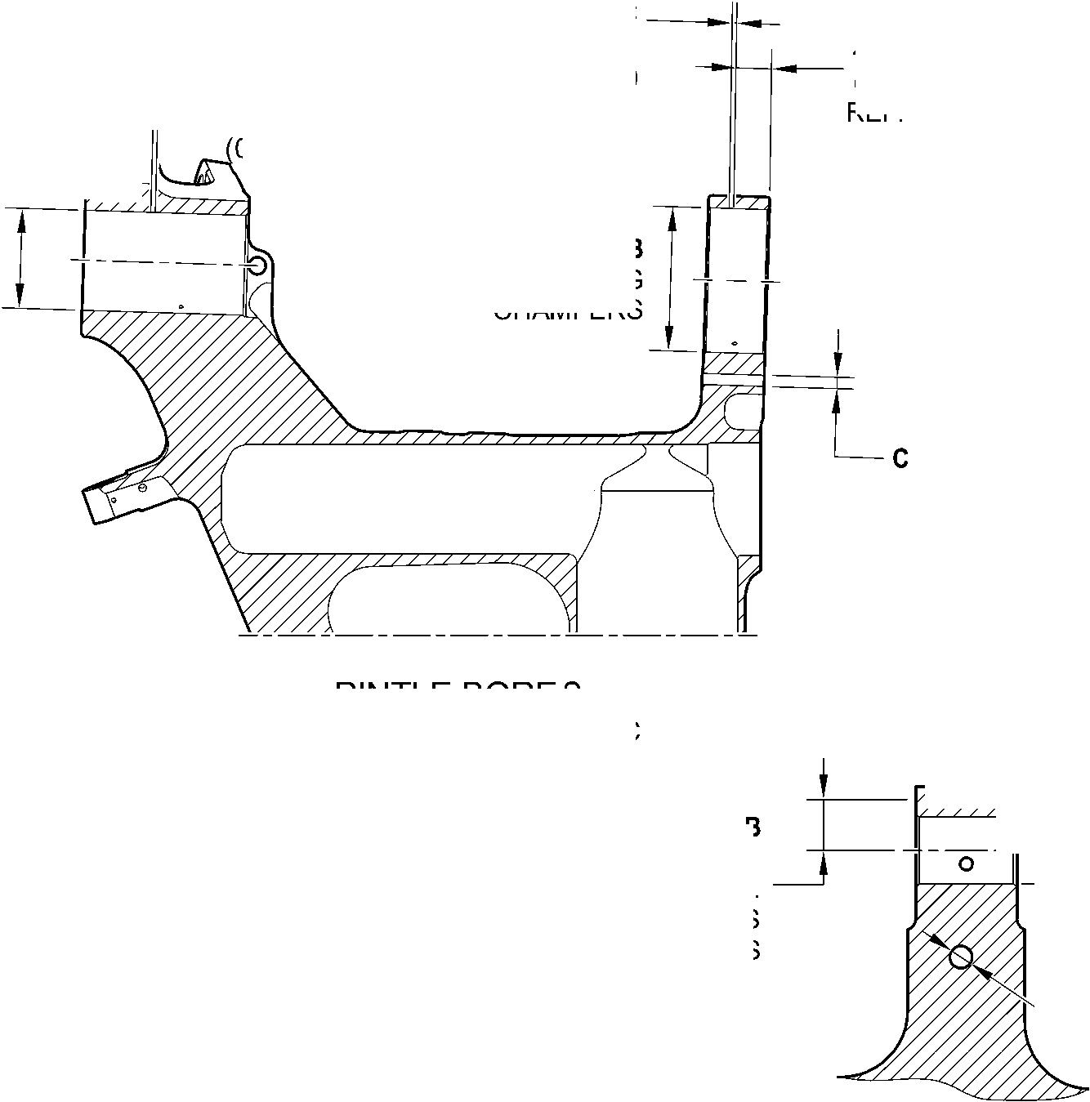
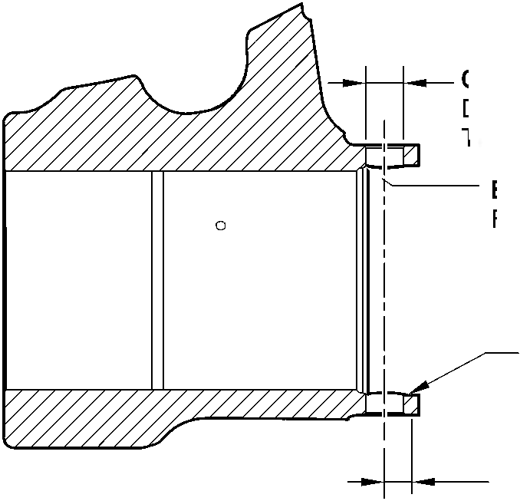
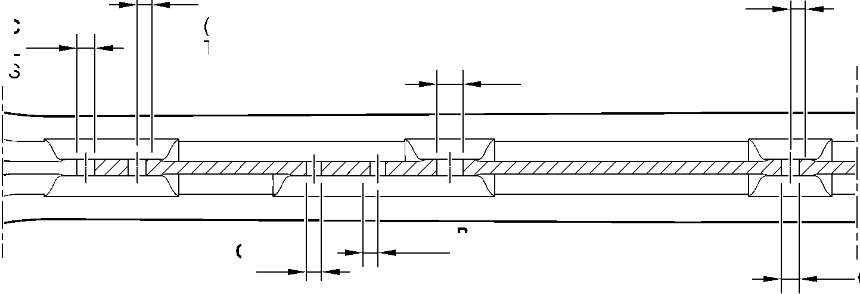

SAFRAN LANDING SYSTEMS UK Ltd
CAGE: K0654

PART No. 201587001 AND 201587002 COMPONENT MAINTENANCE MANUAL
MAIN LANDING GEAR LEG
14,000 to 16,000mm
(0.5511 to 0.6299in) REF.
B
30,000 to 31,000mm
(1.1810 to 1.2204in)
SPOTFACE RAD.
C
5,000 to 7,000mm
(0.1968 to 0.2755in)
TYPICAL 2 PLACES
B
35,500 to 36,500mm
(1.3976 to 1.4370in)
SPOTFACE RAD.
B
DIAMETERS THRU BORES
INCLUDING CHAMFERS
B
29,500 to 30,500mm
(1.1614 to 1.2007in)
SPOTFACE RAD.
B
51,500 to 52,500mm
(2.0275 to 2.0669in)
SPOTFACE RAD.
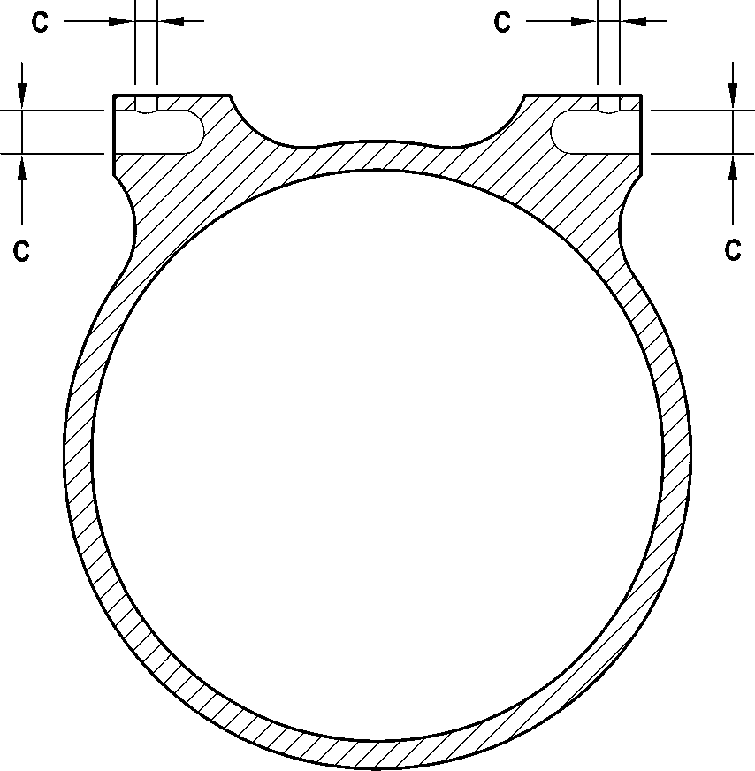
C
SECTION D-D
RETRACTION BORES
FOR MAIN FITTING (20-410C
AND 20-420C) ONLY
C
SECTION E-E
TYPICAL 2 TRANSFER BLOCK LUGS
SECTION F-F
TYPICAL 2 BRAKE MANIFOLD LUGS
C
B
CHAMFERS ONLY
TYPICAL 2 PLACES

SECTION G-G
UPPER DOOR LUGS
SECTION H-H
TOOLING LUG
FOR MAIN FITTING (20-410C
AND 20-420C) ONLY
A321-T-321222-0022-01
Main Fitting (20-410B, 20-420B, 20-410C, 20-420C, 20-410D and 20-420D) - Protective Treatment
Figure 636 - Sheet 3
32-12-22
Page 665
Mar 18/2025
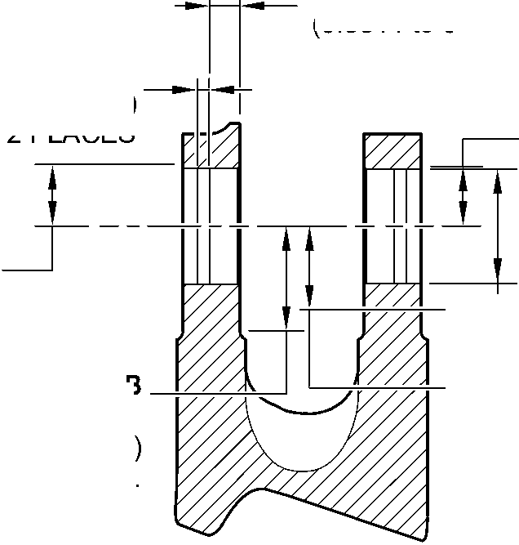
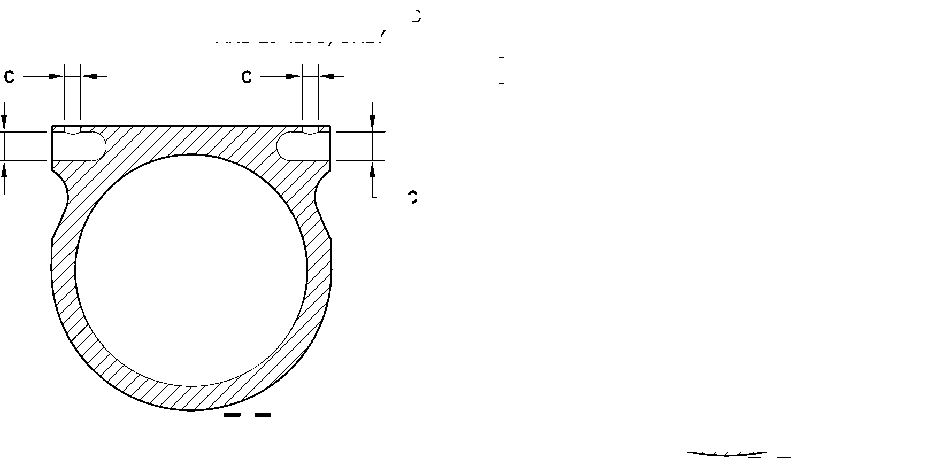
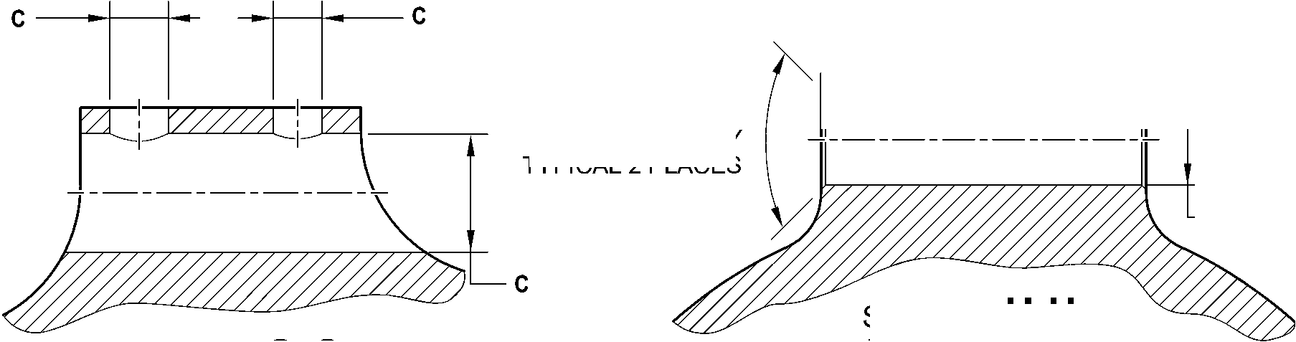

SAFRAN LANDING SYSTEMS UK Ltd
CAGE: K0654
PART No. 201587001 AND 201587002 COMPONENT MAINTENANCE MANUAL
MAIN LANDING GEAR LEG
B
51,500 to 52,500mm
(2.0275 to 2.0669in)
EXTENT
OF FINE LIMIT DIA.
C
5,000 to 7,000mm
(0.1968 to 0.2755in)
B
25,000 to 26,000mm
(0.9842 to 1.0236in)
EXTENT
OF FINE LIMIT DIA.
C
5,000 to 7,000mm
(0.1968 to 0.2755in)
C
2 LUGS
C
2 LUGS
C
2 LUGS
27,000 to 29,000
(1.0629 to 1.1417in)
REF.
B
52,500 to 53,500mm
(2.0669 to 2.1063in)
SPOTFACE RADIUS
INCLUDING CHAMFERS
NO CADMIUM
PLATE OR PAINT
BEYOND THIS LINE
B
DIAMETER THRU BORE
INCLUDING CHAMFERS
B
47,000 to 48,000mm
(1.8503 to 1.8897in)
SPOTFACE RADIUS
INCLUDING CHAMFERS
B
30,500 to 31,500mm
(1.2007 to 1.2401in)
SPOTFACE RADIUS
TYPICAL 2 PLACES
SECTION K-K
LOWER DOOR LUGS
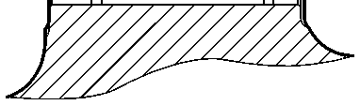
14,000 to 16,000mm
(0.5511 to 0.6299in)
REF.
SECTION M-M
LOWER CARDAN BORE
SECTION J-J
UPPER DIAPHRAGM TUBE
CROSS BORE
FOR MAIN FITTING (20-410C
AND 20-420C) ONLY
A321-T-321222-0023-01
Main Fitting (20-410B, 20-420B, 20-410C, 20-420C, 20-410D and 20-420D) - Protective Treatment
Figure 636 - Sheet 4
32-12-22
Page 666
Mar 18/2025
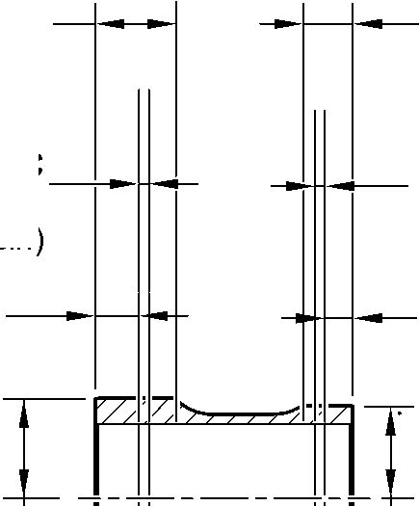
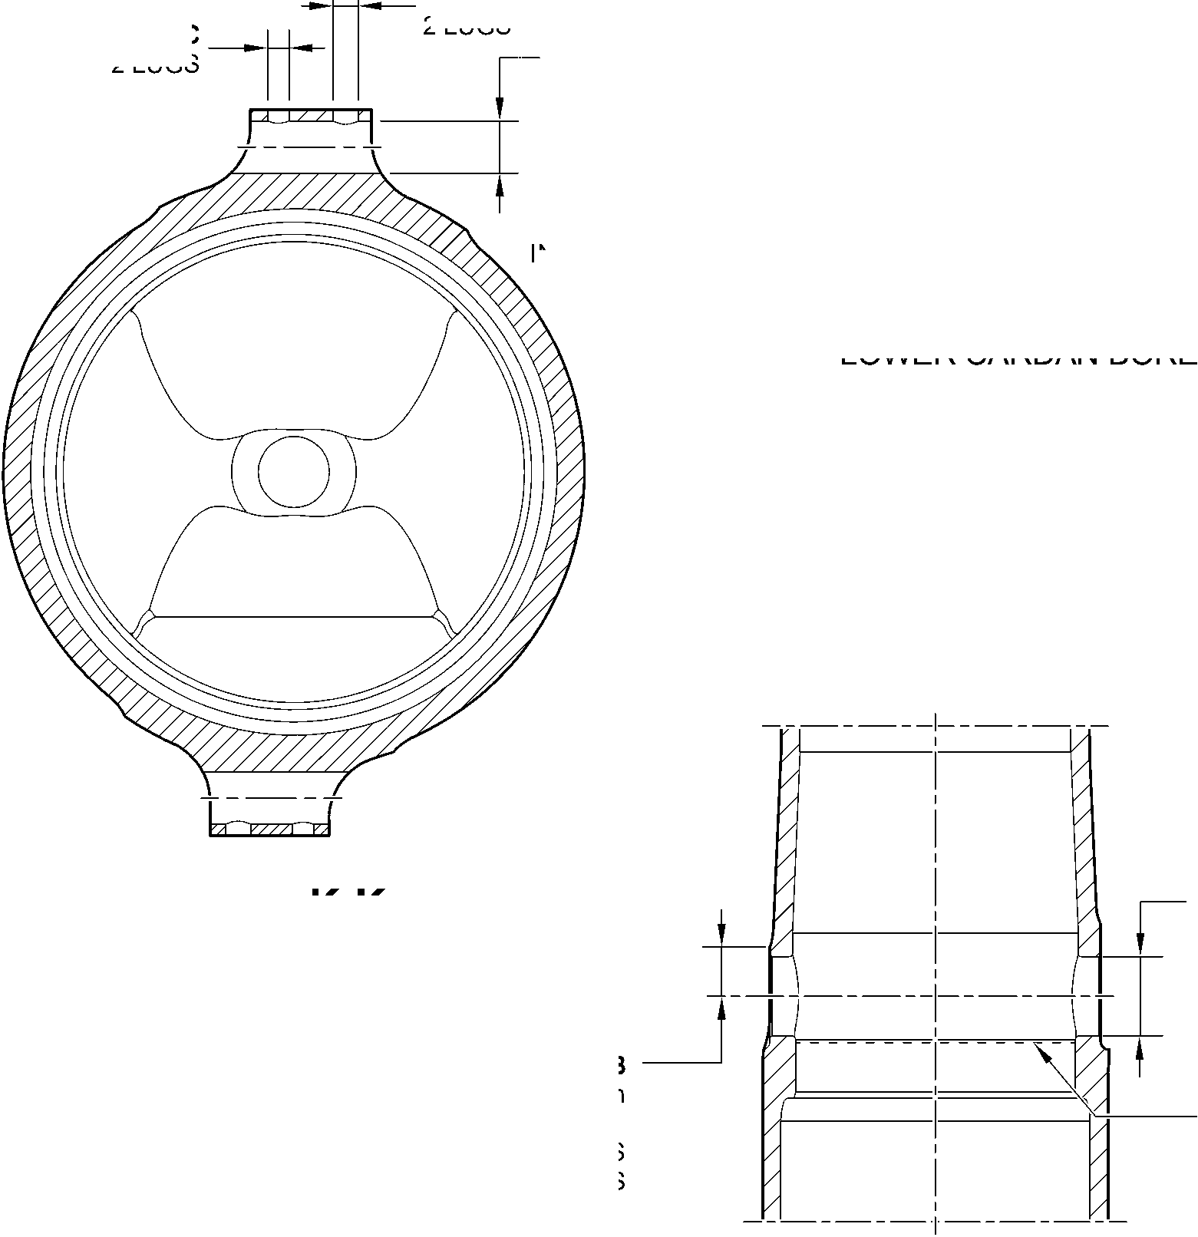

SAFRAN LANDING SYSTEMS UK Ltd
CAGE: K0654

PART No. 201587001 AND 201587002 COMPONENT MAINTENANCE MANUAL
MAIN LANDING GEAR LEG
B
4 HOLES
^{C}
9,000 to 10,000mm
(0.3543 to 0.3936in)
SPOTFACE RAD IUS
C
C
10,500 to 11,500mm
(0.4133 to 0.4527in)
RADIUS TYPICAL 2 PLACES
SECTION N-N
UPLOCK LUGS
22,000 to 24,000mm
(0.8661 to 0.9448in) REF.
C
5,000 to 7,000mm
(0.1968 to 0.2755in)
TYPICAL 2 PLACES
B
INCLUDING CHAMFER
TYPICAL 2 LUGS
B
DIAMETER
INCLUDING CHAMFER
3 BORES
D
B
34,500 to 35,500mm
(1.3583 to 1.3976in)
RADIUS
TYPICAL 2 PLACES
A and C
2 HOLES
B
TYPICAL
4 HOLES
SECTION L-L
CHANGE OVER VALVE
SECTION P-P
TORQUE LINK AND RETAINING PIN BORES
HOLES AND LUGS
A321-T-321222-0024-01
Main Fitting (20-410B, 20-420B, 20-410C, 20-420C, 20-410D and 20-420D) - Protective Treatment
Figure 636 - Sheet 5
32-12-22
Page 667
Mar 18/2025
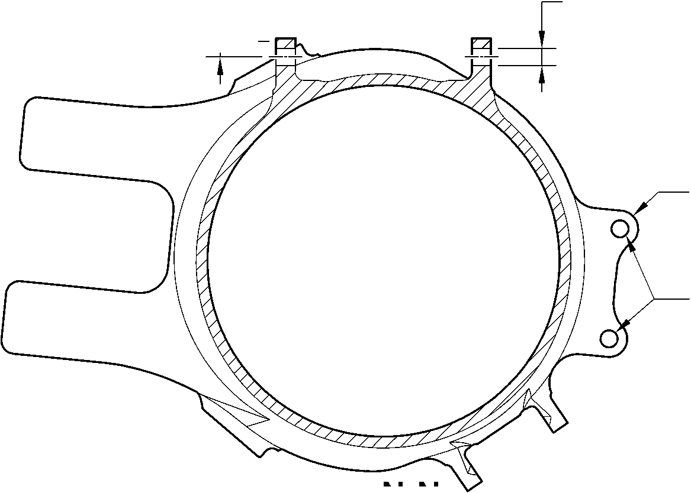
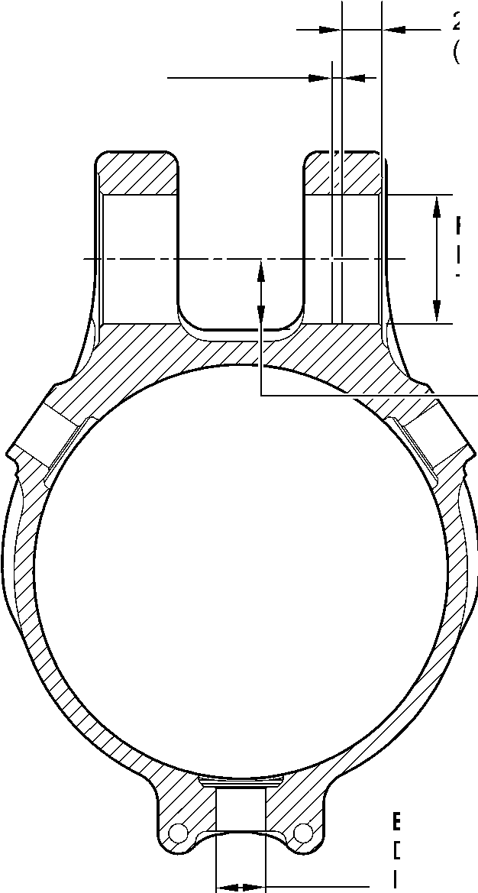
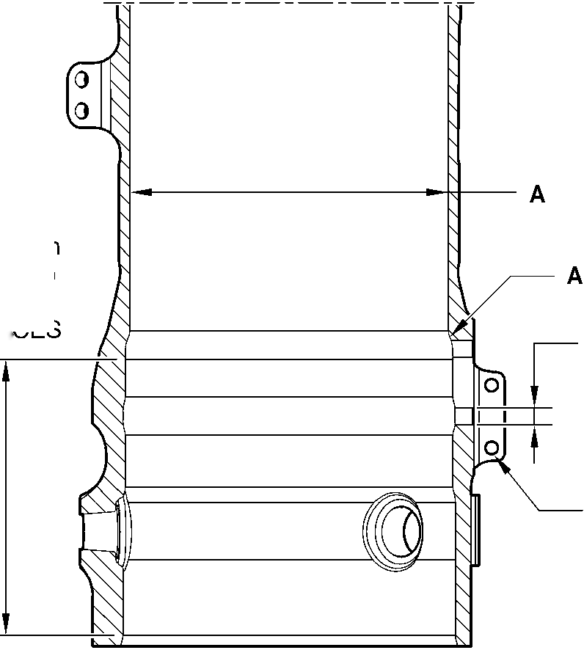

SAFRAN LANDING SYSTEMS UK Ltd
CAGE: K0654
PART No. 201587001 AND 201587002 COMPONENT MAINTENANCE MANUAL
MAIN LANDING GEAR LEG
C
E
5,000 to 7,000mm
(0.1968 to 0.2755in)
B
INCLUDING
CHAMFERS
C
5,000 to 7,000mm
(0.1968 to 0.2755in)
70,000 to 80,000mm
(2.7558 to 3.1495in)
REF.
B1
INCLUDING
CHAMFERS
C
40,000 to 50,000mm
(1.5747 to 1.9684in)
REF.
C
B
11,750 to 12,750mm
(0.4626 to 0.5019in) RAD.
PINTLE BORES
FOR MAIN FITTING (20-410B, 20-420B,
20-410D AND 20-420D) ONLY
C
B
10,750 to 11,750mm
(0.4232 to 0.462in) RAD.
TYPICAL 2 PLACES
C
TYPICAL
2 HOLES
14,000 to 16,000mm
(0.5511 to 0.6299in) REF.
C
5,000 to 7,000mm
(0.1968 to 0.2755in)
TYPICAL 2 PLACES
B
30,000 to 31,000mm
(1.1810 to 1.2204in)
SPOTFACE RAD.
B
DIAMETERS THRU BORES
INCLUDING CHAMFERS
B
35,500 to 36,500mm
(1.3976 to 1.4370in)
SPOTFACE RAD.
B
29,500 to 30,500mm
(1.1614 to 1.2007in)
SPOTFACE RAD.
section B-B
DRAG ARM HOLES
FOR MAIN FITTING (20-410B, 20-420B,
20-410D AND 20-420D) ONLY
B
50,500 to 51,500mm
(1.9881 to 2.0275in)
SPOTFACE RAD.
section D-D
RETRACTION BORES
FOR MAIN FITTING (20-410B, 20-420B,
20-410D AND 20-420D) ONLY
A321-T-32-12-22-125-1
Main Fitting (20-410B, 20-420B, 20-410D and 20-420D) - Protective Treatment
Figure 636 - Sheet 6
32-12-22
Page 668
Mar 18/2025
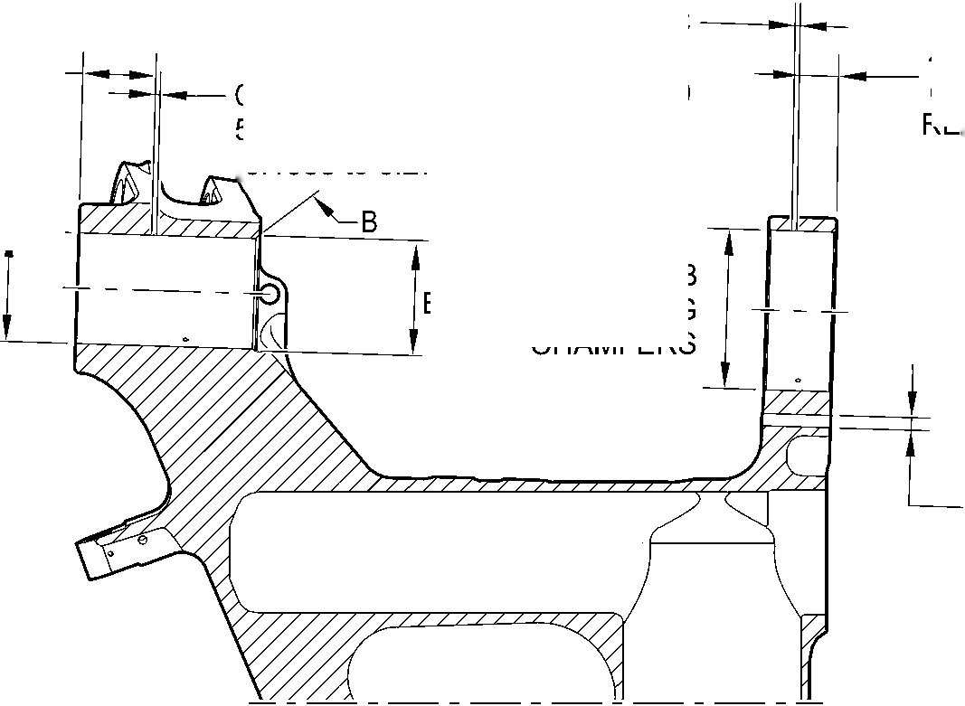
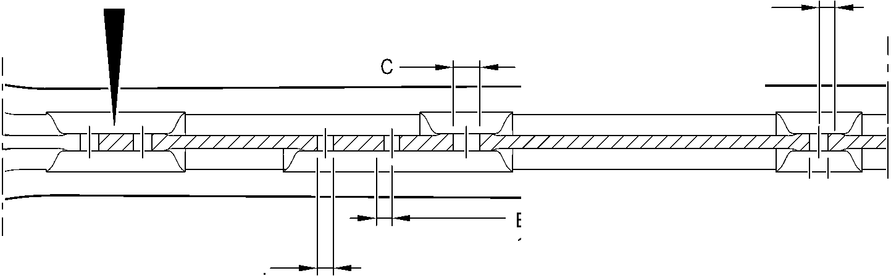
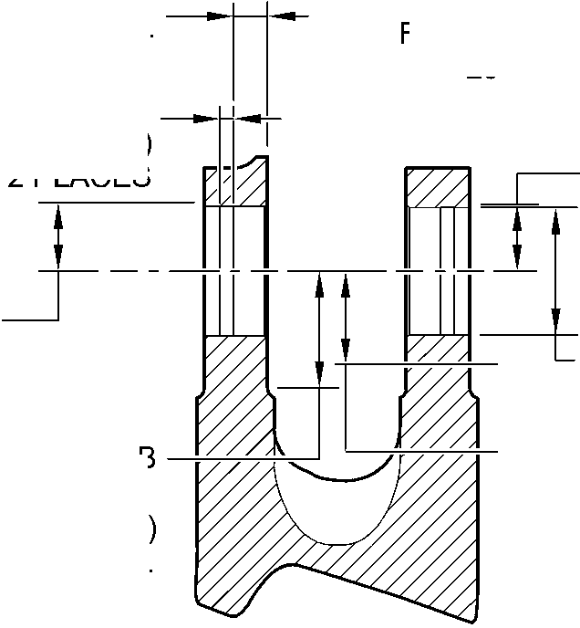

SAFRAN LANDING SYSTEMS UK Ltd
CAGE: K0654

PART No. 201587001 AND 201587002 COMPONENT MAINTENANCE MANUAL
MAIN LANDING GEAR LEG
’7ZZ777777ZZ777777ZA
C
B AND E
CHAMFERS ONLY
TYPICAL 2 PLACES
section H-H
TOOLING LUG
FOR MAIN FITTING (20-410B, 20-420B,
20-410D AND 20-420D) ONLY
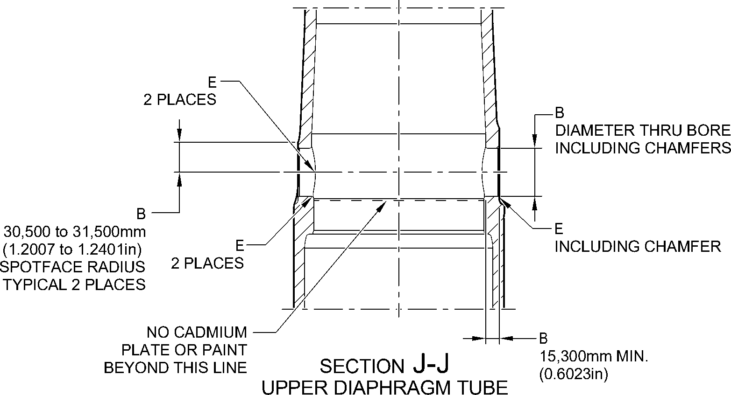
CROSS BORE
FOR MAIN FITTING (20-410B, 20-420B,
20-410D AND 20-420D) ONLY
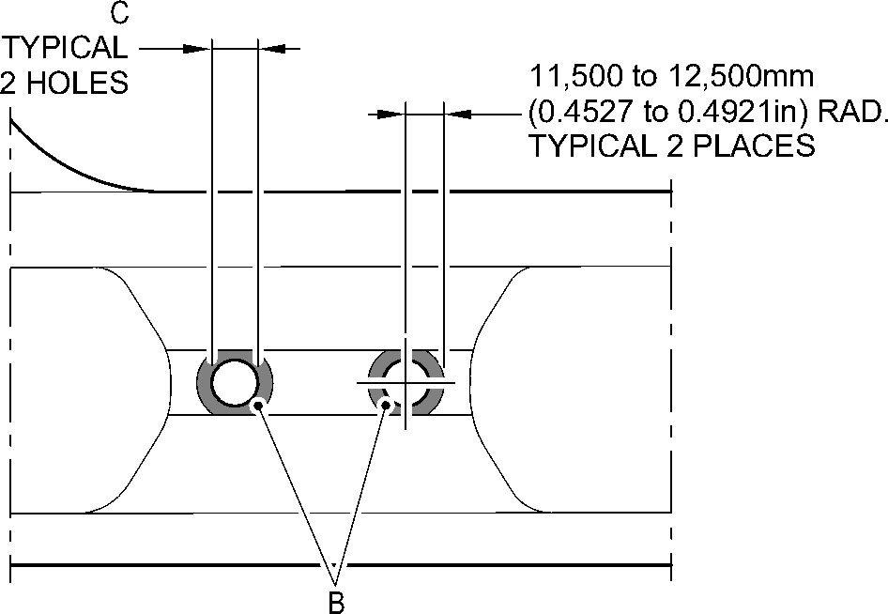
VIEW C
FOR MAIN FITTING (20-410B, 20-420B,
20-410D AND 20-420D) ONLY
A321-T-32-12-22-126-1
Main Fitting (20-410B, 20-420B, 20-410D and 20-420D) - Protective Treatment
Figure 636 - Sheet 7
32-12-22
Page 669
Mar 18/2025
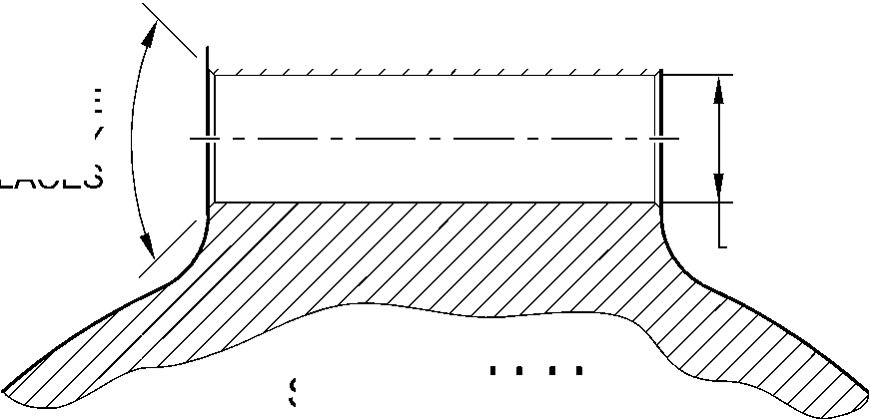

SAFRAN LANDING SYSTEMS UK Ltd
CAGE: K0654

PART No. 201587001 AND 201587002 COMPONENT MAINTENANCE MANUAL
MAIN LANDING GEAR LEG
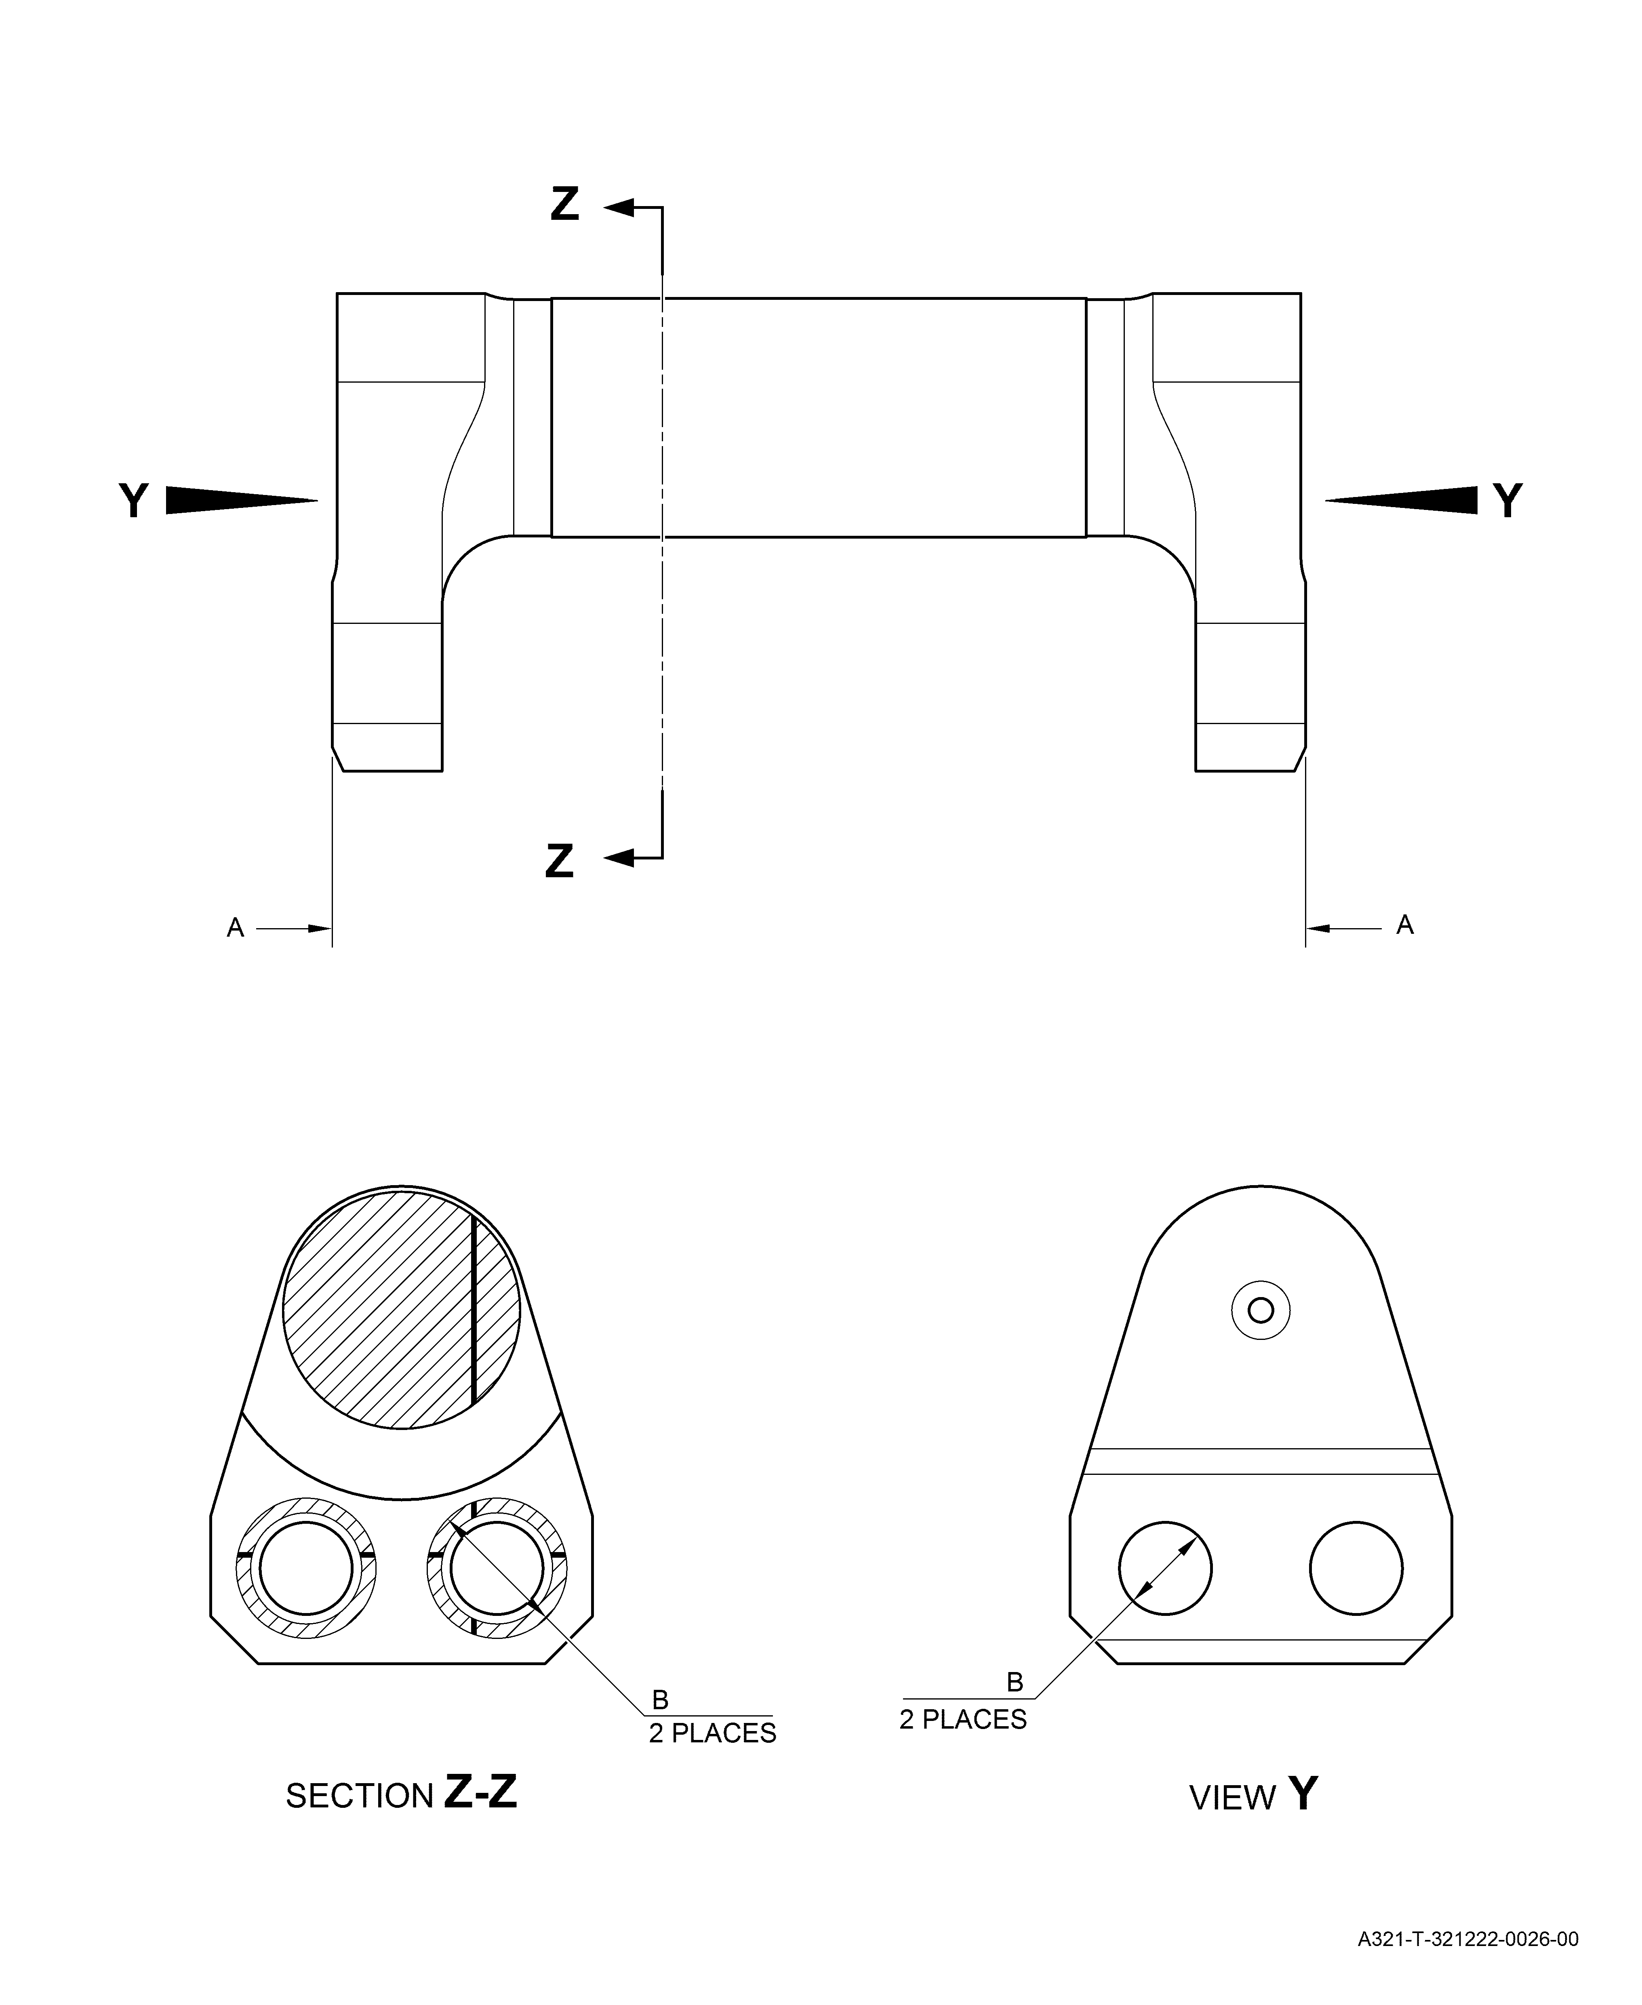
Uplock Pin (5-400A) - Protective Treatment
Figure 637
Page 670
3⁻⁻ Mar 18/2025

SAFRAN LANDING SYSTEMS UK Ltd
CAGE: K0654
Main Fitting Subassembly (20-90B and 20-100B) - Protective Treatment
Figure 638 - Sheet 1
PART No. 201587001 AND 201587002 COMPONENT MAINTENANCE MANUAL
MAIN LANDING GEAR LEG
32-12-22
Page 671
Mar 18/2025
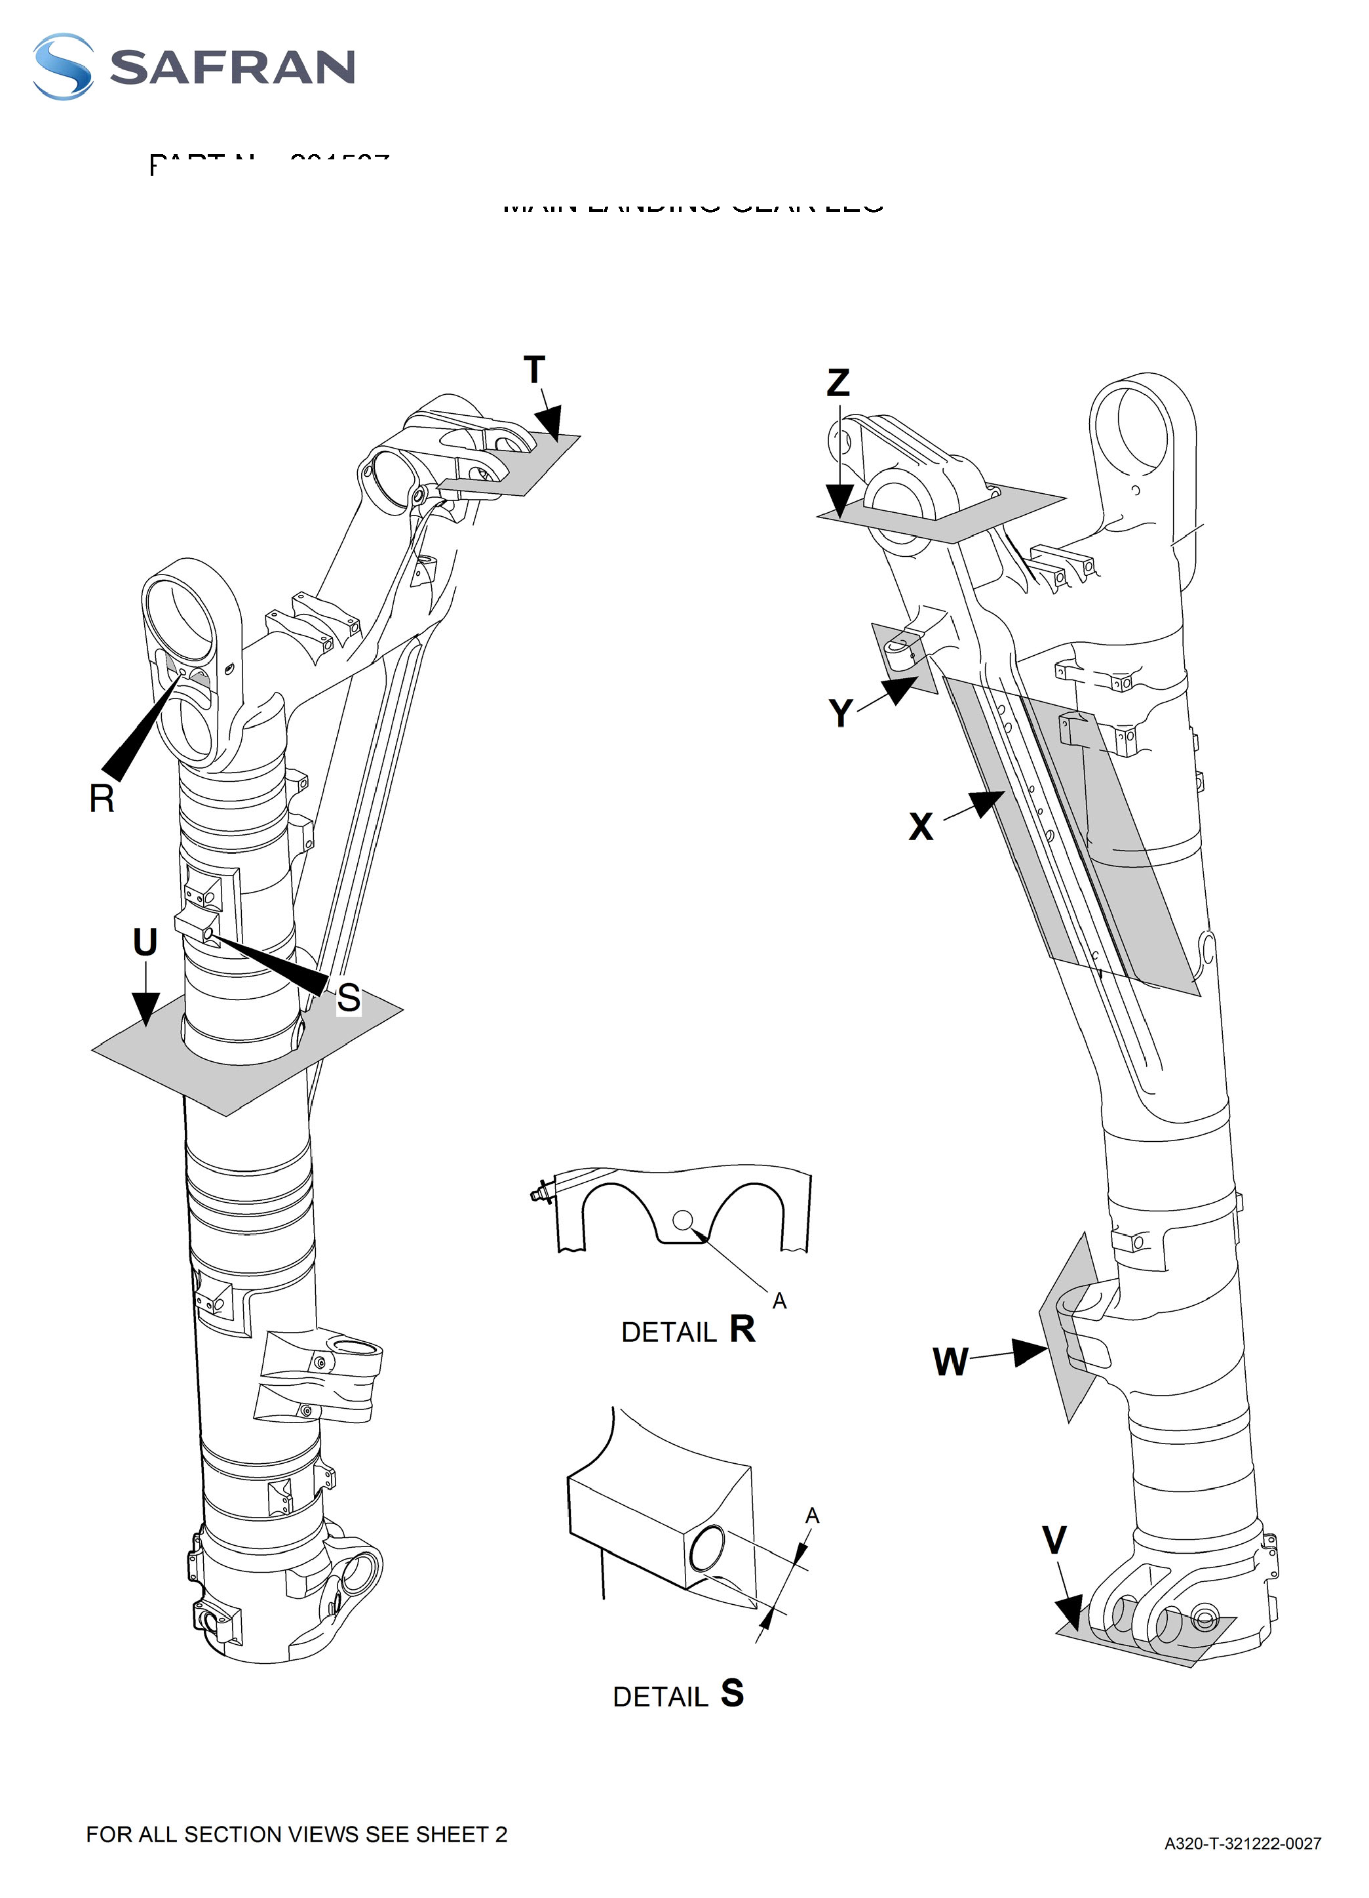

SAFRAN LANDING SYSTEMS UK Ltd
CAGE: K0654

PART No. 201587001 AND 201587002 COMPONENT MAINTENANCE MANUAL
MAIN LANDING GEAR LEG
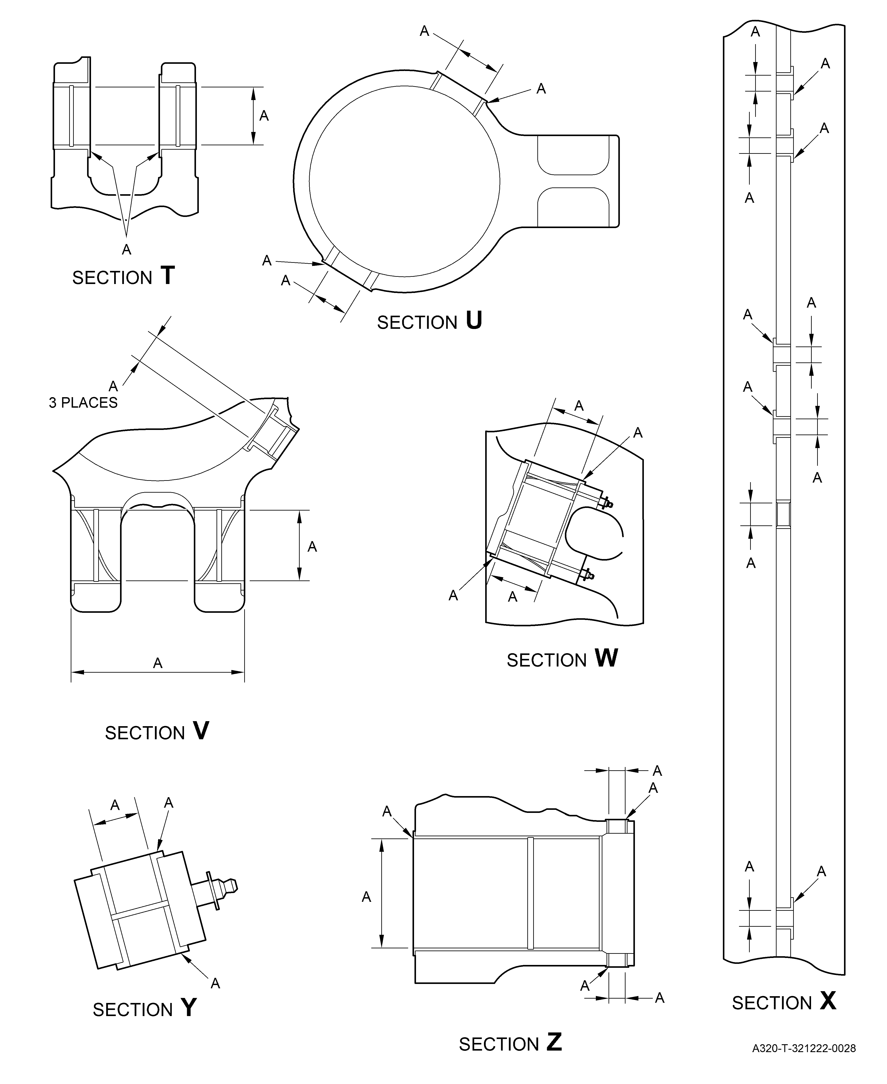
Main Fitting Subassembly (20-90B and 20-100B) - Protective Treatment
Figure 638 - Sheet 2
32-12-22
Page 672
Mar 18/2025

SAFRAN LANDING SYSTEMS UK Ltd
CAGE: K0654

PART No. 201587001 AND 201587002 COMPONENT MAINTENANCE MANUAL
MAIN LANDING GEAR LEG
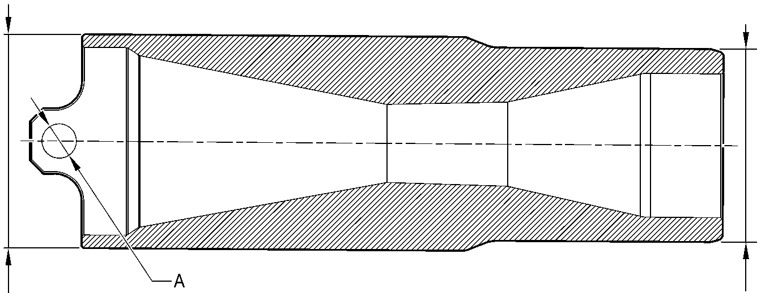
CHROMIUM PLATED ^{TWO PLACES}
SURFACE
SECTION A-A
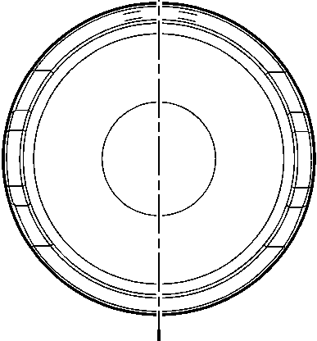
CHROMIUM PLATED
SURFACE
A321-T-32-12-22-124-0
Forward Pintle Pin (1-60A) - Protective Treatment
Figure 639
32-12-22
Page 673
Mar 18/2025

SAFRAN LANDING SYSTEMS UK Ltd
CAGE: K0654

PART No. 201587001 AND 201587002 COMPONENT MAINTENANCE MANUAL
MAIN LANDING GEAR LEG
A
A
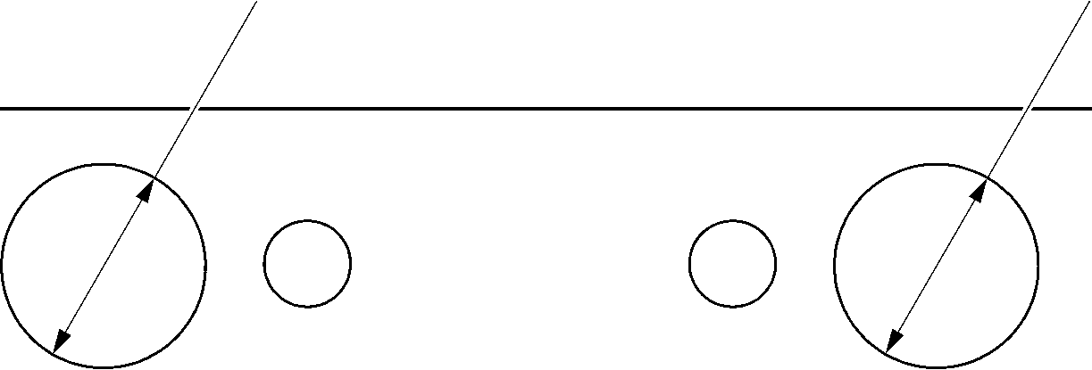
A321-T-32-12-22-131-00
Spacer (4-180) Only - Protective Treatment
Figure 640
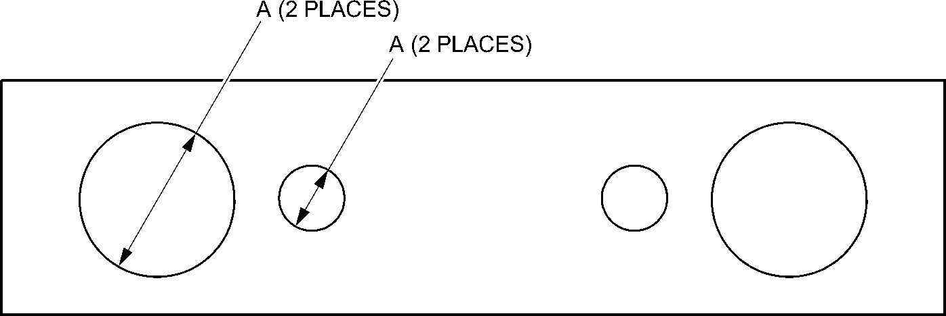
A321-T-32-12-22-132-00
Drag-arm Spacer (4-180A) - Protective Treatment
Figure 641
32-12-22
Page 674
Mar 18/2025

SAFRAN LANDING SYSTEMS UK Ltd
CAGE: K0654
PART No. 201587001 AND 201587002 COMPONENT MAINTENANCE MANUAL
MAIN LANDING GEAR LEG
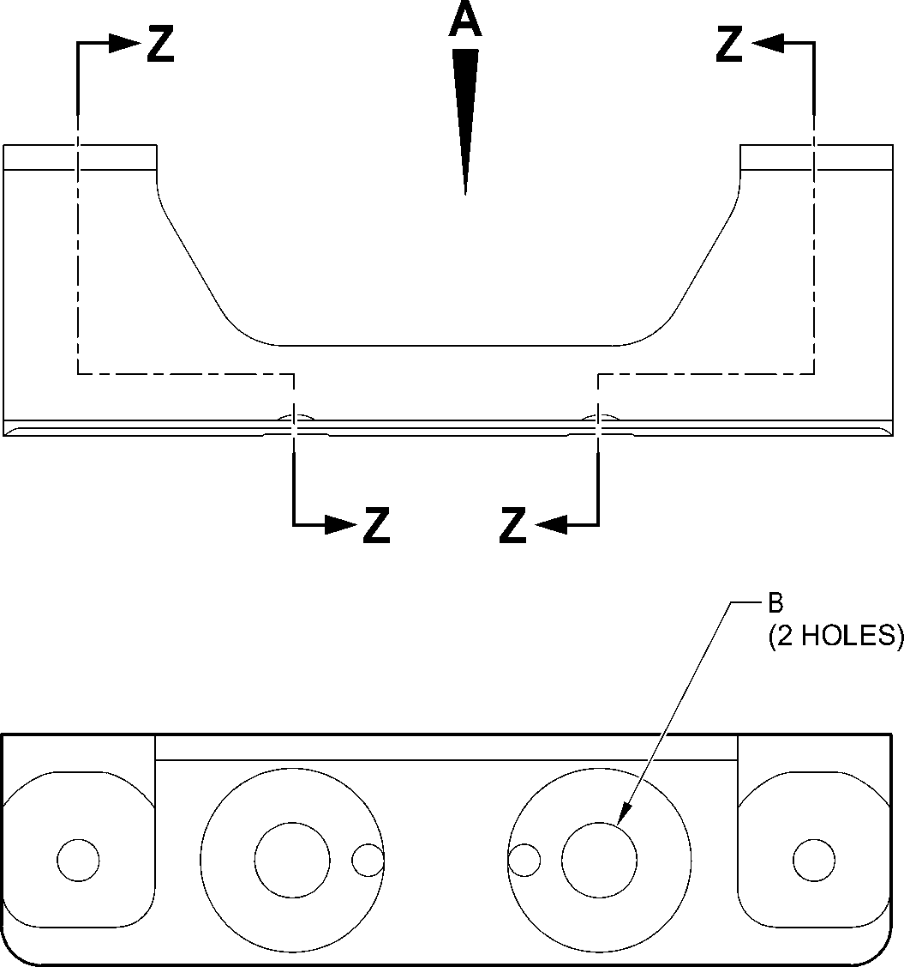
VIEW A
A
23,750 to 24,250mm
(0.9351 to 0.9547in) DIA.
SPOTFACE
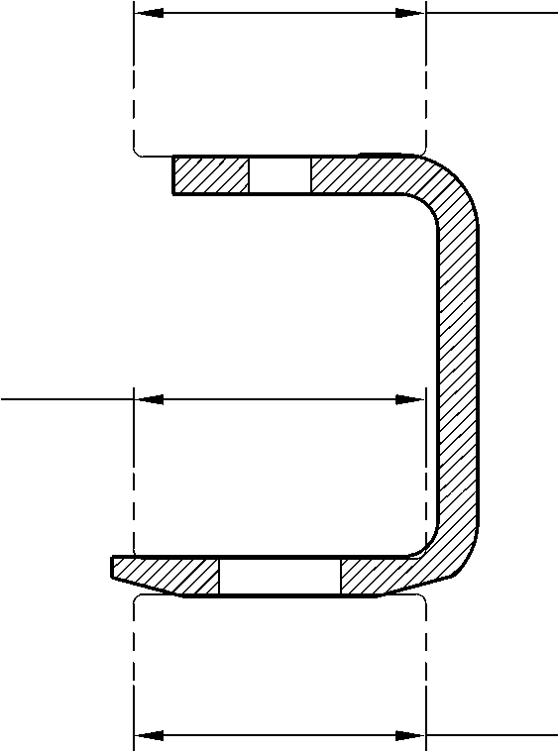
A
23,750 to 24,250mm
(0.9351 to 0.9547in) DIA.
SPOTFACE
A
23,750 to 24,250mm
(0.9351 to 0.9547in) DIA.
SPOTFACE
SECTION Z-Z
TYPICAL
A321-T-32-12-22-106-0
Bracket (4-210) - Protective Treatment
Figure 642
32-12-22
Page 675
Mar 18/2025

SAFRAN LANDING SYSTEMS UK Ltd
CAGE: K0654

PART No. 201587001 AND 201587002 COMPONENT MAINTENANCE MANUAL
MAIN LANDING GEAR LEG
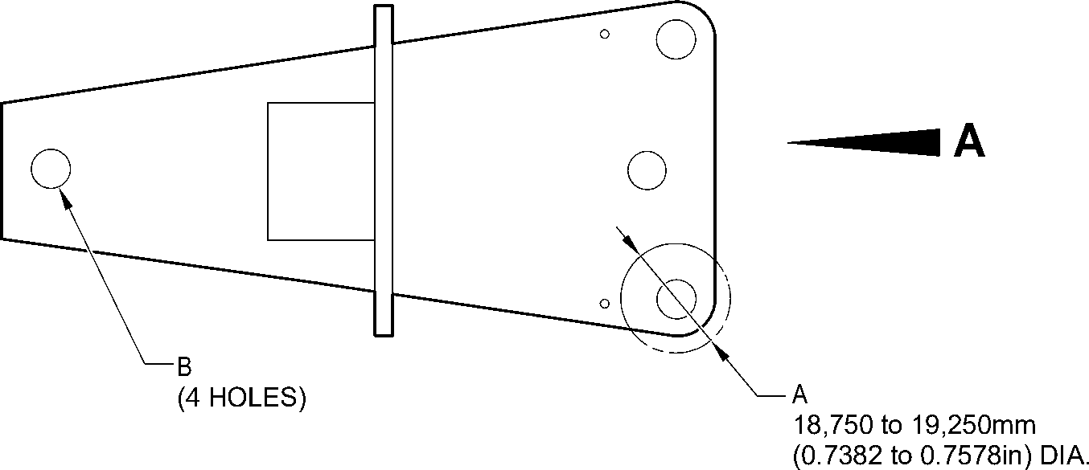
SPOTFACE
(BOTH SIDES)
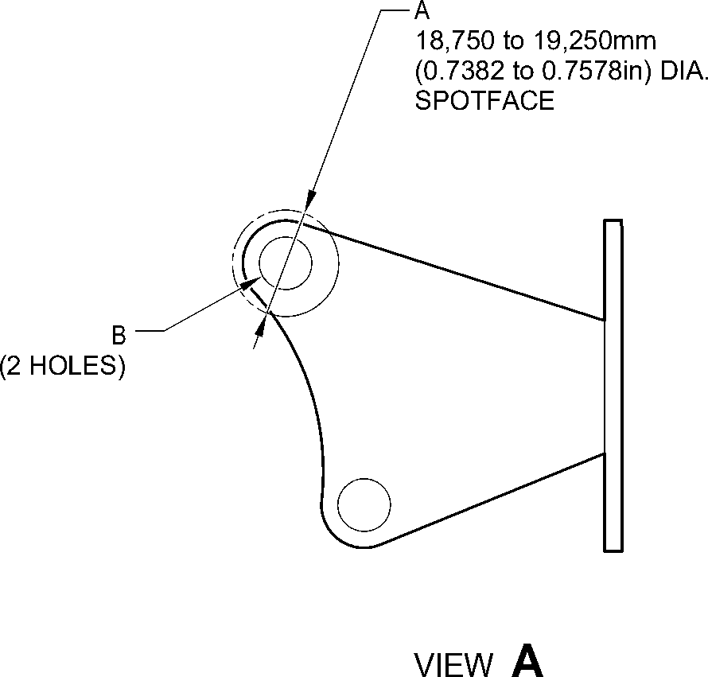
A321-T-32-12-22-103-0
Bracket (9-150) Only - Protective Treatment
Figure 643
32-12-22
Page 676
Mar 18/2025

SAFRAN LANDING SYSTEMS UK Ltd
CAGE: K0654

PART No. 201587001 AND 201587002 COMPONENT MAINTENANCE MANUAL
MAIN LANDING GEAR LEG
A
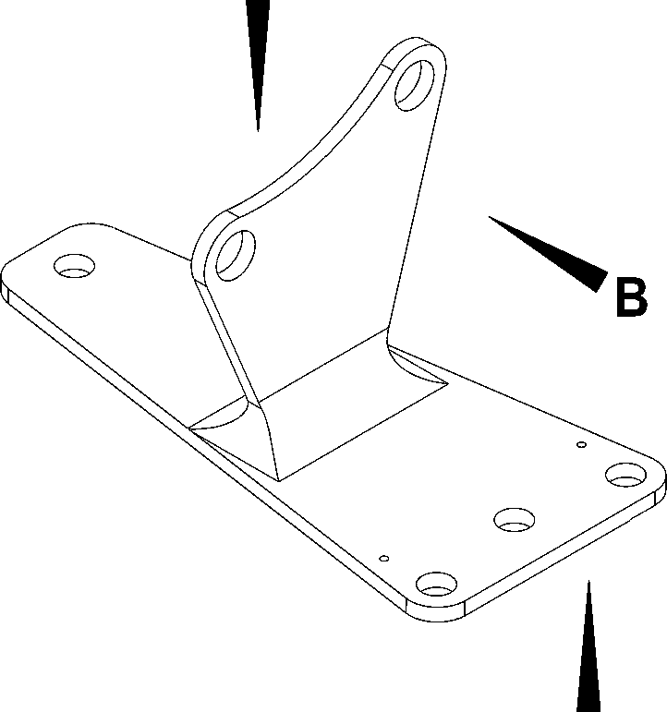
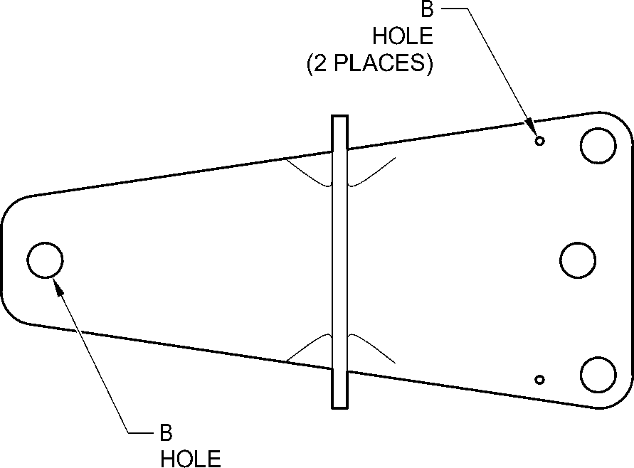
(4 PLACES)
VIEW A
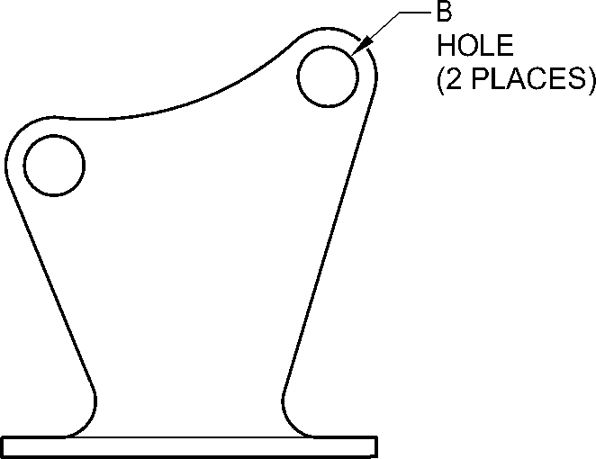
VIEW B
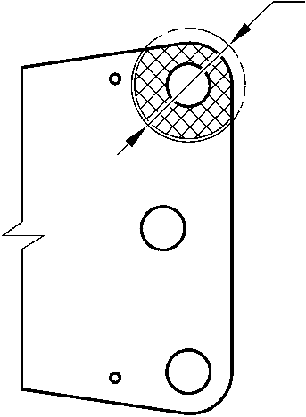
A
18,750 to 19,250mm
(0.7382 to 0.7578in) DIA.
SPOTFACE
VIEW C
A321-T-32-12-22-105-0
Bracket (9-150A) - Protective Treatment
Figure 644
32-12-22
Page 677
Mar 18/2025

SAFRAN LANDING SYSTEMS UK Ltd
CAGE: K0654

PART No. 201587001 AND 201587002 COMPONENT MAINTENANCE MANUAL
MAIN LANDING GEAR LEG
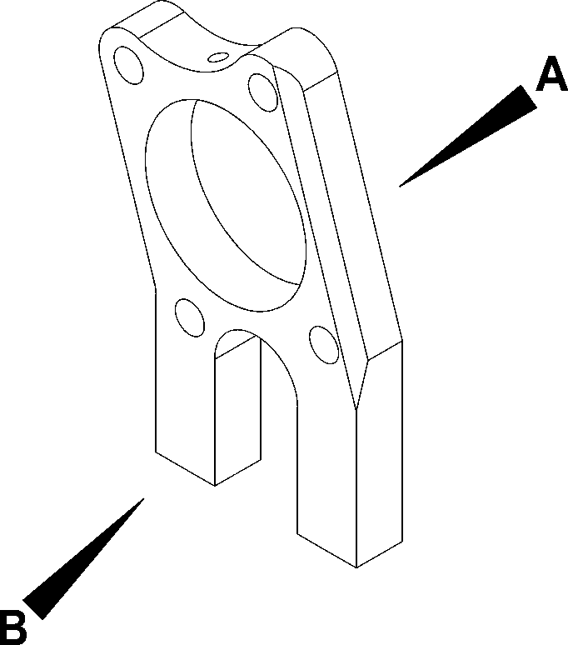
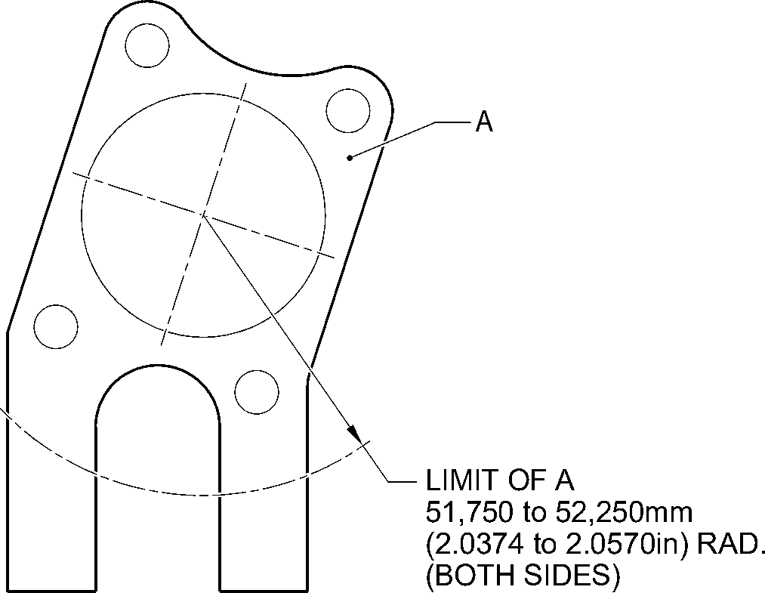
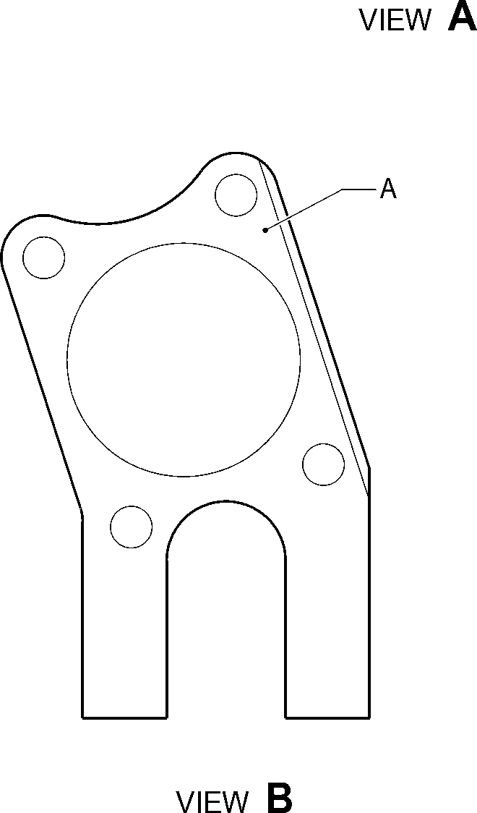
A321-T-32-12-22-102-0
Spacer (9-190) Only - Protective Treatment
Figure 645
32-12-22
Page 678
Mar 18/2025

SAFRAN LANDING SYSTEMS UK Ltd
CAGE: K0654

PART No. 201587001 AND 201587002 COMPONENT MAINTENANCE MANUAL
MAIN LANDING GEAR LEG
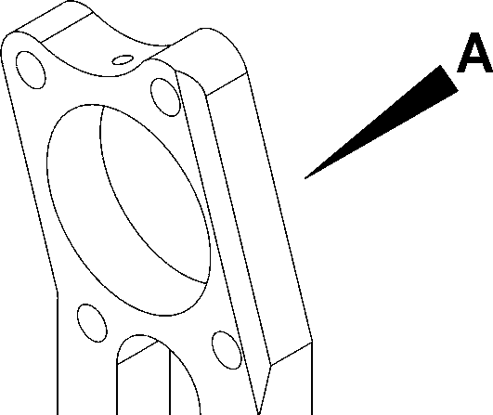
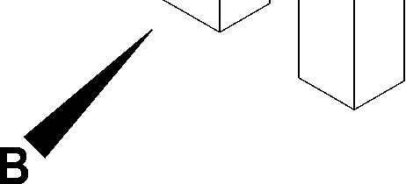
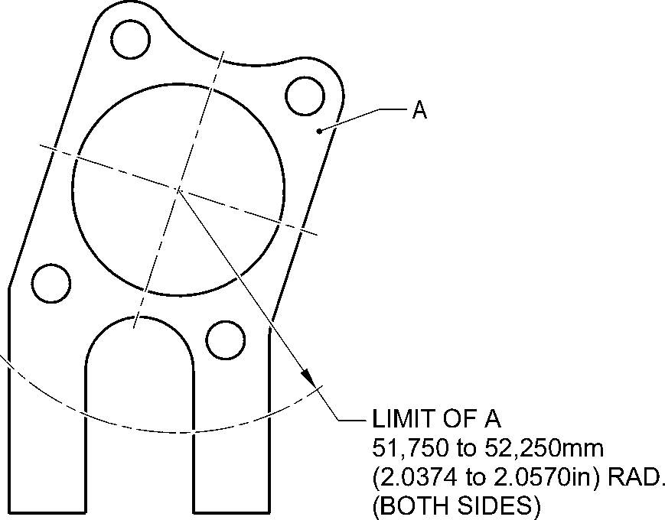
VIEW A
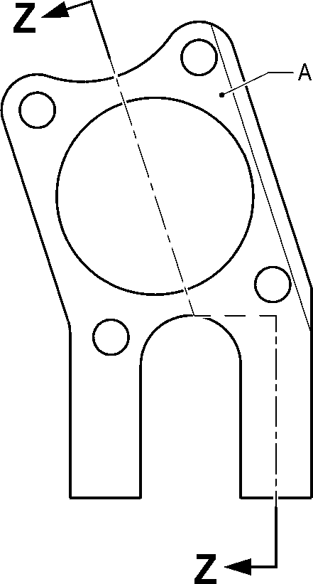
VIEW B
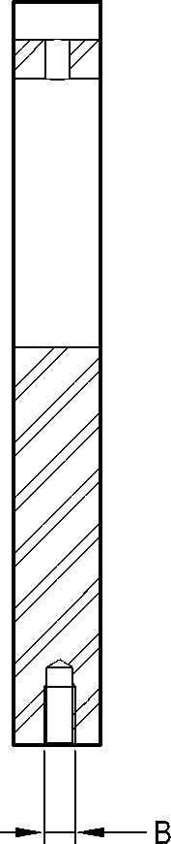
(2 PLACES)
SECTION Z-Z
A321-T-32-12-22-104-0
Spacer (9-190A) - Protective Treatment
Figure 646
32-12-22
Page 679
Mar 18/2025

SAFRAN LANDING SYSTEMS UK Ltd
CAGE: K0654
PART No. 201587001 AND 201587002 COMPONENT MAINTENANCE MANUAL
MAIN LANDING GEAR LEG
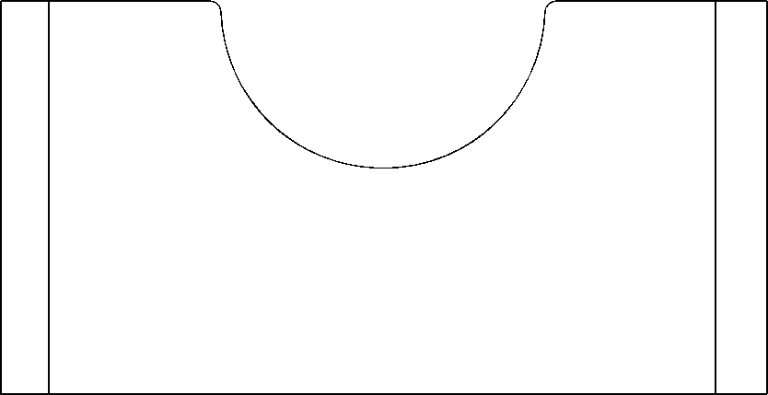
A
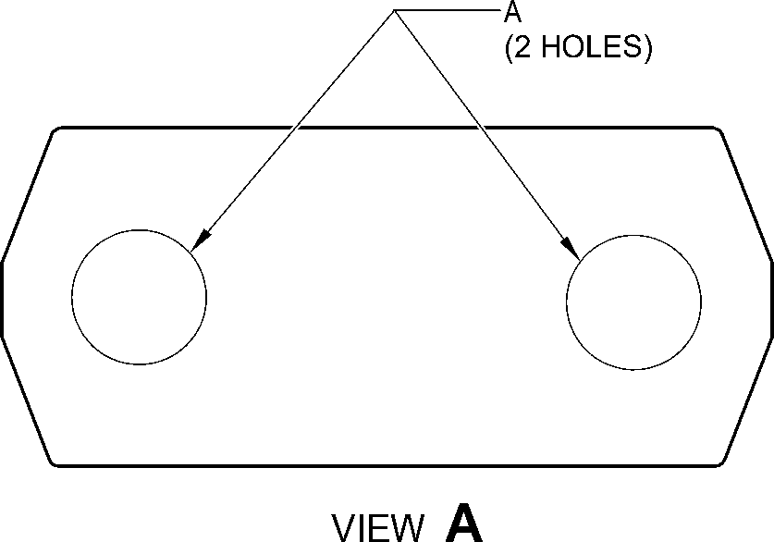
A321-T-32-12-22-101-0
Spacer (11-30) - Protective Treatment
Figure 647
32-12-22
Page 680
Mar 18/2025

SAFRAN LANDING SYSTEMS UK Ltd
CAGE: K0654
PART No. 201587001 AND 201587002 COMPONENT MAINTENANCE MANUAL
MAIN LANDING GEAR LEG
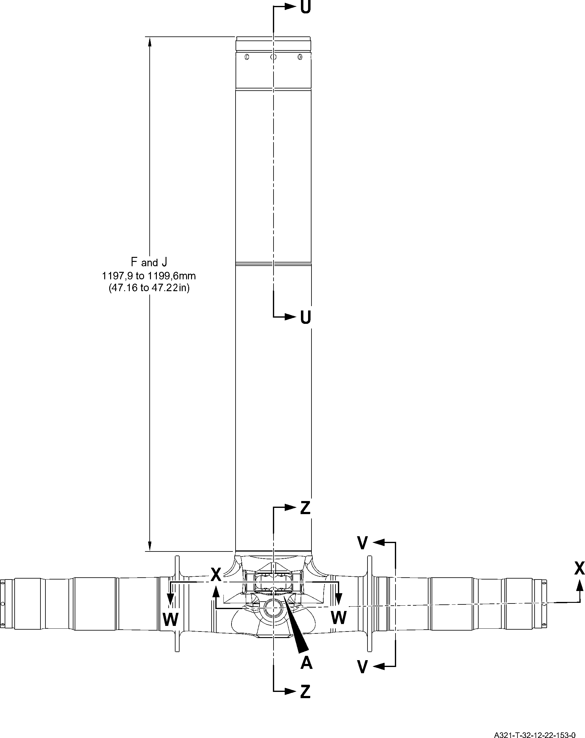
Sliding tube (18-80D, 18-80E, 18-80F and 18-80G) - Protective Treatment
Figure 648 - Sheet 1
32-12-22
Page 681
Mar 18/2025

SAFRAN LANDING SYSTEMS UK Ltd
CAGE: K0654
PART No. 201587001 AND 201587002 COMPONENT MAINTENANCE MANUAL
MAIN LANDING GEAR LEG
C
Y
Y
C and G
17,750 to 18,250mm
(0.6988 to 0.7185in)
C and G
71,750 to 72,250mm
(2.8248 to 2.8444in) DIA.
16,750 to 17,250mm
(0.6595 to 0.6791in)
C and J

SECTION Z-Z
KNUCKLE BORES
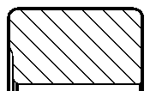
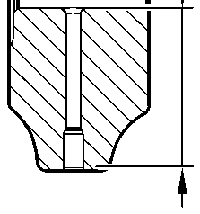
F and J
TYPICAL
2 PLACES
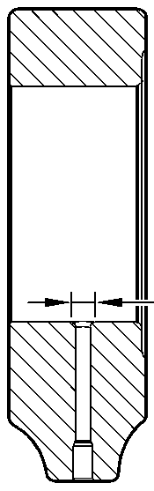
SECTION Y-Y
KNUCKLE TOOLING LUG
GREASE HOLES
D
F and H
TYPICAL
2 PLACES
INCLUDING
RADIUS
D
19,500 to 20,500mm
(0.7677 to 0.8070in)
A and J
119,929 to 119,964mm
(4.7216 to 4.7229in) DIA.
A and J
126,917 to 126,957mm
(4.9967 to 4.9982in) DIA.
G
G
220,000mm
(8.6614in) MIN.
A and J
131,294 to 131,357mm
(5.1690 to 5.1715in) DIA.
limit of D
25,000mm
(0.9842in) DIA. MAX.
12 PLACES
95,500 to 107,500mm
(3.7598 to 4.2323in)
EXTERNAL THICK ZINC-NICKEL
PLATING LIMIT
84,000 to 96,000mm
(3.3071 to 3.7795in)
INTERNAL THICK ZINC-NICKEL
PLATING LIMIT
SECTION X-X
(BOTH SIDES)
AXLE BORE
A321-T-32-12-22-154-0
Sliding tube (18-80D, 18-80E, 18-80F and 18-80G) - Protective Treatment
Figure 648 - Sheet 2
32-12-22
Page 682
Mar 18/2025
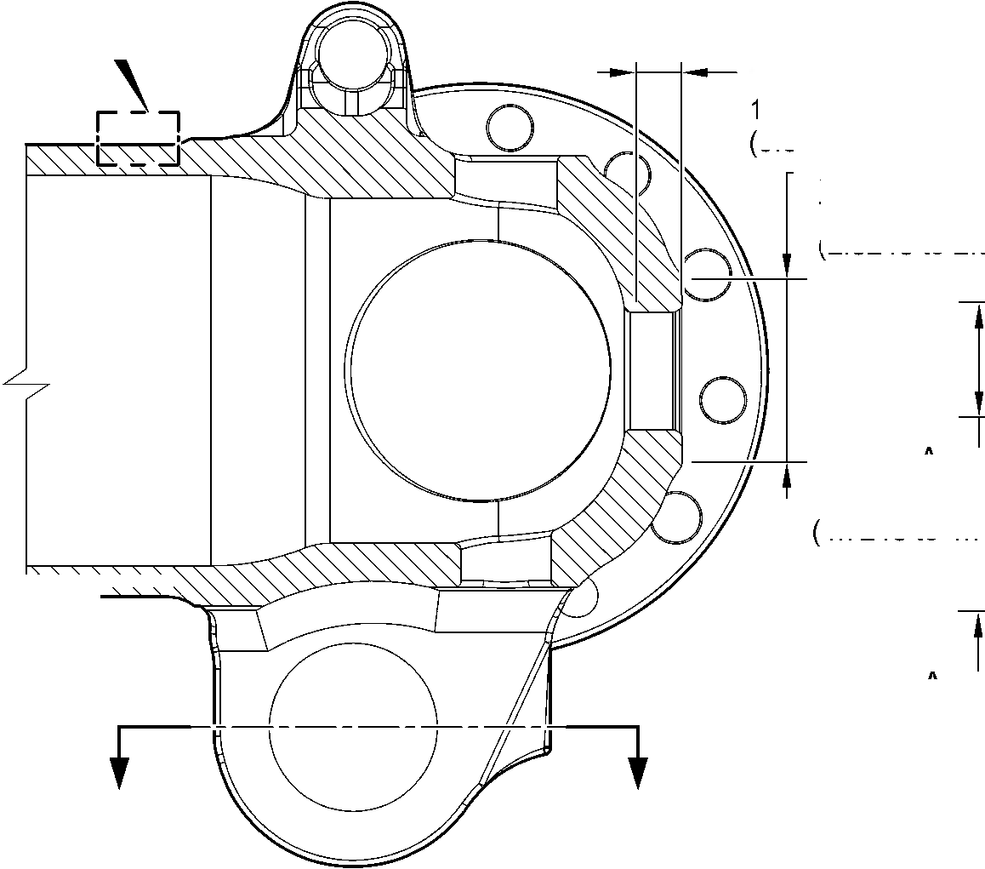
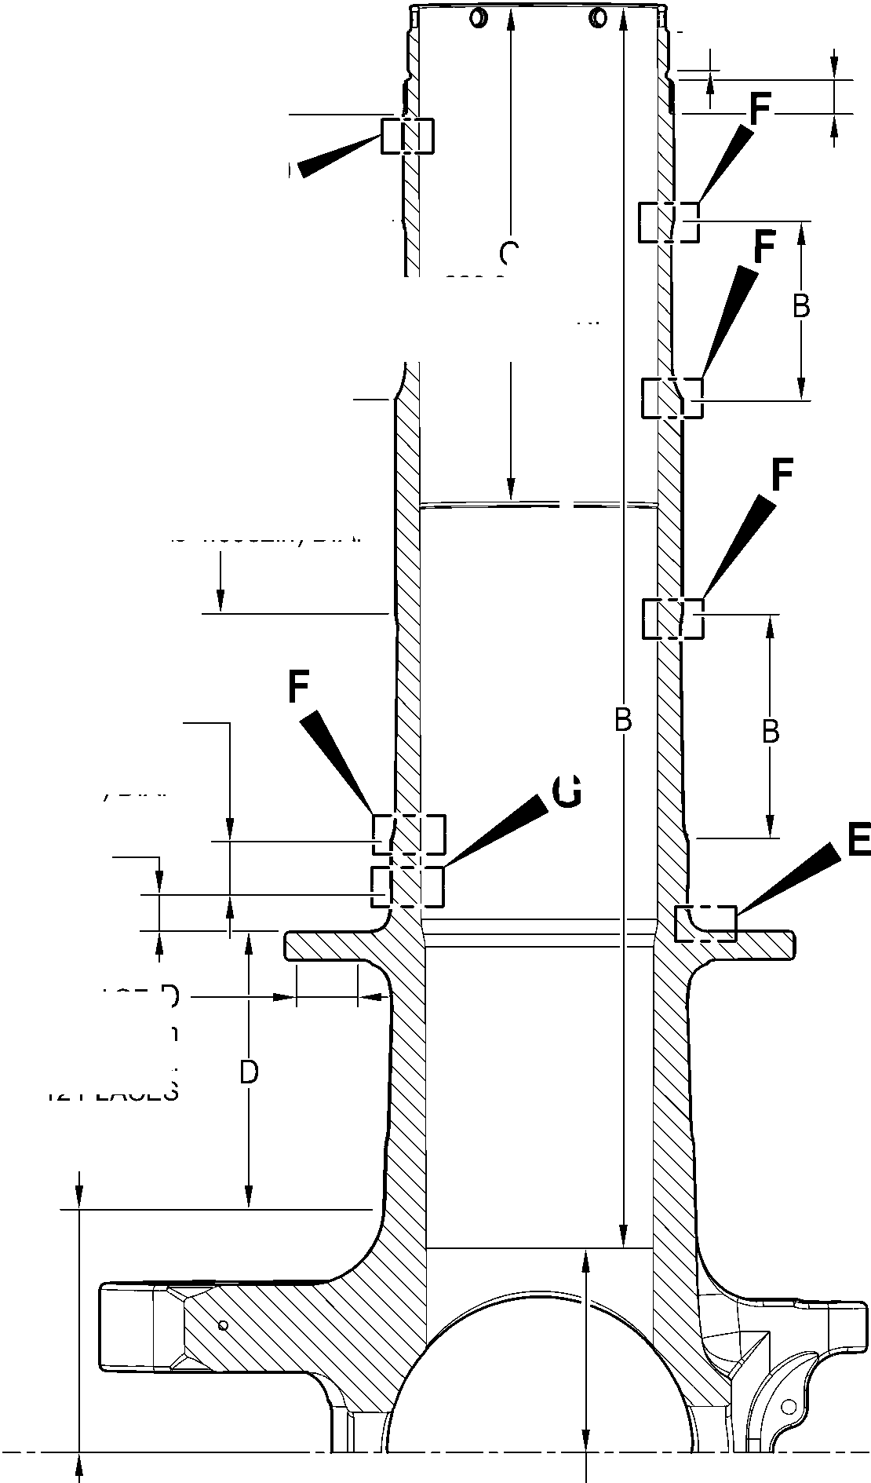

SAFRAN LANDING SYSTEMS UK Ltd
CAGE: K0654
PART No. 201587001 AND 201587002 COMPONENT MAINTENANCE MANUAL
MAIN LANDING GEAR LEG
J
5,000 to 7,000mm
(0.1968 to 0.2755in)
TYPICAL 2 PLACES
19,000 to 21,000mm
(0.7481 to 0.8267in)
TYPICAL 2 PLACES
C and G
TYPICAL
2 PLACES
C and G
23,400mm
(0.9213in) MIN.
TYPICAL 2 PLACES
INCLUDING CHAMFER
C and G
69,750 to 70,250mm
(2.7461 to 2.7657in) DIA.
TYPICAL 2 PLACES
C and G
81,750 to 82,250mm
(3. 2185 to 3. 2381 in) DIA.
TYPICAL 2 PLACES
C and G
38,750 to 39,250mm
(1.5256 to 1.5453in) DIA.
TYPICAL 2 PLACES
G
6,50 to 6,70mm
(0.256 to 0.263in) DIA.
TYPICAL 4 PLACES
J
13,000mm
(0.5118in) DIA.
SPOTFACE
INCLUDING CHAMFER
VIEW A
A321-T-32-12-22-155-0
C and J
TYPICAL 12 PLACES
SECTION W-W
LUG BORES
G
30,750 to 31,250mm
(1.2106 to 1.2303in) DIA.
SPOTFACE TYPICAL
12 PLACES INCLUDING
CHAMFER
SECTION V-V
(BOTH SIDES)
BRAKE FLANGE
Sliding tube (18-80D, 18-80E, 18-80F and 18-80G) - Protective Treatment
Figure 648 - Sheet 3
32-12-22
Page 683
Mar 18/2025
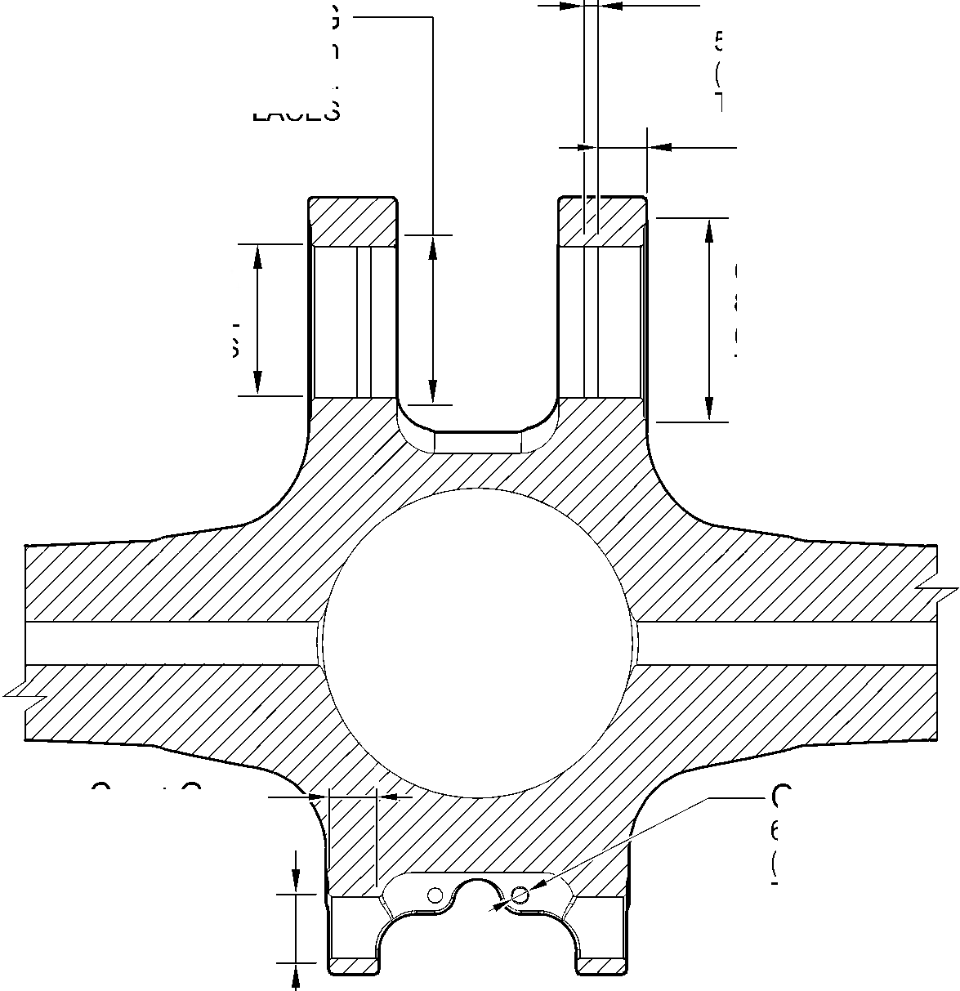
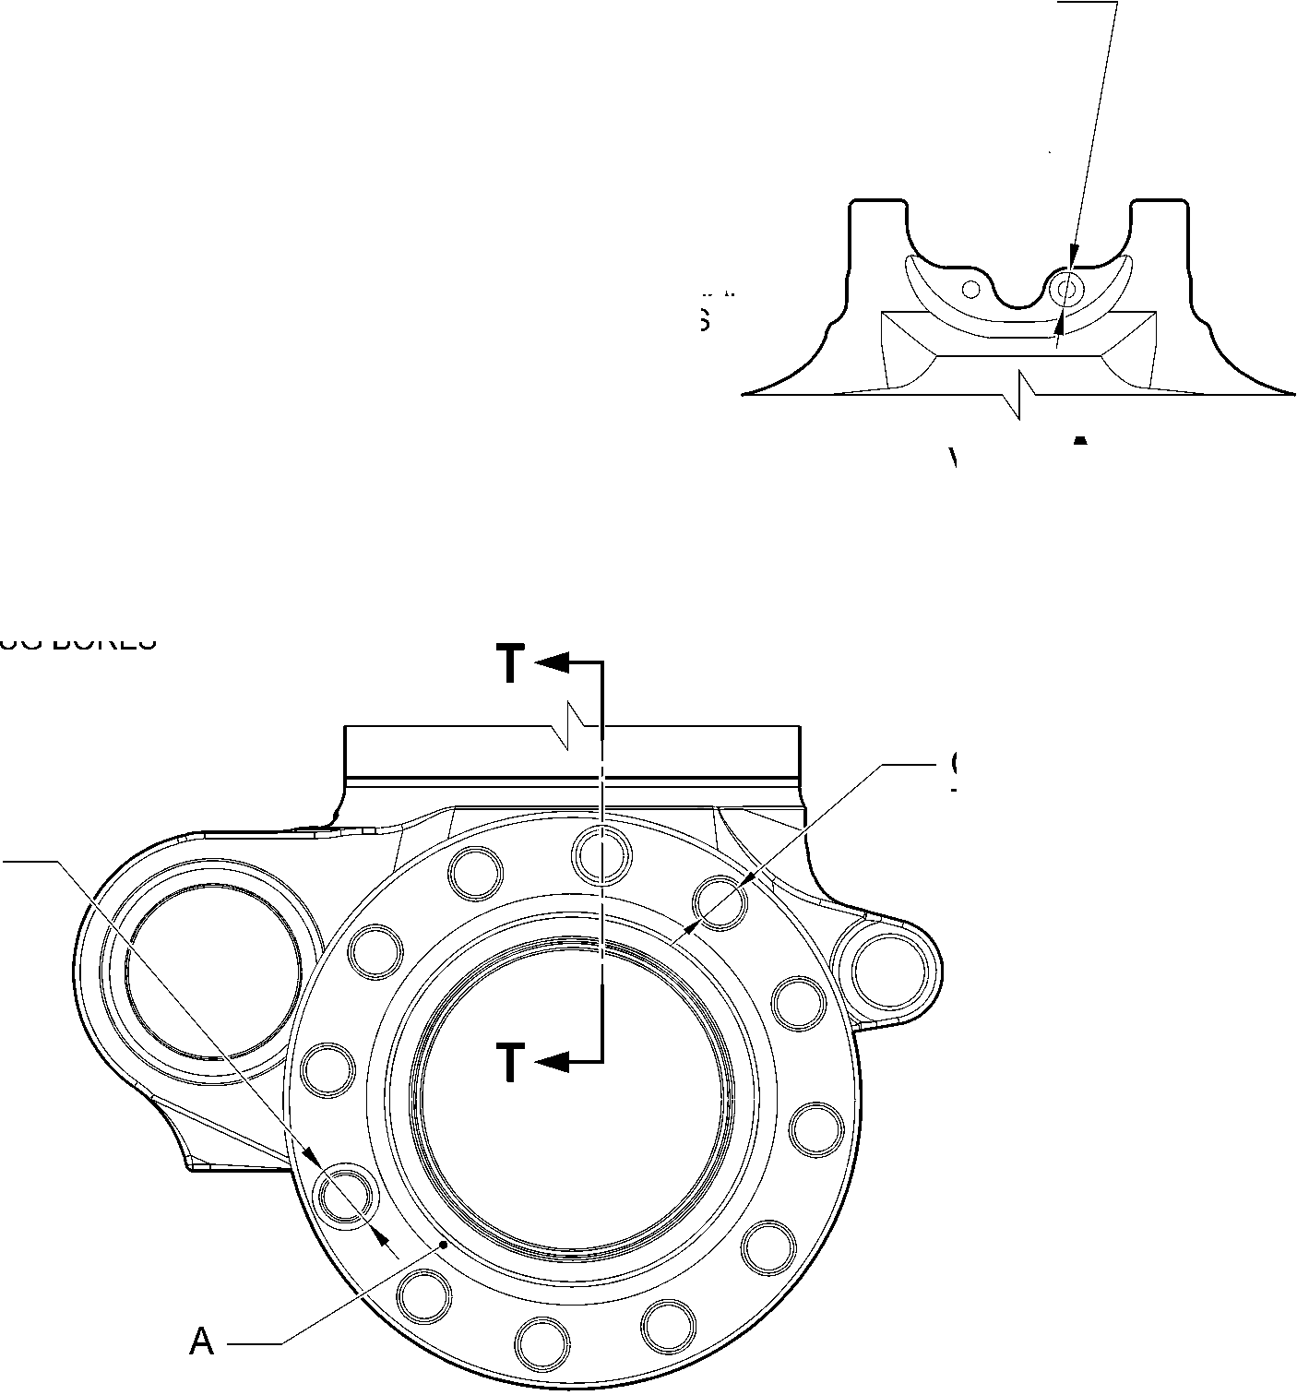

SAFRAN LANDING SYSTEMS UK Ltd
CAGE: K0654

PART No. 201587001 AND 201587002 COMPONENT MAINTENANCE MANUAL
MAIN LANDING GEAR LEG
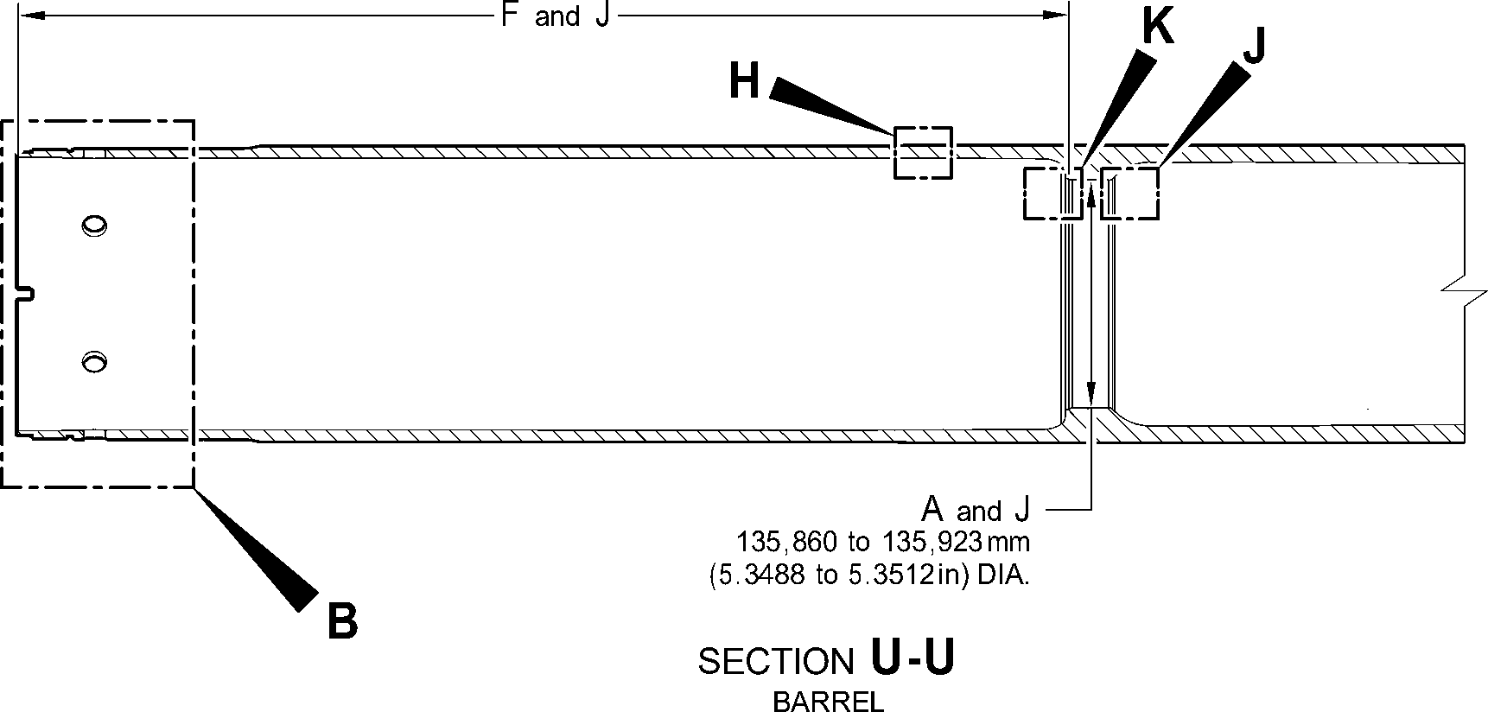
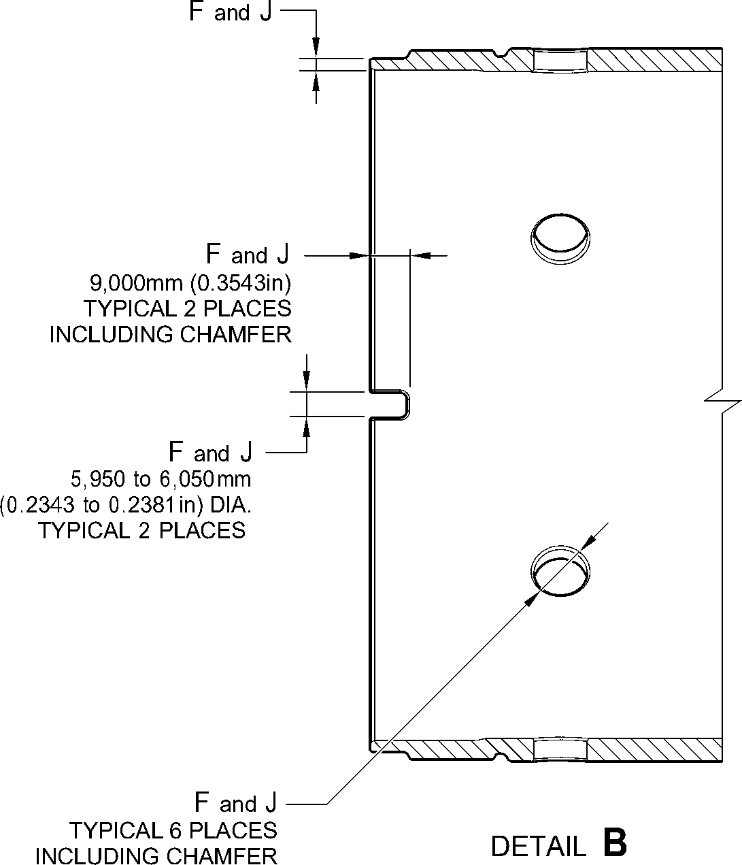
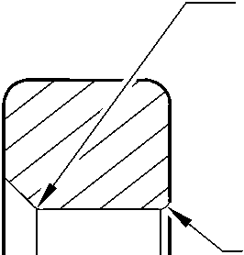
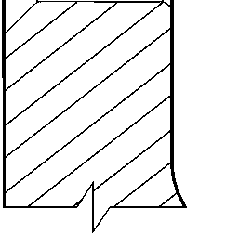
SECTION T-T
BRAKE FLANGE
TYPICAL 12 PLACES
A321-T-32-12-22-156-0
Sliding tube (18-80D, 18-80E, 18-80F and 18-80G) - Protective Treatment
Figure 648 - Sheet 4
32-12-22
Page 684
Mar 18/2025

SAFRAN LANDING SYSTEMS UK Ltd
CAGE: K0654
PART No. 201587001 AND 201587002 COMPONENT MAINTENANCE MANUAL
MAIN LANDING GEAR LEG
FULL CHROME
PLATING THICKNESS
RUN OUT BAND
2,000mm (0.0787in) MAX.
DIA. AFTER
GRINDING CHROME
NO ZINC-NICKEL OR
PAINT DEPOSIT TO REMAIN ON
OR PROUD OF WORKING DIA.
AFTER GRINDING CHROME
ZINC-NICKEL
DEPOSIT OVERLAP
PAINT DEPOSIT
OVERLAP
EDGE BLENDED WITH
A SMOOTH TRANSITION
WAVY OR IRREGULAR
LINE PERMISSIBLE
DETAIL C
BARREL OUTER DIA. LOWER
CHROME TERMINATION
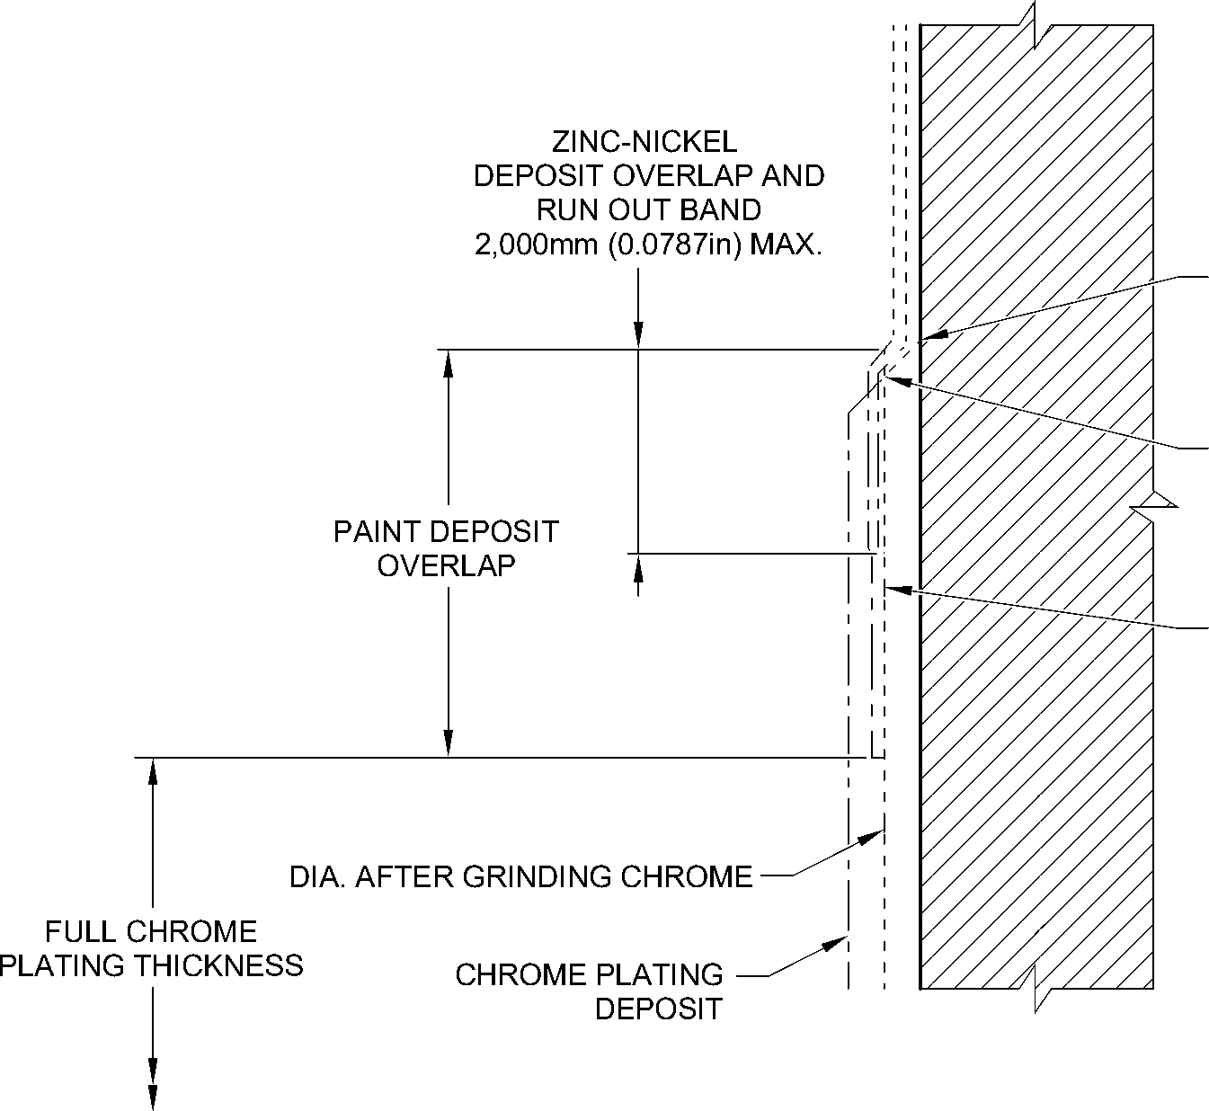
WAVY OR IRREGULAR
LINE PERMISSIBLE
EDGE BLENDED WITH
A SMOOTH TRANSITION
NO ZINC-NICKEL OR PAINT
DEPOSIT TO REMAIN ON OR
PROUD OF WORKING DIA.
AFTER GRINDING CHROME
DETAIL D
JOURNAL A OUTER CHROME TERMINATION
(TYPICAL)
A321-T-32-12-22-157-0
Sliding tube (18-80D, 18-80E, 18-80F and 18-80G) - Protective Treatment
Figure 648 - Sheet 5
32-12-22
Page 685
Mar 18/2025
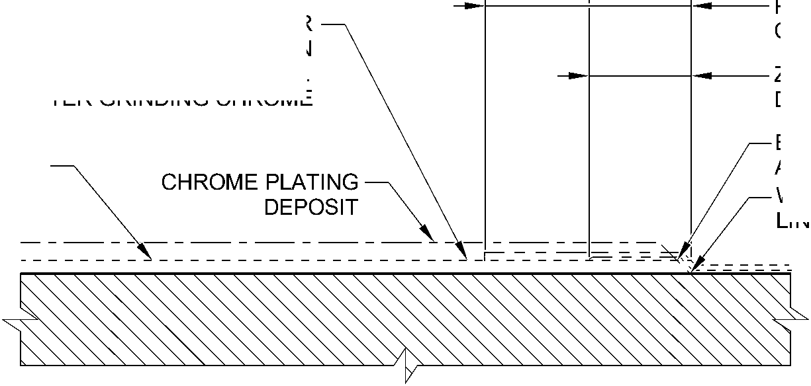

SAFRAN LANDING SYSTEMS UK Ltd
CAGE: K0654

PART No. 201587001 AND 201587002 COMPONENT MAINTENANCE MANUAL
MAIN LANDING GEAR LEG
159,750 to 160,250mm
(6.2894 to 6.3090in) DIA.
PAINT DEPOSIT OVERLAP
157,750mm (6.2106) DIA.
MIN.
PAINT DEPOSIT OVERLAP
^ ^ 150,000mm (5.9054in) DIA.
MAX.
147,500 to 148,000mm
(5.8071 to 5.8267in) DIA.
RUN OUT BAND
0,000 to 2,000mm
(0.000 to 0.0787in)
ZINC-NICKEL
DEPOSIT OVERLAP
NO ZINC-NICKEL OR
PAINT ON THIS
SURFACE
DIA. AFTER
GRINDING CHROME
ZINC-NICKEL
DEPOSIT OVERLAP
RUN OUT BAND
0,000 to 2,000mm
(0.000 to 0.0787in)
DETAIL E
BREAK FLANGE FACE CHROME TERMINATION
(TYPICAL)
ZINC-NICKEL
DEPOSIT OVERLAP
CHROME RUN OUT BAND
(TO RADIUS INTERSECTION POINT)
1,000 to 5,000mm (0.0394 to 0.1968in)
PAINT DEPOSIT
OVERLAP
EDGE BLENDED WITH
A SMOOTH TRANSITION
NO ZINC-NICKEL OR
PAINT DEPOSIT TO REMAIN
FULL CHROME ON OR PROUD OF WORKING DIA.
PLATING THICKNESS AFTER GRINDING CHROME
CHROME PLATING
DEPOSIT
DETAIL F
WAVY OR IRREGULAR
LINE PERMISSIBLE
DIA. AFTER
GRINDING CHROME
JOURNAL A,B,C CHROME TERMINATION
(TYPICAL)
A321-T-32-12-22-158-0
Sliding tube (18-80D, 18-80E, 18-80F and 18-80G) - Protective Treatment
Figure 648 - Sheet 6
32-12-22
Page 686
Mar 18/2025
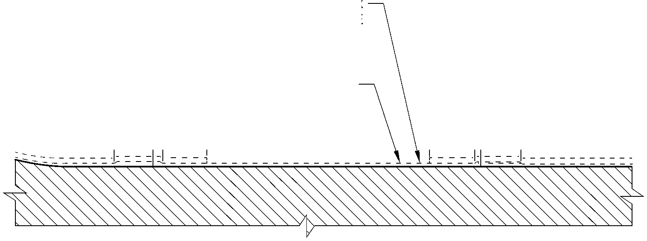
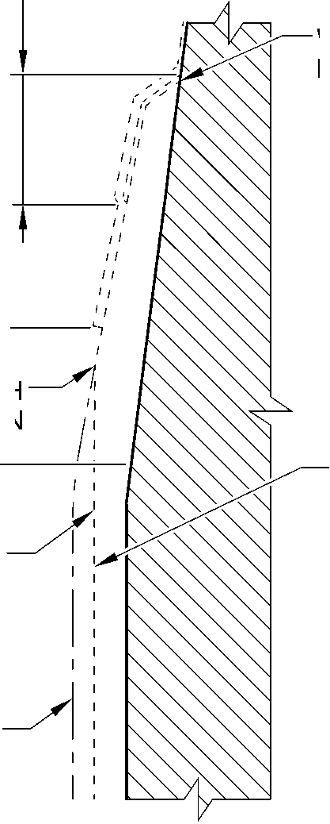

SAFRAN LANDING SYSTEMS UK Ltd
CAGE: K0654

PART No. 201587001 AND 201587002 COMPONENT MAINTENANCE MANUAL
MAIN LANDING GEAR LEG
FULL CHROME
PLATING THICKNESS
NO ZINC-NICKEL OR
PAINT DEPOSIT TO REMAIN
ON OR PROUD OF WORKING DIA.
AFTER GRINDING CHROME
DIA. AFTER
GRINDING CHROME
CHROME PLATING
DEPOSIT
EDGE BLENDED WITH
A SMOOTH TRANSITION
WAVY OR IRREGULAR
LINE PERMISSIBLE
ZINC-NICKEL
DEPOSIT OVERLAP
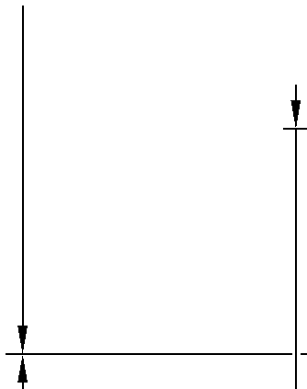
RUN OUT BAND
2,000mm (0.0787in) MAX.
ZINC NICKEL PLATE
PAINT DEPOSIT
OVERLAP
DETAIL G
JOURNAL C INNER CHROME TERMINATION
(TYPICAL)
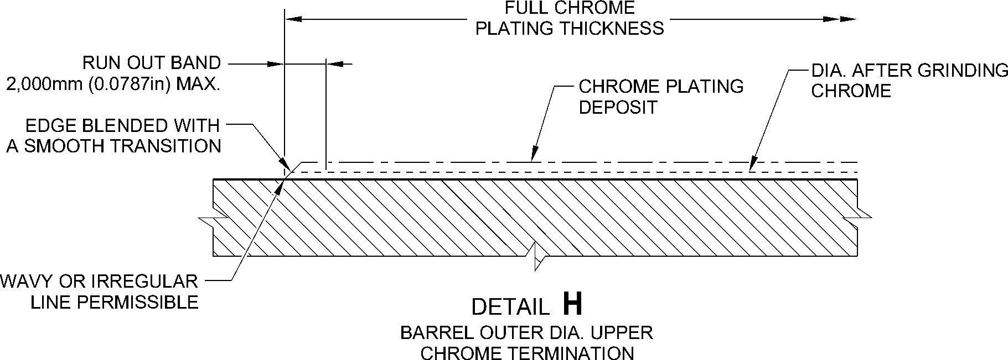
A321-T-32-12-22-159-0
Sliding tube (18-80D, 18-80E, 18-80F and 18-80G) - Protective Treatment
Figure 648 - Sheet 7
32-12-22
Page 687
Mar 18/2025
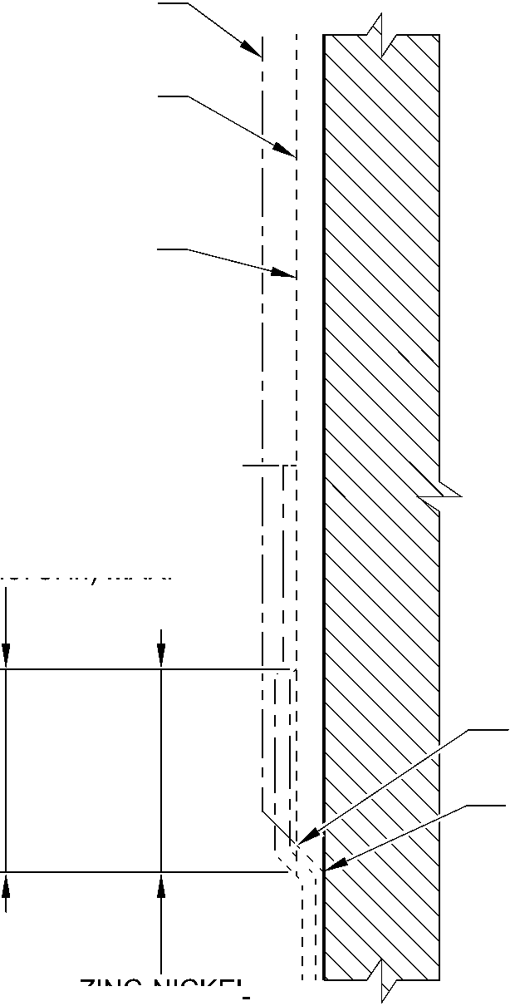

SAFRAN LANDING SYSTEMS UK Ltd
CAGE: K0654

PART No. 201587001 AND 201587002 COMPONENT MAINTENANCE MANUAL
MAIN LANDING GEAR LEG
DIA. AFTER CHROME PLATING
NO ZINC-NICKEL OR
PAINT DEPOSIT
TO REMAIN ON WORKING DIA.
AFTER CHROME PLATING
CHROME RUN OUT BAND
(TO RADIUS INTERSECTION POINT)
1,000 to 5,000mm (0.0394 to 0.1968in)
F and J
WORKING DIA.
26,000mm (1.0236in) MIN.
(TO HPC ABUTMENT FACE)
PAINT DEPOSIT OVERLAP
ZINC-NICKEL
DEPOSIT OVERLAP
DETAIL J
HPC SEAL ABUTMENT LOWER
CHROME TERMINATION
CHROME PLATING WILL
TERMINATE ANYWHERE
ON THE CHAMFER
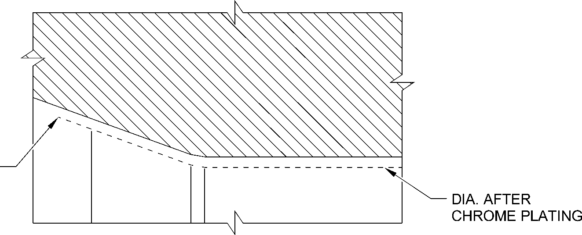
DETAIL K
HPC SEAL ABUTMENT UPPER
CHROME TERMINATION
A321-T-32-12-22-160-0
Sliding tube (18-80D, 18-80E, 18-80F and 18-80G) - Protective Treatment
Figure 648 - Sheet 8
32-12-22
Page 688
Mar 18/2025
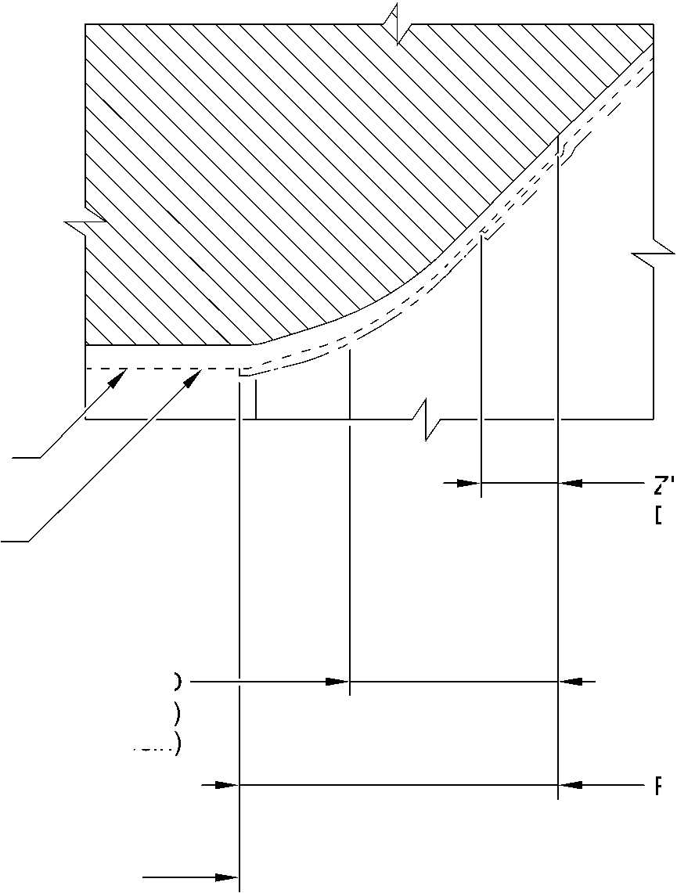

SAFRAN LANDING SYSTEMS UK Ltd
CAGE: K0654
PART No. 201587001 AND 201587002 COMPONENT MAINTENANCE MANUAL
MAIN LANDING GEAR LEG
- Approved Repairs
A. Refer to Figures 649 to 657 and Table 602.
Approved Repairs
Table 602
Repair No. | Messier-Dowty Limited or Safran  Landing Systems Repair No. | Applicable Part
1-1 | 450237790 | Lower bearing subassembly (16-110)
1-2 | 450237610 | Lower bearing subassembly (16-110)
2-1 | 450217145 | Pin (13-190 and 13-190A)
3-1 | 450217385 | Pivot pin (6-90)
4-1 | 450237490 | Uplock pin (5-400)
5-1 | 450217170 | Pin (3-50)
6-1 | 450258420 | Pin (10-80)
6-2 | 450258260 | Pin (10-80)
6-3 | 450266211 | Pin (10-80)
7-1 | 450258410 | Pin (11-130)
7-2 | 450258430 | Pin (11-130)
8-1 | 450217195 | Bracket (5-300)
8-2 | 450217205 | Bracket (5-300)
9-1 | 450258460 | Sliding tube (18-80 and 18-80A)
9-2 | 450266100 | Sliding tube (18-80 and 18-80A)
9-3 | 450258400 (Superseded) | Sliding tube (18-80)
9-4 | 450266290 | Sliding tube (18-80 and 18-80A)
9-5 | 450237720 | Sliding tube (18-80 and 18-80A)
9-6 | 450258470 | Sliding tube (18-80 and 18-80A)
9-7 | 450265140 | Sliding tube (18-80 and 18-80A)
9-8 | 450266310 | Sliding tube (18-80 and 18-80A)
9-9 | 450265180 | Sliding tube (18-80 and 18-80A)
9-10 | 450258401 | Sliding tube (18-80 and 18-80A)
9-11 | 450266295 | Sliding tube (18-80 and 18-80A)
10-1 | 450266210 | Pin (9-70)
11-1 | 450266060 | Main Fitting (20-410, 20-410A, 20-420  and 20-420A)
11-2 | 450266070 | Main Fitting (20-410, 20-410A, 20-420  and 20-420A)
11-3 | 450266020 | Main Fitting (20-410, 20-410A, 20-420  and 20-420A)
32-12-22
Page 689
Mar 18/2025

sSAFRAN SAFRAN LANDING SYSTEMS UK Ltd
CAGE: K0654
PART No. 201587001 AND 201587002 COMPONENT MAINTENANCE MANUAL
MAIN LANDING GEAR LEG
Approved Repairs
Table 602 (Continued)
Repair No. | Messier-Dowty Limited or Safran  Landing Systems Repair No. | Applicable Part
11-4 | 450266075 | Main Fitting (20-410, 20-410A, 20-420  and 20-420A)
11-5 | 450266080 | Main Fitting (20-410, 20-410A, 20-420  and 20-420A)
11-6 | 450266085 | Main Fitting (20-410, 20-410A, 20-420  and 20-420A)
11-7 | 450266045 | Main Fitting (20-410, 20-410A, 20-420  and 20-420A)
11-8 | 450266010 | Main Fitting (20-410, 20-410A, 20-420  and 20-420A)
11-9 | 450266030 | Main Fitting (20-410, 20-410A, 20-420  and 20-420A)
11-10 | 450267270 (Withdrawn) | Main Fitting (20-410 and 20-420 Only)
11-11 | 450266015 | Main Fitting (20-410, 20-410A, 20-420  and 20-420A)
11-12 | 450266035 | Main Fitting (20-410, 20-410A, 20-420  and 20-420A)
11-13 | 450266050 | Main Fitting (20-410, 20-410A, 20-420  and 20-420A)
11-14 | 450266110 | Main Fitting (20-410, 20-410A, 20-420  and 20-420A)
11-15 | 450267230 | Main Fitting (20-410 and 20-420 Only)
11-16 | 450237690 | Main Fitting (20-410 and 20-420 Only)
11-17 | 450237695 | Main Fitting (20-410, 20-410A, 20-420  and 20-420A)
11-18 | 450217235 | Main Fitting (20-410, 20-410A, 20-420  and 20-420A)
11-19 | 450258210 | Main Fitting (20-410, 20-410A, 20-420  and 20-420A)
11-20 | 450265100 (Withdrawn) | Main Fitting (20-410 and 20-420 Only)
11-21 | 450258230 | Main Fitting (20-410, 20-410A, 20-420  and 20-420A)
11-22 | 450266450 | Main Fitting (20-410, 20-410A, 20-420  and 20-420A)
11-23 | 450266400 | Main Fitting (20-410, 20-410A, 20-420  and 20-420A)
11-24 | 450266390 | Main Fitting (20-410, 20-410A, 20-420  and 20-420A)
32-12-22
Page 690
Mar 18/2025

sSAFRAN SAFRAN LANDING SYSTEMS UK Ltd
CAGE: K0654
PART No. 201587001 AND 201587002 COMPONENT MAINTENANCE MANUAL
MAIN LANDING GEAR LEG
Approved Repairs
Table 602 (Continued)
Repair No. | Messier-Dowty Limited or Safran  Landing Systems Repair No. | Applicable Part
11-25 | 450266395 | Main Fitting (20-410, 20-410A, 20-420  and 20-420A)
11-26 | 450267370 | Main Fitting (20-410 and 20-420 Only)
11-27 | 450266040 | Main Fitting (20-410, 20-410A, 20-420  and 20-420A)
11-28 | 450266405 | Main Fitting (20-410, 20-410A, 20-420  and 20-420A)
11-29 | 450267275 | Main Fitting (20-410A and 20-420A  Only)
11-30 | 450267385 | Main Fitting (20-410A and 20-420A  Only)
11-31 | 64-4505236-00 | Main Fitting (20-410B, 20-410C,  20-410D, 20-420B, 20-420C  and 20-420D)
11-32 | 64-4505233-00 | Main Fitting (20-410B, 20-410C,  20-410D, 20-420B, 20-420C  and 20-420D)
11-33 | 64-4505109-00 | Main Fitting (20-410B, 20-410C,  20-410D, 20-420B, 20-420C  and 20-420D)
11-34 | 64-4505112-00 | Main Fitting (20-410B, 20-410C,  20-410D, 20-420B, 20-420C  and 20-420D)
11-35 | 64-4505111-00 | Main Fitting (20-410B, 20-410C,  20-410D, 20-420B, 20-420C  and 20-420D)
11-36 | 64-4505234-00 | Main Fitting (20-410B, 20-410C,  20-410D, 20-420B, 20-420C  and 20-420D)
11-37 | 64-4505126-00 | Main Fitting (20-410B, 20-410C,  20-410D, 20-420B, 20-420C  and 20-420D)
12-1 | 450266350 | Lower Torque Link (11-240)
12-2 | 450266340 | Upper Torque Link (10-260)
12-3 | 450266345 | Upper Torque Link (10-260)
12-4 | 450266355 | Lower Torque Link (11-240)
12-5 | 450266525 | Upper Torque Link (10-260)
13-1 | 450266215 | Upper Slave Link (6-230 and 6-230A)
32-12-22
Page 691
Mar 18/2025

sSAFRAN SAFRAN LANDING SYSTEMS UK Ltd
CAGE: K0654
PART No. 201587001 AND 201587002 COMPONENT MAINTENANCE MANUAL
MAIN LANDING GEAR LEG
Approved Repairs
Table 602 (Continued)
Repair No. | Messier-Dowty Limited or Safran  Landing Systems Repair No. | Applicable Part
13-2 | 450266216 | Upper Slave Link (6-230 and 6-230A)
14-1 | 450266255 | Upper Diaphragm Tube (15-390)
14-2 | 450266285 | Upper Diaphragm Tube (15-390)
14-3 | 450266430 | Upper Diaphragm Tube (15-390)
14-4 | 64-4505141-00 | Upper Diaphragm Tube (15-390A)
15-1 | 450266095 | Bracket (4-360)
15-2 | 450266096 | Bracket (4-360)
16-1 | 450266360 | Bracket (8-170)
17-1 | 450266365 | Pivot Bracket (7-140)
18-1 | 450237795 | Cylinder (17-230)
18-2 | 450258320 | Cylinder (17-230)
18-3 | 450237480 (Withdrawn) | Cylinder (17-230)
18-4 | 450265290 | Cylinder (17-230)
18-5 | 450266505 | Cylinder (17-230)
18-6 | 450266425 | Cylinder (17-230)
18-7 | 450267365 | Cylinder (17-230)
18-8 | 64-4505242-00 | Cylinder (17-230A)
19-1 | 450266104 | Lock Stay Cardan (3-170)
19-2 | 450266105 | Lock Stay Cardan (3-170)
20-1 | 450266270 | Lower Slave Link (6-310)
21-1 | 450266410 | Transfer Block (2-340) Only
21-2 | 450266415 | Transfer Block (2-340) Only
21-3 | 450266420 | Transfer Block (2-340) Only
21-4 | 450266411 | Transfer Block (2-350) Only
21-5 | 450266416 | Transfer Block (2-350) Only
21-6 | 450266421 | Transfer Block (2-350) Only
22-1 | 450266520 | Spherical Bearing (19-50)
23-1 | 450217290 | Pintle Pin (1-60)
23-2 | 450258270 | Pintle Pin (1-60)
24-1 | 450265230 | Harness Support Bracket (11-140)
25-1 | 450266201 | Retaining Pin (13-10A)
25-2 | 450266200 | Retaining Pin (13-10)
26-1 | 450265250 | Upper Pivot Bracket (10-160)
32-12-22
Page 692
Mar 18/2025

SAFRAN LANDING SYSTEMS UK Ltd
CAGE: K0654
PART No. 201587001 AND 201587002 COMPONENT MAINTENANCE MANUAL
MAIN LANDING GEAR LEG
REPAIR No. 22-1
REPAIR No. 5-1
REPAIR No. 19-1 and 19-2
REPAIR No.
REPAIR No. 2-1
A
UPPER TORQUE LINK
REPAIR No.
REPAIR No.
REPAIR No. 10-1
REPAIR No.
REPAIR No. 20-1
UPPER PIVOT BRACKET
REFER TO FIGURE 657
TRANSFER BLOCK
REFER TO FIGURE 655
MAIN FITTING
REFER TO FIGURE 650
REPAIR No. 23-1
and 23-2
15-1 and 15-2
0⁰
REPAIR No. 8-1 and 8-2
DETAIL A
REPAIR No. 25-1 and 25-2
REPAIR No. 6-1, 6-2 and 6-3
REPAIR No. 17-1
REPAIR No. 3-1
13-2
1-1 and 1-2
13-1
LOWER TORQUE LINK
REPAIR No. 16-1
UPPER DIAPHRAGM TUBE
REFER TO FIGURE 653
SLIDING TUBE
REFER TO FIGURE 652
HARNESS SUPPORT BRACKET
REFER TO FIGURE 656
CYLINDER
REFER TO FIGURE 654
REPAIR No. 4-1
A321-S-32-12-22-008-8
Approved Repairs - Key Diagram
Figure 649
32-12-22
Page 693
Mar 18/2025
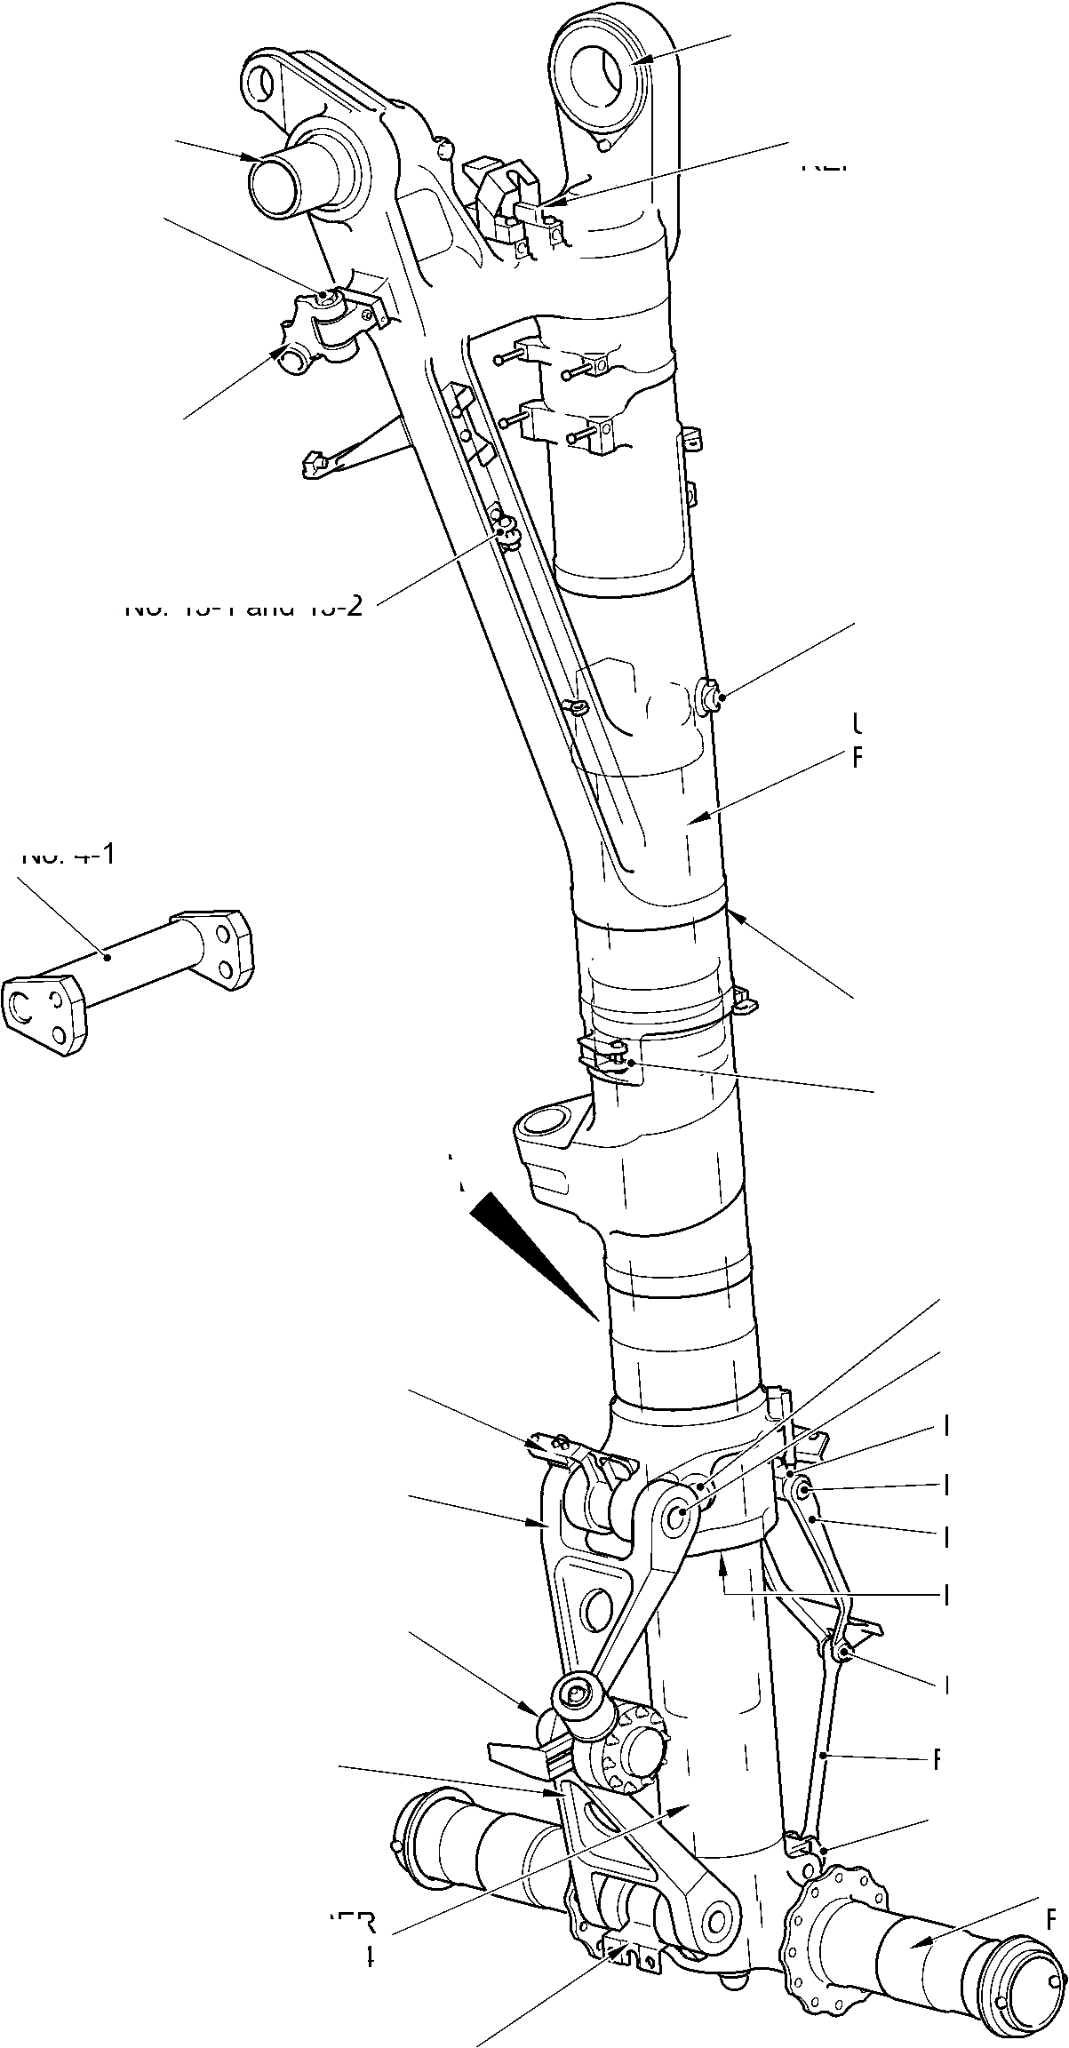

SAFRAN LANDING SYSTEMS UK Ltd
CAGE: K0654

PART No. 201587001 AND 201587002 COMPONENT MAINTENANCE MANUAL
MAIN LANDING GEAR LEG
REPAIR No. 11-14, 11-25 and
11-33
REPAIR No. 11-13
REPAIR No. 11-27
REPAIR No. 11-1
REPAIR No. 11-2 and 11-35
REPAIR No. 11-4, 11-19 and 11-34
REPAIR No.11-6 and 11-20
REPAIR No. 11-21
and 11-24
REPAIR No. 11-31
REPAIR No. 11-11
REPAIR No. 11-22 and 11-36
REPAIR No. 11-12
REPAIR No. 11-9
REPAIR No. 11-5 and 11-18
REPAIR No.11-17
REPAIR No. 11-15 and 11-37
REPAIR No. 11-28
REPAIR No. 11-8
REPAIR No. 11-3, REPAIR 11-23 and 11-32
REPAIR No. 11-7
REPAIR No.11-10, 11-16, 11-26,
11-29 and 11-30
A321-S-32-12-22-063-2
Main Fitting Repairs - Key Diagram
Figure 650
32-12-22
Page 694
Mar 18/2025
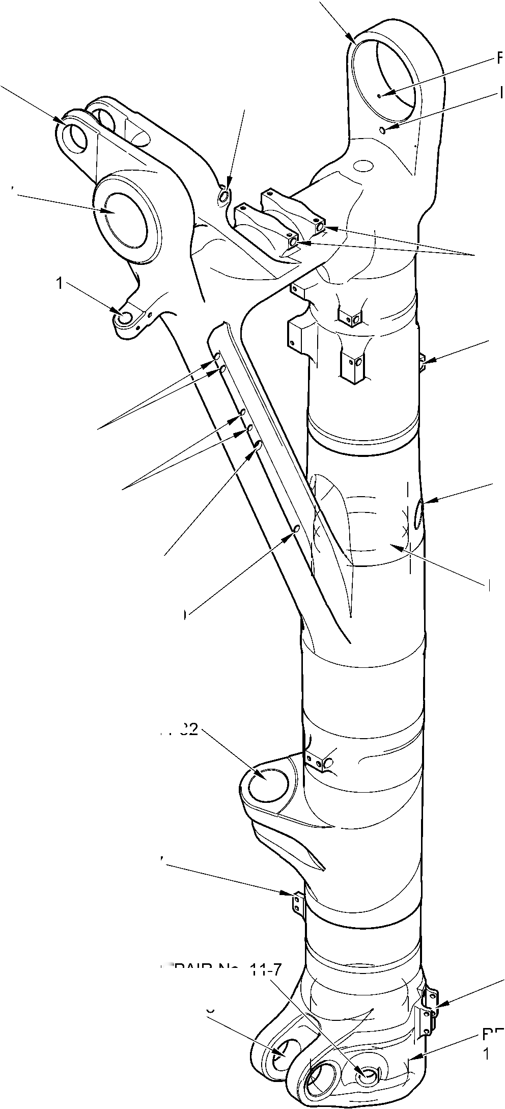

SAFRAN LANDING SYSTEMS UK Ltd
CAGE: K0654

PART No. 201587001 AND 201587002 COMPONENT MAINTENANCE MANUAL
MAIN LANDING GEAR LEG
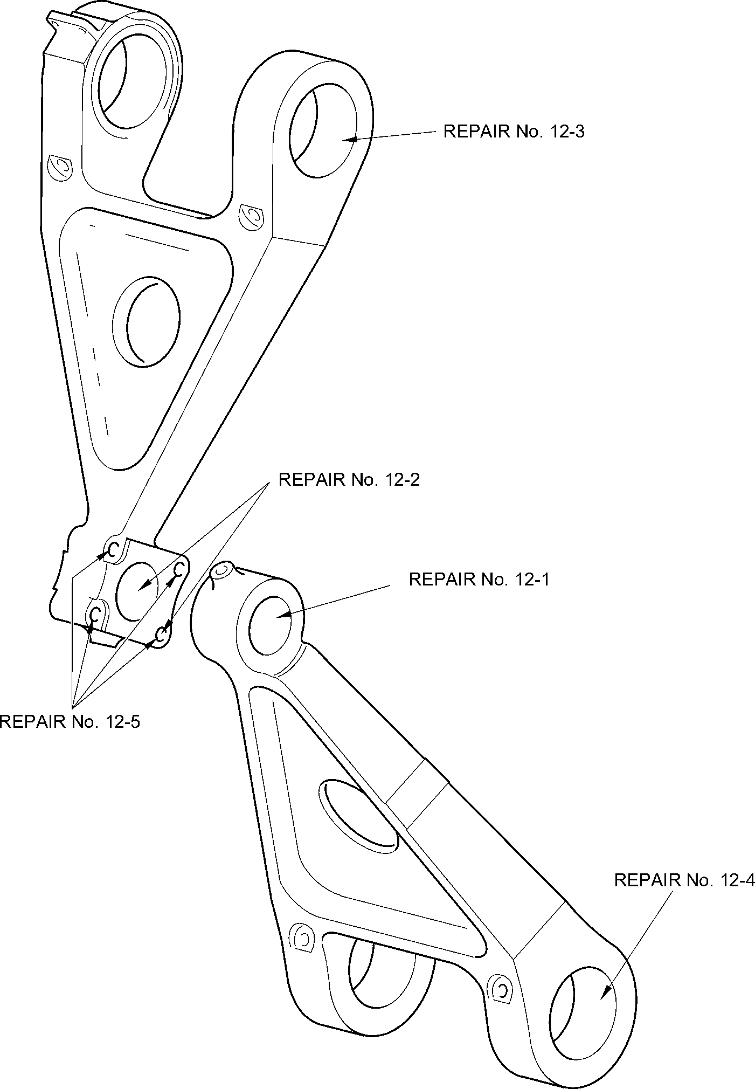
A321-S-32-12-22-029-1
Torque Link Repairs - Key Diagram
Figure 651
32-12-22
Page 695
Mar 18/2025

SAFRAN LANDING SYSTEMS UK Ltd
CAGE: K0654

PART No. 201587001 AND 201587002 COMPONENT MAINTENANCE MANUAL
MAIN LANDING GEAR LEG
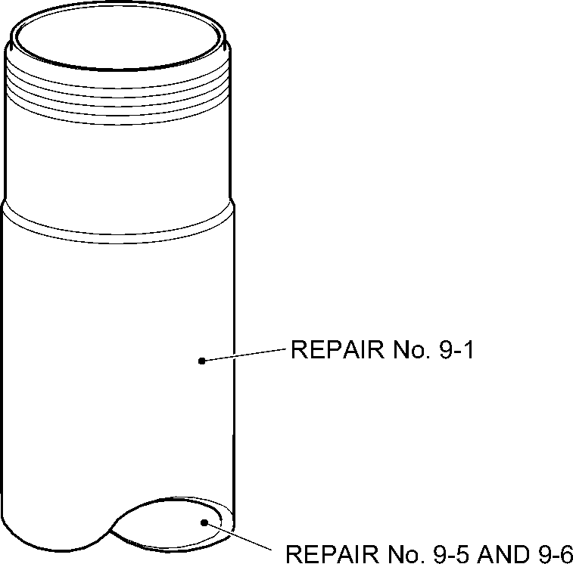
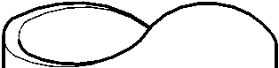
REPAIR No. 9-3 AND 9-10
REPAIR No.9-7
REPAIR No. 9-4
REPAIR No. 9-3 AND 9-10
REPAIR No. 9-8
REPAIR No. 9-9
REPAIR No. 9-11
A321-S-32-12-22-055-1
Sliding Tube Repairs - Key Diagram
Figure 652
32-12-22
Page 696
Mar 18/2025
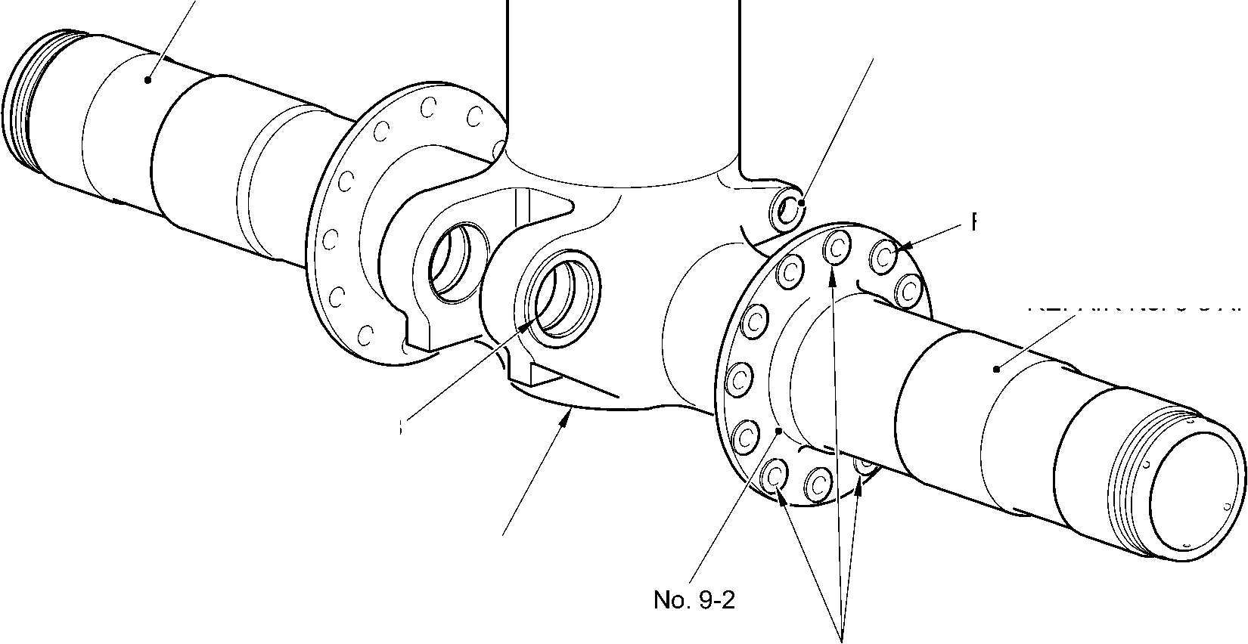

SAFRAN LANDING SYSTEMS UK Ltd
CAGE: K0654

PART No. 201587001 AND 201587002 COMPONENT MAINTENANCE MANUAL
MAIN LANDING GEAR LEG
REPAIR No. 14-2
REPAIR No. 14-3 and 14-4
REPAIR No. 14-1
A321A5909-3
Upper Diaphragm Tube Repairs - Key Diagram
Figure 653
32-12-22
Page 697
Mar 18/2025
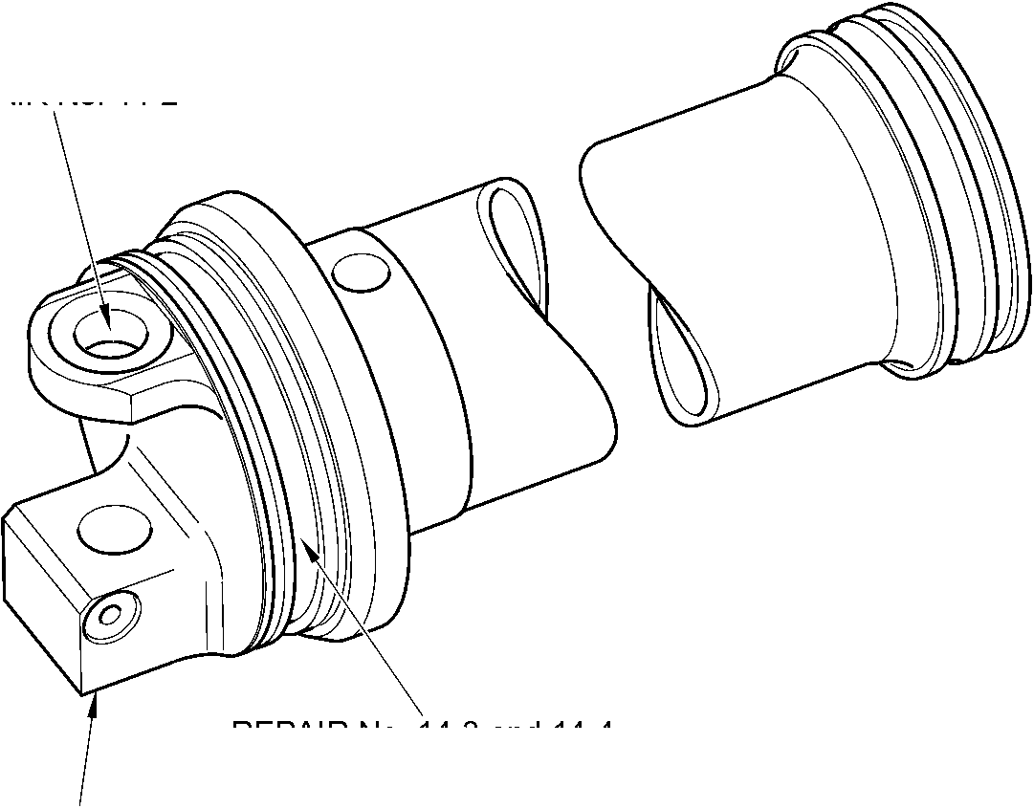

SAFRAN LANDING SYSTEMS UK Ltd
CAGE: K0654

PART No. 201587001 AND 201587002 COMPONENT MAINTENANCE MANUAL
MAIN LANDING GEAR LEG
REPAIR No. 18-1
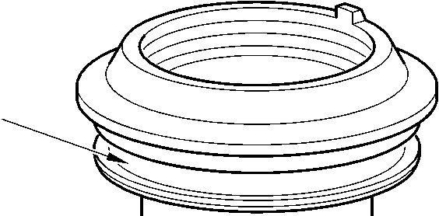

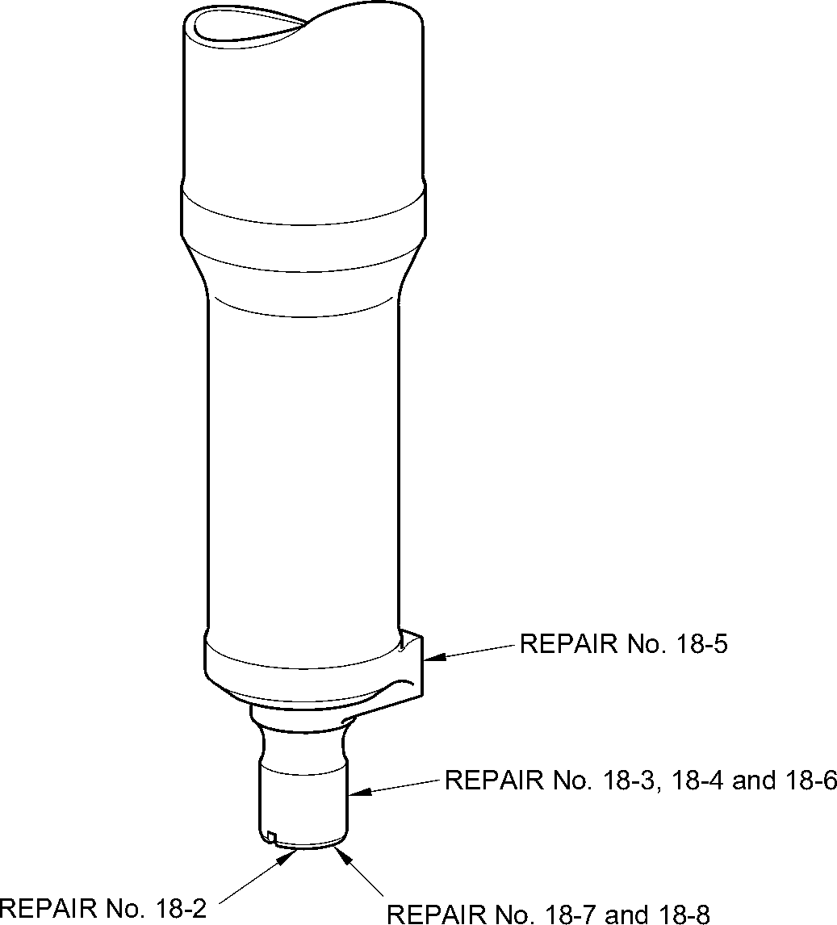
A321-S-32-12-22-043-2
Cylinder Repairs - Key Diagram
Figure 654
32-12-22
Page 698
Mar 18/2025

SAFRAN LANDING SYSTEMS UK Ltd
CAGE: K0654

PART No. 201587001 AND 201587002 COMPONENT MAINTENANCE MANUAL
MAIN LANDING GEAR LEG
REPAIR No. 21-3 and 21-6
REPAIR No. 21-1 and 21-4
REPAIR No. 21-2 and 21-5
A321-S-32-12-22-014-1
Transfer Block Repairs - Key Diagram
Figure 655
32-12-22
Page 698.1
Mar 18/2025
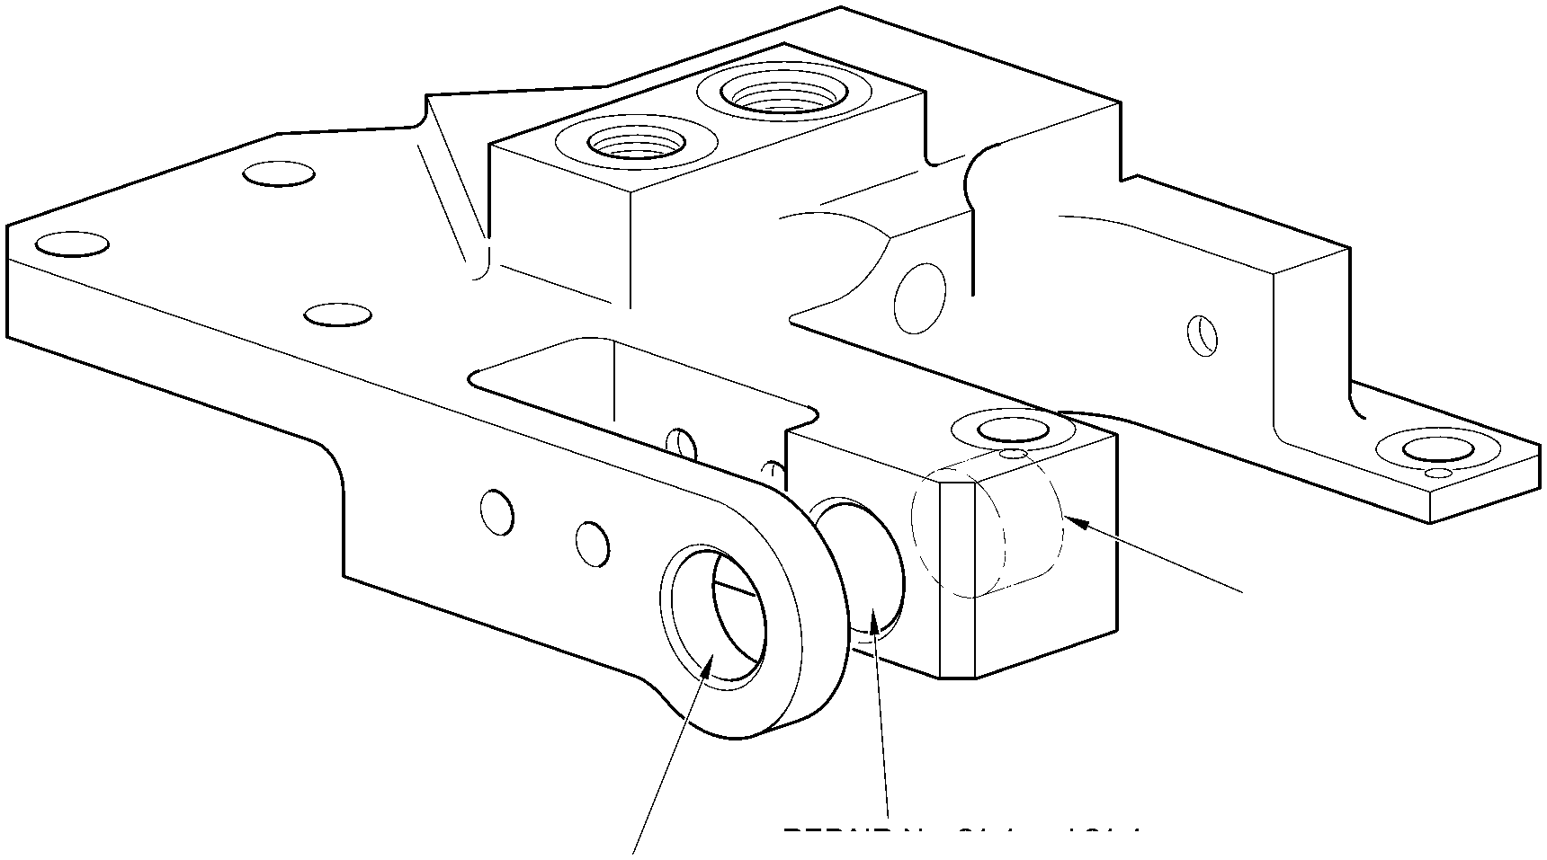

SAFRAN LANDING SYSTEMS UK Ltd
CAGE: K0654

PART No. 201587001 AND 201587002 COMPONENT MAINTENANCE MANUAL
MAIN LANDING GEAR LEG
REPAIR No. 24-1
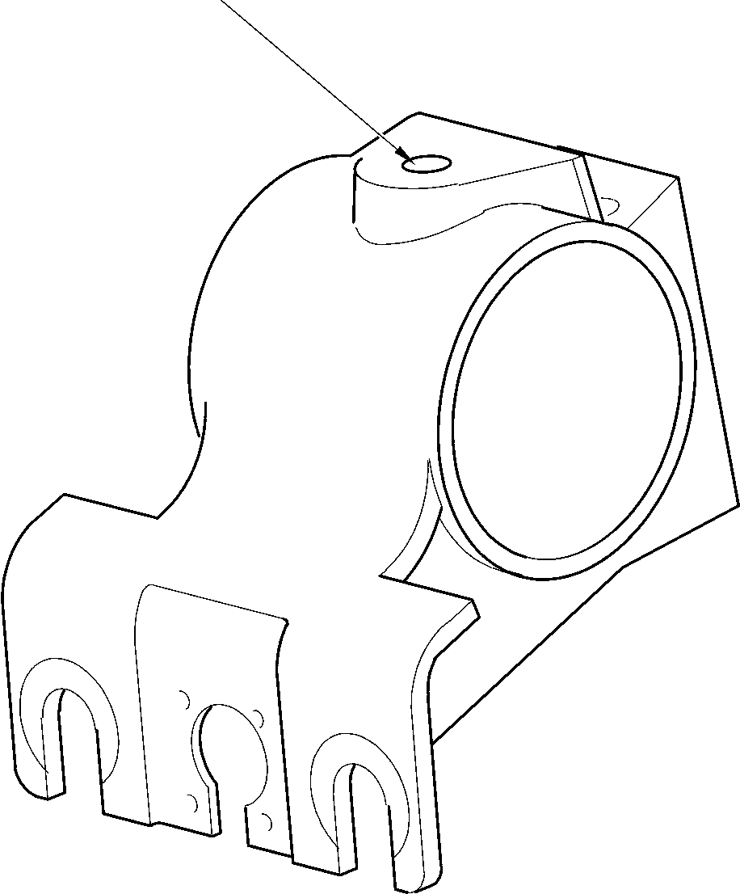
A321-S-32-12-22-007-0
Harness Support Bracket Repairs - Key Diagram
Figure 656
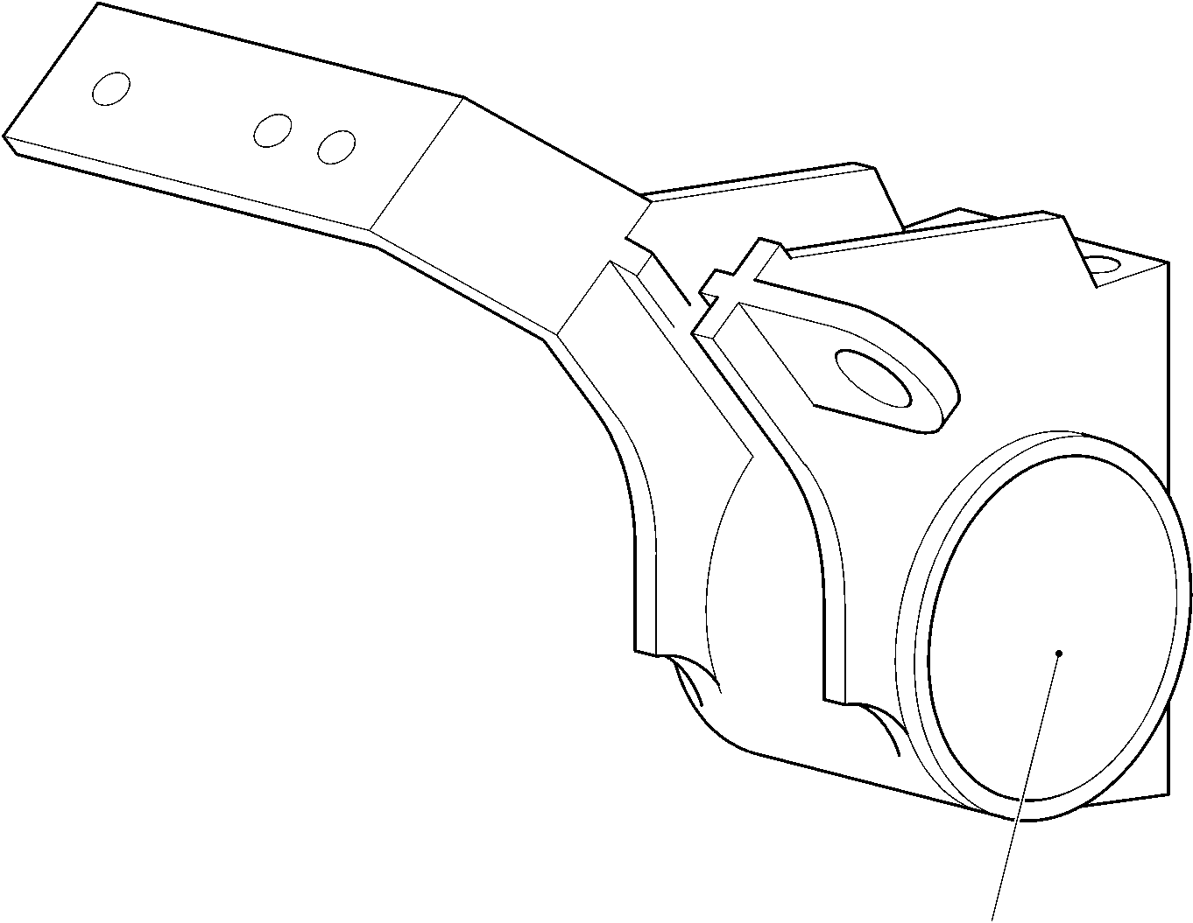
REPAIR No. 26-1
A321-S-32-12-22-057-0
Upper Pivot Bracket Repairs - Key Diagram
Figure 657
32-12-22
Page 698.2
Mar 18/2025

sSAFRAN SAFRAN LANDING SYSTEMS UK Ltd
CAGE: K0654
PART No. 201587001 AND 201587002 COMPONENT MAINTENANCE MANUAL
MAIN LANDING GEAR LEG
- Repair No. 1-1 Lower Bearing Subassembly (16-110)
- Specified Damage and Material Specification.
- Specified Damage
(a) Damaged or loose liner.
- Material Specification
IPL Figure and  Item No. | Name | Material Specification
16-140 | Gland housing | Aluminium Alloy, 2024T35
- Special Tools
- Special tools are not necessary.
- Materials
- These materials are necessary:
NOTE: Alternative equivalents are permitted.
Ref. Item | Material
TBA | Accomet C
TBA | Adhesive PVC tape
TBA | Araldite, 2015
TBA | Cleaning tissues
TBA | Emery cloth, 60-100 grit
08-715 | Masking tape
08-722 | Adhesive
11-583 | Cleaning agent
13-501 | Alocrom
- Repair Parts
(1) These repair parts are necessary:
Part No. | Repair Part | Material Specification
450237823 | Repair liner | Fibreslip B40
- Procedure (Refer to Figure 601)
- Repair loose but undamaged liner:
- Remove all of the adhesive from the external diameter of the gland housing and
the internal diameter of the liner: refer to CLEANING.
Repair No. 1-1
32-12-22
Page 601
Dec 6/2019

sSAFRAN SAFRAN LANDING SYSTEMS UK Ltd
CAGE: K0654
PART No. 201587001 AND 201587002 COMPONENT MAINTENANCE MANUAL
MAIN LANDING GEAR LEG
- Measure the diameter of the gland housing across the contact area: this must be
between 211,328 and 211,368 mm (8.3200 and 8.3215 in).
- Temporarily put the liner in position on the gland housing. If necessary, cut the liner
at the scarf joints to adjust its length.
- Remove the liner from the gland housing.
- Clean the contact surfaces of the liner and the gland housing: use the cleaning
tissues, Material Ref. Item TBA, and the cleaning agent, Material Ref. Item 11-583.
- Apply adhesive, Material Ref. Item 08-722, to the contact surface of the liner near
to the scarf joints: refer to M-DLPS724.
- Assemble the liner to the gland housing.
- Identify the part with the Messier-Dowty Limited repair number 450237790A
adjacent to the part number: refer to PCS-6000-05.
- Examine the part to make sure that you have obeyed all the repair instructions
correctly.
- Repair damaged liner:
- Remove the damaged liner and remove all of the adhesive from the external
diameter of the gland housing: refer to CLEANING.
- Machine the gland housing to the dimensions given in Figure 601 with a surface
finish of 3,2 micrometers (125 micro-inches).
- Examine the gland housing for flaws: refer to M-DLNDT8.
- Apply Alocrom, Material Ref. Item 13-501, to the machined areas: refer to
PCS-2220.
- Temporarily put the repair liner in position on the gland housing. If necessary, cut
the repair liner at the scarf joints to adjust its length.
- Apply adhesive PVC tape, Material Ref. Item TBA, around the gland housing to the
sides of and touching the repair liner. Make sure that the edges of the adhesive
PVC tape, Material Ref. Item TBA, bond tightly to the gland housing.
- Remove the repair liner from the gland housing.
- Use the Emery cloth, 60-100 grit, Material Ref. Item TBA, to roughen the surfaces
to be bonded. Do not damage the edges of the adhesive PVC tape, Material Ref.
Item TBA.
- Use the cleaning agent, Material Ref. Item 11-583, and cleaning tissues, Material
Ref. Item TBA, to clean the roughened surfaces.
- Preheat an oven to between 35 and 45 ºC (95 and 113 ºF).
- Prepare a surface treatment mixture of 1 part by volume of Accomet C, Material
Ref. Item TBA, and 4 parts by volume of clean cold water.
- Use a brush to apply a smooth layer of the prepared surface treatment mixture to
the contact surface of the gland housing.
32-12-22
Repair No. 1-1
Page 602
Dec 6/2019

sSAFRAN SAFRAN LANDING SYSTEMS UK Ltd
CAGE: K0654
PART No. 201587001 AND 201587002 COMPONENT MAINTENANCE MANUAL
MAIN LANDING GEAR LEG
- Put the gland housing in the preheated oven for a minimum of 4 minutes and until
the applied surface treatment mixture is dry.
- Alternative procedure for paragraphs (j) to (m): apply Alocrom to the contact
surface of the gland housing: refer to PCS-2220, type 2.
- Use a brush to apply Araldite, 2015, Material Ref. Item TBA, to the gland housing.
- Assemble the repair liner to the gland housing and use masking tape, Material Ref.
Item 08-715, to hold it in that position. Use one layer of masking tape, Material
Ref. Item 08-715, at each side of the repair liner. The masking tape must be
sufficiently wide to bond to the repair liner and the adhesive PVC tape, Material
Ref. Item TBA: make sure the ends touch but do not overlap.
- Clamp the repair liner to the gland housing using an applicable tool.
- Put the gland housing in the preheated oven, kept at between 35 and 45 °C
(95 and 113 °F), for 345 to 375 minutes.
- Remove the gland housing from the oven and allow to cool for a minimum of 30
minutes.
- Machine the diameter and width of the repair liner to the dimensions given in
Figure 601 then remove the adhesive PVC tape, Material Ref. Item TBA.
- Remove all of the tape and clean the parts as necessary.
- Identify the part with the Messier-Dowty Limited repair number 450237790B
adjacent to the part number: refer to PCS-6000-05.
- Examine the part to make sure that you have obeyed all the repair instructions
correctly.
Repair No. 1-1
Page 603
Dec 6/2019
32-12-22

SAFRAN LANDING SYSTEMS UK Ltd
CAGE: K0654

PART No. 201587001 AND 201587002 COMPONENT MAINTENANCE MANUAL
MAIN LANDING GEAR LEG
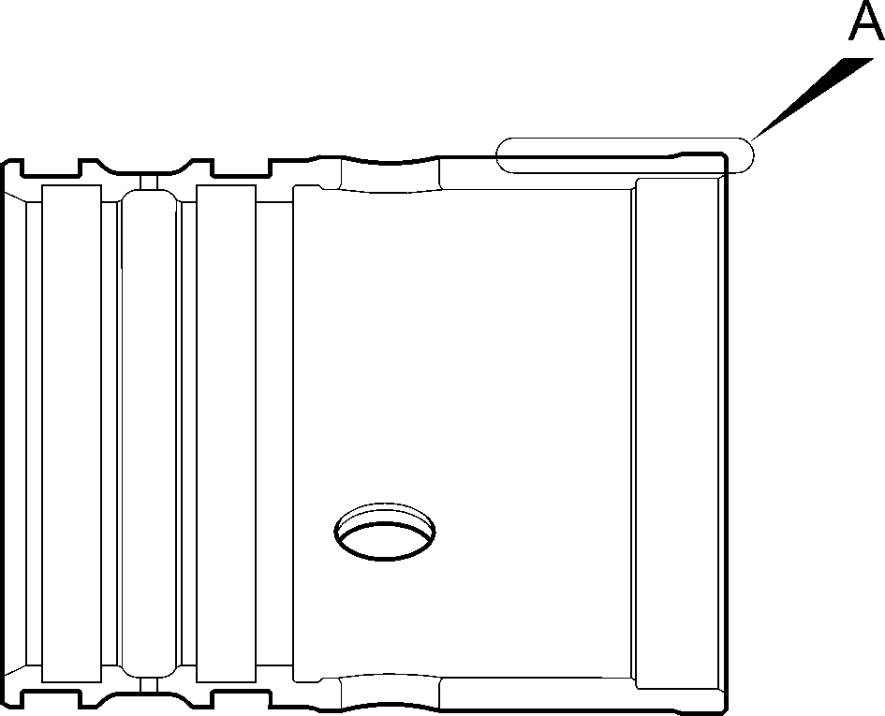
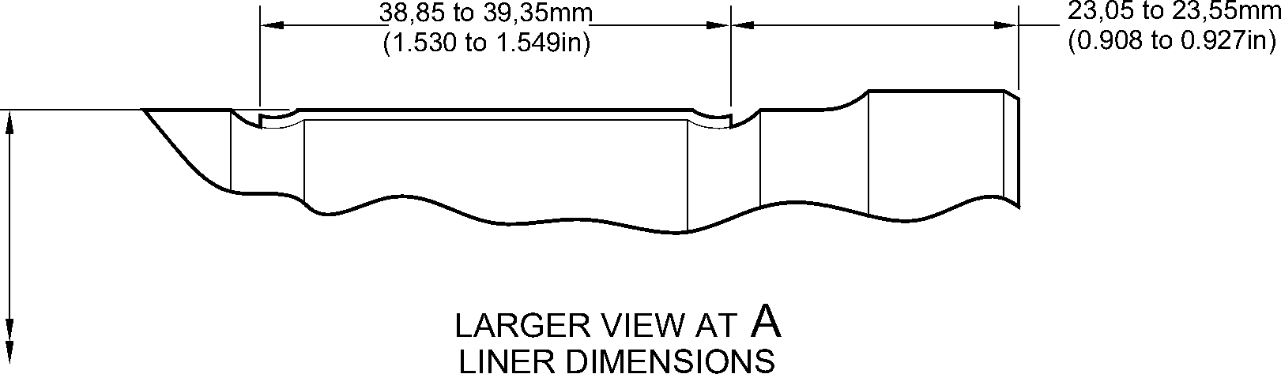
211,868 to 211,938mm
(8.3413 to 8.3440in)
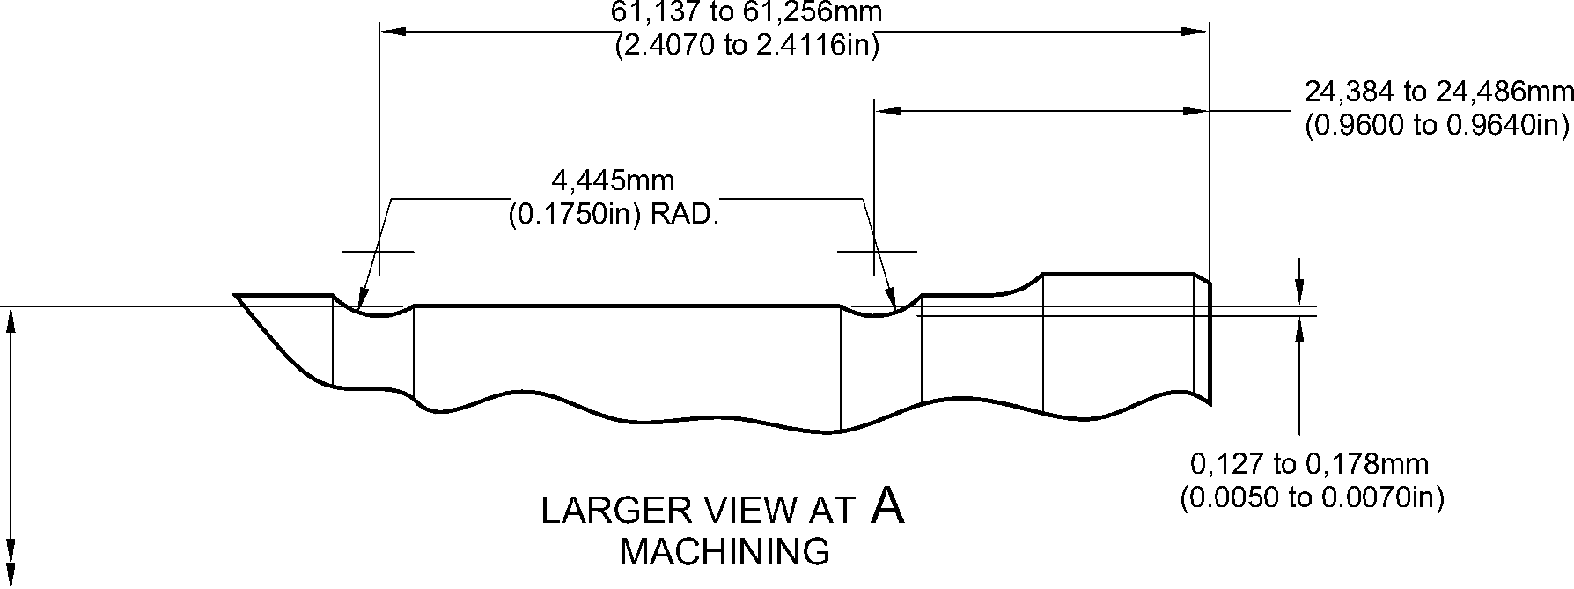
A3219685-1
210,795 to 210,845mm
(8.2991 to 8.3009in)
Repair to Lower Bearing Subassembly
Figure 601
32-12-22
Repair No. 1-1
Page 604
Dec 6/2019

sSAFRAN SAFRAN LANDING SYSTEMS UK Ltd
CAGE: K0654
PART No. 201587001 AND 201587002 COMPONENT MAINTENANCE MANUAL
MAIN LANDING GEAR LEG
- Repair No. 1-2 Lower Bearing Subassembly (16-110A)
- Specified Damage and Material Specification.
- Specified Damage
(a) Loose or damaged liner.
- Material Specification
IPL Figure and  Item No. | Name | Material Specification
16-140 | Gland housing | Aluminium Alloy, 2024T35
- Special Tools
- Special tools are not necessary.
- Materials
- These materials are necessary:
NOTE: Alternative equivalents are permitted.
Ref. Item | Material
TBA | Accomet C
TBA | Adhesive PVC tape
TBA | Araldite, 2015
TBA | Cleaning tissues
TBA | Emery cloth, 60-100 grit
08-715 | Masking tape
08-722 | Adhesive
11-583 | Cleaning agent
- Repair Parts
- These repair parts are necessary:
Part No. | Repair Part | Material Specification
450237823 | Repair liner | Fibreslip, B40
- Procedure (Refer to Figure 601)
- Repair loose but undamaged liner:
- Remove the used adhesive from the external diameter of the gland housing and
the internal diameter of the liner: refer to CLEANING.
- Put the liner in position on the gland housing. If necessary, cut the liner at the scarf
joints to adjust its length.
- Remove the liner from the gland housing.
Repair No. 1-2
32-12-22
Page 601
Dec 6/2019

SAFRAN LANDING SYSTEMS UK Ltd
CAGE: K0654
SSAFRAN
PART No. 201587001 AND 201587002 COMPONENT MAINTENANCE MANUAL
MAIN LANDING GEAR LEG
- Clean the surfaces of the liner and the gland housing that will touch: use the
cleaning tissues, Material Ref. Item TBA and the cleaning agent, Material Ref.
Item 11-583.
- Apply adhesive, Material Ref. Item 08-722, to the cleaned surface of the liner near
to the scarf joints: refer to M-DLPS724.
- Assemble the liner to the gland housing.
- Identify the part with the Messier-Dowty Limited repair number 450237610A
adjacent to the part number: refer to PCS-6000-05.
- Examine the part to make sure that you have obeyed all the repair instructions
correctly.
- Repair damaged liner:
- Remove the damaged liner and remove the used adhesive from the external
diameter of the gland housing: refer to CLEANING.
- Put the repair liner in position on the gland housing. If necessary, cut the repair
liner at the scarf joints to adjust its length.
- Apply adhesive PVC tape, Material Ref. Item TBA, around the gland housing to the
sides of and touching the repair liner. Make sure that the edges of the adhesive
PVC tape, Material Ref. Item TBA, bond tightly to the gland housing.
- Remove the repair liner from the gland housing.
- Use the Emery cloth, 60-100 grit, Material Ref. Item TBA, to make rough, the
surfaces that will bond. Do not damage the edges of the adhesive PVC tape,
Material Ref. Item TBA.
- Use the cleaning agent, Material Ref. Item 11-583, and cleaning tissues, Material
Ref. Item TBA, to clean the surfaces made rough.
- Set the temperature of an oven to between 35 and 45 ºC (95 and 113 ºF).
- Prepare a mixture of 1 part by volume of Accomet C, Material Ref. Item TBA, and
4 parts by volume of clean cold water.
- Use a brush to apply a flat layer of the prepared mixture to the surfaces of the
gland housing made rough.
- Put the gland housing in the oven for a minimum of 4 minutes and until the applied
mixture is dry.
- Alternative procedure for paragraphs (g) to (j): apply Alocrom to the contact surface
of the gland housing: refer to PCS-2220, type 2.
- Use a brush to apply Araldite, 2015, Material Ref. Item TBA, to the gland housing.
- Assemble the repair liner to the gland housing and hold it tightly with the masking
tape, Material Ref. Item 08-715. Bond the masking tape, Material Ref. Item
08-715, to the adjacent adhesive PVC tape, Material Ref. Item TBA. Use one layer
of the masking tape, Material Ref. Item 08-715, only at each side of the repair liner:
make sure that the ends touch but do not overlap.
- Use a clamp to attach the repair liner to the gland housing.
- Put the gland housing in the oven, kept at between 35 and 45 ºC (95 and 113 ºF),
for 345 to 375 minutes.
Repair No. 1-2
Page 602
Dec 6/2019

sSAFRAN SAFRAN LANDING SYSTEMS UK Ltd
CAGE: K0654
PART No. 201587001 AND 201587002 COMPONENT MAINTENANCE MANUAL
MAIN LANDING GEAR LEG
- Remove the gland housing from the oven and let its temperature decrease for a
minimum of 30 minutes.
- Machine the diameter and width of the repair liner to the dimensions shown before
you remove the adhesive PVC tape, Material Ref. Item TBA.
- Remove all of the tape and clean the parts as necessary.
- Identify the part with the Messier-Dowty Limited repair number 450237610B
adjacent to the part number: refer to PCS-6000-05.
- Examine the part to make sure that you have obeyed all the repair instructions
correctly.
Repair No. 1-2
32-12-22
Page 603
Dec 6/2019

SAFRAN LANDING SYSTEMS UK Ltd
CAGE: K0654

PART No. 201587001 AND 201587002 COMPONENT MAINTENANCE MANUAL
MAIN LANDING GEAR LEG
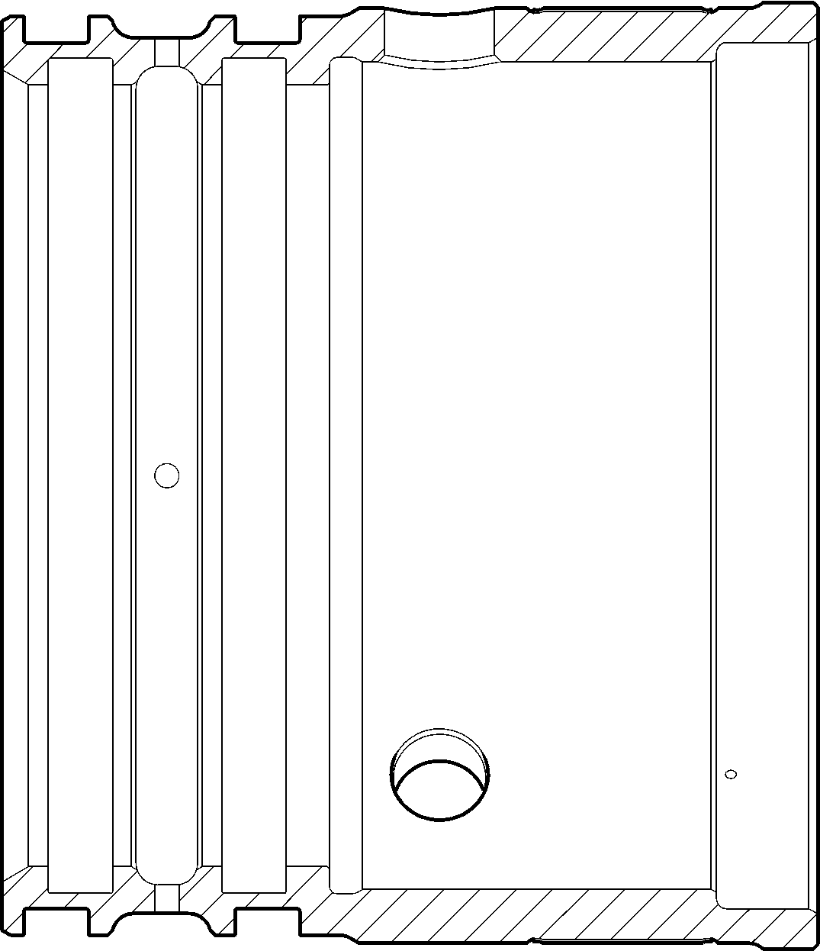
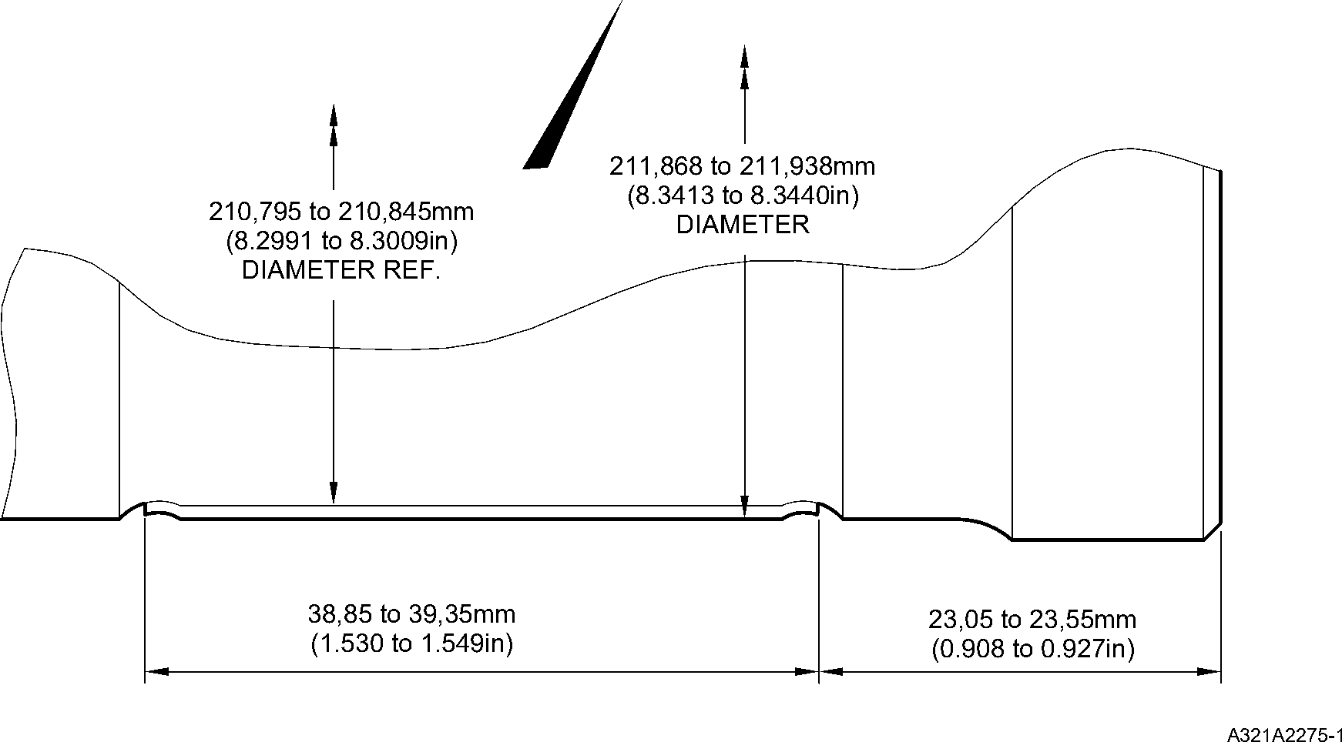
Repair to Lower Bearing Subassembly
Figure 601
32-12-22
Repair No. 1-2
Page 604
Dec 6/2019

sSAFRAN SAFRAN LANDING SYSTEMS UK Ltd
CAGE: K0654
PART No. 201587001 AND 201587002 COMPONENT MAINTENANCE MANUAL
MAIN LANDING GEAR LEG
- Repair No. 2-1 Pin (13-190 and 13-190A)
- Specified Damage and Material Specification.
- Specified Damage
(a) Damage or wear to the diameters A and B.
- Material Specification
IPL Figure and  Item No. | Name | Material Specification
13-190 and  13-190A | Pin | Steel, 35NCD16
- Special Tools
- Special tools are not necessary.
- Materials
- Materials are not necessary.
- Repair Parts
- Repair parts are not necessary.
- Procedure (Refer to Figure 601)
- Remove the chromium plate from diameters A and B.
- Machine the diameters A and B to remove damage or wear after removal of the
chromium plate. Remove the minimum amount of material necessary, to the dimensions
shown in Figure 601, to remove the damage or wear.
- Examine the pin for flaws: refer to PCS-3600 and PCS-3100 inclusion class 3.
- Shot peen the machined areas: refer to M-DLPS123.
- Apply chromium plate to the diameters A and B: refer to M-DLPS101-2. Make sure the
chromium plate terminations are smooth: refer to M-DLPS1031.
- Finish grind the pin to the dimensions shown in Figure 601.
- Examine the pin for flaws: refer to M-DLNDT3.
- Identify the part with the Messier-Dowty Limited repair number 450217145 adjacent to
the part number: refer to PCS-6000-05.
- Examine the part to make sure that you have obeyed all the repair instructions correctly.
Repair No. 2-1
32-12-22
Page 601
Dec 6/2019

SAFRAN LANDING SYSTEMS UK Ltd
CAGE: K0654

PART No. 201587001 AND 201587002 COMPONENT MAINTENANCE MANUAL
MAIN LANDING GEAR LEG
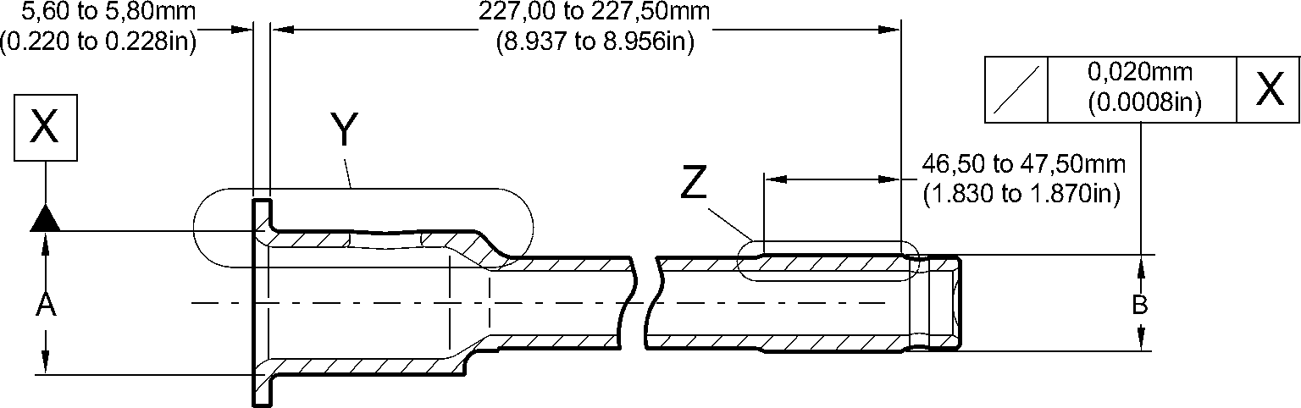
63,50 to 64,50mm
(2.500 to 2.539in)
4,75 to 5,25mm
(0.187 to 0.206in)
LENGTH OF CHROMIUM PLATE
1,00mm (0.039in)
MAXIMUM
1,75 to 2,25mm
(0.068 to 0.088in)
RADIUS
2,00 to 2,50mm
(0.078 to 0.098in)
1,00 to 2,00mm
(0.039 to 0.078in)
45,300mm (1.7834in)
DIAMETER MINIMUM
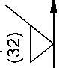
2,00mm
(0.078in)
MAXIMUM
48,00 to 49,00mm
(1.889 to 1.929in)
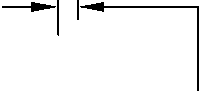
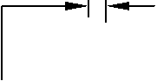
2,00mm
(0.078in)
MAXIMUM
45,950 to 45,975mm
(1.8090 to 1.8100in)
AFTER GRINDING
THE CHROMIUM PLATE MUST STOP
IN THIS LENGTH. AN IRREGULAR
LINE IS PERMITTED
LARGER VIEW AT
Y
CHROMIUM
DEPOSIT
T
LENGTH OF CHROMIUM PLATE
1,00 to 2,00mm
(0.039 to 0.078in)
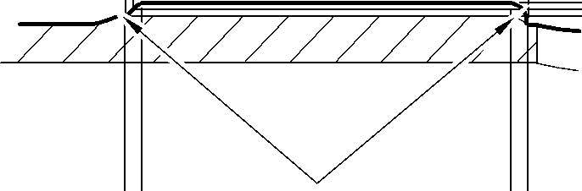
2,00 to 3,00mm
(0.078 to 0.118in)
RADIUS
30,300mm (1.1929in)
DIAMETER MINIMUM
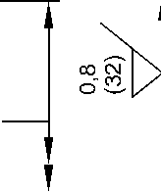
30,950 to 30,975mm
(1.2186 to 1.2195in)
AFTER GRINDING
2,00mm
(0.078in)
MAXIMUM
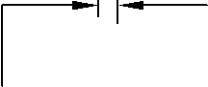
2,00mm
(0.078in)
MAXIMUM
CHROMIUM
DEPOSIT
THE CHROMIUM PLATE MUST STOP
IN THIS LENGTH. AN IRREGULAR
LINE IS PERMITTED
LARGER VIEW AT
Z
A3219755-2
Repair to Pin
Figure 601
32-12-22
Repair No. 2-1
Page 602
Dec 6/2019
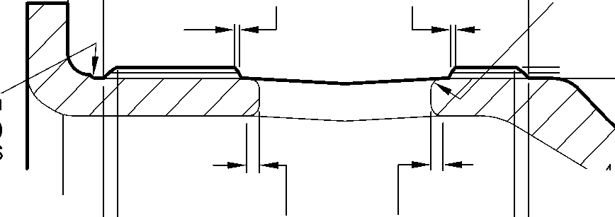

SAFRAN LANDING SYSTEMS UK Ltd
CAGE: K0654

PART No. 201587001 AND 201587002 COMPONENT MAINTENANCE MANUAL
MAIN LANDING GEAR LEG
- Repair No. 3-1 Pivot Pin (6-90)
- Specified Damage and Material Specification.
- Specified Damage
(a) Damage or wear to the diameter A.
- Material Specification
IPL Figure and  Item No. | Name | Material Specification
6-90 | Pivot Pin | Steel, S99
- Special Tools
- Special tools are not necessary.
- Materials
(1) Materials are not necessary.
- Repair Parts
(1) Repair parts are not necessary.
E. Procedure (Refer to Figure 601)
- Remove the chromium plate only from the diameter A to show the parent metal.
- If the parent metal is not damaged or worn:
- Examine the pivot pin for flaws: refer to PCS-3600 and PCS-3100, inclusion
class 3.
- Apply chromium plate to the diameter A: refer to PCS-2110 Type B. Refer to
Figure 601 for chromium plate termination information.
- Grind the diameter A to between 15,960 and 15,987 mm (0.6284 and 0.6294 in).
The surface finish must be 0,8 micrometers (32 micro-inches).
- Examine the pivot pin for flaws: refer to PCS-3002, PCS-3100, inclusion class 3
and PCS-3600.
- Identify the part with the Messier-Dowty Limited repair number 450217385A
adjacent to the part number: refer to PCS-6000-05.
- Examine the part to make sure that you have obeyed all the repair instructions
correctly.
- If the parent metal is damaged or worn:
- Machine the diameter A sufficiently to remove damage and wear, down to a
minimum of 15,377 mm (0.6054 in).
- Examine the pivot pin for flaws: refer to PCS-3600 and PCS-3100, inclusion
class 3.
- Apply chromium plate to the diameter A: refer to PCS-2110 Type B. Refer to
Figure 601 for chromium plate termination information.

Repair No. 3-1
Page 601
May 31/2019
32-12-22

sSAFRAN SAFRAN LANDING SYSTEMS UK Ltd
CAGE: K0654
PART No. 201587001 AND 201587002 COMPONENT MAINTENANCE MANUAL
MAIN LANDING GEAR LEG
- Grind the diameter A to between 15,960 and 15,987 mm (0.6284 and 0.6294 in).
The surface finish must be 0,8 micrometers (32 micro-inches).
- Examine the pivot pin for flaws: refer to PCS-3002, PCS-3100, inclusion class 3
and PCS-3600.
- Identify the part with the Messier-Dowty Limited repair number 450217385B
adjacent to the part number: refer to PCS-6000-05.
- Examine the part to make sure that you have obeyed all the repair instructions
correctly.
32-12-22
Repair No. 3-1
Page 602
May 31/2019

SAFRAN LANDING SYSTEMS UK Ltd
CAGE: K0654

PART No. 201587001 AND 201587002 COMPONENT MAINTENANCE MANUAL
MAIN LANDING GEAR LEG
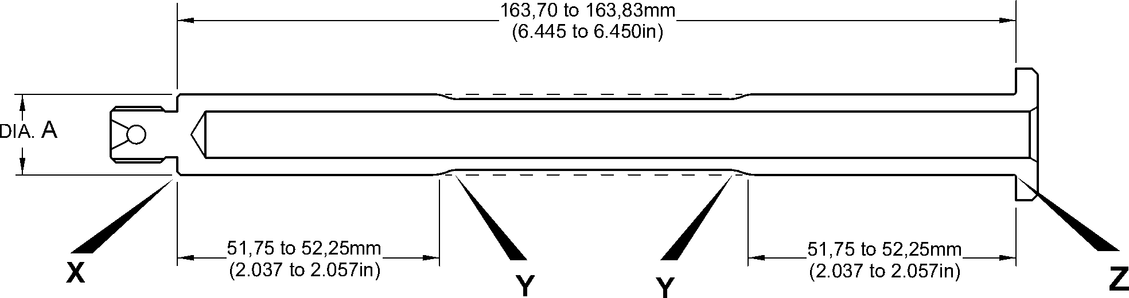
CHROMIUM PLATE CAN STOP
ANYWHERE ON THE CHAMFER.
IT CAN BE FINISHED BY GRINDING
0,92 to 1,45mm
(0.036 to 0.057in)
MAKE EDGES SMOOTH
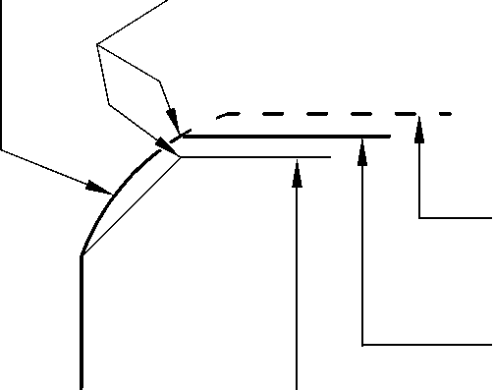
AFTER CHROMIUM PLATE
IS APPLIED AND BEFORE
GRINDING
AFTER GRINDING
0,120 to 0,250mm
(0.0047 to 0.0100in)
RAD.
0,80mm (0.031in)
RAD. MIN.
BEFORE CHROMIUM
PLATE IS APPLIED
CHROMIUM PLATE
TEMINATION TO M-DLPS1031-6
AFTER GRINDING
AFTER CHROMIUM PLATE
IS APPLIED AND BEFORE
BEFORE CHROMIUM
PLATE IS APPLIED
GRINDING
DETAIL X
CHROMIUM PLATE
TEMINATION TO M-DLPS1031-3
DETAIL Z
2,00mm (0.079in) MAX.
CHROMIUM PLATE MUST STOP
IN THIS LENGTH.
AN IRREGULAR LINE IS PERMITTED.
2,00mm (0.079in)
MIN. LENGTH
NOT CHROMIUM PLATED


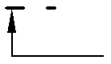
CHROMIUM PLATED LENGTH
AFTER CHROMIUM PLATE
IS APPLIED AND BEFORE
GRINDING
CHROMIUM PLATE
TEMINATION TO M-DLPS1031-1
DETAIL Y
AFTER GRINDING
BEFORE CHROMIUM
PLATE IS APPLIED
A321-S-32-12-22-099-0
Repair to Pivot Pin
Figure 601
Repair No. 3-1
32-12-22
Page 603
Dec 8/2017
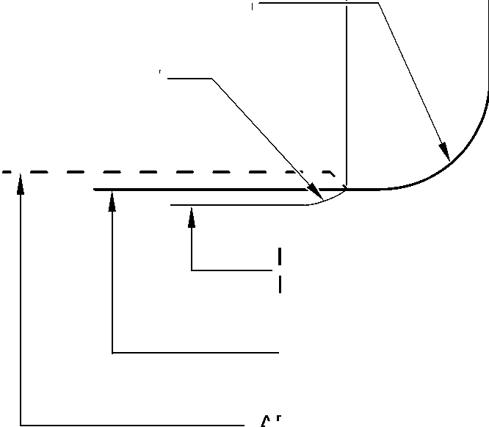

SAFRAN LANDING SYSTEMS UK Ltd
CAGE: K0654

PART No. 201587001 AND 201587002 COMPONENT MAINTENANCE MANUAL
MAIN LANDING GEAR LEG
INTENTIONALLY BLANK
32-12-22
Repair No. 3-1
Page 604

sSAFRAN SAFRAN LANDING SYSTEMS UK Ltd
CAGE: K0654
PART No. 201587001 AND 201587002 COMPONENT MAINTENANCE MANUAL
MAIN LANDING GEAR LEG
- Repair No. 4-1 Uplock Pin (5-400)
- Specified Damage and Material Specification.
- Specified Damage
(a) Damage or wear to diameter A.
- Material Specification
IPL Figure and  Item No. | Name | Material Specification
5-400 | Uplock pin | Steel, S99
- Special Tools
- Special tools are not necessary.
- Materials
- Materials are not necessary.
- Repair Parts
- Repair parts are not necessary.
- Procedure (Refer to Figure 601)
- Remove the chromium plate from diameter A.
- Machine diameter A to remove the damage or wear after removal of the chromium plate.
The minimum diameter is 24,36 mm (0.960 in) and the surface finish must be
0,4 micrometers (16 micro-inches).
- Examine the uplock pin for flaws: refer to PCS-3600 and PCS-3100, inclusion class 3.
- If diameter A has been machined (see para (2)), shot peen the machined area: refer to
M-DLPS123.
- Apply chromium plate to diameter A as shown with a minimum chromium plate thickness
of 0,075 mm (0.0030 in): refer to M-DLPS101-2.
- Machine diameter A to between 24,947 and 24,980 mm (0.9822 and 0.9834 in) with a
surface finish of 0,4 micrometers (16 micro-inches).
- Examine the chromium plated surface for flaws: refer to M-DLNDT3.
- Apply cadmium plate to the machined areas but not where chromium plated: refer to
PCS-2141.
- Spray primer paint lightly on the cadmium plated surface: refer to PCS-2500.
- Refer to PCS-6000-07 and identify the part with the applicable Messier-Dowty Limited
repair number, adjacent to the part number, after painting:
- 450237490A if only the chromium plate has been repaired, or
- 450237490B if chromium plate and parent metal have been repaired.
- Examine the part to make sure that you have obeyed all the repair instructions correctly.
Repair No. 4-1
32-12-22
Page 601
Dec 6/2019

SAFRAN LANDING SYSTEMS UK Ltd
CAGE: K0654

PART No. 201587001 AND 201587002 COMPONENT MAINTENANCE MANUAL
MAIN LANDING GEAR LEG
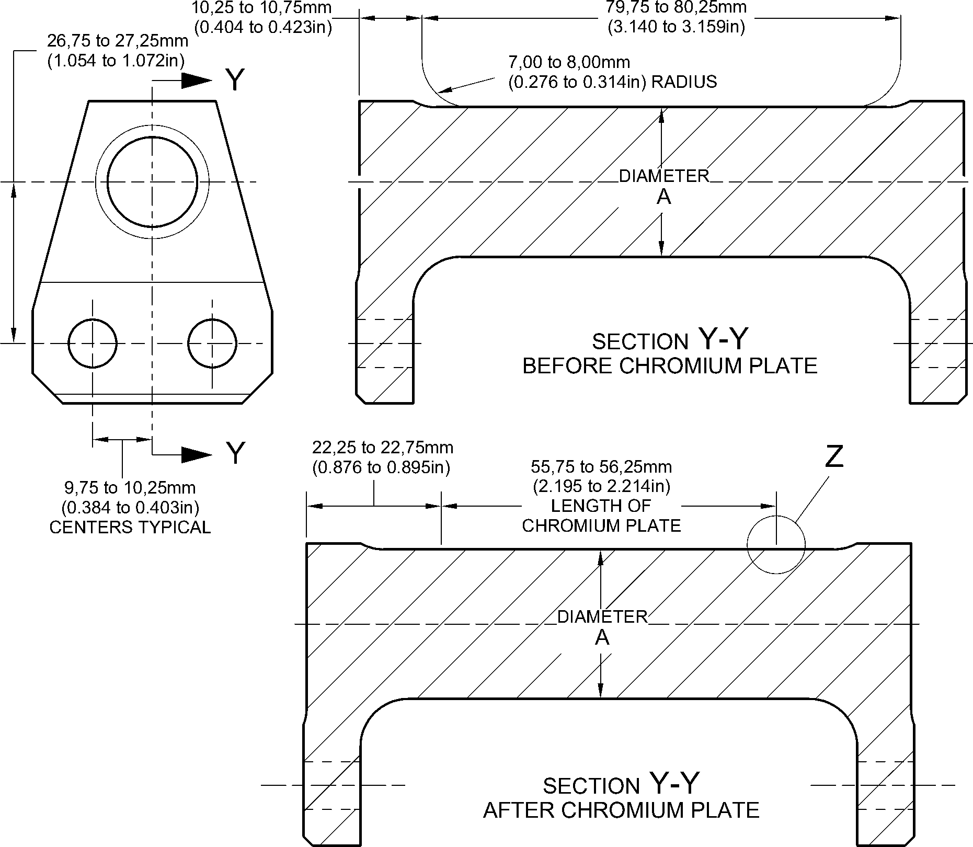
LENGTH OF
CHROMIUM PLATE
M-DLPS1031-2 CHROMIUM PLATE TERMINATION
CHROMIUM PLATE MUST NOT EXTENDED ONTO
7,00 to 8,00mm (0.276 to 0.314in) RADIUS
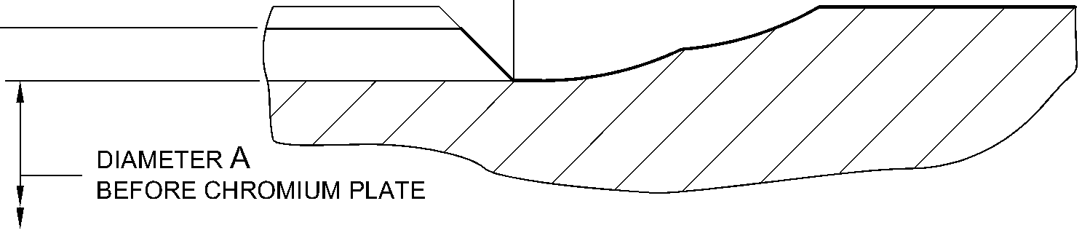
diameter A
AFTER CHROMIUM PLATE AND GRINDING
larger detail Z
NOT TO SCALE
A321A1270-2
Repair to Uplock Pin
Figure 601
32-12-22
Repair No. 4-1
Page 602
Dec 6/2019

sSAFRAN SAFRAN LANDING SYSTEMS UK Ltd
CAGE: K0654
PART No. 201587001 AND 201587002 COMPONENT MAINTENANCE MANUAL
MAIN LANDING GEAR LEG
- Repair No. 5-1 Pin (3-50)
- Specified Damage and Material Specification.
- Specified Damage
(a) Damage or wear to diameter A.
- Material Specification
IPL Figure and  Item No. | Name | Material Specification
3-50 | Pin | Steel, S99
- Special Tools
- Special tools are not necessary.
- Materials
- Materials are not necessary.
- Repair Parts
- Repair parts are not necessary.
- Procedure (Refer to Figure 601)
- Machine diameter A sufficiently to remove the damage or wear and to the dimensions
shown in Figure 601.
- Examine the pin for flaws: refer to PCS-3600 and PCS-3100, inclusion class 2.
- Shot peen the pin: refer to M-DLPS123.
- Apply chromium plate to diameter A to give a minimum diameter of 20,120 mm
(0.7921 in): refer to M-DLPS101-2P.
- Grind diameter A to the dimensions shown with a surface finish of 0,4 micrometers
(16 micro-inches). Refer to M-DLPS1031-3 and M-DLPS1031-6 for the chromium plate
terminations where shown.
- Examine the pin for flaws: refer to M-DLNDT3.
- Identify the part with the Messier-Dowty Limited repair number 450217170 adjacent to
the part number: refer to PCS-6000-05.
- Apply cadmium plate all over the pin, but not on the chromium plated areas: refer to
M-DLPS100-2 or PCS-2141.
- Paint the pin all over, but not on the threads, the thread undercut and the chromium
plated areas: refer to PCS-2500.
- Examine the part to make sure that you have obeyed the repair instructions correctly.
Repair No. 5-1
Page 601
Dec 9/2016
32-12-22

SAFRAN LANDING SYSTEMS UK Ltd
CAGE: K0654

PART No. 201587001 AND 201587002 COMPONENT MAINTENANCE MANUAL
MAIN LANDING GEAR LEG
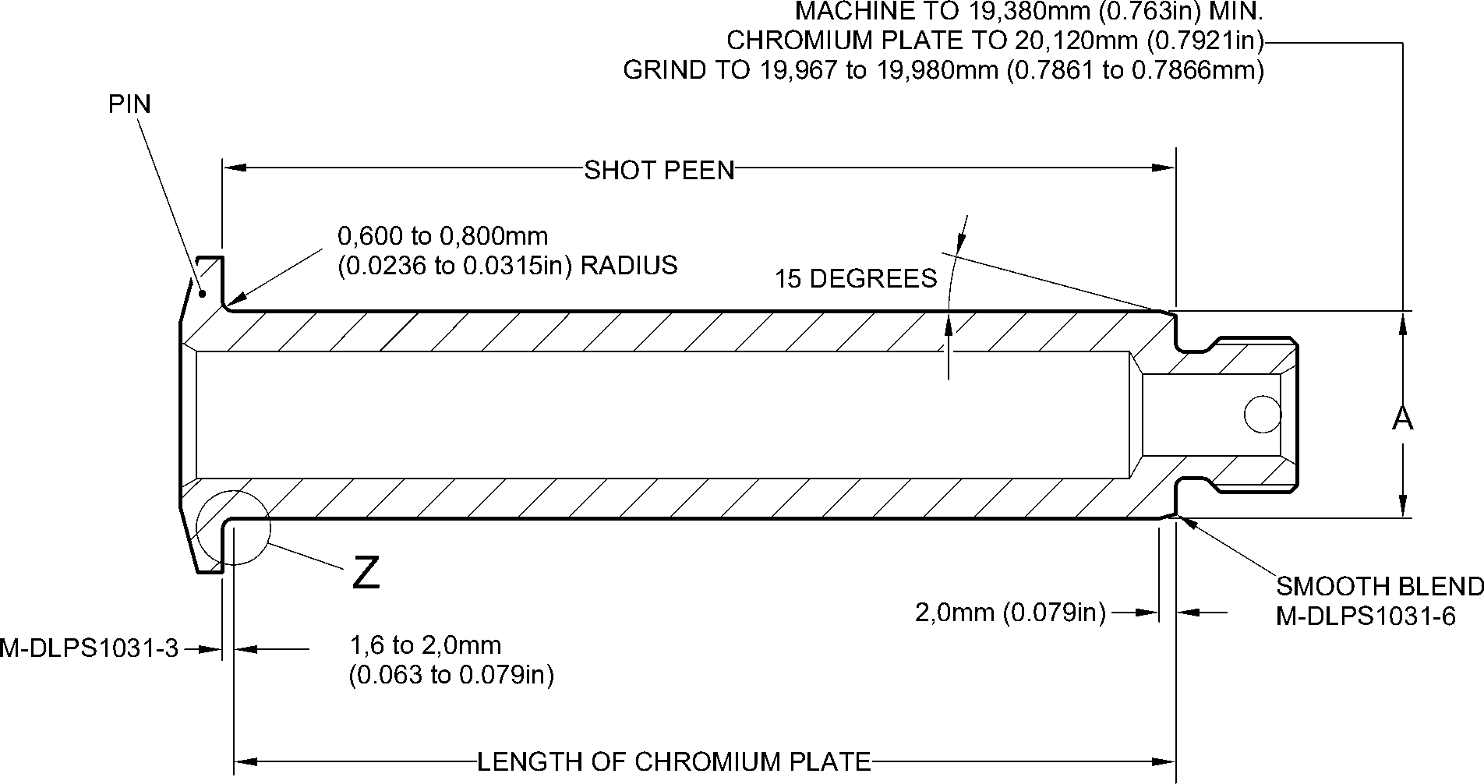
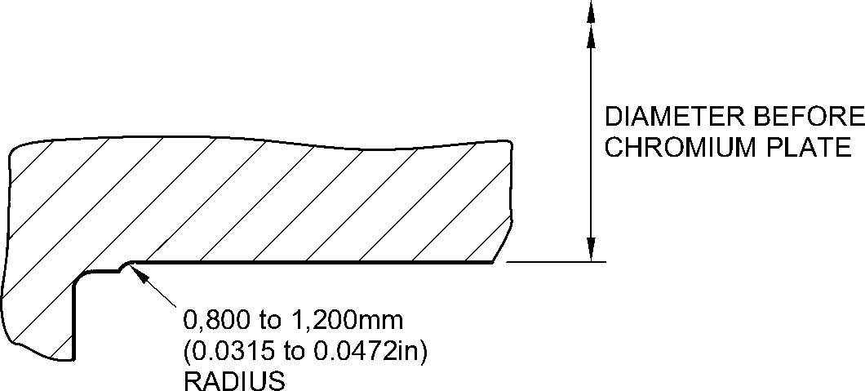
detail Z
A321A2276-1
Repair to Pin
Figure 601
32-12-22
Repair No. 5-1
Page 602
Dec 9/2016

sSAFRAN SAFRAN LANDING SYSTEMS UK Ltd
CAGE: K0654
PART No. 201587001 AND 201587002 COMPONENT MAINTENANCE MANUAL
MAIN LANDING GEAR LEG
- Repair No. 6-1 Pin (10-80)
- Specified Damage and Material Specification.
- Specified Damage
(a) Damage or corrosion to diameter A.
- Material Specification
IPL Figure and  Item No. | Name | Material Specification
10-80 | Pin | UHT Steel (300M), MTL 1201
- Special Tools
- Special tools are not necessary.
- Materials
- Materials are not necessary.
- Repair Parts
- Repair parts are not necessary.
- Procedure (Refer to Figure 601)
- Remove the chromium plate from diameter A: refer to PCS-2110.
- If the bare metal is not damaged or corroded:
- Examine the pin for flaws: refer to PCS-3600 and PCS-3100, inclusion
class 4.
- Shot peen diameter A: refer to M-DLPS123.
- Apply chromium plate to diameter A: refer to PCS-2110, Type C. Refer to
Figure 601 for chromium plate termination information.
- Grind diameter A to between 59,951 and 59,970 mm (2.3603 and 2.3610 in).
The surface finish must be 0,8 micrometers (32 micro-inches).
- Examine the ground chromium plate for flaws: refer to PCS-3100, inclusion
class 4 and PCS-3002.
- Identify the part with the Messier-Dowty Limited repair number 450258420A
adjacent to the part number: refer to PCS-6000-04 and PCS-6000-07.
- Examine the part to make sure that you have obeyed all the repair
instructions correctly.
- If the bare metal is damaged or corroded:
- Machine diameter A just sufficiently to remove the damage or corrosion: refer
to M-DLPS1004-4-1. The diameter must not be less than 59,370 mm
(2.3374 in). The surface finish must be 1,6 micrometers (63 micro-inches).
- Examine the pin for flaws: refer to PCS-3600 and PCS-3100, inclusion
class 4.

Repair No. 6-1
32-12-22
Page 601
Dec 6/2019

sSAFRAN SAFRAN LANDING SYSTEMS UK Ltd
CAGE: K0654
PART No. 201587001 AND 201587002 COMPONENT MAINTENANCE MANUAL
MAIN LANDING GEAR LEG
- Shot peen and apply chromium plate to diameter A: refer to M-DLPS123 and
PCS-2110, Type C. Refer to Figure 601 for chromium plate termination
information.
- Grind diameter A to between 59,951 and 59,970 mm (2.3603 and 2.3610 in).
The surface finish must be 0,8 micrometers (32 micro-inches).
- Examine the ground chromium plate for flaws: refer to PCS-3100, inclusion
class 4 and PCS-3002.
- Identify the part with the Messier-Dowty Limited repair number 450258420B
adjacent to the part number: refer to PCS-6000-04 and PCS-6000-07.
- Examine the part to make sure that you have obeyed all the repair
instructions correctly.
32-12-22
Repair No. 6-1
Page 602
Dec 6/2019

SAFRAN LANDING SYSTEMS UK Ltd
CAGE: K0654

PART No. 201587001 AND 201587002 COMPONENT MAINTENANCE MANUAL
MAIN LANDING GEAR LEG
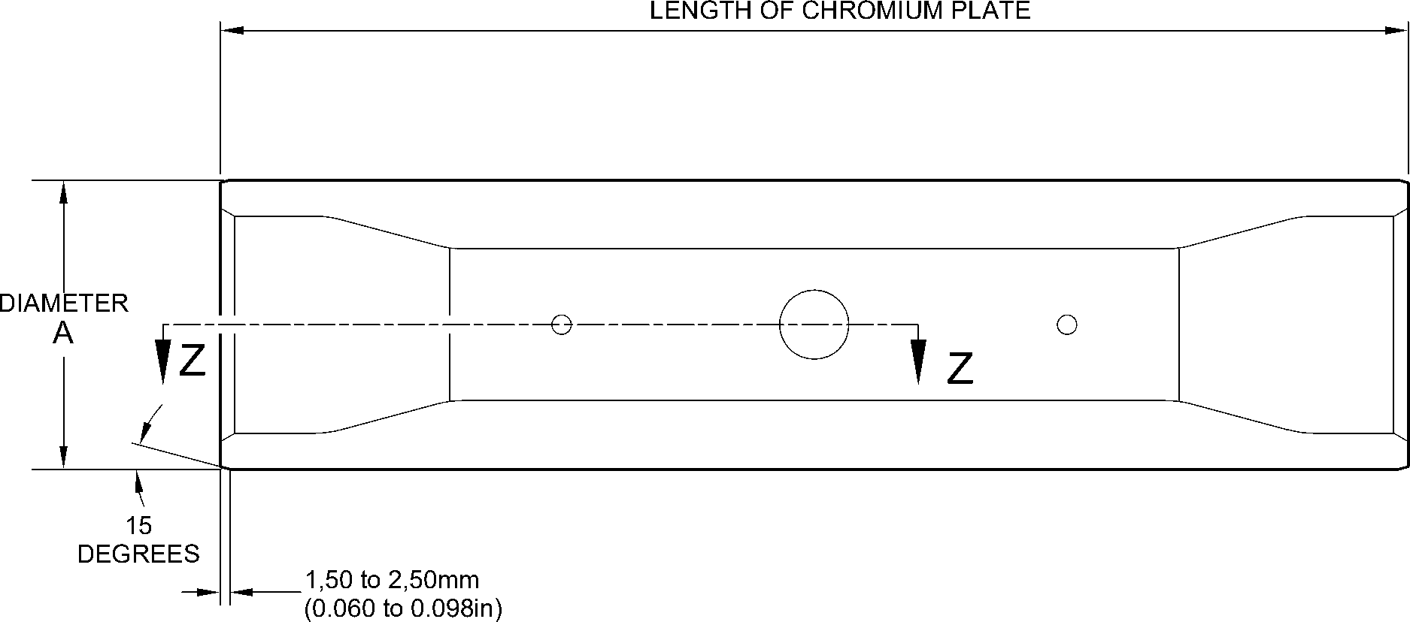
^{EDGES SMOOTHED OUT.} CHROMIUM PLATE TERMINATION
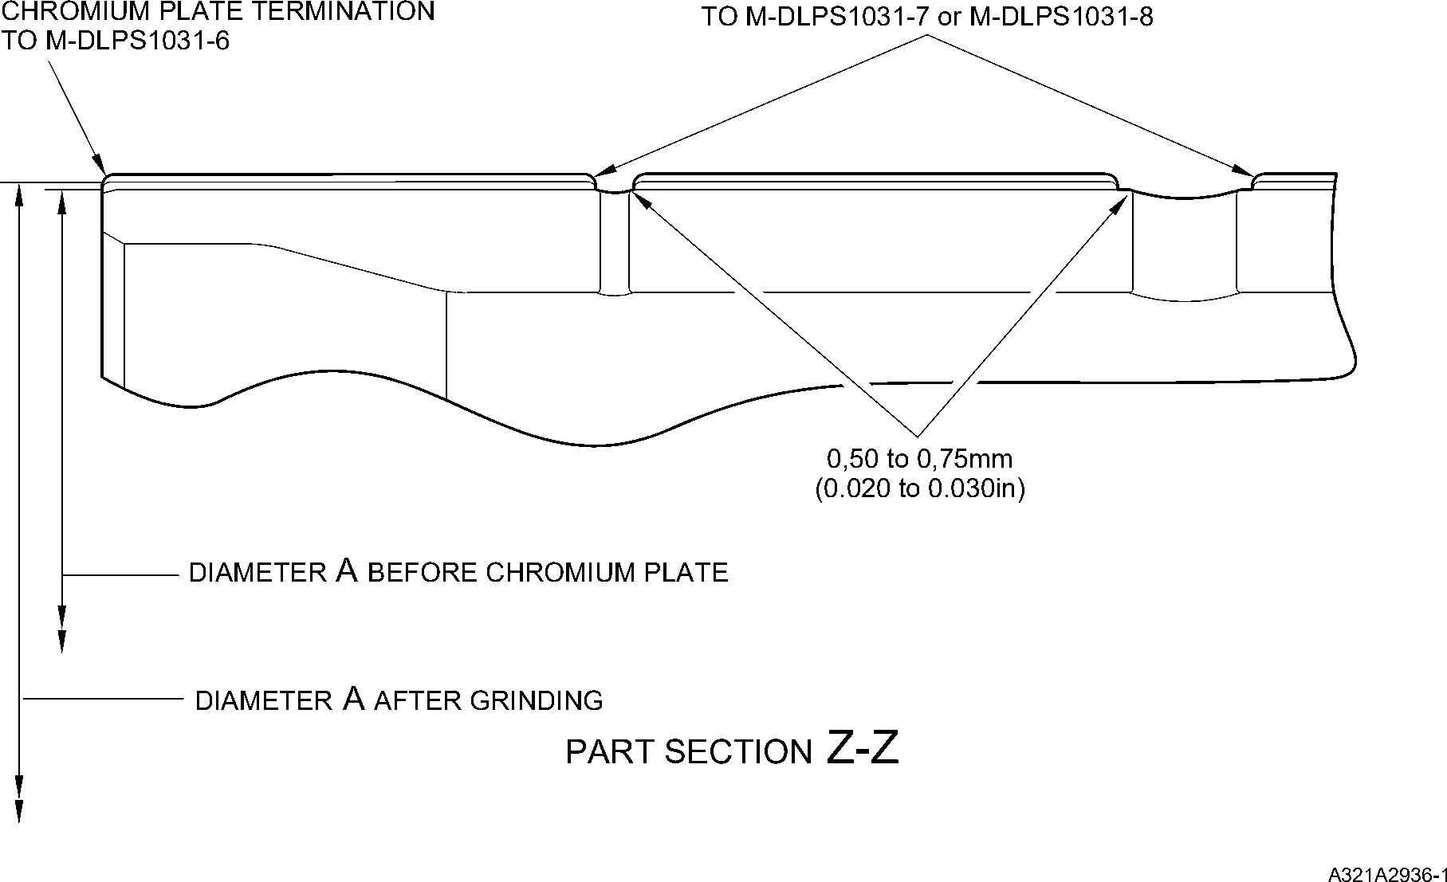
Repair to Pin
Figure 601
Repair No. 6-1
32-12-22
Page 603
Dec 6/2019

SAFRAN LANDING SYSTEMS UK Ltd
CAGE: K0654

PART No. 201587001 AND 201587002 COMPONENT MAINTENANCE MANUAL
MAIN LANDING GEAR LEG
INTENTIONALLY BLANK
Repair No. 6-1
32-12-22 ^{Page 604}

sSAFRAN SAFRAN LANDING SYSTEMS UK Ltd
CAGE: K0654
PART No. 201587001 AND 201587002 COMPONENT MAINTENANCE MANUAL
MAIN LANDING GEAR LEG
- Repair No. 6-2 Pin (10-80)
- Specified Damage and Material Specification.
- Specified Damage
(a) Damage or wear to diameter A.
- Material Specification
IPL Figure and  Item No. | Name | Material Specification
10-80 | Pin | Steel, MTL 1201
- Special Tools
- Special tools are not necessary.
- Materials
- These materials are necessary:
NOTE: Alternative equivalents are permitted.
Ref. Item | Material
08-665 | Adhesive
- Repair Parts
- These repair parts are necessary:
Part No. | Repair Part | Material Specification
450258261 | Repair bush (Qty 2) | Steel, S154
- Procedure (Refer to Figure 601)
- Machine diameter A sufficiently to remove the damage or wear and to between 15,90
and 16,50 mm (0.626 and 0.649 in): refer to M-DLPS1004-4-1. Machine a surface finish
of 1,6 micrometers (63 micro-inches).
- Examine the pin for flaws: refer to PCS-3600 and PCS-3100, inclusion class 4.
- Shot peen the machined areas: refer to M-DLPS123.
- Measure the new diameter A.
- Apply cadmium plate to the machined areas: refer to PCS-2141.
- Calculate diameter C of the repair bushes:
C = A (as measured) + 0,010 to 0,039 mm (0.0004 to 0.0015 in).
- Machine the repair bushes to the dimensions shown and calculated. Machine a surface
finish of 1,6 micrometers (63 micro-inches).
- Examine the repair bushes for flaws: refer to PCS-3100, inclusion class 3.
Repair No. 6-2
Page 601
Dec 6/2019
32-12-22

sSAFRAN SAFRAN LANDING SYSTEMS UK Ltd
CAGE: K0654
PART No. 201587001 AND 201587002 COMPONENT MAINTENANCE MANUAL
MAIN LANDING GEAR LEG
- Apply cadmium plate to all surfaces of the repair bushes: refer to M-DLPS100-1.
- Apply adhesive, Material Ref. Item 08-665, to the outside diameter of the repair bushes:
refer to M-DLPS709-6.
- Install the repair bushes to diameter A until aligned with the outside diameter of the pin:
refer to M-DLPS1011-5.
- Machine the repair bushes to the contour of the pin and the dimensions shown.
- Identify the part with the Messier-Dowty Limited repair number 450258260 adjacent to
the part number: refer to PCS-6000-04 and PCS-6000-07.
- Examine the part to make sure that you have obeyed all the repair instructions correctly.
32-12-22
Repair No. 6-2
Page 602
Dec 6/2019

SAFRAN LANDING SYSTEMS UK Ltd
CAGE: K0654

PART No. 201587001 AND 201587002 COMPONENT MAINTENANCE MANUAL
MAIN LANDING GEAR LEG
Z
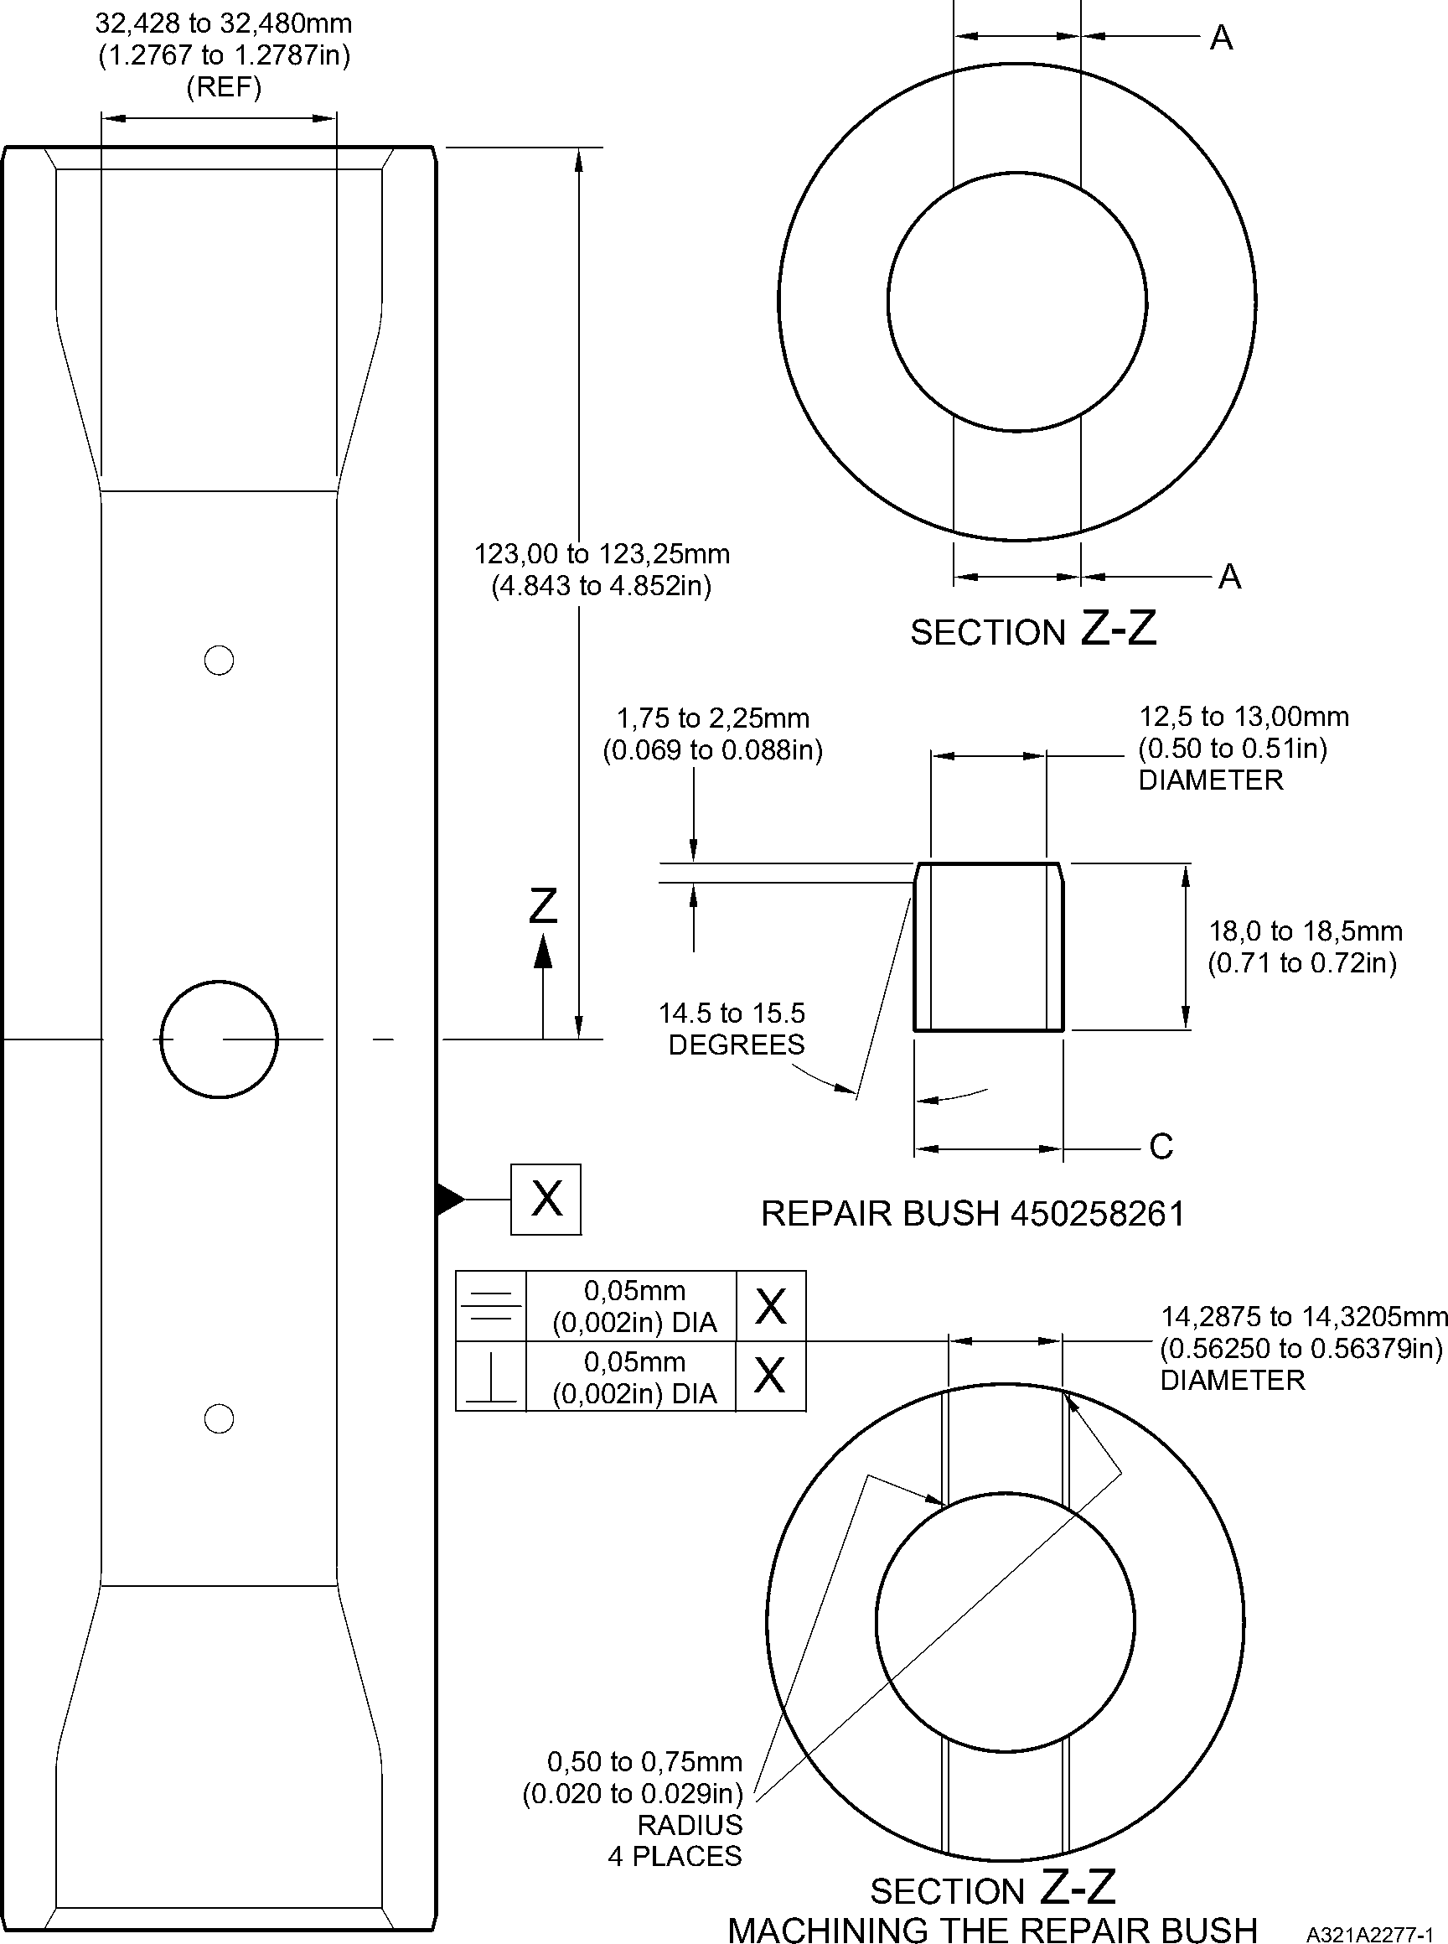
Repair to Pin
Figure 601
Repair No. 6-2
Page 603
Dec 6/2019
32-12-22

SAFRAN LANDING SYSTEMS UK Ltd
CAGE: K0654

PART No. 201587001 AND 201587002 COMPONENT MAINTENANCE MANUAL
MAIN LANDING GEAR LEG
INTENTIONALLY BLANK
Repair No. 6-2
32-12-22 ^{Page 604}

sSAFRAN SAFRAN LANDING SYSTEMS UK Ltd
CAGE: K0654
PART No. 201587001 AND 201587002 COMPONENT MAINTENANCE MANUAL
MAIN LANDING GEAR LEG
- Repair No. 6-3 Pin (10-80)
- Specified Damage and Material Specification
- Specified Damage
(a) Damage or corrosion to diameter A.
- Material Specification
IPL Figure and  Item No. | Name | Material Specification
10-80 | Pin | Steel, MTL1201
- Special Tools
- Special tools are not necessary.
- Materials
- Materials are not necessary.
- Repair Parts
- Repair parts are not necessary.
- Procedure (Refer to Figure 601)
CAUTION: FOR DAMAGE MORE THAN THE LIMITS OF THIS REPAIR SCHEME, WRITE
TO MESSIER-DOWTY LIMITED: REFER TO GUIDE-CS-001.
- Remove the cadmium plate from the pin: refer to PCS-2100.
- Machine the diameter A to remove the minimum amount of material necessary to
remove the damage or wear, restore the 20,00 mm (0.787 in) radius in two places as
shown: refer to M-DLPS1004-4-1 and Figure 601. Do not machine diameter A more
than 33,99 mm (1.3383 in). Make the surface finish 1,6 micrometers (63 micro-inches).
- Machine the radii to the dimensions as shown: refer to Figure 601.
- Examine the part for flaws: refer to PCS-3100 inclusion class 4 and PCS-3600.
- Shot peen the reworked areas over lapping adjacent angled surface by at least 6,35 mm
(0.250 in). Almen A intensity to be 0,20 to 0,030 mm (0.008 to 0.012 in): refer to
M-DLPS123.
- Grit blast the reworked areas: refer to PCS-2610.
- Apply sulphamate nickel plate to the reworked areas: refer to MIL STD 868A solution 2,
PCS-2120 and Figure 601. The sulphamate nickel plate thickness must be sufficient to
get the correct diameter after machining. Make sure that the cross hole and the
lubrication holes are sufficiently masked: refer to Figure 601.
NOTE: The above procedure includes de-embrittle for 23 hours at 185ºC to 195ºC
(366ºF to 383ºF).
Repair No. 6-3
32-12-22
Page 601
Dec 6/2019

sSAFRAN SAFRAN LANDING SYSTEMS UK Ltd
CAGE: K0654
PART No. 201587001 AND 201587002 COMPONENT MAINTENANCE MANUAL
MAIN LANDING GEAR LEG
- Machine (do not grind) the sulphamate nickel plate to get the bore diameter of 32,468 to
32,500 mm (1.2783 to 1.2795 in): refer to Figure 601. Make the surface finish 1,6
micrometers (63 micro-inches).
- Machine the 20,000 mm (0.7874 in) radii as shown: refer to Figure 601.
- If the pin base metal has been machined, examine the machined areas for flaws: refer to
PCS-3600.
NOTE: The above procedure includes de-embrittle for 4 hours at 185ºC to 195ºC
(366ºF to 383ºF).
- Grit blast the sulphamate nickel area: refer to PCS-2610. Make sure that the remainder
of the pin is sufficiently masked.
- Examine the edges of sulphamate nickel plate to make sure they are properly bonded:
use 5 or 10X magnification.
- If there is evidence of delamination, remove the sulphamate nickel plate and do the
repair again.
- Apply cadmium plate all over the pin except where chromium plated: refer to PCS-2100
and Figure 601. The cadmium plate thickness must be between 0,010 and 0,020 mm
(0.0004 and 0.0008 in). Make sure the sulphamate nickel plate is fully encapsulated by
cadmium plate.
- Identify the part with the Messier-Dowty Limited repair number 450266211 adjacent to
the part number: refer to PCS-6000-04.
- Apply paint to the reworked areas: refer to REPAIR and PCS-2500.
- Identify the part with the Messier-Dowty Limited repair number 450266211 adjacent to
the part number: refer to PCS-6000-07.
- Examine the part to make sure that you have obeyed all the repair instructions correctly.
32-12-22
Repair No. 6-3
Page 602
Dec 6/2019

SAFRAN LANDING SYSTEMS UK Ltd
CAGE: K0654

PART No. 201587001 AND 201587002 COMPONENT MAINTENANCE MANUAL
MAIN LANDING GEAR LEG
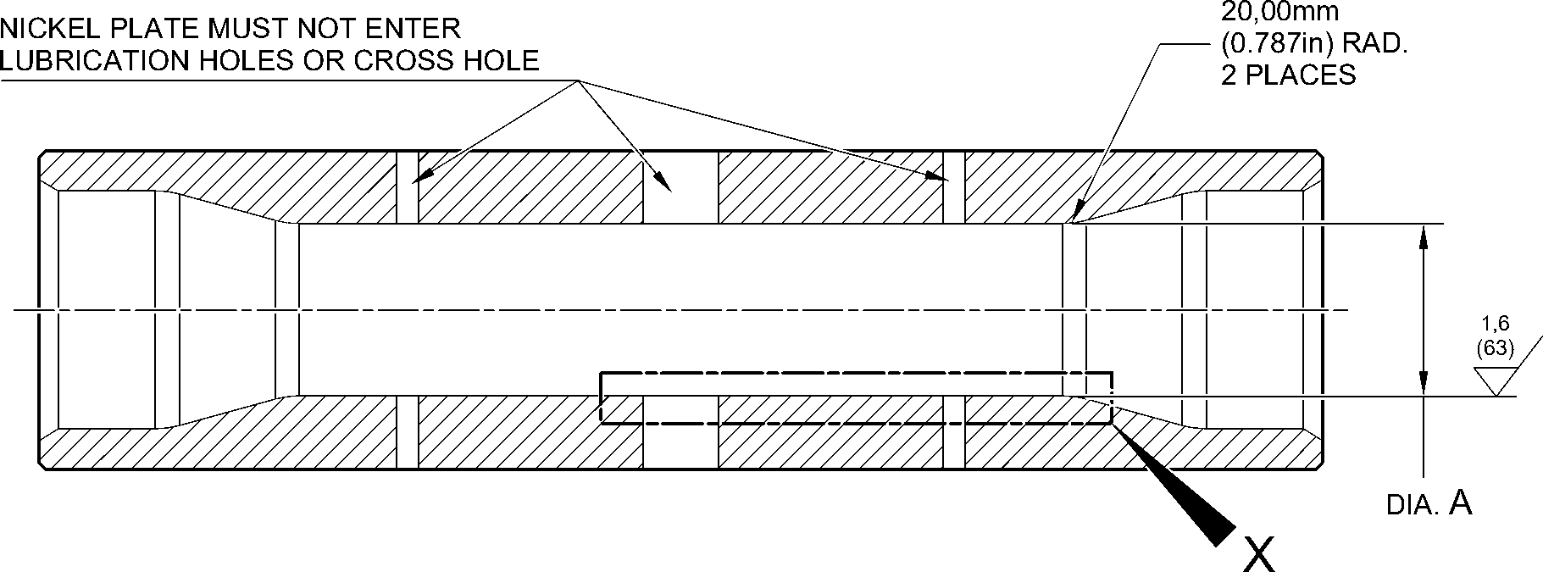
SULPHAMATE NICKEL PLATE DEPOSIT
16,30 to 17,30mm
(0.642 to 0.681in) DIA.
2 PLACES
6,00 to 7,00mm
32,428 to 32,480mm (1.2767 to 1.2787in) DIA. (_{0.236 to 0.276in}) _{DIA.}
AFTER CADMIUM PLATE _{4 PLACES}
32,468 to 32,500mm (1.2783 to 1.2795in) DIA.
AFTER SULPHAMATE NICKEL PLATE
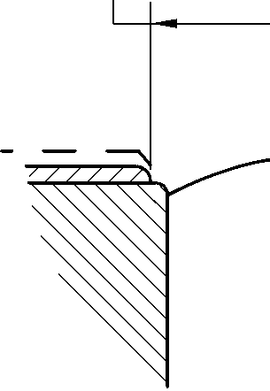
33,99mm (1.3383in) MAXIMUM
DIA. BEFORE SULPHAMATE
NICKEL PLATE
0,500 to 0,750mm
(0.0197 to 0.0295in) RAD. (32)
0,500 to 0,750mm
(0.0197 to 0.0295in) RAD.
1,6
20,00mm ⁽⁶³⁾
(0.787in) RAD.
2 PLACES
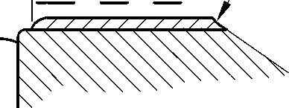
14,30mm
(0.563in) DIA. REF.
4,00mm
(0.157in) DIA. REF.
2 PLACES
detail X
A321-S-32-12-22-001-0
Repair to Pin
Figure 601
Repair No. 6-3
Page 603
Dec 6/2019
32-12-22
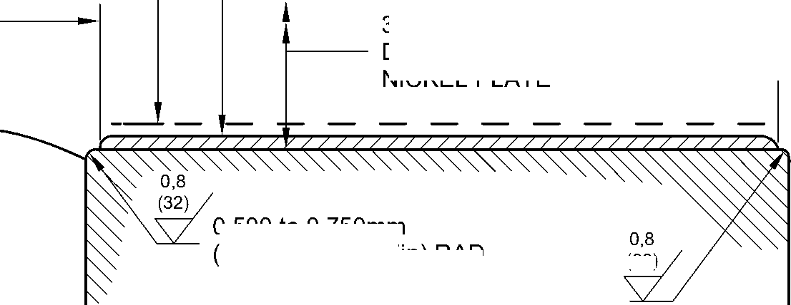

SAFRAN LANDING SYSTEMS UK Ltd
CAGE: K0654

PART No. 201587001 AND 201587002 COMPONENT MAINTENANCE MANUAL
MAIN LANDING GEAR LEG
INTENTIONALLY BLANK
Repair No. 6-3
32-12-22 ^{Page 604}

sSAFRAN SAFRAN LANDING SYSTEMS UK Ltd
CAGE: K0654
PART No. 201587001 AND 201587002 COMPONENT MAINTENANCE MANUAL
MAIN LANDING GEAR LEG
- Repair No. 7-1 Pin (11-130)
- Specified Damage and Material Specification.
- Specified Damage
(a) Damage or corrosion to diameter A.
- Material Specification
IPL Figure and  Item No. | Name | Material Specification
11-130 | Pin | UHT Steel (300M), MTL 1201
- Special Tools
- Special tools are not necessary.
- Materials
- Materials are not necessary.
- Repair Parts
- Repair parts are not necessary.
- Procedure (Refer to Figure 601)
CAUTION: FOR DAMAGE MORE THAN THE LIMITS OF THIS REPAIR SCHEME, WRITE
TO MESSIER-DOWTY LTD: REFER TO GUIDE-CS-001.
- Remove the chromium plate from diameter A: refer to PCS-2110.
- If the bare metal is not damaged or corroded:
1 Examine the pin for flaws: refer to PCS-3600 and PCS-3100, inclusion
class 4.
2 Shot peen diameter A: refer to M-DLPS123.
3 Apply chromium plate to diameter A: refer to PCS-2110, Type C. Refer to
Figure 601 for chromium plate termination information.
4 Grind diameter A to between 59,951 and 59,970 mm (2.3603 and 2.3610 in).
The surface finish must be 0,8 micrometers (32 micro-inches).
5 Examine the ground chromium plate for flaws: refer to PCS-3100, inclusion
class 4 and PCS-3002.
6 Identify the part with the Messier-Dowty Limited repair number 450258410A
adjacent to the part number: refer to PCS-6000-04 and PCS-6000-07.
7 Examine the part to make sure that you have obeyed all the repair
instructions correctly.
- If the bare metal is damaged or corroded:
- Machine diameter A just sufficiently to remove the damage or corrosion: refer
to M-DLPS1004-4-1. The diameter must not be less than 59,370 mm
(2.3374 in). The surface finish must be 1,6 micrometers (63 micro-inches).
Repair No. 7-1
Page 601
Dec 6/2019
32-12-22

sSAFRAN SAFRAN LANDING SYSTEMS UK Ltd
CAGE: K0654
PART No. 201587001 AND 201587002 COMPONENT MAINTENANCE MANUAL
MAIN LANDING GEAR LEG
- Examine the pin for flaws: refer to PCS-3600 and PCS-3100, inclusion
class 4.
- Shot peen and apply chromium plate to diameter A: refer to M-DLPS123 and
PCS-2110, Type C. Refer to Figure 601 for chromium plate termination
information.
- Grind diameter A to between 59,951 and 59,970 mm (2.3603 and 2.3610 in).
The surface finish must be 0,8 micrometers (32 micro-inches).
- Examine the ground chromium plate for flaws: refer to PCS-3100, inclusion
class 4 and PCS-3002.
- Identify the part with the Messier-Dowty Limited repair number 450258410B
adjacent to the part number: refer to PCS-6000-04 and PCS-6000-07.
- Examine the part to make sure that you have obeyed all the repair
instructions correctly.
32-12-22
Repair No. 7-1
Page 602
Dec 6/2019

SAFRAN LANDING SYSTEMS UK Ltd
CAGE: K0654

PART No. 201587001 AND 201587002 COMPONENT MAINTENANCE MANUAL
MAIN LANDING GEAR LEG
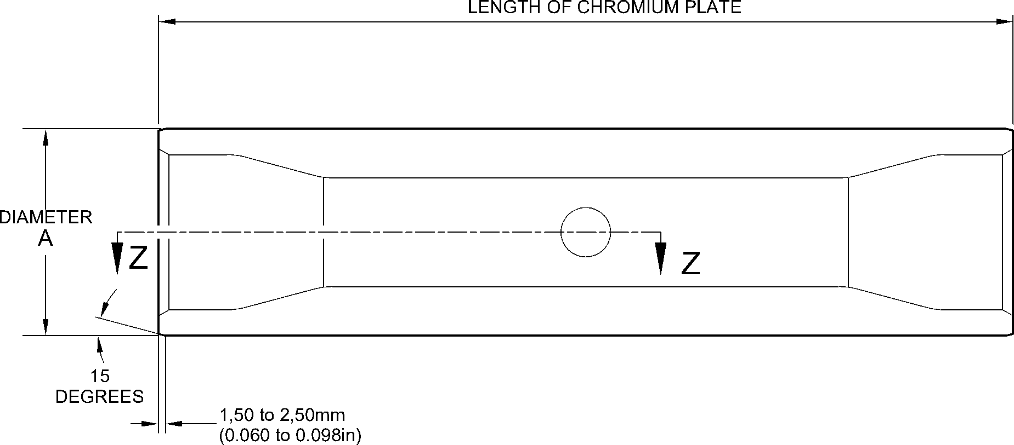
EDGES SMOOTHED OUT. CHROMIUM PLATE TERMINATION
CHROMIUM PLATE TERMINATION TO M-DLPS1031-7 or M-DLPS1031-8
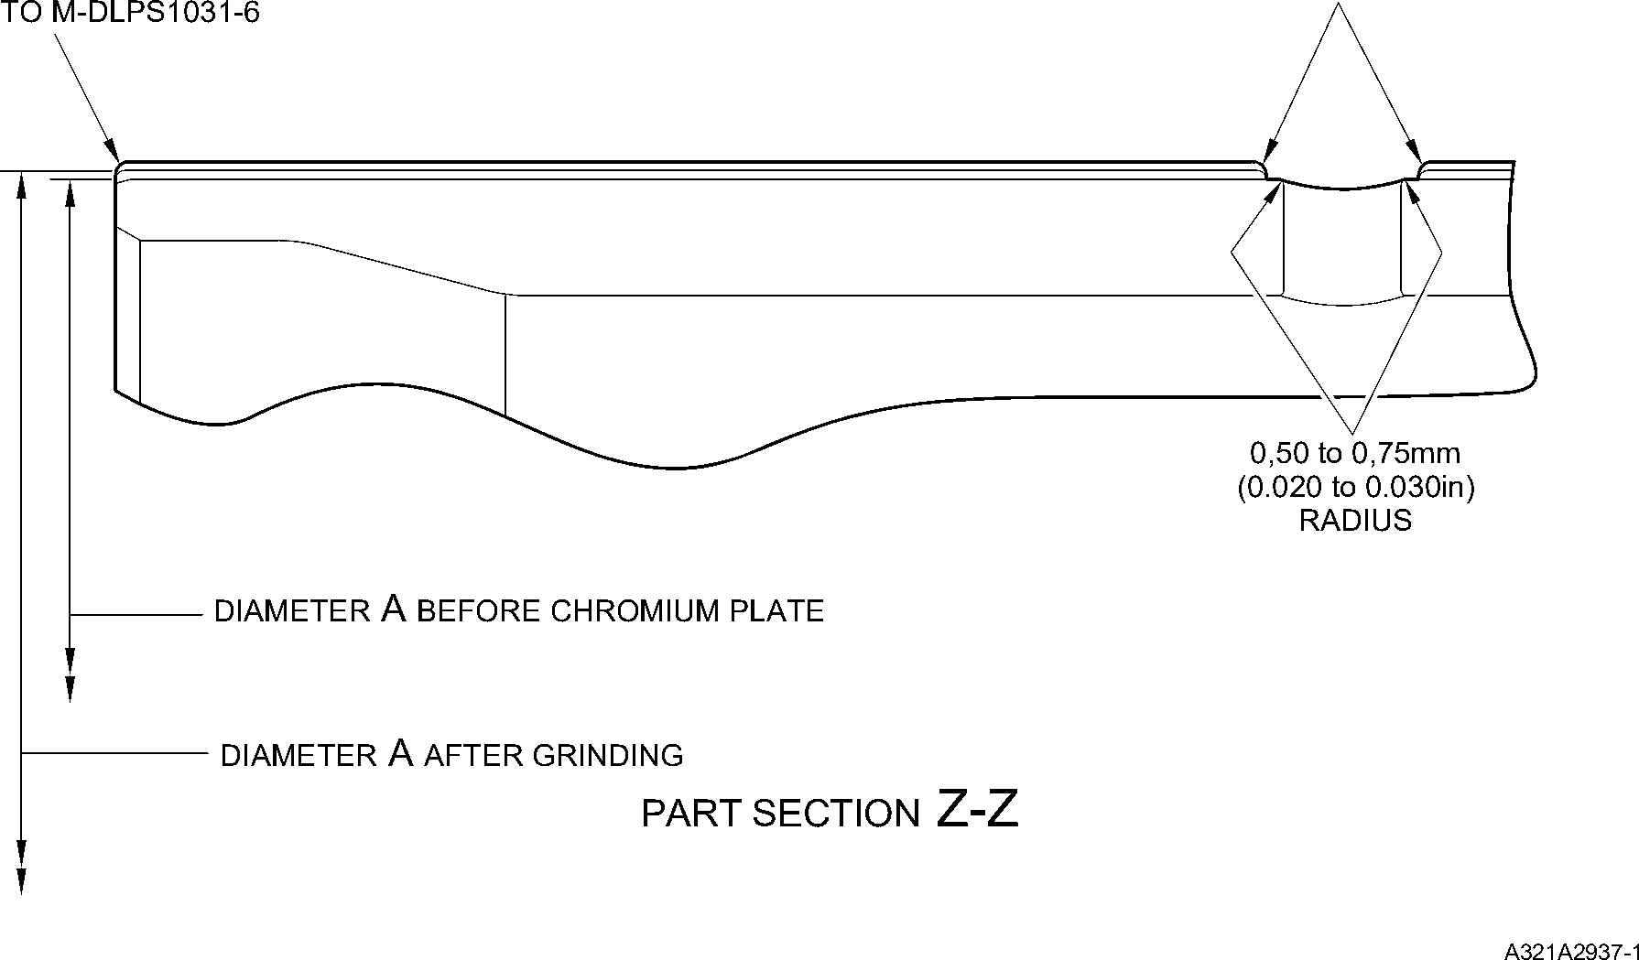
Repair to Pin
Figure 601
Repair No. 7-1
32-12-22
Page 603
Dec 6/2019

SAFRAN LANDING SYSTEMS UK Ltd
CAGE: K0654

PART No. 201587001 AND 201587002 COMPONENT MAINTENANCE MANUAL
MAIN LANDING GEAR LEG
INTENTIONALLY BLANK
Repair No. 7-1
32-12-22 ^{Page 604}

SAFRAN LANDING SYSTEMS UK Ltd
CAGE: K0654

PART No. 201587001 AND 201587002 COMPONENT MAINTENANCE MANUAL
MAIN LANDING GEAR LEG
- Repair No. 7-2 Pin (11-130)
- Specified Damage and Material Specification.
- Specified Damage
(a) Damage or corrosion to diameter A.
- Material Specification
IPL Figure and  Item No. | Name | Material Specification
11-130 | Pin | UHT Steel (300M), MTL 1201
- Special Tools
- Special tools are not necessary.
- Materials
- These materials are necessary:
NOTE: Alternative equivalents are permitted.
Ref. Item | Material
08-665 | Adhesive (Loctite Grade 601)
- Repair Parts
(1) These repair parts are necessary:
Part No. | Repair Part | Material Specification
450258431 | Repair sleeve (Qty 2) | Steel, S154
- Procedure (Refer to Figure 601)
CAUTION: FOR DAMAGE MORE THAN THE LIMITS OF THIS REPAIR SCHEME, WRITE
TO MESSIER-DOWTY LTD: REFER TO GUIDE-CS-001.
- Machine diameter A just sufficiently to remove the damage or corrosion and to between
14,25 and 14,75 mm (0.561 and 0.581 in): refer to M-DLPS1004-4-1. The surface finish
must be 1,6 micrometers (63 micro-inches).
- Examine the pin for flaws: refer to PCS-3600 and PCS-3100, inclusion class 4.
- Measure and record the new diameters A.
- Shot peen the reworked areas: refer to M-DLPS123 and Figure 601.
- Locally apply cadmium plate to the reworked areas: refer to PCS-2141.
- Identify the part with the Messier-Dowty Limited repair number 450258430 adjacent to
the part number: refer to PCS-6000-04.
- Calculate diameter B of the repair sleeves:
Dia. B = Dia. A (as measured) + 0,010 to 0,039 mm (0.0004 to 0.0015 in).
Repair No. 7-2
Page 601
Dec 6/2019
32-12-22

sSAFRAN SAFRAN LANDING SYSTEMS UK Ltd
CAGE: K0654
PART No. 201587001 AND 201587002 COMPONENT MAINTENANCE MANUAL
MAIN LANDING GEAR LEG
- Refer to Figure 601 and machine the repair sleeves to the dimensions shown and
calculated.
- Apply cadmium plate to the outside diameter and the chamfer of the repair sleeves: refer
to PCS-2101.
- Apply adhesive, Material Ref. Item 08-665, to the outside diameter of the repair sleeves:
refer to PCS-5303.
- Install the repair sleeves to diameters A until aligned with the outside diameter of the pin:
refer to M-DLPS1011-5.
- Machine the bores of the repair sleeves to a diameter between 12,700 and 12,733 mm
(0.5000 and 0.5013 in). Machine the inner and outer ends of both sleeves to inner and
outer profile of the pin. Make the radius between 0,5 and 0,75 mm (0.020 and 0.029 in)
at inside and outside of both the sleeves: refer to Figure 601.
- Locally apply cadmium plate to the reworked areas of the sleeves: refer to PCS-2141.
- Identify the part with the Messier-Dowty Limited repair number 450258430 adjacent to
the part number: refer to PCS-6000-07.
- Examine the part to make sure that you have obeyed all the repair instructions correctly.
32-12-22
Repair No. 7-2
Page 602
Dec 6/2019

SAFRAN LANDING SYSTEMS UK Ltd
CAGE: K0654

PART No. 201587001 AND 201587002 COMPONENT MAINTENANCE MANUAL
MAIN LANDING GEAR LEG
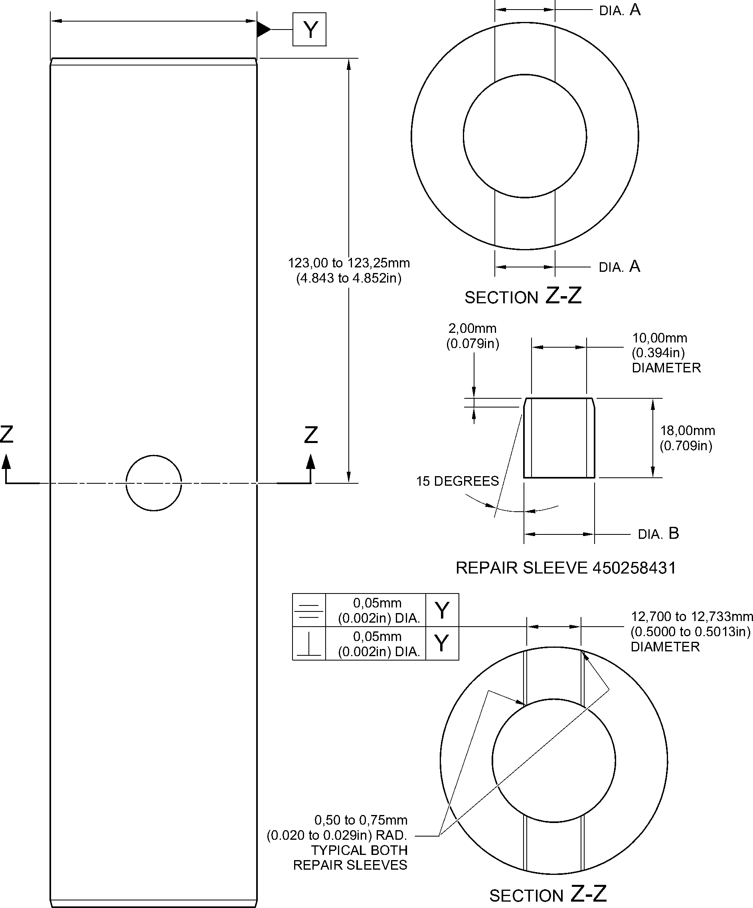
MACHINING REPAIR SLEEVE
A321-S-32-12-22-071-0
Repair to Pin
Figure 601
Repair No. 7-2
Page 603
Dec 6/2019
32-12-22

SAFRAN LANDING SYSTEMS UK Ltd
CAGE: K0654

PART No. 201587001 AND 201587002 COMPONENT MAINTENANCE MANUAL
MAIN LANDING GEAR LEG
INTENTIONALLY BLANK
32-12-22
Repair No. 7-2
Page 604

SAFRAN LANDING SYSTEMS UK Ltd
CAGE: K0654

PART No. 201587001 AND 201587002 COMPONENT MAINTENANCE MANUAL
MAIN LANDING GEAR LEG
- Repair No. 8-1 Bracket (5-300)
- Specified Damage and Material Specification.
- Specified Damage
(a) Damage or wear to the diameter A and/or the adjacent inside face.
- Material Specification
IPL Figure and  Item No. | Name | Material Specification
5-300 | Bracket | Aluminium Alloy, L168T6511
- Special Tools
- These special tools are necessary:
NOTE: Alternative equivalents are permitted.
Part No. | Special Tool | Function
460004330/85 | Press Pad | Install oversize bearing
460004331/7 | Drift | Use with 460004330/85
- Materials
- These materials are necessary:
NOTE: Alternative equivalents are permitted.
Ref. Item | Material
09-510A | Sealant
- Repair Parts
(1) These repair parts are necessary:
Part No. | Repair Part | Material Specification
450217858 | Oversize bearing | Steel, S145
- Procedure (Refer to Figure 601)
- Machine the diameter A to remove the minimum amount of material necessary to
remove the damage or wear: refer to Figure 601 for the dimensions. The surface finish
must be 1,6 micrometers (63 micro-inches).
- Machine the face Q as necessary to remove damage or wear: refer to Figure 601 for the
dimensions. The surface finish must be 1,6 micrometers (63 micro-inches).
- Machine the chamfer to the dimensions shown in Figure 601.
- Measure and make a record of the new diameter A and the thickness of the lug D.
- Examine the bracket for flaws: refer to PCS-3200.
Repair No. 8-1
Page 601
Dec 6/2019
32-12-22

sSAFRAN SAFRAN LANDING SYSTEMS UK Ltd
CAGE: K0654
PART No. 201587001 AND 201587002 COMPONENT MAINTENANCE MANUAL
MAIN LANDING GEAR LEG
- Prepare the machined surfaces of the bracket:
- anodize the surfaces: refer to M-DLPS102-1, or
- apply Alocrom to the surfaces: refer to PCS-2220.
- Calculate the diameter B and the dimension C of the oversize bearing:
B = A (as measured) - 0,006 to + 0,023 mm (- 0.0002 to + 0.0009 in)
C = D (as measured) - 0,15 to - 0,25 mm (- 0.006 to - 0.010 in).
- Machine the oversize bearing to the dimensions shown and calculated: the surface
finish must be 1,6 micrometers (63 micro-inches).
- Passivate the oversize bearing: refer to M-DLPS124.
- Apply cadmium plate to the oversize bearing, but not on the internal diameter. The
thickness of the cadmium plate must be between 0,010 and 0,015 mm (0.0004 and
0.0006 in): refer to M-DLPS100-2S.
- Use the Press Pad 460004330/85 and Drift 460004331/7 to install the oversize bearing
to the bracket: refer to M-DLPS1011-14. Check line ream the oversize bearing to the
dimension shown in Figure 601.
- Apply sealant, Material Ref. Item 09-510A, to seal between the ends of the oversize
bearing and the bracket: refer to M-DLPS709-19.
- Identify the part with the Messier-Dowty Limited repair number 450217195 adjacent to
the part number: refer to PCS-6000-05 and PCS-6000-07.
- Examine the part to make sure that you have obeyed all the repair instructions correctly.
32-12-22
Repair No. 8-1
Page 602
Dec 6/2019

SAFRAN LANDING SYSTEMS UK Ltd
CAGE: K0654

PART No. 201587001 AND 201587002 COMPONENT MAINTENANCE MANUAL
MAIN LANDING GEAR LEG
Z

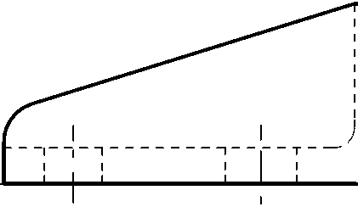
34,750 to 35,250mm
(1.3681 to 1.3877in)
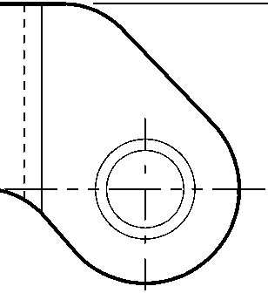
Z
24,750 to 25,250mm
(0.9744 to 0.9940in)
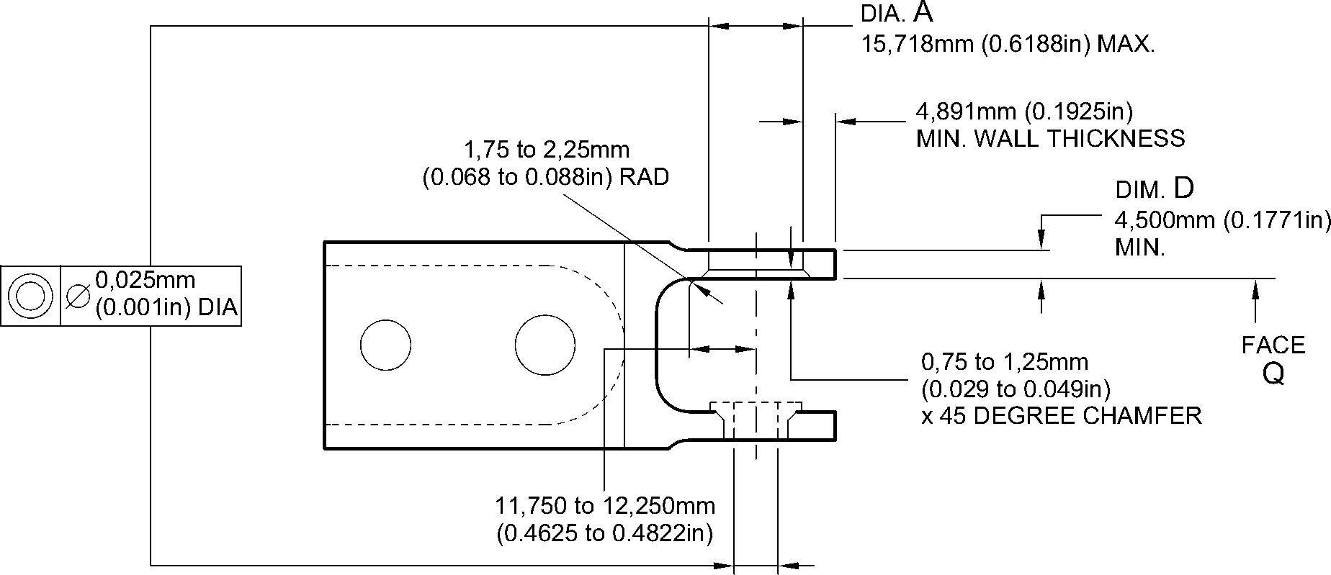
section Z-Z without bearing
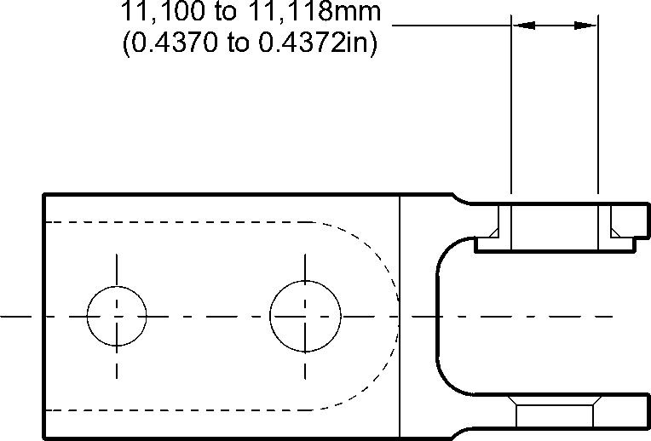
section Z-Z with bearing
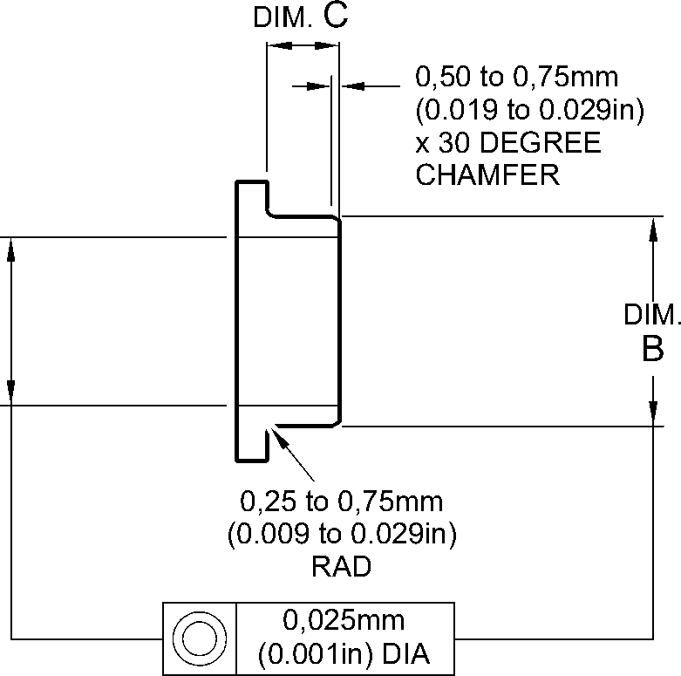
OVERSIZE BEARING - MACHINING
A321A3510-1
Repair to Bracket
Figure 601
Repair No. 8-1
Page 603
Dec 6/2019
32-12-22

SAFRAN LANDING SYSTEMS UK Ltd
CAGE: K0654

PART No. 201587001 AND 201587002 COMPONENT MAINTENANCE MANUAL
MAIN LANDING GEAR LEG
INTENTIONALLY BLANK
Repair No. 8-1
32-12-22 ^{Page 604}

sSAFRAN SAFRAN LANDING SYSTEMS UK Ltd
CAGE: K0654
PART No. 201587001 AND 201587002 COMPONENT MAINTENANCE MANUAL
MAIN LANDING GEAR LEG
- Repair No. 8-2 Bracket (5-300)
- Specified Damage and Material Specification.
- Specified Damage
(a) Damage or wear to the diameter A and/or the adjacent inside face.
- Material Specification
IPL Figure and  Item No. | Name | Material Specification
5-300 | Bracket | Aluminium Alloy, L168T6511
- Special Tools
(1) These special tools are necessary:
NOTE: Alternative equivalents are permitted.
Part No. | Special Tool | Function
460004330/136 | Press Pad | Install the oversize bearing
460004331/7 | Drift | Use with 460004330/136
- Materials
(1) These materials are necessary:
NOTE: Alternative equivalents are permitted.
Ref. Item | Material
09-510A | Sealant
- Repair Parts
(1) These repair parts are necessary:
Part No. | Repair Part | Material Specification
450217859 | Oversize bearing | Steel, S145
- Procedure (Refer to Figure 601)
- Machine the diameter A sufficiently to remove the damage or wear: refer to Figure 601
for the dimensions. The surface finish must be 1,6 micrometers (63 micro-inches).
- Machine the face Q as necessary to remove the damage or wear: refer to Figure 601 for
the dimensions. The surface finish must be 1,6 micrometers (63 micro-inches).
- Machine the chamfer to the dimensions shown in Figure 601.
- Measure and make a record of the new diameter A and the thickness of the lug D.
- Examine the bracket for flaws: refer to PCS-3200.
Repair No. 8-2
Page 601
Dec 6/2019
32-12-22

sSAFRAN SAFRAN LANDING SYSTEMS UK Ltd
CAGE: K0654
PART No. 201587001 AND 201587002 COMPONENT MAINTENANCE MANUAL
MAIN LANDING GEAR LEG
- Prepare the machined surfaces of the bracket:
- anodize the surfaces: refer to M-DLPS102-1, or
- apply Alocrom to the surfaces: refer to PCS-2220.
- Calculate the diameter B and the dimension C of the oversize bearing:
B = A (as measured) - 0,006 to + 0,023 mm (- 0.0002 to + 0.0009 in)
C = D (as measured) - 0,30 to - 0,40 mm (- 0.011 to - 0.015 in).
- Machine the oversize bearing to the dimensions shown and calculated: the surface
finish must be 1,6 micrometers (63 micro-inches).
- Passivate the oversize bearing: refer to M-DLPS124.
- Apply cadmium plate to the oversize bearing, but not on the internal diameter. The
thickness of the cadmium plate must be between 0,010 and 0,015 mm (0.0004 and
0.0006 in): refer to M-DLPS100-2S.
- Use the Press Pad 460004330/136 and Drift 460004331/7 to install the oversize bearing
to the bracket: refer to M-DLPS1011-14. Check line ream the oversize bearing to the
dimension shown in Figure 601.
- Apply sealant, Material Ref. Item 09-510A, to seal between the ends of the oversize
bearing and the bracket: refer to M-DLPS709-19.
- Identify the part with the Messier-Dowty Limited repair number 450217205 adjacent to
the part number: refer to PCS-6000-05.
- Examine the part to make sure that you have obeyed all the repair instructions correctly.
32-12-22
Repair No. 8-2
Page 602
Dec 6/2019

SAFRAN LANDING SYSTEMS UK Ltd
CAGE: K0654

PART No. 201587001 AND 201587002 COMPONENT MAINTENANCE MANUAL
MAIN LANDING GEAR LEG
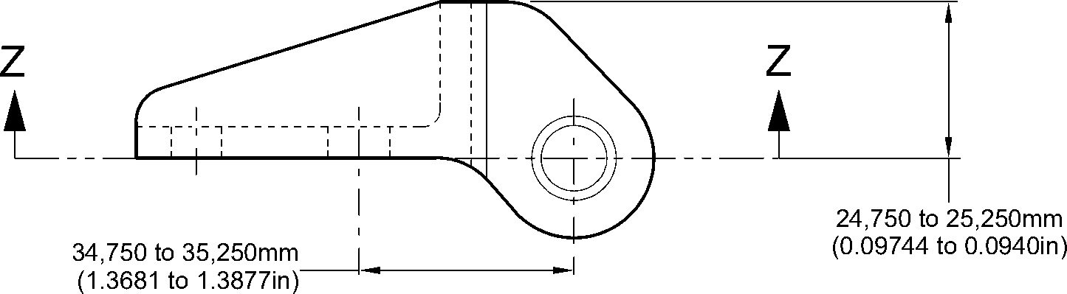
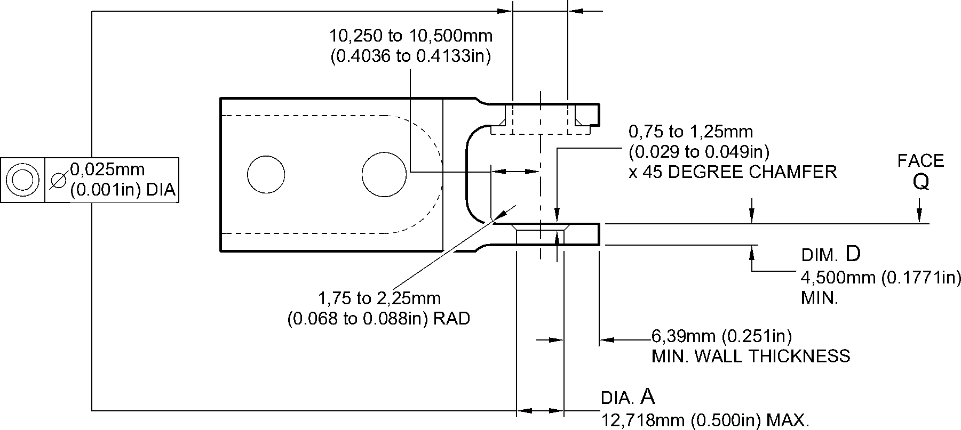
section Z-Z without bearing
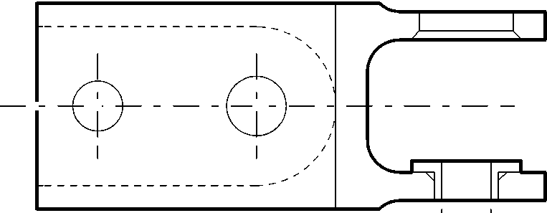
8,000 to 8,015mm
(0.3150 to 0.3155in)
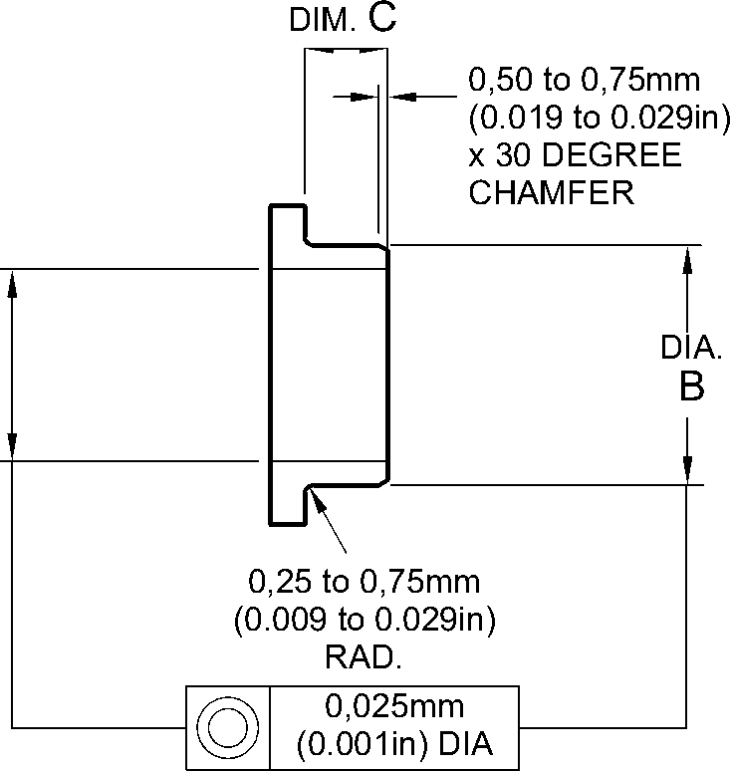
OVERSIZE BEARING - MACHINING
section Z-Z with bearing
A321A3511-1
Repair to Bracket
Figure 601
Repair No. 8-2
Page 603
Dec 6/2019
32-12-22

SAFRAN LANDING SYSTEMS UK Ltd
CAGE: K0654

PART No. 201587001 AND 201587002 COMPONENT MAINTENANCE MANUAL
MAIN LANDING GEAR LEG
INTENTIONALLY BLANK
Repair No. 8-2
32-12-22 ^{Page 604}

SAFRAN LANDING SYSTEMS UK Ltd
CAGE: K0654

PART No. 201587001 AND 201587002 COMPONENT MAINTENANCE MANUAL
MAIN LANDING GEAR LEG

I 1. Repair No. 9-1 Sliding Tube (18-80 and 18-80A)
- Specified Damage and Material Specification
- Specified Damage
(a) Damage or corrosion to diameter A.
- Material Specification
IPL Figure and  Item No. | Name | Material Specification
18-80 and  18-80A | Sliding tube | Steel, S155 (300M)
- Special Tools
- Special tools are not necessary.
- Materials
- Materials are not necessary.
- Repair Parts
- Repair parts are not necessary.
- Procedure (Refer to Figures 601 and 602)
- Remove the chromium plate from diameter A: refer to PCS-2110.
- If the base metal is not damaged or corroded:
- Examine the sliding tube for flaws: refer to PCS-3100, inclusion class 4 and
PCS-3600.
- Apply chromium plate to diameter A: refer to PCS-2110 Type C. Refer
to Figure 601 for chromium plate termination information.
- Grind diameter A to between 177,68 and 177,72 mm (6.995 and 6.997 in).
The surface finish must be 0,25 micrometers (10 micro-inches).
- Examine the ground chromium plate for flaws: refer to M-DLNDT3.
- Identify the part with the Safran Landing Systems repair number
450258460A adjacent to the part number: refer to PCS-6000-19 and
PCS-6000-07.
- Examine the part to make sure that you have obeyed all the repair
instructions correctly.
- If the base metal is damaged or corroded:
- Machine diameter A just sufficiently to remove the damage or corrosion: refer
to M-DLPS1004-4-1. The diameter must not be less than 177,07 mm
(6.971 in). The surface finish must be 1,6 micrometers (63 micro-inches).
- Examine the sliding tube for flaws: refer to PCS-3100, inclusion class 4 and
PCS-3600.
- Shot peen the machined areas: refer to PCS-2300.
Repair No. 9-1
Page 601
Mar 18/2025
32-12-22

sSAFRAN SAFRAN LANDING SYSTEMS UK Ltd
CAGE: K0654
PART No. 201587001 AND 201587002 COMPONENT MAINTENANCE MANUAL
MAIN LANDING GEAR LEG
4 Apply chromium plate to diameter A: refer to PCS-2110 Type C. Refer to
M-DLPS1031 and Figure 602 for chromium plate termination information.
5 Grind diameter A to between 177,68 and 177,72 mm (6.995 and 6.997 in).
The surface finish must be 0,25 micrometers (10 micro-inches).
- Examine the ground chromium plate for flaws: refer to M-DLNDT3.
- Identify the part with the Safran Landing Systems repair number
450258460B adjacent to the part number: refer to PCS-6000-19 and
PCS-6000-07.
- Examine the part to make sure that you have obeyed all the repair
instructions correctly.
32-12-22
Repair No. 9-1
Page 602
Mar 18/2025

SAFRAN LANDING SYSTEMS UK Ltd
CAGE: K0654

PART No. 201587001 AND 201587002 COMPONENT MAINTENANCE MANUAL
MAIN LANDING GEAR LEG
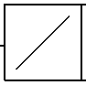
0,04mm
(0.0016in)
Z
Y
531,00 to 533,00mm
(20.906 to 20.984in)
X
Z
531,00 to 533,00mm
(20.906 to 20.984in)
SMOOTH EDGE
0,40 to 1,00mm
(0.016 to 0.039in) RADIUS
8,00 to 10,00mm
(0.315 to 0.394in) RADIUS
^{dia A} 1,6 BEFORE CHROMIUM
(63) PLATE
,25 AFTER CHROMIUM
(10) PLATE
2,00mm (0.079in)
CHROMIUM PLATE MUST
TERMINATE IN THIS LENGTH.
WAVY OR IRREGULAR LINE IS
PERMITTED
1,00mm (0.039in)
DIAMETER BEFORE CHROMIUM PLATE
detail X
DIAMETER AFTER GRINDING
OF CHROMIUM PLATE
CHROMIUM PLATE DEPOSIT
2,00mm (0.079in)
MAXIMUM
CHROMIUM PLATE MUST
TERMINATE IN THIS LENGTH.
WAVY OR IRREGULAR LINE IS
PERMITTED
DIAMETER BEFORE CHROMIUM PLATE
SMOOTH EDGE
15,50 to 16,50mm
(0.610 to 0.649in)
RADIUS
18,00mm
(0.709in)
DIAMETER AFTER GRINDING
OF CHROMIUM PLATE
CHROMIUM PLATE DEPOSIT
detail Y
A321-S-32-12-22-025-0
Repair to Sliding Tube
Figure 601
Repair No. 9-1
Page 603
Dec 6/2019
32-12-22
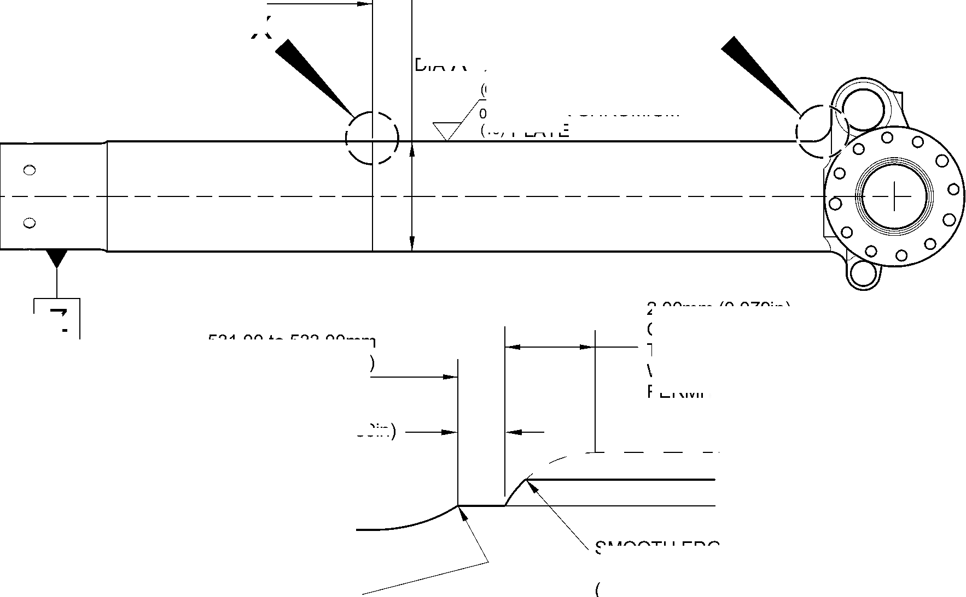
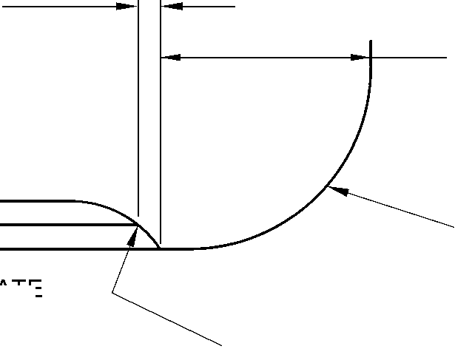

SAFRAN LANDING SYSTEMS UK Ltd
CAGE: K0654

PART No. 201587001 AND 201587002 COMPONENT MAINTENANCE MANUAL
MAIN LANDING GEAR LEG
531,00 to 533,00mm
(20.906 to 20.984in)
REF.
EXTENT OF SHOT PEENING
17,75 to 18,25mm
(0.699 to 0.719in)
0,75 to 1,25mm J
(0.030 to 0.050in)
UNPLATED LENGTH
2,00mm (0.079in) MAX.
CHROMIUM PLATE MUST
TERMINATE IN THIS LENGTH.
WAVY OR IRREGULAR LINE IS PERMITTED
2,00mm (0.079in) MAX.
CHROMIUM PLATE MUST
TERMINATE IN THIS LENGTH.
WAVY OR IRREGULAR
LINE IS PERMITTED
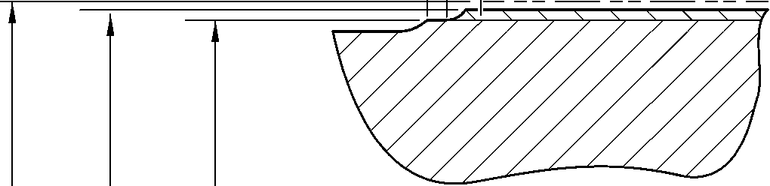
0,40 to 1,00mm
(0.016 to 0.040in)
RADIUS
DETAIL X
(REFER TO FIGURE 601)
DETAIL Y
1,50 to 2,00mm
(0.060 to 0.079in)
RADIUS BEFORE
CHROMIUM PLATE
(REFER TO FIGURE 601)
177,07mm (6.971in) MINIMUM DIAMETER
BEFORE CHROMIUM PLATE
177,68 to 177,72mm (6.995 to 6.997in) DIAMETER
AFTER GRINDING CHROMIUM PLATE
CHROMIUM PLATE DEPOSIT
A321-S-32-12-22-026-0
Repair to Sliding Tube
Figure 602
32-12-22
Repair No. 9-1
Page 604
Dec 6/2019
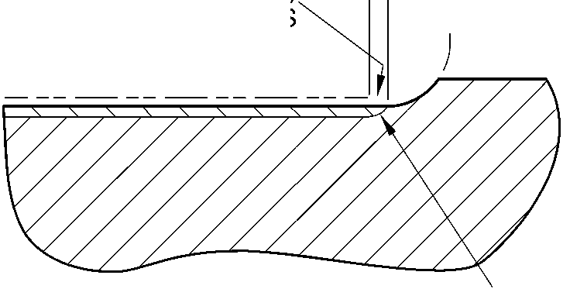

sSAFRAN SAFRAN LANDING SYSTEMS UK Ltd
CAGE: K0654
PART No. 201587001 AND 201587002 COMPONENT MAINTENANCE MANUAL
MAIN LANDING GEAR LEG

I 1. Repair No. 9-2 Sliding Tube (18-80 and 18-80A)
- Specified Damage and Material Specification.
- Specified Damage
(a) Damage or corrosion to the chromium plate band(s) on one or both brake flanges.
- Material Specification
IPL Figure and  Item No. | Name | Material Specification
18-80 and  18-80A | Sliding tube | Steel, S155 (300M)
- Special Tools
- Special tools are not necessary.
- Materials
- Materials are not necessary.
- Repair Parts
- Repair parts are not necessary.
- Procedure (Refer to Figure 601)
CAUTION: REPAIR WILL NOT BE PERMITTED BEYOND THE LIMITS OF THIS REPAIR
SCHEME.
- Remove the chromium plate band(s) from the brake flange(s): refer to M-DLPS101.
- Remove the Sermetel W surface treatment from the sliding tube: refer to M-DLPS637.
- Do this procedure if there is no damage to the parent metal:
- Examine the sliding tube for flaws: refer to M-DLNDT6 and M-DLNDT2, inclusion
class 4.
- Stress relieve the sliding tube for 4 hours at 185 to 195 ºC (366 to 384 ºF).
- Apply chromium plate to make new band(s) on the flange face(s) using one of
these procedures: refer to Figure 601.
1 Apply chromium plate bands to the flange(s): refer to M-DLPS101-7. Grind
the chromium plate to get the dimensions shown in Figure 601: the surface
finish must be 2,5 micrometers (100 micro-inches). Examine the ground
chromium plate for flaws: refer to M-DLNDT3.
OR
2 Apply chromium plate bands to the flange(s) to get a deposit that agrees with
the dimensions shown in Figure 601: refer to M-DLPS101-7. The surface
finish must be 2,5 micrometers (100 micro-inches).
- Apply Sermetel W protective treatment: refer to M-DLPS637 and REPAIR,
Protective Treatment.
Repair No. 9-2
Page 601
Mar 18/2025
32-12-22

sSAFRAN SAFRAN LANDING SYSTEMS UK Ltd
CAGE: K0654
PART No. 201587001 AND 201587002 COMPONENT MAINTENANCE MANUAL
MAIN LANDING GEAR LEG
- Identify the part with the Safran Landing Systems repair number 450266100A
adjacent to the part number: refer to M-DLPS405-4.
- Examine the part to make sure that you have obeyed all the repair instructions
correctly.
- Do this procedure if there is corrosion or damage to the parent metal not more than
0,25 mm (0.010 in) deep.
CAUTION: DO NOT MACHINE ALL OF THE FLANGE FACE.
- Locally make the area smooth and polish just sufficiently to remove the corrosion
or damage from the surface: the minimum flange width is 11,6 mm (0.456 in).
- Examine the sliding tube for flaws: refer to M-DLNDT6 and M-DLNDT2, inclusion
class 4.
- Stress relieve the sliding tube for 4 hours at 185 to 195 ºC (366 to 384 ºF).
- Locally shot peen the sliding tube: refer to M-DLPS123.
- Refer to Figure 601 and M-DLPS101-7. Apply chromium plate to make new bands
on the brake flange surface: make the chromium plate thicker in the areas where
the corrosion or damage has been removed.
- Grind the chromium plate to the dimension shown: refer to Figure 601. The surface
finish must be 2,5 micrometers (100 micro-inches).
- Examine the chromium plate surface: refer to M-DLNDT3.
- Apply Sermetel W protective treatment: refer to M-DLPS637 and REPAIR,
Protective Treatment.
- Identify the part with the Safran Landing Systems repair number 450266100B
adjacent to the part number: refer to M-DLPS405-4.
- Examine the part to make sure that you have obeyed all the repair instructions
correctly.
- Do this procedure if there is corrosion or damage to the parent metal more than 0,25 mm
(0.010 in) deep.
CAUTION: DO NOT MACHINE ALL OF THE FLANGE FACE.
- Locally make the area smooth and polish just sufficiently to remove the corrosion
or damage from the face, the minimum flange width is 11,6 mm (0.456 in).
- Examine the sliding tube for flaws: refer to M-DLNDT6 and M-DLNDT2, inclusion
class 4.
- Stress relieve the sliding tube for 4 hours at 185 to 195 ºC (366 to 384 ºF).
- Locally shot peen the sliding tube: refer to M-DLPS123, Almen A intensity of 0,010
to 0,014 mm (0.0004 to 0.0006 in).
- Refer to M-DLPS200-4 and locally grit blast the sliding tube: give protection from
the grit blast to the areas adjacent to the flanges.
32-12-22
Repair No. 9-2
Page 602
Mar 18/2025

sSAFRAN SAFRAN LANDING SYSTEMS UK Ltd
CAGE: K0654
PART No. 201587001 AND 201587002 COMPONENT MAINTENANCE MANUAL
MAIN LANDING GEAR LEG
- Apply sulphamate nickel plate to the smoothed and polished areas. The
sulphamate nickel plate must fill the smoothed and polished areas and be 0,25 mm
(0.010 in) above the flange face. Refer to MIL STD 868A, solution 2.
- De-embrittle the sliding tube for 23 hours at 185 to 195ºC (366 to 384ºF).
- Machine the sulphamate nickel plate (do not grind), the machined surface must be
0,00 to 0,05 mm (0.000 to 0.002 in) above the brake flange surface. The surface
finish must be 1,6 micrometers (63 micro-inches).
- Examine the sliding tube: refer to M-DLNDT6.
- De-embrittle the sliding tube for 4 hours at 185 to 195ºC (366 to 384ºF).
- If the parent metal was machined at para (h), examine the affected area for flaws:
refer to M-DLNDT2, inclusion class 4.
- Shot peen the flange face(s) including the sulphamate nickel plated areas: refer to
M-DLPS123, Almen A intensity of 0,010 to 0,014 mm (0.0004 to 0.0006 in).
- Refer to M-DLPS200-4 and locally grit blast the sliding tube: give protection from
the grit blast to the areas adjacent to the flanges.
- Use 5 or 10 times magnification to examine the sulphamate nickel plate to make
sure the bond is satisfactory: do the repair again if the bond is not satisfactory.
- Apply chromium plate to make new band(s) on the flange face(s) using one of
these procedures: refer to Figure 601.
- Apply chromium plate to the bands: refer to M-DLPS101-7. Grind the
chromium plate to get the dimensions shown: the surface finish must be
2,5 micrometers (100 micro-inches). Examine the ground chromium plate for
flaws: refer to M-DLNDT3.
OR
- Apply chromium plate to the band to the dimensions shown: refer to
M-DLPS101-7. The surface finish must be 2,5 micrometers
(100 micro-inches).
- Apply Sermetel W protective treatment: refer to M-DLPS637 and REPAIR,
Protective Treatment.
- Identify the part with the Safran Landing Systems repair number 450266100C
adjacent to the part number: refer to M-DLPS405-4.
- Examine the part to make sure that you have obeyed all the repair instructions
correctly.
Repair No. 9-2
Page 603
Mar 18/2025
32-12-22

SAFRAN LANDING SYSTEMS UK Ltd
CAGE: K0654

PART No. 201587001 AND 201587002 COMPONENT MAINTENANCE MANUAL
MAIN LANDING GEAR LEG
AREA OF CHROMIUM PLATE
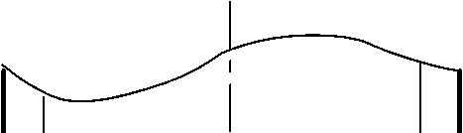

0,020 to 0,045mm
(0.0008 to 0.0018in)
THICKNESS OF
CHROMIUM PLATE
ABOVE OUTER
SURFACE OF FLANGE
0 to 2,00mm
(0 to 0.078in)
CHROMIUM RUNOUT
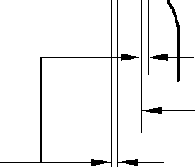
149,90mm
(5.901in)
160,00mm
(6.299in)
section Z-Z
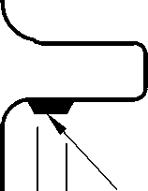
AREA OF CHROMIUM PLATE
NOTE:
THE CHROMIUM PLATE MUST
NOT EXTEND BEYOND THE
DIMENSIONS SHOWN
A321A3513-1
Repair to Sliding Tube
Figure 601
32-12-22
Repair No. 9-2
Page 604
Dec 9/2016
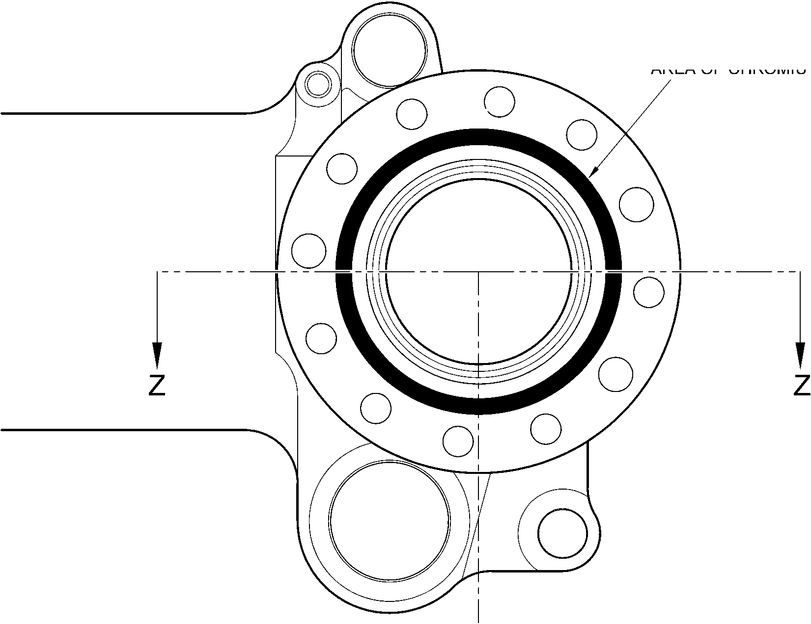

SAFRAN LANDING SYSTEMS UK Ltd
CAGE: K0654

PART No. 201587001 AND 201587002 COMPONENT MAINTENANCE MANUAL
MAIN LANDING GEAR LEG

1. Repair No. 9-3 Sliding Tube (18-80)
A. This Repair, Messier-Dowty Limited Repair No. 450258400, has been superseded by
Repair No. 9-10, Messier-Dowty Limited Repair No. 450258401.
Repair No. 9-3
Page 601
Dec 6/2019
32-12-22

SAFRAN LANDING SYSTEMS UK Ltd
CAGE: K0654

PART No. 201587001 AND 201587002 COMPONENT MAINTENANCE MANUAL
MAIN LANDING GEAR LEG
INTENTIONALLY BLANK
Repair No. 9-3
32-12-22 ^{Page 602}

sSAFRAN SAFRAN LANDING SYSTEMS UK Ltd
CAGE: K0654
PART No. 201587001 AND 201587002 COMPONENT MAINTENANCE MANUAL
MAIN LANDING GEAR LEG

I 1. Repair No. 9-4 Sliding Tube (18-80 and 18-80A)
- Specified Damage and Material Specification.
- Specified Damage
(a) Damage or wear to the diameter(s) A.
- Material Specification
IPL Figure and  Item No. | Name | Material Specification
18-80 and  18-80A | Sliding Tube | Steel, 300M
- Special Tools
- These special tools are necessary:
NOTE: Alternative equivalents are permitted.
Part No. | Special tool | Function
460004330/105 | Press Pad | Install the repair bush(es)
- Material.
- Materials are not necessary.
- Repair Parts
- These repair parts are necessary:
NOTE: Alternative equivalents are permitted.
Part No. | Repair Part | Material Specification
450266336 | Repair Bush (Qty 18) | Stainless Steel, AMS 5643 or 5659
- Procedure (Refer to Figures 601 and 602).
CAUTION: FOR DAMAGE MORE THAN THE LIMITS OF THIS REPAIR SCHEME, WRITE
TO SAFRAN LANDING SYSTEMS: REFER TO GUIDE-CS-001.
- Do this procedure if there is a wear or damage to diameter(s) A:
- Remove the paint locally from the sliding tube: refer to PCS-2700.
- Remove the sermetel from the sliding tube: refer to M-DLPS637.
- Remove the chromium plate locally from the sliding tube: refer to PCS-2110, type C
and Figure 601.
- Machine diameter(s) A sufficiently to remove the damage or wear: refer to
M-DLPS900, M-DL PS1000 and Figure 601. Do not make diameter(s) A more than
18,568 mm (0.7310 in). Make the surface finish 1,6 micrometers (63 micro-inches).
- Machine the chamfers and radii to the dimensions shown: refer to Figure 601.
Repair No. 9-4
Page 601
Mar 18/2025
32-12-22

sSAFRAN SAFRAN LANDING SYSTEMS UK Ltd
CAGE: K0654
PART No. 201587001 AND 201587002 COMPONENT MAINTENANCE MANUAL
MAIN LANDING GEAR LEG
- Measure and record the new diameter(s) A.
- Examine the sliding tube for flaws: refer to PCS-3100 inclusion class 4 and
PCS-3600.
- If necessary, shot peen the machined surfaces: refer to M-DLPS123.
- Apply chromium plate to the reworked diameter(s) A: refer to PCS-2110, type C,
M-DLPS1031-5, M-DLPS1031-7 and Figure 601. Make the chromium plate
thickness between 0,020 and 0,025 mm (0.0008 and 0.0010 in).
- Apply sermetel to the sliding tube: refer to REPAIR and M-DLPS637.
- Identify the part with the Safran Landing Systems repair number 450266290
adjacent to the part number: refer to PCS-6000-05.
- Calculate diameter C for the repair bushes, use the formula:
Dia. C = Dia. A (as measured) + 0,034 to -0,004 mm (+ 0.0013 to -0.0002 in).
- Machine the face B to produce a flange thickness of 2,00 to 2,05 mm (0.079 to
0.080 in): refer to Figure 602. Make the surface finish 1,6 micrometers
(63 micro-inches).
- Machine the repair bushes to the dimensions shown and calculated: refer to
Figure 602. Make the surface finish 1,6 micrometers (63 micro-inches).
- Passivate the repair bushes: refer to AMS 2700.
- Apply IVD alloy coating with chromation yellow all over the bushes, but not to the
bores: refer to ICT 40-893-01MD and Figure 602. The thickness of the coating
must be between 0,007 and 0,012 mm (0.0003 and 0.0005 in).
- Apply primer paint to the sliding tube where the bush flanges will touch: refer to
PCS-2500.
- Use the Press Pad 460004330/105 and install the repair bushes: refer to
M-DLPS1011-20.
- Check the bore diameter of the repair bushes: refer to Figure 602.
- If necessary, hone the bore diameter of repair bushes with a surface finish of
2,5 micrometers (100 micro-inches): refer to Figure 602.
- Apply paint locally to the sliding tube: refer to REPAIR and PCS-2500.
- Identify the part with the Safran Landing Systems repair number 450266290
adjacent to the part number: refer to PCS-6000-07.
- Examine the part to make sure that you have obeyed all the repair instructions
correctly.
32-12-22
Repair No. 9-4
Page 602
Mar 18/2025

SAFRAN LANDING SYSTEMS UK Ltd
CAGE: K0654

PART No. 201587001 AND 201587002 COMPONENT MAINTENANCE MANUAL
MAIN LANDING GEAR LEG
6.57
DEGREES
30
DEGREES
30
DEGREES
30
DEGREES
192,000mm
(7.5591in) DIA.
30
DEGREES
30
DEGREES
30
DEGREES
60
DEGREES
30
DEGREES
60
DEGREES
Y
6,85mm (0.270in)
MINIMUM WALL
THICKNESS
DIA.
A
0,05mm
(0.002in)
30
DEGREES
2,00mm (0.080in)
x 45 DEGREES CHAMFER
0,40 to 1,00mm
(0.016 to 0.040in)
RAD.
0,50 to 2,00mm
(0.020 to 0.080in)
CHROMIUM PLATE
TERMINATION TO M-DLPS1031-5
PRIMER PAINT
WHERE BUSH FLANGE
WILL TOUCH
SECTION Z-Z
(9 PLACES)
(WITHOUT REPAIR BUSHES)
CHROMIUM
PLATE
SERMETEL
COATING
0,00 to 0,80mm
(0.000 to 0.013in)
CHROMIUM PLATE
TERMINATION TO M-DLPS1031-7
FINISH PAINT
DETAIL Y
A321A5544-2
Repair to Sliding Tube - Machining
Figure 601
Repair No. 9-4
Page 603
Aug 11/2023
32-12-22
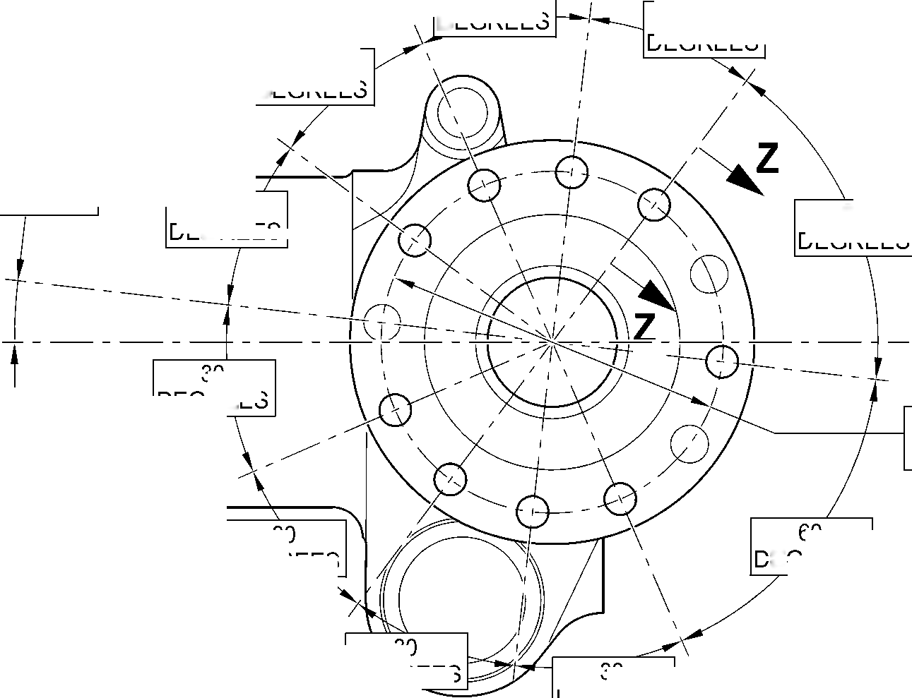
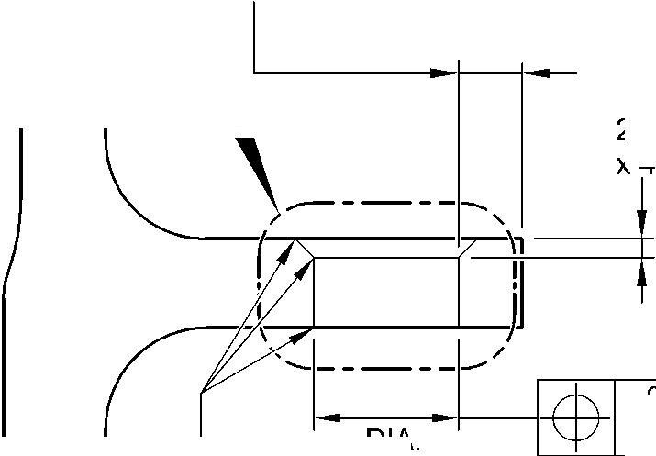
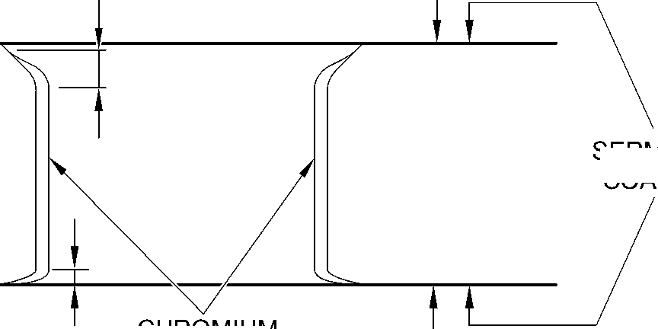

SAFRAN LANDING SYSTEMS UK Ltd
CAGE: K0654

PART No. 201587001 AND 201587002 COMPONENT MAINTENANCE MANUAL
MAIN LANDING GEAR LEG
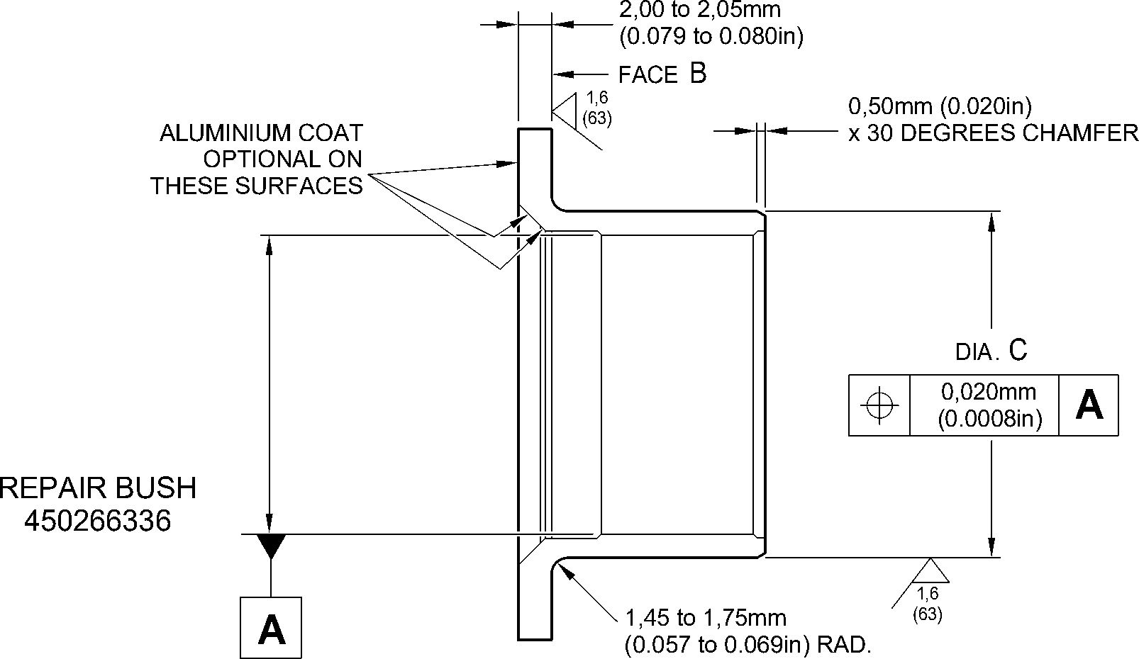
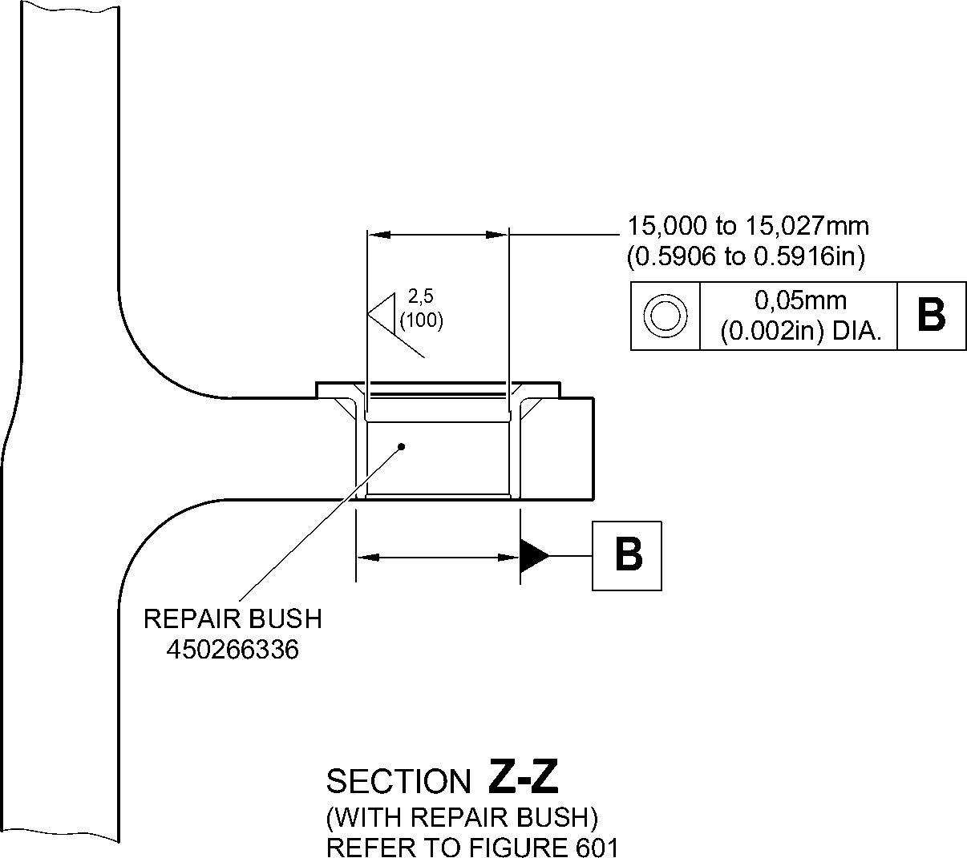
A321A5545-2
Repair Bush - Machining and Installation
Figure 602
32-12-22
Repair No. 9-4
Page 604
Aug 11/2023

sSAFRAN SAFRAN LANDING SYSTEMS UK Ltd
CAGE: K0654
PART No. 201587001 AND 201587002 COMPONENT MAINTENANCE MANUAL
MAIN LANDING GEAR LEG

I 1. Repair No. 9-5 Sliding Tube (18-80 and 18-80A)
- Specified Damage and Material Specification.
- Specified Damage
(a) Damage or wear to diameter A.
- Material Specification
IPL Figure and  Item No. | Name | Material Specification
18-80 and  18-80A | Sliding tube | Steel, 300M
- Special Tools
- Special tools are not necessary.
- Materials
- Materials are not necessary.
- Repair Parts
- Repair parts are not necessary.
- Procedure (Refer to Figure 601)
- Do this procedure only if the base metal is not damaged.
CAUTION: REPAIR WILL NOT BE PERMITTED BEYOND THE LIMITS OF THIS REPAIR
SCHEME.
- Remove the chromium plate from sliding tube: refer to PCS-2110, type C.
- Examine the sliding tube for flaws: refer to PCS-3100, inclusion class 4 and
PCS-3600.
CAUTION: DO NOT USE A MECHANICAL MOP POLISHER TO GET THE
SURFACE FINISH.
- Apply chromium plate to the diameter A: refer to PCS-2110, type C and Figure 601.
Make the surface finish 1,6 micrometers (64 micro-inches). The chromium plate
thickness must be between 0,020 and 0,025 mm (0.0008 and 0.0010 in).
- Identify the part with the Safran Landing Systems repair number 450237720
adjacent to the part number: refer to PCS-6000-19.
- Examine the part to make sure that you have obeyed all the repair instructions
correctly.
Repair No. 9-5
Page 601
Mar 18/2025
32-12-22

SAFRAN LANDING SYSTEMS UK Ltd
CAGE: K0654

PART No. 201587001 AND 201587002 COMPONENT MAINTENANCE MANUAL
MAIN LANDING GEAR LEG
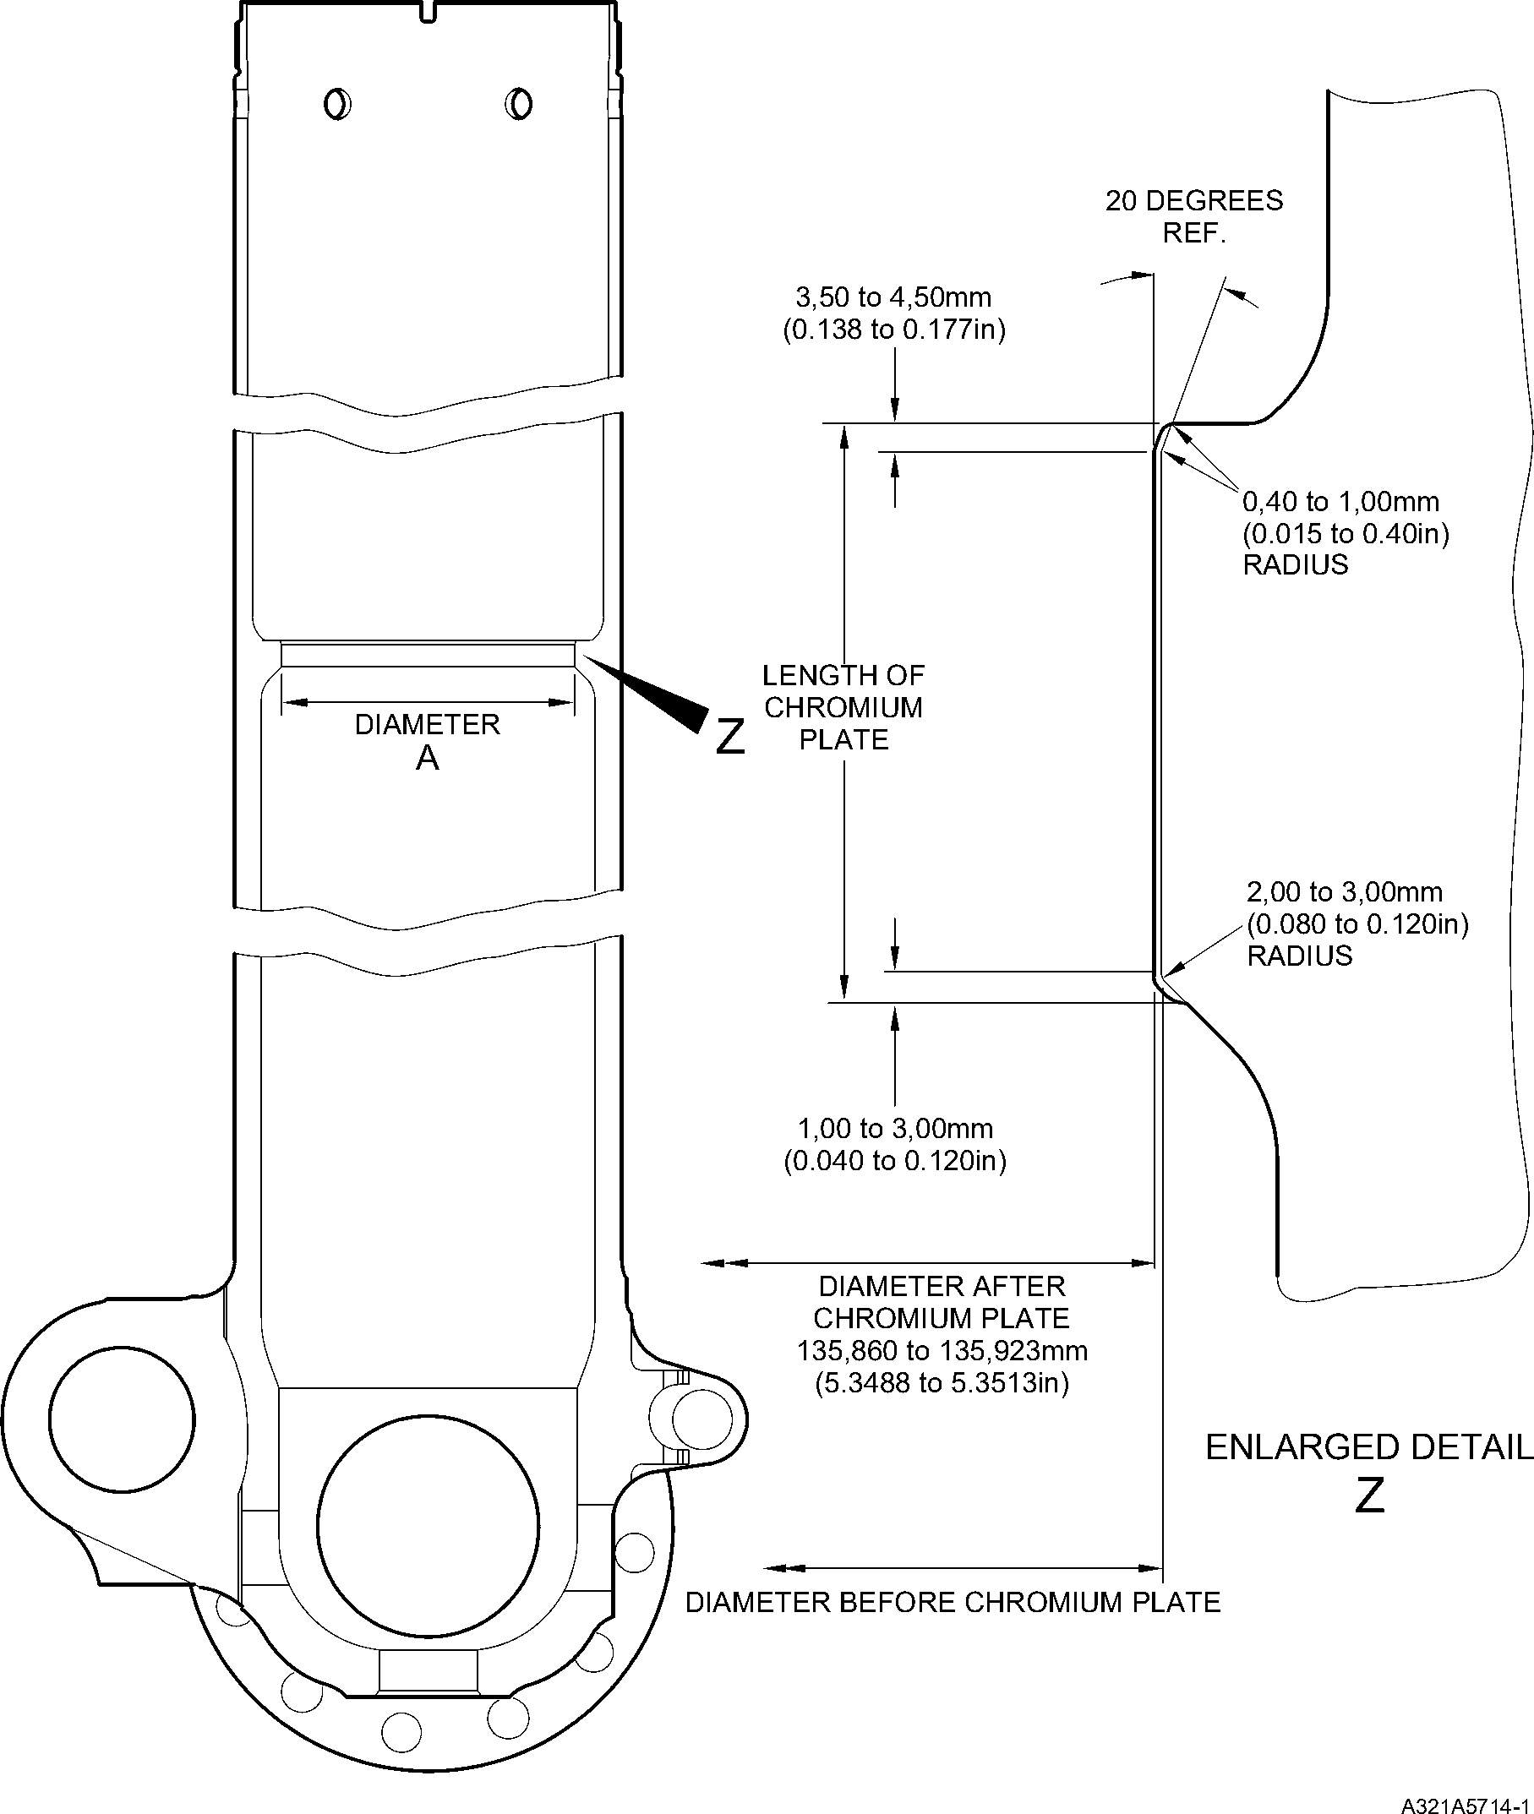
Repair to Sliding Tube
Figure 601
32-12-22
Repair No. 9-5
Page 602
Dec 6/2019

SAFRAN LANDING SYSTEMS UK Ltd
CAGE: K0654

PART No. 201587001 AND 201587002 COMPONENT MAINTENANCE MANUAL
MAIN LANDING GEAR LEG

I 1. Repair No. 9-6 Sliding Tube (18-80 and 18-80A)
- Specified Damage and Material Specification.
- Specified Damage
(a) Damage or corrosion to diameter A.
- Material Specification
IPL Figure and  item No. | Name | Material Specification
18-80 and  18-80A | Sliding tube | Steel, S155 (300M)
- Special Tools
- Special tools are not necessary.
- Materials
- Materials are not necessary.
- Repair Parts
- Repair parts are not necessary.
- Procedure (Refer to Figure 601)
- Do this procedure if both the chromium plate and the base metal are damaged.
NOTE: Refer to Repair No. 9-5, if only the chromium plate is damaged.
- Machine diameter A to remove the damage or corrosion within the dimensions
shown: refer to M-DLPS1004-4-1 and Figure 601.
- Machine the radii to the dimensions as shown: refer to Figure 601.
- Identify the part with the Safran Landing Systems repair number 450258470
adjacent to the part number: refer to PCS-6000-04.
- Examine the reworked area for flaws: refer to PCS-3600 and PCS-3100, inclusion
class 4.
- Shot peen the machined areas: refer to M-DLPS123.
- Apply Sulphamate Nickel plate to diameter A: refer to PCS-2120 for sequence of
operations and to MIL-STD-868A solution 2 and Figure 601.
NOTE: This operation includes 23 hours de-embrittle at 177 to 205 ºC (350 to
400 ºF).
- Machine (do not grind) the sulphamate nickel plate to the dimensions shown: refer
to Figure 601.
- Only required, if the parent metal was machined at step (g), examine the machined
area for flaws: refer to PCS-3600.
NOTE: This operation includes 4 hours de-embrittle at 177 to 205 ºC (350 to
400 ºF).
Repair No. 9-6
Page 601
Mar 18/2025
32-12-22

sSAFRAN SAFRAN LANDING SYSTEMS UK Ltd
CAGE: K0654
PART No. 201587001 AND 201587002 COMPONENT MAINTENANCE MANUAL
MAIN LANDING GEAR LEG
- Only required, if the parent metal was machined at step (g), examine the machined
area for flaws: refer to PCS-3100, inclusion class 4.
- Shot peen the machined areas: refer to M-DLPS123.
- Grit blast the shot peened area: refer to PCS-2610. Make sure that the sliding tube
is correctly masked.
- Examine the edges of sulphamate nickel plate to make sure they are properly
bonded: use 5 or 10X magnification.
- If there is evidence of delamination, remove the sulphamate nickel plate and do the
repair again.
CAUTION: DO NOT USE A MECHANICAL MOP POLISHER TO GET THE
SURFACE FINISH.
- Apply chromium plate to the diameter A: refer to PCS-2110 type C and Figure 601.
Make the chromium plate thickness between 0,020 and 0,025 mm (0.0008 and
0.0010 in). Make the surface finish 1,6 micrometers (63 micro-inches).
NOTE: This operation includes 18 hours de-embrittle at 177 to 205 ºC (350 to
400 ºF).
- Identify the part with the Safran Landing Systems repair number 450258470
adjacent to the part number: refer to PCS-6000-07.
- Examine the part to make sure that you have obeyed all the repair instructions
correctly.
32-12-22
Repair No. 9-6
Page 602
Mar 18/2025

SAFRAN LANDING SYSTEMS UK Ltd
CAGE: K0654
PART No. 201587001 AND 201587002 COMPONENT MAINTENANCE MANUAL
MAIN LANDING GEAR LEG
Y
Z
LENGTH OF
NICKEL PLATE
LENGTH OF
CHROMIUM
PLATE
2,00 to 3,00mm
(0.079 to 0.118in)
RADIUS
0,40 to 1,00mm
(0.015 to 0.40in)
RADIUS
20 DEGREES
REF.
DIAMETER
Y
A321A6706-1
0,04mm
(0.0016in)
DIAMETER BEFORE NICKEL
AND CHROMIUM PLATE
136,410mm (5.3700in) MAXIMUM
DIAMETER AFTER MACHINING
NICKEL PLATE
135,910 to 135,963mm
(5.3508 to 5.3529in)
3,50 to 4,50mm
(0.138 to 0.177in)
1,00 to 3,00mm
(0.040 to 0.120in)
DIAMETER AFTER
CHROMIUM PLATE
135,860 to 135,923mm
(5.3488 to 5.3513in)
ENLARGED DETAIL
Z
Repair to Sliding Tube
Figure 601
Repair No. 9-6
Page 603
Dec 6/2019
32-12-22
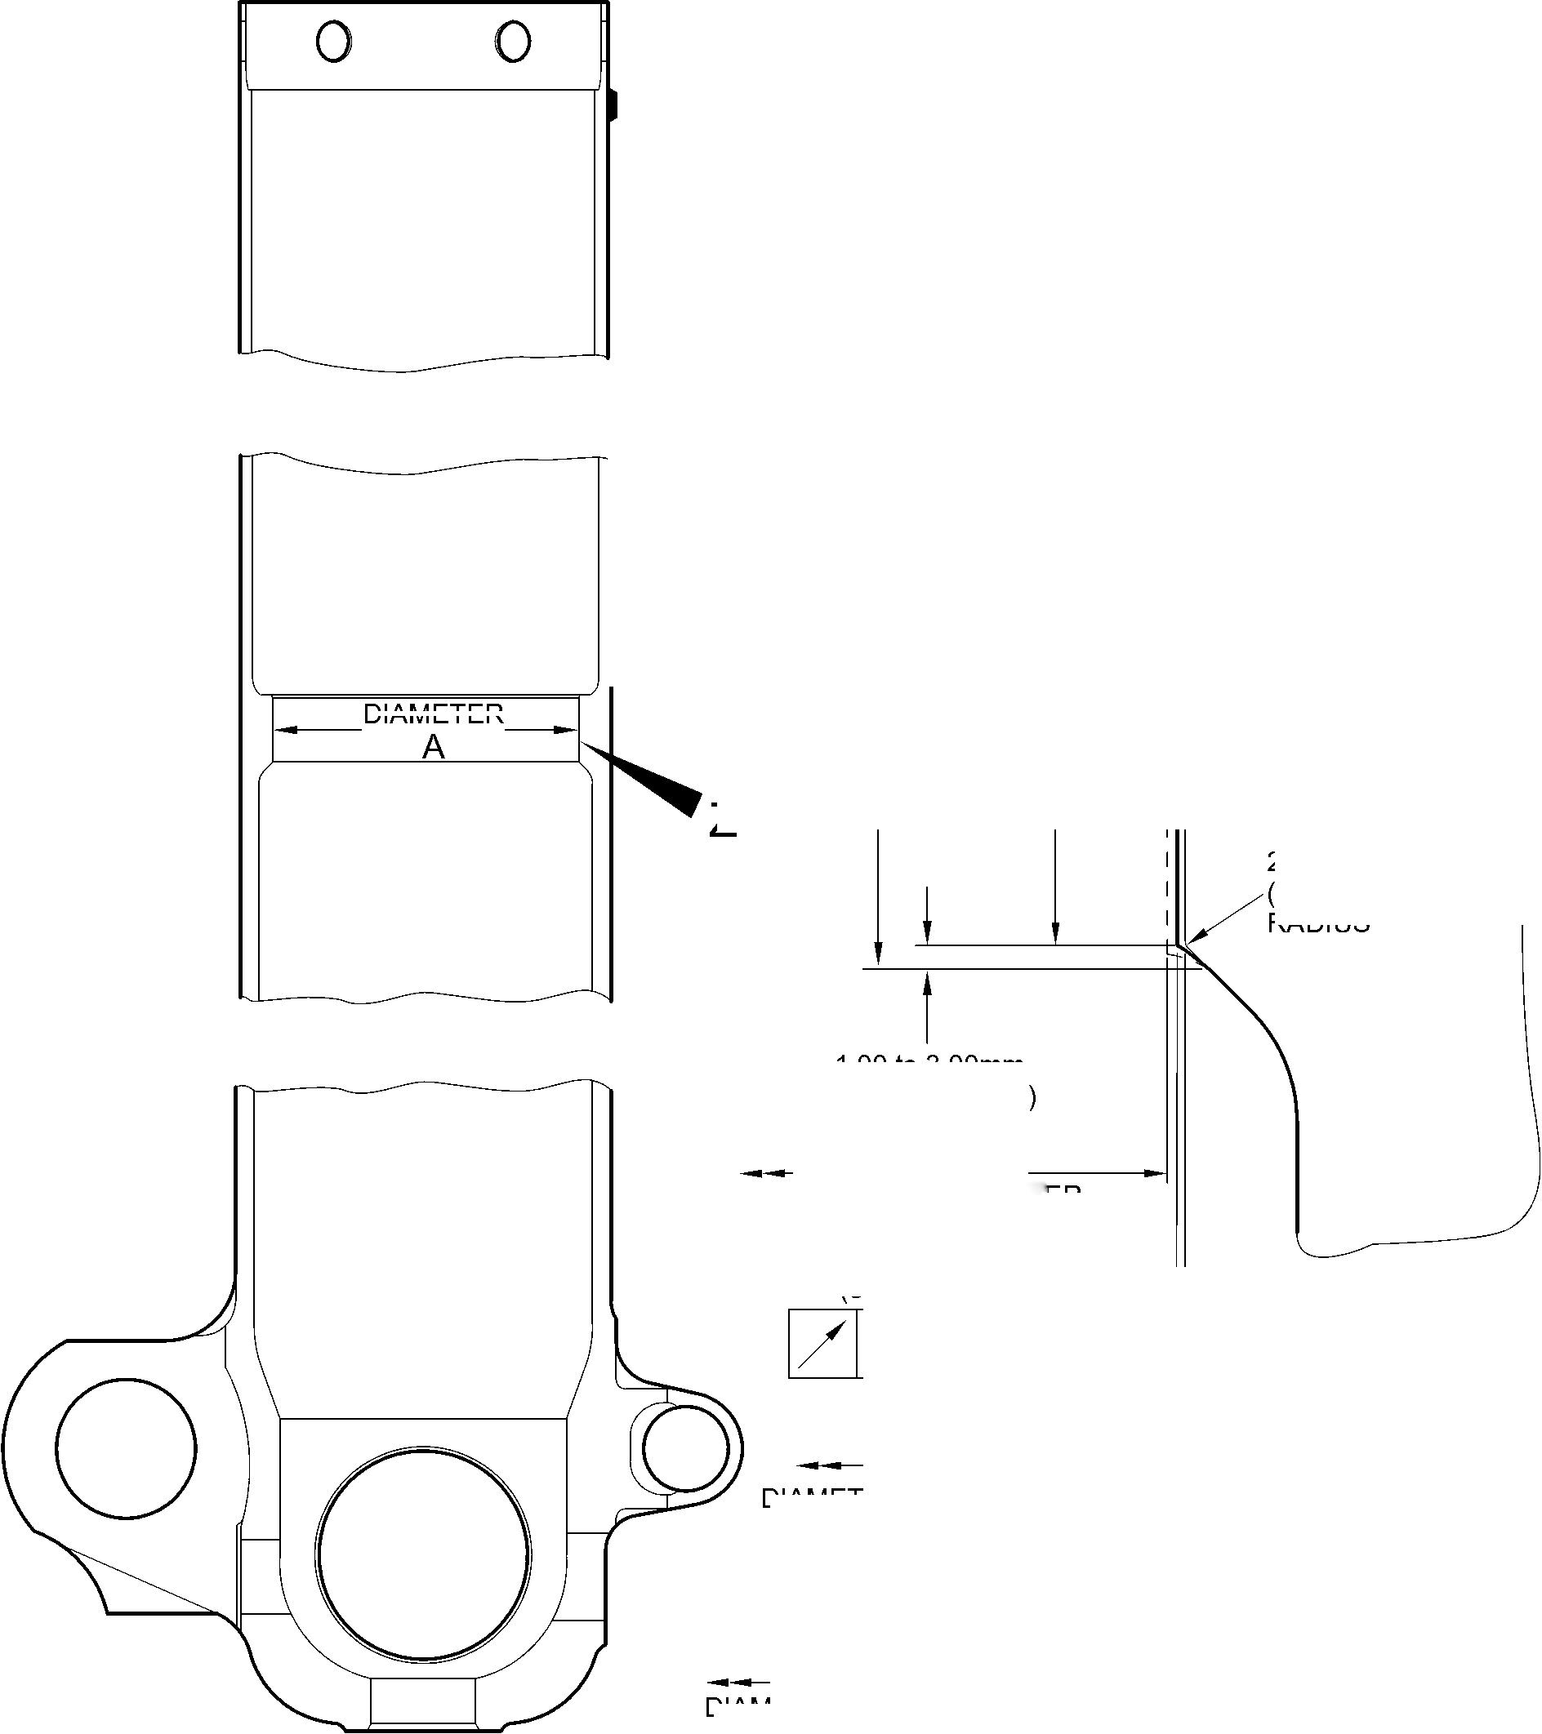
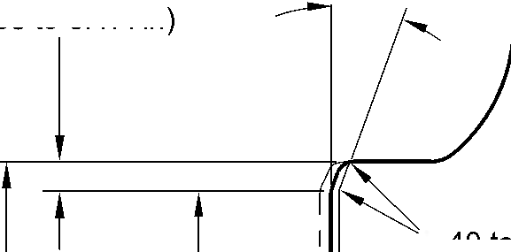
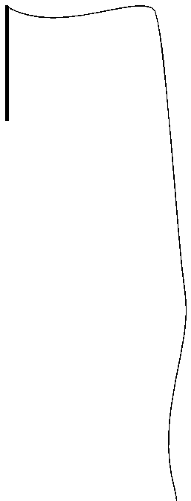

SAFRAN LANDING SYSTEMS UK Ltd
CAGE: K0654

PART No. 201587001 AND 201587002 COMPONENT MAINTENANCE MANUAL
MAIN LANDING GEAR LEG
INTENTIONALLY BLANK
Repair No. 9-6
32-12-22 ^{Page 604}

SAFRAN LANDING SYSTEMS UK Ltd
CAGE: K0654

PART No. 201587001 AND 201587002 COMPONENT MAINTENANCE MANUAL
MAIN LANDING GEAR LEG

I 1. Repair No. 9-7 Sliding Tube (18-80 and 18-80A)
- Specified Damage and Material Specification.
- Specified Damage
(a) Damage or wear to diameter(s) A and faces D and E.
- Material Specification
IPL Figure and  Item No. | Name | Material Specification
18-80 and  18-80A | Sliding Tube | Steel to 300M
- Special Tools
- These special tools are necessary:
NOTE: Alternative equivalents are permitted.
Part No. | Special Tool | Function
460004330/117 | Press Pad | Install oversize bushes
- Materials
- These materials are necessary:
NOTE: Alternative equivalents are permitted.
Ref. Item | Material
TBA | Zinc Powder
05-533 | Mastinox D40
09-510A | Sealant
- Repair Parts
- These repair parts are necessary:
Part No. | Repair Part | Material Specification
450258028 | Repair bush (Qty 2) | Aluminium Bronze
- Procedure (Refer to Figures 601 and 602)
CAUTION: FOR DAMAGE MORE THAN THE LIMITS OF THIS REPAIR SCHEME, WRITE
TO MESSIER-DOWTY LIMITED: REFER TO GUIDE-CS-001.
- Remove the paint locally from the sliding tube: refer to PCS-2700.
- Remove the cadmium plate locally from the sliding tube: refer to PCS-2100.
Repair No. 9-7
Page 601
Mar 18/2025
32-12-22

sSAFRAN SAFRAN LANDING SYSTEMS UK Ltd
CAGE: K0654
PART No. 201587001 AND 201587002 COMPONENT MAINTENANCE MANUAL
MAIN LANDING GEAR LEG
- Machine diameter(s) A sufficiently to remove the minimum amount of material necessary
to remove the wear or damage within the dimensions shown: refer to M-DLPS1004-4-1
and Figure 601. Make the surface finish 1,6 micrometers (63 micro-inches).
- Machine the adjacent spotfaces D and E to remove any damage or wear, within the
dimensions shown: refer to Figure 601. Make the surface finish 1,6 micrometers
(63 micro-inches).
- Machine the chamfers and radii to the dimensions shown: refer to Figure 601.
- Measure and record the new diameter(s) A.
- Examine the machined areas for flaws: refer to PCS-3600 and PCS-3100, inclusion
class 4.
- Shot peen the machined areas: refer to M-DLPS123.
- Apply cadmium plate to the reworked areas: refer to PCS-2100 or PCS-2141.
- Identify the part with the Messier-Dowty Limited repair number 450265140 adjacent to
the part number: refer to PCS-6000-05.
- Calculate diameter B of each repair bush (qty 2), use the formula:
B = A (as measured) - 0,006 mm (0.0002 in) to + 0,028 mm (0.0011 in).
- Machine the repair bushes to the dimensions shown and calculated. Machine face C to
get the correct dimensions after installation: refer to Figure 602. Make the surface finish
1,6 micrometers (63 micro-inches). The bushes must not protrude through the lug after
installation.
- Apply cadmium to the repair bushes, but not to the bores and the flange faces: refer to
PCS-2101 and Figure 602. The cadmium plate thickness must be between 0,010 and
0,015 mm (0.0004 and 0.0006 in).
- Apply primer paint to the sliding tube where the bush flanges will touch: refer to
PCS-2500.
- Use Press Pad 460004330/117 and install the repair bushes: refer to M-DLPS1011-20.
Use electrically conducting Mastinox (made from Mastinox D40, Material Ref.
Item 05-533 and Zinc powder, Material Ref. Item TBA): refer to M-DLPS709-14.
- Check the bores of the repair bushes: refer to Figure 602.
- If necessary, hone the bores of the repair bushes to the dimensions shown: refer to
Figure 602. Make the surface finish 2,5 micrometers (100 micro-inches).
- Apply paint to the repaired area, but not to the bushes: refer to PCS-2500.
- Apply sealant, Material Ref. Item 09-510A, around the joints between the repair bushes
and the sliding tube: refer to PCS-7200 and Figure 602.
- Identify the part with the Messier-Dowty Limited repair number 450265140 adjacent to
the part number: refer to PCS-6000-07.
- Examine the part to make sure that you have obeyed all the repair instructions correctly.
32-12-22
Repair No. 9-7
Page 602
Mar 18/2025

SAFRAN LANDING SYSTEMS UK Ltd
CAGE: K0654

PART No. 201587001 AND 201587002 COMPONENT MAINTENANCE MANUAL
MAIN LANDING GEAR LEG
Z
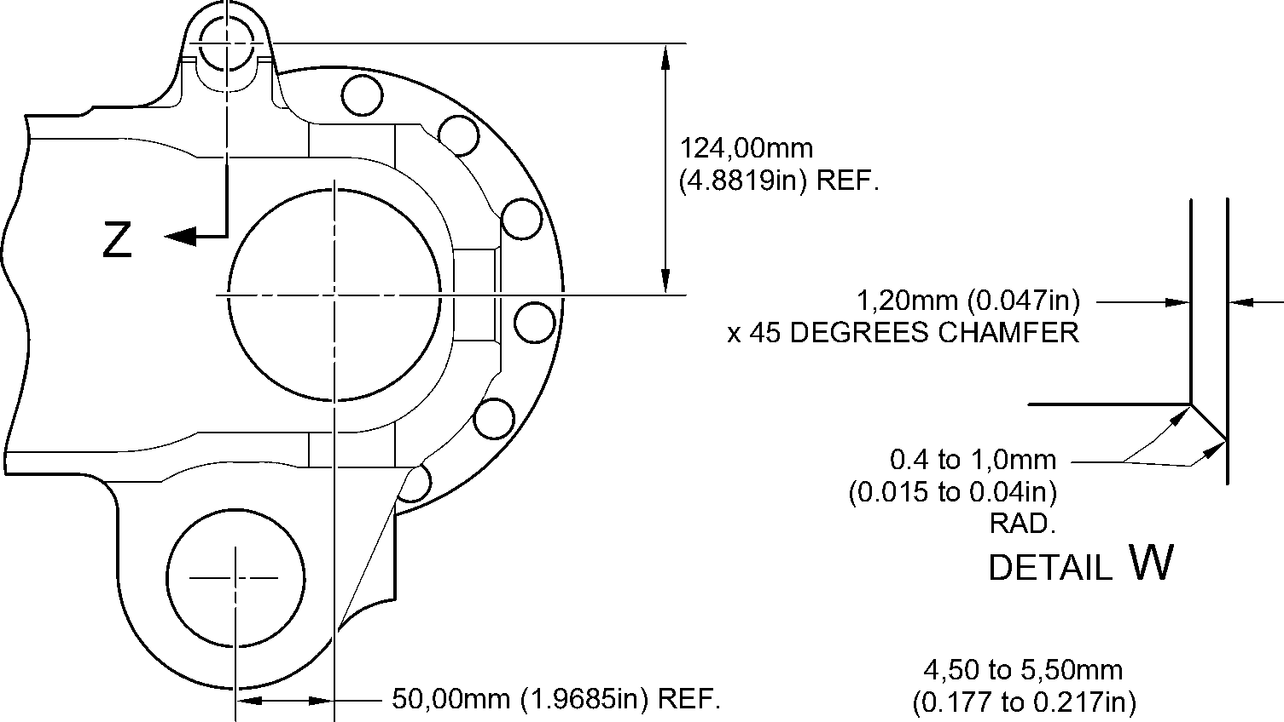
RAD.
49,50 to 50,50mm
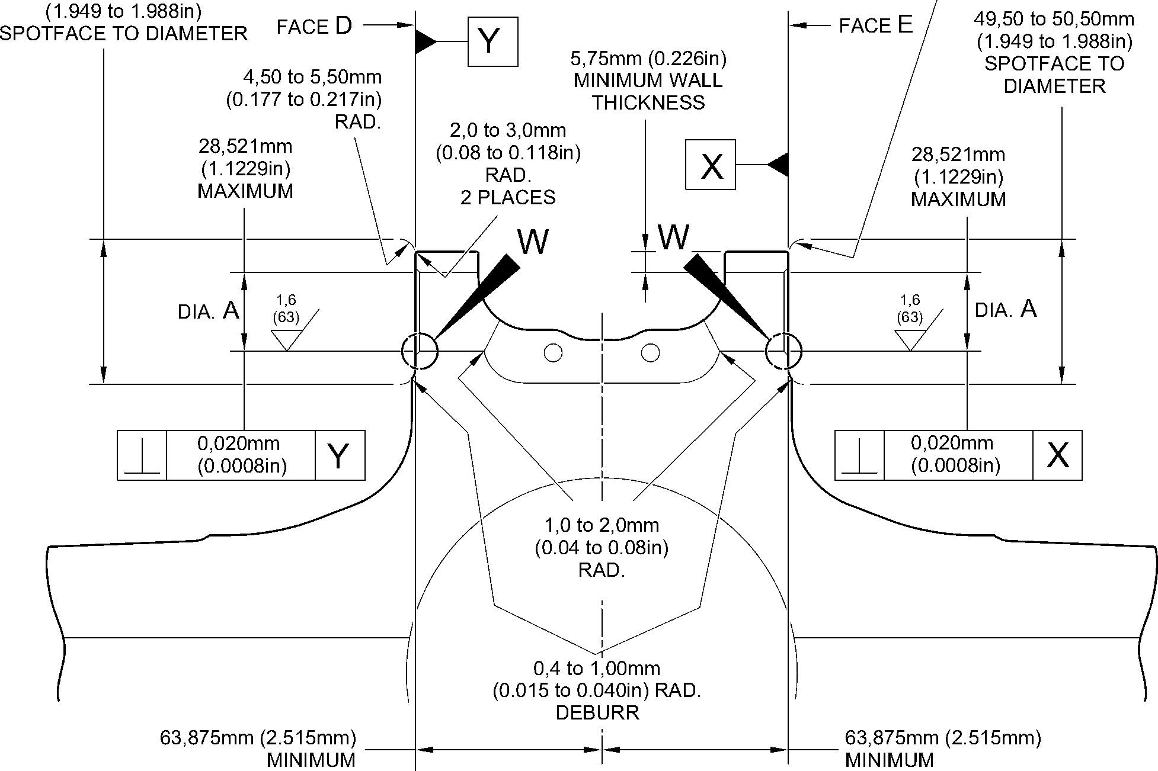
section Z-Z (WITHOUT bushes)
A321-S-32-12-22-038-1
Repair to Sliding Tube - Machining
Figure 601
Repair No. 9-7
Page 603
Dec 6/2019
32-12-22

SAFRAN LANDING SYSTEMS UK Ltd
CAGE: K0654

PART No. 201587001 AND 201587002 COMPONENT MAINTENANCE MANUAL
MAIN LANDING GEAR LEG
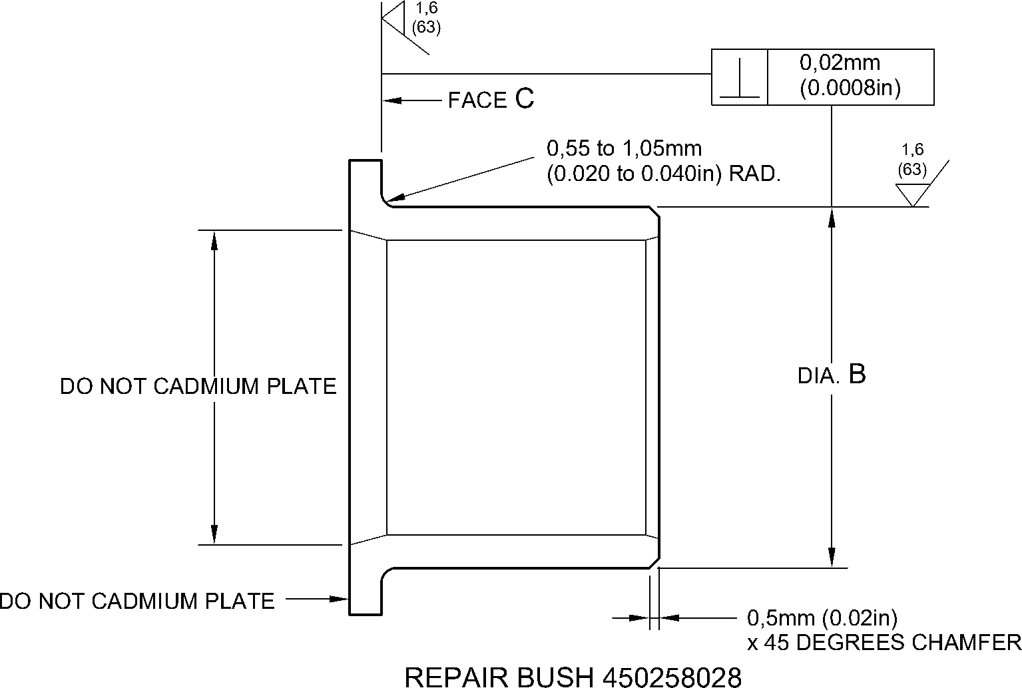
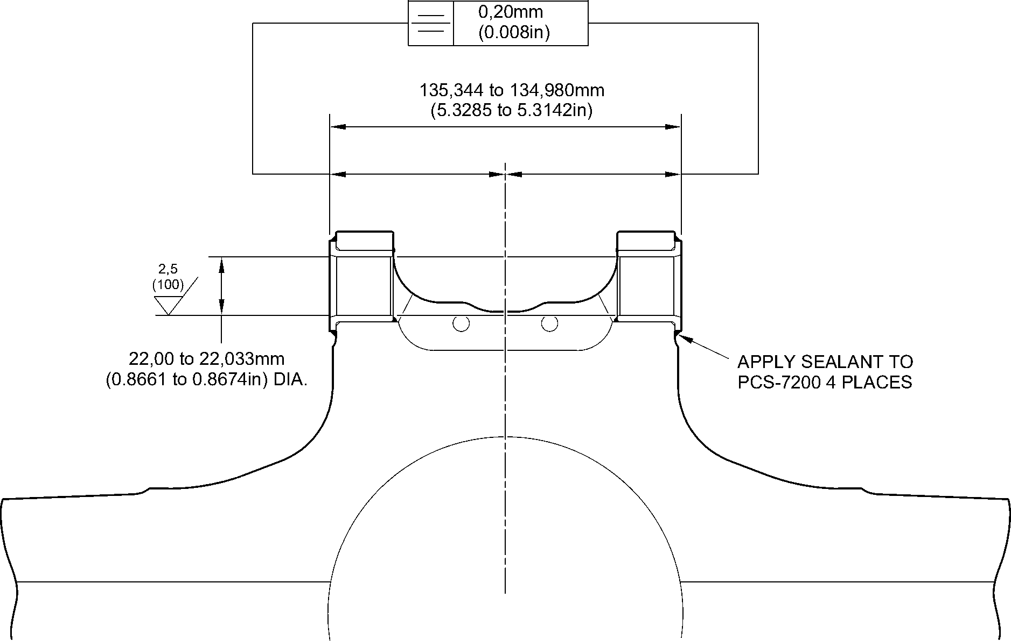
section Z-Z
(_{WITH BUSHES}) A321-S-32-12-22-039-1
Repair Bushes - Machining and Installation
Figure 602
32-12-22
Repair No. 9-7
Page 604
Dec 6/2019

sSAFRAN SAFRAN LANDING SYSTEMS UK Ltd
CAGE: K0654
PART No. 201587001 AND 201587002 COMPONENT MAINTENANCE MANUAL
MAIN LANDING GEAR LEG

I 1. Repair No. 9-8 Sliding Tube (18-80 and 18-80A)
- Specified Damage and Material Specification.
- Specified Damage
(a) Damage or wear to diameter(s) A and/or the adjacent face(s) B.
- Material Specification
IPL Figure and  Item No. | Name | Material Specification
18-80 and  18-80A | Sliding Tube | Steel, 300M
- Special Tools
(1) These special tools are necessary:
Part No. | Special Tool | Function
460006246 | Alignment bar | Install the repair bushes
460006250 | Press Pad Assembly
460006251 | Guide Bush
460006252 | Guide Bush
- Materials
- These materials are necessary:
NOTE: Alternative equivalents are permitted.
Ref. Item | Material
TBA | Zinc Powder
04-512 | Molykote 111
09-510A | Sealant
09-581 | Sealant
- These repair parts are necessary:
Part No. | Repair Part | Material Specification
450217855 | Repair bush (Qty 2) | Bronze, UZ 19A6
Repair No. 9-8
Page 601
Mar 18/2025
32-12-22

sSAFRAN SAFRAN LANDING SYSTEMS UK Ltd
CAGE: K0654
PART No. 201587001 AND 201587002 COMPONENT MAINTENANCE MANUAL
MAIN LANDING GEAR LEG
CAUTION : FOR DEVIATIONS OUTSIDE THE LIMITS OF THIS REPAIR SCHEME CONTACT
SAFRAN LANDING SYSTEMS.
- Procedure (Refer to Figures 601 and 602)
- Do this procedure if there is damage or wear to diameter(s) A and or adjacent face(s) B:
- Machine diameter(s) A sufficiently to remove the damage or wear within the
dimensions shown: refer to M-DLPS1004-4-1 and Figure 601. Make the surface
finish 1,6 micrometers (63 micro-inches).
- Machine the adjacent face(s) B using spotface cutter sufficiently to remove the
damage or wear within the dimensions shown: refer to M-DLPS1004-4-1 and
Figure 601. Make the surface finish 1,6 micrometers (63 micro-inches).
- Machine the chamfers and radii to the dimensions shown: refer to Figure 601.
- Measure and record the new diameter(s) A.
- Examine the machined areas for flaws: refer to PCS-3600 and PCS-3100,
inclusion class 4.
- Shot peen the machined areas: refer to M-DLPS123.
- Identify the part with the Safran Landing Systems repair number 450266310
adjacent to the part number: refer to PCS-6000-05 or PCS-6000-06.
- Apply cadmium plate to the reworked areas: refer to PCS-2141.
- Calculate diameter C and dimension H of each repair bush (qty 2):
Dia. C = Dia. A (as measured) + 0,090 to + 0,139 mm (+ 0.0035 to + 0.0055 in).
Dim. H = Dim. G (as measured) (spotface to grease hole center line)
- 0,10 to + 0,10 mm (- 0.004 to + 0.004 in).
- Machine face D of the repair bush to get the correct dimensions: refer to
Figure 602. Make the surface finish 1,6 micrometers (63 micro-inches).
- Machine the repair bush to the dimensions shown and calculated: refer to
M-DLPS900 and Figure 602.
- Apply cadmium plate to the repair bushes, but not to the bores and the flange
faces: refer to PCS-2101 or PCS-2141.
- Apply primer paint to the sliding tube where the bush flanges will touch: refer to
PCS-2500.
- Apply the electrically conducting Molykote or rubberised sealant to the oversize
bushes and the sliding tube over the dimensions shown: refer to Figure 602. Use
electrically conducting Molykote (made from Molykote 111, Material Ref. Item
04-512 and Zinc powder, Material Ref. Item TBA): refer to PCS-7304. Or use
electrically conducting rubberised sealant, Material Ref. Item 09-581: refer to
IFC30-145-03MD.
- Use the alignment bar 460006246, the press pad assembly 460006250 and the
guide bushes 460006251 and 460006252 and install the oversize bushes: refer to
PCS-5105-2.
32-12-22
Repair No. 9-8
Page 602
Mar 18/2025

sSAFRAN SAFRAN LANDING SYSTEMS UK Ltd
CAGE: K0654
PART No. 201587001 AND 201587002 COMPONENT MAINTENANCE MANUAL
MAIN LANDING GEAR LEG
- Machine the dimension across the bush flanges between 150,917 and
150,957 mm (5.9416 and 5.9432 in). The symmetry must be as shown: refer to
Figure 602.
- Machine the chamfers to the dimensions shown: refer to Figure 602.
- Check the bore diameters of the repair bushes: refer to Figure 602.
- If necessary, hone the bore diameters of the repair bushes to the dimensions
shown: refer to Figure 602. Make the surface finish 2,6 micrometers (100
micro-inches).
- Apply sealant, Material Ref. Item 09-510A, around the joints between the repair
bushes and the sliding tube: refer to PCS-7200 and Figure 602.
- Apply paint to the repaired area: refer to REPAIR and PCS-2500.
- Identify the part with the Safran Landing Systems repair number 450266310
adjacent to the part number: refer to PCS-6000-07.
- Examine the part to make sure that you have obeyed all the repair instructions
correctly.
Repair No. 9-8
Page 603
Mar 18/2025
32-12-22

SAFRAN LANDING SYSTEMS UK Ltd
CAGE: K0654

PART No. 201587001 AND 201587002 COMPONENT MAINTENANCE MANUAL
MAIN LANDING GEAR LEG
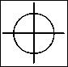

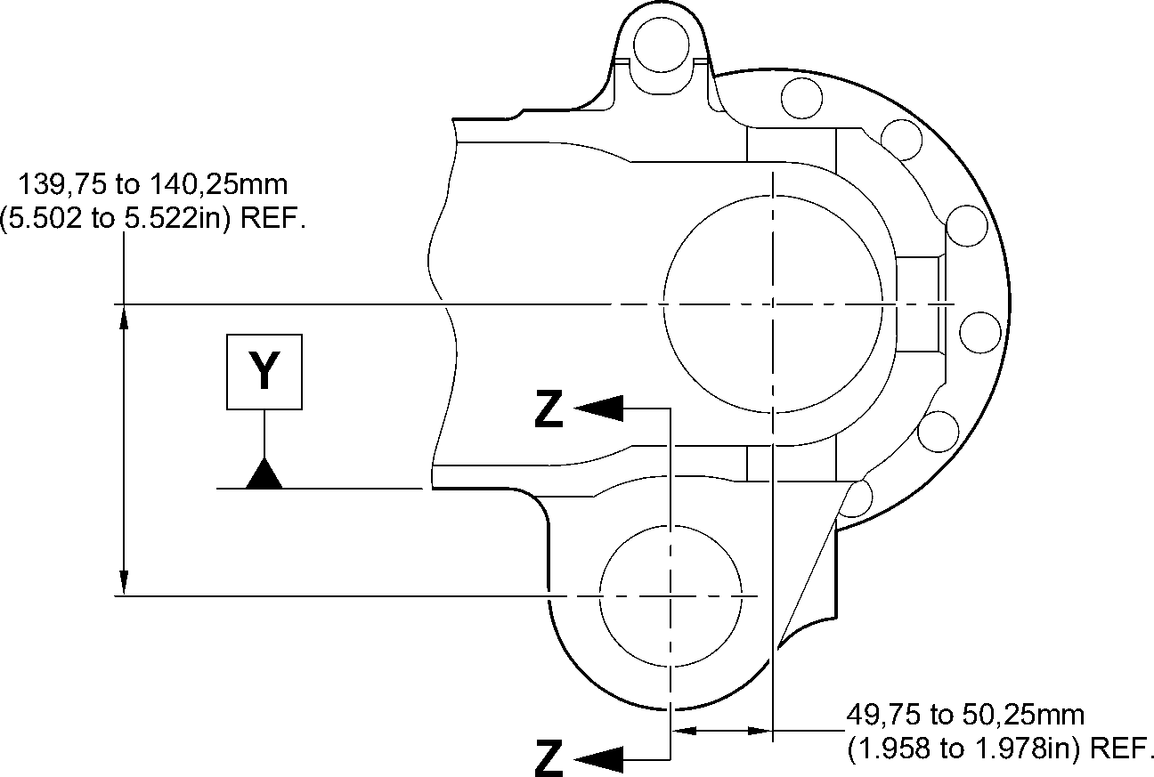
0,5mm
(0.02in) DIA. Y
0,075mm
(0.0030in)
4,50 to 5,50mm
(0.177 to 0.217in) RAD.
TYP. 2 PLACES
19,78mm (0.779in)
MINIMUM WALL
^{dia. A} THICKNESS
68,130mm (2.6823in) _{TYP. 2 PLACES}
MAXIMUM 1,6
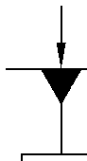
X
2,00 to 3,00mm
(0.080 to 0.118in)
RAD.
TYP. 2 PLACES
89,50 to 90,50mm
(3.524 to 3.563in)
SPOTFACE DIA.
TYP. 2 PLACES
35,95mm (1.415in)
MINIMUM LUG WIDTH
TYP. 2 PLACES
1,2mm (0.047in)
x 45 DEGREES CHAMFER
TYP. 2 PLACES
0,40 to 1,00mm
(0.016 to 0.040in)
RAD.
0,40 to 1,00mm
(0.016 to 0.040in)
RAD.
TYP. 2 PLACES
0,40mm
(0.016in) DIA.
X
face B
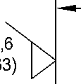
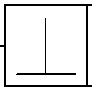
0,05mm
(0.002in)
SECTION Z-Z
(WITHOUT BUSHES)
X
1,00 to 2,00mm
(0.040 to 0.080in) RAD.
TYP. 2 PLACES
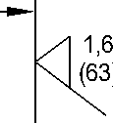
face B
A321A5899-3
Repair to Sliding Tube - Machining
Figure 601
32-12-22
Repair No. 9-8
Page 604
Aug 11/2023
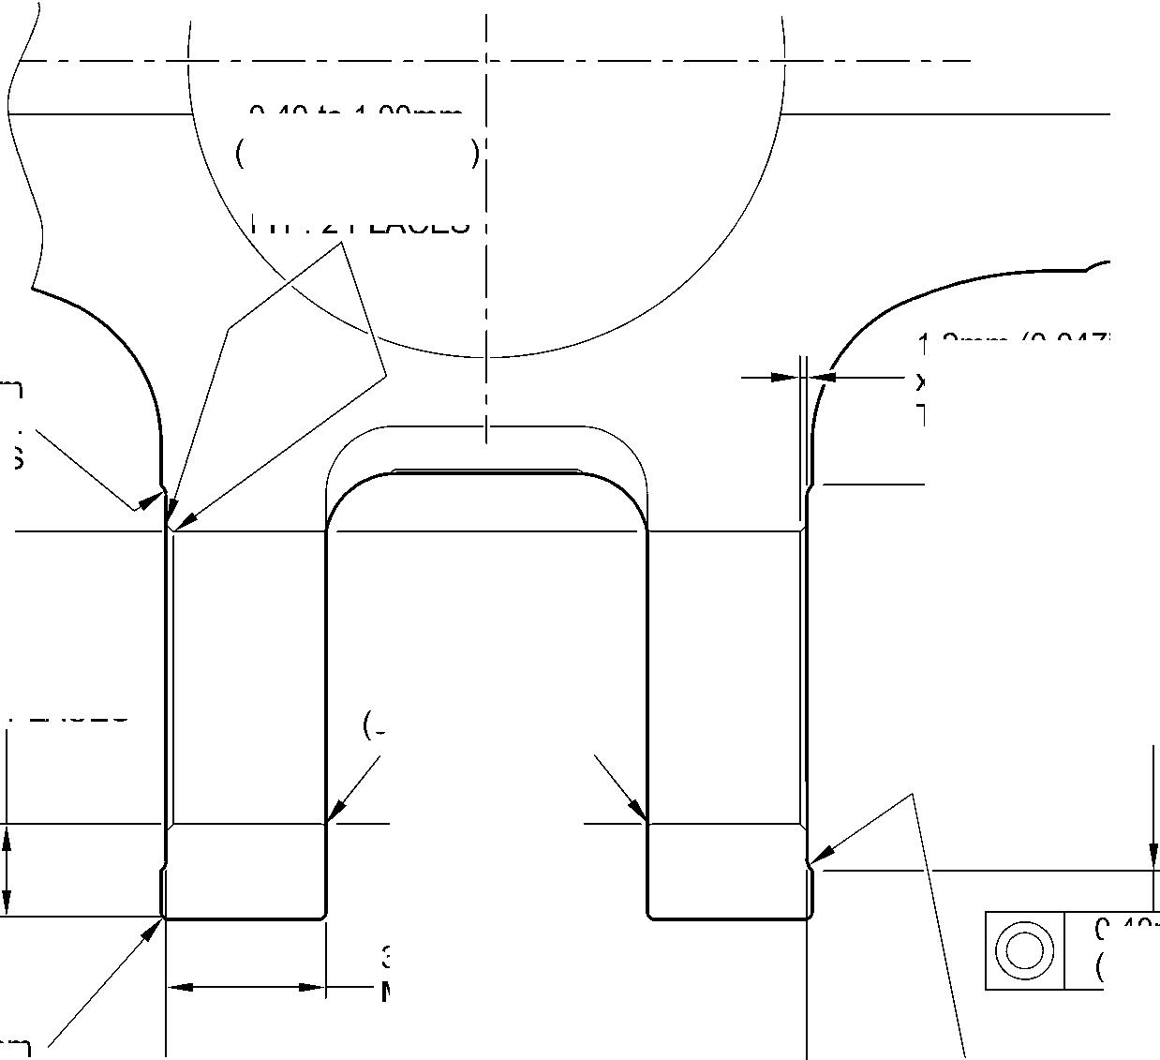

SAFRAN LANDING SYSTEMS UK Ltd
CAGE: K0654

PART No. 201587001 AND 201587002 COMPONENT MAINTENANCE MANUAL
MAIN LANDING GEAR LEG
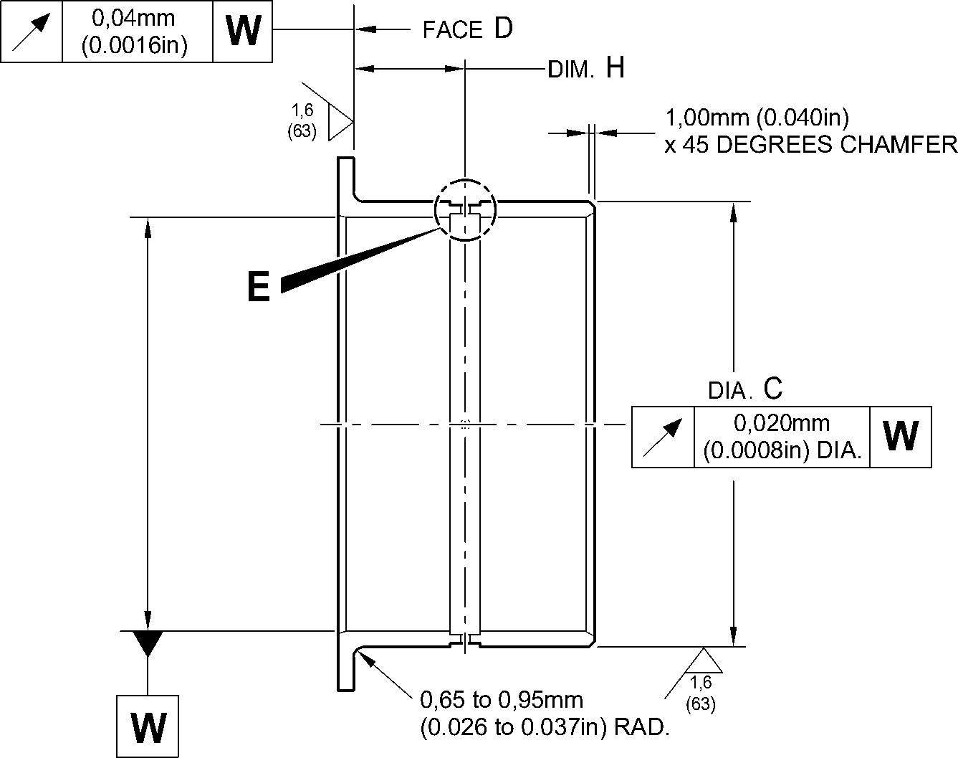
30 30
DEGREES DEGREES
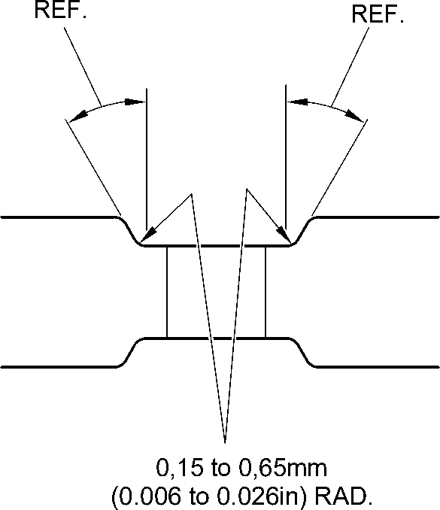
REPAIR BUSH
450217855
DETAIL E
TYP. 4 PLACES
1,00mm (0.039in)
CHAMFER (2 PLACES)
X
DIM.G
Y
REPAIR BUSH
450217855
150,917 to 150,957mm
(5.9416 to 5.9432in)
30 DEGREES
CHAMFER
(2 PLACES)
DETAIL X 60,00 to 60,03mm
(2.362 to 2.363in)
14,00 to 16,00mm
(0.551 to 0.630in)
APPLY ELECTRICALLY
CONDUCTING MOLYKOTE 111
OR RUBBERISED SEALANT
IN THE BORES TO
IFC30-145-03MD OR PCS-7304
TYP. 2 PLACES
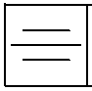
0,1mm
(0.04in)
12,00 to 14,00mm
(0.472 to 0.551in)
APPLY ELECTRICALLY
CONDUCTING MOLYKOTE 111
OR RUBBERISED SEALANT
ON BOTH BUSHES TO
IFC30-145-03MD OR PCS-7304
TYP. 2 PLACES
SECTION Z-Z
(WITH BUSHES)
APPLY SEALANT
TO PCS-7200
WITHOUT OVERFLOW ON
FACES OF THE BUSHES
4 PLACES
A321A5900-4
Repair Bushes - Machining and Installation
Figure 602
Repair No. 9-8
Page 605
Mar 18/2025
32-12-22
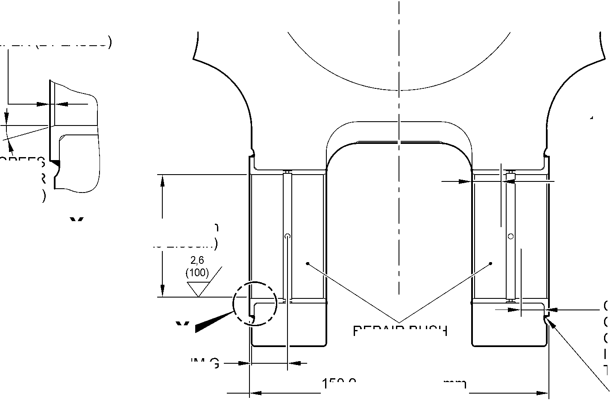

SAFRAN LANDING SYSTEMS UK Ltd
CAGE: K0654

PART No. 201587001 AND 201587002 COMPONENT MAINTENANCE MANUAL
MAIN LANDING GEAR LEG
INTENTIONALLY BLANK
Repair No. 9-8
32-12-22 ^{Page 606}

sSAFRAN SAFRAN LANDING SYSTEMS UK Ltd
CAGE: K0654
PART No. 201587001 AND 201587002 COMPONENT MAINTENANCE MANUAL
MAIN LANDING GEAR LEG

I 1. Repair No. 9-9 Sliding Tube (18-80 and 18-80A)
- Specified Damage and Material Specification.
- Specified Damage
(a) Damage or wear to diameter A and/or adjacent face.
- Material Specification
IPL Figure and  Item No. | Name | Material Specification
18-80 and  18-80A | Sliding Tube | Steel, 300M
- Special Tools
- These special tools are necessary:
NOTE: Alternative equivalents are permitted.
Tool Part No. | Special Tool | Function
460004330/131 | Press Pad | Install the repair bush
- Materials
- These materials are necessary:
NOTE: Alternative equivalents are permitted.
Ref. Item | Material
TBA | Zinc Powder
04-512 | Molykote 111
09-510A | Sealant
- Repair Parts
- These repair parts are necessary:
Part No. | Repair Part | Material Specification
450258015 | Repair Bush | Bronze, UZ19A6
- Procedure (Refer to Figures 601 and 602)
CAUTION: FOR DAMAGE MORE THAN THE LIMITS OF THIS REPAIR SCHEME, WRITE
TO SAFRAN LANDING SYSTEMS: REFER TO GUIDE-CS-001.
- Machine the diameter A and/or the adjacent face to remove the damage or wear within
the dimensions shown: refer to M-DLPS1004-4-1 and Figure 601. Do not increase
diameter A more than 48,125 mm (1.8947 in). Make the surface finish 1,6 micrometers
(63 micro-inches).
Repair No. 9-9
Page 601
Mar 18/2025
32-12-22

sSAFRAN SAFRAN LANDING SYSTEMS UK Ltd
CAGE: K0654
PART No. 201587001 AND 201587002 COMPONENT MAINTENANCE MANUAL
MAIN LANDING GEAR LEG
- Machine the chamfer and radii to the dimensions shown: refer to Figure 601.
- Measure and record the new diameter A.
- Examine the machined areas for flaws: refer to PCS-3600 and PCS-3100, inclusion
class 4.
- Shot peen the machined areas: refer to M-DLPS123.
- Identify the part with the Safran Landing Systems repair number 450265180 adjacent to
the part number: refer to PCS-6000-19.
- Apply cadmium plate to the reworked areas: refer to PCS-2100. The cadmium plate
thickness must be between 0,010 and 0,015 mm (0.0004 and 0.0006 in).
- Calculate the diameter C for the repair bush, use the formula:
C = A (as measured) + 0,018 to 0,059 mm (0.0007 to 0.0023 in).
- Machine the repair bush to the dimensions shown and calculated. Machine face D to get
the correct dimension after installation: refer to M-DLPS900 and Figure 602. Make the
surface finish 1,6 micrometers (63 micro-inches).
- Apply cadmium plate all over to the repair bush: refer to PCS-2101. The cadmium plate
thickness must be between 0,005 and 0,009 mm (0.0002 and 0.0004 in).
- Apply primer paint to the repair bush but not to the areas shown: refer to PCS-2500 and
Figure 602.
- Use the Press Pad 460004330/131 and install the repair bush: refer to M-DLPS1011-14.
Use zinc loaded Molykote (made from Molykote 111, Material Ref. Item 04-512 and Zinc
powder, Material Ref. Item TBA): refer to PCS-7304. The slot in the repair bush must be
in the correct angular position: refer to Figure 602.
- Check the bore of the repair bush: refer to Figure 602.
- If necessary, hone the repair bush bore to the dimensions shown: refer to Figure 602.
- Apply a bead of sealant, Material Ref. Item 09-510A, to the joints between the repair
bush and the sliding tube: refer to PCS-7200 and Figure 602.
- Apply paint locally to the sliding tube: refer to REPAIR and PCS-2500.
- Identify the part with the Safran Landing Systems repair number 450265180 adjacent to
the part number: refer to PCS-6000-07.
- Examine the part to make sure that you have obeyed all the repair instructions correctly.
32-12-22
Repair No. 9-9
Page 602
Mar 18/2025

SAFRAN LANDING SYSTEMS UK Ltd
CAGE: K0654

PART No. 201587001 AND 201587002 COMPONENT MAINTENANCE MANUAL
MAIN LANDING GEAR LEG
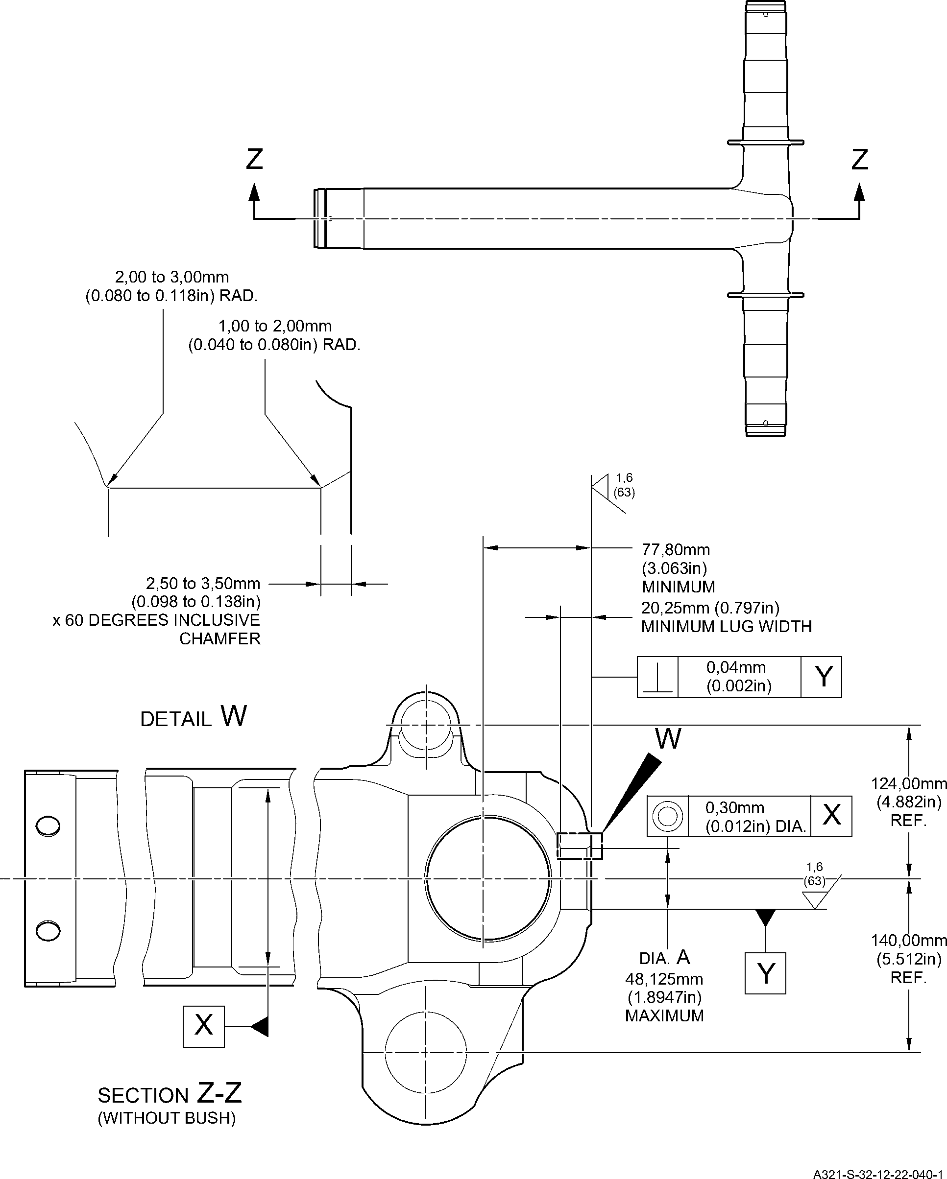
Repair to Sliding Tube - Machining
Figure 601
Repair No. 9-9
Page 603
Dec 6/2019
32-12-22

SAFRAN LANDING SYSTEMS UK Ltd
CAGE: K0654

PART No. 201587001 AND 201587002 COMPONENT MAINTENANCE MANUAL
MAIN LANDING GEAR LEG
83,00 to 83,50mm
(3.268 to 3.287in)
section Z-Z
(WITH BUSH)
REFER TO FIGURE 601
35,40 to 35,60mm
(1.394 to 1.402in) DIA.
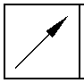
0,05mm
(0.002in)
TRACES OF
PAINT
PERMITTED
Y
REPAIR BUSH
450258015
APPLY SEALANT TO PCS-7200
2 PLACES
view Y
-3 to 3 DEGREES
ORIENTATION IS IMPORTANT
face D
DO NOT PRIMER PAINT
0,50mm (0.020in)
x 45 DEGREES CHAMFER
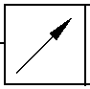
0,03mm
(0.001in)
X
1,00mm (0.040in)
x 60 DEGREES INCLUSIVE
CHAMFER
1,35 to 1,85mm
(0.053 to 0.073in) RAD.
REPAIR BUSH 450258015
X
1,6
dia. C
DO NOT PRIMER
PAINT
A321-S-32-12-22-041-1
Repair Bush - Machining and Installation
Figure 602
32-12-22
Repair No. 9-9
Page 604
Dec 6/2019
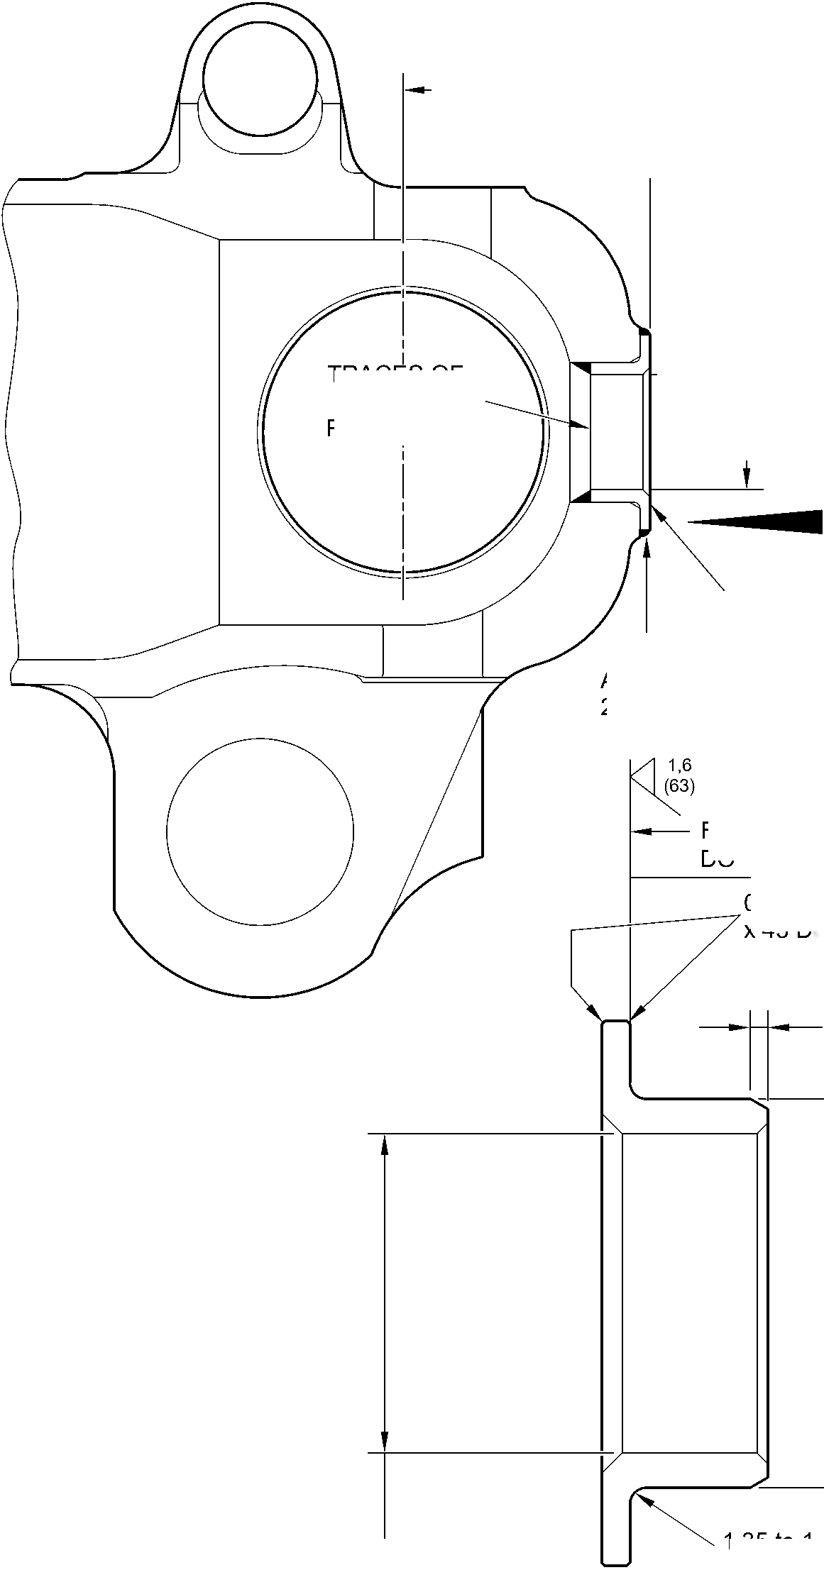
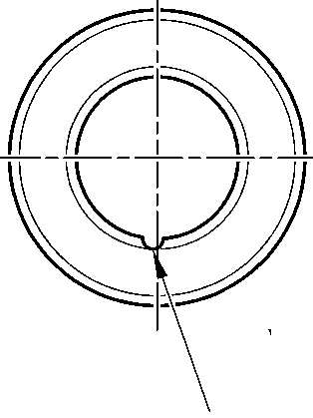

sSAFRAN SAFRAN LANDING SYSTEMS UK Ltd
CAGE: K0654
PART No. 201587001 AND 201587002 COMPONENT MAINTENANCE MANUAL
MAIN LANDING GEAR LEG

I 1. Repair No. 9-10 Sliding Tube (18-80 and 18-80A)
- Specified Damage and Material Specification.
- Specified Damage
(a) Damage or wear to diameters A and/or B and/or C.
- Material Specification
IPL Figure and  Item No. | Name | Material Specification
18-80 and  18-80A | Sliding Tube | Steel, S155 (300M)
- Special Tools
- Special tools are not necessary.
- Materials
- Materials are not necessary.
- Repair Parts
- Repair parts are not necessary.
CAUTION: FOR DEVIATIONS OUTSIDE THE LIMITS OF THIS REPAIR SCHEME CONTACT
SAFRAN LANDING SYSTEMS.
- Procedure (Refer to Figures 601 and 602)
- Do this procedure, if diameter(s) A is damaged or worn:
- Remove the paint from the sliding tube, if necessary: refer to PCS-2700 and
Figure 601.
- Remove the Sermetel from the sliding tube, if necessary: refer to M-DLPS637.
- Remove the cadmium plate from the sliding tube, if necessary: refer to PCS-2100.
- Remove the chromium plate from diameter(s) A: refer to PCS-2110 Type C.
- If the base metal is not damaged or worn:
- Examine the sliding tube for flaws: refer to PCS-3600 and PCS-3100,
inclusion class 4.
- Apply chromium plate to diameter(s) A: refer to PCS-2110 Type C,
M-DLPS1031-1, M-DLPS1031-6 and Figure 601. The chromium plate
thickness must be sufficient to give a minimum thickness of 0,10 mm
(0.004 in) after grinding.
- Finish grind diameter A: refer to M-DLPS1004-4-1 and Figure 601. Make the
surface finish 0,8 micrometers (32 micro-inches).
- Examine the ground chromium plate for flaws: refer to M-DLNDT3.
- Identify the part with the Safran Landing Systems repair number 450258401A
adjacent to the part number: refer to PCS-6000-05 or PCS-6000-19.
Repair No. 9-10
Page 601
Mar 18/2025
32-12-22

sSAFRAN SAFRAN LANDING SYSTEMS UK Ltd
CAGE: K0654
PART No. 201587001 AND 201587002 COMPONENT MAINTENANCE MANUAL
MAIN LANDING GEAR LEG
- If the base metal is damaged or worn:
- Machine the diameter(s) A to remove the damage or wear within the
dimensions shown: refer to M-DLPS1004-4-1 and Figure 601. Make the
surface finish 0,8 micrometers (32 micro-inches).
2 Examine the machined area for flaws: refer to PCS-3600 and PCS-3100,
inclusion class 4.
- Shot peen the machined area: refer to M-DLPS123.
4 Apply chromium plate to diameter(s) A: refer to PCS-2110 Type C,
M-DLPS1031-1, M-DLPS1031-6 and Figure 601. The chromium plate
thickness must be sufficient to give a minimum thickness of 0,10 mm
(0.004 in) after grinding.
- Finish grind diameter A: refer to M-DLPS1004-4-1 and Figure 601. Make the
surface finish 0,8 micrometers (32 micro-inches).
- Examine the ground chromium plate for flaws: refer to M-DLNDT3.
- Identify the part with the Safran Landing Systems repair number 450258401B
adjacent to the part number: refer to PCS-6000-05 or PCS-6000-19.
- Apply cadmium plate to the sliding tube but not on the chromium plated areas: refer
to REPAIR and PCS-2100. Make the cadmium plate thickness between 0,010 and
0,020 mm (0.0004 and 0.0008 in).
- Apply Sermetel to the sliding tube but not on the chromium plated or the cadmium
plated areas: refer to REPAIR and M-DLPS637.
- Apply paint to the sliding tube but not on the chromium plated areas: refer to
REPAIR and PCS-2500.
- Identify the part with the Safran Landing Systems repair number adjacent to the
part number: refer to PCS-6000-07.
- Use the repair number 450258401A if there was no damage to the base metal or
- Use the repair number 450258401B if there was damage to the base metal.
- Examine the part to make sure that you have obeyed all the repair instructions
correctly.
- Do this procedure, if diameter(s) B is damaged or worn:
- Remove the paint from the sliding tube, if necessary: refer to PCS-2700 and
Figure 601.
- Remove the Sermetel from the sliding tube, if necessary: refer to M-DLPS637.
- Remove the cadmium plate from the sliding tube, if necessary: refer to PCS-2100.
- Remove the chromium plate from diameter(s) B: refer to PCS-2110 Type C and
Figure 601.
- If the base metal is not damaged or worn:
1 Examine the sliding tube for flaws: refer to PCS-3600 and PCS-3100,
inclusion class 4.
Repair No. 9-10
32
Page 602
-- Mar 18/2025

sSAFRAN SAFRAN LANDING SYSTEMS UK Ltd
CAGE: K0654
PART No. 201587001 AND 201587002 COMPONENT MAINTENANCE MANUAL
MAIN LANDING GEAR LEG
2 Apply chromium plate to diameter(s) B: refer to PCS-2110 Type C,
M-DLPS1031-1, M-DLPS1031-6 and Figure 601. The chromium plate
thickness must be sufficient to give a minimum thickness of 0,10 mm (0.004
in) after grinding.
- Finish grind diameter B: refer to M-DLPS1004-4-1 and Figure 601. Make the
surface finish 0,8 micrometers (32 micro-inches).
- Examine the ground chromium plate for flaws: refer to M-DLNDT3.
- Identify the part with the Safran Landing Systems repair number 450258401C
adjacent to the part number: refer to PCS-6000-05 or PCS-6000-19.
- If the base metal is damaged or worn:
- Machine the diameter(s) B to remove the damage or wear within the
dimensions shown: refer to M-DLPS1004-4-1 and Figure 601. Make the
surface finish 0,8 micrometers (32 micro-inches).
2 Examine the machined area for flaws: refer to PCS-3600 and PCS-3100,
inclusion class 4.
- Shot peen the machined area: refer to M-DLPS123.
- Apply chromium plate to diameter(s) B: refer to PCS-2110 Type C,
M-DLPS1031-1, M-DLPS1031-6 and Figure 601. The chromium plate
thickness must be sufficient to give a minimum thickness of 0,10 mm
(0.004 in) after grinding.
- Finish grind diameter B: refer to M-DLPS1004-4-1 and Figure 601. Make the
surface finish 0,8 micrometers (32 micro-inches).
- Examine the ground chromium plate for flaws: refer to M-DLNDT3.
- Identify the part with the Safran Landing Systems repair number 450258401D
adjacent to the part number: refer to PCS-6000-05 or PCS-6000-19.
- Apply cadmium plate to the sliding tube but not on the chromium plated areas: refer
to REPAIR and PCS-2100. Make the cadmium plate thickness between 0,010 and
0,020 mm (0.0004 and 0.0008 in).
- Apply Sermetel to the sliding tube but not on the chromium plated or the cadmium
plated areas: refer to REPAIR and M-DLPS637.
- Apply paint to the sliding tube but not on the chromium plated areas: refer to
REPAIR and PCS-2500.
- Identify the part with the Safran Landing Systems repair number adjacent to the
part number: refer to PCS-6000-07.
- Use the repair number 450258401C if there was no damage to the base metal or
- Use the repair number 450258401D if there was damage to the base metal.
- Examine the part to make sure that you have obeyed all the repair instructions
correctly.
Repair No. 9-10
Page 603
Mar 18/2025
32-12-22

sSAFRAN SAFRAN LANDING SYSTEMS UK Ltd
CAGE: K0654
PART No. 201587001 AND 201587002 COMPONENT MAINTENANCE MANUAL
MAIN LANDING GEAR LEG
- Do this procedure, if diameter(s) C is damaged or worn:
- Remove the paint from the sliding tube, if necessary: refer to PCS-2700 and
Figure 601.
- Remove the Sermetel from the sliding tube, if necessary: refer to M-DLPS637.
- Remove the cadmium plate from the sliding tube, if necessary: refer to PCS-2100.
- Remove the chromium plate from diameter(s) C: refer to PCS-2110 Type C and
Figure 602.
- If the base metal is not damaged or worn:
1 Apply chromium plate to diameter(s) C: refer to PCS-2110 Type C,
M-DLPS1031-6, Figure 601 and Figure 602. The chromium plate thickness
must be sufficient to give a minimum thickness of 0,10 mm (0.004 in) after
grinding.
2 Finish grind diameter C: refer to M-DLPS1004-4-1 and Figure 602. Make the
surface finish 0,8 micrometers (32 micro-inches).
3 Examine the ground chromium plate for flaws: refer to M-DLNDT3.
4 Identify the part with the Safran Landing Systems repair number 450258401E
adjacent to the part number: refer to PCS-6000-05 or PCS-6000-19.
- If the base metal is damaged or worn:
- Machine the diameter(s) C to remove the damage or wear within the
dimensions shown: refer to M-DLPS1004-4-1 and Figure 602. Make the
surface finish 0,8 micrometers (32 micro-inches).
2 Examine the machined area for flaws: refer to PCS-3600 and PCS-3100,
inclusion class 4.
- Shot peen the machined area: refer to M-DLPS123.
4 Apply chromium plate to diameter(s) C: refer to PCS-2110 Type C,
M-DLPS1031-2, M-DLPS1031-6 and Figure 602. The chromium plate
thickness must be sufficient to give a minimum thickness of 0,10 mm
(0.004 in) after grinding.
- Finish grind diameter C: refer to M-DLPS1004-4-1 and Figure 602. Make the
surface finish 0,8 micrometers (32 micro-inches).
- Examine the ground chromium plate for flaws: refer to M-DLNDT3.
7 Identify the part with the Safran Landing Systems repair number 450258401F
adjacent to the part number: refer to PCS-6000-05 or PCS-6000-19.
- Apply cadmium plate to the sliding tube but not on the chromium plated areas: refer
to REPAIR and PCS-2100. Make the cadmium plate thickness between 0,010 and
0,020 mm (0.0004 and 0.0008 in).
- Apply Sermetel to the sliding tube but not on the chromium plated or the cadmium
plated areas: refer to REPAIR and M-DLPS637.
Repair No. 9-10
32
Page 604
-12-22 Mar 18/2025

sSAFRAN SAFRAN LANDING SYSTEMS UK Ltd
CAGE: K0654
PART No. 201587001 AND 201587002 COMPONENT MAINTENANCE MANUAL
MAIN LANDING GEAR LEG
- Apply paint to the sliding tube but not on the chromium plated areas: refer to
REPAIR and PCS-2500.
- Identify the part with the Safran Landing Systems repair number adjacent to the
part number: refer to PCS-6000-07.
- Use the repair number 450258401E if there was no damage to the base metal or
- Use the repair number 450258401F if there was damage to the base metal.
- Examine the part to make sure that you have obeyed all the repair instructions
correctly.
Repair No. 9-10
Page 605
Mar 18/2025
32-12-22

SAFRAN LANDING SYSTEMS UK Ltd
CAGE: K0654
PART No. 201587001 AND 201587002 COMPONENT MAINTENANCE MANUAL
MAIN LANDING GEAR LEG
W
V
X
T
0,060mm
(0.0024in)
0,060mm
(0.0024in)
dia A

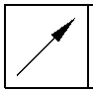
0,040mm
(0.0016in)
Y
dia B

Z
DIA C
T
SLIDING TUBE
OUTSIDE DIAMETER
V
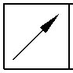
0,040mm
(0.0016in)
V
EDGE SMOOTHED
OUT
EDGE SMOOTHED
OUT
1,00 to 3,00mm
(0.039 to 0.118in)
CHROMIUM PLATE
1,00 to 3,00mm
(0.039 to 0.118in)
CHROMIUM PLATE
TERMINATION TO M-DLPS1031-1
TERMINATION TO M-DLPS1031-6
119,319mm (4.6976in) MINIMUM DIAMETER
BEFORE CHROMIUM PLATE
CHROMIUM PLATE TERMINATION
TYPICAL AROUND 4 SLOTS.
IRREGULAR LINE IS PERMITTED
2,00 to 3,00mm
(0.079 to 0.118in) RADIUS
detail X
detail W
DIA A
119,929 to 119,964mm (4.7216 to 4.7230in)
DIAMETER AFTER GRINDING THE CHROMIUM PLATE
CHROMIUM PLATE DEPOSIT
1,00 to 3,00mm
(0.039 to 0.118in)
CHROMIUM PLATE
TERMINATION TO M-DLPS1031-6.
IRREGULAR LINE IS PERMITTED
EDGE SMOOTHED
OUT
2,00 to 3,00mm
(0.079 to 0.118in)
RADIUS
126,307mm (4.9727in) MINIMUM DIAMETER
BEFORE CHROMIUM PLATE
detail Y
CHROMIUM PLATE
DEPOSIT
dia B
126,917 to 126,957mm (4.9967 to 4.9983in)
DIAMETER AFTER GRINDING THE CHROMIUM PLATE
A321A6875-1
Repair to Sliding Tube
Figure 601
32-12-22
Repair No. 9-10
Page 606
Mar 18/2025
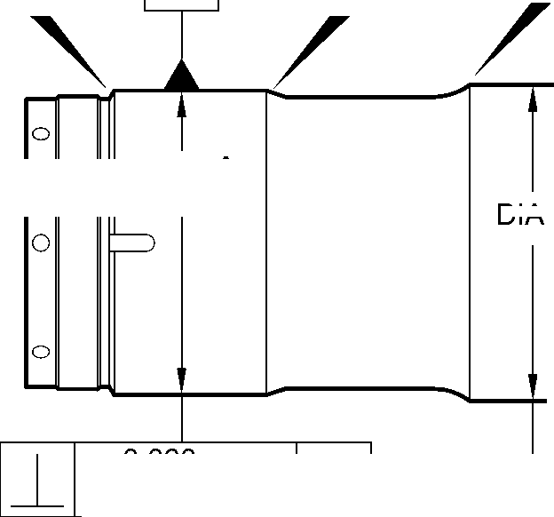
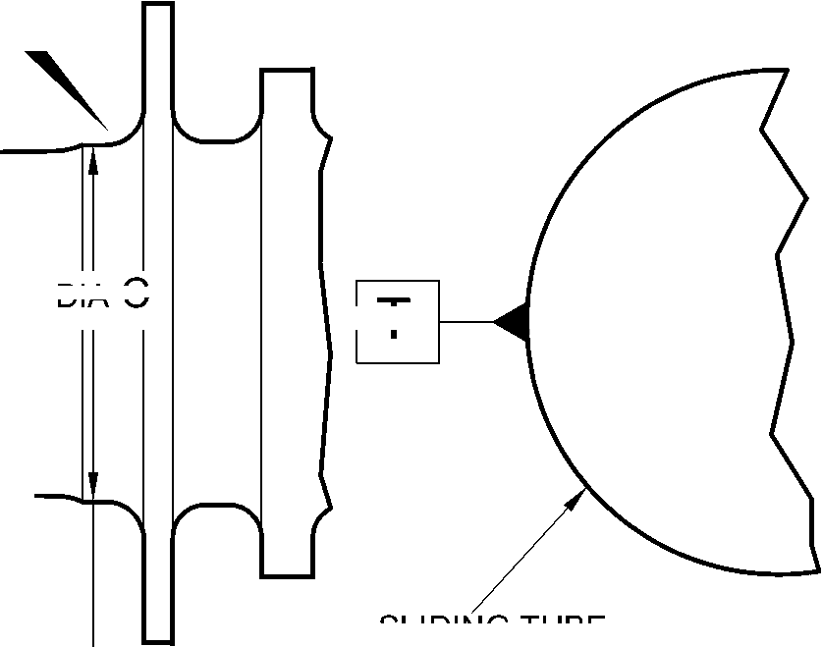
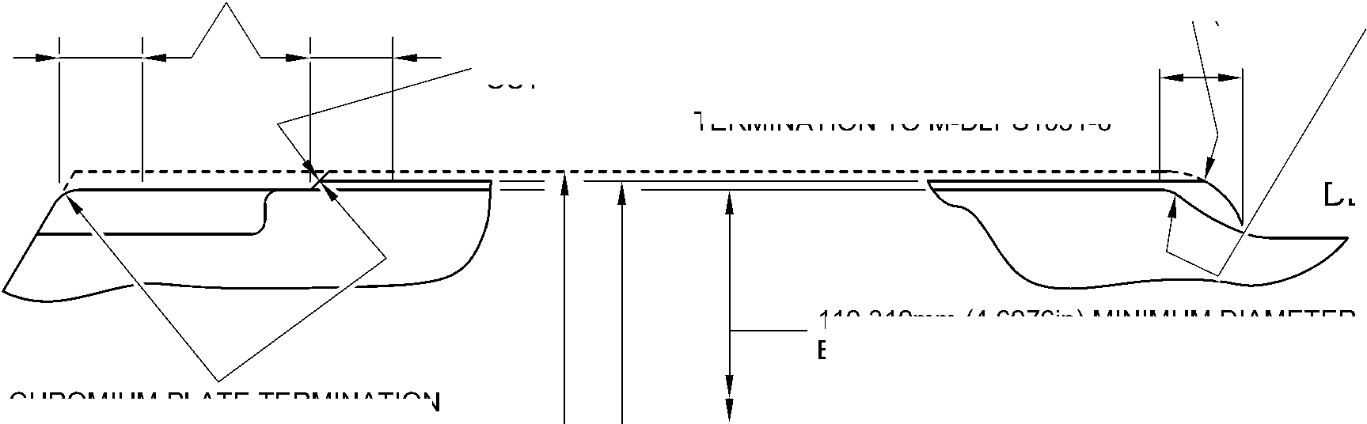
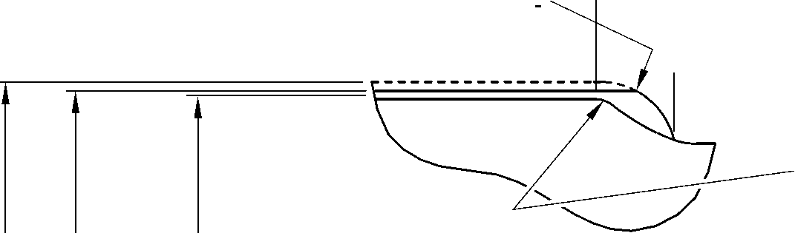

SAFRAN LANDING SYSTEMS UK Ltd
CAGE: K0654
PART No. 201587001 AND 201587002 COMPONENT MAINTENANCE MANUAL
MAIN LANDING GEAR LEG
14,500mm (0.5708in)
REF.
0,0 to 2,0mm (0.00 to 0.08in) CHROMIUM PLATE
MUST TERMINATE WITHIN THIS LENGTH.
WAVY OR IRREGULAR LINE IS PERMITTED.
2,0 to 3,00mm
(0.08 to 0.118in) RAD.
17,750 to 18,250mm
(0.6988 to 0.7185in)
REF.
1,0 to 3,00mm (0.04 to 0.118in) CHROMIUM PLATE
MUST TERMINATE WITHIN THIS LENGTH.
WAVY OR IRREGULAR LINE IS PERMITTED.
EDGE
SMOOTHED
OUT
8,00mm (0.315in)
REF.
30,00mm (1.181in)
RAD. REF.
DIAMETER BEFORE CHROMIUM PLATE
dia C
131,294 to 131,357mm (5.1690 to 5.1715in) AFTER GRINDING
DETAIL Z
(REFER TO FIGURE 601)
IF THE BASE METAL
IS NOT DAMAGED
0,0 to 2,00mm (0.00 to 0.079in)
CHROMIUM PLATE TERMINATION
TO M-DLPS1031-2
CHROMIUM PLATE MUST TERMINATE WITHIN
THIS LENGTH.
WAVY OR IRREGULAR LINE IS PERMISSIBLE.
CHROMIUM PLATE DEPOSIT
2,00 to 3,00mm
(0.079 to 0.118in) RAD.
CHROMIUM PLATE DEPOSIT
2,00 to 3,00mm
(0.079 to 0.118in) RAD.
8,00mm (0.315in)
RAD. REF.
30,00mm (1.181in)
RAD. REF.
1,0 to 2,0mm
(0.04 to 0.08in) RAD.
130,683mm (5.145in) MINIMUM DIAMETER
BEFORE CHROMIUM PLATE
dia C
131,294 to 131,357mm (5.1690 to 5.1715in) AFTER GRINDING
1,750 to 2,250mm
(0.0689 to 0.0886in)
16,25mm (0.640in)
1,0 to 3,00mm (0.04 to 0.118in)
CHROMIUM PLATE TERMINATION TO M-DLPS1031-6
CHROMIUM PLATE MUST TERMINATE WITHIN
THIS LENGTH.
WAVY IRREGULAR LINE IS PERMISSIBLE.
14,500mm (0.5708in)
REF.
DETAIL Z
(REFER TO FIGURE 601)
IF THE BASE METAL
IS DAMAGED
A321A6876-2
Repair to Sliding Tube
Figure 602
Repair No. 9-10
Page 607
Mar 18/2025
32-12-22
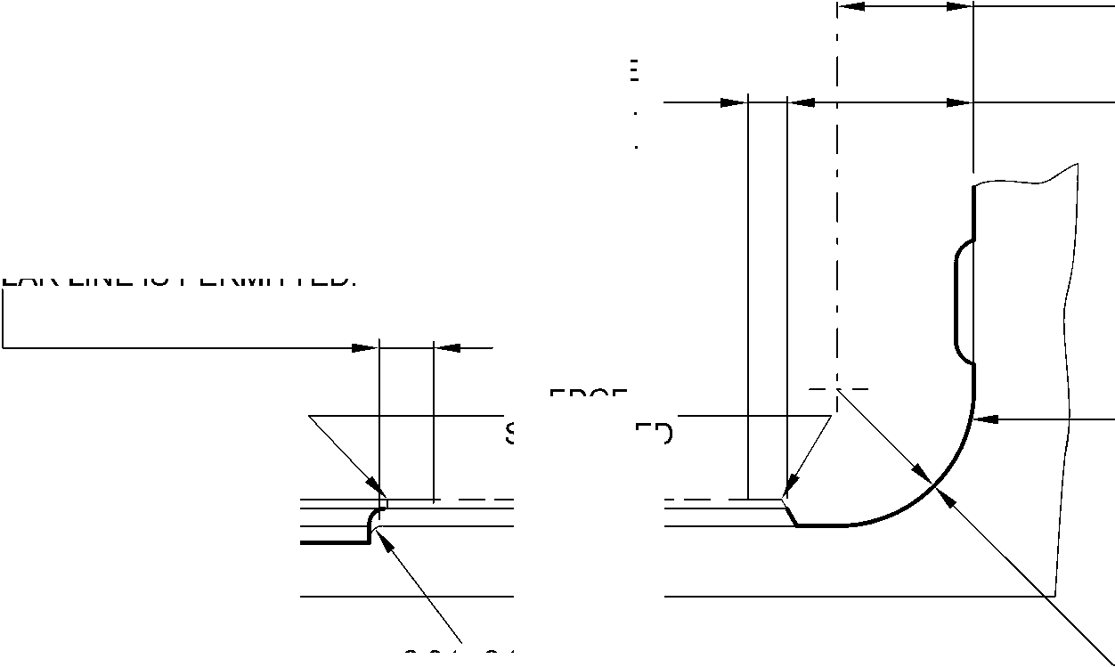
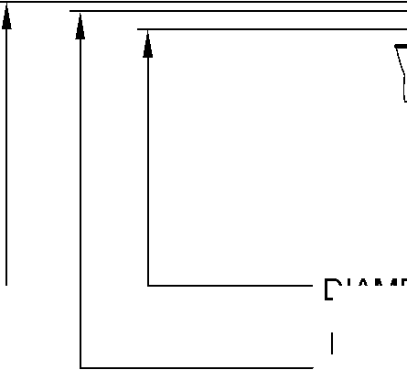
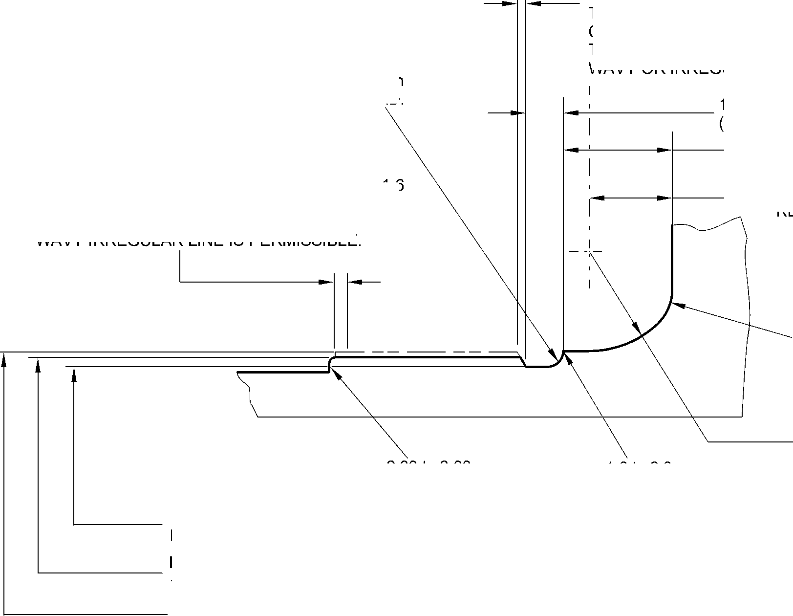

SAFRAN LANDING SYSTEMS UK Ltd
CAGE: K0654

PART No. 201587001 AND 201587002 COMPONENT MAINTENANCE MANUAL
MAIN LANDING GEAR LEG
INTENTIONALLY BLANK
Repair No. 9-10
32-12-22 ^{Page 608}

SAFRAN LANDING SYSTEMS UK Ltd
CAGE: K0654

PART No. 201587001 AND 201587002 COMPONENT MAINTENANCE MANUAL
MAIN LANDING GEAR LEG

I 1. Repair No. 9-11 Sliding Tube (18-80 and 18-80A)
- Specified Damage and Material Specification.
- Specified Damage
(a) Damage or wear to the diameter A.
- Material Spcification
IPL Figure and  Item No. | Name | Material Specification
18-80 and  18-80A | Sliding Tube | Steel, 300M
- Special Tools
- These special tools are necessary:
NOTE: Alternative equivalents are permitted.
Tool Part No. | Special Tool | Function
460004330/105 | Press Pad | To install the repair bush 450266800
- Materials
- Materials are not necessary.
- Repair Parts
- These repair parts are necessary:
Part No. | Repair Part | Material Specification
450266800 | Repair Bush | Stainless Steel, AMS5643 or  AMS5659
- Procedure (Refer to Figures 601 to 603)
CAUTION: FOR DAMAGE MORE THAN THE LIMITS OF THIS REPAIR SCHEME, WRITE
TO SAFRAN LANDING SYSTEMS: REFER TO GUIDE-CS-001.
- Do this procedure if there is wear or damage to diameter A:
- Locally remove the Sermetel layer from the sliding tube: refer to REPAIR and
M-DLPS637.
- Locally remove the chromium plate from the sliding tube: refer to REPAIR
PCS-2110 and Figures 601 and 602.
- If necessary, machine the diameter(s) A to remove the minimum amount of
material necessary to remove the damage or wear: refer to M-DLPS1004-4-1 and
Figure 602. Do not make the diameter A more than 21,073 mm (0.8296 in). Make
the surface finish 1,6 micrometers (63 micro-inches) or better.
- Measure and record the new diameter(s) A.
- Machine the chamfers and radii as shown: refer to Figure 602.
Repair No. 9-11
Page 601
Mar 18/2025
32-12-22

sSAFRAN SAFRAN LANDING SYSTEMS UK Ltd
CAGE: K0654
PART No. 201587001 AND 201587002 COMPONENT MAINTENANCE MANUAL
MAIN LANDING GEAR LEG
- Examine the bare metal for flaws: refer to PCS-3100, inclusion class 4 and
PCS-3600.
- Shot peen the reworked areas: refer to M-DLPS123.
- Apply chromium plate to diameter(s) A: refer to PCS-2110 Type C, M-DLPS1031-5
and Figure 602. The chromium plate thickness must be between 0,020 and
0,025 mm (0.0008 and 0.0010 in).
- Apply Sermetel to the repaired area: refer to M-DLPS637 and Figure 602.
- Identify the part with the Safran Landing Systems repair number 450266295
adjacent to the part number: refer to PCS-6000-05.
- Machine diameter B of the repair bush(es), use formula:
Dia. B = Dia. A (as measured) - 0,005 to + 0,041 mm (- 0.0002 to + 0.0016 in).
- Machine the face R to get the flange thickness of between 2,00 and 2,05 mm
(0.079 and 0.081 in).
- Passivate the repair bush(es): refer to AMS-2700.
- Apply a layer of IVD alloy with elecromation yellow all over the repair bush(es) but
not in the bores: refer to ICT 40-893-01MD and Figure 603. The thickness of the
IVD layer must be between 0,0075 and 0,0125 mm (0.0003 and 0.0005 in).
- Apply primer paint to the sliding tube where the repair bush flanges will touch: refer
to PCS-2500.
- Install the repair bush(es): refer to M-DLPS1011-20 and Figure 603.
- Apply paint to the repaired area: refer to PCS-2500 and REPAIR.
- Identify the part with the Safran Landing Systems repair number 450266295
adjacent to the part number: refer to PCS-6000-07.
- Examine the part to make sure that you have obeyed all the repair instructions
correctly.
32-12-22
Repair No. 9-11
Page 602
Mar 18/2025

SAFRAN LANDING SYSTEMS UK Ltd
CAGE: K0654
PART No. 201587001 AND 201587002 COMPONENT MAINTENANCE MANUAL
MAIN LANDING GEAR LEG
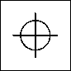
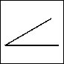
1,60mm
(0.063in)
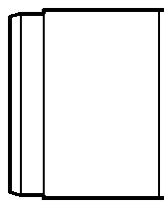
0,20mm
(0.008in) DIA.
X
Z
6 DEGREES
57 MINUTES
dia. A
(3 PLACES)
(BOTH FLANGES)
Z
Y
150 DEGREES
V
V
Y
192,000mm
(7.5591in)
DIA.
6,140mm (0.2417in)
MINIMUM WALL
THICKNESS
W
SEE FIG. 602
X
60 DEGREES
section Z-Z
A321-S-32-12-22-052-0
Repair to Sliding Tube
Figure 601
Repair No. 9-11
32
Page 603
⁻12⁻22 Dec 6/2019
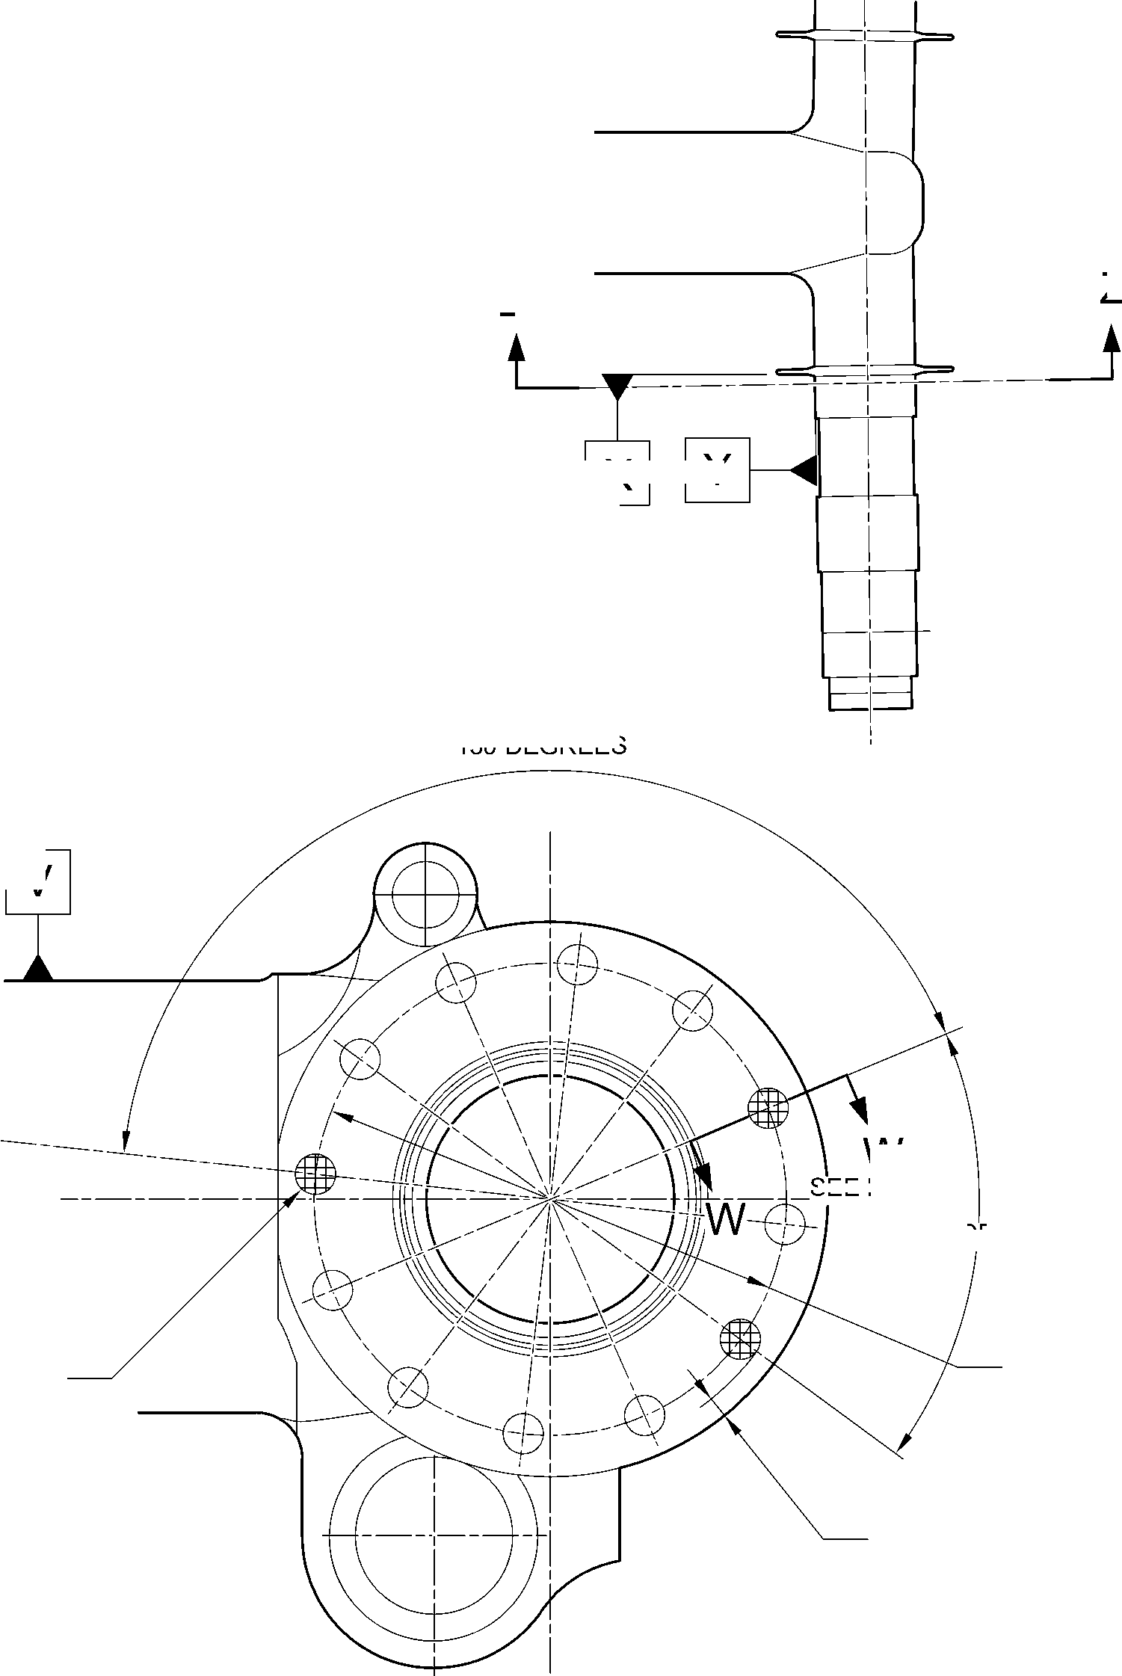

SAFRAN LANDING SYSTEMS UK Ltd
CAGE: K0654

PART No. 201587001 AND 201587002 COMPONENT MAINTENANCE MANUAL
MAIN LANDING GEAR LEG
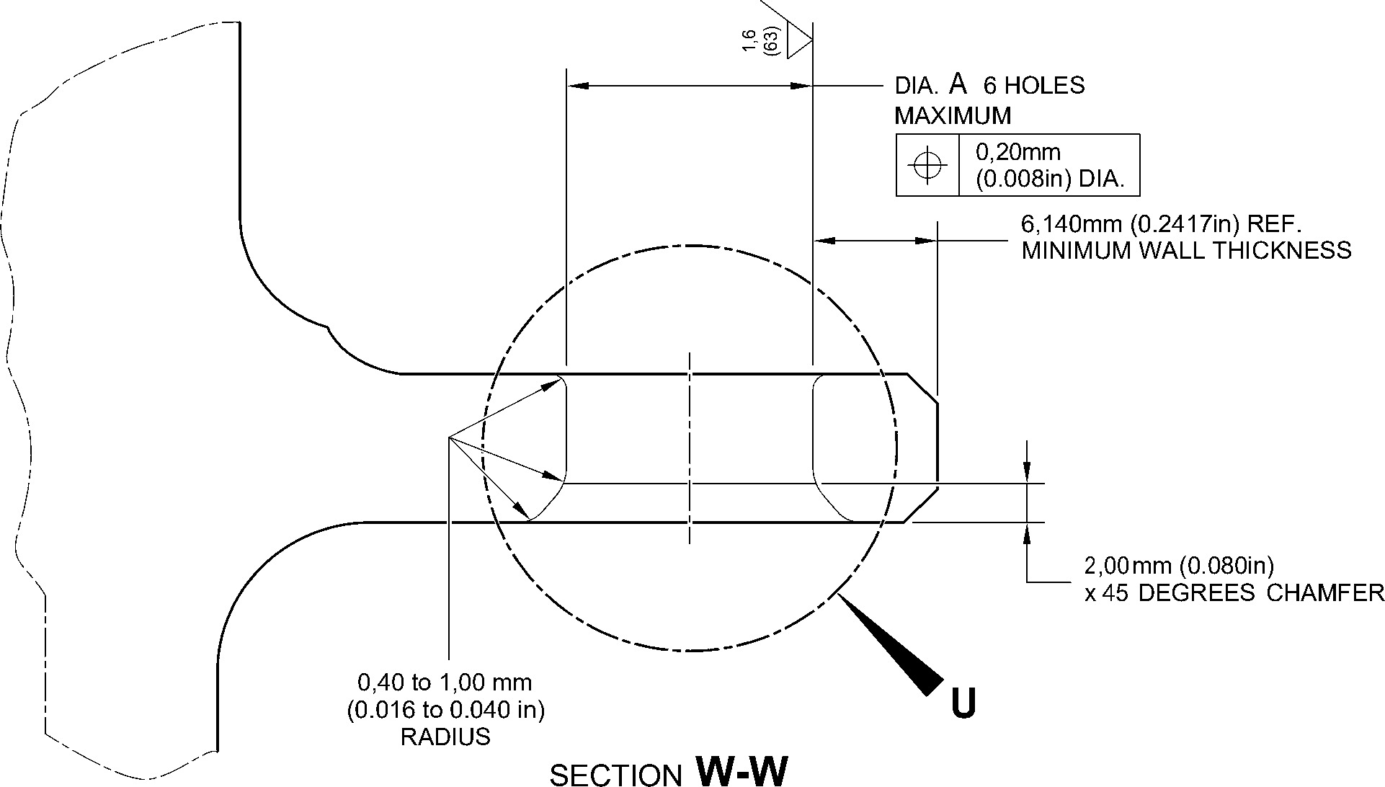
(WITHOUT BUSHES)
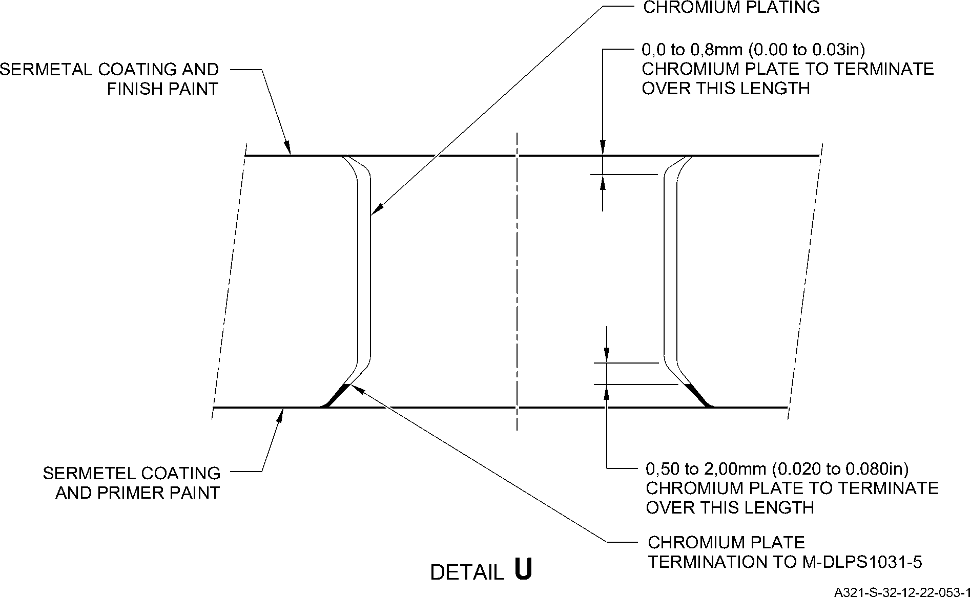
Repair to Sliding Tube - Machining
Figure 602
32-12-22
Page 604
Aug 11/2023
Repair No. 9-11

SAFRAN LANDING SYSTEMS UK Ltd
CAGE: K0654
PART No. 201587001 AND 201587002 COMPONENT MAINTENANCE MANUAL
MAIN LANDING GEAR LEG
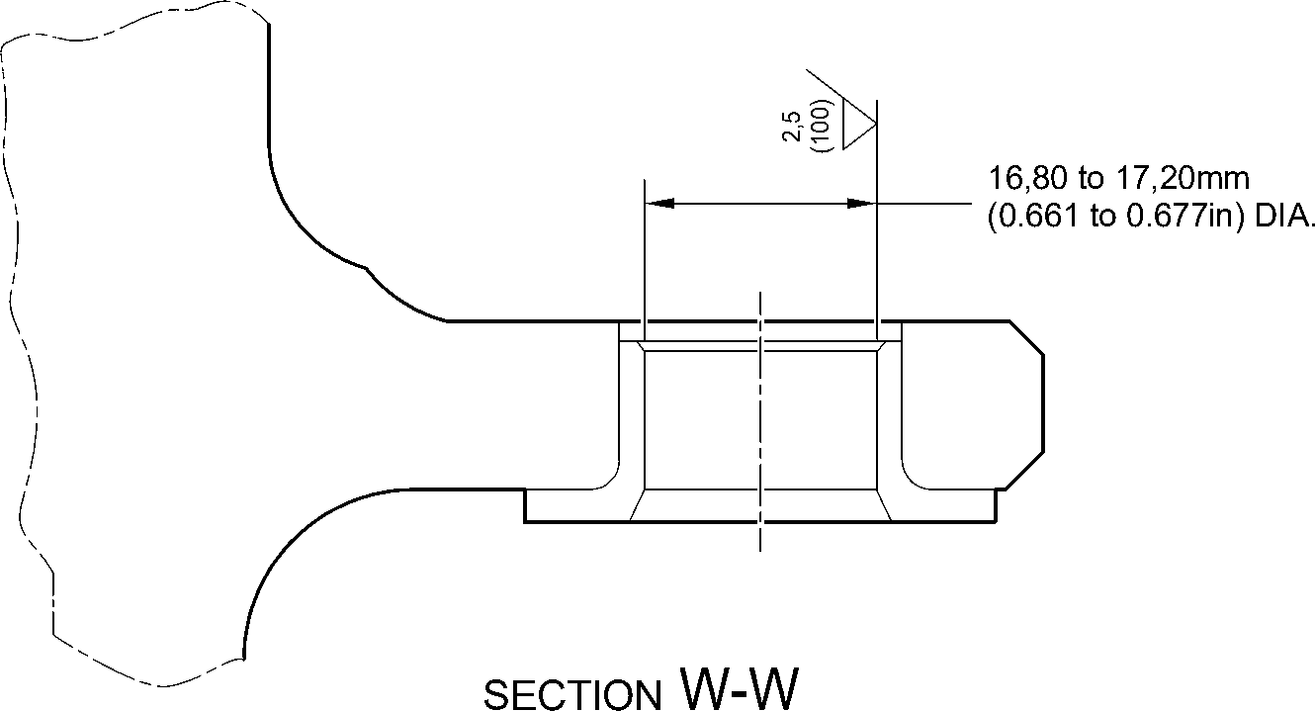
(WITH BUSHES)
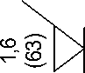
 | L | 0,015mm  (0.0006in) | S
face R
IVD COATING OPTIONAL IN END FACE
APPLY COAT OF ALUMINIUM (IVD)
IVD COATING OPTIONAL
28,75 to 29,25mm
(1.132 to 1.152in) DIA. REF.
APPLY COAT OF ALUMINIUM (IVD)
11,90 to 12,30mm
(0.469 to 0.484in)
2,00 to 2,05mm
(0.079 to 0.081in)
S
0,100mm
(0.0040in)
dia. B
APPLY COAT OF ALUMINIUM (IVD)
16,80 to 17,20mm
(0.661 to 0.677in) DIA. REF.
0,5mm (0.020in) x 60 DEGREES
INCLUSIVE CHAMFER
IVD COATING OPTIONAL
T
RADIUS 1,45 to 1,75mm
(0.057 to 0.069in)
APPLY COAT OF ALUMINIUM (IVD)
REPAIR BUSH 450266800
A321-S-32-12-22-054-1
Repair Bushes - Machining and Installation
Figure 603
Repair No. 9-11
Page 605
Mar 18/2025
32-12-22
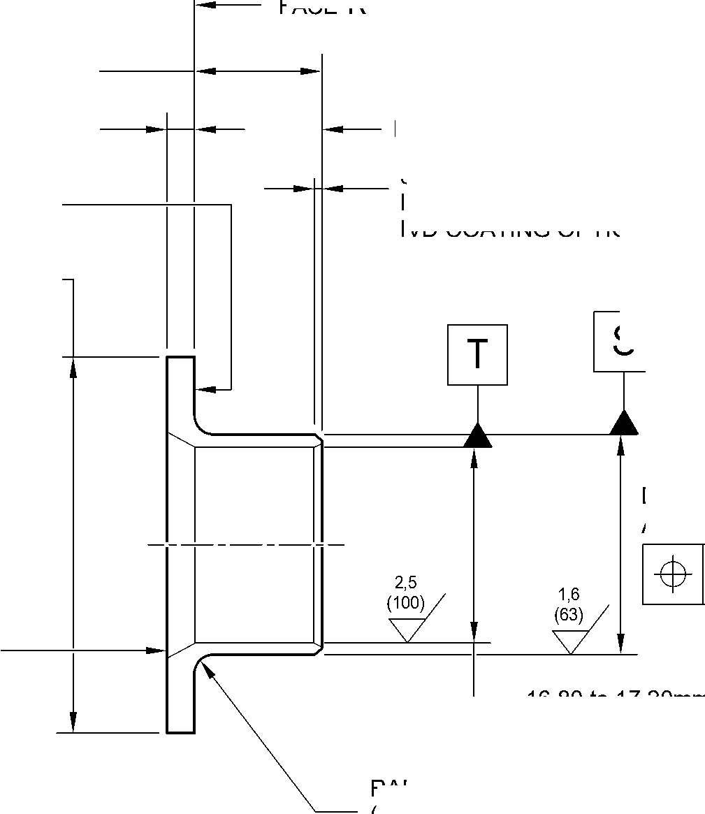

SAFRAN LANDING SYSTEMS UK Ltd
CAGE: K0654

PART No. 201587001 AND 201587002 COMPONENT MAINTENANCE MANUAL
MAIN LANDING GEAR LEG
INTENTIONALLY BLANK
Repair No. 9-11
32-12-22 ^{Page 606}

sSAFRAN SAFRAN LANDING SYSTEMS UK Ltd
CAGE: K0654
PART No. 201587001 AND 201587002 COMPONENT MAINTENANCE MANUAL
MAIN LANDING GEAR LEG
- Repair No. 10-1 Pin (9-70)
- Specified Damage and Material Specification.
- Specified Damage
(a) Damage or corrosion to diameter A.
- Material Specification
IPL Figure and  Item No. | Name | Material Specification
9-70 | Pin | UHT Steel, MTL1201
- Special Tools
- Special tools are not necessary.
- Materials
- Materials are not necessary.
- Repair Parts
- Repair parts are not necessary.
- Procedure (Refer to Figure 601)
- Remove the chromium plate from diameter A: refer to PCS-2110.
- If the base metal is not damaged or corroded:
- Examine the pin for flaws: refer to PCS-3600 and PCS-3100, inclusion
class 4.
- Apply chromium plate to diameter A: refer to PCS-2110, type C: refer
to Figure 601.
- Grind diameter A to between 30,950 and 30,975 mm (1.2185 and 1.2194 in).
The surface finish must be 0,8 micrometers (31 micro-inches).
- Examine the ground chromium plate for flaws: refer to PCS-3100 and
PCS-3002.
- Apply cadmium plate to the areas that do not have chromium plate: refer to
PCS-2141.
- Identify the part with the Messier-Dowty Limited repair number 450266210A
adjacent to the part number: refer to PCS-6000-04, PCS-6000-06 and
PCS-6000-07.
- Examine the part to make sure that you have obeyed all the repair
instructions correctly.
Repair No. 10-1
Page 601
Dec 6/2019
32-12-22

sSAFRAN SAFRAN LANDING SYSTEMS UK Ltd
CAGE: K0654
PART No. 201587001 AND 201587002 COMPONENT MAINTENANCE MANUAL
MAIN LANDING GEAR LEG
- If the bare metal is damaged or corroded:
1 Refer to M-DLPS1004-4-1 and machine diameter A just sufficiently to remove
the damage or corrosion: the diameter must not be less than 30,365 mm
(1.1956 in). The surface finish must be 1,6 micrometers (63 micro-inches).
2 Examine the pin for flaws: refer to PCS-3600 and PCS-3100, inclusion
class 4.
- Shot peen the machined areas: refer to M-DLPS123.
- Apply chromium plate to diameter A: refer to PCS-2110, type C
and Figure 601.
5 Grind diameter A to between 30,950 and 30,975 mm (1.2185 and 1.2194 in).
The surface finish must be 0,8 micrometers (31 micro-inches).
- Examine the ground chromium plate for flaws: refer to PCS-3100 and
PCS-3002.
- Apply cadmium plate to the areas that do not have chromium plate: refer to
PCS-2141.
8 Identify the part with the Messier-Dowty Limited repair number 450266210B
adjacent to the part number: refer to PCS-6000-04, PCS-6000-06 and
PCS-6000-07.
- Examine the part to make sure that you have obeyed all the repair
instructions correctly.
32-12-22
Repair No. 10-1
Page 602
Dec 6/2019

SAFRAN LANDING SYSTEMS UK Ltd
CAGE: K0654

PART No. 201587001 AND 201587002 COMPONENT MAINTENANCE MANUAL
MAIN LANDING GEAR LEG
Z
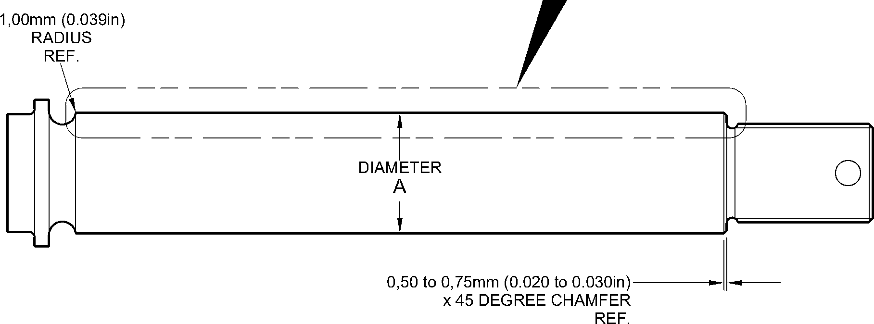
CHROMIUM PLATE
TERMINATION TO
CHROMIUM PLATE
TERMINATION TO
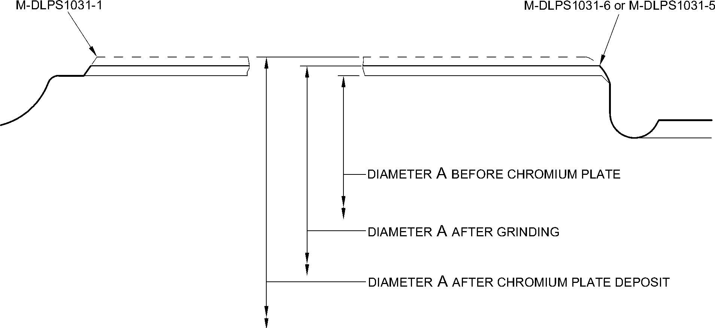
detail Z
A321A3760-1
Repair to Pin
Figure 601
Repair No. 10-1
Page 603
Dec 6/2019
32-12-22

SAFRAN LANDING SYSTEMS UK Ltd
CAGE: K0654

PART No. 201587001 AND 201587002 COMPONENT MAINTENANCE MANUAL
MAIN LANDING GEAR LEG
INTENTIONALLY BLANK
Repair No. 10-1
32-12-22 ^{Page 604}

sSAFRAN SAFRAN LANDING SYSTEMS UK Ltd
CAGE: K0654
PART No. 201587001 AND 201587002 COMPONENT MAINTENANCE MANUAL
MAIN LANDING GEAR LEG

I 1. Repair No. 11-1 Main Fitting (20-410, 20-410A, 20-420 and 20-420A)
- Specified Damage and Material Specification.
- Specified Damage
(a) Damage or wear to the diameter A and/or the adjacent face(s).
- Material Specification
IPL Figure and  Item No. | Name | Material Specification
20-410, 20-410A,  20-420 and  20-420A | Main fitting | Steel, MAT135, 35NCD16THQ
- Special Tools
- Special tools are not necessary.
- Materials
- These materials are necessary:
NOTE: Alternative equivalents are permitted.
Ref. Item | Material
TBA | Electrically conducting Mastinox to M-DLPS709-14
09-510A | Sealant
- Repair Parts
- These repair parts are necessary:
Part No. | Repair Part | Material Specification
450266061 | Blank bushes | Aluminium Bronze, DTD197
- Procedure (Refer to Figures 601 and 602)
- Machine the diameter A sufficiently only to remove the damage or wear: refer to
M-DLPS1004-4-1. The machined diameter A must not be more than 26,921 mm (1.0599
in). The surface finish must be 1,6 micrometers (63 micro-inches). Remove the sharp
edge at the intersection of the lubrication hole with a 0,50 to 2,00 mm (0.020 to 0.079 in)
radius.
- Machine the adjacent face(s) sufficiently only to remove the damage or wear: refer to
M-DLPS1004-4-1. Do not remove more than 1,00 mm (0.039 in) from each face. The
surface finish must be 1,6 micrometers (63 micro-inches).
- Machine the chamfers and radii to the dimensions shown in Figure 601.
- Examine the machined areas for flaws: refer to PCS-3600 and PCS-3100, inclusion
class 4.
Repair No. 11-1
Page 601
Mar 18/2025
32-12-22

sSAFRAN SAFRAN LANDING SYSTEMS UK Ltd
CAGE: K0654
PART No. 201587001 AND 201587002 COMPONENT MAINTENANCE MANUAL
MAIN LANDING GEAR LEG
- Measure and make a record of the new diameter A and the dimensions B and E.
- Shot peen the machined areas: refer to M-DLPS123.
- Apply cadmium plate to the machined areas: refer to PCS-2141.
- Identify the part with the Safran Landing Systems repair number 450266060 adjacent to
the part number: refer to PCS-6000-04, an alternative reference is PCS-6000-06. If the
alternative reference is used, the characters must be 0,051 to 0,102 mm (0.0020 to
0.0040 in) deep and approximately 3,00 mm (0.118 in) high.
- Calculate the diameters F and the dimensions D of the oversize bushes:
F = A (as measured) + 0,007 to 0,041 mm (0.0003 to 0.0016 in)
D (for Bush 1) = B (as measured) - 2,50 to - 2,55 mm (- 0.098 to - 0.100 in)
D (for Bush 2) = 45,733 to 45,820 mm (1.8005 to 1.8039 in) - E (as measured).
- Machine the blank bushes to the dimensions shown and calculated: the surface finish
must be 1,6 micrometers (63 micro-inches). Identify each oversize bush for reference.
- Apply cadmium plate to the oversize bushes, but not on the internal diameter and where
shown: refer to Figure 602 and PCS-2101 or PCS-2141 but do not de-embrittle. The
thickness of the cadmium plate must be between 0,010 and 0,015 mm (0.0004 and
0.0006 in).
- Install the oversize bushes to their correct locations: refer to M-DLPS1011-20 and use
the electrically conducting Mastinox to M-DLPS709-14. Primer paint the gap between
the internal ends of the oversize bushes and keep it free from sealant.
- Check line ream the oversize bushes to the dimension shown in Figure 602.
- Apply sealant, Material Ref. Item 09-510A, around the flanges of the oversize bushes:
refer to PCS-7200.
- Identify the part with the Safran Landing Systems repair number 450266060 adjacent to
the part number: refer to PCS-6000-07.
- Examine the part to make sure that you have obeyed all the repair instructions correctly.
32-12-22
Repair No. 11-1
Page 602
Mar 18/2025

SAFRAN LANDING SYSTEMS UK Ltd
CAGE: K0654
PART No. 201587001 AND 201587002 COMPONENT MAINTENANCE MANUAL
MAIN LANDING GEAR LEG
656,085mm
(25.8301in)
23,50 to 24,50mm
(0.925 to 0.965in)
PLANE PASSES
THROUGH
POINT
3,00 to 4,00mm
(0.118 to 0.157in) RADIUS
TYPICAL AROUND LUG
point C
Z
POINT C
Y
view on arrow Z
dimenSiOn E
35,90mm (1.413in) MINIMUM
diameter A
20 DEGREES
4 MINUTES
27 SECONDS
0,25 to 0,75mm
(0.010 to 0.030in)
x 45 DEGREE CHAMFER
SMOOTH TO RADIUS.
2 PLACES
section Y-Y
WITHOUT BUSHES
dimenSiOn B
6,50mm (0.256in)
MAXIMUM
(REFERENCE)
4 DEGREES 57 MINUTES
31 SECONDS
(REFERENCE)
dimension B
6,50mm (0.256in)
MAXIMUM
A321A4812-1
Repair to Main Fitting
Figure 601
Repair No. 11-1
Page 603
Dec 6/2019
32-12-22
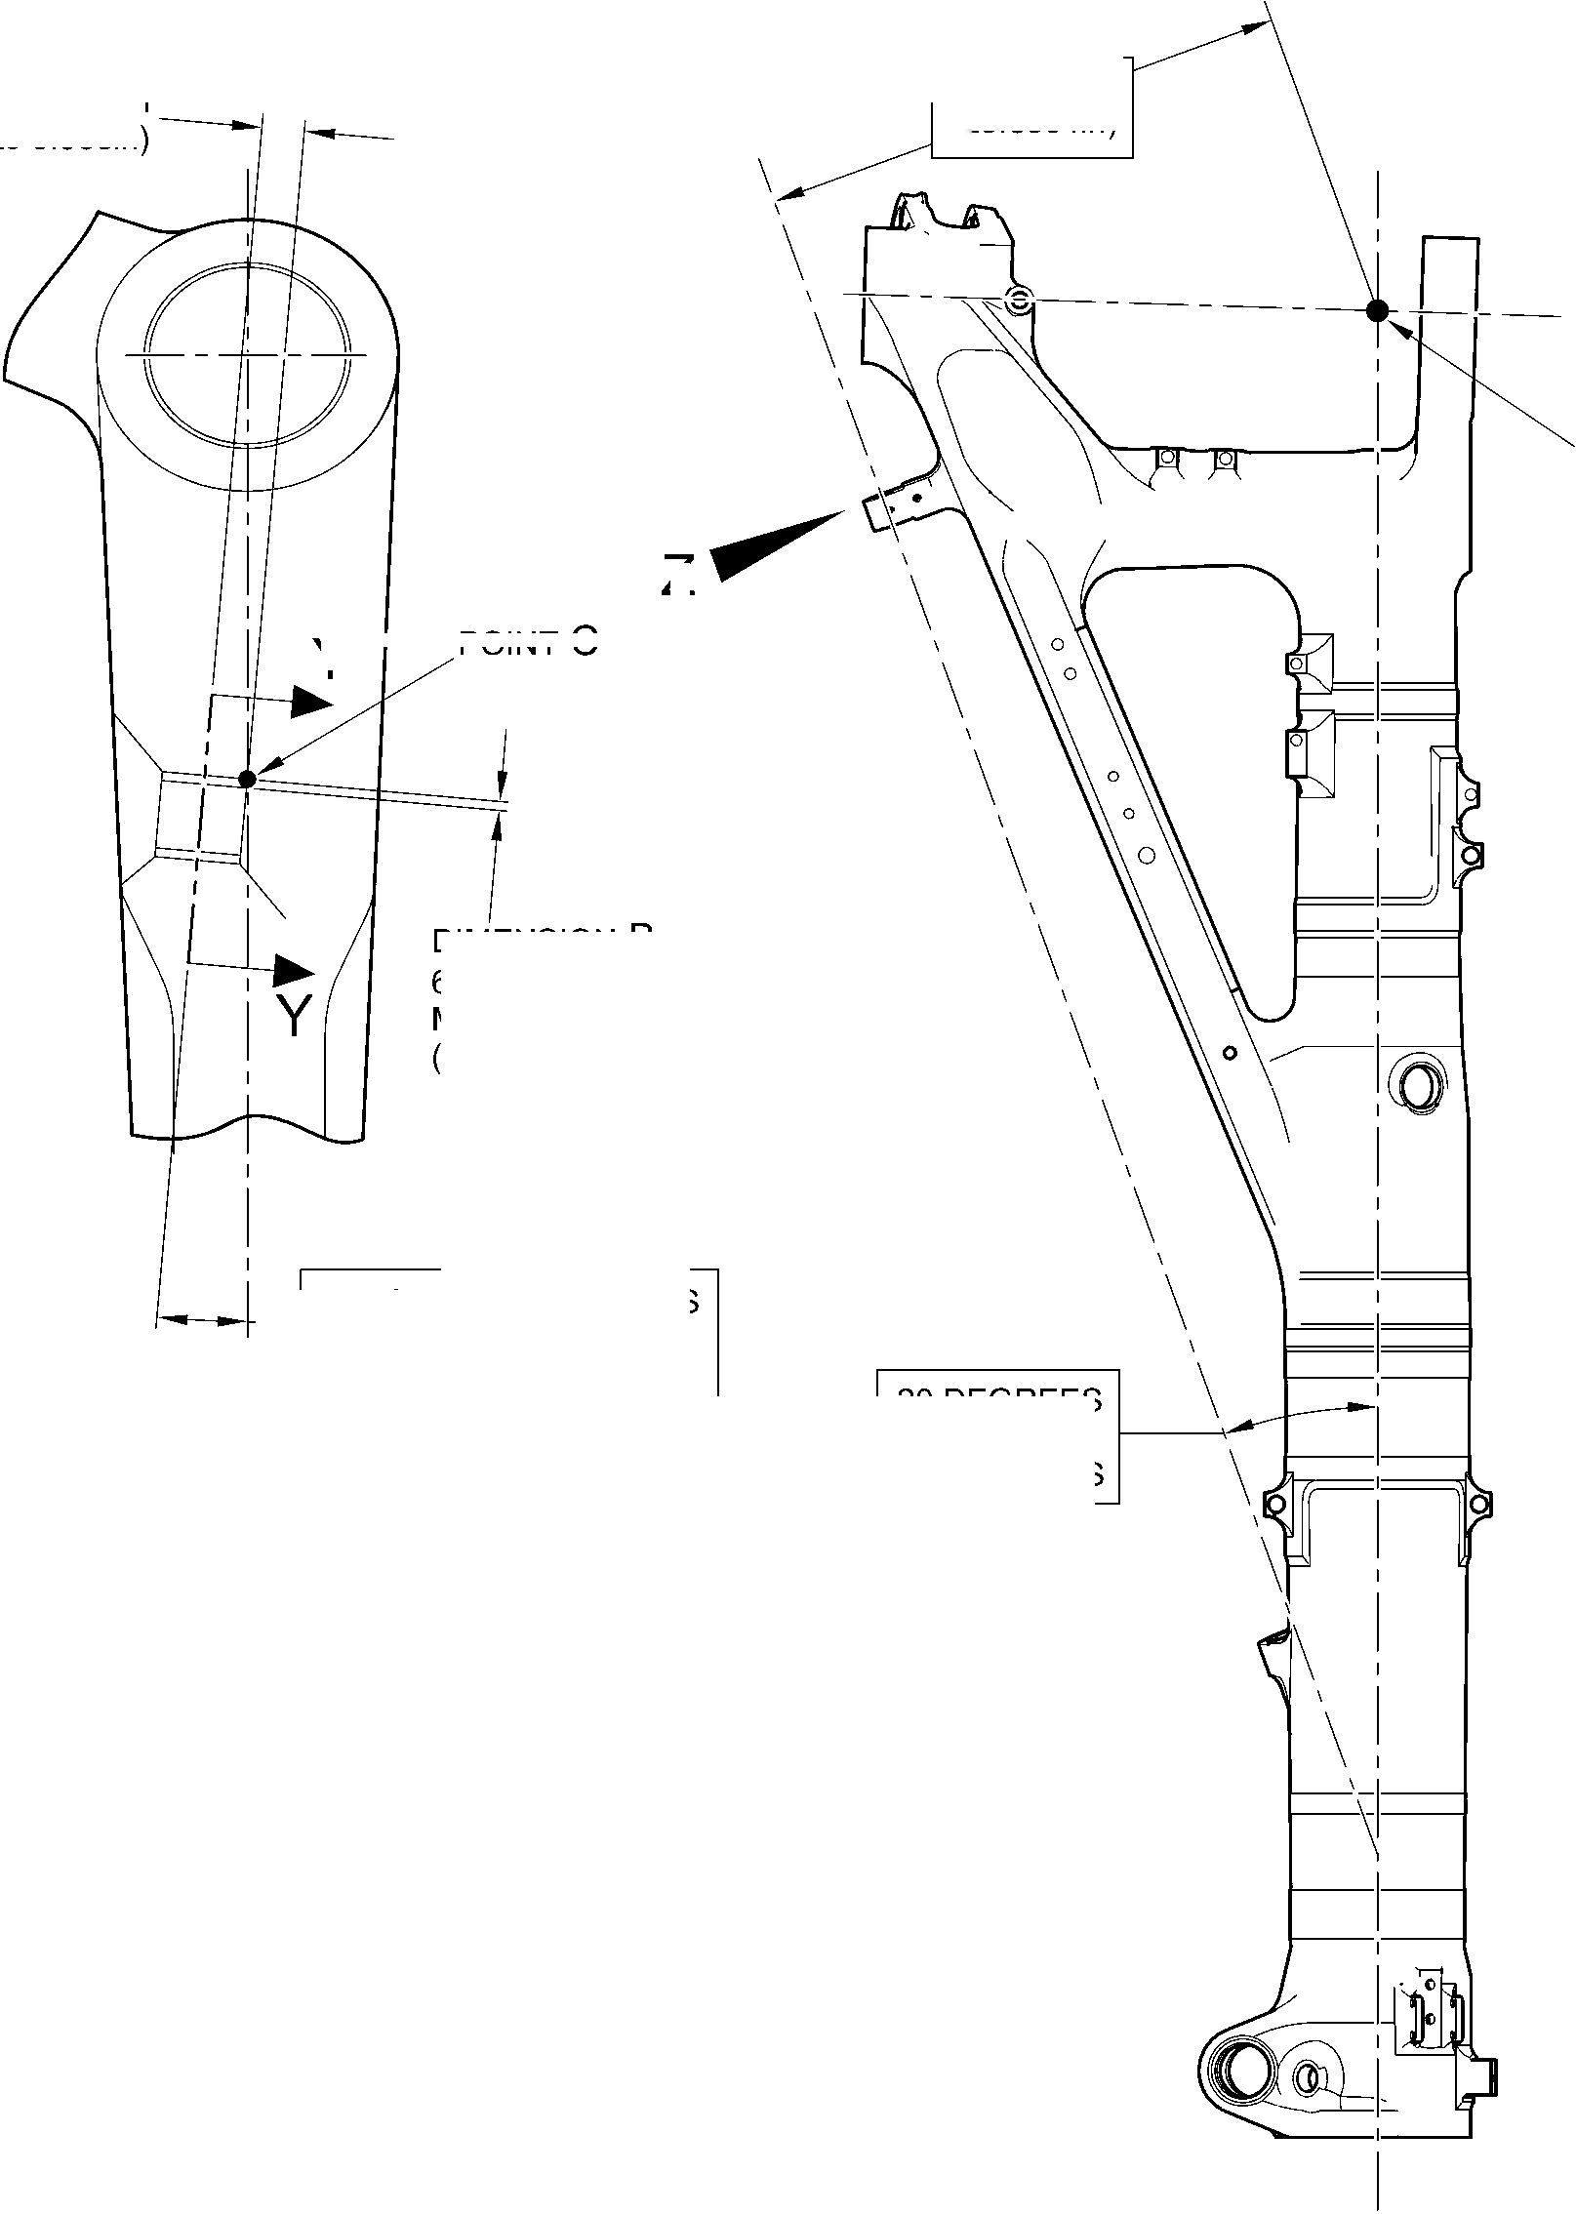
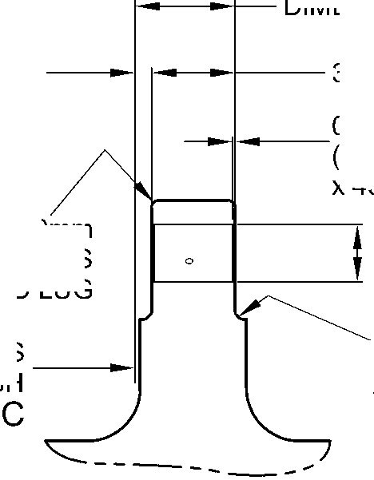

SAFRAN LANDING SYSTEMS UK Ltd
CAGE: K0654

PART No. 201587001 AND 201587002 COMPONENT MAINTENANCE MANUAL
MAIN LANDING GEAR LEG
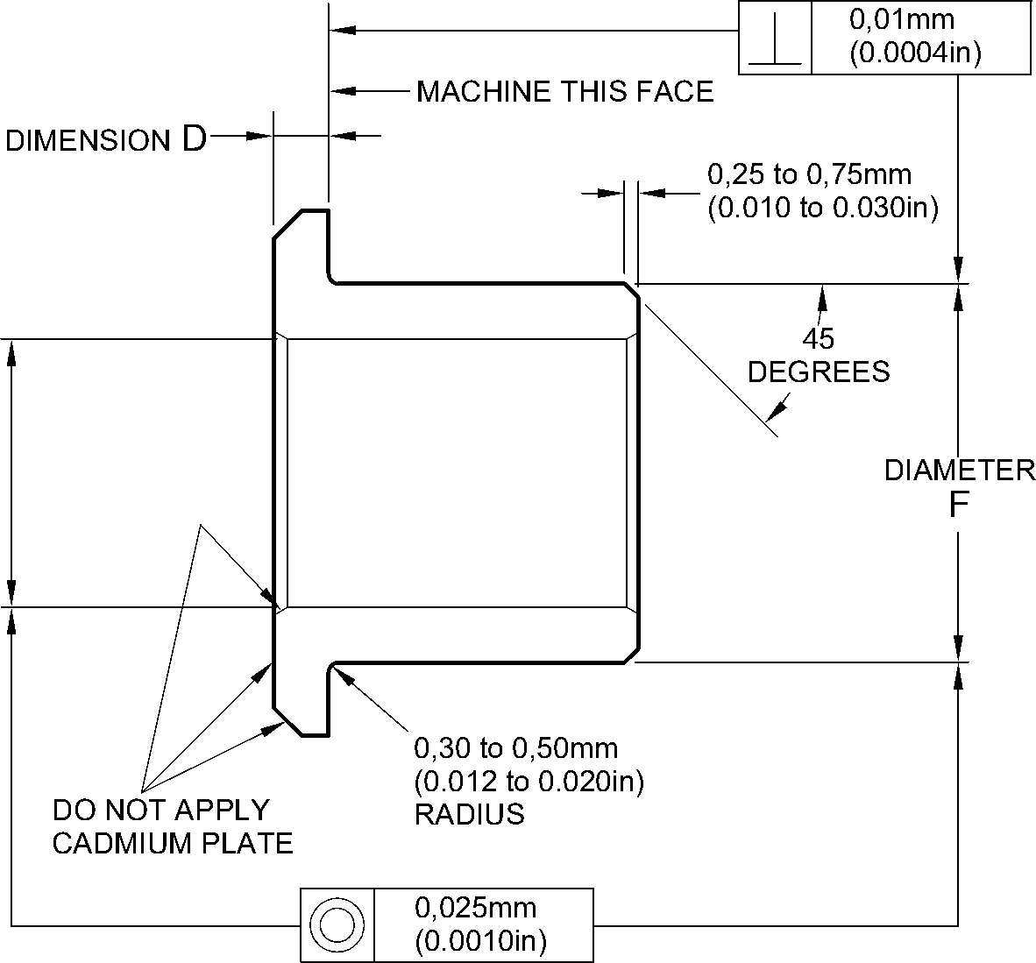
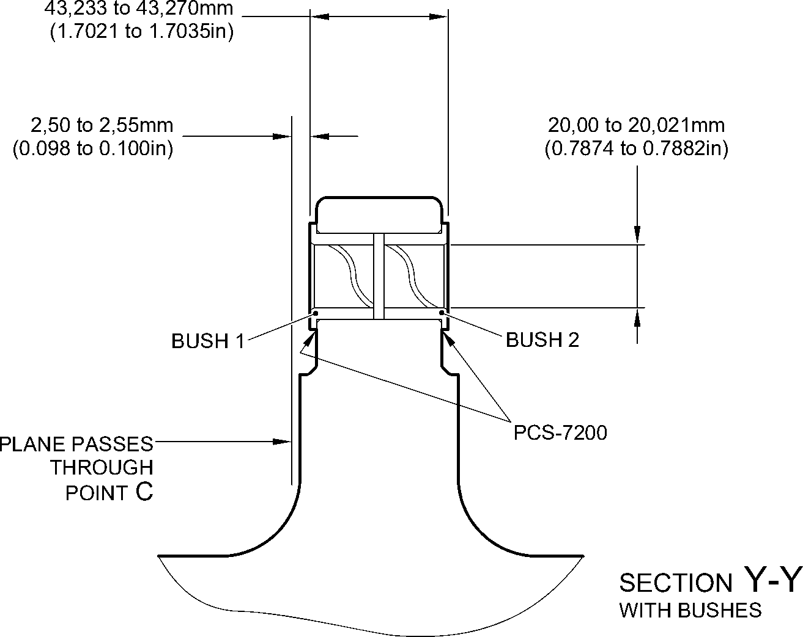
A321A4813-1
Oversize Bushes - Machining and Installation
Figure 602
32-12-22
Repair No. 11-1
Page 604
Dec 6/2019

SAFRAN LANDING SYSTEMS UK Ltd
CAGE: K0654

PART No. 201587001 AND 201587002 COMPONENT MAINTENANCE MANUAL
MAIN LANDING GEAR LEG

I 1. Repair No. 11-2 Main Fitting (20-410, 20-410A, 20-420 and 20-420A)
- Specified Damage and Material Specification.
- Specified Damage
(a) Damage or corrosion to the diameter(s) A.
- Material Specification
IPL Figure and  Item No. | Name | Material Specification
20-410, 20-410A,  20-420 and  20-420A | Main fitting | Steel, MAT135, 35NCD16THQ
- Special Tools
(1) These special tools are necessary:
NOTE: Alternative equivalents are permitted.
Part No. | Special Tool | Function
460007257 | Press Pad | Install the oversize bush(es)
- Materials
- These materials are necessary:
NOTE: Alternative equivalents are permitted.
Ref. Item | Material
TBA | Electrically conducting Mastinox to M-DLPS709-14
09-510A | Sealant
- Repair Parts
- These repair parts are necessary:
Part No. | Repair Part | Material Specification
450258808 | Blank bush | Aluminium Bronze, BSB23 or  AMS4640
E. Procedure (Refer to Figures 601 and 602)
- Machine the diameter(s) A sufficiently to remove the damage or corrosion: refer to
M-DLPS1004-4-1 and to Figure 601 for the dimensions. The surface finish must be
1,6 micrometers (63 micro-inches).
- Examine the part for flaws: refer to PCS-3600 and PCS-3100, inclusion class 4.
- Measure and make a record of the new diameter A.
(4)
Shot peen the machined areas: refer to M-DLPS123.
32-12-22
Repair No. 11-2
Page 601
Mar 18/2025

sSAFRAN SAFRAN LANDING SYSTEMS UK Ltd
CAGE: K0654
PART No. 201587001 AND 201587002 COMPONENT MAINTENANCE MANUAL
MAIN LANDING GEAR LEG
- Apply cadmium plate to the machined areas: refer to PCS-2141.
- Identify the part with the Safran Landing Systems repair number 450266070 adjacent to
the part number: refer to PCS-6000-04, an alternative reference is PCS-6000-06. If the
alternative reference is used, the characters must be 0,051 to 0,102 mm (0.0020 to
0.0040 in) deep and approximately 3,00 mm (0.118 in) high.
- Calculate the diameter D of the oversize bush(es):
D = A (as measured) - 0,009 to + 0,029 mm (- 0.0003 to + 0.0012 in).
- Machine the oversize bush(es) from the blank bush(es) to the dimensions shown and
calculated: the surface finish must be 1,6 micrometers (63 micro-inches).
- Apply cadmium plate to the oversize bush(es). The thickness of the cadmium plate must
be between 0,010 and 0,015 mm (0.0004 and 0.0006 in): refer to PCS-2101 or
PCS-2141 and do not de-embrittle.
- Use the Press Pad 460007257 to install the oversize bush(es): refer to M-DLPS1011-20
and use the electrically conducting Mastinox to M-DLPS709-14, Material Ref Item TBA.
- Check the internal diameter(s) of the installed oversize bush(es) to the dimension shown
in Figure 602.
- Apply sealant, Material Ref. Item 09-510A, around the flanges of the oversize bush(es):
refer to PCS-7200.
- Identify the part with the Safran Landing Systems repair number 450266070 adjacent to
the part number: refer to PCS-6000-07.
- Examine the part to make sure that you have obeyed all the repair instructions correctly.
32-12-22
Repair No. 11-2
Page 602
Mar 18/2025

SAFRAN LANDING SYSTEMS UK Ltd
CAGE: K0654

PART No. 201587001 AND 201587002 COMPONENT MAINTENANCE MANUAL
MAIN LANDING GEAR LEG
412,50 to 413,50mm
(16.240 to 16.280in)
36,86mm
(1.451in)
point C
Z
15,54mm
(0.612in)
section Z-Z
WITHOUT BUSHES
0,80 to 1,20mm
(0.032 to 0.047in)
TYPICAL BOTH BORES
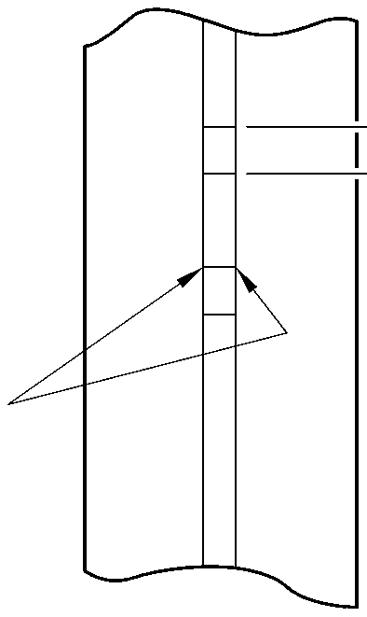
g—0
Z
diameter A
15,727mm (0.6192in)
MAXIMUM
TYPICAL BOTH BORES
Repair to Main Fitting
Figure 601
396,37 to 397,37mm
(15.605 to 15.644in)
A321A4810-1
Repair No. 11-2
Page 603
Dec 6/2019
32-12-22
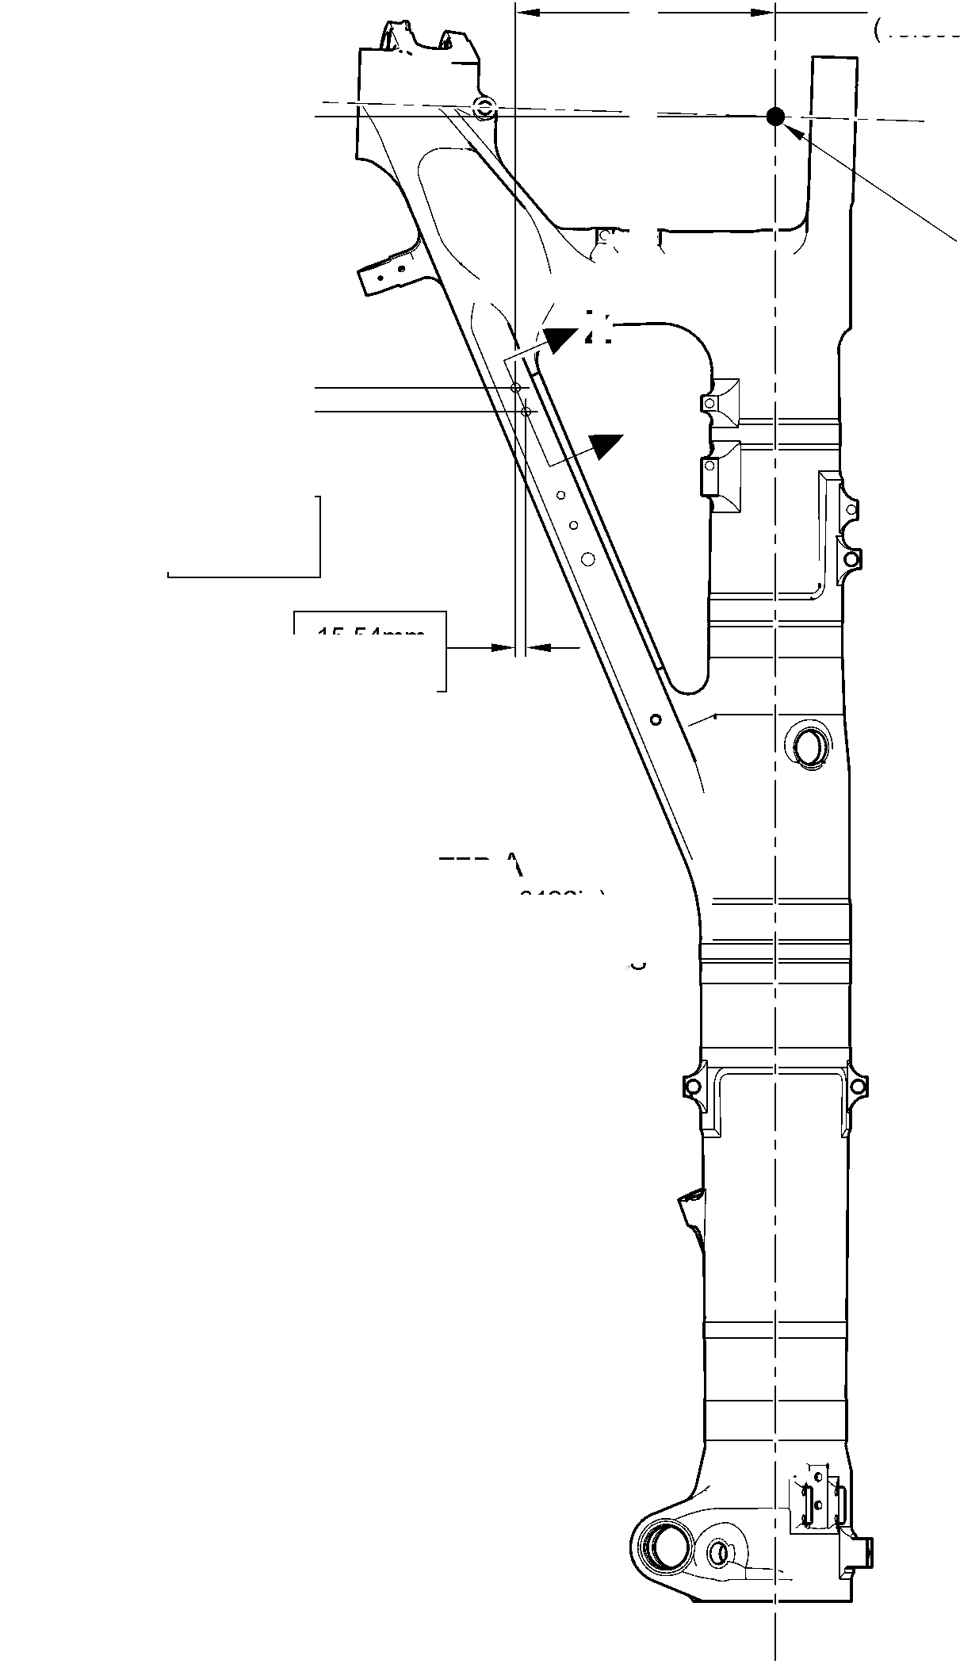

SAFRAN LANDING SYSTEMS UK Ltd
CAGE: K0654

PART No. 201587001 AND 201587002 COMPONENT MAINTENANCE MANUAL
MAIN LANDING GEAR LEG
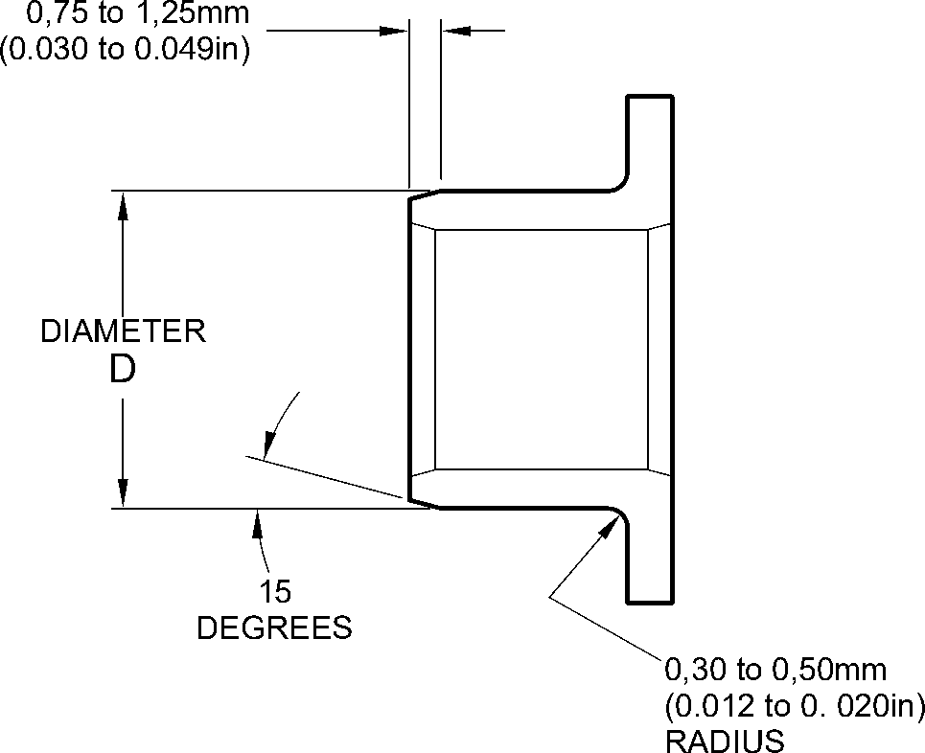
REPAIR BUSH 450258808
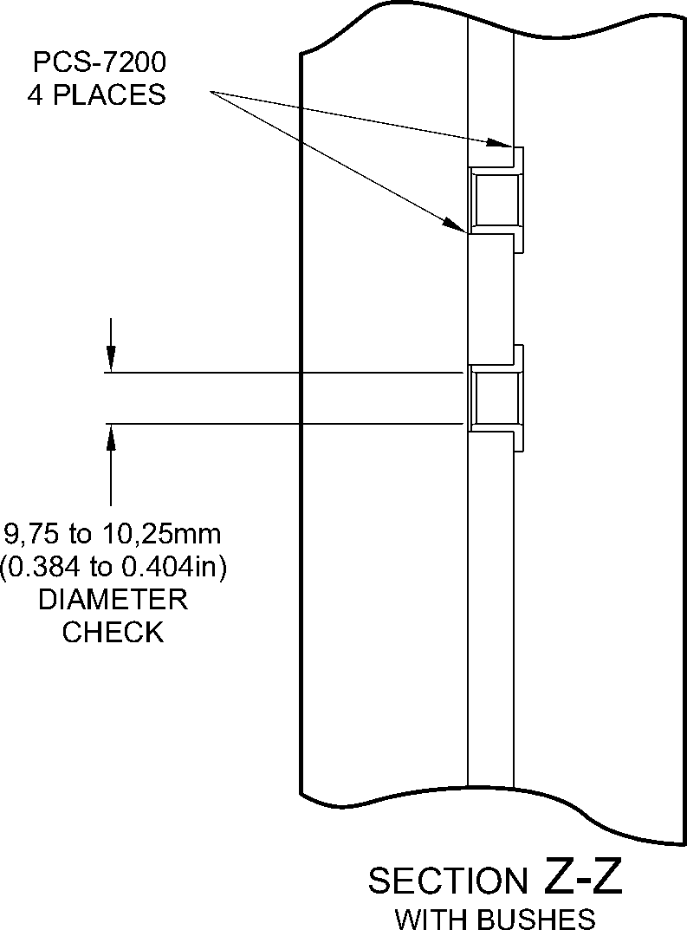
A321A4811-1
Oversize Bush(es) - Machining and Installation
Figure 602
Repair No. 11-2
32
Page 604
Dec 6/2019

sSAFRAN SAFRAN LANDING SYSTEMS UK Ltd
CAGE: K0654
PART No. 201587001 AND 201587002 COMPONENT MAINTENANCE MANUAL
MAIN LANDING GEAR LEG

I 1. Repair No. 11-3 Main Fitting (20-410, 20-410A, 20-420 and 20-420A)
- Specified Damage and Material Specification.
- Specified Damage
(a) Damage or corrosion to the diameter A and/or faces B and C (Refer to Figure 601).
- Material Specification
IPL Figure and  Item No. | Name | Material Specification
20-410, 20-410A,  20-420 and  20-420A | Main fitting | Steel, MAT135, 35NCD16THQ
- Special Tools
(1) These special tools are necessary:
Part No. | Special Tool | Function
460004330/259 | Press Pad | Install the repair bush 450258811
460004330/260 | Press Pad | Install the repair bush 450258812
- Materials
(1) These materials are necessary:
NOTE: Alternative equivalents are permitted.
Ref. Item | Material
09-510A | Sealant: refer to PCS-7200
TBA | Electrically conducting zinc loaded Mastinox D40: refer to  M-DLPS709-14
- Repair Parts
(1) These repair parts are necessary:
Part No. | Repair Part | Material Specification
450258811 | Repair bush | Aluminium bronze AMS4590 or  AMS4881 centrifugally cast
450258812 | Repair bush | Aluminium bronze AMS4590 or  AMS4881 centrifugally cast
Repair No. 11-3
Page 601
Mar 18/2025
32-12-22

sSAFRAN SAFRAN LANDING SYSTEMS UK Ltd
CAGE: K0654
PART No. 201587001 AND 201587002 COMPONENT MAINTENANCE MANUAL
MAIN LANDING GEAR LEG
- Procedure (Refer to Figures 601, 602 and 603)
- Machine the diameter A, sufficiently only to remove the damage or corrosion: refer to
M-DLPS1004-4-1. Diameter A must not be more than 77,13 mm (3.037 in). The
minimum wall dimension F must not be less than 17,385 mm (0.6844 in). The minimum
wall dimension G must not be less than 11,935 mm (0.4699 in). The surface finish must
be 1,6 micrometers (63 micro-inches): refer to Figure 602.
- Measure and make a record of the new diameter A.
- Measure and make a record of the dimension D1.
- Machine the face B, sufficiently only to remove the damage or corrosion: refer to
M-DLPS1004-4-1. Do not remove more than 1,00 mm (0.039 in) of material from the
face B. The surface finish must be 1,6 micrometers (63 micro-inches).
- Measure and make a record of the dimension D2.
- Measure and make a record of the dimension E.
- Machine the face C, sufficiently only to remove the damage or corrosion: refer to
M-DLPS1004-4-1. Do not remove more than 1,00 mm (0.039 in) of material from the
face C. The surface finish must be 1,6 micrometers (63 micro-inches). Dimension E
must not be less than 128,00 mm (5.039 in).
- Measure and make a record of the new dimension E. Calculate the amount of material,
K, removed from the face C, as follows:
(a) K = Dimension E (as measured in para (6)) - Dimension E (as measured in
para (8)).
- Machine the chamfers and radii as shown: refer to Figure 602.
- Examine the bare metal for flaws: refer to PCS-3600 and PCS-3100, inclusion class 4.
- Shot peen the machined area: refer to M-DLPS123.
- Apply cadmium plate to the machined area: refer to PCS-2141.
- Identify the part with the Safran Landing Systems repair number 450266020 adjacent to
the part number: refer to PCS-6000-04, an alternative reference is PCS-6000-06. If the
alternative reference is used, the characters must be 0,051 to 0,102 mm (0.0020 to
0.0040 in) deep and approximately 3,00 mm (0.118 in) high.
- Prepare the repair bush 450258812 for installation: refer to Figure 603:
- Machine diameter H of the repair bush to the diameter from this formula:
H = A (as measured in para (2)) + 0,029 to 0,078 mm (+ 0.0012 to 0.0030 in)
The surface finish must be 1,6 micrometers (63 micro-inches).
- Machine face L to get the dimension J from this formula:
J = 12,5 mm (0.492 in) - K (as measured in para (8) (a))
The surface finish must be 1,6 micrometers (63 micro-inches).
- Apply cadmium plate to the repair bush, but not in the bore and internal grooves:
refer to PCS-2101. The cadmium plate thickness must be between 0,010 and
0,015 mm (0.0004 and 0.0006 in).
32-12-22
Repair No. 11-3
Page 602
Mar 18/2025

sSAFRAN SAFRAN LANDING SYSTEMS UK Ltd
CAGE: K0654
PART No. 201587001 AND 201587002 COMPONENT MAINTENANCE MANUAL
MAIN LANDING GEAR LEG
- Prepare the repair bush 450258811 for installation: refer to Figure 603:
- Machine diameter M of the repair bush to the diameter from this formula:
M = A (as measured in para (2)) + 0,029 to 0,078 mm (0.0012 to +0.0030 in)
The surface finish must be 1,6 micrometers (63 micro-inches).
- Machine face N to get the dimension P from this formula:
P = 25,25 mm (0.994 in) - (D1 + D2) (as measured in para (3) and (5))
The surface finish must be 1,6 micrometers (63 micro-inches).
- Apply cadmium plate to the repair bush, but not in the bore and internal grooves:
refer to PCS-2101. The cadmium plate thickness must be between 0,010 and
0,015 mm (0.0004 and 0.0006 in).
- Use jointing compound, electrically conducting zinc loaded Mastinox D40, Material Ref.
Item, TBA and the Press Pad 460004330/259 to install the repair bush 450258811. Use
jointing compound, electrically conducting zinc loaded Mastinox D40, Material Ref. Item,
TBA and the Press Pad 460004330/260 to install the repair bush 450258812. Refer to
M-DLPS709-14, M-DLPS1011-20 and Figure 603.
- Machine the flange face Q of the repair bush 450258812 to get a dimension R of
between 137,917 and 137,957 mm (5.4298 and 5.4314 in). Do not machine face S of
the repair bush 450258811. The surface finish must be 1,6 micrometers
(63 micro-inches).
- Check line ream the bores of the repair bushes to between 70,00 and 70,03 mm
(2.756 and 2.757 in).
- Apply sealant, Material Ref. Item 09-510A, between the repair bushes and the main
fitting: refer to PCS-7200: refer to Figure 603.
- Identify the part with the Safran Landing Systems repair number 450266020 adjacent to
the part number: refer to PCS-6000-07.
- Examine the part to make sure that you have obeyed all the repair instructions correctly.
Repair No. 11-3
Page 603
Mar 18/2025
32-12-22

SAFRAN LANDING SYSTEMS UK Ltd
CAGE: K0654

PART No. 201587001 AND 201587002 COMPONENT MAINTENANCE MANUAL
MAIN LANDING GEAR LEG
153,194mm
(6.0313in)
REFERENCE
Z
point D
detail Y
Z
(REFER TO FIGURE 602)
100,616mm (3.9613in)
REFERENCE
Y
A321A5064-1
Repair to Main Fitting
Figure 601
32-12-22
Repair No. 11-3
Page 604
Dec 6/2019
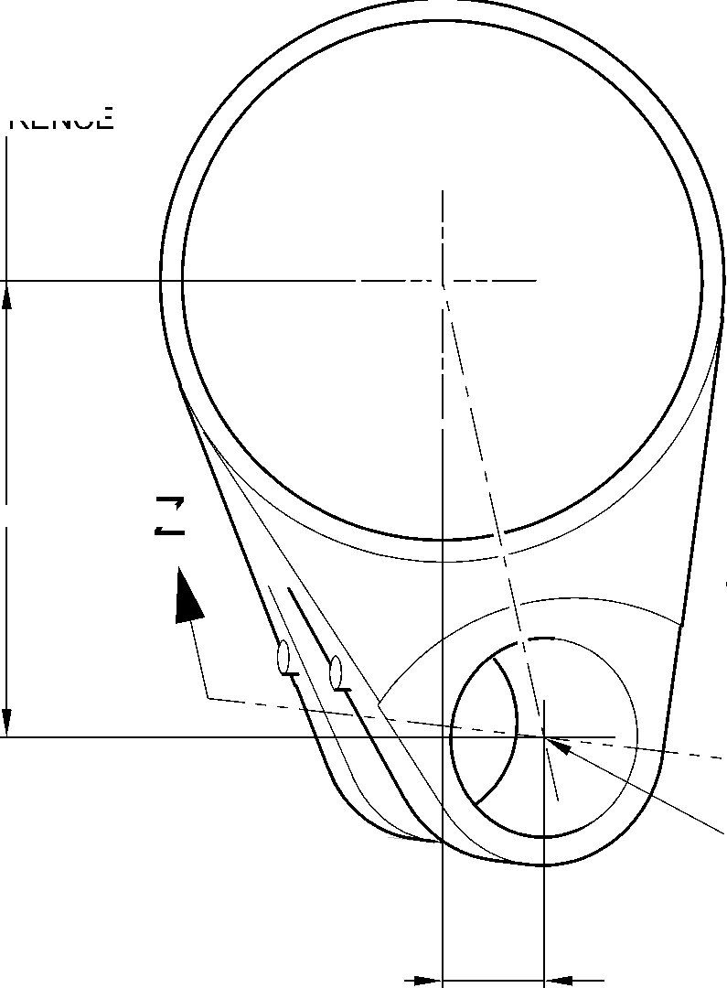
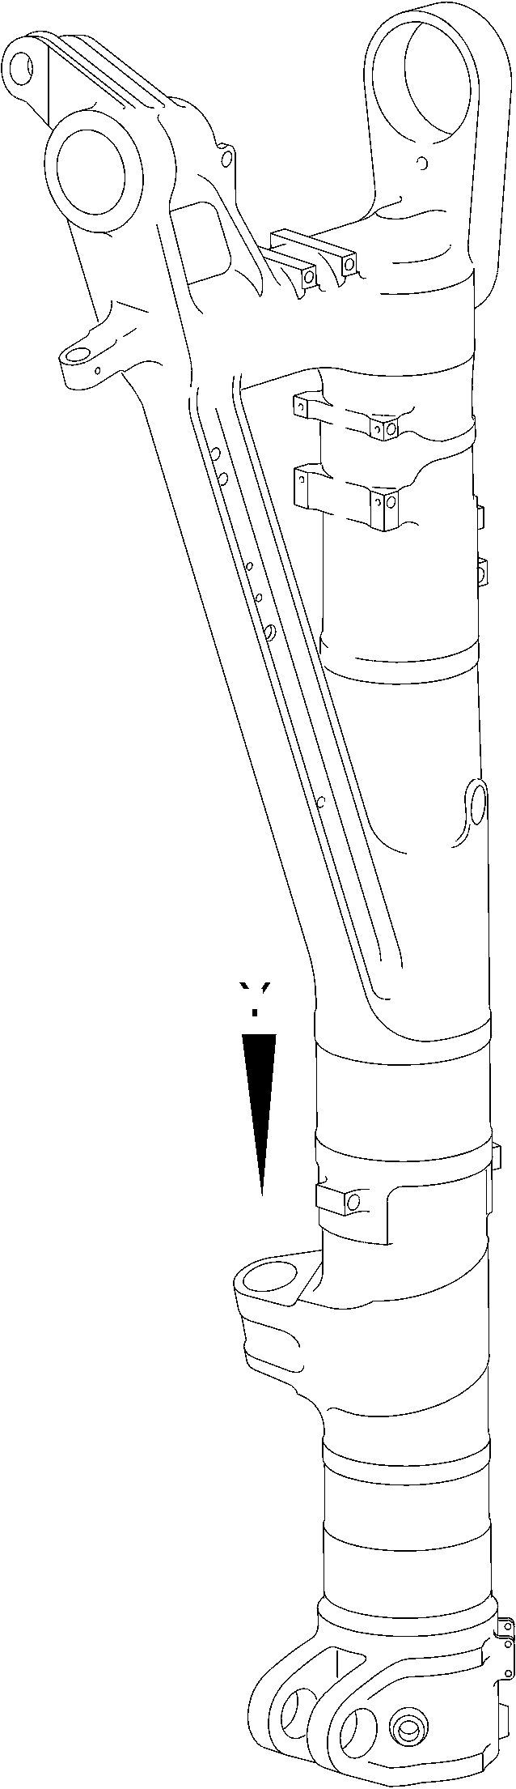

SAFRAN LANDING SYSTEMS UK Ltd
CAGE: K0654
PART No. 201587001 AND 201587002 COMPONENT MAINTENANCE MANUAL
MAIN LANDING GEAR LEG
D1 before machining
D2 after machining
2,00 to 4,00mm
(0.079 to 0.157in)
RADIUS ALL AROUND AT
ENTRY OF LUBRICATION
bore into diameter A.
(2 PLACES)
V
diameter A
20.653
DEGREES
X
face C
0,05mm
(0.002in)
4,00 to 5,00mm
(0.157 to 0.197in)
CORNER RADIUS
^{(2 PLACES)} 1,25 to 1,75mm
(0.049 to 0.069in)
x 45 DEGREE CHAMFER
(2 PLACES)
W
face B

0,05mm
(0.002in)
X
X
51,00 to 52,00mm
(2.008 to 2.047in)
OVER RADIUS.
100,00mm (3.937in)
RADIUS MINIMUM
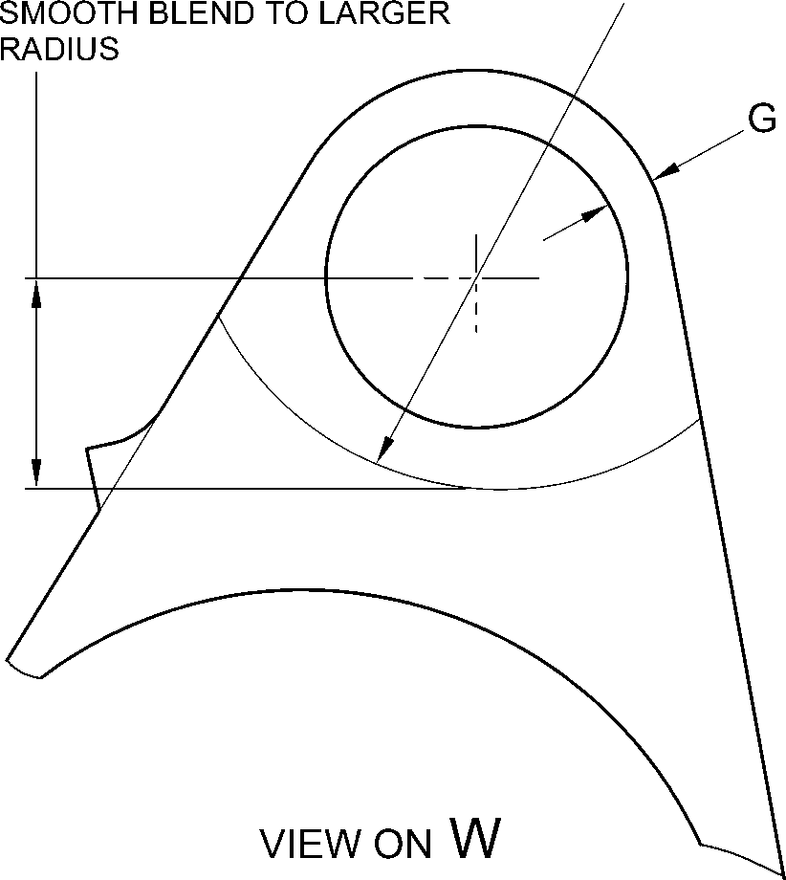
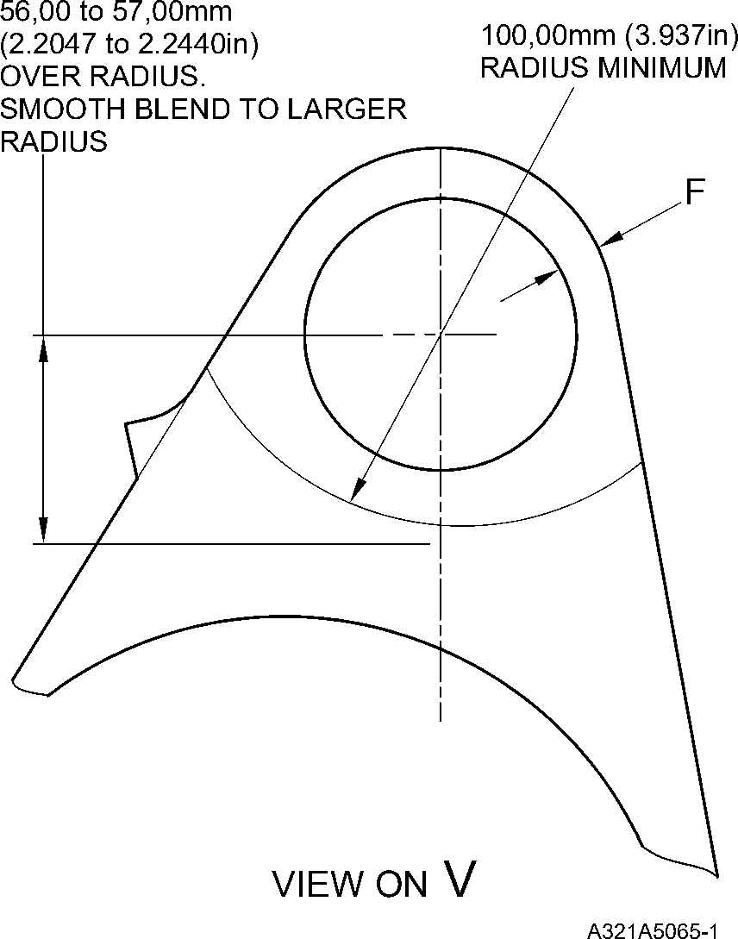
Repair to Main Fitting
Figure 602
Repair No. 11-3
Page 605
Dec 6/2019
32-12-22
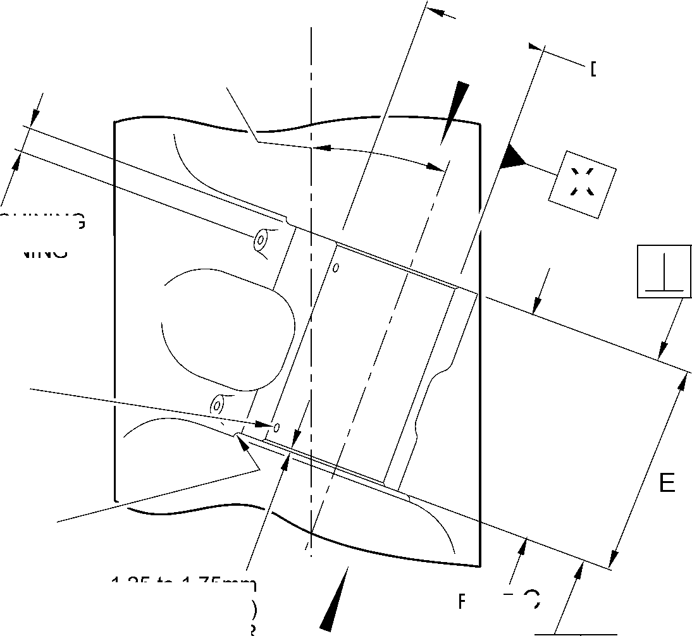

SAFRAN LANDING SYSTEMS UK Ltd
CAGE: K0654

PART No. 201587001 AND 201587002 COMPONENT MAINTENANCE MANUAL
MAIN LANDING GEAR LEG
SEALANT TO PCS-7200
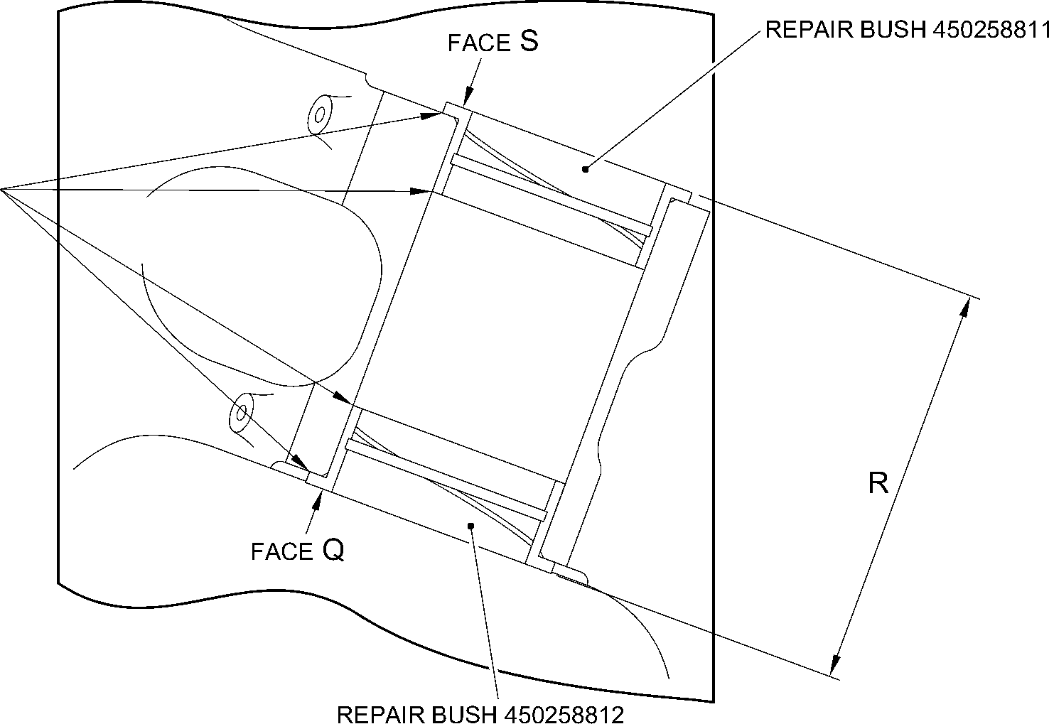
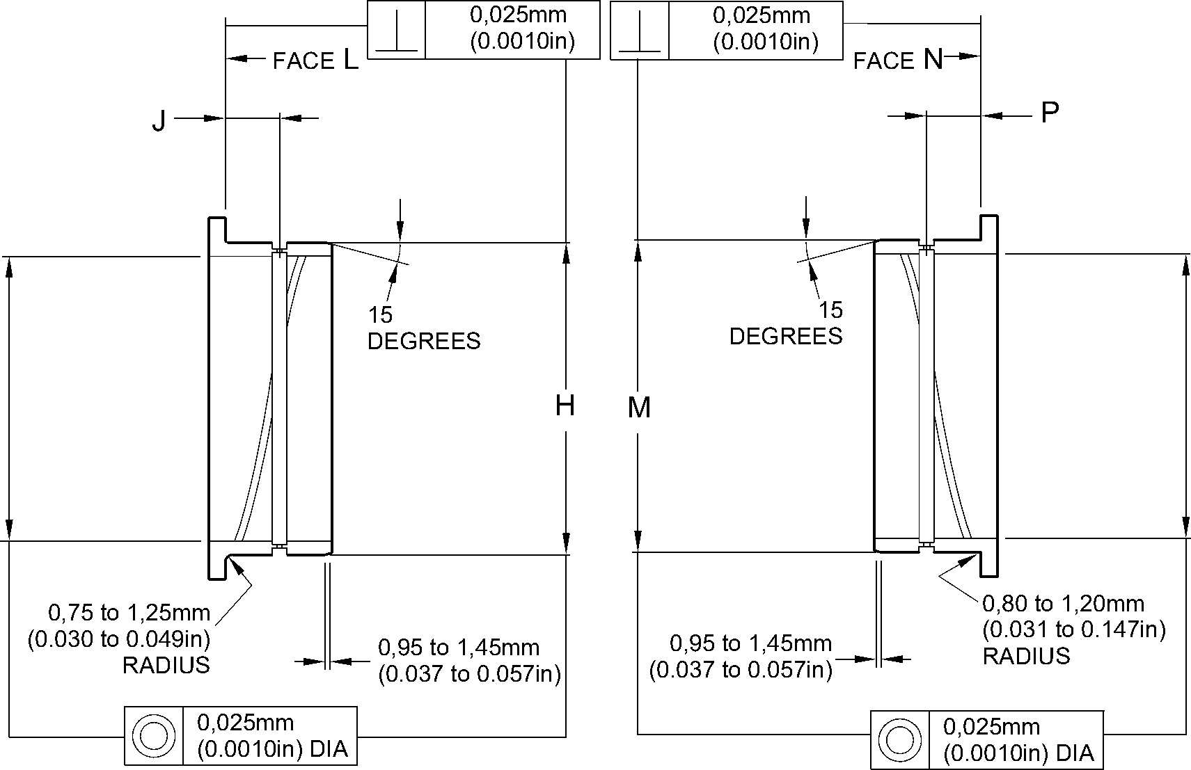
REPAIR BUSH 450258812 MACHINING
REPAIR BUSH 450258811 MACHINING
A321A5066-1
Repair to Main Fitting - Repair Bush Machining and Installation
Figure 603
32-12-22
Repair No. 11-3
Page 606
Dec 6/2019

SAFRAN LANDING SYSTEMS UK Ltd
CAGE: K0654

PART No. 201587001 AND 201587002 COMPONENT MAINTENANCE MANUAL
MAIN LANDING GEAR LEG

I 1. Repair No. 11-4 Main Fitting (20-410, 20-410A, 20-420 and 20-420A)
- Specified Damage and Material Specification.
- Specified Damage
(a) Damage or corrosion to diameter(s) A (Refer to Figure 601).
- Material Specification
IPL Figure and  Item No. | Name | Material Specification
20-410, 20-410A,  20-420 and  20-420A | Main fitting | Steel, MAT135, 35NCD16THQ
- Special Tools
(1) These special tools are necessary:
NOTE: Alternative equivalents are permitted.
Part No. | Special Tool | Function
460004330/110 | Press Pad | Install the repair bush 450237819
- Materials
(1) These materials are necessary:
NOTE: Alternative equivalents are permitted.
Ref. Item | Material
TBA | Electrically conducting Mastinox D40: refer to  M-DLPS709-14
09-510A | Sealant: refer to PCS-7200
- Repair Parts
(1) These repair parts are necessary:
Part No. | Repair Part | Material Specification
450237819 | Blank bush | Aluminium Bronze, DTD197
E. Procedure (Refer to Figures 601 and 602)
- Machine the diameter(s) A, sufficiently only to remove the damage or corrosion, do not
make diameter A larger than 13,727 mm (0.5404 in): refer to M-DLPS1004-4-1. The
surface finish must be 1,6 micrometers (63 micro-inches).
- Measure and record the new diameter(s) A.
- Examine the bare metal for flaws: refer to PCS-3600 and PCS-3100, inclusion class 4.
(4)
Shot peen the machined area(s): refer to M-DLPS123.
Repair No. 11-4
Page 601
Mar 18/2025
32-12-22

sSAFRAN SAFRAN LANDING SYSTEMS UK Ltd
CAGE: K0654
PART No. 201587001 AND 201587002 COMPONENT MAINTENANCE MANUAL
MAIN LANDING GEAR LEG
- Apply cadmium plate to the machined area(s): refer to PCS-2141.
- Identify the part with the Safran Landing Systems repair number 450266075 adjacent to
the part number: refer to PCS-6000-04, an alternative reference is PCS-6000-06. If the
alternative reference is used, the characters must be 0,051 to 0,102 mm (0.0020 to
0.0040 in) deep and approximately 3,00 mm (0.118 in) high.
- Calculate diameter B of the repair bush(es):
B = A (as measured) + 0,009 to 0,029 mm (0.0003 to 0.0011 in).
- Machine the repair bush to the dimensions shown and calculated with a surface finish of
1,6 micrometers (63 micro-inches): refer to Figure 602. Diameter B must make a smooth
joint with the adjacent corner radius.
- Apply cadmium plate to the repair bush: refer to PCS-2101. The cadmium plate
thickness must be between 0,010 and 0,015 mm (0.0004 and 0.0006 in).
- Install the repair bush(es): refer to M-DLPS1011-20. Use electrically conducting
Mastinox D40, Material Ref. Item. TBA: refer to M-DLPS709-14,.
- Apply sealant, Material Ref. Item 09-510A, between the repair bush and the main fitting:
refer to PCS-7200.
- Identify the part with the Safran Landing Systems repair number 450266075 adjacent to
the part number: refer to PCS-6000-07 and Figure 602.
- Examine the part to make sure that you have obeyed all the repair instructions correctly.
32-12-22
Repair No. 11-4
Page 602
Mar 18/2025

SAFRAN LANDING SYSTEMS UK Ltd
CAGE: K0654
PART No. 201587001 AND 201587002 COMPONENT MAINTENANCE MANUAL
MAIN LANDING GEAR LEG
point C I
327,22 to 328,22mm
(12.883 to 12.922in)
46,07mm
(1.814in)
CRS
Z
DIAMETER
19,425mm
(0.7648in)
CRS
576,50 to 577,50mm
(22.697 to 22.736in)
Z
DIAMETER
0,80 to 1,20mm
(0.032 to 0.047in)
RADIUS
TYPICAL
BOTH BORES
section Z-Z
MACHINING
A321A5058-1
Repair to Main Fitting
Figure 601
Repair No. 11-4
Page 603
Dec 6/2019
32-12-22
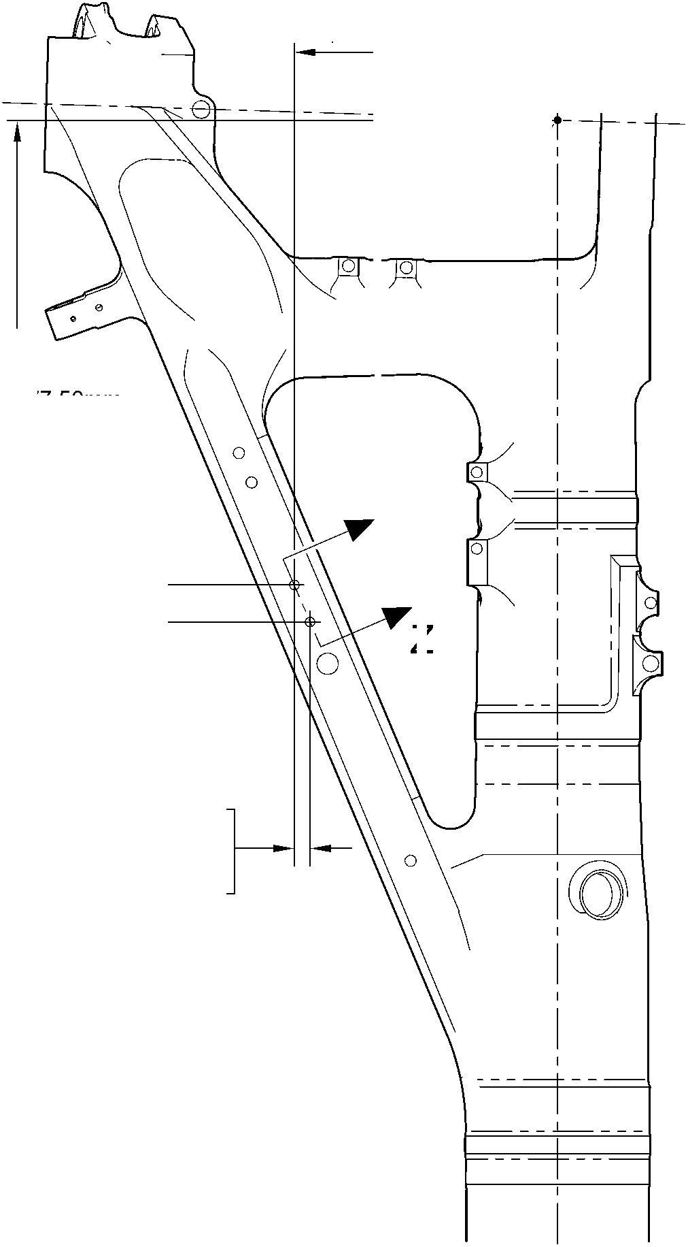
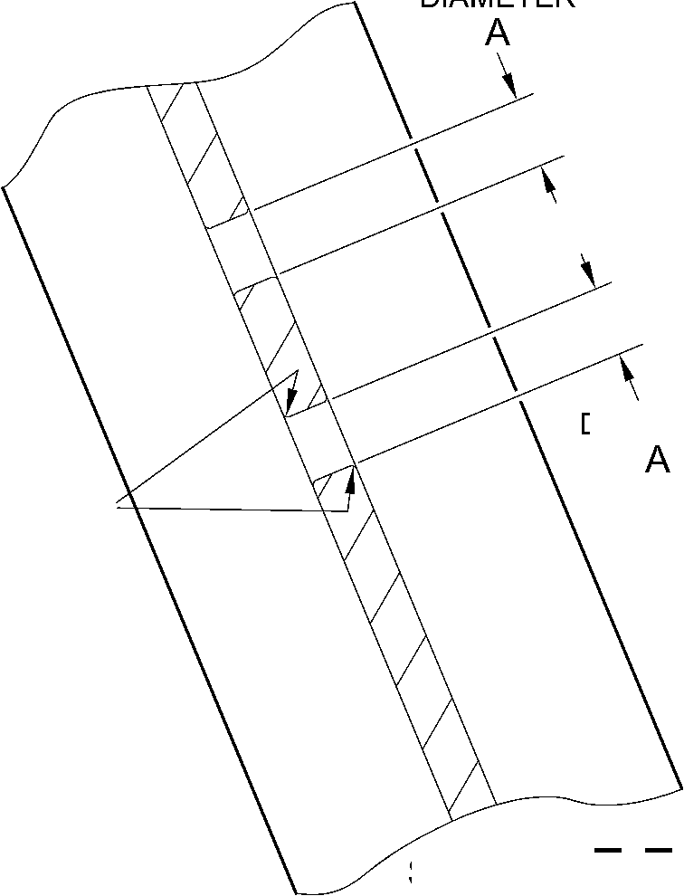

SAFRAN LANDING SYSTEMS UK Ltd
CAGE: K0654

PART No. 201587001 AND 201587002 COMPONENT MAINTENANCE MANUAL
MAIN LANDING GEAR LEG
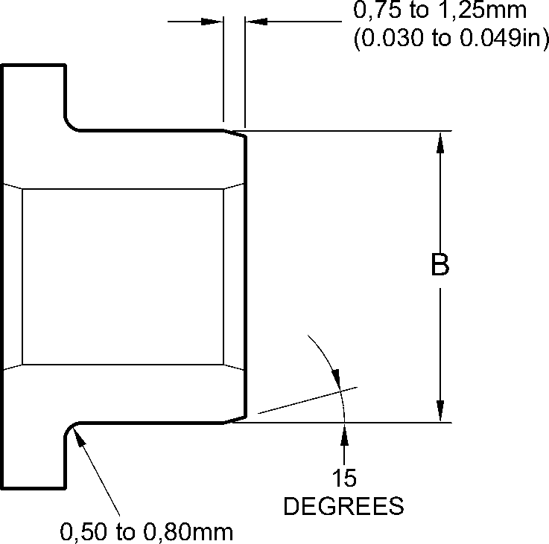
(0.020 to 0.032in) RAD.
REPAIR BUSH 450237819
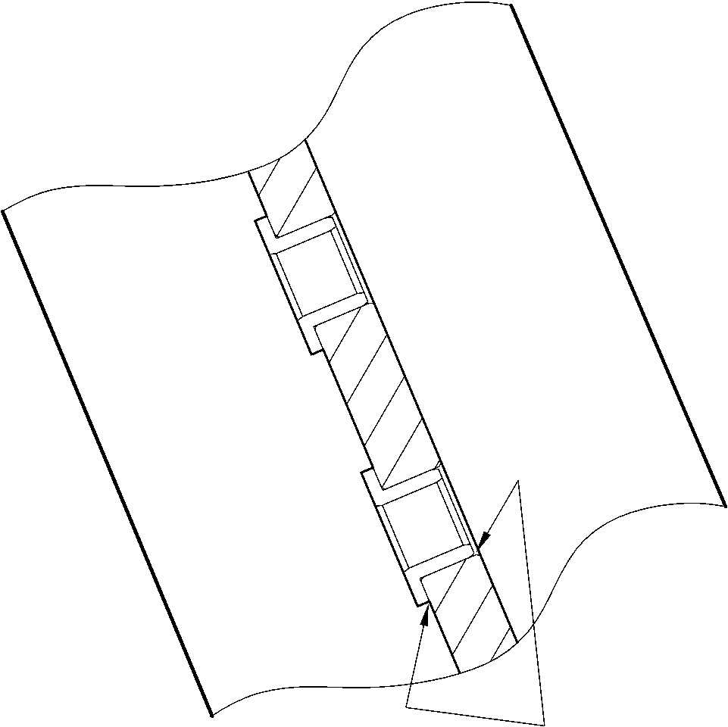
SEALANT TO
PCS 7200
4 PLACES
part section Z-Z
WITH REPAIR BUSHES
A321A5059-1
Repair Bush - Machining and Installation
Figure 602
32-12-22
Repair No. 11-4
Page 604
Dec 6/2019

SAFRAN LANDING SYSTEMS UK Ltd
CAGE: K0654

PART No. 201587001 AND 201587002 COMPONENT MAINTENANCE MANUAL
MAIN LANDING GEAR LEG

I 1. Repair No. 11-5 Main Fitting (20-410, 20-410A, 20-420 and 20-420A)
- Specified Damage and Material Specification.
- Specified Damage
(a) Damage or corrosion to diameter A (Refer to Figure 601).
- Material Specification
IPL Figure and  Item No. | Name | Material Specification
20-410, 20-410A,  20-420 and  20-420A | Main fitting | Steel, MAT135, 35NCD16THQ
- Special Tools
(1) These special tools are necessary:
NOTE: Alternative equivalents are permitted.
Part No. | Special Tool | Function
460006267 | Press Pad | Install the repair bearing 450266081
- Materials
- These materials are necessary:
NOTE: Alternative equivalents are permitted.
Ref. Item | Material
TBA | Electrically conducting Mastinox D40: refer to  M-DLPS709-14
09-510A | Sealant: refer to PCS-7200
- Repair Parts
- These repair parts are necessary:
Part No. | Repair Part | Material Specification
450266081 | Blank bearing | Aluminium Bronze, DTD197
E. Procedure (Refer to Figures 601 and 602)
- Machine the diameter A, sufficiently only to remove the damage or corrosion, do not
make diameter A larger than 21,933 mm (0.8635 in): refer to M-DLPS1004-4-1. The
surface finish must be 1,6 micrometers (63 micro-inches).
- Machine the radii as shown.
- Measure and record the new diameter A.
(4)
Examine the bare metal for flaws: refer to PCS-3600 and PCS-3100, inclusion class 4.
Repair No. 11-5
Page 601
Mar 18/2025
32-12-22

sSAFRAN SAFRAN LANDING SYSTEMS UK Ltd
CAGE: K0654
PART No. 201587001 AND 201587002 COMPONENT MAINTENANCE MANUAL
MAIN LANDING GEAR LEG
- Shot peen the machined area: refer to M-DLPS123.
- Apply cadmium plate to the machined area: refer to PCS-2141.
- Identify the part with the Safran Landing Systems repair number 450266080 adjacent to
the part number: refer to PCS-6000-04, an alternative reference is PCS-6000-06. If the
alternative reference is used, the characters must be 0,051 to 0,102 mm (0.0020 to
0.0040 in) deep and approximately 3,00 mm (0.118 in) high.
- Calculate diameter B of the repair bearing:
B = A (as measured) + 0,002 to 0,048 mm (0.0008 to 0.0019 in).
- Machine the repair bearing to the dimensions shown and calculated with a surface finish
of 1,6 micrometers (63 micro-inches): refer to Figure 602.
- Apply cadmium plate to the repair bearing: refer to PCS-2101. The cadmium plate
thickness must be between 0,010 and 0,015 mm (0.0004 and 0.0006 in).
- Install the repair bearing: refer to M-DLPS1011-20. Use electrically conducting Mastinox
D40, Material Ref. Item. TBA: refer to M-DLPS709-14.
- Check line ream the repair bearing to the dimension shown: refer to Figure 602.
- Apply sealant, Material Ref. Item 09-510A, between the repair bearing and the main
fitting: refer to PCS-7200 and Figure 602.
- Identify the part with the Safran Landing Systems repair number 450266080 adjacent to
the part number: refer to PCS-6000-07.
- Examine the part to make sure that you have obeyed all the repair instructions correctly.
32-12-22
Repair No. 11-5
Page 602
Mar 18/2025

SAFRAN LANDING SYSTEMS UK Ltd
CAGE: K0654

PART No. 201587001 AND 201587002 COMPONENT MAINTENANCE MANUAL
MAIN LANDING GEAR LEG
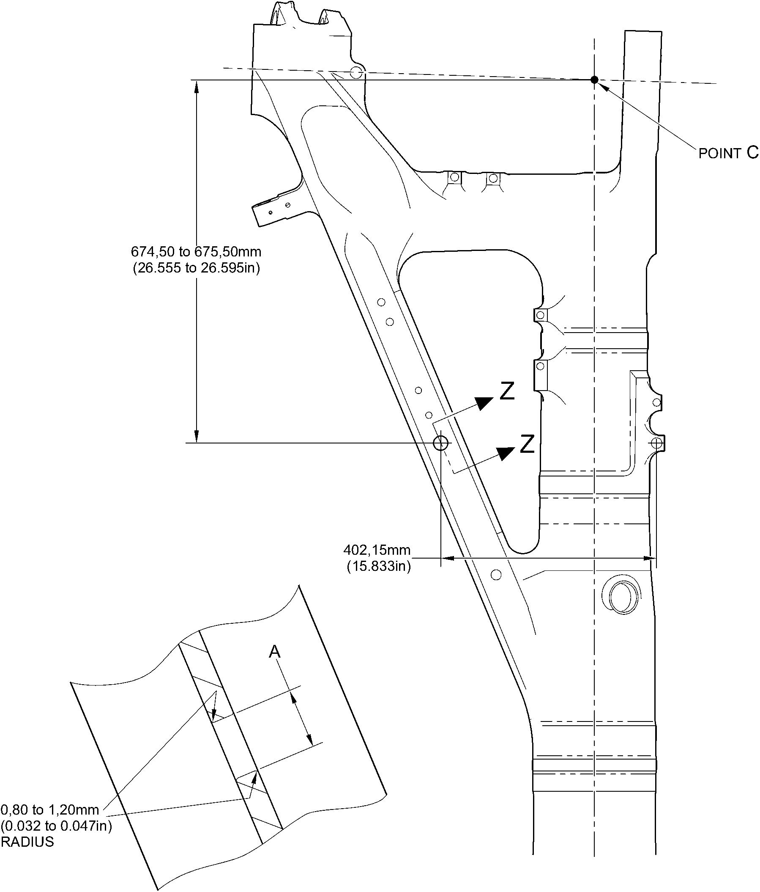
section Z-Z machining
A321A5060-1
Repair to Main Fitting
Figure 601
Repair No. 11-5
Page 603
Dec 6/2019
32-12-22

SAFRAN LANDING SYSTEMS UK Ltd
CAGE: K0654

PART No. 201587001 AND 201587002 COMPONENT MAINTENANCE MANUAL
MAIN LANDING GEAR LEG
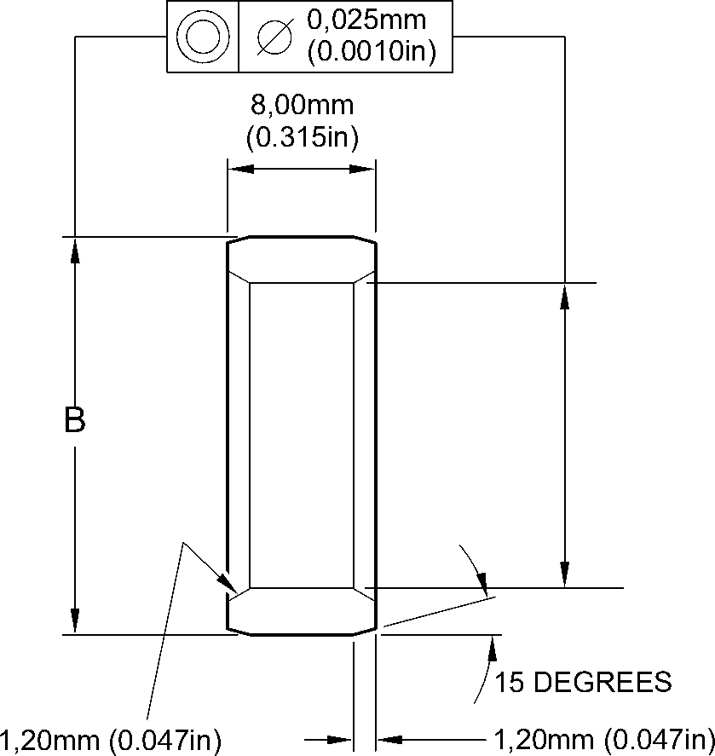
CHAMFER BOTH ENDS
X 60 DEGREES INCLUSIVE
BOTH ENDS
INSTALL BEARING
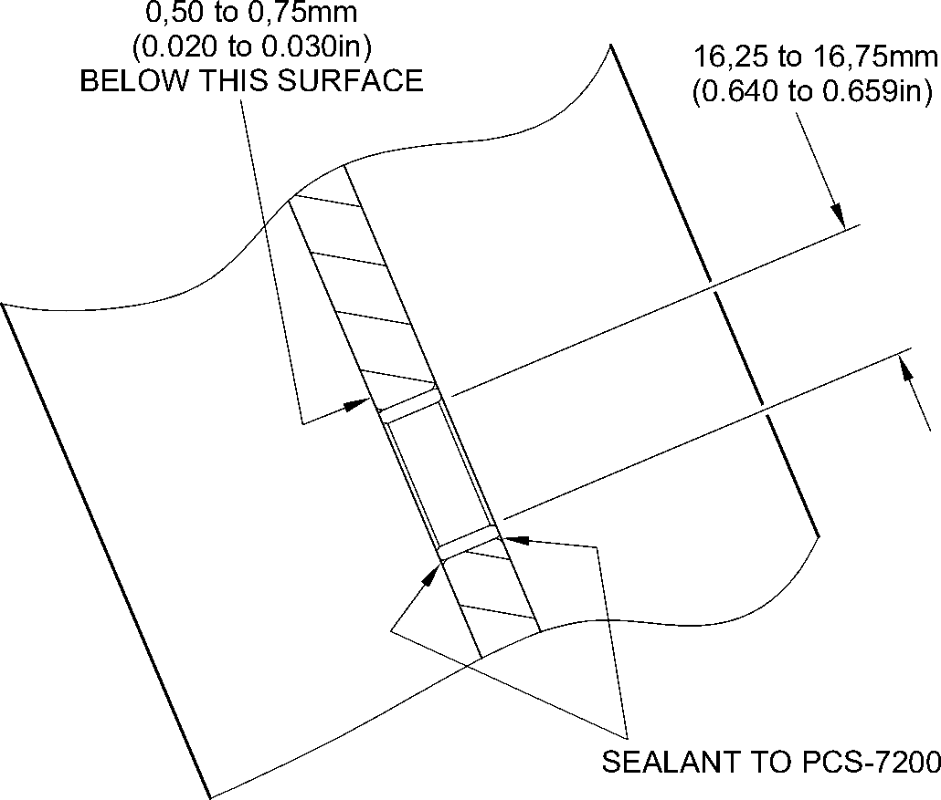
part section Z-Z
WITH BEARING
A321A5061-1
Repair Bush - Machining and Installation
Figure 602
32-12-22
Repair No. 11-5
Page 604
Dec 6/2019

SAFRAN LANDING SYSTEMS UK Ltd
CAGE: K0654

PART No. 201587001 AND 201587002 COMPONENT MAINTENANCE MANUAL
MAIN LANDING GEAR LEG

I 1. Repair No. 11-6 Main Fitting (20-410, 20-410A, 20-420 and 20-420A)
- Specified Damage and Material Specification
- Specified Damage
(a) Damage or corrosion to diameter A.
- Material Specification
IPL Figure and  Item No. | Name | Material Specification
20-410, 20-410A,  20-420 and  20-420A | Main fitting | Steel, MAT135, 35NCD16THQ
- Special Tools
(1) These special tools are necessary:
NOTE: Alternative equivalents are permitted.
Part No. | Special Tool | Function
460004330/169 | Press Pad | Install the blank bush 450237817
- Materials
(1) These materials are necessary:
NOTE: Alternative equivalents are permitted.
Ref. Item | Material
TBA | Electrically conducting Mastinox D40
09-510A | Sealant
- Repair Parts
(1) These repair parts are necessary:
Part No. | Repair Part | Material Specification
450237817 | Blank bush | Aluminium Bronze, BSB23 or  AMS4640
E. Procedure (Refer to Figures 601 and 602)
- Machine the diameter A, sufficiently only to remove the damage or corrosion, do not
make diameter A larger than 15,727 mm (0.6192 in): refer to M-DLPS1004-4-1
and Figure 601. The surface finish must be 1,6 micrometers (63 micro-inches).
- Measure and record the new diameter A.
- Examine the bare metal for flaws: refer to PCS-3100, inclusion class 4 and PCS-3600.
(4)
Locally cadmium plate the reworked areas: refer to PCS-2141.
Repair No. 11-6
Page 601
Mar 18/2025
32-12-22

sSAFRAN SAFRAN LANDING SYSTEMS UK Ltd
CAGE: K0654
PART No. 201587001 AND 201587002 COMPONENT MAINTENANCE MANUAL
MAIN LANDING GEAR LEG
- Identify the part with the Safran Landing Systems repair number 450266085 adjacent to
the part number: refer to PCS-6000-04, an alternative reference is PCS-6000-06. If the
alternative reference is used, the characters must be 0,051 to 0,102 mm (0.0020 to
0.0040 in) deep and approximately 3,00 mm (0.118 in) high.
- Calculate diameter B of the repair bush:
Dia. B = Dia. A (as measured) + 0,029 to - 0,009 mm (+ 0.0012 to - 0.0003 in).
- Machine the blank bush 450237817 to the dimensions shown and calculated. Machine
face C to get a dimension D of between 1,75 and 2,00 mm (0.069 and 0.078 in). The
surface finish must be 1,6 micrometers (63 micro-inches) all over the bush: refer
to Figure 602.
- Apply cadmium plate all over the oversize bush: refer to PCS-2101. The cadmium plate
thickness must be between 0,010 and 0,015 mm (0.0004 and 0.0006 in).
- Install the oversize bush: refer to M-DLPS1011-20. Use electrically conducting Mastinox
D40, Material Ref. Item. TBA: refer to PCS-7304 and Figure 602.
- Apply a bead of sealant, Material Ref. Item 09-510A, to the oversize bush: refer to
PCS-7200 and Figure 602.
- Identify the part with the Safran Landing Systems repair number 450266085 adjacent to
the part number: refer to PCS-6000-07.
- Examine the part to make sure that you have obeyed all the repair instructions correctly.
32-12-22
Repair No. 11-6
Page 602
Mar 18/2025

SAFRAN LANDING SYSTEMS UK Ltd
CAGE: K0654

PART No. 201587001 AND 201587002 COMPONENT MAINTENANCE MANUAL
MAIN LANDING GEAR LEG
0,80 to 1,20mm
(0.032 to 0.047in)
RADIUS
diameter A
15,727mm (0.6192in)
MAXIMUM
point C
Z
Z
919,50 to 920,50mm
(36.201 to 36.240in)
182,61 to 183,61mm
(7.189 to 7.229in)
SECTION Z-Z
WITHOUT BUSH
A321-S-32-12-22-022-0
Repair to Main Fitting
Figure 601
Repair No. 11-6
Page 603
Dec 6/2019
32-12-22
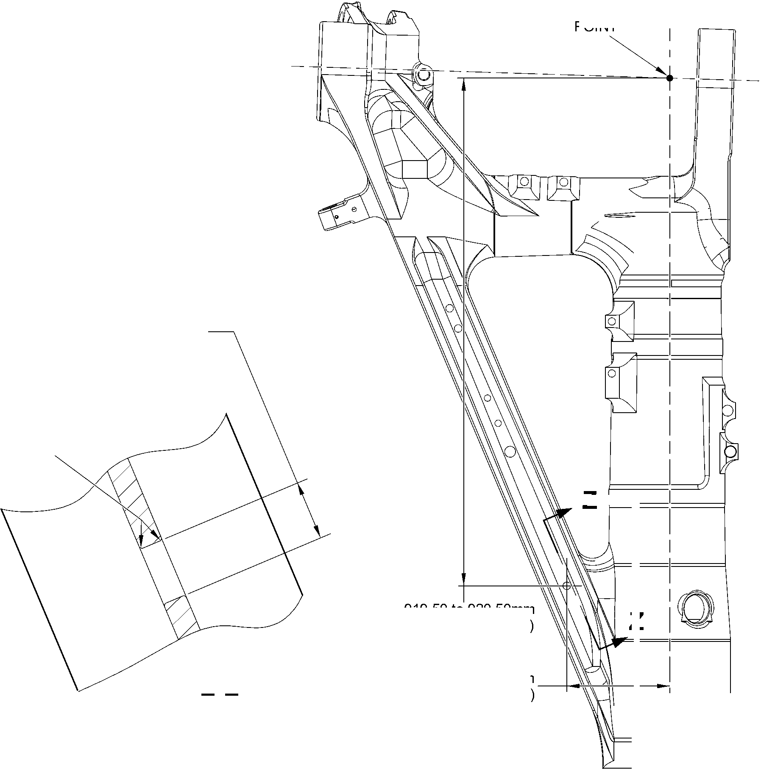

SAFRAN LANDING SYSTEMS UK Ltd
CAGE: K0654

PART No. 201587001 AND 201587002 COMPONENT MAINTENANCE MANUAL
MAIN LANDING GEAR LEG
15
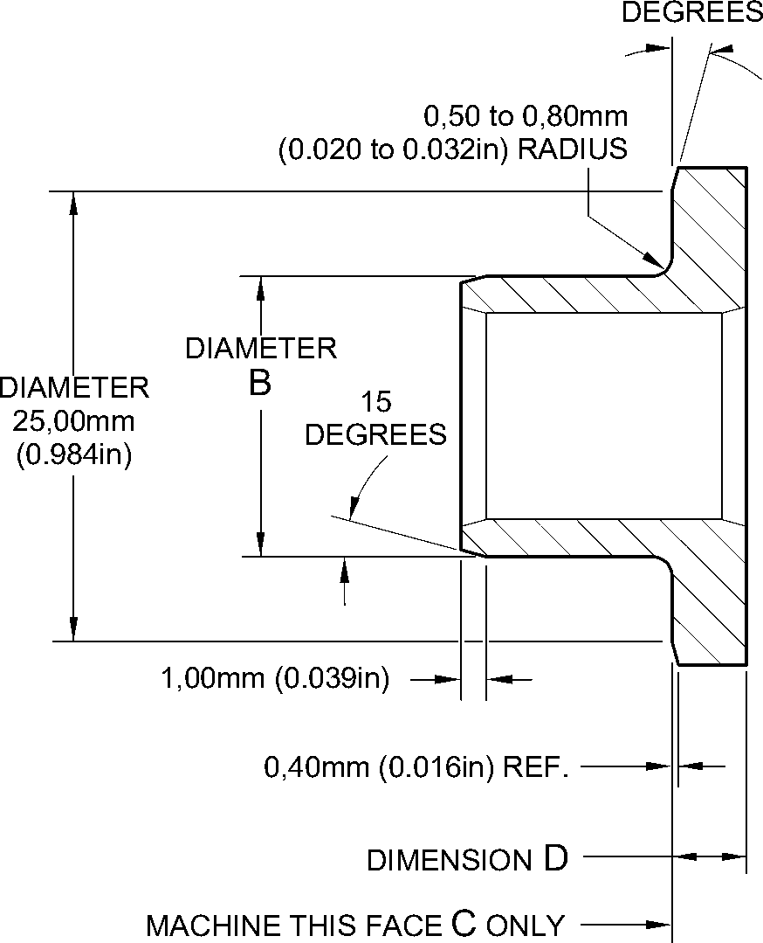
REPAIR BUSH 450237817
MACHINING
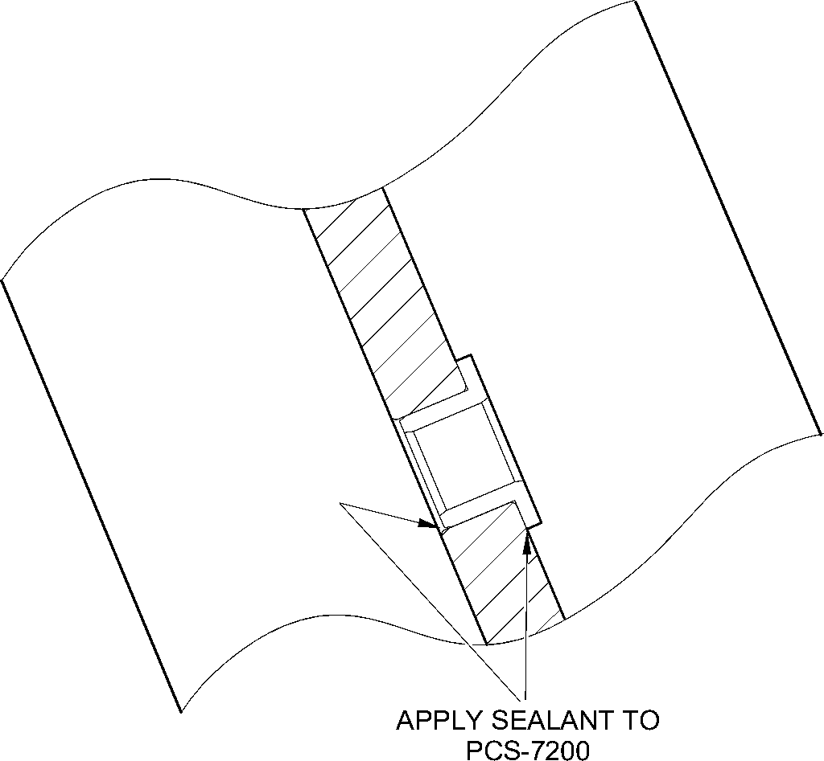
section Z-Z
WITH BUSH
A321-S-32-12-22-023-0
Repair Bush - Machining and Installation
Figure 602
32-12-22
Repair No. 11-6
Page 604
Dec 6/2019

sSAFRAN SAFRAN LANDING SYSTEMS UK Ltd
CAGE: K0654
PART No. 201587001 AND 201587002 COMPONENT MAINTENANCE MANUAL
MAIN LANDING GEAR LEG

I 1. Repair No. 11-7 Main Fitting (20-410, 20-410A, 20-420 and 20-420A)
- Specified Damage and Material Specification.
- Specified Damage
(a) Damage or wear to the diameter(s) A, B or C or spotface(s) D, E or F or faces G, H
and/or J.
- Material Specification
IPL Figure and  Item No. | Name | Material Specification
20-410, 20-410A,  20-420 and  20-420A | Main fitting | Steel, MAT135, 35NCD16THQ
- Special Tools
- These special tools are necessary:
NOTE: Alternative equivalents are permitted.
Part No. | Special Tool | Function
460007258 | Press Pad and Drawbolt | Install the repair bush 450258800
- Materials
- These materials are necessary:
NOTE: Alternative equivalents are permitted.
Ref. Item | Material
TBA | Zinc Powder
05-533 | Mastinox D40
09-510A | Sealant
- Repair Parts
- These repair parts are necessary:
Part No. | Repair Part | Material Specification
450258800 | Repair bush (Qty 3) | Stainless Steel,S145
- Procedure (Refer to Figures 601, 602 and 603)
CAUTION: FOR DAMAGE MORE THAN THE LIMITS OF THIS REPAIR SCHEME, WRITE
TO SAFRAN LANDING SYSTEMS: REFER TO GUIDE-CS-001.
- Machine the diameter A and/or diameter B and/or diameter C, sufficiently only to remove
the damage or wear: refer to M-DLPS1004-4-1. Diameter A and/or diameter B and/or
diameter C must not be more than 33,925 mm (1.3356 in). The surface finish must be
1,6 micrometers (63 micro-inches).
Repair No. 11-7
Page 601
Mar 18/2025
32-12-22

SSAFRAN
SAFRAN LANDING SYSTEMS UK Ltd
CAGE: K0654
PART No. 201587001 AND 201587002 COMPONENT MAINTENANCE MANUAL
MAIN LANDING GEAR LEG
- Use a 45,75 to 46,50 mm (1.801 to 1.831 in) spotface cutter with a 2,50 mm (0.1 in)
corner radius and machine the spotfaces D and/or E and/or F, suffciently to remove the
damage or corrosion: refer to M-DLPS1004-4-1 and Figure 602. Make the surface finish
1,6 micrometers (63 micro-inches).
- Machine the faces G and/or H and/or J to get the lug width dimensions the lug widths K
or L or M: refer to M-DLPS1004-4-1 and Figure 602. Do not make the lug widths K or L
or M less than 21,50 mm (0.846 in). Make the surface finish 1,6 micrometers
(63 micro-inches).
- Machine the radii to the dimensions shown: refer to M-DLPS1004-4-1 and Figure 602. If
necessary, blend any generated sharp edges to the adjacent surface.
- Measure and record the new diameter(s) A, B and C and the lug widths K, L and M.
- Examine the machined areas for flaws: refer to PCS-3100, inclusion Class 4 and
PCS-3600.
- Shot peen the machined area: refer to M-DLPS123.
- Identify the part with the Safran Landing Systems repair number 450266045 adjacent to
the part number: refer to PCS-6000-04.
- Apply cadmium plate to the machined area: refer to PCS-2100 or PCS-2141. The
cadmium plate thickness must be between 0,010 to 0,020 mm (0.0004 and 0.0008 in).
- Apply primer paint to the main fitting, where the bush flanges will touch: refer to
PCS-2500.
- Calculate the dimensions for each repair bush (qty 3), use formula:
Dia N = Dia A or B or C (as measured) + 0,018 to 0,059 mm (0.0007 to 0.0023 in).
Dim P= Lug width K or L or M (as measured) - 0,1 mm (- 0.004 in) to - 0,5 mm
(- 0.019 in).
- Machine the repair bushes to the dimensions as calculated and as shown. Machine the
face Q of repair bushes to get the correct dimension P: refer to Figure 603. Make the
surface finish 1,6 micrometers (63 micro-inches).
- Examine the machined areas: refer to PCS-3100, inclusion class 3.
- Passivate the repair bushs: refer to AMS 2700.
- Use Press Pad and Drawbolt 460007258 and install the repair bushes: refer to
M-DLPS1011-20. Use electrically conducting Mastinox (made from Mastinox D40,
Material Ref. Item 05-533 and Zinc powder, Material Ref. Item TBA).
- Check the bore diameters of the repair bushes: refer to Figure 603.
- If necessary hone or ream the repair bushes to the dimensions shown: refer to
Figure 603. Make the surface finish 1,6 micrometers (63 micro-inches).
- Apply a bead of sealant, Material Ref. Item 09-510A, between the repair bush(es) and
the main fitting: refer to PCS-7200 and Figure 603.
- Apply paint to the repaired areas, but not to the bores of the repair bushes: refer to
PCS-2500.
- Identify the part with the Safran Landing Systems repair number 450266045 adjacent to
the part number: refer to PCS-6000-07.
- Examine the part to make sure that you have obeyed all the repair instructions correctly.
Repair No. 11-7
Page 602
Mar 18/2025

SAFRAN LANDING SYSTEMS UK Ltd
CAGE: K0654

PART No. 201587001 AND 201587002 COMPONENT MAINTENANCE MANUAL
MAIN LANDING GEAR LEG
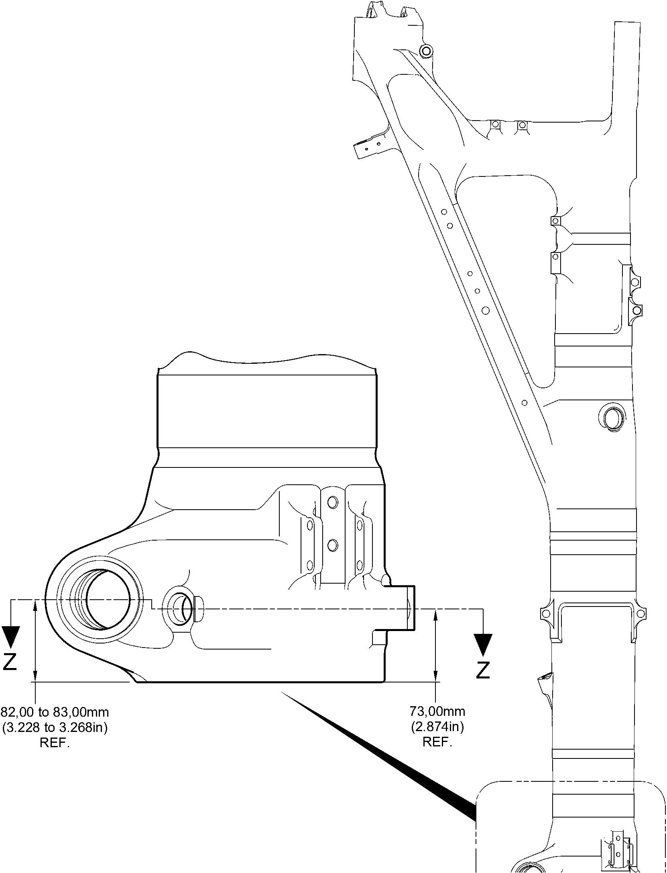
Repair to Main Fitting
Figure 601
Repair No. 11-7
Page 603
Dec 6/2019
32-12-22

SAFRAN LANDING SYSTEMS UK Ltd
CAGE: K0654
PART No. 201587001 AND 201587002 COMPONENT MAINTENANCE MANUAL
MAIN LANDING GEAR LEG
face G
dia B
face J
dia A
face E
TO SPOTFACE
faCe D
TO SPOTFACE
section Z-Z
face H
face F
TO SPOTFACE
2,50mm (0.098in) RADIUS
TYPICAL 3 PLACES
45,75 to 46,50mm
(1.801 to 1.831in) DIA. SPOTFACE.
TYPICAL 3 PLACES
125
DEGREES
50,00mm (1.969in) DIA
SPOTFACE
WITH 5,00mm (0.197in)
CORNER RADIUS
YA I
132,35mm
(5.211in)
REF.
125
DEGREES
WITHOUT REPAIR BUSHES
dia C
W
dia A typical
dia B and dia C
0,05mm
(0.002in)
0,14mm
(0.006in) DIA
1,00mm (0.040in)
RADIUS OR
X 45 DEGREES CHAMFER
0,5 to 1,0mm (0.02 to 0.04in)
RADIUS OR
X 45 DEGREES CHAMFER
W
X
section Y-Y
A321A5149-2
Repair to Main Fitting
Figure 602
32-12-22
Repair No. 11-7
Page 604
Dec 6/2019
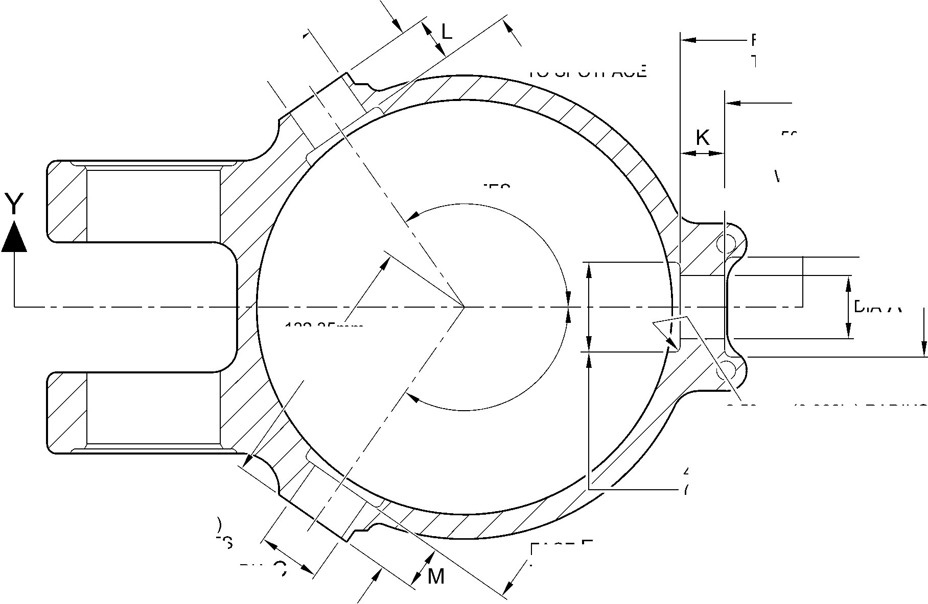
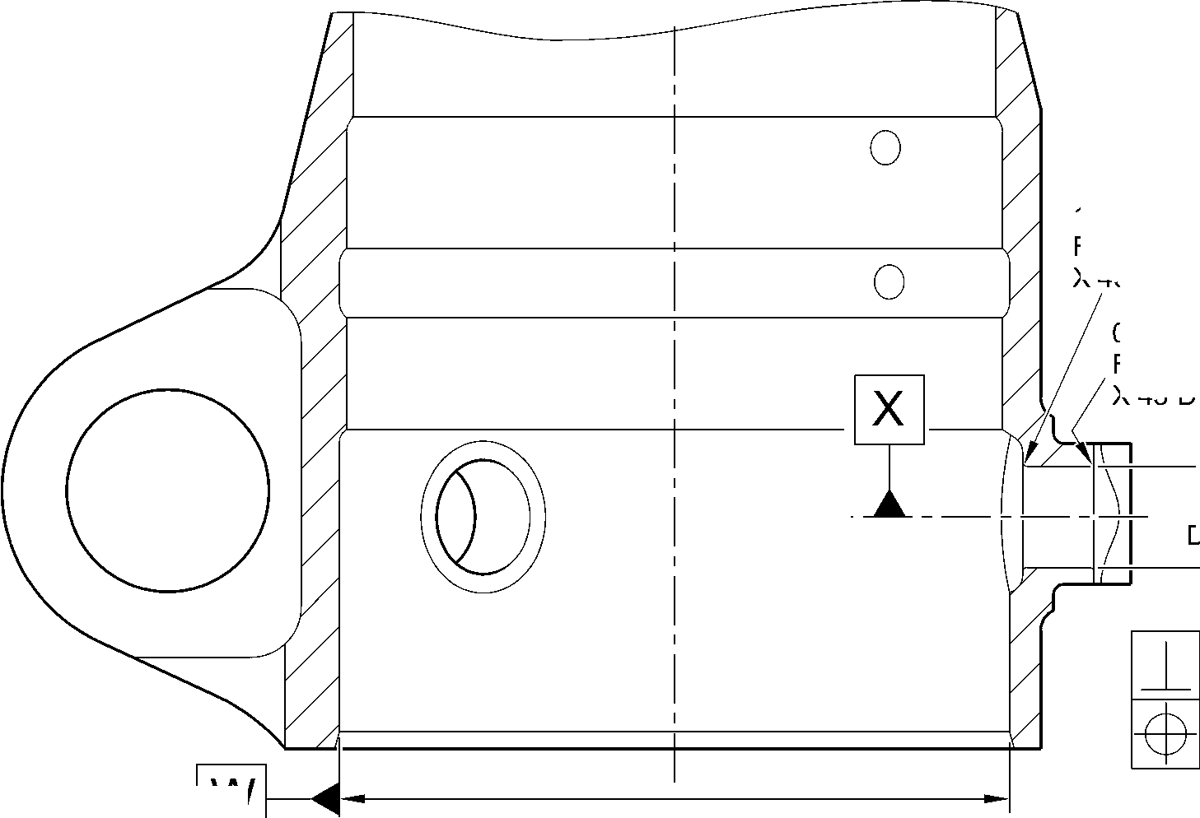

SAFRAN LANDING SYSTEMS UK Ltd
CAGE: K0654

PART No. 201587001 AND 201587002 COMPONENT MAINTENANCE MANUAL
MAIN LANDING GEAR LEG
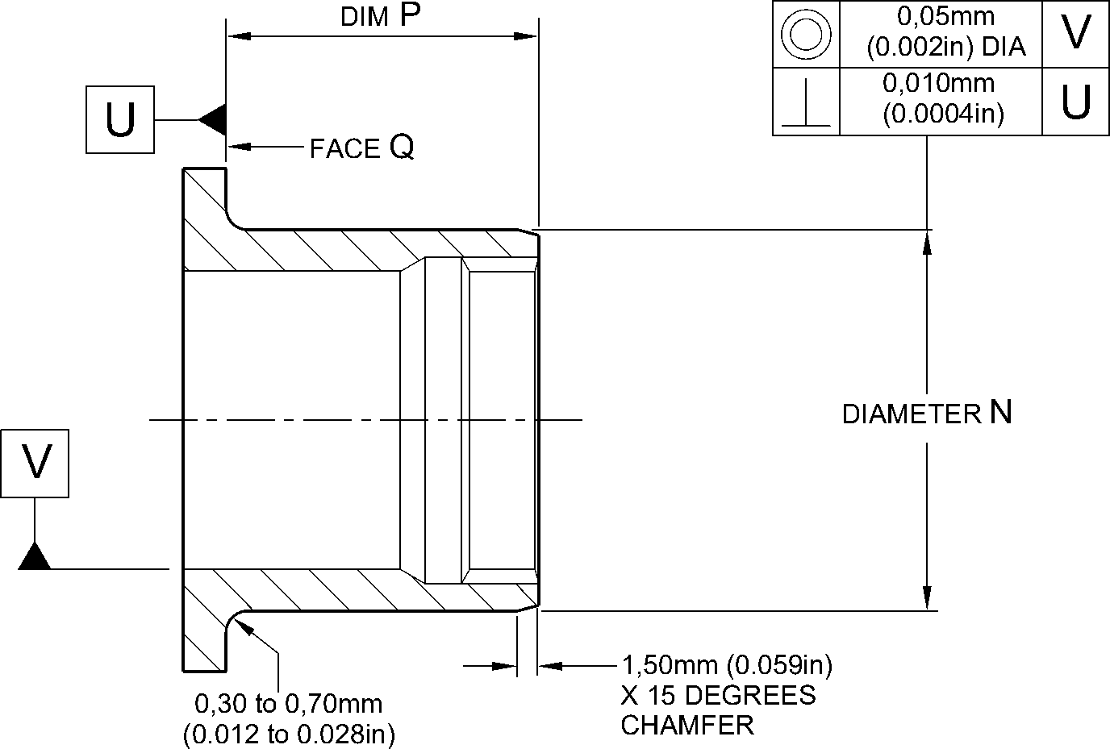
RADIUS
REPAIR BUSH 450258800
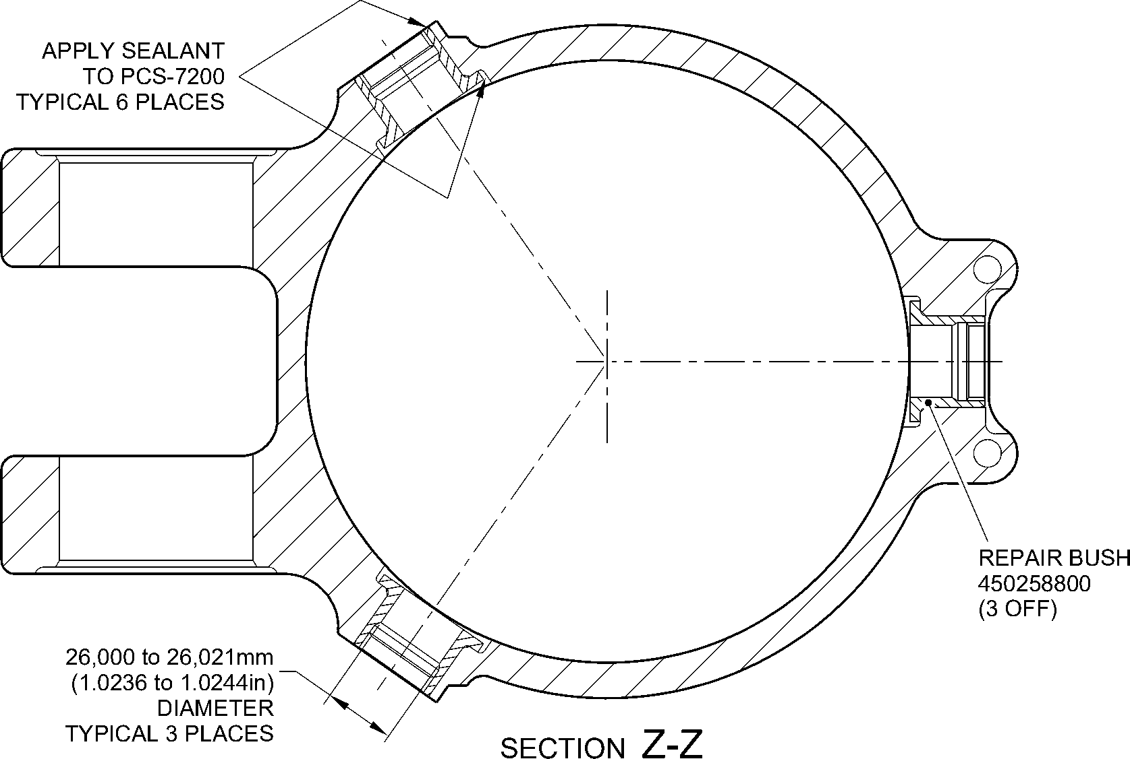
(REFER TO FIGURE 601)
WITH REPAIR BUSHES INSTALLED
A321A5150-2
Repair to Main Fitting - Repair Bush Machining and Installation
Figure 603
Repair No. 11-7
Page 605
Dec 6/2019
32-12-22

SAFRAN LANDING SYSTEMS UK Ltd
CAGE: K0654

PART No. 201587001 AND 201587002 COMPONENT MAINTENANCE MANUAL
MAIN LANDING GEAR LEG
INTENTIONALLY BLANK
Repair No. 11-7
32-12-22 ^{Page 606}

SAFRAN LANDING SYSTEMS UK Ltd
CAGE: K0654

PART No. 201587001 AND 201587002 COMPONENT MAINTENANCE MANUAL
MAIN LANDING GEAR LEG

I 1. Repair No. 11-8 Main Fitting (20-410, 20-410A, 20-420 and 20-420A)
- Specified Damage and Material Specification.
- Specified Damage
(a) Damage or corrosion to the diameter A and/or the adjacent face(s) B. (Refer to
Figure 601).
- Material Specification
IPL Figure and  Item No. | Name | Material Specification
20-410, 20-410A,  20-420 and  20-420A | Main fitting | Steel, MAT135, 35NCD16THQ
- Special Tools
- These special tools are necessary:
Part No. | Special Tool | Function
460006246 | Alignment Bar | Install the repair bush 450258806
460006249/1 | Cutter | Finish machine the repair bush  450258806
460006250 | Press Pad | Install the repair bush 450258806
- Materials
- These materials are necessary:
NOTE: Alternative equivalents are permitted.
Ref. Item | Material
- | Electrically conducting zinc loaded Molykote 111: refer to  PCS-7304
09-510A | Sealant: refer to PCS-7200
- Repair Parts
- These repair parts are necessary:
Part No. | Repair Part | Material Specification
450258806 | Repair bush (Qty 2) | TBA
E. Procedure (Refer to Figures 601 and 602)
CAUTION: FOR DAMAGE MORE THAN THE LIMITS OF THIS REPAIR SCHEME, WRITE
TO SAFRAN LANDING SYSTEMS: REFER TO GUIDE-CS-001.
(1)
Machine the diameter A, sufficiently only to remove the damage or corrosion: refer to
M-DLPS1004-4-1. Diameter A must not be more than 68,13 mm (2.682 in). Dimension C
must not be less than 22,15 mm (0.872 in). The surface finish must be 1,6 micrometers
(63 micro-inches): refer to Figure 601.
Repair No. 11-8
Page 601
Mar 18/2025
32-12-22

sSAFRAN SAFRAN LANDING SYSTEMS UK Ltd
CAGE: K0654
PART No. 201587001 AND 201587002 COMPONENT MAINTENANCE MANUAL
MAIN LANDING GEAR LEG
- Measure and record the diameter A.
- If necessary, machine the spotface(s) sufficiently to remove the damage or corrosion:
refer to M-DLPS1004-4-1. Do not remove more than 1,00 mm (0.040 in) of material from
each face. Make the chamfers and radii as shown, do not reduce the dimension(s) D to
less than 71,250 mm (2.805 in): refer to Figure 601. The surface finish must be
1,6 micrometers (63 micro-inches).
- Measure and record the dimension(s) D.
- Examine the bare metal for flaws: refer to PCS-3600 and PCS-3100, inclusion class 4.
- Shot peen the machined areas: refer to M-DLPS123.
- Apply cadmium plate locally to the machined areas: refer to PCS-2141.
- Identify the part with the Safran Landing Systems repair number 450266010 adjacent to
the part number: refer to PCS-6000-04, an alternative reference is PCS-6000-06. If the
alternative reference is used, the characters must be 0,051 to 0,102 mm (0.0020 to
0.0040 in) deep and approximately 3,00 mm (0.118 in) high.
- Prepare the repair bush(es) 450258806 for installation: refer to Figure 602:
- Machine diameter G of the repair bush to the diameter from this formula:
Dia. G = Dia. A (as measured in para (2)) + 0,029 to 0,078 mm (+ 0.0011 to
0.0030 in). The surface finish must be 1,6 micrometers (63 micro-inches).
- Machine face H of the repair bush to get a dimension J from this formula:
Dim. J = Dim. D (as measured in para (4)) - 29,745 mm to 30,00 mm (1.171 to
1.181 in). The surface finish must be 1,6 micrometers (63 micro-inches).
- Locally apply cadmium plate all over the repair bush(es) but not to the bore,
internal grooves and face M: refer to PCS-2101 or PCS-2141. The cadmium plate
thickness must be between 0,010 and 0,015 mm (0.0004 and 0.0006 in).
- Use zinc loaded molykote 111 and the Alignment Bar 460006246 and Press Pad
460006250 to install the repair bush(es): refer to PCS-5105, PCS-7304 and Figure 602.
- If necessary, hand ream or hone the bore of the repair bushes to between 60,00 and
60,03 mm (2.362 and 2.363 in). Do not machine: refer to Figure 602.
- If necessary, use the Cutter 460006249/1 to machine the flange face(s) M of the repair
bushes to get a dimension K of between 75,459 and 75,479 mm (2.9708 and 2.9716 in)
and a dimension L of between 150,917 and 150,957 mm (5.9416 and 5.9432 in): refer to
Figure 602. The surface finish must be 1,6 micrometers (63 micro-inches).
- If necessary, machine the internal chamfers of the repair bushes as shown: refer to
Figure 602. The surface finish must be 1,6 micrometers (63 micro-inches).
- Apply sealant, Material Ref. Item 09-510A, between the repair bush(es) and the main
fitting: refer to PCS-7200 and Figure 602.
- Identify the part with the Safran Landing Systems repair number 450266010 adjacent to
the part number: refer to PCS-6000-07.
- Examine the part to make sure that you have obeyed all the repair instructions correctly.
32-12-22
Repair No. 11-8
Page 602
Mar 18/2025

SAFRAN LANDING SYSTEMS UK Ltd
CAGE: K0654

PART No. 201587001 AND 201587002 COMPONENT MAINTENANCE MANUAL
MAIN LANDING GEAR LEG
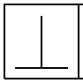
0,05mm
(0.002in)
X
DIM. C
MINIMUM WALL
THICKNESS
dia. A
68,13mm
(2.682in)
MAXIMUM
face R
0,05mm
(0.002in)
X
face B
X
Z
160,00mm
(6.299in)
REF.
A321-S-32-12-22-080-1
1,75 to 2,25mm
(0.069 to 0.089in)
X 45 DEGREES
CHAMFER
(2 PLACES)
142,75mm (5.620in) MIN.
BETWEEN SPOTFACES
DIM. D
71,250mm
(2.805in) MIN.
PART SECTION Z-Z
WITHOUT REPAIR BUSHES
88,75 to 89,25mm
(3.494 to 3.514in)
DIAMETER
SPOTFACE
WITH
4,75 to 5,25mm
(0.187 to 0.207in)
CORNER RADIUS
(2 PLACES)
82,00 to 83mm
(3.228 to 3.268in)
REF.
Repair to Main Fitting
Figure 601
Repair No. 11-8
Page 603
May 31/2019
32-12-22
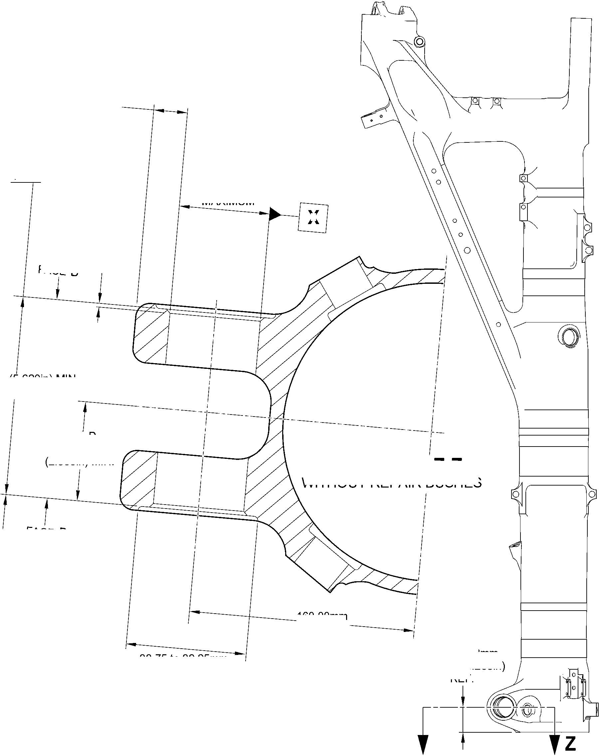

SAFRAN LANDING SYSTEMS UK Ltd
CAGE: K0654

PART No. 201587001 AND 201587002 COMPONENT MAINTENANCE MANUAL
MAIN LANDING GEAR LEG
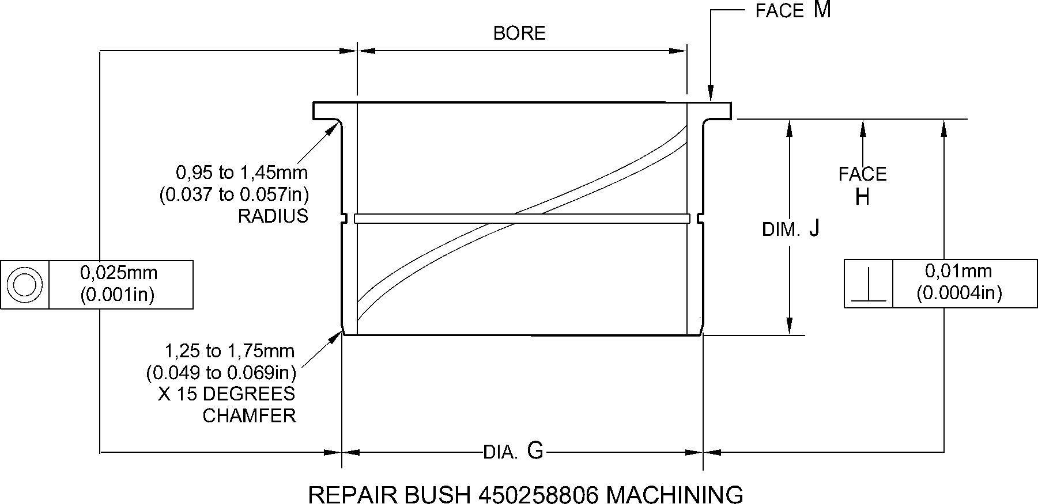
SEALANT TO
PCS-7200
(BOTH BUSHES)
DIM. K
0,95 to 1,45mm
(0.037 to 0.057in)
X 60 DEGREES
INCLUSIVE
CHAMFER
(2 PLACES)
PART SECTION Z-Z
WITH REPAIR BUSHES INSTALLED
dim. L
REPAIR BUSH
450258806
A321-S-32-12-22-081-1
Repair to Main Fitting - Repair Bush Machining and Installation
Figure 602
32-12-22
Repair No. 11-8
Page 604
May 31/2019
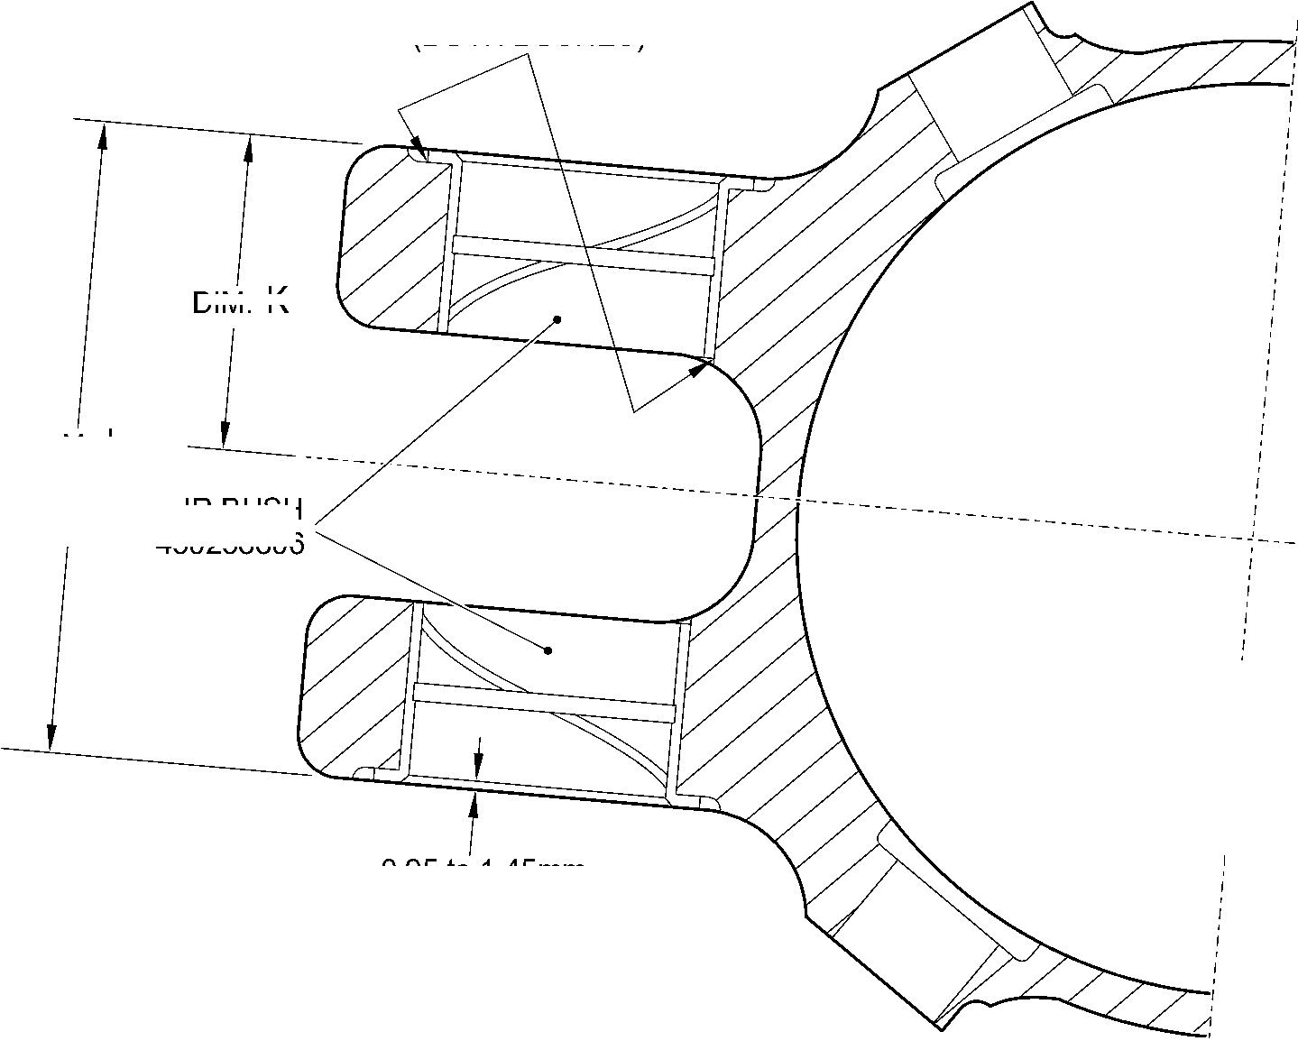

sSAFRAN SAFRAN LANDING SYSTEMS UK Ltd
CAGE: K0654
PART No. 201587001 AND 201587002 COMPONENT MAINTENANCE MANUAL
MAIN LANDING GEAR LEG

I 1. Repair No. 11-9 Main Fitting (20-410, 20-410A, 20-420 and 20-420A)
- Specified Damage and Material Specification.
- Specified Damage
(a) Damage or corrosion to the diameter(s) A and the adjacent face(s) B. (Refer to
Figure 601).
- Material Specification
IPL Figure and  Item No. | Name | Material Specification
20-410, 20-410A,  20-420 and  20-420A | Main fitting | Steel, MAT135, 35NCD16THQ
- Special Tools
- These special tools are necessary:
Part No. | Special Tool | Function
460004330/122 | Press Pad | Install the repair bush 450217852
460004330/123 | Press Pad | Install the repair bush 450217851
- Materials
- These materials are necessary:
NOTE: Alternative equivalents are permitted.
Ref. Item | Material
09-510A | Sealant: refer to PCS-7200
TBA | Jointing Compound, zinc loaded Mastinox D40: refer to  M-DLPS709-14
- Repair Parts
- These repair parts are necessary:
Part No. | Repair Part | Material Specification
450217851 | Repair bush | Aluminium Bronze, DTD197
450217852 | Repair bush | Aluminium Bronze, DTD197
- Procedure (Refer to Figures 601, 602 and 603)
- Machine the diameter(s) A, sufficiently only to remove the damage or corrosion: refer to
M-DLPS1004-4-1. Diameter A must not be more than 54,130 mm (2.1311 in). The
surface finish must be 1,6 micrometers (63 micro-inches).
Repair No. 11-9
Page 601
Mar 18/2025
32-12-22

sSAFRAN SAFRAN LANDING SYSTEMS UK Ltd
CAGE: K0654
PART No. 201587001 AND 201587002 COMPONENT MAINTENANCE MANUAL
MAIN LANDING GEAR LEG
- Machine the face(s) B, sufficiently only to remove the damage or wear: refer to
M-DLPS1004-4-1. Do not remove more than 1,00 mm (0.039 in) of material from the
face(s) B. The surface finish must be 1,6 micrometers (63 micro-inches).
- Machine the chamfers and radii as shown: refer to Figure 602.
- Measure and record the new diameter(s) A and the dimensions C1 and C2.
- Examine the bare metal for flaws: refer to PCS-3600 and PCS-3100, inclusion class 4.
- Shot peen the machined area: refer to M-DLPS123.
- Apply cadmium plate to the machined area: refer to PCS-2141.
- Identify the part with the Safran Landing Systems repair number 450266030 adjacent to
the part number: refer to PCS-6000-04, an alternative reference is PCS-6000-06. If the
alternative reference is used, the characters must be 0,051 to 0,102 mm (0.0020 to
0.0040 in) deep and approximately 3,00 mm (0.118 in) high.
- Prepare the repair bush(es) 450217851 and 450217852 for installation: refer to
Figure 602:
- Calculate diameter D1 of the repair bush 450217851 from this formula:
D1 = A (as measured in para (4)) + 0,023 to 0,072 mm (+ 0.0009 to 0.0028 in).
- Calculate dimension F1 of the repair bush 450217851 from this formula:
F1 = C1 (as measured in para (4)) + 0,00 to 1,25 mm (+ 0.000 to 0.049 in).
- Calculate diameter D2 of the repair bush 450217852 from this formula:
D2 = A (as measured in para (4)) + 0,023 to 0,072 mm (+ 0.0009 to 0.0028 in).
- Calculate dimension F2 of the repair bush 450217852 from this formula:
F2 = C2 (as measured in para (4)) + 0,00 to 1,25 mm (+ 0.000 to 0.049 in).
- Machine the repair bushes to the dimensions shown and calculated. Make the
surface finish 1,6 micrometers (63 micro-inches).
- Apply cadmium plate to the repair bush(es): refer to PCS-2101 or PCS-2141. Do
not apply cadmium plate to the bores of the bush(es). The cadmium plate
thickness must be between 0,010 and 0,015 mm (0.0004 and 0.0006 in).
- Use jointing compound, zinc loaded Mastinox D40, Material Ref. Item, TBA and the
Press Pads 460004330/122 and 460004330/123 to install the repair bush(es): refer to
M-DLPS709-14, M-DLPS1011-20 and Figure 603. Make sure that the drain hole J is
free from jointing compound: refer to Figure 603.
- Machine the flanges of the bush(es) to get:
- A dimension H of between 111,25 and 111,45 mm (4.380 and 4.388 in): refer to
Figure 603. The surface finish must be 1,6 micrometers (63 micro-inches).
- A dimension G of between 222,50 and 222,75 mm (8.760 and 8.770 in): refer to
Figure 603. The surface finish must be 1,6 micrometers (63 micro-inches).
- Machine the chamfers of the repair bush(es) to the dimensions shown. The surface
finish must be 1,6 micrometers (63 micro-inches).
32-12-22
Repair No. 11-9
Page 602
Mar 18/2025

sSAFRAN SAFRAN LANDING SYSTEMS UK Ltd
CAGE: K0654
PART No. 201587001 AND 201587002 COMPONENT MAINTENANCE MANUAL
MAIN LANDING GEAR LEG
- If necessary, check line ream the bore of the bush 450217851 to between 36,000 and
36,025 mm (1.4170 and 1.4180 in).
- If necessary, check line ream the bore of the bush 450217852 to between 46,825 and
46,864 mm (1.8440 and 1.8450 in).
- Apply sealant, Material Ref. Item 09-510A, between the repair bush(es) and the main
fitting: refer to PCS-7200 and Figure 603.
- Identify the part with the Safran Landing Systems repair number 450266030 adjacent to
the part number: refer to PCS-6000-07.
- Examine the part to make sure that you have obeyed all the repair instructions correctly.
Repair No. 11-9
Page 603
Mar 18/2025
32-12-22

SAFRAN LANDING SYSTEMS UK Ltd
CAGE: K0654

PART No. 201587001 AND 201587002 COMPONENT MAINTENANCE MANUAL
MAIN LANDING GEAR LEG
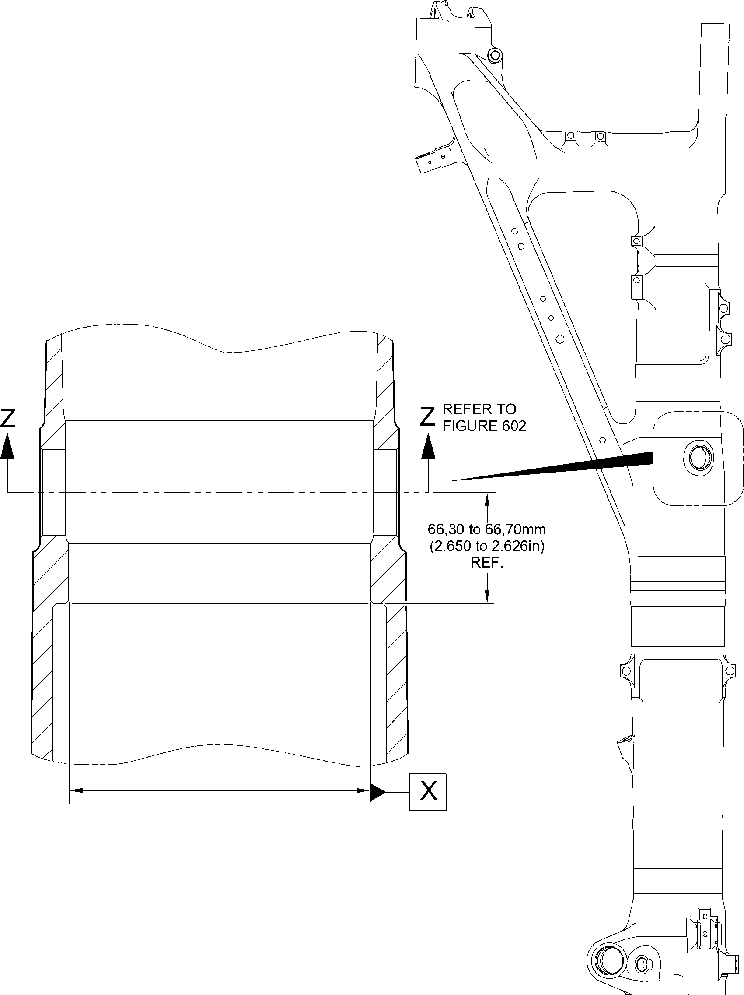
A321A5153-1
Repair to Main Fitting
Figure 601
32-12-22
Repair No. 11-9
Page 604
Dec 6/2019

SAFRAN LANDING SYSTEMS UK Ltd
CAGE: K0654

PART No. 201587001 AND 201587002 COMPONENT MAINTENANCE MANUAL
MAIN LANDING GEAR LEG
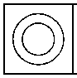
0,05mm
(0.002in)
faCe B
DIAMETER
0,025mm
(0.0010in)
C2
face B
C1
Y
1,00 to 2,00mm
(0.039 to 0.079in)
RADIUS TYPICAL
1,25 to 1,75mm (0.049 to 0.069in)
X 44.5 to 45.5 DEGREES
CHAMFER
DIAMETER
A
section Z-Z
29.5 to 30.5 DEGREES _{WITHOUT BUSHES}
Y
215,50mm (8.484in)
MINIMUM

0,030mm
(0.0012in)
Y
107,75mm
(4.242in)
X
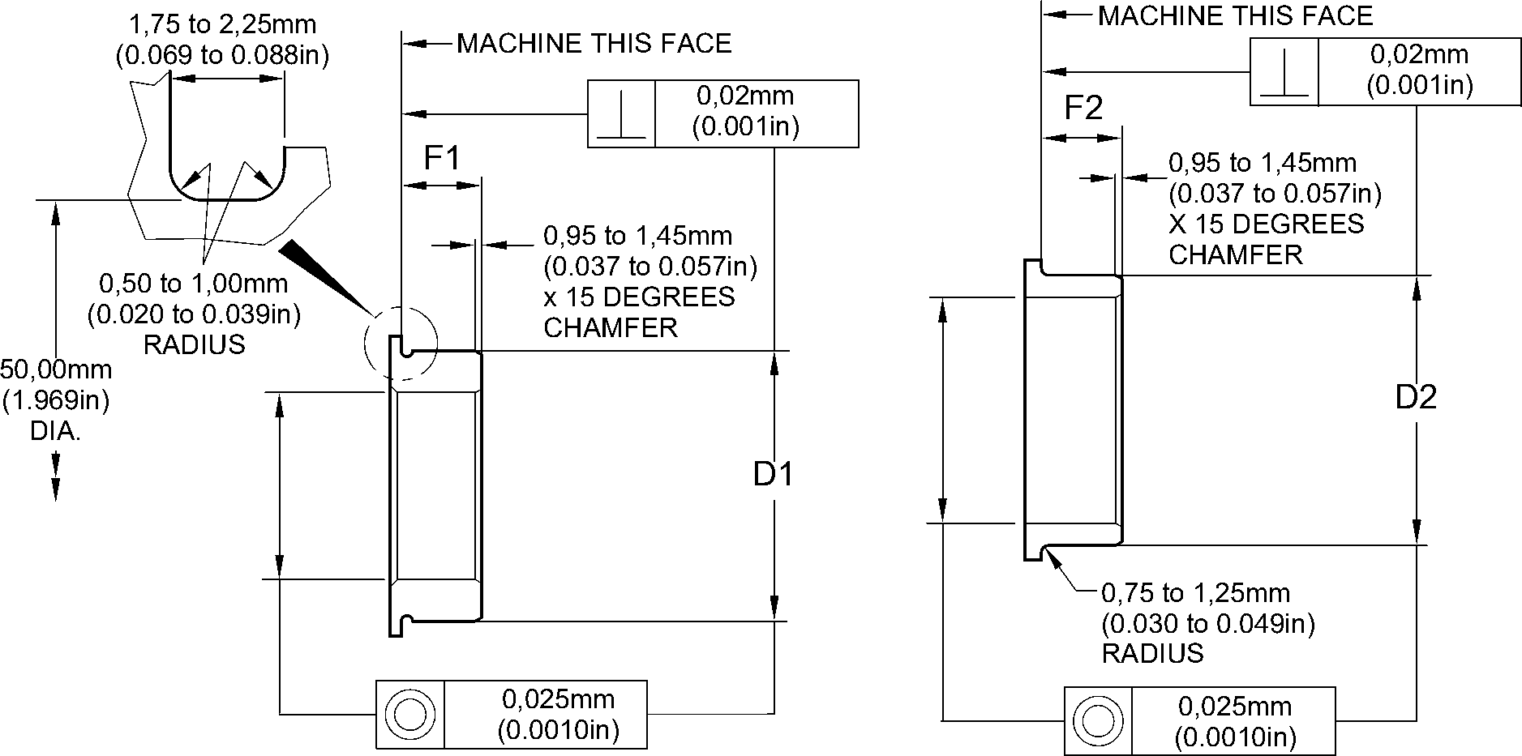
REPAIR BUSH
450217851
REPAIR BUSH
450217852
A321A5154-1
Repair to Main Fitting - Machining
Figure 602
Repair No. 11-9
32-12-22
Page 605
Dec 6/2019
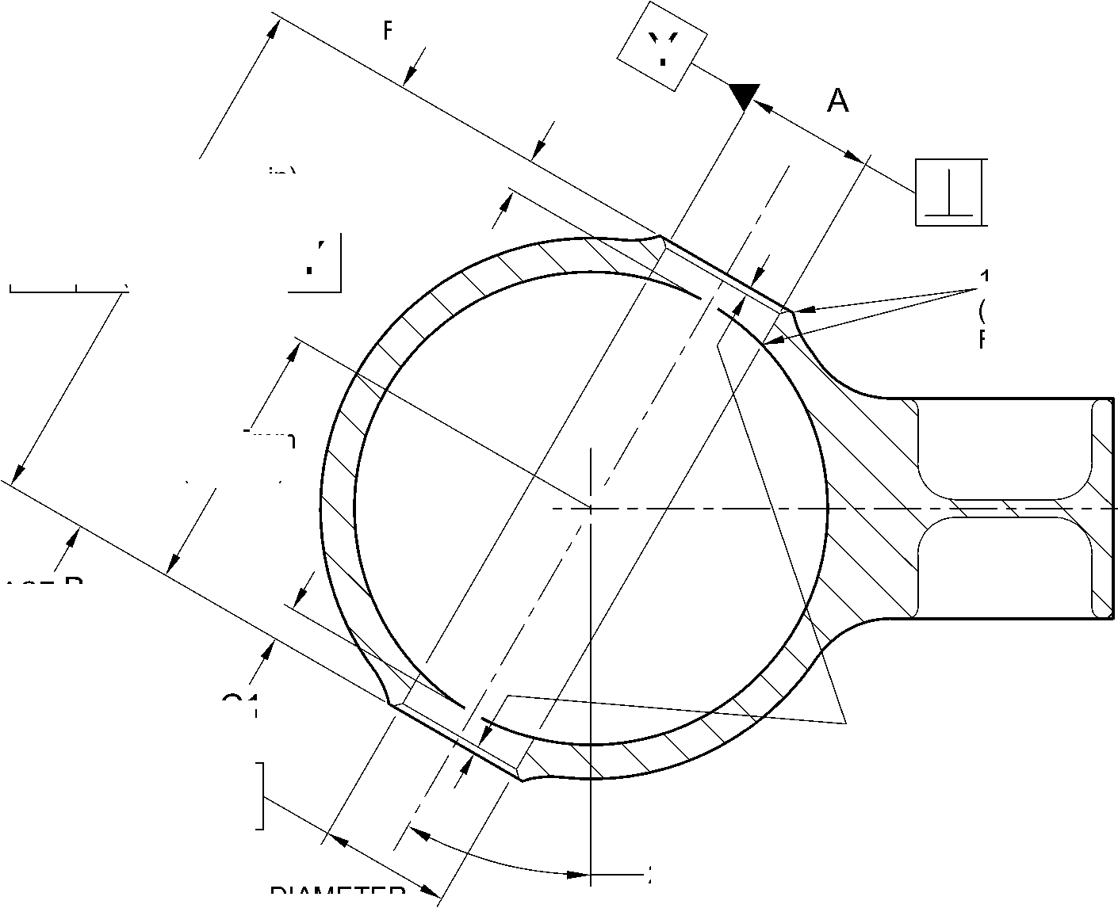

SAFRAN LANDING SYSTEMS UK Ltd
CAGE: K0654

PART No. 201587001 AND 201587002 COMPONENT MAINTENANCE MANUAL
MAIN LANDING GEAR LEG
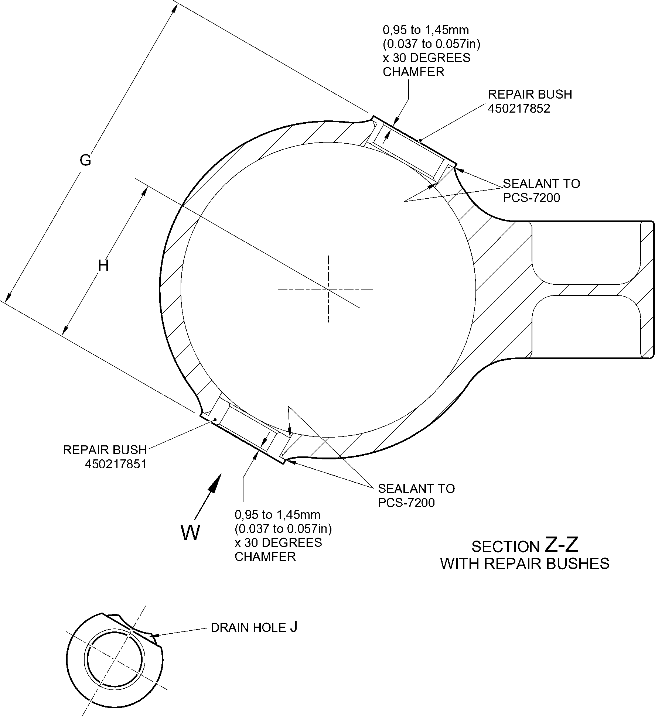
view W
REFERENCE BOTTOM
OF MAIN FITTING
A321A5155-1
Repair to Main Fitting - Repair Bush Installation
Figure 603
Repair No. 11-9
32
Page 606
Dec 6/2019

SAFRAN LANDING SYSTEMS UK Ltd
CAGE: K0654

PART No. 201587001 AND 201587002 COMPONENT MAINTENANCE MANUAL
MAIN LANDING GEAR LEG

I 1. Repair No. 11-10 Main Fitting (20-410 and 20-420 Only)
A. This repair, Messier-Dowty Limited Repair No. 450267270, has been withdrawn from use. It is
superseded by Repair No. 11-29 (450267275) or Repair No. 11-30 (450267385).
Repair No. 11-10
32-12-22
Page 601
Dec 4/2020

SAFRAN LANDING SYSTEMS UK Ltd
CAGE: K0654

PART No. 201587001 AND 201587002 COMPONENT MAINTENANCE MANUAL
MAIN LANDING GEAR LEG
INTENTIONALLY BLANK
Repair No. 11-10
32-12-22 ^{Page 602}

SAFRAN LANDING SYSTEMS UK Ltd
CAGE: K0654

PART No. 201587001 AND 201587002 COMPONENT MAINTENANCE MANUAL
MAIN LANDING GEAR LEG

I 1. Repair No. 11-11 Main Fitting (20-410, 20-410A, 20-420 and 20-420A)
- Specified Damage and Material Specification
- Specified Damage
(a) Damage or corrosion to the diameter A.
- Material Specification
IPL Figure and  Item No. | Name | Material Specification
20-410, 20-410A,  20-420 and  20-420A | Main Fitting | Steel, MAT135, 35NCD16THQ
- Special Tools
(1) These special tools are necessary:
NOTE: Alternative equivalents are permitted.
Part No. | Special Tool | Function
460004330/91 | Press Pad | Install the repair bearing
- Materials
(1) These materials are necessary:
NOTE: Alternative equivalents are permitted.
Ref. Item | Material
04-512 | Molykote 111
09-510A | Sealant
- Repair Parts
(1) These repair parts are necessary:
Part No. | Repair Part | Material Specification
450237824 | Repair Bearing | Aluminium Bronze, DTD197
E. Procedure (Refer to Figures 601 and 602)
CAUTION: FOR DAMAGE MORE THAN THE LIMITS OF THIS REPAIR SCHEME,
WRITE TO SAFRAN LANDING SYSTEMS: REFER TO GUIDE-CS-001.
- Machine diameter A sufficiently to remove the damage or wear and to between 14,018
and 14,485 mm (0.5519 and 0.5703 in): refer to M-DLPS914, M-DLPS1004-4-1
and Figure 601. Make the surface finish 1,6 micrometers (63 micro-inches) or better.
- Examine the main fitting for flaws: refer to PCS-3100, inclusion class 4 and PCS-3600.
- Measure and record the new diameter A.
Repair No. 11-11
32-12-22
Page 601
Mar 18/2025

sSAFRAN SAFRAN LANDING SYSTEMS UK Ltd
CAGE: K0654
PART No. 201587001 AND 201587002 COMPONENT MAINTENANCE MANUAL
MAIN LANDING GEAR LEG
- Identify the part with the Safran Landing Systems repair number 450266015 adjacent to
the part number: refer to PCS-6000-04 or PCS-6000-06.
- Apply cadmium plate to the reworked area: refer to PCS-2100 and PCS-2141. Fadeout
of cadmium plate is permitted in bore.
- Apply primer paint to reworked areas: refer to PCS-2500.
- Calculate the diameter B of the repair bearing, use formula:
Dia. B = Dia. A (as measured) - 0,006 to + 0,023 mm (- 0.0002 to + 0.0009 in).
- Machine the repair bearing to the diameter calculated and as shown: refer
to Figure 602. Make the surface finish 1,6 micrometers (63 micro-inches).
- Apply cadmium plate all over the repair bearing: refer to PCS-2101 or PCS-2141. The
cadmium plate thickness must be between 0,010 and 0,015 mm (0.0004 and
0.0006 in).
- Use the press pad 460004330/91 to install the repair bearing. Use Molykote 111,
Material Ref. Item 04-512: refer to PCS-7304. The ends of the bearing must be below
the end of the bearing hole: refer to Figure 602.
- Check the bore diameters of the repair bearing: refer to Figure 602.
- Do not machine the repair bearing. If necessary, hone the bore diameters of the repair
bearing to the dimensions shown: refer to Figure 602.
- Apply sealant, Material Ref. Item 09-510A, to the joints between the repair bearing and
main fitting: refer to PCS-7200 and Figure 602.
- Apply paint to the repaired area, except where indicated: refer to PCS-2500, REPAIR
and Figure 602.
- Identify the part with the Safran Landing Systems repair number 450266015 adjacent to
the part number: refer to PCS-6000-07.
- Examine the part to make sure that you have obeyed all the repair instructions correctly.
32-12-22
Repair No. 11-11
Page 602
Mar 18/2025

SAFRAN LANDING SYSTEMS UK Ltd
CAGE: K0654

PART No. 201587001 AND 201587002 COMPONENT MAINTENANCE MANUAL
MAIN LANDING GEAR LEG
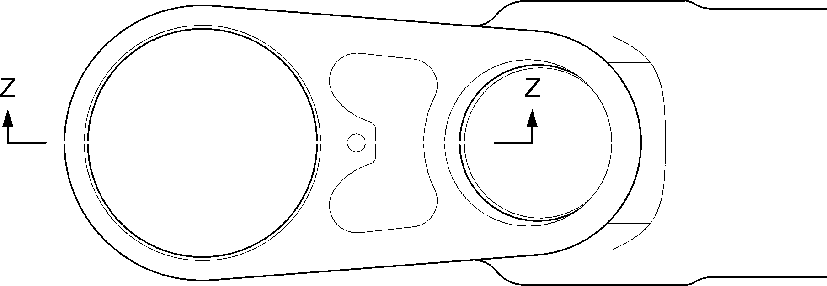
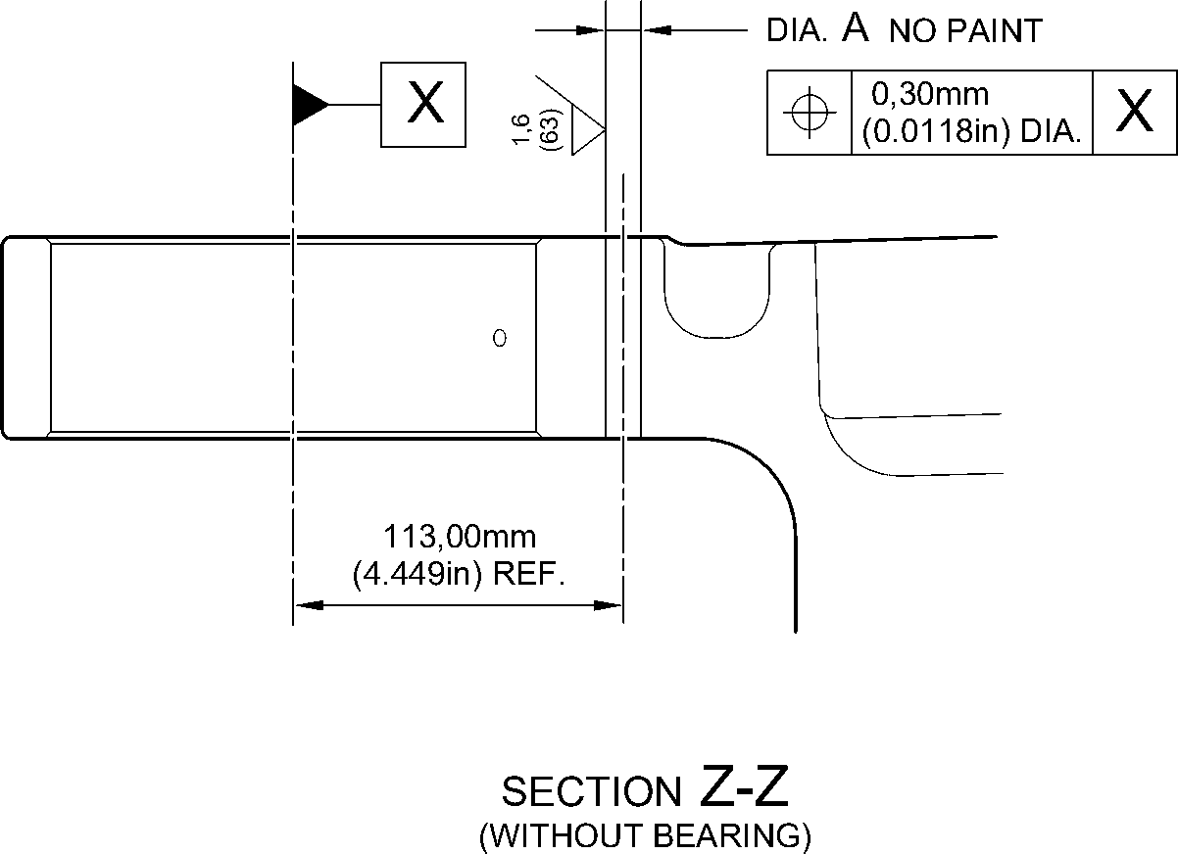
A321-S-32-12-22-018-1
Repair to Main Fitting - Machining
Figure 601
Repair No. 11-11
32-12-22
Page 603
Dec 6/2019

SAFRAN LANDING SYSTEMS UK Ltd
CAGE: K0654
PART No. 201587001 AND 201587002 COMPONENT MAINTENANCE MANUAL
MAIN LANDING GEAR LEG
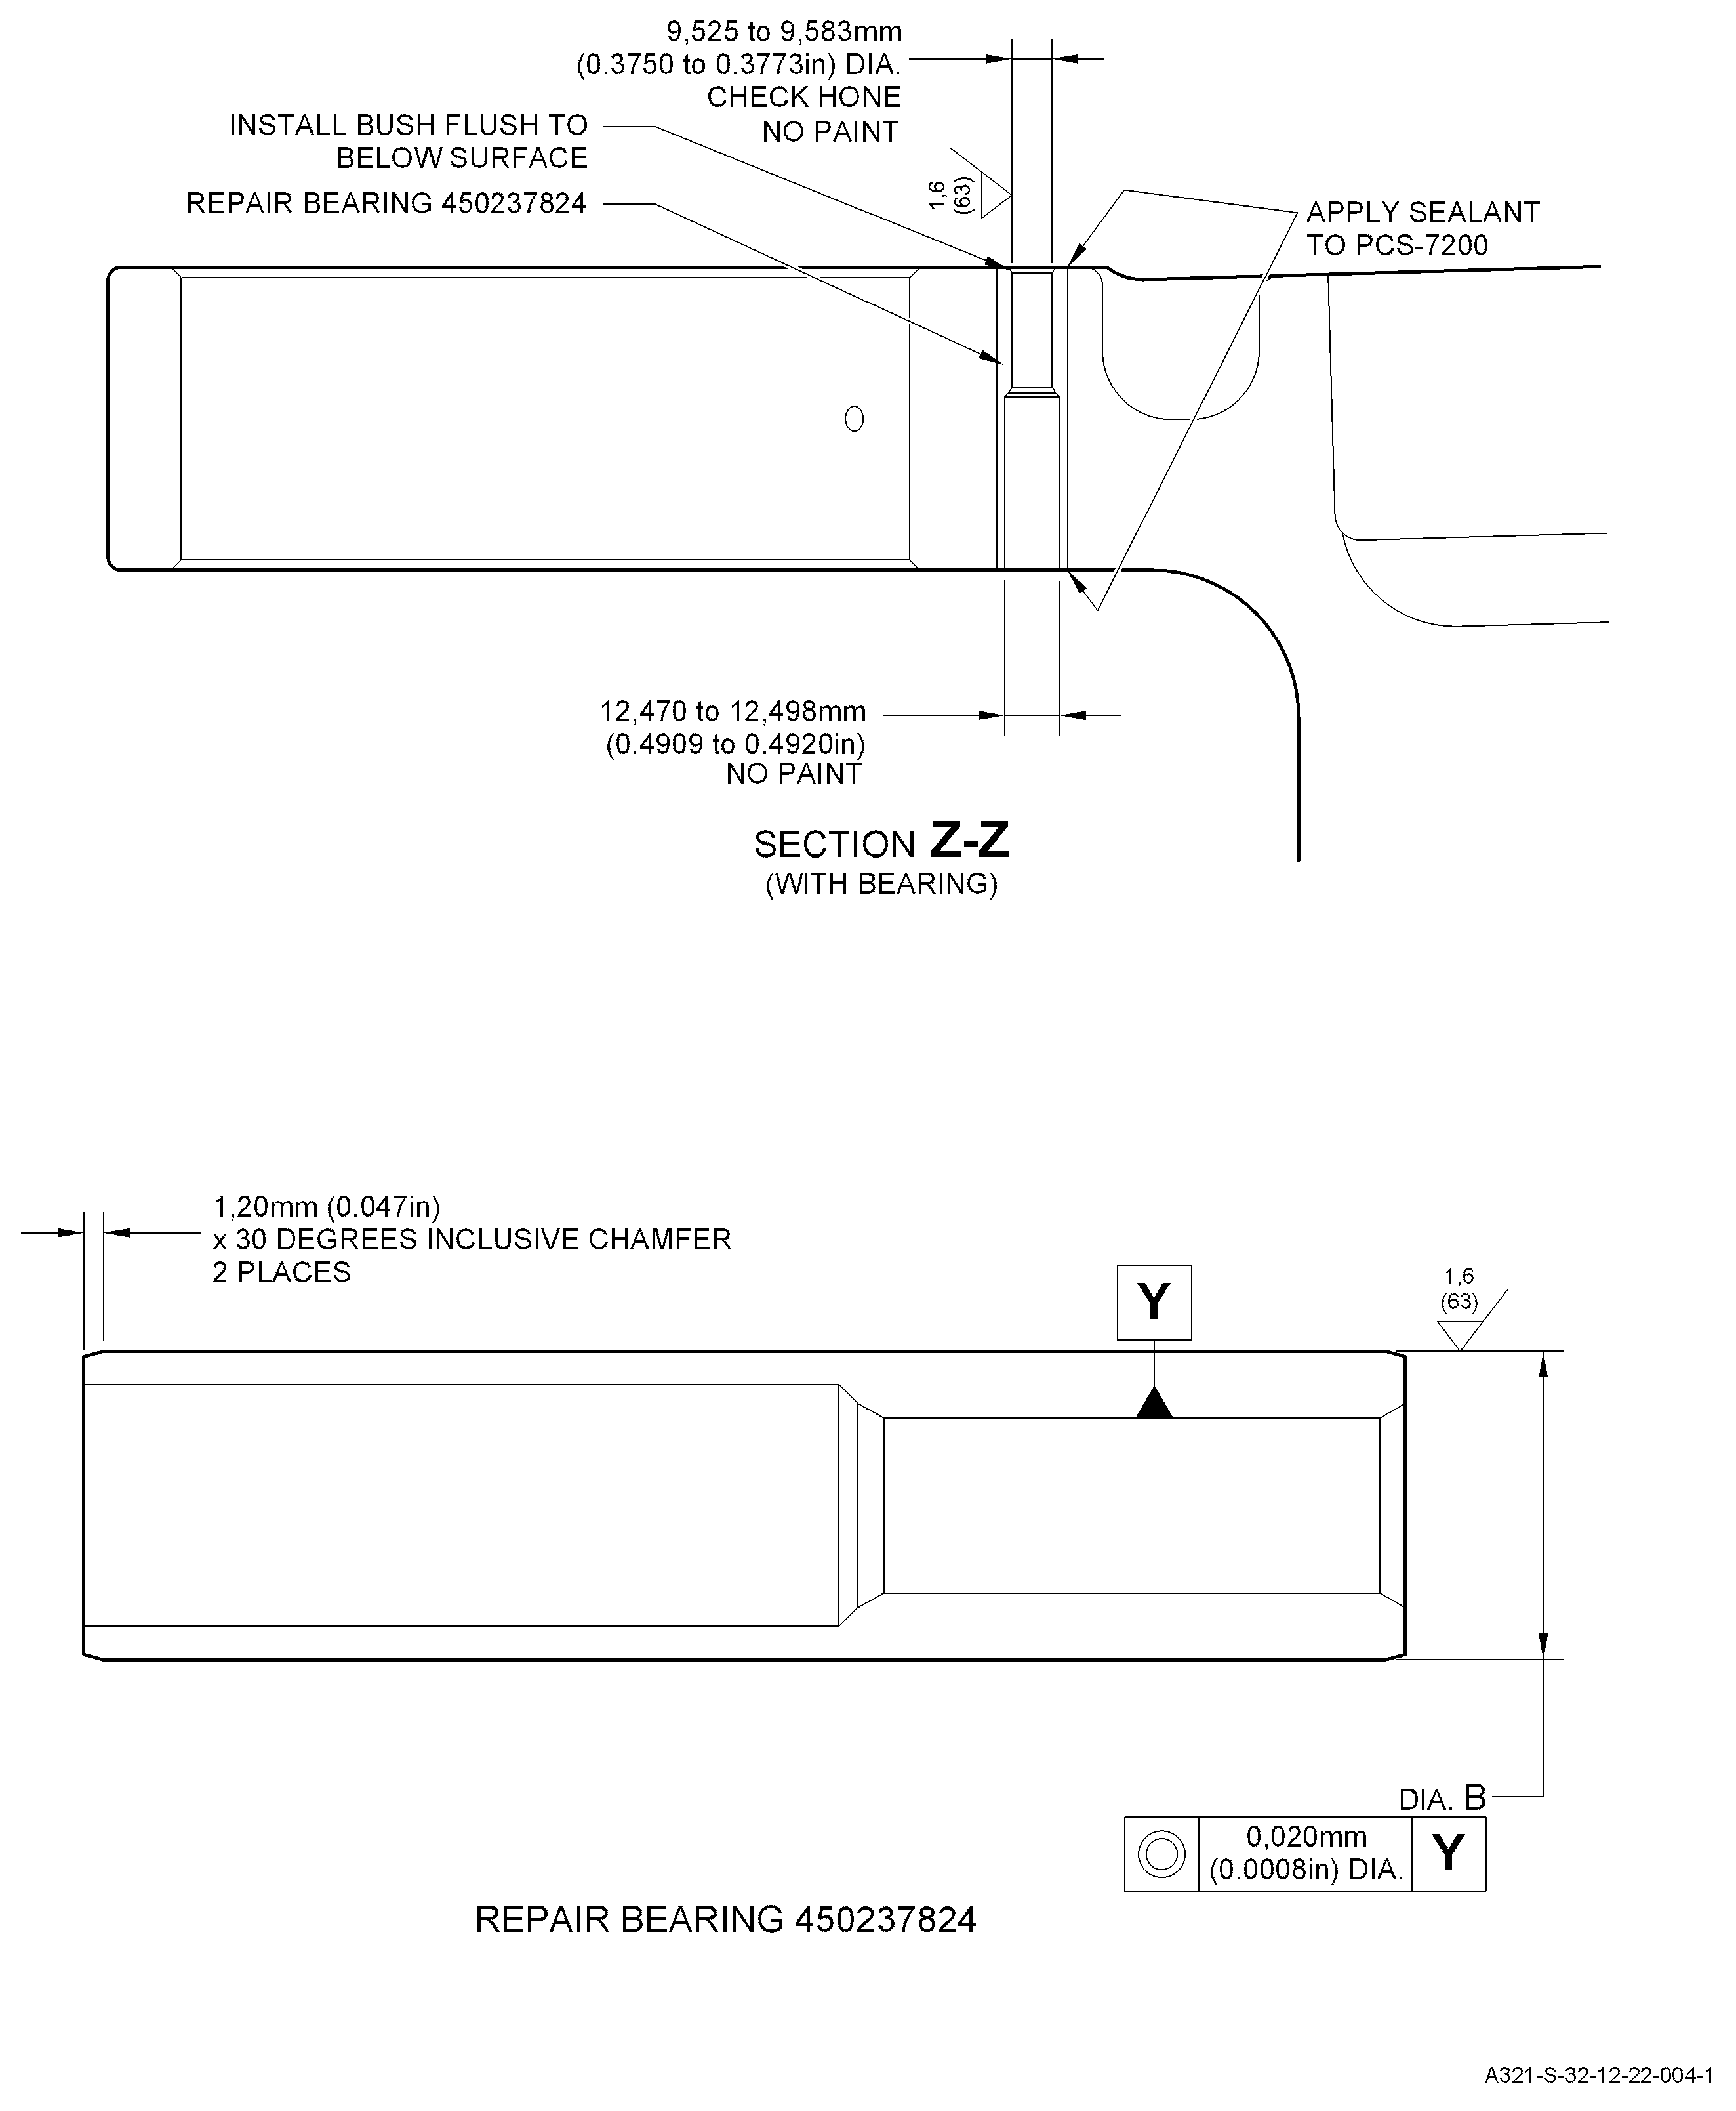
Repair Bearing - Machining and Installation
Figure 602
Repair No. 11-11
32
Page 604
-12-22 Dec 6/2019

SAFRAN LANDING SYSTEMS UK Ltd
CAGE: K0654

PART No. 201587001 AND 201587002 COMPONENT MAINTENANCE MANUAL
MAIN LANDING GEAR LEG

I 1. Repair No. 11-12 Main Fitting (20-410, 20-410A, 20-420 and 20-420A)
- Specified Damage and Material Specification.
- Specified Damage
(a) Damage or wear to the diameter A.
- Material Specification
IPL Figure and  Item No. | Name | Material Specification
20-410, 20-410A,  20-420 and  20-420A | Main fitting | Steel, MAT135, 35NCD16THQ
- Special Tools
(1) These special tools are necessary:
NOTE: Alternative equivalents are permitted.
Part No. | Special Tool | Function
460006265 | Press Pad | Install the bush 450237800
- Materials
(1) These materials are necessary:
NOTE: Alternative equivalents are permitted.
Ref. Item | Material
08-704 | Adhesive
09-510A | Sealant
- Repair Parts
(1) These repair parts are necessary:
Part No. | Repair Part | Material Specification
450237800 | Blank bush | Aluminium Bronze, DTD197
E.
Procedure (Refer to Figures 601 and 602)
CAUTION: FOR DAMAGE MORE THAN THE LIMITS OF THIS REPAIR SCHEME, WRITE
TO SAFRAN LANDING SYSTEMS: REFER TO GUIDE-CS-001.
(1)
(2)
(3)
Remove the paint locally from the main fitting: refer to PCS-2700.
Remove the cadmium plate locally from the main fitting: refer to PCS-2100.
Machine diameter A sufficiently to remove the wear or damage within the dimensions
shown: refer to M-DLPS914, M-DLPS1004-4-1 and Figure 601. Make the surface finish
1,6 micrometers (63 micro-inches) or better.
Repair No. 11-12
32
Page 601
-12-22 Mar 18/2025

sSAFRAN SAFRAN LANDING SYSTEMS UK Ltd
CAGE: K0654
PART No. 201587001 AND 201587002 COMPONENT MAINTENANCE MANUAL
MAIN LANDING GEAR LEG
- Measure and record the new diameter A.
- Examine the main fitting for flaws: refer to PCS-3600 and PCS-3100, inclusion class 4.
- Shot peen the reworked areas: refer to M-DLPS123.
- Identify the part with the Safran Landing Systems repair number 450266035 adjacent to
the part number: refer to PCS-6000-04 or PCS-6000-06.
- Apply cadmium plate to the reworked area: refer to PCS-2100 and PCS-2141. Fadeout
of cadmium plate is permitted in bore.
- Calculate the diameter of the blank bush, use formula:
B = A (as measured) - 0,265 to -0,350 mm (-0.0104 to -0.0138 in).
- Machine the blank bush to the diameter calculated and as shown: refer to Figure 602.
- Apply cadmium plate all over the repair bush: refer to PCS-2101. The cadmium plate
thickness must be between 0,003 and 0,005 mm (0.00015 and 0.00020 in).
- Apply adhesive, Material Ref. Item 08-704, to the outside diameter of the repair bush
and to the hole of the main fitting where you will install the repair bush: refer to
PCS-5303.
- Use Press Pad 460006265 and install the repair bush: refer to Figure 602. The ends of
the bush must be below the main fitting surface after installation.
- Check the bore diameter of the repair bush: refer to Figure 602.
- If necessary, hone the bore diameter of the repair bush to the dimensions shown: refer
to Figure 602.
- Apply sealant, Material Ref. Item 09-510A, to the joints between the repair bush and
main fitting: refer to PCS-7200 and Figure 602.
- Apply paint locally to the repaired area, but not to the repair bush bore: refer to
PCS-2500 and Figure 602.
- Identify the part with the Safran Landing Systems repair number 450266035 adjacent to
the part number: refer to PCS-6000-07.
- Examine the part to make sure that you have obeyed all the repair instructions correctly.
32-12-22
Repair No. 11-12
Page 602
Mar 18/2025

SAFRAN LANDING SYSTEMS UK Ltd
CAGE: K0654
PART No. 201587001 AND 201587002 COMPONENT MAINTENANCE MANUAL
MAIN LANDING GEAR LEG
Z
Z
14,25mm (0.5610in) REF.
section Z-Z
(WITHOUT BUSH)
1,00mm (0.039in)
x 45 DEGREES
CHAMFER
(2 PLACES)
dia. A
21,50mm
(0.8465in)
MAXIMUM
NO PAINT
69,75 to 71,75mm
(2.7461 to 2.8248in)
A321-S-32-12-22-036-1
Repair to Main Fitting - Machining
Figure 601
Repair No. 11-12
32-12-22
Page 603
Dec 6/2019
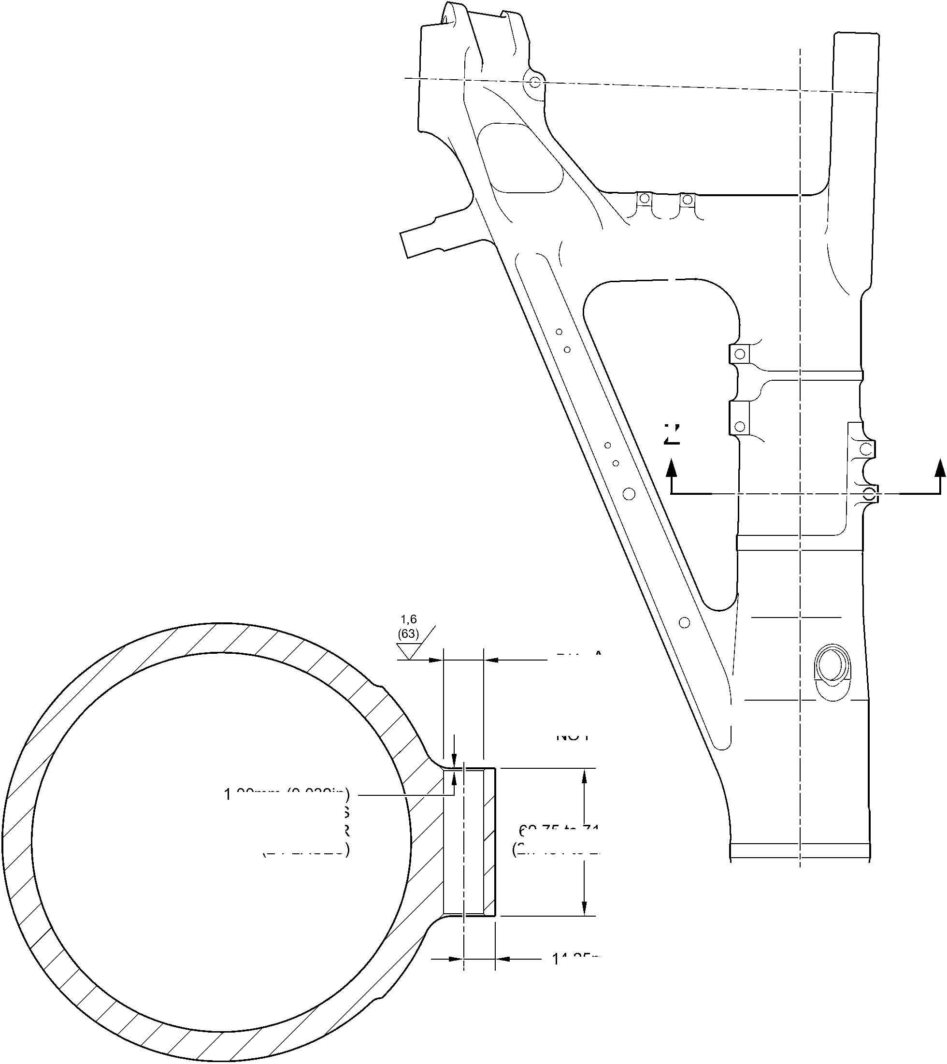

SAFRAN LANDING SYSTEMS UK Ltd
CAGE: K0654

PART No. 201587001 AND 201587002 COMPONENT MAINTENANCE MANUAL
MAIN LANDING GEAR LEG
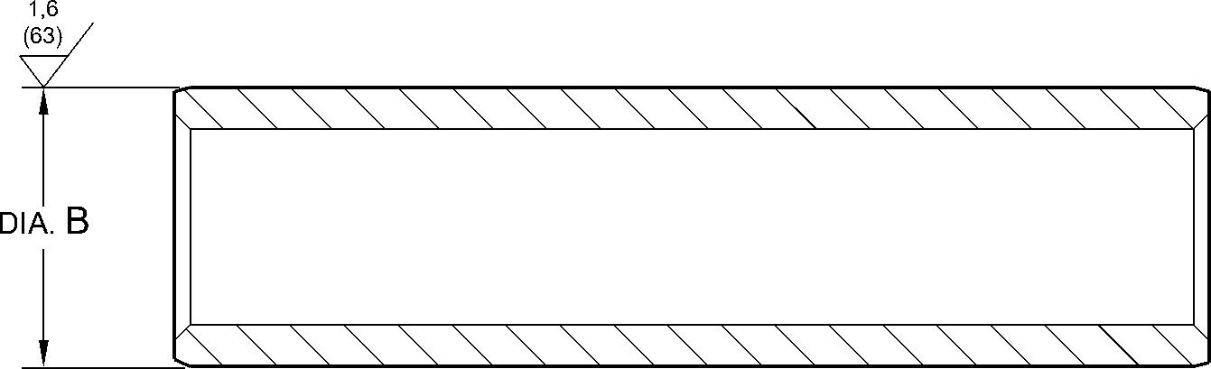
1,20mm (0.047in)
x 30 DEGREES INCLUSIVE CHAMFER
BOTH ENDS
REPAIR BUSH 450237800
1,6
APPLY SEALANT
TO PCS-7200
REPAIR
BUSH
450237800
16,50mm (0.650in) DIA.
CHECK HONE
NO PAINT
APPLY SEALANT
TO PCS-7200
section Z-Z
(REFER TO FIGURE 601)
WITH REPAIR BUSH
A321-S-32-12-22-037-1
Repair Bush - Machining and Installation
Figure 602
32-12-22
Repair No. 11-12
Page 604
Dec 6/2019
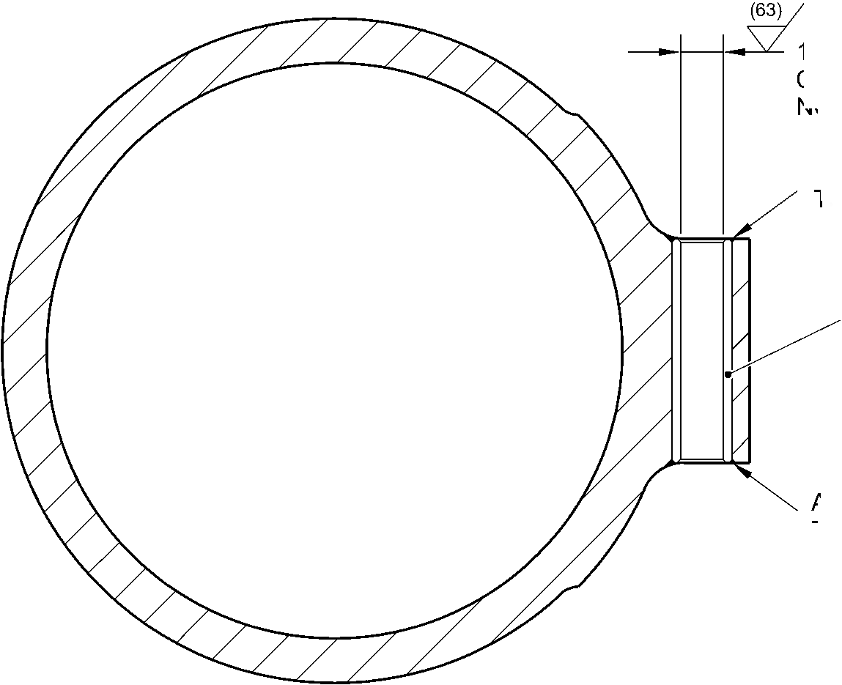

sSAFRAN SAFRAN LANDING SYSTEMS UK Ltd
CAGE: K0654
PART No. 201587001 AND 201587002 COMPONENT MAINTENANCE MANUAL
MAIN LANDING GEAR LEG

I 1. Repair No. 11-13 Main Fitting (20-410, 20-410A, 20-420 and 20-420A)
- Specified Damage and Material Specification.
- Specified Damage
(a) Damage or corrosion to the diameters A and/or B and/or adjacent internal faces.
- Material Specification
IPL Figure and  Item No. | Name | Material Specification
20-410, 20-410A,  20-420 and  20-420A | Main fitting | Steel, MAT135, 35NCD16THQ
- Special Tools
- These special tools are necessary:
NOTE: Alternative equivalents are permitted.
Part No. | Special Tool | Function
460006600 | Press Pad Assembly | Install the repair bush 450237810
460006601 | Alignment Bar | Use with Press Pad 460006600
460006602 | Cutter | To get the correct dimension across  the repair bushes
460006603 | Press Pad Assembly | Install the bush made from  450237811
460006604 | Guide Bush | Use with Press Pad 460006603
- Materials
- These materials are necessary:
NOTE: Alternative equivalents are permitted.
Ref. Item | Material
TBA | Mastinox, D40
TBA | Zinc Powder
09-510A | Sealant
Repair No. 11-13
32-12-22
Page 601
Mar 18/2025

sSAFRAN SAFRAN LANDING SYSTEMS UK Ltd
CAGE: K0654
PART No. 201587001 AND 201587002 COMPONENT MAINTENANCE MANUAL
MAIN LANDING GEAR LEG
- Repair Parts
(1) These repair parts are necessary:
Part No. | Repair Part | Material Specification
450237810 | Blank Bush | Aluminium Bronze, DTD197 or  AMS4-880C
450237811 | Blank Bush  (Refer to Table 1 for  oversize bushes) | Steel, S132
- Procedure (Refer to Figures 601 and 602)
- Machine diameters A and/or B sufficiently to remove the damage or corrosion within the
dimensions shown: refer to M-DLPS1004-4-1 and Figure 601. Make the surface finish
1,6 micrometers (63 micro-inches).
- Machine the adjacent internal faces sufficiently to remove the damage or corrosion
within the dimensions shown: refer to M-DLPS1004-4-1 and Figure 601. Make the
surface finish 1,6 micrometers (63 micro-inches).
- Machine the radii and chamfers to the dimensions shown: refer to Figure 601.
- Measure and record the new diameters A and B and dimensions D and E.
- Examine the main fitting for flaws: refer to PCS-3600 and PCS-3100, inclusion class 4.
- Shot peen the machined areas: refer to M-DLPS123.
- Apply cadmium plate to the reworked areas: refer to PCS-2141.
- Identify the part with the Safran Landing Systems repair number 450266050 adjacent to
the part number: refer to PCS-6000-04 or PCS-6000-06. If the PCS-6000-06 is used, the
letters must have a depth of 0,051 to 0,102 mm (0.0020 to 0.0040 in) and an
approximate height of 3,00 mm (0.118 in).
- Calculate the dimensions to machine the repair bush 450237810 for diameter A:
F = A (as measured) + 0,023 to 0,072 mm (0.0009 to 0.0028 in),
G = D (as measured) + 0,65 to 1,35 mm (0.026 to 0.053 in).
- Machine the repair bush 450237810 to the dimensions shown and calculated: refer to
Figure 602. Make the surface finish 1,6 micrometers (63 micro-inches).
- With the measured dimension E, select the applicable oversize bush from Table 1.
- Calculate the diameter of the oversize bush for diameter B:
H = B (as measured) + 0,023 to 0,072 mm (0.0009 to 0.0028 in).
- Machine the oversize bush to the dimensions shown and calculated: refer to Figure 602.
Make the surface finish 1,6 micrometers (63 micro-inches).
- If necessary machine the flange face of the repair bush (450237810) to get the correct
dimension between the bush faces on assembly as shown: refer to Figure 602.
- Restore the chamfers to the dimensions as shown: refer to Figure 602.
32-12-22
Repair No. 11-13
Page 602
Mar 18/2025

sSAFRAN SAFRAN LANDING SYSTEMS UK Ltd
CAGE: K0654
PART No. 201587001 AND 201587002 COMPONENT MAINTENANCE MANUAL
MAIN LANDING GEAR LEG
- Apply cadmium plate all over the repair bush (450237810) and only to the reworked
areas of selected oversize bush: refer to PCS-2101 and PCS-2141. Do not apply
cadmium plate to the bush bores. Make the cadmium plate thickness between 0,010
and 0,015 mm (0.0004 to 0.0006 in).
- Use press pad assembly 460006600 and alignment bar 460006601 and install the repair
bush. Use press pad assembly 460006603, alignment bar 460006601 and guide bush
460006604 and install the oversize bush: refer to M-DLPS1011-20. Use electrically
conducting mastinox (make from Mastinox D40, Material Ref. Item TBA and Zinc
powder, Material Ref. Item TBA): refer to M-DLPS709-14.
- Check line ream the repair bushes to the dimensions shown: refer to Figure 602.
- Apply sealant, Material Ref. Item 09-510A to the joints between the repair bushes and
the main fitting: refer to PCS-7200 and Figure 602.
- Identify the main fitting with the Safran Landing Systems repair number 450266050
adjacent to the part number: refer to PCS-6000-07.
- Examine the part to make sure that you have obeyed all the repair instructions correctly.
Table 1
Oversize Bushes For Diameter B
Oversize | Step  mm (in) | Oversize  Bush | Dimension E  (as measured)  mm (in) | Dimension J  mm (in)
- | Std | 450237351 | 27,75 to 28,25  (1.093 to 1.112) | 2,45 to 2,55  (0.096 to 0.100)
1 | 0,127  (0.005) | 450237352 | 27,62 to 28,12  (1.087 to 1.107) | 2,58 to 2,68  (0.102 to 0.106)
2 | 0,254  (0.010) | 450237353 | 27,50 to 28,00  (1.083 to 1.102) | 2,70 to 2,80  (0.106 to 0.110)
3 | 0,381  (0.015) | 450237354 | 27,37 to 27,87  (1.078 to 1.097) | 2,83 to 2,93  (0.111 to 0.115)
4 | 0,508  (0.020) | 450237355 | 27,24 to 27,74  (1.072 to 1.092) | 2,96 to 3,06  (0.117 to 0.120)
Repair No. 11-13
32-12-22
Page 603
Mar 18/2025

SAFRAN LANDING SYSTEMS UK Ltd
CAGE: K0654

PART No. 201587001 AND 201587002 COMPONENT MAINTENANCE MANUAL
MAIN LANDING GEAR LEG
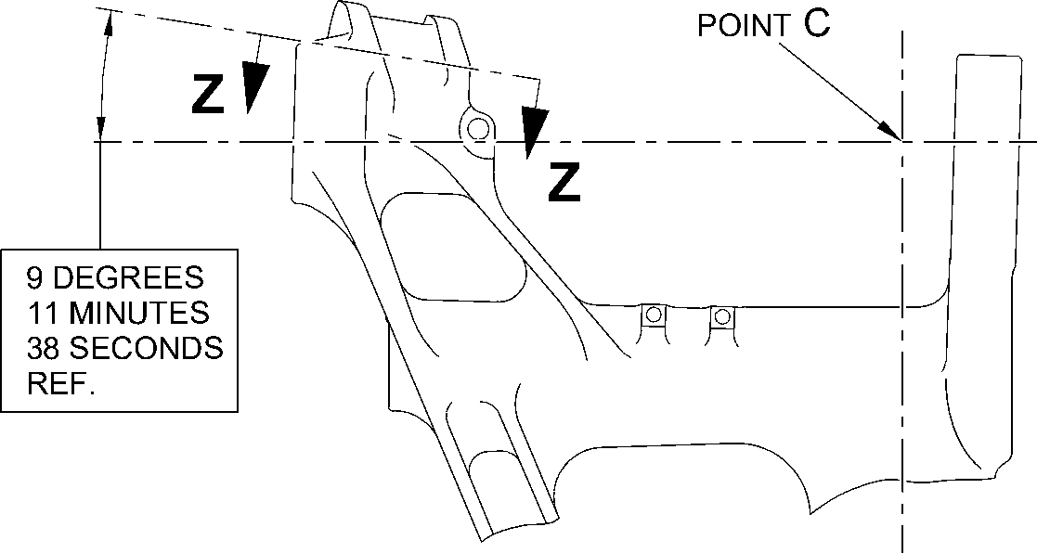
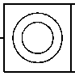
0,05mm
(0.002in) DIA.
dim. C
62,760mm
(2.4709in)
MAX.
14,515mm (0.5714in)
MIN. WALL THICKNESS
DIA. A
58,13mm (2.2886in) MAXIMUM
262,01mm (10.315in)
to point 'C'
8 DEGREES 13 MINUTES
17 SECONDS
REF.
dim. D
27,25mm (1.072in)
MIN.
BLEND SMOOTHLY
TO EXISTING RADIUS
4,00 to 5,00mm
(0.157 to 0.197in) RAD.
1,25 to 1,75mm (0.049 to 0.069in)
x 45 DEGREES CHAMFER
dim. E
27,25mm (1.072in)
MIN.
PART SECTION Z-Z
WITHOUT BUSHES
1,00 to 2,00mm
(0.039 to 0.079in)
RAD.
dia. B
59,130mm (2.3279in)
MAX.
A321-S-32-12-22-100-0
Repair to Main Fitting
Figure 601
32-12-22
Repair No. 11-13
Page 604
Dec 8/2017
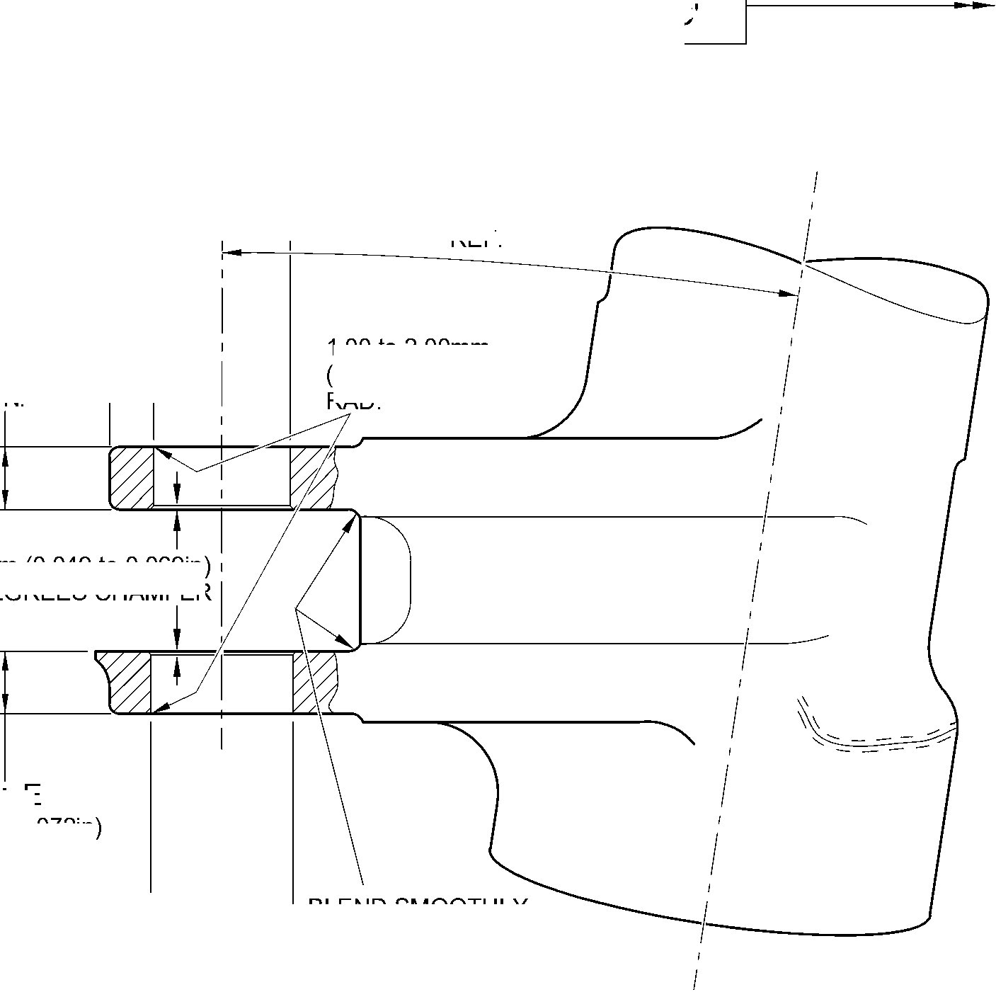

SAFRAN LANDING SYSTEMS UK Ltd
CAGE: K0654

PART No. 201587001 AND 201587002 COMPONENT MAINTENANCE MANUAL
MAIN LANDING GEAR LEG
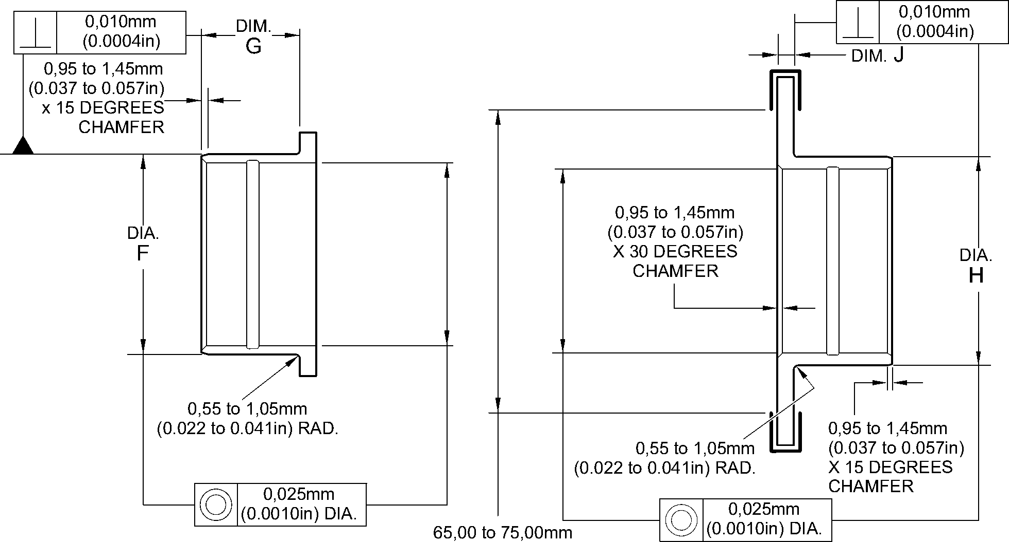
OVERSIZE BUSH 450237810 (2.559 to 2.953in) DIA. OVERSIZE BUSH
(REFER TO TABLE 1)
NITRIDING DEPTH 0,18 to 0,23mm (0.007 to 0.009in), 0,02 to 0,04mm (0.0008 TO
0.0016in) REMOVAL OVER AREA SHOWN 750HV MIN. ^^^^
NOTE: REPAIR BUSHES 450237351, 450237352, 450237353, 450237354 AND 450237355
ARE TO BE NITRIDED BEFORE DESPATCH TO OVERHAUL AGENCY.
DIAMETER H AND CORNER RADIUS ARE TO BE MACHINED ON RECEIPT
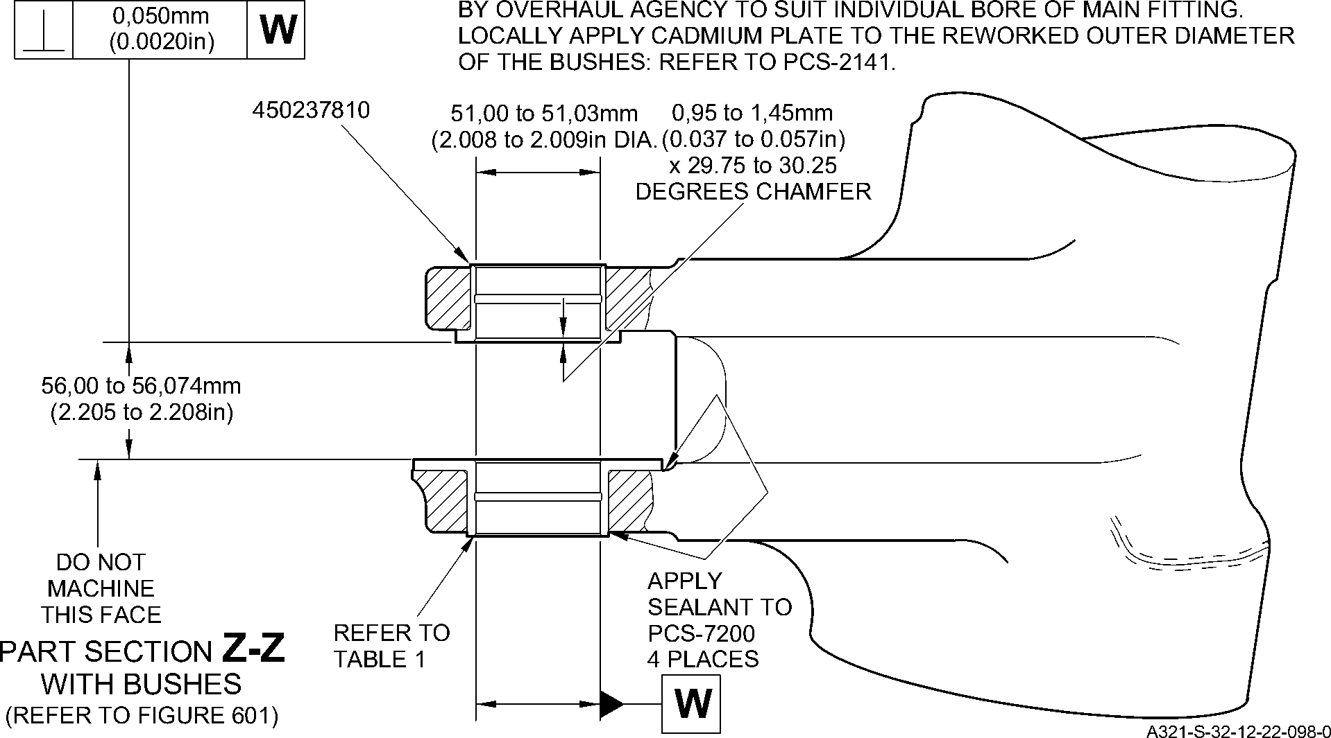
Repair Bushes - Machining and Installation
Figure 602
Repair No. 11-13
32-12-22
Page 605
Dec 8/2017

SAFRAN LANDING SYSTEMS UK Ltd
CAGE: K0654

PART No. 201587001 AND 201587002 COMPONENT MAINTENANCE MANUAL
MAIN LANDING GEAR LEG
INTENTIONALLY BLANK
Repair No. 11-13
32-12-22 ^{Page 606}

SAFRAN LANDING SYSTEMS UK Ltd
CAGE: K0654

PART No. 201587001 AND 201587002 COMPONENT MAINTENANCE MANUAL
MAIN LANDING GEAR LEG

I 1. Repair No. 11-14 Main Fitting (20-410, 20-410A, 20-420 and 20-420A)
- Specified Damage and Material Specification.
- Specified Damage
(a) Damage or corrosion to the diameter A and/or adjacent faces B.
- Material Specification
IPL Figure and  Item No. | Name | Material Specification
20-410, 20-410A,  20-420 and  20-420A | Main fitting | Steel, MAT135, 35NCD16THQ
- Special Tools
- Special tools are not necessary.
- Materials
- These materials are necessary:
NOTE: Alternative equivalents are permitted.
Ref. Item | Material
TBA | Mastinox, D40
TBA | Zinc Powder
09-510A | Sealant
- Repair Parts
- These repair parts are necessary:
Part No. | Repair Part | Material Specification
Refer to Table 1 for oversize bearing
- Procedure (Refer to Figure 601)
- Machine the diameter A to the smallest oversize shown in Table 1 to remove the
damage or corrosion: refer to M-DLPS1004-4-1 and Figure 601. Do not make diameter
A more than 167,587 mm (6.598 in). Make the surface finish 1,6 micrometers
(63 micro-inches).
- Machine the face(s) B, sufficiently only to remove the damage or corrosion within the
dimensions shown: refer to M-DLPS1004-4-1 and Figure 601. Do not machine more
than 0,75 mm (0.0295 in) from each of the faces. Make the surface finish
1,6 micrometers (63 micro-inches).
- Machine the radii and chamfers to the dimensions shown: refer to Figure 601.
- Examine the main fitting for flaws: refer to PCS-3600 and PCS-3100, inclusion class 4.
Repair No. 11-14
32-12-22
Page 601
Mar 18/2025

SAFRAN LANDING SYSTEMS UK Ltd
CAGE: K0654

PART No. 201587001 AND 201587002 COMPONENT MAINTENANCE MANUAL
MAIN LANDING GEAR LEG
- Shot peen the machined area: refer to M-DLPS123.
- Apply cadmium plate locally to the reworked area: refer to PCS-2141.
- Use the selected spherical bearing assembly in the place of (19-50): refer to
ASSEMBL .
- Identify the part with the Safran Landing Systems repair number 450266110 adjacent to
the part number: refer to PCS-6000-07.
- Examine the part to make sure that you have obeyed all the repair instructions correctly.
Table 1
Oversize | Step  mm (in) | Diameter A  mm (in) | Housing O/D (Ref.)  mm (in) | Oversize Bearing  Assembly
- | Std | 166,000 to 166,063  (6.5354 to 6.5378) | 165,934 to165,959  (6.5328 to 6.5337) | -
1 | 0,127  (.005) | 166,127 to 166,190  (6.5404 to 6.5428) | 166,061 to166,086  (6.5378 to 6.5387) | 450258301
2 | 0,254  (.010) | 166,254 to 166,317  (6.5454 to 6.5478) | 166,188 to 166,213  (6.5428 to 6.5437) | 450258302
3 | 0,381  (.015) | 166,381 to 166,444  (6.5504 to 6.5528) | 166,315 to 166,340  (6.5478 to 6.5487) | 450258303
4 | 0,508  (.020) | 166,508 to 166,571  (6.5554 to 6.5578) | 166,442 to 166,467  (6.5528 to 6.5537) | 450258304
5 | 0,635  (.025) | 166,635 to 166,698  (6.5604 to 6.5628) | 166,569 to 166,594  (6.5578 to 6.5587) | 450258305
6 | 0,762  (.030) | 166,762 to 166,825  (6.5654 to 6.5678) | 166,696 to 166,721  (6.5628 to 6.5637) | 450258306
7 | 0,889  (.035) | 166,889 to 166,952  (6.5704 to 6.5728) | 166,823 to 166,848  (6.5678 to 6.5687) | 450258307
8 | 1,016  (.040) | 167,016 to 167,079  (6.5754 to 6.5778) | 166,950 to 166,975  (6.5728 to 6.5737) | 450258308
9 | 1,143  (.045) | 167,143 to 167,206  (6.5804 to 6.5828) | 167,077 to 167,102  (6.5778 to 6.5787) | 450258309
10 | 1,270  (.050) | 167,270 to 167,333  (6.5854 to 6.5878) | 167,204 to 167,229  (6.5828 to 6.5837) | 450258310
11 | 1,397  (.055) | 167,397 to 167,460  (6.5904 to 6.5928) | 167,331 to 167,356  (6.5878 to 6.5887) | 450258311
12 | 1,524  (.060) | 167,524 to 167,587  (6.5954 to 6.5978) | 167,458 to 167,483  (6.5928 to 6.5937) | 450258312
32-12-22
Repair No. 11-14
Page 602
Mar 18/2025

SAFRAN LANDING SYSTEMS UK Ltd
CAGE: K0654

PART No. 201587001 AND 201587002 COMPONENT MAINTENANCE MANUAL
MAIN LANDING GEAR LEG
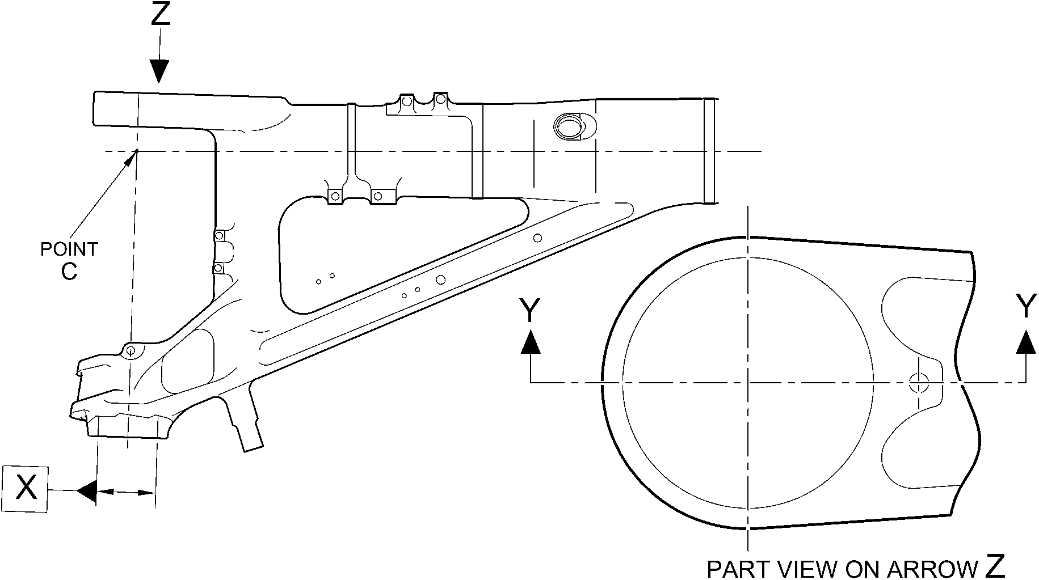
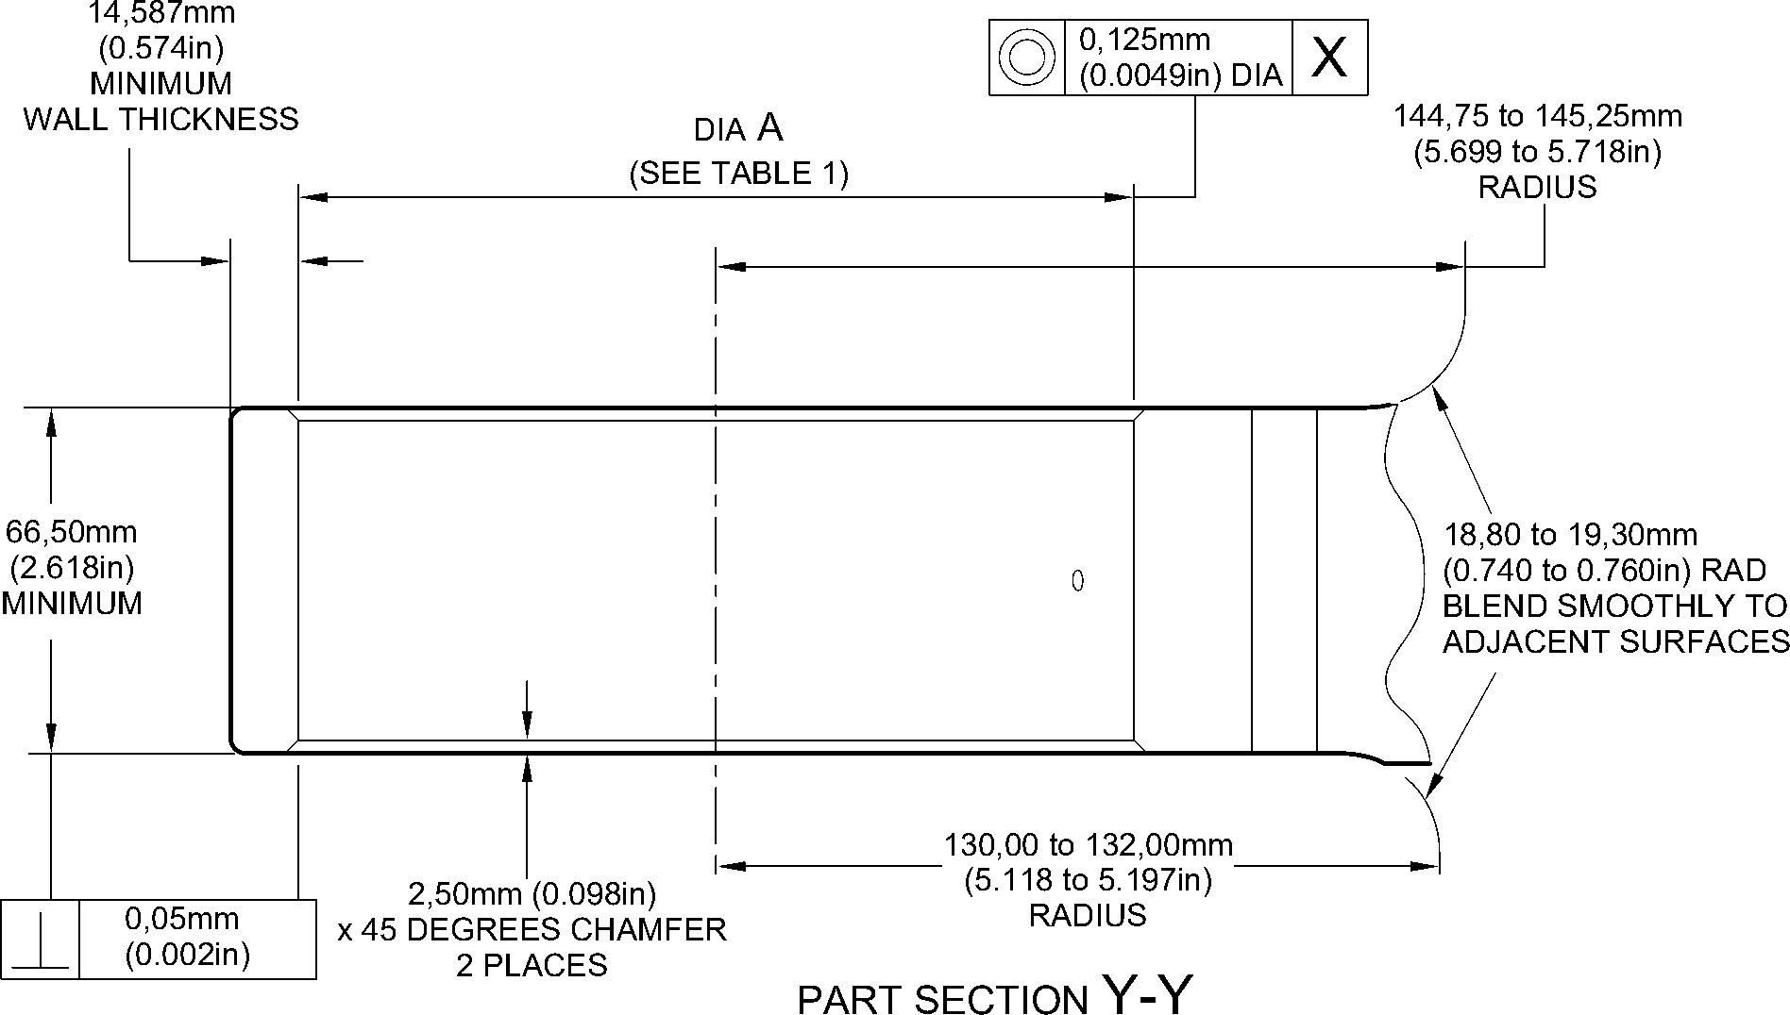
A321A5543-1
(WITHOUT OVERSIZE BEARING)
Repair to Main Fitting - Machining
Figure 601
Repair No. 11-14
32-12-22
Page 603
Dec 6/2019

SAFRAN LANDING SYSTEMS UK Ltd
CAGE: K0654

PART No. 201587001 AND 201587002 COMPONENT MAINTENANCE MANUAL
MAIN LANDING GEAR LEG
INTENTIONALLY BLANK
Repair No. 11-14
32-12-22 ^{Page 604}

sSAFRAN SAFRAN LANDING SYSTEMS UK Ltd
CAGE: K0654
PART No. 201587001 AND 201587002 COMPONENT MAINTENANCE MANUAL
MAIN LANDING GEAR LEG

I 1. Repair No. 11-15 Main Fitting (20-410 and 20-420 Only)
- Specified Damage and Material Specification.
- Specified Damage
(a) Damage or corrosion to the diameter(s) A and/or adjacent faces B and/or C.
- Material Specification
IPL Figure and  Item No. | Name | Material Specification
20-410 and  20-420 Only | Main fitting | Steel, MAT135, 35NCD16THQ
- Special Tools
- Special tools are not necessary.
- Materials
- These materials are necessary:
NOTE: Alternative equivalents are permitted.
Ref. Item | Material
TBA | Mastinox, D40
TBA | Zinc Powder
08-665 | Adhesive
09-510A | Sealant
- Repair Parts
- These repair parts are necessary:
Part No. | Repair Part | Material Specification
450237825 | Repair Bush (Qty 4) | Steel, S154
- Procedure (Refer to Figures 601 to 603).
CAUTION: REPAIR WILL NOT BE PERMITTED BEYOND THE LIMITS OF THIS REPAIR
SCHEME.
CAUTION: USE THIS PROCEDURE IF THE DAMAGE OR CORROSION TO FACES B
OR C IS MORE THAN A DEPTH OF 0,75 MM (0.030 IN).
- Remove the paint locally from the main fitting: refer to PCS-2700.
- Remove the cadmium plate locally from the main fitting: refer to PCS-2100.
- Machine diameter A sufficiently to remove the damage or corrosion: refer to
M-DLPS1004-4-1 and Figure 602. Diameter(s) A must be between 9,60 and 10,00 mm
(0.378 and 0.394 in). Make the surface finish 1,6 micrometers (63 micro-inches).
Repair No. 11-15
32-12-22
Page 601
Dec 4/2020

sSAFRAN SAFRAN LANDING SYSTEMS UK Ltd
CAGE: K0654
PART No. 201587001 AND 201587002 COMPONENT MAINTENANCE MANUAL
MAIN LANDING GEAR LEG
- Machine the faces B and/or C sufficiently to remove the damage or corrosion: refer to
Figure 602. Do not remove more than 1,0 mm (0.040 in) from each of the faces. Lug
width D must not be less than 8,75 mm (0.344 in). Make the surface finish
1,6 micrometers (63 micro-inches).
- Machine the radii as shown: refer to Figure 602.
- Measure and record the new diameters A.
- Examine the main fitting for flaws: refer to PCS-3600 and PCS-3100, inclusion class 4.
- Shot peen the machined areas: refer to M-DLPS123.
- Apply cadmium plate to the reworked areas: refer to PCS-2100 or PCS-2141.
- Identify the part with the Messier-Dowty Limited repair number 450267230 adjacent to
the part number: refer to PCS-6000-04.
- Calculate the diameter of each repair bush, use formula:
E = A (as measured) + 0,008 to 0,032 mm (0.0004 to 0.0012 in).
- Machine the repair bush(es) to the diameter(s) calculated and as shown. Machine the
face F to get the correct dimensions after installation: refer to Figure 603.
- Apply cadmium plate all over the repair bushes: refer to PCS-2101 or PCS-2141. The
cadmium plate thickness must be between 0,010 and 0,015 mm (0.0004 and 0.0006 in).
- Apply primer paint to main fitting, where the bush flanges will touch: refer to PCS-2500.
- Apply zinc loaded mastinox (made from Mastinox D40, Material Ref. Item TBA and Zinc
Powder, Material Ref. Item TBA) to the inner side of bush flanges. Apply adhesive,
Material Ref. Item 08-665 to the machined diameter of bushes: refer to PCS-5303.
- Install the repair bushes: refer to M-DLPS1011-5, M-DLPS1011-20 and Figure 603.
- If necessary, machine the bush flange faces and bores to get the dimensions as shown:
refer to Figure 603.
- If necessary, apply cadmium plate to the reworked area of repair bushes: refer to
PCS-2141.
- Apply sealant Material Ref. Item 09-510A to the joints between the repair bushes and
the main fitting: refer to PCS-7200.
- Apply paint to the repaired area: refer to REPAIR and PCS-2500.
- Identify the part with the Messier-Dowty Limited repair number 450267230 adjacent to
the part number: refer to PCS-6000-07.
- Examine the part to make sure that you have obeyed all the repair instructions correctly.
32-12-22
Repair No. 11-15
Page 602
Dec 6/2019

SAFRAN LANDING SYSTEMS UK Ltd
CAGE: K0654

PART No. 201587001 AND 201587002 COMPONENT MAINTENANCE MANUAL
MAIN LANDING GEAR LEG
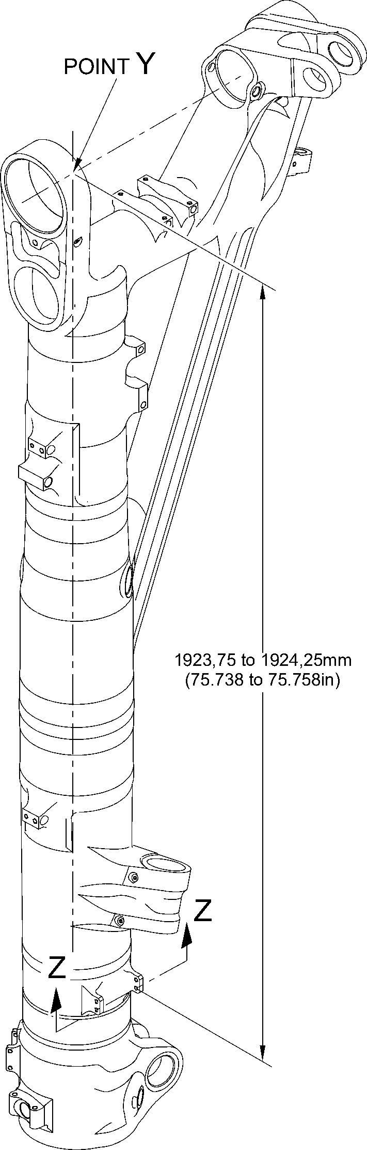
A321A5549-1
Repair to Main Fitting
Figure 601
Repair No. 11-15
32-12-22
Page 603
Dec 6/2019

SAFRAN LANDING SYSTEMS UK Ltd
CAGE: K0654

PART No. 201587001 AND 201587002 COMPONENT MAINTENANCE MANUAL
MAIN LANDING GEAR LEG
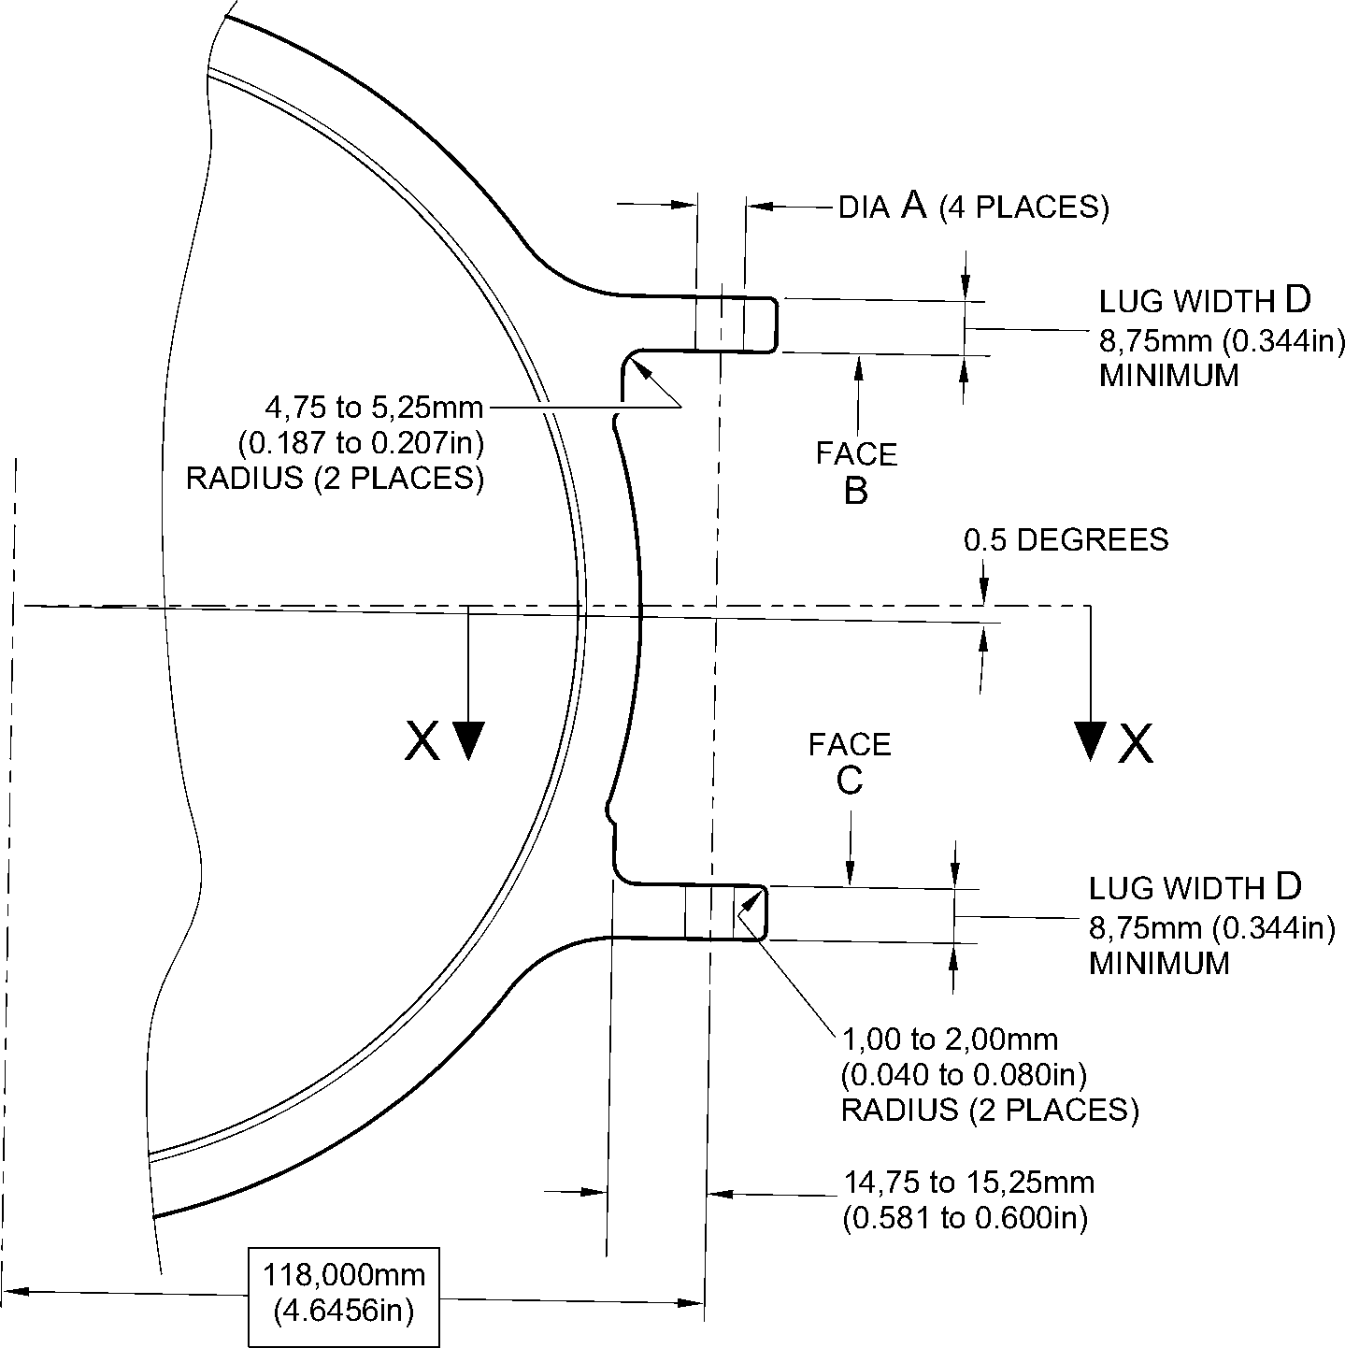
section Z-Z
(WITHOUT BUSHES)
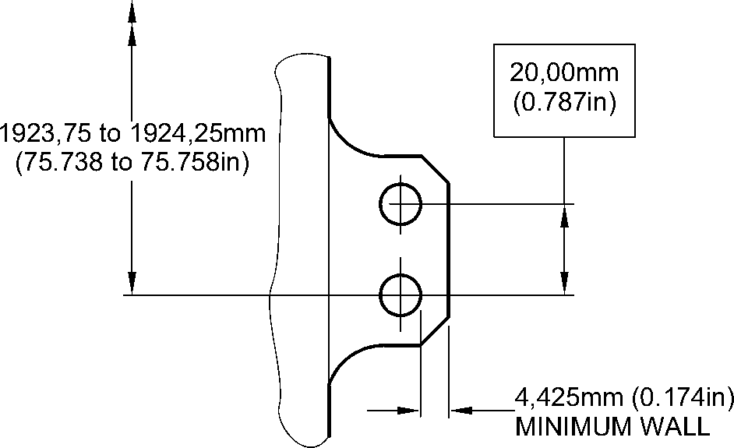
section X-X
(WITHOUT BUSHES)
A321A5550-2
Repair to Main Fitting - Machining
Figure 602
32-12-22
Repair No. 11-15
Page 604
Dec 6/2019

SAFRAN LANDING SYSTEMS UK Ltd
CAGE: K0654

PART No. 201587001 AND 201587002 COMPONENT MAINTENANCE MANUAL
MAIN LANDING GEAR LEG
0,25 to 0,75mm
(0.010 to 0.030in)
RADIUS

i 1,00mm(0.040in)
X 15 DEGREES
t CHAMFER
faCe F
dia E
REPAIR BUSH 450237825
0,030mm
(0.012in)
REPAIR BUSH
450237825
(4 PLACES)
8,00 to 8,15mm (0.315 to 0.321in)
DIAMETER
M-DLPS1011-5 and
M-DLPS709-6
(4 PLACES)
M-DLPS1011-20
(4 PLACES)
1,00 to 2,00mm
(0.040 to 0.080in)
RADIUS
(8 PLACES)
section Z-Z
(WITH BUSHES)
9,75 to 10,25mm
(0.384 to 0.404in)
102,00 to 102,127mm
(4.016 to 4.021in)
9,75 to 10,25mm
(0.384 to 0.404in)
FLANGES OF REPAIR
BUSHES MAY BE
LOCALLY REMOVED
IF NECESSARY
section X-X
(WITH BUSHES)
A321A5551-1
Repair Bush - Machining and Installation
Figure 603
Repair No. 11-15
32-12-22
Page 605
Dec 6/2019
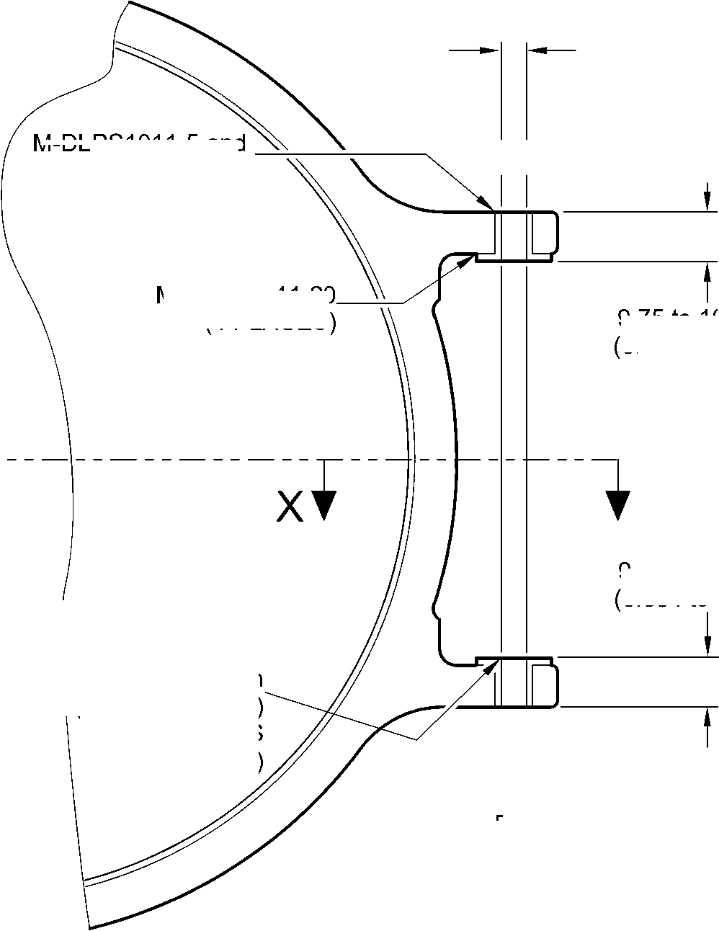
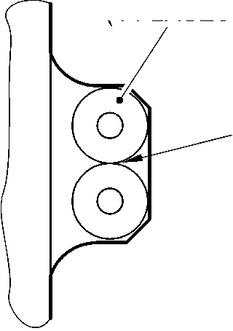

SAFRAN LANDING SYSTEMS UK Ltd
CAGE: K0654

PART No. 201587001 AND 201587002 COMPONENT MAINTENANCE MANUAL
MAIN LANDING GEAR LEG
INTENTIONALLY BLANK
Repair No. 11-15
32-12-22 ^{Page 606}

SAFRAN LANDING SYSTEMS UK Ltd
CAGE: K0654

PART No. 201587001 AND 201587002 COMPONENT MAINTENANCE MANUAL
MAIN LANDING GEAR LEG

I 1. Repair No. 11-16 Main Fitting (20-410 and 20-420 Only)
- Specified Damage and Material Specification.
- Specified Damage
(a) Damage or corrosion to the chromium plate on diameter A and/or diameter B.
- Material Specification
IPL Figure and  Item No. | Name | Material Specification
20-410 and  20-420 Only | Main fitting | Steel, MAT135, 35NCD16THQ
- Special Tools
- Special tools are not necessary.
- Materials
- Materials are not necessary.
- Repair Parts
- Repair parts are not necessary.
- Procedure (Refer to Figure 601)
CAUTION: REPAIR WILL NOT BE PERMITTED BEYOND THE LIMITS OF THIS REPAIR
SCHEME.
- Chemically remove the chromium plate from diameters A and/or B: refer to PCS-2110
and Figure 601.
- Examine the base metal for damage or corrosion:
- If there is no damage or corrosion to the base metal proceed with the repair.
- If there is damage or corrosion to the base metal, use another applicable repair or
apply for a concession.
CAUTION: DO NOT USE A MECHANICAL MOP POLISHER TO GET THE SURFACE
FINISH.
CAUTION: DO NOT USE HARD CHROMIUM PLATING TO DIAMETERS A AND B.
(3)
(4)
(5)
(6)
Apply flash chromium plate to diameters A and/or B to a thickness of between 0,0075
and 0,0125 mm (0.0003 and 0.0005 in): refer to PCS-2110, type C. The new diameters
must be:
Diameter A = 212,000 to 212,072 mm (8.3465 to 8.3493 in) with a surface finish of
1,6 micrometers (64 micro-inches)
Diameter B = 208,890 to 208,966 mm (8.2240 to 8.2270 in) with a surface finish of
0,8 micrometers (32 micro-inches).
Examine the reworked area for flaws: refer to PCS-3100, inclusion class 4.
Identify the part with the Messier-Dowty Limited repair number 450237690 adjacent to
the part number: refer to PCS-6000-04.
Examine the part to make sure that you have obeyed all the repair instructions correctly.
Repair No. 11-16
32-12-22
Page 601
Dec 4/2020

SAFRAN LANDING SYSTEMS UK Ltd
CAGE: K0654

PART No. 201587001 AND 201587002 COMPONENT MAINTENANCE MANUAL
MAIN LANDING GEAR LEG
Z
Z
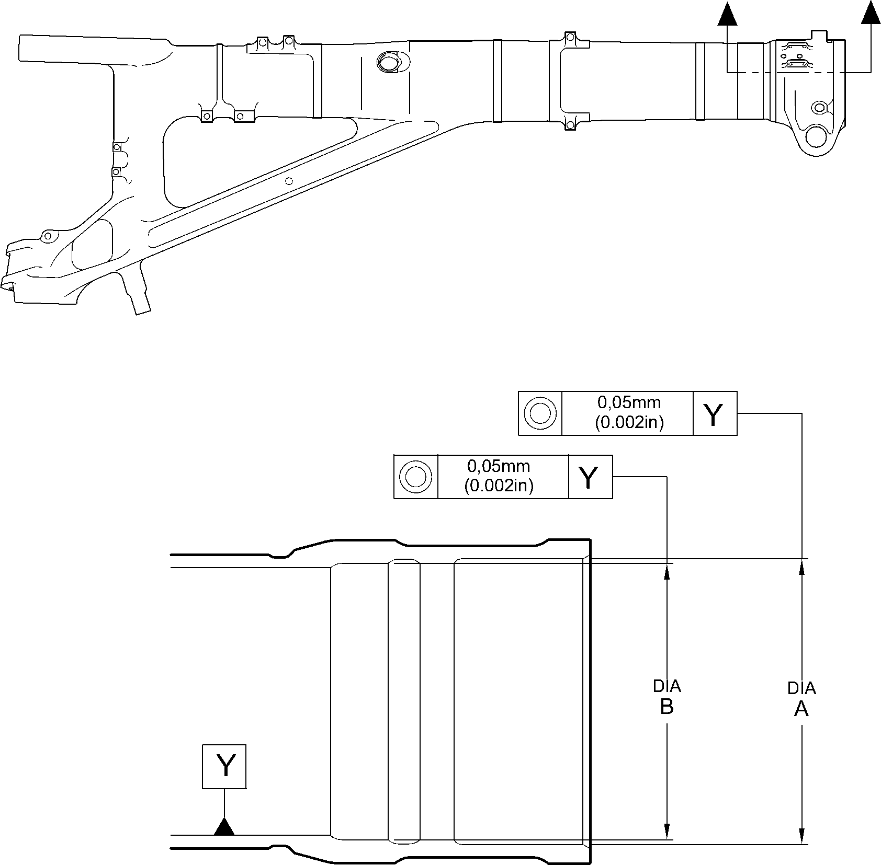
section Z-Z
A321A5695-1
Repair to Main Fitting
Figure 601
32-12-22
Repair No. 11-16
Page 602
Dec 6/2019

sSAFRAN SAFRAN LANDING SYSTEMS UK Ltd
CAGE: K0654
PART No. 201587001 AND 201587002 COMPONENT MAINTENANCE MANUAL
MAIN LANDING GEAR LEG

I 1. Repair No. 11-17 Main Fitting (20-410, 20-410A, 20-420 and 20-420A)
- Specified Damage and Material Specification.
- Specified Damage
(a) Damage or corrosion to the chromium plate on diameter A.
- Material Specification
IPL Figure and  Item No. | Name | Material Specification
20-410, 20-410A,  20-420 and  20-420A | Main fitting | Steel, MAT135, 35NCD16THQ
- Special Tools
- Special tools are not necessary.
- Materials
- Materials are not necessary.
- Repair Parts
- Repair parts are not necessary.
- Procedure (Refer to Figure 601)
- Chemically remove the chromium plate from diameter A: refer to PCS-2110 and
Figure 601.
- Examine the base metal for damage or corrosion:
- If there is no damage or corrosion to the base metal proceed with the repair.
- If there is damage or corrosion to the base metal, use another applicable repair or
apply for a concession.
CAUTION: DO NOT USE A MECHANICAL MOP POLISHER TO GET THE SURFACE
FINISH.
CAUTION: HARD CHROMIUM PLATE MUST NOT BE USED ON THIS DIAMETER.
- Apply flash chromium plate to diameter A as shown: refer to PCS-2110, type C and
Figure 601. The chromium plate thickness must be between 0,0075 and 0,0120 mm
(0.0003 and 0.0005 in). Make the surface finish 0,8 micrometers (32 micro-inches).
Make the surface finish on the chamfer 1,6 micrometers (63 micro-inches).
- Examine the reworked area for flaws: refer to PCS-3100, inclusion class 4.
- Identify the part with the Safran Landing Systems repair number 450237695 adjacent to
the part number: refer to PCS-6000-04.
- Examine the part to make sure that you have obeyed all the repair instructions correctly.
Repair No. 11-17
32-12-22
Page 601
Mar 18/2025

SAFRAN LANDING SYSTEMS UK Ltd
CAGE: K0654

PART No. 201587001 AND 201587002 COMPONENT MAINTENANCE MANUAL
MAIN LANDING GEAR LEG
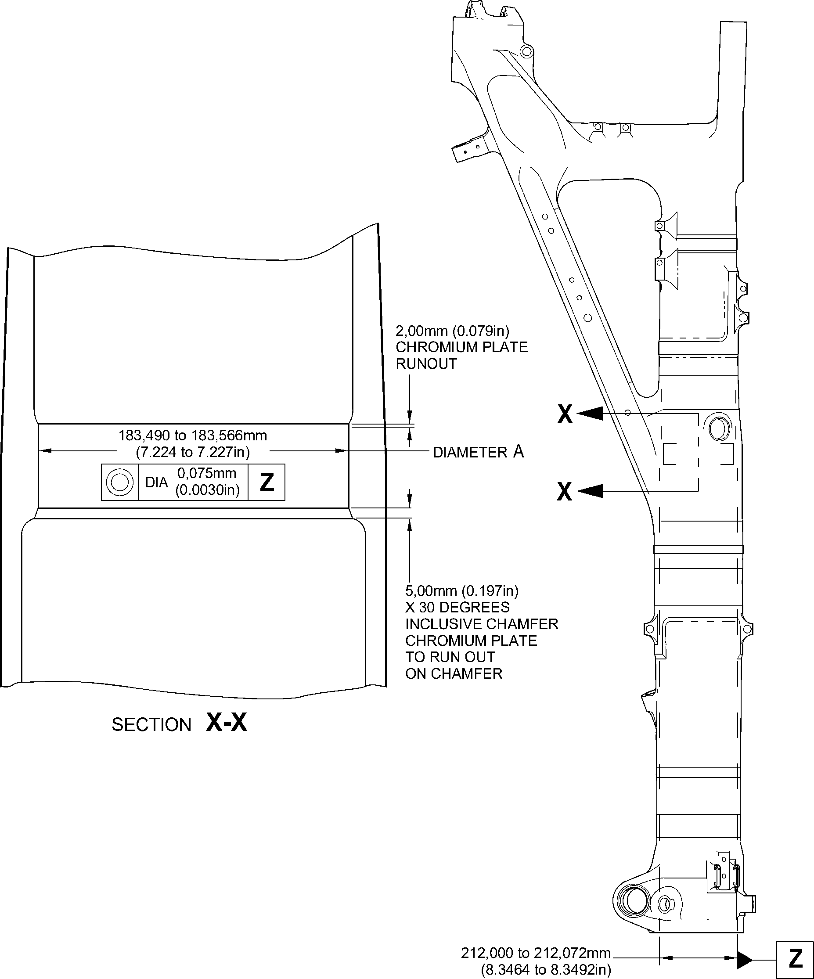
DIAMETER REF.
A321A5708-2
Repair to Main Fitting
Figure 601
32-12-22
Repair No. 11-17
Page 602
May 31/2019

sSAFRAN SAFRAN LANDING SYSTEMS UK Ltd
CAGE: K0654
PART No. 201587001 AND 201587002 COMPONENT MAINTENANCE MANUAL
MAIN LANDING GEAR LEG

I 1. Repair No. 11-18 Main Fitting (20-410, 20-410A, 20-420 and 20-420A)
- Specified Damage and Material Specification.
- Specified Damage
(a) Damage or wear to diameter A.
- Material Specification
IPL Figure and  Item No. | Name | Material Specification
20-410, 20-410A,  20-420 and  20-420A | Main fitting | Steel, MAT135, 35NCD16THQ
- Special Tools
- These special tools are necessary:
NOTE: Alternative equivalents are permitted.
Part No. | Special Tool | Function
460006267 | Press Pad Assembly | Install the repair bearing
- Materials
- These materials are necessary:
NOTE: Alternative equivalents are permitted.
Ref. Item | Material
09-510A | Sealant
- Repair Parts
- These repair parts are necessary:
Part No. | Repair Part | Material Specification
- | Repair bearing | Aluminium Bronze, DTD197
- Procedure (Refer to Figures 601 and 602)
- Machine diameter A sufficiently to remove the damage or wear within the dimensions
shown: refer to M-DLPS1004-4-1 and Figure 601. Make the surface finish
1,6 micrometers (63 micro-inches).
- Machine the radius to the dimensions shown: refer to Figure 601.
- Measure and record the new diameter A.
- Examine the machined area for flaws: refer to PCS-3600 and PCS-3100, inclusion
class 4.
Repair No. 11-18
32-12-22
Page 601
Mar 18/2025

sSAFRAN SAFRAN LANDING SYSTEMS UK Ltd
CAGE: K0654
PART No. 201587001 AND 201587002 COMPONENT MAINTENANCE MANUAL
MAIN LANDING GEAR LEG
- Apply cadmium plate to the reworked area: refer to PCS-2100 or PCS-2141.
- Identify the part with the Messier-Dowty Limited repair number 450217235 adjacent to
the part number: refer to PCS-6000-04.
- Calculate the diameter B for the repair bearing, use the formula:
B = A (as measured) + 0,0020 to 0,0480 mm (0.00008 to 0.00190 in).
- Machine the repair bearing to the dimensions shown and calculated: refer to Figure 602.
Make the surface finish 3,2 micrometers (125 micro-inches).
- Examine the repair bearing for flaws: refer to PCS-3200.
- Apply cadmium plate all over the repair bearing: refer to M-DLPS100-1. The cadmium
plate thickness must be between 0,010 and 0,015 mm (0.0004 and 0.0006 in).
- Use press pad assembly 460006267 and install the repair bearing: refer to
M-DLPS1011-14. The bearing must be flush or up to 0,250 mm (0.010 in) below the
surface of main fitting.
- Apply sealant, Material Ref. Item 09-510A, to the joints between the repair bearing and
the main fitting: refer to PCS-7200 and Figure 602.
- Identify the part with the Messier-Dowty Limited repair number 450217235 adjacent to
the part number: refer to PCS-6000-07.
- Examine the part to make sure that you have obeyed all the repair instructions correctly.
32-12-22
Repair No. 11-18
Page 602
Mar 18/2025

SAFRAN LANDING SYSTEMS UK Ltd
CAGE: K0654

PART No. 201587001 AND 201587002 COMPONENT MAINTENANCE MANUAL
MAIN LANDING GEAR LEG
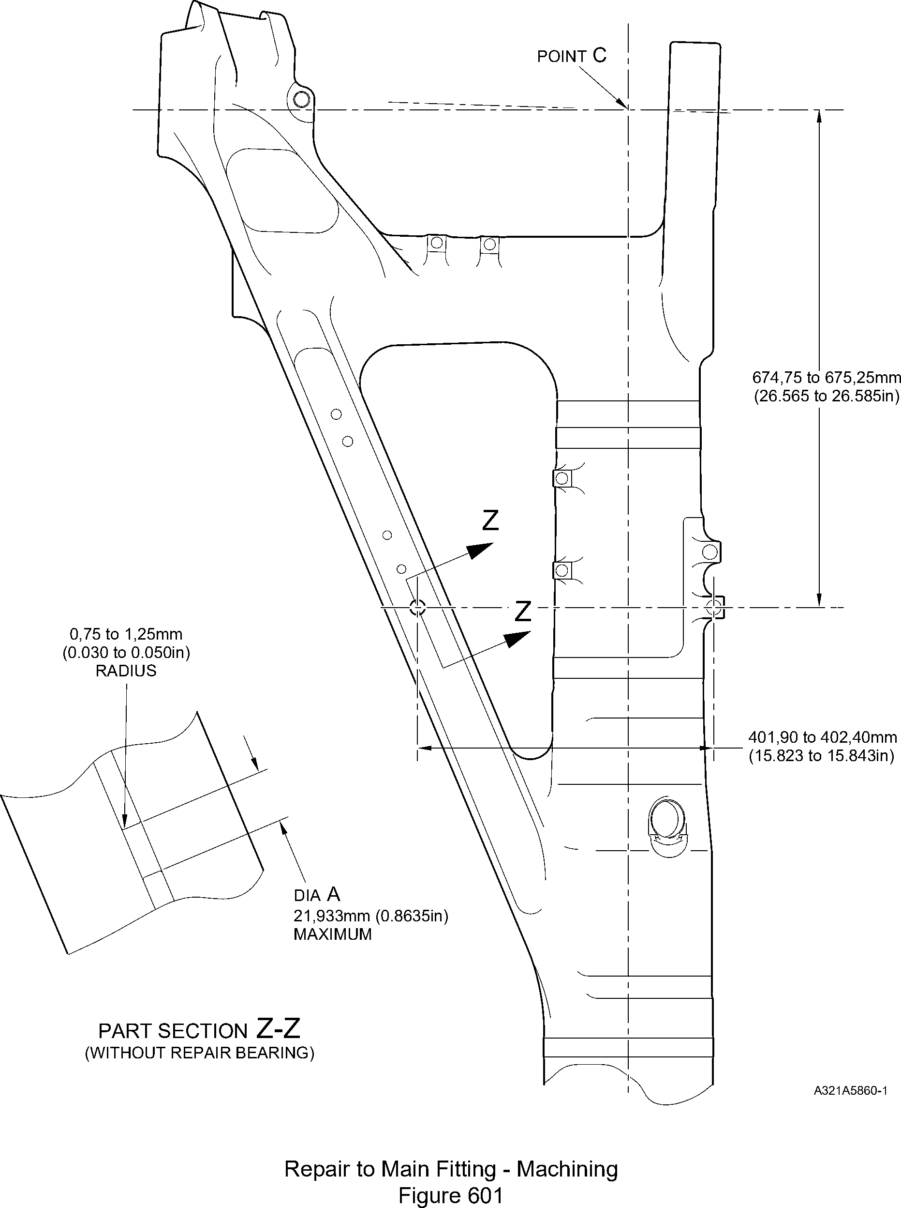
Repair No. 11-18
32-12-22
Page 603
Dec 6/2019

SAFRAN LANDING SYSTEMS UK Ltd
CAGE: K0654

PART No. 201587001 AND 201587002 COMPONENT MAINTENANCE MANUAL
MAIN LANDING GEAR LEG
0,95 to 1,45mm
(0.037 to 0.057in)
x 15DEGREES
7,75 to 8,25mm CHAMFER
(0.305 to 0.325in) (2 PLACES)
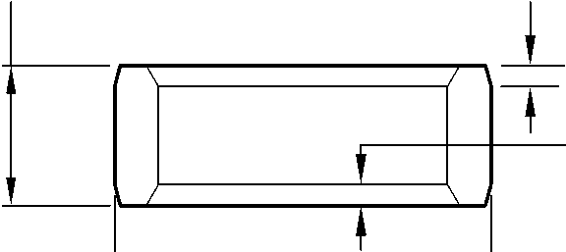
0,95 to 1,45mm
(0.037 to 0.057in)
x 30 DEGREES
CHAMFER
(2 PLACES)
DIA
B
REPAIR BEARING
APPLY SEALANT
TO PCS-7200
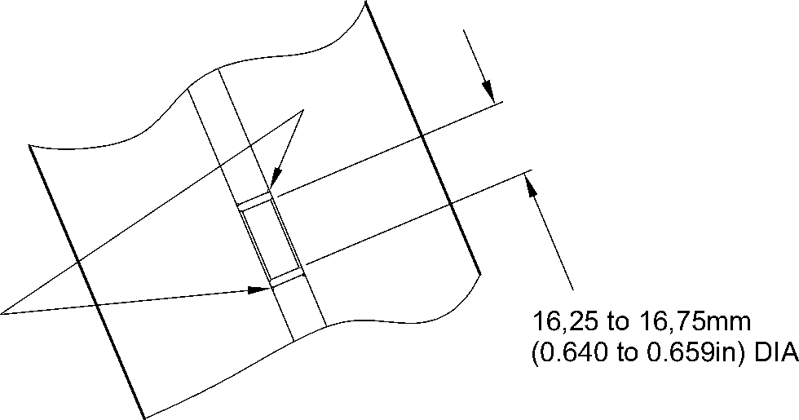
part section Z-Z
(WITH REPAIR BEARING)
A321A5991-1
Repair Bearing - Machining and Installation
Figure 602
32-12-22
Repair No. 11-18
Page 604
Dec 6/2019

sSAFRAN SAFRAN LANDING SYSTEMS UK Ltd
CAGE: K0654
PART No. 201587001 AND 201587002 COMPONENT MAINTENANCE MANUAL
MAIN LANDING GEAR LEG

I 1. Repair No. 11-19 Main Fitting (20-410, 20-410A, 20-420 and 20-420A)
- Specified Damage and Material Specification.
- Specified Damage
(a) Damage or wear to diameter(s) A.
- Material Specification
IPL Figure and  Item No. | Name | Material Specification
20-410, 20-410A,  20-420 and  20-420A | Main fitting | Steel, MAT135, 35NCD16THQ
- Special Tools
- These special tools are necessary:
NOTE: Alternative equivalents are permitted.
Tool Part No. | Special Tool | Function
460004330/110 | Press Pad | Install the repair bushes
460004331/2 | Drift
- Materials
- These materials are necessary:
NOTE: Alternative equivalents are permitted.
Ref. Item | Material
TBA | Zinc powder
05-533 | Mastinox, D40
09-510A | Sealant
- Repair Parts
- These repair parts are necessary:
Part No. | Repair Part | Material Specification
450237819 | Repair bush (Qty 2) | Aluminium Bronze, DTD197
- Procedure (Refer to Figures 601 and 602)
- Machine diameter(s) A sufficiently to remove the damage or wear within the dimensions
shown: refer to M-DLPS1004-4-1 and Figure 602. Make the surface finish
3,2 micrometers (125 micro-inches).
- Machine the radii to the dimensions shown: refer to Figure 602.
Repair No. 11-19
32-12-22
Page 601
Mar 18/2025

sSAFRAN SAFRAN LANDING SYSTEMS UK Ltd
CAGE: K0654
PART No. 201587001 AND 201587002 COMPONENT MAINTENANCE MANUAL
MAIN LANDING GEAR LEG
- Measure and record the new diameter(s) A.
- Examine the machined area for flaws: refer to PCS-3600 and PCS-3100, inclusion
class 4.
- Shot peen the machined areas: refer to M-DLPS123.
- Identify the part with the Messier-Dowty Limited repair number 450258210 adjacent to
the part number: refer to PCS-6000-05.
- Apply cadmium plate to the reworked areas: refer to PCS-2141.
- Apply primer paint to the reworked areas: refer to PCS-2500.
- Calculate the diameter B for the repair bush(es) (qty 2), use the formula:
B = A (as measured) - 0,009 mm (0.0004 in) to + 0,029 mm (0.0011 in).
- Machine the repair bush(es) to the dimensions shown and calculated: refer to
Figure 602. Make the surface finish 1,6 micrometers (63 micro-inches).
- Apply cadmium plate all over the repair bush(es): refer to M-DLPS100-1. The cadmium
plate thickness must be between 0,010 and 0,015 mm (0.0004 and 0.0006 in).
- Use the Press Pad 460004330/110 and Drift 460004331/2 and install the repair
bush(es): refer to M-DLPS1011-20. Use electrically conducting Mastinox (made from
Mastinox D40, Material Ref. Item 05-533 and Zinc powder, Material Ref. Item TBA):
refer to M-DLPS709-14.
- Apply sealant, Material Ref. Item 09-510A, to the joints between the repair bush(es) and
the main fitting: refer to PCS-7200 and Figure 602.
- Identify the part with the Messier-Dowty Limited repair number 450258210 adjacent to
the part number: refer to PCS-6000-07.
- Examine the part to make sure that you have obeyed all the repair instructions correctly.
32-12-22
Repair No. 11-19
Page 602
Mar 18/2025

SAFRAN LANDING SYSTEMS UK Ltd
CAGE: K0654

PART No. 201587001 AND 201587002 COMPONENT MAINTENANCE MANUAL
MAIN LANDING GEAR LEG
point C
327,47 to 327,97mm
(12.893 to 12.912in)
Z
A321A5861-1
19,425mm
(0.7648in) CRS
(REF)
576,75 to 577,25mm
(22.707 to 22.726in)
Z refer to figure 602
46,07mm
(1.814in)
(REF)
Repair to Main Fitting - Machining
Figure 601
Repair No. 11-19
32-12-22
Page 603
Dec 6/2019
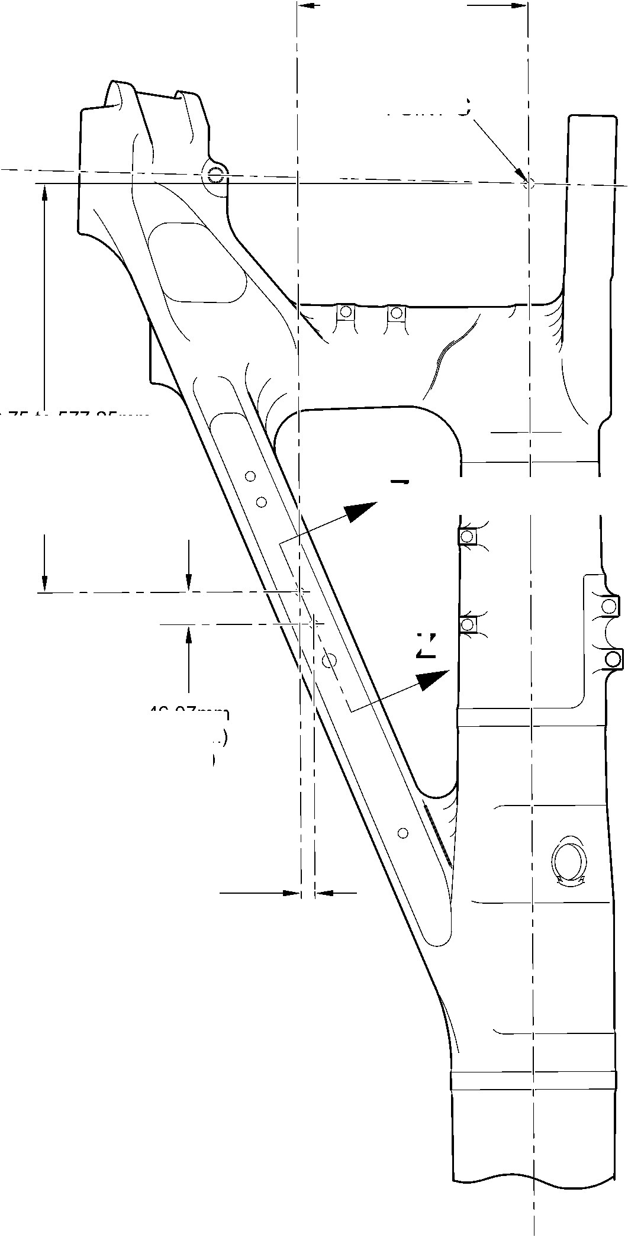

SAFRAN LANDING SYSTEMS UK Ltd
CAGE: K0654

PART No. 201587001 AND 201587002 COMPONENT MAINTENANCE MANUAL
MAIN LANDING GEAR LEG
diameter A
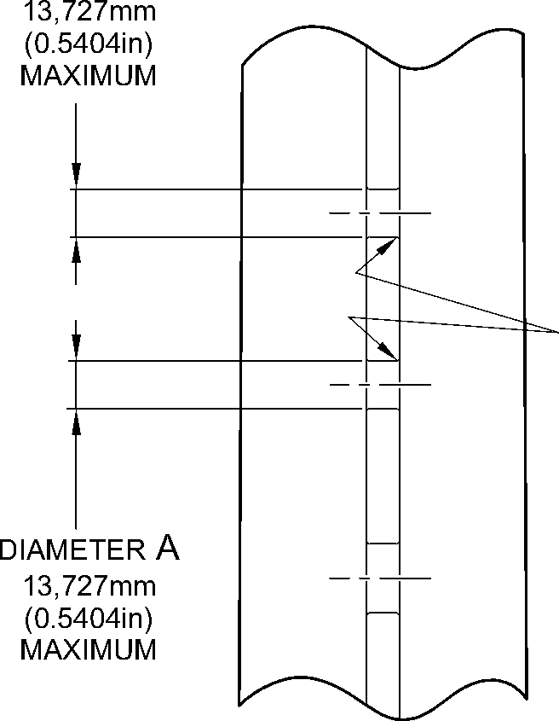
part section Z-Z
REFER TO FIGURE 601
(WITHOUT REPAIR BUSHES)
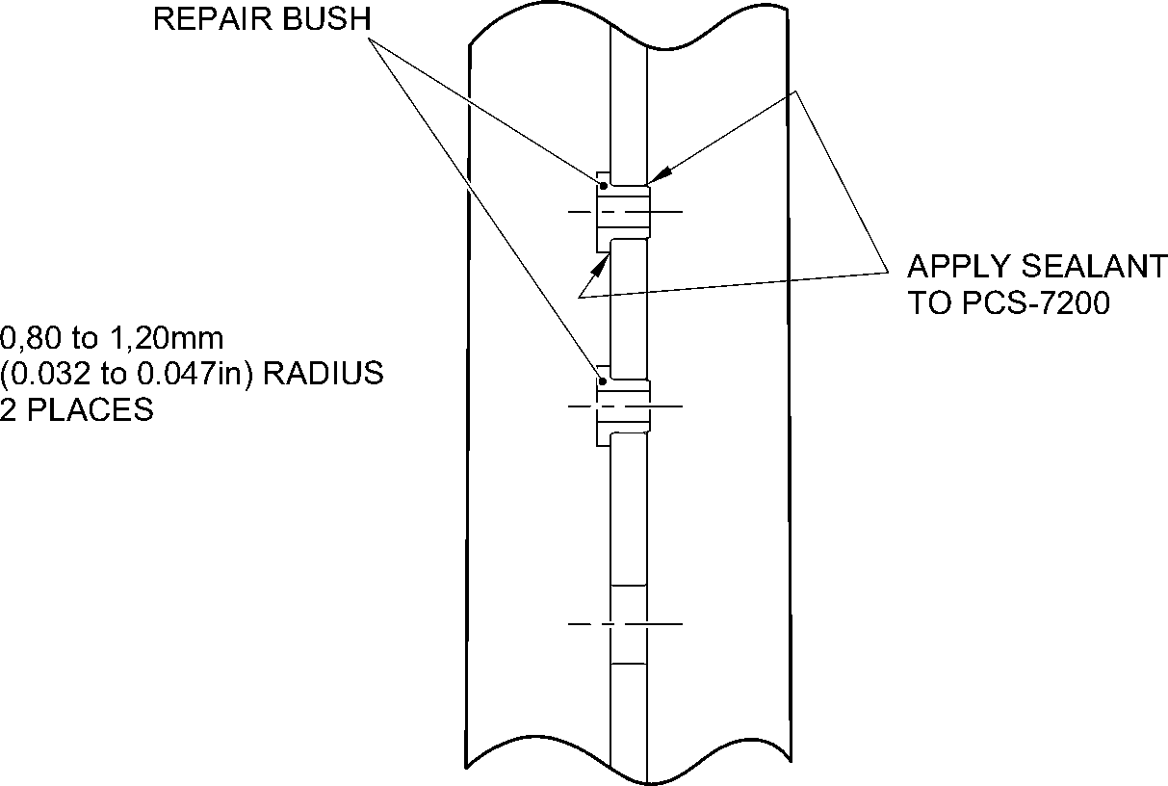
part section Z-Z
REFER TO FIGURE 601
(WITH REPAIR BUSHES)
8,25 to 8,75mm
(0.325 to 0.344in)
(REF)
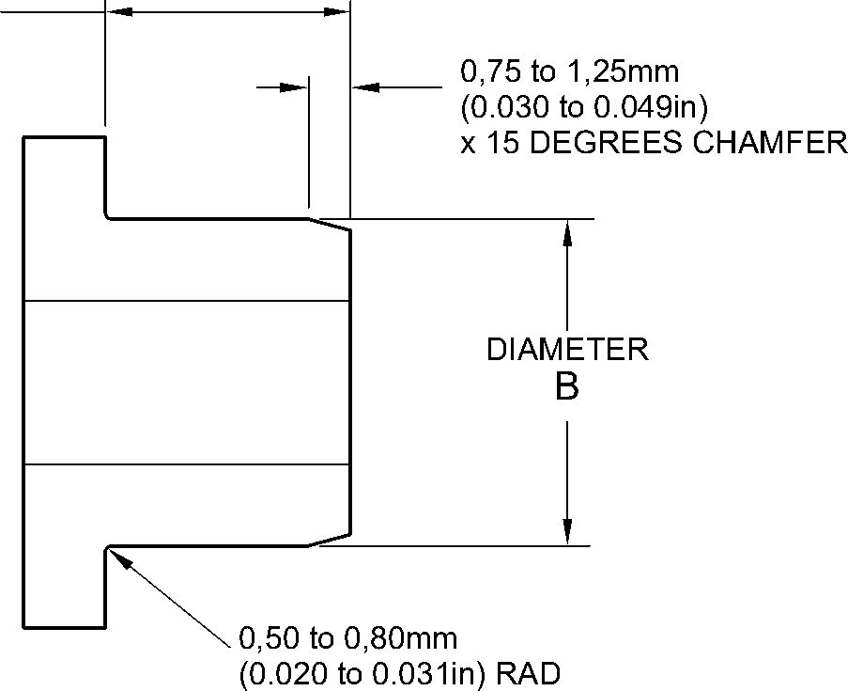
REPAIR BUSH
A321A5992-1
Repair Bushes - Machining and Installation
Figure 602
32-12-22
Repair No. 11-19
Page 604
Dec 6/2019

SAFRAN LANDING SYSTEMS UK Ltd
CAGE: K0654
PART No. 201587001 AND 201587002 COMPONENT MAINTENANCE MANUAL
MAIN LANDING GEAR LEG
- Repair No. 11-20 Main Fitting (20-410 and 20-420 Only)
A. This Repair, Safran Landing Systems Repair No. 450265100, has been withdrawn from use.
Repair No. 11-20
32-12-22
Page 601
Mar 18/2025

SAFRAN LANDING SYSTEMS UK Ltd
CAGE: K0654

PART No. 201587001 AND 201587002 COMPONENT MAINTENANCE MANUAL
MAIN LANDING GEAR LEG
INTENTIONALLY BLANK
Repair No. 11-20
32-12-22 ^{Page 602}

sSAFRAN SAFRAN LANDING SYSTEMS UK Ltd
CAGE: K0654
PART No. 201587001 AND 201587002 COMPONENT MAINTENANCE MANUAL
MAIN LANDING GEAR LEG

I 1. Repair No. 11-21 Main Fitting (20-410, 20-410A, 20-420 and 20-420A)
- Specified Damage and Material Specification.
- Specified Damage
(a) Damage or wear to diameters A and/or B and/or adjacent spotfaces.
- Material Specification
IPL Figure and  Item No. | Name | Material Specification
20-410, 20-410A,  20-420 and  20-420A | Main fitting | Steel, MAT135, 35NCD16THQ
- Special Tools
- These special tools are necessary:
NOTE: Alternative equivalents are permitted.
Part No. | Special Tool | Function
460004330/257 | Press Pad | Install the oversize bearing  450258809
460004330/258 | Press Pad | Install the oversize bearing  450258810
- Materials
- These materials are necessary:
NOTE: Alternative equivalents are permitted.
Ref. Item | Material
09-510A | Sealant
- Repair Parts
- These repair parts are necessary:
Part No. | Repair Part | Material Specification
450258809 | Oversize bearing | Aluminium Bronze, DTD197
450258810 | Oversize bearing | Aluminium Bronze, DTD197
- Procedure (Refer to Figures 601 and 602)
- Machine diameter(s) A and/or B sufficiently to remove damage or wear within the
dimensions shown: refer to M-DLPS1004-4-1, M-DLPS914 and Figure 601. Make the
surface finish 1,6 micrometers (63 micro-inches).
Repair No. 11-21
32-12-22
Page 601
Mar 18/2025

sSAFRAN SAFRAN LANDING SYSTEMS UK Ltd
CAGE: K0654
PART No. 201587001 AND 201587002 COMPONENT MAINTENANCE MANUAL
MAIN LANDING GEAR LEG
- Machine the adjacent spotfaces, sufficiently to remove the damage or wear within the
dimensions shown: refer to M-DLPS1004-4-1, M-DLPS914 and Figure 601. Do not
machine below the minimum dimensions C and D. Make the surface finish 1,6
micrometers (63 micro-inches).
- Machine the chamfers and radii as shown: refer to Figure 601.
- Measure and record the new diameters A and B and dimensions C and D.
- Examine the machined areas for flaws: refer to PCS-3600 and PCS-3100, inclusion
class 4.
- Shot peen the machined areas: refer to M-DLPS123.
- Apply cadmium plate to the machined areas: refer to PCS-2141.
- Identify the part with the Messier-Dowty Limited repair number 450258230 adjacent to
the part number: refer to PCS-6000-05.
- Calculate the dimensions of the oversize bearing 450258809, use formulae:
E = A (as measured) - 0,006 (0.0002 in) to + 0,028 mm (0.0011 in).
F = C (as measured) - 57,25 to 57,75 mm (2.254 to 2.273 in).
- Calculate the dimensions of the oversize bearing 450258810, use formulae:
G = B (as measured) - 0,006 (0.0002 in) to + 0,028 mm (0.0011 in).
H = C (as measured) - 57,25 to 57,75 mm (2.254 to 2.273 in).
- Machine the oversize bearings to the dimensions shown and calculated: refer to
Figure 601. Make the surface finish 1,6 micrometers (63 micro-inches).
- Apply cadmium plate to the oversize bearings all over, but not to the bores: refer to
M-DLPS100-1. The cadmium plate thickness must be between 0,010 and 0,015 mm
(0.0004 and 0.0006 in).
- Use the Press Pad 460004330/257 and install the oversize bearing 450258809 to
diameter A: refer to M-DLPS1011-20.
- Use the Press Pad 460004330/258 and install the oversize bearing 450258810 to
diameter B: refer to M-DLPS1011-20.
- Check the bores of oversize bearings to the dimensions shown: refer to Figure 602.
- Apply sealant, Material Ref. Item 09-510A, to the joints between the oversize bearings
and main fitting: refer to PCS-7200 and Figure 602.
- Apply paint to the reworked areas: refer to REPAIR.
- Identify the part with the Messier-Dowty Limited repair number 450258230 adjacent to
the part number: refer to PCS-6000-07.
- Examine the part to make sure that you have obeyed all the repair instructions correctly.
32-12-22
Repair No. 11-21
Page 602
Dec 6/2019

SAFRAN LANDING SYSTEMS UK Ltd
CAGE: K0654

PART No. 201587001 AND 201587002 COMPONENT MAINTENANCE MANUAL
MAIN LANDING GEAR LEG
10,75 to 11,25mm
(0.423 to 0.443in)
Z
5,00 to 6,00mm (0.197 to 0.236in)
SPOTFACE CORNER RADIUS (TYP)
30,75 to 31,25mm
(1.211 to 1.230in)
RADIUS
192,75 to 193,25mm
(7.589 to 7.608in)
2,00 to 3,00mm (0.079 to 0.118in)
REMOVE SHARP EDGES
RADIUS (TYP)
Y
dia A 20,721mm (0.8157in) maximum
dim. C
69,50mm
(2.736in)
MINIMUM
1,25 to 1,75mm (0.049 to 0.069in)
x 44.5 to 45.5 DEGREES
CHAMFER 2 PLACES
dim. D
139,25mm
(5.482in)
MINIMUM
ACROSS SPOTFACES
dia B
20,721mm (0.8157in)
MAXIMUM

0,05mm
(0.002in) DIA
Y
section Z-Z

0,05mm
(0.002in) DIA
Y
A321A6383-1
Repair to Main Fitting - Machining
Figure 601
Repair No. 11-21
32-12-22
Page 603
Dec 6/2019
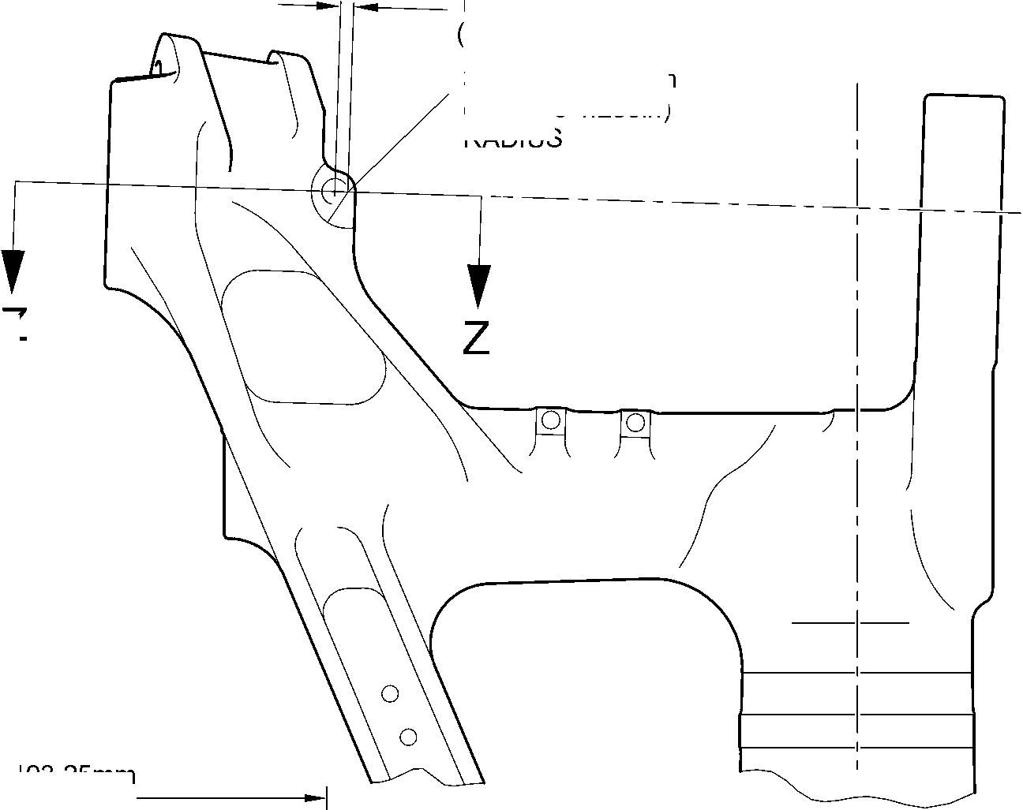
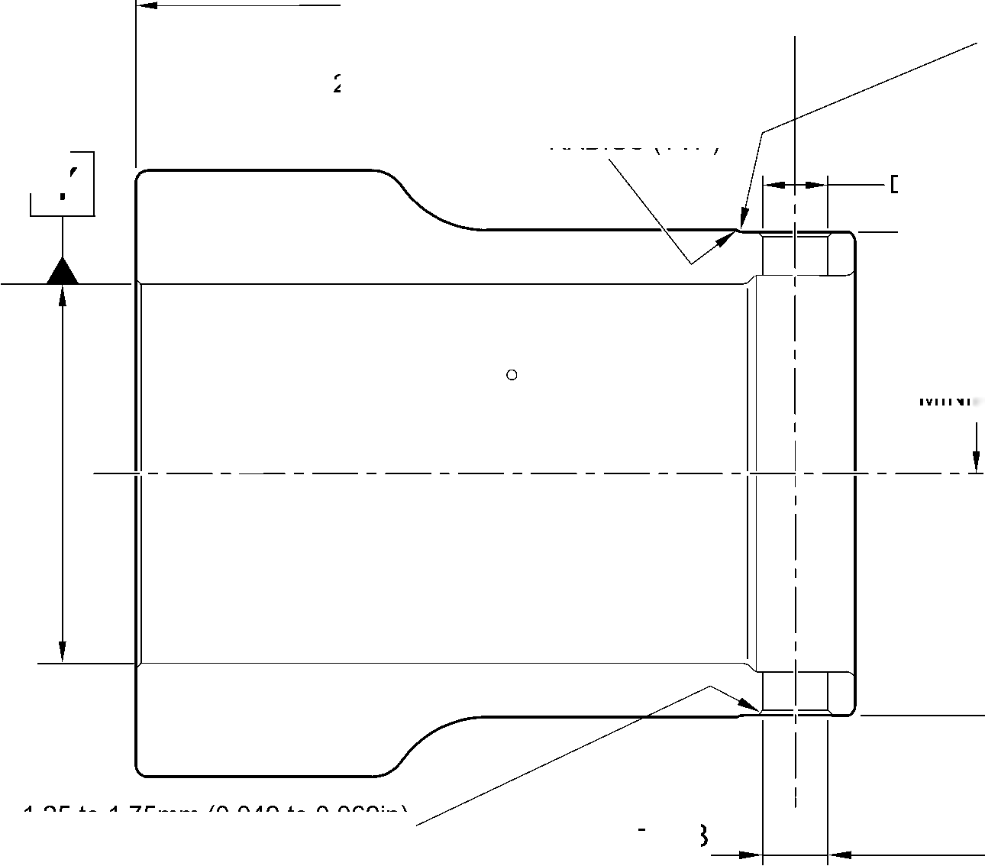

SAFRAN LANDING SYSTEMS UK Ltd
CAGE: K0654

PART No. 201587001 AND 201587002 COMPONENT MAINTENANCE MANUAL
MAIN LANDING GEAR LEG
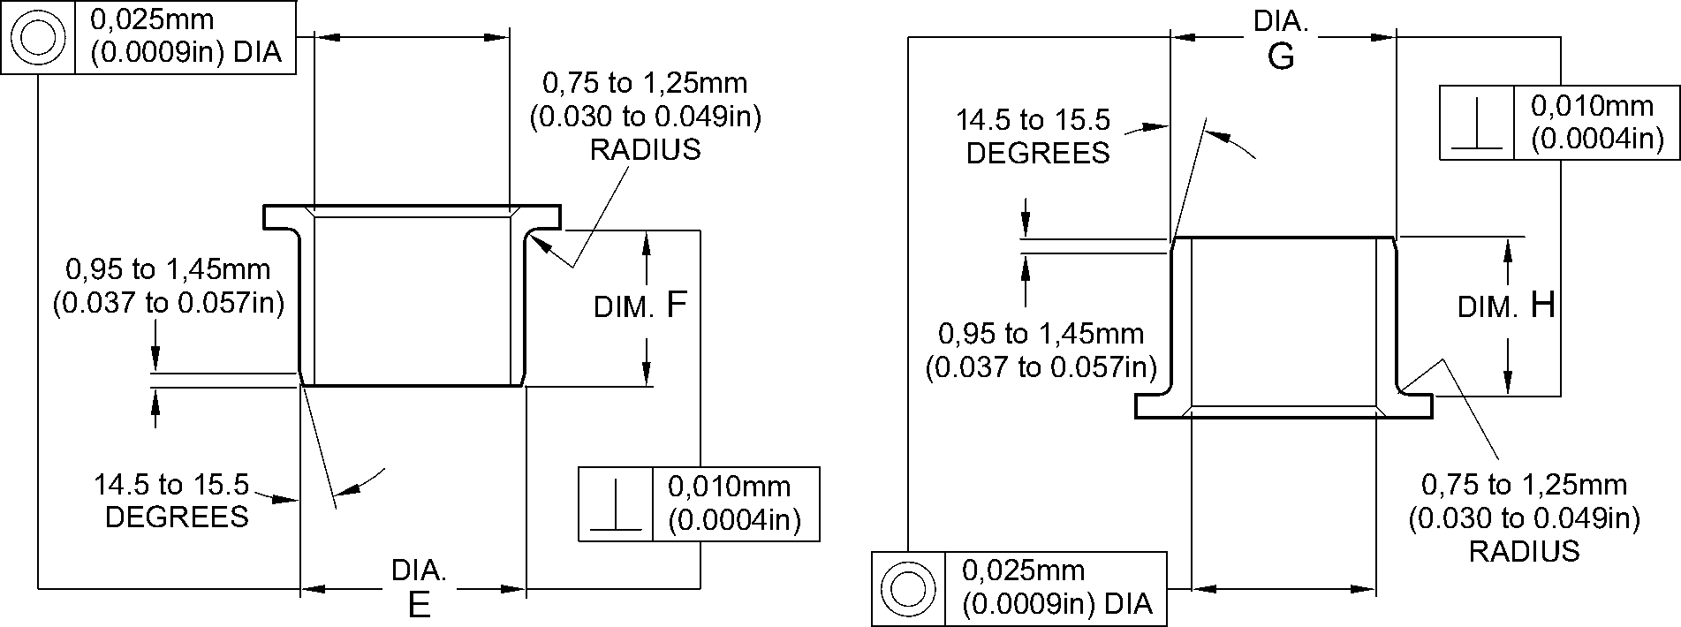
OVERSIZE BEARING
450258809
OVERSIZE BEARING
450258810
16,500 to 16,527mm
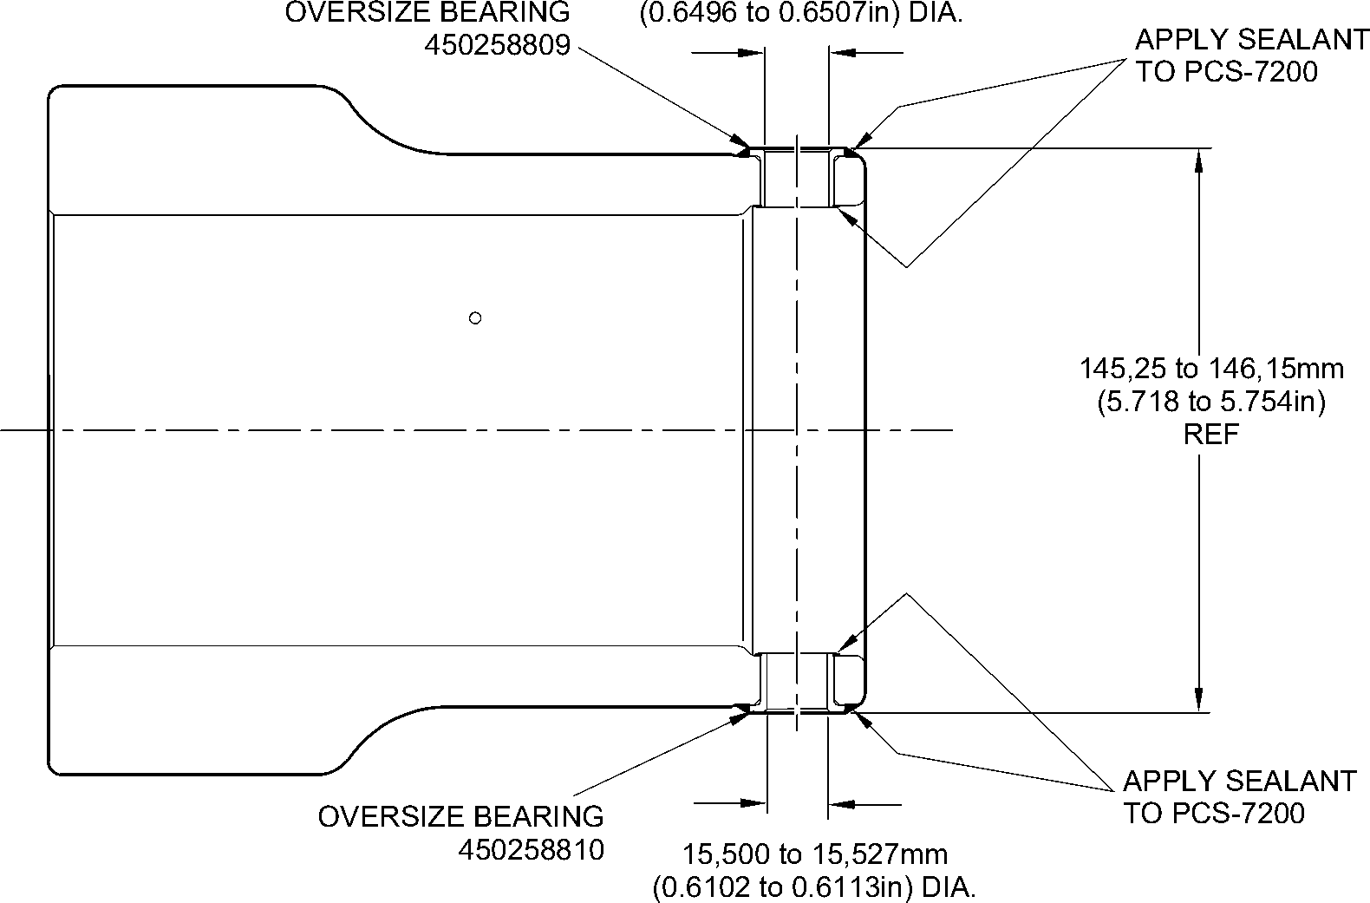
section Z-Z
(REFER TO FIGURE 601)
A321A6384-2
Oversize Bearings - Machining and Installation
Figure 602
32-12-22
Repair No. 11-21
Page 604
Dec 6/2019

sSAFRAN SAFRAN LANDING SYSTEMS UK Ltd
CAGE: K0654
PART No. 201587001 AND 201587002 COMPONENT MAINTENANCE MANUAL
MAIN LANDING GEAR LEG

I 1. Repair No. 11-22 Main Fitting (20-410, 20-410A, 20-420 and 20-420A)
- Specified Damage and Material Specification
- Specified Damage
(a) Damage or wear to the diameter A.
- Material Specification
IPL Figure and  Item No. | Name | Material Specification
20-410, 20-410A,  20-420 and  20-420A | Main Fitting | Steel, MAT135, 35NCD16THQ
- Special Tools
- Special tools are not necessary.
- Materials
- Materials are not necessary.
- Repair Parts
- Repair parts are not necessary.
- Procedure (Refer to Figure 601)
CAUTION: FOR DAMAGE MORE THAN THE LIMITS OF THIS REPAIR SCHEME,
WRITE TO SAFRAN LANDING SYSTEMS: REFER TO GUIDE-CS-001.
- Machine diameter A to remove the damage or wear, removing the minimum amount of
material to a maximum diameter of 16,170 mm (0.6366 in) and a minimum wall
thickness of 1,915 mm (0.0754 in): refer to M-DLPS1004-4-1 and Figure 601. Make the
surface finish 1,6 micrometers (63 micro-inches) or better.
- Examine the bare metal for flaws: refer to PCS-3100, inclusion class 4 and PCS-3600.
- Identify the main fitting with the Safran Landing Systems repair number 450266450
adjacent to the part number: refer to PCS-6000-04 or PCS-6000-06.
- Apply cadmium plate to the repaired areas. The cadmium plate thickness must be
between 0,010 and 0,020 mm (0.0004 and 0.0008 in): refer to PCS-2141.
- If necessary, apply paint around the repaired areas, except where shown: refer to
PCS-2500 and Figure 601.
- Identify the main fitting with the Safran Landing Systems repair number 450266450
adjacent to the part number: refer to PCS-6000-07.
- Examine the part to make sure that you have obeyed all the repair procedure
instructions correctly.
Repair No. 11-22
32-12-22
Page 601
Mar 18/2025

SAFRAN LANDING SYSTEMS UK Ltd
CAGE: K0654
PART No. 201587001 AND 201587002 COMPONENT MAINTENANCE MANUAL
MAIN LANDING GEAR LEG
72, 00mm
(2.834in)
10,50mm
(0.413in)
27,5 to 28,5mm
(1.08 to 1.12in)
4 PLACES
8,3mm (0.33in) DIA.
4 HOLES
0,50 to 1,00mm
(0.020 to 0.040in)
REMOVE EDGES
RADIUS
4 PLACES
SPHERICAL RAD.
4 PLACES
NO PAINT
144,5 to 145,5mm
(5.689 to 5.728in)
124,00 mm
(4.882in)
0,20mm
(0.008in) DIA.
1,915mm
(0.0754in)
MINIMUM WALL
THICKNESS
4 PLACES
DIA. A
16,17mm
(0.6366in)
MAXIMUM
4 HOLES
NO PAINT
1,00 to 2,00mm
(0.040 to 0.080in)
REMOVE EDGES
RADIUS
4 PLACES
DETAIL Y
A321-S-32-12-22-024-1
Repair to Main Fitting
Figure 601
Repair No. 11-22
32
Page 602
⁻⁻ Mar 24/2017
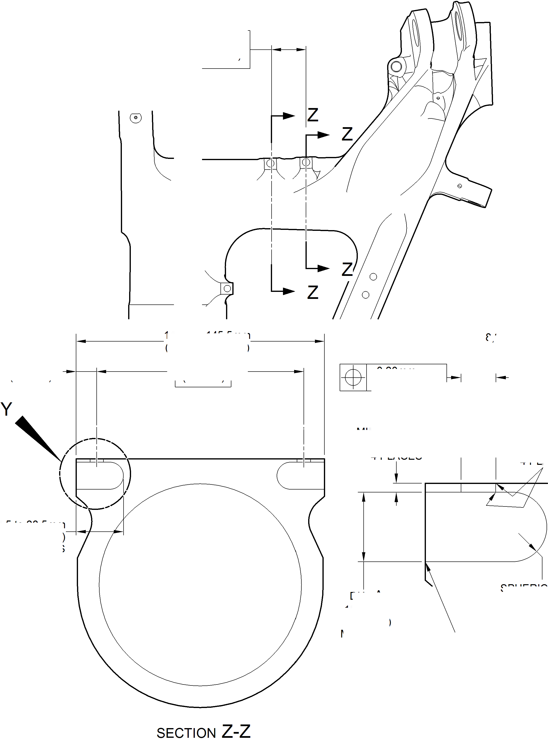

SAFRAN LANDING SYSTEMS UK Ltd
CAGE: K0654

PART No. 201587001 AND 201587002 COMPONENT MAINTENANCE MANUAL
MAIN LANDING GEAR LEG

I 1. Repair No. 11-23 Main Fitting (20-410, 20-410A, 20-420 and 20-420A)
- Specified Damage and Material Specification.
- Specified Damage
(a) Damage or wear to the diameter A and/or B.
- Material Specification
IPL Figure and  Item No. | Name | Material Specification
20-410, 20-410A,  20-420 and  20-420A | Main Fitting | Steel, MAT135, 35NCD16THQ
- Special Tools
- These special tools are necessary:
NOTE: Alternative equivalents are permitted.
Tool Part No. | Special Tool | Function
460006268 | Press Pad | Install the oversize lubrication  adapters
- Materials
- These materials are necessary:
NOTE: Alternative equivalents are permitted.
Ref. Item | Material
08-558 | Adhesive
- Repair Parts
- Refer to Table 1.
- Procedure (Refer to Figures 601, 602 and 603)
CAUTION: FOR DAMAGE MORE THAN THE LIMITS OF THIS REPAIR SCHEME, WRITE
TO SAFRAN LANDING SYSTEMS.
- Machine diameter A and/or diameter B to the smallest oversize dimensions shown in
Table 1 to remove the damage or wear: refer to M-DLPS1004-4-1. Make the surface
finish 1,6 micrometers (63 micro-inches).
- Machine the chamfers to the dimensions shown: refer to Figure 602.
- Examine the machined areas for flaws: refer to PCS-3600 and PCS-3100 inclusion
class 4.
- Identify the part with the Safran Landing Systems repair number 450266400 adjacent to
the part number: refer to PCS-6000-04 or PCS-6000-06.
Repair No. 11-23
32-12-22
Page 601
Mar 18/2025

sSAFRAN SAFRAN LANDING SYSTEMS UK Ltd
CAGE: K0654
PART No. 201587001 AND 201587002 COMPONENT MAINTENANCE MANUAL
MAIN LANDING GEAR LEG
- Apply cadmium plate to repaired areas. The cadmium plate thickness must be between
0,010 and 0,020 mm (0.0004 and 0.0008 in): refer to PCS-2141.
- Select the applicable oversize lubrication adaptor (Qty 2) for diameter A and/or diameter
B from Table 1.
- Install the selected lubrication adaptors to the related diameter: refer to PCS-7310. Use
adhesive, Material Ref. Item 08-558: refer to PCS-5303.
- Apply paint to the repaired areas: refer to REPAIR.
- Identify the part with the Safran Landing Systems repair number 450266400 adjacent to
the part number: refer to PCS-6000-07.
- Examine the part to make sure that you have obeyed all the repair instructions correctly.
Oversize Lubrication Adaptor
Table 1
Oversize | Diameter A or B  mm (in) | Oversize Lubrication Adaptor  Part No.
1 | 4,986 to 5,052  (0.1963 to 0.1989) | 450250161
2 | 5,113 to 5,179  (0.2013 to 0.2039) | 450250162
3 | 5,240 to 5,306  (0.2063 to 0.2089) | 450250163
4 | 5,367 to 5,433  (0.2113 to 0.2139) | 450250164
5 | 5,494 to 5,560  (0.2163 to 0.2189) | 450250165
6 | 5,621 to 5,687  (0.2213 to 0.2239) | 450250166
7 | 5,748 to 5,814  (0.2263 to 0.2289) | 450250241
8 | 5,875 to 5,941  (0.2313 to 0.2339) | 450250242
9 | 6,002 to 6,068  (0.2363 to 0.2389) | 450250243
10 | 6,129 to 6,195  (0.2413 to 0.2439) | 450250244
11 | 6,256 to 6,322  (0.2463 to 0.2489) | 450250245
12 | 6,383 to 6,449  (0.2513 to 0.2539) | 450250246
32-12-22
Repair No. 11-23
Page 602
Mar 18/2025

SAFRAN LANDING SYSTEMS UK Ltd
CAGE: K0654

PART No. 201587001 AND 201587002 COMPONENT MAINTENANCE MANUAL
MAIN LANDING GEAR LEG
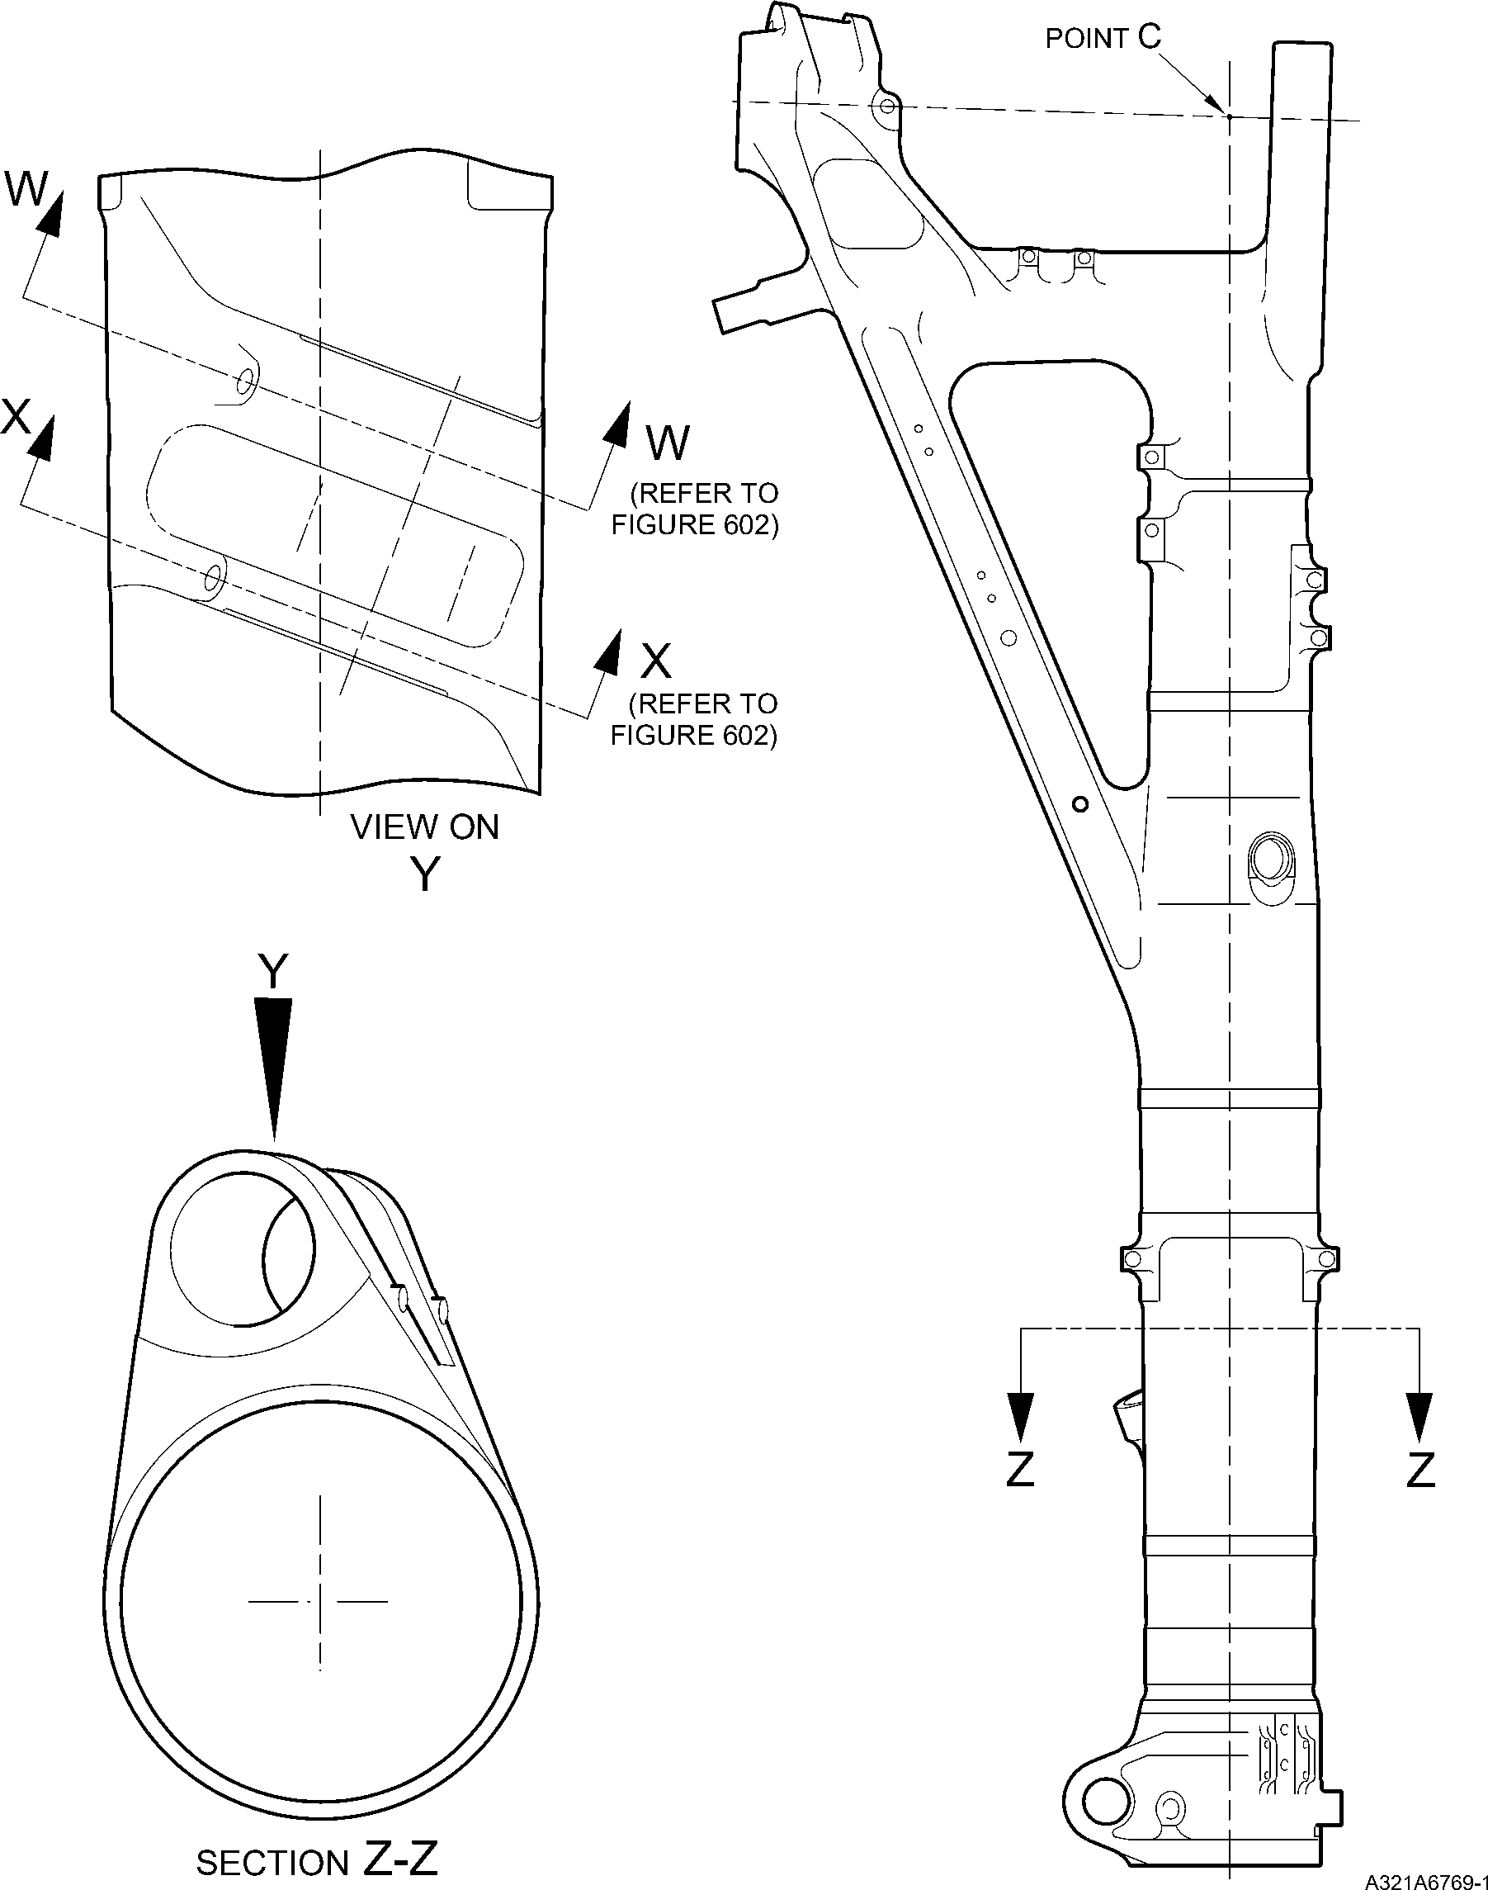
Repair to Main Fitting
Figure 601
Repair No. 11-23
32-12-22
Page 603
Dec 6/2019

SAFRAN LANDING SYSTEMS UK Ltd
CAGE: K0654
PART No. 201587001 AND 201587002 COMPONENT MAINTENANCE MANUAL
MAIN LANDING GEAR LEG
28,75 to 30,25mm
(1.132 to 1.191in) REF
5 DEGREES
REF
11,20 to 12,80mm
(0.441 to 0.503in) REF
diameter A
8,00mm (0.315in)
DEEP WITH
0,5mm (0.020in)
x 45 DEGREES CHAMFER
section W-W
(WITHOUT LUBRICATION ADAPTOR)
5 DEGREES
REF
95,200 to 96,800mm
(3.7480 to 3.8110in)
REF.
NOTE:
DIAMETERS A MUST FOLLOW
THE LINE OF EXISTING BORES
diameter B
8,00mm (0.315in)
DEEP WITH
0,5mm (0.020in)
x 45 DEGREES CHAMFER
87,20 to 88,80mm
(3.433 to 3.496in)
REF.
section X-X
(WITHOUT LUBRICATION ADAPTOR)
A321A6770-1
Repair to Main Fitting - Machining
Figure 602
32-12-22
Repair No. 11-23
Page 604
Dec 6/2019
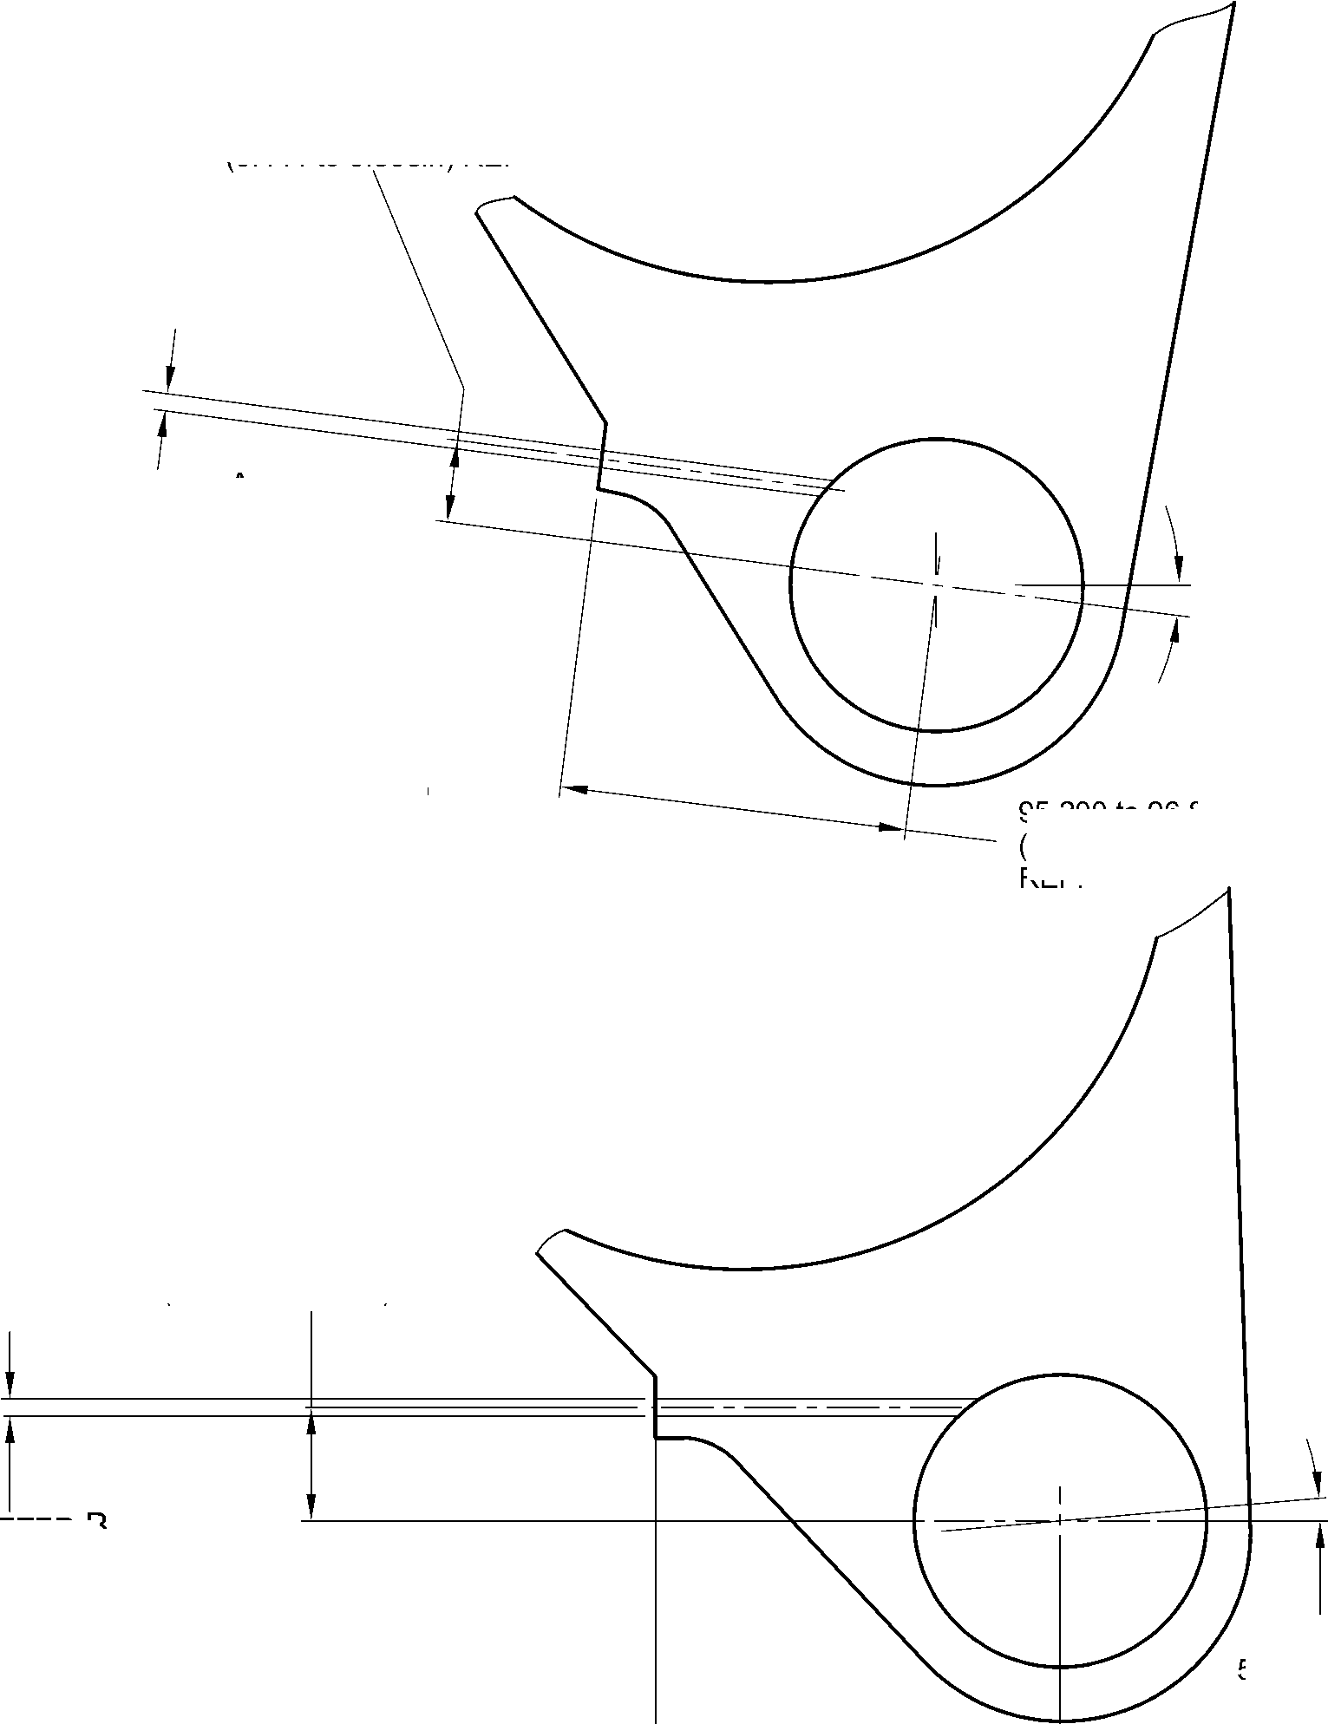

SAFRAN LANDING SYSTEMS UK Ltd
CAGE: K0654

PART No. 201587001 AND 201587002 COMPONENT MAINTENANCE MANUAL
MAIN LANDING GEAR LEG
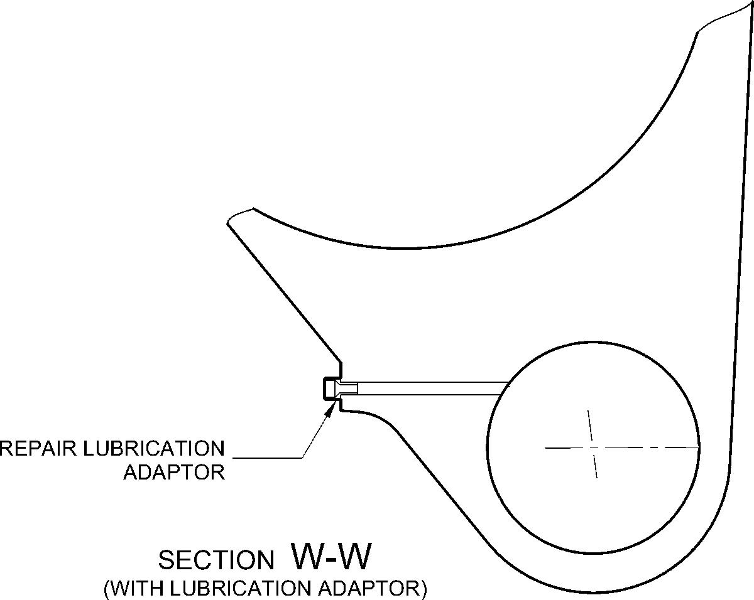
REPAIR LUBRICATION
ADAPTOR
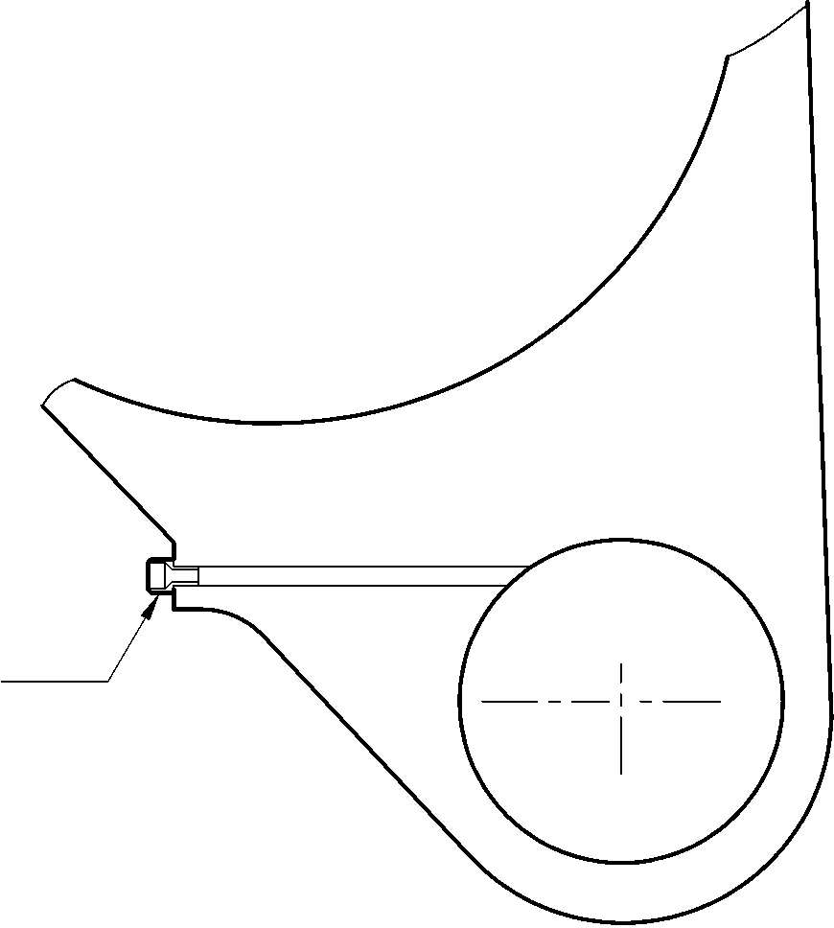
section X-X
(WITH LUBRICATION ADAPTOR)
A321A6771-1
Oversize Lubrication adapter - Installation
Figure 603
Repair No. 11-23
32-12-22
Page 605
Dec 6/2019

SAFRAN LANDING SYSTEMS UK Ltd
CAGE: K0654

PART No. 201587001 AND 201587002 COMPONENT MAINTENANCE MANUAL
MAIN LANDING GEAR LEG
INTENTIONALLY BLANK
Repair No. 11-23
32-12-22 ^{Page 606}

sSAFRAN SAFRAN LANDING SYSTEMS UK Ltd
CAGE: K0654
PART No. 201587001 AND 201587002 COMPONENT MAINTENANCE MANUAL
MAIN LANDING GEAR LEG

I 1. Repair No. 11-24 Main Fitting (20-410, 20-410A, 20-420 and 20-420A)
- Specified Damage and Material Specification.
- Specified Damage
(a) Damage or wear to the diameter A.
- Material Specification
IPL Figure and  Item No. | Name | Material Specification
20-410, 20-410A,  20-420 and  20-420A | Main Fitting | Steel, MAT135, 35NCD16THQ
- Special Tools
- These special tools are necessary:
NOTE: Alternative equivalents are permitted.
Tool Part No. | Special Tool | Function
460006268 | Press Pad | Install the oversize lubrication  adaptor
- Materials
- These materials are necessary:
NOTE: Alternative equivalents are permitted.
Ref. Item | Material
08-558 | Adhesive
- Repair Parts
- Refer to Table 1.
CAUTION: FOR DEVIATIONS OUTSIDE THE LIMITS OF THIS REPAIR SCHEME CONTACT
SAFRAN LANDING SYSTEMS.
- Procedure (Refer to Figures 601 and 602)
- Machine diameter A to the smallest oversize dimensions shown in Table 1 to remove the
damage or wear: refer to M-DLPS1004-4-1 and Figure 602. Make the surface finish
1,6 micrometers (63 micro-inches).
- Machine the chamfers to the dimensions shown: refer to Figure 602.
- Examine the machined areas for flaws: refer to PCS-3600 and PCS-3100 inclusion
class 4.
- Identify the part with the Safran Landing Systems repair number 450266390 adjacent to
the part number: refer to PCS-6000-04 or PCS-6000-06.
Repair No. 11-24
32-12-22
Page 601
Mar 18/2025

SAFRAN LANDING SYSTEMS UK Ltd
CAGE: K0654

PART No. 201587001 AND 201587002 COMPONENT MAINTENANCE MANUAL
MAIN LANDING GEAR LEG
- Apply cadmium plate to the machined areas: refer to PCS-2141. The cadmium plate
thickness must be between 0,010 and 0,020 mm (0.0004 and 0.0008 in).
- Select the applicable oversize lubrication adaptor for diameter A from Table 1.
- Install the selected lubrication adaptor: refer to PCS-7310. Use adhesive, Material Ref.
Item 08-558: refer to PCS-5303.
- Apply paint to the repaired areas: refer to PCS-2500 and REPAIR.
- Identify the part with the Safran Landing Systems repair number 450266390 adjacent to
the part number: refer to PCS-6000-07.
- Examine the part to make sure that you have obeyed all the repair instructions correctly.
Oversize Lubrication Adaptors
Table 1
Oversize | Diameter A  mm (in) | Oversize Lubrication Adaptor  Part No.
1 | 4,986 to 5,052  (0.1963 to 0.1989) | 450250161
2 | 5,113 to 5,179  (0.2013 to 0.2039) | 450250162
3 | 5,240 to 5,306  (0.2063 to 0.2089) | 450250163
4 | 5,367 to 5,433  (0.2113 to 0.2139) | 450250164
5 | 5,494 to 5,560  (0.2163 to 0.2189) | 450250165
6 | 5,621 to 5,687  (0.2213 to 0.2239) | 450250166
7 | 5,748 to 5,814  (0.2263 to 0.2289) | 450250241
8 | 5,875 to 5,941  (0.2313 to 0.2339) | 450250242
9 | 6,002 to 6,068  (0.2363 to 0.2389) | 450250243
10 | 6,129 to 6,195  (0.2413 to 0.2439) | 450250244
11 | 6,256 to 6,322  (0.2463 to 0.2489) | 450250245
12 | 6,383 to 6,449  (0.2513 to 0.2539) | 450250246
32-12-22
Repair No. 11-24
Page 602
Mar 18/2025

SAFRAN LANDING SYSTEMS UK Ltd
CAGE: K0654

PART No. 201587001 AND 201587002 COMPONENT MAINTENANCE MANUAL
MAIN LANDING GEAR LEG
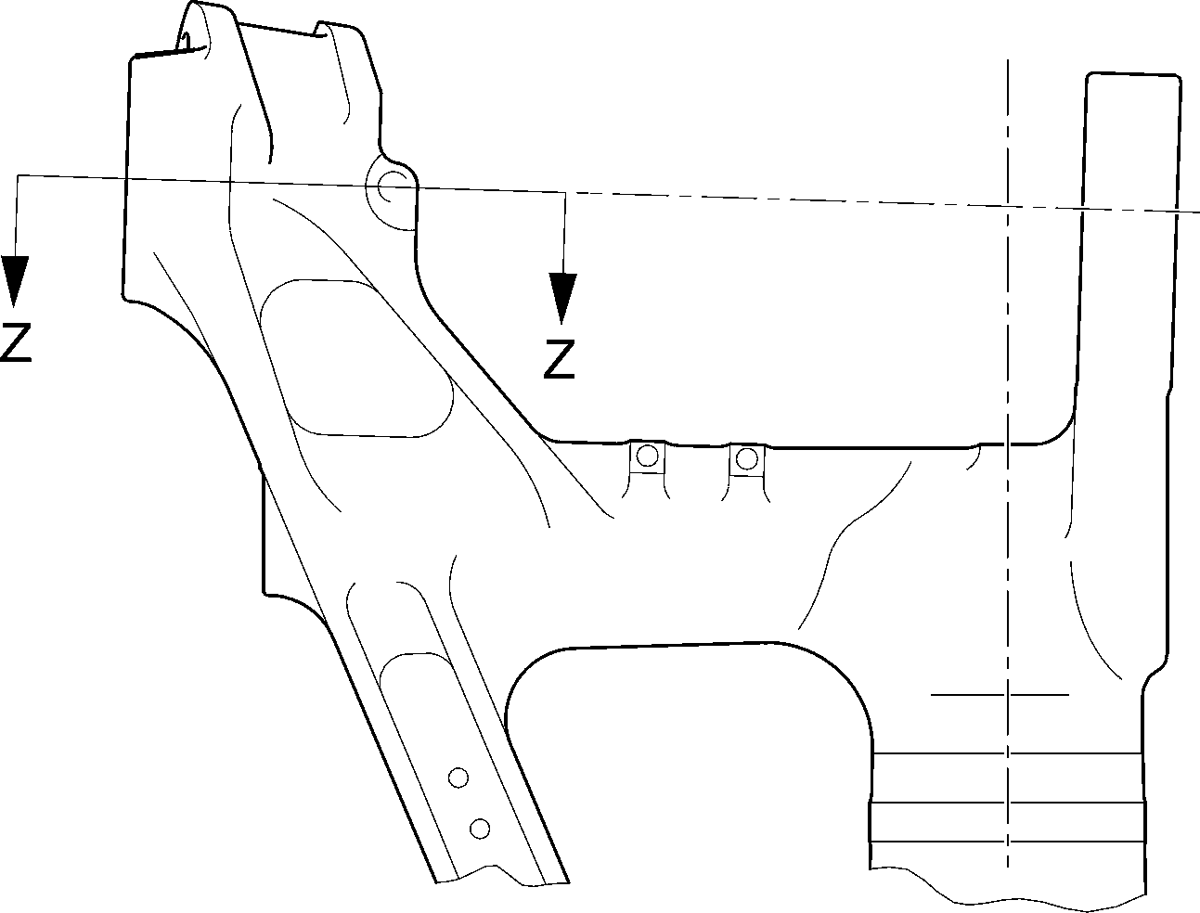
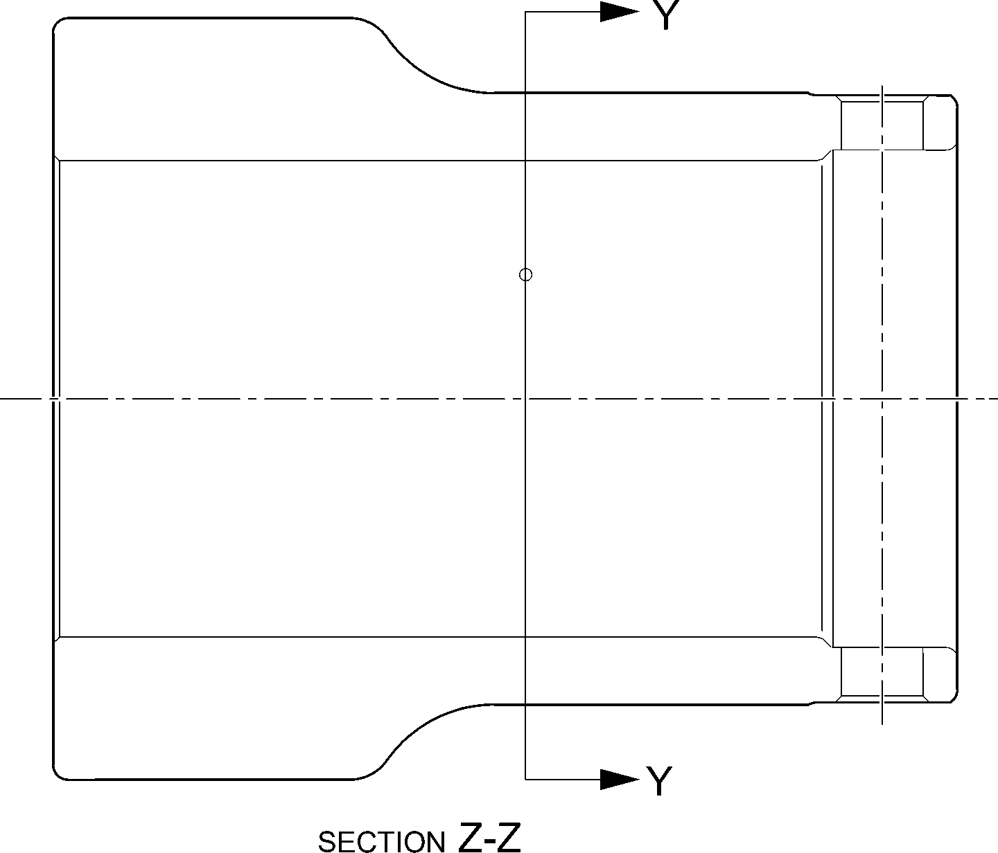
Repair to Main Fitting
Figure 601
A321A6877-1
Repair No. 11-24
32-12-22
Page 603
Dec 6/2019

SAFRAN LANDING SYSTEMS UK Ltd
CAGE: K0654

PART No. 201587001 AND 201587002 COMPONENT MAINTENANCE MANUAL
MAIN LANDING GEAR LEG
49.5 to 50.5
DEGREES REF.
dia. A
x 8,00mm
(0.315in) DEEP
80,00 to 81,60mm
(3.150 to 3.213in)
REF.
detail X
X
section Y-Y
REFER TO FIGURE 601
(WITHOUT LUBRICATION ADAPTOR)
0,50mm (0.020in)
x 45 DEGREES CHAMFER
18,20 to 19,80mm
(0.716 to 0.779in) REF.
NOTE:-
diameter A must follow
THE LINE OF EXISTING BORE
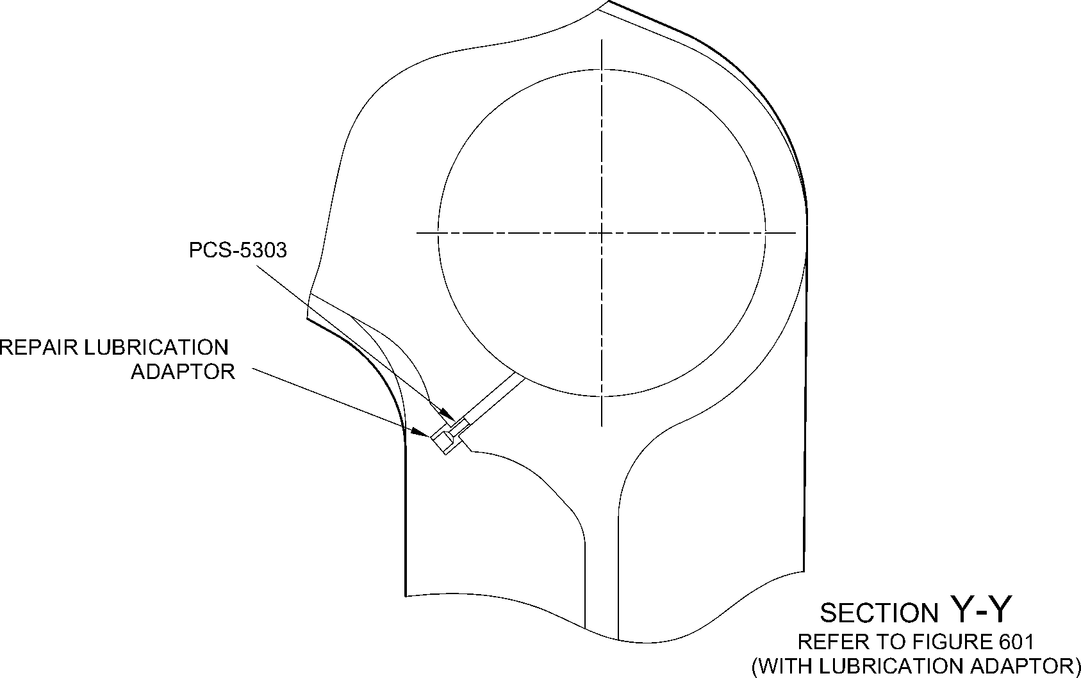
A321A6878-1
Repair to Main Fitting
Figure 602
32-12-22
Repair No. 11-24
Page 604
Dec 6/2019
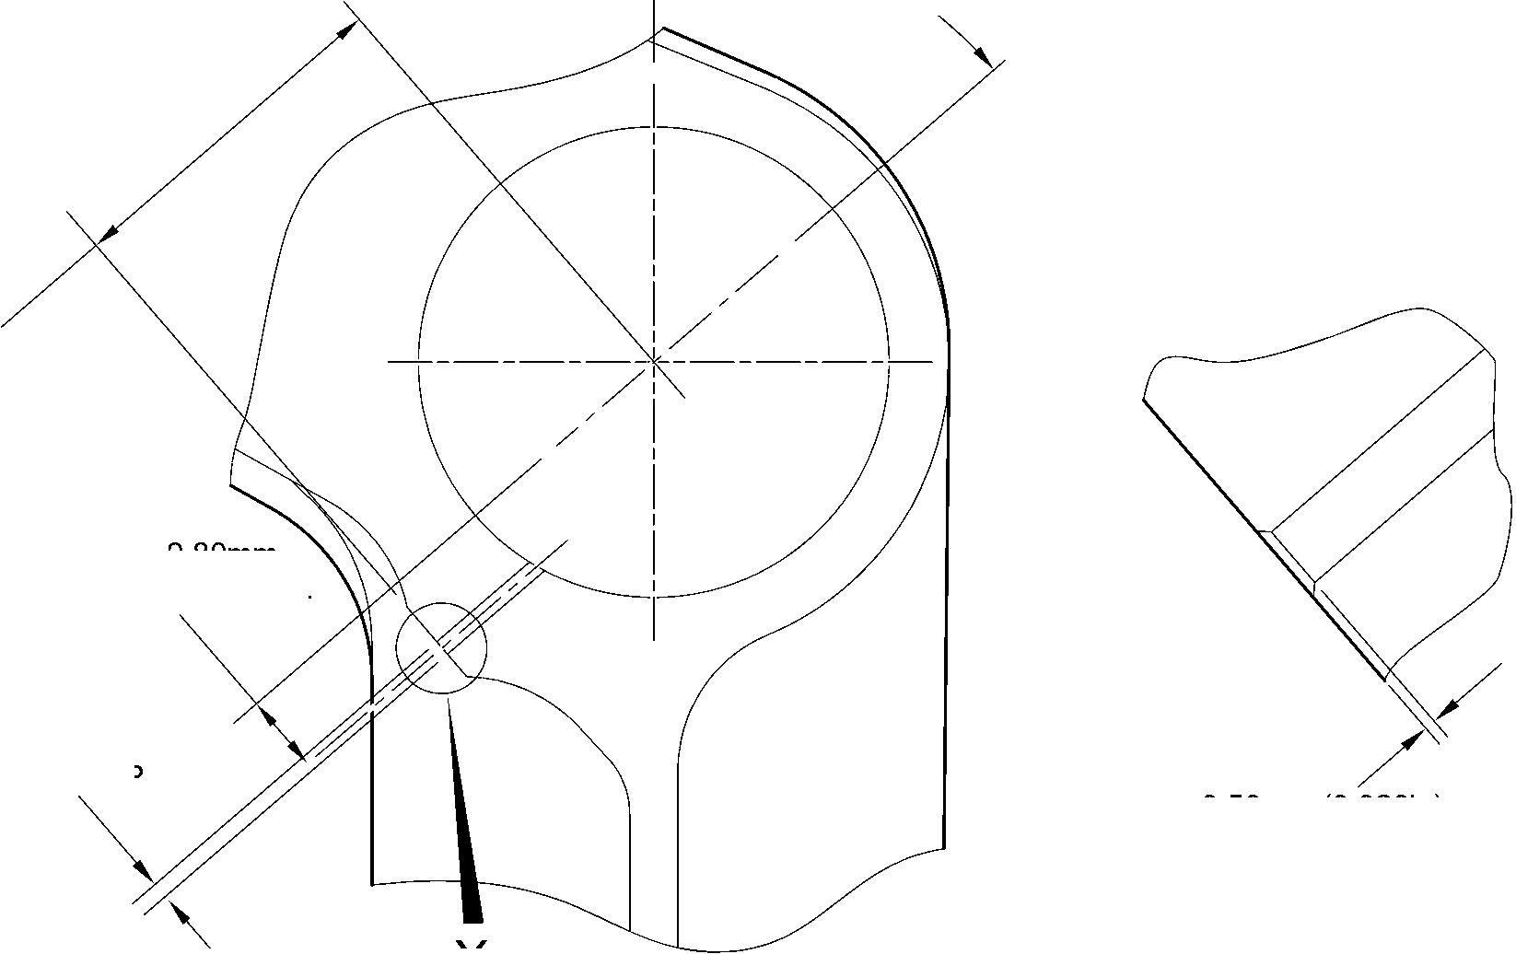

sSAFRAN SAFRAN LANDING SYSTEMS UK Ltd
CAGE: K0654
PART No. 201587001 AND 201587002 COMPONENT MAINTENANCE MANUAL
MAIN LANDING GEAR LEG

I 1. Repair No. 11-25 Main Fitting (20-410, 20-410A, 20-420 and 20-420A)
- Specified Damage and Material Specification.
- Specified Damage
(a) Damage or wear to the diameter A.
- Material Specification
IPL Figure and  Item No. | Name | Material Specification
20-410, 20-410A,  20-420 and  20-420A | Main Fitting | Steel, MAT135, 35NCD16THQ
- Special Tools
- These special tools are necessary:
NOTE: Alternative equivalents are permitted.
Tool Part No. | Special Tool | Function
460006268 | Press Pad | Install the oversize lubrication  adaptor
- Materials
- These materials are necessary:
NOTE: Alternative equivalents are permitted.
Ref. Item | Material
08-558 | Adhesive
- Repair Parts
- Refer to Table 1.
CAUTION: FOR DEVIATIONS OUTSIDE THE LIMITS OF THIS REPAIR SCHEME CONTACT
SAFRAN LANDING SYSTEMS.
- Procedure (Refer to Figure 601)
- Machine diameter A to the smallest oversize dimensions shown in Table 1 to remove the
damage or wear: refer to M-DLPS1004-4-1. Make the surface finish 1,6 micrometers
(63 micro-inches).
- Machine the chamfer to the dimensions shown: refer to Figure 601.
- Examine the machined areas for flaws: refer to PCS-3600 and PCS-3100 inclusion
class 4.
- Identify the part with the Safran Landing Systems repair number 450266395 adjacent to
the part number: refer to PCS-6000-04 or PCS-6000-06.
Repair No. 11-25
32-12-22
Page 601
Mar 18/2025

SAFRAN LANDING SYSTEMS UK Ltd
CAGE: K0654

PART No. 201587001 AND 201587002 COMPONENT MAINTENANCE MANUAL
MAIN LANDING GEAR LEG
- Apply cadmium plate to the machined areas. The cadmium plate thickness must be
between 0,010 and 0,020 mm (0.0004 and 0.0008 in): refer to PCS-2141.
- Select the applicable oversize lubrication adaptor for diameter A from Table 1.
- Install the selected lubrication adaptor: refer to PCS-7310. Use adhesive, Material Ref.
Item 08-558: refer to PCS-5303.
- Apply paint to the repaired areas: refer to REPAIR.
- Identify the part with the Safran Landing Systems repair number 450266395 adjacent to
the part number: refer to PCS-6000-07.
- Examine the part to make sure that you have obeyed all the repair instructions correctly.
Oversize Lubrication Adaptor
Table 1
Oversize | Diameter A  mm (in) | Oversize Lubrication Adaptor  Part No.
1 | 4,986 to 5,052  (0.1963 to 0.1989) | 450250161
2 | 5,113 to 5,179  (0.2013 to 0.2039) | 450250162
3 | 5,240 to 5,306  (0.2063 to 0.2089) | 450250163
4 | 5,367 to 5,433  (0.2113 to 0.2139) | 450250164
5 | 5,494 to 5,560  (0.2163 to 0.2189) | 450250165
6 | 5,621 to 5,687  (0.2213 to 0.2239) | 450250166
7 | 5,748 to 5,814  (0.2263 to 0.2289) | 450250241
8 | 5,875 to 5,941  (0.2313 to 0.2339) | 450250242
9 | 6,002 to 6,068  (0.2363 to 0.2389) | 450250243
10 | 6,129 to 6,195  (0.2413 to 0.2439) | 450250244
11 | 6,256 to 6,322  (0.2463 to 0.2489) | 450250245
12 | 6,383 to 6,449  (0.2513 to 0.2539) | 450250246
32-12-22
Repair No. 11-25
Page 602
Mar 18/2025

SAFRAN LANDING SYSTEMS UK Ltd
CAGE: K0654

PART No. 201587001 AND 201587002 COMPONENT MAINTENANCE MANUAL
MAIN LANDING GEAR LEG
Z
Z
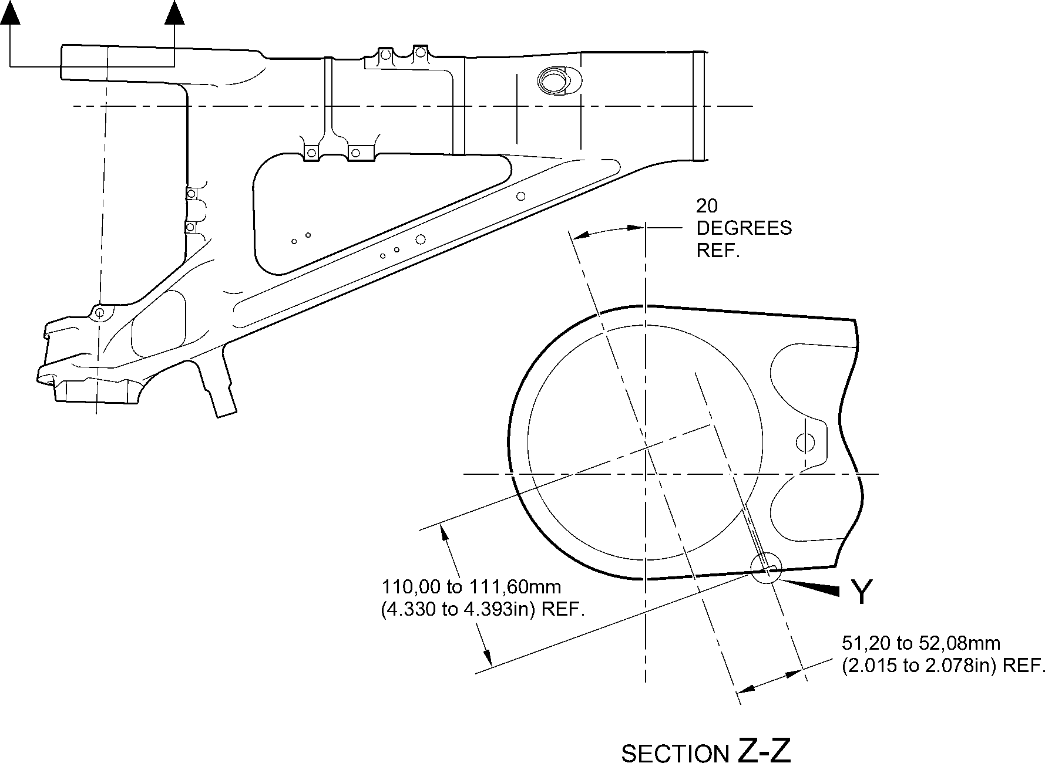
NOTE:-
DIAMETER A MUST FOLLOW REPAIR LUBRICATION
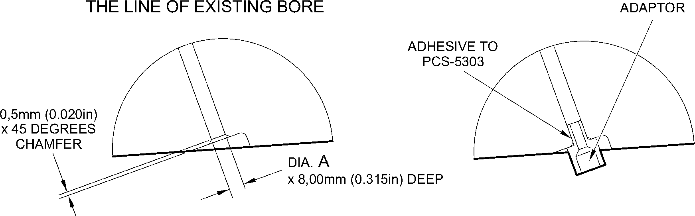
detail Y
(WITHOUT LUBRICATION ADAPTOR)
detail Y
(WITH LUBRICATION ADAPTOR)
A321A6879-1
Repair to Main Fitting
Figure 601
Repair No. 11-25
32-12-22
Page 603
Dec 6/2019

SAFRAN LANDING SYSTEMS UK Ltd
CAGE: K0654

PART No. 201587001 AND 201587002 COMPONENT MAINTENANCE MANUAL
MAIN LANDING GEAR LEG
INTENTIONALLY BLANK
Repair No. 11-25
32-12-22 ^{Page 604}

SAFRAN LANDING SYSTEMS UK Ltd
CAGE: K0654

PART No. 201587001 AND 201587002 COMPONENT MAINTENANCE MANUAL
MAIN LANDING GEAR LEG

I 1. Repair No. 11-26 Main Fitting (20-410 and 20-420 Only)
- Specified Damage and Material Specification.
- Specified Damage
(a) Damage or wear to diameter(s) A and B.
- Material Specification
IPL Figure and  Item No. | Name | Material Specification
20-410 and  20-420 Only | Main Fitting | Steel, MAT135, 35NCD16THQ
- Special Tools
(1) These special tools are necessary:
NOTE: Alternative equivalents are permitted.
Tool Part No. | Special Tool | Function
460006405 | Assembly sleeve | Install the lower bearing  subassembly
- Materials
(1) These materials are necessary:
NOTE: Alternative equivalents are permitted.
Ref. Item | Material
04-512 | Molykote 111
- Repair Parts
(1) These repair parts are necessary:
NOTE: Alternative equivalents are permitted.
Part No. | Repair Part | Material Specification
450266371 to 383 | Repair lower bearing  subassembly | -
201646300 | Repair inner liner | -
Repair No. 11-26
32-12-22
Page 601
Dec 4/2020

SAFRAN LANDING SYSTEMS UK Ltd
CAGE: K0654
SSAFRAN
PART No. 201587001 AND 201587002 COMPONENT MAINTENANCE MANUAL
MAIN LANDING GEAR LEG
CAUTION: FOR DEVIATIONS OUTSIDE THE LIMITS OF THIS REPAIR SCHEME CONTACT
M-DL GLOUCESTER.
E. Procedure (Refer to Figures 601, 602 and 603)
CAUTION: USE THIS PROCEDURE ONLY FOR POST SB 201-32-58 UNITS AND
REQUIREMENTS OF THESE SB MUST BE FOLLOWED FULLY. FOR PRE
SB 201-32-58 UNITS REFER TO REPAIR NO. 11-10.
- Machine diameters A and B to the nearest oversize dimensions shown in Table 1 to
remove the damage or wear: refer to M-DLPS1004-4-1 and Figure 602. Blend any sharp
edges smoothly into the adjacent surfaces. Make the surface finish for diameter A,
1,6 micrometers (63 micro-inches) and the surface finish for diameter B,
0,8 micrometers (32 micro-inches).
- Measure and record the new diameters A and B for information at para (8).
- Machine the chamfers and radii as shown: refer to Figure 602.
- Examine the machined areas for flaws: refer to PCS-3600 and PCS-3100 inclusion
class 4.
- Shot peen the machined areas in the main fitting: refer to M-DLPS123.
- Hone the shot peened diameters A and B to the recorded diameters at para (2) +0,00 to
0,025 mm (0.000 to 0.001 in).
CAUTION: DO NOT USE A MECHANICAL MOP POLISHER TO GET THE SURFACE
FINISH.
- Apply thin chromium plate to diameters A and B to the dimensions shown in Table 1:
refer to PCS-2110 Type C. The chromium plate thickness must be between 0,0075 and
0,0125 mm (0.00030 and 0.00050 in).
- Select the applicable oversize lower bearing subassembly for diameters A and B from
Table 1.
NOTE: The oversize lower bearing subassembly can be made from the related
PRE SB 201-32-58 lower bearing subassembly: refer to Table 2.
- If necessary, machine the inner diameter of bronze liner: Figure 603.
NOTE: The lower bearing 201522662 can only be machined when it is installed in
the lower bearing subassembly.
- If necessary, examine the reworked area of inner liner for flaws: refer to PCS-3200.
- If necessary, apply Molykote 111, Material Ref. Item 04-521 to the outside diameter of
liner. Install the inner liner into the oversize lower bearing subassembly: refer to
PCS-7303. The holes in the inner liner must align with the holes in the oversize lower
bearing subassembly.
- If necessary, strike through the old part number and re-identify the new lower bearing
subassembly with the new inner liner with part number identified in Table 2: refer to
PCS-6000-07.
- Use the Assembly Sleeve 460006405 to install the oversize lower bearing subassembly
on the sliding tube subassembly at the applicable assembly stage: refer to ASSEMBLY.
Repair No. 11-26
2Page 602
Mar 15/2024
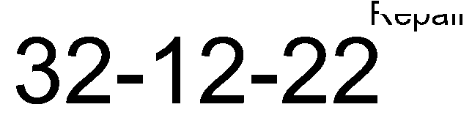

sSAFRAN SAFRAN LANDING SYSTEMS UK Ltd
CAGE: K0654
PART No. 201587001 AND 201587002 COMPONENT MAINTENANCE MANUAL
MAIN LANDING GEAR LEG
- Apply paint locally to the main fitting: refer to PCS-2500 and REPAIR.
- Install the repaired shock absorber subassembly in the main fitting at the applicable
assembly stage: refer to ASSEMBL .
- Identify the main fitting with the Messier-Dowty Limited repair number 450267370
adjacent to the part number: refer to PCS-6000-04.
- Examine the part to make sure that you have obeyed all the repair instructions correctly
Lower Bearing Subassembly Details
Table 1
 | Bore Diameter A |  | Bore Diameter B
 | Machined Diameter  A  mm (in) | After honing and  chromium plating  mm (in) | Machined Diameter  B  mm (in) | After honing and  chromium plating  mm (in) | Lower bearing  subassembly
1 | 212,138 to 212,194  (8.3519 to 8.3541) | 212,122 to 212,194  (8.3513 to 8.3541) | 209,027 to 209,088  (8.2294 to 8.2318) | 209,012 to 209,088  (8.2288 to 8.2318) | 450267371
2 | 212,288 to 212,344  (8.3578 to 8.3600) | 212,272 to 212,344  (8.3572 to 8.3600) | 209,177 to 209,238  (8.2353 to 8.2377) | 209,162 to 209,238  (8.2347 to 8.2377) | 450267373
3 | 212,438 to 212,494  (8.3637 to 8.3659) | 212,422 to 212,494  (8.3631 to 8.3659) | 209,327 to 209,388  (8.2412 to 8.2436) | 209,312 to 209,388  (8.2406 to 8.2436) | 450267375
4 | 212,588 to 212,644  (8.3696 to 8.3718) | 212,572 to 212,644  (8.3690 to 8.3718) | 209,477 to 209,538  (8.2471 to 8.2495) | 209,462 to 209,538  (8.2465 to 8.2495) | 450267377
5 | 212,738 to 212,794  (8.3755 to 8.3777) | 212,722 to 212,794  (8.3749 to 8.3777) | 209,627 to 209,688  (8.2530 to 8.2554) | 209,612 to 209,688  (8.2524 to 8.2554) | 450267379
6 | 213,129 to 213,185  (8.3909 to 8.3931) | 213,113 to 213,185  (8.3902 to 8.3931) | 209,627 to 209,688  (8.2530 to 8.2554) | 209,612 to 209,688  (8.2524 to 8.2554) | 450267381
7 | 213,429 to 213,485  (8.4027 to 8.4049) | 213,413 to 213,485  (8.4020 to 8.4049) | 209,627 to 209,688  (8.2530 to 8.2554) | 209,612 to 209,688  (8.2524 to 8.2554) | 450267383
Oversize Lower Bearing Subassembly
Table 2
PRE SB 200-32-58  Part Number | POST SB  200-32-58  Part Number
450266261 | 450267371
450266262 | 450267373
450266263 | 450267375
450266264 | 450267377
450266265 | 450267379
450266266 | 450267381
450266267 | 450267383
Repair No. 11-26
32-12-22
Page 603
Mar 15/2024

SAFRAN LANDING SYSTEMS UK Ltd
CAGE: K0654

PART No. 201587001 AND 201587002 COMPONENT MAINTENANCE MANUAL
MAIN LANDING GEAR LEG
Z
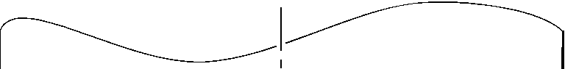
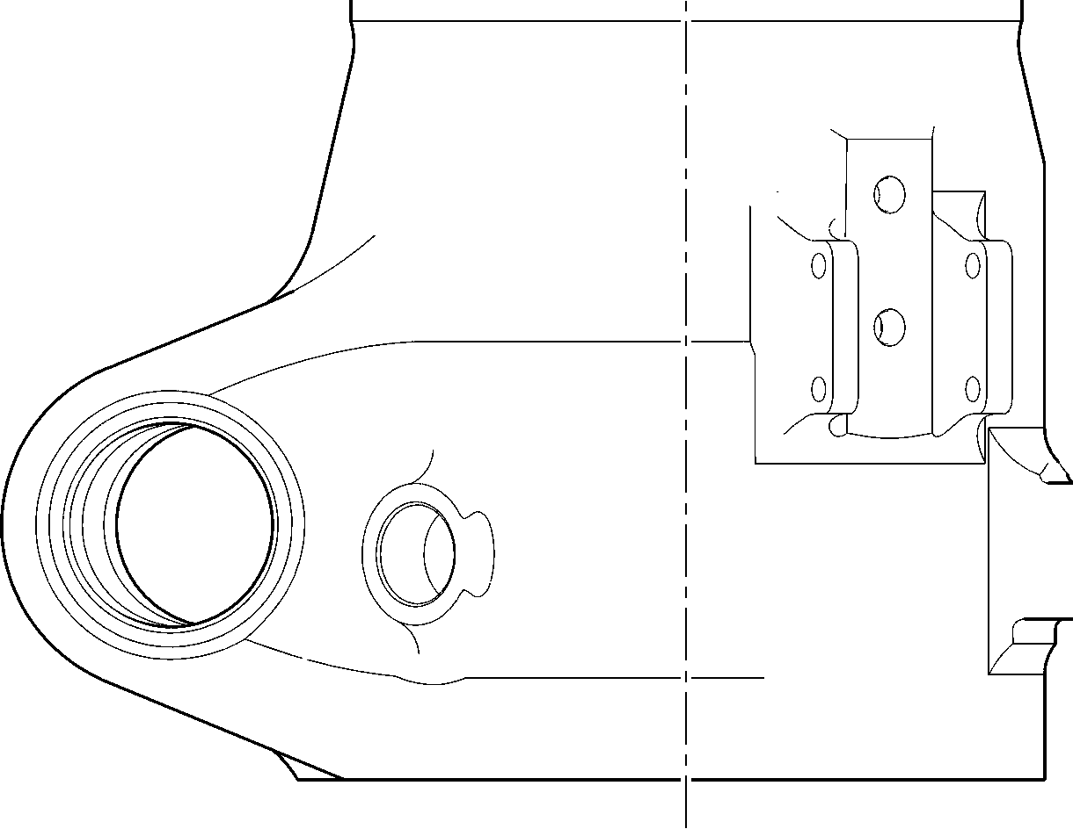
Z
A321A6881-1
Repair to Main Fitting
Figure 601
32-12-22
Repair No. 11-26
Page 604
Dec 6/2019

SAFRAN LANDING SYSTEMS UK Ltd
CAGE: K0654

PART No. 201587001 AND 201587002 COMPONENT MAINTENANCE MANUAL
MAIN LANDING GEAR LEG
19,75 to 20,25mm
(0.778 to 0.797 in)
RADIUS
183,00mm (7.205in)
MIN.EXTENT OF FINE LIMIT
REMAINDER MAY BE
dia. B -0,254mm (0.0100in)
Y
dia. B
55,00mm (2.165in)
MIN. EXTENT OF
5,60mm (0.220in)
X 15 DEGREES
CHAMFER
15
DEGREES
99,75 to 100,50mm
(3.927 to 3.957in)
dia. A -0,254mm (0.0100in)
FINE LIMIT 1,6
REMAINDER MAY BE H (6,3)
A -0254mm (0 0100in)
5,00 to 10,00mm
(0.197 to 0.394in)
EXTENT OF
CHROMIUM
PLATE FADE OUT
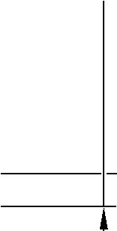
9,00 to 11,00mm
0.354 to 0.433in)
RADIUS
198,25 to 199,00mm
(7.805 to 7.835in)
THIN CHROMIUM PLATE
dia. A
© | 0,05mm  (0.002in) | Y
A321A6882-2
Repair to Main Fitting - Machining
Figure 602
Repair No. 11-26
32-12-22
Page 605
Mar 15/2024
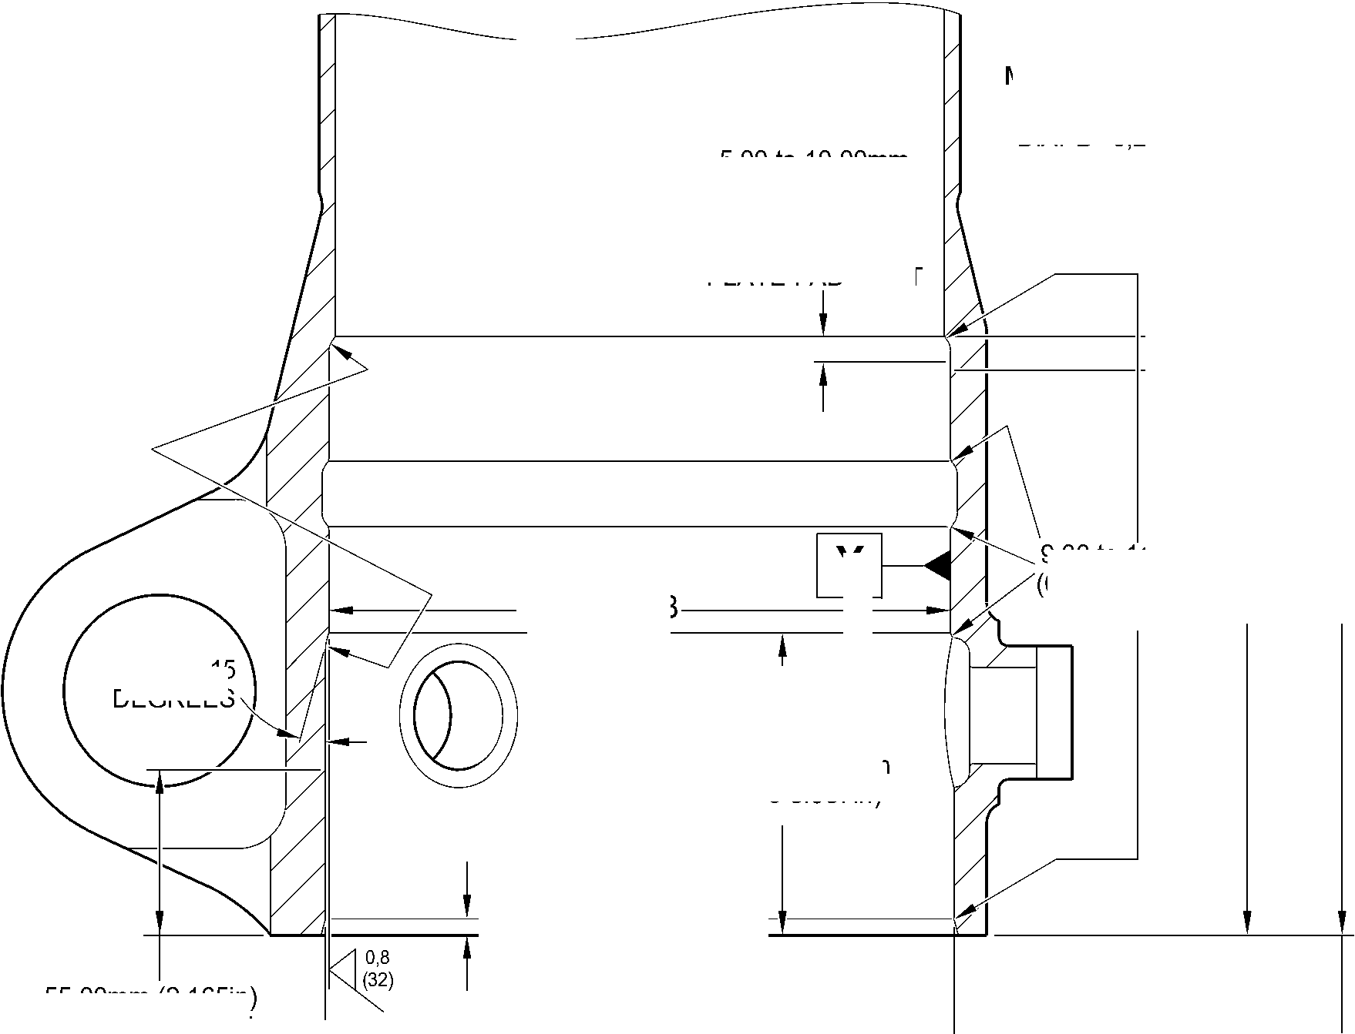

SAFRAN LANDING SYSTEMS UK Ltd
CAGE: K0654

PART No. 201587001 AND 201587002 COMPONENT MAINTENANCE MANUAL
MAIN LANDING GEAR LEG
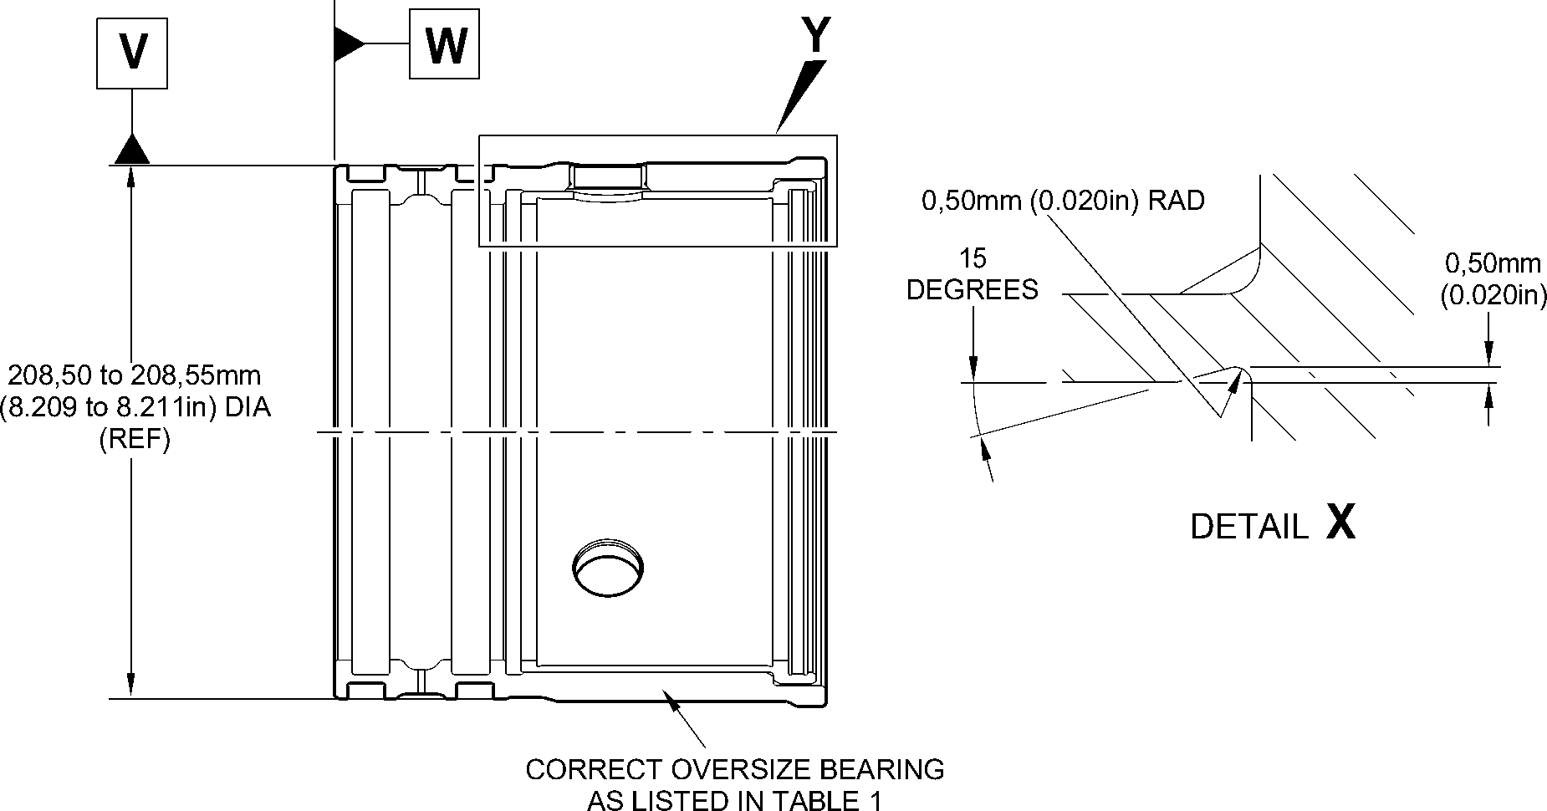
92,85 to 93,00mm
(3.656 to 3.661in)
X
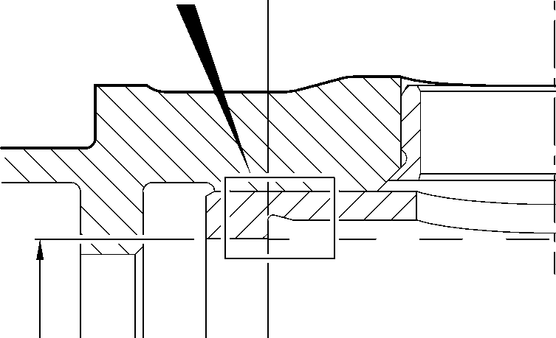
X
64,650 to 64,775mm
(2.5453 to 2.5502in)
178,87 to 179,07mm 182,453 to 182,516mm
(7.042 to 7.050in) DIA (7.1832 to 7.1857in) DIA
DETAIL Y

0,025mm
(0.0010in)
0,040mm
(0.0015in) DIA
W
0.333 to 0.867
DEGREES
MODIFIED REPAIR LOWER
BEARING SUBASSEMBLY
DETAIL Y
WITH INNER LINER
NEW INNER LINER
201646300
A321A6964-2
Lower Bearing Subassembly Machining and Liner Installation
Figure 603
32-12-22
Repair No. 11-26
Page 606
Mar 15/2024
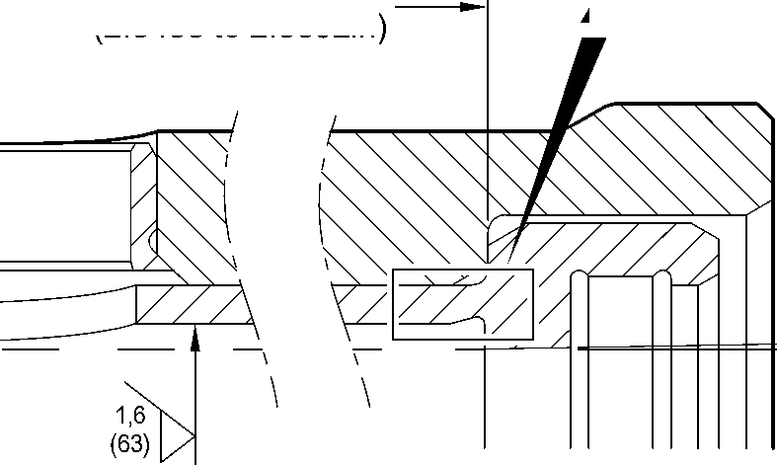
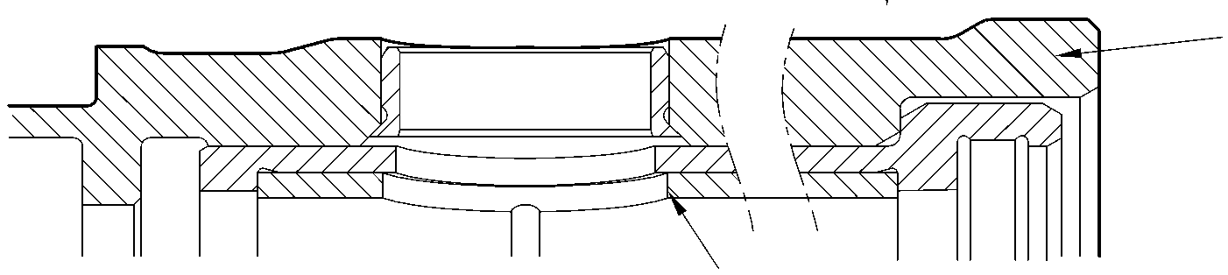

sSAFRAN SAFRAN LANDING SYSTEMS UK Ltd
CAGE: K0654
PART No. 201587001 AND 201587002 COMPONENT MAINTENANCE MANUAL
MAIN LANDING GEAR LEG

I 1. Repair No. 11-27 Main Fitting (20-410, 20-410A, 20-420 and 20-420A)
- Specified Damage and Material Specification
- Specified Damage
(a) Damage or wear to diameter A and/or face B.
- Material Specification
IPL Figure and  Item No. | Name | Material Specification
20-410, 20-410A,  20-420 and  20-420A | Main Fitting | Steel, MAT135, 35NCD16THQ
- Special Tools
- These special tools are necessary:
NOTE: Alternative equivalents are permitted.
Tool Part No. | Special Tool | Function
460006614 | Assembly tool | Install the bearing
- Materials
- These materials are necessary:
NOTE: Alternative equivalents are permitted.
Ref. Item | Material
TBA | Zinc
05-533 | MastinoxD40
09-510A | Sealant
- Repair Parts
(1) These repair parts are necessary:
NOTE: Alternative equivalents are permitted.
Part No. | Repair Part | Material Specification
450266337 | Repair Bearing | AMS 4881 or AMS 4590
- Procedure (Refer to Figures 601 and 602)
CAUTION: FOR DAMAGE MORE THAN THE LIMITS OF THIS REPAIR SCHEME, WRITE
TO SAFRAN LANDING SYSTEMS: REFER TO GUIDE-CS-001.
- Machine diameter A and/or face B sufficiently to remove the damage or wear within the
dimensions shown: refer to M-DLPS1004-4-1 and Figure 601. Make the surface finish
1,6 micrometers (63 micro-inches).
Repair No. 11-27
32-12-22
Page 601
Mar 18/2025

sSAFRAN SAFRAN LANDING SYSTEMS UK Ltd
CAGE: K0654
PART No. 201587001 AND 201587002 COMPONENT MAINTENANCE MANUAL
MAIN LANDING GEAR LEG
- Machine the radii and chamfer as the dimensions shown: refer to Figure 601.
- Measure and record the new diameter A and length C.
- Examine the reworked area for flaws: refer to PCS-3600 and PCS-3100, inclusion
class 4.
- Shot peen the machined surfaces: refer to M-DLPS123.
- Apply cadmium plate to the machined areas: refer to PCS-2100 or PCS-2141.The
cadmium plate thickness must be between 0,01 and 0,02 mm (0.004 and 0.008 in).
- Identify the part with the Safran Landing Systems repair number 450266040 adjacent to
the part number: refer to PCS-6000-04, an alternative reference is PCS-6000-06. If the
alternative reference is used, the characters must be 0,051 to 0,102 mm (0.0020 to
0.0040 in) deep and approximately 3,00 mm (0.118 in) high.
- Calculate the dimensions for the repair bush, use formula:
Diameter D = Diameter A (as measured) + 0.069 to 0.126 mm (0.0027 to 0.0049 in)
Length E = Length C (as measured) + 2,25 to 3,00 mm (0.089 to 0.118 in).
- Machine the repair bearing to the dimensions shown and calculated: refer to Figure 602.
Make the surface finish 1,6 micrometers (63 micro-inches).
- Apply cadmium plate all over the repair bearing except the bore and the internal
grooves: refer to PCS-2101. The cadmium plate thickness must be between 0,01 and
0,015 mm (0.0004 and 0.0006 in).
- Use Assembly Tool 460006614 and install the repair bearing: refer to PCS-5100. Use
electrically conducting Mastinox (made from Mastinox D40, Material Ref. Item 05-533
and Zinc powder, Material Ref. Item TBA).
- Check ream the repair bearing bore to the dimensions shown: refer to Figure 602.
- Apply a bead of sealant, Material Ref. Item 09-510A to joints between the repair bearing
and the main fititng: refer to PCS-7200 and Figure 602.
- Identify the part with the Safran Landing Systems repair number 450266040 adjacent to
the part number: refer to PCS-6000-07.
- Examine the part to make sure that you have obeyed all the repair instructions correctly.
32-12-22
Repair No. 11-27
Page 602
Mar 18/2025

SAFRAN LANDING SYSTEMS UK Ltd
CAGE: K0654

PART No. 201587001 AND 201587002 COMPONENT MAINTENANCE MANUAL
MAIN LANDING GEAR LEG
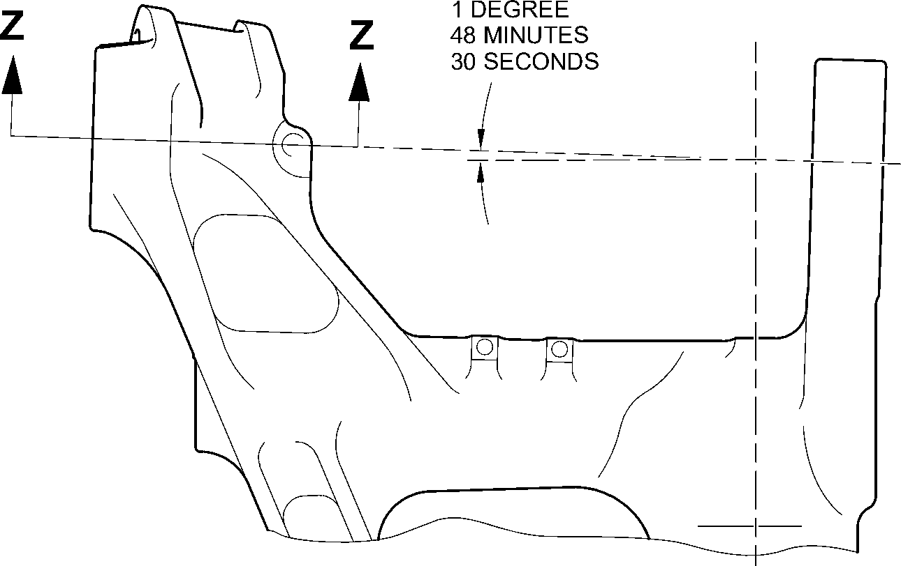
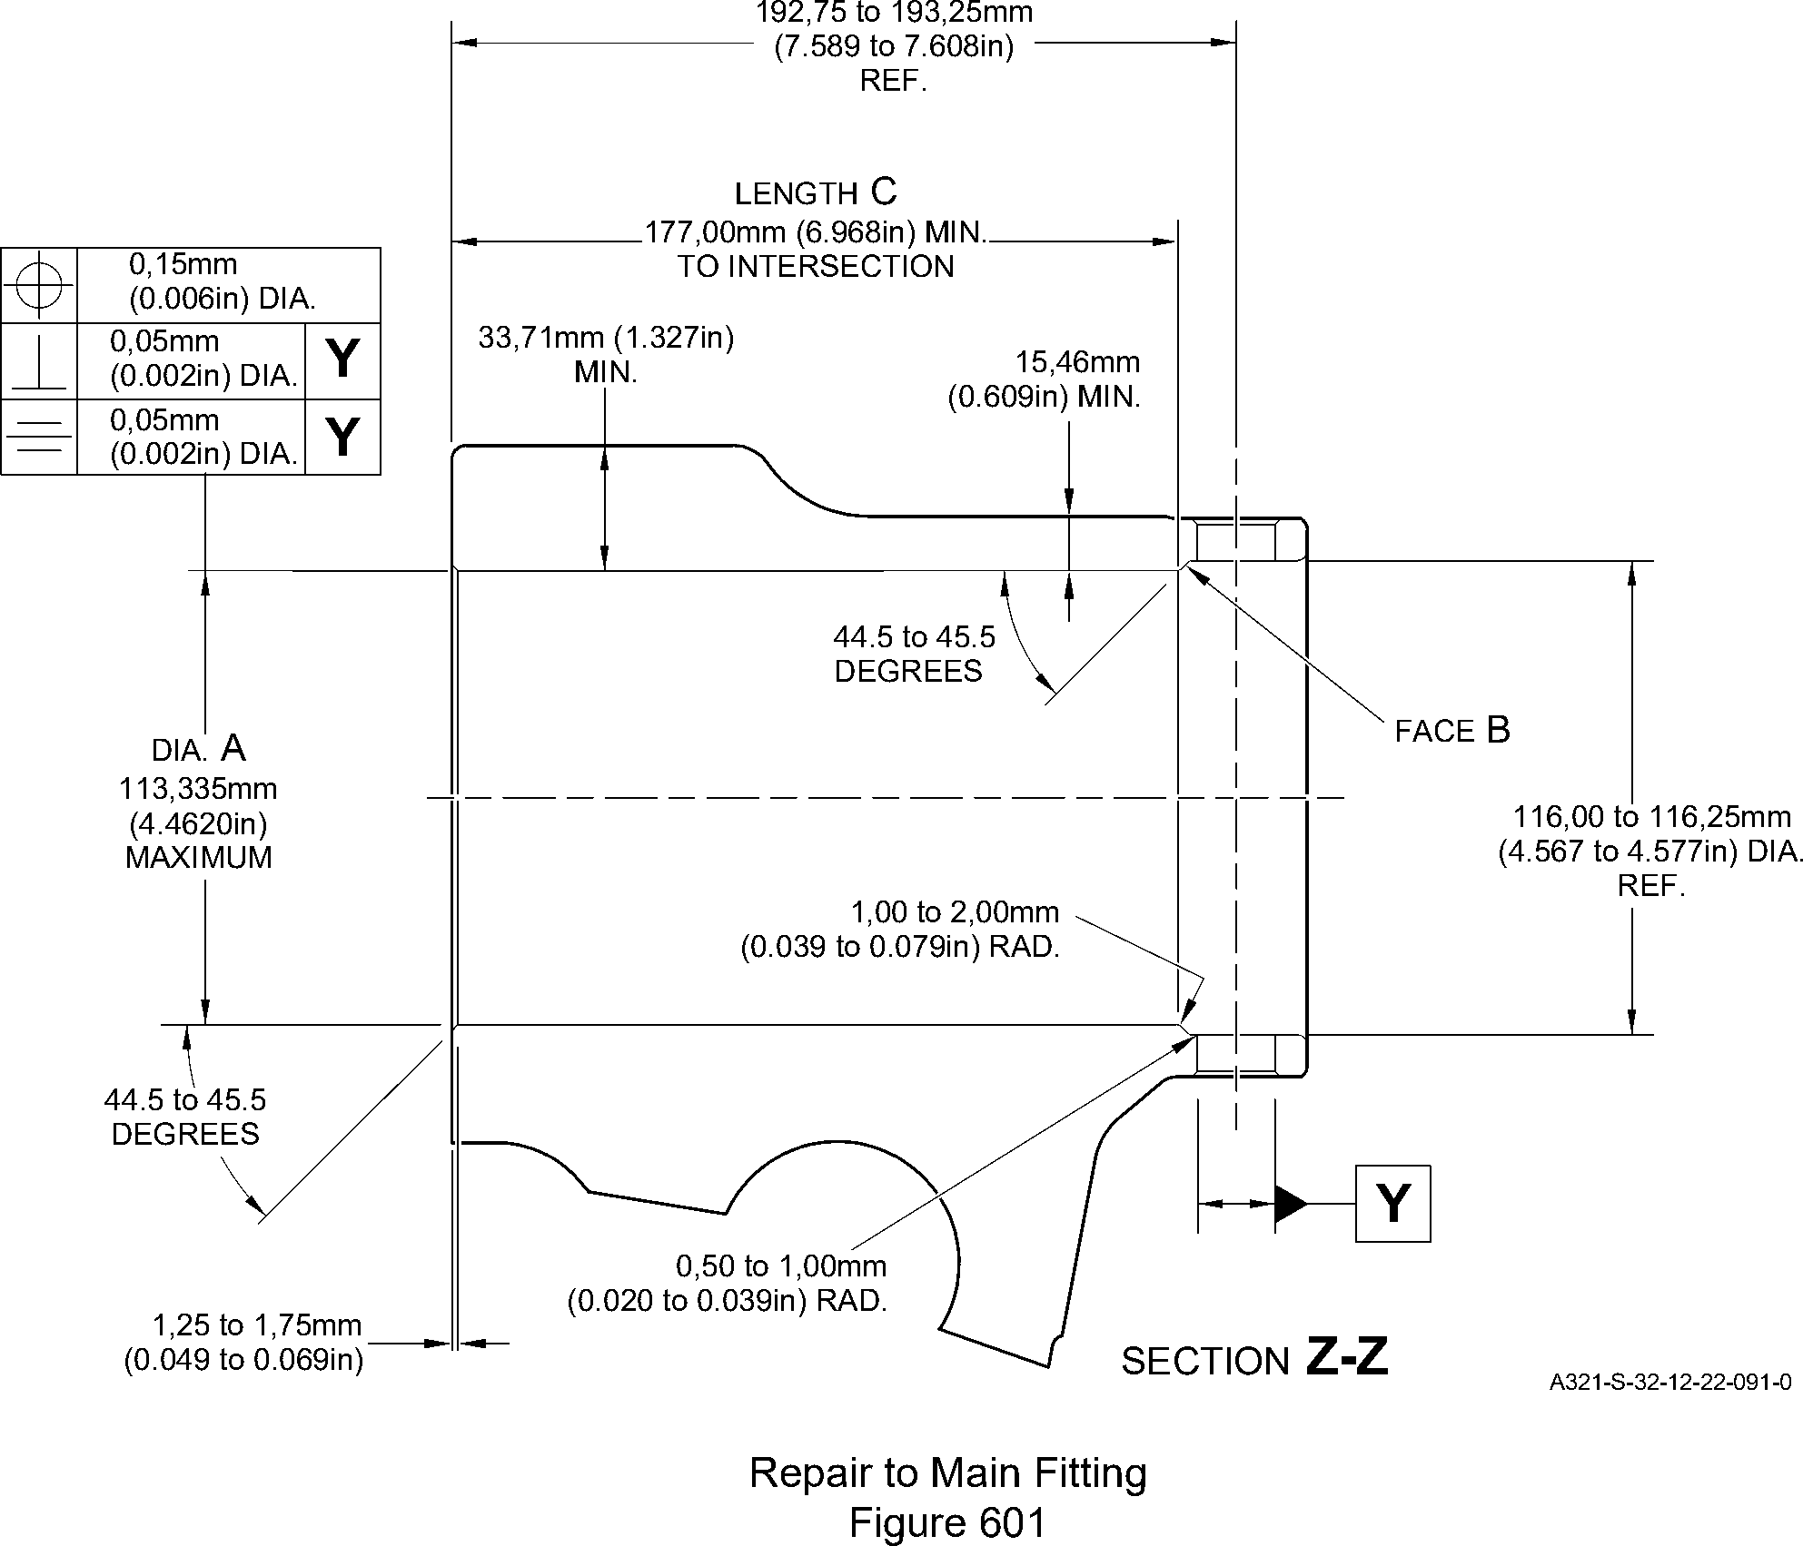
Page 603
Mar 24/2017
Repair No. 11-27
32-12-22

SAFRAN LANDING SYSTEMS UK Ltd
CAGE: K0654

PART No. 201587001 AND 201587002 COMPONENT MAINTENANCE MANUAL
MAIN LANDING GEAR LEG
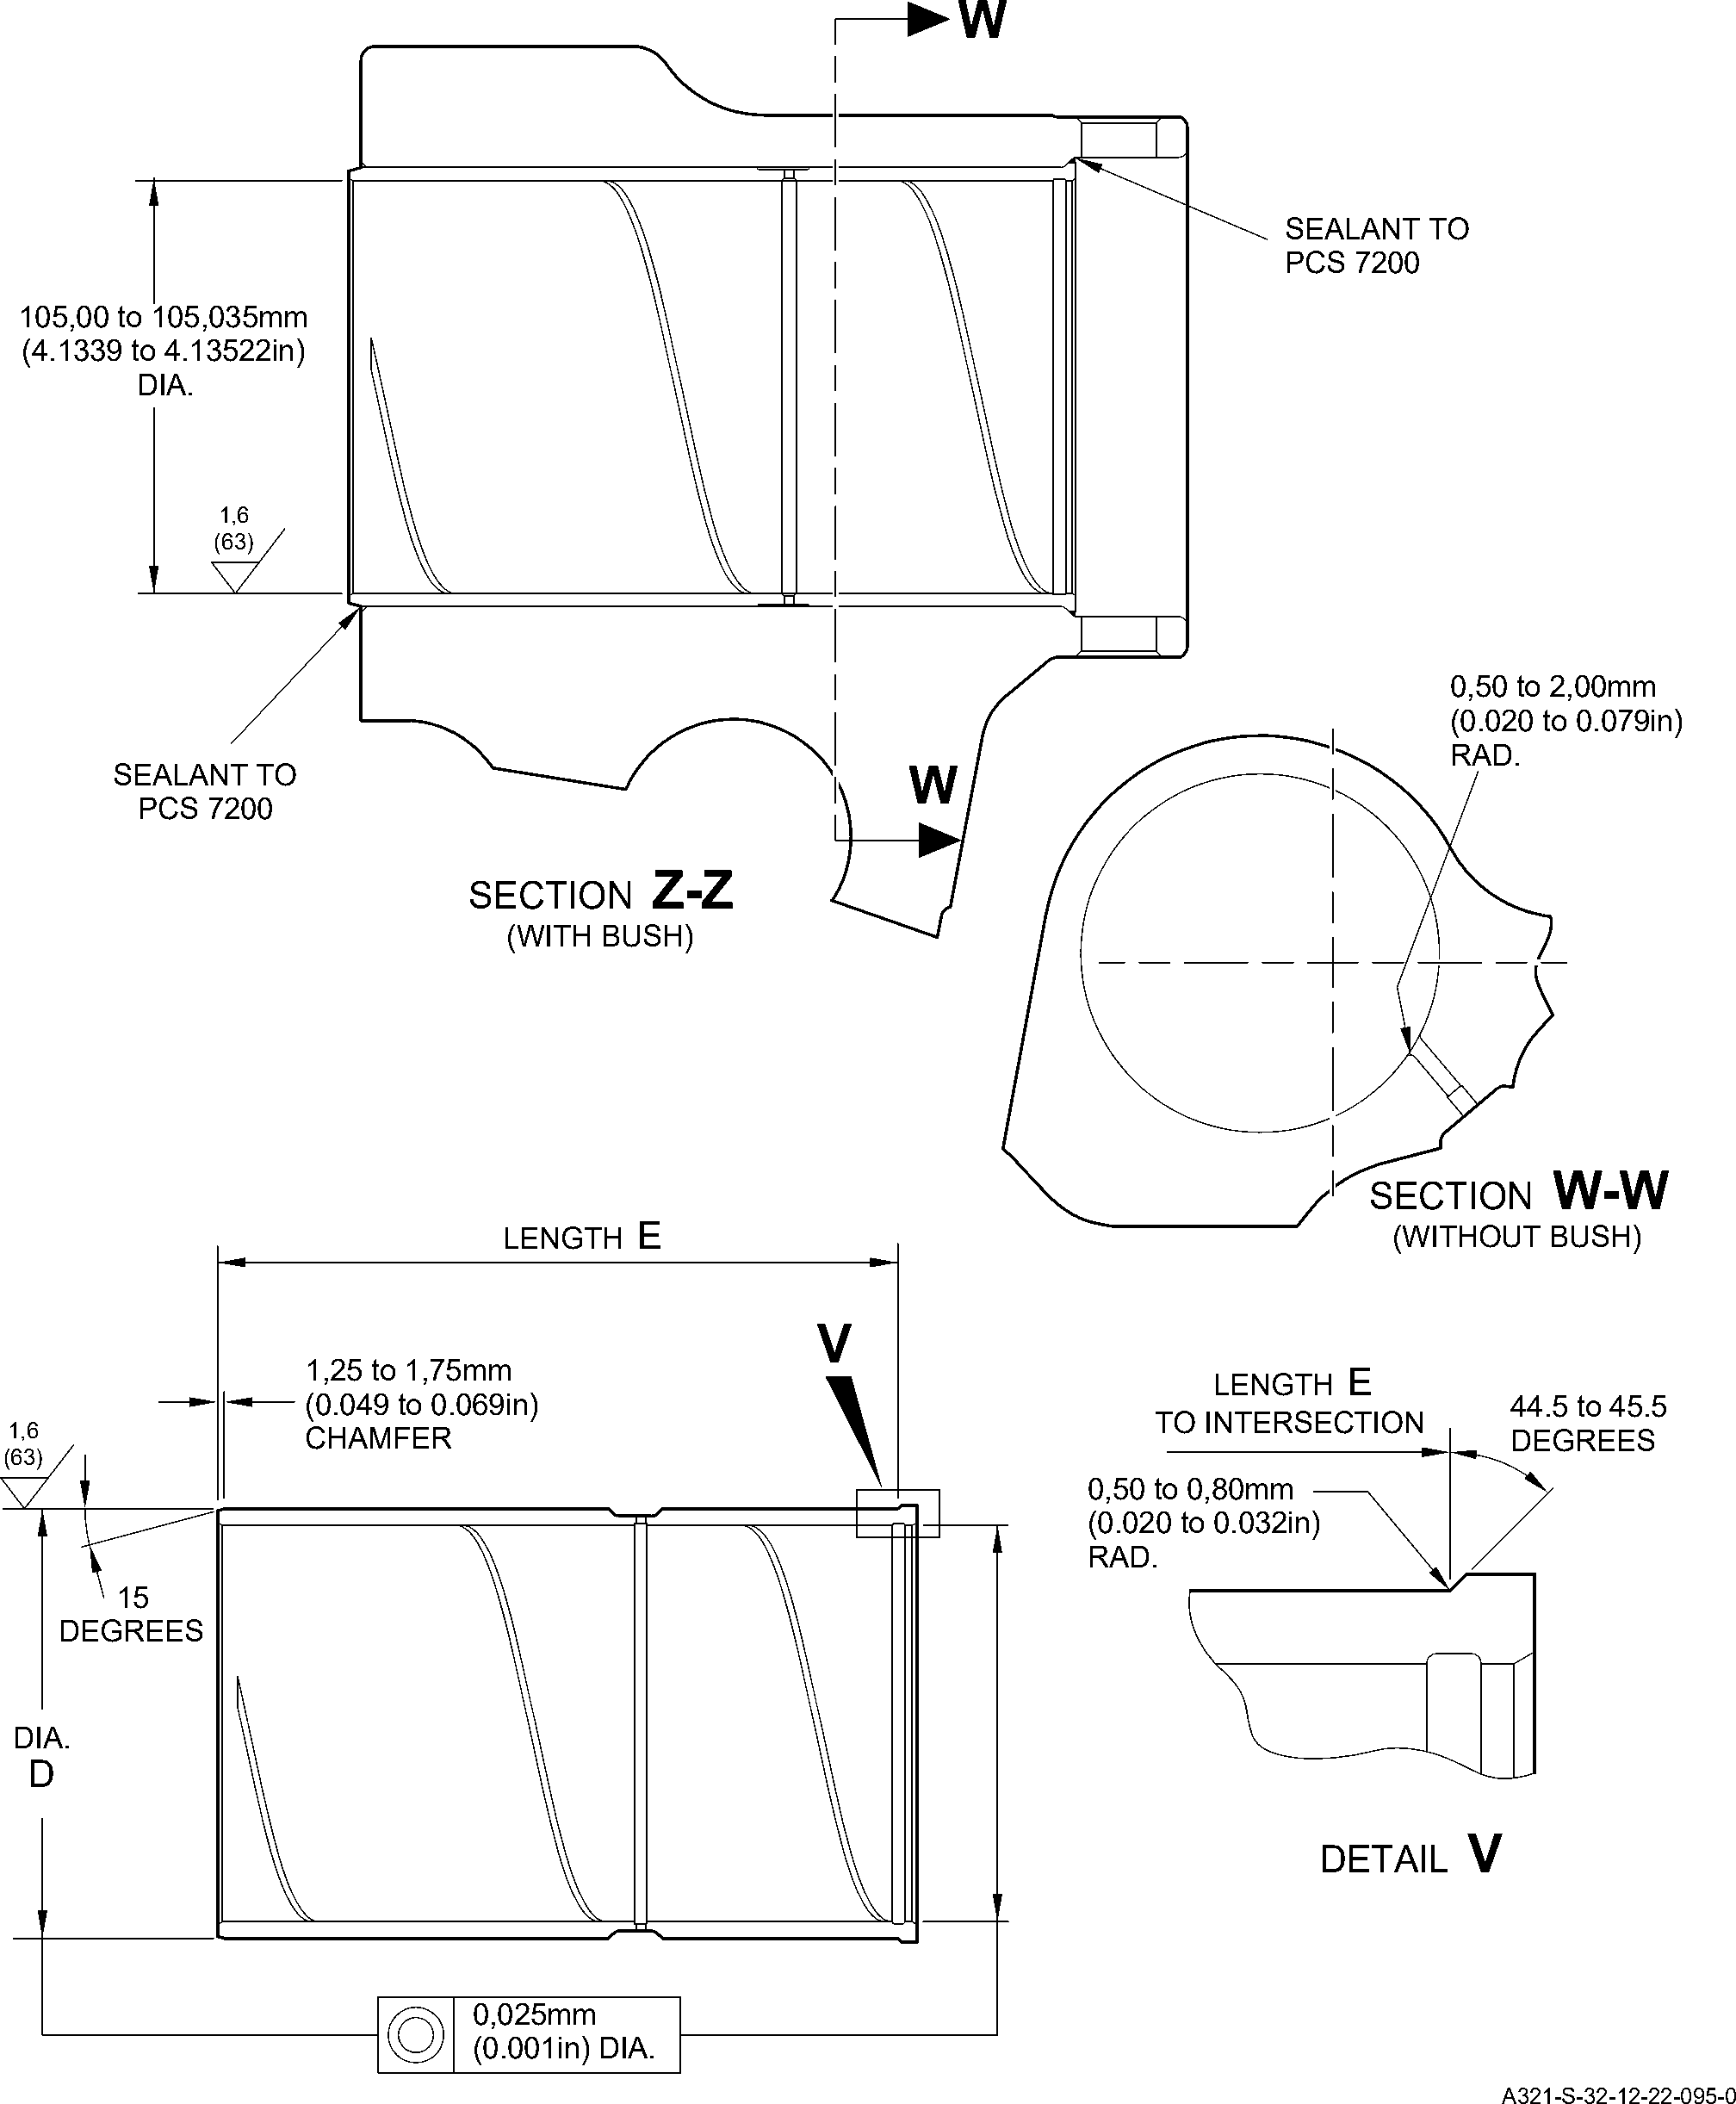
Repair Bearing - Machining and Installation
Figure 602
Repair No. 11-27
32
Page 604
-12-22 Mar 24/2017

SAFRAN LANDING SYSTEMS UK Ltd
CAGE: K0654

PART No. 201587001 AND 201587002 COMPONENT MAINTENANCE MANUAL
MAIN LANDING GEAR LEG

I 1. Repair No. 11-28 Main Fitting (20-410, 20-410A, 20-420 and 20-420A)
- Specified Damage and Material Specification
- Specified Damage
(a) Damage or wear to diameters A and/or C.
- Material Specification
IPL Figure and  Item No. | Name | Material Specification
20-410, 20-410A,  20-420 and  20-420A | Main Fitting | Steel, MAT135, 35NCD16THQ
- Special Tools
- Special tools are not necessary.
- Materials
- Materials are not necessary.
- Repair Parts
- These repair parts are necessary:
NOTE: Alternative equivalents are permitted.
Part No. | Repair Part | Material Specification
MS28774-012 | 1st Oversize backing ring | -
MS28774-013 | 2nd Oversize backing ring | -
MS28775-012 | 1st Oversize O-ring | -
MS28775-013 | 2nd Oversize O-ring | -
450239351 | 1st Oversize transfer  dowel | Aluminium alloy L168-T6511
450239352 | 2nd Oversize transfer  dowel | Aluminium alloy L168-T6511
- Procedure (Refer to Figures 601 and 602)
CAUTION: FOR DAMAGE MORE THAN THE LIMITS OF THIS REPAIR SCHEME, WRITE
TO SAFRAN LANDING SYSTEMS: REFER TO GUIDE-CS-001.
- Do this procedure if there is damage or wear to diameter A:
- Machine diameter A sufficiently to remove the damage or wear to the nearest
possible dimensions as shown in Table 601: refer to M-DLPS1004-4-1 and
Figure 602. Make the surface finish 1,6 micrometers (63 micro-inches).
- Examine the reworked area for flaws: refer to PCS-3100, inclusion class 4 and
PCS-3600.
Repair No. 11-28
32-12-22
Page 601
Mar 18/2025

sSAFRAN SAFRAN LANDING SYSTEMS UK Ltd
CAGE: K0654
PART No. 201587001 AND 201587002 COMPONENT MAINTENANCE MANUAL
MAIN LANDING GEAR LEG
- Identify the part with Safran Landing Systems repair number 450266405A for 1st
oversize or 450266405B for 2nd oversize adjacent to the part number: refer to
PCS-6000-04 or PCS-6000-06.
- Select the applicable oversize transfer dowel, oversize O-ring and oversize
backing ring: refer to Table 601.
- Install the selected oversize parts to the main fitting: refer to Figure 603.
- Apply paint to external surfaces, but not to the dowel bores: refer to PCS-2500.
- Identify the part with Safran Landing Systems repair number 450266405A for
1st oversize or 450266405B for 2nd oversize adjacent to the part number: refer to
PCS-6000-07.
- Examine the part to make sure that you have obeyed all the repair instructions
correctly.
Oversize dimensions
Table 601
Oversize | Diameter A  mm (in) | Diameter B  mm (in) | Oversize  Transfer dowel  Part No. | Oversize O-ring  Part No. | Oversize  Backing ring  Part No.
1 | 12,3190 to 12,3444  (0.4850 to 0.4860) | 13,65  (0.537) | 450239351 | MS28775-012 | MS28774-012
2 | 13,9700 to 14,0208  (0.5500 to 0.5520) | 15,37  (0.605) | 450239352 | MS28775-013 | MS28774-013
- Do this procedure, if there is damage or wear to diameter C:
- Machine diameter C sufficiently to remove the damage or wear to the nearest
possible dimensions as shown in Table 602: refer to M-DLPS1004-4-1 and
Figure 602. Make the surface finish 1,6 micrometers (63 micro-inches).
- Examine the reworked area for flaws: refer to PCS-3100, inclusion class 4 and
PCS-3600.
- Identify the part with Safran Landing Systems repair number 450266405D for
1st oversize or 450266405E for 2nd oversize adjacent to the part number: refer to
PCS-6000-04 or PCS-6000-06.
- Select the applicable oversize transfer dowel, oversize O-ring and oversize
backing ring: refer to Table 602.
- Install the selected oversize parts to the main fitting: refer to Figure 603.
- Apply paint to external surfaces, but not to the dowel bores: refer to PCS-2500.
- Identify the part with Safran Landing Systems repair number 450266405D for
1st oversize or 450266405E for 2nd oversize adjacent to the part number: refer to
PCS-6000-07.
32-12-22
Repair No. 11-28
Page 602
Mar 18/2025

SAFRAN LANDING SYSTEMS UK Ltd
CAGE: K0654

PART No. 201587001 AND 201587002 COMPONENT MAINTENANCE MANUAL
MAIN LANDING GEAR LEG
- Examine the part to make sure that you have obeyed all the repair instructions
correctly.
Oversize dimensions
Table 602
Oversize | Diameter C  mm (in) | Diameter D  mm (in) | Oversize  Transfer dowel  Part No. | Oversize O-ring  Part No. | Oversize  Backing ring  Part No.
1 | 12,3190 to 12,3444  (0.4850 to 0.4860) | 13,65  (0.537) | 450239351 | MS28775-012 | MS28774-012
2 | 13,9700 to 14,0208  (0.5500 to 0.5520) | 15,37  (0.605) | 450239352 | MS28775-013 | MS28774-013
Repair No. 11-28
32-12-22
Page 603
Dec 6/2019

SAFRAN LANDING SYSTEMS UK Ltd
CAGE: K0654
43,00mm
(1.693in)
CRS
Y
(REFER TO FIGURE 602)
Y
X
Z
detail Z
146,00 to 147,00mm
(5.748 to 5.787in)
X
(REFER TO FIGURE 602)
PART No. 201587001 AND 201587002 COMPONENT MAINTENANCE MANUAL
MAIN LANDING GEAR LEG
A321A7163-1
Repair to Main Fitting
Figure 601
32-12-22
Repair No. 11-28
Page 604
Dec 6/2019
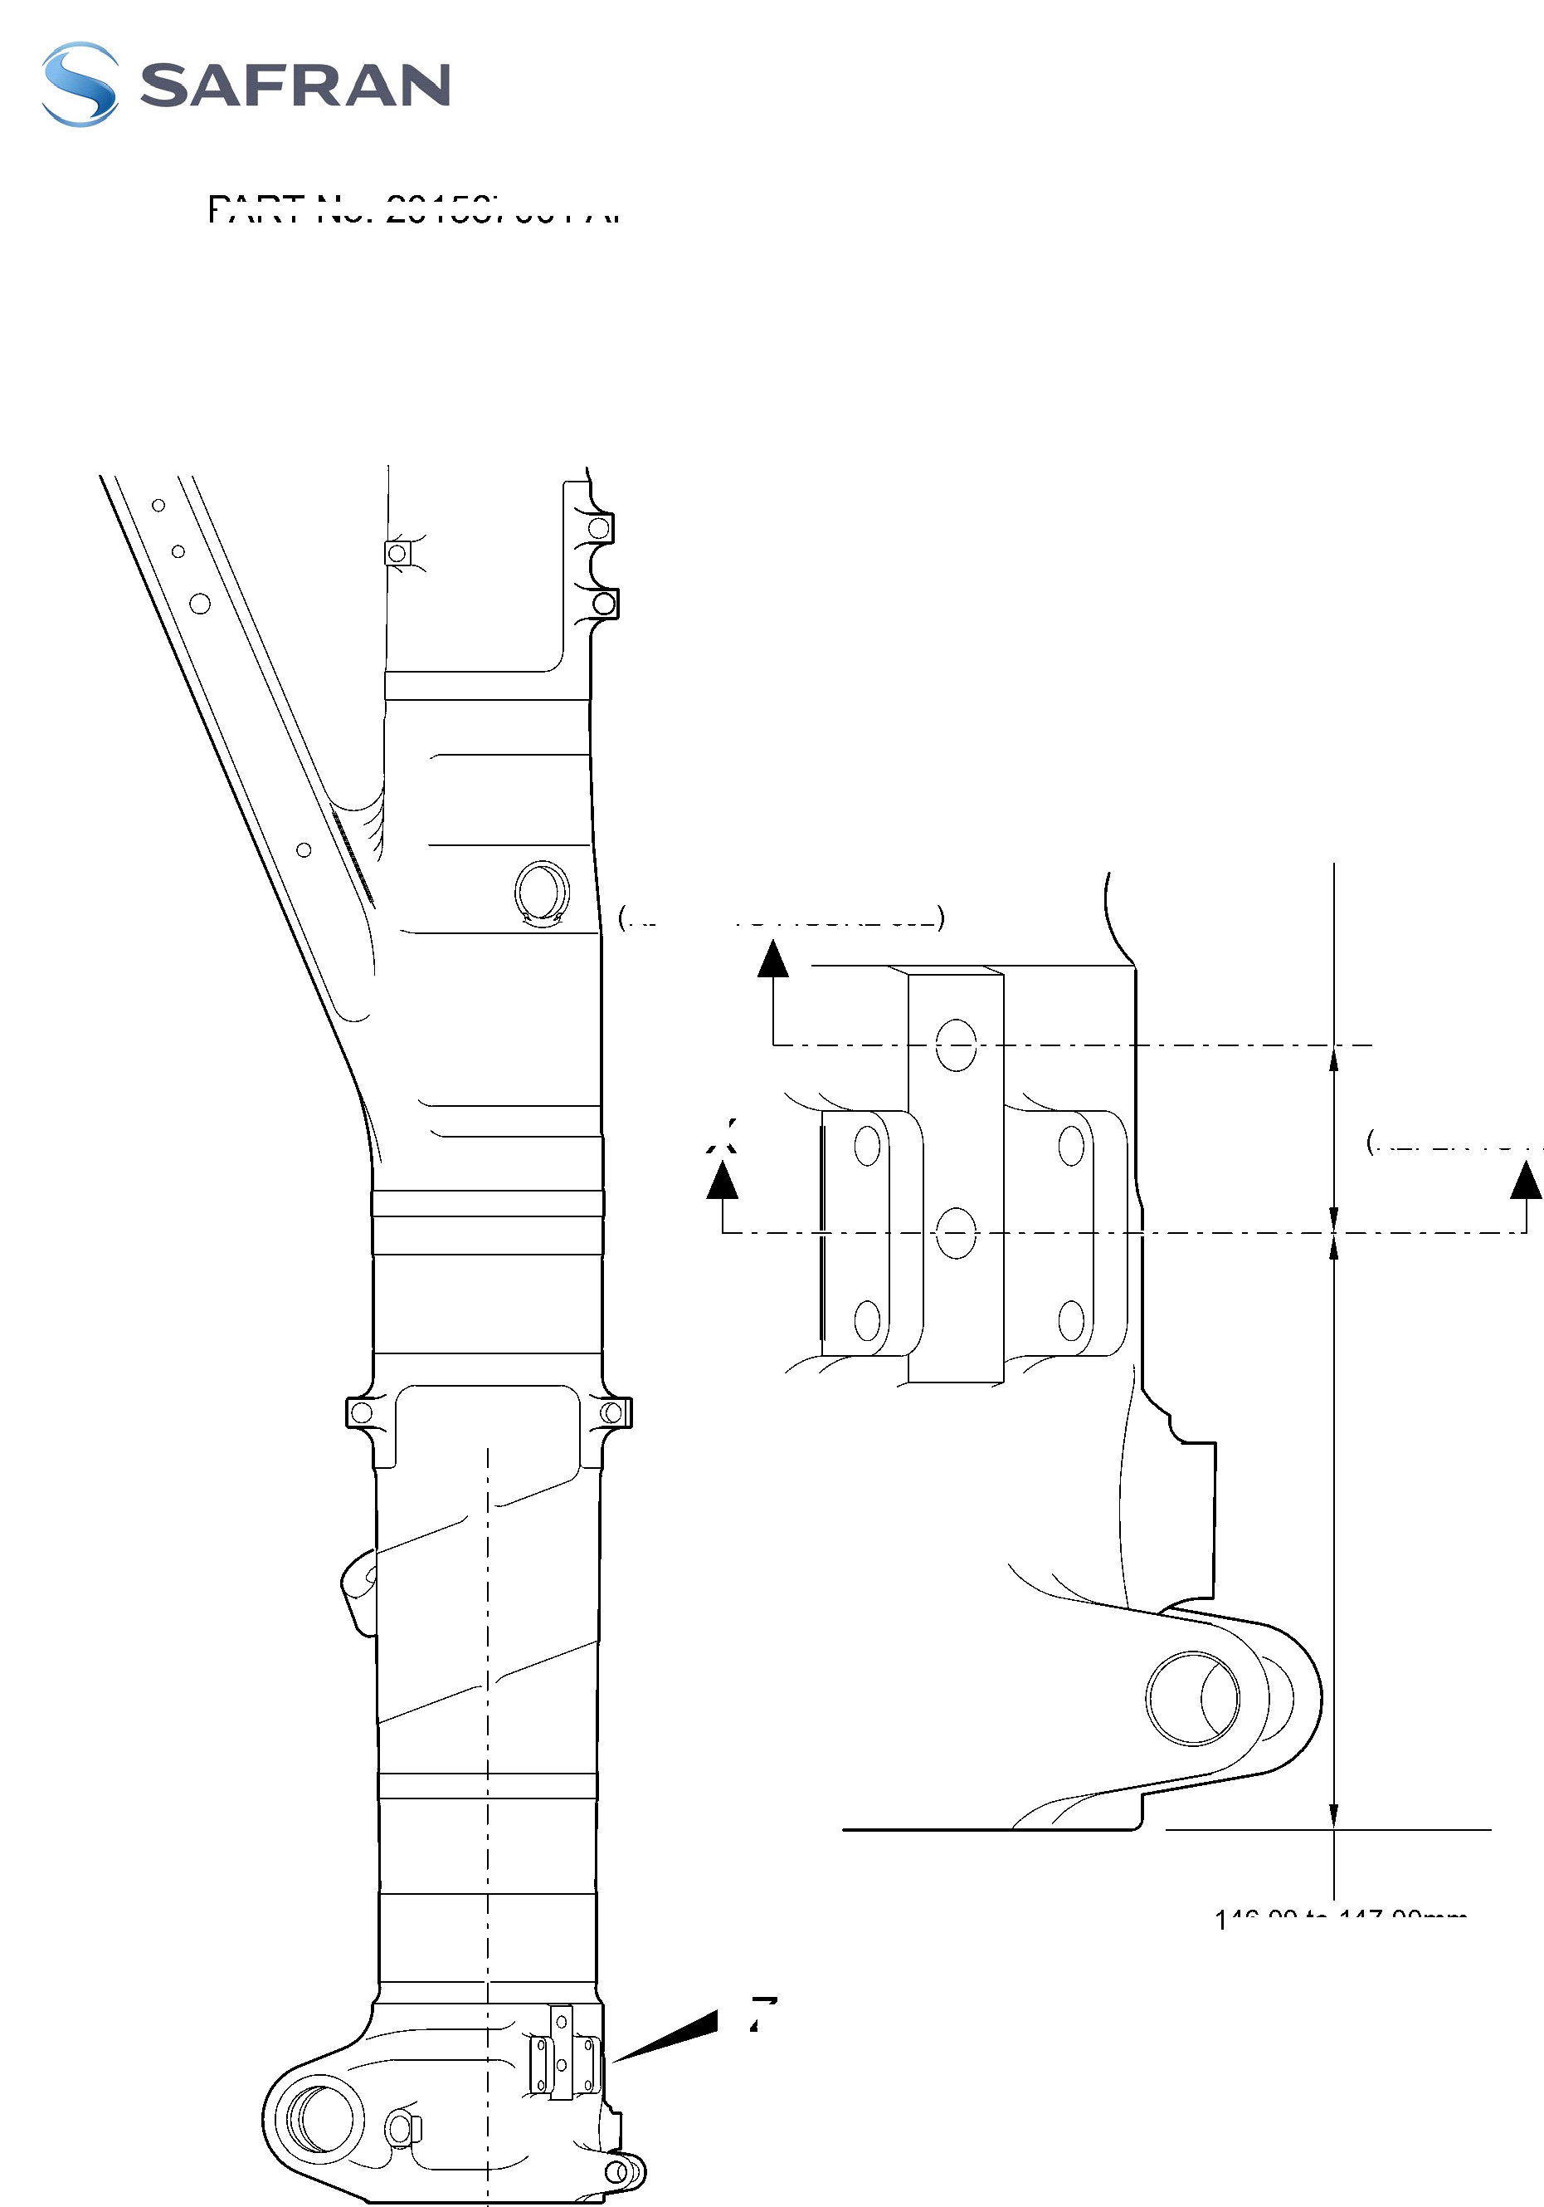

SAFRAN LANDING SYSTEMS UK Ltd
CAGE: K0654

PART No. 201587001 AND 201587002 COMPONENT MAINTENANCE MANUAL
MAIN LANDING GEAR LEG
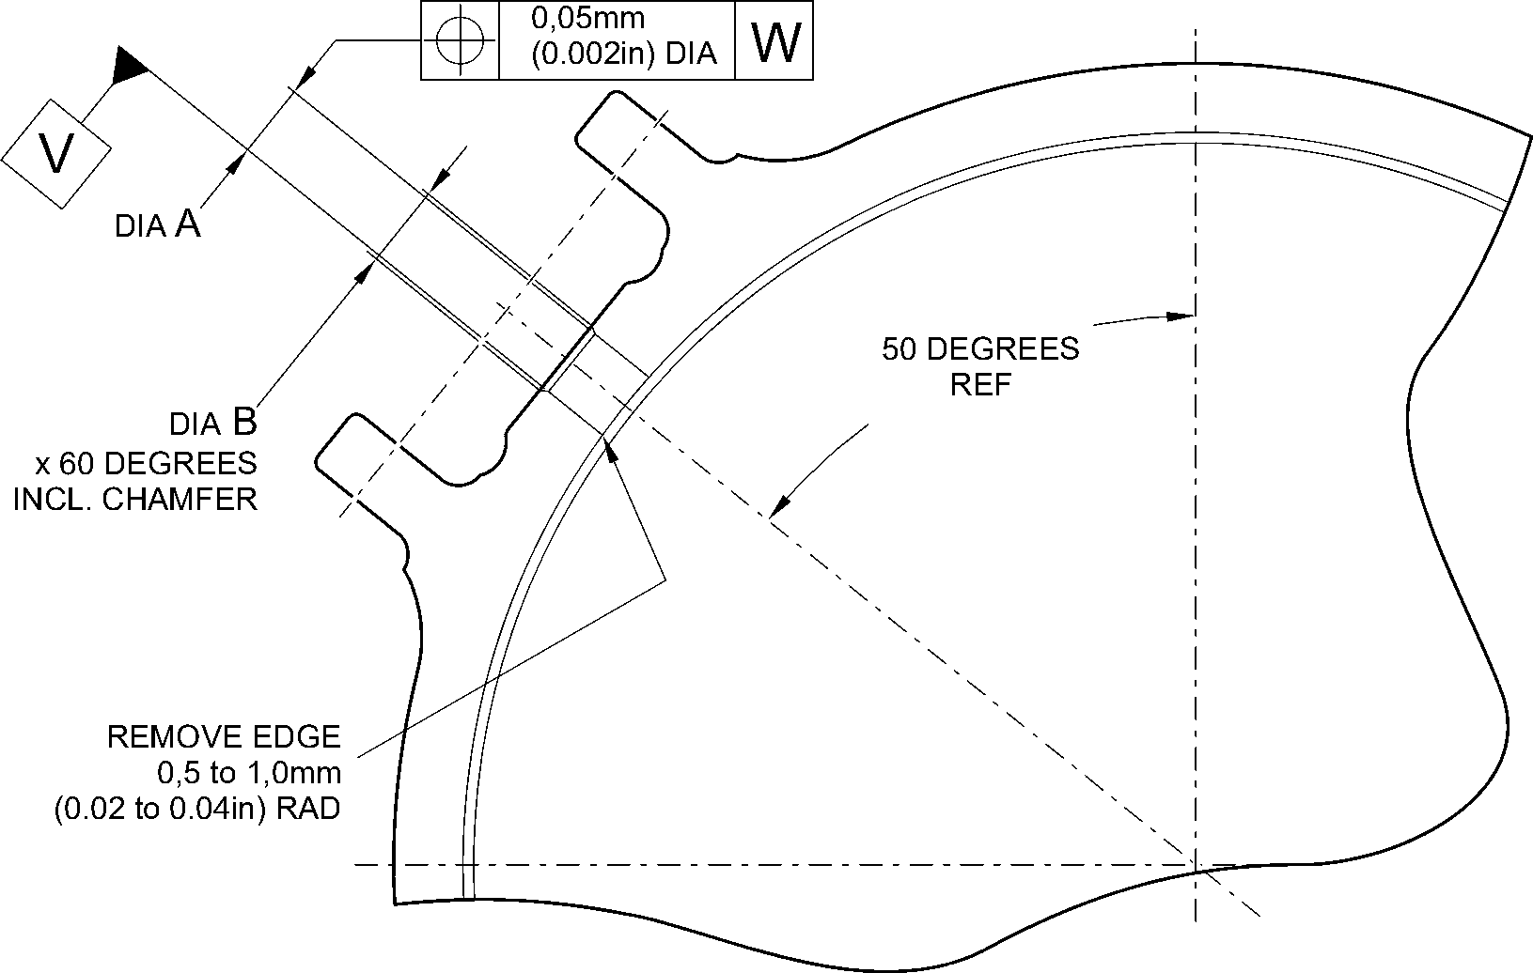
section X-X
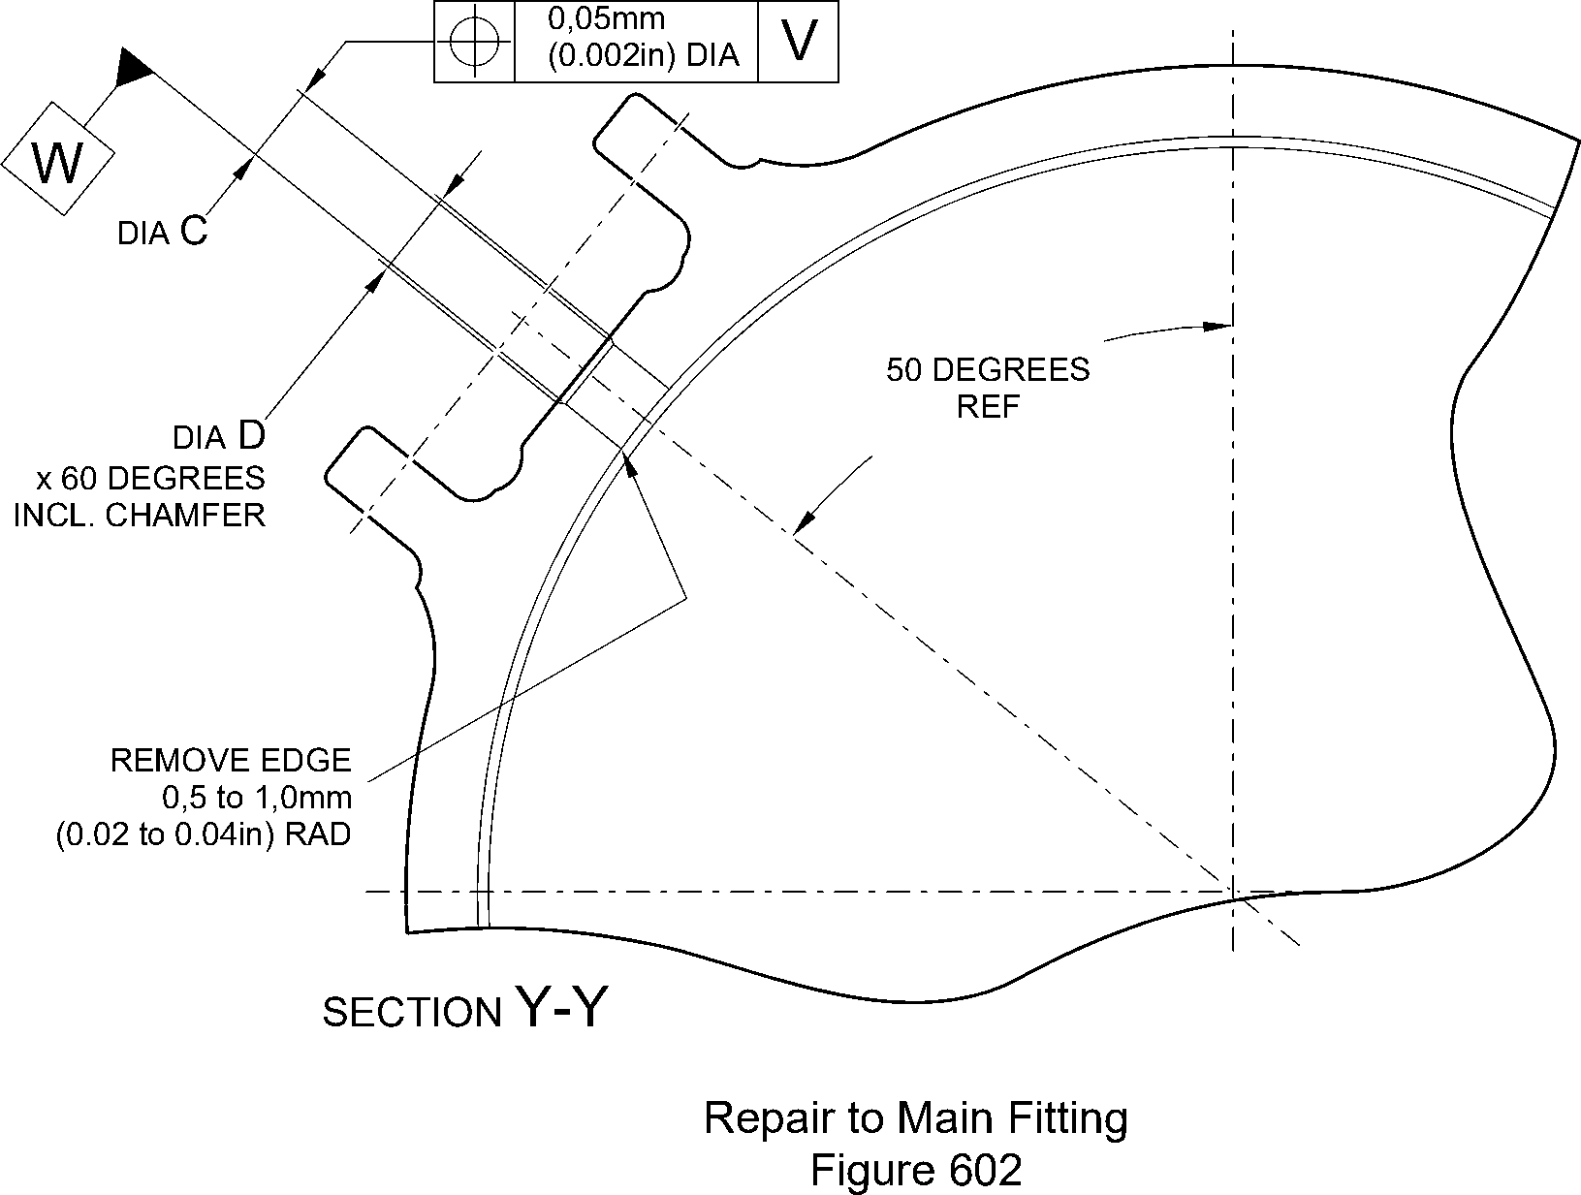
A321A7164-1
Repair No. 11-28
32-12-22
Page 605
Dec 6/2019

SAFRAN LANDING SYSTEMS UK Ltd
CAGE: K0654

PART No. 201587001 AND 201587002 COMPONENT MAINTENANCE MANUAL
MAIN LANDING GEAR LEG
OVERSIZE TRANSFER DOWEL
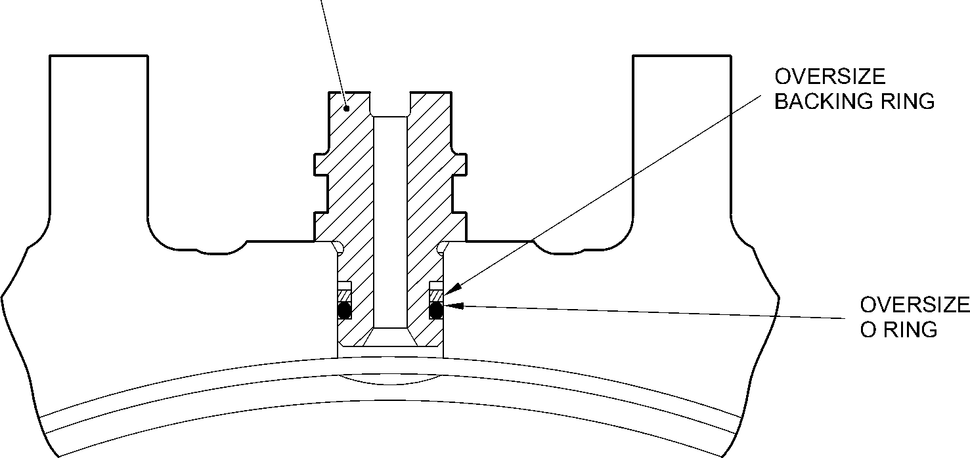
TYPICAL INSTALLATION OF
OVERSIZE COMPONENTS
A321A7181-1
Oversize Transfer Dowel - Installation
Figure 603
32-12-22
Repair No. 11-28
Page 606
Dec 6/2019

sSAFRAN SAFRAN LANDING SYSTEMS UK Ltd
CAGE: K0654
PART No. 201587001 AND 201587002 COMPONENT MAINTENANCE MANUAL
MAIN LANDING GEAR LEG
- Repair No. 11-29 Main Fitting (20-410A and 20-420A Only)
- Specified Damage and Material Specification.
- Specified Damage
(a) Damage or corrosion to the diameter(s) A and/or B.
- Material Specification
IPL Figure and  Item No. | Name | Material Specification
20-410A and  20-420A Only | Main fitting | Steel, MAT135, 35NCD16THQ
- Special Tools
- These special tools are necessary:
NOTE: Alternative equivalents are permitted.
Part No. | Special Tool | Function
460006405 | Assembly Sleeve | Install the lower bearing  subassembly
- Materials
- None.
- Repair Parts
- These repair parts are necessary:
Part No. | Repair Part | Material Specification
450266221 to  450266225 | Lower bearing  subassembly (Option 1 -  Pre SB 201-32-49) | -
450266261 to  450266267 | Lower bearing  subassembly (Option 2 -  Post SB 201-32-49) | -
- Procedure (Refer to Figures 601, 602 and 603)
CAUTION: FOR DAMAGE MORE THAN THE LIMITS OF THIS REPAIR SCHEME, WRITE
TO MESSIER-DOWTY LIMITED: REFER TO GUIDE-CS-001.
- Do this procedure if there is damage or corrosion to the chromium plate on
diameter(s) A and/or B. The bare metal must not be damaged.
- Remove the paint from the main fitting as necessary: refer to PCS-2700
and REPAIR.
- Locally remove the chromium plate from diameter(s) A and/or B: refer to
PCS-2110.
Repair No. 11-29
32-12-22
Page 601
Dec 23/2022

sSAFRAN SAFRAN LANDING SYSTEMS UK Ltd
CAGE: K0654
PART No. 201587001 AND 201587002 COMPONENT MAINTENANCE MANUAL
MAIN LANDING GEAR LEG
- Examine the bare metal for flaws: refer to PCS-3100, inclusion class 4 and
PCS-3600.
CAUTION: DO NOT USE A MECHANICAL MOP POLISHER TO GET THE
SURFACE FINISH. USE HONING OR LAPPING TOOLS.
- Apply chromium plate to diameter A to between 212,000 and 212,072 mm (8.3465
and 8.3493 in) with a surface finish of 1,6 micrometers (63 micro-inches) and to
diameter B between 208,890 and 208,966 mm (8.2240 and 8.2270 in) with a
surface finish of 0,8 micrometers (32 micro-inches): refer to PCS-2110
and Figures 601, 602 and 603. The plating thickness must be between 0,040 and
0,060 mm (0.0016 and 0.0024 in).
- Examine the reworked areas for flaws: refer to PCS-3100, inclusion class 4.
- Apply wet primer to diameters A and B: refer to PCS-2804.
- Identify the part with the Messier-Dowty Limited repair number 450267275A
adjacent to the part number: refer to PCS-6000-04, maximum depth 0,13 mm
(0.005 in).
- Restore all protective treatments to the main fitting: refer to REPAIR.
- Identify the part with the Messier-Dowty Limited repair number 450267275A
adjacent to the part number: refer to PCS-6000-07.
- Examine the part to make sure that you have obeyed all the repair instructions
correctly.
- Do this procedure to diameter A and/or B if there is damage to the bare metal.
- Remove the paint from the main fitting as necessary: refer to PCS-2700
and REPAIR.
- Remove the chromium plate from diameter(s) A and/or B: refer to PCS-2110.
- Machine diameters A and B, as a matched pair to remove the wear or damage.
Remove the minimum amount of material to get the nearest oversize pair of bores
given in Table 601 (Option 1 and 2). Blend any sharp edges smoothly into the
adjacent surfaces. The surface finish for diameter A must be 1,6 micrometers
(63 micro-inches) and the surface finish for diameter B must be 0,8 micrometers
(32 micro-inches): refer to M-DLPS1004-4-1 and Figure 601.
- Measure and record the machined diameter(s) A and/or B.
- Examine the bare metal for flaws: refer to PCS-3100, inclusion class 4 and
PCS-3600.
- Shot peen the reworked areas of the main fitting: refer to M-DLPS123.
- Hone diameters A and B shot peened areas to the recorded diameters +0,00 to
0,05 mm (0.000 to 0.002 in).
32-12-22
Repair No. 11-29
Page 602
Dec 23/2022

sSAFRAN SAFRAN LANDING SYSTEMS UK Ltd
CAGE: K0654
PART No. 201587001 AND 201587002 COMPONENT MAINTENANCE MANUAL
MAIN LANDING GEAR LEG
CAUTION: DO NOT USE A MECHANICAL MOP POLISHER TO GET THE
SURFACE FINISH. USE HONING OR LAPPING TOOLS.
- Apply chromium plate to diameters A and B to the nearest dimensions shown
in Table 601 (Option 1 and 2): refer to PCS-2110, Figures 601, 602 and 603. The
plating thickness must be between 0,040 and 0,060 mm (0.0016 and 0.0024 in).
Refer to Figure 601 for the surface finish of diameters A and B.
- Examine the reworked areas for flaws: refer to PCS-3100, inclusion class 4.
- Apply wet primer to diameters A and B: refer to PCS-2804.
- Identify the part with the Messier-Dowty Limited repair number 450267275B
adjacent to the part number: refer to PCS-6000-04, maximum depth 0,13 mm
(0.005 in).
- Restore all protective treatments to the main fitting: refer to REPAIR.
- Use the correct lower bearing subassembly from the Table 601 (Option 1 or 2).
- Use the Assembly Sleeve 460006405 to install the lower bearing subassembly.
NOTE: If you use an Option 2 Lower bearing subassembly you must use the
sealant procedure Post SB 201-32-49 at installation of the sliding
tube subassembly to the main fitting.
- Identify the part with the Messier-Dowty Limited repair number 450267275B
adjacent to the part number: refer to PCS-6000-07.
- Examine the part to make sure that you have obeyed all the repair instructions
correctly.
Repair No. 11-29
32-12-22
Page 603
Dec 6/2019

SAFRAN LANDING SYSTEMS UK Ltd
CAGE: K0654

PART No. 201587001 AND 201587002 COMPONENT MAINTENANCE MANUAL
MAIN LANDING GEAR LEG
Table 601 (Option 1 - Pre SB 201-32-49)
 | Bore Diameter A |  | Bore Diameter B
 | Before chromium  plate  mm (in) | After chromium  plate  mm (in) | Before chromium  plate  mm (in) | After chromium  plate  mm (in) | Lower  bearing  subassembly
1 | 212,242 to 212,274  (8.3560 to 8.3572) | 212,122 to 212,194  (8.3513 to 8.3541) | 209,132 to 209,168  (8.2335 to 8.2350) | 209,012 to 209,088  (8.2288 to 8.2318) | 450266221
2 | 212,392 to 212,424  (8.3619 to 8.3631) | 212,272 to 212,344  (8.3572 to 8.3600) | 209,282 to 209,318  (8.2394 to 8.2409) | 209,162 to 209,238  (8.2347 to 8.2377) | 450266222
3 | 212,542 to 212,574  (8.3678 to 8.3691) | 212,422 to 212,494  (8.3631 to 8.3659) | 209,432 to 209,468  (8.2454 to 8.2468) | 209,312 to 209,388  (8.2406 to 8.2436) | 450266223
4 | 212,692 to 212,724  (8.3737 to 8.3750) | 212,572 to 212,644  (8.3690 to 8.3718) | 209,582 to 209,618  (8.2513 to 8.2527) | 209,462 to 209,538  (8.2465 to 8.2495) | 450266224
5 | 212,842 to 212,874  (8.3796 to 8.3809) | 212,722 to 212,794  (8.3749 to 8.3777) | 209,732 to 209,768  (8.2572 to 8.2586) | 209,612 to 209,688  (8.2524 to 8.2554) | 450266225
Table 601 (Option 2 - Post SB 201-32-49)
 | Bore Diameter A |  | Bore Diameter B |  | Lower bearing  subassembly
 | Before  chromium plate  mm (in) | After  chromium plate  mm (in) | Before  chromium plate  mm (in) | After  chromium plate  mm (in)
1 | 212,242 to  212,274  (8.3560 to  8.3572) | 212,122 to  212,194  (8.3513 to  8.3541) | 209,132 to  209,168  (8.2335 to  8.2350) | 209,012 to  209,088  (8.2288 to  8.2318) | 450266261
2 | 212,392 to  212,424  (8.3619 to  8.3631) | 212,272 to  212,344  (8.3572 to  8.3600) | 209,282 to  209,318  (8.2394 to  8.2409) | 209,162 to  209,238  (8.2347 to  8.2377) | 450266262
3 | 212,542 to  212,574  (8.3678 to  8.3691) | 212,422 to  212,494  (8.3631 to  8.3659) | 209,432 to  209,468  (8.2454 to  8.2468) | 209,312 to  209,388  (8.2406 to  8.2436) | 450266263
4 | 212,692 to  212,724  (8.3737 to  8.3750) | 212,572 to  212,644  (8.3690 to  8.3718) | 209,582 to  209,618  (8.2513 to  8.2527) | 209,462 to  209,538  (8.2465 to  8.2495) | 450266264
5 | 212,842 to  212,874  (8.3796 to  8.3809) | 212,722 to  212,794  (8.3749 to  8.3777) | 209,732 to  209,768  (8.2572 to  8.2586) | 209,612 to  209,688  (8.2524 to  8.2554) | 450266265
32-12-22
Repair No. 11-29
Page 604
Dec 23/2022

SAFRAN LANDING SYSTEMS UK Ltd
CAGE: K0654

PART No. 201587001 AND 201587002 COMPONENT MAINTENANCE MANUAL
MAIN LANDING GEAR LEG
Table 601 (Option 2 - Post SB 201-32-49) (Continued)
 | Bore Diameter A |  | Bore Diameter B |  | Lower bearing  subassembly
 | Before  chromium plate  mm (in) | After  chromium plate  mm (in) | Before  chromium plate  mm (in) | After  chromium plate  mm (in)
6 | 213,233 to  213,265  (8.3950 to  8.3963) | 213,113 to  213,185  (8.3903 to  8.3931) | 209,732 to  209,768  (8.2572 to  8.2586) | 209,612 to  209,688  (8.2524 to  8.2554) | 450266266
7 | 213,533 to  213,565  (8.4068 to  8.4081) | 213,413 to  213,485  (8.4020 to  8.4049) | 209,732 to  209,768  (8.2572 to  8.2586) | 209,612 to  209,688  (8.2524 to  8.2554) | 450266267
Repair No. 11-29
32-12-22
Page 605
Dec 23/2022

SAFRAN LANDING SYSTEMS UK Ltd
CAGE: K0654
PART No. 201587001 AND 201587002 COMPONENT MAINTENANCE MANUAL
MAIN LANDING GEAR LEG
5,00 to 10,00mm
(0.2 to 0.4in)
EXTENT OF
CHROME
FADE OUT
X
20,00mm (0.787in) RAD.
0,05mm
(0.002in) DIA.
20,00mm (0.787in) RAD.
CHROMIUM PLATE MAY
TERMINATE ANYWHERE
ON THIS RADIUS
9,00 to 11,00mm
(0.354 to 0.433in) RAD.
Z
DEGREES
W
99,75 to 100,5mm
(3.927 to 3.957in)
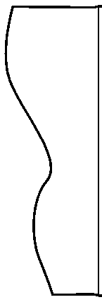
198,25 to 199,00mm
(7.805 to 7.835in)
CHROMIUM PLATE
183,00mm (7.205in)
MINIMUM EXTENT OF FINE LIMIT DIA.
REMAINDER MAY BE
bore dia. B -0,254mm (-0.010in)
dia. B
dia. A
0,8
55,00mm (2.165in) MINIMUM EXTENT
OF FINE LIMIT DIA.
REMAINDER MAY BE
bOre dia. A -0,254mm (-0.010in)
215,00mm (8.465in) DIA.
x 30 DEGREES
CHAMFER
INCLUSIVE
SECTION Z-Z
A321-S-32-12-22-060-2
Repair to Main Fitting - Machining
Figure 601
Repair No. 11-29
32
Page 606
⁻12⁻22 Dec 23/2022
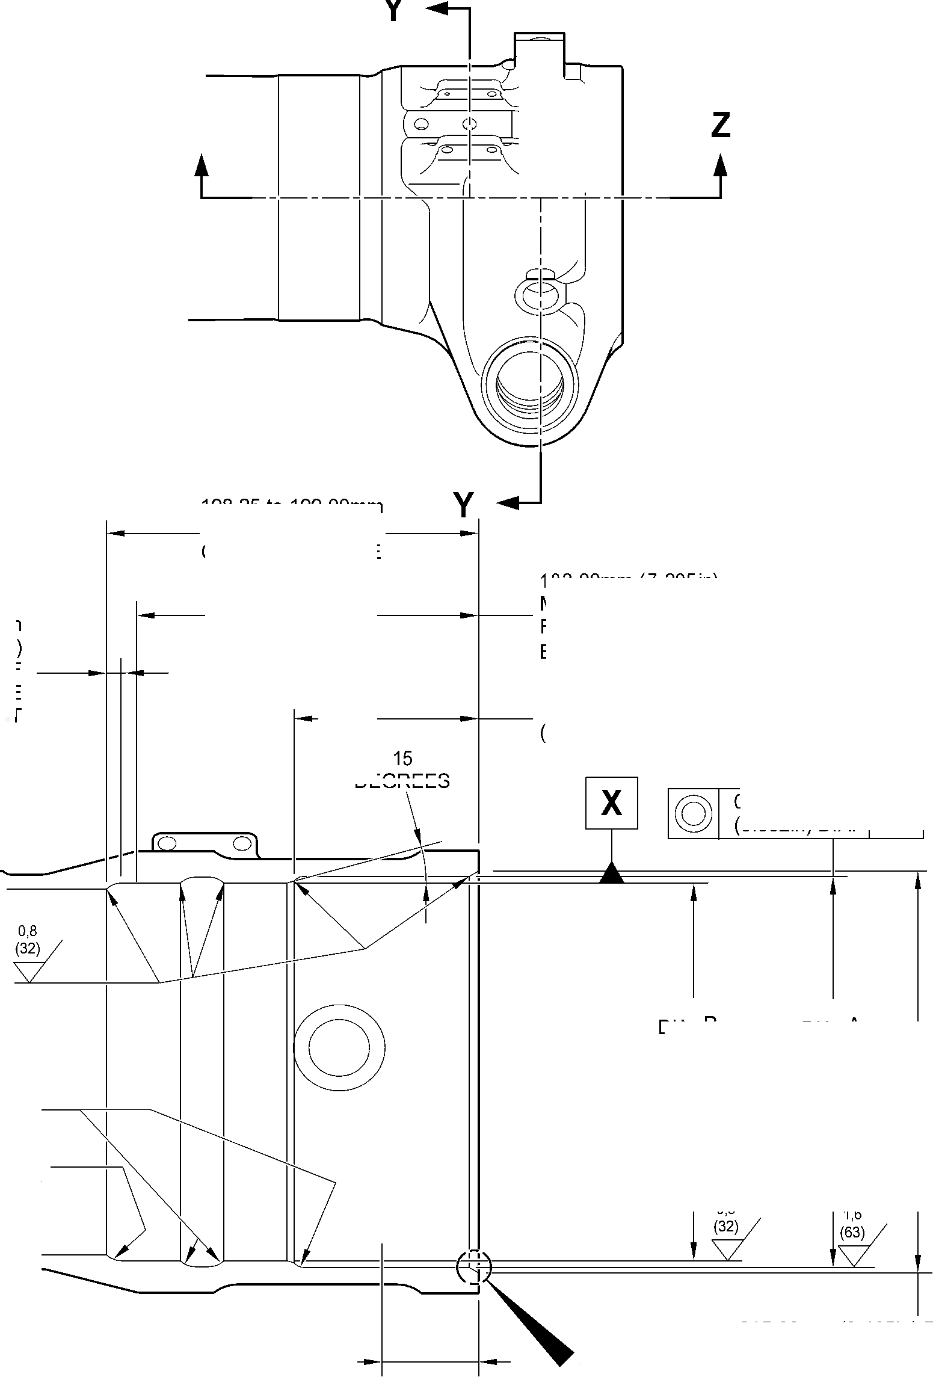

SAFRAN LANDING SYSTEMS UK Ltd
CAGE: K0654

PART No. 201587001 AND 201587002 COMPONENT MAINTENANCE MANUAL
MAIN LANDING GEAR LEG
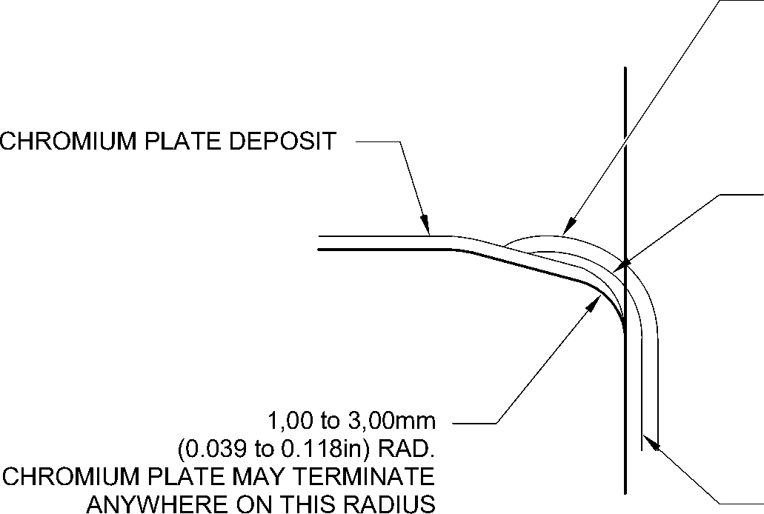
PAINT MUST OVERLAP CADMIUM PLATE
NO BARE METAL PERMISSIBLE
NO CADMIUM OR PAINT DEPOSIT TO
ENTER OR STAND PROUD OF CHROMIUM
PLATED BORE
CADMIUM PLATE MUST OVERLAP
CHROMIUM PLATE
CADMIUM PLATE
detail W
CHROMIUM PLATE TERMINATION
LOWER BARREL
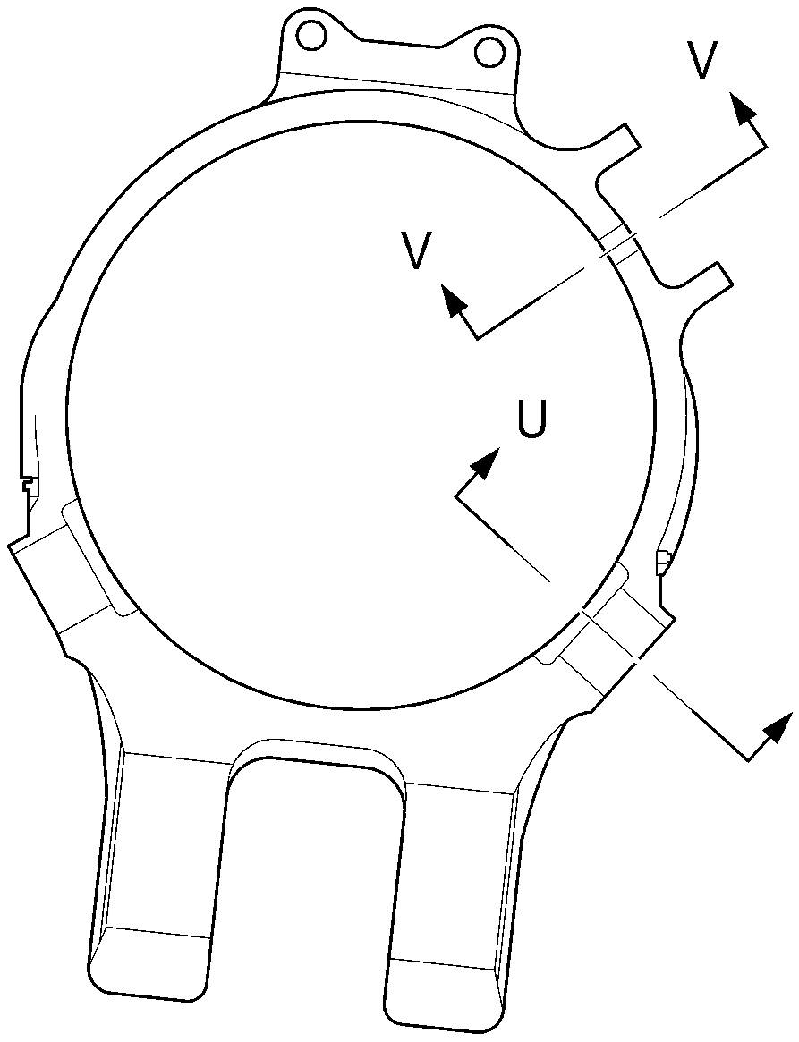
U
section Y-Y
A321-S-32-12-22-061-1
Repair to Main Fitting
Figure 602
Repair No. 11-29
32-12-22
Page 607
Dec 23/2022

SAFRAN LANDING SYSTEMS UK Ltd
CAGE: K0654

PART No. 201587001 AND 201587002 COMPONENT MAINTENANCE MANUAL
MAIN LANDING GEAR LEG
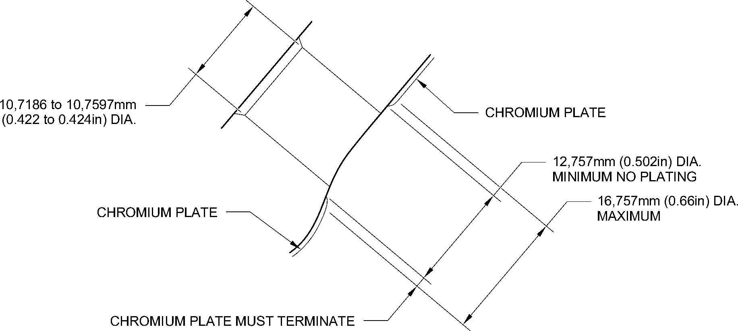
WITHIN THIS BAND. 1,00mm (0.039in) MAXIMUM RUNOUT
SECTION V-V
CHROMIUM PLATE TERMINATION
AROUND CHANGEOVER VALVE HOLES
TYPICAL 2 POSITIONS
1,00mm (0.039in) MAXIMUM
CHROMIUM PLATE
PERMISSIBLE FADE OUT
CADMIUM PLATE
CADMIUM PLATE MUST OVERLAP
CHROMIUM PLATE
NO BARE METAL PERMISSIBLE
NO CADMIUM PLATE TO
ENTER OR STAND PROUD OF CHROMIUM
PLATED DIAMETER
1,00 to 3,00mm
(0.039 to 0.118in) RAD.
CHROMIUM PLATE MAY TERMINATE
ANYWHERE ON THIS RADIUS
CHROMIUM PLATE
50,50mm (1.988in) DIA. MAXIMUM
EXTENT OF CADMIUM FADE OUT
SECTION U-U
CHROMIUM PLATE TERMINATION
AROUND DOWEL HOLES
TYPICAL 3 POSITIONS
A321-S-32-12-22-062-1
Repair to Main Fitting - Chromium Plate Termination
Figure 603
32-12-22
Repair No. 11-29
Page 608
Dec 9/2022
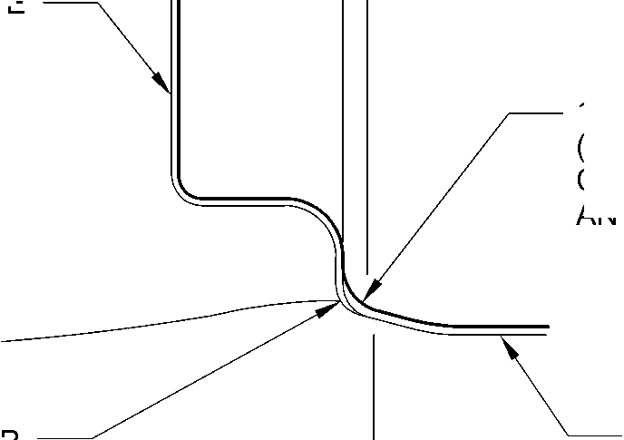

sSAFRAN SAFRAN LANDING SYSTEMS UK Ltd
CAGE: K0654
PART No. 201587001 AND 201587002 COMPONENT MAINTENANCE MANUAL
MAIN LANDING GEAR LEG

I 1. Repair No. 11-30 Main Fitting (20-410A and 20-420A Only)
CAUTION: THIS REPAIR IS FOR THE POST SB 201-32-58 UNITS ONLY. FOLLOW THE
REQUIREMENTS OF SB 201-32-58 COMPLETELY. FOR PRE SB 201-32-58,
REFER TO REPAIR NO. 11-29 (450267275).
- Specified Damage and Material Specification.
- Specified Damage
(a) Damage or corrosion to the diameter(s) A and/or B.
- Material Specification
IPL Figure and  Item No. | Name | Material Specification
20-410A and  20-420A Only | Main fitting | Steel to MAT135 (35NCD16THQ)
- Special Tools
- These special tools are necessary:
NOTE: Alternative equivalents are permitted.
Part No. | Special Tool | Function
460006405 | Assembly Sleeve | Install the lower bearing  subassembly
- Materials
- This material is necessary:
NOTE: Alternative equivalents are permitted.
Ref. Item | Material
TBA | Molykote 111, PCS-7303
- Repair Parts
(1) These repair parts are necessary:
Part No. | Repair Part | Material Specification
450267371 to  450267383  Refer to Table 601 | Lower bearing  subassembly | -
201646300 | Inner liner | -
Repair No. 11-30
32-12-22
Page 601
Dec 4/2020

sSAFRAN SAFRAN LANDING SYSTEMS UK Ltd
CAGE: K0654
PART No. 201587001 AND 201587002 COMPONENT MAINTENANCE MANUAL
MAIN LANDING GEAR LEG
- Procedure (Refer to Figures 601, 602, 603 and 604)
CAUTION: FOR DAMAGE MORE THAN THE LIMITS OF THIS REPAIR SCHEME, WRITE
TO MESSIER-DOWTY LIMITED: REFER TO GUIDE-CS-001.
- Do this procedure if there is damage or corrosion to the chromium plate on
diameter(s) A and/or B. The bare metal must not be damaged.
- Remove the paint from the main fitting as necessary: refer to PCS-2700.
- Locally remove the chromium plate from diameter(s) A and/or B: refer to
PCS-2110.
CAUTION: DO NOT USE A MECHANICAL MOP POLISHER TO GET THE
SURFACE FINISH. USE HONING OR LAPPING TOOLS.
- Apply chromium plate to diameter A to between 212,000 and 212,072 mm (8.3465
and 8.3493 in) with a surface finish of 1,6 micrometers (63 micro-inches) and to
diameter B to between 208,890 and 208,966 mm (8.2240 and 8.2270 in) with a
surface finish of 0,8 micrometers (32 micro-inches): refer to PCS-2110 and
Figures 601, 602 and 603. The plating thickness must be between 0,040 and 0,060
mm (0.0016 and 0.0024 in).
- Examine the reworked areas for flaws: refer to PCS-3100, inclusion class 4.
- Apply wet primer to diameters A and B: refer to PCS-2804.
- Identify the part with the Messier-Dowty Limited repair number 450267385A
adjacent to the part number: refer to PCS-6000-04, maximum depth 0,13 mm
(0.005 in).
- Restore all protective treatments to the main fitting: refer to REPAIR.
- Identify the part with the Messier-Dowty Limited repair number 450267385A
adjacent to the part number: refer to PCS-6000-07.
- Examine the part to make sure that you have obeyed all the repair instructions
correctly.
- Do this procedure to diameter(s) A and/or B if there is damage to the bare metal.
- Remove the paint from the main fitting as necessary: refer to PCS-2700.
- Locally remove the chromium plate from diameter(s) A and B: refer to PCS-2110.
- Machine diameters A and B, as a matched pair to remove the wear or damage.
Remove the minimum amount of material to get the nearest oversize pair of bores
given in Table 601. Blend any sharp edges smoothly into the adjacent surfaces.
The surface finish for diameter A must be 1,6 micrometers (63 micro-inches) and
the surface finish for diameter B must be 0,8 micrometers (32 micro-inches): refer
to M-DLPS1004-4-1 and Figure 601.
- Machine the chamfers and radii as shown: refer to Figures 601, 602 and 603.
Blend all sharp edges smoothly into the adjacent surface. Make the surface finish
for the radii 0,8 micrometers (32 micro-inches).
- Measure and record the machined diameter(s) A and/or B.
32-12-22
Repair No. 11-30
Page 602
Dec 6/2019

SAFRAN LANDING SYSTEMS UK Ltd
CAGE: K0654

PART No. 201587001 AND 201587002 COMPONENT MAINTENANCE MANUAL
MAIN LANDING GEAR LEG
- Examine the bare metal for flaws: refer to PCS-3100, inclusion class 4 and
PCS-3600.
- Shot peen the reworked areas of the main fitting: refer to M-DLPS123.
- Hone diameters A and B shot peened areas to the recorded diameters +0,00 to
0,025 mm (0.000 to 0.001 in).
CAUTION: DO NOT USE A MECHANICAL MOP POLISHER TO GET THE
SURFACE FINISH. USE HONING OR LAPPING TOOLS.
- Apply chromium plate to diameters A and B to the nearest dimensions shown
in Table 601. The plating thickness must be between 0,040 and 0,060 mm (0.0016
and 0.0024 in). To get the necessary surface finish hone or lap diameters A and B:
refer to PCS-2110 and Figures 601 to 603.
- Examine the reworked areas for flaws: refer to PCS-3100, inclusion class 4.
- Apply wet primer to diameters A and B: refer to PCS-2804.
- Identify the part with the Messier-Dowty Limited repair number 450267385B
adjacent to the part number on the main fitting: refer to PCS-6000-04, maximum
depth 0,13 mm (0.005 in).
- Restore all protective treatments to the main fitting. Make sure that the cadmium
plate overlaps the chromium plate terminations: refer to REPAIR, Figures 602
and 603.
- Select the correct oversize lower bearing subassembly from the Table 601 for the
repaired diameters A and B.
NOTE: Each POST oversize lower bearing subassembly can be made from
the related PRE SB 201-32-58 lower bearing subassembly: refer
to Table 602.
- If necessary, machine the inner bore of the bronze liner: refer to Figure 604.
NOTE: The lower bearing (16-150) bore can only be machined when it is
installed in the lower bearing subassembly.
- If necessary, examine the machined area for flaws: refer to PCS-3200.
- If necessary, apply a small quantity of Molykote 111, Material Ref. Item TBA, to the
outside diameter of inner liner (16A-117) and install it in the lower bearing
subassembly: refer to PCS-7303 and Figure 604. Make sure that the holes in the
new inner liner align with the holes in the lower bearing subassembly.
- If necessary, strike through the old part number and re-identify the new lower
bearing subassembly with the new inner liner with a part number given
in Table 602: refer to PCS-6000-04 and PCS-6000-07.
- At the applicable assembly step, use the Assembly Sleeve 460006405 and install
the lower bearing subassembly on the sliding tube subassembly: refer
to ASSEMBLY (INLUDING STORAGE).
(t)
At the applicable assembly step, install the repaired shock absorber subassembly
in the main fitting: refer to ASSEMBLY (INLUDING STORAGE).
Repair No. 11-30
32-12-22
Page 603
Dec 6/2019

SAFRAN LANDING SYSTEMS UK Ltd
CAGE: K0654

PART No. 201587001 AND 201587002 COMPONENT MAINTENANCE MANUAL
MAIN LANDING GEAR LEG
- Identify the part with the Messier-Dowty Limited repair number 450267385B
adjacent to the part number: refer to PCS-6000-07.
- Examine the part to make sure that you have obeyed all the repair instructions
correctly.
Oversize Lower Bearing Subassembly Dimensions (Post SB 201-32-58)
Table 601
 | Bore Diameter A |  | Bore Diameter B
 | Before chromium  plate  mm (in) | After chromium  plate  mm (in) | Before chromium  plate  mm (in) | After chromium  plate  mm (in) | Lower bearing  subassembly
1 | 212,242 to 212,274  (8.3560 to 8.3572) | 212,122 to 212,194  (8.3513 to 8.3541) | 209,132 to 209,168  (8.2335 to 8.2350) | 209,012 to 209,088  (8.2288 to 8.2318) | 450267371
2 | 212,392 to 212,424  (8.3619 to 8.3631) | 212,272 to 212,344  (8.3572 to 8.3600) | 209,282 to 209,318  (8.2394 to 8.2409) | 209,162 to 209,238  (8.2347 to 8.2377) | 450267373
3 | 212,542 to 212,574  (8.3678 to 8.3691) | 212,422 to 212,494  (8.3631 to 8.3659) | 209,432 to 209,468  (8.2454 to 8.2468) | 209,312 to 209,388  (8.2406 to 8.2436) | 450267375
4 | 212,692 to 212,724  (8.3737 to 8.3750) | 212,572 to 212,644  (8.3690 to 8.3718) | 209,582 to 209,618  (8.2513 to 8.2527) | 209,462 to 209,538  (8.2465 to 8.2495) | 450267377
5 | 212,842 to 212,874  (8.3796 to 8.3809) | 212,722 to 212,794  (8.3749 to 8.3777) | 209,732 to 209,768  (8.2572 to 8.2586) | 209,612 to 209,688  (8.2524 to 8.2554) | 450267379
6 | 213,233 to 213,265  (8.3950 to 8.3963) | 213,113 to 213,185  (8.3903 to 8.3931) | 209,732 to 209,768  (8.2572 to 8.2586) | 209,612 to 209,688  (8.2524 to 8.2554) | 450267381
7 | 213,533 to 213,565  (8.4068 to 8.4081) | 213,413 to 213,485  (8.4020 to 8.4049) | 209,732 to 209,768  (8.2572 to 8.2586) | 209,612 to 209,688  (8.2524 to 8.2554) | 450267383
Oversize Lower Bearing Subassembly
Table 602
Pre SB 201-32-58  Part number | Post SB 201-32-58  Part number  (fitted with inner liner 201646300)
450266261 | 450267371
450266262 | 450267373
450266263 | 450267375
450266264 | 450267377
450266265 | 450267379
450266266 | 450267381
450266267 | 450267383
32-12-22
Repair No. 11-30
Page 604
Dec 6/2019

SAFRAN LANDING SYSTEMS UK Ltd
CAGE: K0654
PART No. 201587001 AND 201587002 COMPONENT MAINTENANCE MANUAL
MAIN LANDING GEAR LEG
Y
X
dia. A
20,00mm (0.787in) RAD.
0,05mm
(0.002in) DIA.
20,00mm (0.787in) RAD.
CHROMIUM PLATE MAY
TERMINATE ANYWHERE
ON THIS RADIUS
5,00 to 10,00mm
(0.2 to 0.4in)
EXTENT OF
CHROMIUM
FADE OUT
9,00 to 11,00mm
(0.354 to 0.433in) RAD.
Z
Z
dia. B
W
99,75 to 100,5mm
(3.927 to 3.957in)
183,00mm (7.205in)
MINIMUM EXTENT OF FINE LIMIT DIA.
REMAINDER MAY BE
bore dia. B -0,254mm (-0.010in)
198,25 to 199,00mm
(7.805 to 7.835in)
CHROMIUM PLATE
Y
15
DEGREES
55,00mm (2.165in) MINIMUM EXTENT
OF FINE LIMIT DIA.
REMAINDER MAY BE
bOre dia. A -0,254mm (-0.010in)
section Z-Z
215,00mm (8.4645in) DIA.
x 30 DEGREES
CHAMFER
INCLUSIVE
A321-S-32-12-22-064-0
Repair to Main Fitting - Machining
Figure 601
Repair No. 11-30
32-12-22
Page 605
Dec 6/2019
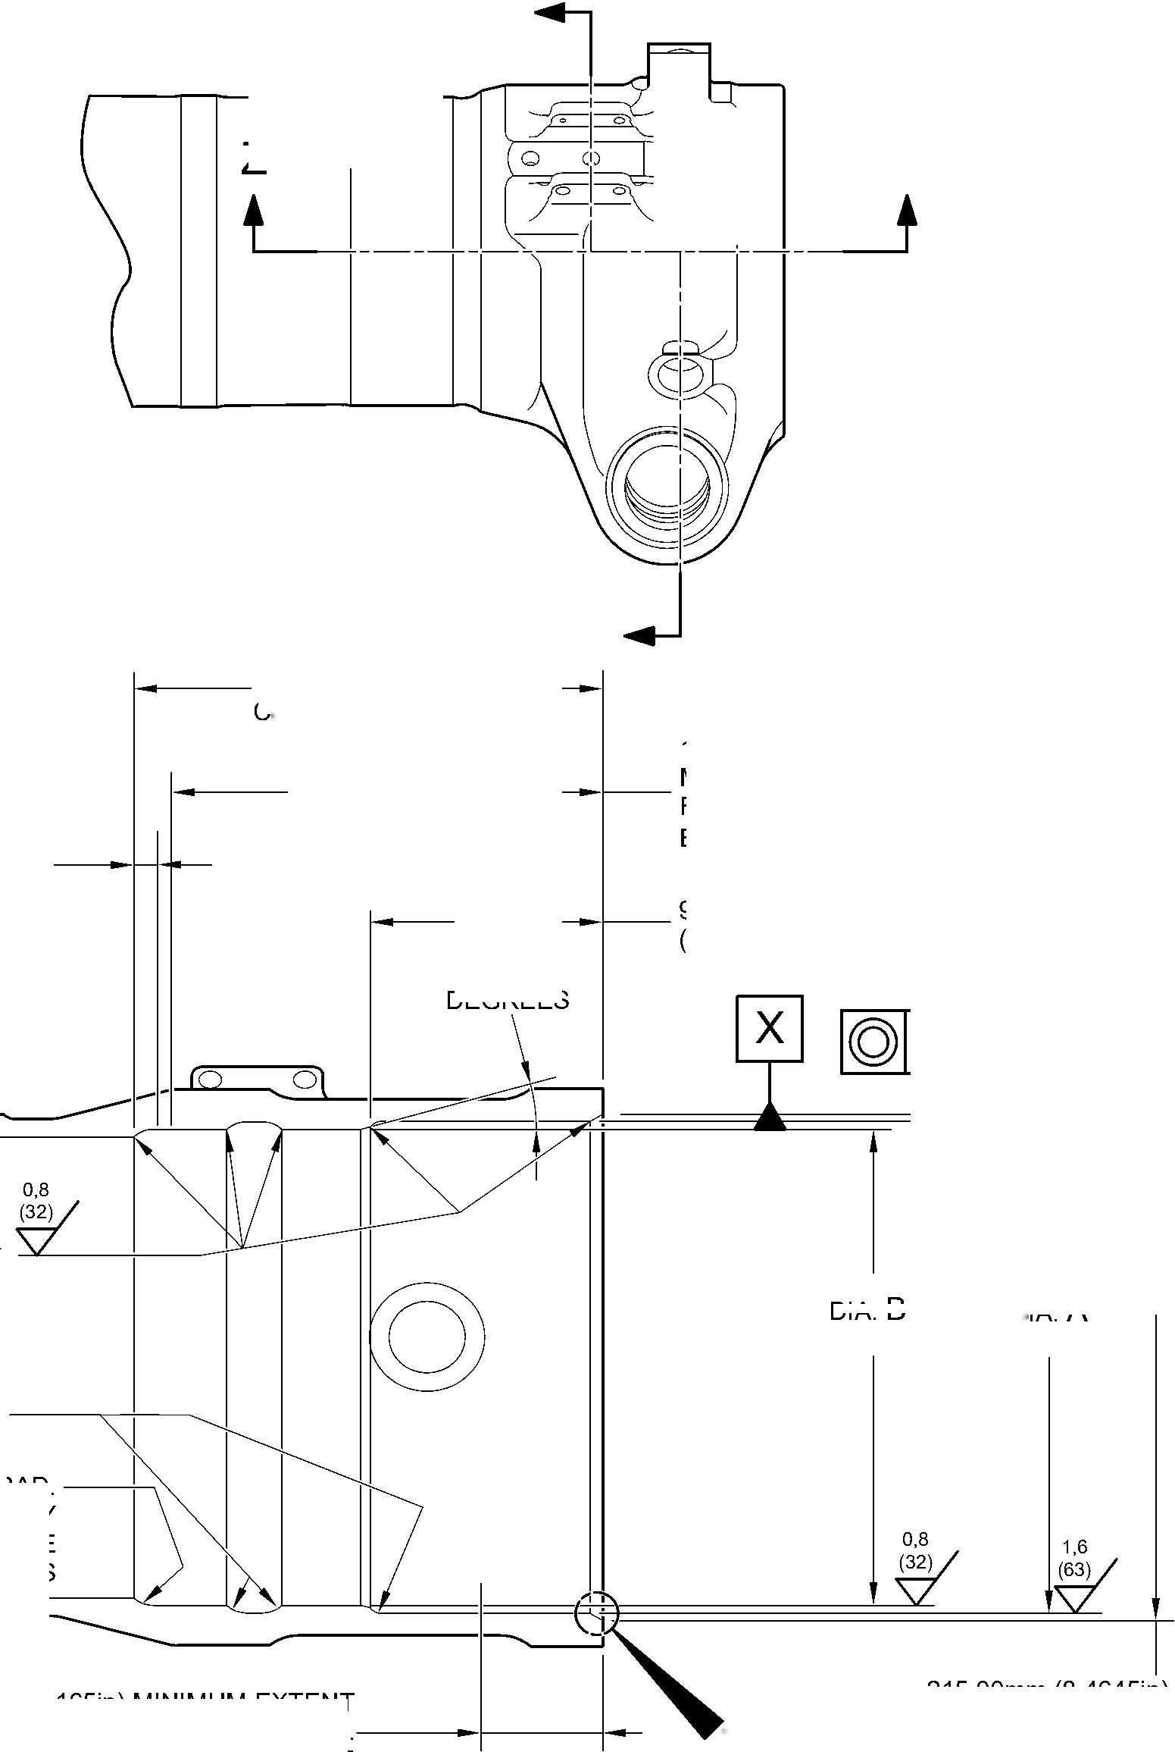

SAFRAN LANDING SYSTEMS UK Ltd
CAGE: K0654
PART No. 201587001 AND 201587002 COMPONENT MAINTENANCE MANUAL
MAIN LANDING GEAR LEG
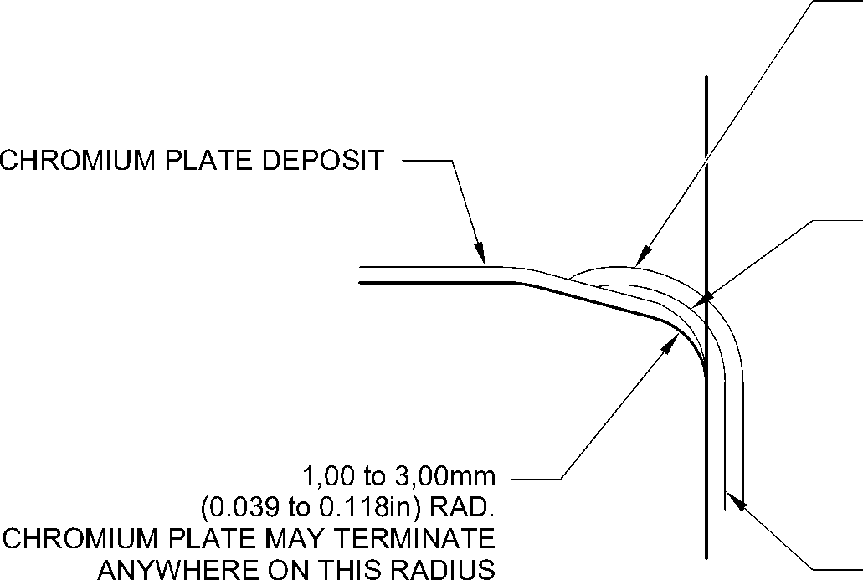
PAINT MUST OVERLAP CADMIUM PLATE
NO BARE METAL PERMISSIBLE
NO CADMIUM OR PAINT DEPOSIT TO
ENTER OR STAND PROUD OF CHROMIUM
PLATED BORE
CADMIUM PLATE MUST OVERLAP
CHROMIUM PLATE
CADMIUM PLATE
detail W
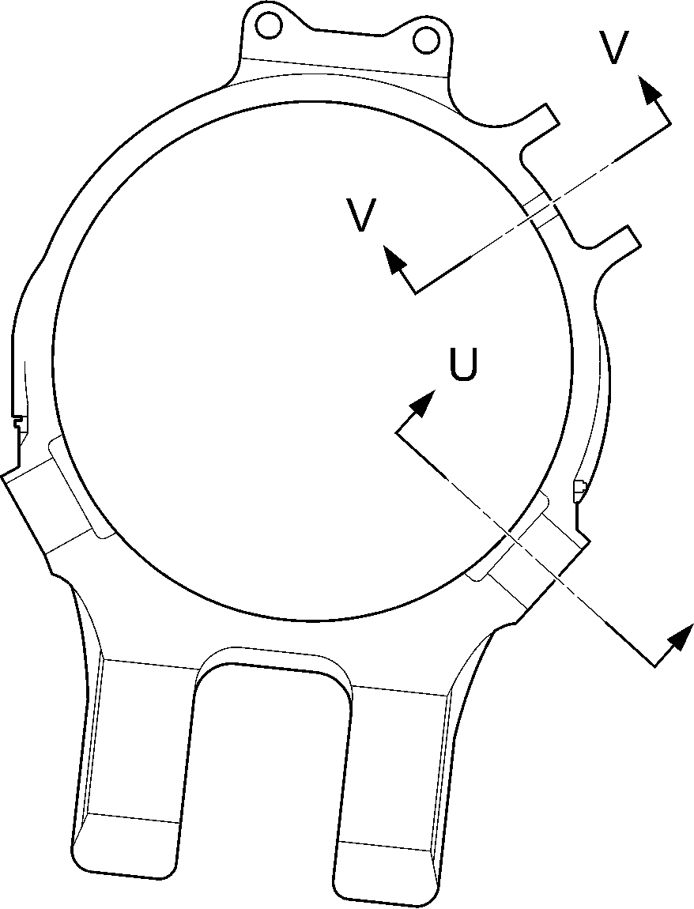
U
section Y-Y
A321-S-32-12-22-065-0
Repair to Main Fitting
Figure 602
32-12-22
Repair No. 11-30
Page 606
Dec 6/2019

SAFRAN LANDING SYSTEMS UK Ltd
CAGE: K0654

PART No. 201587001 AND 201587002 COMPONENT MAINTENANCE MANUAL
MAIN LANDING GEAR LEG
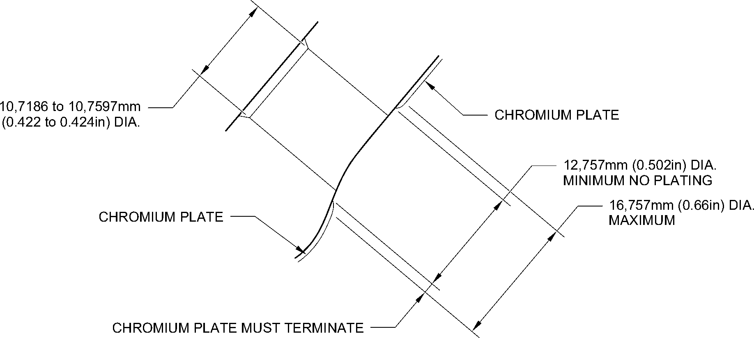
WITHIN THIS BAND. 1,00mm (0.039in) MAXIMUM RUNOUT
section V-V
CHROMIUM PLATE TERMINATION
AROUND CHANGEOVER VALVE HOLES
TYPICAL 2 POSITIONS
1,00mm (0.039in) MAXIMUM
CHROMIUM PLATE
PERMISSIBLE FADE OUT
CADMIUM PLATE
1,00 to 3,00mm
(0.039 to 0.118in) RAD.
CHROMIUM PLATE MAY TERMINATE
ANYWHERE ON THIS RADIUS
CADMIUM PLATE MUST OVERLAP
CHROMIUM PLATE
NO BARE METAL PERMISSIBLE
NO CADMIUM PLATE TO
ENTER OR STAND PROUD OF CHROMIUM
PLATED DIAMETER
50,50mm (1.988in)MAXIMUM
EXTENT OF CADMIUM FADE OUT
section U-U
CHROMIUM PLATE TERMINATION
AROUND DOWEL HOLES
TYPICAL 3 POSITIONS
CHROMIUM PLATE
A321-S-32-12-22-066-0
Repair to Main Fitting - Chromium Plate Termination
Figure 603
Repair No. 11-30
32-12-22
Page 607
Dec 6/2019
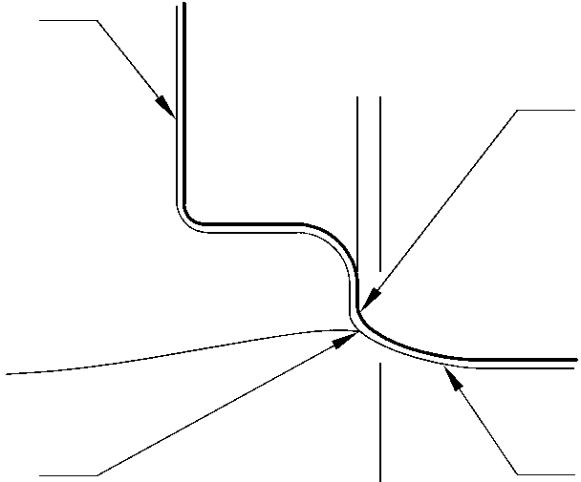

SAFRAN LANDING SYSTEMS UK Ltd
CAGE: K0654
PART No. 201587001 AND 201587002 COMPONENT MAINTENANCE MANUAL
MAIN LANDING GEAR LEG
X
Z
Y
Y
X
0,5mm (0.02in)
182,453 to 182,516mm
(7.183 to 7.186in) DIA.
CORRECT OVERSIZE
AS IN TABLE 602
10,00mm (0.394in)
0.333 to 0.667 DEGREES
REF.
0,025mm
(0.001in)
0,04mm
(0.0016in) DIA.
0,5mm (0.02in)
A321-S-32-12-22-067-0
MODIFIED REPAIR LOWER BEARING
SUBASSEMBLY

178,87 to 179,07mm
(7.042 to 7.050in) DIA.
10,00mm (0.394in)
0,5mm (0.02in)
RAD.
15 DEGREES
0,5mm (0.02in)
RAD.
15 DEGREES
64,65 to 64,775mm
(2.545 to 2.550in)
92,85 to 93,00mm
(3.656 to 3.661in)
detail Z
NEW INNER LINER
(16A-117)

Lower Bearing Subassembly - Machining and Inner Liner Installation
Figure 604
32-12-22
Repair No. 11-30
Page 608
Dec 6/2019
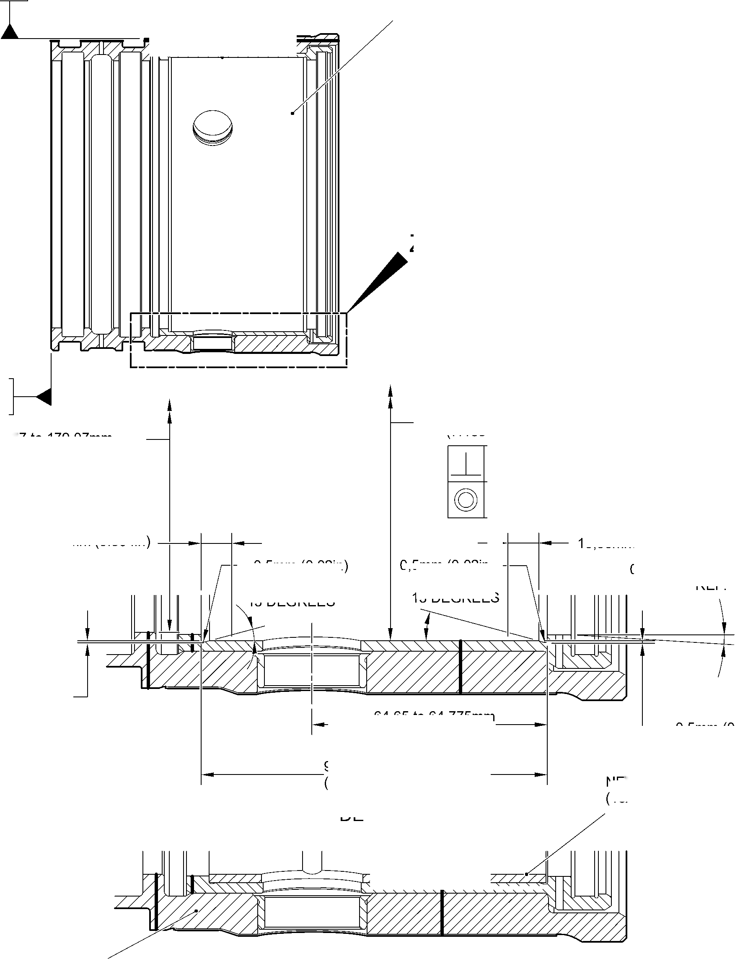

sSAFRAN SAFRAN LANDING SYSTEMS UK Ltd
CAGE: K0654
PART No. 201587001 AND 201587002 COMPONENT MAINTENANCE MANUAL
MAIN LANDING GEAR LEG
- Repair No. 11-31 Main Fitting (20-410B, 20-410C, 20-410D, 20-420B, 20-420C and 20-420D)
- Specified Damage and Material Specification
- Specified Damage
(a) Wear or damage or corrosion to diameter A.
- Material Specification
IPL Figure and  Item No. | Name | Material Specification
20-410B and  20-420B | Main fitting | UHT Steel E35NCD16THQ to MTL-1203  with UTS 1800 MPa (261.0 ksi)
20-410C,  20-410D,  20-420C and  20-420D | Main fitting | UHT Steel 300M to MTL-1201 with  UTS 1930 MPa (279.9 ksi)
- Special Tools
- Special tools are not necessary.
- Materials
- This material is necessary:
NOTE: Alternative equivalents are permitted.
Ref. Item | Material
TBA | Loctite Grade 270
- Repair Parts
- These repair parts are necessary:
Part No. | Repair Part | Material Specification
450250161 to  450250166 | Oversize lubrication  adaptor | Steel, S154 or 4340 to  AMS6409 and heat treated to  S154
450250241 to  450250246 | Oversize lubrication  adaptor | Steel, S154 or 4340 to  AMS6409 and heat treated to  S154
Repair No. 11-31
32-12-22
Page 601
Mar 18/2025

sSAFRAN SAFRAN LANDING SYSTEMS UK Ltd
CAGE: K0654
PART No. 201587001 AND 201587002 COMPONENT MAINTENANCE MANUAL
MAIN LANDING GEAR LEG
- Procedure (Refer to Figure 601)
CAUTION: FOR DAMAGE MORE THAN THE LIMITS OF THIS REPAIR SCHEME, WRITE
TO SAFRAN LANDING SYSTEMS: REFER TO GUIDE-CS-001.
CAUTION: APPLY TEMPORARY CORROSION AND DAMAGE PROTECTION: REFER
TO PCS-2800.
- Do this procedure if there is wear or damage or corrosion to diameter A: refer to
Figure 601.
- Remove the paint from the main fitting: refer to PCS-2700.
- Remove the cadmium plate from the main fitting: refer to PCS-2100.
- Machine diameter A to the nearest dimensions shown in Table 601 to remove the
damage or wear or corrosion. Do not increase diameter A to more than 6,449 mm
(0.2539 in). The surface finish must be 1,6 micrometers (63 micro-inches) or better:
refer to PCS-4100 and Figure 601.
- Measure and record the diameter A.
- Machine the chamfer(s) and/or radii as shown: refer to PCS-4100 and Figure 601.
- Examine the machined area for flaws: refer to PCS-3100, inclusion Class 4 and
PCS-3600.
- Apply cadmium plate all over but not to the areas shown. The cadmium plate
thickness must be between 0,010 and 0,020 mm (0.0004 and 0.0008 in): refer to
PCS-2100 and Figure 601.
- Select the correct oversize lubrication adaptor from Table 601 applicable for
diameter A.
- Use Loctite Grade 270, Material Ref. Item TBA, to install the correct oversize
lubrication adaptor from Table 601: refer to PCS-5303 and Figure 601.
- Apply primer and top coat paint all over but not to the areas shown: refer to
PCS-2500 and Figure 601.
- Record the repair number onto the documentation which is attached to the part.
Optionally, identify the part with the Safran Landing Systems repair number
64-4505236-00 adjacent to the existing part number: refer to PCS-6000-07.
- Examine the part to make sure that you have obeyed all the repair instructions
correctly.
32-12-22
Repair No. 11-31
Page 602
Mar 18/2025

SAFRAN LANDING SYSTEMS UK Ltd
CAGE: K0654
PART No. 201587001 AND 201587002 COMPONENT MAINTENANCE MANUAL
MAIN LANDING GEAR LEG
Oversize Lubrication Adaptors
Table 601
Oversize | Oversize Step  mm (in) | Bore Diameter A  mm (in) | Oversize  Lubrication  Adaptor Number
₋ | Production | 4,859 to 4,925  (0.1913 to 0.1939) | 899005010
1st | 0,127  (0.0050) | 4,986 to 5,052  (0.1963 to 0.1989) | 450250161
2nd | 0,127  (0.0050) | 5,113 to 5,179  (0.2013 to 0.2039) | 450250162
3rd | 0,127  (0.0050) | 5,240 to 5,306  (0.2063 to 0.2089) | 450250163
4th | 0,127  (0.0050) | 5,367 to 5,433  (0.2113 to 0.2139) | 450250164
5th | 0,127  (0.0050) | 5,494 to 5,560  (0.2163 to 0.2189) | 450250165
6th | 0,127  (0.0050) | 5,621 to 5,687  (0.2213 to 0.2239) | 450250166
7th | 0,127  (0.0050) | 5,748 to 5,814  (0.2263 to 0.2289) | 450250241
8th | 0,127  (0.0050) | 5,875 to 5,941  (0.2313 to 0.2339) | 450250242
9th | 0,127  (0.0050) | 6,002 to 6,068  (0.2363 to 0.2389) | 450250243
10th | 0,127  (0.0050) | 6,129 to 6,195  (0.2413 to 0.2439) | 450250244
11th | 0,127  (0.0050) | 6,256 to 6,322  (0.2463 to 0.2489) | 450250245
12th | 0,127  (0.0050) | 6,383 to 6,449  (0.2513 to 0.2539) | 450250246
Repair No. 11-31
32-12-22
Page 603
Mar 18/2025

SAFRAN LANDING SYSTEMS UK Ltd
CAGE: K0654
PART No. 201587001 AND 201587002 COMPONENT MAINTENANCE MANUAL
MAIN LANDING GEAR LEG
Z
dia. A
A
SECTION Z-Z
(WITH LUBRICATION ADAPTOR)
SECTION Z-Z
(WITHOUT LUBRICATION ADAPTOR)
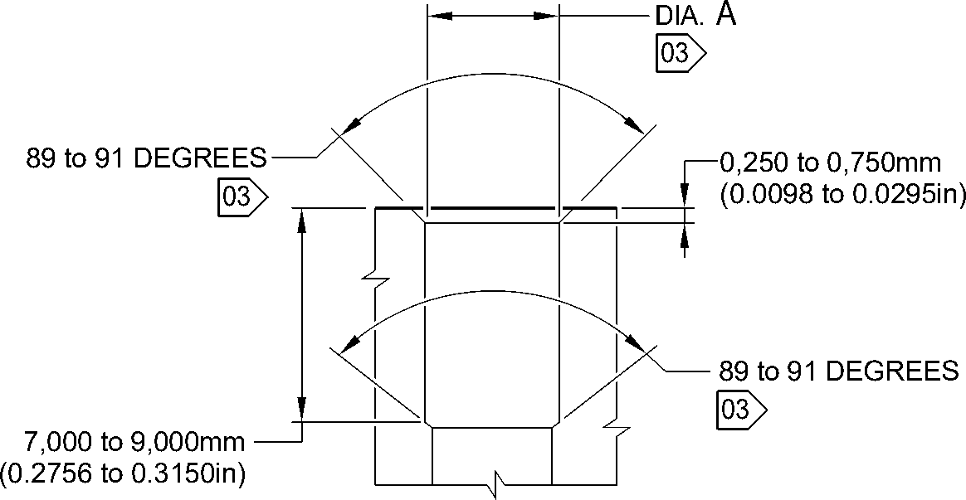
NOTE:
THE SURFACE FINISH MUST BE
1,6
(63)
DETAIL A
OR BETTER UNLESS GIVEN DIFFERENTLY.
DIAMETER A MUST BE FOLLOW THE LINE OF EXISTING BORE.
01 APPLY LOCTITE GRADE 270 TO ADAPTOR INTERFACE WITH MAIN FITTING: REFER TO PCS-5303.
02 INSTALL THE APPLICABLE LUBRICATION ADAPTOR: REFER TO TABLE 601. _{A321-T-32-12-22-111-0}
03 CADMIUM PLATE OPTIONAL AND NO PAINT.
Repair to Main Fitting
Figure 601
Repair No. 11-31
32
Page 604
⁻12⁻22 Mar 18/2025
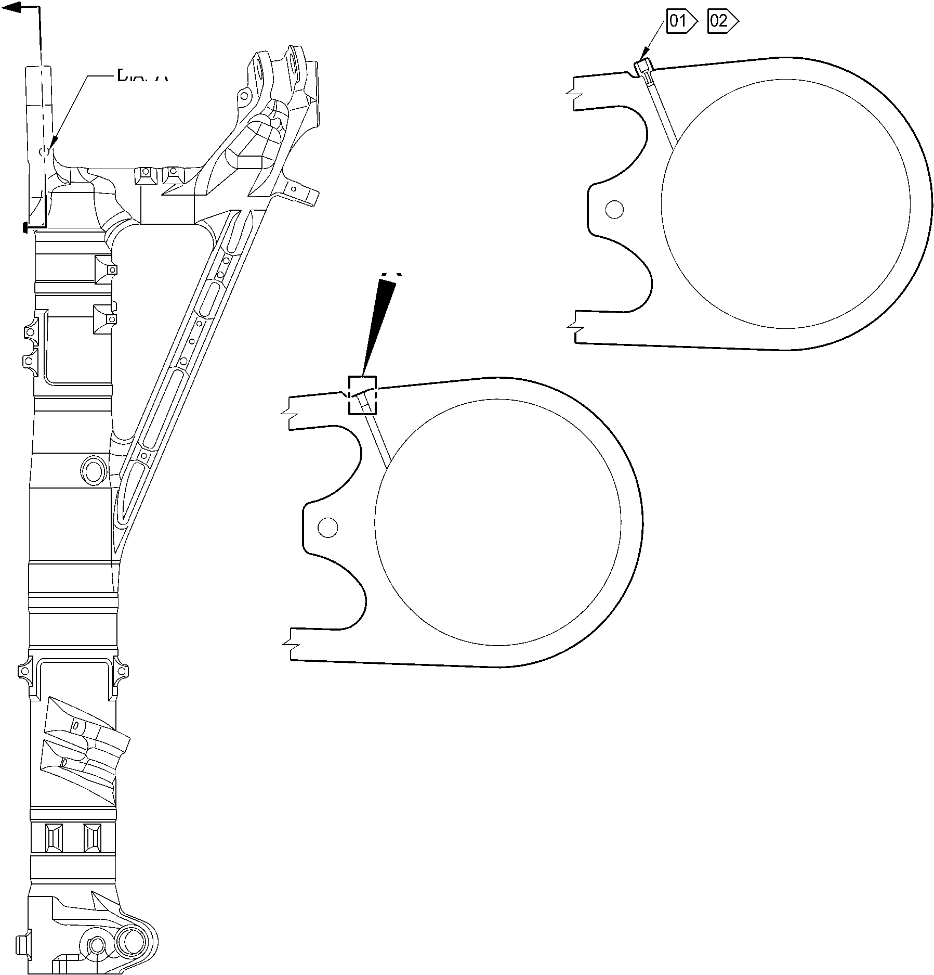

sSAFRAN SAFRAN LANDING SYSTEMS UK Ltd
CAGE: K0654
PART No. 201587001 AND 201587002 COMPONENT MAINTENANCE MANUAL
MAIN LANDING GEAR LEG
- Repair No. 11-32 Main Fitting (20-410B, 20-410C, 20-410D, 20-420B, 20-420C and 20-420D)
- Specified Damage and Material Specification
- Specified Damage
(a) Wear or damage or corrosion to diameter(s) A and/or B.
- Material Specification
IPL Figure and  Item No. | Name | Material Specification
20-410B and  20-420B | Main fitting | UHT Steel E35NCD16THQ to MTL-1203  with UTS 1800 MPa (261.0 ksi)
20-410C,  20-410D,  20-420C and  20-420D | Main fitting | UHT Steel 300M to MTL-1201 with  UTS 1930 MPa (279.9 ksi)
- Special Tools
- Special tools are not necessary.
- Materials
- This material is necessary:
NOTE: Alternative equivalents are permitted.
Ref. Item | Material
TBA | Loctite Grade 270
- Repair Parts
- These repair parts are necessary:
Part No. | Repair Part | Material Specification
450250161 to  450250166 | Oversize lubrication  adaptor | Steel, S154 or 4340 to  AMS6409 and heat treated to  S154
450250241 to  450250246 | Oversize lubrication  adaptor | Steel, S154 or 4340 to  AMS6409 and heat treated to  S154
Repair No. 11-32
32-12-22
Page 601
Mar 18/2025

sSAFRAN SAFRAN LANDING SYSTEMS UK Ltd
CAGE: K0654
PART No. 201587001 AND 201587002 COMPONENT MAINTENANCE MANUAL
MAIN LANDING GEAR LEG
- Procedure (Refer to Figure 601)
CAUTION: FOR DAMAGE MORE THAN THE LIMITS OF THIS REPAIR SCHEME, WRITE
TO SAFRAN LANDING SYSTEMS: REFER TO GUIDE-CS-001.
CAUTION: APPLY TEMPORARY CORROSION AND DAMAGE PROTECTION: REFER
TO PCS-2800.
- Do this procedure if there is wear or damage or corrosion to diameter(s) A and/or B:
refer to Figure 601.
- Remove the paint from the main fitting: refer to PCS-2700.
- Remove the cadmium plate from the main fitting: refer to PCS-2100.
- Machine diameter(s) A and/or B to the nearest dimensions shown in Table 601 to
remove the damage or wear or corrosion. Do not increase the diameter(s) A and/or
B to more than 6,449 mm (0.2539 in). The surface finish must be 1,6 micrometers
(63 micro-inches) or better: refer to PCS-4100 and Figure 601.
- Measure and record the diameter(s) A and/or B. Refer to Table 601 for the oversize
lubrication adaptor.
- Machine the chamfer(s) and/or radii as shown: refer to PCS-4100 and Figure 601.
- Examine the machined area(s) for flaws: refer to PCS-3100, inclusion Class 4 and
PCS-3600.
- Apply cadmium plate all over but not to the areas shown. The cadmium plate
thickness must be between 0,010 and 0,020 mm (0.0004 and 0.0008 in): refer to
PCS-2100 and Figure 601.
- Select the correct oversize lubrication adaptor from Table 601 applicable for
diameter(s) A and/or B.
- Use Loctite Grade 270, Material Ref. Item TBA, to install the correct oversize
lubrication adaptor from Table 601 (qty 1 to 2 as necessary): refer to PCS-5303
and Figure 601.
- Apply primer and top coat paint all over but not to the areas shown: refer to
PCS-2500 and Figure 601.
- Record the repair number onto the documentation which is attached to the part.
Optionally, identify the part with the Safran Landing Systems repair number
64-4505233-00 adjacent to the existing part number: refer to PCS-6000-07.
- Examine the part to make sure that you have obeyed all the repair instructions
correctly.
32-12-22
Repair No. 11-32
Page 602
Mar 18/2025

SAFRAN LANDING SYSTEMS UK Ltd
CAGE: K0654
PART No. 201587001 AND 201587002 COMPONENT MAINTENANCE MANUAL
MAIN LANDING GEAR LEG
Oversize Lubrication Adaptors
Table 601
Oversize | Oversize Step  mm (in) | Bore Diameter(s)  A and/or B  mm (in) | Oversize  Lubrication  Adaptor Number
₋ | Production | 4,859 to 4,925  (0.1913 to 0.1939) | 899005010
1st | 0,127  (0.0050) | 4,986 to 5,052  (0.1963 to 0.1989) | 450250161
2nd | 0,127  (0.0050) | 5,113 to 5,179  (0.2013 to 0.2039) | 450250162
3rd | 0,127  (0.0050) | 5,240 to 5,306  (0.2063 to 0.2089) | 450250163
4th | 0,127  (0.0050) | 5,367 to 5,433  (0.2113 to 0.2139) | 450250164
5th | 0,127  (0.0050) | 5,494 to 5,560  (0.2163 to 0.2189) | 450250165
6th | 0,127  (0.0050) | 5,621 to 5,687  (0.2213 to 0.2239) | 450250166
7th | 0,127  (0.0050) | 5,748 to 5,814  (0.2263 to 0.2289) | 450250241
8th | 0,127  (0.0050) | 5,875 to 5,941  (0.2313 to 0.2339) | 450250242
9th | 0,127  (0.0050) | 6,002 to 6,068  (0.2363 to 0.2389) | 450250243
10th | 0,127  (0.0050) | 6,129 to 6,195  (0.2413 to 0.2439) | 450250244
11th | 0,127  (0.0050) | 6,256 to 6,322  (0.2463 to 0.2489) | 450250245
12th | 0,127  (0.0050) | 6,383 to 6,449  (0.2513 to 0.2539) | 450250246
Repair No. 11-32
32-12-22
Page 603
Mar 18/2025

SAFRAN LANDING SYSTEMS UK Ltd
CAGE: K0654

PART No. 201587001 AND 201587002 COMPONENT MAINTENANCE MANUAL
MAIN LANDING GEAR LEG
dia. A
A
VIEW A
dia. B
A321-T-32-12-22-112-0
Repair to Main Fitting
Figure 601 - Sheet 1
32-12-22
Repair No. 11-32
Page 604
Mar 18/2025
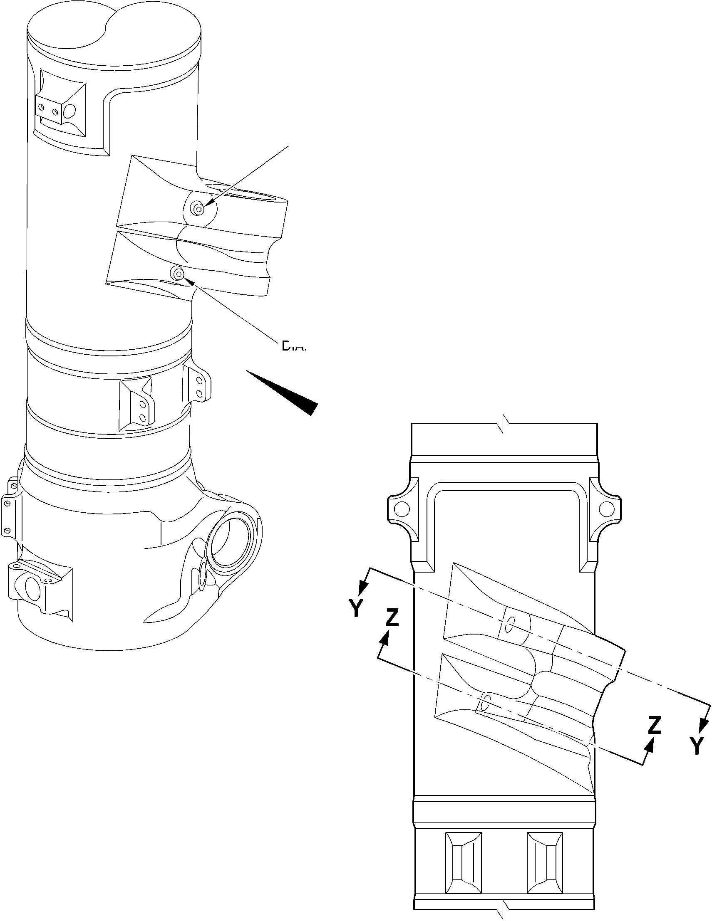

SAFRAN LANDING SYSTEMS UK Ltd
CAGE: K0654

PART No. 201587001 AND 201587002 COMPONENT MAINTENANCE MANUAL
MAIN LANDING GEAR LEG
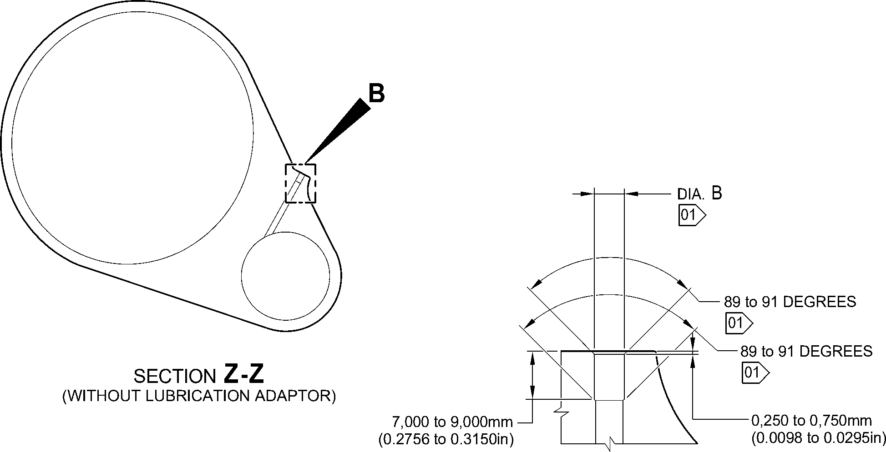
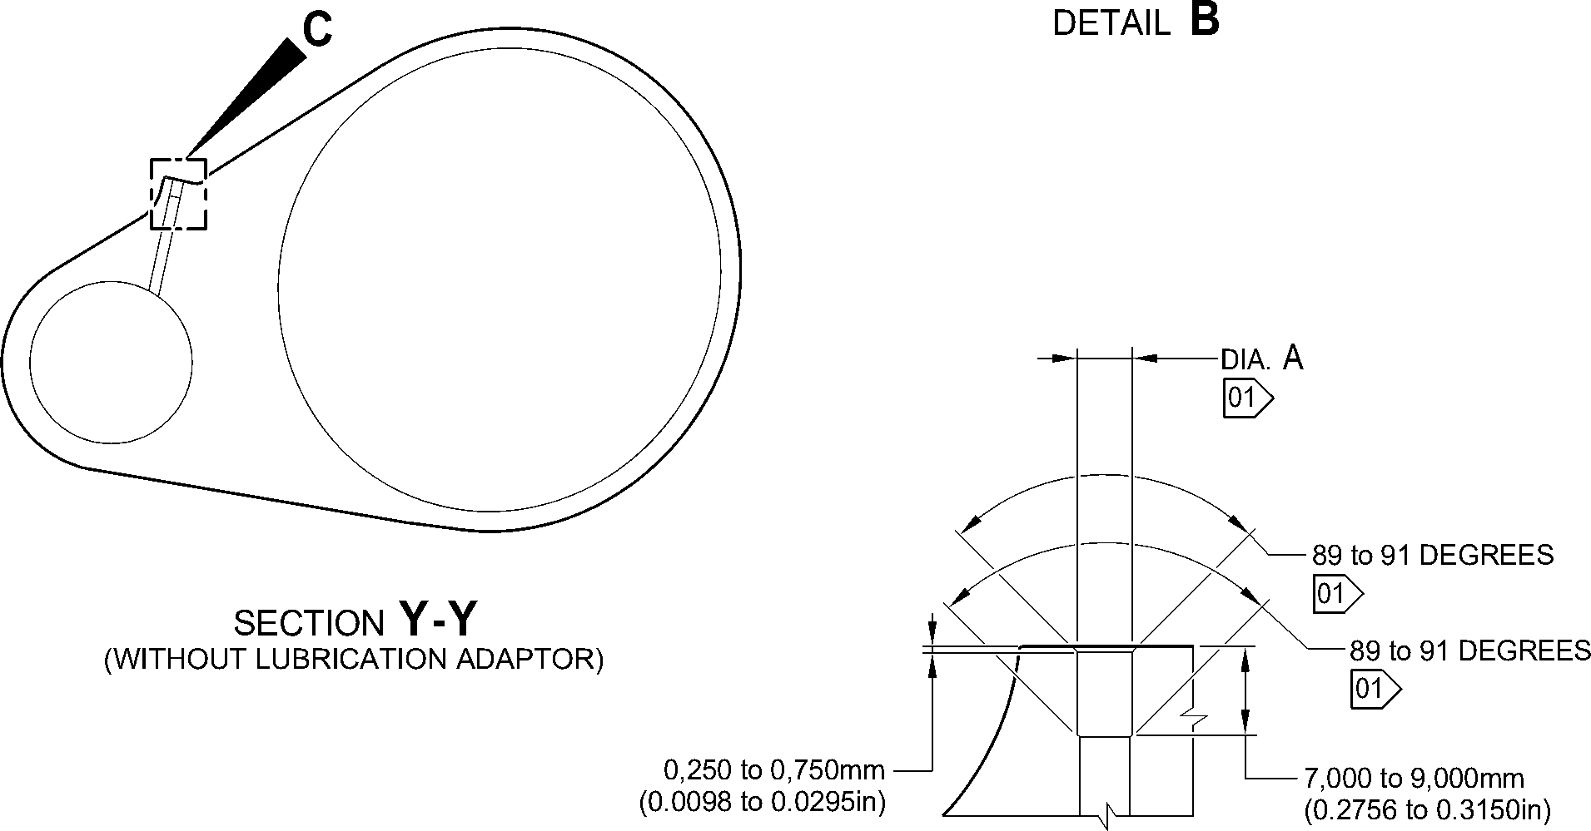
DETAIL C
1,6
NOTE: (63)
THE SURFACE FINISH MUST BE V OR BETTER UNLESS GIVEN DIFFERENTLY.
DIAMETER(S) A AND/OR B MUST FOLLOW THE LINE OF EXISTING BORES.
01 CADMIUM PLATE OPTIONAL AND NO PAINT.
A321-T-32-12-22-113-0
Repair to Main Fitting
Figure 601 - Sheet 2
Repair No. 11-32
32-12-22
Page 605
Mar 18/2025

SAFRAN LANDING SYSTEMS UK Ltd
CAGE: K0654

PART No. 201587001 AND 201587002 COMPONENT MAINTENANCE MANUAL
MAIN LANDING GEAR LEG
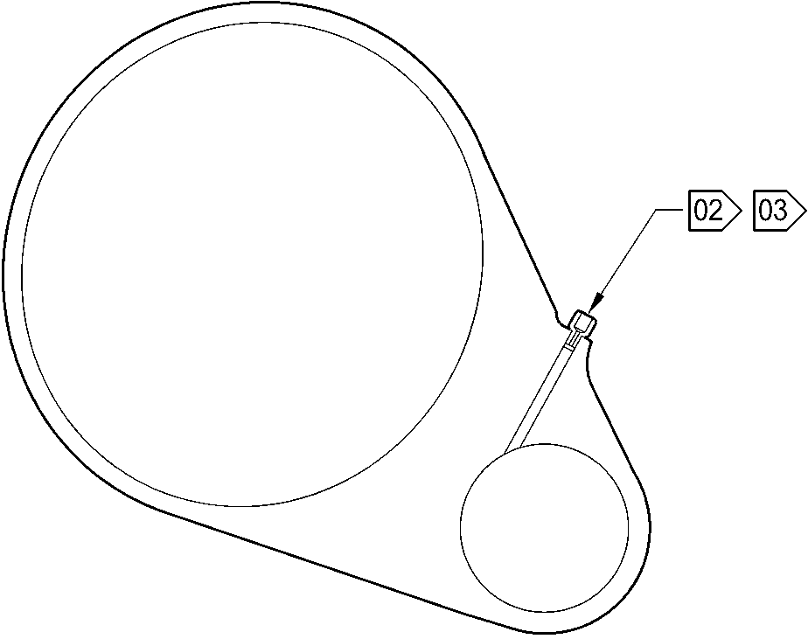
SECTION Z-Z
(WITH LUBRICATION ADAPTOR)
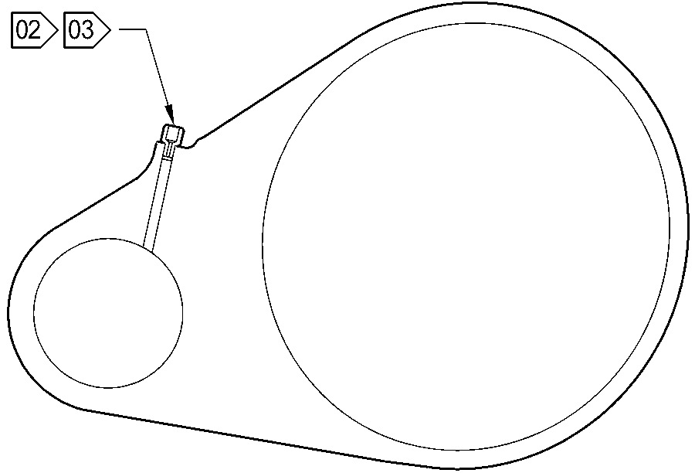
SECTION Y-Y
(WITH LUBRICATION ADAPTOR)
NOTE:
02 APPLY LOCTITE GRADE 270 TO ADAPTOR INTERFACE WITH MAIN FITTING: REFER TO PCS-5303.
03 INSTALL THE APPLICABLE LUBRICATION ADAPTOR: REFER TO TABLE 601.
A321-T-32-12-22-114-0
Repair to Main Fitting
Figure 601 - Sheet 3
32-12-22
Repair No. 11-32
Page 606
Mar 18/2025

sSAFRAN SAFRAN LANDING SYSTEMS UK Ltd
CAGE: K0654
PART No. 201587001 AND 201587002 COMPONENT MAINTENANCE MANUAL
MAIN LANDING GEAR LEG
- Repair No. 11-33 Main Fitting (20-410B, 20-410C, 20-410D, 20-420B, 20-420C and 20-420D)
- Specified Damage and Material Specification
- Specified Damage
(a) Wear or damage or corrosion to diameter A.
- Material Specification
IPL Figure and  Item No. | Name | Material Specification
20-410B and  20-420B | Main fitting | Steel 35NCD16THQ to MTL-1203 with  UTS 1800 MPa (261.0 ksi)
20-410C,  20-410D,  20-420C and  20-420D | Main fitting | UHT steel, 300M to MTL-1201 with  UTS 1930 MPa (279.9 ksi)
- Special Tools
- Special tools are not necessary.
- Materials
- These materials are necessary:
NOTE: Alternative equivalents are permitted.
Ref. Item | Material
TBA | Zinc loaded Molykote 111
TBA | Sealant
- Repair Parts
- These repair parts are necessary:
Part No. | Repair Part | Material Specification
Refer to Table 601 for the correct oversize  spherical bearing assembly |  | -
- Procedure (Refer to Figure 601)
CAUTION: FOR DAMAGE MORE THAN THE LIMITS OF THIS REPAIR SCHEME, WRITE
TO SAFRAN LANDING SYSTEMS: REFER TO GUIDE-CS-001.
- Do this procedure if there is wear or damage to diameter A: refer to Figure 601.
- Remove the paint from the main fitting: refer to PCS-2700.
- Remove the cadmium plate from the main fitting: refer to PCS-2100.
Repair No. 11-33
32-12-22
Page 601
Mar 18/2025

sSAFRAN SAFRAN LANDING SYSTEMS UK Ltd
CAGE: K0654
PART No. 201587001 AND 201587002 COMPONENT MAINTENANCE MANUAL
MAIN LANDING GEAR LEG
- Machine diameter A to the nearest dimensions shown in Table 601 to remove the
damage or wear. Do not increase diameter A to more than 167,587 mm
(6.5979 in). The surface finish must be 1,6 micrometers (63 micro-inches) or better.
The minimum wall thickness must not be between 15,382 mm (0.6056 in) and
15,582 mm (0.6134 in): refer to PCS-4100 and Figure 601.
- Measure and record diameter A. Refer to Table 601 for correct oversize spherical
bearing assembly.
- Machine the chamfer(s) and/or radii as shown: refer to PCS-4100 and Figure 601.
- Examine the machined areas for flaws: refer to PCS-3100, inclusion Class 4 and
PCS-3600.
- Shot peen the reworked areas only: refer to PCS-2300.
- Apply cadmium plate all over but not to the areas shown. The cadmium plate
thickness must be between 0,010 and 0,020 mm (0.0004 and 0.0008 in): refer to
PCS-2100. No bare metal is permitted.
- Apply primer paint where shown: refer to PCS-2500 and Figure 601.
- Select the correct oversize spherical bearing assembly from Table 601 applicable
for diameter A.
- Install the spherical bearing assembly to the main fitting.
- Use Zinc loaded Molykote 111, Material Ref. Item TBA, to install the oversize
spherical bearing assembly from Table 601 (qty 1 as necessary): refer to
PCS-7303 and Figure 601.
- Apply fillet of Sealant, Material Ref. Item TBA, to the oversize spherical bearing
assembly: refer to PCS-7200 and Figure 601.
- Apply top coat paint all over but not to the areas shown: refer to PCS-2500 and
Figure 601.
- Record the repair number onto the documentation which is attached to the part.
Optionally, identify the part with the Safran Landing Systems repair number
64-4505109-00 adjacent to the existing part number: refer to PCS-6000-07.
- Examine the part to make sure that you have obeyed all the repair instructions
correctly.
32-12-22
Repair No. 11-33
Page 602
Mar 18/2025

SAFRAN LANDING SYSTEMS UK Ltd
CAGE: K0654
PART No. 201587001 AND 201587002 COMPONENT MAINTENANCE MANUAL
MAIN LANDING GEAR LEG
Oversize Lubrication Adaptors
Table 601
Oversize | Oversize Step  mm (in) | Inner Diameter A  Before Plating  mm (in) | Oversize Bearing  Housing Outer  Diameter Ref.  mm (in) | Oversize  Spherical  Bearing  Assembly  Number
- | Production | 166,000 to 166,063  (6.5354 to 6.5379) | 165,934 to 165,959  (6.5328 to 6.5338) | -
1st | 0,127  (0.0050) | 166,127 to 166,190  (6.5404 to 6.5429) | 166,061 to 166,086  (6.5378 to 6.5388) | 450258301
2nd | 0,254  (0.0100) | 166,254 to 166,317  (6.5454 to 6.5479) | 166,188 to 166,213  (6.5428 to 6.5438) | 450258302
3rd | 0,381  (0.0150 | 166,381 to 166,444  (6.5504 to 6.5529) | 166,315 to 166,340  (6.5478 to 6.5488) | 450258303
4th | 0,508  (0.0200) | 166,508 to 166,571  (6.5554 to 6.5579) | 166,442 to 166,467  (6.5528 to 6.5538) | 450258304
5th | 0,635  (0.0250) | 166,635 to 166,698  (6.5604 to 6.5629) | 166,569 to 166,594  (6.5578 to 6.5588) | 450258305
6th | 0,762  (0.0300) | 166,762 to 166,825  (6.5654 to 6.5679) | 166,696 to 166,721  (6.5628 to 6.5638) | 450258306
7th | 0,889  (0.0350) | 166,889 to 166,952  (6.5704 to 6.5729) | 166,823 to 166,848  (6.5678 to 6.5688) | 450258307
8th | 1,016  (0.0400) | 167,016 to 167,079  (6.5754 to 6.5779) | 166,950 to 166,975  (6.5728 to 6.5738) | 450258308
9th | 1,143  (0.0450) | 167,143 to 167,206  (6.5804 to 6.5829) | 167,077 to 167,102  (6.5778 to 6.5788) | 450258309
10th | 1,270  (0.0500) | 167,270 to 167,333  (6.5854 to 6.5879) | 167,204 to 167,229  (6.5828 to 6.5838) | 450258310
11th | 1,397  (0.0550) | 167,397 to 167,460  (6.5904 to 6.5929) | 167,331 to 167,356  (6.5878 to 6.5888) | 450258311
12th | 1,524  (0.0600) | 167,524 to 167,587  (6.5954 to 6.5979) | 167,458 to 167,483  (6.5928 to 6.5938) | 450258312
Repair No. 11-33
32-12-22
Page 603
Mar 18/2025

SAFRAN LANDING SYSTEMS UK Ltd
CAGE: K0654

PART No. 201587001 AND 201587002 COMPONENT MAINTENANCE MANUAL
MAIN LANDING GEAR LEG
A
B
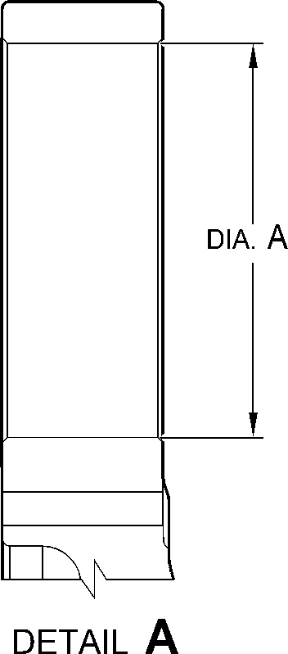
Z
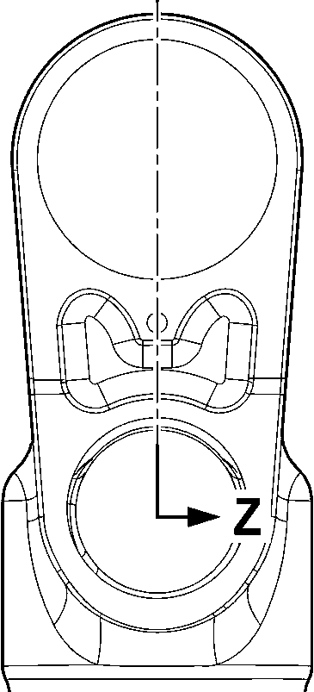
—F-
VIEW B
A321-T-32-12-22-146-0
Repair to Main Fitting
Figure 601 - Sheet 1
32-12-22
Repair No. 11-33
Page 604
Mar 18/2025
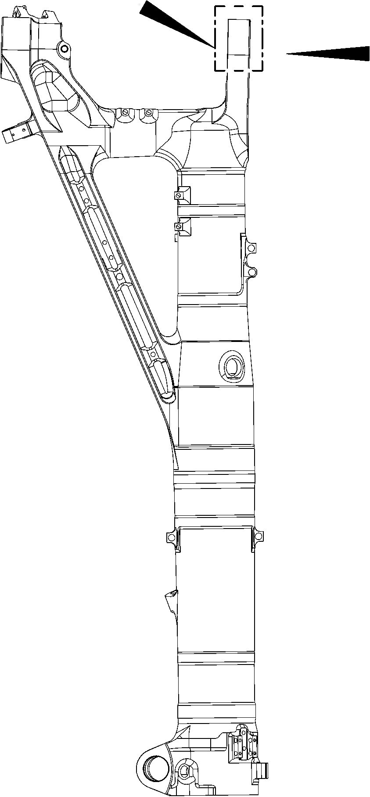

SAFRAN LANDING SYSTEMS UK Ltd
CAGE: K0654
PART No. 201587001 AND 201587002 COMPONENT MAINTENANCE MANUAL
MAIN LANDING GEAR LEG
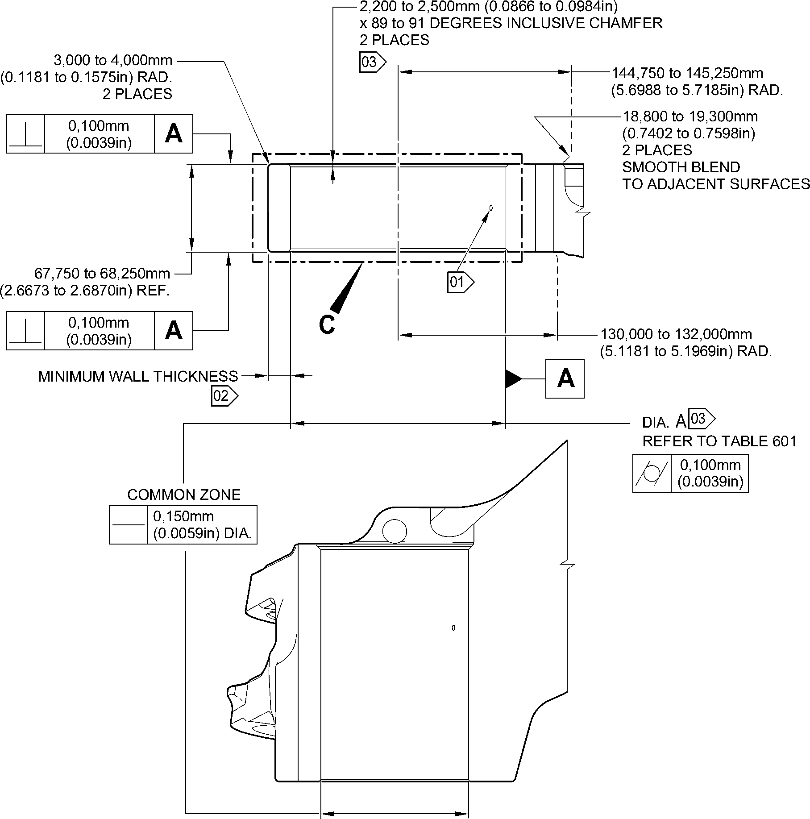
SECTION Z-Z
(WITHOUT OVERSIZE REAR SPHERICAL BEARING)
90 DEGREES ROTATED
1,6
NOTE: (63)
THE SURFACE FINISH MUST BE V OR BETTER UNLESS GIVEN DIFFERENTLY.
DIAMETER A MUST FOLLOW THE AXIS OF EXISTING BORE.
01 REMOVE THE BREAK EDGES WITHIN 0,500 to 2,000mm (0.0197 to 0.0787in) RAD.
02 FOR THE MAIN FITTING (20-410B), (20-410C), (20-420B) and (20-420C):
THE MINIMUM WALL THICKNESS IS 15,382mm (0.6056in).
FOR THE MAIN FITTING (20-410D) and (20-420D):
THE MINIMUM WALL THICKNESS IS 15,582mm (0.6134in).
03 PRIMER PAINT ONLY: REFER TO PCS-2500. NO WITNESS OF TOP COAT PAINT PERMITTED
ON THESE SURFACES.
A321-T-32-12-22-147-0
Repair to Main Fitting
Figure 601- Sheet 2
Repair No. 11-33
32
Page 605
⁻12⁻22 Mar 18/2025

SAFRAN LANDING SYSTEMS UK Ltd
CAGE: K0654

PART No. 201587001 AND 201587002 COMPONENT MAINTENANCE MANUAL
MAIN LANDING GEAR LEG
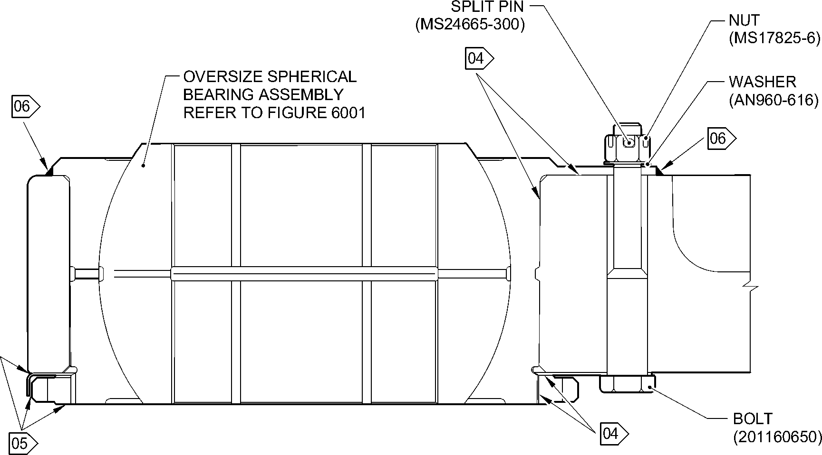
SECTION Z-Z
(WITH OVERSIZE REAR SPHERICAL BEARING)
90 DEGREES ROTATED
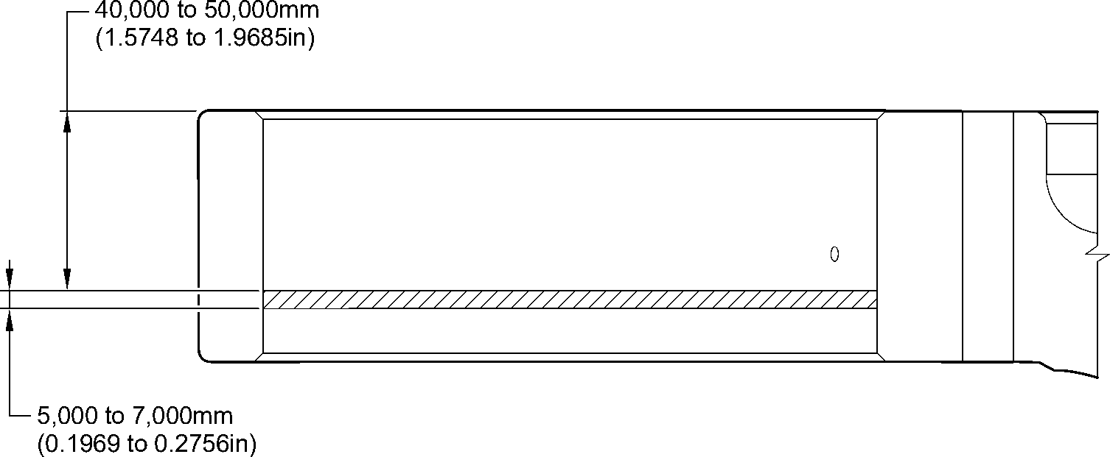
NO PAINT _{DETAIL} C
NOTE:
04 APPLY MOLYKOTE 111 TO THE BOLT SHANKS, THREADS, UNDERCUTS AND ALL INTERFACES
BETWEEN MATING PARTS MUST BE COATED BEFORE ASSEMBLY: REFER TO PCS-7303.
ALL CAVITIES AND VOIDS MUST BE FILLED TO PREVENT MOISTURE INGRESS.
05 APPLY A FULL BEAD OF SEALANT, PR340-2 WITH A MAXIMUM HEIGHT OF
1,000mm (0.0394in) ABOVE ADJOINING SURFACES: REFER TO PCS-7200.
06 APPLY SEALANT: REFER TO PCS-7200 TYPE 2.
A321-T-32-12-22-148-0
Repair to Main Fitting
Figure 601 - Sheet 3
32-12-22
Repair No. 11-33
Page 606
Mar 18/2025

sSAFRAN SAFRAN LANDING SYSTEMS UK Ltd
CAGE: K0654
PART No. 201587001 AND 201587002 COMPONENT MAINTENANCE MANUAL
MAIN LANDING GEAR LEG
- Repair No. 11-34 Main Fitting (20-410B, 20-410C, 20-410D, 20-420B, 20-420C and 20-420D)
- Specified Damage and Material Specification
- Specified Damage
(a) Wear or damage or corrosion to diameter(s) A and/or B.
- Material Specification
IPL Figure and  Item No. | Name | Material Specification
20-410B and  20-420B | Main fitting | UHT Steel E35NCD16THQ to MTL-1203  with UTS 1800 MPa (261.0 ksi)
20-410C,  20-410D,  20-420C and  20-420D | Main fitting | UHT Steel 300M to MTL-1201 with  UTS 1930 MPa (279.9 ksi)
- Special Tools
- Special tools are not necessary.
- Materials
- These materials are necessary:
NOTE: Alternative equivalents are permitted.
Ref. Item | Material
TBA | Zinc loaded Molykote 111
TBA | Sealant
- Repair Parts
- These repair parts are necessary:
Part No. | Repair Part | Material Specification
61-4533019-00 | Repair blank bush | Aluminium Bronze to  AMS-4640 Ftu ≥ 758 MPa  (109.9 ksi)
Repair No. 11-34
32-12-22
Page 601
Mar 18/2025

SAFRAN LANDING SYSTEMS UK Ltd
CAGE: K0654
SSAFRAN
PART No. 201587001 AND 201587002 COMPONENT MAINTENANCE MANUAL
MAIN LANDING GEAR LEG
- Procedure (Refer to Figure 601 and Figure 602)
CAUTION: FOR DAMAGE MORE THAN THE LIMITS OF THIS REPAIR SCHEME, WRITE
TO SAFRAN LANDING SYSTEMS: REFER TO GUIDE-CS-001.
CAUTION: APPLY TEMPORARY CORROSION AND DAMAGE PROTECTION: REFER
TO PCS-2800
- Do this procedure if there is wear or damage or corrosion to diameter(s) A and/or B:
refer to Figure 601 and Figure 602.
- Remove the paint from the main fitting: refer to PCS-2700.
- Remove the cadmium plate from the main fitting: refer to PCS-2100.
- Machine diameter(s) A and/or B to remove the minimum amount of material to
remove the wear or damage or corrosion. Do not increase diameter(s) A and/or B
to more than 13,727 mm (0.5404 in). The surface finish must be 1,6 micrometers
(63 micro-inches) or better: refer to PCS-4100 and Figure 601.
- Measure and record the diameter(s) A and/or B.
- Machine the chamfer(s) and/or radii as shown: refer to PCS-4100 and Figure 601.
- Examine the machined areas for flaws: refer to PCS-3100, inclusion Class 4 and
PCS-3600.
- Shot peen the machined areas only: refer to PCS-2300.
- Apply cadmium plate all over but not to the areas shown. The cadmium plate
thickness must be between 0,010 and 0,020 mm (0.0004 and 0.0008 in): refer to
PCS-2100. No bare metal is permitted.
- Apply primer paint to the main fitting where shown: refer to PCS-2500.
- Prepare the repair bush from the blank bush 61-4533019-00 with these dimensions
for installation (qty 1 to 2 as necessary): refer to Figure 601 and Figure 602.
- Machine diameter Z, use the formula:
Dia. Z = Diameter A and/or B (as measured) + 0,018 to + 0,029 mm
(+ 0.0007 to + 0.0011 in).
- Apply cadmium plate all over. The cadmium plate thickness must be between
0,010 and 0,015 mm (0.0004 and 0.0006 in): refer to PCS-2101 and
Figure 602.
- Use Zinc loaded Molykote 111, Material Ref. Item TBA, to install the repair bush.
Apply heat to the housing to 100°C and then cool the repair bushes: refer to
PCS-5105-2, PCS-7304 and Figure 601 and Figure 602.
- Apply fillet of Sealant, Material Ref. Item TBA, to the bush flange and bush tail end:
refer to PCS-7200 and Figure 601.
- Apply top coat paint all over but not to the areas where shown: refer to PCS-2500.
- Record the repair number onto the documentation which is attached to the part.
Optionally, identify the part with the Safran Landing Systems repair number
64-4505112-00 adjacent to the existing part number: refer to PCS-6000-07.
- Examine the part to make sure that you have obeyed all the repair instructions
correctly.
Repair No. 11-34
Page 602
Mar 18/2025
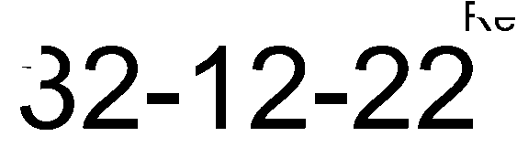

SAFRAN LANDING SYSTEMS UK Ltd
CAGE: K0654
PART No. 201587001 AND 201587002 COMPONENT MAINTENANCE MANUAL
MAIN LANDING GEAR LEG
dia. B
Y
Y
COMMON ZONE
Y
Y
SECTION Z-Z
A321-T-32-12-22-134-0
0.150mm
(0.0059in) DIA.
0,100mm
(0.0039in) DIA.
50,000mm (1.9685in)

Y_{Y}
dia. A
Repair to Main Fitting
Figure 601 - Sheet 1
Repair No. 11-34
32
Page 603
⁻12⁻22 Mar 18/2025
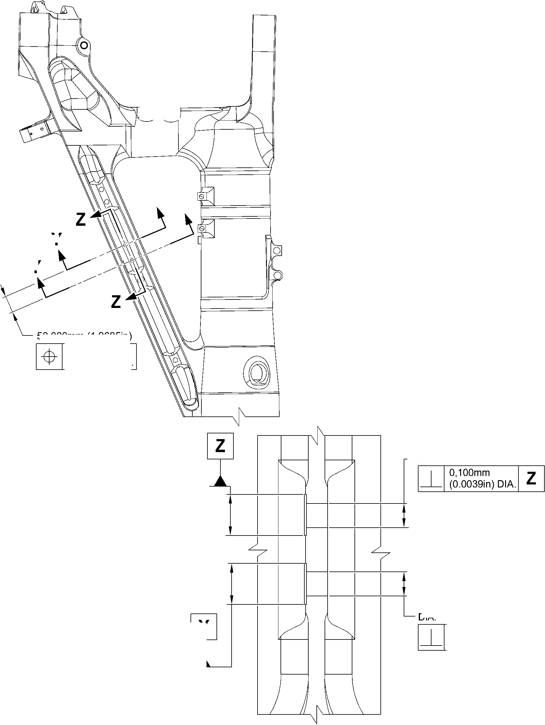

SAFRAN LANDING SYSTEMS UK Ltd
CAGE: K0654
PART No. 201587001 AND 201587002 COMPONENT MAINTENANCE MANUAL
MAIN LANDING GEAR LEG
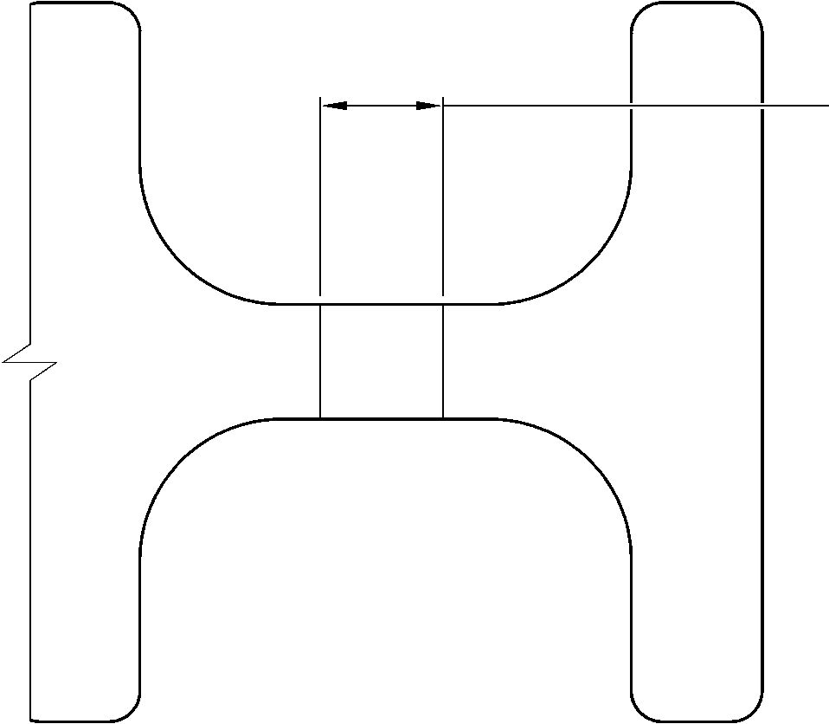
dia. A and B
13,727mm (0.5404in) DIA.
MAX.
SECTION Y-Y
(WITHOUT BUSHES)
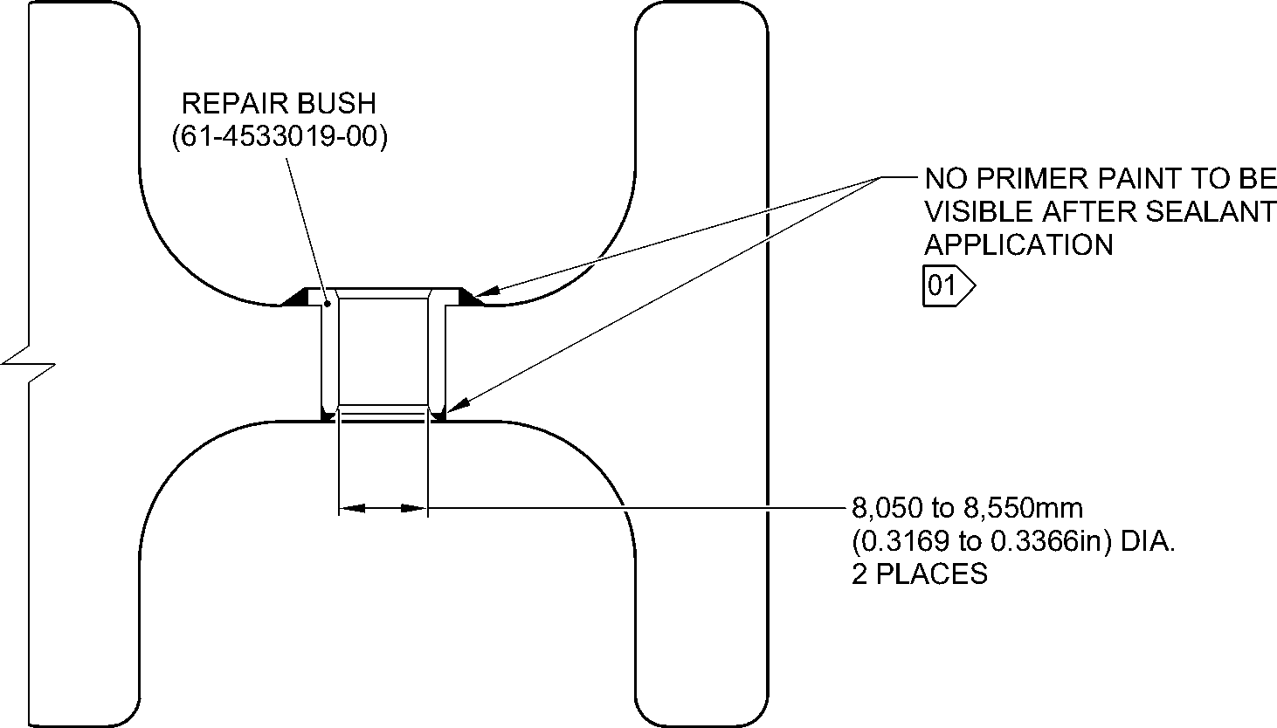
SECTION Y-Y
(WITH BUSHES)
1,6
NOTE: (63)
THE SURFACE FINISH MUST BE V OR BETTER UNLESS GIVEN DIFFERENTLY.
DIAMETERS A AND B MUST FOLLOW THE AXIS OF EXISTING BORE.
DEBURR THE SHARP EDGES WITH 0,500 to 1,000mm (0.0197 to 0.0394in) RAD.
UNLESS GIVEN DIFFERENTLY.
01 APPLY FILLET SEALANT: REFER TO PCS-7200. MAKE SURE THAT THE SEALANT
COMPLETELY COVERS EXPOSED PRIMER PAINT.
A321-T-32-12-22-135-0
Repair to Main Fitting
Figure 601 - Sheet 2
32-12-22
Repair No. 11-34
Page 604
Mar 18/2025

SAFRAN LANDING SYSTEMS UK Ltd
CAGE: K0654
PART No. 201587001 AND 201587002 COMPONENT MAINTENANCE MANUAL
MAIN LANDING GEAR LEG
2,900 to 3,150mm
(0.1142 to 0.1240in)
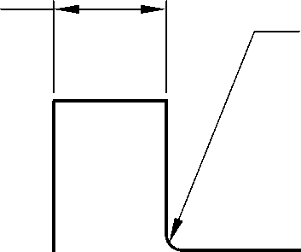
0,300 to 0,500mm
(0.0118 to 0.0196in) RAD.
—► 0,750 to 1,250mm
(0.0295 to 0.0492in)
x 14,5 to 15,5 DEGREES
CHAMFER
dia. Z
1,6
(63)
8,050 to 8,550mm
(0.3169 to 0.3366in) DIA. REF.
0,750 to 1,250mm
(0.0295 to 0.0492in)
x 14,5 to 15,5 DEGREES
CHAMFER
11,500 to 12,000mm
(0.4528 to 0.4724in)
3,2
NOTE: (125)
THE SURFACE FINISH MUST BE OR BETTER UNLESS GIVEN DIFFERENTLY.
DEBURR THE SHARP EDGES WITH 0,130 to 0,380mm (0.0051 to 0.0150in) RAD.
UNLESS GIVEN DIFFERENTLY.
APPLY CADMIUM PLATE ALL OVER: REFER TO PCS-2101. THE CADMIUM PLATE
THICKNESS MUST BE BETWEEN 0,010 to 0,015mm (0.0004 to 0.0006in).
A321-T-32-12-22-136-0
Repair to Main Fitting - Bush
Figure 602
Repair No. 11-34
32-12-22
Page 605
Mar 18/2025

SAFRAN LANDING SYSTEMS UK Ltd
CAGE: K0654

PART No. 201587001 AND 201587002 COMPONENT MAINTENANCE MANUAL
MAIN LANDING GEAR LEG
INTENTIONALLY BLANK
Repair No. 11-34
32-12-22 ^{Page 606}

sSAFRAN SAFRAN LANDING SYSTEMS UK Ltd
CAGE: K0654
PART No. 201587001 AND 201587002 COMPONENT MAINTENANCE MANUAL
MAIN LANDING GEAR LEG
- Repair No. 11-35 Main Fitting (20-410B, 20-410C, 20-410D, 20-420B, 20-420C and 20-420D)
- Specified Damage and Material Specification
- Specified Damage
(a) Wear or damage or corrosion to diameter(s) A and B.
- Material Specification
IPL Figure and  Item No. | Name | Material Specification
20-410B and  20-420B | Main fitting | UHT Steel E35NCD16THQ to MTL-1203  with UTS 1800 MPa (261.0 ksi)
20-410C,  20-410D,  20-420C and  20-420D | Main fitting | UHT Steel 300M to MTL-1201 with  UTS 1930 MPa (279.9 ksi)
- Special Tools
- Special tools are not necessary.
- Materials
- These materials are necessary:
NOTE: Alternative equivalents are permitted.
Ref. Item | Material
TBA | Zinc loaded Molykote 111
TBA | Sealant
- Repair Parts
- These repair parts are necessary:
Part No. | Repair Part | Material Specification
61-4533018-00 | Repair blank bush | Aluminium Bronze to  AMS-4640 Ftu ≥ 758 MPa  (109.9 ksi)
Repair No. 11-35
32-12-22
Page 601
Mar 18/2025

SAFRAN LANDING SYSTEMS UK Ltd
CAGE: K0654
SSAFRAN
PART No. 201587001 AND 201587002 COMPONENT MAINTENANCE MANUAL
MAIN LANDING GEAR LEG
- Procedure (Refer to Figure 601 and Figure 602)
CAUTION: FOR DAMAGE MORE THAN THE LIMITS OF THIS REPAIR SCHEME, WRITE
TO SAFRAN LANDING SYSTEMS: REFER TO GUIDE-CS-001.
CAUTION: APPLY TEMPORARY CORROSION AND DAMAGE PROTECTION: REFER
TO PCS-2800
- Do this procedure if there is wear or damage or corrosion to diameter(s) A and B: refer
to Figure 601 and Figure 602.
- Remove the paint from the main fitting: refer to PCS-2700.
- Remove the cadmium plate from the main fitting: refer to PCS-2100.
- Machine diameter(s) A and B to remove the minimum amount of material to
remove the wear or damage or corrosion. Do not increase diameter(s) A and B to
more than 15,727 mm (0.6192 in). The surface finish must be 1,6 micrometers
(63 micro-inches) or better: refer to PCS-4100 and Figure 601.
- Measure and record the diameter(s) A and B.
- Machine the chamfer(s) and/or radii as shown: refer to PCS-4100 and Figure 601.
- Examine the machined areas for flaws: refer to PCS-3100 inclusion, Class 4 and
PCS-3600.
- Shot peen the machined areas only: refer to PCS-2300.
- Apply cadmium plate all over but not to the areas shown. The plating thickness
must be between 0,010 and 0,020 mm (0.0004 and 0.0008 in): refer to PCS-2100.
No bare metal is permitted.
- Apply primer paint to the main fitting where shown: refer to PCS-2500.
- Prepare the repair bushes from the blank bush 61-4533018-00 with these
dimensions for installation (qty 1 to 2 as necessary): refer to Figure 602.
- Machine diameter Z, use the formula:
Dia. Z = Dia. A (as measured) + 0,018 to + 0,029 mm
(+ 0.0007 to + 0.0011 in).
- Apply cadmium plate all over. The plating thickness must be between 0,010
and 0,015 mm (0.0004 and 0.0006 in): refer to PCS-2101 and Figure 602.
- Use Zinc loaded Molykote 111, Material Ref. Item TBA, and install the repair
bushes. Apply heat to the housing to 100°C and then cool the repair bushes: refer
to PCS-5105-2, PCS-7304 and Figure 601 and Figure 602.
- Apply fillet of Sealant, Material Ref. Item TBA, to the bush flange and bush tail end:
refer to PCS-7200 and Figure 601.
- Apply top coat paint all over but not to the areas shown: refer to PCS-2500.
- Record the repair number onto the documentation which is attached to the part.
Optionally, identify the part with the Safran Landing Systems repair number
64-4505111-00 adjacent to the existing part number: refer to PCS-6000-07.
- Examine the part to make sure that you have obeyed all the repair instructions
correctly.
Repair No. 11-35
Page 602
Mar 18/2025
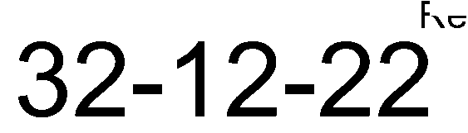

SAFRAN LANDING SYSTEMS UK Ltd
CAGE: K0654

PART No. 201587001 AND 201587002 COMPONENT MAINTENANCE MANUAL
MAIN LANDING GEAR LEG
40,000mm (1.5478in)
COMMON ZONE
Y
Y
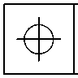
0.150mm
(0.0059in) DIA.

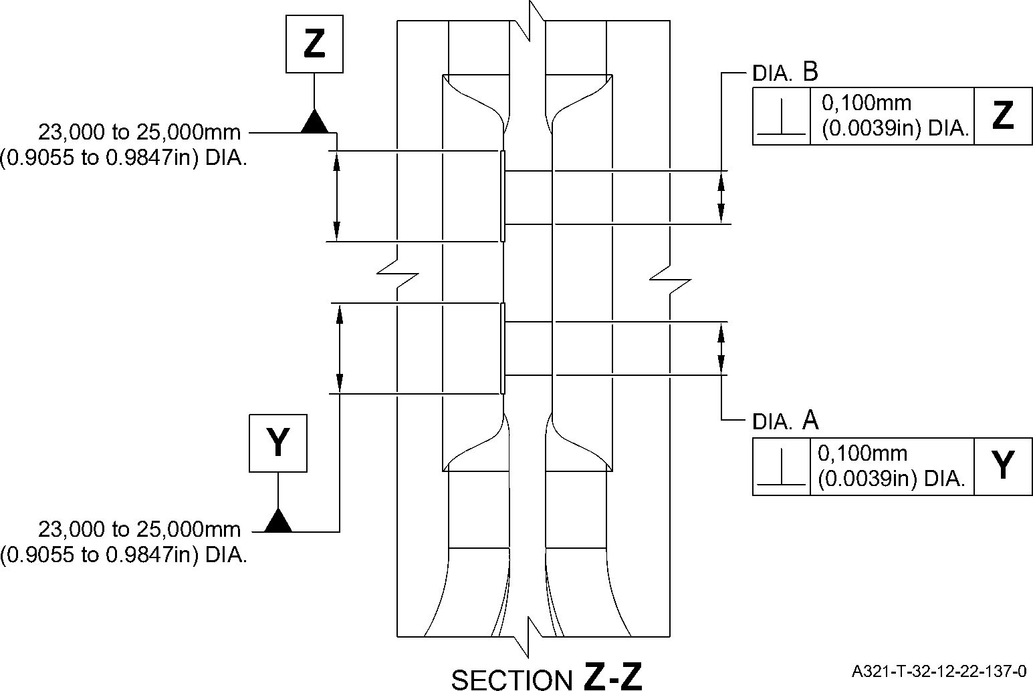
Repair to Main Fitting
Figure 601 - Sheet 1
Repair No. 11-35
32-12-22
Page 603
Mar 18/2025
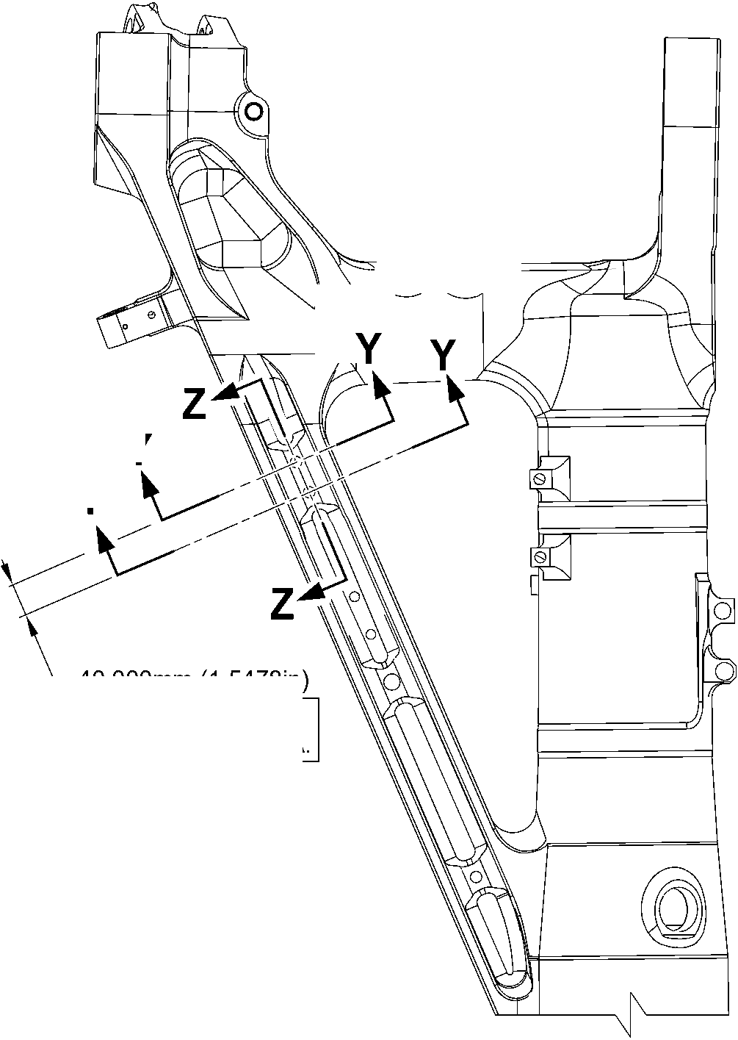

SAFRAN LANDING SYSTEMS UK Ltd
CAGE: K0654
PART No. 201587001 AND 201587002 COMPONENT MAINTENANCE MANUAL
MAIN LANDING GEAR LEG
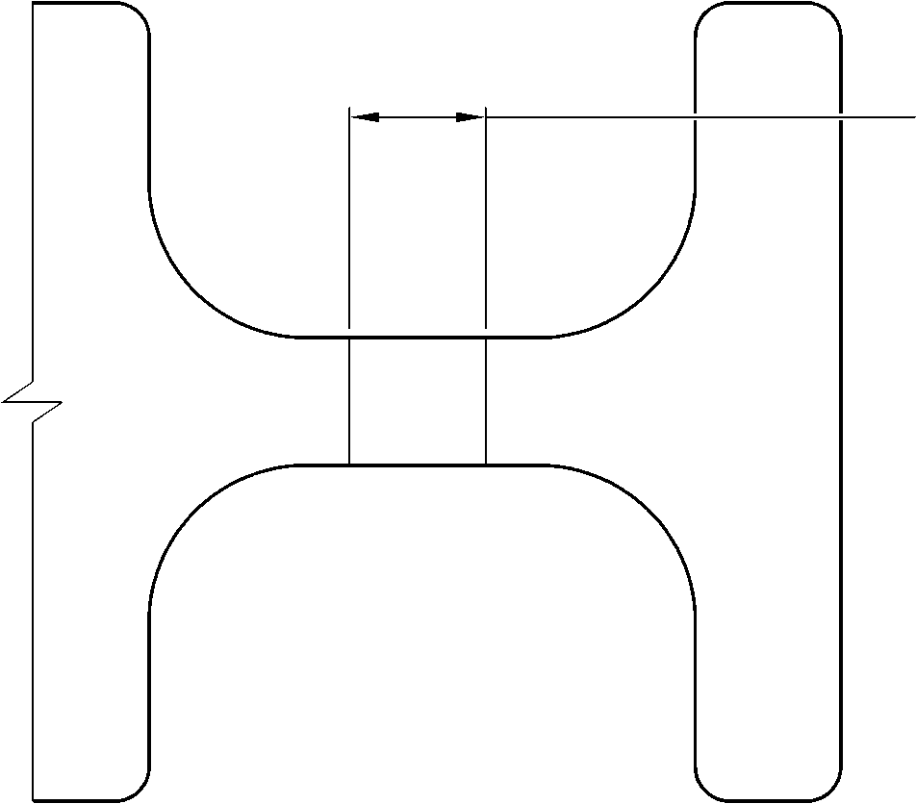
dia. A and B
15,727mm (0.6192in) DIA.
MAX.
A
SECTION Y-Y
(WITHOUT BUSHES)
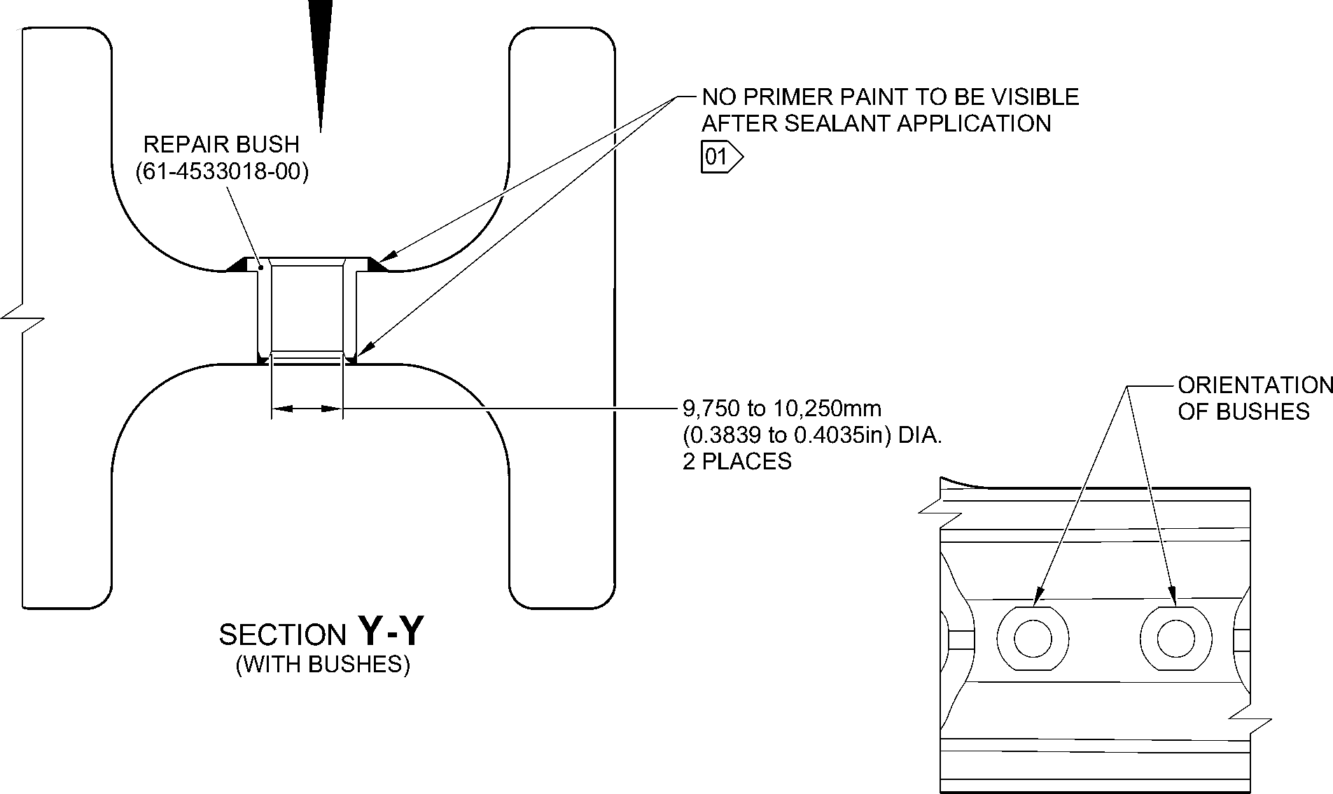
1,6
NOTE: ⁽⁶³⁾ VIEW
THE SURFACE FINISH MUST BE V OR BETTER UNLESS GIVEN DIFFERENTLY.
DIAMETERS A AND B MUST FOLLOW THE AXIS OF EXISTING BORE.
DEBURR THE SHARP EDGES WITH 0,500 to 1,000mm (0.0197 to 0.0394in) RAD.
UNLESS GIVEN DIFFERENTLY.
01 APPLY FILLET SEALANT: REFER TO PCS-7200. MAKE SURE THAT THE SEALANT COMPLETELY
COVERS EXPOSED PRIMER PAINT.
A321-T-32-12-22-138-0
Repair to Main Fitting
Figure 601 - Sheet 2
32-12-22
Repair No. 11-35
Page 604
Mar 18/2025

SAFRAN LANDING SYSTEMS UK Ltd
CAGE: K0654
PART No. 201587001 AND 201587002 COMPONENT MAINTENANCE MANUAL
MAIN LANDING GEAR LEG
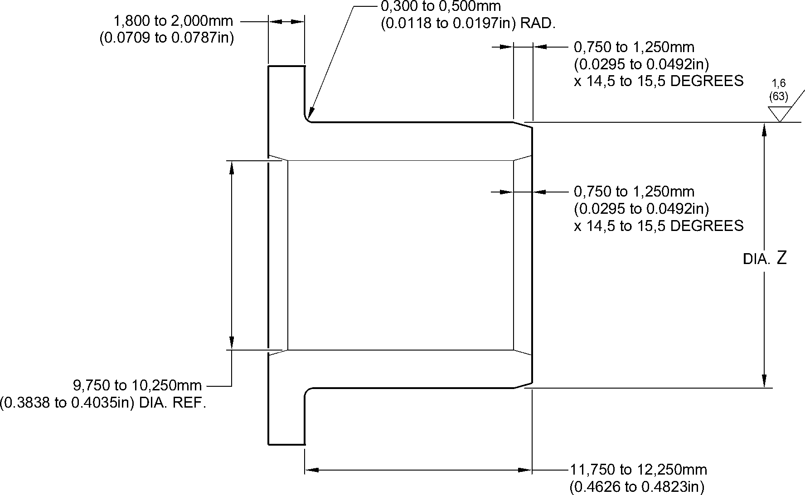
3,2
NOTE: (125)
THE SURFACE FINISH MUST BE V OR BETTER UNLESS GIVEN DIFFERENTLY.
APPLY CADMIUM PLATE ALL OVER: REFER TO PCS-2101. THE PLATING THICKNESS
MUST BE BETWEEN 0,010 to 0,015mm (0.0004 to 0.0006in).
DEBURR THE SHARP EDGES WITH 0,130 to 0,380mm (0.0051 to 0.0150in) RAD.
UNLESS GIVEN DIFFERENTLY.
A321-T-32-12-22-139-0
Repair to Main Fitting - Bush
Figure 602
Repair No. 11-35
32-12-22
Page 605
Mar 18/2025

SAFRAN LANDING SYSTEMS UK Ltd
CAGE: K0654

PART No. 201587001 AND 201587002 COMPONENT MAINTENANCE MANUAL
MAIN LANDING GEAR LEG
INTENTIONALLY BLANK
Repair No. 11-35
32-12-22 ^{Page 606}

sSAFRAN SAFRAN LANDING SYSTEMS UK Ltd
CAGE: K0654
PART No. 201587001 AND 201587002 COMPONENT MAINTENANCE MANUAL
MAIN LANDING GEAR LEG
- Repair No. 11-36 Main Fitting (20-410B, 20-410C, 20-410D, 20-420B, 20-420C and 20-420D)
- Specified Damage and Material Specification
- Specified Damage
(a) Wear or damage or corrosion to diameter(s) A and/or B and/or C and/or D.
- Material Specification
IPL Figure and  Item No. | Name | Material Specification
20-410B and  20-420B | Main fitting | UHT Steel E35NCD16THQ to MTL-1203  with UTS 1800 MPa (261.0 ksi)
20-410C,  20-410D,  20-420C and  20-420D | Main fitting | UHT Steel 300M to MTL-1201 with  UTS 1930 MPa (279.9 ksi)
- Special Tools
- Special tools are not necessary.
- Materials
- Materials are not necessary.
- Repair Parts
- Repair parts are not necessary.
- Procedure (Refer to Figure 601)
CAUTION: FOR DAMAGE MORE THAN THE LIMITS OF THIS REPAIR SCHEME, WRITE
TO SAFRAN LANDING SYSTEMS: REFER TO GUIDE-CS-001.
CAUTION: APPLY TEMPORARY CORROSION AND DAMAGE PROTECTION: REFER
TO PCS-2800
- Do this procedure if there is wear or damage or corrosion to diameter(s) A and/or B
and/or C and/or D: refer to Figure 601.
- Remove the paint from the main fitting: refer to PCS-2700.
- Remove the cadmium plate from the main fitting: refer to PCS-2100.
- Machine diameter(s) A and/or B and/or C and/or D to remove the minimum amount
of material to remove wear or damage. Do not increase diameter(s) A and/or B
and/or C and/or D to more than 16,170 mm (0.6366 in). The surface finish must
be 1,6 micrometers (63 micro-inches) or better: refer to PCS-4100 and
Figure 601. The minimum wall thickness must not be less than 1,915 mm
(0.0754 in): refer to Figure 601.
- Machine the chamfer(s) and/or radii as shown: refer to PCS-4100 and Figure 601.
- Examine the machined areas for flaws: refer to PCS-3100, inclusion Class 4 and
refer to PCS-3600.
Repair No. 11-36
32-12-22
Page 601
Mar 18/2025

sSAFRAN SAFRAN LANDING SYSTEMS UK Ltd
CAGE: K0654
PART No. 201587001 AND 201587002 COMPONENT MAINTENANCE MANUAL
MAIN LANDING GEAR LEG
- Shot peen the machined areas only: refer to PCS-2300.
- Apply cadmium plate all over. The plating thickness must be between 0,010
and 0,020 mm (0.0004 and 0.0008 in): refer to PCS-2100 or PCS-2141. No bare
metal is permitted.
- Apply primer and paint finish all over but not to the areas shown. No bare cadmium
is permitted but not to the areas where there is no paint: refer to PCS-2500 and
Figure 601.
- Record the repair number onto the documentation which is attached to the part.
Optionally, identify the part with the Safran Landing Systems repair number
64-4505234-00 adjacent to the existing part number: refer to PCS-6000-07.
- Examine the part to make sure that you have obeyed all the repair instructions
correctly.
32-12-22
Repair No. 11-36
Page 602
Mar 18/2025

SAFRAN LANDING SYSTEMS UK Ltd
CAGE: K0654
PART No. 201587001 AND 201587002 COMPONENT MAINTENANCE MANUAL
MAIN LANDING GEAR LEG
dia. D
dia. C
dia. B
DIA. A
A
VIEW A
A321-T-32-12-22-140-0
Repair to Main Fitting
Figure 601 - Sheet 1
Repair No. 11-36
32
Page 603
⁻12⁻22 Mar 18/2025
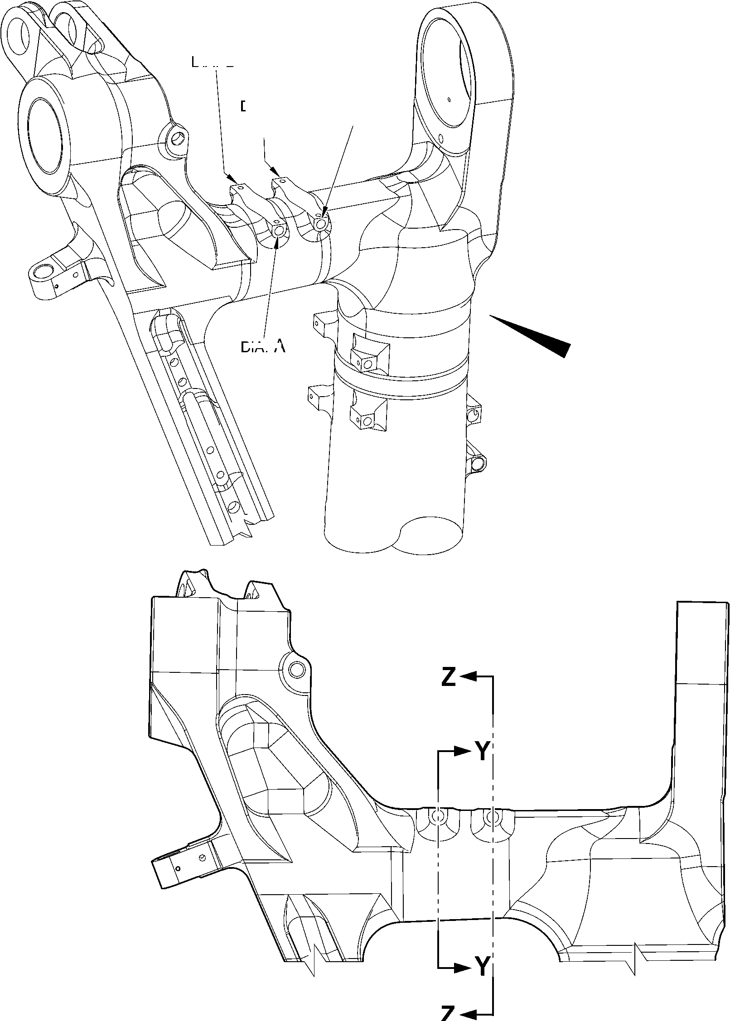

SAFRAN LANDING SYSTEMS UK Ltd
CAGE: K0654

PART No. 201587001 AND 201587002 COMPONENT MAINTENANCE MANUAL
MAIN LANDING GEAR LEG
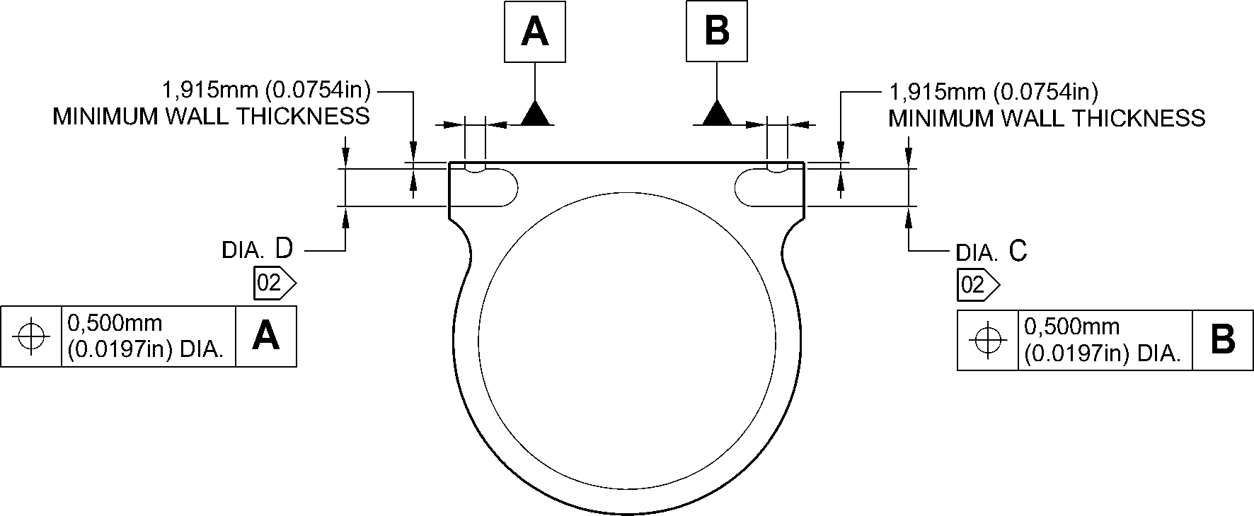
SECTION Z-Z
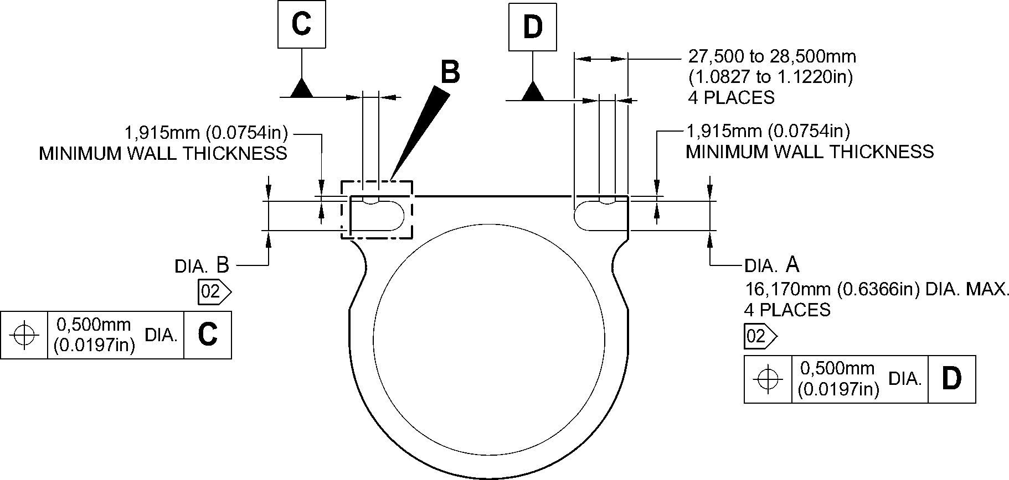
SECTION Y-Y
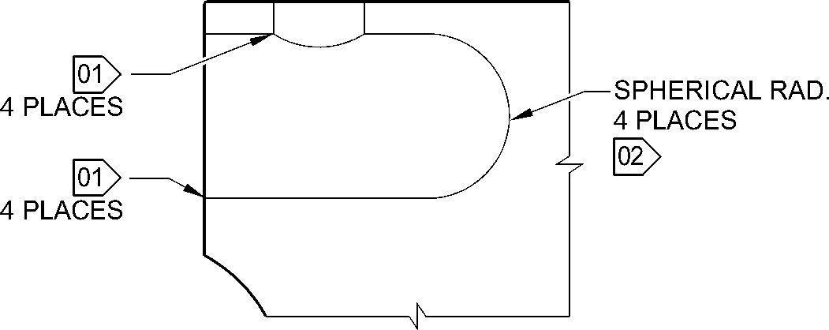
NOTE: (¹6,3⁶) DETAIL B
THE SURFACE FINISH MUST BE OR BETTER UNLESS GIVEN DIFFERENTLY.
DIAMETERS A, B, C AND D MUST FOLLOW THE AXIS OF EXISTING BORES.
01 REMOVE THE SHARP EDGES OF 0,250 to 1,000mm (0.0098 to 0.0394in) RAD.
02 NO PAINT.
A321-T-32-12-22-141-0
Repair to Main Fitting
Figure 601 - Sheet 2
32-12-22
Repair No. 11-36
Page 604
Mar 18/2025

sSAFRAN SAFRAN LANDING SYSTEMS UK Ltd
CAGE: K0654
PART No. 201587001 AND 201587002 COMPONENT MAINTENANCE MANUAL
MAIN LANDING GEAR LEG
- Repair No. 11-37 Main Fitting (20-410B, 20-410C, 20-410D, 20-420B, 20-420C and 20-420D)
- Specified Damage and Material Specification
- Specified Damage
(a) Wear or damage or corrosion to diameter(s) A.
- Material Specification
IPL Figure and  Item No. | Name | Material Specification
20-410B and  20-420B | Main fitting | UHT Steel E35NCD16THQ to MTL-1203  with UTS 1800 MPa (261.0 ksi)
20-410C,  20-410D,  20-420C and  20-420D | Main fitting | UHT Steel 300M to MTL-1201 with  UTS 1930 MPa (279.9 ksi)
- Special Tools
- Special tools are not necessary.
- Materials
- These materials are necessary:
NOTE: Alternative equivalents are permitted.
Ref. Item | Material
TBA | Loctite Grade 601
TBA | Molykote 111
- Repair Parts
- These repair parts are necessary:
Part No. | Repair Part | Material Specification
62-4505252-00 | Repair sleeve | Stainless Steel -17-4PH to  AMS5643 H1025
- Procedure (Refer to Figure 601 and Figure 602)
CAUTION: FOR DAMAGE MORE THAN THE LIMITS OF THIS REPAIR SCHEME, WRITE
TO SAFRAN LANDING SYSTEMS: REFER TO GUIDE-CS-001.
- Do this procedure if there is wear or damage or corrosion to one or more holes
diameter A: refer to Figure 601 and Figure 602.
- Remove the paint from the main fitting: refer to PCS-2700.
- Remove the cadmium plate from the main fitting: refer to PCS-2100.
Repair No. 11-37
32-12-22
Page 601
Mar 18/2025

