 | KONERU LAKSHMAIAH EDUCATION FOUNDATION  (Deemed to be University estd, u/s, 3 of the UGC Act, 1956)  (NAAC Accredited “A++” Grade University)  Green Fields, Guntur District, A.P., India – 522502  Department of Electronics and Communication Engineering  (DST - FIST Sponsored Department) | 
B.Tech. II ECE PROGRAM
A.Y.2023-24ODD, Semester-III
22EC22104Analog Electronic Circuit Design
CO2
SESSION 2
CHARACTERISTICS: PINCH-OFF VOLTAGE, DRAIN SATURATION CURRENT
1. Course Description (Description about the subject)
This course provides the student with the fundamental skills to apply the basics of semiconductor and devices like Bipolar junction transistor, FET, MOSFET and operational amplifier. It would build mathematical and numerical background for design of electronics circuit. Students equipped with the knowledge and skilling provided in the course would enable them to design, develop electronic circuits for real time applications.
2. Aim
The aim of this course is to make the students to apply the basics of semiconductor physics, outline the input and output characteristics of bipolar and unipolar transistors such as JFET and MOSFET, interpret its behavior under different biasing condition, discuss the characteristics of Op-amp, analyze its variouslinear, nonlinear applications, and characterize the design of an OP-amp filters, Oscillators, and itsapplications.
3. Instructional Objectives (Course Objectives)
- To impart knowledge on working of a bipolar transistor, its configuration, and its applications.
- To impart knowledge on the need of biasing, types of biasing and interpret its performance.
- To impart knowledge on working of a JFET and MOSFET and interpret its characteristics and parameters.
- To impart knowledge on operational amplifiers and analyse the characteristics of Op-Amp circuitsto perform various linear and nonlinear applications.
- To impart knowledge on Operational amplifiers to perform as Active filters and Oscillators andanalyse its applications.
- To familiarize with theoretical and mathematical aspects related to electronic circuits, such thatstudent will be able to design electronic systems for real time applications.

4. Learning Outcomes (Course Outcome)
CO.No. | Course Outcome (CO) | PO/PSO | BTL
CO 1 | Apply the knowledge of Semiconductor physics and discuss BJT biasing and amplifiers. | PO1, PSO1 | 3
CO 2 | Apply the limitations of BJT and discuss the characteristics and applications of JFET and MOSFET. | PO1, PSO1 | 3
CO 3 | Analyze the characteristics of operational Amplifiers using linear and nonlinear circuits approaches | PO1, PO2, PSO1 | 4
CO 4 | Analyze Oscillators and multivibrators with the concept of feedback system | PO1, PO2, PSO1 | 4
CO 5 | Design and analyze analog circuits for real time applications with Passive and Active Components using Multisim and myDAC. | PO2, PO3, PSO1 | 4
CO 6 | Design and Implement practical electronic circuits using FET and opamps | PO2, PO3, PSO1 | 4

5. Module Description (CO-2 Description)
This module provides the application and analysis the basic concept of JFET and MOFFETS
6. Session Outcomes
- Describe the working principle of JFET.
- Demonstrate the applications of JFET and MOSFET circuits .
7. Session Introduction
The drain characteristic of a JFET illustrates the relationship between the drain current (I_{D}) and the drain-source voltage (V_{DS}), while keeping the gate-source voltage (V_{GS}) constant. In the active region, where VGS is below the pinch-off voltage (Vp), the drain current ID increases linearly with V_{DS}. This indicates that the JFET operates as a voltage-controlled resistor in this region. As V_{DS} increases, the channel between the drain and source becomes wider, allowing more current to flow. However, once V_{DS} reaches a certain level, saturation occurs, and the drain current reaches a maximum value, known as the saturation current (I_{DSS}). In saturation, the JFET acts as a current-controlled current source, and further increases in V_{DS} do not affect the drain current significantly. The transfer characteristic of a JFET shows the relationship between the drain current (I_{D}) and the gate-source voltage (V_{GS}) while maintaining a constant V_{DS}. In the cutoff region, where V_{GS} is less than Vp, the JFET is non-conductive, and I_{D} is almost zero. As V_{GS} increases beyond Vp, the JFET enters the ohmic region, where I_{D} rises rapidly with a slight increase in V_{GS}. This region demonstrates that the JFET operates as a voltage-controlled resistor. However, as V_{GS} continues to increase, the JFET eventually enters the saturation region, where the drain current remains relatively constant despite further increases in V_{GS}. The transconductance (g_{m}) of the JFET is the measure of how much the drain current changes for a given change in gate-source voltage and is an important parameter for amplification purposes.
8. Session description
Characteristics of JFET: The characteristics of JFET are defined by a plotting a curve between the drain current and drain-source voltage. The variation of drain current with respect to the voltage applied at drain-source terminals keeping the gate-source voltage constant are termed as its characteristics. Basically, the characteristics are of two types that are output characteristics or drain characteristics, and the another is transfer characteristics.

In the first case the output characteristics are observed when there is no bias, i.e. there is no voltage applied between gate and source terminals. Another condition is that the biasing is applied between gate and source terminals. In both the condition the variation of drain current is different.

Output Characteristics or Drain Characteristics
In the absence of external bias: In this case, as there is no voltage between gate and source terminal, thus, the drain current will flow from drain terminal to source terminal. We have already discussed in the working of JFET that majority charge carriers flow from source to drain and as a consequence of which the current flows from drain to source.

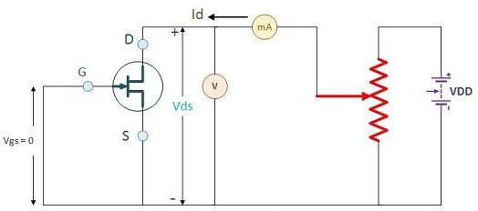

It clearly implies that the channel width is more as the width of depletion layer will not vary initially because there is no external reverse biasing. This allows a large magnitude of current to flow through the channel.
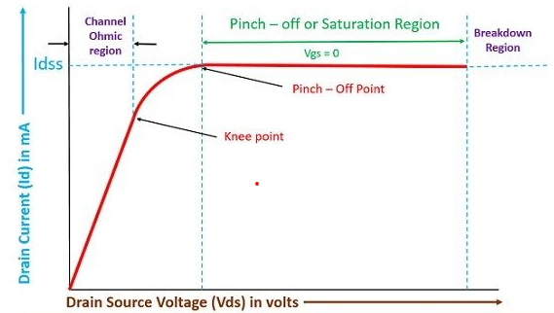
In this case, the N-type channel will simply behave as resistance region. The flow of current from drain to source will create the voltage drop between gate and source. This will eventually result in reverse biasing of the gate-source terminal. The reverse biasing will be more towards drain region that source region.

Terminologies involved in JFET characteristics

Knee Point: There exists a point in the characteristics curve where the variation of drain current with drain-source voltage appears to be linear. But after this point, the linearity changes into a curve.
Channel Ohmic Region: The region to the left of the knee point in the characteristics curve is the channel ohmic region.
Pinch-off point: The point in the curve above which the drain current does not increases further no matter how much we are increasing the drain to source voltage, this point is termed as the pinch-off point.
Pinch-off Voltage: The voltage at the pinch-off point is termed as pinch-off voltage because at this voltage the current is completely turned to be constant.
Drain-Source Saturation Current: The drain to source saturation current is the current which becomes constant or completely enters a saturation state.
The region after the pinch-off point in the curve is termed as saturation region. When the JFET is allowed to work as an amplification device, the JFET utilizes this region for operation.

With external bias: When the external bias is applied to the gate-source terminal, the gate-source terminal becomes reversed bias externally. Obviously, if we are supplying an external voltage, then we can achieve the pinch-off point quite early as compared to the circuit which is not biased. It is clearly evident from the characteristics curve of external bias. The different values of voltage give different values of current.
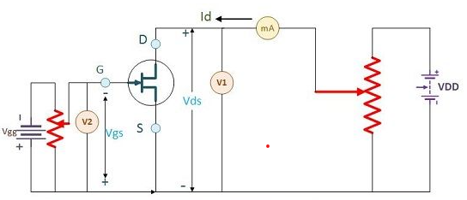
When we are observing the drain characteristics with respect to the variation in drain-source voltage, then the value of gate-source voltage should be kept constant.
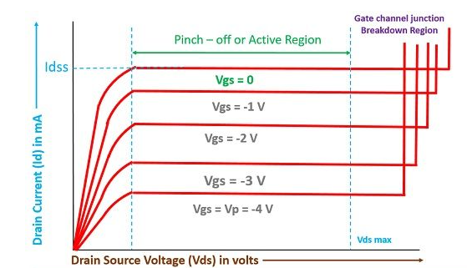

Transfer Characteristics

The transfer characteristics can be determined by observing different values of drain current with variation in gate-source voltage provided that the drain-source voltage should be constant. The transfer characteristics are just opposite to drain characteristics. One just needs to remember the concept that in drain characteristics we are keeping the gate-source voltage constant and determining the values of drain current at different values of drain-source voltage while in transfer characteristics we are keeping the value of drain-source voltage constant. The characteristic curve of transfer characteristics of JFET is described below; it can be easily observed that the value of drain current varies inversely with respect to gate-source voltage when the drain-source voltage is constant.
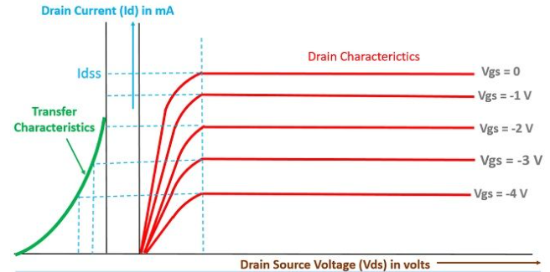
9. Activities/ Case studies/related to the session
Apply the above concept to p-channel JFET to understand the characteristics and to observe the working of p-channel JFET
10. Examples & contemporary extracts of articles/ practices to convey the idea of the session
NA
11. SAQ's-Self Assessment Questions
In a JFET, the channel conductivity is controlled by:
a) Gate-to-source voltage
b) Drain-to-source voltage
c) Gate-to-drain voltage
d) Gate-to-channel voltage
The output characteristic curve of a JFET shows the relationship between:
a) Drain current and drain-to-source voltage
b) Drain current and gate-to-source voltage
c) Drain current and drain-to-gate voltage
d) Gate current and gate-to-source voltage
The pinch-off voltage of a JFET is defined as the gate-to-source voltage at which:
a) The channel conductivity decreases
b) The channel conductivity increases
c) The channel width decreases
d) The channel width increases
The slope of the transfer characteristic curve of a JFET represents its:
a) Transconductance
b) Output impedance
c) Drain current
d) Gate voltage
The region of operation in a JFET where the drain current is relatively constant with changes in drain-to-source voltage is called:
a) Saturation region
b) Linear region
c) Cutoff region
d) Breakdown region
The input impedance of a JFET is typically:
a) High
b) Low
c) Moderate
d) Zero
The control parameter for the JFET is:
a) Base current
b) Emitter current
c) Collector current
d) Gate voltage
The cutoff voltage of a JFET is defined as the gate-to-source voltage at which:
a) The channel conductivity decreases
b) The channel conductivity increases
c) The channel width decreases
d) The channel width increases
The drain current in a JFET is primarily determined by:
a) Gate current
b) Gate voltage
c) Drain voltage
d) Source resistance
The cutoff region of a JFET is characterized by:
a) High drain current and low gate voltage
b) High drain current and high gate voltage
c) Low drain current and low gate voltage
d) Low drain current and high gate voltage
The drain current in a JFET is proportional to:
a) Gate current
b) Gate voltage
c) Drain voltage
d) Source resistance
The region of operation in a JFET where the drain current decreases with an increase in drain-to-source voltage is called:
a) Saturation region
b) Linear region
c) Cutoff region
d) Breakdown region
The output impedance of a JFET is typically:
a) High
b) Low
c) Moderate
d) Zero
In a JFET, the gate-to-source voltage at which the channel is completely closed is called:
a) Cutoff voltage
b) Breakdown voltage
c) Threshold voltage
d) Saturation voltage
The transconductance (gm) of a JFET is defined as the change in:
a) Drain current per unit change in gate voltage
b) Drain voltage per unit change in drain current
c) Gate current per unit change in drain voltage
d) Source current per unit change in gate voltage
The drain current in a JFET is maximum when the gate-to-source voltage is:
a) Zero
b) Positive
c) Negative
d) Can be positive or negative
The relationship between drain current and gate-to-source voltage in the cutoff region is:
a) Linear
b) Exponential
c) Inverse square
d) Logarithmic
The transconductance of a JFET is a measure of its:
a) Gain bandwidth
b) Power dissipation
c) Input impedance
d) Amplification factor
The cutoff region of a JFET is characterized by:
a) Zero drain current
b) Maximum drain current
c) Linear relationship between gate-to-source voltage and drain current
d) Nonlinear relationship between gate-to-source voltage and drain current
The saturation region of a JFET is characterized by:
a) High drain current and low gate voltage
b) High drain current and high gate voltage
c) Low drain current and low gate voltage
d) Low drain current and high gate voltage
12. Summary
The junction field-effect transistor (JFET) is a three-terminal semiconductor device with a unique voltage-controlled current flow. Its drain characteristics describe the relationship between the drain current (ID) and drain-to-source voltage (VDS) when the gate-to-source voltage (VGS) is constant. The drain current remains relatively constant as VDS increases until it reaches a saturation point. The transfer characteristics of the JFET illustrate the relationship between the drain current and the gate-to-source voltage when VDS is held constant. In the active region, the drain current is primarily controlled by the VGS, resulting in a linear relationship. However, as VGS decreases beyond a threshold voltage, the drain current decreases exponentially. These characteristics make JFETs suitable for various applications, such as amplifiers and switches.
13. Terminal Questions
1. With neat sketch explain the drain characteristics of n-channel JFET
2. Write short notes on transfer characteristics of JFET

14. Case Studies (Co Wise)
NA
15. Answer Key
a) Gate-to-source voltage
a) Drain current and drain-to-source voltage
a) The channel conductivity decreases
a) Transconductance
b) Linear region
a) High
d) Gate voltage
a) The channel conductivity decreases
b) Gate voltage
c) Low drain current and low gate voltage
c) Drain voltage
c) Cutoff region
a) High
a) Cutoff voltage
a) Drain current per unit change in gate voltage
a) Zero
a) Linear
c) Input impedance
a) Zero drain current
c) Low drain current and low gate voltage
Glossary
Drain Characteristics: The drain characteristics of a junction field-effect transistor (JFET) describe the relationship between the drain current (ID) and the drain-to-source voltage (VDS) while keeping the gate-to-source voltage (VGS) constant. As VDS increases, the drain current remains relatively constant until it reaches a saturation point. This behavior is due to the voltage-controlled current flow in the JFET.
Transfer Characteristics: The transfer characteristics of a JFET illustrate the relationship between the drain current (ID) and the gate-to-source voltage (VGS) while maintaining a constant drain-to-source voltage (VDS). In the active region, the drain current is primarily determined by the VGS, resulting in a linear relationship. However, as VGS decreases beyond a threshold voltage, the drain current decreases exponentially. The transfer characteristics demonstrate the JFET's ability to amplify or switch signals based on the gate voltage control.
16. References of books, sites, links
- https://www.circuitstoday.com/characteristics-of-jfets
- https://electronicscoach.com/characteristics-of-jfet.html
- https://www.watelectronics.com/junction-field-effect-transistor-working-characteristics-applications/

Text Books:
1. Robert L. Boylestad and Louis Nashelsky - “Electronic Devices and Circuit Theory”, 7th Edition, Prentice Hall Publication (1998).
2.Ramakanth A. Gaykwad – “Op-Amps and Linear IC Applications”, 4th Edition, Pearson Education (2015)
3. Thomas L. Floyd – “Electronic Devices – Electron Flow Version”, 4th Edition, Pearson Education (2001)
4. A.S. Sedra&K.C.Smith, Microelectronics Circuits, 7th Edition, Oxford University Press (2014)

Reference Books:
1. Jacob Millman - “Electronic Devices and Circuits”, 4th Edition, McGraw Hill Education (2015)
2. D Roy Choudhury and Shail B. Jain – “Linear Integrated Circuits”, 4th Edition, New Age International Pvt.Ltd. (2017)
3. David A. Bell - “Electronic Devices and Circuits”, 5th Edition, Oxford University Press (2008)
4. Behzad Razavi – “Design of Analog CMOS Integrated Circuit”,2nd Edition, McGraw Hill Education (2017)
5. M. S. Tyagi “Introduction to Semiconductor Materials and Devices”, 2nd Edition, John Wiley & Sons Inc (2008)
17. Keywords
Drain Characteristics: drain current, drain-to-source voltage, gate-to-source voltage, saturation point, voltage-controlled current flow.
Transfer Characteristics: drain current, gate-to-source voltage, drain-to-source voltage, active region, threshold voltage, linear relationship, exponential decrease.

