 | KONERU LAKSHMAIAH EDUCATION FOUNDATION  (Deemed to be University estd, u/s, 3 of the UGC Act, 1956)  (NAAC Accredited “A++” Grade University)  Green Fields, Guntur District, A.P., India – 522502  Department of Electronics and Communication Engineering  (DST - FIST Sponsored Department) | 
B.Tech. II ECE PROGRAM
A.Y.2023-24ODD, Semester-III
22EC22104Analog Electronic Circuit Design
CO2
SESSION 4
METAL OXIDE SEMICONDUCTOR FIELD EFFECT TRANSISTOR (MOSFET): – ENHANCEMENT
1. Course Description (Description about the subject)
This course provides the student with the fundamental skills to apply the basics of semiconductor and devices like Bipolar junction transistor, FET, MOSFET and operational amplifier. It would build mathematical and numerical background for design of electronics circuit. Students equipped with the knowledge and skilling provided in the course would enable them to design, develop electronic circuits for real time applications.
2. Aim
The aim of this course is to make the students to apply the basics of semiconductor physics, outline the input and output characteristics of bipolar and unipolar transistors such as JFET and MOSFET, interpret its behavior under different biasing condition, discuss the characteristics of Op-amp, analyze its variouslinear, nonlinear applications, and characterize the design of an OP-amp filters, Oscillators, and itsapplications.
3. Instructional Objectives (Course Objectives)
- To impart knowledge on working of a bipolar transistor, its configuration, and its applications.
- To impart knowledge on the need of biasing, types of biasing and interpret its performance.
- To impart knowledge on working of a JFET and MOSFET and interpret its characteristics and parameters.
- To impart knowledge on operational amplifiers and analyse the characteristics of Op-Amp circuitsto perform various linear and nonlinear applications.
- To impart knowledge on Operational amplifiers to perform as Active filters and Oscillators andanalyse its applications.
- To familiarize with theoretical and mathematical aspects related to electronic circuits, such thatstudent will be able to design electronic systems for real time applications.
4. Learning Outcomes (Course Outcome)
CO.No. | Course Outcome (CO) | PO/PSO | BTL
CO 1 | Apply the knowledge of Semiconductor physics and discuss BJT biasing and amplifiers. | PO1, PSO1 | 3
CO 2 | Apply the limitations of BJT and discuss the characteristics and applications of JFET and MOSFET. | PO1, PSO1 | 3
CO 3 | Analyze the characteristics of operational Amplifiers using linear and nonlinear circuits approaches | PO1, PO2, PSO1 | 4
CO 4 | Analyze Oscillators and multivibrators with the concept of feedback system | PO1, PO2, PSO1 | 4
CO 5 | Design and analyze analog circuits for real time applications with Passive and Active Components using Multisim and myDAC. | PO2, PO3, PSO1 | 4
CO 6 | Design and Implement practical electronic circuits using FET and opamps | PO2, PO3, PSO1 | 4

5. Module Description (CO-2 Description)
This module provides the application and analysis the basic concept of JFET and MOFFETS
6. Session Outcomes
- Describe the working principle of MOSFET.
- Demonstrate the applications of MOSFET circuits .
7. Session Introduction
A MOSFET (Metal-Oxide-Semiconductor Field-Effect Transistor) is a fundamental semiconductor device used in modern electronics. It consists of a gate, source, and drain terminals. The key feature of a MOSFET is its ability to control the flow of current through a channel by applying a voltage to the gate terminal. The gate voltage determines the conductivity of the channel, allowing or blocking the flow of current between the source and drain. MOSFETs offer advantages like high switching speed, low power consumption, and scalability, making them essential in integrated circuits for applications ranging from digital logic to power amplification.
8. Session description
The most common type of insulated gate FET which is used in many different types of electronic circuits is called the Metal Oxide Semiconductor Field Effect Transistor or MOSFET for short.
The IGFET or MOSFET is a voltage controlled field effect transistor that differs from a JFET in that it has a “Metal Oxide” Gate electrode which is electrically insulated from the main semiconductor n-channel or p-channel by a very thin layer of insulating material usually silicon dioxide, commonly known as glass. This ultra thin insulated metal gate electrode can be thought of as one plate of a capacitor. The isolation of the controlling Gate makes the input resistance of the MOSFET extremely high way up in the Mega-ohms ( MΩ ) region thereby making it almost infinite.
As the Gate terminal is electrically isolated from the main current carrying channel between the drain and source, “NO current flows into the gate” and just like the JFET, the MOSFET also acts like a voltage controlled resistor where the current flowing through the main channel between the Drain and Source is proportional to the input voltage. Also like the JFET, the MOSFETs very high input resistance can easily accumulate large amounts of static charge resulting in the MOSFET becoming easily damaged unless carefully handled or protected. Like the previous JFET tutorial, MOSFETs are three terminal devices with a Gate, Drain and Source and both P-channel (PMOS) and N-channel (NMOS) MOSFETs are available. The main difference this time is that MOSFETs are available in two basic forms:

Depletion Type – the transistor requires the Gate-Source voltage, ( VGS ) to switch the device “OFF”. The depletion mode MOSFET is equivalent to a “Normally Closed” switch.
Enhancement Type – the transistor requires a Gate-Source voltage, ( VGS ) to switch the device “ON”. The enhancement mode MOSFET is equivalent to a “Normally Open” switch. The symbols and basic construction for both configurations of MOSFETs are shown below.

The four MOSFET symbols above show an additional terminal called the Substrate and is not normally used as either an input or an output connection but instead it is used for grounding the substrate. It connects to the main semiconductive channel through a diode junction to the body or metal tab of the MOSFET. Usually in discrete type MOSFETs, this substrate lead is connected internally to the source terminal. When this is the case, as in enhancement types it is omitted from the symbol for clarification. The line in the MOSFET symbol between the drain (D) and source (S) connections represents the transistors semiconductive channel. If this channel line is a solid unbroken line then it represents a “Depletion” (normally-ON) type MOSFET as drain current can flow with zero gate biasing potential.

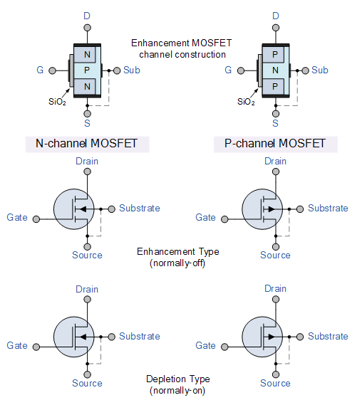

If the channel line is shown as a dotted or broken line, then it represents an “Enhancement” (normally-OFF) type MOSFET as zero drain current flows with zero gate potential. The direction of the arrow pointing to this channel line indicates whether the conductive channel is a P-type or an N-type semiconductor device.
Basic MOSFET Structure and Symbol

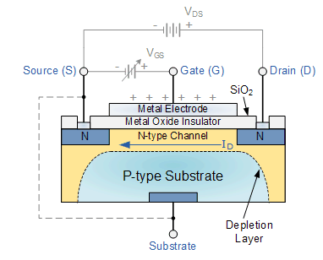
The construction of the Metal Oxide Semiconductor FET is very different to that of the Junction FET. Both the Depletion and Enhancement type MOSFETs use an electrical field produced by a gate voltage to alter the flow of charge carriers, electrons for n-channel or holes for P-channel, through the semiconductive drain-source channel. The gate electrode is placed on top of a very thin insulating layer and there are a pair of small n-type regions just under the drain and source electrodes. We saw in the previous tutorial, that the gate of a junction field effect transistor, JFET must be biased in such a way as to reverse-bias the pn-junction. With a insulated gate MOSFET device no such limitations apply so it is possible to bias the gate of a MOSFET in either polarity, positive (+ve) or negative (-ve). This makes the MOSFET device especially valuable as electronic switches or to make logic gates because with no bias they are normally non-conducting and this high gate input resistance means that very little or no control current is needed as MOSFETs are voltage controlled devices. Both the p-channel and the n-channel MOSFETs are available in two basic forms, the Enhancement type and the Depletion type.
Depletion-mode MOSFET
The Depletion-mode MOSFET, which is less common than the enhancement mode types is normally switched “ON” (conducting) without the application of a gate bias voltage. That is the channel conducts when VGS = 0 making it a “normally-closed” device. The circuit symbol shown above for a depletion MOS transistor uses a solid channel line to signify a normally closed conductive channel. For the n-channel depletion MOS transistor, a negative gate-source voltage, -VGS will deplete (hence its name) the conductive channel of its free electrons switching the transistor “OFF”. Likewise for a p-channel depletion MOS transistor a positive gate-source voltage, +VGS will deplete the channel of its free holes turning it “OFF”. In other words, for an n-channel depletion mode MOSFET: +VGS means more electrons and more current. While a -VGS means less electrons and less current. The opposite is also true for the p-channel types. Then the depletion mode MOSFET is equivalent to a “normally-closed” switch.

Depletion-mode N-Channel Circuit Symbols
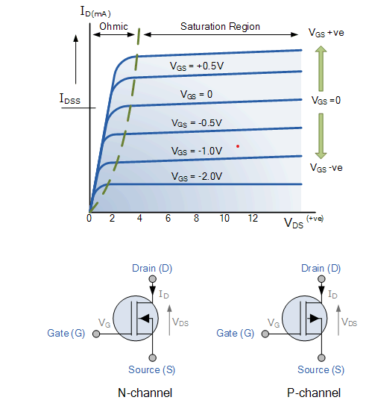
9. Activities/ Case studies/related to the session
NA
10. Examples & contemporary extracts of articles/ practices to convey the idea of the session
- https://www.researchgate.net/figure/Construction-of-single-gate-MOSFET-10-It-is-the-insulating-layer-of-HfO2-in-the_fig6_310178066
- https://electric-shocks.com/fet-transistor-basics/
- https://eng.libretexts.org/Bookshelves/Electrical_Engineering/Electronics/Book%3A_Semiconductor_Devices_Theory_and_Application_(Fiore)/12%3A_Metal_Oxide_Semiconductor_FETs_(MOSFETs)/12.4%3A_The_E-MOSFET

11. SAQ's-Self Assessment Questions

Enhancement mode MOSFET is typically operated in which region?
a) Saturation region
b) Linear region
c) Cutoff region
d) Breakdown region
The channel in an enhancement mode MOSFET is formed by:
a) N-type material
b) P-type material
c) Intrinsic material
d) Insulating material
In an enhancement mode MOSFET, the gate voltage is applied:
a) Above the threshold voltage
b) Below the threshold voltage
c) Equal to the threshold voltage
d) Can be above or below the threshold voltage
The conductivity of the channel in an enhancement mode MOSFET is controlled by:
a) Gate-to-source voltage
b) Drain-to-source voltage
c) Gate-to-drain voltage
d) Gate-to-channel voltage
The threshold voltage of an enhancement mode MOSFET is the:
a) Minimum gate voltage required to create a channel
b) Maximum gate voltage allowed to prevent channel formation
c) Difference between the drain voltage and the source voltage
d) Gate voltage required for maximum drain current
The drain current in an enhancement mode MOSFET is primarily determined by:
a) Gate current
b) Gate voltage
c) Drain voltage
d) Source resistance
In an enhancement mode MOSFET, when the gate voltage is below the threshold voltage, the device is in:
a) Saturation region
b) Linear region
c) Cutoff region
d) Breakdown region
The output characteristic curve of an enhancement mode MOSFET shows the relationship between:
a) Drain current and drain-to-source voltage
b) Drain current and gate-to-source voltage
c) Drain current and drain-to-gate voltage
d) Gate current and gate-to-source voltage
The drain current in an enhancement mode MOSFET is maximum when the gate-to-source voltage is:
a) Zero
b) Positive
c) Negative
d) Can be positive or negative
The input impedance of an enhancement mode MOSFET is typically:
a) High
b) Low
c) Moderate
d) Zero
The voltage at which the channel of an enhancement mode MOSFET begins to conduct is called:
a) Saturation voltage
b) Breakdown voltage
c) Threshold voltage
d) Cutoff voltage
The drain current in an enhancement mode MOSFET is proportional to:
a) Gate current
b) Gate voltage
c) Drain voltage
d) Source resistance
The region of operation in an enhancement mode MOSFET where the drain current decreases with an increase in drain-to-source voltage is called:
a) Saturation region
b) Linear region
c) Cutoff region
d) Breakdown region
The output impedance of an enhancement mode MOSFET is typically:
a) High
b) Low
c) Moderate
d) Zero
The transconductance of an enhancement mode MOSFET is defined as the change in:
a) Drain current per unit change in gate voltage
b) Drain voltage per unit change in drain current
c) Gate current per unit change in drain voltage
d) Source current per unit change in gate voltage

The region of operation in an enhancement mode MOSFET where the drain current is relatively constant with respect to the drain-to-source voltage is called:
a) Saturation region
b) Linear region
c) Cutoff region
d) Breakdown region
The drain current in an enhancement mode MOSFET is maximum when the gate voltage is:
a) Above the threshold voltage
b) Below the threshold voltage
c) Equal to the threshold voltage
d) Can be above or below the threshold voltage
The output voltage swing of an enhancement mode MOSFET is typically limited by:
a) Drain current
b) Gate voltage
c) Drain voltage
d) Source resistance
In an enhancement mode MOSFET, the channel conducts when the gate voltage is:
a) Positive
b) Negative
c) Zero
d) Can be positive or negative
The drain current in an enhancement mode MOSFET is minimum when the gate-to-source voltage is:
a) Zero
b) Positive
c) Negative
d) Can be positive or negative.
13. Terminal Questions
- Draw the structure of n channel enhancement mode MOSFET
- Explain the operation of enhancement mode MOSFET

14. Case Studies (Co Wise)
NA
15. Answer Key
b) Linear region
a) N-type material
a) Above the threshold voltage
a) Gate-to-source voltage
a) Minimum gate voltage required to create a channel
b) Gate voltage
c) Cutoff region
a) Drain current and drain-to-source voltage
c) Negative
a) High
c) Threshold voltage
b) Gate voltage
c) Cutoff region
a) High
a) Drain current per unit change in gate voltage
b) Linear region
d) Can be above or below the threshold voltage
c) Drain voltage
a) Positive
c) Negative
16. Glossary
Enhancement mode MOSFET: A type of MOSFET that operates in a normally off state and requires a positive gate voltage to create a conductive channel between the source and drain terminals.
MOSFET: Metal-Oxide-Semiconductor Field-Effect Transistor, a three-terminal semiconductor device that uses an electric field to control the flow of current.
Gate Terminal: The terminal in an enhancement mode MOSFET that controls the conductivity of the channel. A positive voltage applied to this terminal enables current flow between the source and drain.
Source Terminal: The terminal in an MOSFET from which the current flows into the device.
Drain Terminal: The terminal in an MOSFET where the current flows out of the device.
Normally Off: Refers to the inherent state of an enhancement mode MOSFET, where no current flows between the source and drain in the absence of a gate voltage.
Conductive Channel: The path through which current flows between the source and drain terminals when a suitable gate voltage is applied.
Input Impedance: The measure of how much an enhancement mode MOSFET resists the flow of current into the gate terminal when a voltage is applied.
Power Consumption: The amount of power consumed by an enhancement mode MOSFET during operation, typically characterized by low power consumption.
Switching: The ability of an enhancement mode MOSFET to turn on and off efficiently by controlling the gate voltage, making it suitable for digital logic circuits.

16. References of books, sites, links
- https://www.watelectronics.com/what-is-enhancement-mosfet-its-operation/
- https://www.electronics-tutorials.ws/transistor/tran_6.html
- https://www.electronicshub.org/mosfet/
Text Books:
1. Robert L. Boylestad and Louis Nashelsky - “Electronic Devices and Circuit Theory”, 7th Edition, Prentice Hall Publication (1998).
2.Ramakanth A. Gaykwad – “Op-Amps and Linear IC Applications”, 4th Edition, Pearson Education (2015)
3. Thomas L. Floyd – “Electronic Devices – Electron Flow Version”, 4th Edition, Pearson Education (2001)
4. A.S. Sedra&K.C.Smith, Microelectronics Circuits, 7th Edition, Oxford University Press (2014)

Reference Books:
1. Jacob Millman - “Electronic Devices and Circuits”, 4th Edition, McGraw Hill Education (2015)
2. D Roy Choudhury and Shail B. Jain – “Linear Integrated Circuits”, 4th Edition, New Age International Pvt.Ltd. (2017)
3. David A. Bell - “Electronic Devices and Circuits”, 5th Edition, Oxford University Press (2008)
4. Behzad Razavi – “Design of Analog CMOS Integrated Circuit”,2nd Edition, McGraw Hill Education (2017)
5. M. S. Tyagi “Introduction to Semiconductor Materials and Devices”, 2nd Edition, John Wiley & Sons Inc (2008)
17. Keywords
Enhancement mode MOSFET, Normally off MOSFET, Gate control, Conductive channel, Source terminal, Drain terminal, Input impedance, Power consumption, Switching, Digital circuits, Power management, Voltage-controlled device, Simplified circuit design, High input impedance, Threshold voltage, On-state resistance, Current flow control, Sub-threshold region
Threshold voltage control, Threshold voltage adjustment

