 | KONERU LAKSHMAIAH EDUCATION FOUNDATION  (Deemed to be University estd, u/s, 3 of the UGC Act, 1956)  (NAAC Accredited “A++” Grade University)  Green Fields, Guntur District, A.P., India – 522502  Department of Electronics and Communication Engineering  (DST - FIST Sponsored Department) | 
B.Tech. II ECE PROGRAM
A.Y.2023-24ODD, Semester-III
22EC22104Analog Electronic Circuit Design
CO2
SESSION-5
METAL OXIDE SEMICONDUCTOR FIELD EFFECT TRANSISTOR (MOSFET): – DEPLETION
1. Course Description (Description about the subject)
This course provides the student with the fundamental skills to apply the basics of semiconductor and devices like Bipolar junction transistor, FET, MOSFET and operational amplifier. It would build mathematical and numerical background for design of electronics circuit. Students equipped with the knowledge and skilling provided in the course would enable them to design, develop electronic circuits for real time applications.
2. Aim
The aim of this course is to make the students to apply the basics of semiconductor physics, outline the input and output characteristics of bipolar and unipolar transistors such as JFET and MOSFET, interpret its behavior under different biasing condition, discuss the characteristics of Op-amp, analyze its variouslinear, nonlinear applications, and characterize the design of an OP-amp filters, Oscillators, and itsapplications.
3. Instructional Objectives (Course Objectives)
- To impart knowledge on working of a bipolar transistor, its configuration, and its applications.
- To impart knowledge on the need of biasing, types of biasing and interpret its performance.
- To impart knowledge on working of a JFET and MOSFET and interpret its characteristics and parameters.
- To impart knowledge on operational amplifiers and analyse the characteristics of Op-Amp circuitsto perform various linear and nonlinear applications.
- To impart knowledge on Operational amplifiers to perform as Active filters and Oscillators andanalyse its applications.
- To familiarize with theoretical and mathematical aspects related to electronic circuits, such thatstudent will be able to design electronic systems for real time applications.

4. Learning Outcomes (Course Outcome)
CO.No. | Course Outcome (CO) | PO/PSO | BTL
CO 1 | Apply the knowledge of Semiconductor physics and discuss BJT biasing and amplifiers. | PO1, PSO1 | 3
CO 2 | Apply the limitations of BJT and discuss the characteristics and applications of JFET and MOSFET. | PO1, PSO1 | 3
CO 3 | Analyze the characteristics of operational Amplifiers using linear and nonlinear circuits approaches | PO1, PO2, PSO1 | 4
CO 4 | Analyze Oscillators and multivibrators with the concept of feedback system | PO1, PO2, PSO1 | 4
CO 5 | Design and analyze analog circuits for real time applications with Passive and Active Components using Multisim and myDAC. | PO2, PO3, PSO1 | 4
CO 6 | Design and Implement practical electronic circuits using FET and opamps | PO2, PO3, PSO1 | 4

5. Module Description (CO-2 Description)
This module provides the application and analysis the basic concept of JFET and MOFFETS
6. Session Outcomes
- Describe the working principle of depletion MOSFET.
- Demonstrate the applications of depletion mode MOSFETS.
Session Introduction
A depletion mode MOSFET is a type of MOSFET that operates in a normally on state. It requires a zero or negative gate voltage to create a conductive channel between the source and drain terminals. In the absence of a gate voltage, current flows between the source and drain. Applying a negative gate voltage depletes the channel, reducing or blocking the current flow. Depletion mode MOSFETs offer advantages such as simplicity, high linearity, and suitability for analog applications. They are commonly used in amplifier circuits, voltage regulators, and other applications where precise control of current flow is required.
Session description
N channel depletion MOSFET is a 3 terminal device similar to N channel enhancement MOSFET. The only difference between the two is the existence of an N-channel. In N-channel depletion MOSFET, N-channel is already present. All other things are the same, as you can see in the figure below.
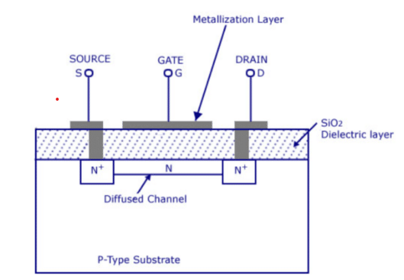

N Channel Depletion MOSFET – Working

Let us move on to the working of N channel depletion MOSFET followed by the VI characteristics. Since the channel is already present, unlike the enhancement type MOSFET, you also will get drain current at zero gate voltage.
In our first case, let us connect the Gate terminal to the ground and apply a positive voltage at the drain and source. On applying positive V_{DS}, the electrons in the N channel will move towards the positive drain terminal, and the drain current will start flowing from drain to source. On increasing V_{DS} further, keeping V_{GS} 0, a time will come where I_{D} will become constant, and that value of drain current is called saturation current. We can conclude from this discussion that when V_{GS} = 0 and V_{DS} > 0, current I_{D} flows from drain to source, and on increasing V_{DS} further, I_{D} = I_{S} = I_{DSS}, as shown in the figure below.

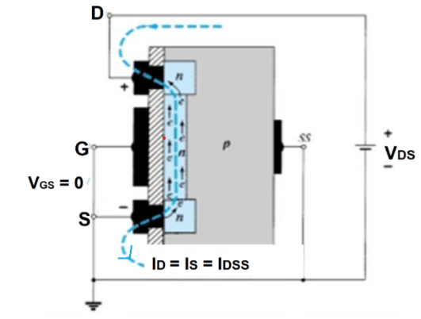
The effect of gate voltage on N channel depletion MOSFET.

Apply V_{GS} < 0. Holes from the P-type substrate will attract towards the negative gate terminal and recombine with electrons in the N channel, forming electron-hole pairs. On increasing negative potential at the gate, more electron-hole combinations will occur, decreasing the number of free electrons in the N channel. As a result, I_{D} decreases. A time will come when the drain current will become zero. The negative gate voltage at which the drain current is zero is called pinch-off voltage or VP. We can conclude from this discussion at pinch-off, V_{GS} = V_{P}, V_{DS} > 0, and I_{D} = 0, as shown in the figure below.
On applying VGS > 0, the minority carriers in the p-type substrate, i.e. electrons, will get attracted towards the gate terminal, thereby increasing the concentration of electrons in the N-channel. As a result, the drain current will increase and exceed the saturation current. We can conclude from this discussion, when VGS > 0 and VDS > 0, then ID > IDSS, as shown in the figure below.

N channel Depletion MOSFET V-I Characteristics

Depletion-type MOSFET worked for both positive and negative gate voltages. Now we can plot VI characteristics very easily. In the VI characteristics, you will see the plots of VDS vs ID for various values of VGS.
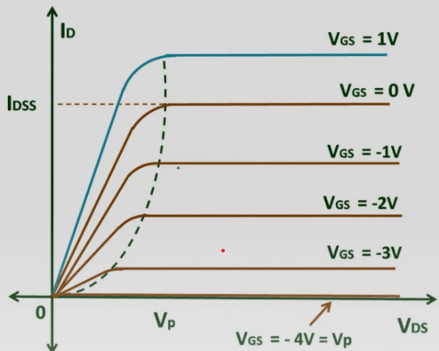
The graph shows that the current ID will flow for both positive and negative values of VGS. You can see from the graph that the drain current is less than the saturation current for the negative value of gate voltage, whereas for the positive value of gate voltage, the drain current exceeds the saturation current. V_{GS} = V_{P} is also represented in this graph for which drain current is zero irrespective of drain to source voltage.
Activities/ Case studies/related to the session
NA
Examples & contemporary extracts of articles/ practices to convey the idea of the session
- https://static1.squarespace.com/static/64490ab7509e733f1bd93101/t/6456d73ea358897b46748fcd/1683412799097/vobodazejasewolulexuveza.pdf
- https://www.polytechnichub.com/construction-depletion-type-n-channel-mosfet/
- https://www.watelectronics.com/what-is-enhancement-mosfet-its-operation/

10. SAQ's-Self Assessment Questions
Enhancement mode MOSFET operates in which region?
a) Saturation region
b) Linear region
c) Cutoff region
d) Breakdown region

The channel in an enhancement mode MOSFET is formed by:
a) N-type material
b) P-type material
c) Intrinsic material
d) Insulating material

In an enhancement mode MOSFET, the gate voltage is applied:
a) Above the threshold voltage
b) Below the threshold voltage
c) Equal to the threshold voltage
d) Can be above or below the threshold voltage

The conductivity of the channel in an enhancement mode MOSFET is controlled by:
a) Gate-to-source voltage
b) Drain-to-source voltage
c) Gate-to-drain voltage
d) Gate-to-channel voltage

The threshold voltage of an enhancement mode MOSFET is the:
a) Minimum gate voltage required to create a channel
b) Maximum gate voltage allowed to prevent channel formation
c) Difference between the drain voltage and the source voltage
d) Gate voltage required for maximum drain current

The drain current in an enhancement mode MOSFET is primarily determined by:
a) Gate current
b) Gate voltage
c) Drain voltage
d) Source resistance

In an enhancement mode MOSFET, when the gate voltage is below the threshold voltage, the device is in:
a) Saturation region
b) Linear region
c) Cutoff region
d) Breakdown region

The output characteristic curve of an enhancement mode MOSFET shows the relationship between:
a) Drain current and drain-to-source voltage
b) Drain current and gate-to-source voltage
c) Drain current and drain-to-gate voltage
d) Gate current and gate-to-source voltage

The drain current in an enhancement mode MOSFET is maximum when the gate-to-source voltage is:
a) Zero
b) Positive
c) Negative
d) Can be positive or negative

The input impedance of an enhancement mode MOSFET is typically:
a) High
b) Low
c) Moderate
d) Zero

The voltage at which the channel of an enhancement mode MOSFET begins to conduct is called:
a) Saturation voltage
b) Breakdown voltage
c) Threshold voltage
d) Cutoff voltage

The drain current in an enhancement mode MOSFET is proportional to:
a) Gate current
b) Gate voltage
c) Drain voltage
d) Source resistance

The region of operation in an enhancement mode MOSFET where the drain current decreases with an increase in drain-to-source voltage is called:
a) Saturation region
b) Linear region
c) Cutoff region
d) Breakdown region

The output impedance of an enhancement mode MOSFET is typically:
a) High
b) Low
c) Moderate
d) Zero

The transconductance of an enhancement mode MOSFET is defined as the change in:
a) Drain current per unit change in gate voltage
b) Drain voltage per unit change in drain current
c) Gate current per unit change in drain voltage
d) Source current per unit change in gate voltage

The region of operation in an enhancement mode MOSFET where the drain current is relatively constant with respect to the drain-to-source voltage is called:
a) Saturation region
b) Linear region
c) Cutoff region
d) Breakdown region

The drain current in an enhancement mode MOSFET is maximum when the gate voltage is:
a) Above the threshold voltage
b) Below the threshold voltage
c) Equal to the threshold voltage
d) Can be above or below the threshold voltage

The output voltage swing of an enhancement mode MOSFET is typically limited by:
a) Drain current
b) Gate voltage
c) Drain voltage
d) Source resistance

In an enhancement mode MOSFET, the channel conducts when the gate voltage is:
a) Positive
b) Negative
c) Zero
d) Can be positive or negative

The drain current in an enhancement mode MOSFET is minimum when the gate-to-source voltage is:
a) Zero
b) Positive
c) Negative
d) Can be positive or negative
11. Summary
A depletion mode MOSFET is a type of MOSFET that operates in a normally on state. It does not require a gate voltage to create a conductive channel between the source and drain terminals. In the absence of a gate voltage, current flows freely. However, applying a negative gate voltage depletes the channel, reducing or blocking the current flow. Depletion mode MOSFETs are known for their simplicity, high linearity, and suitability for analog applications. They are commonly used in amplifier circuits, voltage regulators, and other applications where precise control of current flow is required, making them valuable components in electronic systems.
12. Terminal Questions
- Explain about depletion mode operation of MOSFET?
- Draw the characteristics of depletion mode MOSFETS?

13. Case Studies (Co Wise)
NA
14. Answer Key
b) Linear region
a) N-type material
a) Above the threshold voltage
a) Gate-to-source voltage
a) Minimum gate voltage required to create a channel
b) Gate voltage
c) Cutoff region
a) Drain current and drain-to-source voltage
c) Negative
a) High
c) Threshold voltage
b) Gate voltage
b) Linear region
a) High
a) Drain current per unit change in gate voltage
b) Linear region
a) Above the threshold voltage
c) Drain voltage
a) Positive
c) Negative
15. Glossary
Depletion mode MOSFET: A type of MOSFET that operates in a normally on state and does not require a gate voltage to create a conductive channel between the source and drain terminals.
MOSFET: Metal-Oxide-Semiconductor Field-Effect Transistor, a three-terminal semiconductor device that uses an electric field to control the flow of current.
Gate Terminal: The terminal in a depletion mode MOSFET that controls the conductivity of the channel. A zero or negative voltage applied to this terminal depletes the channel and reduces or blocks current flow.
Source Terminal: The terminal in a MOSFET from which the current flows into the device.
Drain Terminal: The terminal in a MOSFET where the current flows out of the device.
Normally On: Refers to the inherent state of a depletion mode MOSFET, where current flows freely between the source and drain in the absence of a gate voltage.
Conductive Channel: The path through which current flows between the source and drain terminals in a MOSFET when the channel is not depleted.
High Linearity: The characteristic of a depletion mode MOSFET that allows it to exhibit a linear relationship between input and output, making it suitable for analog applications.
Analog Applications: Applications where continuous variable signals are processed or amplified, such as in audio amplifiers, voltage regulators, and signal processing circuits.
Amplifier Circuits: Circuits that increase the amplitude of an input signal, where depletion mode MOSFETs are commonly used due to their linear characteristics.
Voltage Regulators: Circuit components that maintain a constant output voltage regardless of input voltage changes, where depletion mode MOSFETs are used for precise control of current flow.
Current Flow Control: The ability of a depletion mode MOSFET to regulate the amount of current flowing through the channel by varying the gate voltage.

Simplified Circuit Design: The advantage of using depletion mode MOSFETs in circuit design due to their simplicity and direct current flow without additional gate control components.
Negative Gate Voltage: A voltage applied to the gate terminal of a depletion mode MOSFET that depletes the channel, reducing or blocking the current flow.
Zero Gate Voltage: The absence of a gate voltage in a depletion mode MOSFET, resulting in a conductive channel and free current flow between the source and drain terminals.

16. References of books, sites, links
- https://www.electrical4u.com/mosfet-characteristics/
- https://www.watelectronics.com/basics-of-mosfet-working-types-and-its-applications/
- https://citizenchoice.in/course/Electronics%20Engineering/Chapter%203/MOSFET
Text Books:
1. Robert L. Boylestad and Louis Nashelsky - “Electronic Devices and Circuit Theory”, 7th Edition, Prentice Hall Publication (1998).
2.Ramakanth A. Gaykwad – “Op-Amps and Linear IC Applications”, 4th Edition, Pearson Education (2015)
3. Thomas L. Floyd – “Electronic Devices – Electron Flow Version”, 4th Edition, Pearson Education (2001)
4. A.S. Sedra&K.C.Smith, Microelectronics Circuits, 7th Edition, Oxford University Press (2014)

Reference Books:
1. Jacob Millman - “Electronic Devices and Circuits”, 4th Edition, McGraw Hill Education (2015)
2. D Roy Choudhury and Shail B. Jain – “Linear Integrated Circuits”, 4th Edition, New Age International Pvt.Ltd. (2017)
3. David A. Bell - “Electronic Devices and Circuits”, 5th Edition, Oxford University Press (2008)
4. Behzad Razavi – “Design of Analog CMOS Integrated Circuit”,2nd Edition, McGraw Hill Education (2017)
5. M. S. Tyagi “Introduction to Semiconductor Materials and Devices”, 2nd Edition, John Wiley & Sons Inc (2008)
17. Keywords
Depletion mode MOSFET, Normally on MOSFET, Gate control, Conductive channel, Source terminal, Drain terminal, Zero gate voltage, Negative gate voltage, Analog applications, Amplifier circuits, Voltage regulators, Current flow control, Simplified circuit design, High linearity, Channel depletion, Threshold voltage, Enhancement region, Saturation region, Cut-off region, Transconductance

