 | KONERU LAKSHMAIAH EDUCATION FOUNDATION  (Deemed to be University estd, u/s, 3 of the UGC Act, 1956)  (NAAC Accredited “A++” Grade University)  Green Fields, Guntur District, A.P., India – 522502  Department of Electronics and Communication Engineering  (DST - FIST Sponsored Department) | 
B.Tech. II ECE PROGRAM
A.Y.2023-24ODD, Semester-III
22EC22104Analog Electronic Circuit Design
CO2
SESSION 9
COMMON GATE AMPLIFIER
1. Course Description (Description about the subject)
This course provides the student with the fundamental skills to apply the basics of semiconductor and devices like Bipolar junction transistor, FET, MOSFET and operational amplifier. It would build mathematical and numerical background for design of electronics circuit. Students equipped with the knowledge and skilling provided in the course would enable them to design, develop electronic circuits for real time applications.
2. Aim
The aim of this course is to make the students to apply the basics of semiconductor physics, outline the input and output characteristics of bipolar and unipolar transistors such as JFET and MOSFET, interpret its behavior under different biasing condition, discuss the characteristics of Op-amp, analyze its variouslinear, nonlinear applications, and characterize the design of an OP-amp filters, Oscillators, and itsapplications.
3. Instructional Objectives (Course Objectives)
- To impart knowledge on working of a bipolar transistor, its configuration, and its applications.
- To impart knowledge on the need of biasing, types of biasing and interpret its performance.
- To impart knowledge on working of a JFET and MOSFET and interpret its characteristics and parameters.
- To impart knowledge on operational amplifiers and analyse the characteristics of Op-Amp circuitsto perform various linear and nonlinear applications.
- To impart knowledge on Operational amplifiers to perform as Active filters and Oscillators andanalyse its applications.
- To familiarize with theoretical and mathematical aspects related to electronic circuits, such thatstudent will be able to design electronic systems for real time applications.

4. Learning Outcomes (Course Outcome)
CO.No. | Course Outcome (CO) | PO/PSO | BTL
CO 1 | Apply the knowledge of Semiconductor physics and discuss BJT biasing and amplifiers. | PO1, PSO1 | 3
CO 2 | Apply the limitations of BJT and discuss the characteristics and applications of JFET and MOSFET. | PO1, PSO1 | 3
CO 3 | Analyze the characteristics of operational Amplifiers using linear and nonlinear circuits approaches | PO1, PO2, PSO1 | 4
CO 4 | Analyze Oscillators and multivibrators with the concept of feedback system | PO1, PO2, PSO1 | 4
CO 5 | Design and analyze analog circuits for real time applications with Passive and Active Components using Multisim and myDAC. | PO2, PO3, PSO1 | 4
CO 6 | Design and Implement practical electronic circuits using FET and opamps | PO2, PO3, PSO1 | 4

5. Module Description (CO-2 Description)
This module provides the application and analysis the basic concept of JFET and MOFFETS
6. Session Outcomes
- Describe the analysis of common gate amplifier.
- Demonstrate the applications of CG amplifier.
7. Session Introduction
A common gate amplifier is a configuration of a field-effect transistor (FET) amplifier commonly used in electronic circuits. In this setup, the input signal is applied to the source terminal, while the output is taken from the drain terminal. The gate terminal is connected to a common reference point. The common gate amplifier provides voltage amplification and offers a low input impedance, making it suitable for interfacing with signal sources that have low output impedance. It exhibits high input and output isolation, which can be advantageous in certain applications. The common gate amplifier is commonly used in RF amplification, buffer stages, and impedance matching circuits due to its unique characteristics and performance attributes.
8. Session description
Common Gate Amplifier
In this circuit, input is applied between source and gate and output is taken between drain and gate.
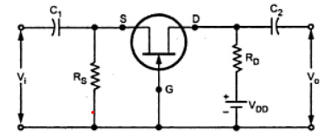
In CG Configuration, gate potential is at constant potential. so, increase in input voltage Vi in positive direction increase the negative gate source voltage. Due to ID reduces, reduces, reducing the drop IDRD. Since VD= VDD-IDRD, the reduction in ID results in an increase in output voltage.
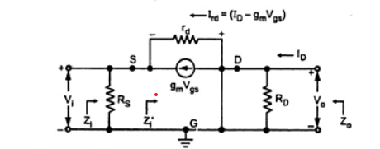

1. Input Impedance (Zi)
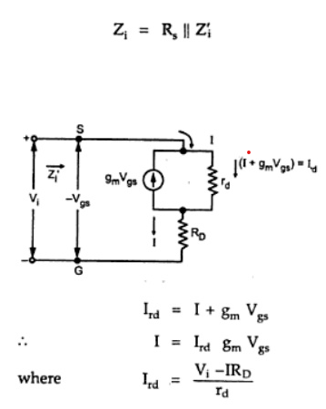
After substituting and simplification,
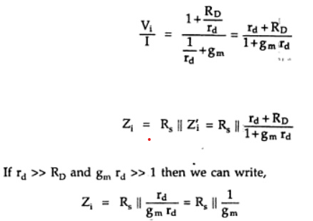
2. Output Impedance Zo
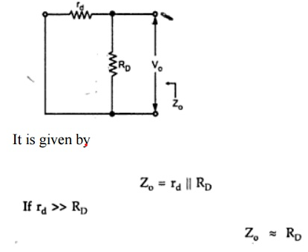

3. Voltage gain (Av)

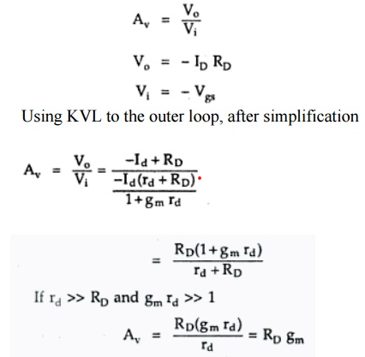

9. Activities/ Case studies/related to the session

Design a common gate amplifier for desired gain and input impedance

10 Examples & contemporary extracts of articles/ practices to convey the idea of the session
- https://www.electronics-notes.com/articles/analogue_circuits/fet-field-effect-transistor/common-gate-amplifier-circuit.php
- https://www.semiconductorforu.com/common-gate-amplifier-circuit-and-its-applications/
- https://www.allaboutcircuits.com/textbook/semiconductors/chpt-6/the-common-gate-amplifier-igfet/

11. SAQ's-Self Assessment Questions
The common-gate amplifier is a type of:
a) Voltage amplifier
b) Current amplifier
c) Power amplifier
d) Differential amplifier
In the common-gate amplifier, the input is applied to the:
a) Gate terminal
b) Drain terminal
c) Source terminal
d) Body terminal
The common-gate amplifier configuration uses a:
a) Common-emitter transistor
b) Common-base transistor
c) Common-collector transistor
d) MOSFET
The output voltage of the common-gate amplifier is taken from the:
a) Drain terminal
b) Gate terminal
c) Source terminal
d) Body terminal
The common-gate amplifier provides:
a) Voltage gain
b) Current gain
c) Power gain
d) Transconductance gain
The common-gate amplifier exhibits:
a) Inverting voltage gain
b) Non-inverting voltage gain
c) Unity voltage gain
d) No voltage gain
The input impedance of the common-gate amplifier is:
a) High
b) Low
c) Moderate
d) Unity
The output impedance of the common-gate amplifier is:
a) High
b) Low
c) Moderate
d) Unity
The biasing of the common-gate amplifier is typically achieved using:
a) Fixed biasing
b) Self-biasing
c) Voltage divider biasing
d) AC coupling
The coupling capacitor in the common-gate amplifier is used to:
a) Block DC voltage
b) Increase voltage gain
c) Stabilize biasing point
d) Reduce input impedance
The common-gate amplifier provides a phase shift of:
a) 0 degrees
b) 90 degrees
c) 180 degrees
d) 360 degrees
The voltage gain of the common-gate amplifier is primarily determined by the:
a) Load resistor
b) Drain resistor
c) Source resistor
d) Gate resistor
The common-gate amplifier exhibits a relatively:
a) High input impedance and low output impedance
b) Low input impedance and high output impedance
c) High input impedance and high output impedance
d) Low input impedance and low output impedance
The small-signal model of the common-gate amplifier includes a:
a) Voltage-controlled current source
b) Current-controlled voltage source
c) Resistor and capacitor network
d) Inductor and capacitor network
The common-gate amplifier is commonly used in:
a) Audio amplifiers
b) Power amplifiers
c) Radio receivers
d) Digital circuits
The common-gate amplifier is characterized by a voltage gain that is:
a) Independent of frequency
b) Dependent on frequency
c) Unity at all frequencies
d) Zero at all frequencies

The common-gate amplifier exhibits a relatively:
a) High voltage gain and low current gain
b) Low voltage gain and high current gain
c) High voltage gain and high current gain
d) Low voltage gain and low current gain
The common-gate amplifier operates in:
a) Class A
b) Class B
c) Class AB
d) Class C
The common-gate amplifier provides a relatively:
a) Large output swing
b) Small output swing
c) Balanced output swing
d) No output swing
The common-gate amplifier can be used for:
a) Amplification and buffering
b) Filtering and modulation
c) Oscillation and feedback
d) Sampling and quantization
12. Summary
A common gate amplifier is a type of field-effect transistor (FET) amplifier configuration commonly used in electronic circuits. In this setup, the input signal is applied to the source terminal, and the output is taken from the drain terminal, while the gate terminal is connected to a common reference point. The common gate amplifier provides voltage amplification and exhibits a low input impedance, making it suitable for interfacing with signal sources that have low output impedance. It also offers high input and output isolation, which can be beneficial in specific applications. Common gate amplifiers find application in RF amplification, buffer stages, and impedance matching circuits due to their unique characteristics and performance attributes.
Terminal Questions
- Draw the small signal model of common gate amplifier
- Find the input impedance and voltage gain of common gate amplifier

Case Studies (Co Wise)
NA
Answer Key
a) Voltage amplifier
a) Gate terminal
d) MOSFET
c) Source terminal
b) Current gain
a) Inverting voltage gain
a) High
b) Low
c) Voltage divider biasing
a) Block DC voltage
c) 180 degrees
c) Source resistor
a) High input impedance and low output impedance
b) Current-controlled voltage source
a) Audio amplifiers
b) Dependent on frequency
b) Low voltage gain and high current gain
a) Class A
b) Small output swing
a) Amplification and buffering

References of books, sites, links
  - https://www.electronics-tutorial.net/Analog-CMOS-Design/MOSFET-Amplifiers/Common-Gate-Amplifier/
  - https://www.semiconductorforu.com/common-gate-amplifier-circuit-and-its-applications/
  - https://inst.eecs.berkeley.edu/~ee105/sp08/lectures/lecture19_2.pdf

Text Books:
1. Robert L. Boylestad and Louis Nashelsky - “Electronic Devices and Circuit Theory”, 7th Edition, Prentice Hall Publication (1998).
2.Ramakanth A. Gaykwad – “Op-Amps and Linear IC Applications”, 4th Edition, Pearson Education (2015)
3. Thomas L. Floyd – “Electronic Devices – Electron Flow Version”, 4th Edition, Pearson Education (2001)
4. A.S. Sedra&K.C.Smith, Microelectronics Circuits, 7th Edition, Oxford University Press (2014)

Reference Books:
1. Jacob Millman - “Electronic Devices and Circuits”, 4th Edition, McGraw Hill Education (2015)
2. D Roy Choudhury and Shail B. Jain – “Linear Integrated Circuits”, 4th Edition, New Age International Pvt.Ltd. (2017)
3. David A. Bell - “Electronic Devices and Circuits”, 5th Edition, Oxford University Press (2008)
4. Behzad Razavi – “Design of Analog CMOS Integrated Circuit”,2nd Edition, McGraw Hill Education (2017)
5. M. S. Tyagi “Introduction to Semiconductor Materials and Devices”, 2nd Edition, John Wiley & Sons Inc (2008)
17. Keywords
Common gate amplifier, FET (Field-Effect Transistor), Amplifier configuration, Voltage amplification, Input impedance, Low input impedance, Gate terminal, Source terminal Drain terminal, RF amplification, Buffer stage, Impedance matching, Input isolation Output isolation, Gain, Biasing, DC blocking capacitor, Load resistor, Source resistor RF applications

