 | KONERU LAKSHMAIAH EDUCATION FOUNDATION  (Deemed to be University estd, u/s, 3 of the UGC Act, 1956)  (NAAC Accredited “A++” Grade University)  Green Fields, Guntur District, A.P., India – 522502  Department of Electronics and Communication Engineering  (DST - FIST Sponsored Department)

B.Tech.II ECE PROGRAM
A.Y.2023-24ODD, Semester-III
24EC22104 Analog Electronic Circuit Design
CO1
SESSION-4
DC load line analysis and operating point

1.Course Description (Description about the subject)
This course provides the student with the fundamental skills to apply the basics of semiconductor and devices like Bipolar junction transistor, FET, MOSFET and operational amplifier. It would build mathematical and numerical background for design of electronics circuit. Students equipped with the knowledge and skilling provided in the course would enable them to design, develop electronic circuits for real time applications.
2.Aim
The aim of this course is to make the students to apply the basics of semiconductor physics, outline the input and output characteristics of bipolar and unipolar transistors such as JFET and MOSFET, interpret its behavior under different biasing condition, discuss the characteristics of Op-amp, analyze its various linear, nonlinear applications, and characterize the design of an OP-amp filters, Oscillators, and its applications.
3. Instructional Objectives (Course Objectives)
- To impart knowledge on working of a bipolar transistor, its configuration, and its applications.
- To impart knowledge on the need of biasing, types of biasing and interpret its performance.
- To impart knowledge on working of a JFET and MOSFET and interpret its characteristics and parameters.
- To impart knowledge on operational amplifiers and analyse the characteristics of Op-Amp circuits to perform various linear and nonlinear applications.
- To impart knowledge on Operational amplifiers to perform as Active filters and Oscillators and analyse its applications.
- To familiarize with theoretical and mathematical aspects related to electronic circuits, such that student will be able to design electronic systems for real time applications.
4.Learning Outcomes (Course Outcome)
CO.No. | Course Outcome (CO) | PO/PSO | BTL
CO 1 | Apply the knowledge of Semiconductor physics and discuss BJT configurations and its applications | PO1, PSO1 | 3
CO 2 | Apply the limitations of BJT and discuss the characteristics and applications of Field Effect Transistors | PO1, PSO1 | 3
CO 3 | Apply the linear and nonlinear circuits approaches and realise the characteristics of operational Amplifiers | PO1, PO2, PSO1 | 4
CO 4 | Apply the concept of feedback system and realise the working principles of Oscillators and multivibrators | PO1, PO2, PSO1 | 4
CO 5 | Design and analyse analog circuits for real time applications using Passive and Active Components. | PO2, PO3, PSO1 | 4
CO 6 | Simulate and analyse Electronic Circuit using Multisim and myDAQ. | PO2, PO3, PSO1 | 4

5. Module Description (CO-1 Description)
This module provides the application and analysis the basic concept of BJT and biasing of BJT for amplification of signals
6. Session Outcomes
- Describe the operating point in BJT.
- Discuss the DC load line in BJT
7. Session Introduction
DC load line analysis and operating point are crucial aspects of Bipolar Junction Transistors (BJTs). DC load line analysis involves plotting the load line on a current-voltage graph to determine the transistor's operating regions and establish the desired operating point. The load line represents the relationship between the collector current and collector-emitter voltage for a given biasing configuration. The intersection of the load line with the transistor's characteristic curves defines the operating point, indicating the collector current and voltage at that point. The operating point determines the BJT's biasing conditions and affects its amplification or switching capabilities. Proper analysis of the DC load line ensures appropriate biasing and helps achieve desired transistor performance.
8. Session description
The transistor operates well in active region and hence it is also called as linear region. The outputs of the transistor are the collector current and collector voltages.
8.1 Output Characteristics
When the output characteristics of a transistor are considered, the curve looks as below for different input values.
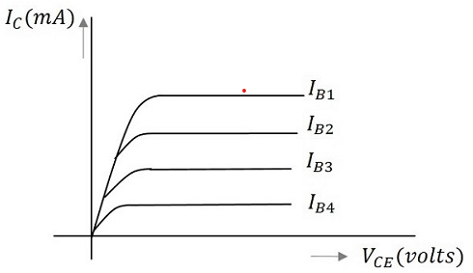
Figure 1: output characteristics of a BJT

In the above figure, the output characteristics are drawn between collector current IC and collector voltage VCE for different values of base current IB. These are considered here for different input values to obtain different output curves.
8.2 Load Line
When a value for the maximum possible collector current is considered, that point will be present on the Y-axis, which is nothing but the Saturation point. As well, when a value for the maximum possible collector emitter voltage is considered, that point will be present on the X-axis, which is the Cutoff point.

When a line is drawn joining these two points, such a line can be called as Load line. This is called so as it symbolizes the output at the load. This line, when drawn over the output characteristic curve, makes contact at a point called as Operating point or quiescent point or simply Q-point.
The concept of load line can be understood from the following graph.
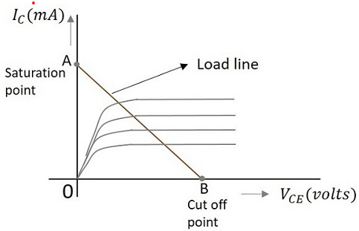
Figure 2: Load line of BJT

The load line is drawn by joining the saturation and cut off points. The region that lies between these two is the linear region. A transistor acts as a good amplifier in this linear region.

If this load line is drawn only when DC biasing is given to the transistor, but no input signal is applied, then such a load line is called as DC load line. Whereas the load line drawn under the conditions when an input signal along with the DC voltages are applied, such a line is called as an AC load line.
8.3 DC Load Line
When the transistor is given the bias and no signal is applied at its input, the load line drawn under such conditions, can be understood as DC condition. Here there will be no amplification as the signal is absent. The circuit will be as shown below.
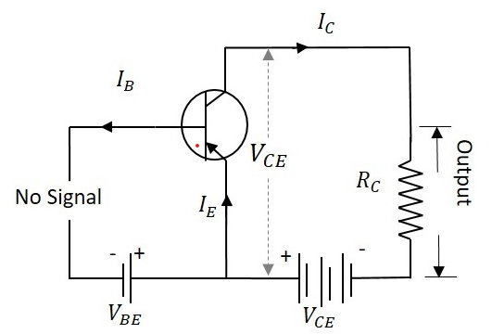
Figure 3: BJT without biased signal

The value of collector emitter voltage at any given time will be

V_{CE}=V_{CC}−I_{C}R_{C}
As VCC and RC are fixed values, the above one is a first degree equation and hence will be a straight line on the output characteristics. This line is called as D.C. Load line. The figure below shows the DC load line.

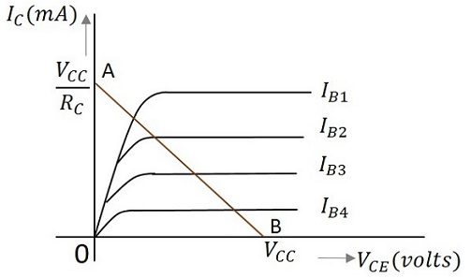
Figure 4: D.C. Load line of BJT

To obtain the load line, the two end points of the straight line are to be determined. Let those two points be A and B.
To obtain A
When collector emitter voltage V_{CE} = 0, the collector current is maximum and is equal to V_{CC}/R_{C}. This gives the maximum value of V_{C}E. This is shown as
V_{CE}=V_{CC}−I_{C}R_{C}
0=V_{CC}−I_{C}R_{C}
I_{C}=V_{CC}/R_{C}
This gives the point A (OA = V_{CC}/R_{C}) on collector current axis, shown in the above figure.
To obtain B
When the collector current I_{C} = 0, then collector emitter voltage is maximum and will be equal to the VCC. This gives the maximum value of IC. This is shown as

V_{CE}=V_{CC}−I_{C}R_{C}
=V_{CC} (AS I_{C} = 0)

This gives the point B, which means (OB = VCC) on the collector emitter voltage axis shown in the above figure.
Hence we got both the saturation and cutoff point determined and learnt that the load line is a straight line. So, a DC load line can be drawn.
8.4 AC Load Line
The DC load line discussed previously, analyzes the variation of collector currents and voltages, when no AC voltage is applied. Whereas the AC load line gives the peak-to-peak voltage, or the maximum possible output swing for a given amplifier.
We shall consider an AC equivalent circuit of a CE amplifier for our understanding.
From the figure,
V_{CE}=(R_{C}//R1)×I_{C}
r_{C}=R_{C}//R1
For a transistor to operate as an amplifier, it should stay in active region. The quiescent point is so chosen in such a way that the maximum input signal excursion is symmetrical on both negative and positive half cycles.
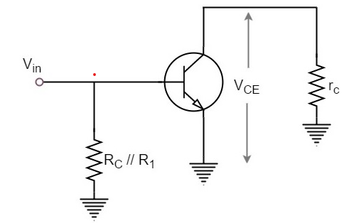
Figure 5: CE BJT

Hence,
Vmax=V_{CEQ}
and Vmin=−V_{CEQ}
Where V_{CEQ} is the emitter-collector voltage at quiescent point
The following graph represents the AC load line which is drawn between saturation and cut off points.

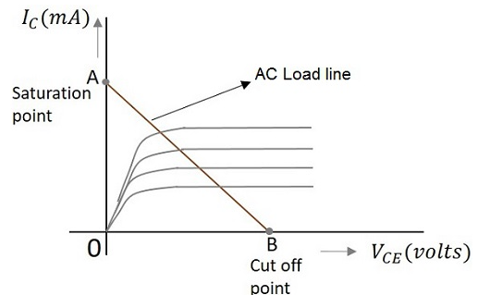
Figure 6: AC load line

From the graph above, the current IC at the saturation point is

I_{C}(sat)=I_{CQ}+(V_{CEQ}/r_{C})
The voltage V_{CE} at the cutoff point is
V_{CE}(off)=V_{CEQ}+I_{CQ}r_{C}
Hence the maximum current for that corresponding V_{CEQ} = V_{CEQ} / (R_{C} // R₁) is
I_{CQ}=I_{CQ}∗(R_{C}//R1)
Hence by adding quiescent currents the end points of AC load line are
I_{C(sat)=}IC_{Q}+VCEQ/(RC//R1)
VCE(off)=VCEQ+ICQ∗(RC//R1)
9. Activities/ Case studies/related to the session
Consider an example and determine the DC operating point (Q-point) of the BJT circuit by analyzing the biasing conditions and the load resistor. This involves calculating the collector current (IC), base current (IB), and voltage across the load resistor.
- Determine the Q-point and find the maximum peak value of the base current for linear operation. Assume β_{DC} = 200.
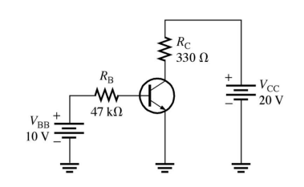
Figure: EX1

- (a)Determine the Q-point values of IC and VCE for the circuit in Figure. Assume V_{CE} = 8 V, R_{B} = 360 kΩ and RC = 2 kΩ. (b) Construct the dc load line and plot the Q-point.
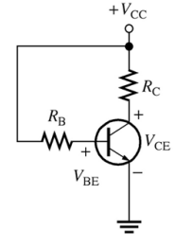
Figure: EX2

10. Examples & contemporary extracts of articles/ practices to convey the idea of the session
New equations for biasing the BJT-CE amplifier (Source: ieeexplore.ieee.org)
This paper introduces two original equations for biasing the common-emitter bipolar-junction transistor (BJT-CE) amplifier. These equations permit placing both Q-point coordinates (i.e. current and voltage) within known bounds in the presence of transistor parameter variations. An illustrative design example is provided.
11. SAQ's-Self Assessment Questions
Certainly! Here are 20 multiple-choice questions (MCQs) on DC load line analysis and operating point in BJT circuits:

1. What is the purpose of constructing a DC load line in a BJT circuit?
a) To determine the transistor type
b) To analyze the AC behavior of the circuit
c) To visualize the relationship between collector current and collector-emitter voltage
d) To calculate the biasing resistors' values

2. The DC load line is constructed on a graph that plots:
a) Collector current (IC) versus base current (IB)
b) Collector current (IC) versus collector-emitter voltage (VCE)
c) Base current (IB) versus base-emitter voltage (VBE)
d) Collector-emitter voltage (VCE) versus base-emitter voltage (VBE)

3. The slope of the DC load line is determined by:
a) The collector resistor (RC)
b) The base resistor (RB)
c) The emitter resistor (RE)
d) The transistor's beta (β)

4. The intercept of the DC load line on the vertical axis represents:
a) The collector-emitter voltage (VCE)
b) The base-emitter voltage (VBE)
c) The collector current (IC)
d) The base current (IB)

5. The Q-point on the DC load line represents:
a) The maximum collector current (IC) value
b) The maximum power dissipation of the transistor
c) The operating point of the transistor under DC conditions
d) The saturation region of the transistor

6. In a BJT circuit, the operating point should ideally be located:
a) In the middle of the load line
b) At the highest possible collector current (IC) value
c) At the lowest possible collector-emitter voltage (VCE) value
d) Outside the active region of the transistor characteristic curves

7. What happens if the Q-point is located too close to the saturation region of the transistor?
a) The transistor operates in cutoff mode
b) The transistor operates in active mode
c) The transistor operates in saturation mode
d) The Q-point becomes unstable

8. What is the primary purpose of adjusting the operating point (Q-point) in a BJT circuit?
a) To ensure maximum power dissipation
b) To achieve the highest possible gain
c) To meet specific circuit requirements and performance specifications
d) To shift the load line to the left on the graph

9. Sensitivity analysis of the operating point in a BJT circuit helps to evaluate:
a) The impact of temperature variations on the Q-point
b) The effect of input signal frequency on the Q-point
c) The influence of power supply voltage fluctuations on the Q-point
d) The transistor's manufacturing tolerances and parameter variations

10. What parameter is typically used to evaluate the stability of the Q-point in a BJT circuit?
a) Transistor gain (β)
b) Power dissipation
c) Load resistor value
d) Operating frequency

11. The DC load line analysis in a BJT circuit is applicable for:
a) AC analysis only
b) DC analysis only
c) Both AC and DC analysis
d) None of the above

12. What happens if the load resistor (RC) in a BJT circuit is increased?
a) The slope of the DC load line decreases
b) The slope of the DC load line increases
c) The Q-point shifts to the left on the load line
d) The Q-point shifts to the right on the load line

13. The operating point (Q-point) on the DC load line is primarily determined by:
a) The power supply voltage (VCC)
b

) The base-emitter voltage (VBE)
c) The collector-emitter voltage (VCE)
d) The load resistor value (RC)

14. What is the typical range of the Q-point collector current (IC) in a BJT circuit?
a) Microamperes (μA)
b) Milliamperes (mA)
c) Amperes (A)
d) Kilohms (kΩ)

15. The DC load line analysis assumes that the transistor operates in:
a) Active mode
b) Saturation mode
c) Cutoff mode
d) Oscillation mode

16. In a BJT circuit, what is the effect of decreasing the base current (IB) on the operating point (Q-point)?
a) The Q-point shifts towards the saturation region
b) The Q-point shifts towards the cutoff region
c) The Q-point remains unchanged
d) The Q-point becomes unstable

17. The DC load line analysis is useful for calculating the:
a) Input resistance of the BJT circuit
b) Output resistance of the BJT circuit
c) Voltage gain of the BJT circuit
d) Biasing resistors' values

18. What happens if the load resistor (RC) in a BJT circuit is shorted (RC = 0)?
a) The DC load line disappears
b) The Q-point shifts to the left on the load line
c) The Q-point shifts to the right on the load line
d) The Q-point remains unchanged

19. The DC load line analysis is commonly used in the design of:
a) Amplifier circuits
b) Digital logic circuits
c) Filter circuits
d) Oscillator circuits

20. The DC load line analysis primarily focuses on the _______ behavior of the BJT.
a) Dynamic
b) Static
c) High-frequency
d) Nonlinear

12. Summary
DC load line analysis is a graphical technique used to analyze the operating characteristics of a bipolar junction transistor (BJT) circuit. It involves plotting the load line on a voltage-current graph to determine the transistor's operating point. The load line represents the relationship between the collector current and collector-emitter voltage for a given circuit configuration. The operating point, also known as the Q-point, represents the stable DC bias conditions for the BJT. It determines the transistor's voltage and current values when no input signal is present. By analyzing the load line, designers can assess the transistor's linearity, gain, and biasing stability, enabling them to optimize the circuit's performance.
13. Terminal Questions
- Discuss about DC load line analysis in BJT circuits
- Write a short notes on DC operating point with an example
- What is the purpose of DC load line analysis in a BJT circuit?
- How is the DC load line constructed in a BJT circuit?
- What information can be determined from the DC load line analysis?
- How does the position of the load line affect the operating point of a BJT?
- What are the key parameters used to define the operating point of a BJT?
- How is the Q-point determined on the load line graphically?
- What is the significance of the Q-point in BJT circuit design?
- How does a change in load resistance affect the operating point of a BJT?
- What is meant by the saturation and cutoff regions on the DC load line?
- How can the operating point be stabilized in a BJT circuit?

14. Case Studies (Co Wise)
Case Study: Design of a BJT Amplifier for Audio Applications
Overview: An audio equipment manufacturer is developing a new amplifier for high-quality audio reproduction. The design team decides to use a BJT amplifier configuration due to its low distortion, good linearity, and wide bandwidth characteristics.
15. Answer Key
1. c) To visualize the relationship between collector current and collector-emitter voltage
2. b) Collector current (IC) versus collector-emitter voltage (VCE)
3. a) The collector resistor (RC)
4. a) The collector-emitter voltage (VCE)
5. c) The operating point of the transistor under DC conditions
6. c) At the lowest possible collector-emitter voltage (VCE) value
7. c) The transistor operates in saturation mode
8. c) To meet specific circuit requirements and performance specifications
9. d) The transistor's manufacturing tolerances and parameter variations
10. a) Transistor gain (β)
11. c) Both AC and DC analysis
12. a) The slope of the DC load line decreases
13. d) The load resistor value (RC)
14. b) Milliamperes (mA)
15. a) Active mode
16. b) The Q-point shifts towards the cutoff region
17. c) Voltage gain of the BJT circuit
18. b) The Q-point shifts to the left on the load line
19. a) Amplifier circuits
20. b) Static
16. Glossary
DC load line analysis: A graphical technique used to analyze the operating characteristics of a bipolar junction transistor (BJT) circuit. It involves plotting the load line on a voltage-current graph, representing the relationship between the collector current and collector-emitter voltage. By analyzing the load line, designers can determine the transistor's operating point.
Operating point: Also known as the Q-point, it represents the stable DC bias conditions for a BJT. It defines the transistor's voltage and current values when no input signal is present. The operating point is crucial for ensuring proper transistor operation and optimizing circuit performance.
The DC load line and operating point analysis allow designers to assess linearity, gain, and biasing stability. It helps in determining suitable biasing conditions, optimizing power transfer, and ensuring the transistor operates within its safe operating region.

17. References of books, sites, links
Text Books:
1. Robert L. Boylestad and Louis Nashelsky - “Electronic Devices and Circuit Theory”, 7th Edition, Prentice Hall Publication (1998).
2.Ramakanth A. Gaykwad – “Op-Amps and Linear IC Applications”, 4th Edition, Pearson Education (2015)
3. Thomas L. Floyd – “Electronic Devices – Electron Flow Version”, 4th Edition, Pearson Education (2001)
4. A.S. Sedra&K.C.Smith, Microelectronics Circuits, 7th Edition, Oxford University Press (2014)

Reference Books:
1. Jacob Millman - “Electronic Devices and Circuits”, 4th Edition, McGraw Hill Education (2015)
2. D Roy Choudhury and Shail B. Jain – “Linear Integrated Circuits”, 4th Edition, New Age International Pvt.Ltd. (2017)
3. David A. Bell - “Electronic Devices and Circuits”, 5th Edition, Oxford University Press (2008)
4. Behzad Razavi – “Design of Analog CMOS Integrated Circuit”,2nd Edition, McGraw Hill Education (2017)
5. M. S. Tyagi “Introduction to Semiconductor Materials and Devices”, 2nd Edition, John Wiley & Sons Inc (2008)
Weblinks/MOOCs:
1. https://nptel.ac.in/courses/108102095
2. https://www.coursera.org/learn/electronics?
17. Keywords
DC load line analysis, operating point, Q-point, BJT, bipolar junction transistor, voltage-current graph, load line, collector current, collector-emitter voltage, biasing conditions, linearity, gain, stability, safe operating region, power transfer.

