 | KONERU LAKSHMAIAH EDUCATION FOUNDATION  (Deemed to be University estd, u/s, 3 of the UGC Act, 1956)  (NAAC Accredited “A++” Grade University)  Green Fields, Guntur District, A.P., India – 522502  Department of Electronics and Communication Engineering  (DST - FIST Sponsored Department)

B.Tech.II ECE PROGRAM
A.Y.2023-24ODD, Semester-III
24EC22104 Analog Electronic Circuit Design
CO1
SESSION-9
Design of BJT amplifier
1.Course Description (Description about the subject)
This course provides the student with the fundamental skills to apply the basics of semiconductor and devices like Bipolar junction transistor, FET, MOSFET and operational amplifier. It would build mathematical and numerical background for design of electronics circuit. Students equipped with the knowledge and skilling provided in the course would enable them to design, develop electronic circuits for real time applications.
2.Aim
The aim of this course is to make the students to apply the basics of semiconductor physics, outline the input and output characteristics of bipolar and unipolar transistors such as JFET and MOSFET, interpret its behavior under different biasing condition, discuss the characteristics of Op-amp, analyze its various linear, nonlinear applications, and characterize the design of an OP-amp filters, Oscillators, and its applications.
3. Instructional Objectives (Course Objectives)
- To impart knowledge on working of a bipolar transistor, its configuration, and its applications.
- To impart knowledge on the need of biasing, types of biasing and interpret its performance.
- To impart knowledge on working of a JFET and MOSFET and interpret its characteristics and parameters.
- To impart knowledge on operational amplifiers and analyse the characteristics of Op-Amp circuits to perform various linear and nonlinear applications.
- To impart knowledge on Operational amplifiers to perform as Active filters and Oscillators and analyse its applications.
- To familiarize with theoretical and mathematical aspects related to electronic circuits, such that student will be able to design electronic systems for real time applications.
4.Learning Outcomes (Course Outcome)
CO.No. | Course Outcome (CO) | PO/PSO | BTL
CO 1 | Apply the knowledge of Semiconductor physics and discuss BJT configurations and its applications | PO1, PSO1 | 3
CO 2 | Apply the limitations of BJT and discuss the characteristics and applications of Field Effect Transistors | PO1, PSO1 | 3
CO 3 | Apply the linear and nonlinear circuits approaches and realise the characteristics of operational Amplifiers | PO1, PO2, PSO1 | 4
CO 4 | Apply the concept of feedback system and realise the working principles of Oscillators and multivibrators | PO1, PO2, PSO1 | 4
CO 5 | Design and analyse analog circuits for real time applications using Passive and Active Components. | PO2, PO3, PSO1 | 4
CO 6 | Simulate and analyse Electronic Circuit using Multisim and myDAQ. | PO2, PO3, PSO1 | 4

5. Module Description (CO-1 Description)
This module provides the application and analysis the basic concept of BJT and biasing of BJT for amplification of signals
6. Session Outcomes
- Describe the different BJT amplifiers.
- Demonstrate the applications of BJT as amplifier.
7. Session Introduction
The design of a BJT (Bipolar Junction Transistor) amplifier involves the systematic process of selecting component values and configuring the circuit to achieve desired performance characteristics. The objective is to design an amplifier that meets specific requirements for gain, bandwidth, impedance matching, and linearity. The process involves determining the biasing conditions, selecting appropriate coupling and bypass capacitors, choosing the amplifier configuration (e.g., common emitter, common base, or common collector), and calculating component values for resistors and capacitors. The design must also consider factors such as stability, temperature variations, and power supply considerations. By carefully designing the BJT amplifier, it is possible to create a circuit that meets the desired specifications for a wide range of applications.

8. Session description
The BJT common emitter amplifier is a general-purpose BJT-based amplifier that it typically used for voltage amplification. It offers great voltage gain and ok current gain. The input impedance is moderate but unfortunately it has high output impedance. The output is inverted with respect to the input. It is commonly followed with a buffer circuit such as a common-collector amplifier to reduce the output impedance. The common emitter amplifier find use in audio and RF applications.

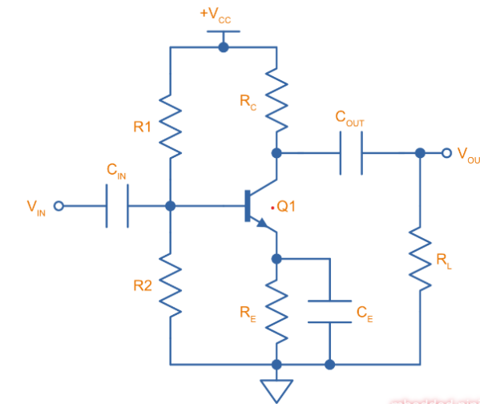
Figure 1: BJT common emitter amplifier

R1 and R2 are used to provide a DC bias point for the base of the transistor, using the standard resistor divider technique (to be exact, you also have to take into account that the transistor draws some current from the output of the resistor divider, but generally you can ignore that).
C1 is used to AC couple the input signal to the DC bias point – it’s value is chosen so that it appears as a short for the AC signal frequencies of interest but blocks DC.
R_{E} adds emitter degeneration1 and makes the amplifier gain more stable with variations in
β. C_{E} is the emitter bypass capacitor and is used to bypass R_{E} so that the AC signal essentially sees the emitter connected directly to ground.
R_{C} is the collector resistor which helps set the voltage gain of the amplifier. Sometimes this is called the load resistor2, however this can be confusing, as typically the “load” is placed after the output AC coupling capacitor.
R_{L} is the load resistance. You may see this and C_{OUT} omitted from some diagrams of the common emitter amplifier.
C_{OUT} is the AC coupling capacitor on the output, which blocks the DC component, similarly to
C_{IN}.

8.1 Common Emitter Amplifier Design
1. Choose collector current: Chose a suitable DC collector current for your amplifier. A reasonable choice would be
I_{C}=10mA (max. IC for the BC547B is 100mA).
2. Determine the emitter resistor R_{E}: As a rule of thumb, 10% of V_{CC} is normally dropped across R_{E}
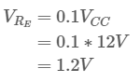
And then:
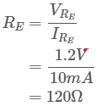
3. Find the collector resistor R_{C}: We are dropping 1.2V across the emitter resistor. That leaves 10.8V to be dropped across the collector resistor and the BJT. Assuming a saturation voltage of 200mV, this gives the BJT 10.6V of swing. For maximum symmetrical output, we want to drop half of this 10.6V across the collector resistor:
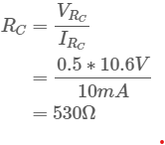
4. Find the base current: Calculate I_{B} using the approximate gain:
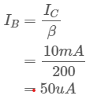
5. Determine the base voltage V_{B}: V_{B} is just the emitter voltage plus the diode V_{BE} drop:
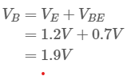
6. Calculate resistor divider values: Chose R1 and R2 to set the output of the resistor divider to match this base voltage. We also want to make sure the current flowing through the resistor is 10x the current that will be sucked out of it into the base of the transistor, that way we can ignore the loading of the BJT when calculating the resistor values.
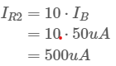
Now we can easily calculate the value of R2:
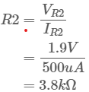
And R1:
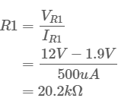
7. Calculate input AC coupling capacitor: The rule of thumb is to make sure the impedance of the capacitor is 10x less that the AC impedance of the resistor divider at the lowest frequency of interest5. Our lowest frequency of interest is 20Hz.

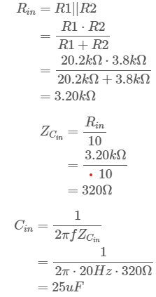
8. Calculate emitter bypass capacitor: The same rule of thumb applies to CE, except this time it’s impedance should be 10x smaller than RE:
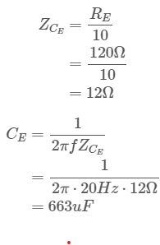
9. Calculate the gain:
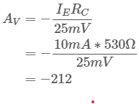
Or in dB:
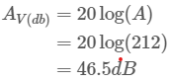

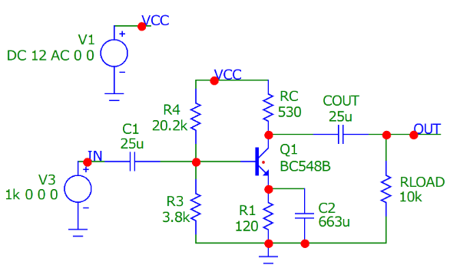
Figure 2: Common Emitter Amplifier Design

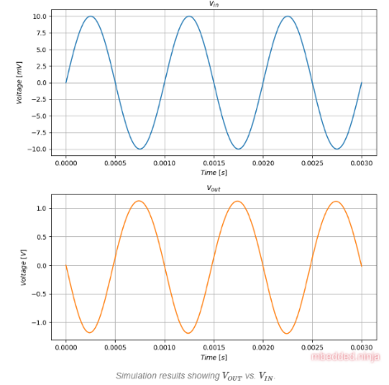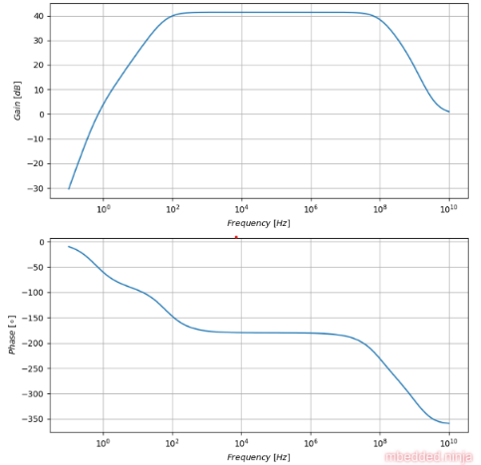

Figure 3: Common Emitter Amplifier Frequency response

9. Activities/ Case studies/related to the session
Activities:

For the circuit shown in Fig. 13, find (i) the d.c. bias levels (ii) d.c. voltages across the capacitors (iii) a.c. emitter resistance (iv) voltage gain and (v) state of the transistor.
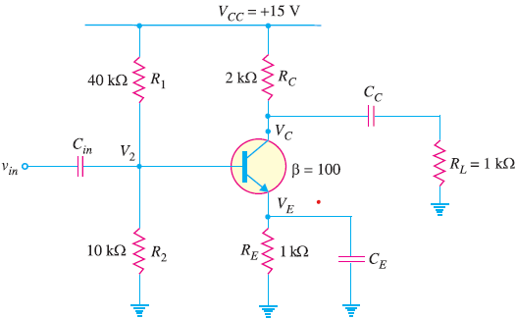
10. Examples & contemporary extracts of articles/ practices to convey the idea of the session
Design and Analysis of a Multistage Common Emitter Amplifier for Low Frequency Applications (Source: https://www.researchgate.net/)
Extract: The design and analysis of the multistage common emitter (CE) amplifier for improved voltage gain over the single stage CE amplifier is presented in this paper. The design procedure started with the design of a single stage CE amplifier. The design specifications for the CE amplifier were specified. The design of the multistage CE amplifier was done using the designed single stage CE amplifier as the basic configuration. The designed single stage and multistage CE amplifiers were simulated in the linear technology simulation program with integrated circuit emphasis (LT SPICE). The results obtained show that using analytical method a voltage gain of 45 dB was obtained for the single stage and 54 dB was obtained for the multistage respectively, the LT SPICE simulation software presented a result of 44 dB for the single stage and 54 dB for the multistage. The proposed amplifier may find suitable applications in devices operating in the low frequency such as audio signal applications. Furthermore, judging from these results coupling of more stages of the transistor amplifier to obtain greater voltage, current and power gains is recommended.
11. SAQ's-Self Assessment Questions
Certainly! Here are 20 multiple-choice questions (MCQs) on the design of BJT amplifiers:

1. The purpose of biasing in a BJT amplifier is to:
a) Increase the power output
b) Reduce distortion
c) Improve efficiency
d) All of the above

2. The biasing point of a BJT amplifier is determined by:
a) The collector current (IC)
b) The base current (IB)
c) The collector-emitter voltage (VCE)
d) All of the above

3. The voltage divider biasing technique in a BJT amplifier uses resistors to:
a) Set the base bias voltage
b) Set the collector bias voltage
c) Set the emitter bias voltage
d) None of the above

4. The purpose of a bypass capacitor in a BJT amplifier is to:
a) Block DC voltage from the input signal
b) Improve the frequency response
c) Stabilize the DC operating point
d) Reduce distortion

5. The emitter resistor in a BJT amplifier is commonly used for:
a) Setting the base bias voltage
b) Setting the collector bias voltage
c) Providing negative feedback
d) Improving the voltage gain

6. The purpose of emitter degeneration in a BJT amplifier is to:
a) Increase the input impedance
b) Increase the output impedance
c) Improve the linearity
d) Reduce the power consumption

7. The Miller effect in a BJT amplifier refers to:
a) The increase in effective input capacitance
b) The increase in effective output capacitance
c) The reduction in power dissipation
d) The reduction in distortion

8. The CE (common emitter) configuration is commonly used in BJT amplifiers because it provides:
a) High voltage gain and low input impedance
b) High voltage gain and high input impedance
c) Low voltage gain and low input impedance
d) Low voltage gain and high input impedance

9. The AC coupling capacitor in a BJT amplifier is used to:
a) Block DC voltage from the input signal
b) Provide DC biasing for the transistor
c) Improve the frequency response
d) Increase the voltage gain

10. The purpose of a load resistor in a BJT amplifier is to:
a) Provide biasing for the transistor
b) Control the gain of the amplifier
c) Block DC voltage from the output signal
d) Improve the stability of the amplifier

11. The quiescent point (Q-point) in a BJT amplifier represents:
a) The point of maximum power dissipation
b) The DC bias point of the transistor
c) The center frequency of operation
d) The point of saturation of the transistor

12. The voltage gain of a BJT amplifier is primarily determined by:
a) The collector current (IC)
b) The base current (IB)
c) The load resistor
d) The transistor's beta (β) value

13. The purpose of a coupling capacitor in a BJT amplifier is to:
a) Block DC voltage from the output signal
b) Improve the frequency response
c) Provide DC biasing for the transistor
d) Control the gain of the amplifier

14. The thermal compensation technique in a BJT amplifier is used to:
a) Stabilize the DC operating point
b) Improve the voltage gain
c) Increase the power output
d) Reduce the distortion

15. The stability of a BJT amplifier can be improved by:
a) Using negative feedback
b) Using positive feedback
c) Increasing the power supply voltage
d) Decreasing the input impedance

16. The purpose of bypass capacitors in a BJT amplifier is to

:
a) Improve the frequency response
b) Provide DC biasing for the transistor
c) Control the gain of the amplifier
d) Reduce the distortion

17. The input impedance of a BJT amplifier is primarily determined by:
a) The base-emitter junction
b) The collector-emitter junction
c) The emitter resistor
d) The load resistor

18. The output impedance of a BJT amplifier is primarily determined by:
a) The base-emitter junction
b) The collector-emitter junction
c) The emitter resistor
d) The load resistor

19. The purpose of a bypass capacitor in the emitter resistor of a BJT amplifier is to:
a) Improve the frequency response
b) Stabilize the DC operating point
c) Increase the voltage gain
d) Reduce the distortion

20. The stability of a BJT amplifier can be affected by variations in:
a) Temperature
b) Power supply voltage
c) Transistor characteristics
d) All of the above
12. Summary
BJT amplifier design involves the systematic process of selecting components and configuring the circuit to meet specific performance requirements. It encompasses considerations such as biasing, coupling capacitors, amplifier configuration, component calculations, stability, temperature variations, power supply, load resistor, frequency response, impedance matching, negative feedback, low-noise design, distortion reduction, power amplifier techniques, and efficiency improvement. By carefully designing the BJT amplifier, it is possible to achieve desired specifications for gain, impedance, linearity, frequency response, and other important characteristics. The design process requires a balance of trade-offs and optimization to create a circuit that meets the intended application's needs and objectives.
13. Terminal Questions
- What are the key considerations in BJT amplifier design?
- What are the different amplifier configurations that can be used in BJT amplifier design?
- How do you determine the biasing conditions for a BJT amplifier?
- What is the purpose of coupling and bypass capacitors in BJT amplifier design?
- How do you select the appropriate value for the coupling capacitor in a BJT amplifier?
- How does the choice of amplifier configuration impact the gain and input/output impedance?
- What are the trade-offs between voltage gain and current gain in BJT amplifier design?
- How do you calculate the component values for resistors and capacitors in a BJT amplifier?
- What are the factors to consider when designing for stability in a BJT amplifier?
- How do you account for temperature variations in BJT amplifier design?
- What are the considerations for power supply selection and decoupling in BJT amplifier design?
- How does the choice of load resistor affect the performance of a BJT amplifier?
- What are the challenges and considerations in high-frequency BJT amplifier design?
- How can the frequency response of a BJT amplifier be optimized for a specific bandwidth?
- What are the methods for impedance matching in BJT amplifier design?
- How does negative feedback impact BJT amplifier design and performance?
- What are the considerations for designing a low-noise BJT amplifier?
- How can distortion be minimized in BJT amplifier design?
- What are the techniques for power amplifier design using BJTs?
- How can the efficiency of a BJT amplifier be improved in design?

14. Case Studies (Co Wise)
Case Study: Design of a BJT Amplifier for Audio Applications
Overview: An audio equipment manufacturer is developing a new amplifier for high-quality audio reproduction. The design team decides to use a BJT amplifier configuration due to its low distortion, good linearity, and wide bandwidth characteristics.
15. Answer Key
1. d) All of the above
2. d) All of the above
3. a) Set the base bias voltage
4. b) Improve the frequency response
5. c) Providing negative feedback
6. c) Improve the linearity
7. a) The increase in effective input capacitance
8. b) High voltage gain and high input impedance
9. a) Block DC voltage from the input signal
10. b) Control the gain of the amplifier
11. b) The DC bias point of the transistor
12. a) The collector current (IC)
13. a) Block DC voltage from the output signal
14. a) Stabilize the DC operating point
15. a) Using negative feedback
16. a) Improve the frequency response
17. a) The base-emitter junction
18. c) The emitter resistor
19. a) Improve the frequency response
20. d) All of the above

16. Glossary
Biasing: The process of setting the DC operating point of a BJT amplifier to ensure proper transistor operation and stability.

Load Line: A graphical representation of the possible combinations of collector current (IC) and collector-emitter voltage (VCE) for a given BJT amplifier circuit.

Operating Point: The DC operating conditions of a BJT amplifier, typically represented by the collector current (IC) and collector-emitter voltage (VCE) values.

Voltage Divider Bias: A biasing technique that uses resistors to create a voltage divider network, which provides the required base bias voltage for the BJT amplifier.

Emitter Bias: A biasing technique that uses a resistor connected to the emitter terminal to establish the required base-emitter voltage for the BJT amplifier.

Stabilization Techniques: Various methods employed to enhance the stability of a BJT amplifier, such as bypass capacitors, emitter degeneration, and thermal compensation.
17. References of books, sites, links

Text Books:
1. Robert L. Boylestad and Louis Nashelsky - “Electronic Devices and Circuit Theory”, 7th Edition, Prentice Hall Publication (1998).
2.Ramakanth A. Gaykwad – “Op-Amps and Linear IC Applications”, 4th Edition, Pearson Education (2015)
3. Thomas L. Floyd – “Electronic Devices – Electron Flow Version”, 4th Edition, Pearson Education (2001)
4. A.S. Sedra&K.C.Smith, Microelectronics Circuits, 7th Edition, Oxford University Press (2014)
Reference Books:
1. Jacob Millman - “Electronic Devices and Circuits”, 4th Edition, McGraw Hill Education (2015)
2. D Roy Choudhury and Shail B. Jain – “Linear Integrated Circuits”, 4th Edition, New Age International Pvt.Ltd. (2017)
3. David A. Bell - “Electronic Devices and Circuits”, 5th Edition, Oxford University Press (2008)
4. Behzad Razavi – “Design of Analog CMOS Integrated Circuit”,2nd Edition, McGraw Hill Education (2017)
5. M. S. Tyagi “Introduction to Semiconductor Materials and Devices”, 2nd Edition, John Wiley & Sons Inc (2008)
Weblinks/MOOCs:
1. https://nptel.ac.in/courses/108102095
2. https://www.coursera.org/learn/electronics?

17. Keywords
Biasing, coupling capacitors, amplifier configuration, component calculations, stability, temperature variations, power supply, load resistor, frequency response, impedance matching, negative feedback, low-noise design, distortion reduction, power amplifier techniques, efficiency improvement, gain, input impedance, output impedance, voltage gain, current gain, common emitter, common base, common collector,

