 | KONERU LAKSHMAIAH EDUCATION FOUNDATION  (Deemed to be University estd, u/s, 3 of the UGC Act, 1956)  (NAAC Accredited “A++” Grade University)  Green Fields, Guntur District, A.P., India – 522502  Department of Electronics and Communication Engineering  (DST - FIST Sponsored Department) | 
B.Tech. II ECE PROGRAM
A.Y.2023-24ODD, Semester-III
22EC22104Analog Electronic Circuit Design
CO2
SESSION-1
JFET Construction and operation

1. Course Description (Description about the subject)
This course provides the student with the fundamental skills to apply the basics of semiconductor and devices like Bipolar junction transistor, FET, MOSFET and operational amplifier. It would build mathematical and numerical background for design of electronics circuit. Students equipped with the knowledge and skilling provided in the course would enable them to design, develop electronic circuits for real time applications.
2. Aim
The aim of this course is to make the students to apply the basics of semiconductor physics, outline the input and output characteristics of bipolar and unipolar transistors such as JFET and MOSFET, interpret its behavior under different biasing condition, discuss the characteristics of Op-amp, analyze its variouslinear, nonlinear applications, and characterize the design of an OP-amp filters, Oscillators, and itsapplications.
3. Instructional Objectives (Course Objectives)
- To impart knowledge on working of a bipolar transistor, its configuration, and its applications.
- To impart knowledge on the need of biasing, types of biasing and interpret its performance.
- To impart knowledge on working of a JFET and MOSFET and interpret its characteristics and parameters.
- To impart knowledge on operational amplifiers and analyse the characteristics of Op-Amp circuitsto perform various linear and nonlinear applications.
- To impart knowledge on Operational amplifiers to perform as Active filters and Oscillators andanalyse its applications.
- To familiarize with theoretical and mathematical aspects related to electronic circuits, such thatstudent will be able to design electronic systems for real time applications.

4. Learning Outcomes (Course Outcome)
CO.No. | Course Outcome (CO) | PO/PSO | BTL
CO1 | Apply the knowledge of Semiconductor physics and discuss BJT biasing and amplifiers. | PO1, PSO1 | 3
CO2 | Apply the limitations of BJT and discuss the characteristics and applications of JFET and MOSFET. | PO1, PSO1 | 3
CO3 | Analyze the characteristics of operational Amplifiers using linear and nonlinear circuits approaches | PO1, PO2, PSO1 | 4
CO4 | Analyze Oscillators and multivibrators with the concept of feedback system | PO1, PO2, PSO1 | 4
CO5 | Design of A/D interfaces by applying the concept of sampling and comparator circuits. | PO1, PO2, PSO1 | 4
CO6 | Design and analyse analog circuits for real time applications with Passive and Active Components using Multisim and myDAC. | PO2, PO3, PSO1 | 4
CO7 | Design and Implement practical electronic circuits using FET and opamps | PO2, PO3, PSO1 | 4

5. Module Description (CO-2 Description)
This module provides the application and analysis the basic concept of JFET and MOFFETS
6. Session Outcomes
- Describe the working principle of JFET.
- Demonstrate the applications of JFET and MOSFET circuits .
7. Session Introduction
Junction Field-Effect Transistors, commonly known as JFETs, are three-terminal semiconductor devices that belong to the family of field-effect transistors. They are widely used in various electronic circuits and applications due to their unique characteristics and advantages. Unlike their bipolar junction transistor (BJT) counterparts, JFETs are voltage-controlled devices that rely on the modulation of current flow through a semiconductor channel. This channel is formed between two regions of opposite conductivity types, referred to as the "source" and the "drain." The controlling element of a JFET is the "gate," which is typically made of a reverse-biased p-n junction.

8. Session description
Construction of JFET
A JFET is a three-terminal semiconductor device that is constructed using doped regions within a semiconductor material. It consists of a channel region and two junctions, which are formed by introducing impurities into the semiconductor material. The construction of a JFET involves creating a thin semiconductor channel between two heavily doped regions, typically referred to as the source and the drain. The channel region is either of n-type or p-type material, depending on whether it is an n-channel JFET or a p-channel JFET.

For an n-channel JFET, the semiconductor material is typically made of p-type silicon, and two heavily doped n-type regions, called the source and the drain, are created on either side of the channel. Similarly, for a p-channel JFET, the semiconductor material is typically n-type silicon, and two heavily doped p-type regions are formed. The construction process begins by preparing a silicon wafer of the desired conductivity type (p-type or n-type). Then, a layer of insulating material, usually silicon dioxide (SiO2), is deposited on the surface of the wafer. Openings, known as windows, are created in the oxide layer to expose specific areas of the wafer where the source and drain regions will be formed.
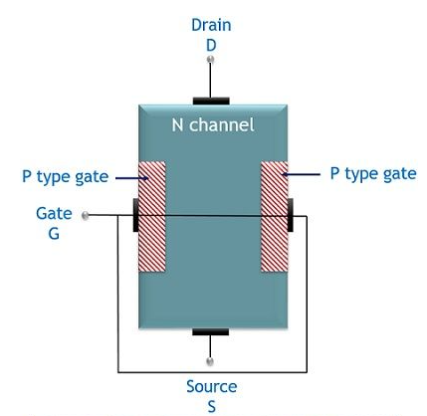
In the case of an n-channel JFET, phosphorus or arsenic, which are donor impurities, are diffused into the exposed regions. This diffusion process creates the heavily doped n-type regions, forming the source and drain. Conversely, for a p-channel JFET, boron or gallium, which are acceptor impurities, are diffused to create the heavily doped p-type regions. Once the source and drain regions are formed, the oxide layer is etched away, and a metal contact layer is deposited on top of the source and drain regions to provide electrical connections. Next, the gate region is created by depositing a thin layer of metal or doped polysilicon on the surface of the semiconductor material, near the channel region. The gate electrode is separated from the channel by a thin insulating layer, usually silicon dioxide, to prevent direct electrical contact. The final step involves adding wire bonds or other suitable connectors to the source, drain, and gate terminals, allowing external electrical connections to be made to the JFET.

Overall, the construction of a JFET involves carefully doping the semiconductor material to create the source and drain regions, forming a channel region between them, and separating the gate from the channel using an insulating layer. This construction enables the JFET to operate as a voltage-controlled current regulator or amplifier in electronic circuits.

Operation of JFET

Case 1: When no external potential is provided to neither gate nor drain corresponding to the source terminal. This means V_{GS} = V_{DS} = 0
In this case, the two pn junctions will have depletion regions of the same thickness. As no any external biasing is provided, this means due to temperature variation the majority charge carriers (electrons) move from source to the drain terminal.
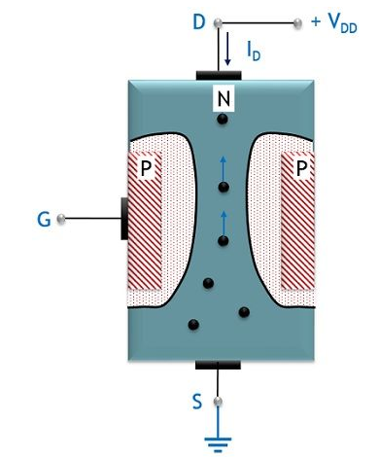
Due to this conduction takes place in the direction from drain to source i.e., opposite to the direction of flow of carriers. Hence, the current is termed as the drain current. It is noteworthy here that in unbiased condition a thin depletion region exists between the two p-n junctions which are shown above.
Case 2: When a small voltage is provided between the gate-source terminal. This means V_{GS} ≠ 0
In this condition, when the small reverse potential is provided between gate to source terminal then the reverse voltage enhances (increases) the depletion width of the pn junctions. Also, we know n channel exhibits resistive nature. So, the voltage drop is noticed in the channel. This is due to the current flowing between the terminals drain and source. Due to the voltage drop, the two junctions becomes more reverse bias thereby causing the depletion region to penetrate more into the channel.
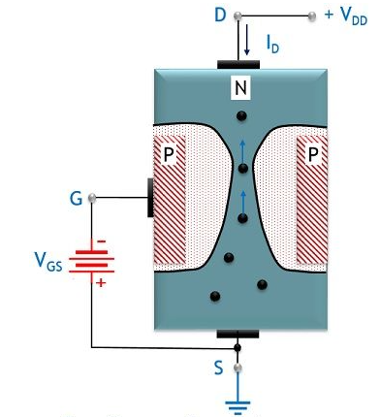
As the above figure clearly represents that the width of the depletion region is more towards the drain side than the source side. This is so because the voltage drop at the drain is comparatively higher than the voltage at the source side. This clearly implies that the reverse biasing provided to the terminal is non-uniform over the channel i.e., it is more near the drain than the source. Due to the increase in the depletion width, the channel region for the flow of electrons gets reduced. This results in a reduction in the current flowing from drain to source terminal.
Case 3: When high gate to source reverse potential is applied. So, in this case, due to the high reverse gate-source voltage, the depletion width increases further. At the higher gate to source voltage, a point is reached where the two depletion layers meet each other.
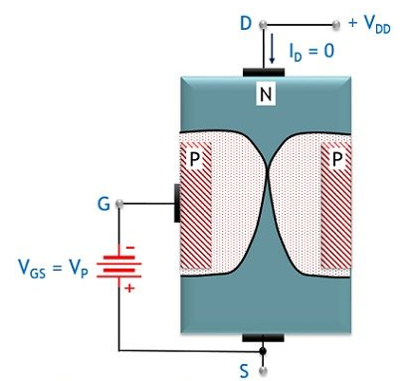

This will lead to completely blocking some region of the channel thereby blocking the movement of majority charge carriers. Due to this, the flow of current through the channel totally cuts off. So, the particular gate to source voltage that totally stops the conduction through the device is known as cut-off or pinch-off voltage. It is noteworthy here that with the decrease in the reverse applied voltage at the gate terminal the channel resistance also shows a reduction. Resultantly, causing a rise in the drain current.
9. Activities/ Case studies/related to the session
NA
10. Examples & contemporary extracts of articles/ practices to convey the idea of the session
Water analogy does provide a sense for the JFET control at the gate terminal and the appropriateness of the terminology applied to the terminals of the device. The source of water pressure can be likened to the applied voltage from drain to source, which establishes a flow of water (electrons) from the spigot (source).
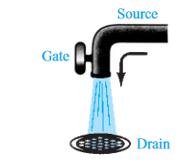
The “gate,” through an applied signal (potential), controls the flow of water (charge) to the “drain.” The drain and source terminals are at opposite ends of the n -channel as introduced in Fig because the terminology is defined for electron flow.
11. SAQ's-Self Assessment Questions
- How BJT is different from FET?
- What id pinch off region of operation?
- What is gate terminal in FET?
12. Summary
A junction field-effect transistor (JFET) is a three-terminal semiconductor device widely used in electronics. It is constructed using a single semiconductor material, either n-type or p-type. The JFET consists of a channel region with two ohmic contacts called the source and drain, and a control terminal known as the gate. Its operation is based on the formation of a depletion region in the channel when a voltage is applied between the gate and the source. This depletion region controls the flow of current in the channel, resulting in a voltage-controlled current device. By varying the gate voltage, the JFET regulates the output current, making it suitable for various applications such as amplifiers and switches.
13. Terminal Questions
The JFET is a type of:
a) Bipolar junction transistor
b) Field-effect transistor
c) Vacuum tube
d) Power diode
In a JFET, the control voltage is applied to the:
a) Gate terminal
b) Source terminal
c) Drain terminal
d) Base terminal
The majority carriers in an n-channel JFET are:
a) Electrons
b) Holes
c) Protons
d) Neutrons
The construction of a JFET involves:
a) P-N junctions
b) N-P-N layers
c) P-P-N layers
d) N-N-P layers
The two basic types of JFET are:
a) NPN and PNP
b) N-type and P-type
c) Enhancement mode and depletion mode
d) High power and low power
In an n-channel JFET, the channel is formed between the:
a) Gate and source terminals
b) Source and drain terminals
c) Gate and drain terminals
d) Base and emitter terminals
The depletion region in a JFET is formed when:
a) The gate voltage is zero
b) The drain voltage is zero
c) The source voltage is zero
d) The channel is closed
The JFET operates under which principle:
a) Voltage control
b) Current control
c) Power control
d) Temperature control
The gate-source junction of a JFET is normally:
a) Forward-biased
b) Reverse-biased
c) Short-circuited
d) Open-circuited
In a depletion-mode JFET, the channel conductivity is controlled by:
a) Applying a reverse bias to the gate-source junction
b) Applying a forward bias to the gate-source junction
c) Varying the drain voltage
d) Varying the source voltage
The pinch-off voltage in a JFET refers to the:
a) Voltage at which the channel is closed
b) Voltage at which the channel is fully open
c) Voltage at which the gate-source junction breaks down
d) Voltage at which the drain-source junction breaks down
The drain current in a JFET is primarily determined by:
a) The gate-source voltage
b) The gate-drain voltage
c) The drain-source voltage
d) The source current
The transfer characteristic of a JFET is a plot of:
a) Drain current versus gate-source voltage
b) Gate current versus drain-source voltage
c) Gate current versus gate-source voltage
d) Drain current versus drain-source voltage
The cutoff region in a JFET corresponds to:
a) The region of zero drain current
b) The region of maximum drain current
c) The region of maximum transconductance
d) The region of minimum transconductance
The saturation region in a JFET corresponds to:
a) The region of zero drain current
b) The region of maximum drain current
c) The region of maximum transconductance
d) The region of minimum transconductance
The transconductance (gm) of a JFET is a measure of its:
a) Voltage gain
b) Current gain
c) Power gain
d) Conductance variation
The input impedance of a JFET is typically:
a) High
b) Low
c) Variable
d) Constant
The output impedance of a JFET is typically:
a) High
b) Low
c) Variable
d) Constant
The JFET is commonly used in applications such as:
a) Audio amplifiers
b) Power supplies
c) Switching circuits
d) All of the above
The JFET is classified as a:
a) Current-controlled device
b) Voltage-controlled device
c) Power-controlled device
d) Temperature-controlled device
14. Case Studies (Co Wise)
NA
14. Answer Key
Answer: b) Field-effect transistor
Answer: a) Gate terminal
Answer: a) Electrons
Answer: a) P-N junctions
Answer: c) Enhancement mode and depletion mode
Answer: b) Source and drain terminals
Answer: a) The gate voltage is zero
Answer: a) Voltage control
Answer: b) Reverse-biased
Answer: a) Applying a reverse bias to the gate-source junction
Answer: a) Voltage at which the channel is closed
Answer: a) The gate-source voltage
Answer: a) Drain current versus gate-source voltage
Answer: a) The region of zero drain current
Answer: b) The region of maximum drain current
Answer: b) Current gain
Answer: a) High
Answer: b) Low
Answer: d) All of the above
Answer: b) Voltage-controlled device
15. Glossary
- JFET: Acronym for Junction Field-Effect Transistor, a three-terminal semiconductor device used in electronic circuits.
- Semiconductor: A material that has electrical conductivity between that of a conductor and an insulator.
- Construction: The physical arrangement of the JFET device, typically made using a single semiconductor material.
- Channel: The region within the JFET where the current flows between the source and drain terminals.
- Source: One of the terminals of the JFET that acts as the current input.
- Drain: One of the terminals of the JFET where the current exits the device.
- Gate: The control terminal of the JFET that regulates the current flow through the channel.
- Depletion Region: A region in the channel that forms when a voltage is applied between the gate and the source, restricting the current flow.
- Voltage-Controlled: The JFET operates by varying the voltage applied to the gate terminal, which controls the current flowing through the device.
- Current Device: A device that regulates the flow of current, such as the JFET, which adjusts the output current based on the gate voltage.
- Amplifiers: JFETs can be used in amplifier circuits to amplify weak signals.
- Switches: JFETs can function as electronic switches, controlling the flow of current in a circuit.
16. References of books, sites, links
- https://www.learnelectronicswithme.com/2020/07/what-is-jfet-construction-and-working.html
- https://electronicspost.com/explain-the-construction-and-working-of-a-jfet-what-is-the-difference-between-a-jfet-and-a-bjt/
- https://electronicsdesk.com/junction-field-effect-transistor.html

Text Books:
1. Robert L. Boylestad and Louis Nashelsky - “Electronic Devices and Circuit Theory”, 7th Edition, Prentice Hall Publication (1998).
2.Ramakanth A. Gaykwad – “Op-Amps and Linear IC Applications”, 4th Edition, Pearson Education (2015)
3. Thomas L. Floyd – “Electronic Devices – Electron Flow Version”, 4th Edition, Pearson Education (2001)
4. A.S. Sedra&K.C.Smith, Microelectronics Circuits, 7th Edition, Oxford University Press (2014)

Reference Books:
1. Jacob Millman - “Electronic Devices and Circuits”, 4th Edition, McGraw Hill Education (2015)
2. D Roy Choudhury and Shail B. Jain – “Linear Integrated Circuits”, 4th Edition, New Age International Pvt.Ltd. (2017)
3. David A. Bell - “Electronic Devices and Circuits”, 5th Edition, Oxford University Press (2008)
4. Behzad Razavi – “Design of Analog CMOS Integrated Circuit”,2nd Edition, McGraw Hill Education (2017)
5. M. S. Tyagi “Introduction to Semiconductor Materials and Devices”, 2nd Edition, John Wiley & Sons Inc (2008)
17. Keywords
JFET, Semiconductor device, Three-terminal, Construction, Channel, Source, Drain, Gate Depletion region, Voltage-controlled, Current device, Amplifiers, Switches, Current flow Voltage applied, Semiconductor material, Ohmic contacts, Current regulation, Input terminal Output terminal.

