SRP

CsclService (Proxy over CsclClient)

SRP for methods

Method does too much:

- validates list of customers

- send notifications

- choose appropriate strategy to handle queue message

Method does too much:

- fetches and transform information from multiple sources

- update statuses of customer contacts

- call another API to remove invalidated contacts

Smells:

- combining different levels of abstractions (low level string operations + high level API calls)

- use huge lambdas for stream processing

OCP

Switch-case statement for each type of received message. Can be refactored with pattern like Strategy, etc...

Complex status management logic is hard to maintain because of complex if-else condition and domain rules. Can be refactored with Chain-Of-Responsibility, where each chain represents a certain domain rule (Ongoing task).

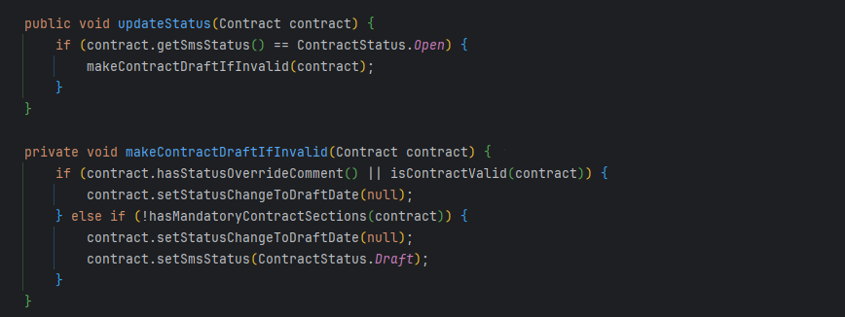

OCP/SRP. ContractObjectStateComparator (ChangeLog). Each time we add a new field/fix bug, we make changes in a single class and have to perform regression testing (hopefully by unit tests) that everything is still working.

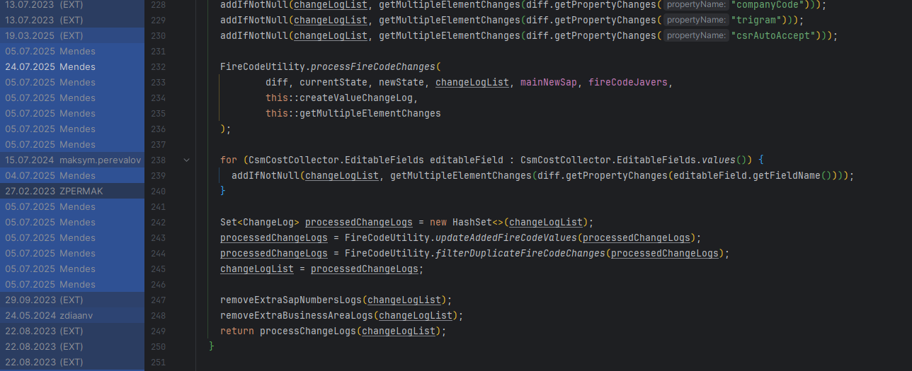

LSP

ContractValidationSnapshot interface

ISP

Complex interface, can be splitted into smaller ones.

DIP

Usage of concrete collection instead of interface in Contract entity

Usage of EnumSet inside ContractReport filters. 