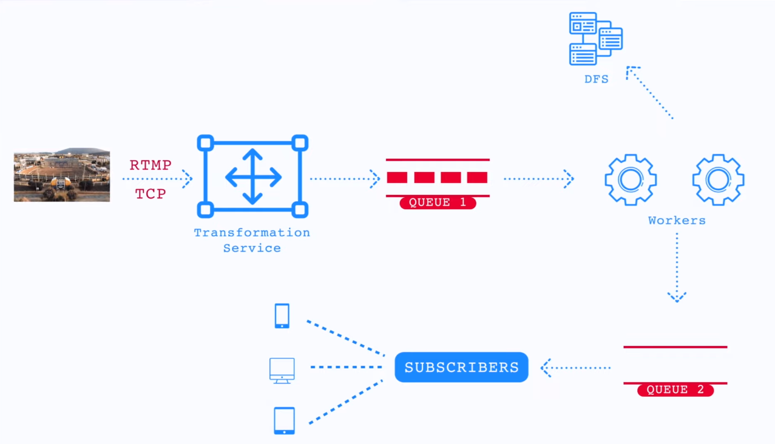

From streamer to the server: RTMP (Real Time Messaging Protocol) TCP based or SRT (Secure Reliable Transport) UDP based.

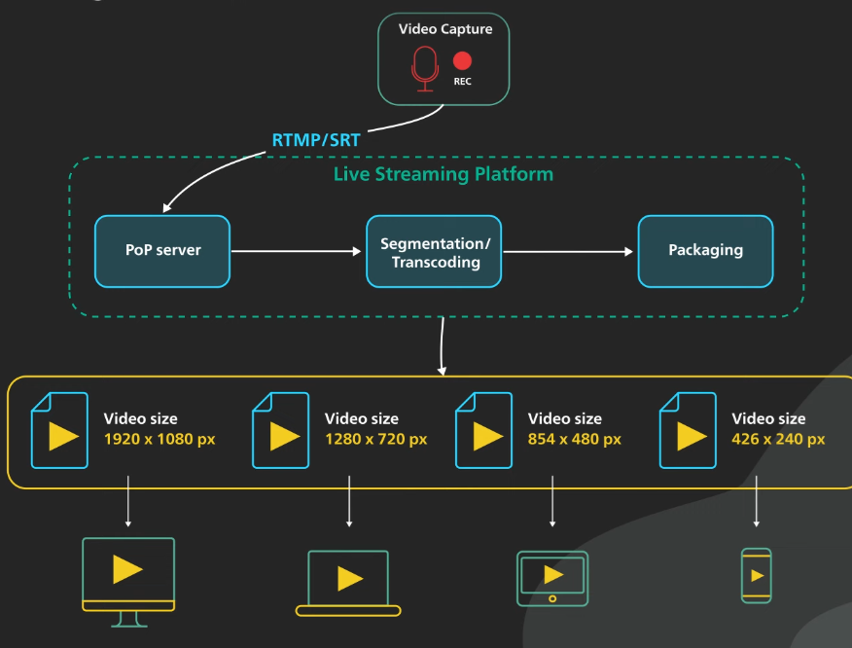

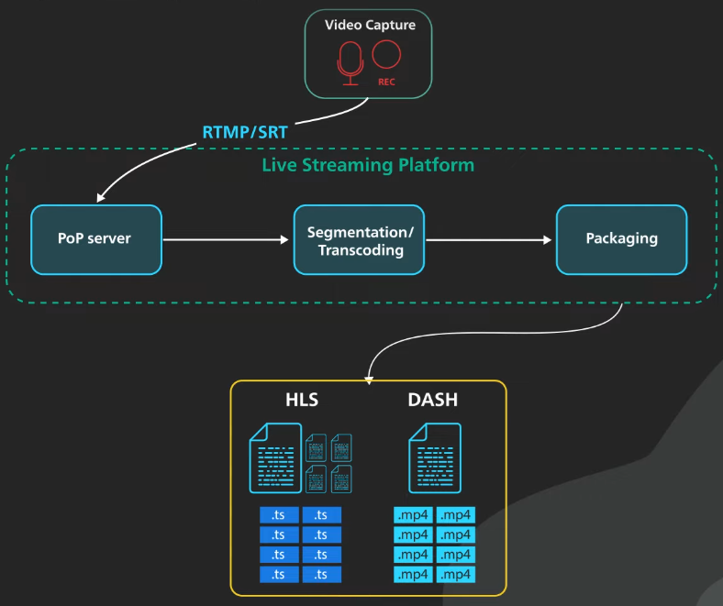

HLS (HTTP Live Streaming), DASH (Dynamic Adaptive Streaming over HTTP)

