**ANL201**

**Data Visualisation for Business**



**Group-Based Assignment (GBA01)**

**January 2024**

**Due Date: 14 March 2024 Thursday 2355 hrs**



|  |  |  |
| --- | --- | --- |
| **Team Members** | **P.I. Number** | **Role** |
| Yang Xian Wei Shawn | B2110802 | Leader |
| Teh Leng Leng (Zheng Ling Ling) | N0300867 | Member |
| Lee Jun Cheng | Z2380644 | Member |
| Muhammad Syafii bin Hamidon | H2372059 | Member |

**T-Group & Team No.** : **T07 & Team No. 4**

**​​Date of Submission : 11/03/2024**

## **Question 1**

## **Question 1(a) (16 marks)**

**ANS: Word Count: 181 Words**

The organisation that our group has agreed on is DBS Bank.

|  |  |  |  |
| --- | --- | --- | --- |
| **Balanced scorecard perspective** | **Strategic Objective** | **Measure** | **Target** |
| 1. Financial Measures | Generate consistent revenue growth | Total Revenue | 16% increase |
| 2. Financial Measures | Improve return on equity | Percentage of Return On Equity (ROE) | 3% increase |
| 3. Customer Measures | Improve Customer Satisfaction | Customer Satisfaction Index (CSI) For Finance and Insurance Sector Rating  CSI For Finance and Insurance Sector Ranking | Increase By 10 Points  Retain 1st Place |
| 4. Customer Measures | Enhance Customer Engagement | Customer Engagement Score (CES) | Scale: 1 = worst, 5 = best    Above 4 |
| 5. Internal Business Process | Increase usage of new DBS iBanking features | Adoption Rate Of New DBS iBanking Features | 10% Increase |
| 6. Internal Business Process | Enhance Cost-to-Income Ratio | Cost Income Ratio | 10% Decrease |
| 7. Learning and Growth Measures | Increase employee internal mobility rate | Internal Mobility Rate | Maintain a 7.7% (2022) or higher internal mobility rate |
| 8. Learning and Growth Measures | Increase in diversity of the overall workforce | Diversity, Equity and Inclusion Policy focused on women in technology (WIT) | Maintain 50% (2023) of female workforce across the total organisation population. |

## **Question 1(b) (40 marks)**

**ANS: Word Count: 500 Words (Excluding Chart Titles)**

***1. Total Revenue (Financial Measure 1)***

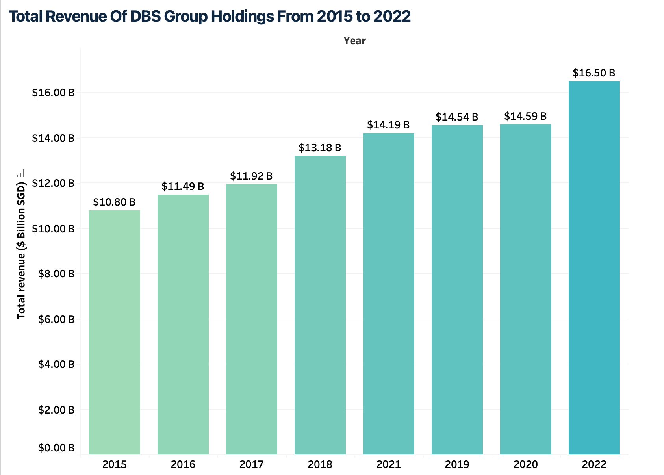

A bar chart is the ideal chart because it visualises the year-on-year change of the total revenue where it experienced slight increases from 2015 to 2019. An insight identified is the Total Revenue sharply grew by 16% between 2022 and 2021 (DBS, n.d.). DBS Bank experienced its largest total revenue in 2022 at 16.5 billion and lowest of 10.8 billion in 2015 (Statista, 2023).

**2. Return on Equity (ROE) *(Financial Measures 2)***

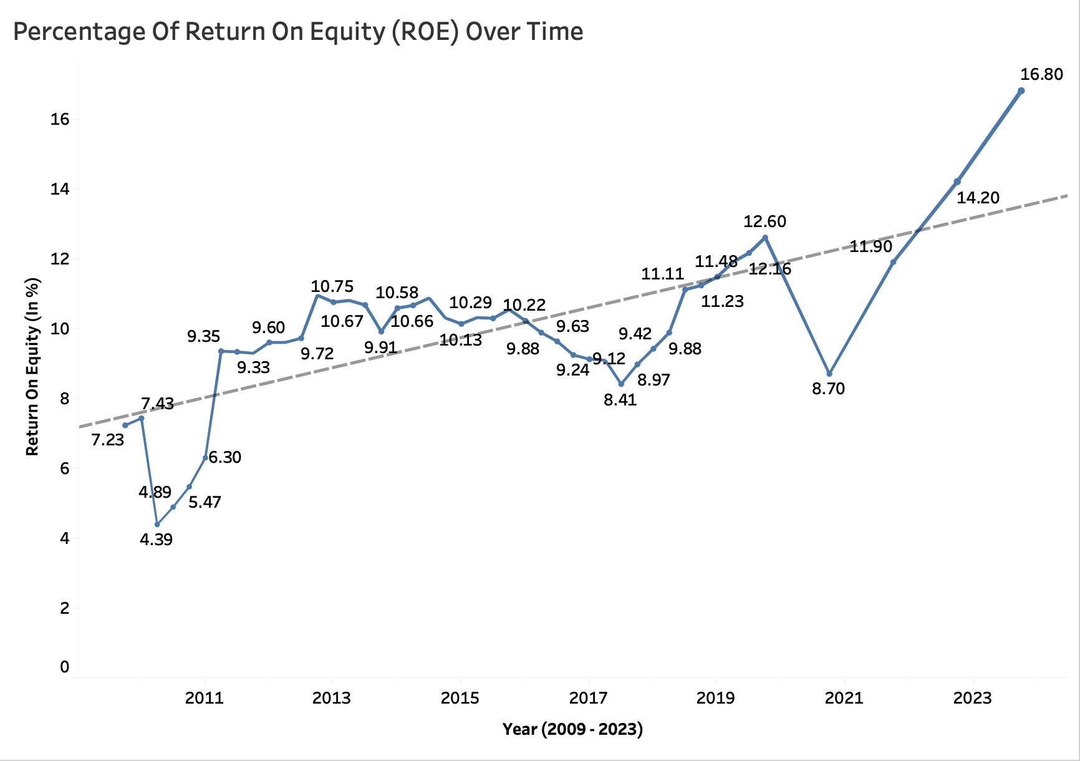

A line chart is the ideal chart because it shows how DBS ROE has fluctuated between 2009 and 2023 and the trend line indicates that there has been a linear increase. The ROE performance has been volatile as there are no obvious upward or downward trends. The ROE that began with a value of 7.23% has increased sharply to 16.80% by 2023 which represents an overall positive trend.

**3. *CSI For Finance and Insurance Sector* (Customer Measures 1)**

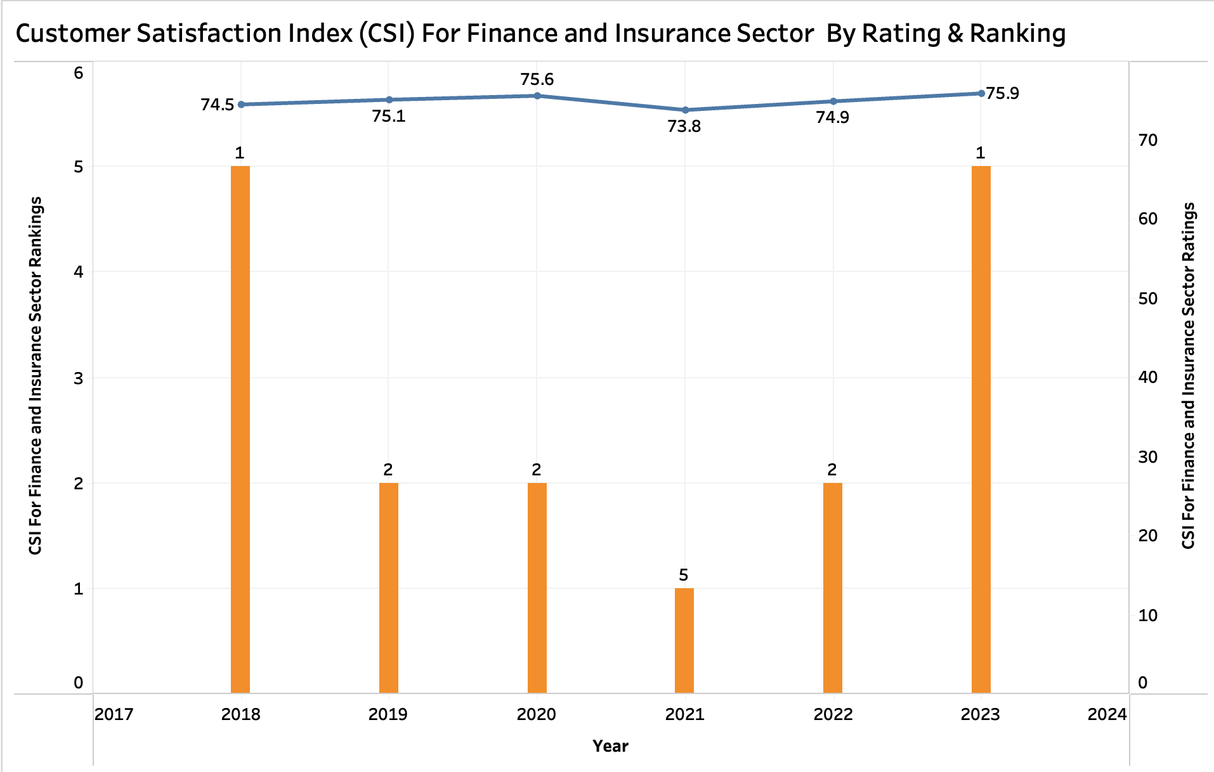

A line and bar chart are the ideal chart because it shows how ratings have remained steady with the lowest rating of 73.8 in 2021 and highest rating of 75.9 in 2023 and rankings have fluctuated with 5th place in 2022 and 1st place in 2018 and 2023 (DBS Group Holdings Ltd, n.d).

**4. Customer Engagement Score (CES) (Customer Measures 2)**

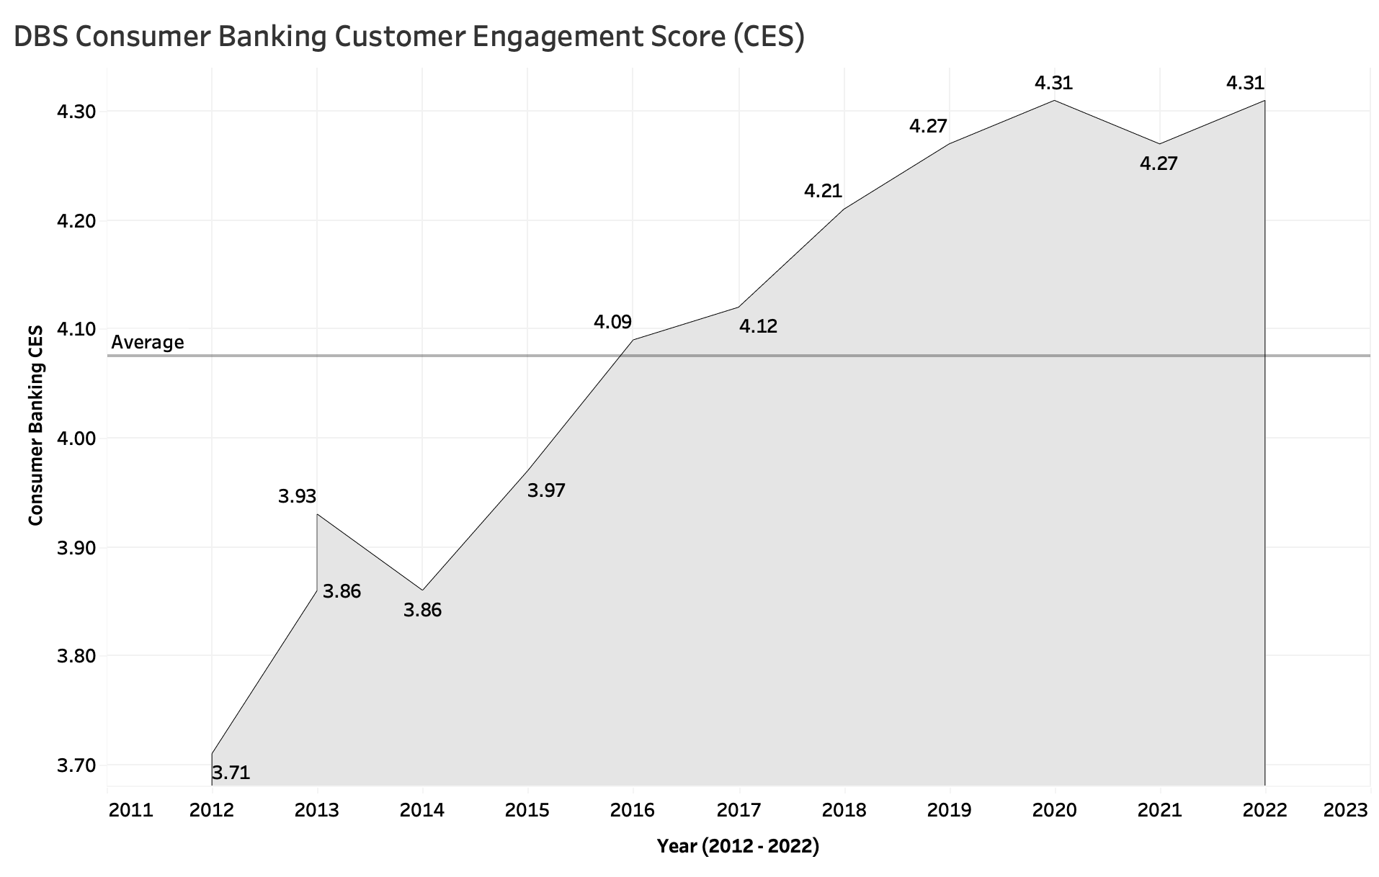

An area chart is an ideal chart because it shows a rapid increase in the Consumer Banking CES from the lowest point of 3.71 in 2012 to the highest point of 4.31 in 2022. The average line shows that the average is 4.08 which indicates that the majority of consumers are well engaged with a scale of 1 being the worst and 5 being the best.

**5. Adoption Rate Of New DBS iBanking Features (Internal Business Process 1)**

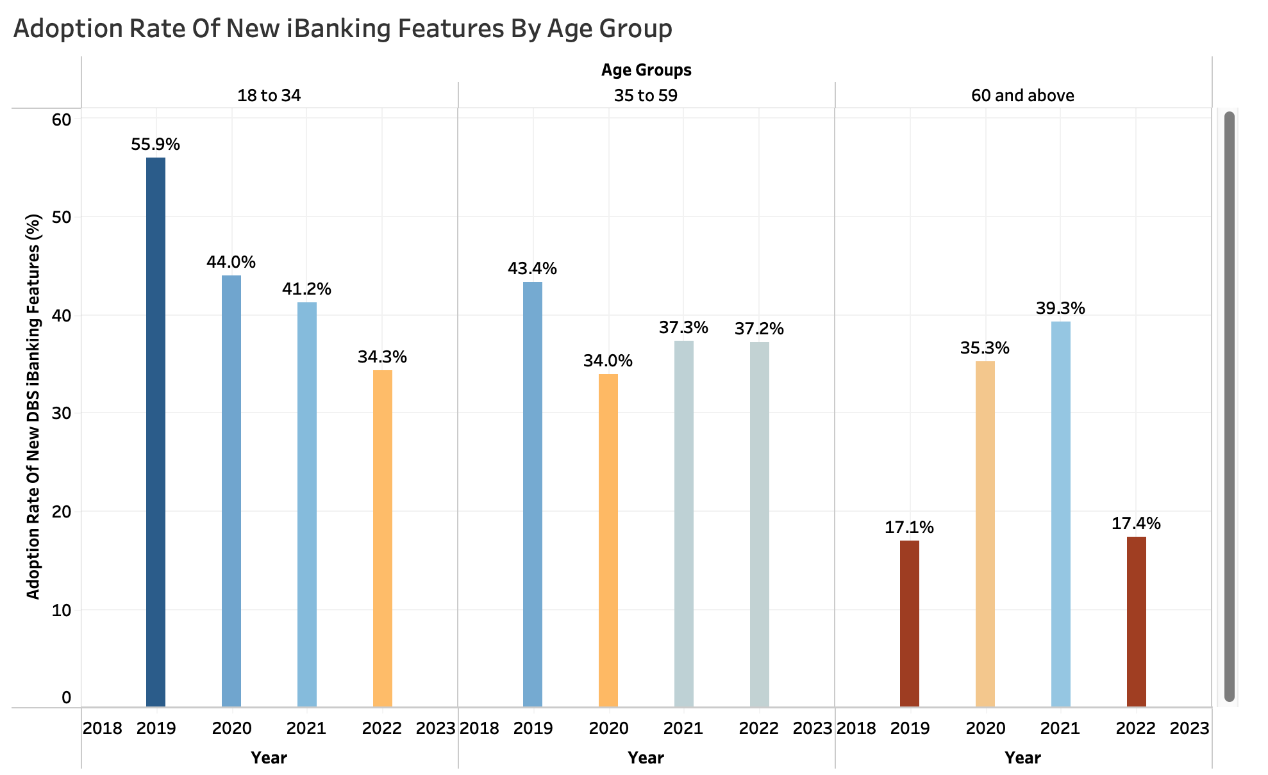

A side-bar-side chart is an ideal chart because it enables a granular comparison of the declining adoption rate between 2019 and 2022 for 3 age groups. The chart shows the age group 18 to 34 had the smallest reduction in adoption meanwhile the age group 60 and above had the highest reduction in adoption.

***6. Cost-to-Income Ratio (Internal Business Process 2)***

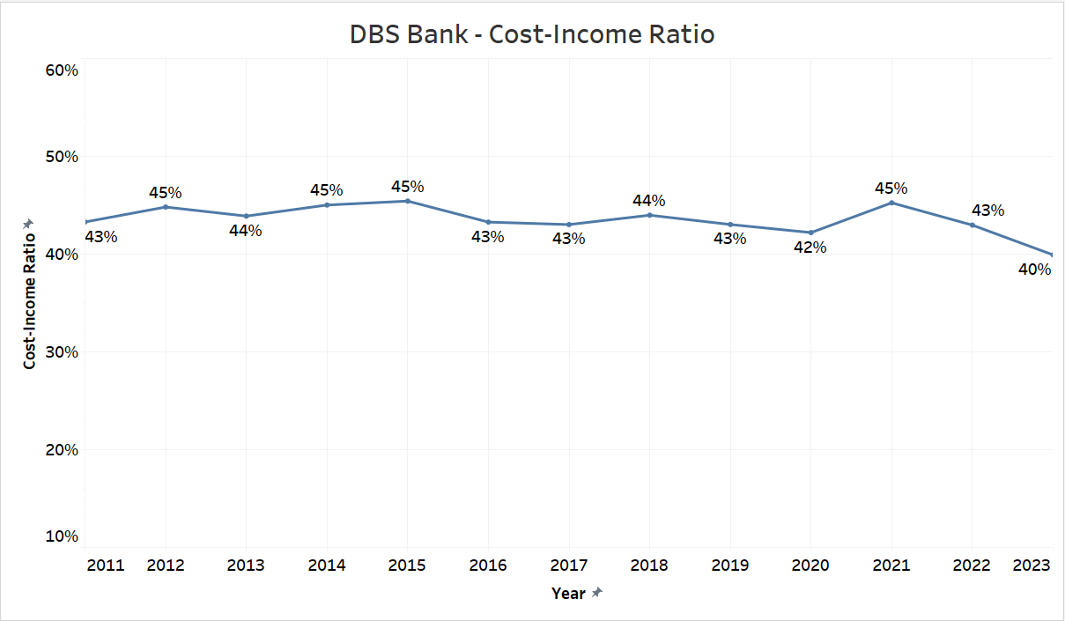

A line chart is an ideal chart because it visualises the DBS cost-to-income ratio, hovering between 43% to 45%. There was a spike in 2021, attributed to staff costs due to base salary increments. A chart insight is that improvements were seen in 2022 and 2023, driven by high-interest rates leading to deposit base growth.

***7. Internal Mobility Rate (Learning and Growth Measures 1)***

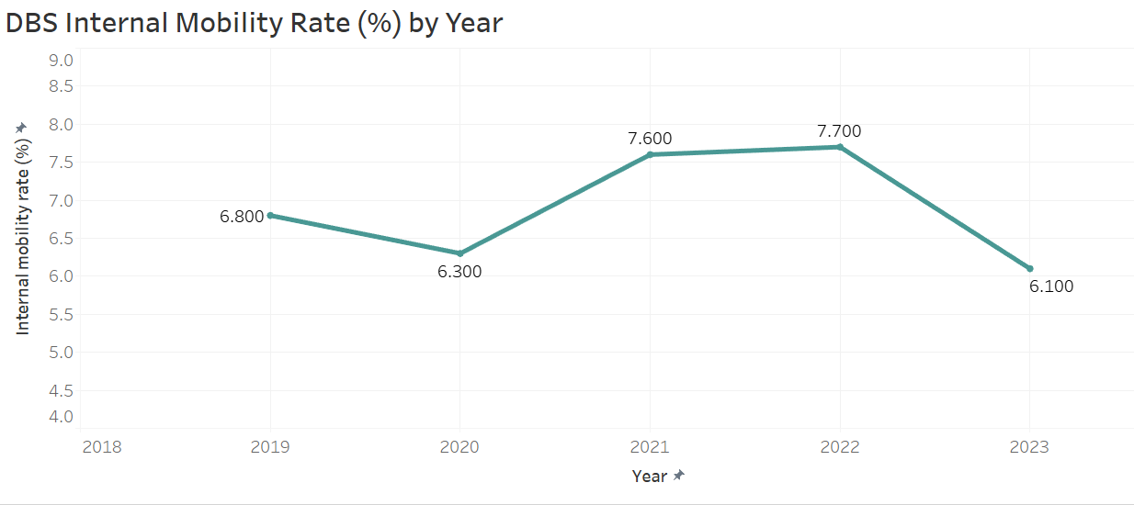

A line chart is an ideal chart because it visualises DBS's internal mobility rate decreasing from 7.7% in 2022 to 6.7% in 2023 due to a lower attrition rate (DBS Group Holdings Ltd, 2022). However, DBS should target the internal mobility rate in 2024 to recover to 7.7% or more (DBS Group Holdings Ltd, 2022) as this would indicate the versatility and upskill employees in the company.

***8. Increase Diversity Across the Workforce (Internal Business Process 2)***

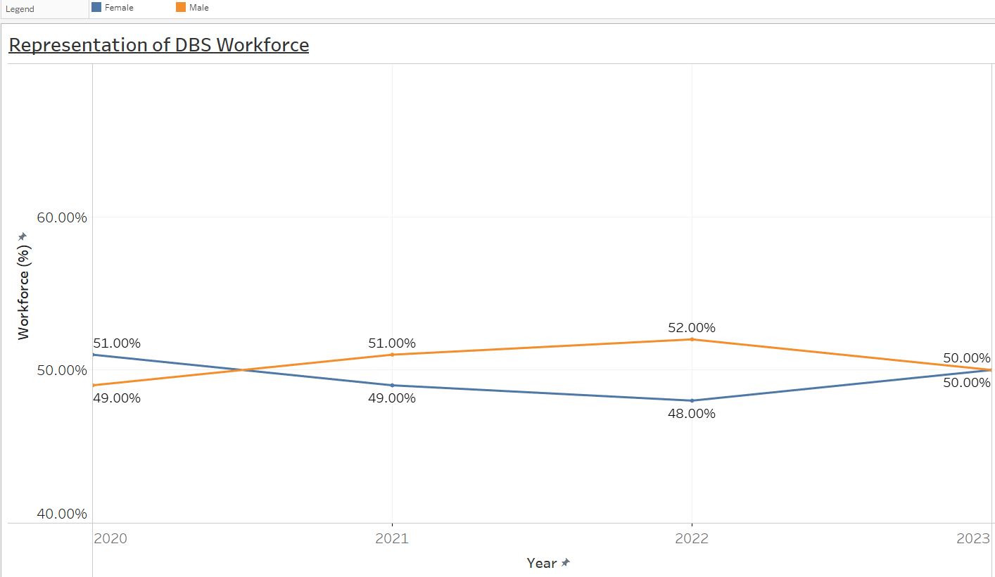

The line chart is the ideal chart because women make up 50% of their workforce with 41% in senior management positions (DBS Group Holdings Ltd, 2023). The representation of women in DBS has dropped from 52% in 2020 (DBS Group Holdings Ltd, 2022) to 50% in 2023 due to increased hiring of technology roles, which consists of lesser female talents (DBS Group Holdings Ltd, 2023).

**Question 2**

**Question 2(a) (8 marks)**

**ANS:**

|  |  |  |  |
| --- | --- | --- | --- |
| **Variable** | **Data Type** | **Number of Observations** | **Summary Statistics** |
| 2021  Country Name | Nominal | 70 values  0 missing values | Mean: Not Applicable  Median: Not Applicable  Mode: Not Applicable |
| Year | Interval | 70 values  0 missing values | Mean: 2020.01714285714  (Round Off 3 Decimal Place: 2020.017)  Median: 2020  Mode: 2019 |
| CO2 emissions (metric tons per capita) | Ratio | 67 values  3 missing values | Mean: 5.25439104048744  (Round Off 3 Decimal Place: 5.254)  Median: 3.01471126646524  (Round Off 3 Decimal Place: 3.015)  Mode: 1.55225942282078  (Round Off 3 Decimal Place: 1.552) |
| Forest area (sq. km) | Ratio | 70 values  0 missing values | Mean: 853415.120985714  (Round Off 3 Decimal Place: 853415.121)  Median: 419388.1335  (Round Off 3 Decimal Place: 419388.134)  Mode: 589426.267 |
| GDP per capita (current US$) | Ratio | 70 values  0 missing values | Mean: 24106.3952015026  (Round Off 3 Decimal Place: 24106.395)  Median: 9513.21310500499  (Round Off 3 Decimal Place: 9513.213)  Mode: Not Applicable |
| Tax revenue (% of GDP) | Ratio | 70 values  0 missing values | Mean: 15.4044652909995  (Round Off 3 Decimal Place: 15.404)  Median: 14.0277503531203  (Round Off 3 Decimal Place: 14.028)  Mode: 14.4469045418074  (Round Off 3 Decimal Place: 14.447) |

**Question 2(b) (16 marks)**

**ANS: Word Count: 248 Words (Excluding Figure Titles)**

**Issue 1 - Country Name**

To check for data quality issues, we can either use the Excel Function "Data →Filter" or use the Pivot table. We used the Pivot table to check for data quality issues.

Based on the data quality check, except for “Forest area (sq. km)” and “GDP per capita (current US$)”, the rest of the columns required data treatment.

There is an inconsistent format in Country Name where Vietnam is spelt with no space and with space in between and Australia is spelt as Austrlia. We could use the replace function using the Ctrl+H function to do the replacement or manually replace it by overwriting the cell.

|  |  |
| --- | --- |
|  |  |
| *Figure 2.1 Inconsistent format for countries Vietnam and Australia* | *Figure 2.2 Treated data for Countries Vietnam and Australia* |

**Issue 2 - Year**

Under column "Year", there are 2 inconsistent formats, 2018.4 and 2020.8. Similarly, we could use the Ctrl+H function to do the replacement.

|  |  |
| --- | --- |
|  |  |
| *Figure 2.3: Year - Inconsistent format* | *Figure 2.4: Treated Data for Years 2018 & 2020* |

**Issue 3 - CO2 emissions (metric tons per capita)**

Under this CO2 emissions field, there are 3 blanks of data for countries Belgium, Indonesia and Cambodia. To treat the missing fields, we could use the mean to replace the missing values by calculating the average CO2 emissions of each country and replace manually.

|  |  |
| --- | --- |
|  |  |
| Exact Missing Fields | Calculating the mean of each country to replace the missing values |
| *Figure 2.5 - Missing values for CO2 emissions* | *Figure 2.6 - Treated data by imputing missing values with mean* |

**Issue 4 - Tax revenue (% of GDP)**

Under Tax revenue (% of GDP), we noticed one outlier for the country Belgium under the Year 2022, i.e. 101 which is likely due to data input error. To rectify this outlier, we assumed the Year 2022 Tax to be the same as the Year 2021, hence, we replaced it with 23%.

|  |  |
| --- | --- |
|  |  |
| *Figure 2.7: Tax revenue (% of GDP) outlier under Country Belgium* | *Figure 2.8: Treated for outlier* |

**References (APA Style 7th Edition):**

DBS. (n.d.). *DBS full-year net profit rises 20% to record SGD 8.19 billion*. Retrieved March 8, 2024, from <https://www.dbs.com/newsroom/DBS_full_year_net_profit_rises_20pct_to_record_SGD_8_19_billion>

Statista. (2023, November 28). *Total income of DBS Group Holdings 2015-2022*. Retrieved March 10, 2024, from <https://www.statista.com/statistics/1134576/dbs-group-holdings-total-income/>

DBS Group Holdings Ltd. (n.d.). *DBS Group Holdings Ltd Annual Report 2022*. Retrieved March 9, 2024, from <https://www.dbs.com/annualreports/2022/files/media/dbs-annual-report-2022.pdf>

DBS Group Holdings Ltd. (2022). *Sparking change: DBS Group Holdings Ltd Sustainability Report 2022*. Retrieved March 10, 2024, from <https://www.dbs.com/iwov-resources/images/sustainability/reporting/pdf/web/DBS_SR2022.pdf?pid=sg-group-pweb-sustainability-pdf-dbs-sustainability-report-2022>

DBS Group Holdings Ltd. (2023). *Sustainability Report 2023*. Retrieved March 10, 2024, from <https://www.dbs.com/iwov-resources/images/sustainability/reporting/pdf/web/DBS_SR2023.pdf?pid=sg-group-pweb-sustainability-pdf-dbs-sustainability-report-2023>

**---- END OF ASSIGNMENT ---**